Incidence of Salmonella species in Commercially Processed Chicken Meat Sold in River State, Nigeria

Omorodion NJP and Odu NN

Department of Microbiology, University of Port Harcourt, P.M.B. 5323, Port Harcourt, Nigeria.
*Corresponding author. Tel: +2349083622583,
E-mail: nnenna.omorodion@uniport.edu.ng, nnennaomorodion@gmail.com

Abstract: Chicken meat promotes good health but at the same time is a major reservoir of microbial contaminant. In this study the incidence of Salmonella sp and other food borne pathogens were evaluated. A total of 12 samples were gotten which included 6wings and 6thighs from the different retail stores in Port Harcourt. The microbial quality of frozen or commercially processed chicken bought from different retail stores at Rumuokwuta, Alakahia, Choba in port Harcourt metropolis, Rivers state were assessed for the incidence of Salmonella sp. Total bacterial count, total Salmonella count, was done using plate count agar, Salmonella-Shigella agar, respectively. The result showed that for the total bacterial count on the chicken wing ranged from (1.15 x 10⁶- 2.57 x 10⁶) and for total Salmonella count it ranged from(1.09 x 10⁶ – 4.98 x 10⁶). The result for chicken thigh showed for the total viable count ranged from (1.72 x 10⁷) - (6.3 x 10⁷) while for total Salmonella count it ranged from (1.85 x 10⁶ - 1.77 x 10⁷). Biochemical tests were done to identify the isolates and a total of 24 isolates were obtained. From the isolates about 9 organisms were identified Escherichia coli (17%), Salmonella sp (17%), Citrobacter sp (4%), Pseudomonas sp (4%), Enterobacter sp (4%), Shigella sp (8%), Proteus sp (4%), Serretia sp (17%) and Staphylococcus sp (25%). The presence of microorganisms in refrigerated chicken meat should be as a result of the hygiene practices from the farm, during transportation, during slaughtering and finally in the retail stores. Other factors could be inadequate preservation techniques such as freezing in places of limited power supply. Therefore proper hygiene should be carried out to avoid contamination and proper and good manufacturing practices should be encouraged.
[Omorodion NJP and Odu NN. Incidence of Salmonella species in Commercially Processed Chicken Meat Sold in River State, Nigeria. Researcher 2016;8(4):59-64]. ISSN 1553-9865 (print); ISSN 2163-8950 (online). http://www.sciencepub.net/researcher. 9. doi:10.7537/marsrsj08041609.

Keywords: Incidence, Salmonella species, Commercially Processed Chicken, Meat, Nigeria

1. Introduction
Poultry meat can be referred to as the combination of muscle tissues, attached skin, connective tissues and edible organs of avian species commonly used as food. Poultry is an important animal food and their volume of production, marketing and consumption is increasing to satisfy the public demand worldwide within the last decades (Bryan, 1980; Anand et al., 1989; Mead 1997). Frozen chicken meat or commercially processed chicken meat is popular in Nigeria. It could be sold sliced or whole. The production and consumption of poultry meat are on the increase because of the high demand especially during ceremonies. However, inspection of slaughter houses, processing plants, storage shops are critical points to be considered. The role of poultry meat in most human food borne diseases are known (Alvarez-Astoralga et al., 2006). Frozen poultry meat can be contaminated during chill storage (lidija et al., 2006).
However, healthy chickens entering the slaughter stand a chance of being highly contaminated by food borne pathogens such as Salmonella sp, Campylobacter sp, Escherichia coli, and Staphylococcus sp. In developing countries diarrheic diseases kill 2.2million people annually (McMahon and Wilson, 2001). Food borne illness is a major international health problem (Raajat Hassanein et al., 2011). Salmonella is one of the most important pathogenic genera implicated in food borne bacterial outbreaks and diseases. Special attention must be observed in commercially processed chicken meat because of possible contamination from alimentary tracts, water, packaging, utensils and handlers (Ramastry et al, 1999). All significant poultry operations in Australia have a systematic preventive approach to managing food safety rules, with approved and regularly audited hazard analysis critical control point (HACCP) progress in place. Raw chicken meat maintains its quality longer in the freezer as compared to when having been cooked because moisture is lost during cooking. Generally raw chicken may be a carrier of Salmonella therefore the safe minimum cooking temperature recommended by the U.S. department of health and human service is 65ºF (74ºF) to prevent food borne illness because of bacteria and parasite.
Poultry meat are domesticated birds kept by humans for the eggs they produce, their meat, their feathers or sometimes as pets (Wikipedia, 2011). Poultry also includes other birds that are killed for their meat but does not include those hunted for games. Modern poultry processing requires a high rate of throughput to meet consumer demands, as poultry meat can be contaminated with microorganism due to many factors such as nutrients, high water activity, and neutral pH, (Kabour, 2011). Quality efforts should be put in place to avoid contamination along the production line. Rinsing of the carcasses, especially during defeathering and evisceration is therefore of great importance (Mead, 1982; Anand et al, 1989; Mead, 1989). One of such systems of quality effort will be the use of the hazard analysis critical control point (HACCP), which is designed to prevent, reduce or eliminate identified hazards in food products and systems, (KuKay et al, 1996). Also it is widely accepted that the HACCP is the safest and most effective way of eliminating or reducing contamination during food processing (NACMCF, 1998).
Salmonellosis have been described as the leading causes of food borne illnesses worldwide (Pansiello et al., 2000), therefore, it becomes important that consumer health concerns the greater involvement of the health sector Salmonella is of an increasing public health concern because they are the most incriminated pathogenic microorganisms of bacterial food poisoning especially present in poultry meat, with infection being through the handling of raw poultry carcasses together with the consumption of undercooked poultry meat (Pansiello et al., 2000). Consequently a few practices could be responsible for this contamination and they include; contaminated utensils and cutting tools, slaughter table, during packaging and even spoilage organisms in the freezer or cold room. The aim of the study is to evaluate the sanitary quality of commercially processed chicken meat sold at retail stores in Rivers State, Nigeria with regards to microbial load and the isolation of Salmonella species.

2. Methods
2.1. Sample Collection: A total of 12 samples of commercially processed chicken, 6 of which were thighs and the other 6 were wings were purchased from the following retail outlets Choba, Rumuokwuta, and Alakahia. All samples were collected aseptically in sterile bags and transported to the laboratory for immediate analysis.
2.2. Sample preparation: Chicken sample preparation. The chicken skin is being aseptically removed and cut in little bit of sizes in other to make weighing a lot easier. 25g of the chicken flesh is weighed before microbiological assessment.
2.3. Culturing and Enumeration: Six test tubes were labeled accordingly for each of the test tubes and each of the chicken samples (wings and thighs). Twenty-five grams (25g) of the homogenized chicken sample was introduced in 225ml of buffered peptone water. A sterile syringe was used to collect 1ml of the diluents which was transferred to the first test tube containing 9mls of buffered peptone water and was shaken properly. This gave the 1:10 dilution also known as 10⁻¹. Another sterile syringe was used to collect 1ml from the 10⁻¹ then introduce it into the 10⁻² tube and these procedures are repeated continuously till it gets to the 1:10⁶ or 10⁻⁶. After the syringes were used they were disposed of properly. For the chicken meat samples 0.1ml of dilutions 10⁻³ and 10⁻⁴ were plated out in Salmonella-Shigella agar (SSA) for total salmonella count and for the total viable count 0.1ml of dilutions 10⁻⁴ and 10⁻⁵ were plated out in plate count agar (PCA) respectively in duplicates. The plates were then packed and incubated in an inverted position at a temperature of 37oC for 18-24hrs. After which the plates are removed from the incubator, colonies were counted for the total salmonella count and the total viable count.
2.4. Isolation and Identification: Each colony was isolated in a pure from by sub culturing for further studies and identification for morphologically distinct characteristics of each pure culture such as elevation, edges, color, colony margin. Pure cultures were then stored as slants in bijou bottles. Isolates were identified using biochemical tests.

3. Results
All the chicken samples in this study were contaminated. However the microbial load of the different parts of the chicken varied. From this results, it has been observed that the total bacterial count on plate count Agar was higher for the chicken wings from Rumuokwuta as illustrated by the bar chart in Figure 1, while the total Salmonella count on Salmonella-Shigella Agar for the chicken wings were higher for Alakahia as illustrated in Figure 2. For the chicken thighs the total bacterial count and total Salmonella was higher at Rumuokwuta as illustrated in the bar chart as opposed to other retail stores (Figure 3).
During the course of the study, 24 bacterial isolates and nine different organisms: Escherichia coli, Serretia sp, Shigella sp, Pseudomonas sp, Salmonella sp, Proteus sp, Citrobacter sp, Enterobacter sp, and Staphylococcus sp were identified using biochemical tests (Figures 4-6). While pie charts were used to illustrate the percentage distribution of organisms in samples from the different locations (Figures 7-10).

Figure 1: A bar chart showing Average total bacterial count of Chicken wings from the different locations

Figure 2: A bar chart showing Average total Salmonella count of chicken wings from different locations

Figure 3: A bar chart showing Average total bacterial count of chicken thighs from different locations

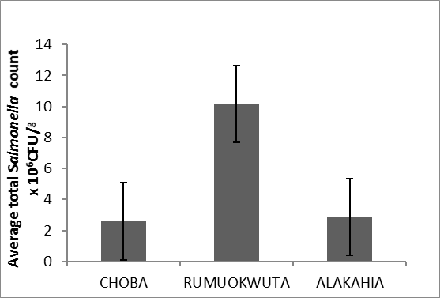
Figure 4: A bar chart showing Average total Salmonella count of chicken thighs from different location

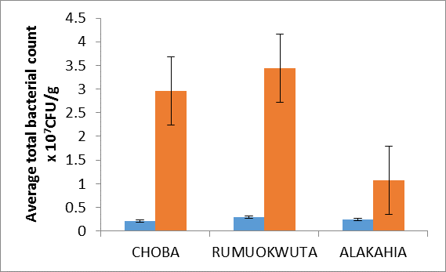
Figure 5: A bar chart comparing the Average total bacterial count of wings and thighs from different locations. KEY: Chicken wings; Chicken thigh

Figure 6: A bar chart comparing Average total salmonella count of chicken thighs and chicken wings from different location. KEY: Chicken wings; Chicken thigh

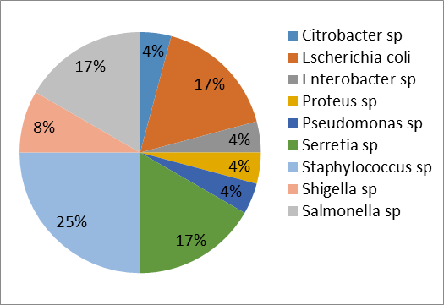
Figure 7: A pie chart showing the frequencies of microorganisms throughout the work from different samples and locations.

Figure 8: A pie chart showing the percentage distribution of organism found in samples purchased From Choba

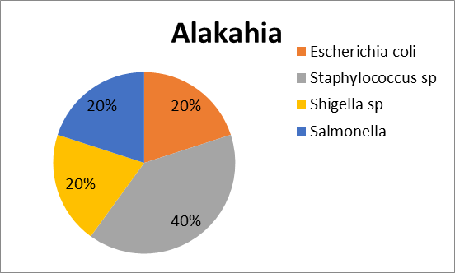
Figure 9: A pie chart Showing Percentage distribution of organisms in the samples purchased from Alakahia.

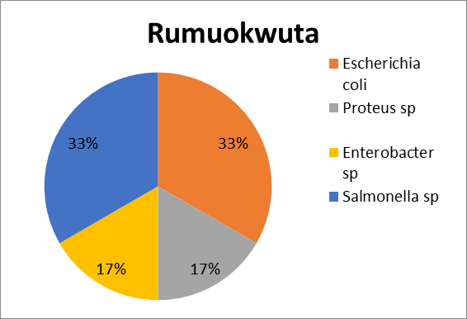
Figure 10: A pie chart showing percentage occurrence / incidence of organisms in samples purchased from Rumuokwuta

4. Discussion
Chicken meat is generally accepted worldwide, by various culture and nationalities as it is rich in nutrients and easily digestible. The present study is aimed to assess the incidence of Salmonella in refrigerated chicken meat. From the results, it is or can be right to say that Salmonella has a 17% prevalence or incidence in chicken meat sampled within the area of study. From the isolates about 9 organisms were identified Escherichia coli (17%), Salmonella sp (17%), Citrobacter sp (4%), Pseudomonas sp (4%), Enterobacter sp (4%), Shigella sp (8%), Proteus sp (4%), Serretia sp (17%), and Staphylococcus sp (25%).
With reference to the microbiological acceptable limit of contamination in chicken meat, which states that 5 x 10⁵ colonies per gram of sample for total viable count, the average total viable count ranging from 1.15 x 10⁶- 2.57 x 10⁶ for chicken wings exceeded the limit and also for that of the chicken thighs it ranged from 1.72 x 10⁷ -6.3 x 10⁷ CFU/g exceeded the acceptable limit. For the total salmonella count the chicken wing had a range of 1.09 x 10⁶ – 4.98 x 10⁶ CFU/g and for the thigh 1.85 x 10⁶ - 1.77 x 10⁷ CFU/g which exceeded the standard that states that Salmonella shall be absent from 25g of chicken meat as stated by W.H.O 2000. For the total viable count, the standard by PHLS (2000) and ICSMF (1986) is log 6 or 7 in the study the counts exceeded the stated limit, this similar to other studies by Chu et al. (2009), Bhandari et al. (2013). Choba had the least contamination on the chicken thigh and also had the highest contamination of the chicken wings. The total bacterial count range was higher from both the wings and thighs when compared to Nguyen thi et al. (2005) that had 0.18 x 10⁶ -47.8 x 10⁶ CFU/g as a range of value. Apart from Salmonella other organisms were isolated from the samples. Chicken meat cannot be found sterile as the natural environment of the live bird and its skin normal flora also affect the microbiological quality of the meat (Mead, 2000). All the bacteria isolated from this study have been identified by Bot Chris et al (2012).
The Salmonella contamination in the samples from this study is different from that of Sunpetch Angkititrakul et al. (2002) in which poultry meat from retail markets and supermarkets had a 75% contamination of Salmonella. However the methods of handling and storage might somewhat improve or worsen its natural state and thus this contamination can be curtailed by proper hygiene and cooking of food. Shigella sp is also amongst the isolated organisms in this research, therefore food contaminated by Shigella sp is mostly as a result of poor hygiene of an infected food handler. Escherichia coli appearance in food indicates fecal contamination possibly from unwashed hands of vendors and workers. Staphylococcus sp was the highest occurring pathogen as seen in the result from the research which could be as a result of its presence on the skin of birds and even on humans’ e.g. food handlers, also air and water. Staphylococcus causes food borne intoxication; the heat resistant enterotoxin may lead to nausea, vomiting, cramps, chills and a weak pulse.
The presence and occurrence of Salmonella sp in chicken samples may be as a result of the varying locations, type and size of sample analyzed and the methodology used (Bohaychuk et al., 2005). According to center for disease control and preventions emerging infections program, food borne diseases active surveillance network (Food Net), Shigella sp was the third most reported food borne bacterial pathogen in 2002. Therefore survival of Shigella is often associated and increased when food is held at refrigerated temperatures (Warren et al., 2003).
In conclusion, Salmonella sp is a major contaminant of poultry products and its meat. There is need to emphasize the importance of handling chicken and raw products carefully both in the home and catering establishments and on the importance of implementing effective and useful HACCP in places within the commercial environment. The poultry slaughtered and dressed under certain conditions carrying high initial contaminations would be present in meat as inherent contamination in the finished product. The bottom line is that chicken is said to be safe when properly cooked and handled, and that chicken producers and processors are continually working to make them even safer. The retail broiler meat sample from the locations contains high count of bacteria suggesting deplorable state of hygienic and sanitary practices.
The presence of Salmonella sp and Staphylococcus aureus organisms over the permissible limits are of special concern because this accounts for potential food borne intoxication. The marked growth of bacteria suggest that retail broiler meat is not suitable for consumption unless when properly cook Standards of food quality as regards imports of meat and meat products should be set up and demand for quality certification of products shown before the products are allowed into the country.
It is important that the use of HACCP (Hazard analysis critical control point) approach, based on the use of multi-functional strategies (combining the innovative use of sanitizers and modern disinfection techniques) and supervised by professional food handlers and food regulators with visionary commitment by manufacturers from the production, through the processing, preservation, handling and final preparatory stages be imposed to help eliminate or reduce significantly the prevalence of Salmonella sp, Escherichia coli and other food borne pathogens/ contaminant and the consequent food poisoning in the society. Therefore the need for microbial assessment of fresh meat and meat products processed for human consumption are recommended.

References
- Alvarez – Astoregi, M., M. Capita C. Alonso-Calleja, B. Moreno, M. Delcanmi and Garaa – femandez (2002). Microbiological quality of retail chicken by product in span..meat sci. 62: 45-50.
- Anand, S.K. Mahapatra, C.M., Pandey, N.K and Verma, S.S. (1989) Microbiological changes on chicken carcass during processing. Indian Journal of poultry science, 24(3), 203-209.
- Bhandari N, Nepali DB, Paudyal S 2013Assessment of bacterial load in broiler chicken meat from the retail meat shops in Chitwan, Nepal. Int J Infect Microbiol 2013;2(3):99-104.
- Bohaychuk, V.M., G.E. Gensler, R.K. King., J.T. Wu, and I.M. McMullen 2005. Evaluation of detection methods for screening meat and poultry products for the presence of foodborne pathogens. J. Food prot.68:2637-2647.
- Bot Chris J; Woma Timothy Yusufu; Abiayi Elmina; Mangut P E; and Ishaya David in the Vom Journal of veterinary Sciences, 9(1), 61-65 2012.
- Bryan F.L. 1980. Poultry and meat products (Edited by Silliker J.H., Elliot R.P., Baird-Parker A.C, Bryan F.L., Christian J.H.B., Clark D.S., Olson J.C and T.A.Roberts). Microbial Ecology of Foods, Food Commodities, 2: 410-458.
- Chu Thi Thanh Huong, Nguyen Thi Hai Duong, Nguyen Thi Thu Hien( 2009) Contamination of some bacteria isolated from chicken meat in retail markets in Hanoi and examination of the antibiotic resistance ability of Salmonella and E.coli strains isolated. J. Sci. Dev. 2009, 7 (Eng. Iss. 2): 181 – 186.
- Hassanein, R., Ali, S. F. H., AbdElMalek, A. M., Mohamed, M. A. and Elsayh, K.I. 2011. Detection and identification of Salmonella species in minced beef and chicken meats by using Multiplex PCR in Assiut city. Vet. World. 4: 5-11.
- Kabour G. A. (2011). Evaluation of microbial contamination of chicken carcasses during processing in Kharfoum of science and technology, Sudan.
- Kukay, C.C., L.H. Holcomb, J.M. Sofos, Morgan J.B, Tatum J.D, Clayton P.P and Smith G.C, 1996. Application of HACCP by small scale and medium scale meat processors. Dairy, food and environmental sanitation, 16, 74-80.
- Lidija, K., H. Mirza and Nevijo, Z. (2006). Microbiological quality of poultry meat on the Croatian market. Vetennary. Arch. 76 (4): 305-313.
- McMahon MAS and Wilson IG. (2001). The occurrence of enteric pathogens and Aeromonas species in organic vegetables. International Journal of Food Microbiology; 70: 155-162.
- Mead G.C. (1982), Microbiology of poultry and game birds. [Edited by Brown M.H.] In meat Microbiology, Applied science publishers Ltd
- Mead G.C. (1989), Hygiene problems and control of process contamination, [Edited by Mead G.C]. In processing of poultry. Elsevier Science publishers Ltd, 183-220.
- Meat, G. C. (1997). Bacteria in the gastrointestinal tract of birds. In Gastrointestinal Microbiology 2. Gastrointestinal Microbes and host interaction. R. J. Mackie, B. A. White, and R. E. Issacs on ed. Chapman and Hall, New York, pp 216-240.
- Mead G.C. (2000). Microbiological quality of poultry meat: a review. Brazilian Journal of Poultry Science, 6(3): 135 – 142.
- National Advisory committee on Microbiological Criteria for foods (NACMCF), (1998). Hazard analysis critical control point principles and guidelines. J. Food protection, 61:762-775.
- Nguyen Van Ton (2005). Research on the situation of poultry slaughter house, some Veterinarian criteria in chicken in urban of Hanoi and response. Thesis of Masters’ degree, Hanoi University of Agriculture.
- Nurmi, E. and M. Rentala (1973). New aspects of Salmonella infection in process production. Native 241:210-211.
- Panisello PJ, Rooney R, Quantick PC, Stanwell-Smith R. Application of foodborne disease outbreak data in the development and maintenance of HACCP systems. Int J Food Microbiol. 2000; 59:221–234.
- PHLS (2000): Guidelines for the microbiological quality of some ready-to-eat foods sampled at the point of sale. Comm. Dis. and Public Health 3(3): 163-167.
- Ramasastry, P., M. Ramaknohna and Mrunalini, N. (1999). Bacterial profiles of frozen. Ind. vet. 3: 76: 409-411.
- Sunpetch Angkititrakul, Chariya Chomvarin, Titima chaita, Kwankate Kanistanon and Supaporn Waethewutajarn (2005). Epidemiology of antimicrobial resistance in salmonella isolated from Pork, chicken meat and humans in Thailand. Southeast Asian J Trop Med Public Health, 36:6.
- Warren, H. E., Scollan, N. D., Hallett, K., Enser, M., Richardson, R. I., Nute, G. R., & Wood, J. D. (2002). The effects of breed and diet on the lipid composition and quality of bovine muscle. Proceedings of the 48th Congress of Meat Science and Technology, 1:370–371.

4/19/2016

