**Kinetics, isotherm and thermodynamic studies for adsorption of nitrate on sugarcane bagasse vermicompost**

Laleh Divband Hafshejani1, Abdolrahim Hooshmand 1, Abd Ali Naseri 1, Amir Soltani Mohammadi 1, Fariborz Abbasi 2

1. Department of Irrigation and Drainage Engineering, Faculty of Water Sciences Engineering, Shahid Chamran University of Ahvaz, Khuzestan, Iran

2. Agricultural Engineering Research Institute (AERI), Agricultural Research, Education & Extension Organization (AREEO), Karaj, Iran

[mdivband@gmail.com](mailto:mdivband@gmail.com)

**Abstract:** In present study, studies of kinetics, isotherm and thermodynamic for nitrate adsorption from aqueous solutions onto sugarcane bagasse vermicompost was investigated. Adsorption kinetics was determined by the fittings of the experimental data to three well-known kinetic models including pseudo-ﬁrst-order, pseudo-second-order and intraparticle diffusion. The experimental data were fitted to different adsorption isotherm models (Langmuir, Freundlich and Sips) and maximum adsorption capacity of sugarcane bagasse vermicompost was determined. Result this study showed the pseudo-second-order and Langmuir models gave the best fit for kinetic and isotherm studies, respectively. The maximum adsorption capacity of vermicompost for nitrate adsorption was found to be 15.773 mg/g, The thermodynamic studies (The values of ΔHº, ΔGº and ΔSº) showed that the adsorption of nitrate was spontaneous and exothermic in nature.

[Divband Hafshejani L, Hooshmand AR, Naseri AA, Soltani Mohammadi A,Abbasi F. **Kinetics, Isotherm and Thermodynamic Studies for Adsorption of Nitrate on Sugarcane Bagasse Vermicompost.** *Researcher* 2016;8(2):31-35]. ISSN 1553-9865 (print); ISSN 2163-8950 (online). <http://www.sciencepub.net/researcher>. 5. doi:[10.7537/marsrsj08021605](http://www.dx.doi.org/10.7537/marsrsj08021605).

**Keywords:** Adsorption, pseudo-second-order, Langmuir, nitrate

**1. Introduction**

In in recent years, exist of nitrate in the groundwater and surface water has become an important problem (Bhatnagar et al., 2010). The agricultural wastewater is one of main sources of production nitrate (Bhatnagar et al., 2010). Increasing of nitrate in drinking water can cause health problems especially in infants, such as blue baby syndrome (Wan et al., 2012; Moradzadeh et al., 2014). The US environmental protection agency (U.S. EPA) has said that the maximum allowable concentration of nitrate is 10 mg/L in drinking water (Bhatnagar et al., 2010). Numerous techniques (reverse osmosis, electrodialysis, ion exchange, chemical precipitation and adsorption) have been applied to remove nitrate from contaminated water (Bhatnagar and Sillanpää, 2011). Among other methods for removal of nitrate, adsorption is one of the most effective methods (Olgun et al., 2013; Wan et al., 2012).

Numerous materials have been used for the nitrate adsorption from aqueous solution such as sugarcane bagasse, rice hull, zeolite, chitosan, clays, slag and fly ash (Bhatnagar and Sillanpää, 2011). The use of agricultural wastes materials have been increased in recent years for the production of Vermicompost, because these are available abundantly, cheap and non-toxic. Vermicomposting is a low cost technology system used for conversion of agricultural waste into organic materials. Use of agricultural wastes for vermicompost production can improve the agricultural waste.

In this study, sugarcane bagasse vermicompost modified was applied for adsorption of nitrate and studies of kinetics, isotherm and thermodynamic for nitrate adsorption from aqueous solutions onto sugarcane bagasse vermicompost was investigated. The experimental data were analyzed using kinetic models (pseudo-ﬁrst-order, pseudo-second-order and intraparticle diffusion) and isotherm models (Langmuir, Freundlich and Sips). Also the values of ΔHº, ΔGº and ΔSº (thermodynamic parameters) were determined.

**2. Material and Methods**

**Adsorption kinetic studies**

0.1 g sugarcane bagasse vermicompost was added to 50 mL of nitrate solutions whit initial concentration of 50 mg/L. The solutions were oscillated in varying contact time ranged between 5–180 min, at temperature of 22± 1 ºC with speed of 120 rpm. Samples were centrifuged and nitrate concentrations were analyzed using spectrophotometer. The amount of nitrate adsorbed per unit weight of adsorbent and nitrate adsorption percentage were calculated by the equations (1).

|  |  |
| --- | --- |
|  | (1) |

where Ci and Ce are initial and equilibrium concentrations of nitrate in solution (mg/L), V is the volume of solution (L) and m is mass of the modified vermicompost (g).

In this study, three models were used for analyzing adsorption mechanism.

The pseudo-ﬁrst-order model describes adsorption behavior in solid-liquid systems based on the adsorption capacity of solids. The nonlinear form of pseudo-ﬁrst order model is described as follows (Lagergren, 1898):

|  |  |
| --- | --- |
|  | (2) |

Where k1 is the rate constant of pseudo-ﬁrst-order model (1/min), qe (mg/g) and qt (mg/g) are adsorption capacities at time equilibrium and at time t (min), respectively.

The pseudo-second-order model is applied for investigating or studying chemisorption kinetics from liquid solutions. The nonlinear form of pseudo-second order model is described below (Ho and McKay, 1999):

|  |  |
| --- | --- |
|  | (3) |

Where k2 is the rate constant of pseudo-second-order model (g/mg.min), qe (mg/g) and qt (mg/g) are adsorption capacities at time equilibrium and at time t (min), respectively.

The intraparticle diffusion model is used to identify an adsorption controlled process by diffusion mechanism in the liquid-solid system. The nonlinear form of intraparticle diffusion model is described below (Weber and Morris, 1963):

|  |  |
| --- | --- |
|  | (4) |

Where Kp is the intraparticle diffusion rate constant (mg.min1/2/g) and I (mg/g) is the intercept of intraparticle diffusion model, respectively.

**Adsorption isotherm studies**

0.1 g sugarcane bagasse vermicompost was added to 50 mL of solutions containing nitrate at the concentration range of 1-100 mg/L. The solutions were stirred at temperature of 22± 1 ºC for 120 min (equilibrium time), with speed of 120 rpm. Three adsorption isotherm models, Freundlich, Langmuir and Sips models were used to analyze the experimental data. The Freundlich isotherm was applied to describe the heterogeneous systems. The nonlinear form of Freundlich isotherm model is described as (Malekian et al., 2011).

|  |  |
| --- | --- |
|  | (5) |

Where qe (mg/g) and Ce (mg/L) are the adsorption capacity and concentration of the nitrate ions at equilibrium time. KF (mg. L1/n/g.mg1/n) and n (g/L) are Freundlich isotherm constants related to adsorption capacity and intensity, respectively.

The Sips adsorption model is one of the empirical adsorption equation with three parameters that is combination of Langmuir and Freundlich equations. The nonlinear form of the Sips isotherm model is explained as (Sips, 1948):

|  |  |
| --- | --- |
|  | (6) |

Where qe (mg/g), qm (mg/g) and Ce (mg/L) are the adsorption capacity, maximum adsorption capacity and equilibrium concentration of the nitrate ions, respectively. Ks (L/mg) is the affinity constant for adsorption.

The Langmuir adsorption model is based on the assumption that the adsorption occurs uniformly on the active sites of the adsorbent. The nonlinear form of the Langmuir isotherm model is expressed as (Langmuir, 1916):

|  |  |
| --- | --- |
|  | (7) |

Where qe (mg/g), qm (mg/g) and Ce (mg/L) are the adsorption capacity, maximum adsorption capacity and equilibrium concentration of the nitrate ions, respectively. KL (1/min) is the Langmuir constant related to the energy of adsorption.

**Adsorption thermodynamic**

The effect of temperature in the adsorption process is one of important factor. Therefore its effect on nitrate adsorption mechanism by modified vermicompost was evaluated at three different temperatures (10, 22 ºC (room temperature)). The thermodynamic parameters such as standard free energy change (ΔGº) (Eq. (8)), standard enthalpy (ΔHº) (Eq. (9)) and standard entropy (ΔSº) (Eq. (10)) were used to study the thermodynamics of adsorption.

|  |  |
| --- | --- |
|  | (8) |
|  | (9) |
|  | (10) |

Where ΔGº is standard free energy change (kJ/ mol), R (8.314 J/K.mol) and T (Kelvin) are the universal gas constant and absolute temperature, respectively. ΔHº is standard enthalpy (kJ/mol), ΔSº is standard entropy (J/mol.K), and K is the equilibrium constant which related to the Langmuir model (Eq. (11)).

|  |  |
| --- | --- |
|  | (11) |

Where the value 55.5 corresponds to the molar concentration of the water (Bhatnagar et al., 2010).

**Error analysis**

For evaluate the goodness of fit of the applied adsorption models to the experimental data, Two Error functions, Root Mean Square Error (RMSE) and coefficient of determination (R2) were applied (Divband Hafshejani et al., 2015).

1. The coefficient of determination (R2)

|  |  |
| --- | --- |
|  | (12) |

2. Root Mean Square Error (RMSE)

|  |  |
| --- | --- |
|  | (13) |

Where Oi and Pi are ith of the observed and predicted measurement, respectively. Oave and Pave are average of the observed and predicted measurement and n is number of observations.

**3. Results**

The fitting of different kinetic models (pseudo-first-orde, pseudo-second-orde, Intraparticle diffusion) to the experimental data is shown in Figure. 1 (a-b) and table 1.

Table 1. Kinetic parameters of nitrate adsorption

|  |  |  |
| --- | --- | --- |
| models | Parameter | Value |
| Pseudo-first-order | qe(exp) (mg/g) | 12.98 |
| K1 (min) | 0.048 |
| qe(cal) (mg/g) | 11.175 |
| RMSE | 0.892 |
| R2 | 0.979 |
| Pseudo-second-order | qe(exp) (mg/g) | 12.98 |
| K2 (g/mg.min) | 0.004 |
| qe(cal) (mg/g) | 12.8 |
| RMSE | 0.466 |
| R2 | 0.993 |
| Intraparticle diffusion | I (mg/g) | 2.062 |
| KP (mg/g.min) | 0.854 |
| RMSE | 3.044 |
| R2 | 0.741 |

In Comparing with other kinetic models, the pseudo-second-order model fits better with the experimental data due to the higher correlation coefficient (0.993) and lower root mean square error (0.466).

**(a)**

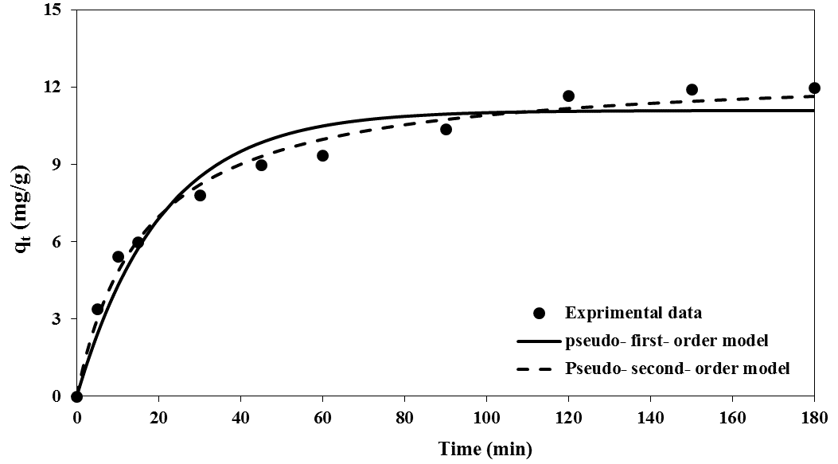

**(b)**

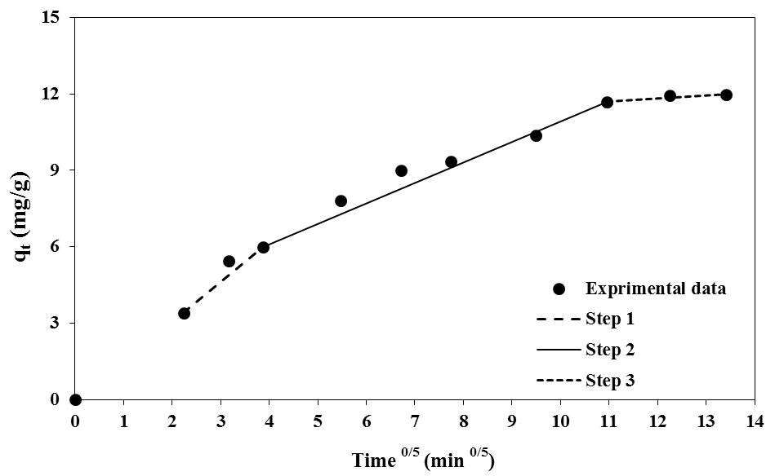

Figure 1. Fitting of kinetic models of nitrate adsorption

**Adsorption isotherm studies**

The results of Langmuir, Freundlich and Sips isotherms for the adsorption of nitrate by modified vermicompost are presented in Table 2 and Figure 2. The results indicate that Langmuir isotherm model with higher values of R2 (0.999) and lower values of RMSE (0.323) shows better fit to experimental data as compared to other isotherm models.

The maximum adsorption capacity of nitrate, maximum adsorption capacity in Langmuir model calculated 15.773 mg/g.

Table 1. Isotherm parameters of nitrate adsorption

|  |  |  |
| --- | --- | --- |
| models | Parameter | Value |
| Sips | qm (mg/g) | 17.190 |
| Ks (L/mg) | 0.16 |
| n | 1.199 |
| RMSE | 0.475 |
| R2 | 0.999 |
| Langmuir | qm (mg/g) | 15.773 |
| b (L/mg) | 0.140 |
| RL | 0.877 |
| RMSE | 0.323 |
| R2 | 0.999 |
| Freundlich | KF (mg. L/g) | 4.220 |
| n (g/L) | 2.291 |
| RMSE | 1.079 |
| R2 | 0.987 |

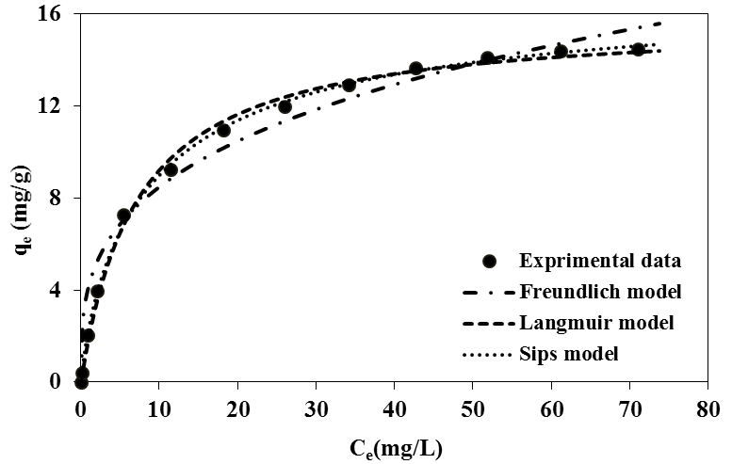

Figure 2. Fitting of isotherm models of nitrate adsorption

**Adsorption thermodynamic studies**

The obtained results of thermodynamic studies of nitrate adsorption by modified sugarcane bagasse vermicompost are presented in Table 3.

Table 3. Thermodynamic parameters of nitrate adsorption

|  |  |  |  |
| --- | --- | --- | --- |
| Temperature (ºC) | ΔGº | ΔHº | ΔSº |
| 10 | -32.12 | 21.21 | 180.67 |
| 22 |

The results show that the value of ΔGº is negative (−32.12 kJ/mol), the value of ΔHº is positive (21.21 kJ/mol) and the value of ΔSº is positive also (180.67 J/mol.K).

**4. Discussions**

The result this study showed that modified sugarcane bagasse vermicompost can be applied as low cost adsorbent for nitrate adsorption.

The result indicated that the pseudo-second-order model have better agreement whit experimental data. This result agrees with the results reported by other researchers for the nitrate adsorption where pseudo-second-order kinetic model has good agreement with the experimental data (Ganesan et al., 2013; Hu et al., 2015).

Table 1 shows the theoretical calculated qe(cal) values obtained from the pseudo-second order kinetic model are closer than to the experimental ones (qexp).

In this study, intraparticle diffusion model applied for identify the diffusion mechanism. The plot of (qt) versus (t0/5) showed multi-linearity for nitrate adsorption (Fig. 1.b). This would indicate the existence of more than one kinetic stage in adsorption process.

A good fit of experimental data with the Langmuir model shows all sites on surface of modified vermicompost of sugarcane bagasse have the equal energy for nitrate adsorption.

The values of Freundlich isotherm constant “n” is 2.291 (between 1 and 10). This evidence shows adsorption of nitrate by modified sugarcane bagasse vermicompost is favorable.

The good fit of experimental data with the Langmuir isotherm model could indicate the monolayer nitrate adsorption on homogenous surface of vermicompost of sugarcane bagasse.

Similar results have also been reported by other researchers where Langmuir isotherm model has shown good agreement with the experimental data for nitrate adsorption (Ganesan et al., 2013; Milmile, et al., 2011).

The negative value of ΔGº (−32.12 kJ/mol) shows that the nitrate adsorption by modified vermicompost is spontaneous in nature. The positive value of ΔHº (21.21 kJ/mol) indicates that nitrate adsorption mechanism is endothermic in nature. Similar results have also been reported by other researchers where nitrate adsorption process by different material is endothermic in nature (Bhatnagar et al., 2010; Liu and Zhang, 2015).

The positive value of ΔSº (180.67 J/mol.K) shows the affinity of the modified sugarcane bagasse vermicompost for nitrate adsorption.

The ΔGº value obtained in this study is lower than −10 kJ/mol, it can be indicated that the nitrate adsorption process is physical (Liu and Zhang, 2015).

**Acknowledgements:**

The authors would like to thank Shahid Chamran University of Ahwaz, Iran, for the financial and other supports.

**Corresponding Author:**

Laleh Divband Hafshejani

Department of Irrigation and Drainage Engineering

Faculty of Water Sciences Engineering

Shahid Chamran University of Ahvaz, Khuzestan, Iran

Telephone: +989132387133

E-mail: [mdivband@gmail.com](mailto:mdivband@gmail.com)

**References**

1. Bhatnagar A, Kumar E, Sillanpää M. Nitrate removal from water by nano-alumina: Characterization and sorption studies. Chemical Engineering Journal 2010; 163: 317-323.
2. Bhatnagar A, Sillanpää M. A review of emerging adsorbents for nitrate removal from water. Chemical Engineering Journal 2011; 168, 493-504.
3. Ganesan P, Kamaraj R, Vasudevan S. Application of isotherm, kinetic and thermodynamic models for the adsorption of nitrate ions on graphene from aqueous solution. Journal of the Taiwan Institute of Chemical Engineers 2013; 44: 808-814.
4. Divband Hafshejani L, Boroomand Nasab S, Mafi Gholami R, Moradzadeh M, Izadpanah Z, Bibak Hafshejani S, Bhatnagar A. Removal of zinc and lead from aqueous solution by nanostructured cedar leaf ash as biosorbent. Journal of Molecular Liquids 2015; 211: 448-456.
5. Ho Y, Porter J, McKay G. Equilibrium isotherm studies for the sorption of divalent metal ions onto peat: copper, nickel and lead single component systems. Water, Air, and Soil Pollution 2002; 141:1-33.
6. Hu Q, Chen N, Feng C, Hu W. Nitrate adsorption from aqueous solution using granular chitosan Fe3+ complex. Applied Surface Science 2015; 347: 1-9.
7. Lagergren, S. About the Theory of So-Called Adsorption of Soluble Substances Zur Theorieder Sogenannten. Kungliga Svenska Vetenskap sakademiens Handlingar; 1898: 24, 1-39.
8. Langmuir, I. The constitution and fundamental properties of solid and liquids. Part I. Journal of the American Chemical Society 1916: 38; 2221-2295.
9. Liu X, Zhang L. Removal of phosphate anions using the modified chitosan beads: Adsorption kinetic, isotherm and mechanism studies. Powder Technology 2015; 277: 112-119.
10. Milmile SN, Pande JV, Karmakar S, Bansiwal, A, Chakrabarti T, Biniwale RB. Equilibrium isotherm and kinetic modeling of the adsorption of nitrates by anion exchange Indion NSSR resin. Desalination 2011; 276: 38-44.
11. Moradzadeh M, Moazed H, Sayyad, G, Khaledian, M. Transport of nitrate and ammonium ions in a sandy loam soil treated with potassium zeolite–Evaluating equilibrium and non-equilibrium equations. Acta Ecologica Sinica 2014; 34: 342-350.
12. Olgun A, Atar N, Wang S. Batch and column studies of phosphate and nitrate adsorption on waste solids containing boron impurity. Chemical Engineering Journal 2013; 222: 108-119.
13. Sips R. On the structure of a catalyst surface. The Journal of Chemical Physics 1948; 16: 490-495.
14. Wan D, Liu H, Liu R, Qu J, Li S, Zhang J. Adsorption of nitrate and nitrite from aqueous solution onto calcined (Mg-Al) hydrotalcite of different Mg/Al ratio. Chemical Engineering Journal 2012; 195:241-247.
15. Weber W, Morris J. Intraparticle diffusion during the sorption of surfactants onto activated carbon. J Sanit Eng Div Am Soc Civ Eng 1963; 89: 53-61.
16. Malekian R, Abedi-Koupai J, Eslamian SS, Mousavi SF, Abbaspour K, Afyuni M. Ion-exchange process for ammonium removal and release using natural Iranian zeolite. Applied Clay Science 2011; 51: 323-329.

2/14/2016