Results of Researches on Weather Changes And Natural Hazards

Gangadhara Rao Irlapati

H.No.5-30-4/1, Saibaba Nagar, Jeedimetla, Hyderabad – 500 055, Telangana State, INDIA
Public Service Commission, Andhra Pradesh, India
Email ID: scientistgangadhar@gmail.com

Abstract: I have conducted many studies and researches on disasters and natural calamities and proposed a number of models to forecast the disaster and natural calamities in advance, Mainly the first one is Global Monsoon Time Scale which can help to forecast the monsoon movements, cyclones, low pressure systems, depressions, heavy rains & floods, droughts & famines etc and the second one is Geoscope which can help to forecast the geological and geophysical disasters such as tsunamis, earthquakes, underground water, mines etc.
[Gangadhara Rao Irlapati. Results of Researches on Weather Changes And Natural Hazards. Researcher 2016;8(1s):536-565]. ISSN 1553-9865 (print); ISSN 2163-8950 (online). http://www.sciencepub.net/researcher. 20. doi:10.7537/marsrsj0801s16.20.

Key words: Disasters, Natural calamitites, earth quakes, Global Monsoon Time Scale, Geoscope

Introduction:
Global Monsoon Time Scale: The global Monsoon Time Scale – a Chronological sequence of events arranged in between time and weather with the help of a scale for studying the past’s, present and future movements of monsoon of a country and its relationship with rainfall and other weather problem and natural calamities.
Prepare the Global Monsoon Time Scale having 365 horizontal days from March 21st to next year March 20th of a required period comprising of a large time and weather have been taken and framed into a square graphic scale. The main weather events if any of the country have been entering on the scale as per date and month of the each and every year. If we have been managing the scale of a country in this manner continuously, we can study the past, present and future movements of monsoon of a country. We can make separate monsoon time scales per each and every individual country.
Indian Monsoon Time Scale: For example, I have prepared the monsoon time scale for India by preparing the scale having 365 horizontal days from 1st April to next year March 31st of 128 years from 1888 to 2016 of the required period comprising of large time and weather have been taken and framed into a square graphic scale. The monsoon pulses in the form of low pressure systems over the Indian region have been entering on the scale in stages by 1 for low, 2 for depression, 3 for storm, 4 for severe storm and 5 for severe storm with core of hurricane winds pertaining to the date and month of the each and every year. If we have been managing the scale in this manner continuously, we can study the past’ present’s and future’s of the India Monsoon and its relationship with rainfall and other weather problems & natural calamities in India.
Analysis: The India Monsoon Time Scale reveals many secrets of the Indian monsoon and its relationship with rainfall & other weather problems and natural calamities. For example, some bands, clusters and paths of low pressure systems along with the main paths of the Indian Monsoon (South-east monsoon and north-west monsoon) clearly seen in the map of the Indian monsoon it have been some cut-edged paths passing through its systematic zigzag cycles in ascending and descending orders which causes heavy rains & floods in some years and droughts & famines in another years according to their travel. For example, during 1871-1990’s, the main path of the Indian Monsoon was rising over June, July, August and creating heavy rains and floods in most years. During 1900-1920’s, it was raising over August, September and resulting good rainfall in more years. During 1965-2004’s it was falling over September and causing low rainfall and droughts in many years. At present it is rising upwards over June, July, August, September and will be resulting heavy rains & floods in coming years during 2004-2060. The tracking date of main path & other various paths such as south-east monsoon and north-west monsoon etc., of the Indian Monsoon denotes the onset of the monsoon, monsoon pulses or low pressure systems. And also we can find out many more secrets of the Indian monsoon such as droughts, famines, cyclones, heavy rains, floods, real images of the Indian monsoon, and onset & withdrawals of south east monsoon and north-west monsoon etc. by keen study of the Indian Monsoon Time Scale.
Principle: This is an Astrogeophysical/ Astrometeorological phenomenon of effects of astronomical bodies and forces on the earth’s geophysical atmosphere. The cause is unknown however the year to year change of movement of axis of the earth inclined at 23½ degrees from vertical to its path around the sun does play a significant role in formation of clusters, bands & paths of the Indian Monsoon and stimulates the Indian weather. The inter-tropical convergence zone at the equator follows the movement of the sun and shifts north of the equator merges with the heat low pressure zone created by the rising heat of the sub-continent due to direct and converging rays of the summer sun on the India Sub-Continent and develops into the monsoon trough and maintain monsoon circulation.
Geoscope: Geoscope means- a mechanical architecture established in between the underground and observatory with the help of bore-well proposed for conducting geological studies to know the earthquakes, ores and water currents etc.
A borehole having suitable width and depth has to be dug. An observatory having research &analysis facilities has to be constructed on the borehole Apparatus & sensors to recognize the geo- physical and geo-chemical changes generated in the underground such as foreshocks, chemical changes, electrogeopulses, micro-vibrations, pressure, geomagnetic forces etc should be inserted into the underground and linked with the concerned analysis sections of the observatory that is above the ground to study the changes taking place in the underground.
That means-relative results of geological & geographical researches &developments of past, present and future should be interposed, coordinated and constantly developed. The apparatus related to the geology and geography such as Richter scale etc also should be set in the observatories of the Geoscope. we can make many more modern ideas& modifications thus bringing many more improvements & developments in the Geoscope.
And we can build many more types of Geoscopes thus connecting many more levels for national wide network, more and required geoscope centers should be established in the earthquake zones where earthquakes occur frequently and there should be establish a central office to co-ordinate and codify the data of warnings about the onset of earthquake. The central office should analysis the data and estimate the time, epicenter, area etc details of the impending earthquake and send to the authorities and people to take precautions.
National Geoscope Project: Many extensive researches were conducted on the national geoscopic forewarning system to detect the geological changes in advance. In this system, there should be established three level centers i.e., Local Geoscope Centre, Regional Geoscope Centre and Central Geoscope Centre for maintaining the system in a coordinated manner.
Local Geoscope Centre: One or more required number of Geoscopes should be established in the expected earthquake zones. The observation personnel in the respective Geoscopes should watch the onset of earthquakes day and night.
Regional Geoscope Centre: There should be established a Regional Geoscopic Centre at every expected quake zone to co-ordinate and codify the information supplied by the local geoscopic centers of the zone.
Central Geoscope Centre: There should be established a Central Geoscopic Centre to co-ordinate and codify the information supplied by the Regional Geoscopic Centers from all over country in a coordinated manner.
Performance: Whenever a Local Geoscopic Centre sends warning about the onset of earthquakes, the observation personal should immediately send the information to its Regional Geoscopic Centre. The Regional Geoscopic Centre should analysis the information and send it to the Central Geoscopic Centre. The Central Geoscope Centre analyze the information supplied by the Local Geoscopic Centers, Regional Geoscopic Centers and estimates the epicenter, time, area to be affected urban places etc., details of the impending earthquake and send to the authorities, and media and warnings in advance to take precautions.
Types Of Geoscope Models:
Three Tpes Of Geoscope Models Is Simple Geoscope, Homemade Geoscope And Micro Geoscope Models Are Proposed As Given Below.
Simple Geoscope: This is a simple construction involving no expenditure. A deep well having suitable width and depth has to be dug. Construct a room over the well. Wash the inner walls of the room with white Lime. Fix an ordinary electric bulb in the room.
Home Made Geoscope: This construction involves no expenditure. Even students, children’s and science enthusiasts can make the Home-Made Geoscope and detect the earth-quakes 24 to 28 hrs in advance. By making certain changes and alterations, the house having a well can be converted into a Geoscope i.e., wash the inner walls of the house with white Lime. Fix ordinary electric bulbs in the room.
Performance: Observe the colour of the room lighting daily. When the bulb glows, the light in room generally appears white in color, but before occurrence of an earth-quake, the room lighting turns blue in colour. The onset of earth-quake can be guessed by this “Seismic luminescence Emission”.
Micro-Geoscope: Micro-Geoscope is a giant mechanical architecture established in between the underground and observatory with the help of a bore well proposed for conducting geological studies to forecast the earth Quakers. A deep bore-well having suitable width and depth has to be dug. An observatory having the most modern high-technological research facilities has to be constructed on that well. Most modern mechanical systems like electronic, physical and chemical sensors and apparatus to recognize the rise and fall of the underground water levels, micro-vibrations and waves generated in the underground, differences in pressure, temperature and other seismic activities should be inserted into the underground and linked with the concerned research analyzing departments of the observatory that is above the well to observe the seismic changes taking place in the underground. The results of researches on the quakes like Richter scale etc., also should be setup in the Geoscope. That means relative results of past, present and future pertaining to the earthquakes or seismic researches should be interposed, co-ordinate, and constantly developed. We can make many more changes thus bringing many more developments in the geoscope.
Observe the geophysical & geochemical changes such as foreshocks, chemical changes, ground water levels, strain in rocks, thermal anomalies, fractroluminescence’s gas anomalies, electrogeopulses, micro-vibrations, pressure, geomagnetic forces, etc taking place in the underground. The onset of earthquakes can be guessed by observing the aforesaid changes in the concerned analyzing departments of the observatory.
Studies: I have proposed many type of laboratory studies to study and forearm the earth’s underground through the Geoscope. At present we discuss two types of studies of many of them.
Seismic Luminescence Study: This is a very easy and simple study in the Geoscope Project. Construct a room over a well having suitable width and depth. Wash the inner walls of the room with white lime. Fix an ordinary electric bulb in the room. (Otherwise by making certain changes and alternations any home or office having a well can be converted into the Geoscope. Wash the inner walls of the house with white lime. Fix an ordinary electric bulb but don’t fix fluorescent lamp in the house. This method involves no expenditure).
Observe the colour of the lightning in the Geoscope room daily 24 hours 365 days. When the bulb glows, the lightning in the room generally appears as white (reddish). But before occurrence of an earth-quake, the room lightning turns violet in colour.
Because, before occurring of an earthquake-gas anomalies such as radon, helium, hydrogen and chemico-mineral evaporations such as sulphur, calcium, nitrogen and other fracto-luminescence radiations show up earlier even at large distances from the epicenter due to stress, disturbances, shock waves and fluctuations in the underground forces. These gas anomalies & fracto luminescence radiations and other chemical evaporations enter into the well through the underground springs. When these anomalies occupy the room above the well, the room lighting turns violet in colour. The light in the room scattered in the presence of these gas anomalies, fracto-luminescence radiations and other chemico-mineral evaporations the ultra violet radiation is emitted more and the room lighting turns in violet colour. Our eye catches these variations in the radiation of the lighting in the room easily since:
- The violet rays having smaller wave length.
- The violet radiation having property of extending greatly.
- The light becoming weak in the violet region.
- The eyes having greater sensitivity to violet radiation.
Due to all reasons the room may appear violet in colour then we can predict the impending earth quakes 12 hours in advance.
Due to stress of continental plates and some other reasons on a place where there are favorable chances for earth-quake to occur, the pressure is induced in the underground. As a result, there is a steady rise in the pressure around the focus centre. Because of the large disparity in the magnitude of energies involved, gas anomalies such as (a) Helium emission (b) chemicoseismic anomalies of sulphur, calcium, nitrogen etc., chemical compounds (c) seismic atomic radiations of radioactive mineral compounds show up much earlier even at large distance from the epic-centre which enter the well through the underground springs. These gas anomalies occupy the room in this manner; emit radiation which gives blue colour (some times red) to the room.
Electro Geopulses Study: This is also easy study to recognize the impending earth quake. A borehole having suitable width and depth has to be dug. An earth wire or rod should be inserted into the underground by the borehole and linked with the concerned analysis section in the observatory which having apparatus to detect, compare measure of the electric currents of the electric circuit of the earth systems. Otherwise by observing the home electric fans.etc, We can also study the electrogeopulses studies to predict the impending earth quake.
Observe the changes in the electric currents of the earth system 24 hours, 365 days. From a power station, the electricity is distributed to the far-off places. Normally the circuit of the power supply being completed through the earth system. Whenever if the disturbances occurs in the layers of the earth’s underground, the fluctuation rate will be more due to the earth quake obstructions such as pressure, faults, vibrations, water currents etc, of the earth’s underground. So we can forecast the impending earth quake by observing the obstruction of electric currents of circuit of the earth system in the observatory of the Geoscope and also by the obstruction sounds in the electric fans etc.
Conclusions:
We can make many more modifications thus bringing many more developments in the Global Monsoon Time Scale and Geoscope.

Appendices:

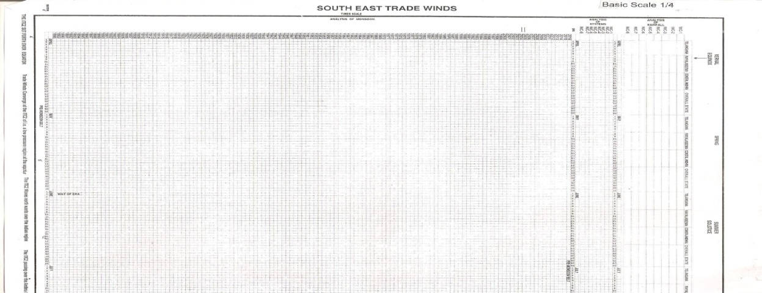
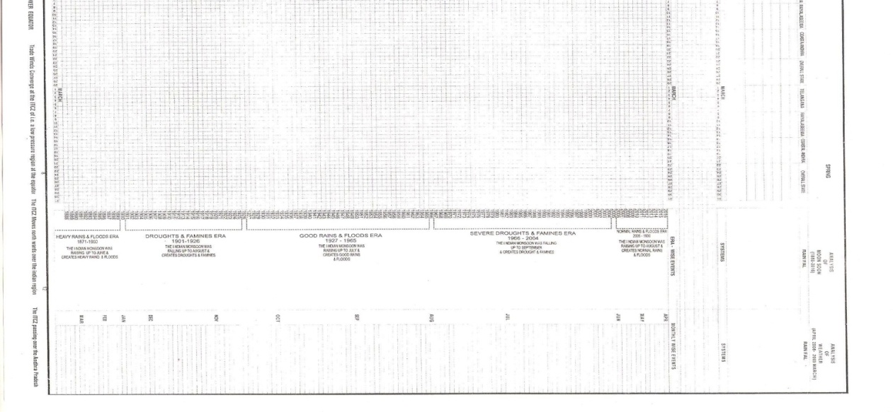

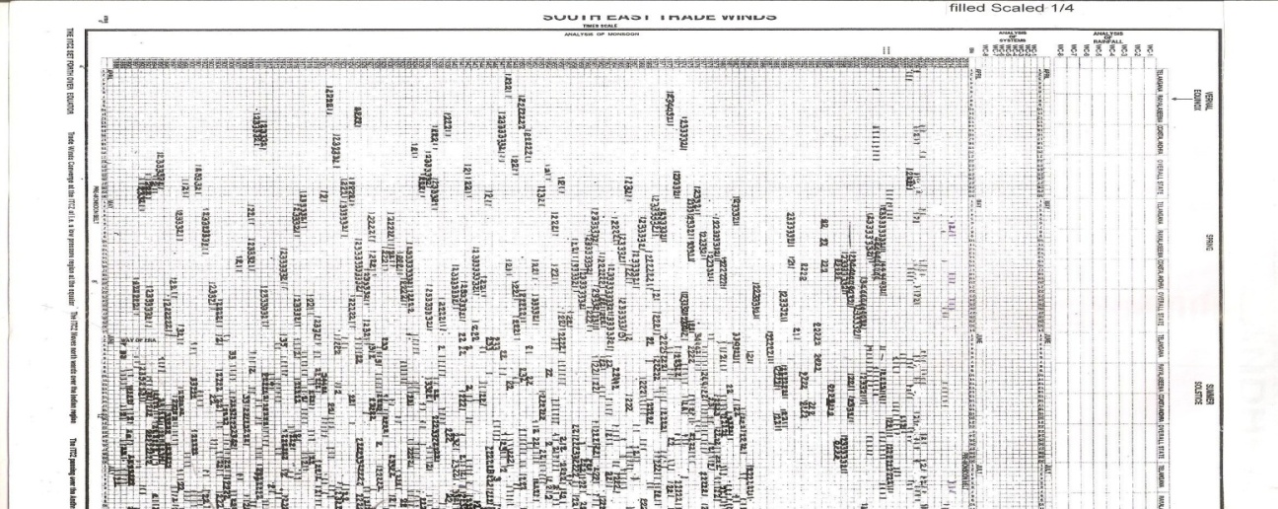
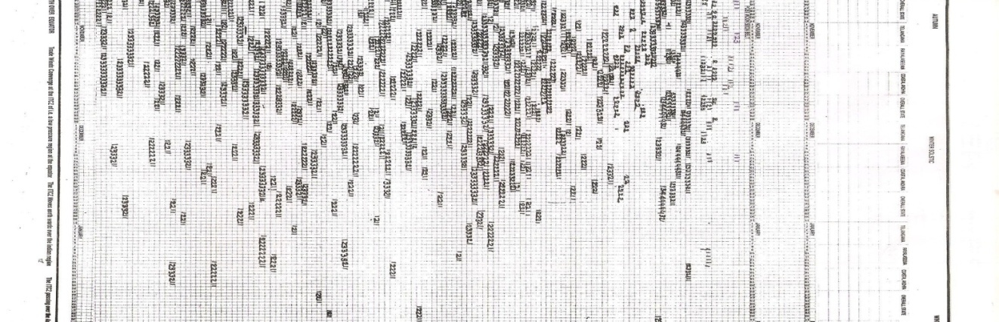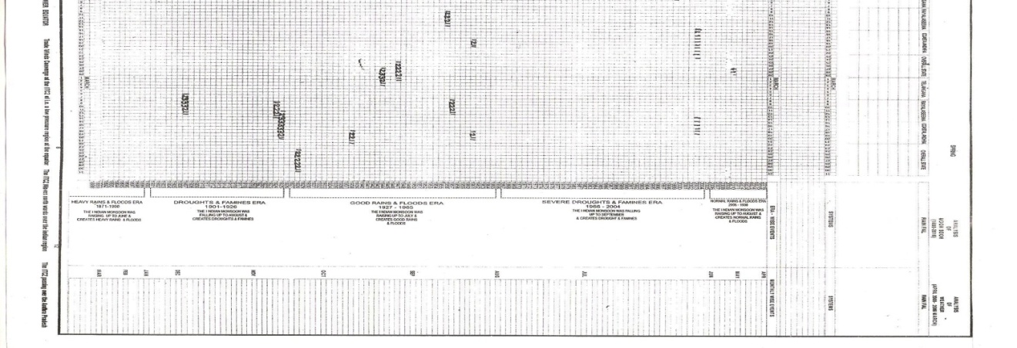

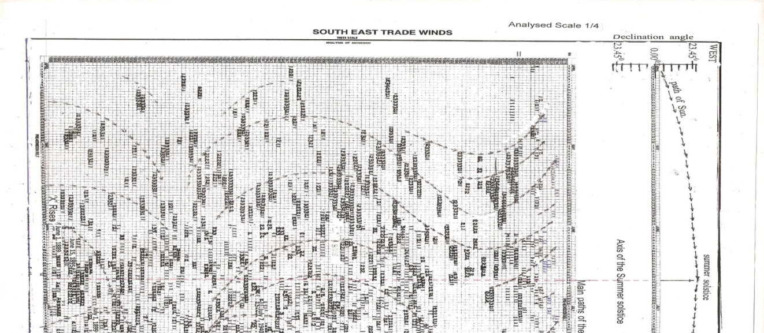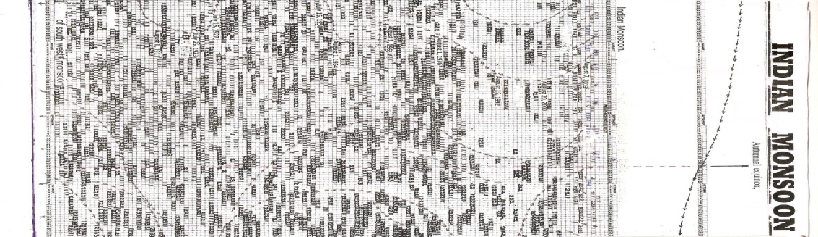
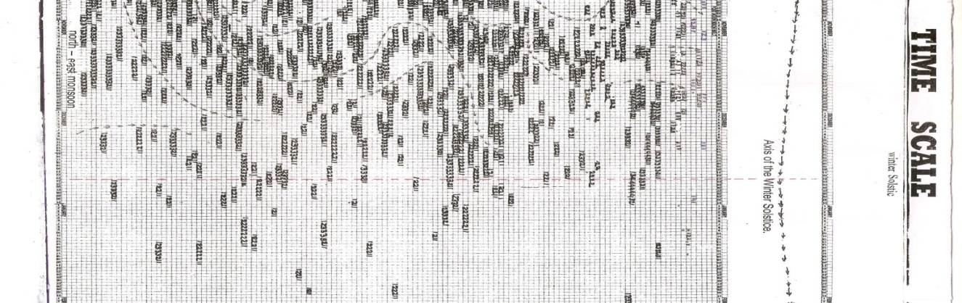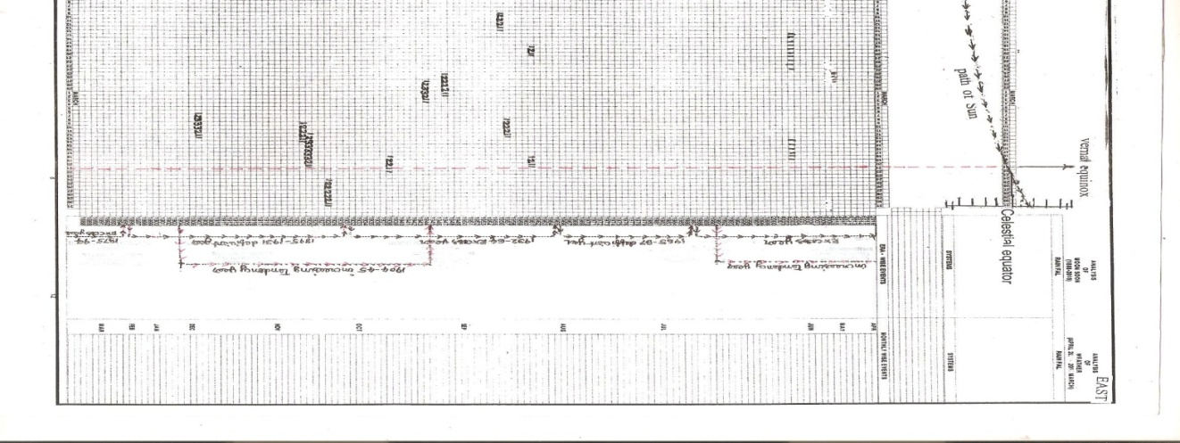

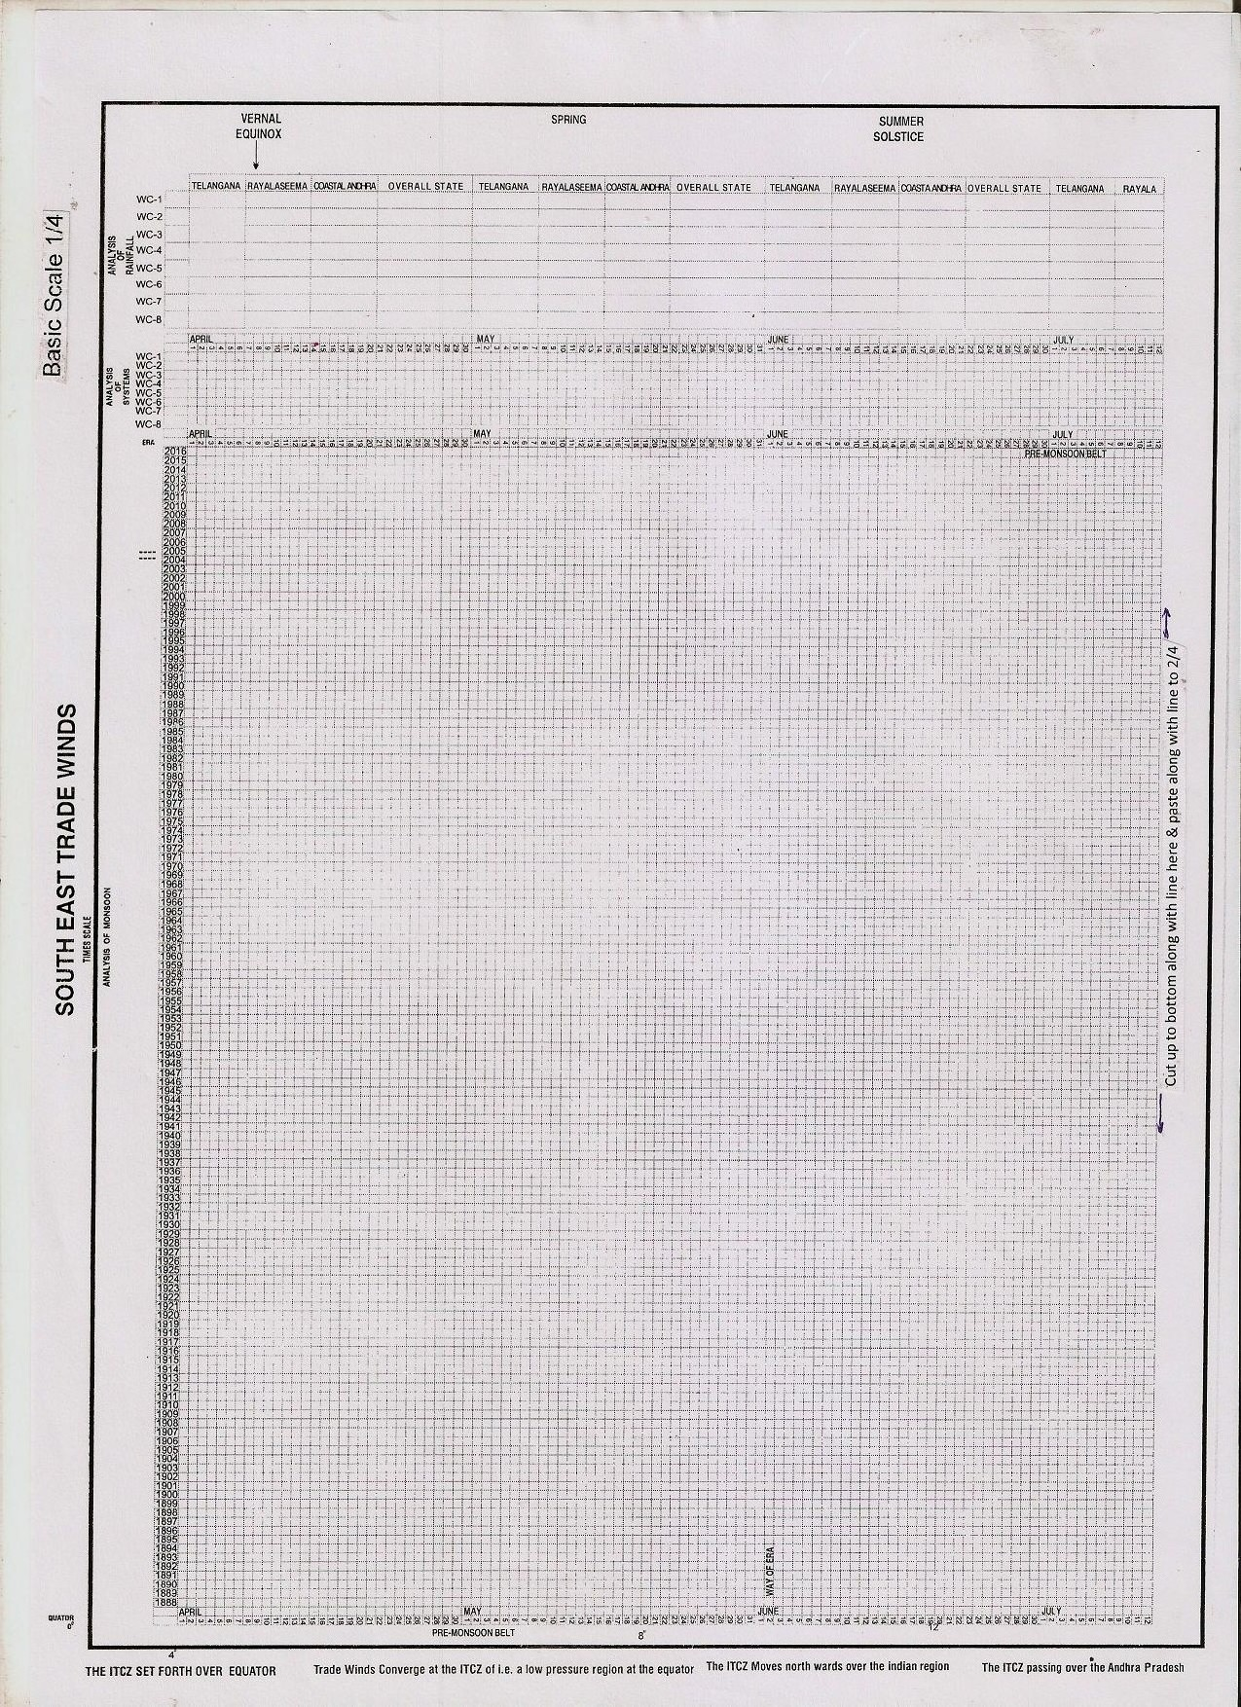
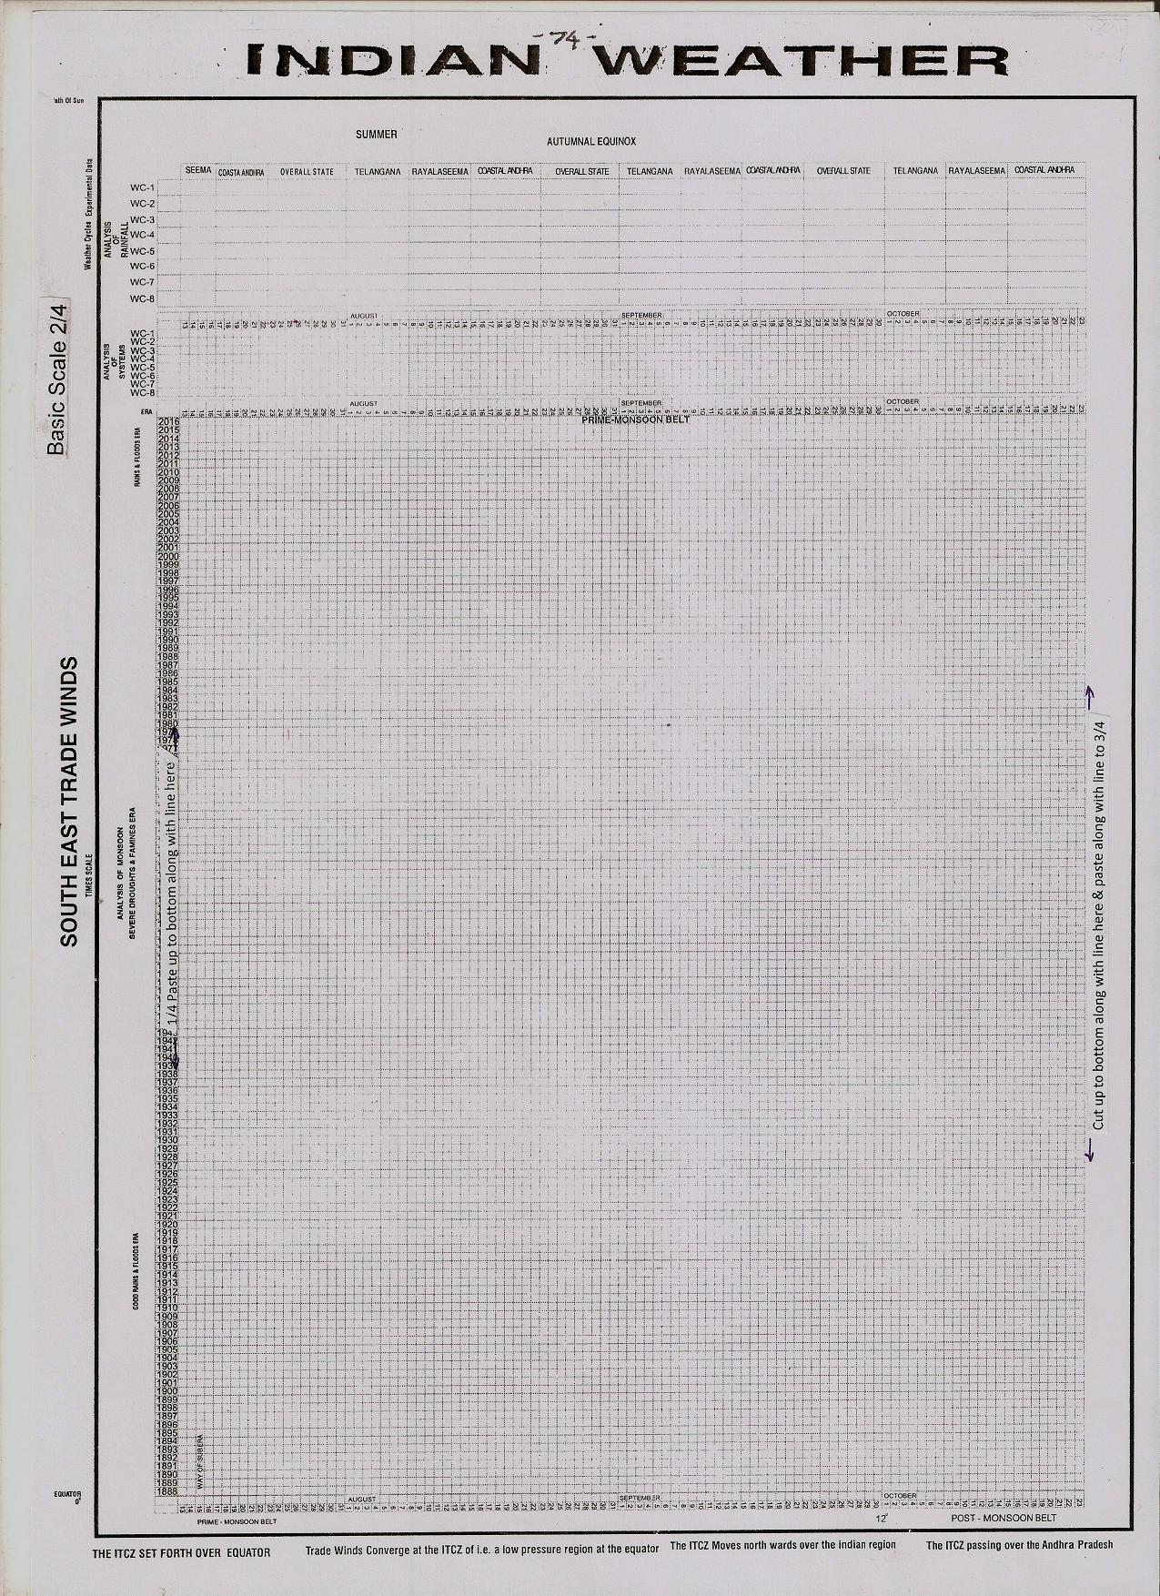
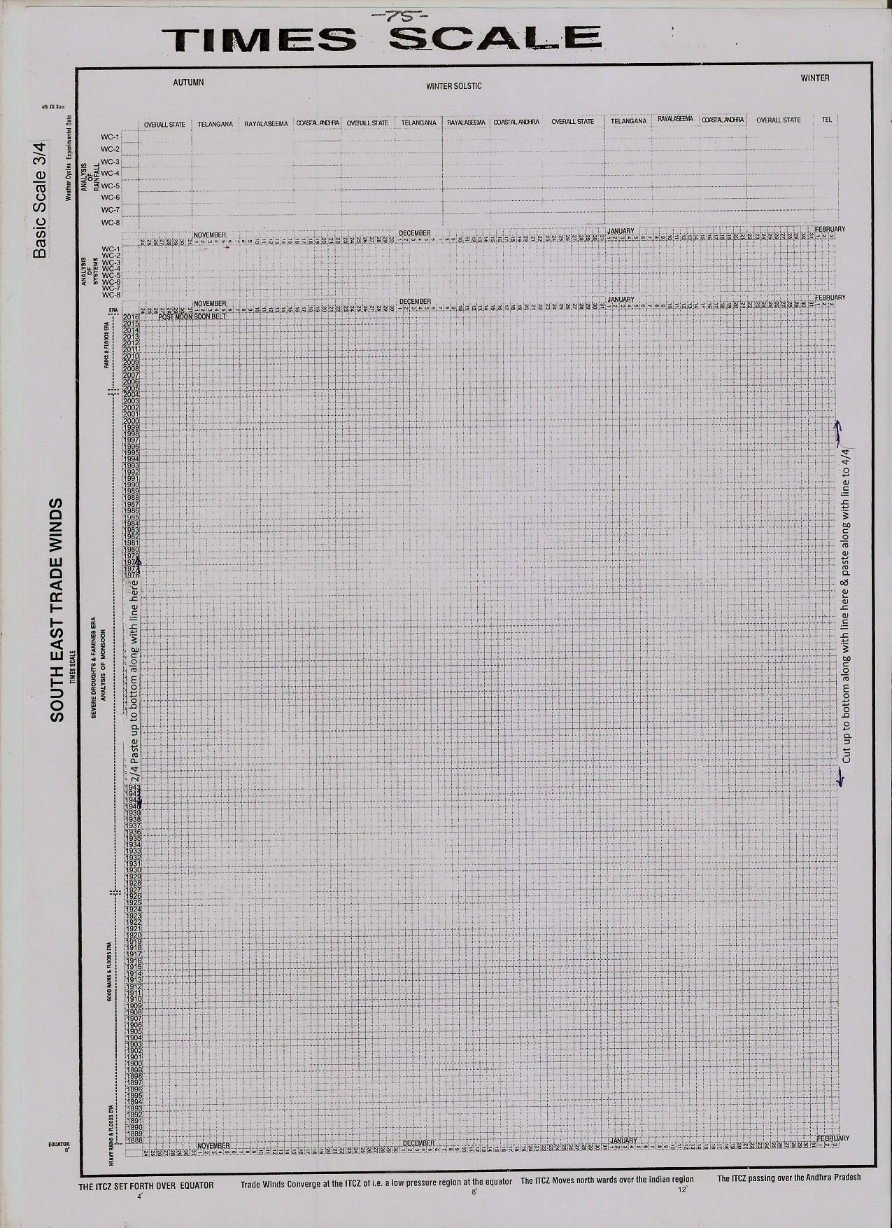
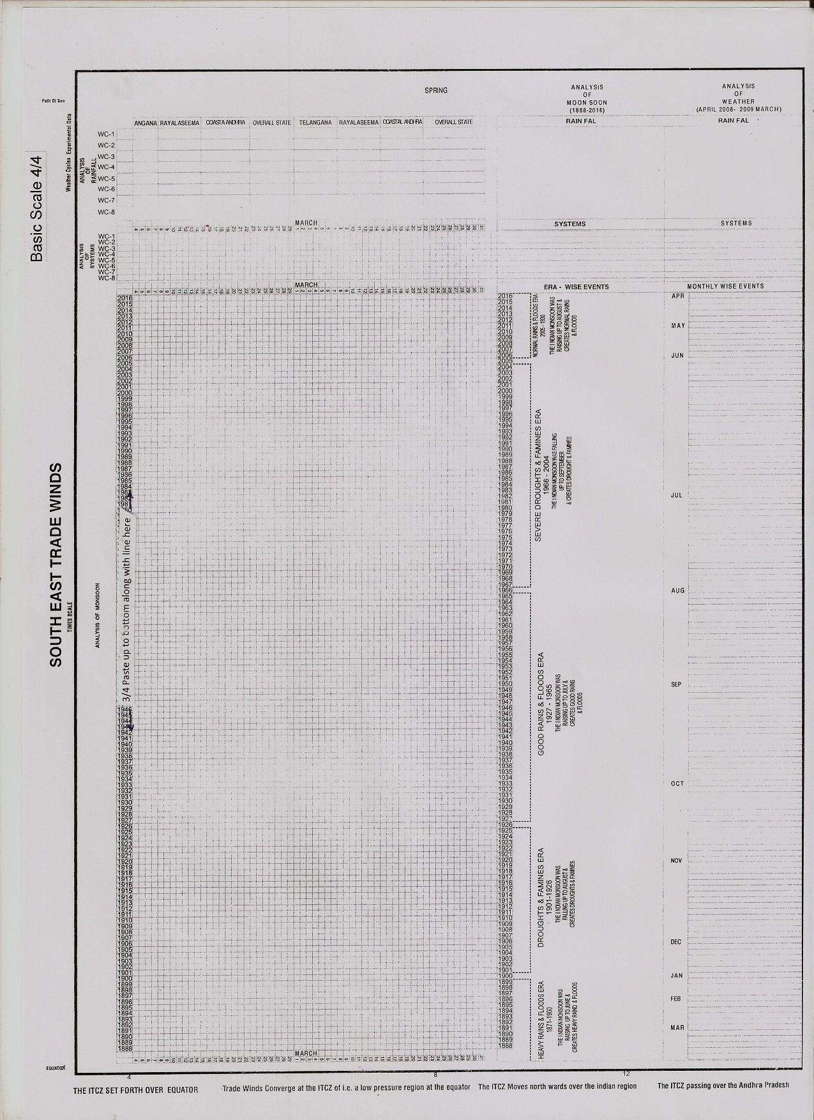
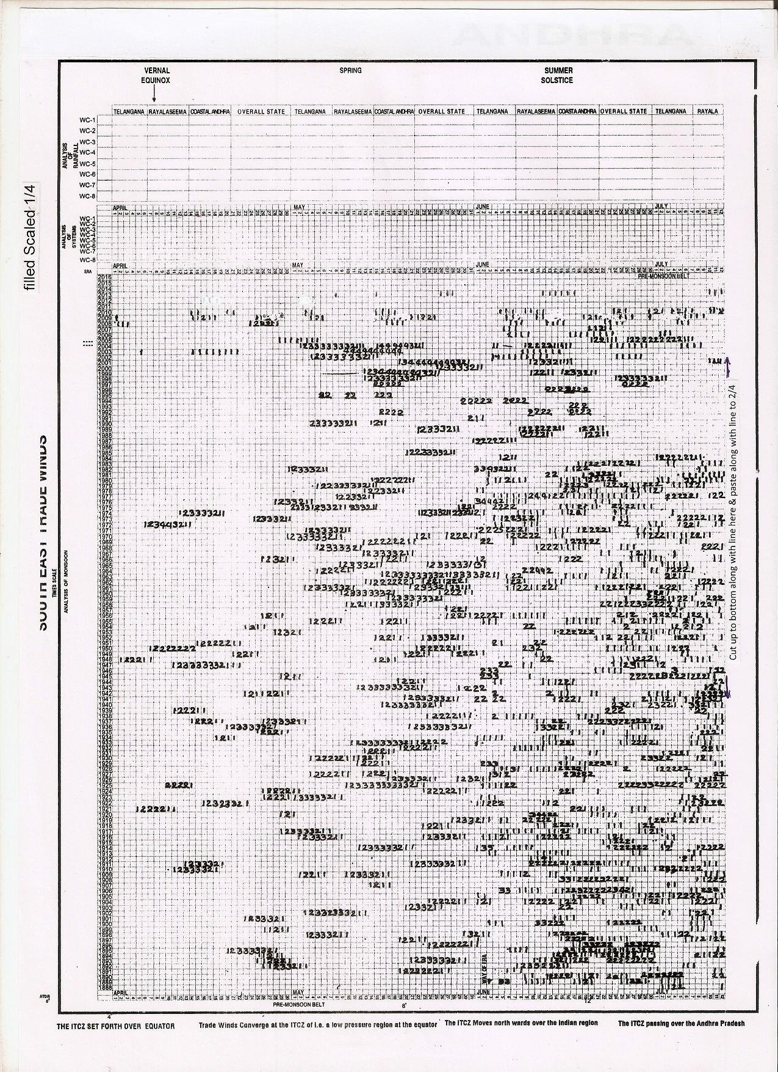
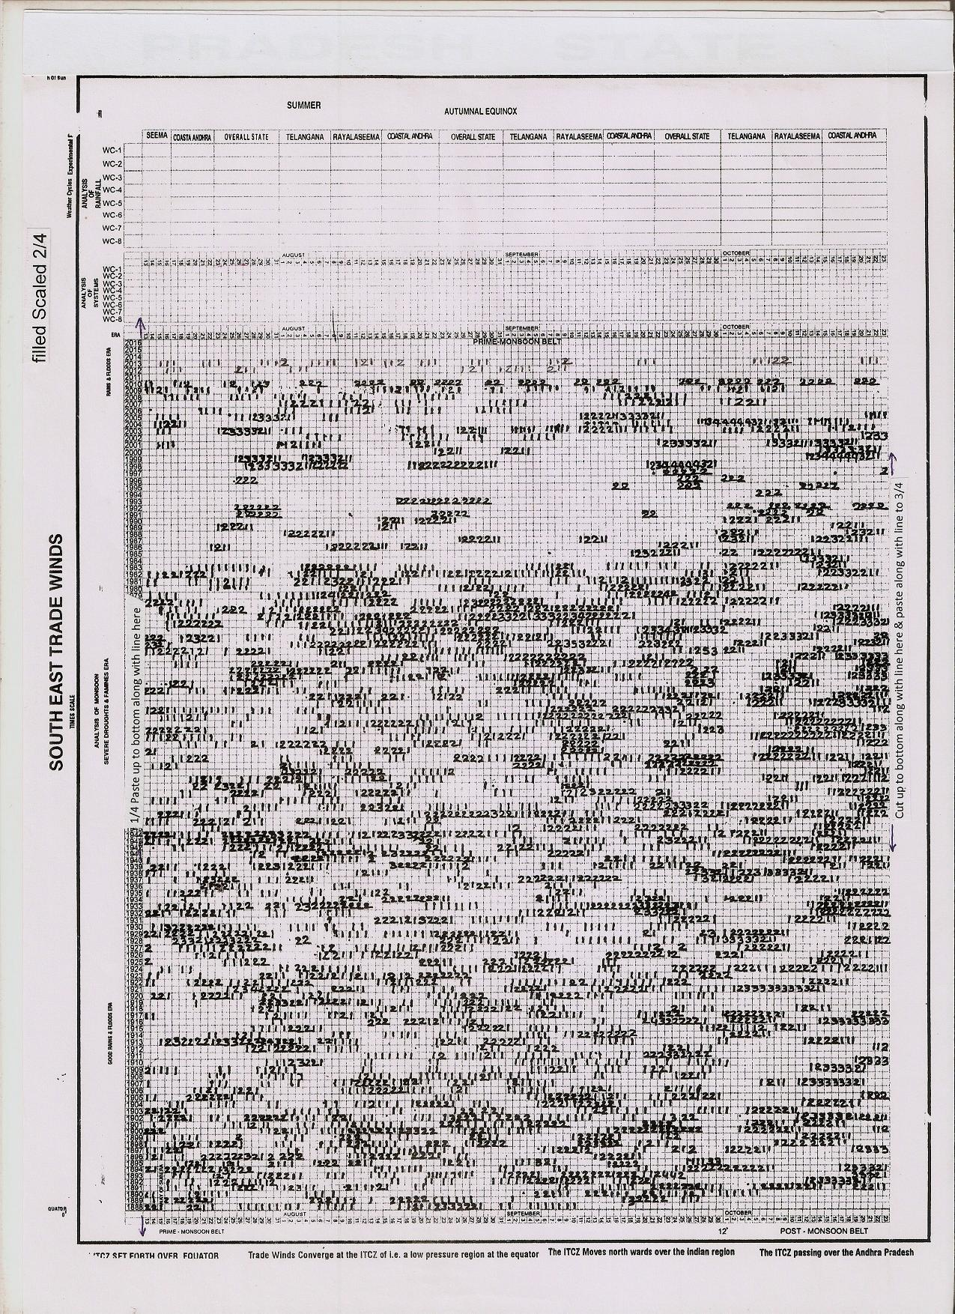
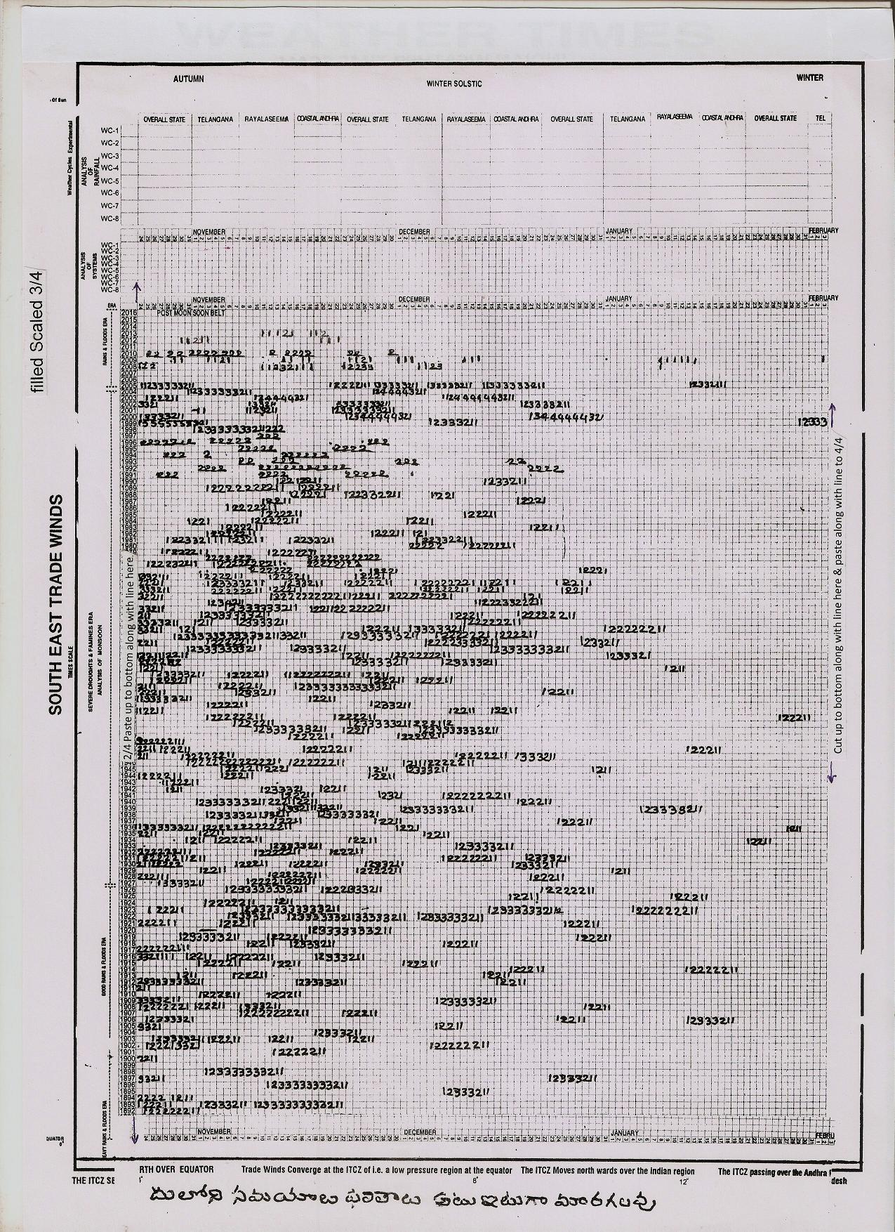
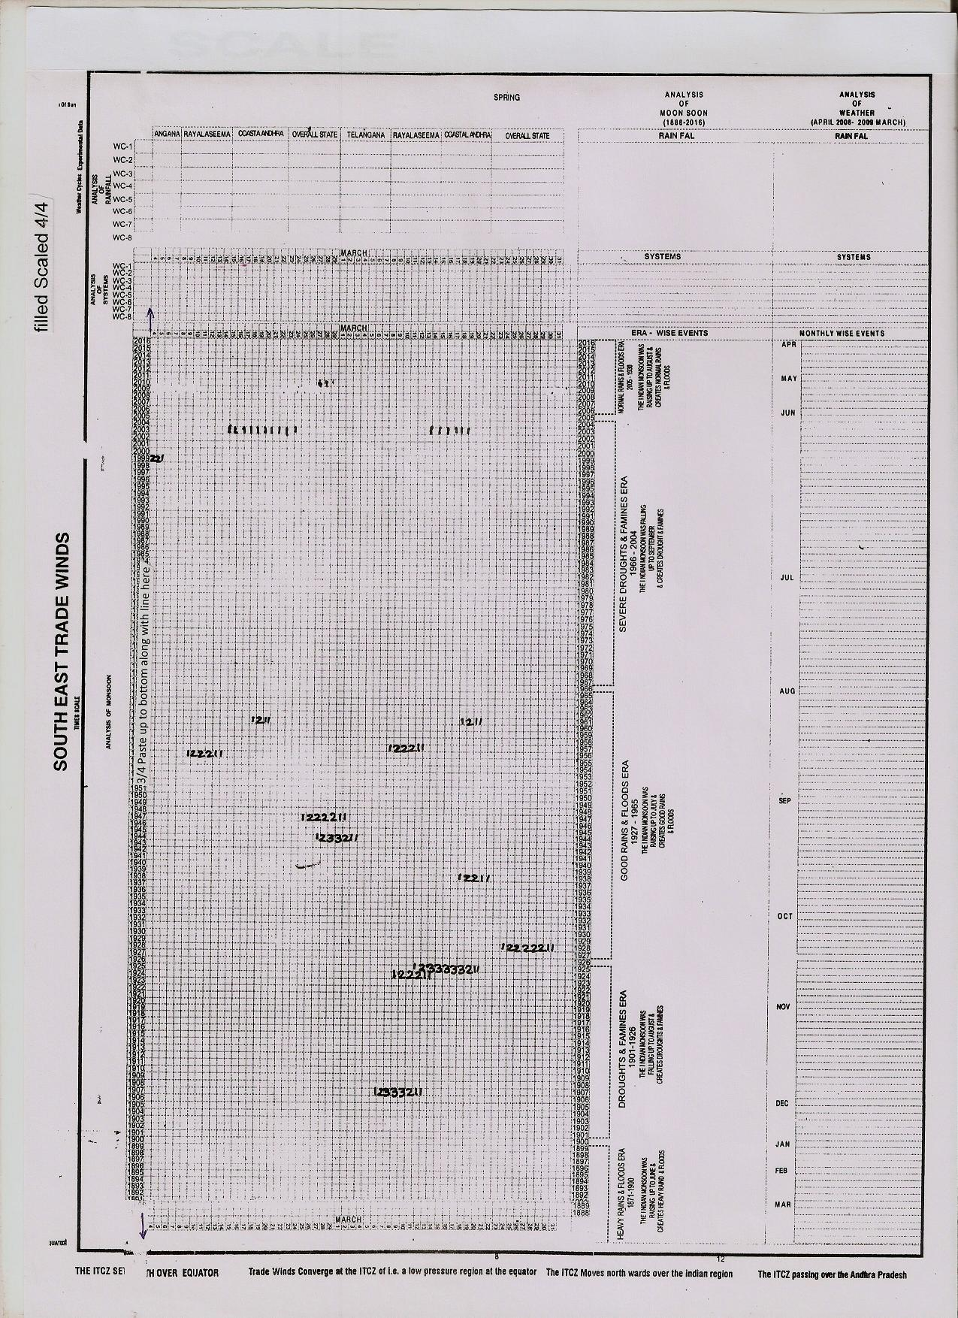
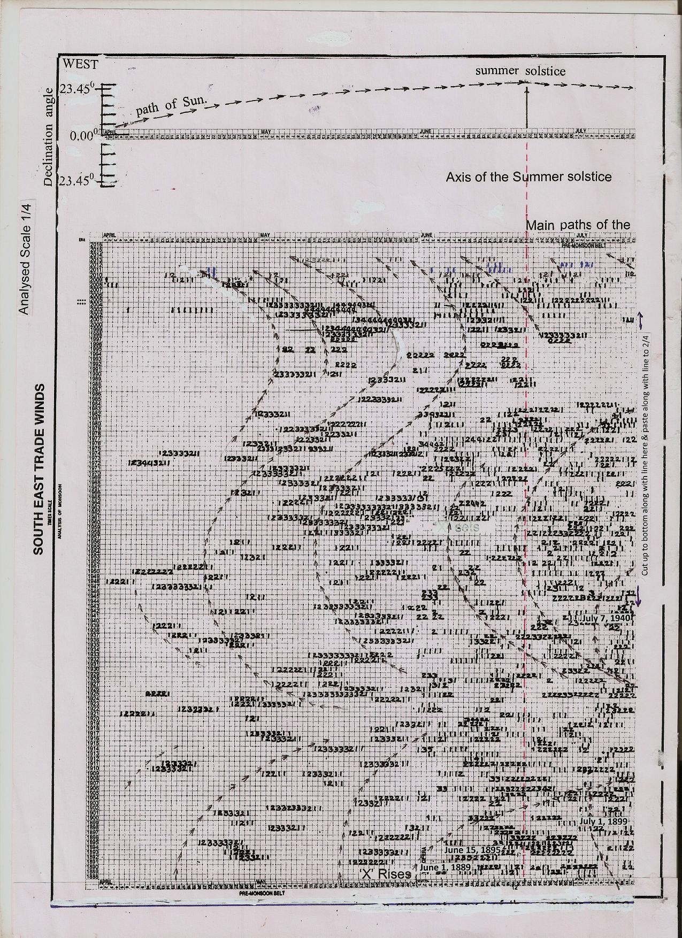
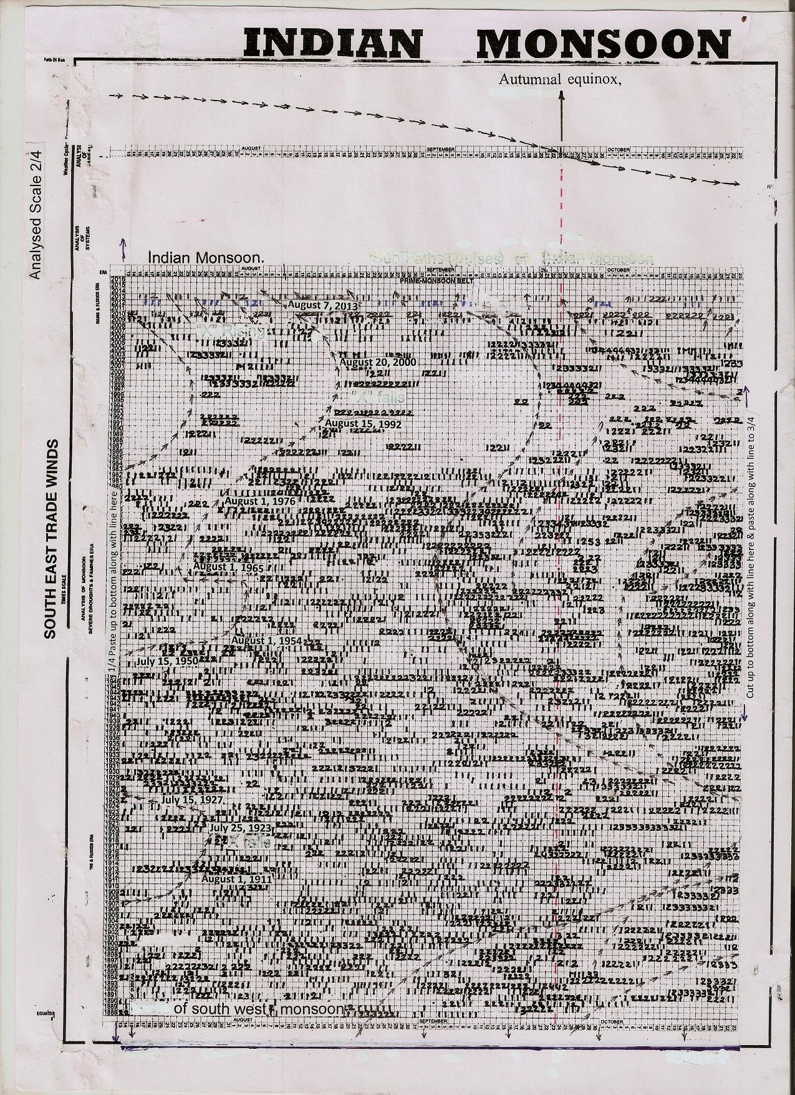
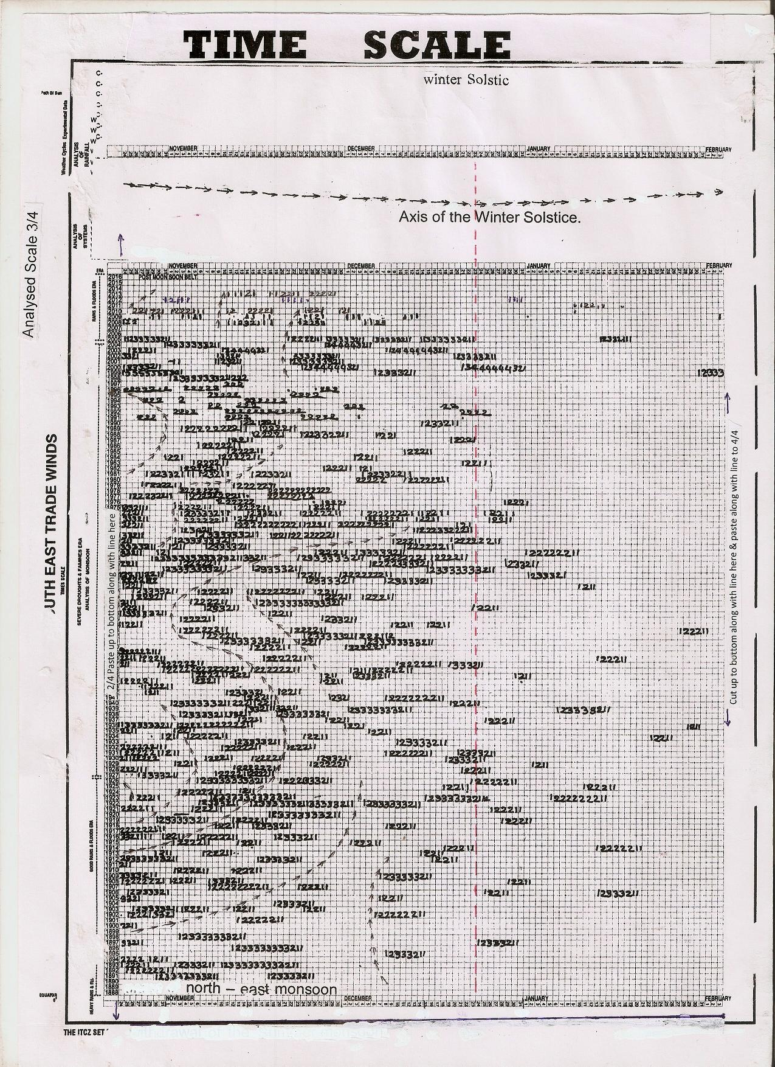
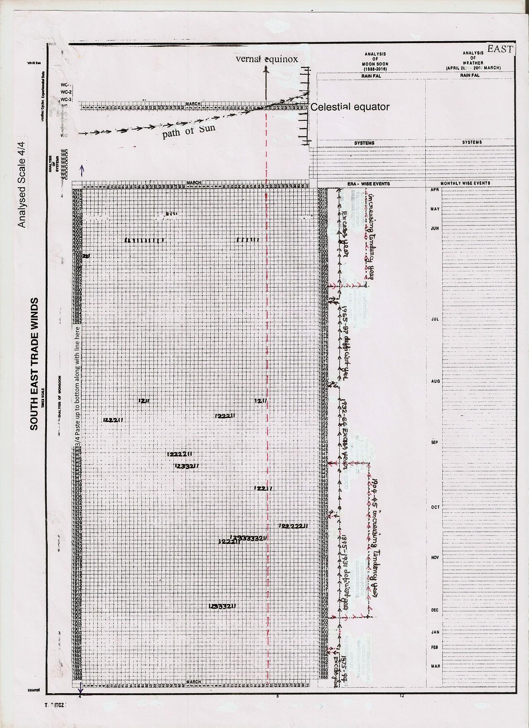
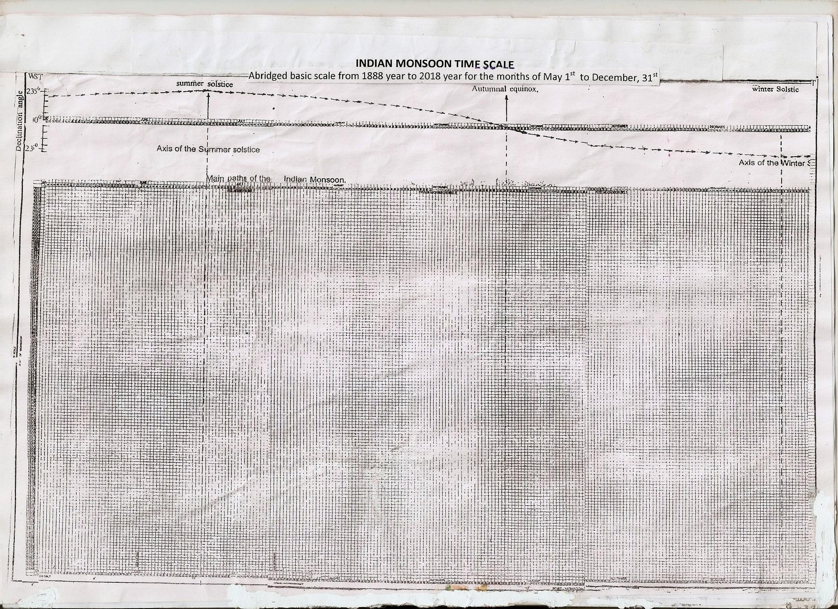
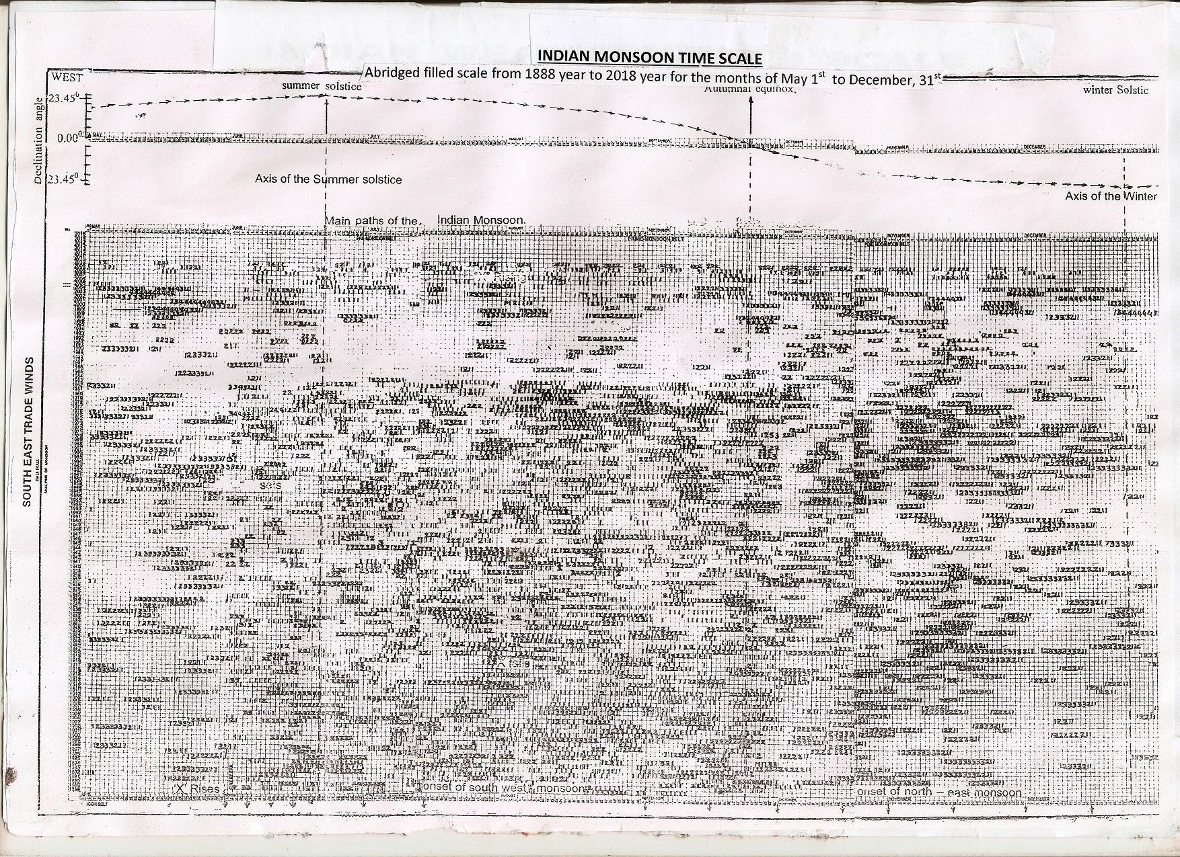
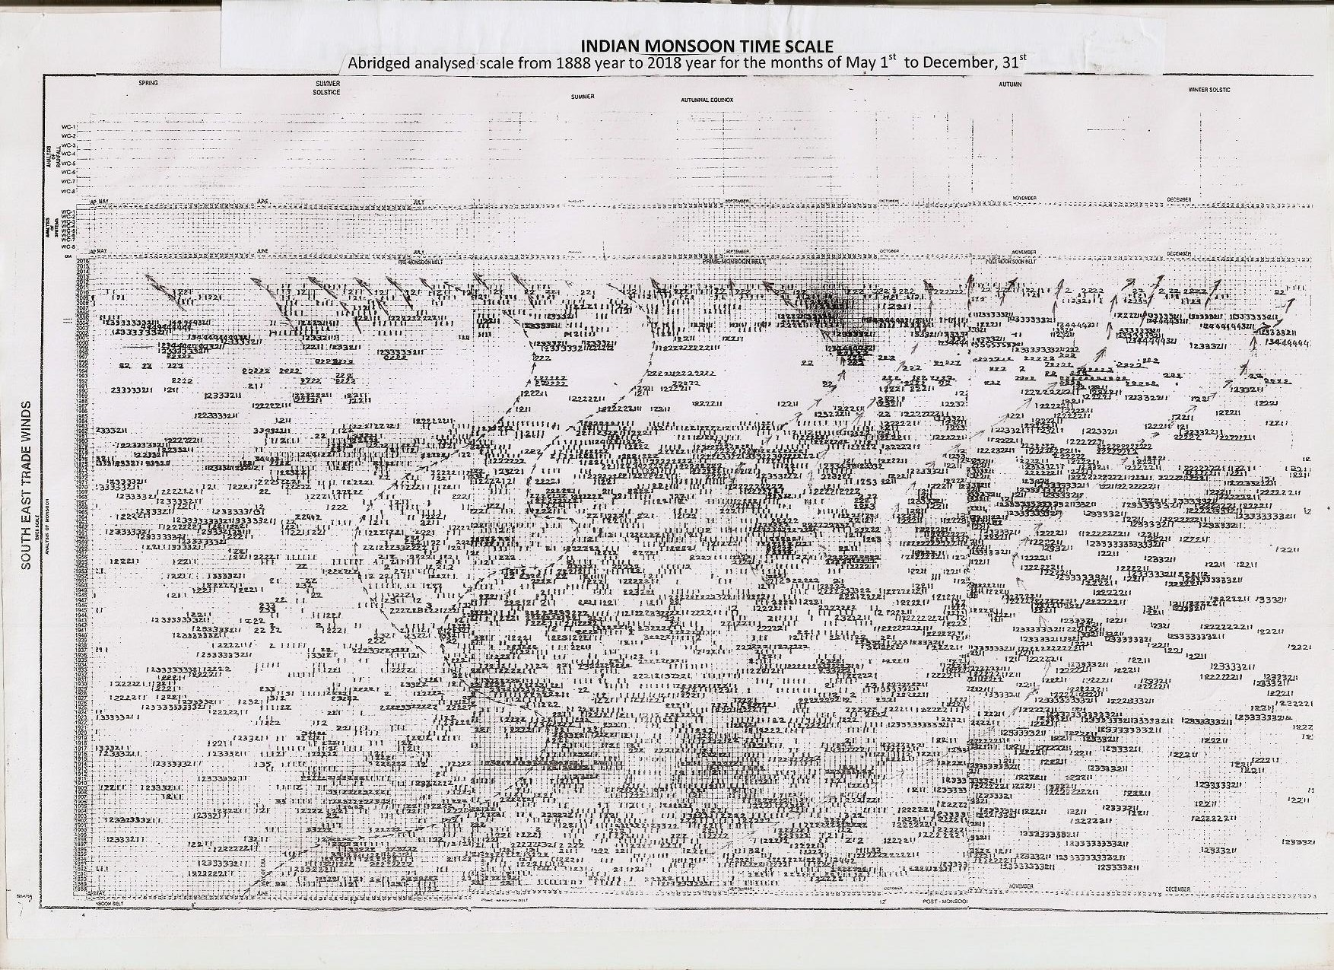
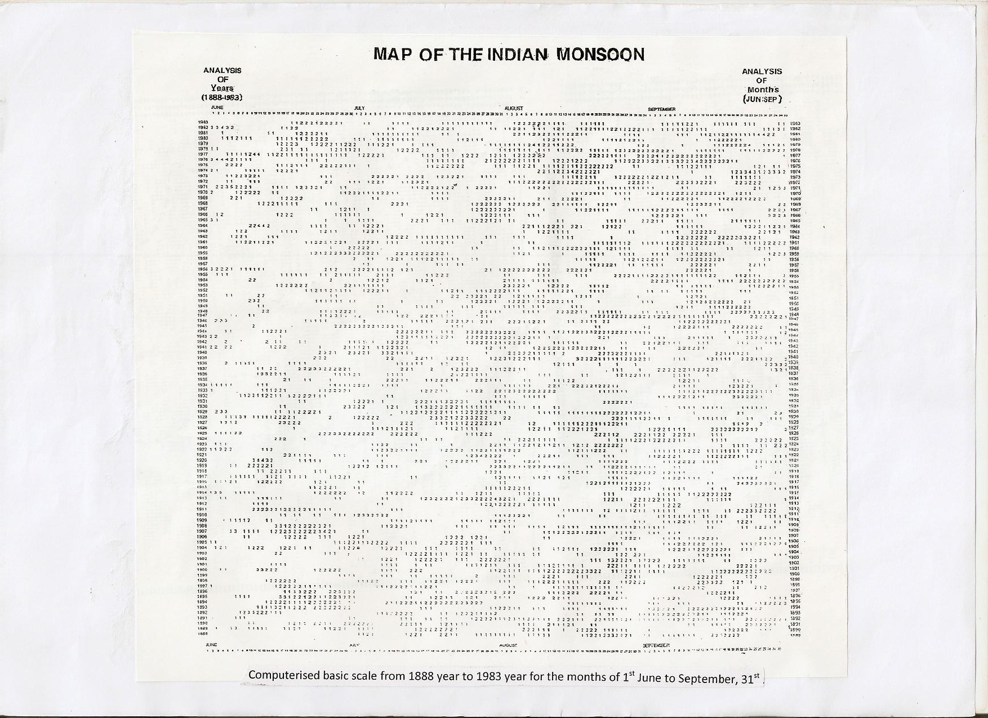

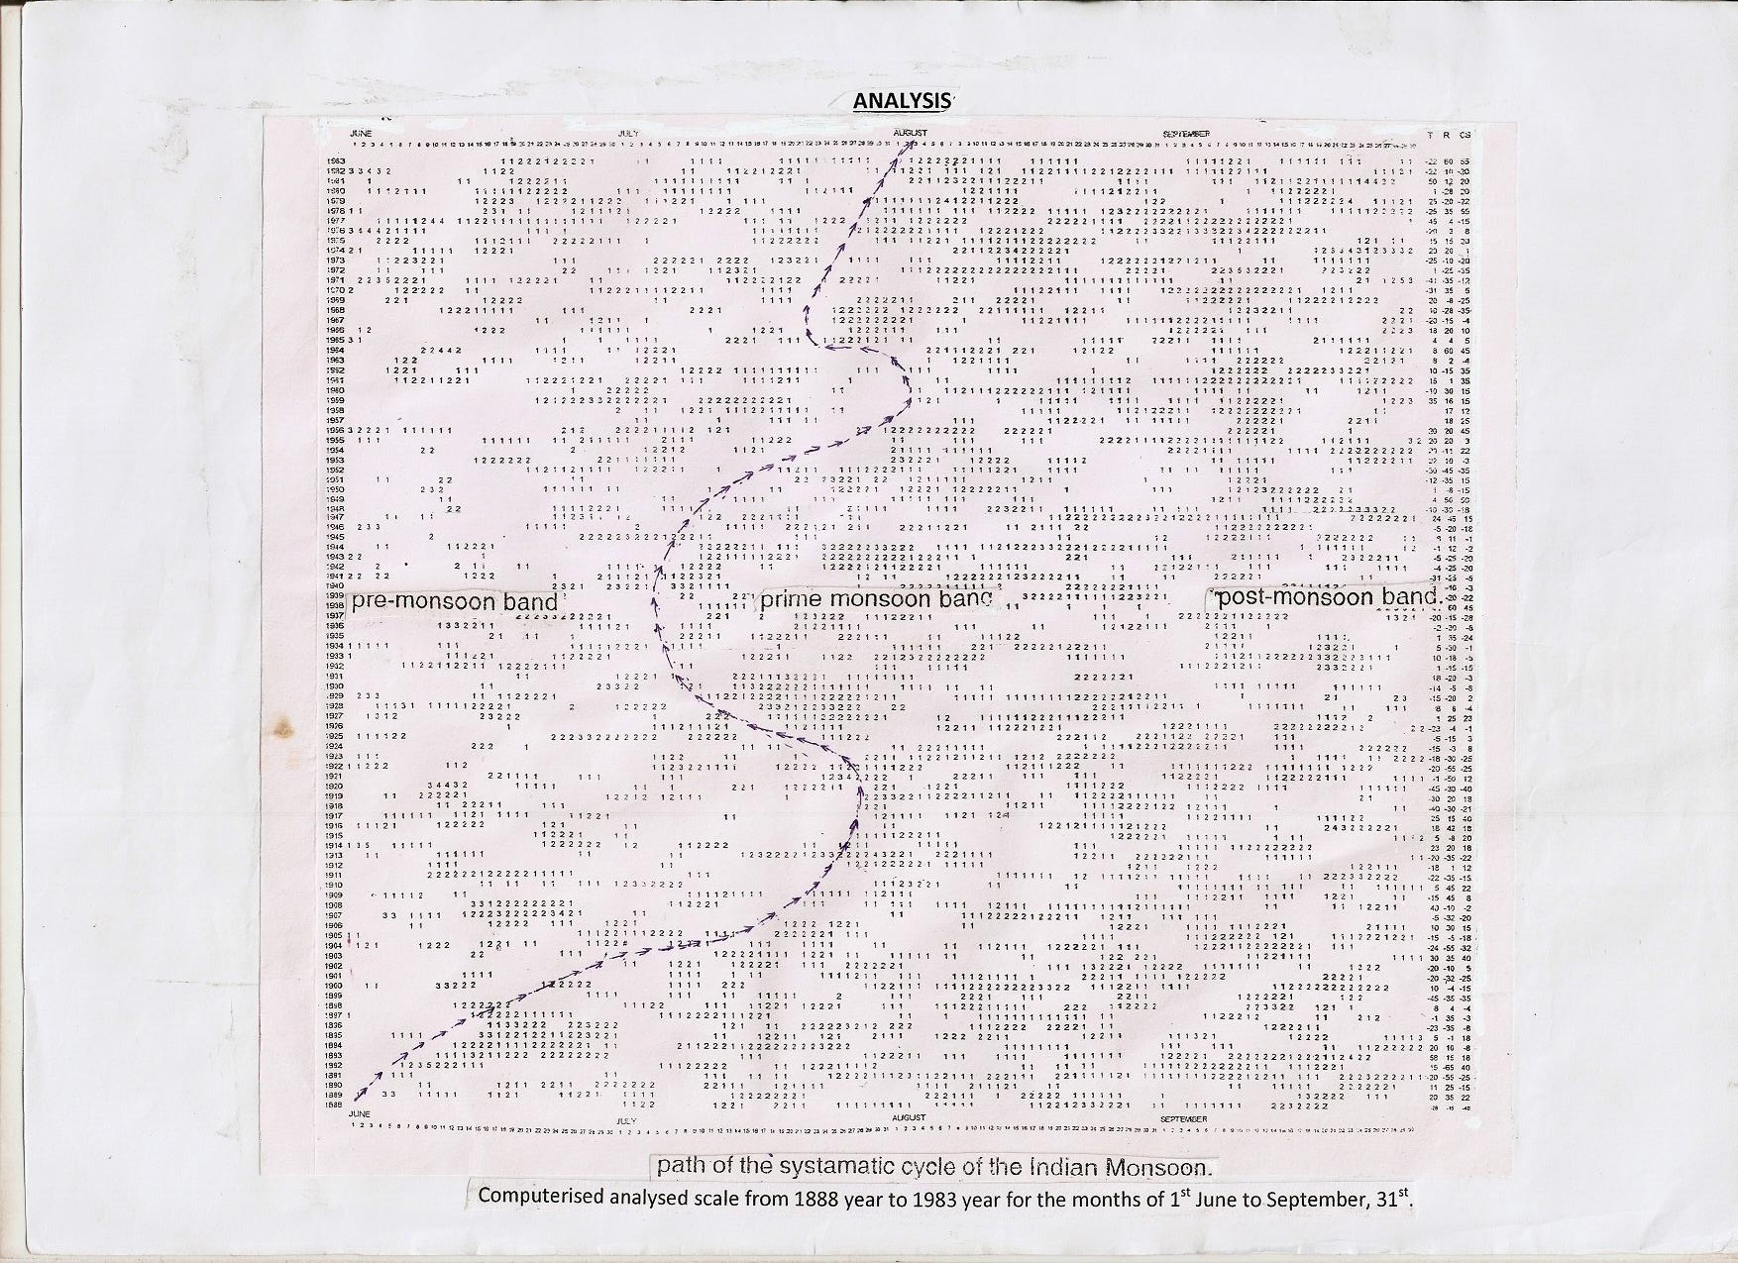

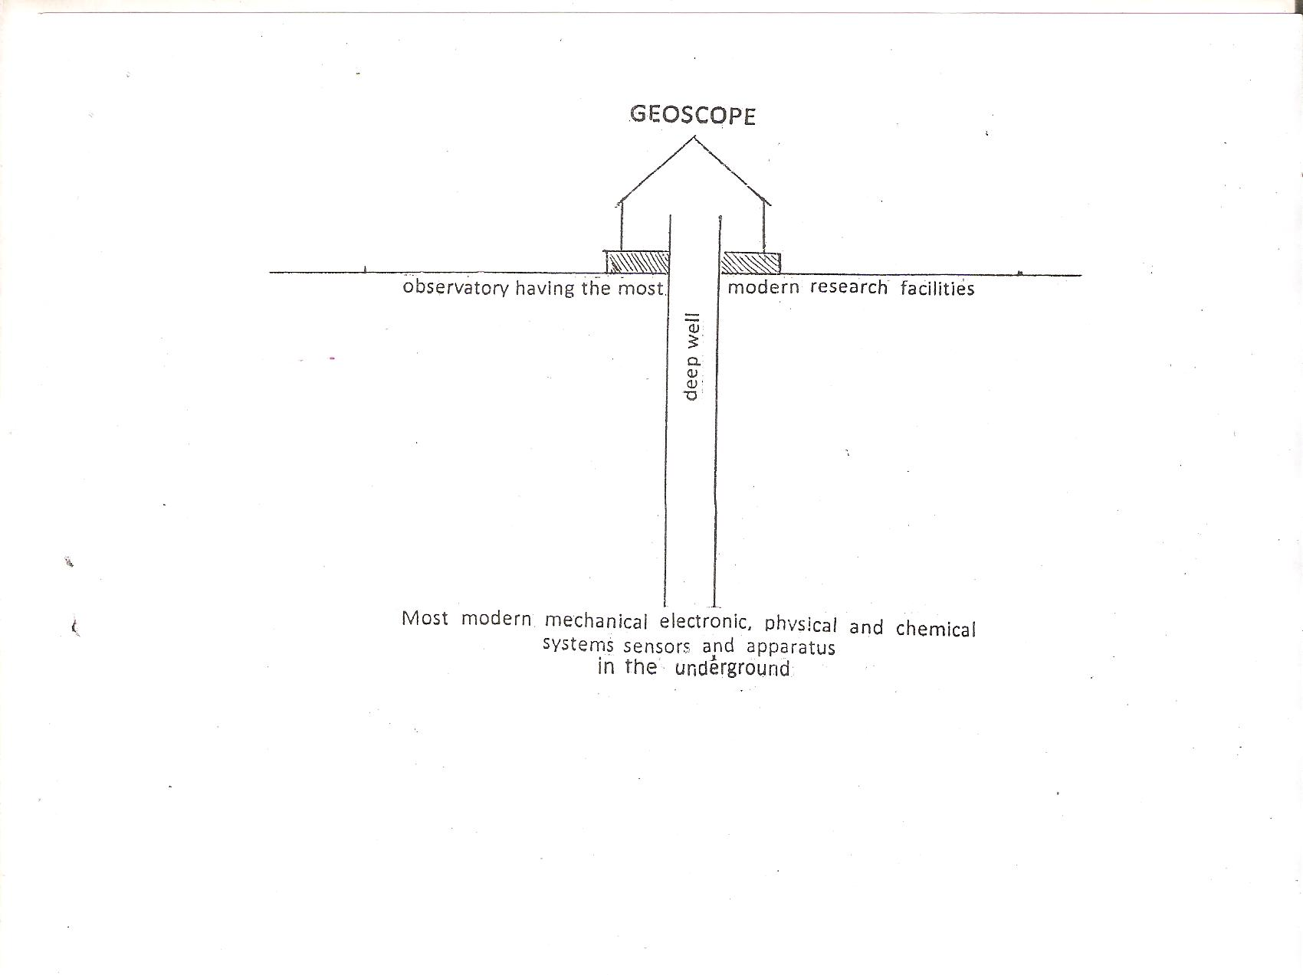
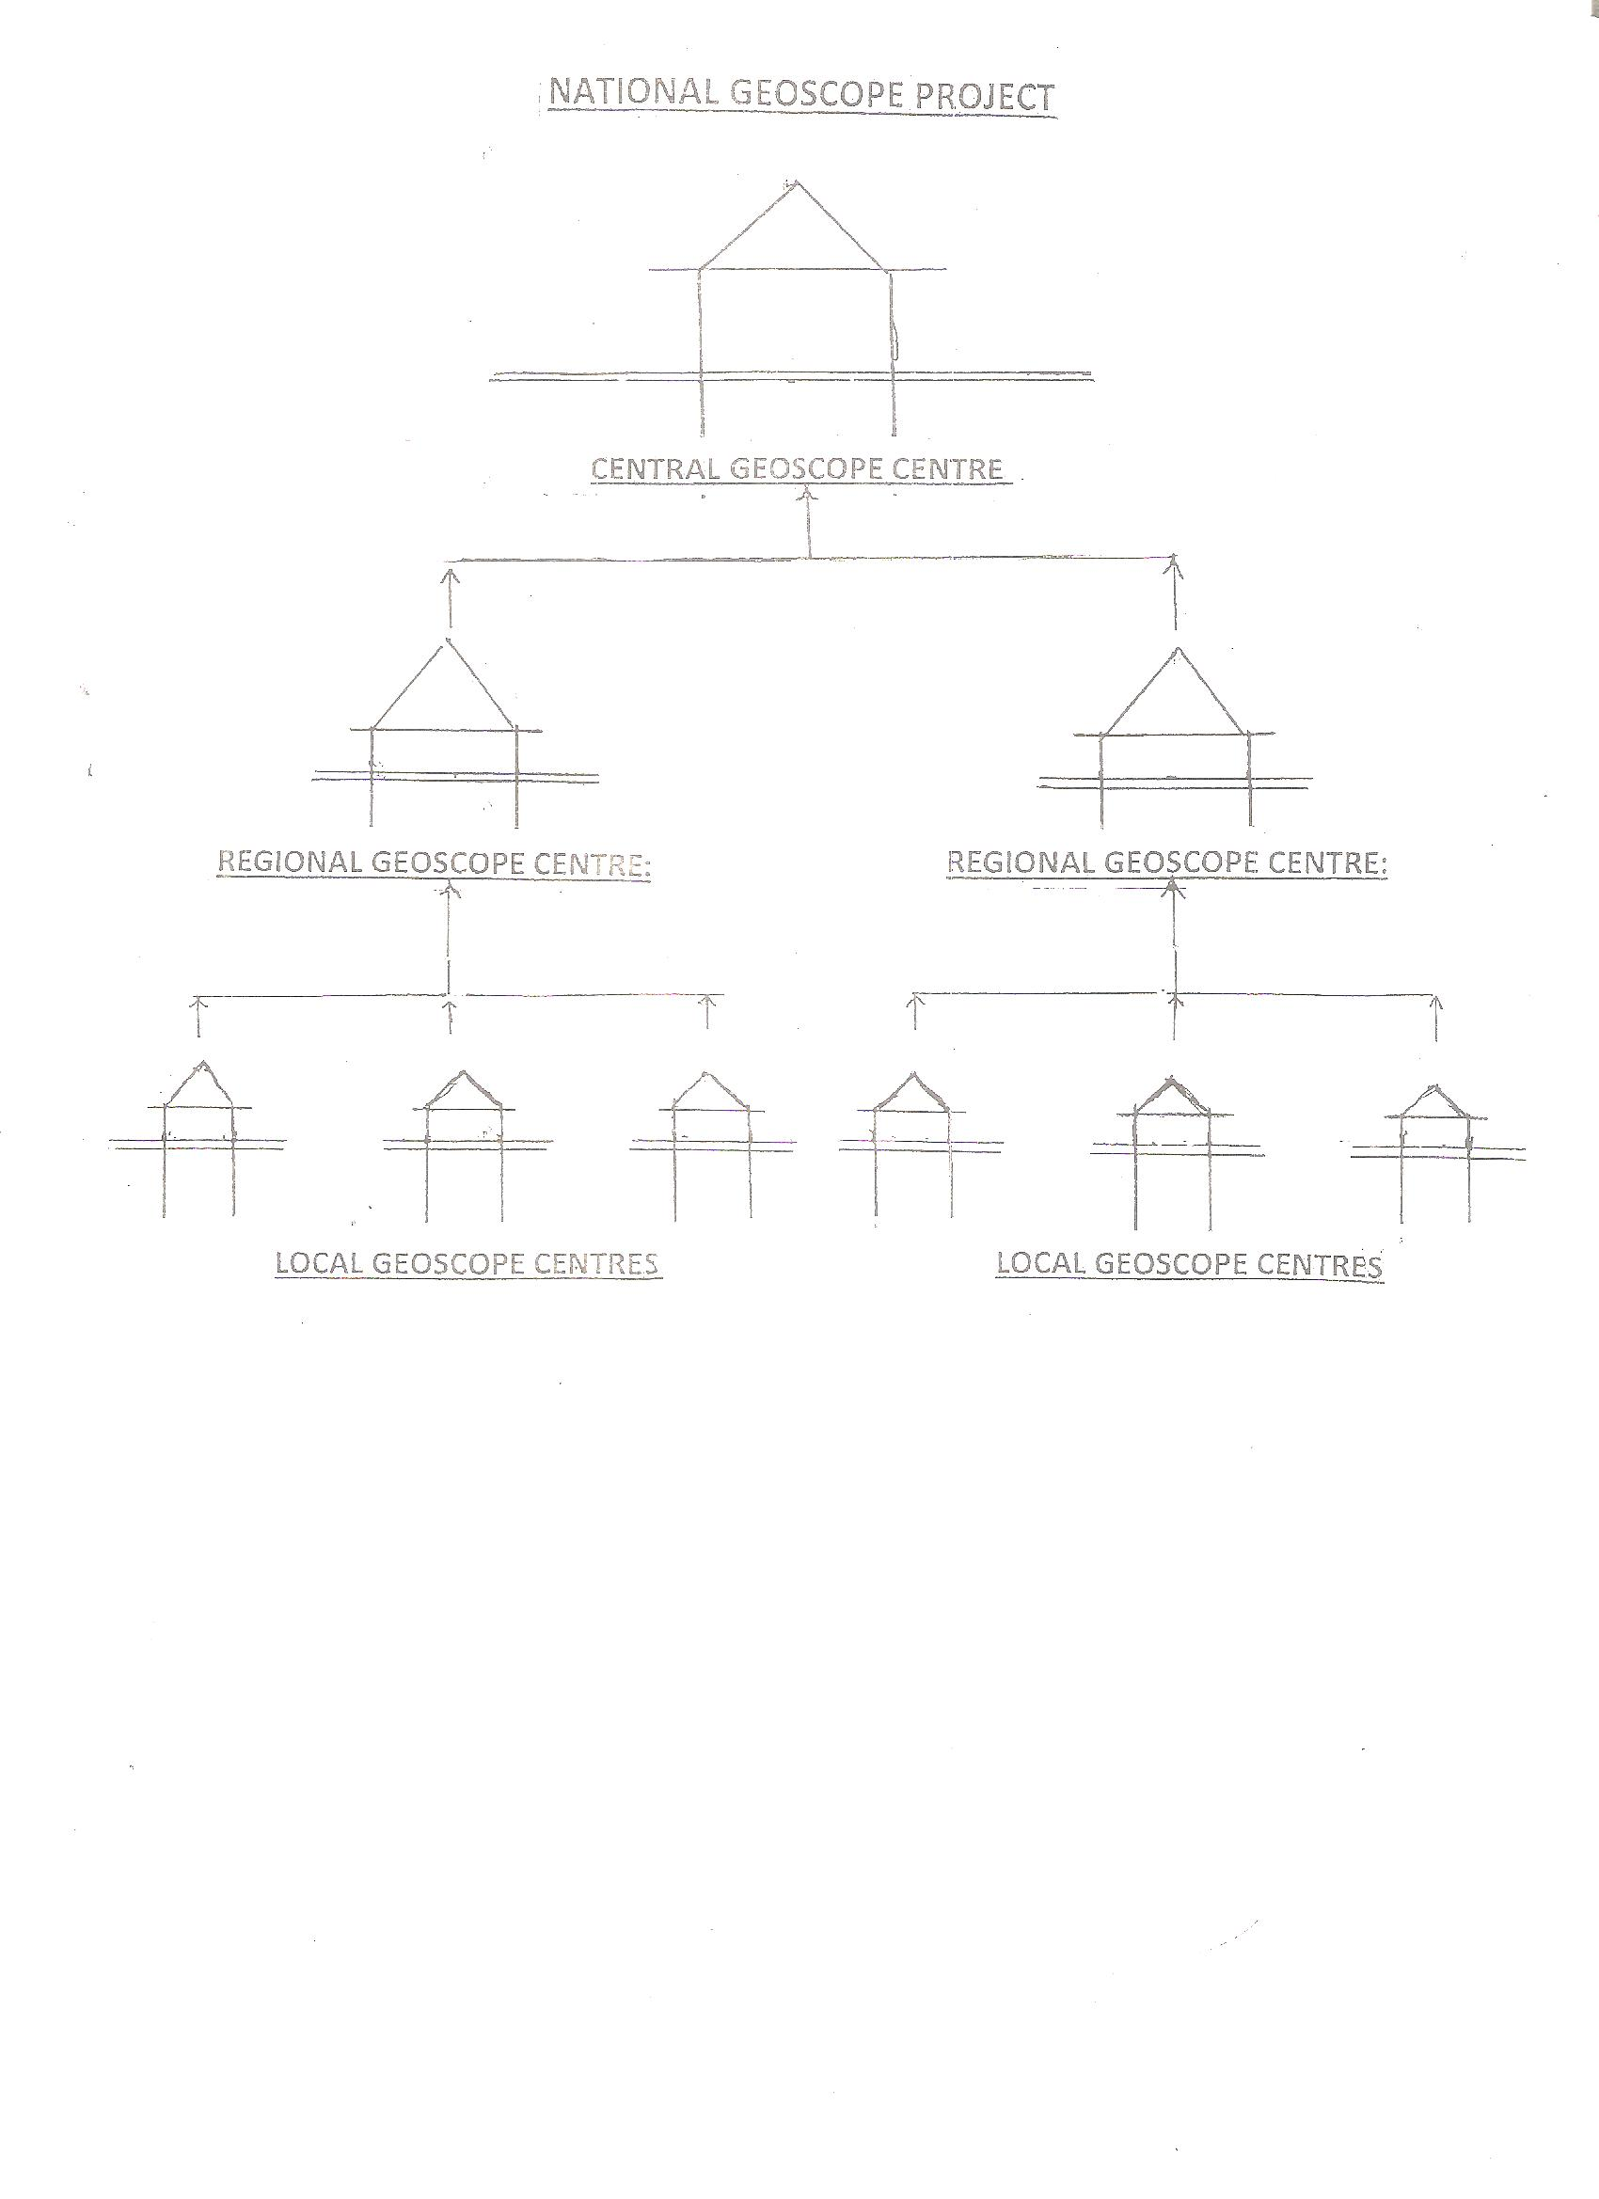
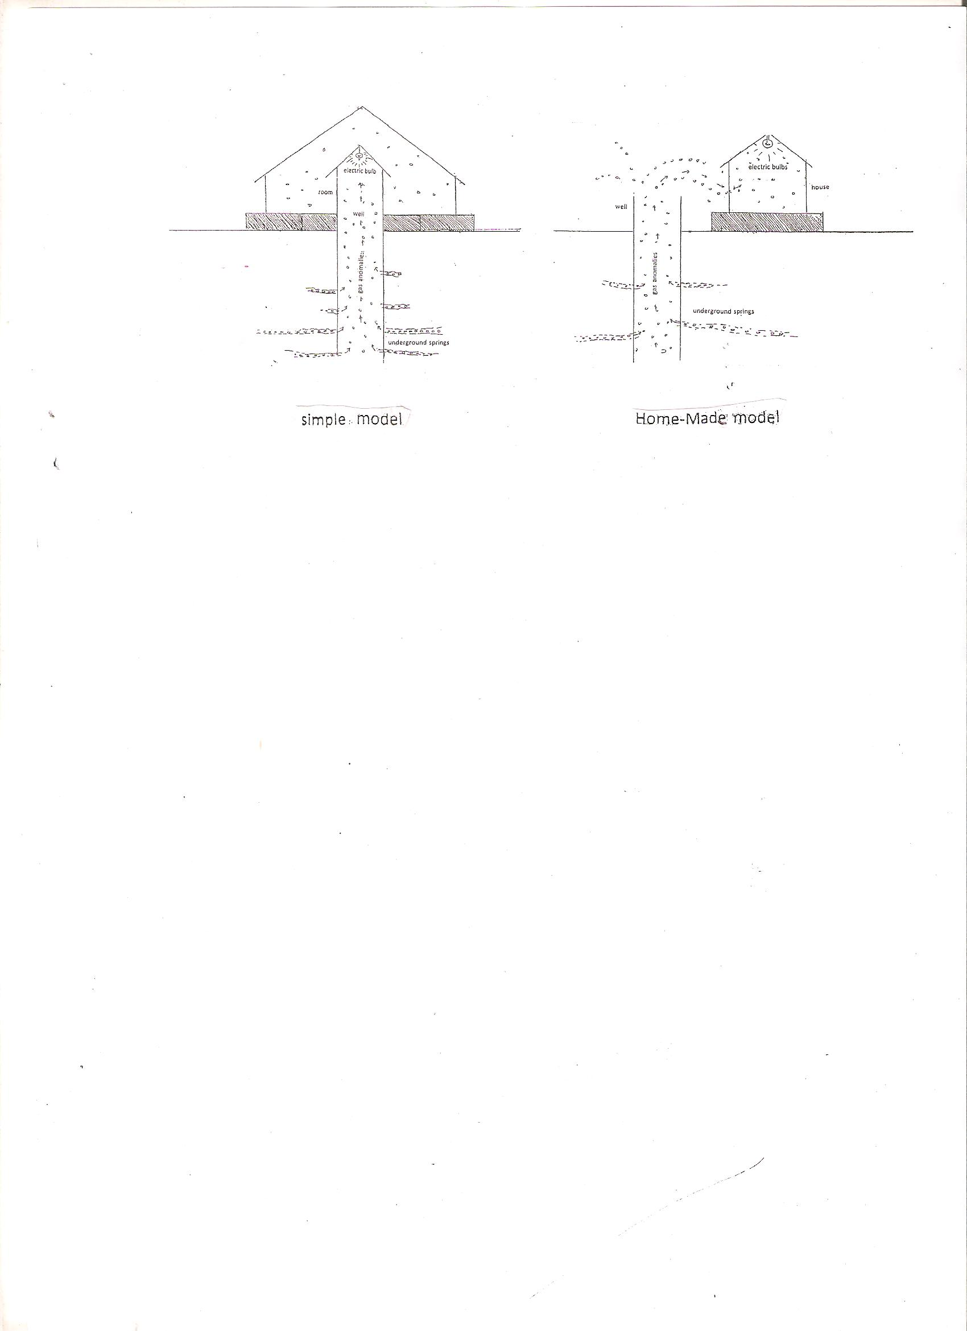
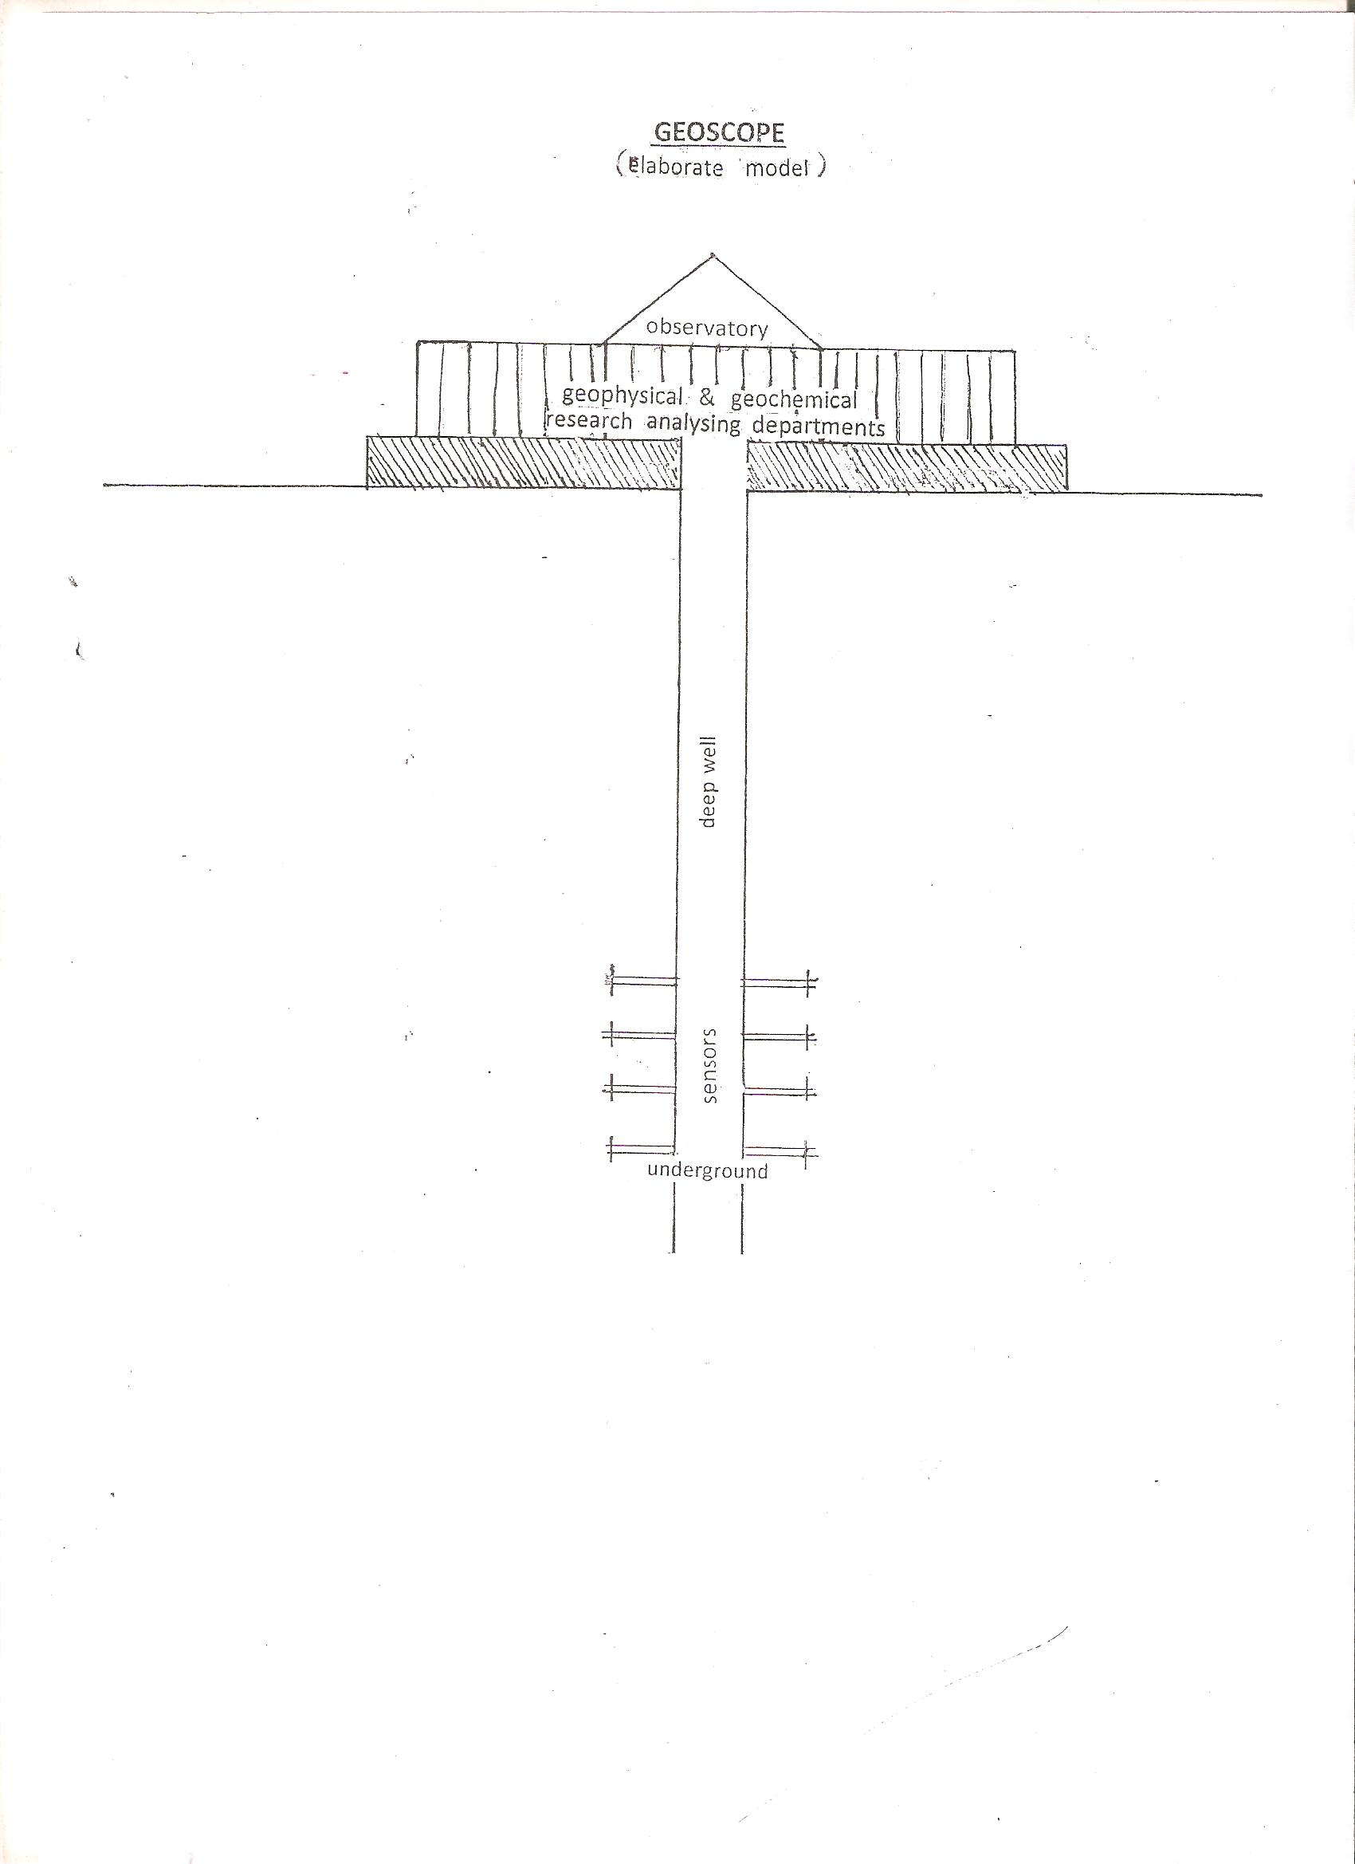
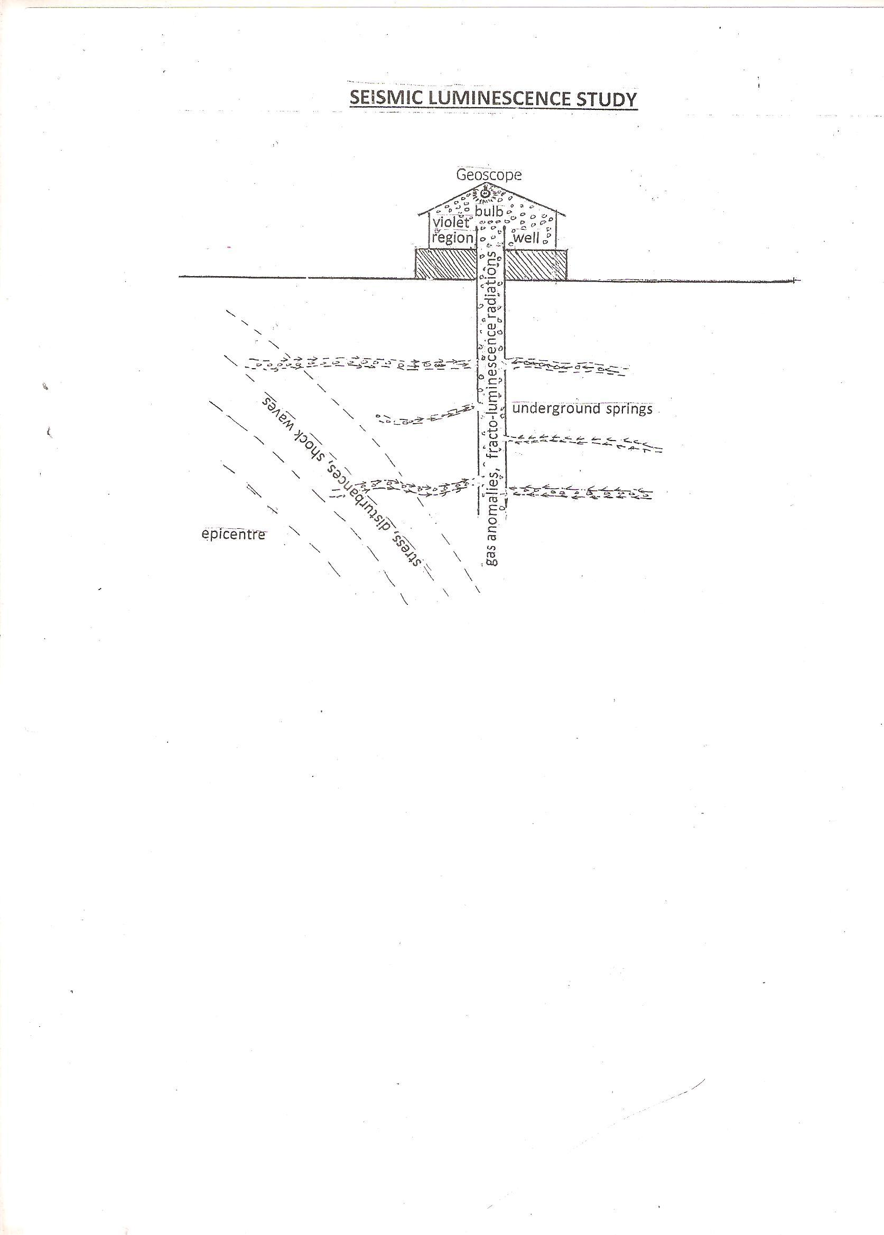
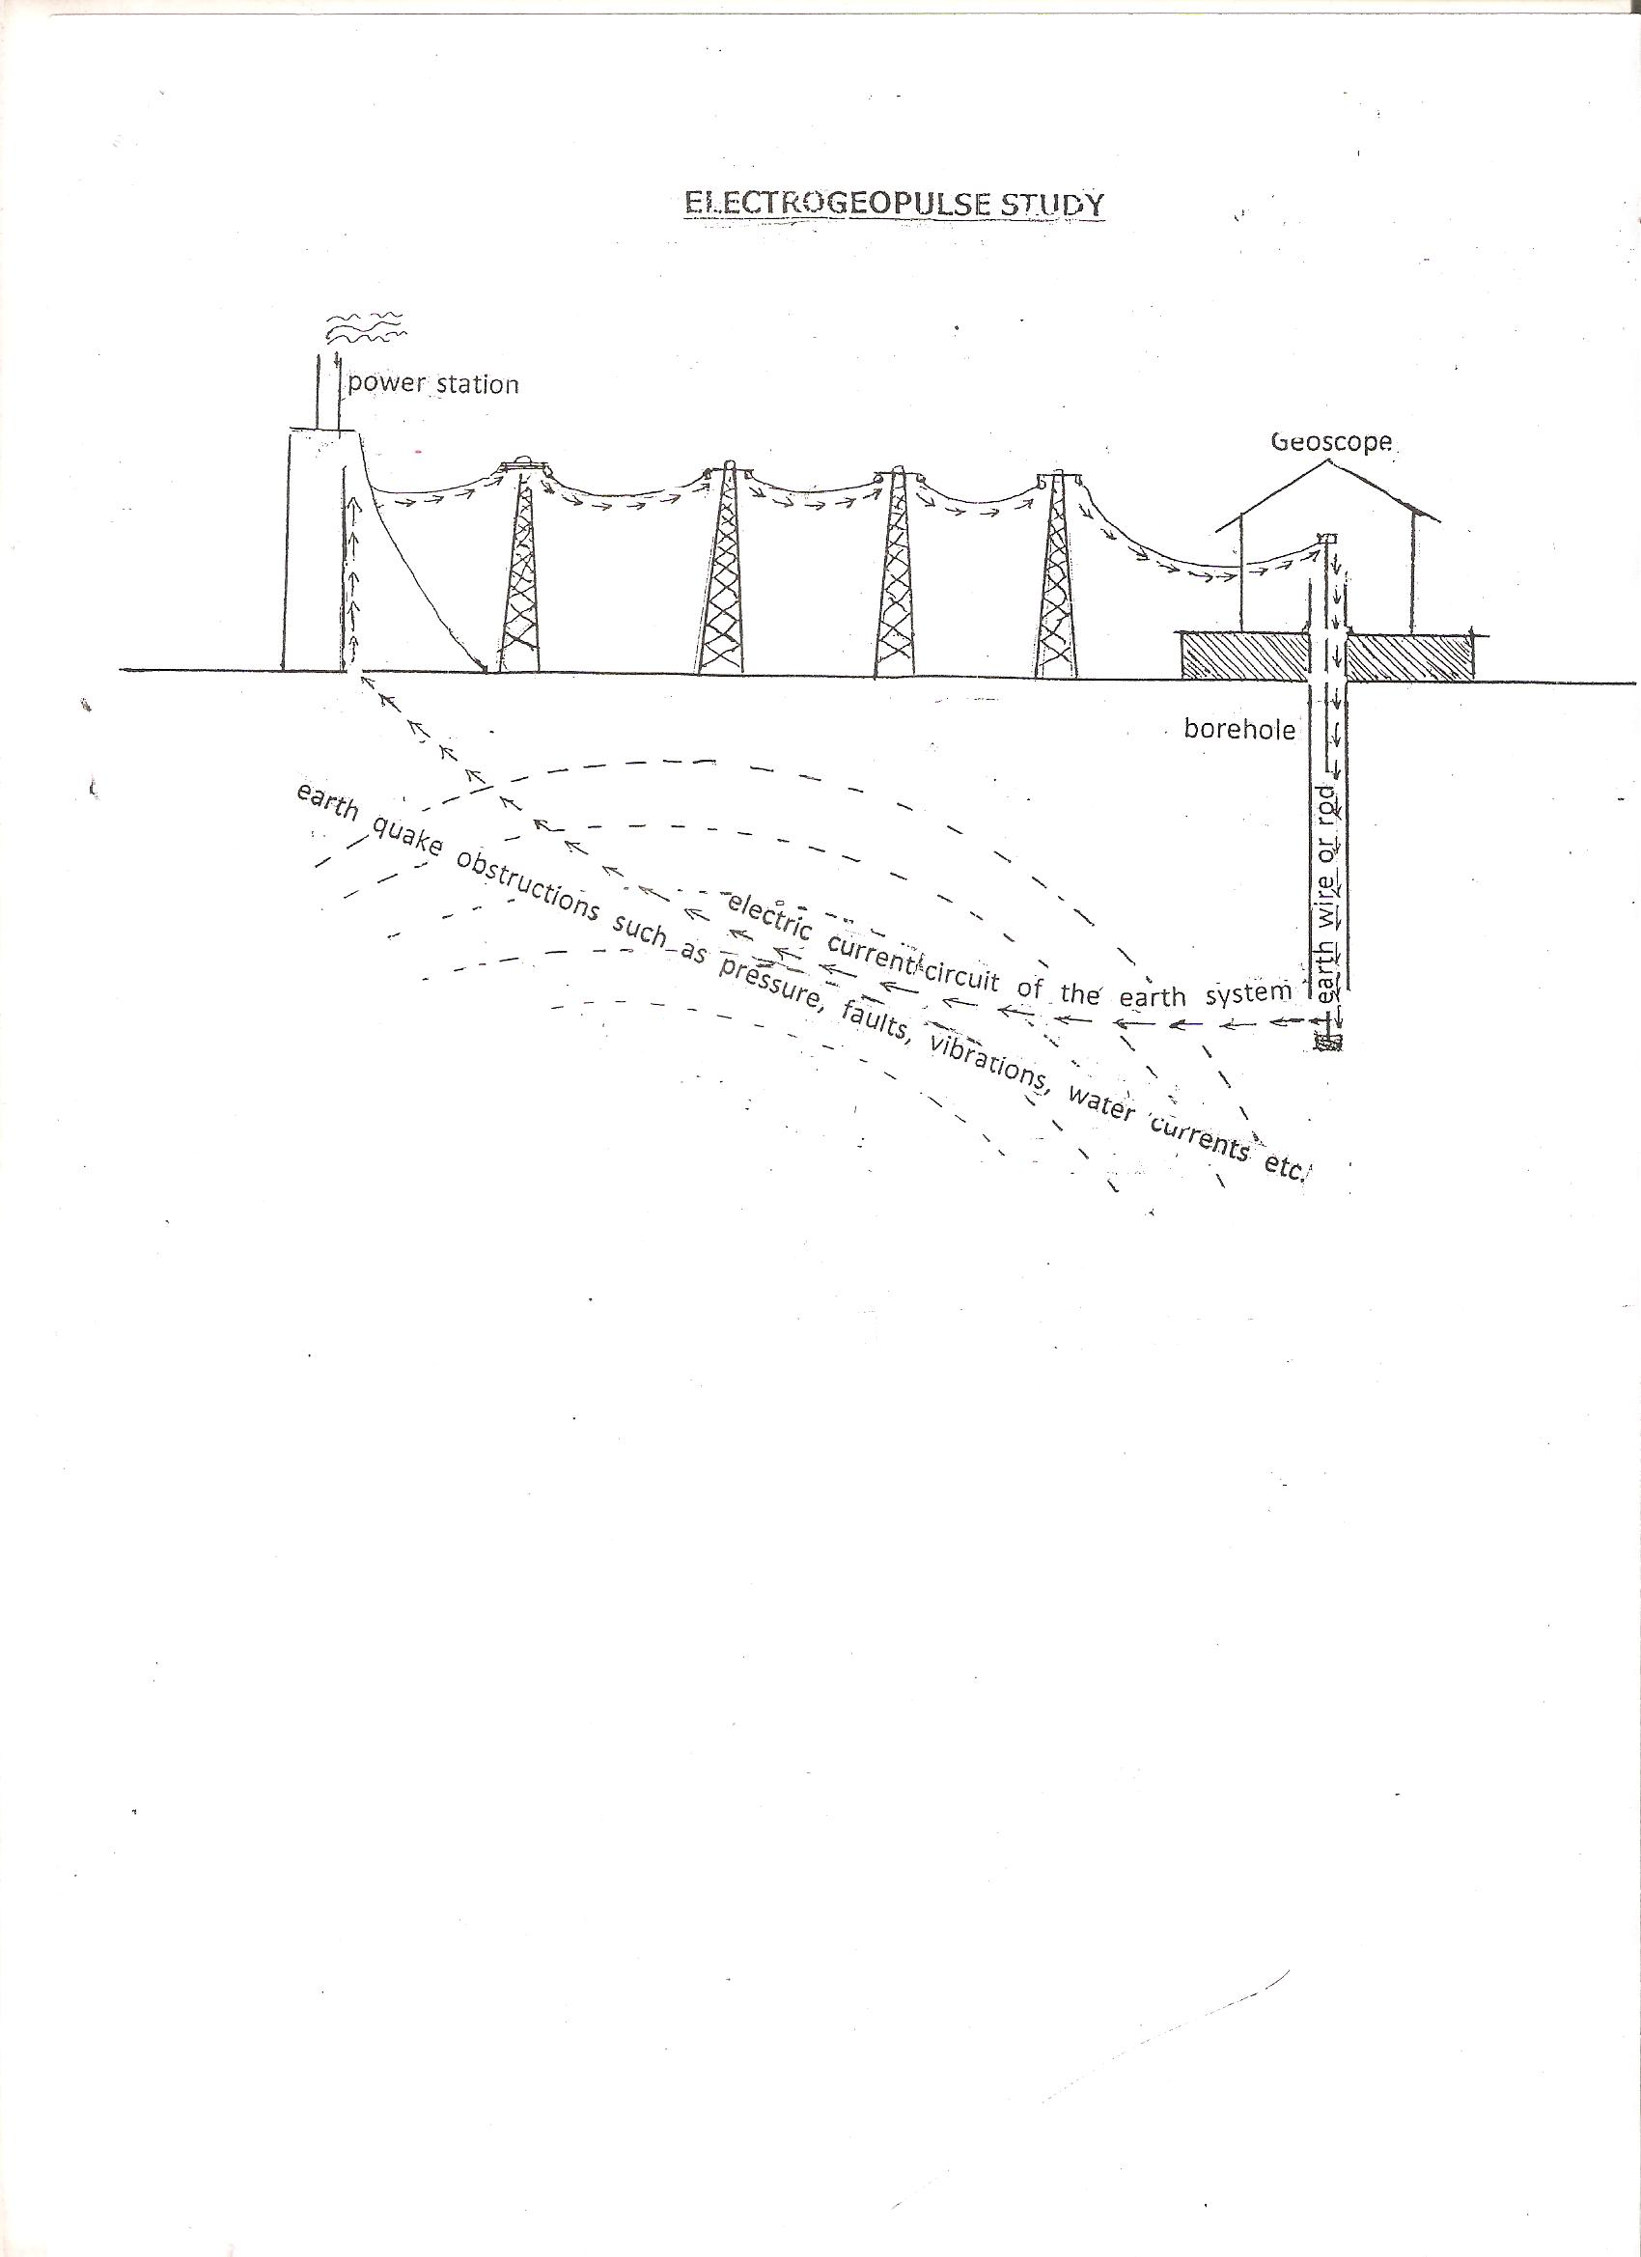

9/1/2016

