Results Of Research On Monsoon Sciences

Gangadhara Rao Irlapati

H.No.5-30-4/1, Saibaba Nagar, Jeedimetla, Hyderabad – 500 055, Telangana State, INDIA
Email ID: scientistgangadhar@gmail.com

Abstract: Monsoon is traditionally defined as a seasonal reversing wind accompanied by corresponding changes in preciption. The major monsoon systems of the wprld consist of west African, Asia Australian, north and south American monsoons including Indian monsoon. I have conducted many researches on the world monsoon systems and invented some related discoveries & inventions which may also be useful in understanding the extent of the use of monsoons.
[Gangadhara Rao Irlapati. Results Of Research On Monsoon Sciences. Researcher 2016;8(1s):468-499]. ISSN 1553-9865 (print); ISSN 2163-8950 (online). http://www.sciencepub.net/researcher. 18. doi:10.7537/marsrsj0801s16.18.

Keywords: Indian Monsoon Time Scale, Monsoons, Cyclones.

Introduction:
I have conducted many scientific researches on the Indian Monsoon during the period of 1980-91, and invented the Indian Monsoon Time Scale which can help to study the past, present and future movements of the Indian Monsoon. In 1991, Sri G. M. C. Balayogi, Member of Parliament (Lok Sabha) recommended the Indian Monsoon Time Scale to the India Meteorological Department for implementation in the services of the country. In 1994, the cabinet secretary of India recommended the Indian Monsoon Time Scale to the Ministry of Science & Technology, Govt of India for implementation. In 1996, Many consultations were made with the parliament house, president of India and other VVIPS of India. In 2005, consultations were made with the India Meteorological Department about the Indian Monsoon Time Scale for further research and development in the services of the country. In 2009, the Secretary, Minister of science and technology was also recommended the Indian monsoon Time scale to the Indian Institute of tropical Meteorology for research and development.
Construction: The Indian Monsoon Time Scale-a chronological sequence of events arranged in between time and weather with the help of a scale for studying the past, present and future movements of monsoon of India and its relationship with rainfall and other weather problem and natural calamities.
Prepare the Indian Monsoon Time Scale having 365 horizontal days March 21st to next year March 20th of a required period comprising of a large time and weather have been taken and framed into a square graphic scale. The main weather events if any have been entering on the scale as per date and month of the each and every year. If we have been managing the scale in this manner continuously we can study the past, present and future movements of the Indian Monsoon.
For example, I have prepared the Indian Monsoon Time Scale by Preparing the Scale having 365 horizontal days from 1st April to next year March 31st of 128 years from 1888 to 2016 for the required period comprising of large time and weather have been taken and framed into a square graphic scale. The monsoon pulses in the form of low pressure systems over the Indian region have been entering on the scale in stages by 1 for low, 2 for depression, 3 for storm, 4 for severe storm and 5 for severe storm with core of hurricane winds pertaining to the date and month of the each and every year. If we have been managing the scale in this manner continuously, we can study the past’s present’s and future’s of the India monsoon and its relationship with rainfall and other weather problems & natural calamities in India.
Analysis: The Indian Monsoon Time Scale reveals many secrets of the monsoon & its relationship with rainfall & other weather problems and natural calamities. For example, some bands, clusters and paths of low pressure systems along with the main paths of the Indian Monsoon (South-west monsoon and north-east monsoon) clearly seen in the map of the Indian monsoon it have been some cut-edge paths passing through its systematic zigzag cycles in ascending and ascending order which causes heavy rains & floods in some years and droughts & famines in another years according to their travel. For example, during 1871-1990’s the main path of the Indian monsoon was rising over June, July, August and creating heavy rains and floods in most years. During 1900-1920’s it was falling over August, September and causing low rainfall in many years, During 1920-1965’s, it was rising again over July, August, September and resulting good rainfall in more years. During 1965-2004’s it was falling over September and causing low rainfall and droughts in many years. At present it is rising upwards over June, July, August, and will be resulting heavy rains & floods in coming years during 2004-2060. The tracking date of main path & other various paths such as south-east monsoon and north-west monsoon etc., of the Indian Monsoon denotes the onset of the monsoon, monsoon pulses or low pressure systems. And also we can find out many more secrets of the Indian monsoon such as droughts, famines, cyclones, heavy rains, floods, real images of the Indian Monsoon, and onset & withdrawals of south east monsoon and north-west monsoon etc. by keen study of the Indian Monsoon Time Scale.
Principle: This is an Astrogeophysical/ Astrometeorological Phenomenon of effects of astronomical bodies and forces on the earth’s geophysical atmosphere. The cause is unknown however the year to year change of movement of axis of the earth inclined at 23 ½ degrees from vertical to its path around the sun does play a significant role in formation of clusters, bands & paths of the Indian Monsoon and Stimulates the Indian weather. The inter-tropical convergence zone at the equator follows the movement of the sun and shifts north of the equator merges with the heat low pressure zone created by the rising heat of the sub-continent due to the direct and converging rays of the summer sun on the Indian Sub-continent and develops into the monsoon trough and maintain monsoon circulation.
Experiments Carriedout: Many experiments were carried out on the Indian Monsoon Time Scale and Successfully proved out in practice.
Publications: Many journals announced the Indian Monsoon Time Scale In 2004, a news commentary was published in the popular daily Vartha. The journal of environmental & ecology announced the Indian Monsoon Time Scale and Global Monsoon Time Scale in 2015.
Conclulsions: We can make many more modifications thus bringing many developments in the Indian Monsoon Time Scale.
Lisposcope: I first started the researches in 1963-65 @ 5 to 7 years age with little instruments such as papers and pencils, water drop etc. and invented the light spot scope (Liposcope). Liposcope is a simple but wonderful instrument which functions with a natural doctrine hidden secretly in the function of the eye which can help to find out some inventions and discoveries like biolumicells, bioforecast effect etc, Liposcope is my first invention.
Construction: Take one small glass/steel ball or water drop on an object and stand in sun the light. Expose the ball/drop to the sun rays. As a result of the sun rays, there will be a light spot in the drop/ball. Place the light spot closely to the eye. The light spot apperars many times bigger as a circular screen. The appearance in the screen of light spot is the surface of the eyeball. This can be proved by moving eyelids, the movement of eyelids, eye water and some bioluminescent particles on the eyeball can be observed in the screen of light spot.
Principle: The principle of the lisposcope is that the eye lens changes its focal length from a minimum distance to the object at infinity and can see the object. If the distance decreases below minimum, the clarity of vision decreases. At this position, the eye lens acts as a simple microscope and form virtual images of all objects in front of it. We can see them on the screen of light spot if place just unside its minimum distance.
I have discovered the biolumicells (Bioluminescentmicells) on the eyeball in 1964 in the Lisposcope experiments. These particles are a part and parcel of the human body, may be released within the human body and secreting to the eyeball through the eye water. This is my second invention.
In the lipscope observations we can see three types of bioumicells on the eyeball the first one is the most bright and active and it is seen rarely on the eyeball and this biolumicell is has high velocity, mechanical energy, spin around itself it. The second one has normal bright seen normally on the eyeball and the third and last one is bright less, it is seen frequently on the eyeball.
Looking the screen of light spot and move the eyelids. We can see some biolmicells on the eyeball. After finding a number of biolumicells all at once in cloud or group, you must count them without eyelid movement. Firstly, observe with one eye two or three times. Later on another eye. As we examine one after another with both eyes, we have to take into account the greatest number of particles.
Analyze the data and make a table with the particulars-date of observation, time of observation , number of particles and weather report. Firstly we must put the date, next the time of observation, then the number of particles available in the observation. Do the observations three or four times daily in the morning & evening and record the number. At last, record the weather report of the country on the same day. If we do our observations and analyze in that manner, we can notice that there is a relation between the differences in particles number in the table and the changes in the weather after about 18 days. If the particles number is minimum the weather after 18 days will be normal. On the other hand if the particles number is at maximum there will be a change in the weather after 18 days.
Principle: The cause is unknown however it can understand that generally biolumicells secrete in less or minimum levels at normal weather conditions, but over the formation of low pressure weather conditions, biolumicells begin to secrete at maximum levels due to a fall in weather pressure on the human body.
Great Prediction: The important prediction of the bioforecast effect was proved in 1991. In 1991, the Andhra Pradesh state council of science & Technology, The Andhra Pradesh Remote Sensing Applications Centre and the Andhra Pradesh Science Centre were conducted experiments on the relationship between the biosphere and atmosphere (explore the inter-connection of earths geomagnetic field with natural calamities and their effect on human impulse). In these observations, the maximum level of the biolumicells were recorded between 7th to 11th of April, 1991. It is the sign of the ensuring cyclone of the 28th April 1991. The three directors of the said institutions were met in the Andhra Pradesh state Council of Sciences & Technology on 9TH, April 1991 and discussed about the prediction. As predicted on 9th April 1991, in the meeting a severe cyclone was formed in Bay of Bengal and struct the Bangladesh on 28th April 1991. As a result, thousands of people were killed and crores of rupees property was damaged. This is the great prediction by the bioforecast and the remaining predictions were weak.

Conclusion:we can make many more changes thus bringing many more changes in the biofore casting scale.

References
- Mooley DA, Shukla J(1987); Charecteristics of the west ward-moving summer monsoon low pressure systems over the Indian region and their relationship with the monsoon rainfall. centre for ocean-land atmospheric interactions, university of Maryland, college park, MD.
- All india monthly and seasonal rainfall series, 18711993, B. Parthasarathy, A. AMunot, D. R. Kothawale, Theoritical and applied climatology, 1994, Springer.
- Das P. K. and B. L. Bose, 1958, Numerical study of movement of monsoon depression, Ind. journal of meteor. Geophysics.
- Analysis of variability and trends of extreme rainfall events over india using 104 years of gridded daily rainfall data, M. Rajeevan, J. Bhate, A. K. Jaswal, Geophysical Research letters, 2008, online library.
- Jadhav, S. K. and A. A. Munot,2004; statistical study of the low pressure systems during summer monsoon season over the Indian region, mausam, 55,15-30.
- Clusturing of low pressure system during the Indian summer monsoon by intra seasonal oscillations, bn. goswani, rs. ajaya mohan, prince kxavier, and d. sengupta, centre for atmospheric and oceanic studies, Indian institute of science, bangolour, india.
- Composite structure of monsoon low pressure system and its relation to Indian rainfall, v. krishna murthy and rs. ajaya mohan, 2010, j. climate, 23,4285-4305.
- Indian monsoon university of st Andrews www.Andrews.Ac.Uk/Dibz/Asia/Monsoon/Html.
- Indian monsoon /meteorology/britanica/.com www.britanica.com/science /indian monsoon.
- The global monsoon system : research and fore cast; caos.iisc.in/faculty/bng/iwm-iii-bng-overview.
- Climate predictron centre-global monsoon; www.cpc ncep.noaa.gov, climate.weather.
- The global monsoon system, www.wcrp-climate.org/documents/monsoon –factssheet.
- All india monthly and seasonal rainfall series, 1871-1993, b. parthasarathy, a. a munot, Drkothawale, theiritical and applied climatology, 1994, springer.
- Parthasarathy b, munot aa, kothawale dr, monthly and seasonal rainfall series for all india homogeneous regions and meteorological sub-divisions, 1871-1994, research report, iitm pune.
- Longest instrumental rainfall series of the Indian regions (1813-2006), Indian institute of tropical meteonology, pune.
- All Indian data series-(imd) pune.
- Monthly rainfall data series-ministry of earth sciences, moes. gov. in.
- 114 years rainfall in india-interactive, india environmentportal. org. in/rainfall in india.
- Nelson john H, cosmic patterns; theirs influence on man and his communications 1974 American federation of astrologers.
- Nelson j. h, RCA review, april 1951.
- Nelson J. H., J. geocosmic research, summer 1974.
- SATO live bioforecasting www.Jst.go.Jp.
- Bio weather forecast; www.weather forecasting.com/locations/bio-3/forecasts latests.

Appendices: (Indian Monsoon Time Scale)

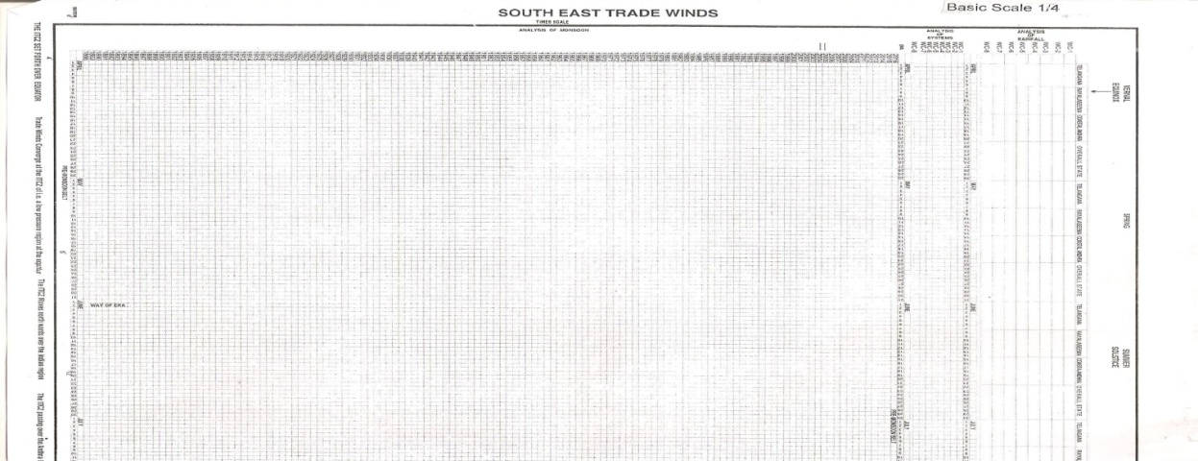
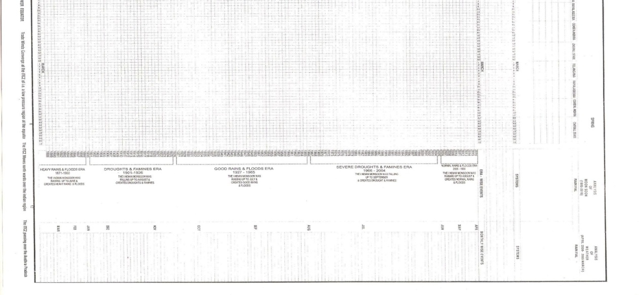

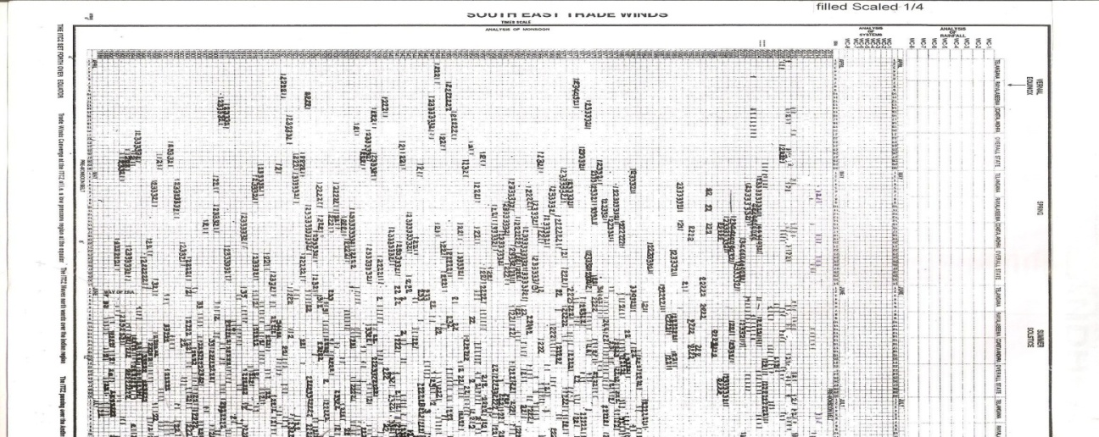
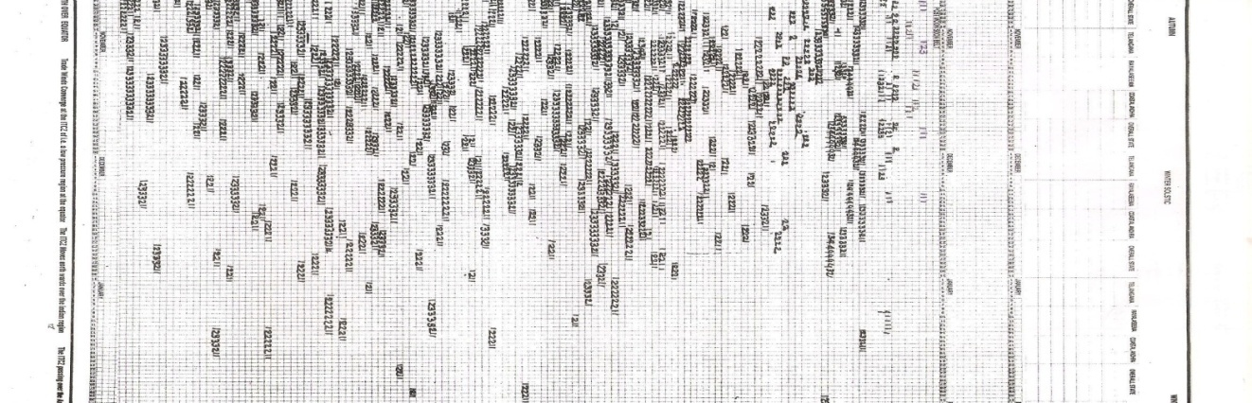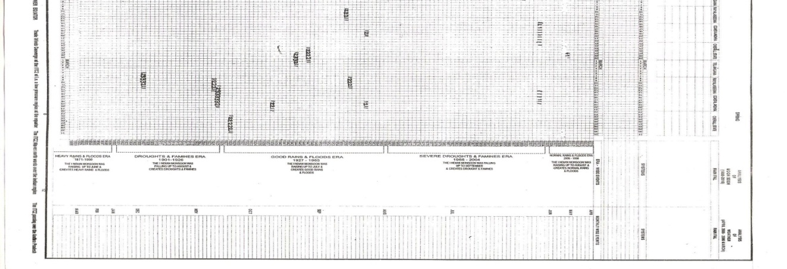

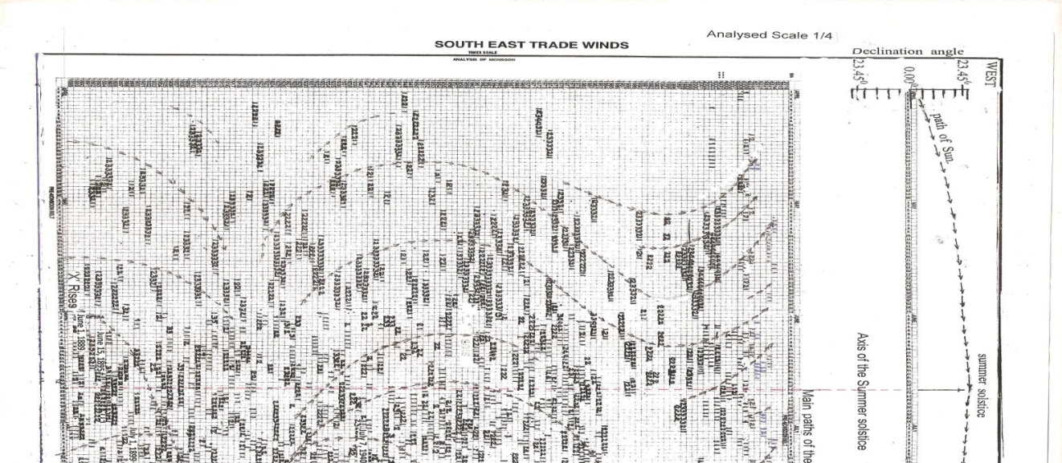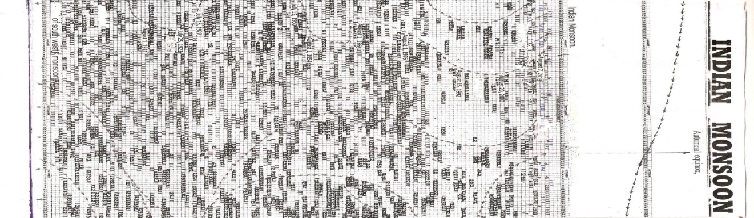
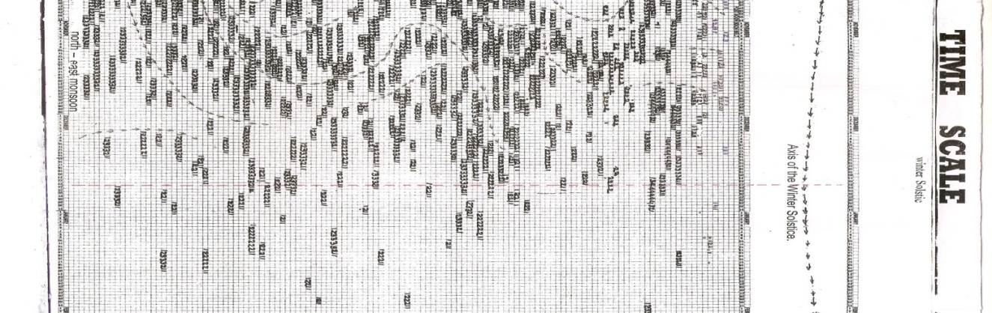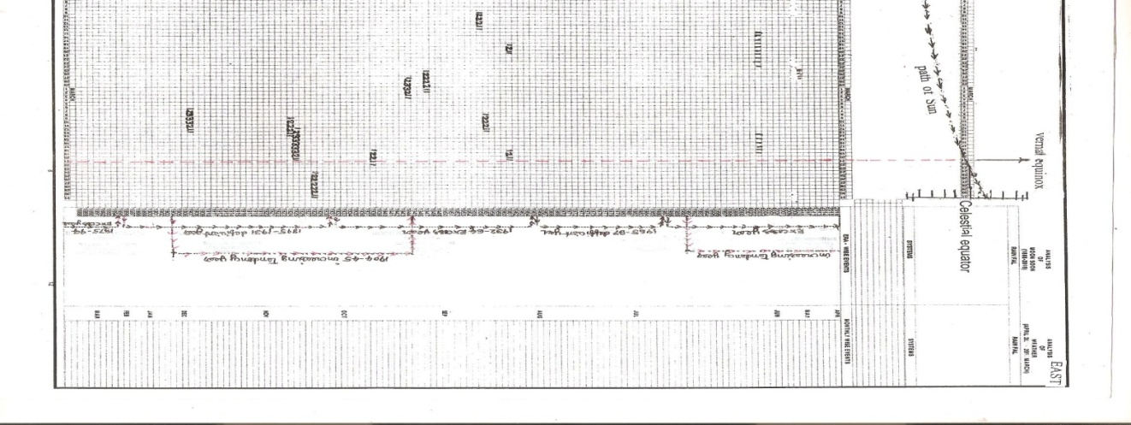

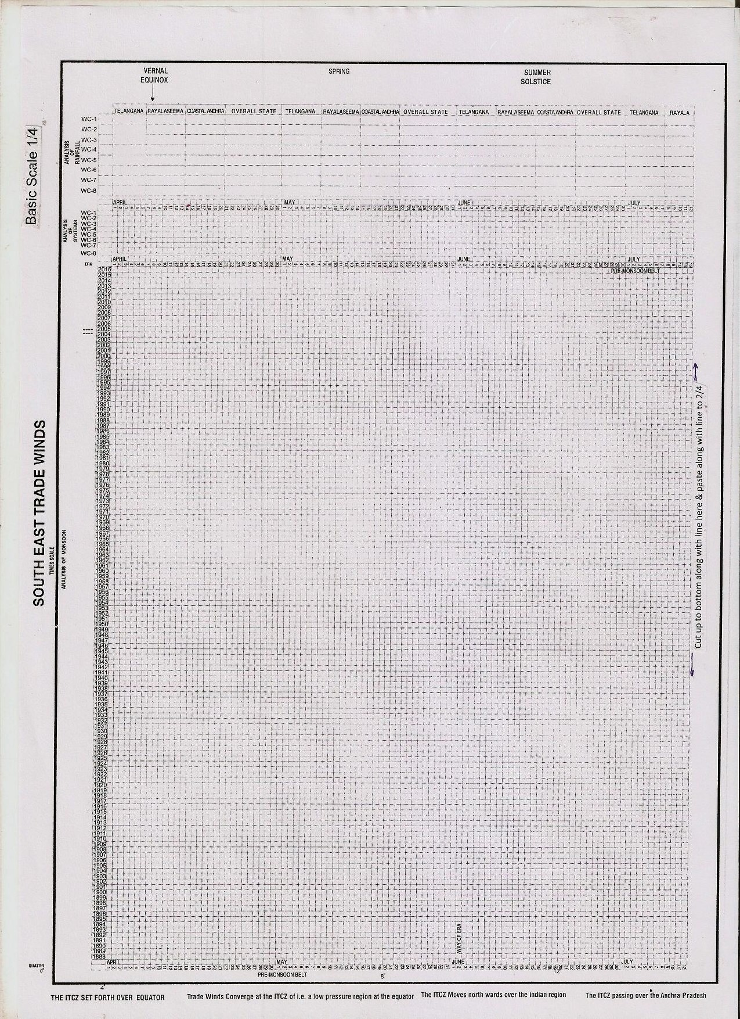
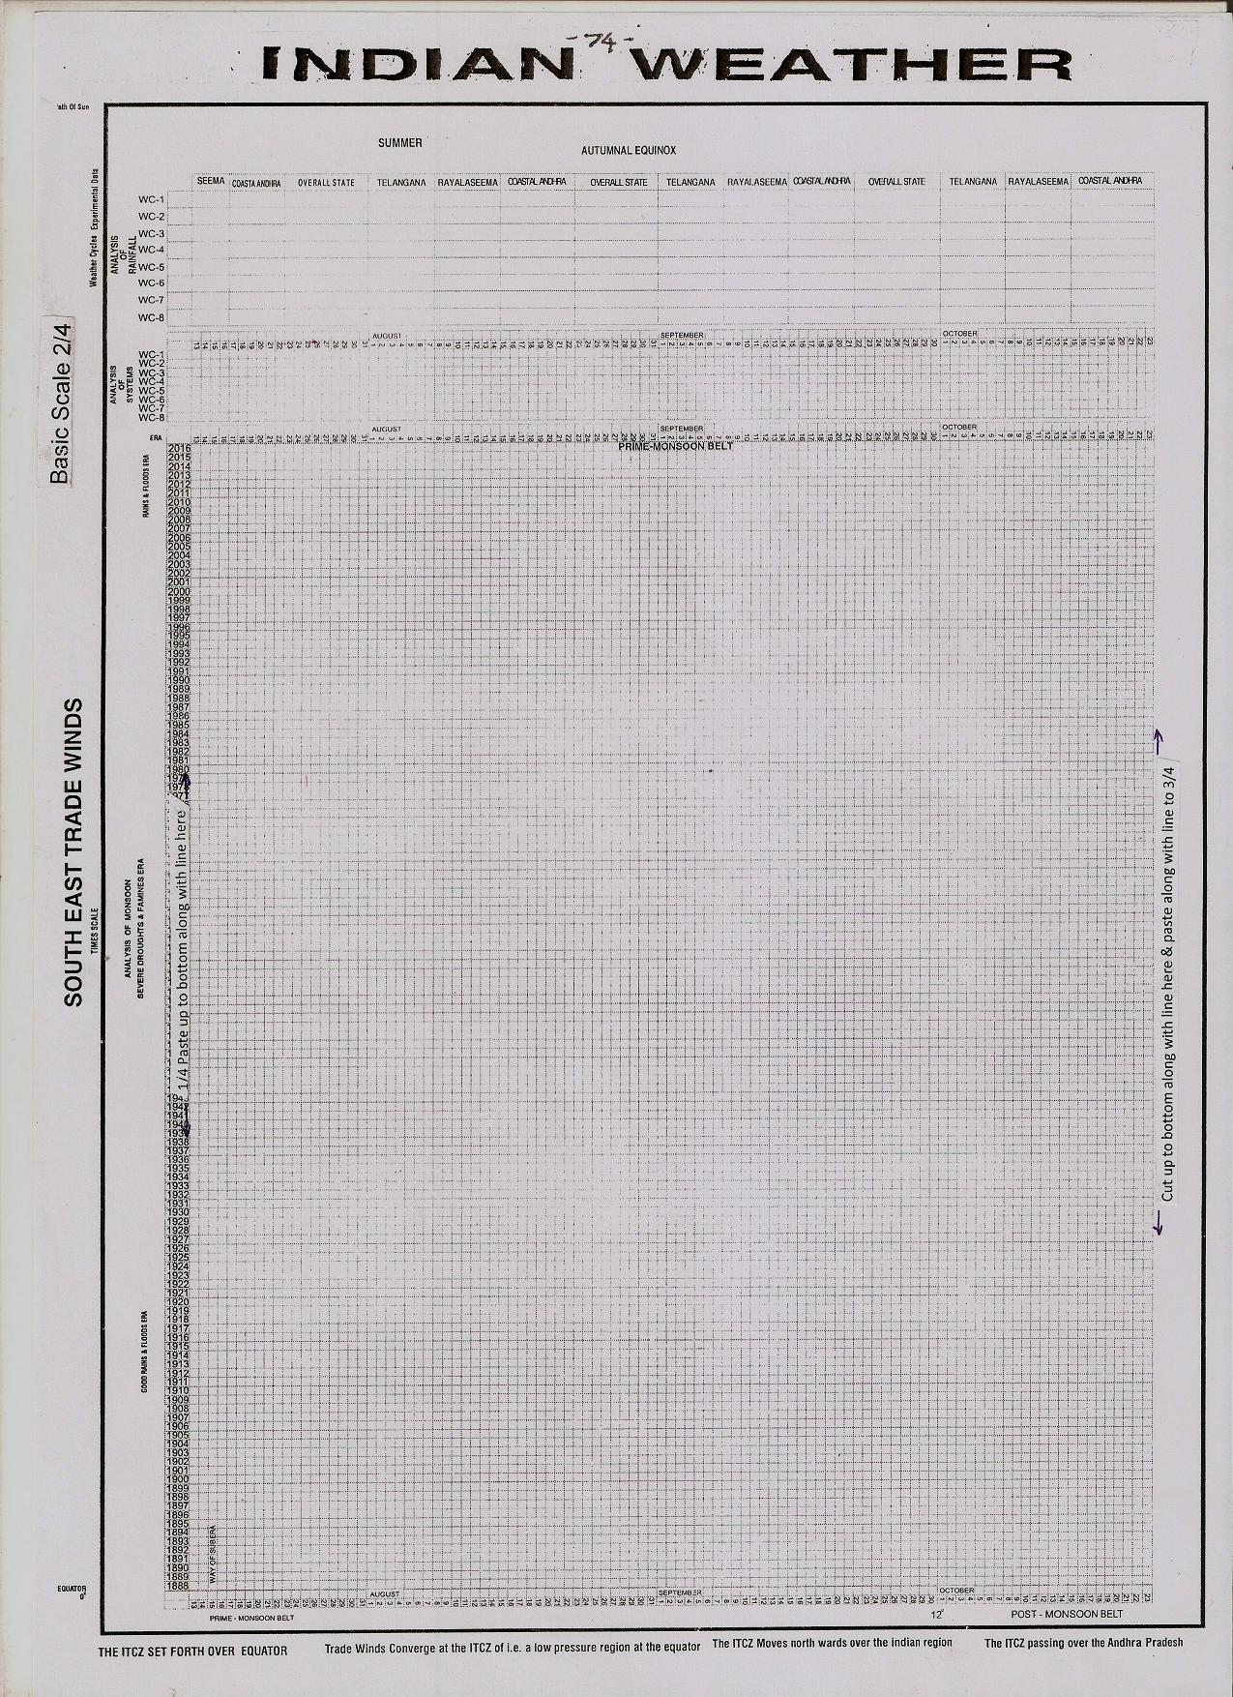
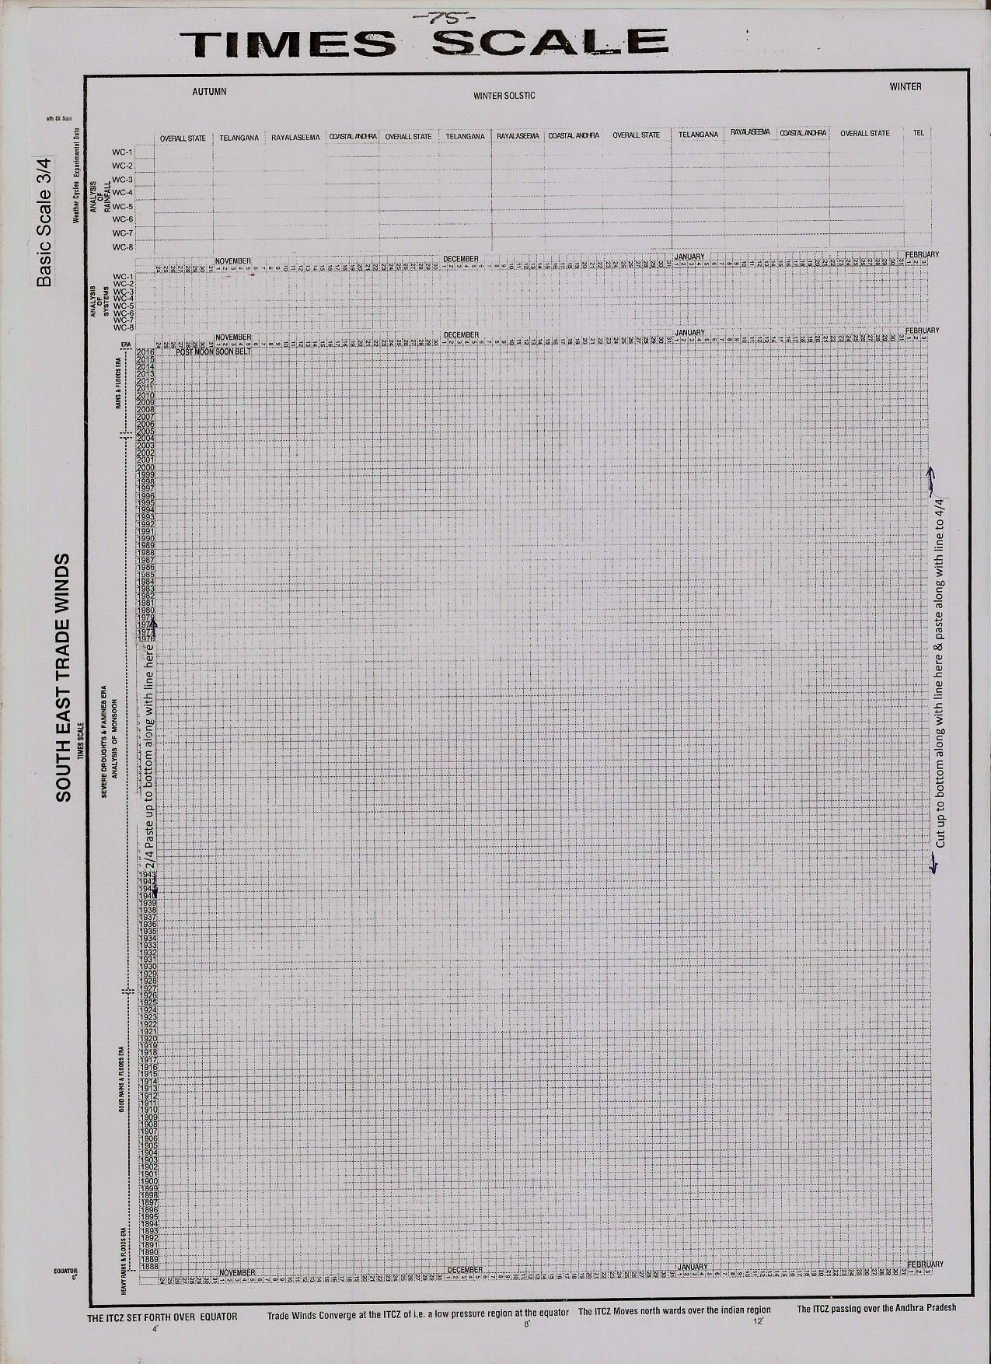
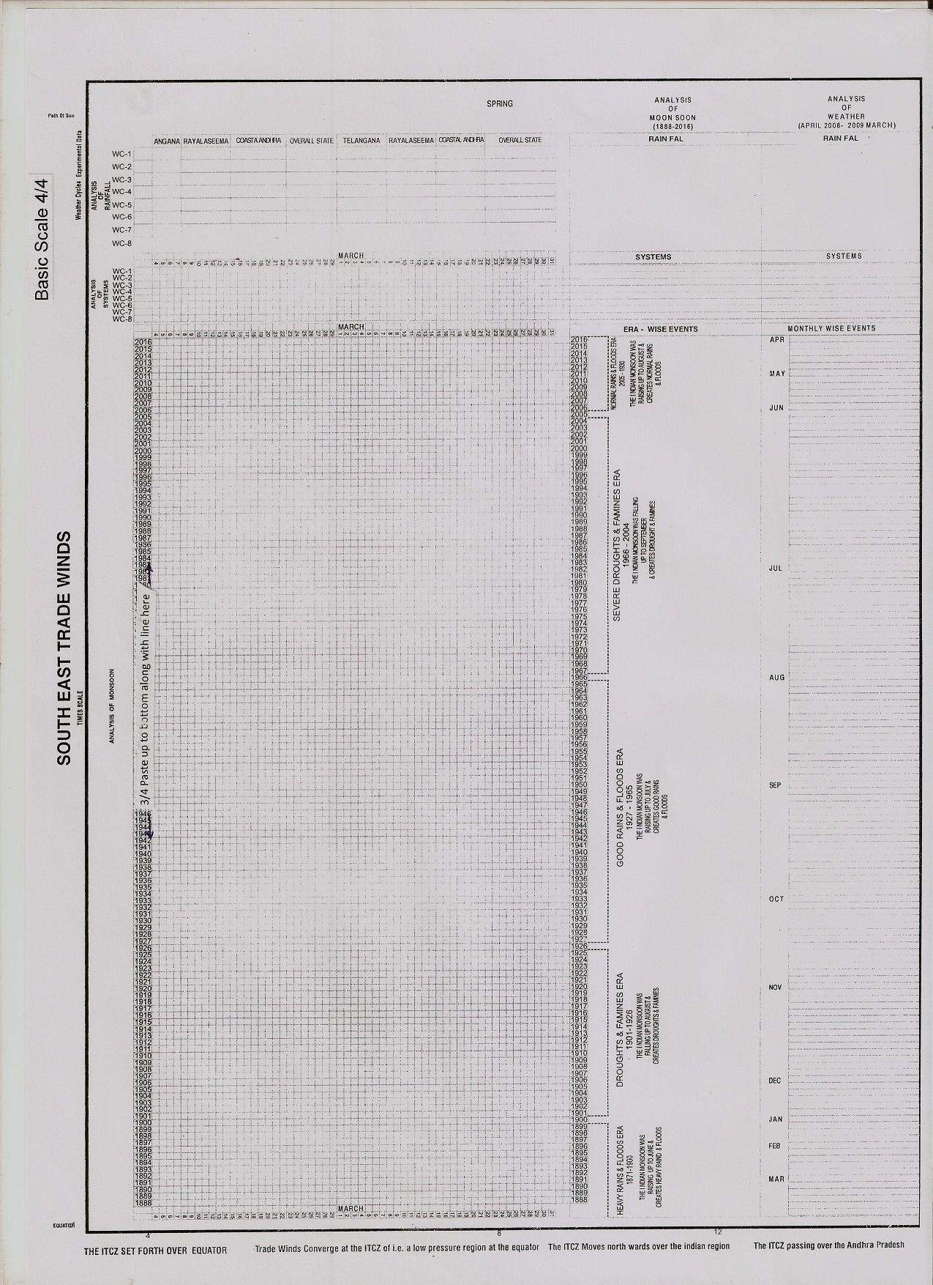
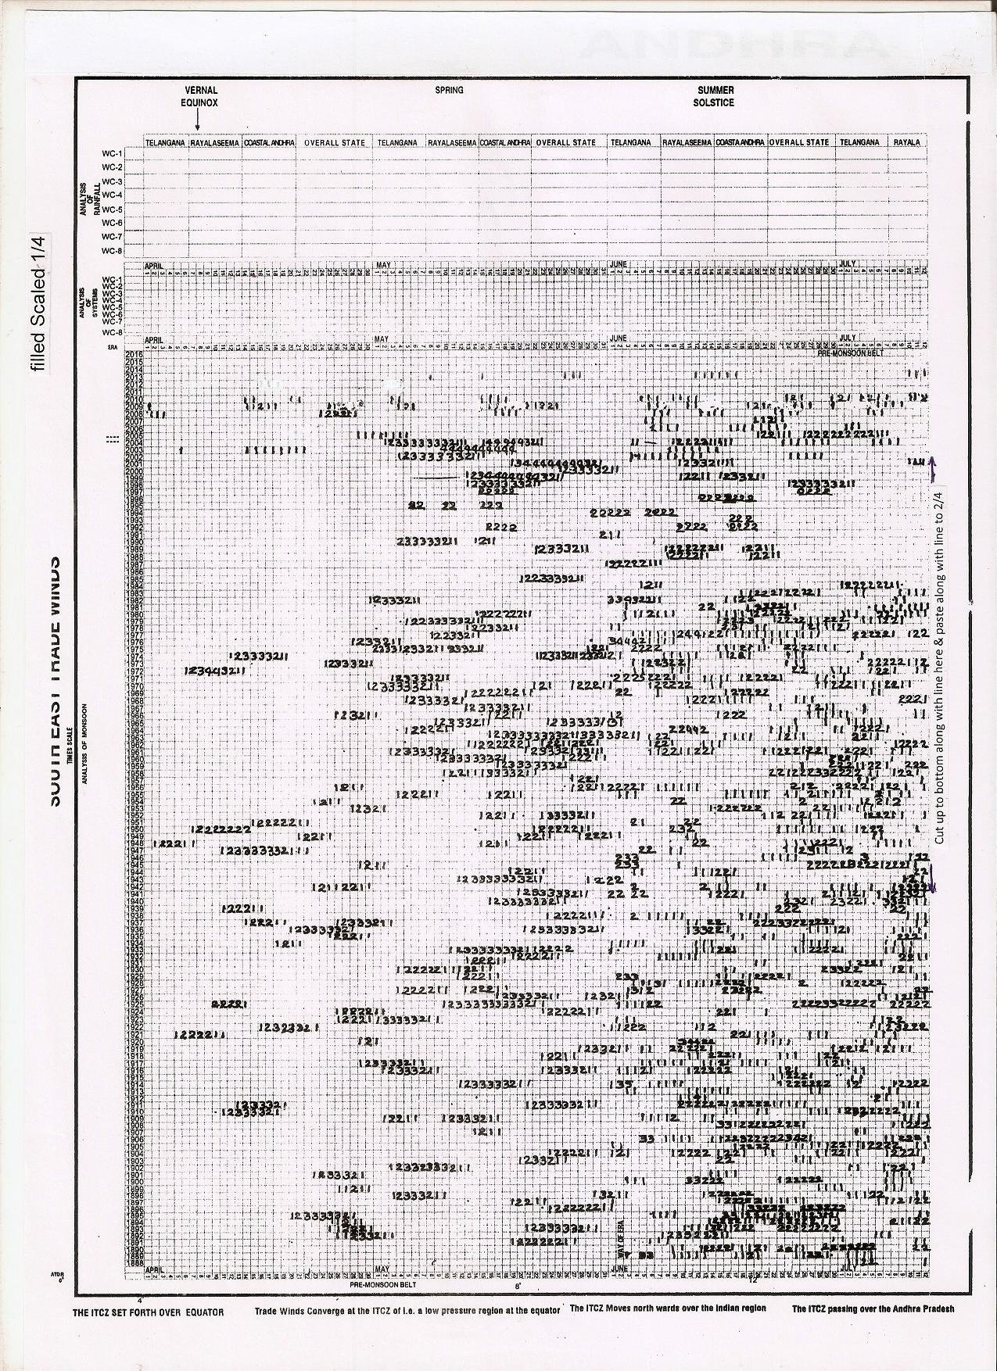
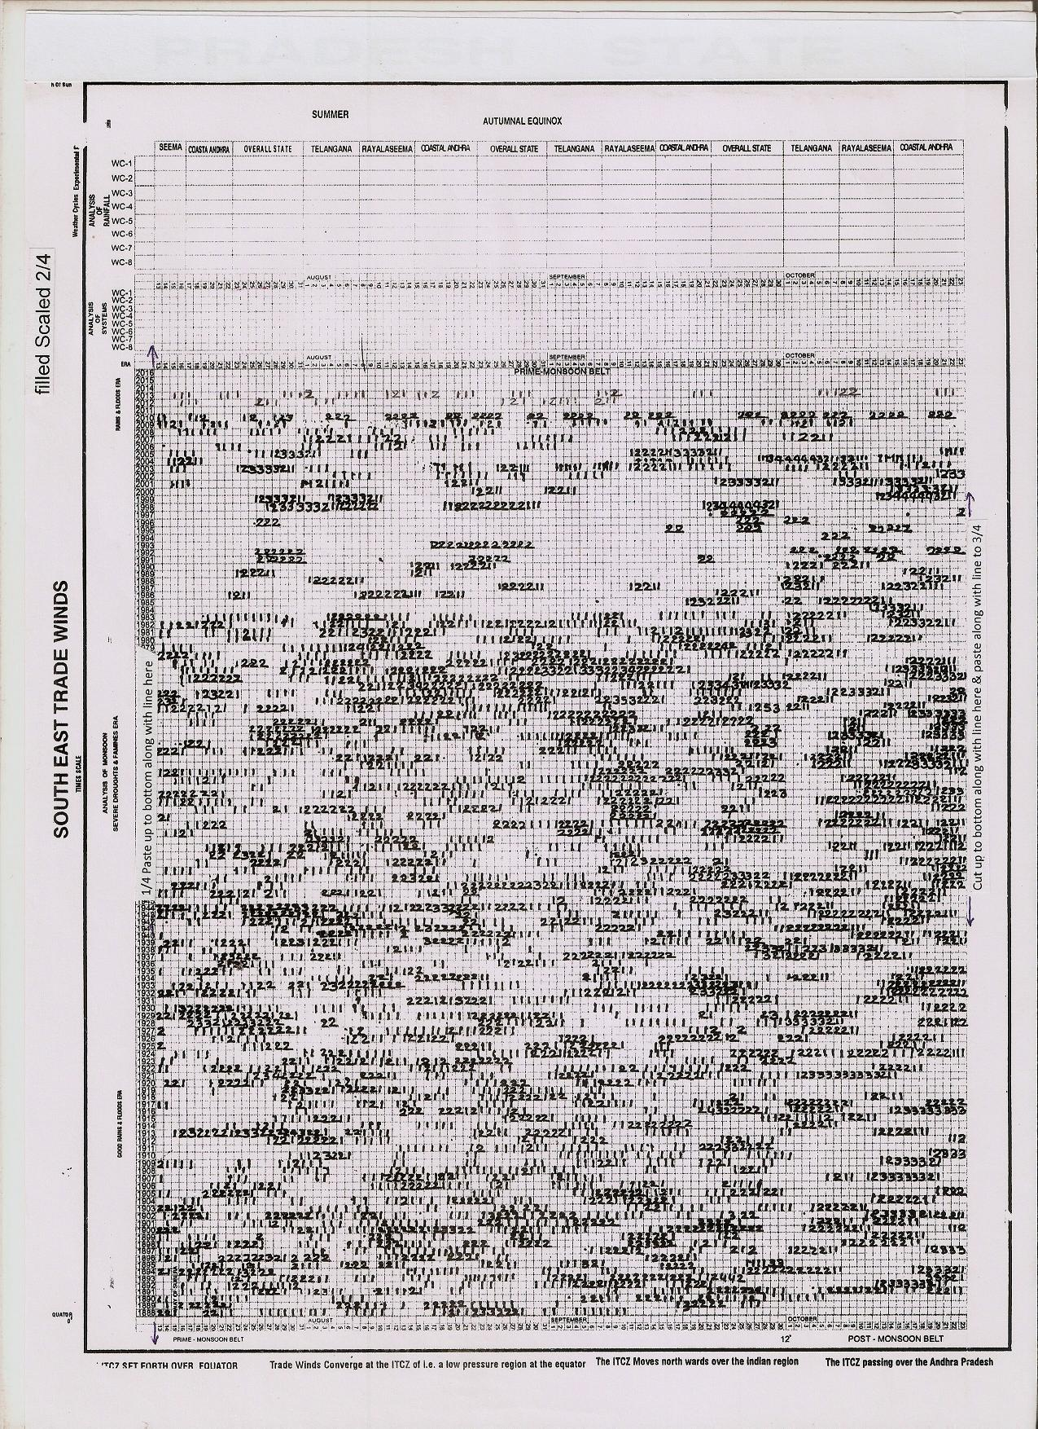
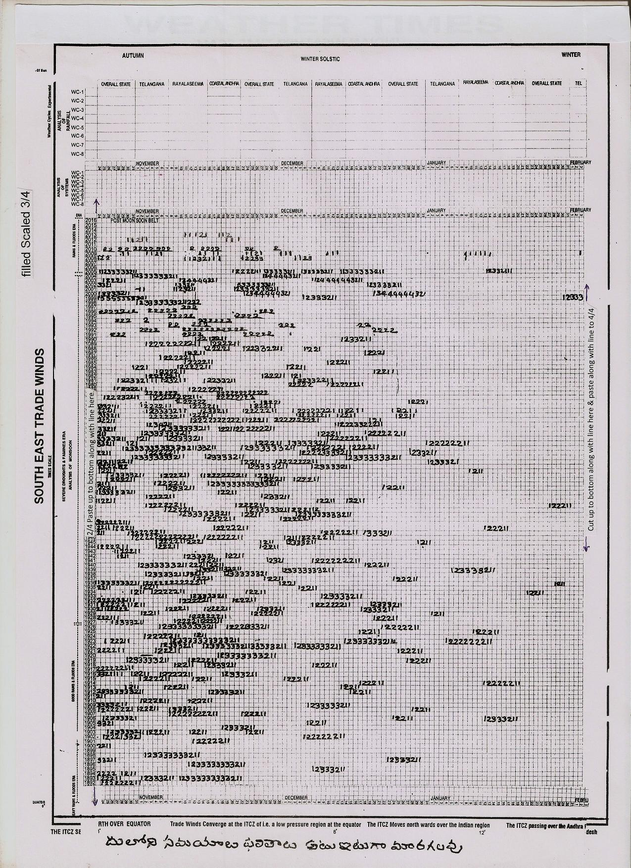
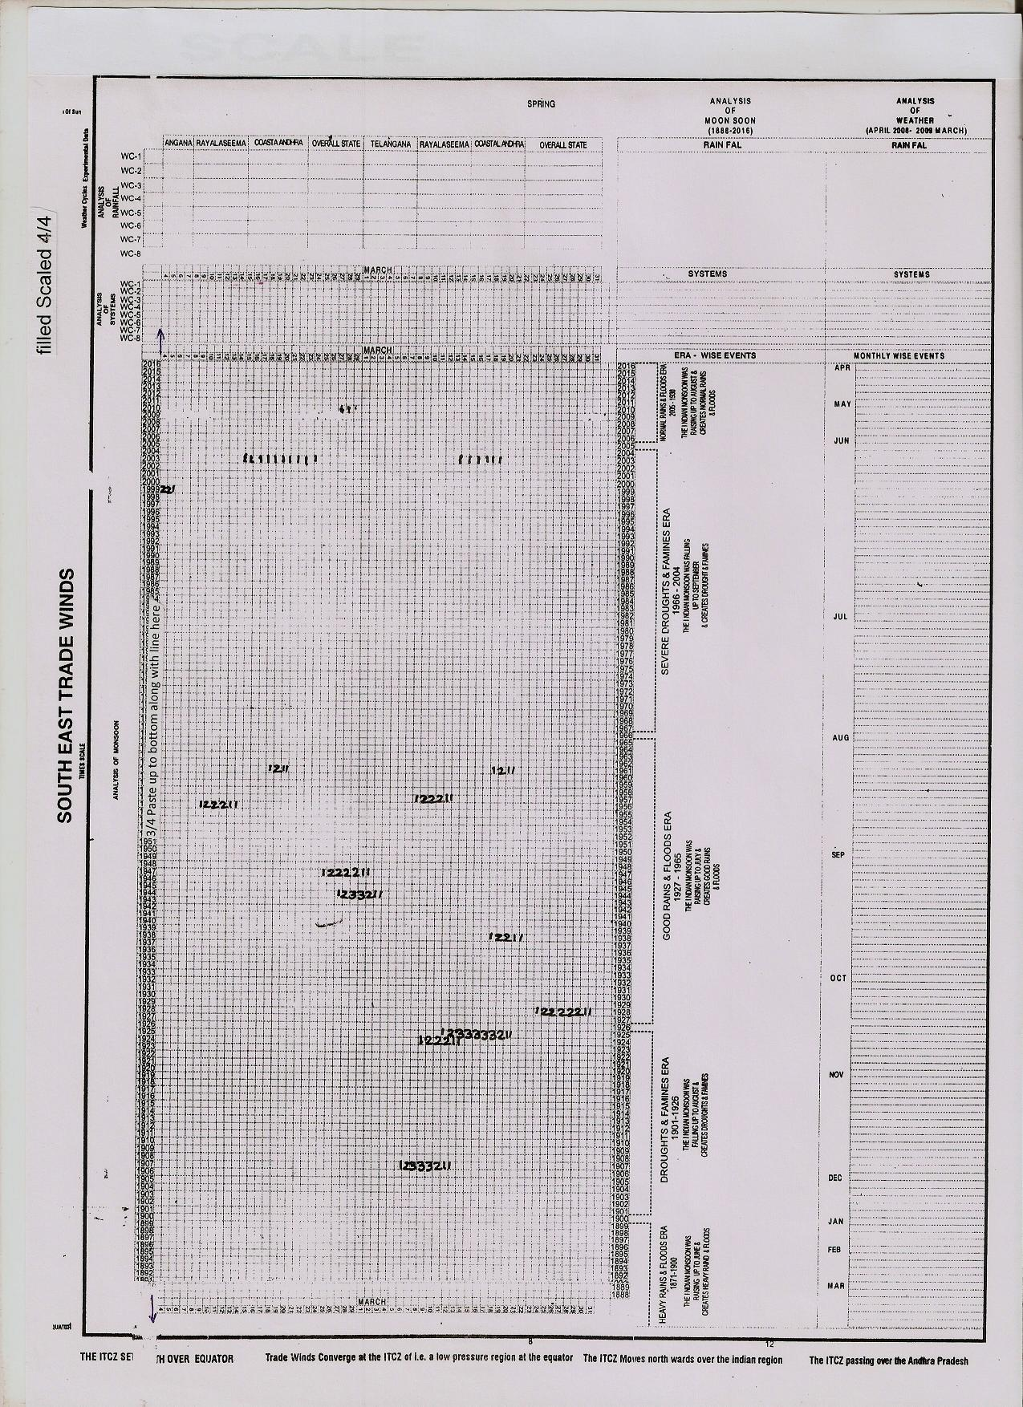
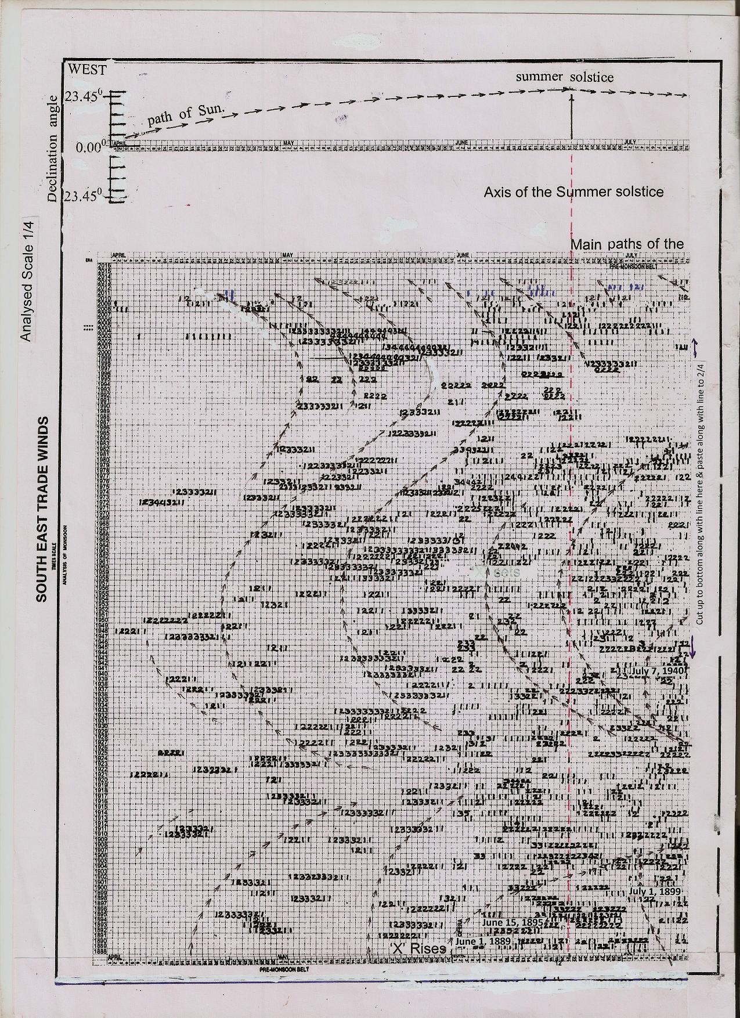
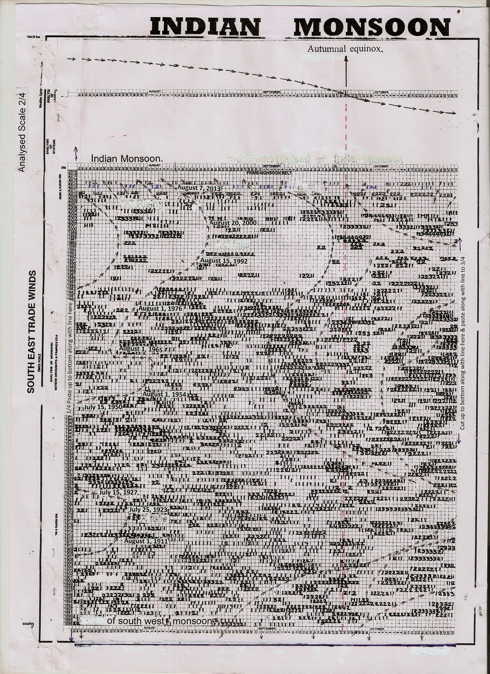
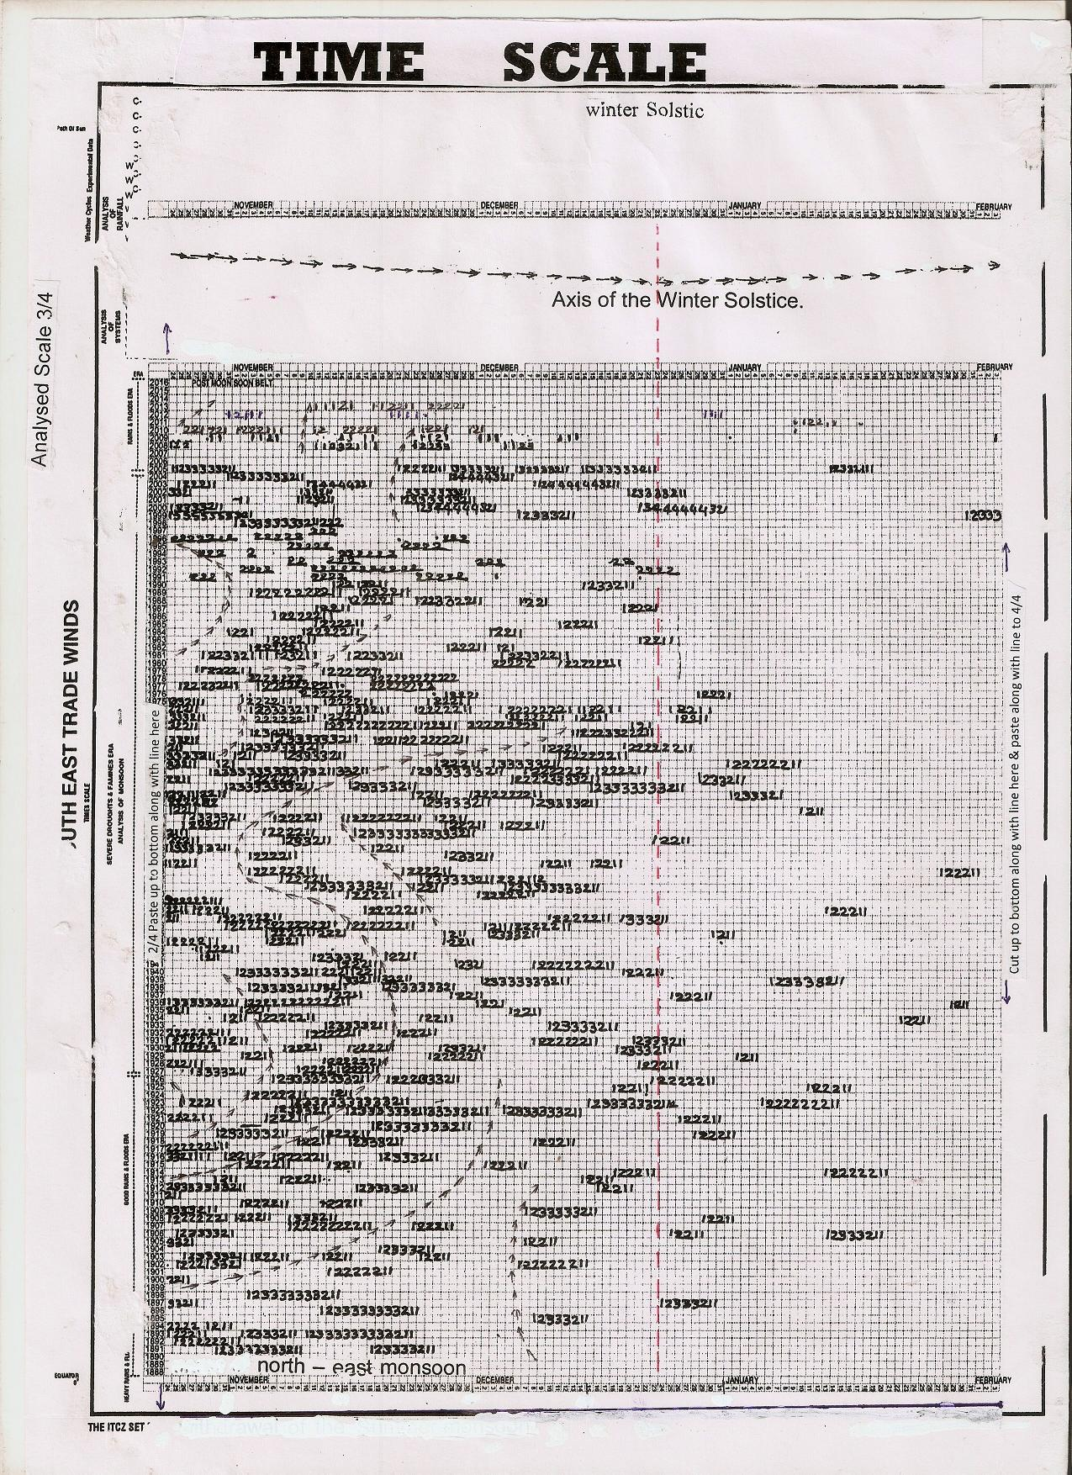
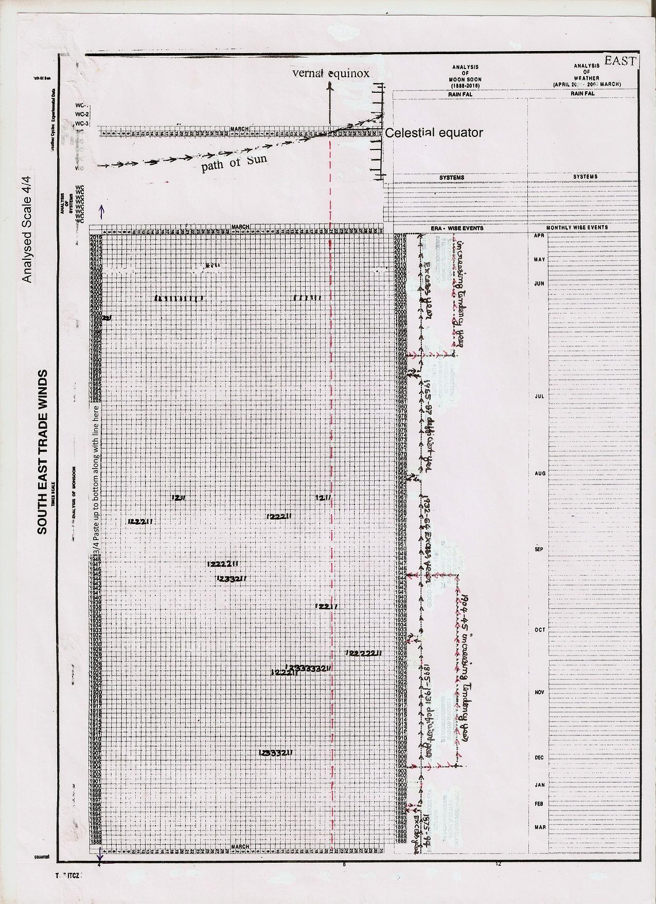
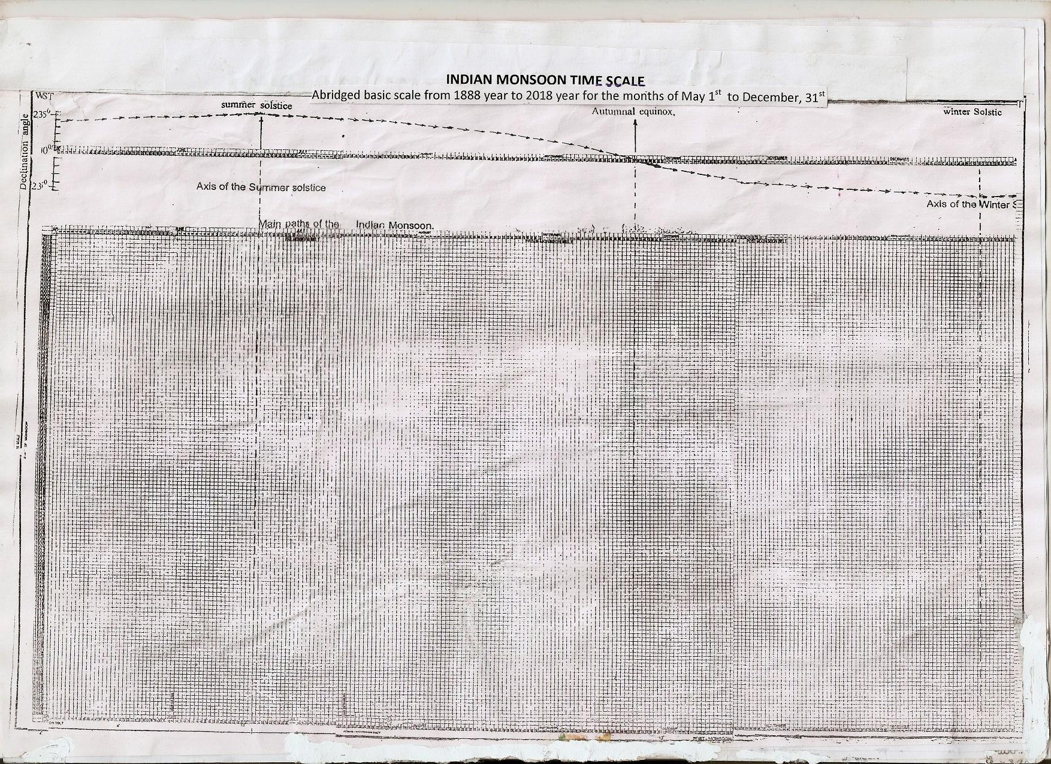
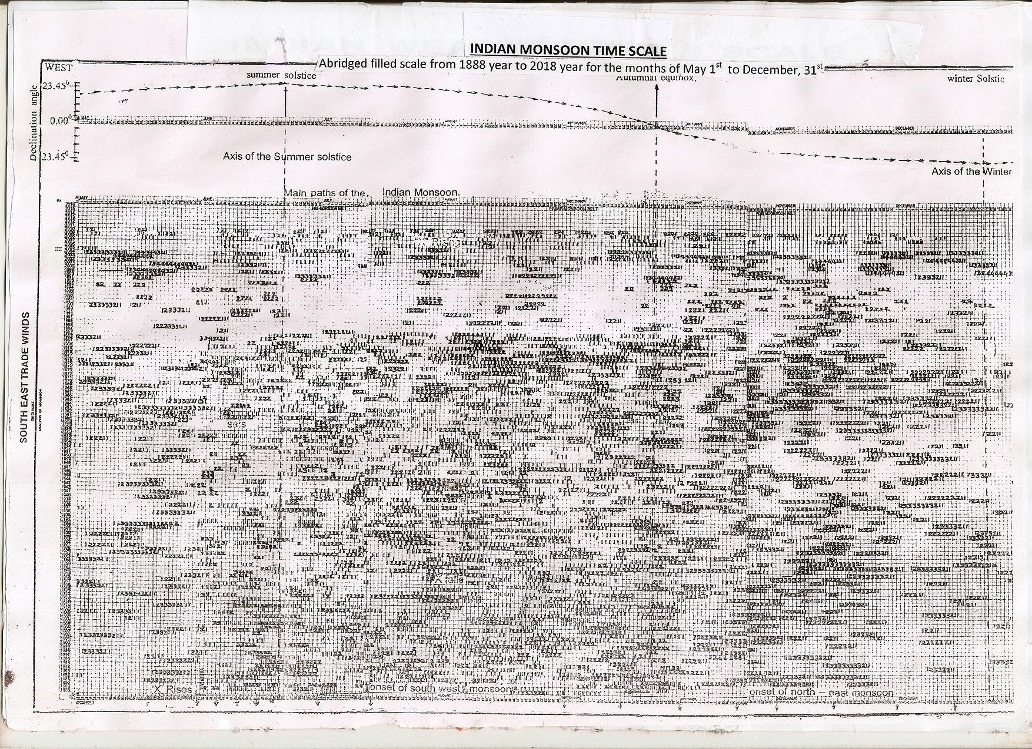
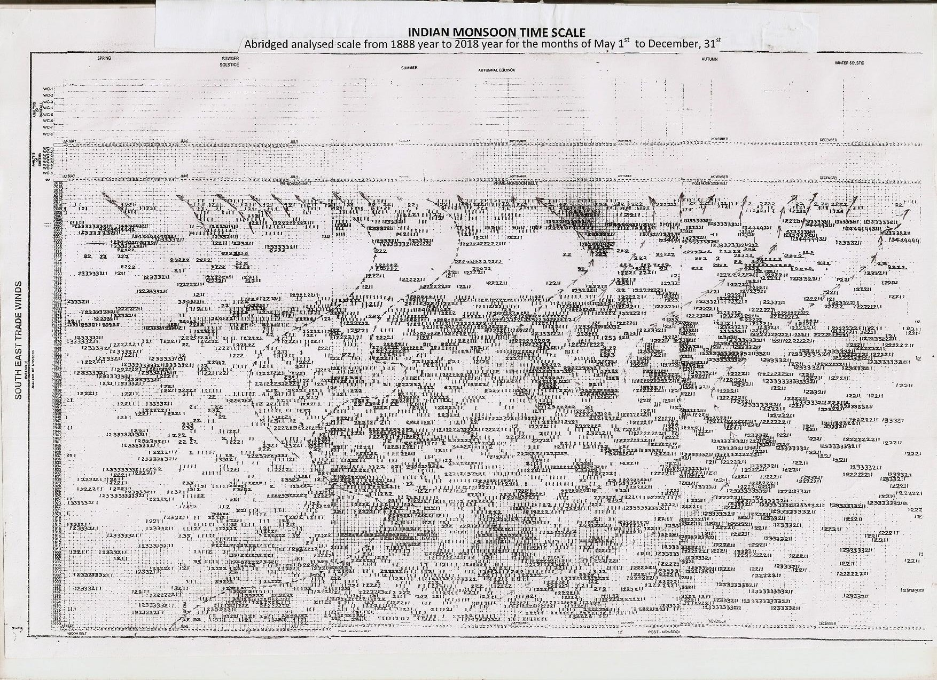
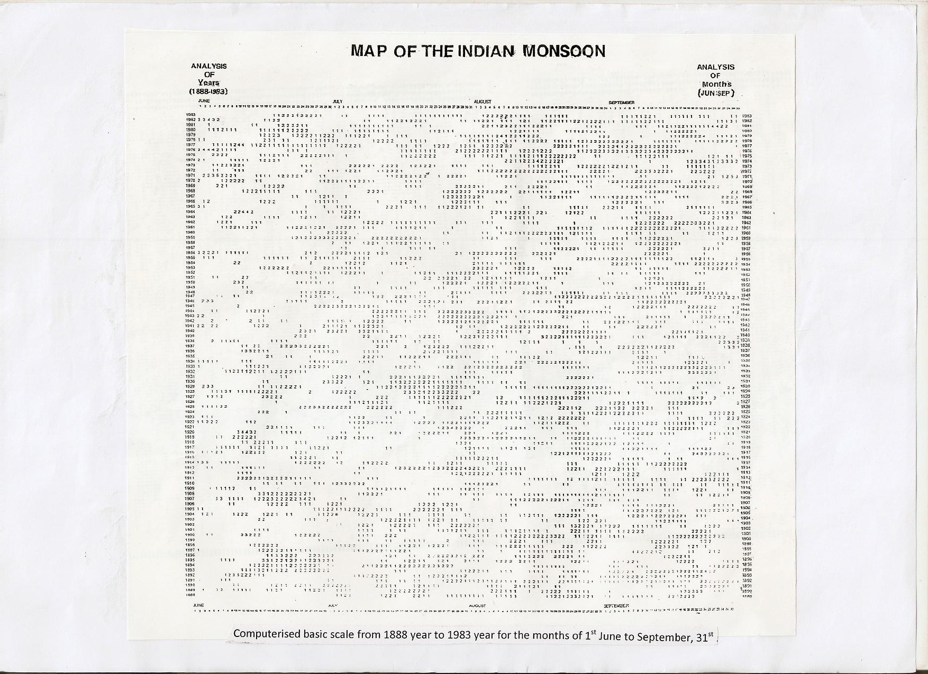

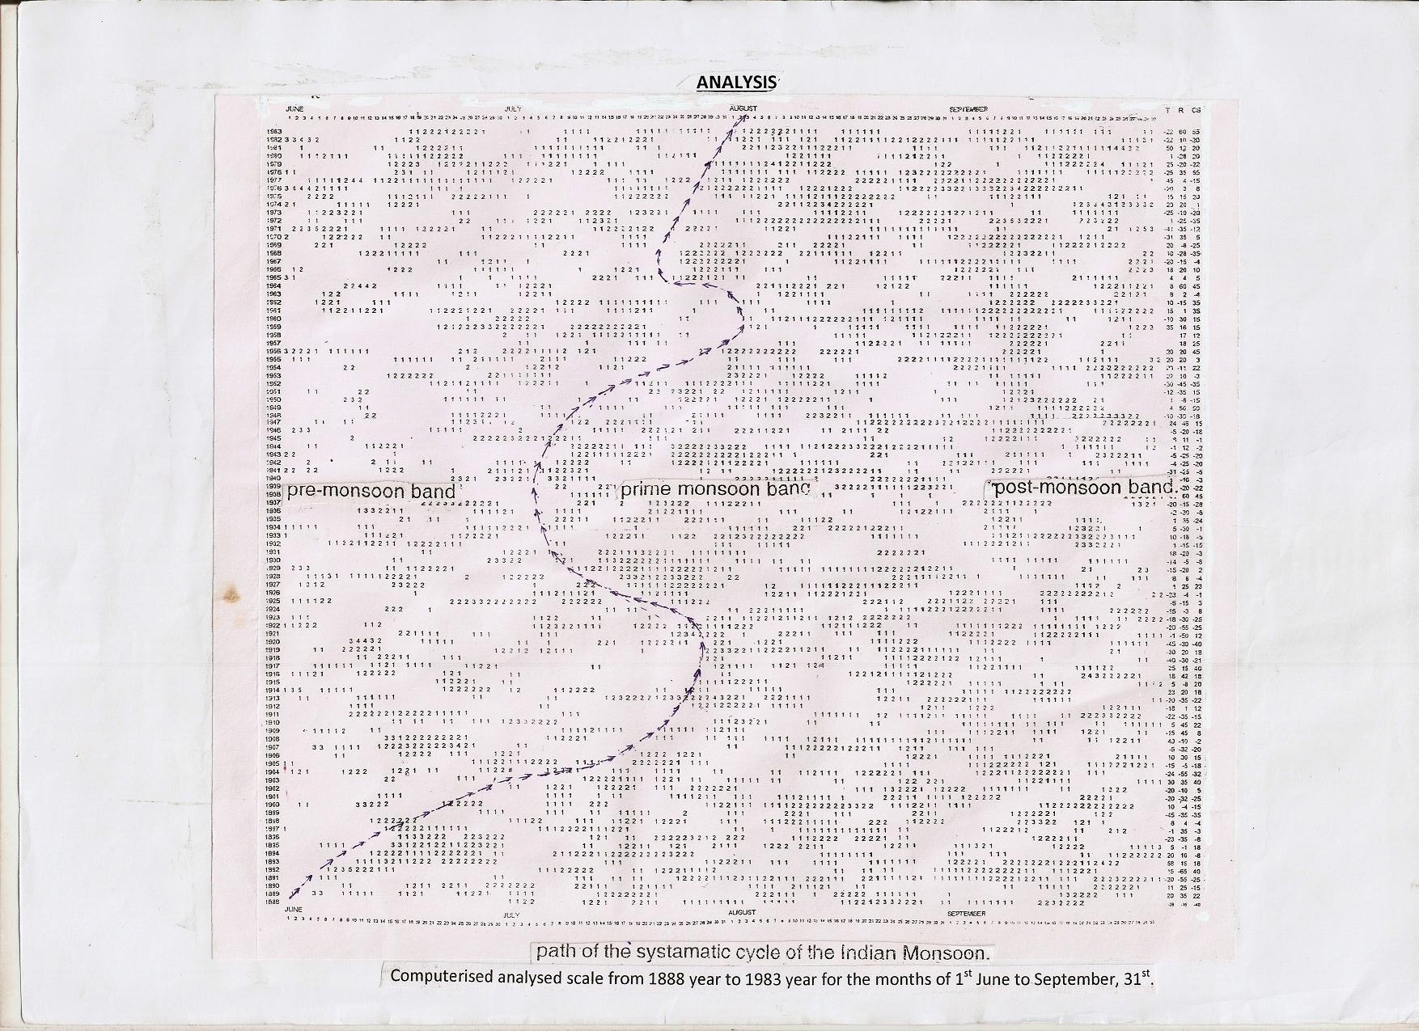

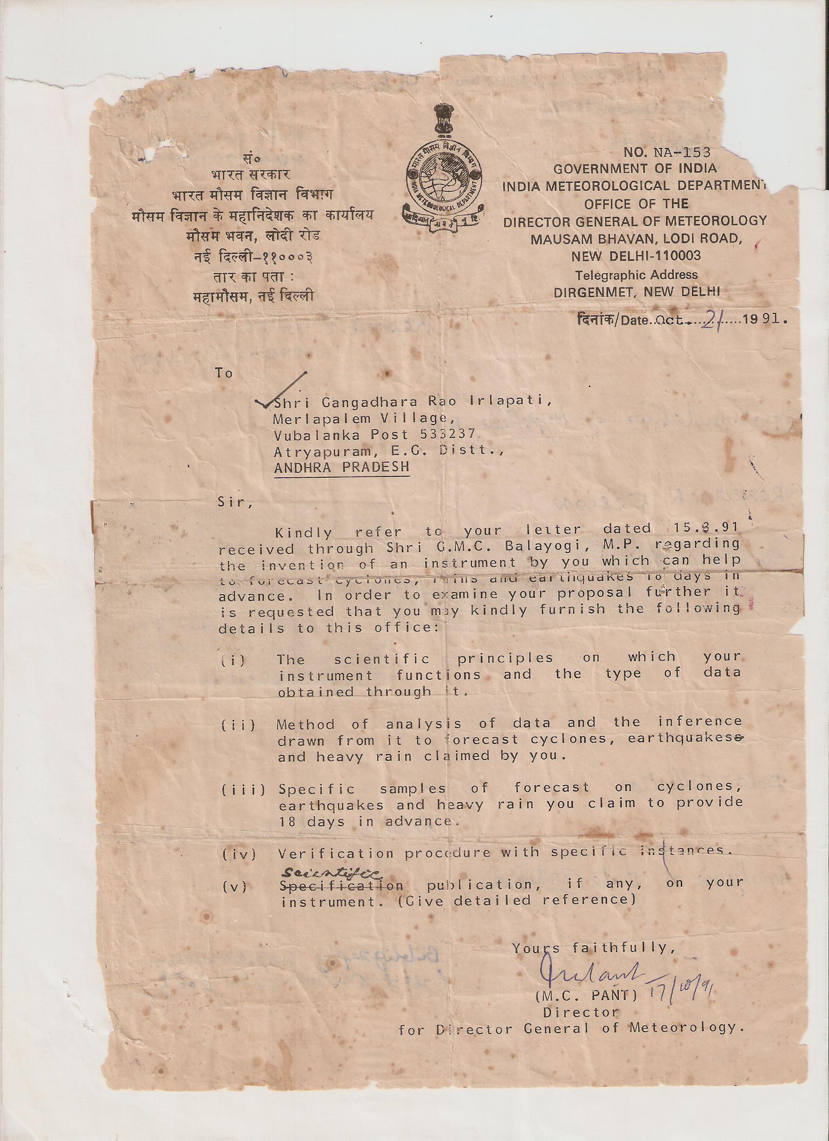
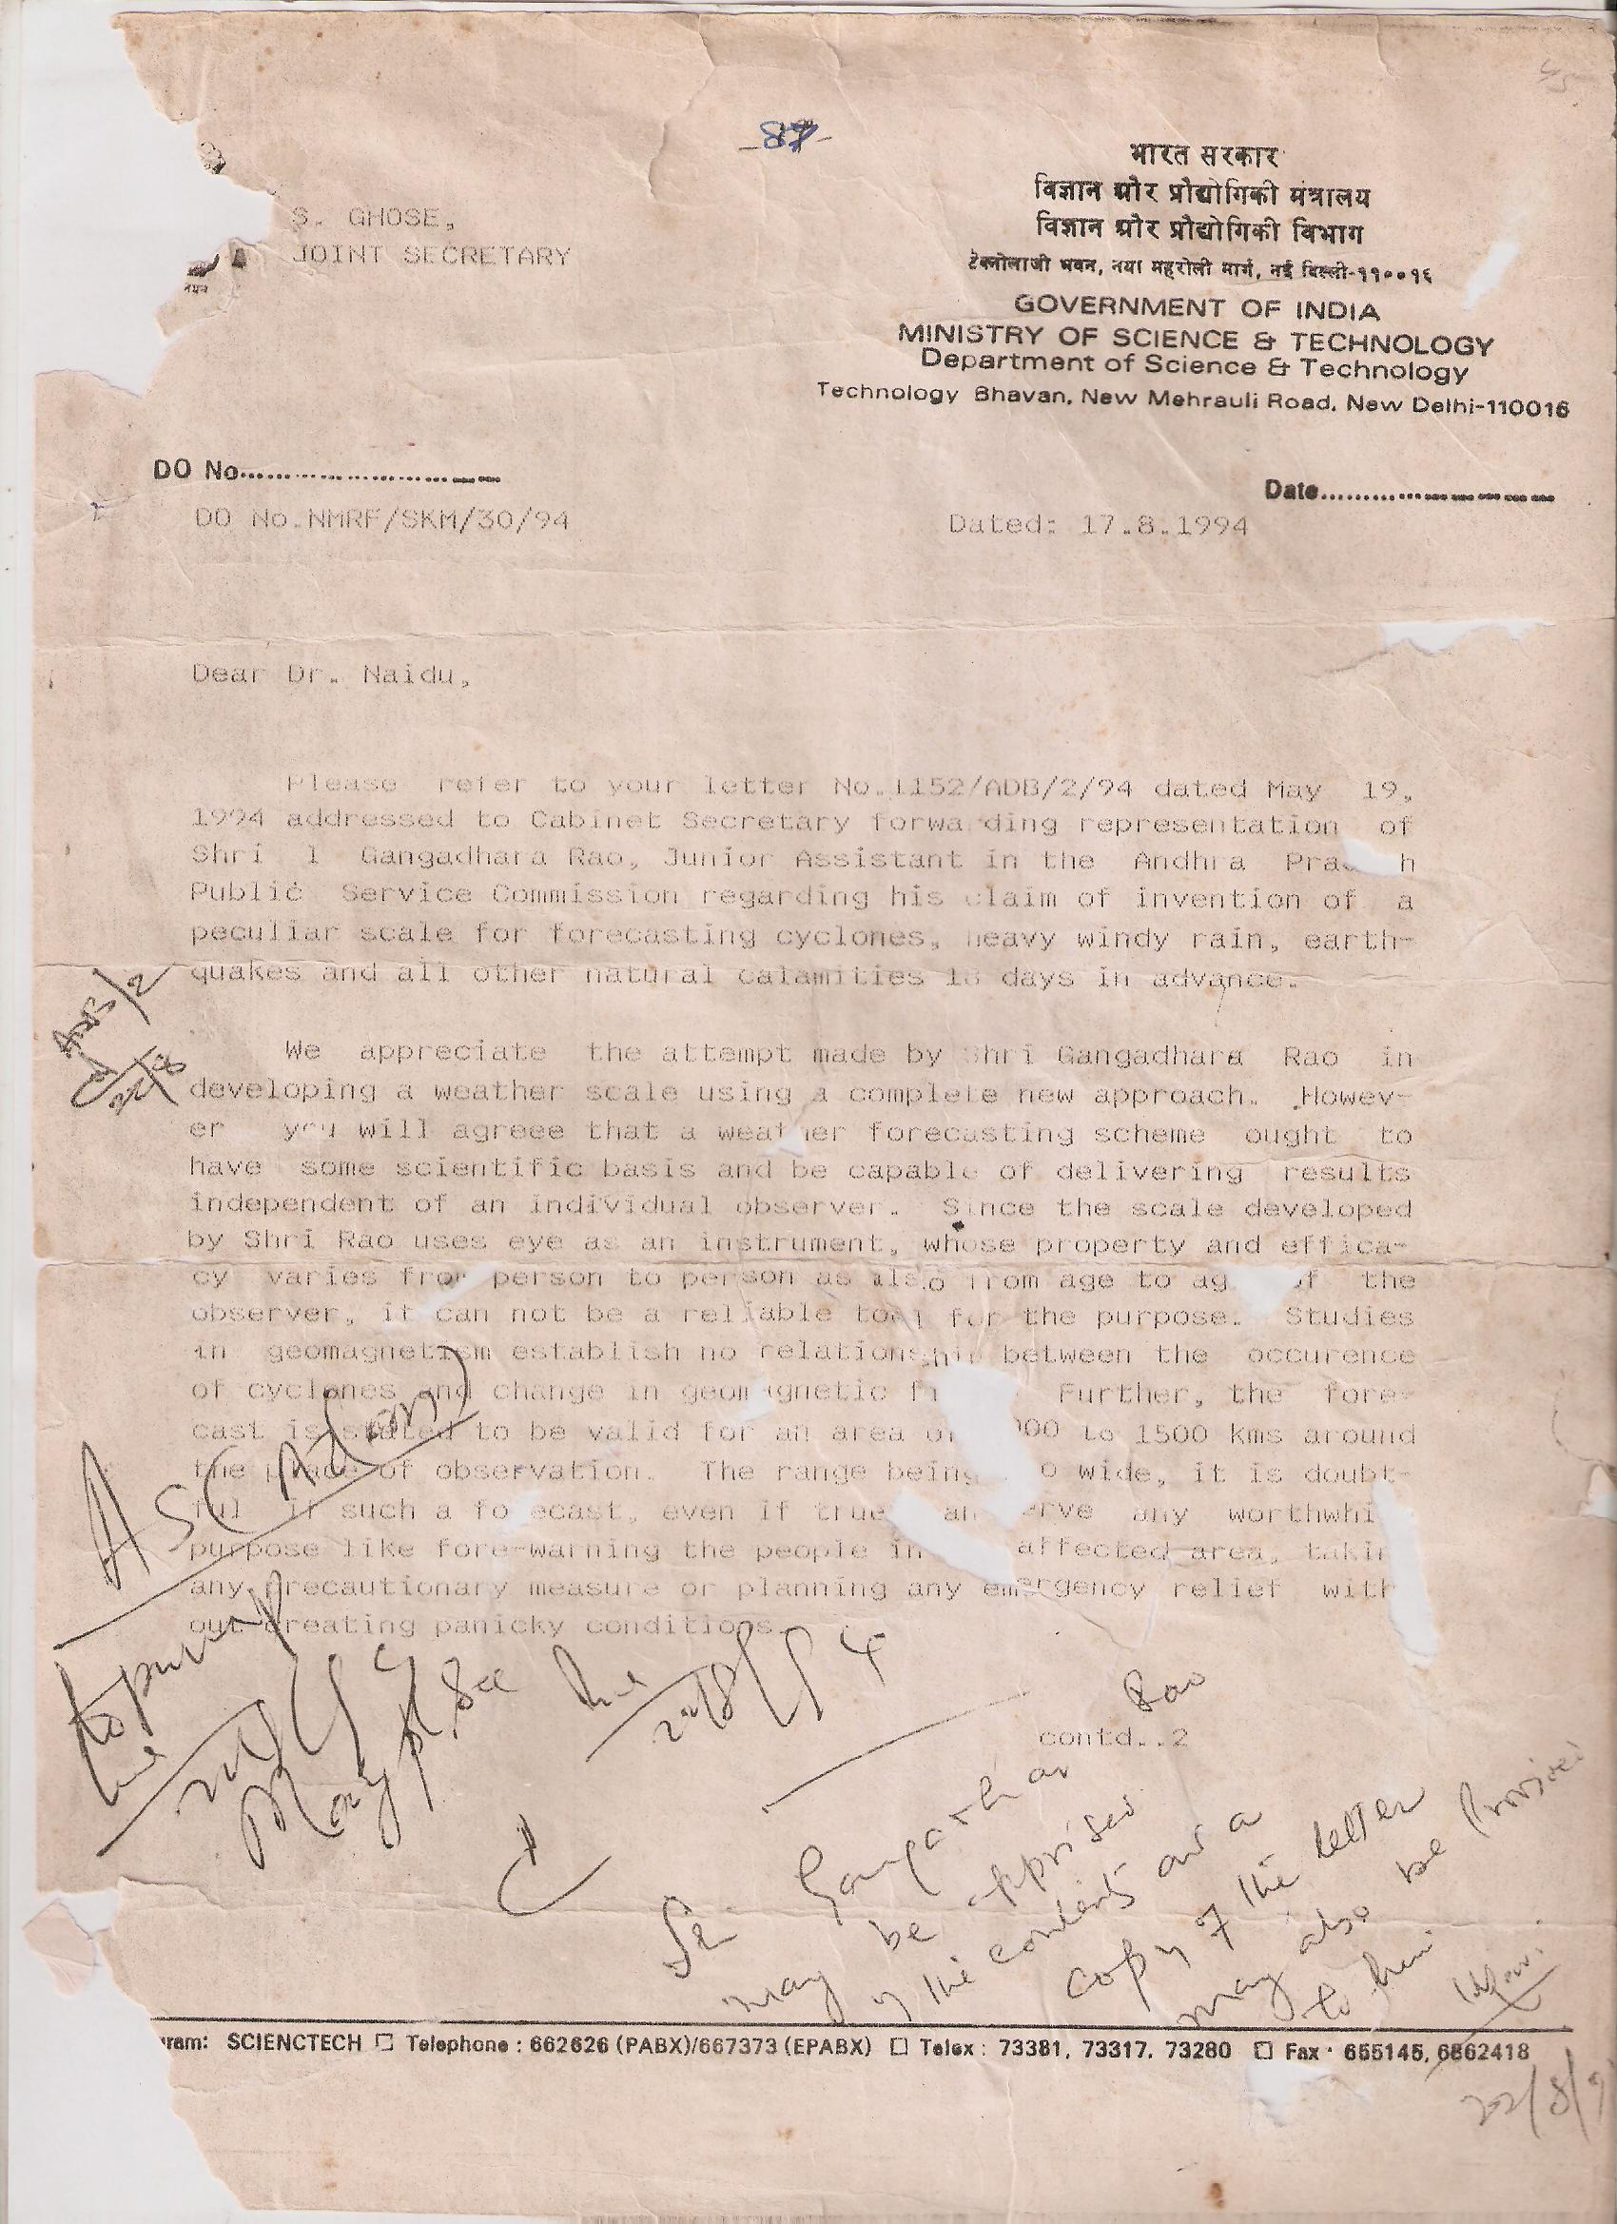
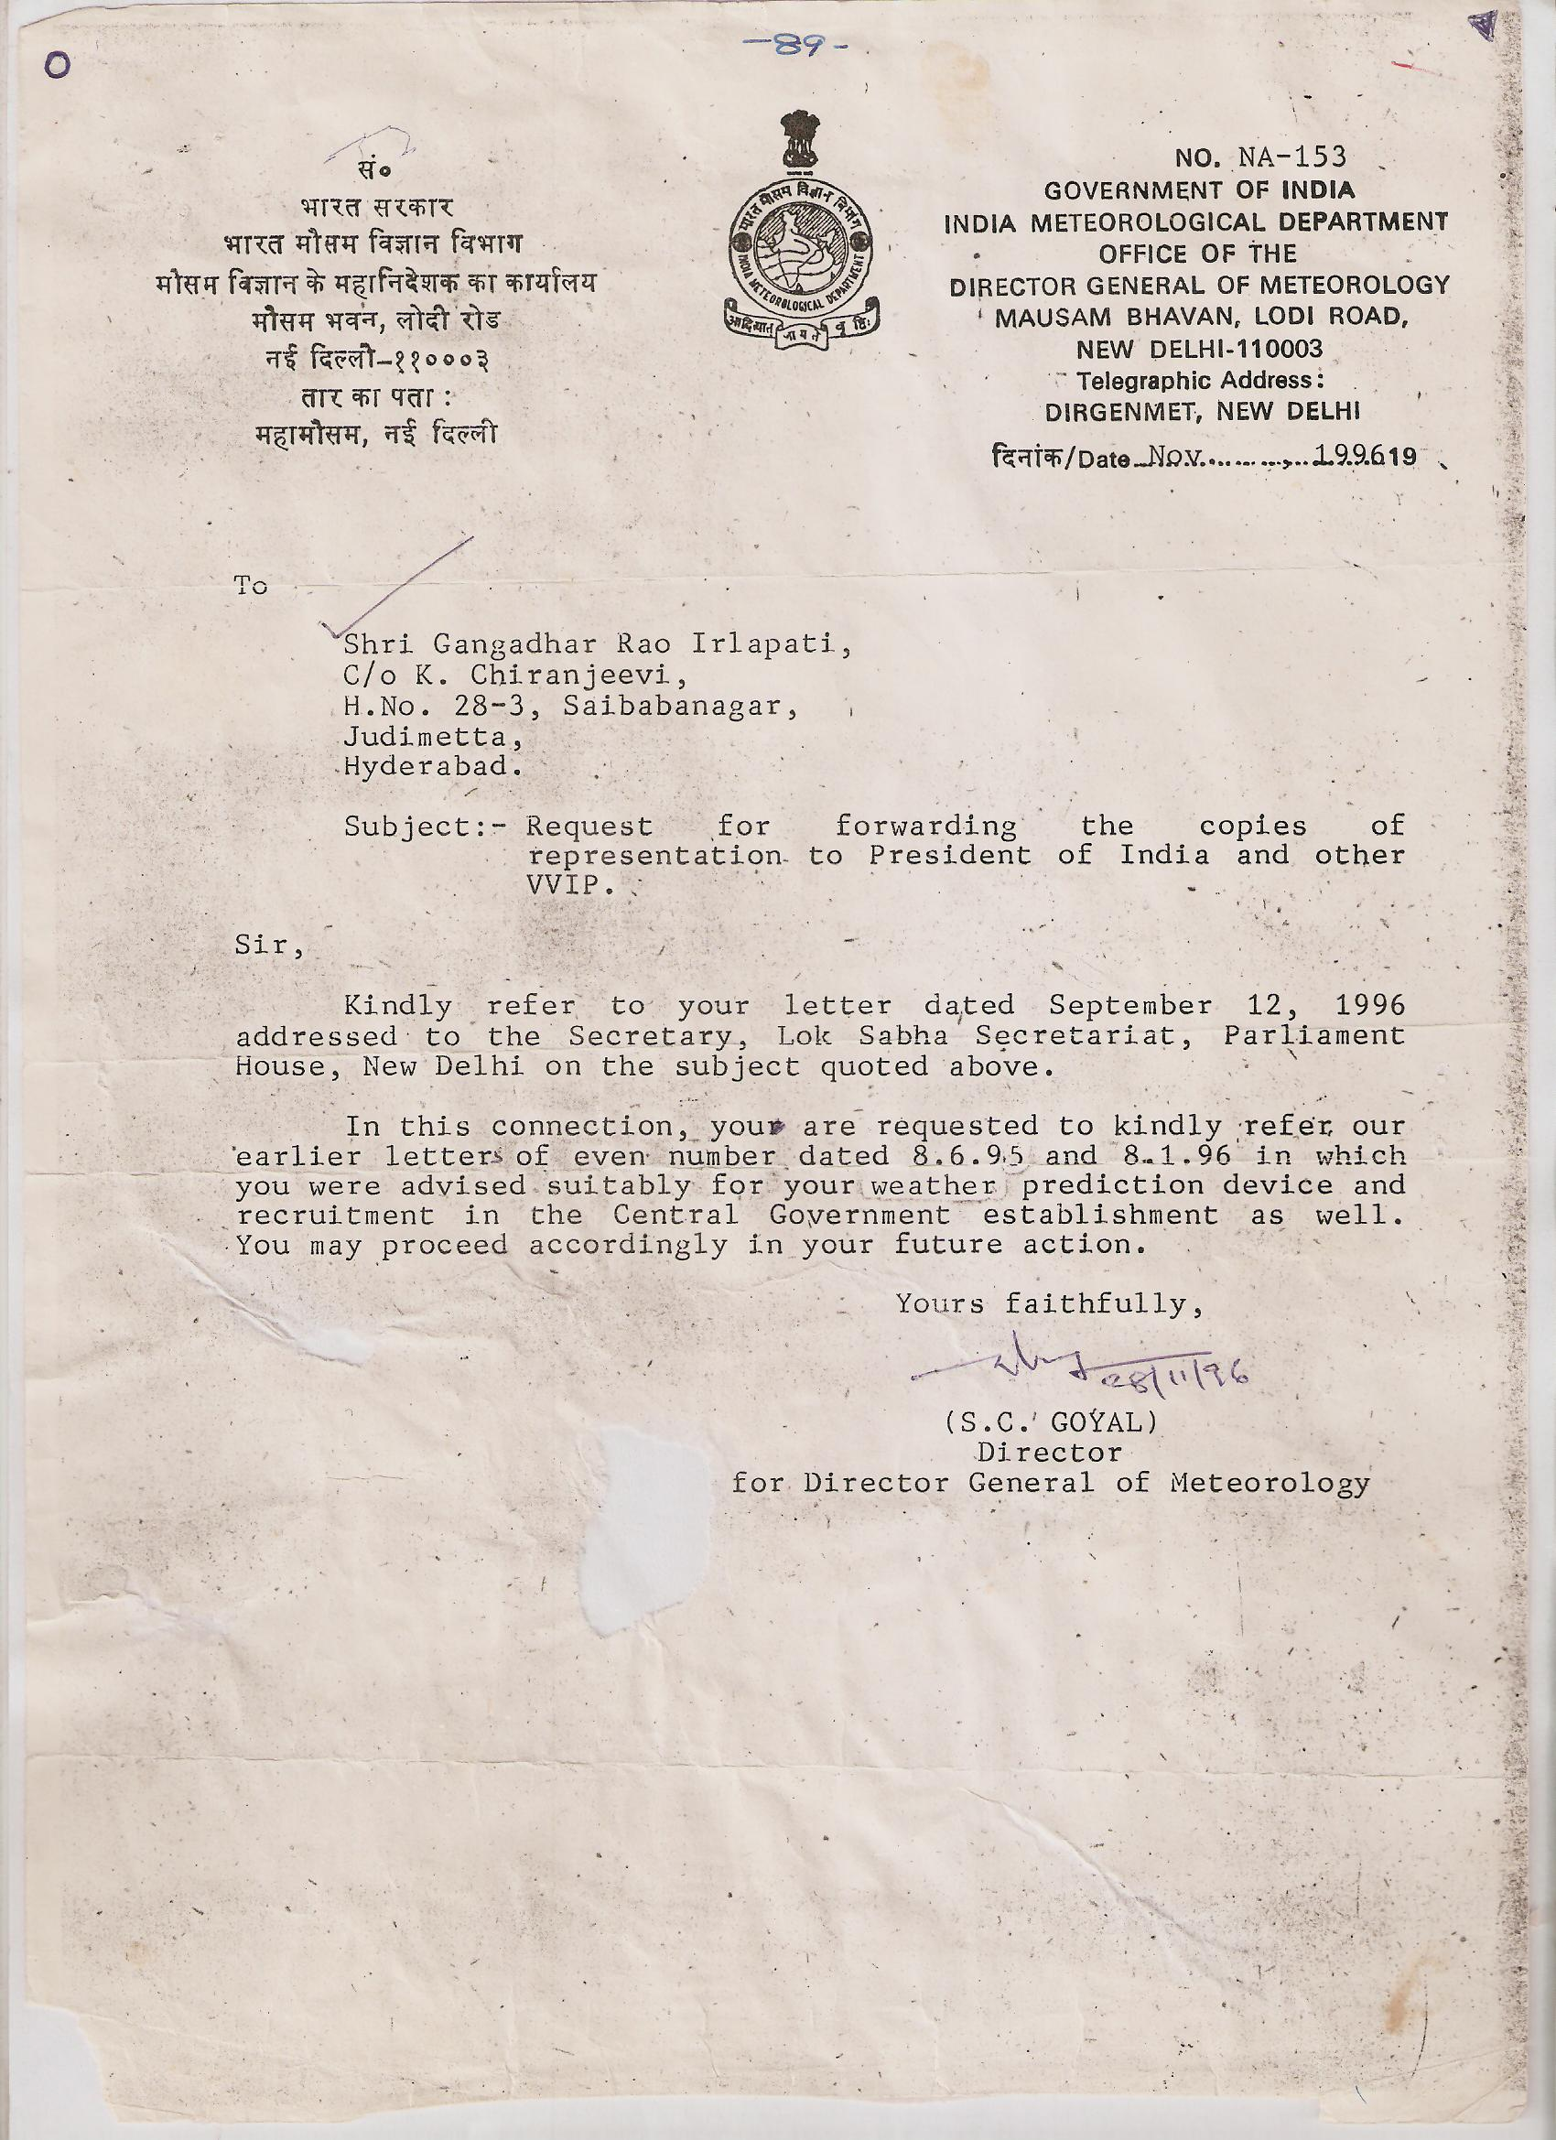
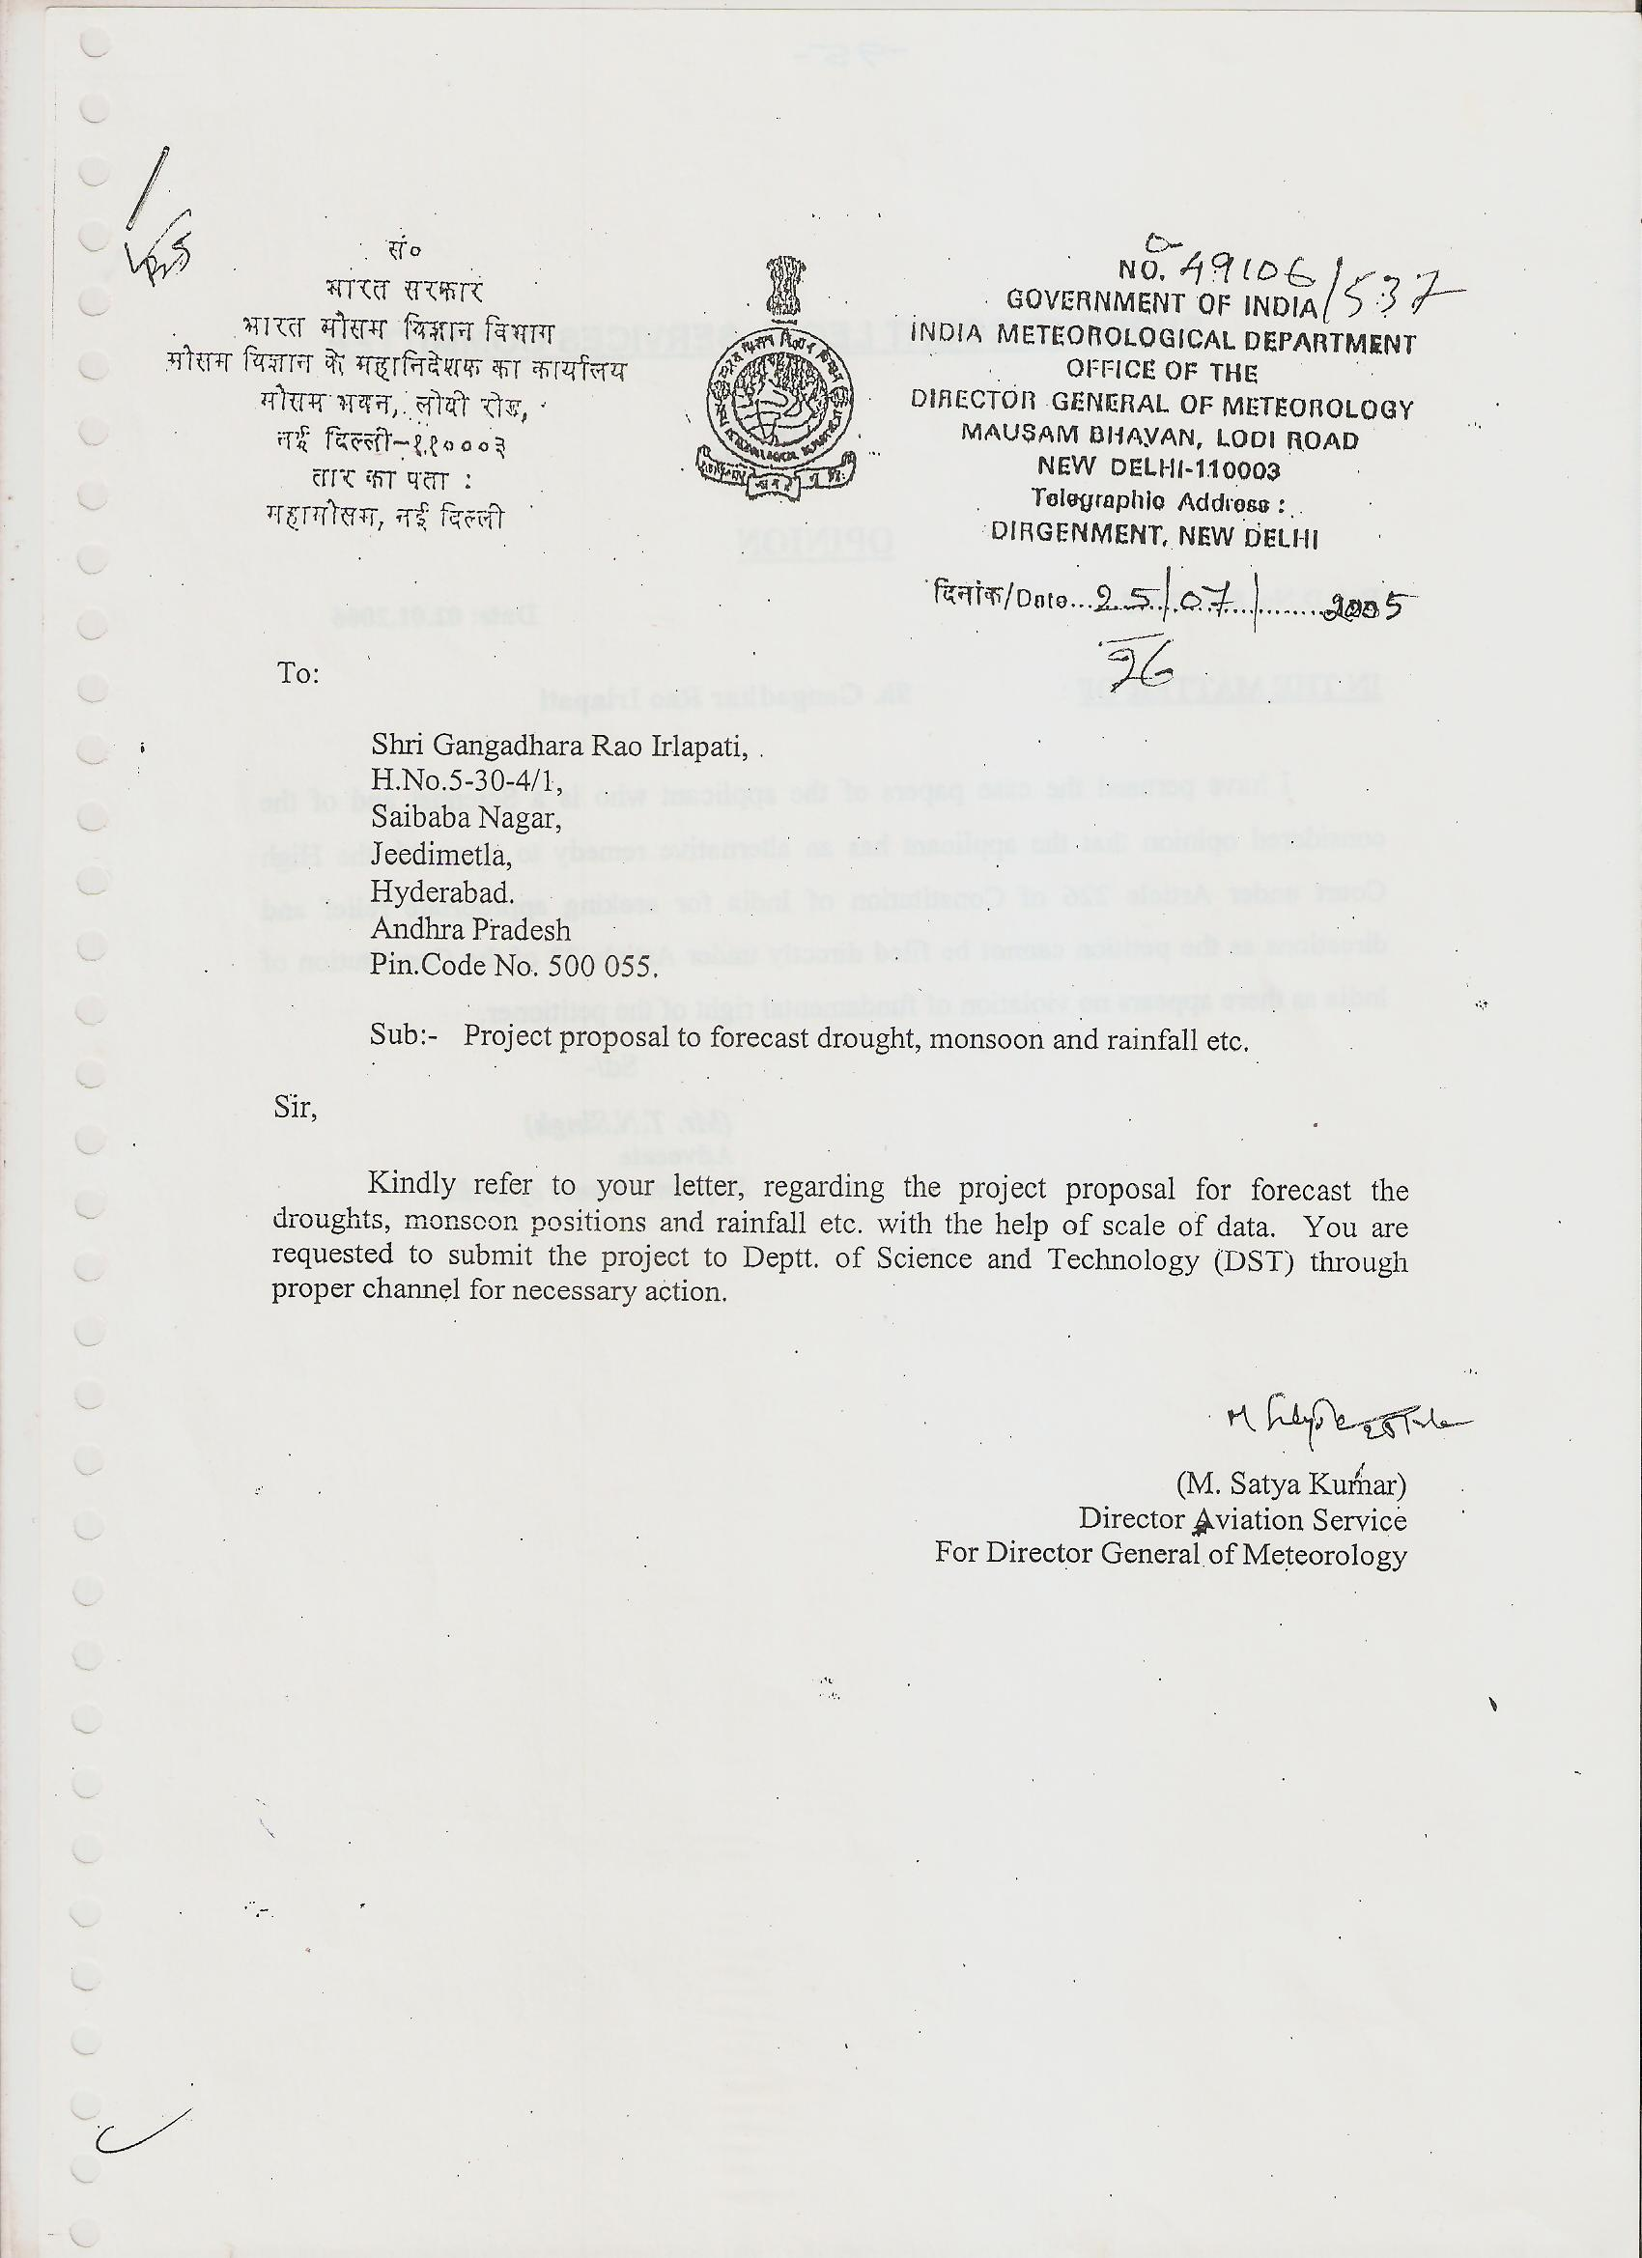
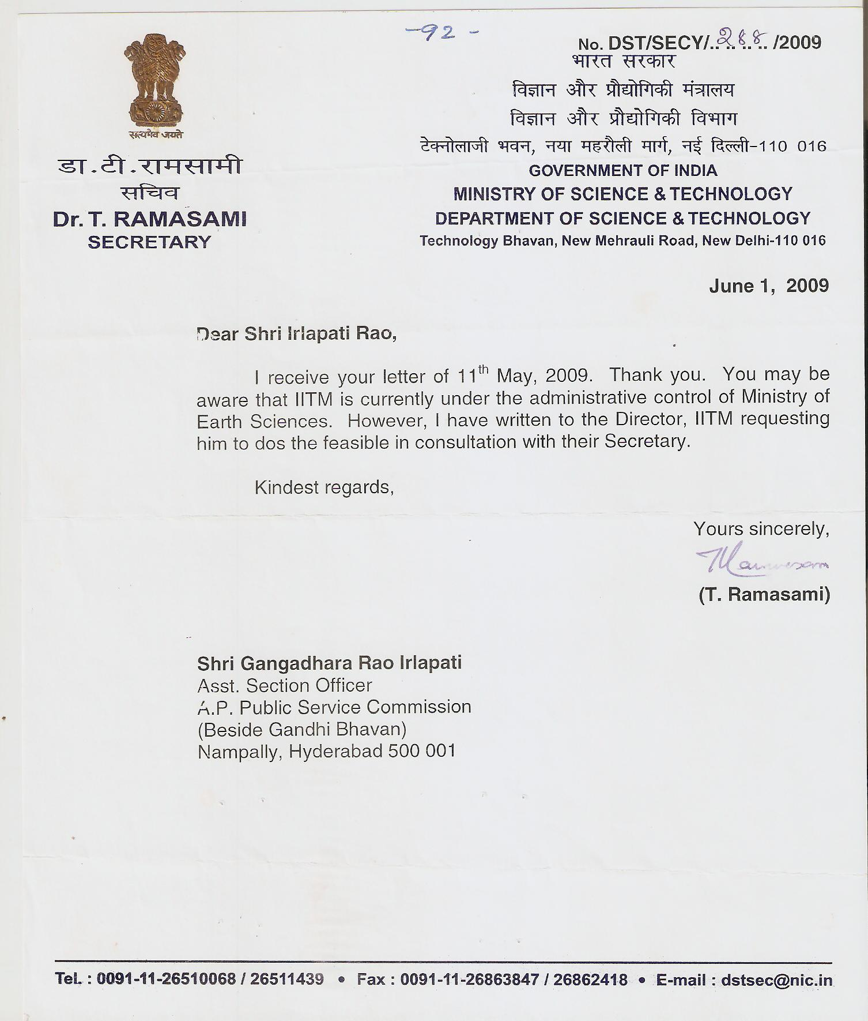

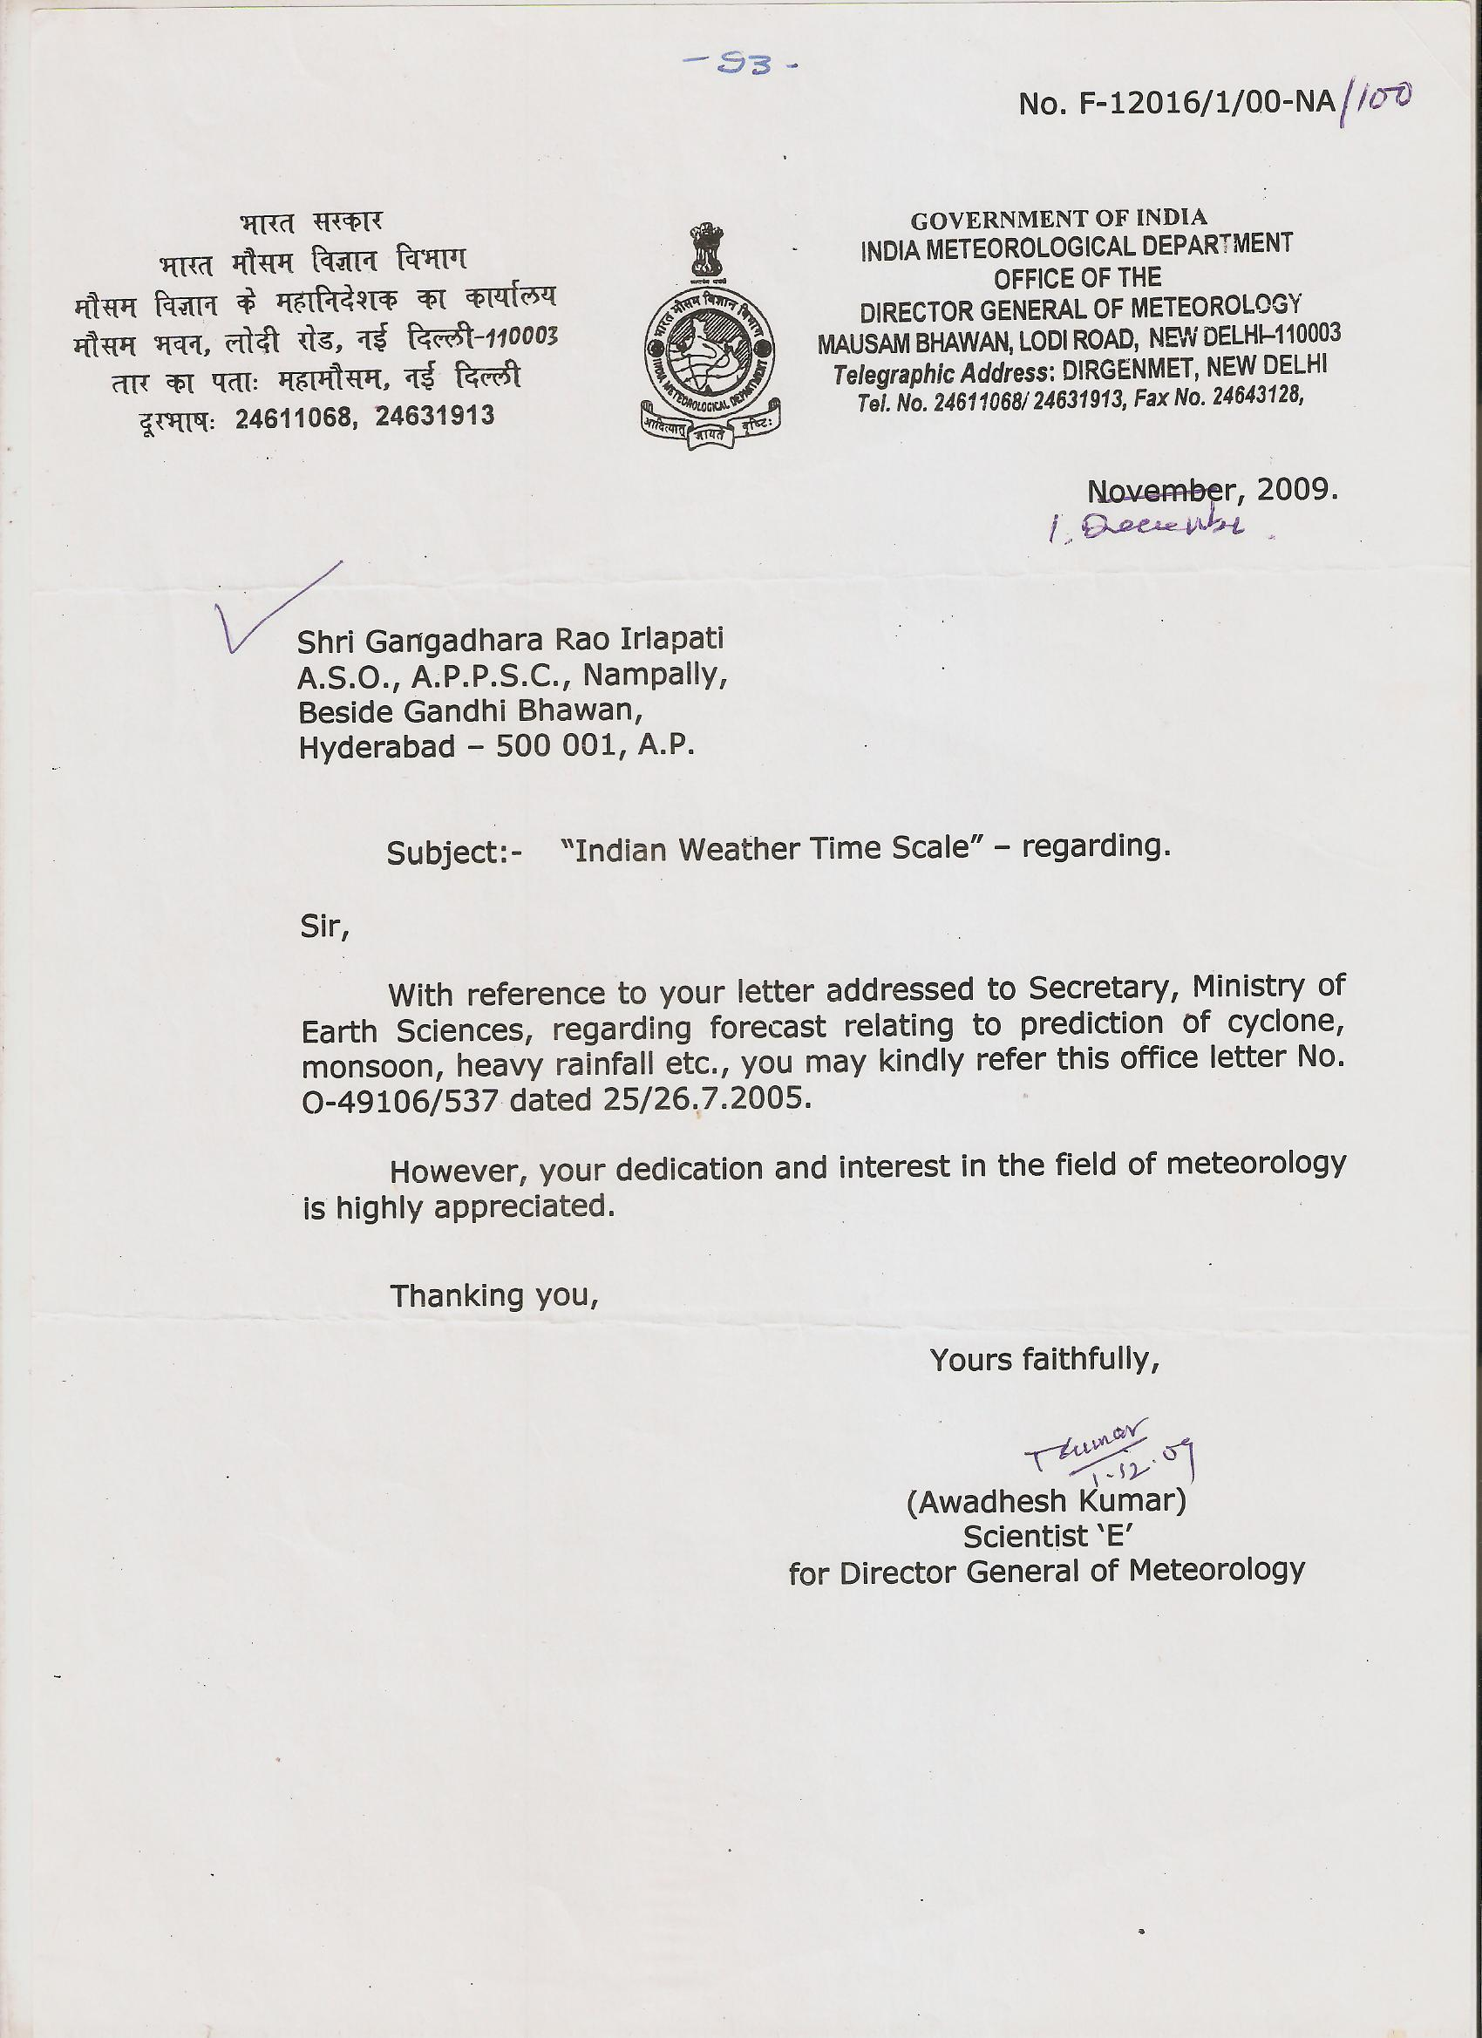

Analysis Of Data Of Bio Forecast

Date of Experiment | Number of Biolumicells | Actual Weather
1-May-1991 | 8
2-May-1991 | 14
3-May-1991 | 19
4-May-1991 | 20
5-May-1991 | 28
6-May-1991 | 22
7-May-1991 | 50
8-May-1991 | 65
9-May-1991 | 83
10-May-1991 | 89
11-May-1991 | 72
12-May-1991 | 40
13-May-1991 | 30
14-May-1991 | 14
15-May-1991 | 11
16-May-1991 | 6
17-May-1991 | 12
18-May-1991 | 3
19-May-1991 | 10
20-May-1991 | 8
21-May-1991 | 16
22-May-1991 | 9
23-May-1991 | 12
24-May-1991 | 5
25-May-1991 | 6 | Low
26-May-1991 | 10 | Low
27-May-1991 | 19 | Depression
28-May-1991 | 8 | Cyclone
29-May-1991 | 3 | Cyclone
30-May-1991 | 11 | Depression
31-May-1991 | 9 | Depression

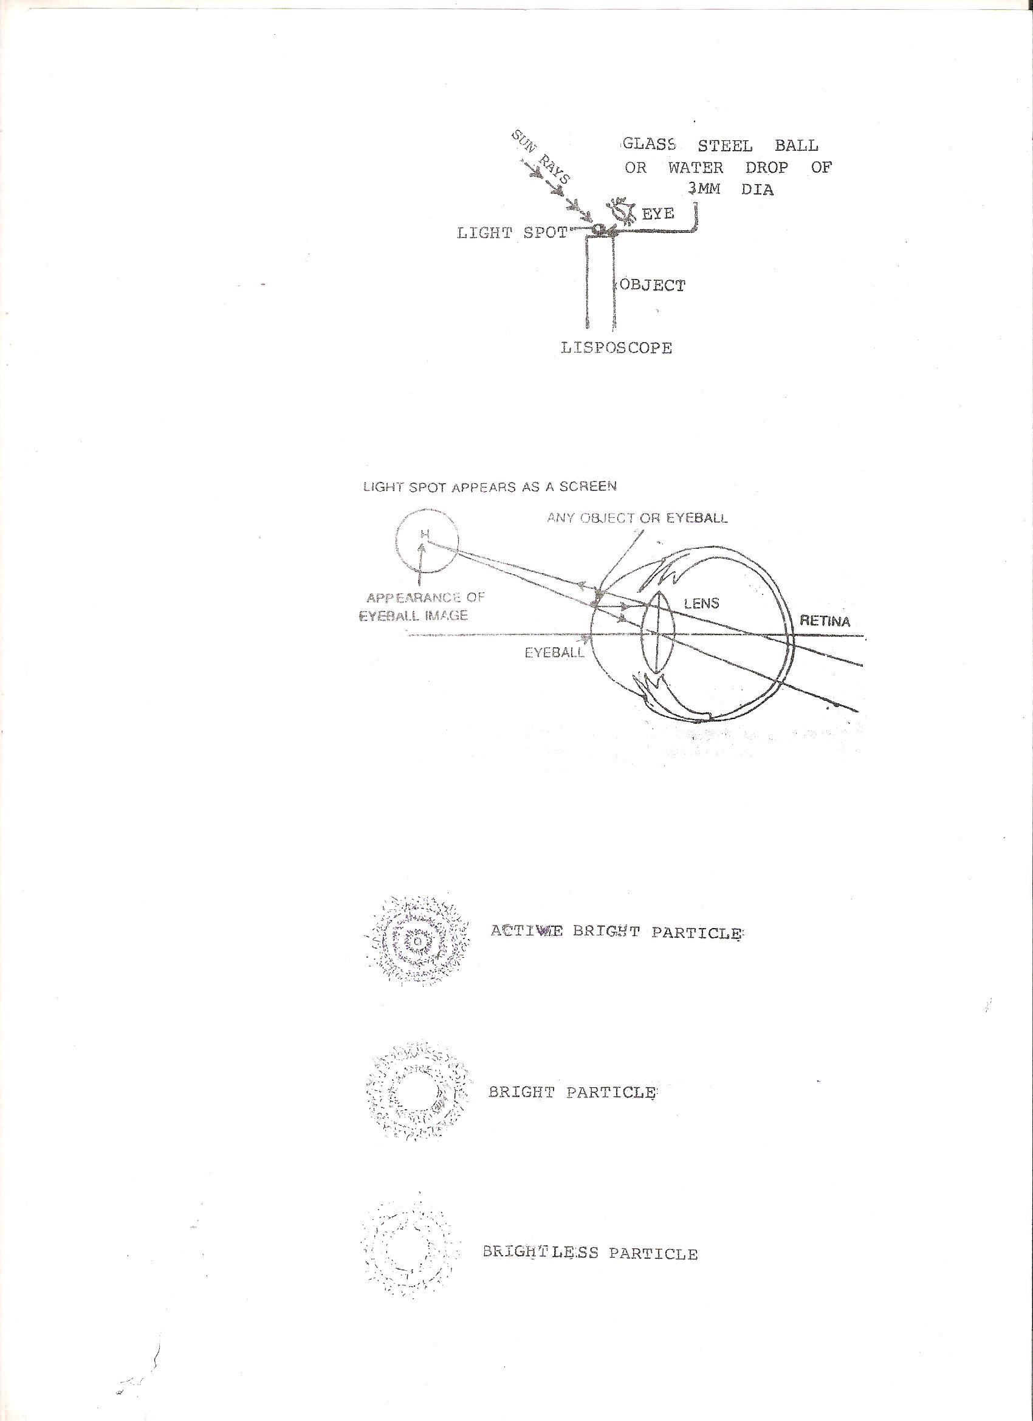
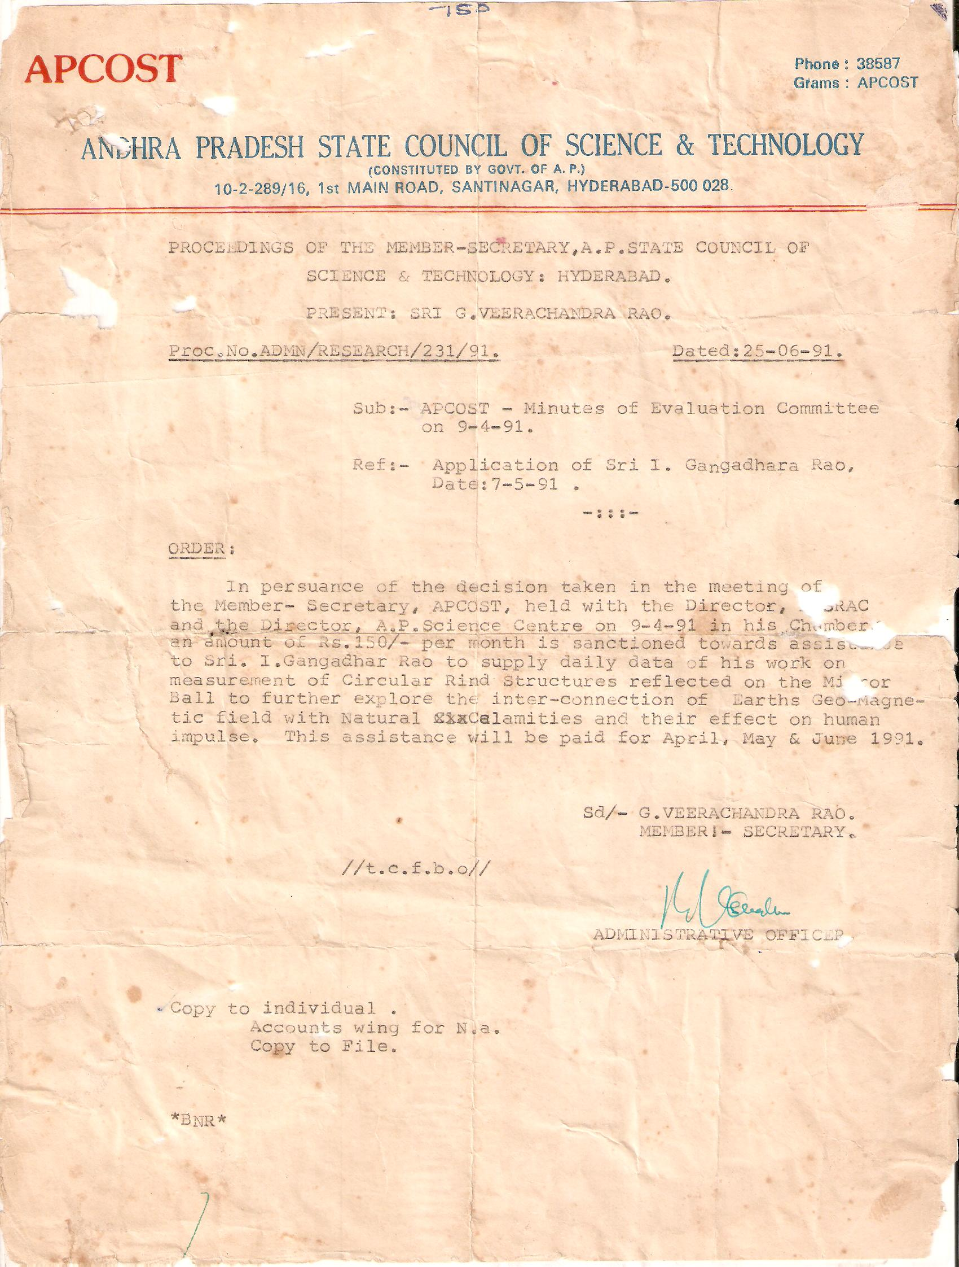

9/1/2016

