Results Of Research On Astroclimatology

Gangadhara Rao Irlapati

H.No.5-30-4/1, Saibaba Nagar, Jeedimetla, Hyderabad – 500 055, Telangana State, INDIA
Email ID: scientistgangadhar@gmail.com

Abstract: Astroclimate is the part of climate of place that is a result of solar radiation. I have conducted many researches in the field of Astroclimatology and invented some related discoveries & inventions which may also be useful in understanding the extent of the use of Astroclimatology.
[Gangadhara Rao Irlapati. Results Of Research On Astroclimatology. Researcher 2016;8(1s):213-241]. ISSN 1553-9865 (print); ISSN 2163-8950 (online). http://www.sciencepub.net/researcher. 9. doi:10.7537/marsrsj0801s16.09.

Key Words: A new Hypothetical Model of Cosmology, Universe.

Introduction: I have conducted many studies on the origin, nature structure and evolution of the universe during the 1970-77 and proposed a new Hypothetical model of cosmology with hundreds or postulations. In 1977, a book was published in the name of IRLAPATISM-IRLAPTATI THEORY OF UNIVERSE on the basis of the postulations of the hypothesis by the supporters. The postulations about the universe, existence of god, theory of evolution etc in the book were exposed to the anger of fanatic people and I got into a violent altercation about these postulations of the hypothesis. As a result I was subjected to the suppressions and persecutions. I reported these suppressions and torments to the revenue divisional officer. Amalapuram on 6-7-1977 the revenue divisional officer was conducted an enquiry about this matter on forenoon, July 21st, 1977 while returning from the enquiry, I was attacked by a mob and they had taken me to the village chavadi. Followed by an altercation with tortures about the theory, they beaten and f forced me to put signatures on some false documents, and an offence falsely framed and foisted against me. After that I was sent to the taluk magistrate, kothapeta for another trial with the investigation of the superstitions, the taluk magistrate was declared me as a dangerous boy and up to anything and issued sentence to punish me and handed over to the police station, ravulapalem. The police was arrested me on July 21, 1977 registered a case and sent to remand, I was kept imprisoned some months in subjail and remaining period interrogated periodically by panatics and officers. The trials were done between April 2, 1979 to November 20,1979 after trials, the Honble Additional Judicial First Class Magistrate court was found me not guilty and acquitted on November 27,1979.
A New Hypothetical Model Of Cosmology: The cosmos is made up of universes in infinite number, having similar structure and properties, embedded one in each other and extended in ascending and descending order. To explain and justify this model, there are three universes so far known to us (a) Geo-Universe (b) Atomic-Universe (c) Energy-Universe. These three are having similar structure and properties, embedded one in each other and extended in ascending and descending order. Of these three, we known some extent about the internal structure and properties of the Geo-Universe but we do not known its external structure. We know some extent about the external structure and properties of the Energy-Universe but we do not know its internal structure. Between of these three universes, we came to know a large extent about the internal & un external structure and properties of the Atomic-Universe. Hence, I have taken the similarities of external structure & properties between the Geo-Universe & Atomic-Universe to propose that all the universes in ascending and descending order of the creation are having similar internal structure and properties. The similarities of external structure & properties between the Atomic Universe and Energy-Universe are taken to propose that all the universe in ascending and descending order of creation are having similar external structure and properties. And the manner in which of these three universes i.e., embedded one in each other, extended in ascending and descending order to propose that all the universes in ascending and descending order of the creation are embedded one in each other and extended in ascending and descending order.
Similar External Structure & Properties
According to the model, all the universes in ascending and descending order of the creation are having similar external structure and properties. To justify this, I have taken many similarities between the atom and photon.
For example:

Atomic-Universe Energy-Universe
1) The atom appearing in several forms such as 1) The particle “Photon” related to
Hydrogen to uranium etc., being due to the energy appearing in several forms such
Internal structure having different atomic particles as radio waves, gamma rays, violet rays
at various numbers. etc being may be probably due to the
internal structure having different
particles at various numbers.
2)The atom exhibiting several physical and chemical 2)The particle “photon” related to energy
Properties such as weight, colour, taste, hardness exhibiting properties such as wave length,
etc being due to the internal structure having different colour, temperature etc being may be
particles at various number. Probably due to the internal structure
having different particles at various
number.

Similar Internal Structure & Properties:
According to the model, all the universes in ascending and descending order of the creation are having similar internal structure and properties. To explain and justify this, I have taken many similarities between the atomic-universe and Geo-Universe.

Atomic-Universe Geo-Universe
1)Various atomic particles at different sizes in 1) Various astronomical objects at different
several numbers are present in the atom. sizes in several numbers are present in the
Geo- Universe.
2) These atomic particles having three types of 2) These astronomical objects having three
charges at negative, positive and neutral states type of charges at positive, negative and
are present in the atom. neutral states are present in the
Geo-Universe
3) Positively charged protons are present in the nucleus. 3) Stars built by atoms having positive
charged nucleus are present in centre of
the Geo-Universe
4) Neutrons at neutral state are present in the Nucleus. 4) Planets at neutral state are present in
Centre of the Geo-Universe.
5) Negatively charged electrons are present at large 5) There is a concept that anti-matter cosmic
distance of the atomic nucleus in the atom. bodies built by atoms having negatively
charged nucleus are present at large
distance of the Geo-Universe.
6) Additional neutrons called isotopes are present. 6) Additional planets called satellites around
the planets are present.
7) Radiation emitting from the atom. 7) Cosmic rays emitting from the Geo-
Universe.
8) There is a property of nuclear fission is in the atom. 8) There is a property of super Nova is in the Geo- Universe.

Descending Order Of Creation: The Geo-Universe that means the Universe seen around our earth is having magnificent structure and properties such as galaxies, stars and planets and some planets such as earth having continents, countries, oceans, trees, animals. Cyclones, human beings etc. Such Geo-Universe being built by Universes of its descending order of creation that means atoms.
Atomic-Universe that means the atom present in several forms from hydrogen to uranium etc is another universe having magnificent structure and properties such as electrons, protons, neutrons, etc., and continents, countries, oceans, cyclones, trees, animals, human beings may be present on some neutrons having suitable conditions exactly similar to the earth planet resembling to the Geo-Universe. Such atomic Universe being built by universes of its descending order of creation that means energy particle ‘photons”.
The Energy-Universe that means the particle “photon” related to energy present in several forms of electromagnetic radiation is also another universe having magnificent structure and properties resembling to Geo-Universe and atom. Such Energy-Universe may also being built by Universes of its descending order of creation that is not yet known to us.
Thus the descending order of creation continuous infinitely.
Ascending Order Of Creation: The Energy-universe that means the particle related to energy “photon” having magnificent structure and properties is being as a primary syntactic unit in the universe of its ascending order of creation that means atom. All components in the atom are built by these “photons” in infinite number. Such each and every energy particle “photon” is basis to an infinite descending order of creation.
The Atomic—Universe that means the “Atom” having magnificent structure and properties is being as a primary syntactic unit in the universe of its ascending order of creation that means in our Geo-Universe. All components in the Geo-Universe such as stars, planets etc., are built by these atoms in infinite number. Such each and every atom is basis to an infinite descending order of creation.
The Geo-Universe that means the “Universe” seen around our earth having magnificent structure and properties is being as a primary syntactic unit in the universe of its ascending order of creation that is not yet known to us. All components in that Universe are built by these Geo-Universes in infinite number. Such each and every Geo-Universe in that ascending creation is basis to an infinite descending order of creation.
Thus the ascending order of creation continuous infinite.
Cosmic-Environments:The fill of structure and characteristics in the universe of the cosmos proposed as Cosmic Environments. For example the fill of structure and characteristics like galaxies, stars, planets etc in the Geo-Universe proposed as Geo-Environment, the fill of structure and characteristics like proton, neutrons and electrons etc in the Atomic-Universe proposed as Atomic-Environment and the fill of structure and characteristics in the Energy-Universe that means in the photon that is not yet known proposed As Energy-Environment.
Space Weather:The fill of structure and characteristics like galaxies, Stars, Planets and their orbits and other physical forces etc that surrounds in the universe proposed as Space Atmosphere, the state of galaxies, stars, planets, nebulas. Pulsars etc at a particular region over a long period of time proposed as Space-Climate, the state of characteristics of space- climate like solar wind flares, asteroids etc at a particular region during a short period of time proposed as Space-Weather.
Space Regions: The state of space atmosphere being in still proposed as “Inactive Space Region”, the state of space atmosphere being in active proposed as “Active Space Region” The region of space atmosphere in which the celestial bodies are more widespread areas proposed as “Space High Pressure Area” the less widespread areas proposed as “ Space Low Pressure Area”.
Space Low Pressure Systems: Some space times happens variation of differences of pressure in the space-climate, At such a juncture, the celestial bodies and other space dust present in the space high pressure area will try to occupy the space low pressure area all at once. In this attempt, they will whirl around the space low pressure. The centre of space low pressure area itself is the black-hole and the circular whirling celestial bodies & other space dust etc caused by the space low pressure area proposed as Galaxy.
Studies Carried Out: many studies were carried out on this Hypothesis and it was successfully proved out in the studies.
Indian Weather Time Scale: I have conducted many extensive researches on the astronomical forces and its effects on the earth climate particularly on various regions of the India. The variations in the solar cycle affects and stimulate the earth climate. The moon affects and stimulate the ocean tides and atmosphere too. The movement of axis of the earth inclined at 23 ½ degrees from vertical to its path around the sun affects and stimulate the earth weather and leads to formation of monsoons and seasons etc. So the astronomical forces affect and stimulate the earth climate it may be more or less but it is true. These scales may be taken as a part of scientific study of astronomical forces & its effects on the earth climate.
In the time and scale of the universe some things from astronomy to atom including living beings have been repeating once in every certain time or period. For example, the south and north magnetic poles have been shifting in every certain period. The sun spots have been repeating once in every eleven years. The lunar and solar eclipses have also been occurring once in every 18.6 years. The seasons such as winter, autumn etc. also have been repeating once in every year in the same month of the year. The periodical menses in the females repeating once in every month.
On the basis of the said universal facts, I have prepared a time scale with 21 blocks, each block containing certain prescribed cycle of years in which similar calendar years repeating one after another that leads similar weather conditions of those previous years to future years likely repeating every year approximately. The rainfall of the years, have been entering in the scale in percentages or as it is pertaining to month, season, annual wise of the each and every year. If we managing the scale in this manner continuously, we may assuming the weather conditions of the anterior years on the basis of the posteriors years weather. On the basis of the principle, we can assume that a considerable, of course it may be little chance of predication for an ensuing years by study the data of earlier years.
I have prepared a model Indian weather time scale along with hundreds of additional scales (1617 scales, 12 months, 4 seasons, 50 regions & 150 above years were studied) in which all weather conditions such as rainfall, temperature, cyclones, river water etc of all homogeneous regions sub-divisions of India were studied and analyzed elaborately.
Studies Carried Out :
Firstly, see the Indian weather forecasting study model time scale. In this scale, the June, July, August and September months of the summer monsoon season were taken in a table in which the each month is also divided into three parts the Telangana, Rayalaseema and Coastal Andhra regions. The monthly wise rainfall data of the months of the regions from 1870 to till available years are taken in the form of percentages or as it is and entering in the scale pertaining to the region wise of the each and every year. If we managing the scale in this manner continuously, we may assuming the weather conditions of the anterior years on the basis of the posterior years weather.
Example for assuming the dry season or suppose to predict the rainfall situation in the summer season of the ensuing year 2019: study the 7th cycle in which wet conditions in 10 years and dry conditions in 14 years were occurred in the month of June : wet conditions in 2 years and dry conditions in 22 years were occurred in the month of July : wet conditions in 4 years and dry conditions in 20 years were occurred in the month of August and wet conditions in 8 years and dry conditions in 16 years were occurred in the month of September. On the whole, wet conditions in 24 times and dry conditions in 72 times repeated in the summer monsoon season of the 7th cycle (As a result, there were dry conditions occurred in the 2002 year also). Therefore it is a considerable chance to predict that a dry season will be repeated in the ensuing year of 2019.
Example for assuming the wet season or suppose to predict the rainfall situation in the summer season of the ensuing year 2022: study the 10th cycle in which wet conditions in 13 years and dry conditions in 8 years were occurred in the month of June: wet conditions in 13 years and dry conditions in 8 years were occurred in the month of July: wet conditions in 9 years and dry conditions in 12 years were occurred in the month of August and wet conditions in 19 years and dry conditions in 2 years were occurred in the month of September. On the whole, wet conditions in 54 times and dry conditions 30 times were repeated in the summer monsoon season of the 10th cycle. As a result, there were wet conditions occurred in the 2005 years also. Therefore, it is a considerable chance to predict that a wet season will be occurred in the ensuing year of 2022.
In the same manner, we can study the remaining all Indian weather time scales of all Indian Homogeneous regions and subdivisions, states and districts of India.
We can make many more modifications thus bringing many more developments in the Indian weather time scale and its all additional Indian weather time scale.

References
- www/en-wikipedia.org/wiki/cyclic model.
- The Steinhardt-turok model.
- The Baun-frampton model.
- Loop quantum cosmology.
- En.wikipedia.org/wiki/multiverse.
- Heliocentric model.
- Geocentric model.
- Copernican model.
- Heliocentric model vs geocentric model.
- en.wikipedia.org/wiki/big bang theory.
- en.wkipedia.org/wiki/steadystate theory.
- www.astro.ucla.edu/-wright/steady stat.
- www.ncdc.noaa.gov/data-access/numerical-weather-prediction.
- En.wikipedia.org/wiki/numerical- weather- prediction.
- The history of numerical weather prediction –NOAA.
- Fundamentals of numerical weather prediction/ebooks.cambridge.org.
- Ken ring, the moon and lunar science predict weather.
- Moon predict weather lore / www.almanac.com/content/moon-lore-weather.
- Climate change, sunspots activity & lunar /cosmic cycles(www.the longerview.com.au/sunmoon-climate.html.
- Astrometeorology & agriculture by Robert nelson.
- Marvis. Dr. H. B. journal American (NY) 1 oct 1938.
- Goss, M. J. geophysical reviews, march 1953.
- Jevons. w. s. nature,14 nov 1878.
- Hove, JimTen, astrological journal 15(3)17-23.
- Luby, w. A. popular Astronomy dec 1940.
- Nelson. J. H. cosmic pattern, their influence on man and his communications 1974 American federation of astrologers.
- Nelson J. H, RCA review, April 1951.
- Nelson JH, J. geocosmic research, summer 1974.
- Meteorology astrology (Astrometeorology) lewis. james. R, march 2003, astrology book 2003, p453.
- www.physics for ums.com/threads/astro-meteorology.

Appendices: (Indian Weather Time Scale)

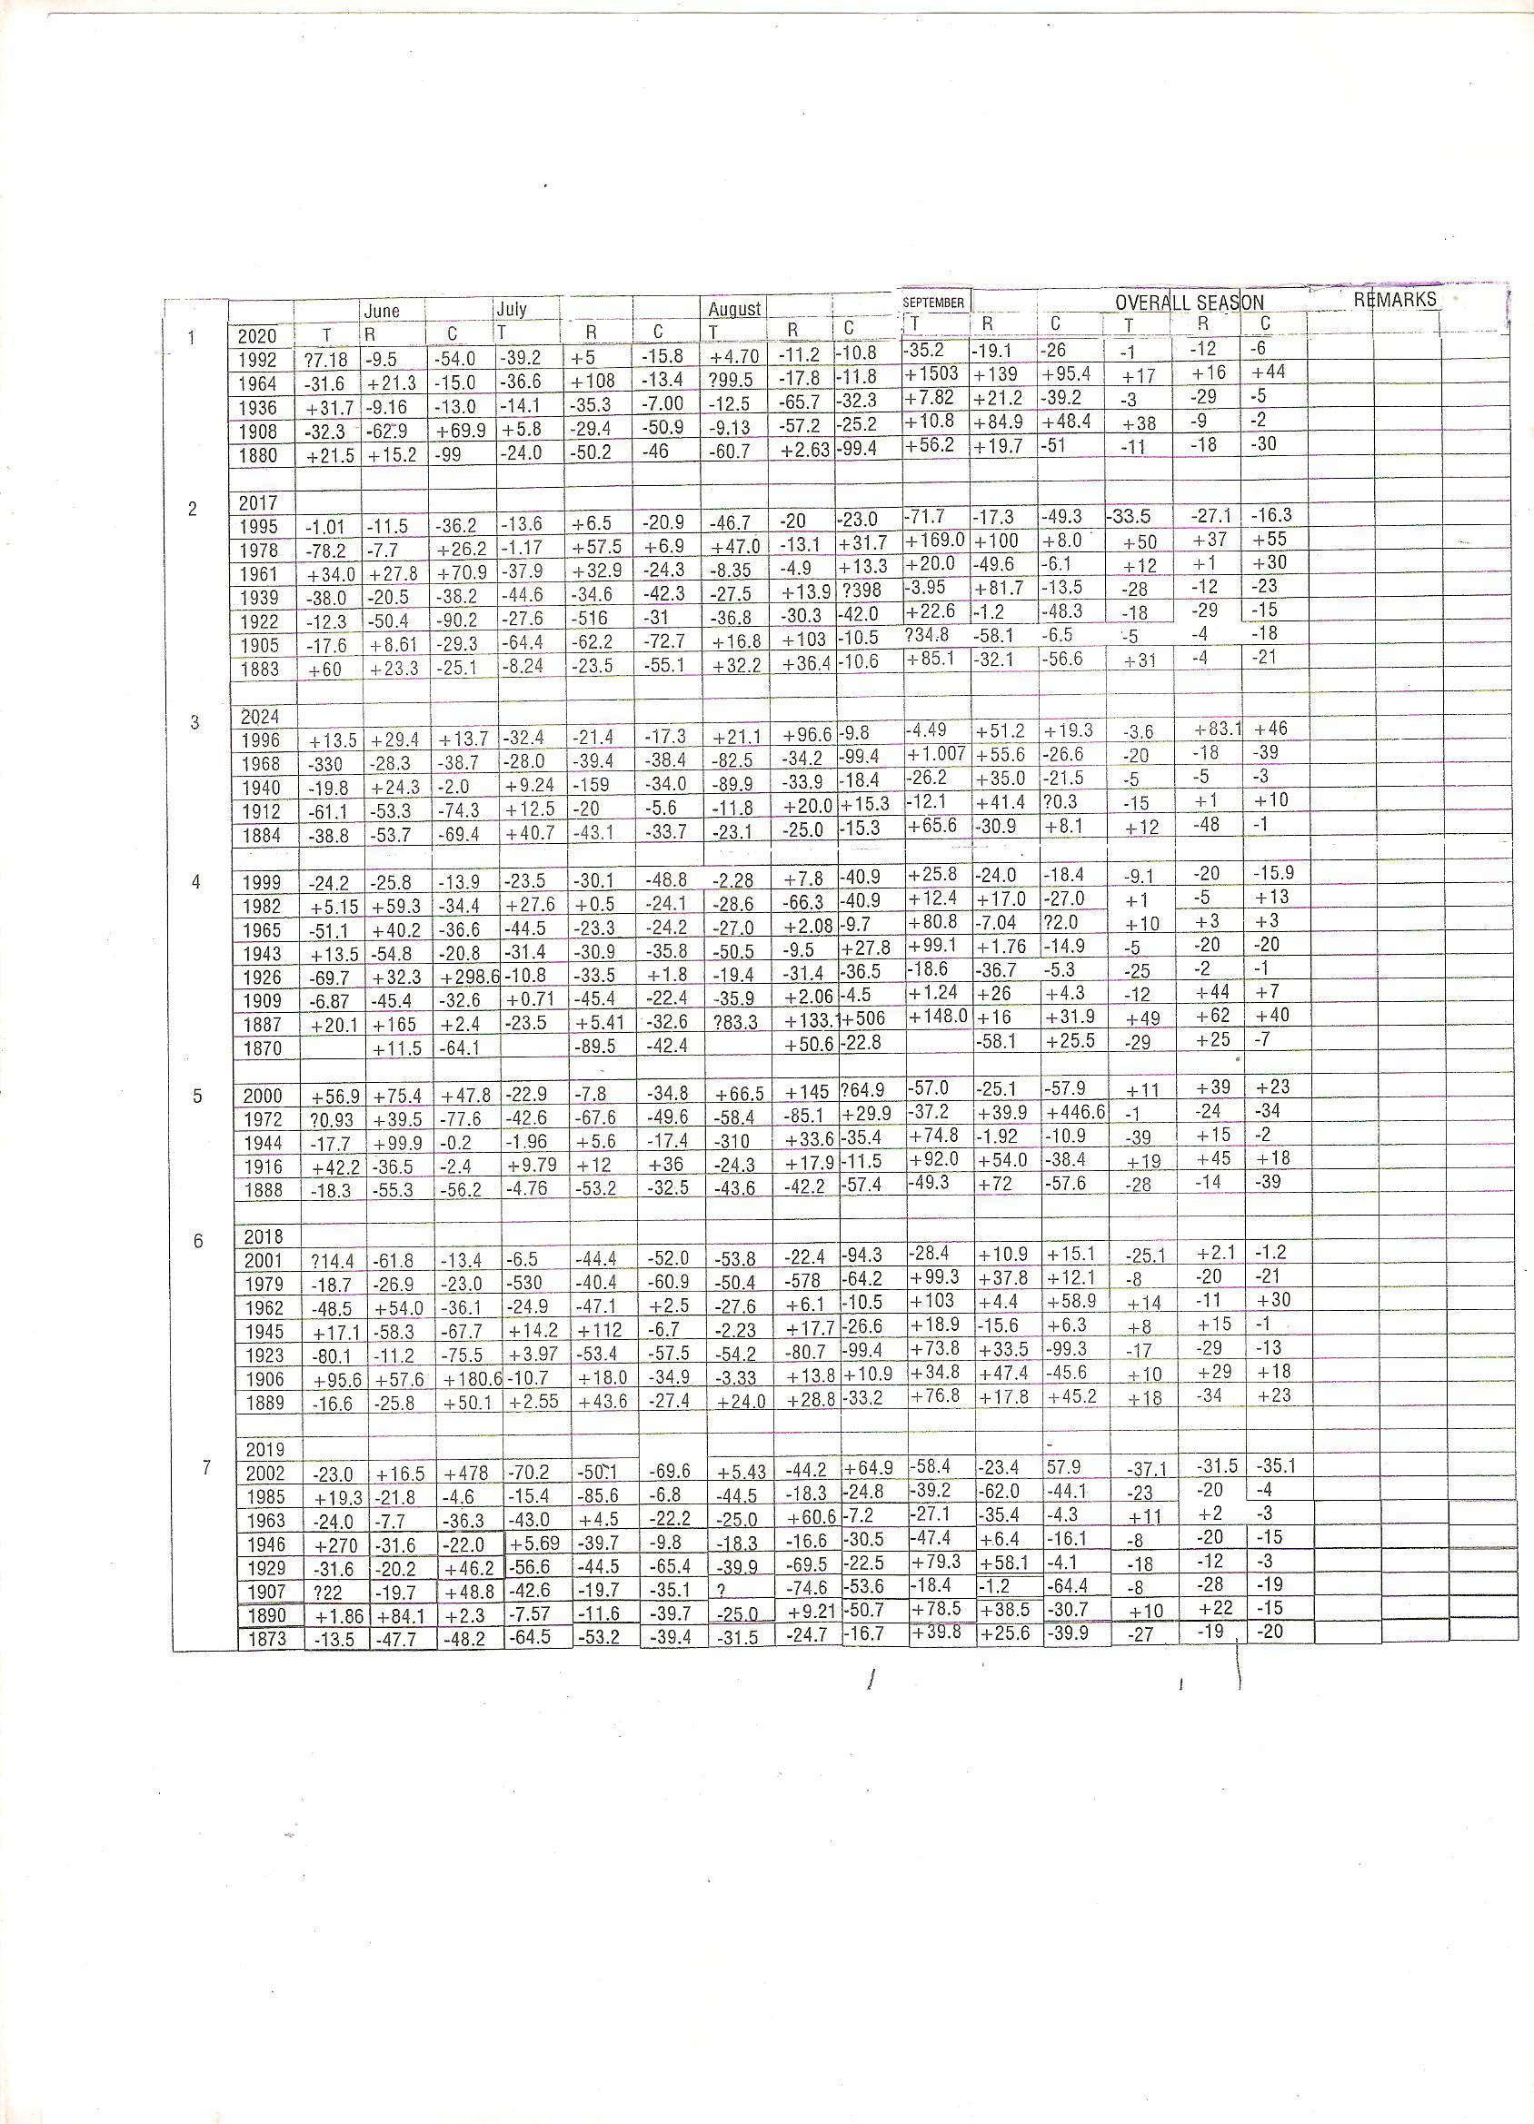

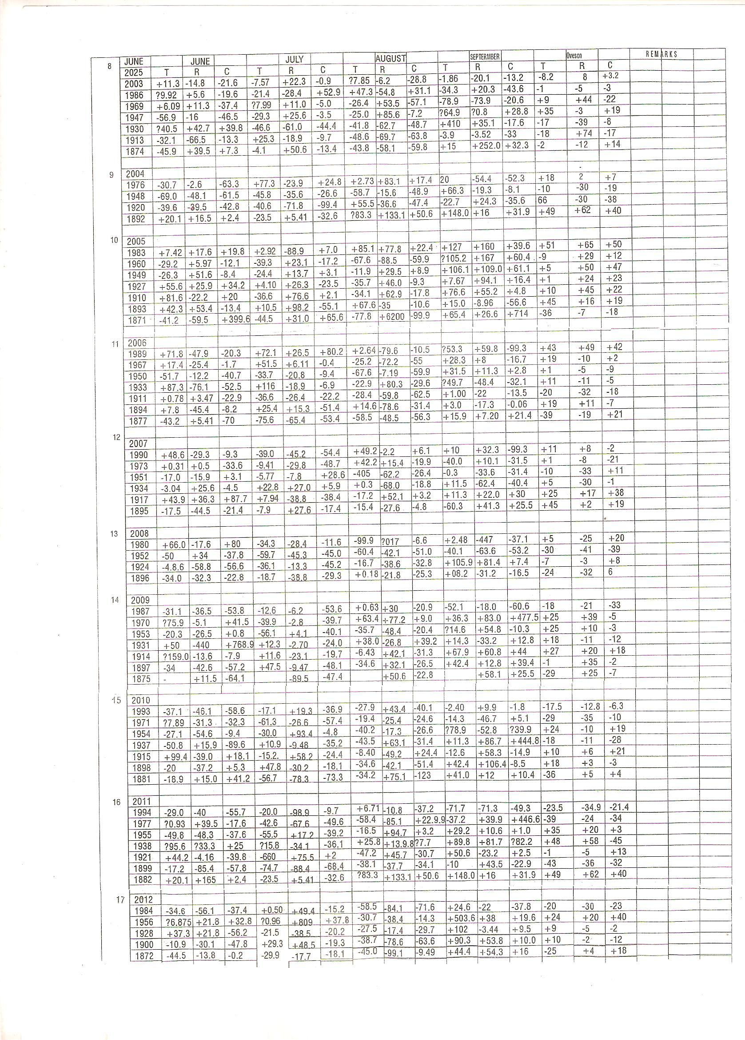

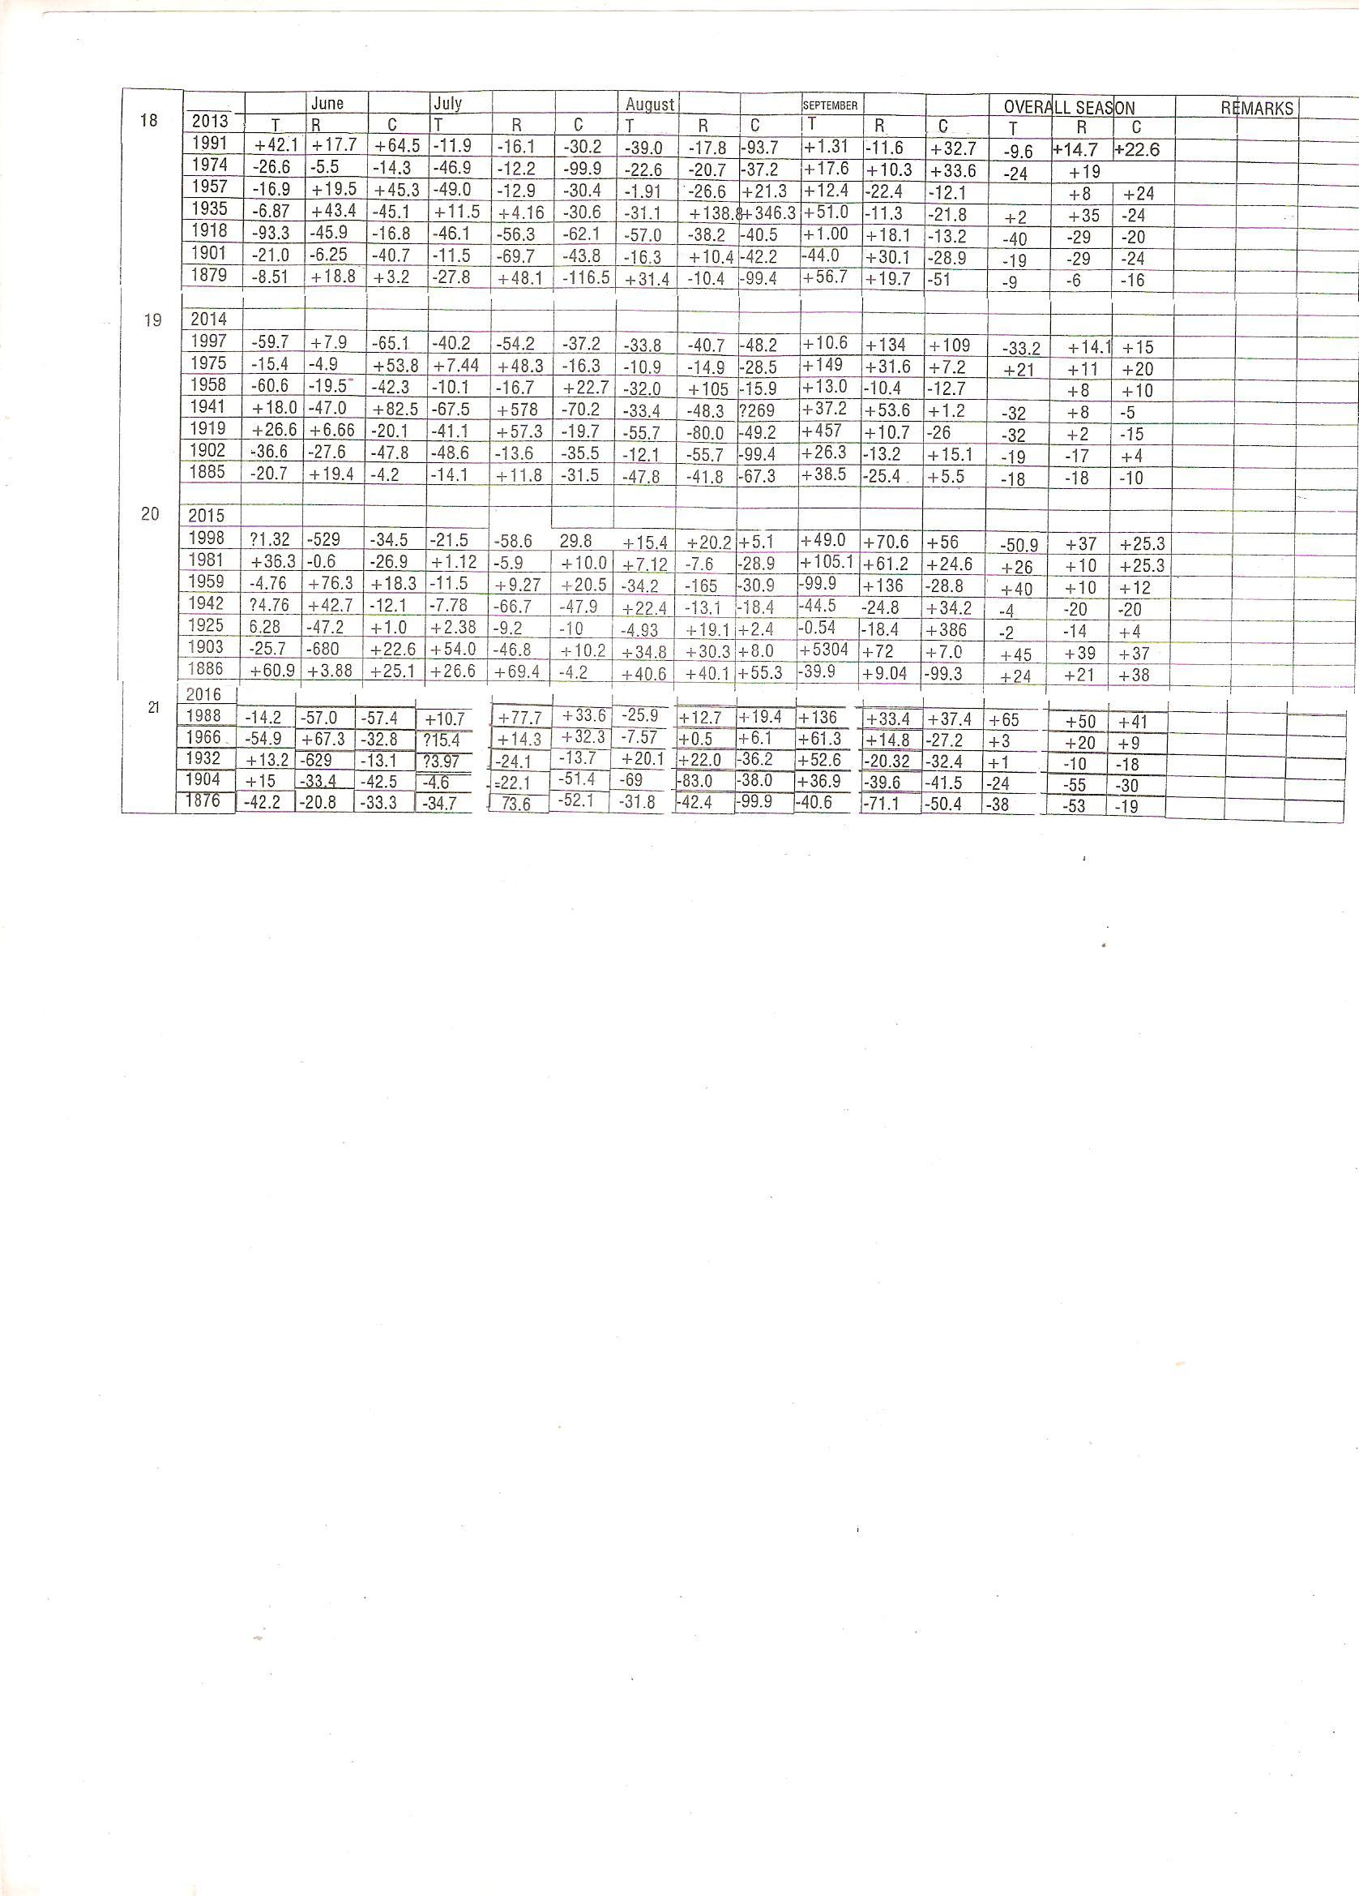

Appendicies: (A New Hypothetical Moel Of Cosmology)

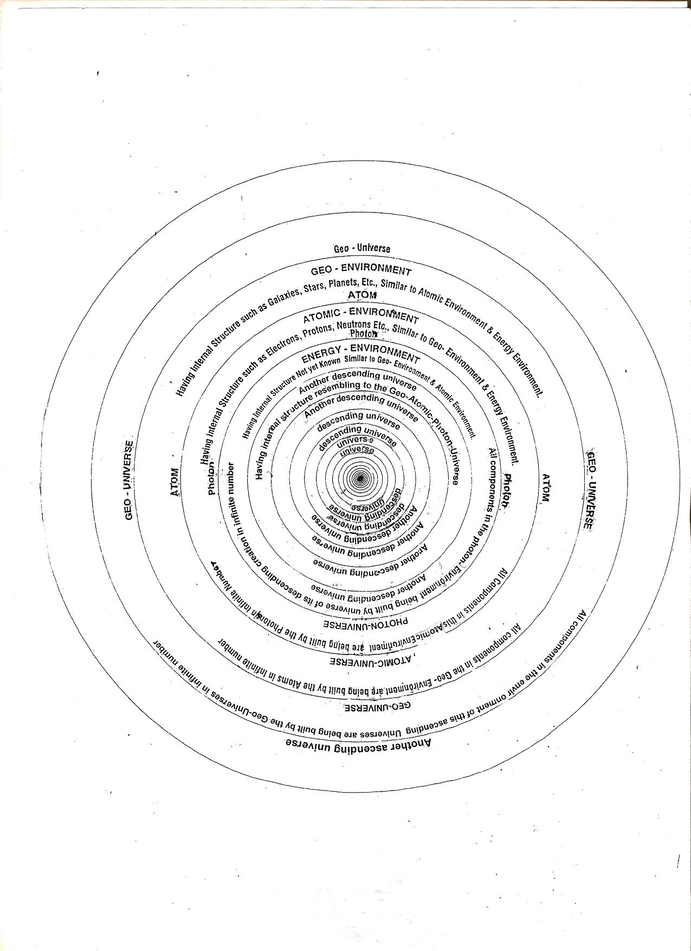
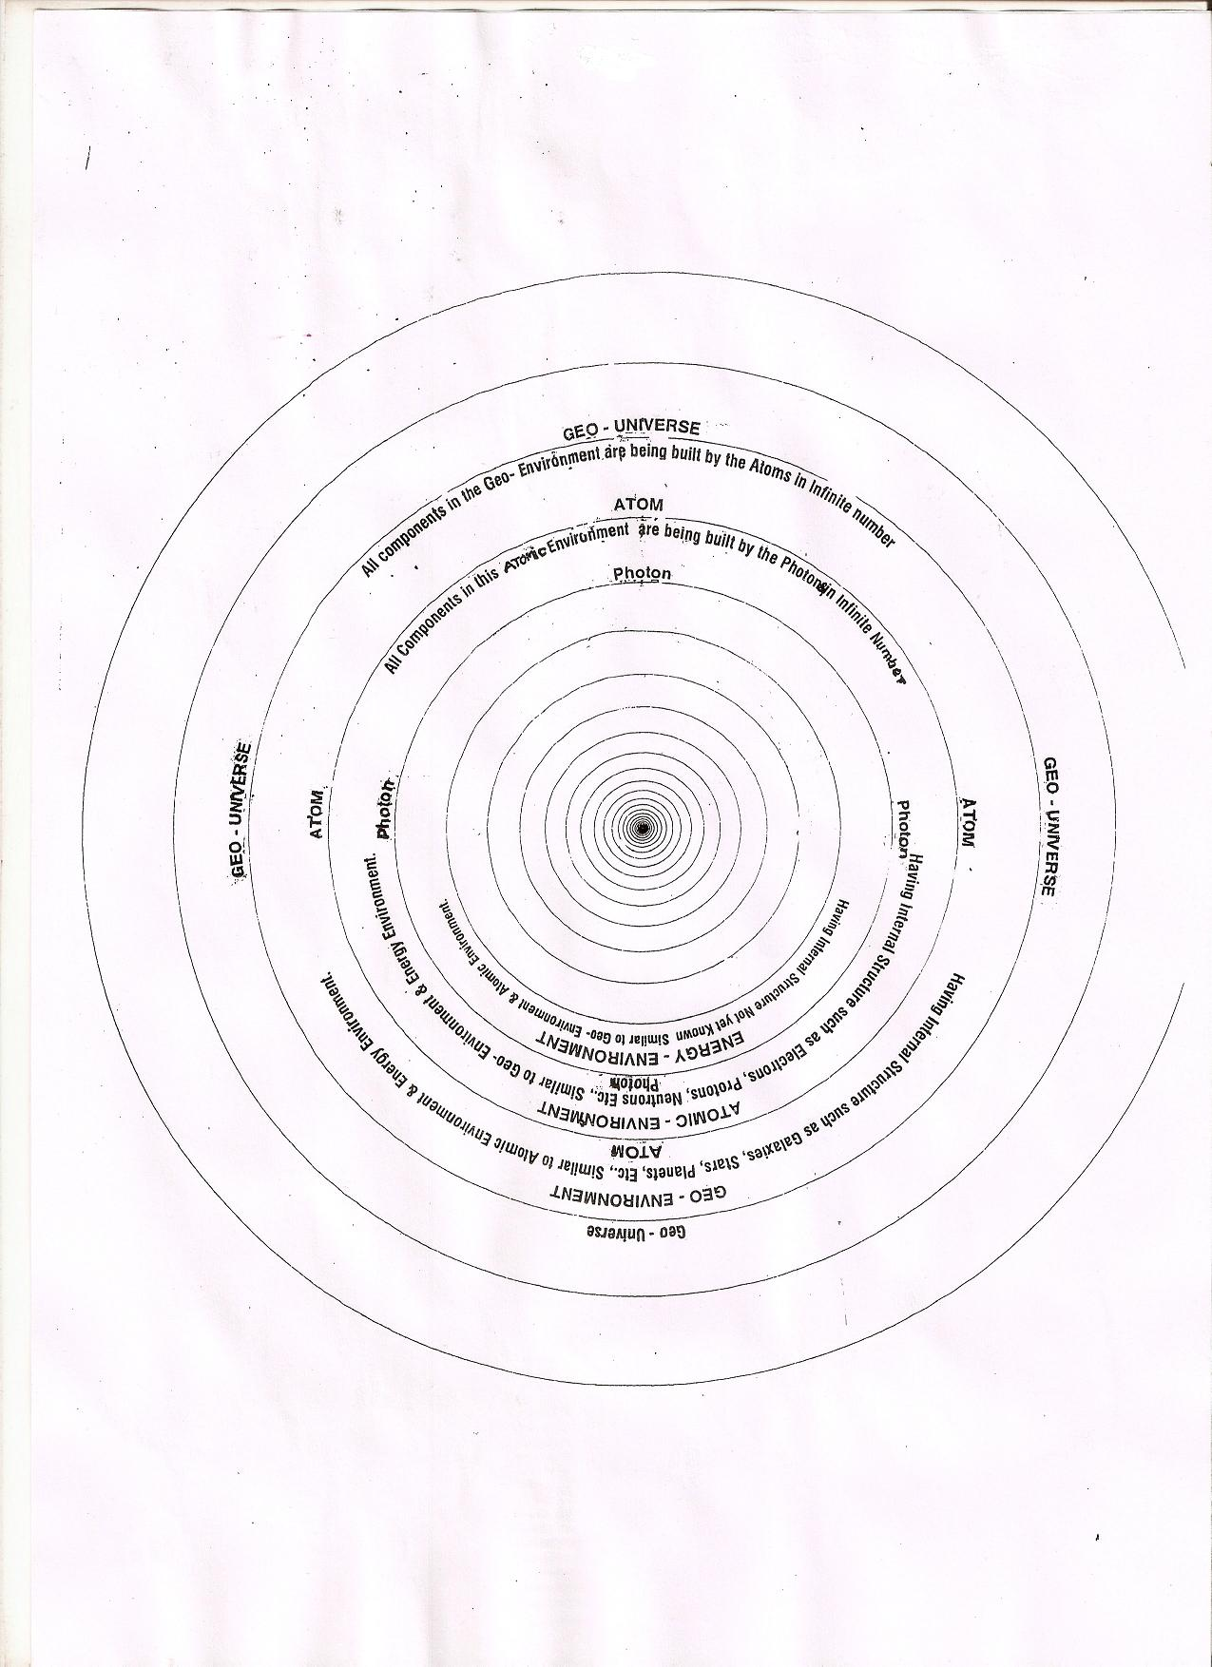

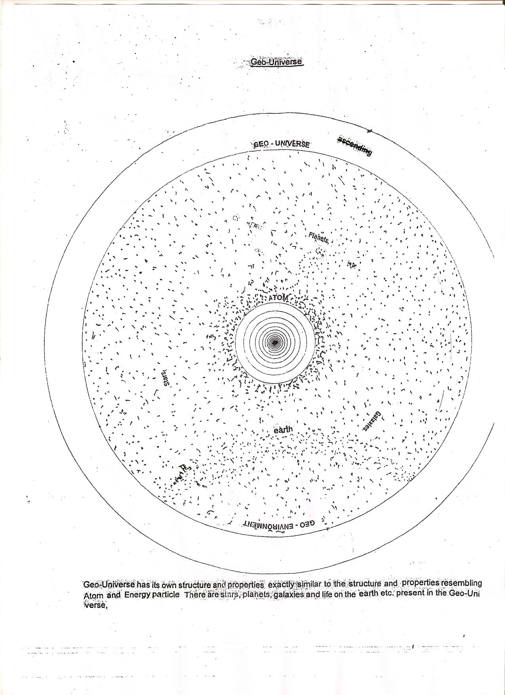

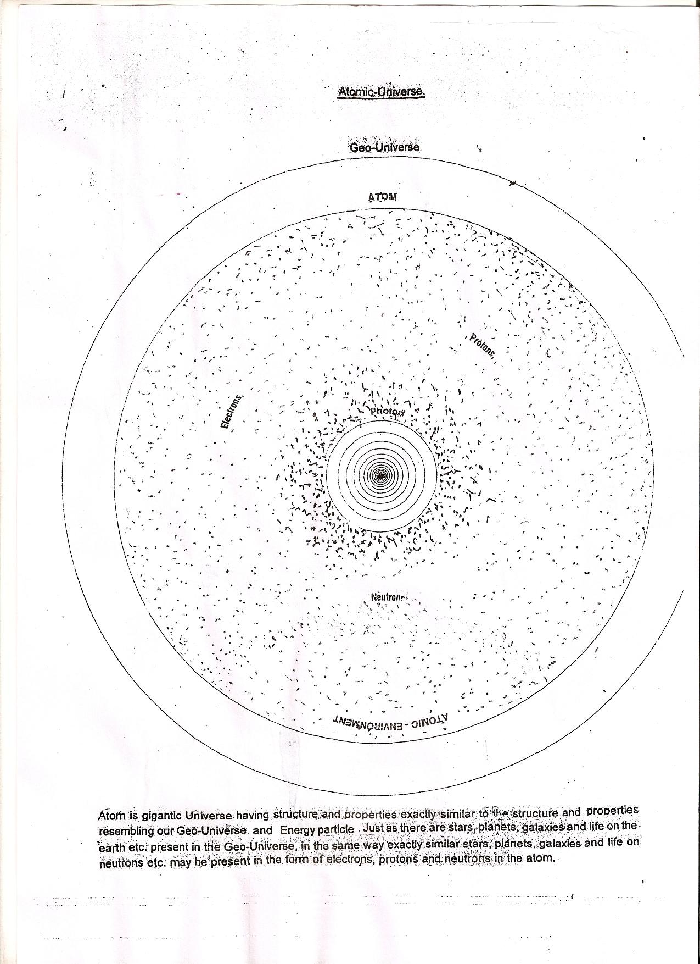

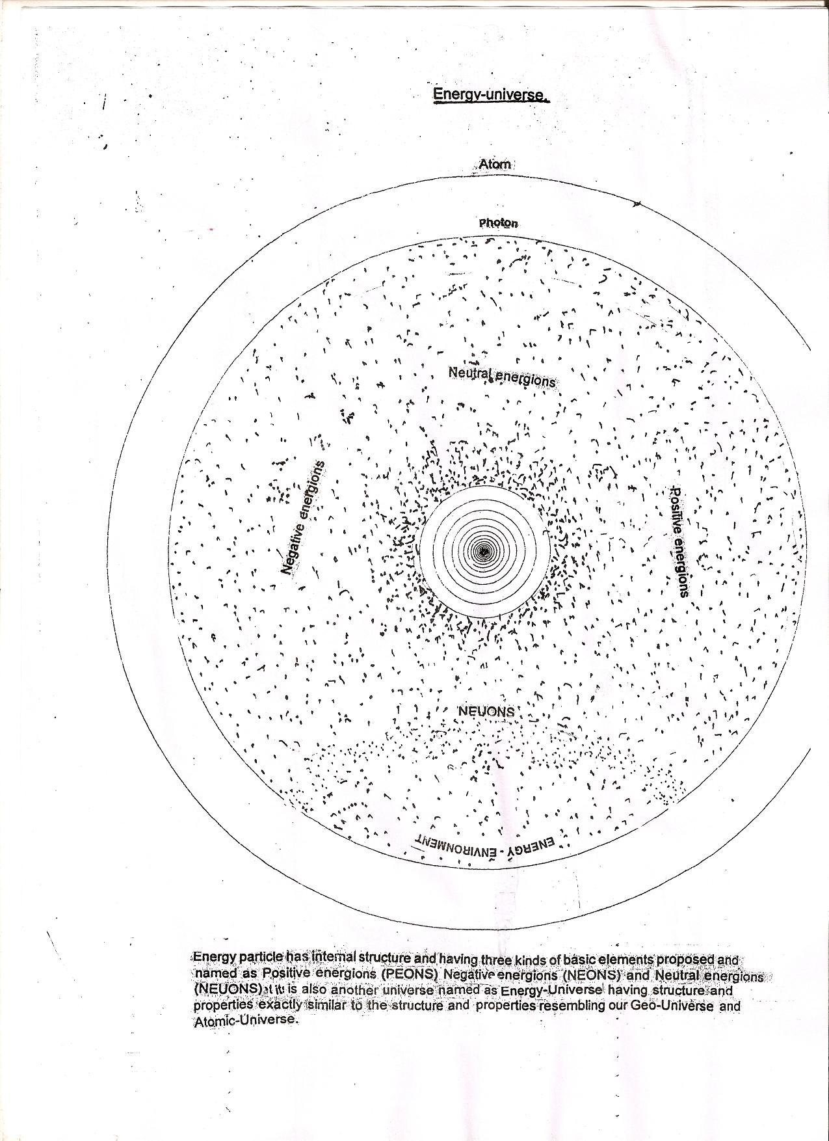

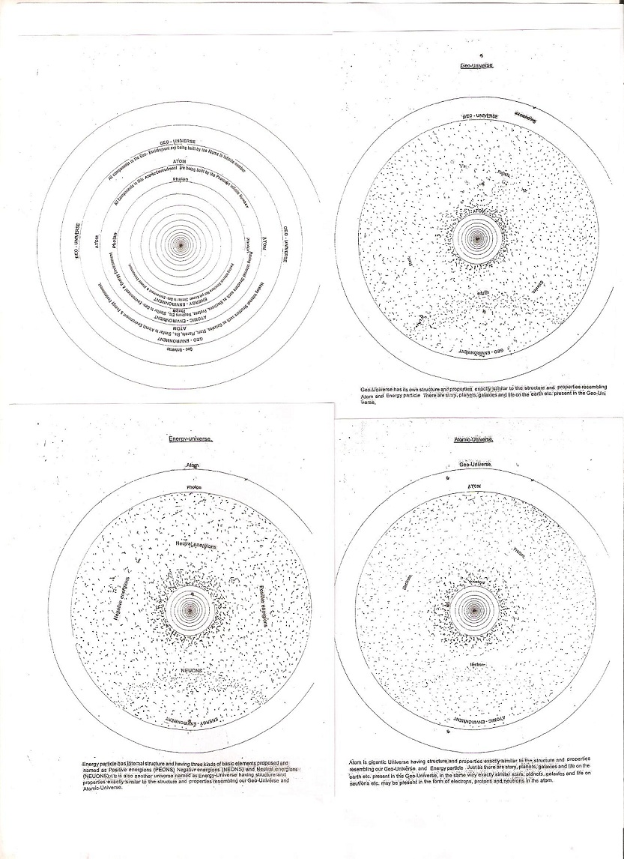

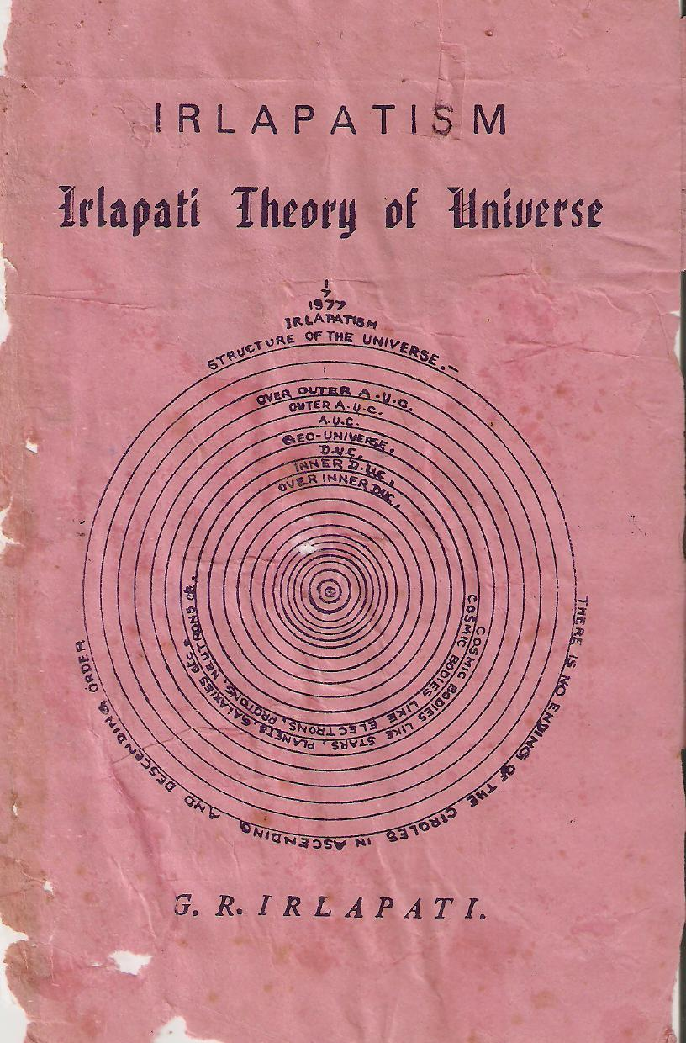
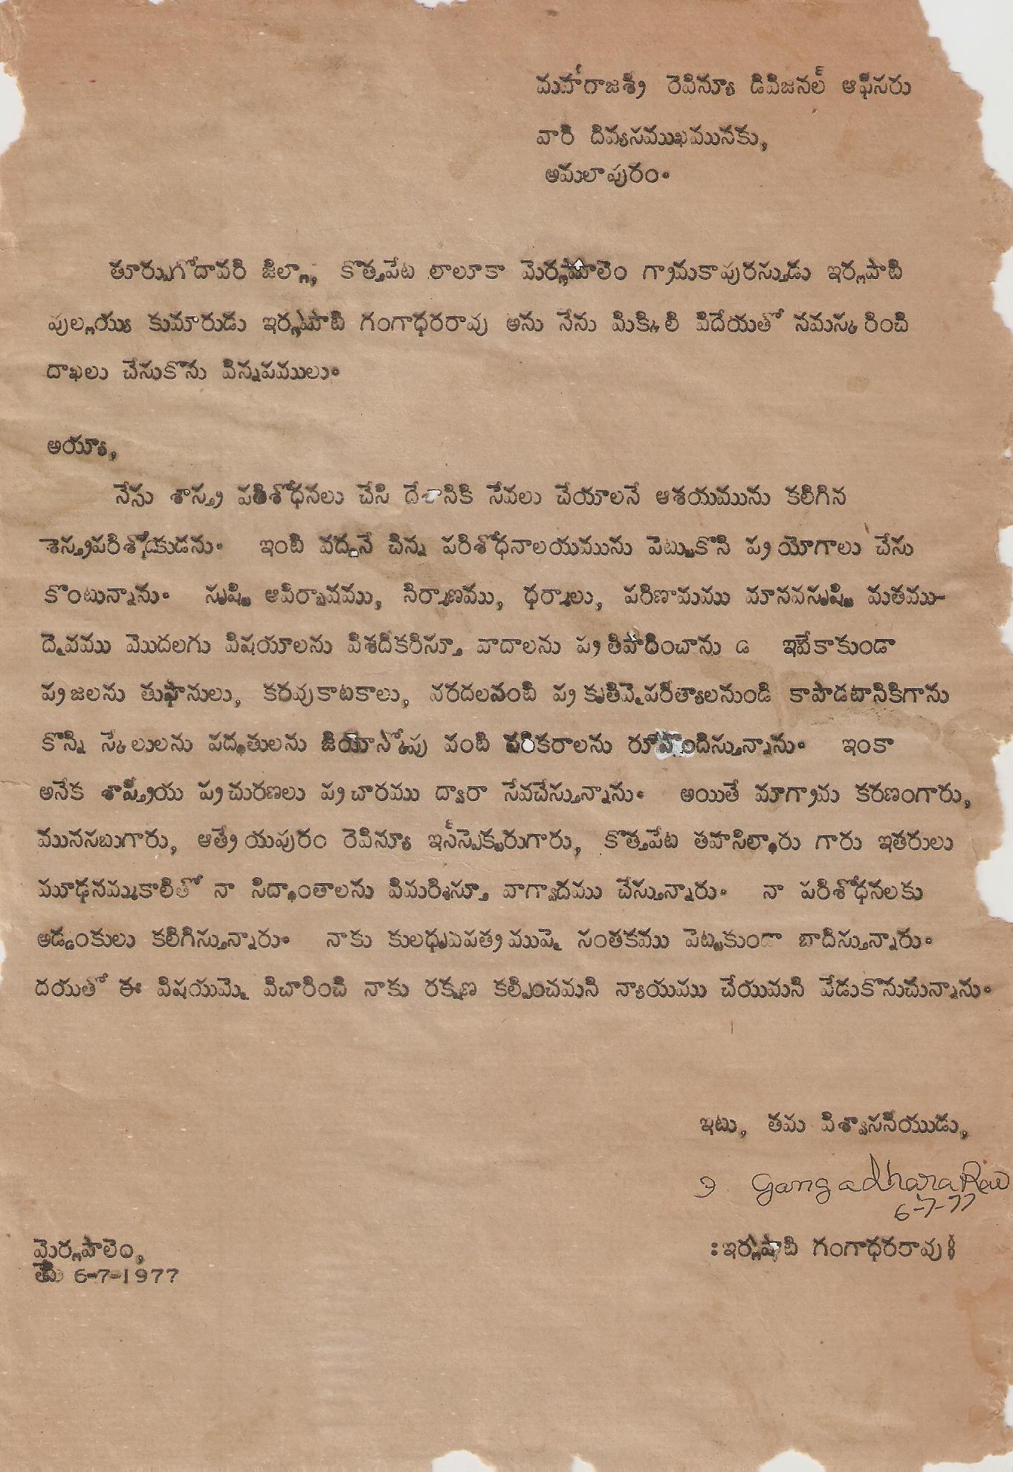
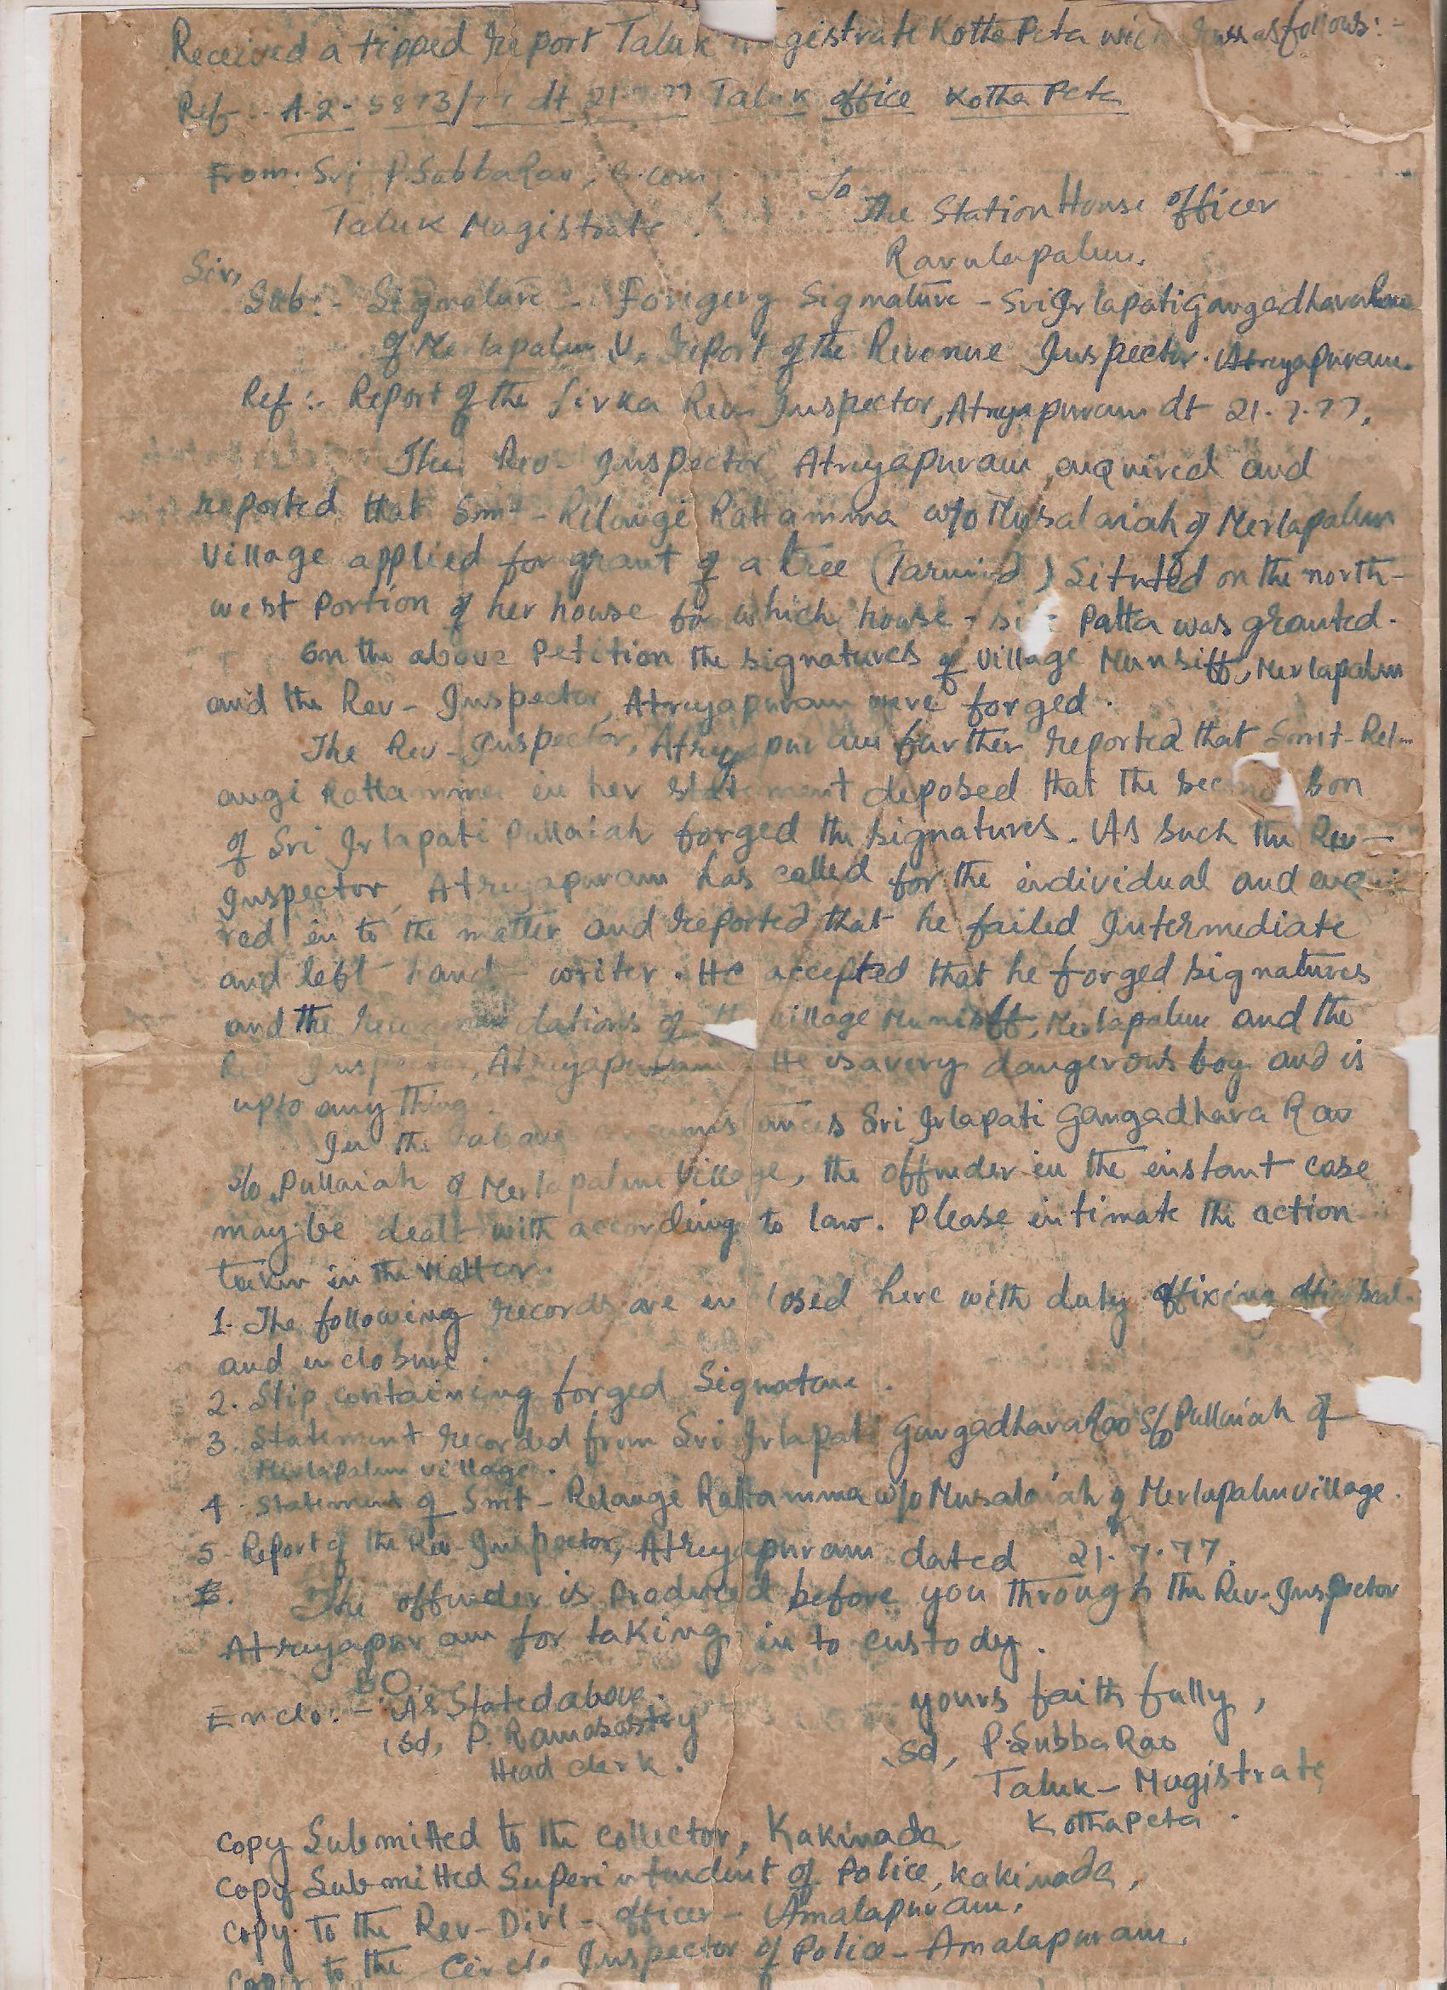

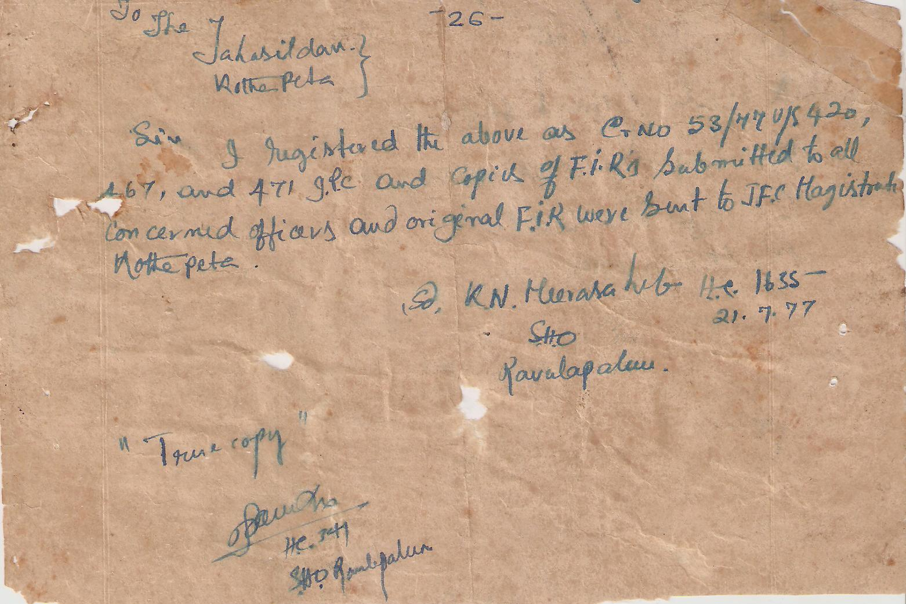

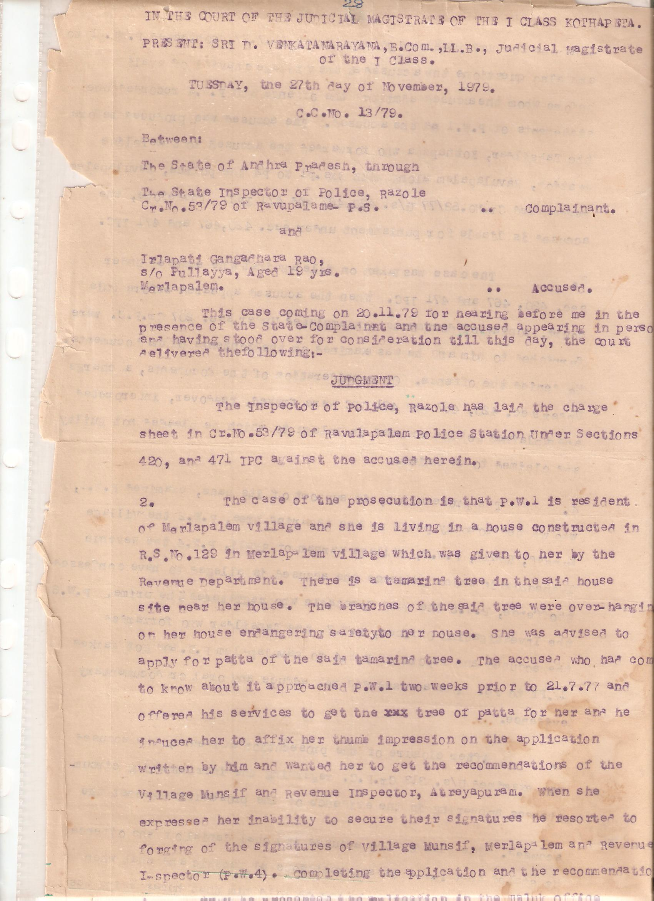

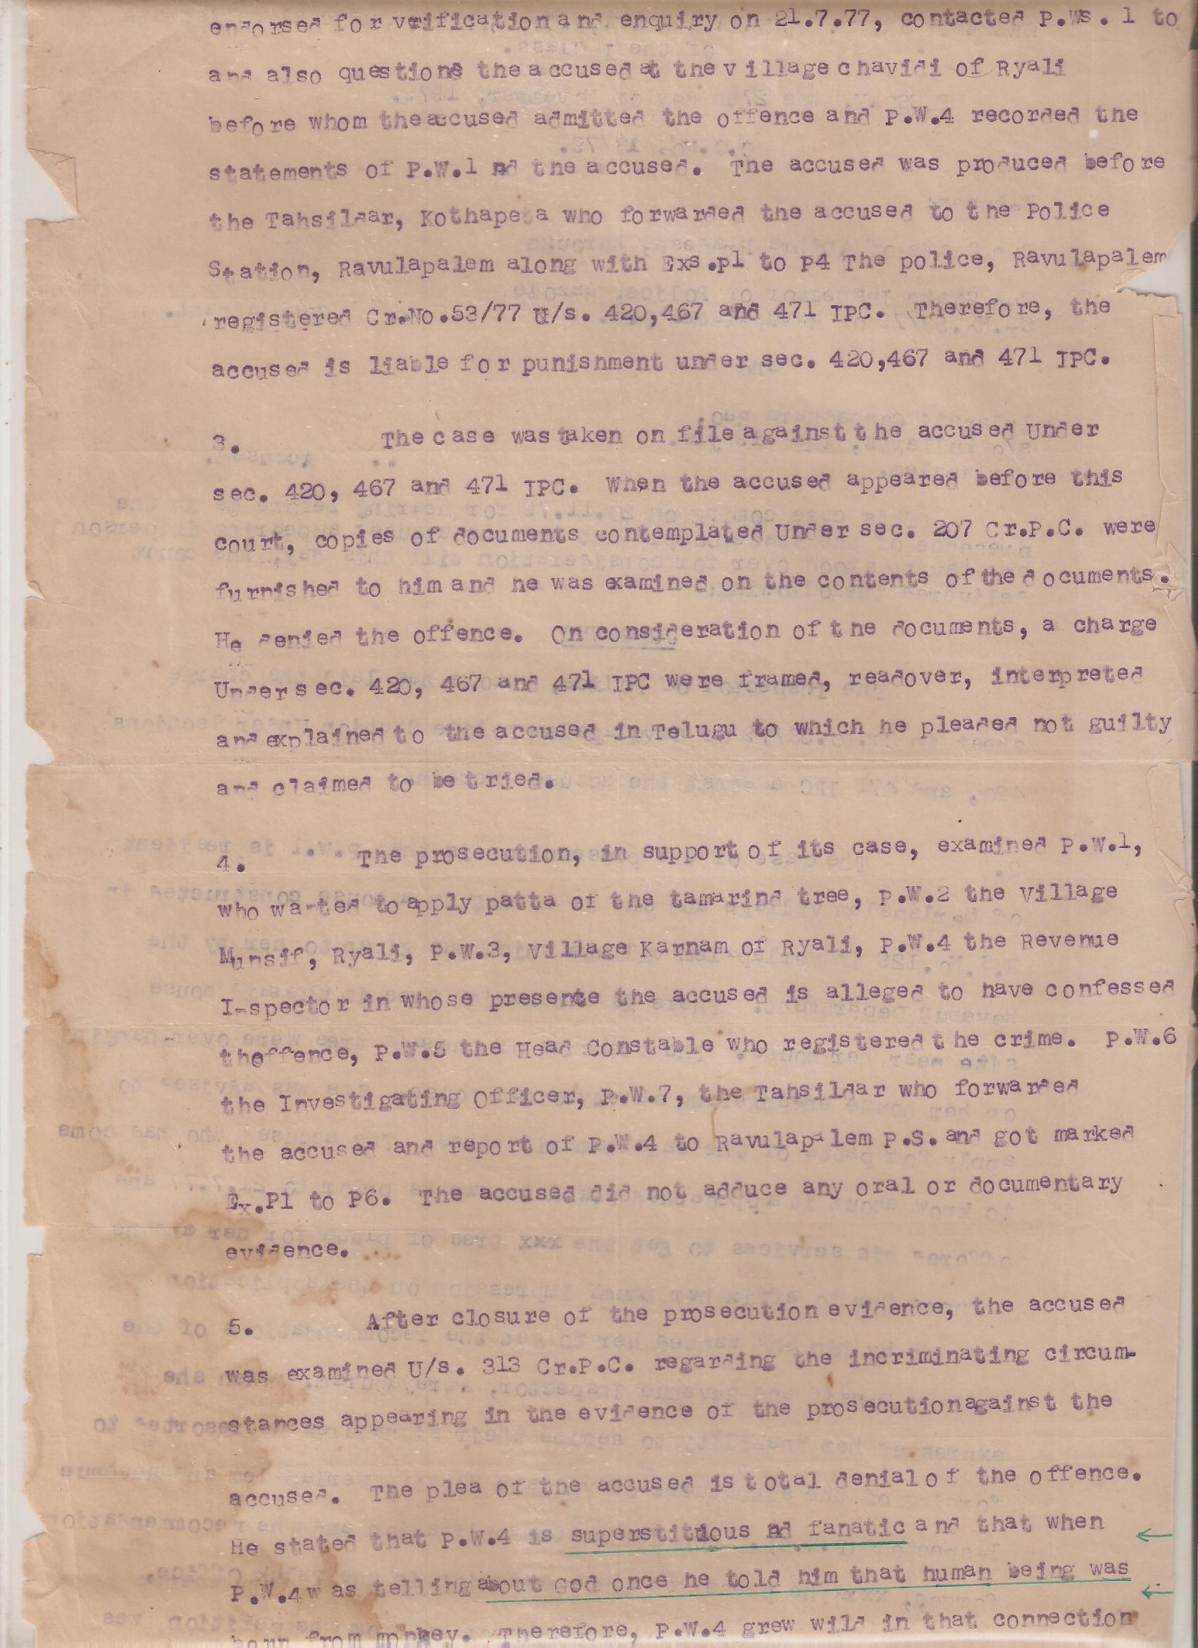
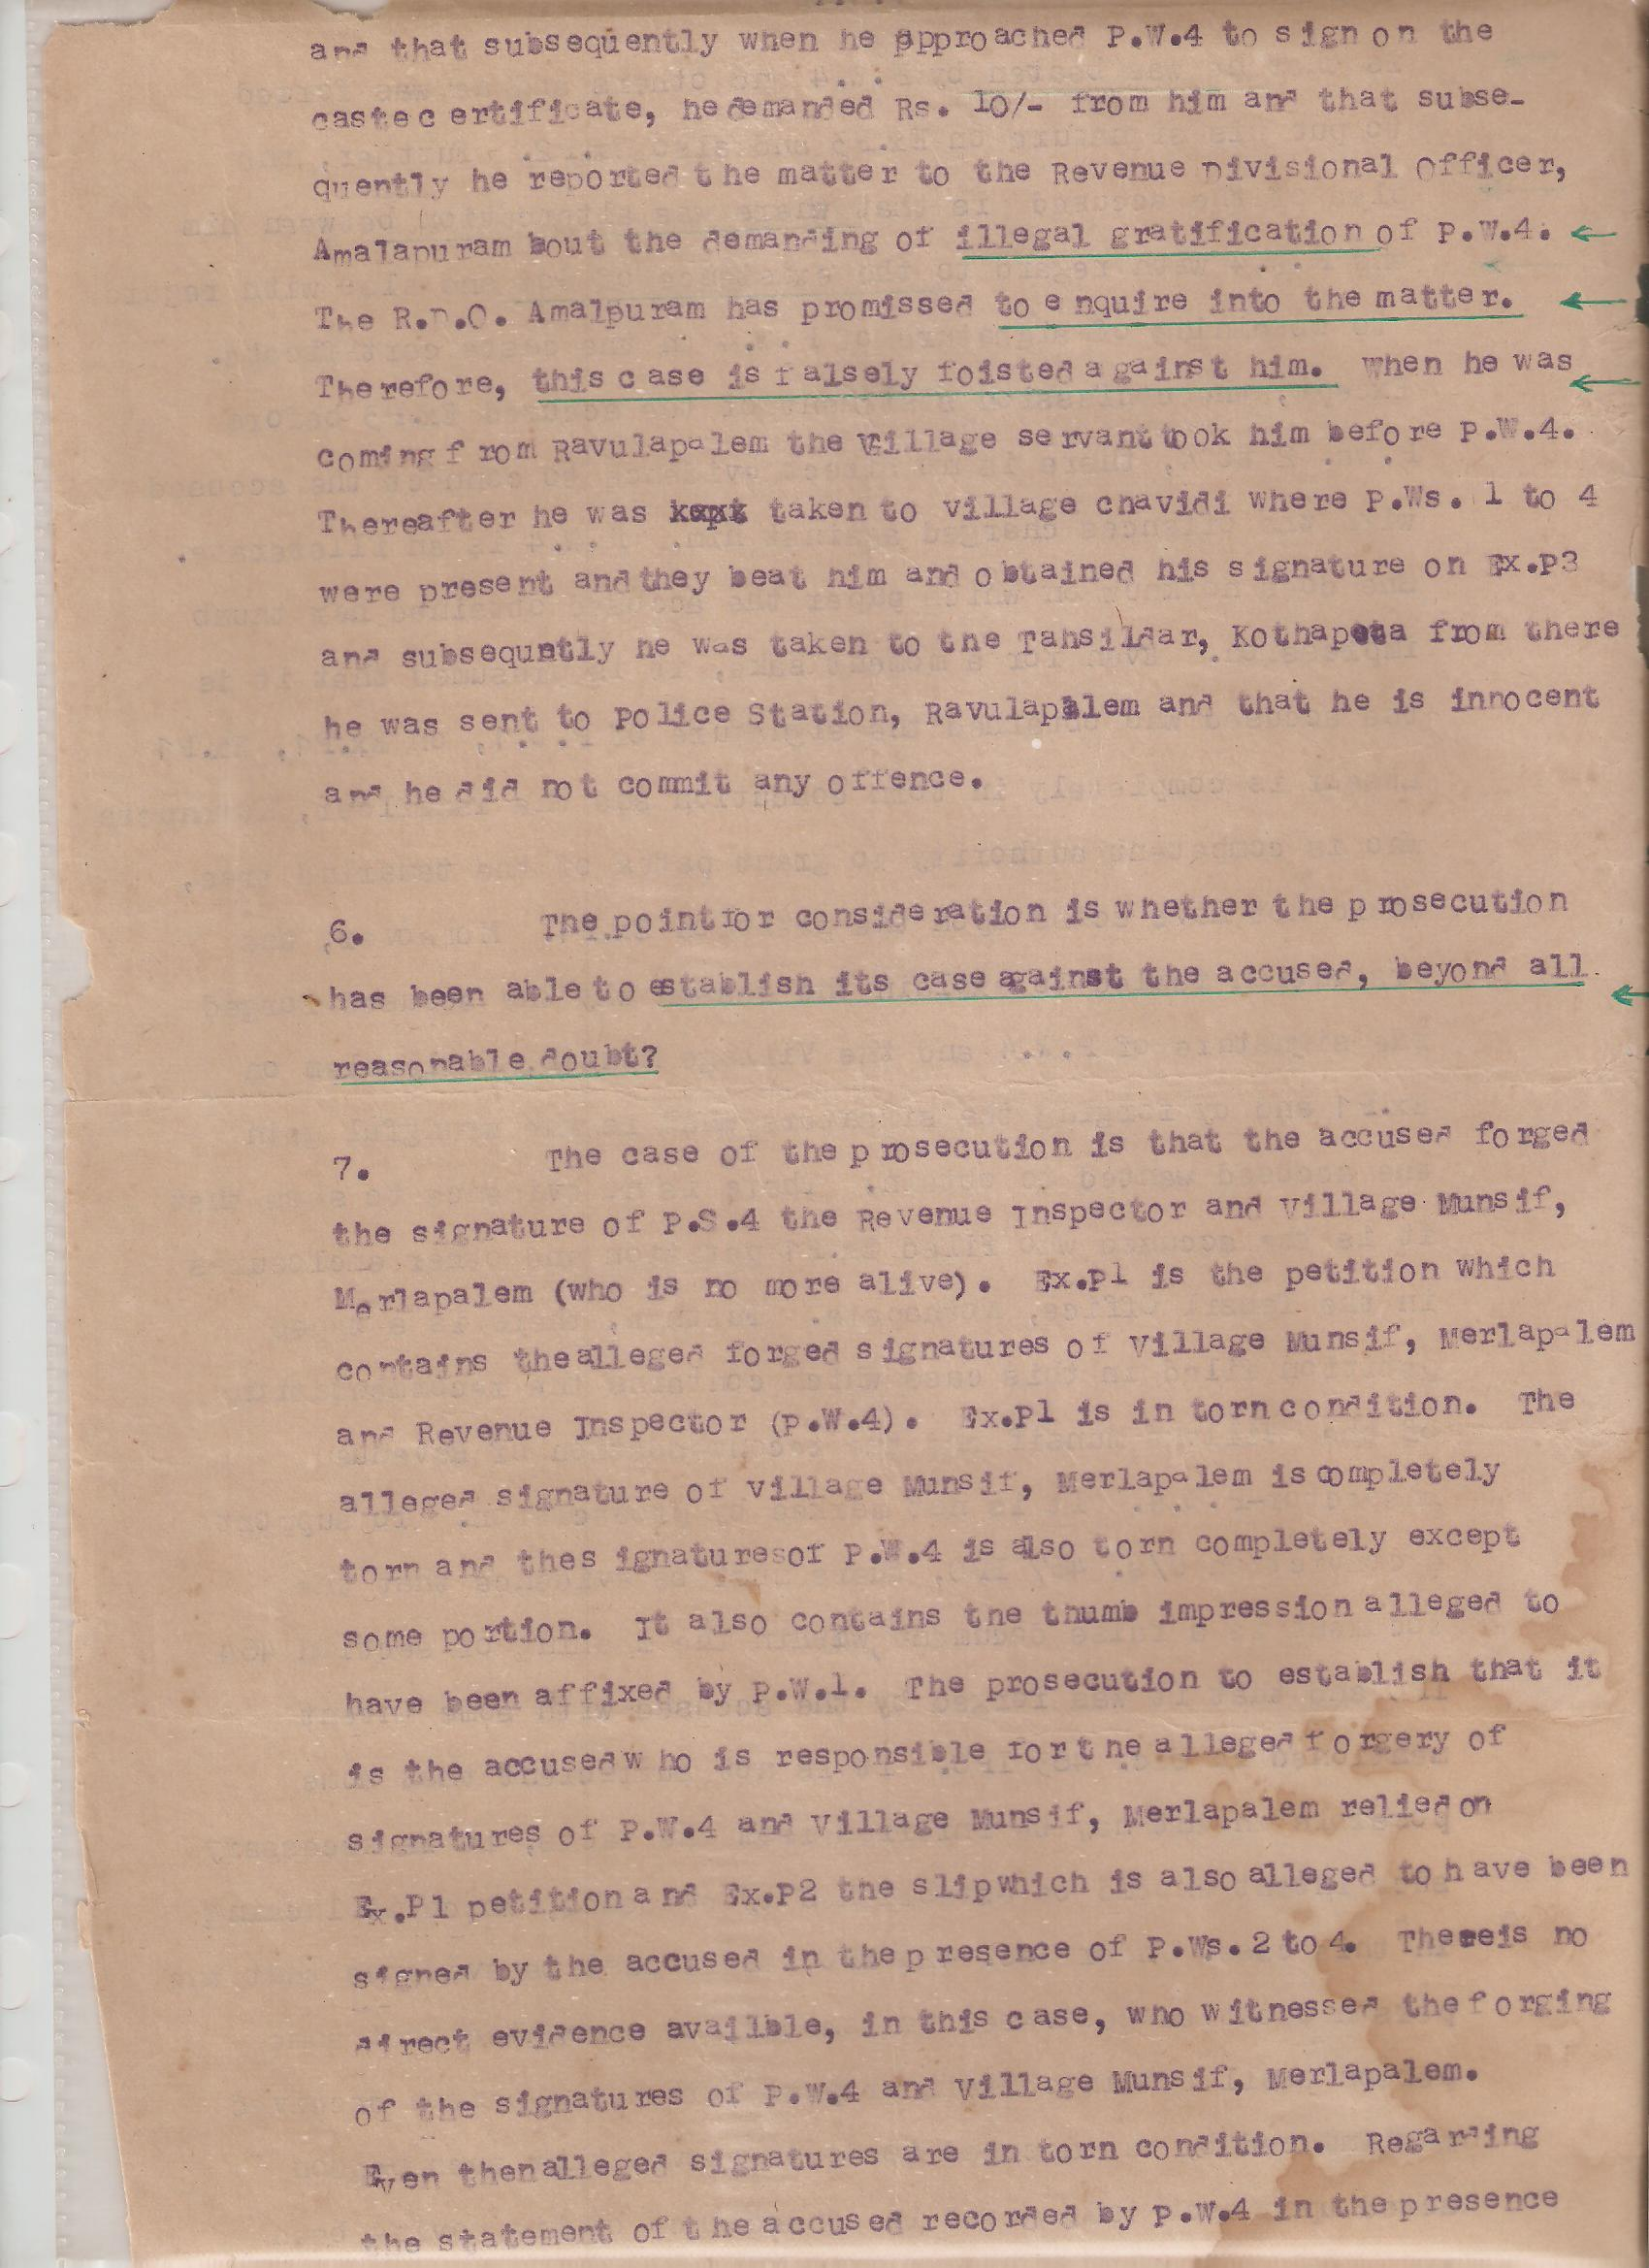
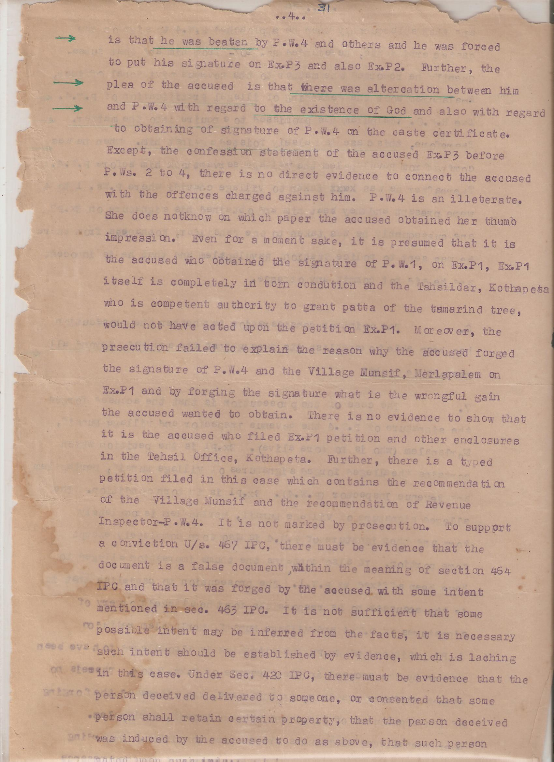

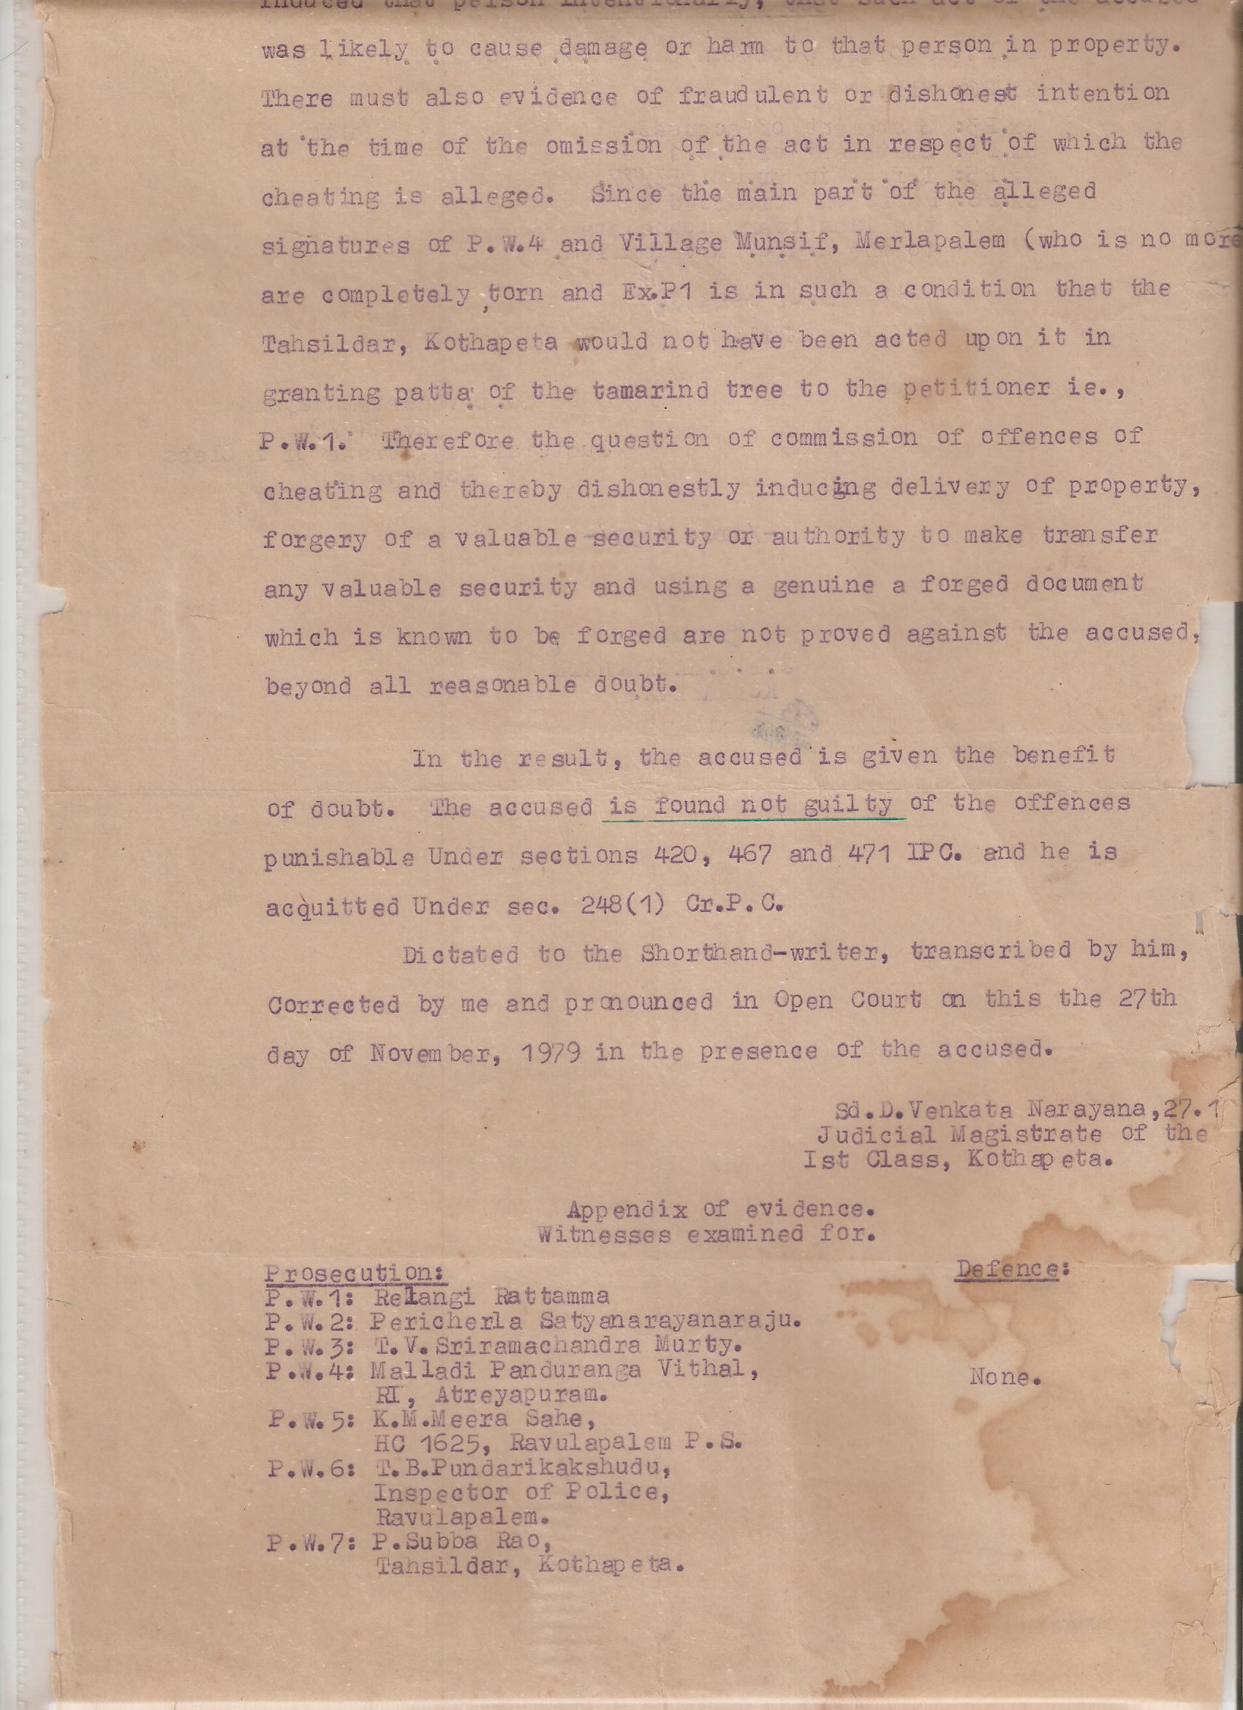

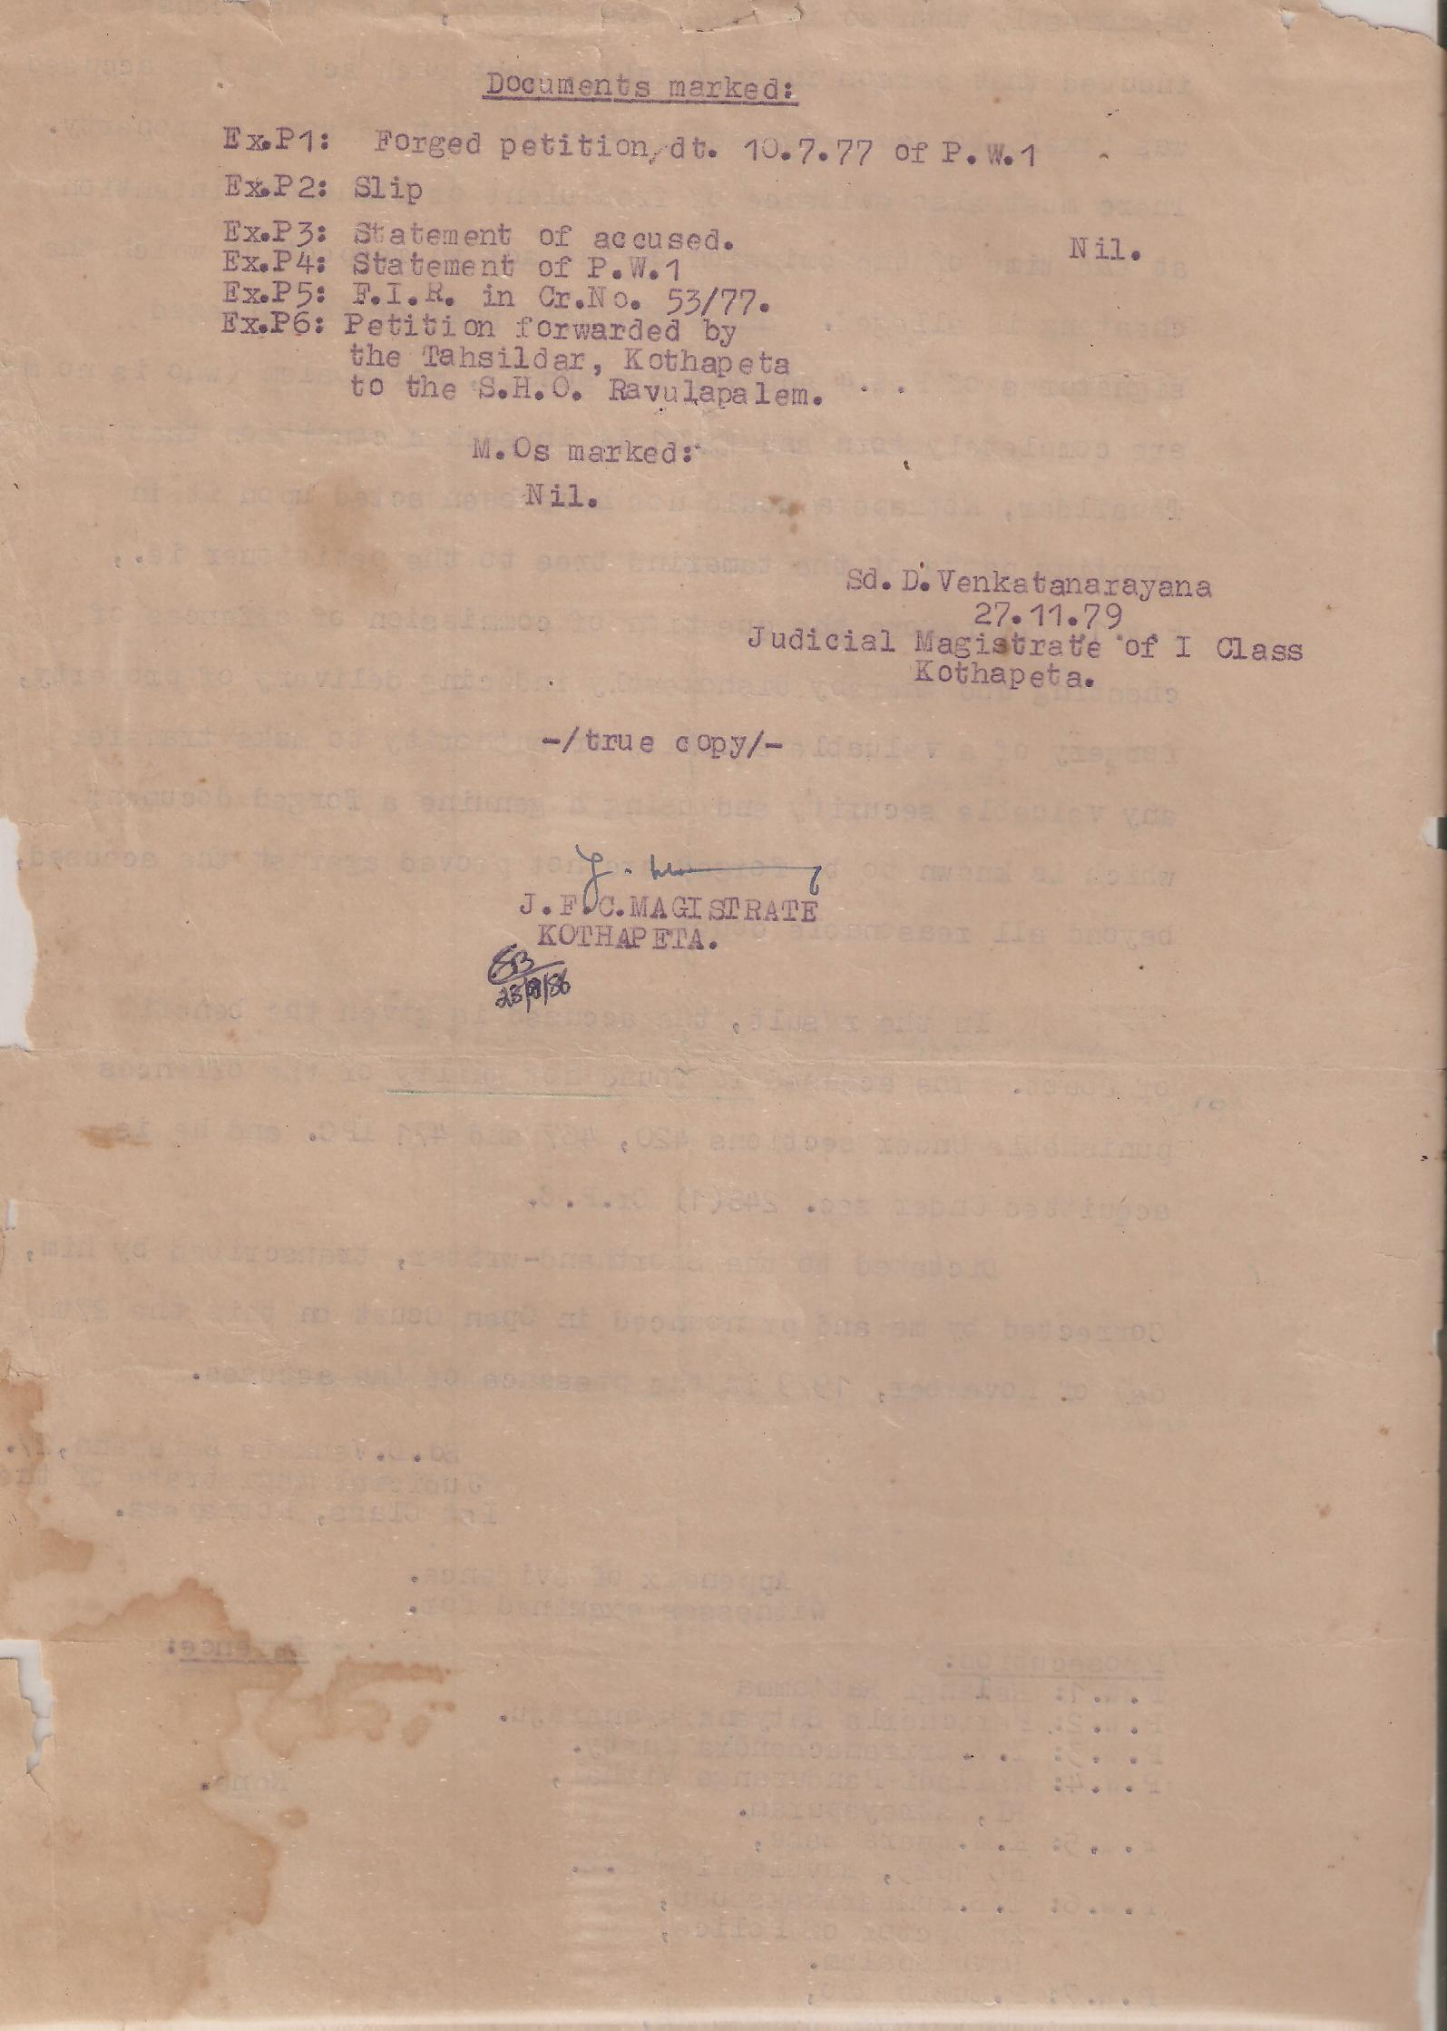




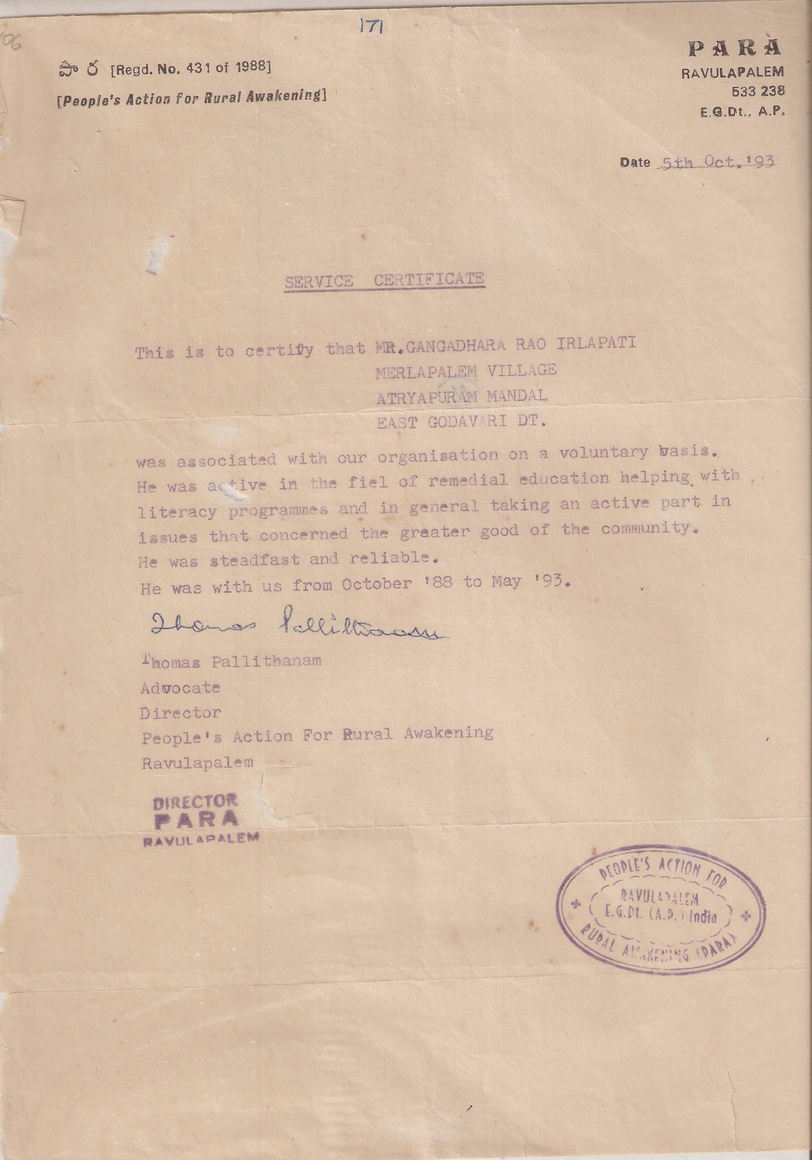
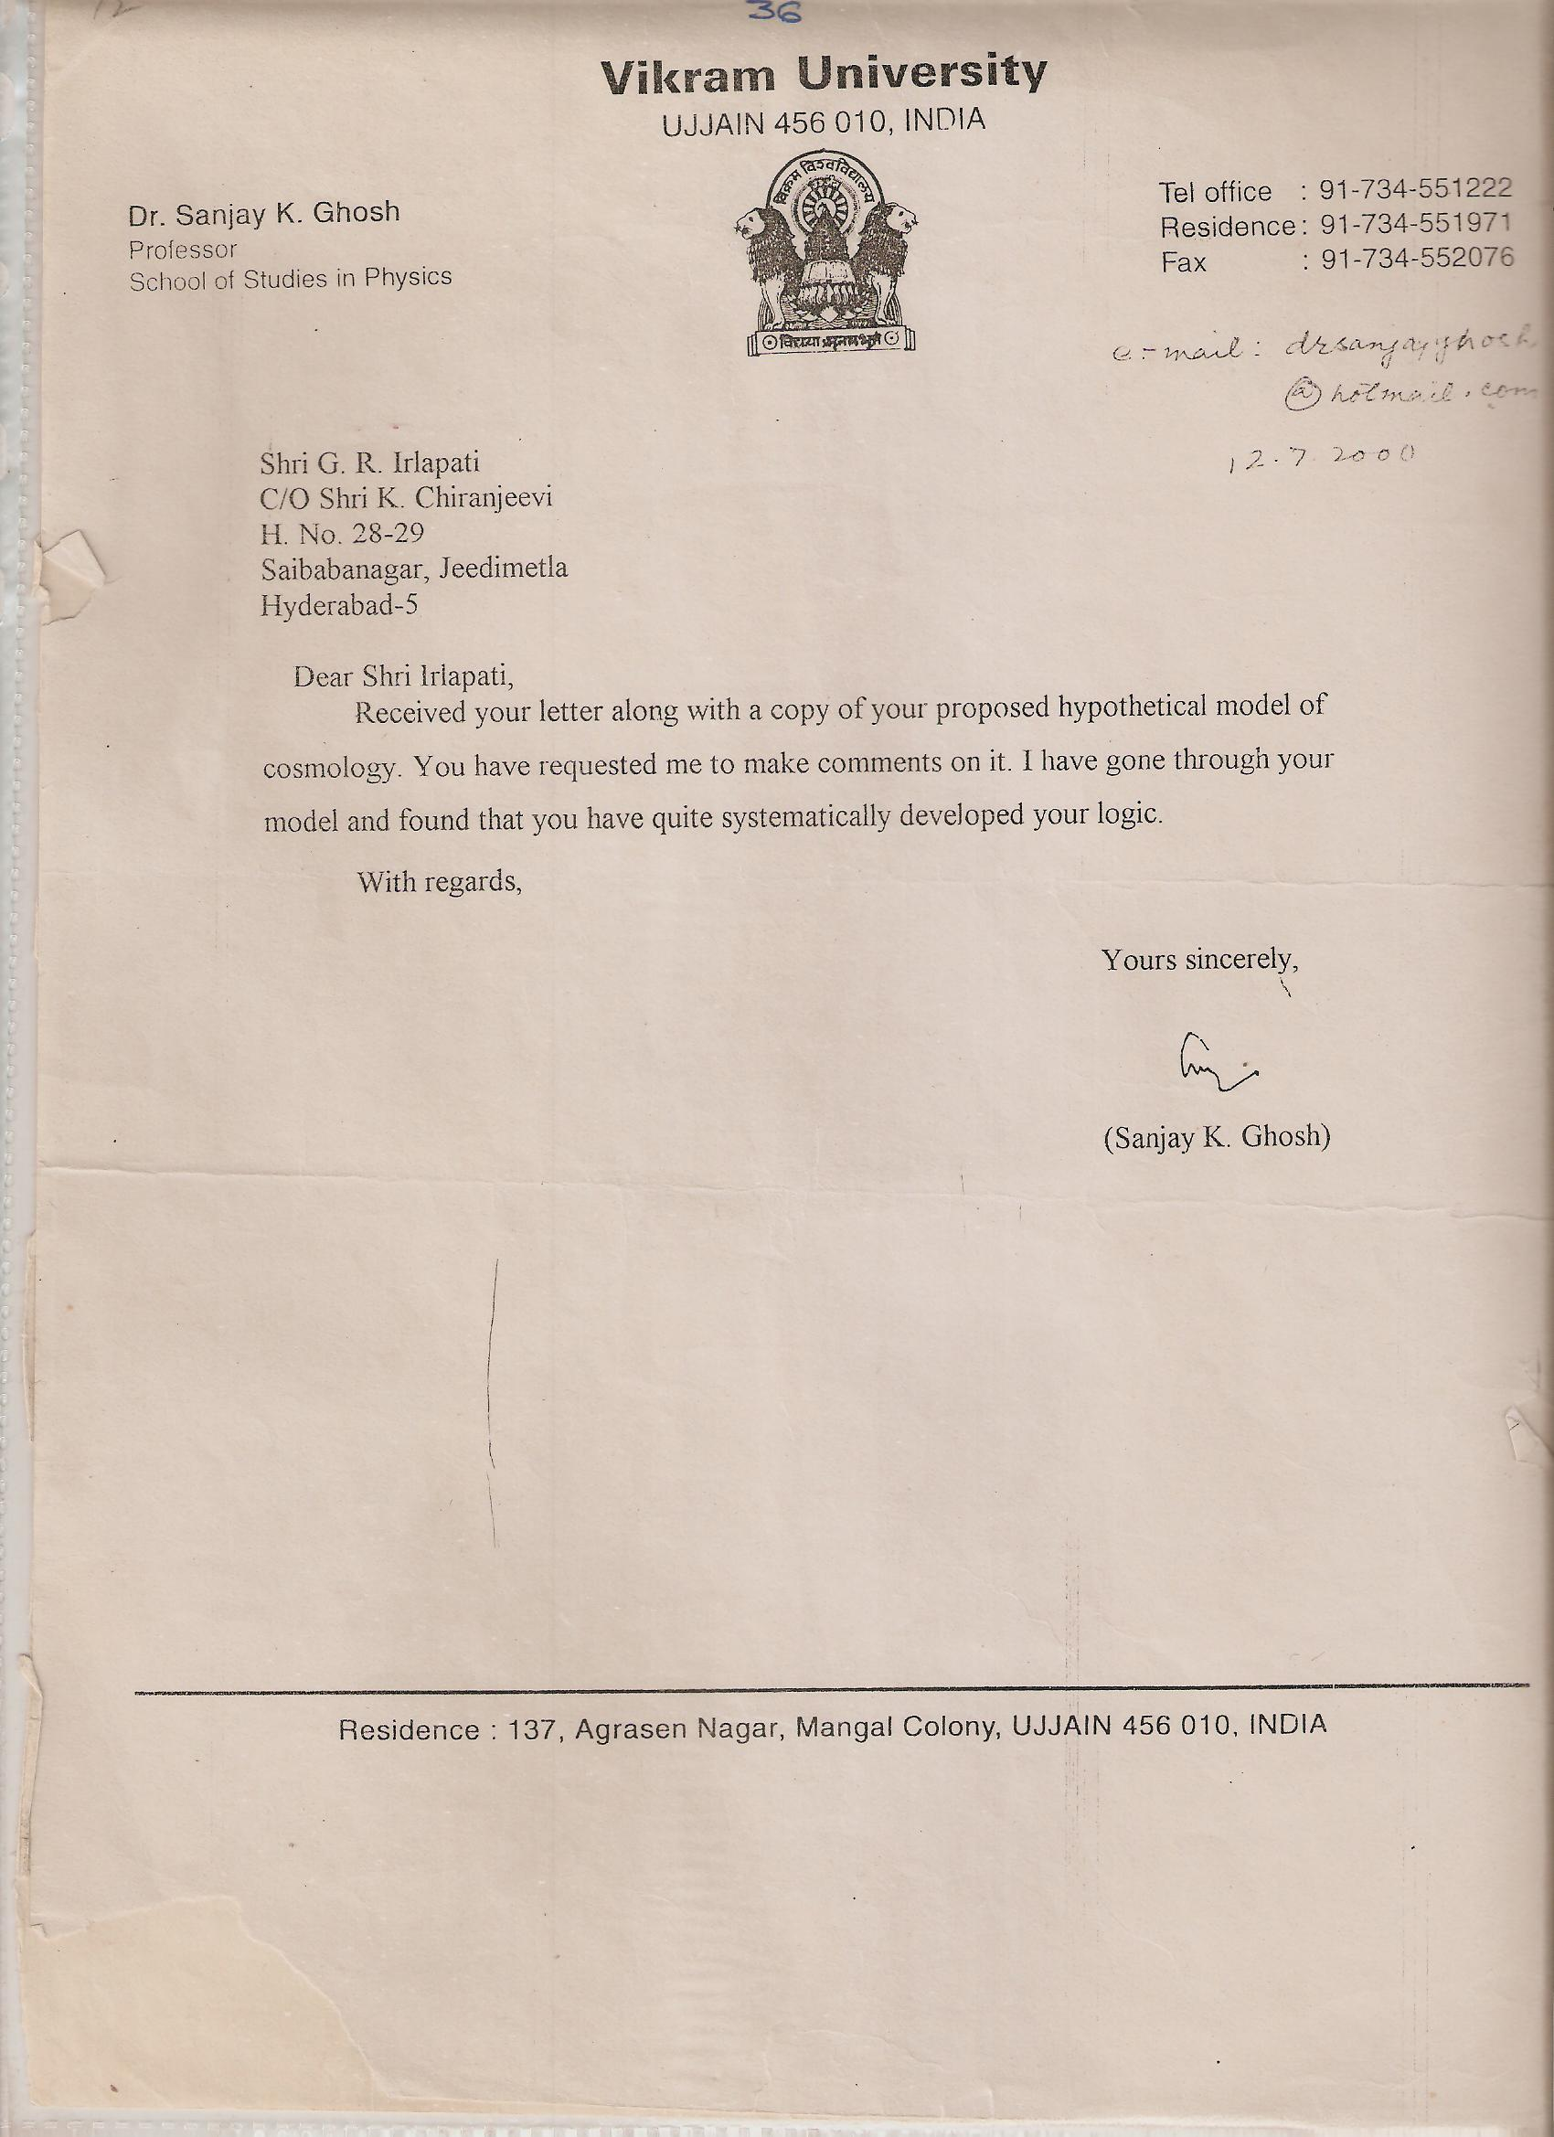
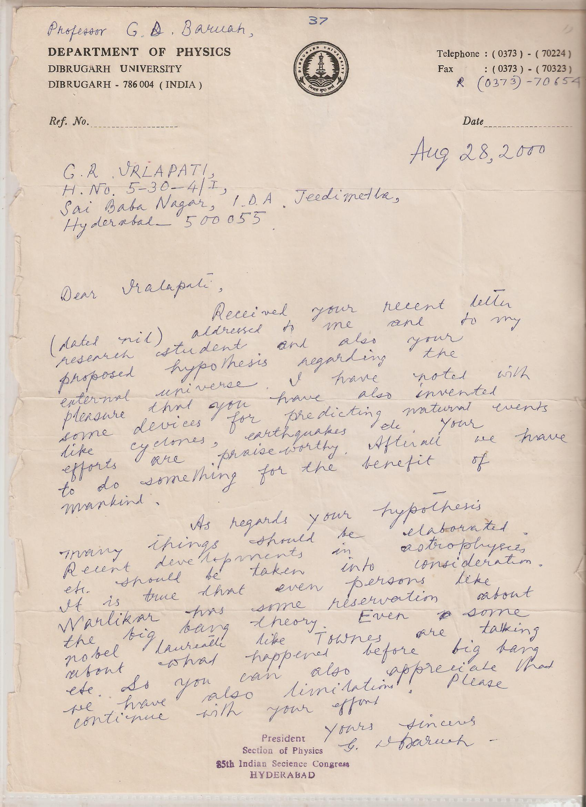

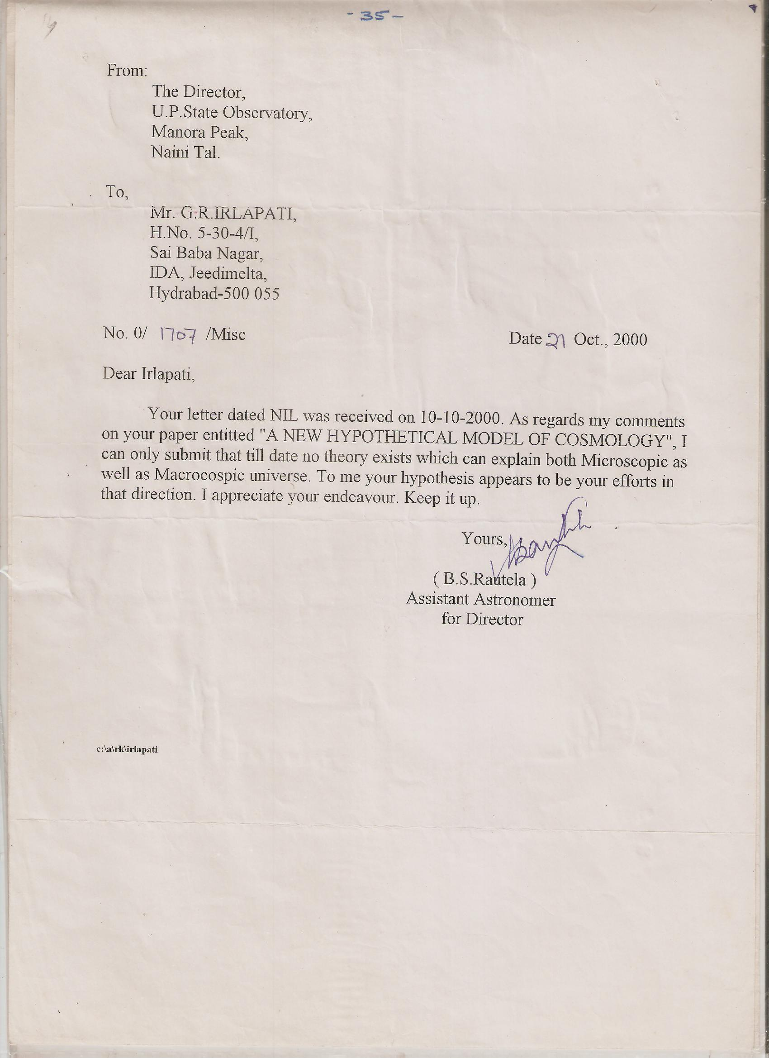

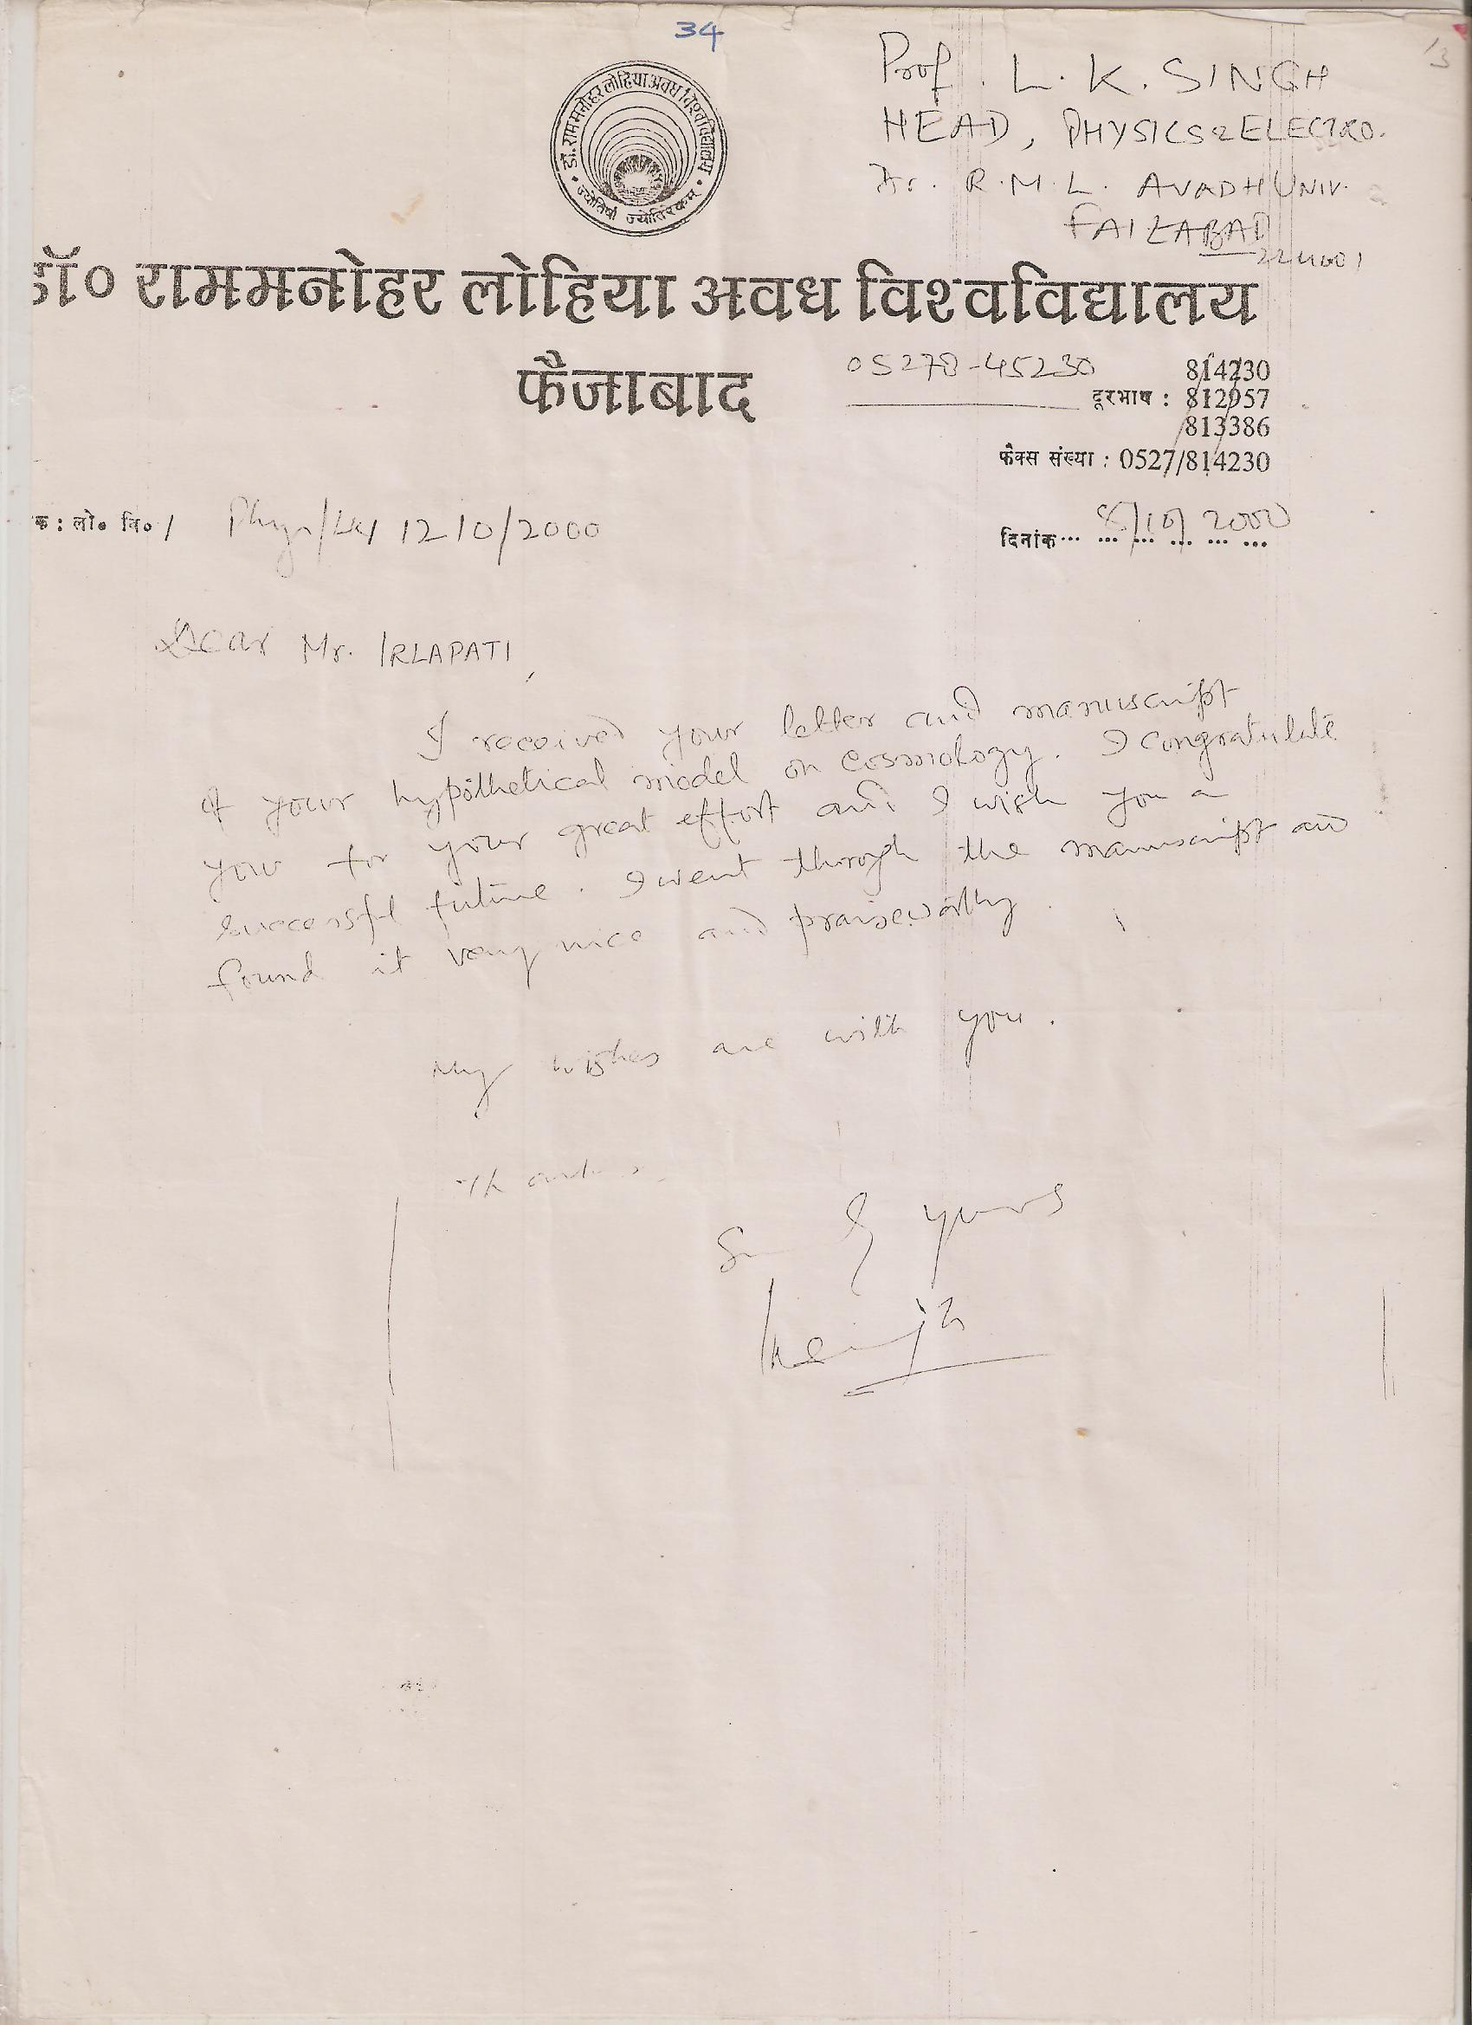

9/1/2016

