Results Of Research On Biophysics “Lisposcope, Biolumicells, Bioforecast”

Gangadhara Rao Irlapati

H.No.5-30-4/1, Saibaba Nagar, Jeedimetla, Hyderabad – 500 055, Telangana State, INDIA
Email ID: scientistgangadhar@gmail.com

Abstract: Biophysics is an interdisciplinary science that applies the approaches and methods of physics to study biological systems. I have conducted many researches in the field of Biophysics and invented some related discoveries & inventions which may also be useful in understanding the extent of the use of biophysics.
[Gangadhara Rao Irlapati. Results Of Research On Biophysics “Lisposcope, Biolumicells, Bioforecast”. Researcher 2016;8(1s):191-194]. ISSN 1553-9865 (print); ISSN 2163-8950 (online). http://www.sciencepub.net/researcher. 7. doi:10.7537/marsrsj0801s16.07.

Key Words: Biolumicells, Lisposcope, Bioforecast.

Introduction:
I have conducted many researches on the bio forecasting methods and invented the simple but peculiar Bio forecasting system in 1965. A research project was jointly conducted with Andhra Pradesh state council of science & Technology, Andhra Pradesh state remote sensing applications centre and Andhra Pradesh Science Centre in 1991. I have invented the bioforecast effect in 1965 by keen study and observations of the LIPOSCOPES biolumicells. Although weakened by forecasting property with less successive rate, it is a primary and natural forecasting method. This is my invention which can help to forecast the weather changes 18 days in advance.
Lisposcope: I first started the researches in 1963-65 @ 5 to 7 years age with little instruments such as papers and pencils, water drop etc. and invented the light spot scope (Liposcope). Liposcope is a simple but wonderful instrument which functions with a natural doctrine hidden secretly in the function of the eye which can help to find out some inventions and discoveries like biolumicells, bioforecast effect etc, Liposcope is my first invention.
Construction: Take one small glass/steel ball or water drop on an object and stand in sun the light. Expose the ball/drop to the sun rays. As a result of the sun rays, there will be a light spot in the drop/ball. Place the light spot closely to the eye. The light spot apperars many times bigger as a circular screen. The appearance in the screen of light spot is the surface of the eyeball. This can be proved by moving eyelids, the movement of eyelids, eye water and some bioluminescent particles on the eyeball can be observed in the screen of light spot.
Principle: The principle of the lisposcope is that the eye lens changes its focal length from a minimum distance to the object at infinity and can see the object. If the distance decreases below minimum, the clarity of vision decreases. At this position, the eye lens acts as a simple microscope and form virtual images of all objects in front of it. We can see them on the screen of light spot if place just unside its minimum distance.
Biolumicells: I have discovered the biolumicells (Bioluminescentmicells) on the eyeball in 1964 in the Lisposcope experiments. These particles are a part and parcel of the human body, may be released within the human body and secreting to the eyeball through the eye water. This is my second invention.
In the lipscope observations we can see three types of bioumicells on the eyeball the first one is the most bright and active and it is seen rarely on the eyeball and this biolumicell is has high velocity, mechanical energy, spin around itself it. The second one has normal bright seen normally on the eyeball and the third and last one is bright less, it is seen frequently on the eyeball.
Bioforecast: Looking the screen of light spot and move the eyelids. We can see some biolmicells on the eyeball. After finding a number of biolumicells all at once in cloud or group, you must count them without eyelid movement. Firstly, observe with one eye two or three times. Later on another eye. As we examine one after another with both eyes, we have to take into account the greatest number of particles.
Analyze the data and make a table with the particulars-date of observation, time of observation , number of particles and weather report. Firstly we must put the date, next the time of observation, then the number of particles available in the observation. Do the observations three or four times daily in the morning & evening and record the number. At last, record the weather report of the country on the same day. If we do our observations and analyze in that manner, we can notice that there is a relation between the differences in particles number in the table and the changes in the weather after about 18 days. If the particles number is minimum the weather after 18 days will be normal. On the other hand if the particles number is at maximum there will be a change in the weather after 18 days.
Principle: The cause is unknown however it can understand that generally biolumicells secrete in less or minimum levels at normal weather conditions, but over the formation of low pressure weather conditions, biolumicells begin to secrete at maximum levels due to a fall in weather pressure on the human body.
Experiment Carried Out: Many experiments were carried out on the liposcope, biolumicells and its bioforecasting methods & it were successfully proved out in practice.
Great Prediction: The important prediction of the bioforecast effect was proved in 1991. In 1991, the Andhra Pradesh state council of science & Technology, The Andhra Pradesh Remote Sensing Applications Centre and the Andhra Pradesh Science Centre were conducted experiments on the relationship between the biosphere and atmosphere (explore the inter-connection of earths geomagnetic field with natural calamities and their effect on human impulse). In these observations, the maximum level of the biolumicells were recorded between 7th to 11th of April, 1991. It is the sign of the ensuring cyclone of the 28th April 1991. The three directors of the said institutions were met in the Andhra Pradesh state Council of Sciences & Technology on 9TH, April 1991 and discussed about the prediction. As predicted on 9th April 1991, in the meeting a severe cyclone was formed in Bay of Bengal and struct the Bangladesh on 28th April 1991. As a result, thousands of people were killed and crores of rupees property was damaged. This is the great prediction by the bioforecast and the remaining predictions were weak.

References
- Nelson john H, cosmic patterns; theirs influence on man and his communications 1974 American federation of astrologers.
- Nelson j. h, RCA review, april 1951.
- Nelson J. H., J. geocosmic research, summer 1974.
- SATO live bioforecasting www.Jst.go.Jp.
- Bio weather forecast; www.weather forecasting.com/locations/bio-3/forecasts latests.

Appendicies: (Biophysics)

Analysis Of Data Of Bio Forecast
Date of Experiment | Number of Biolumicells | Actual Weather
1-May-1991 | 8
2-May-1991 | 14
3-May-1991 | 19
4-May-1991 | 20
5-May-1991 | 28
6-May-1991 | 22
7-May-1991 | 50
8-May-1991 | 65
9-May-1991 | 83
10-May-1991 | 89
11-May-1991 | 72
12-May-1991 | 40
13-May-1991 | 30
14-May-1991 | 14
15-May-1991 | 11
16-May-1991 | 6
17-May-1991 | 12
18-May-1991 | 3
19-May-1991 | 10
20-May-1991 | 8
21-May-1991 | 16
22-May-1991 | 9
23-May-1991 | 12
24-May-1991 | 5
25-May-1991 | 6 | Low
26-May-1991 | 10 | Low
27-May-1991 | 19 | Depression
28-May-1991 | 8 | Cyclone
29-May-1991 | 3 | Cyclone
30-May-1991 | 11 | Depression
31-May-1991 | 9 | Depression

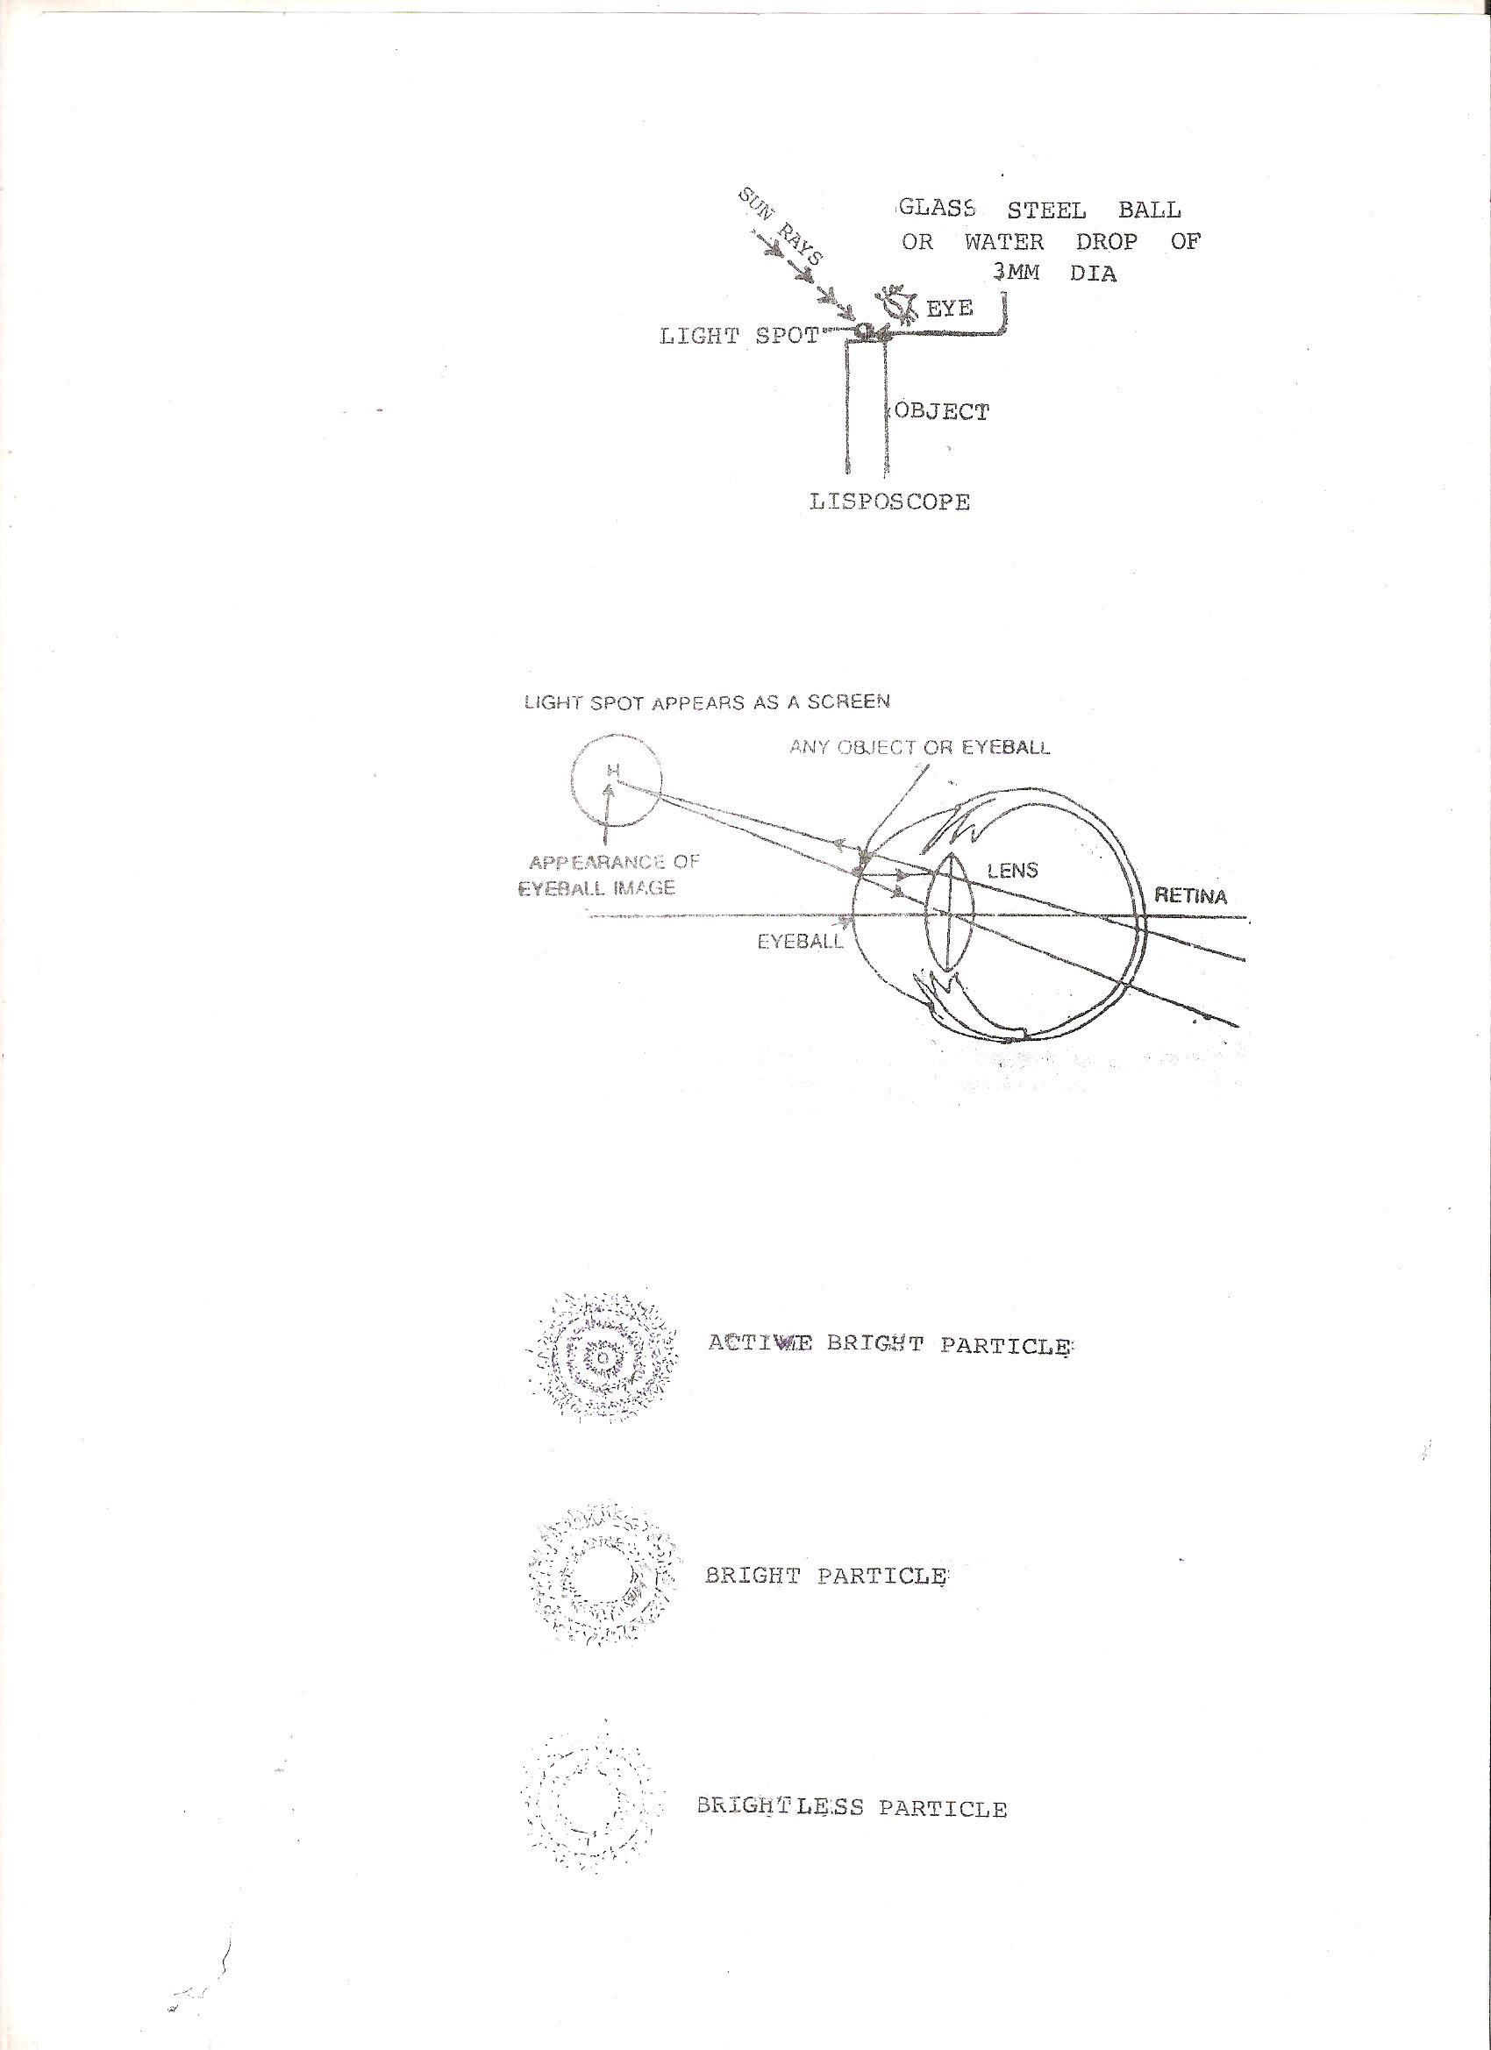
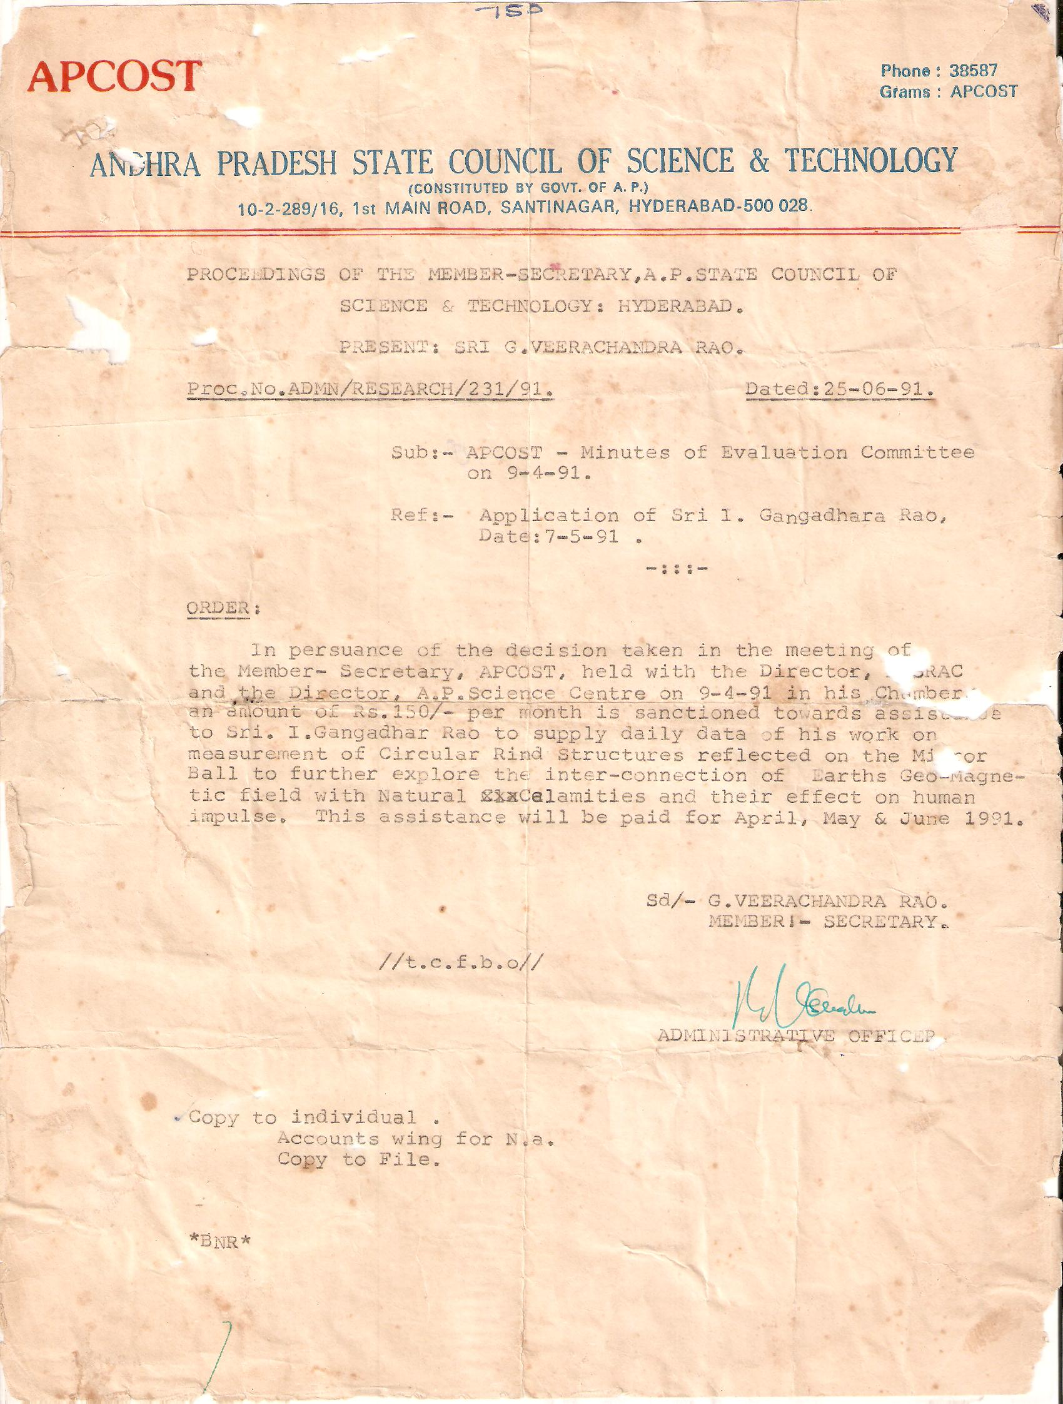

9/1/2016

