Results of Research on Astrophysics (Inventions of A New Hypothetical Model of Cosmology & Global Monsoon Time Scale)

Gangadhara Rao Irlapati

H.No.5-30-4/1, Saibaba Nagar, Jeedimetla, Hyderabad – 500 055, Telangana State, INDIA
Public Service Commission, Andhra Pradesh, India
Email ID: scientistgangadhar@gmail.com

Abstract: I have conducted many studies on astrophysical sciences and proposed many inventions which can help to study astrophysical sciences. A new Hypothetical Model of cosmology by which we can study the origin, structure, nature and evaluation of the universe and the other is Global Monsoon Time Scale by which we can study the relationship in between the around the sun and its influence on the earth’s weather in formation of the Global Monsoons.
[Gangadhara Rao Irlapati. Results of Research on Astrophysics (Inventions of A New Hypothetical Model of Cosmology & Global Monsoon Time Scale). Researcher 2016;8(1s):162-190]. ISSN 1553-9865 (print); ISSN 2163-8950 (online). http://www.sciencepub.net/researcher. 6. doi:10.7537/marsrsj0801s16.06.

Keywords: Research; Astrophysics; Inventions; Hypothetical Model; Cosmology; Global Monsoon Time Scale

A New Hypothetical Model Of Cosmology:
The cosmos is made up of universes in infinite number, having similar structure and properties, embedded one in each other and extended in ascending and descending order.
To explain and justify this model, there are three universes so far known to us (a) Geo-Universe (b) Atomic-Universe (c) Energy-Universe. These three are having similar structure and properties, embedded one in each other and extended in ascending and descending order. Of these three, we known some extent about the internal structure and properties of the Geo-Universe but we do not known its external structure. We know some extent about the external structure and properties of the Energy-Universe but we do not know its internal structure. Between of these three universes, we came to know a large extent about the internal & external structure and properties of the Atomic-Universe. Hence, I have taken the similarities of internal structure & properties between the Geo-Universe & Atomic-Universe to propose that all the universes in ascending and descending order of the creation are having similar internal structure and properties. The similarities of external structure & properties between the Atomic Universe and Energy-Universe are taken to propose that all the universe in ascending and descending order of creation are having similar external structure and properties. And the manner in which of these three universes i.e., embedded one in each other, extended in ascending and descending order to propose that all the universes in ascending and descending order of the creation are embedded one in each other and extended in ascending and descending order.
Similar External Structure & Properties:
According to the model, all the universes in ascending and descending order of the creation are having similar external structure and properties. To justify this, I have taken many similarities between the atom and photon For example:

Atomic-Universe Energy-Universe
1) The atom appearing in several forms such as 1) The particle “Photon” related to
Hydrogen to uranium etc., being due to the energy appearing in several forms such
Internal structure having different atomic particles as radio waves, gamma rays, violet rays
at various numbers. etc being may be probably due to the
internal structure having different
particles at various numbers.
2)The atom exhibiting several physical and chemical 2)The particle “photon” related to energy
Properties such as weight, colour, taste, hardness exhibiting properties such as wave length,
etc being due to the internal structure having different colour, temperature etc being may be
particles at various number. Probably due to the internal structure
having different particles at various
number.

Similar Internal Structure & Properties:
According to the model, all the universes in ascending and descending order of the creation are having similar internal structure and properties. To explain and justify this, I have taken many similarities between the atomic-universe and Geo-Universe.

Atomic-Universe Geo-Universe
1)Various atomic particles at different sizes in 1) Various astronomical objects at different
several numbers are present in the atom. sizes in several numbers are present in the
Geo- Universe.
2) These atomic particles having three types of 2) These astronomical objects having three
charges at negative, positive and neutral states type of charges at positive, negative and
are present in the atom. neutral states are present in Geo-Universe
3) Positively charged protons are present in the nucleus. 3) Stars built by atoms having positive
charged nucleus are present in centre of
the Geo-Universe
4) Neutrons at neutral state are present in the Nucleus. 4) Planets at neutral state are present in
Centre of the Geo-Universe.
5) Negatively charged electrons are present at large 5) There is a concept that anti-matter cosmic
distance of the atomic nucleus in the atom. bodies built by atoms having negatively
charged nucleus are present at large
distance of the Geo-Universe.
6) Additional neutrons called isotopes are present. 6) Additional planets called satellites around
the planets are present.
7) Radiation emitting from the atom. 7) Cosmic rays emitting from the Geo-
Universe.
8) There is a property of nuclear fission is in the atom. 8) There is a property of super Nova is in the Geo- Universe.

Descending Order Of Creation:
The Geo-Universe that means the Universe seen around our earth is having magnificent structure and properties such as galaxies, stars and planets and some planets such as earth having continents, countries, oceans, trees, animals. Cyclones, human beings etc. Such Geo-Universe being built by Universes of its descending order of creation that means atoms.
Atomic-Universe that means the atom present in several forms from hydrogen to uranium etc is another universe having magnificent structure and properties such as electrons, protons, neutrons, etc., and continents, countries, oceans, cyclones, trees, animals, human beings may be present on some neutrons having suitable conditions exactly similar to the earth planet resembling in the Geo-Universe. Such atomic Universe being built by universes of its descending order of creation that means energy particle ‘photons”.
The Energy-Universe that means the particle “photon” related to energy present in several forms of electromagnetic radiation is also another universe having magnificent structure and properties resembling to Geo-Universe and atom. Such Energy-Universe may also being built by Universes of its descending order of creation that is not yet known to us.
Thus the descending order of creation continuous infinitely.
Ascending Order Of Creation:
The Energy-universe that means the particle related to energy “photon” having magnificent structure and properties is being as a primary syntactic unit in the universe of its ascending order of creation that means atom. All components in the atom are built by these “photons” in infinite number. Such each and every energy particle “photon” is basis to an infinite descending order of creation.
The Atomic—Universe that means the “Atom” having magnificent structure and properties is being as a primary syntactic unit in the universe of its ascending order of creation that means in our Geo-Universe. All components in the Geo-Universe such as stars, planets etc., are built by these atoms in infinite number. Such each and every atom is basis to an infinite descending order of creation.
The Geo-Universe that means the “Universe” seen around our earth having magnificent structure and properties is being as a primary syntactic unit in the universe of its ascending order of creation that is not yet known to us. All components in that Universe are built by these Geo-Universes in infinite number. Such each and every Geo-Universe in that ascending creation is basis to an infinite descending order of creation.
Thus the ascending order of creation continuous infinite.
Cosmic-Environments:
The fill of structure and characteristics in the universe of the cosmos proposed as cosmic environments. For example the fill of structure and characteristics like galaxies, stars, planets etc in the Geo-Universe proposed as Geo-Environment, the fill of structure and characteristics like proton, neutrons and electrons etc in the Atomic-Universe proposed as Atomic-Environment and the fill of structure and characteristics in the Energy-Universe that means in the photon that is not yet known proposed as Energy-Environment.
Space Weather:
The fill of structure and characteristics like galaxies, Stars, Planets and their orbits and other physical forces etc that surrounds in the universe proposed as space atmosphere, the state of galaxies, stars, planets, nebulas. Pulsars etc at a particular region over a long period of time proposed as space-climate, the state of characteristics of space- climate like solar wind flares, asteroids etc at a particular region during a short period of time proposed as space-weather.
Space Regions:
The state of space atmosphere being in still proposed as “Inactive Space Region”, the state of space atmosphere being in active proposed as “Active Space Region” The region of space atmosphere in which the celestial bodies are more widespread areas proposed as “Space High Pressure Area”, the less widespread areas proposed as “ Space Low Pressure Area”.
Space Low Pressure Systems:
Some space times, happens variation of differences of pressure in the space-climate, At such a juncture, the celestial bodies and other space dust present in the space high pressure area will try to occupy the space low pressure area all at once. In this attempt, they will whirl around the space low pressure area. The centre of space low pressure area itself is the black-hole and the circular whirling celestial bodies & other space dust etc caused by the space low pressure area proposed as Galaxy.
Global Monsoon Time Scale:
The global Monsoon Time Scale – a Chronological sequence of events arranged in between time and weather with the help of a scale for studying the past’s, present and future movements of monsoon of a country and its relationship with rainfall and other weather problem and natural calamities.
Prepare the Global Monsoon Time Scale having 365 horizontal days from March 21st to next year March 20th of a required period comprising of a large time and weather have been taken and framed into a square graphic scale. The main weather events if any of the country have been entering on the scale as per date and month of the each and every year. If we have been managing the scale of a country in this manner continuously, we can study the past, present and future movements of monsoon of a country. We can make separate monsoon time scales per each and every individual country.
Indian Monsoon Time Scale:
For example, I have prepared the monsoon time scale for India by preparing the scale having 365 horizontal days from 1st April to next year March 31st of 128 years from 1888 to 2016 of the required period comprising of large time and weather have been taken and framed into a square graphic scale. The monsoon pulses in the form of low pressure systems over the Indian region have been entering on the scale in stages by 1 for low, 2 for depression, 3 for storm, 4 for severe storm and 5 for severe storm with core of hurricane winds pertaining to the date and month of the each and every year. If we have been managing the scale in this manner continuously, we can study the past’ present’s and future’s of the India Monsoon and its relationship with rainfall and other weather problems & natural calamities in India.
Analysis: The India Monsoon Time Scale reveals many secrets of the Indian monsoon and its relationship with rainfall & other weather problems and natural calamities. For example, some bands, clusters and paths of low pressure systems along with the main paths of the Indian Monsoon (South-east monsoon and north-west monsoon) clearly seen in the map of the Indian monsoon it have been some cut-edged paths passing through its systematic zigzag cycles in ascending and descending orders which causes heavy rains & floods in some years and droughts & famines in another years according to their travel. For example, during 1871-1990’s, the main path of the Indian Monsoon was rising over June, July, August and creating heavy rains and floods in most years. During 1900-1920’s, it was raising over August, September and resulting good rainfall in more years. During 1965-2004’s it was falling over September and causing low rainfall and droughts in many years. At present it is rising upwards over June, July, August, September and will be resulting heavy rains & floods in coming years during 2004-2060. The tracking date of main path & other various paths such as south-east monsoon and north-west monsoon etc., of the Indian Monsoon denotes the onset of the monsoon, monsoon pulses or low pressure systems. And also we can find out many more secrets of the Indian monsoon such as droughts, famines, cyclones, heavy rains, floods, real images of the Indian monsoon, and onset & withdrawals of south east monsoon and north-west monsoon etc. by keen study of the Indian Monsoon Time Scale.
Principle: This is an Astrogeophysical/ Astrometeorological phenomenon of effects of astronomical bodies and forces on the earth’s geophysical atmosphere. The cause is unknown however the year to year change of movement of axis of the earth inclined at 23½ degrees from vertical to its path around the sun does play a significant role in formation of clusters, bands & paths of the Indian Monsoon and stimulates the Indian weather. The inter-tropical convergence zone at the equator follows the movement of the sun and shifts north of the equator merges with the heat low pressure zone created by the rising heat of the sub-continent due to direct and converging rays of the summer sun on the India Sub-Continent and develops into the monsoon trough and maintain monsoon circulation.
Conclusions:
We can make many more modifications thus bringing many more developments in the Global Monsoon Time Scale. We can also make many more changes and development in the monsoon time scales and make separate monsoon time scales in name of each and every country of the world in accordance with the weather circumstances of the countries.
And also we can make many more modifications thus bringing many more developments in the Geoscope and make many types of Geoscope models and centres.

Appendices:
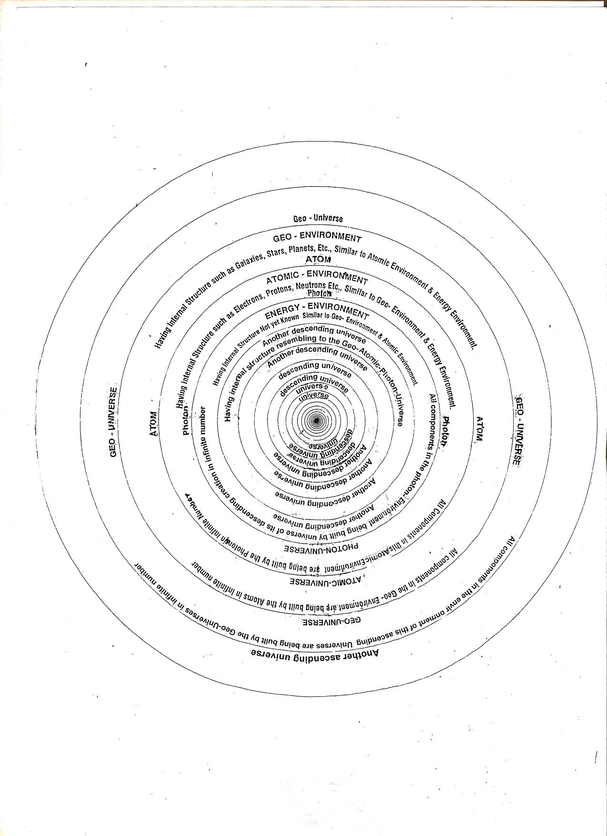

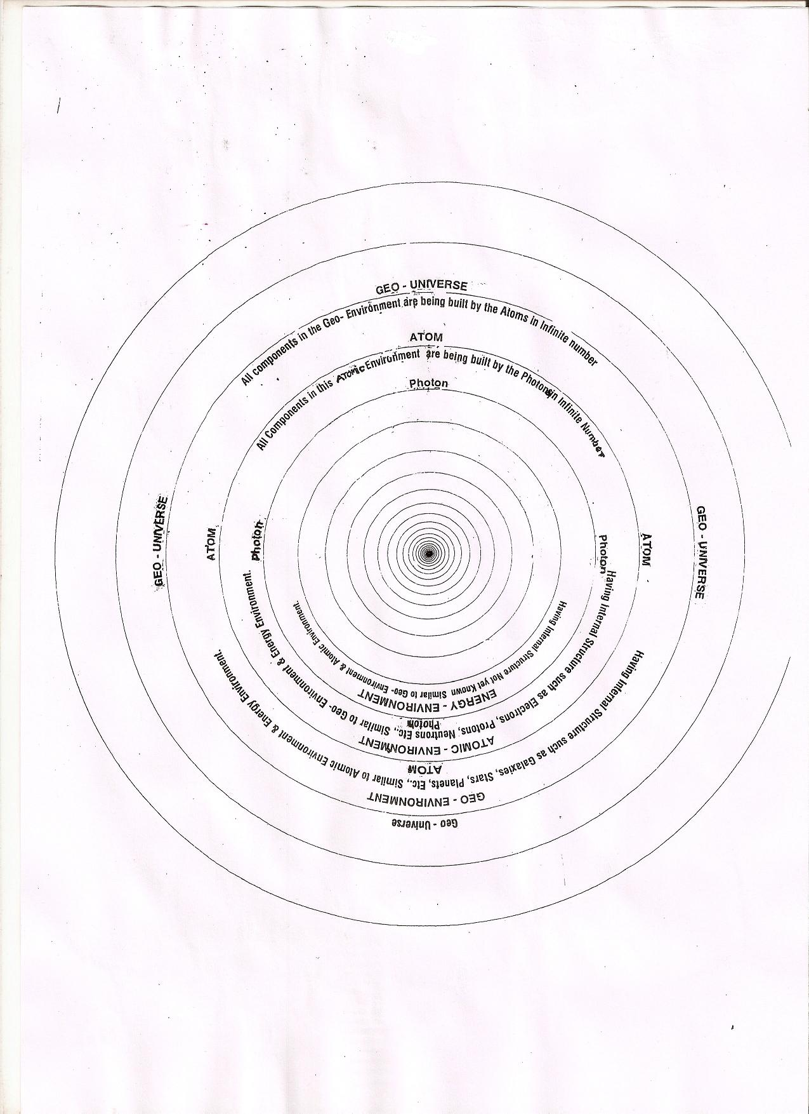

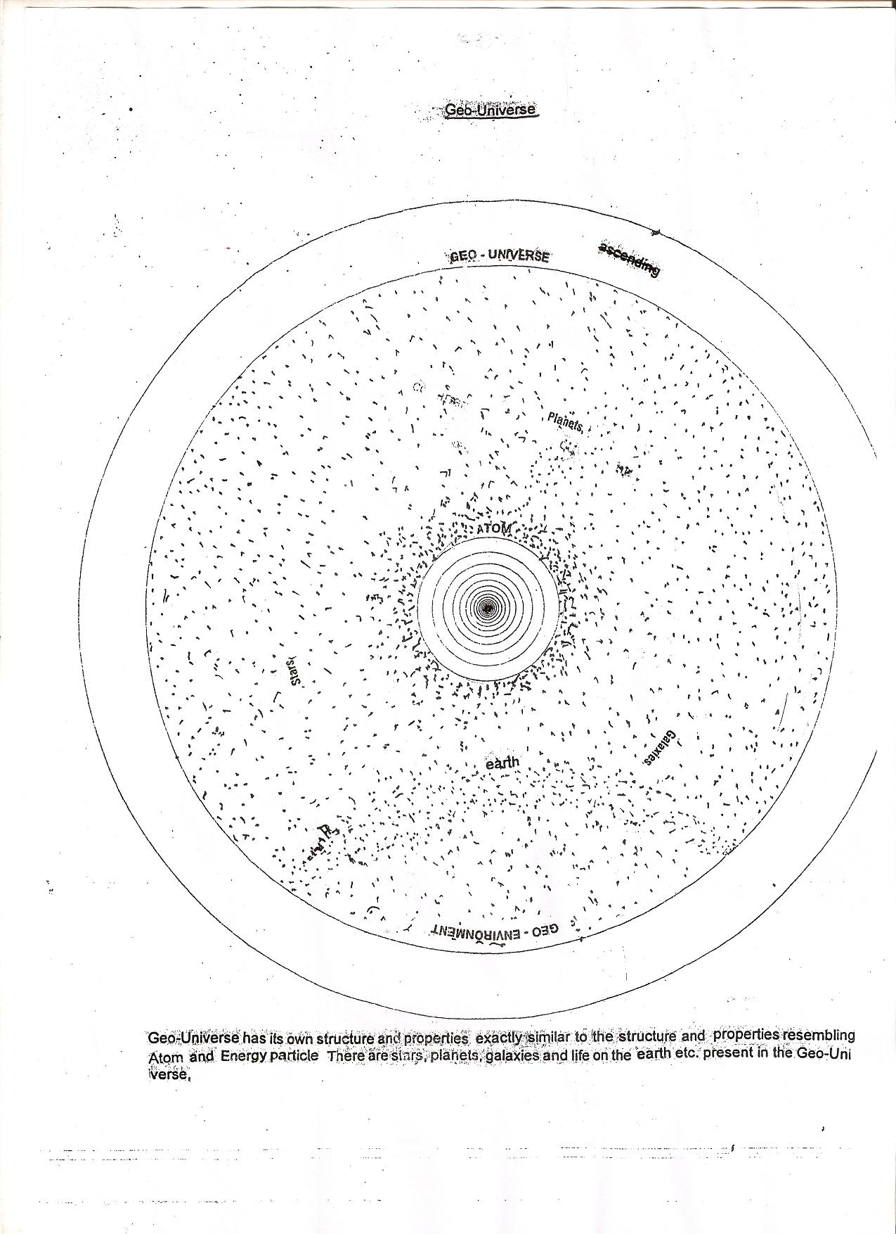

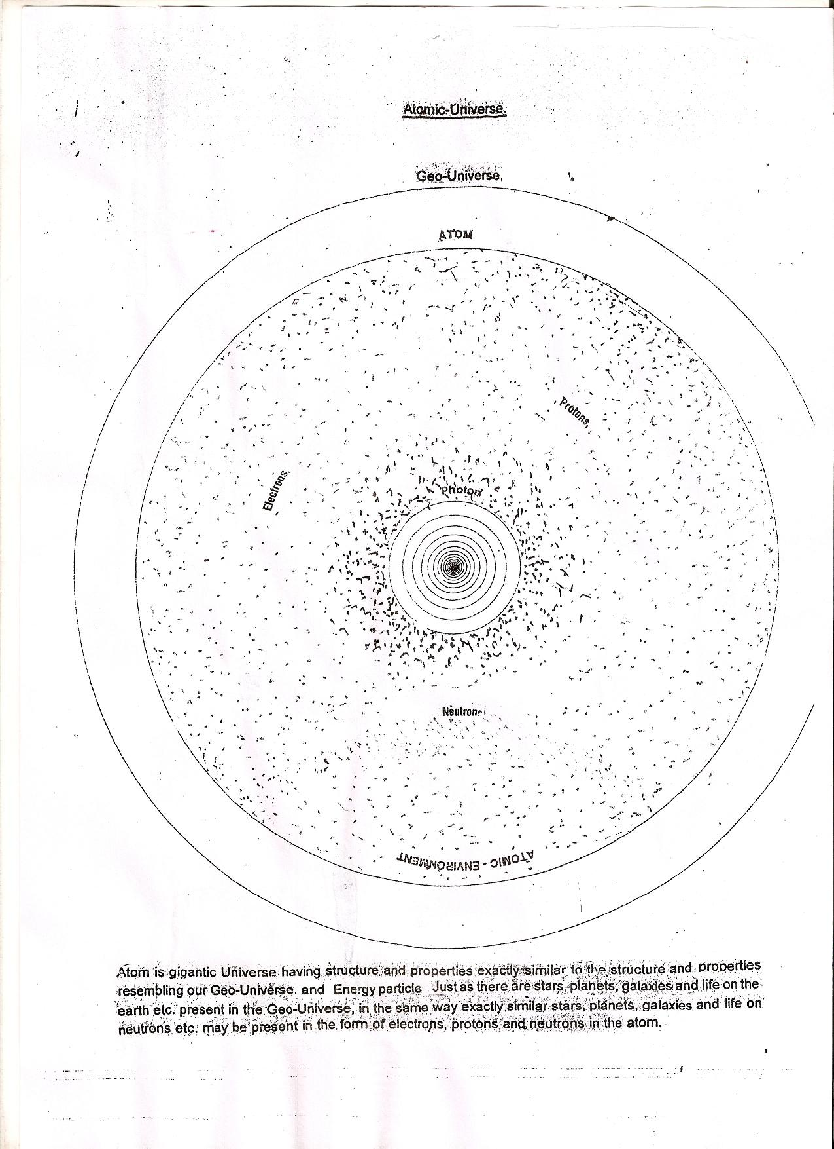

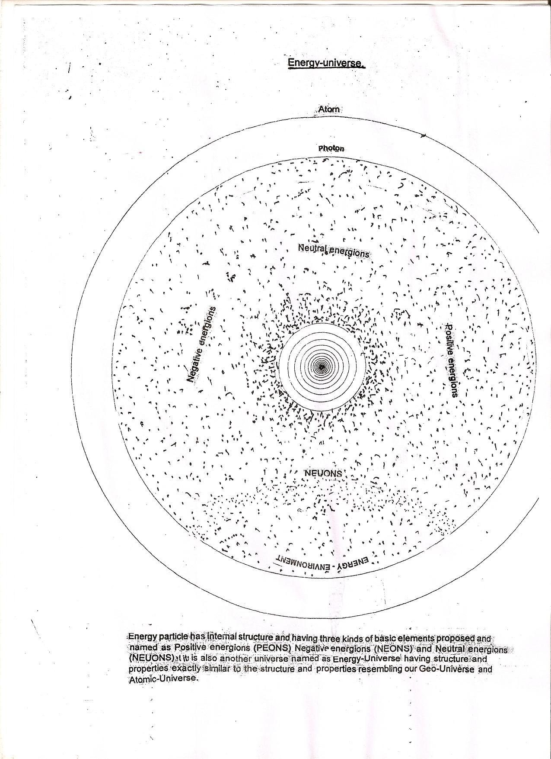

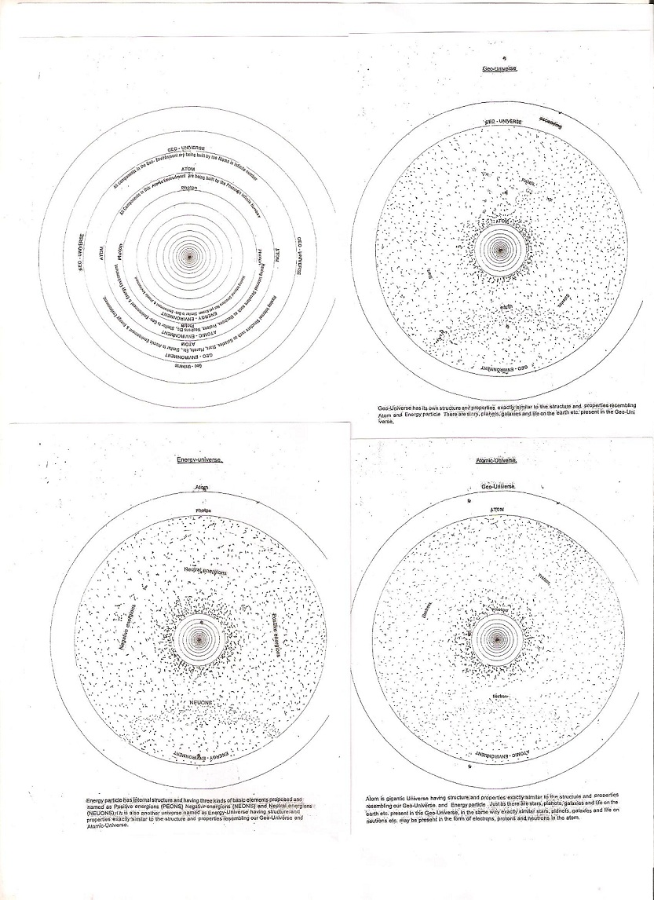

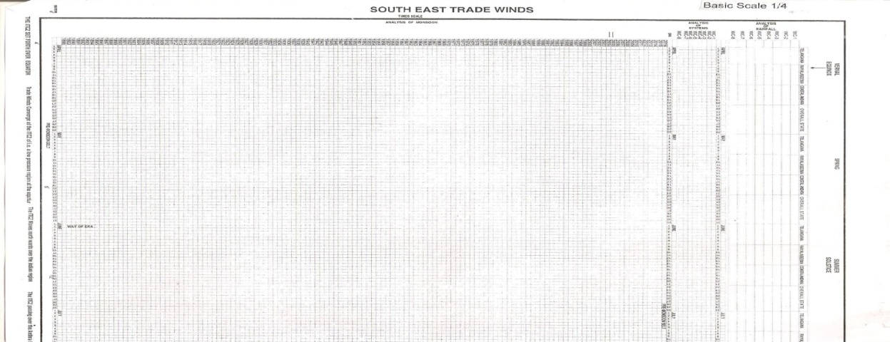
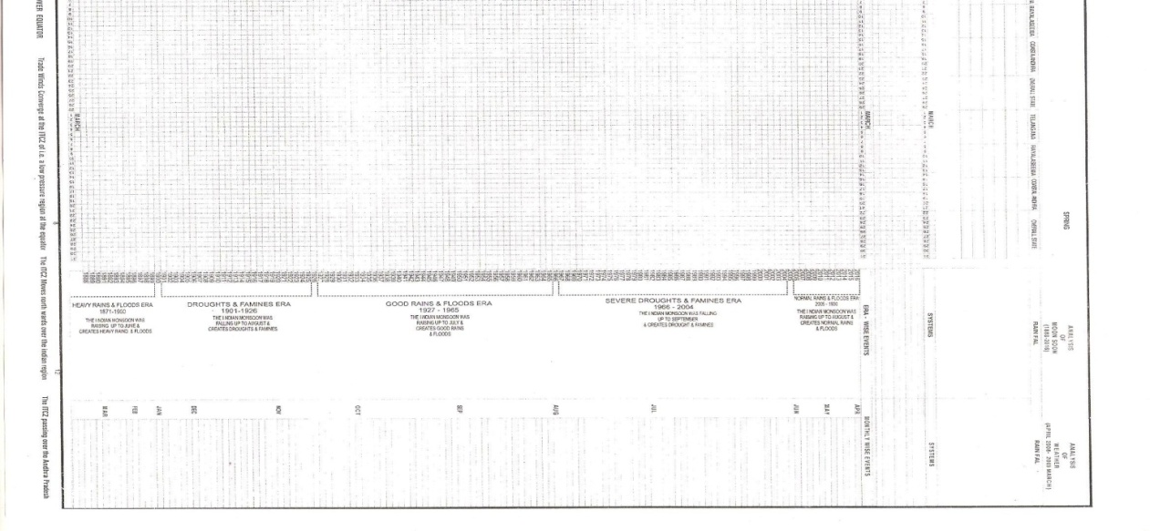

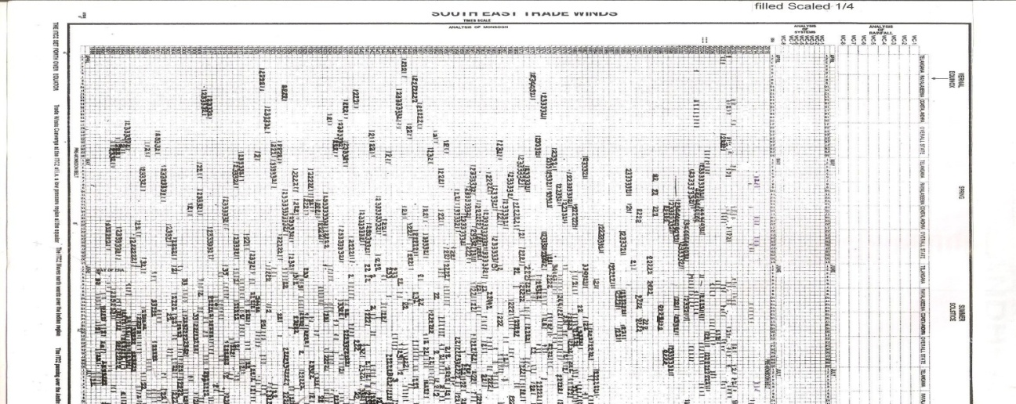
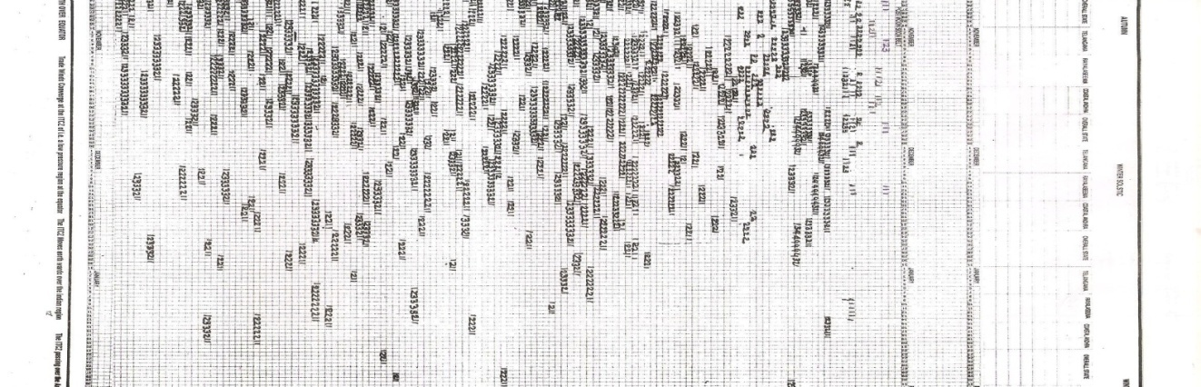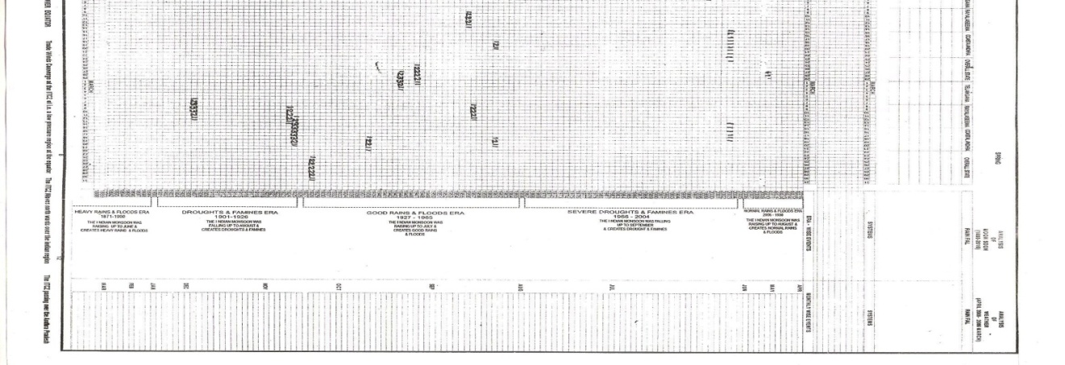

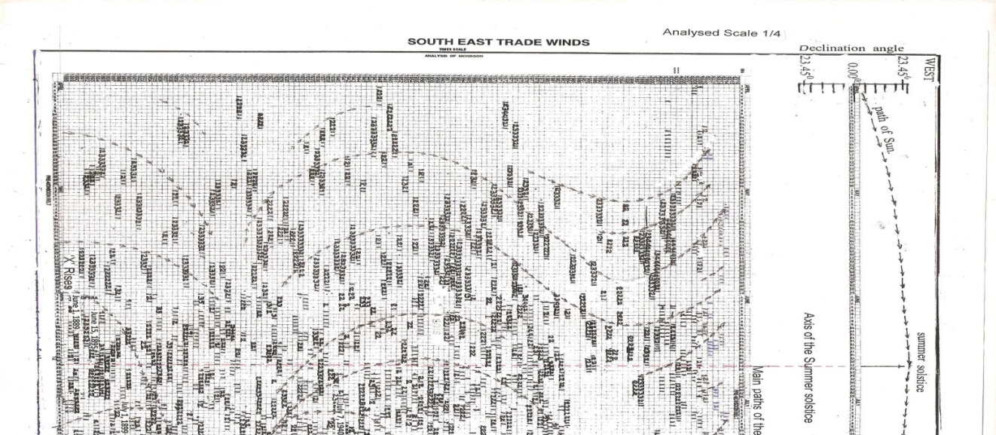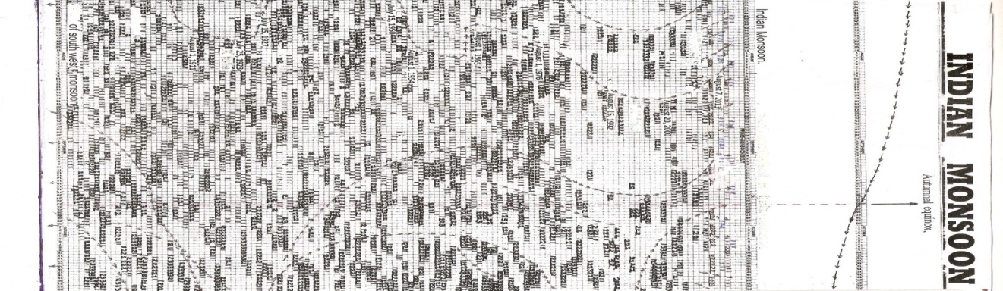
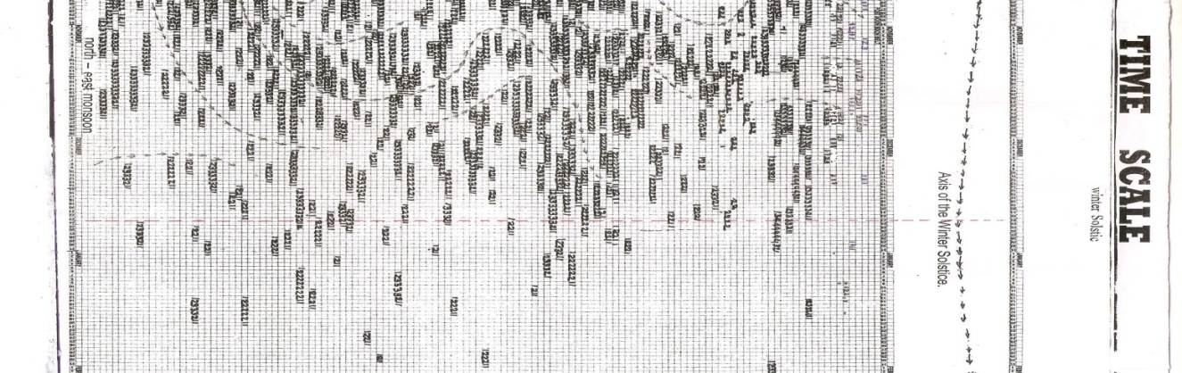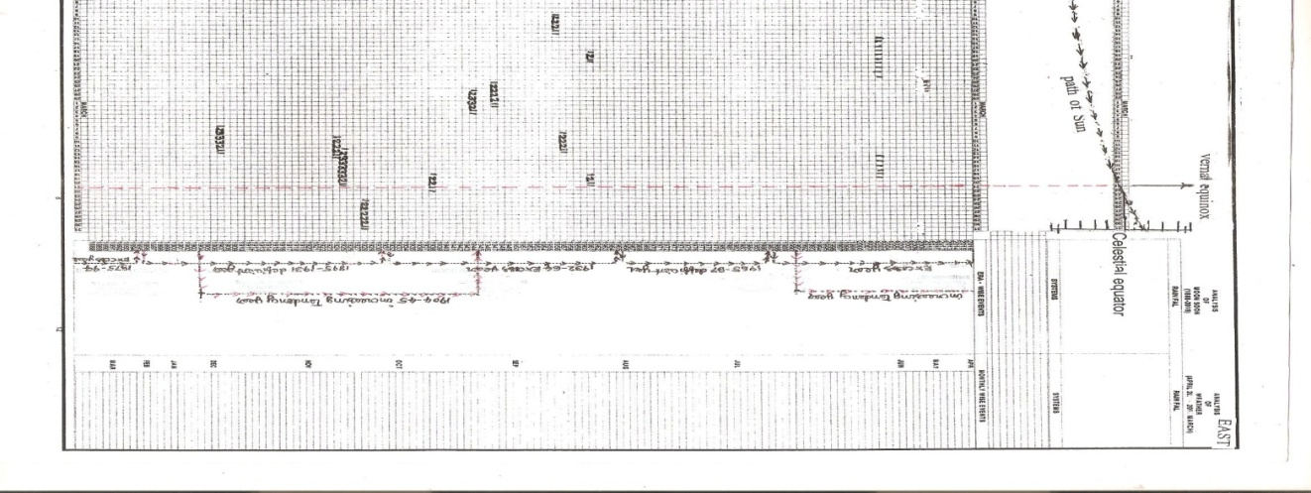

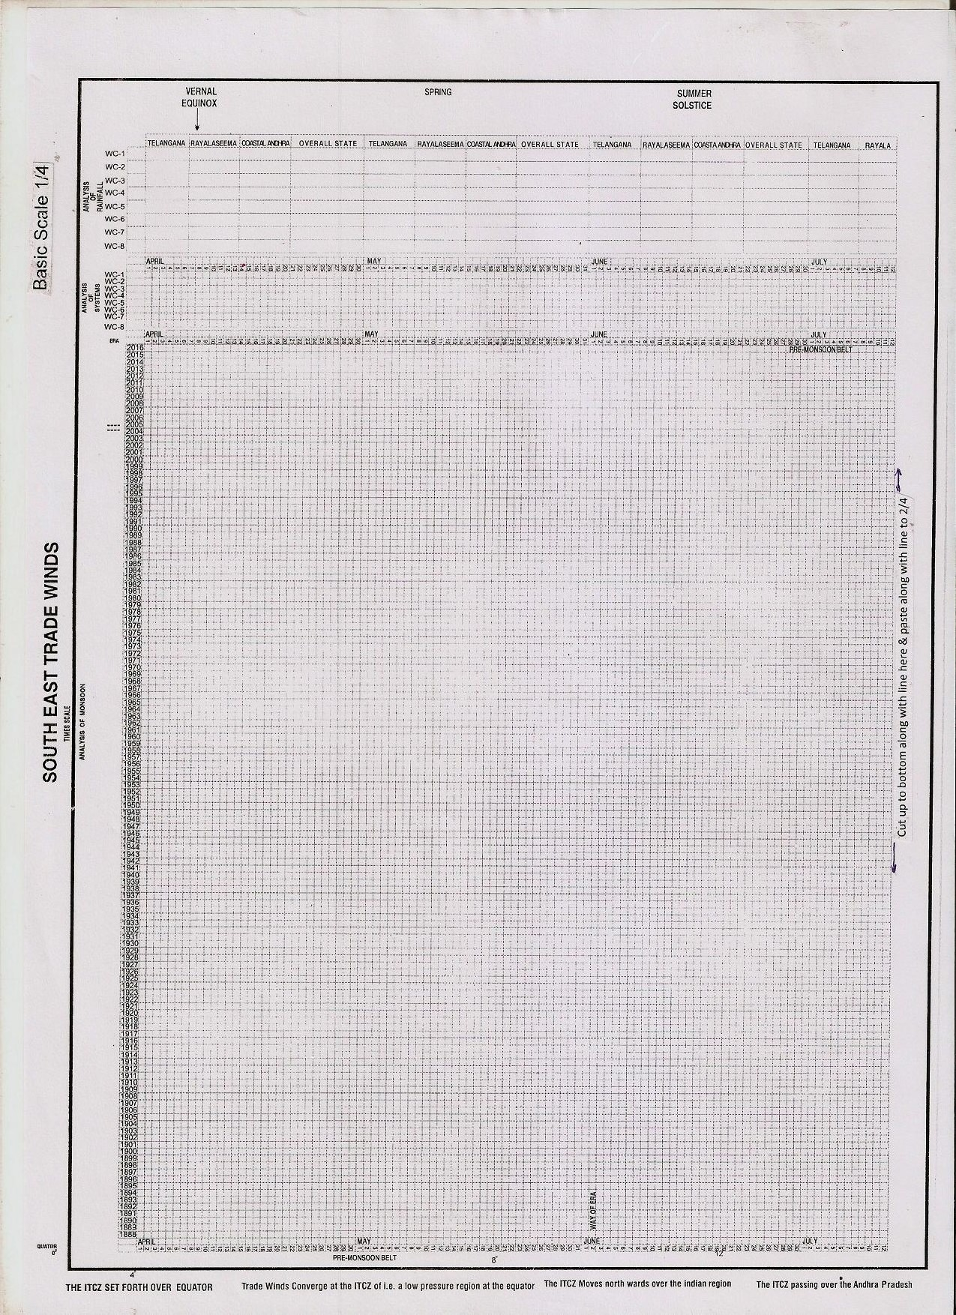
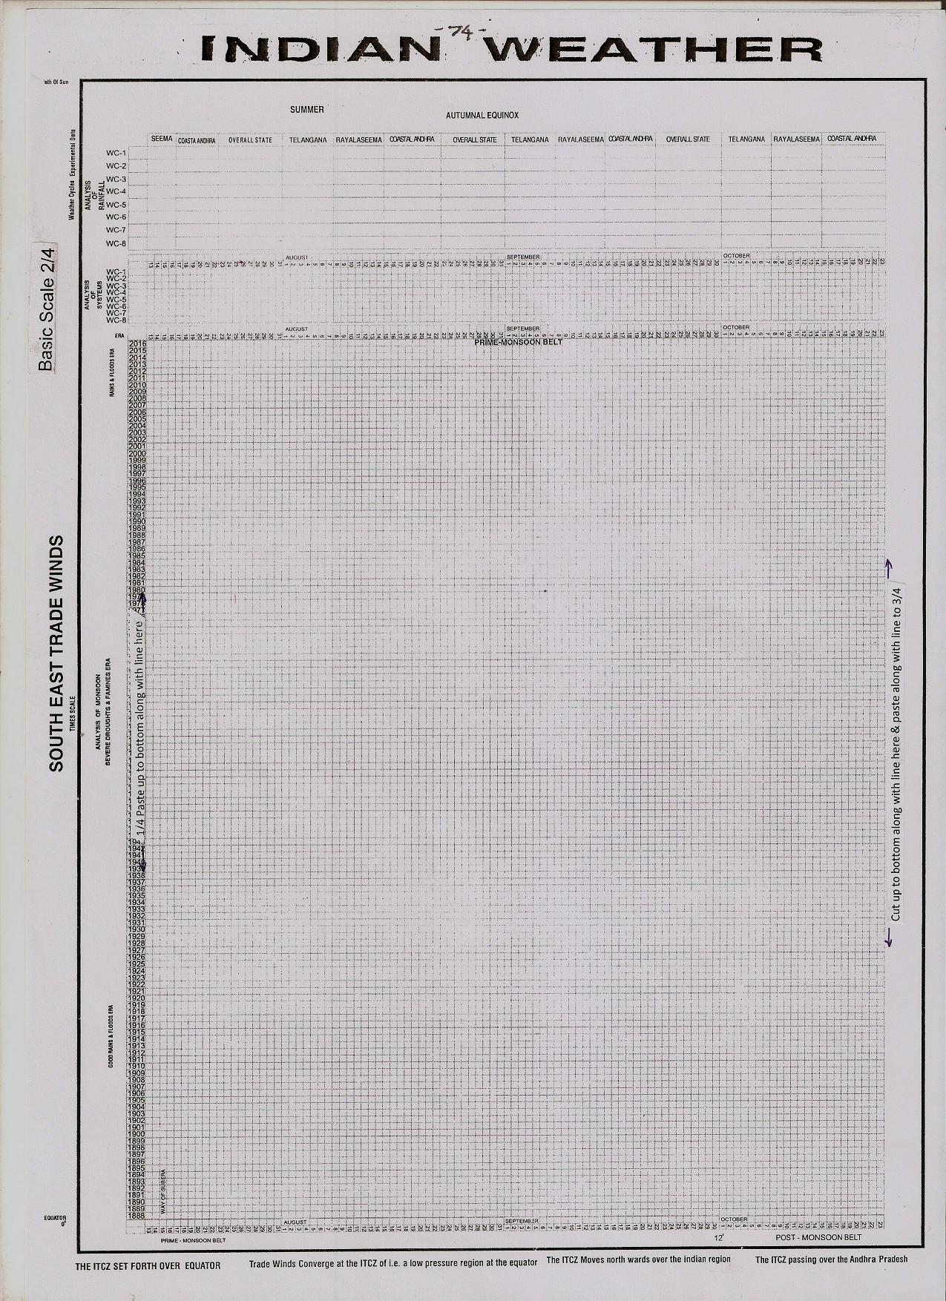
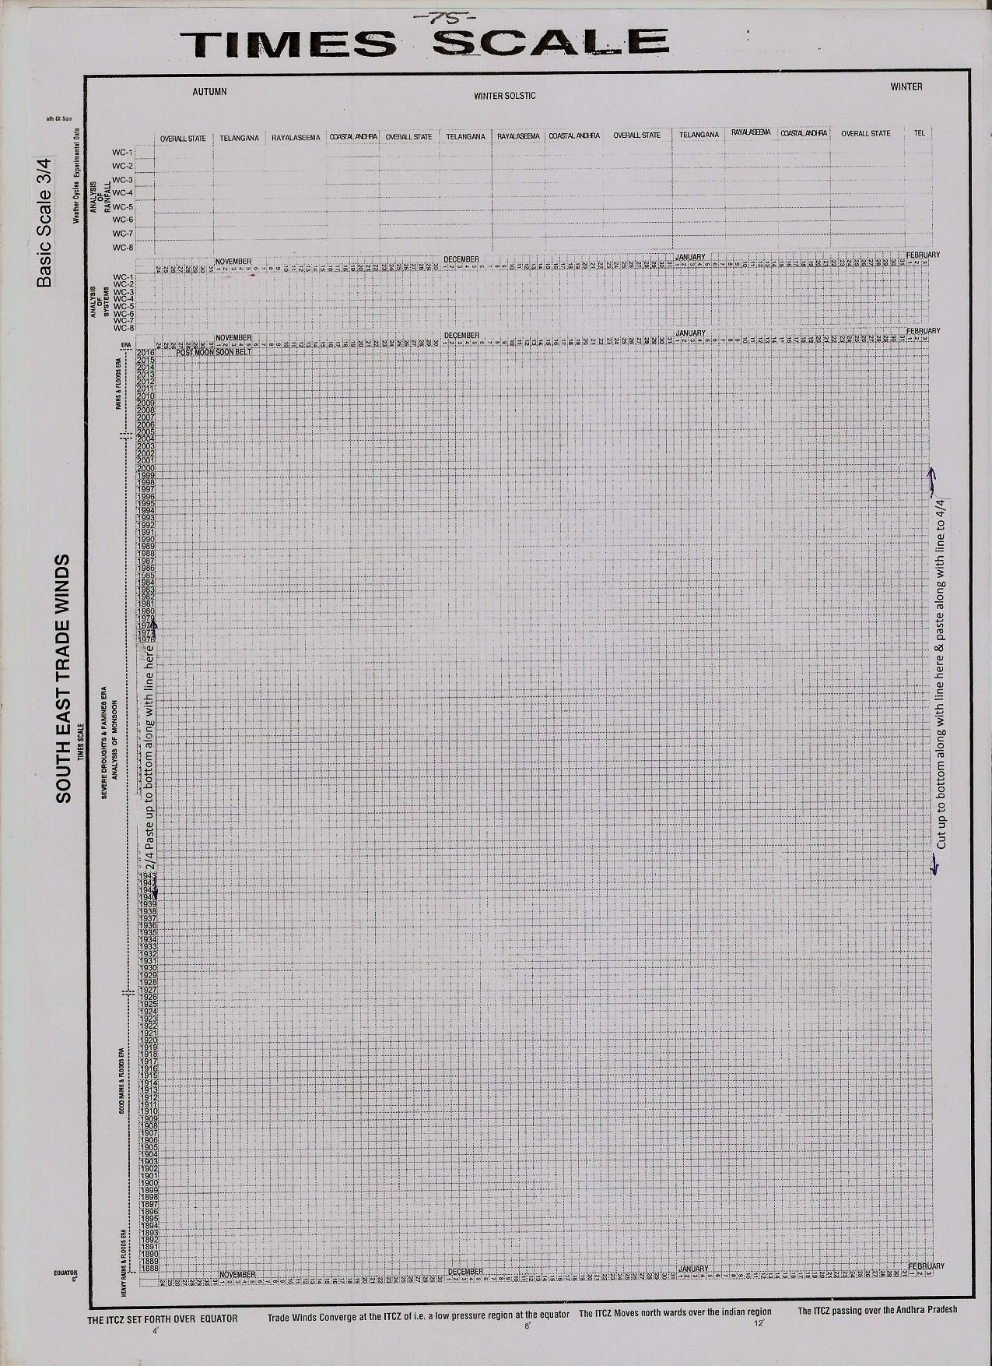
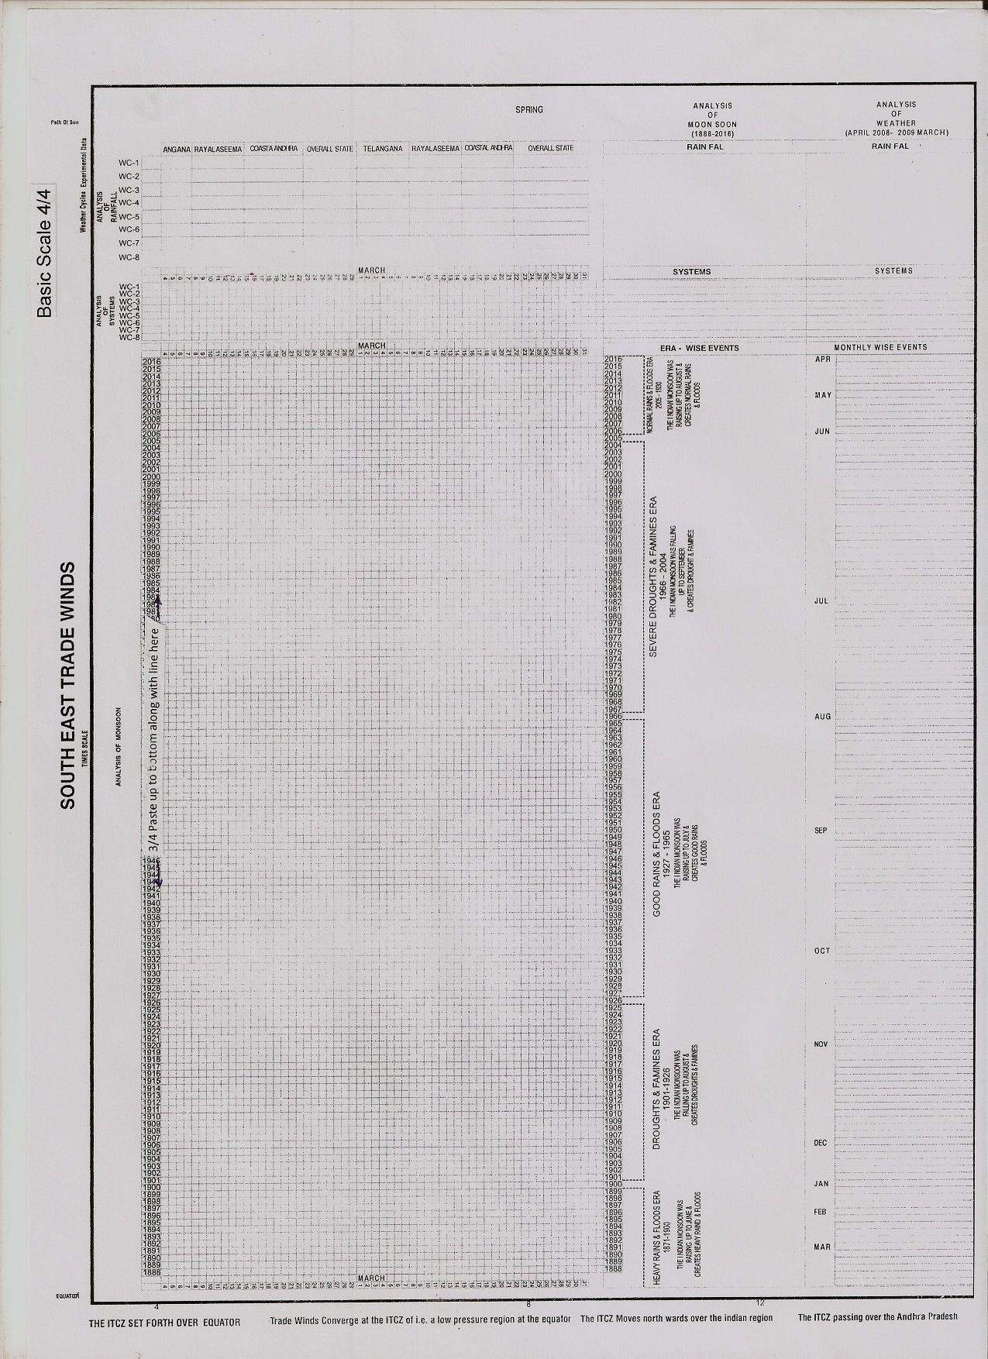
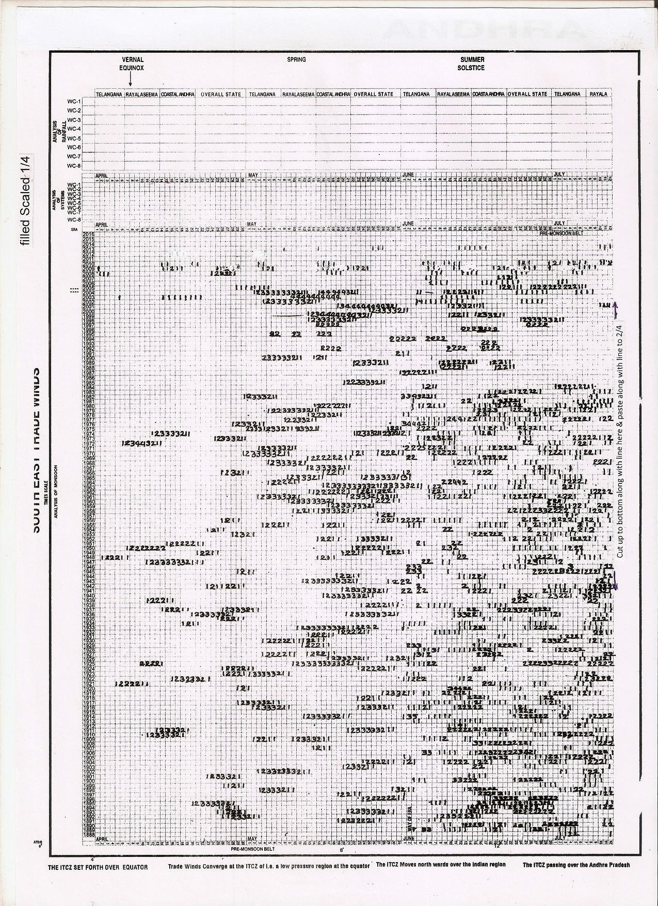
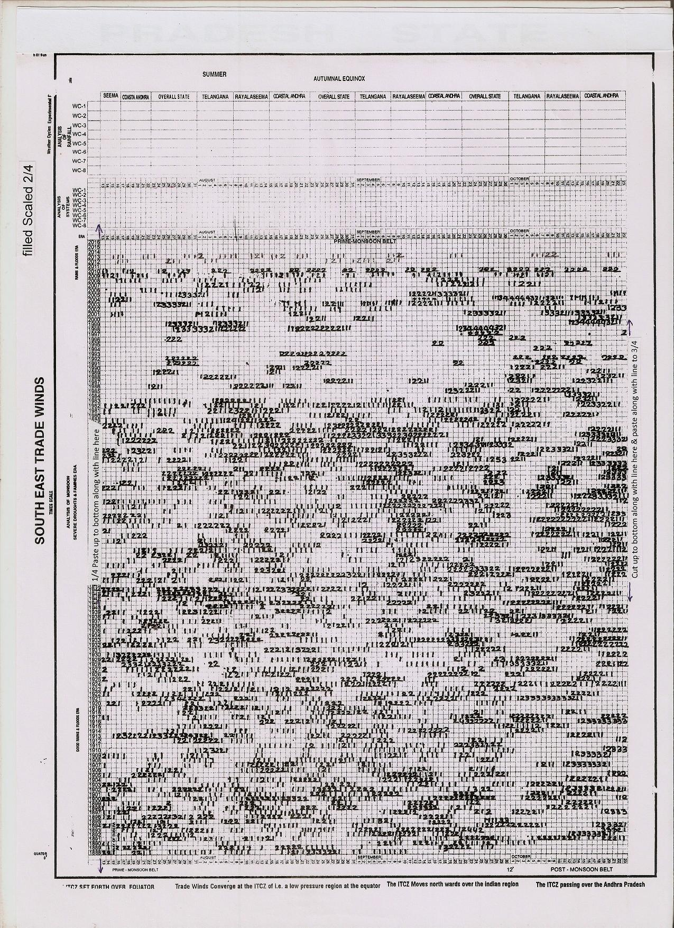
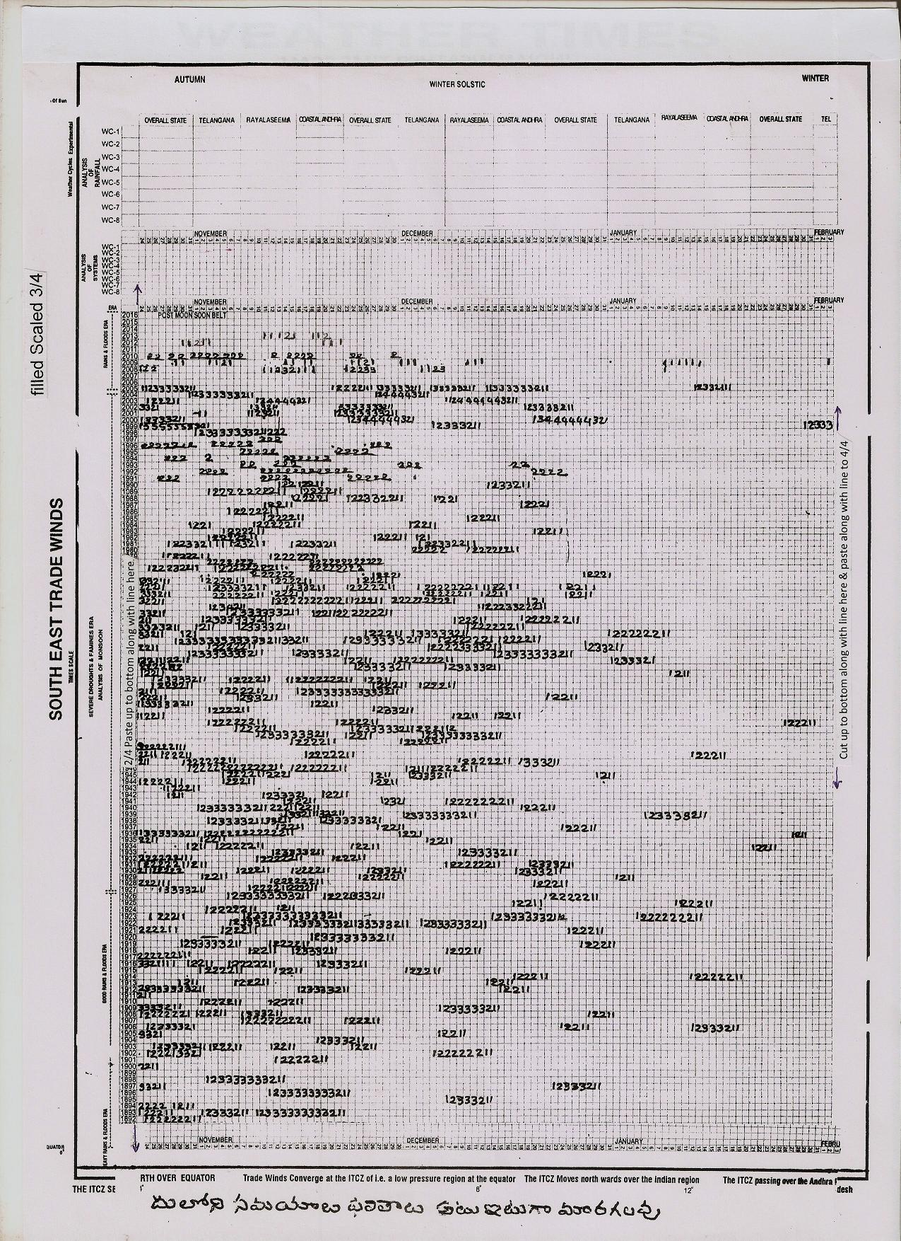
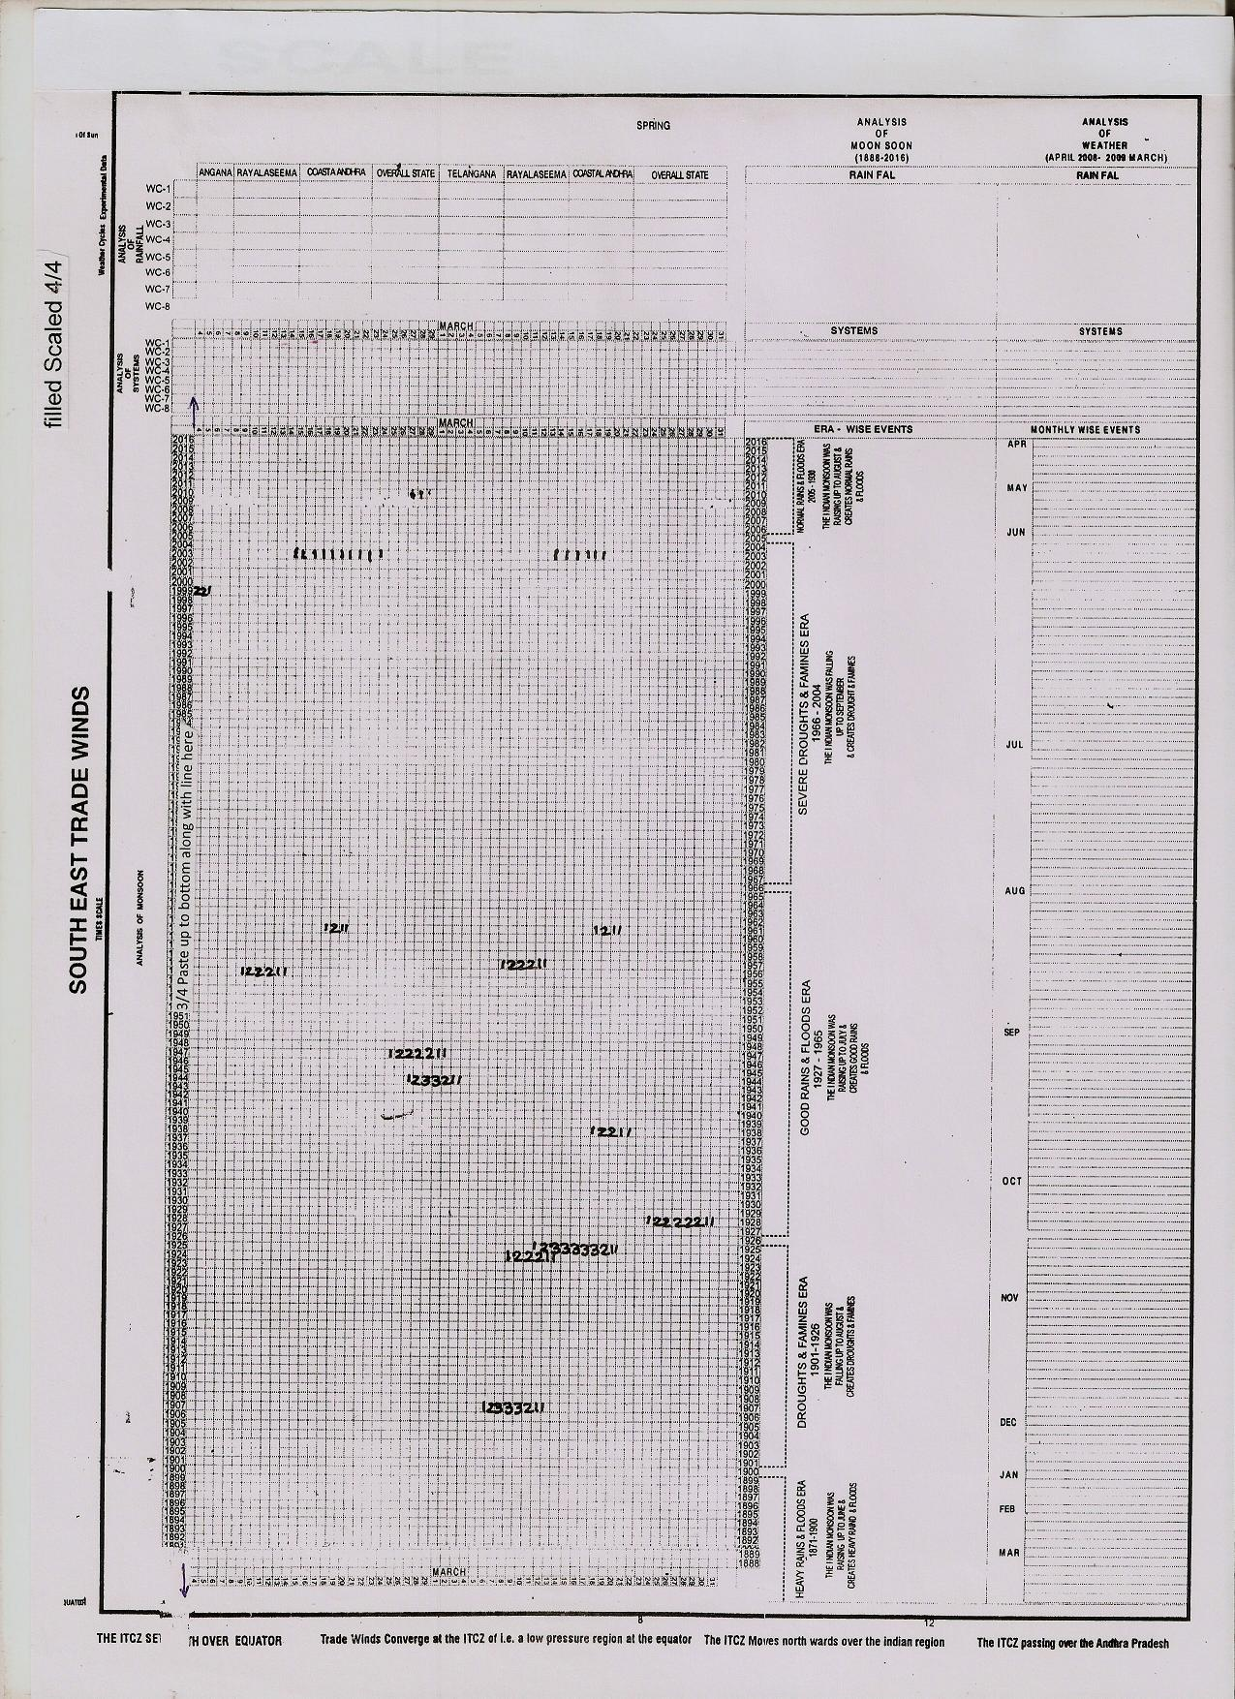
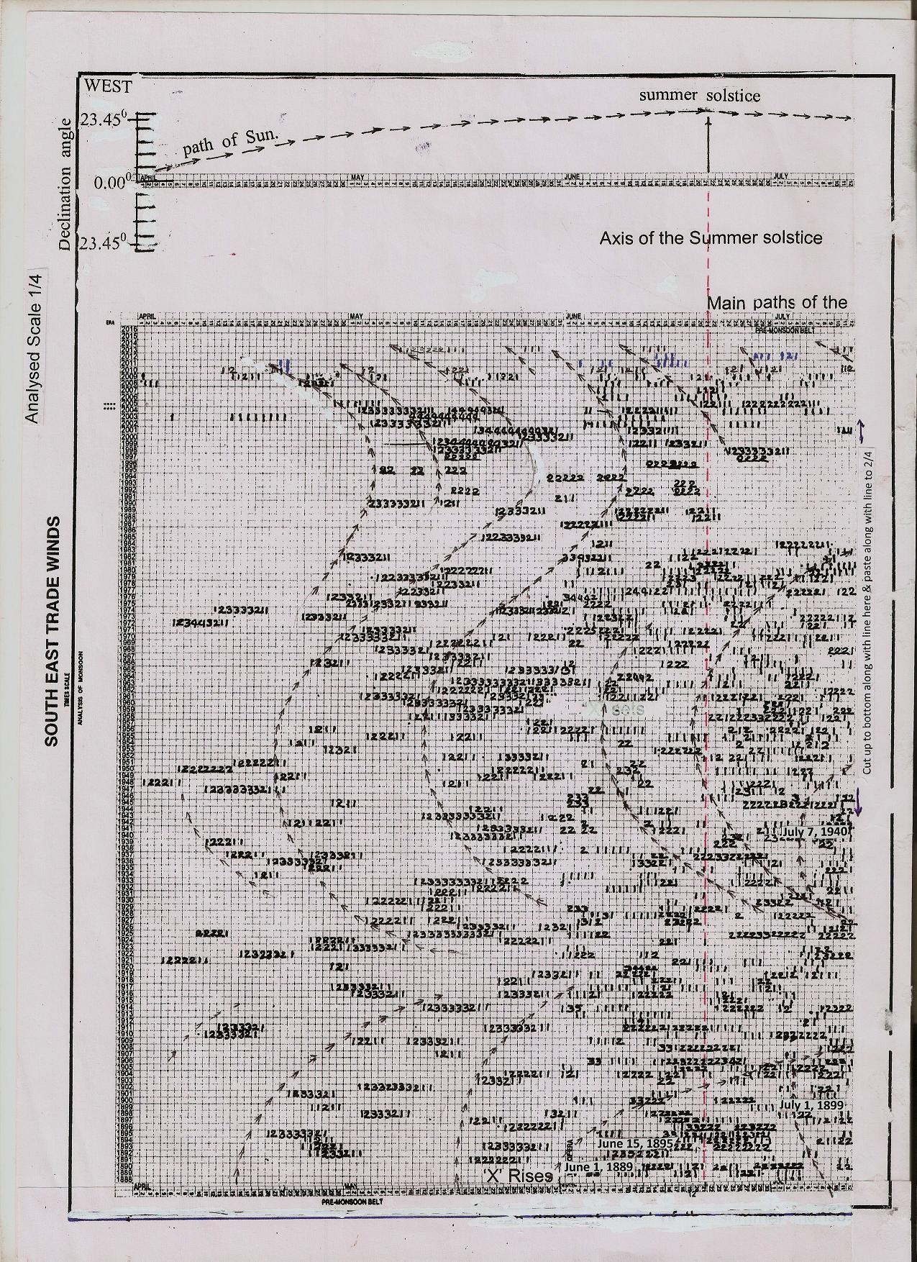
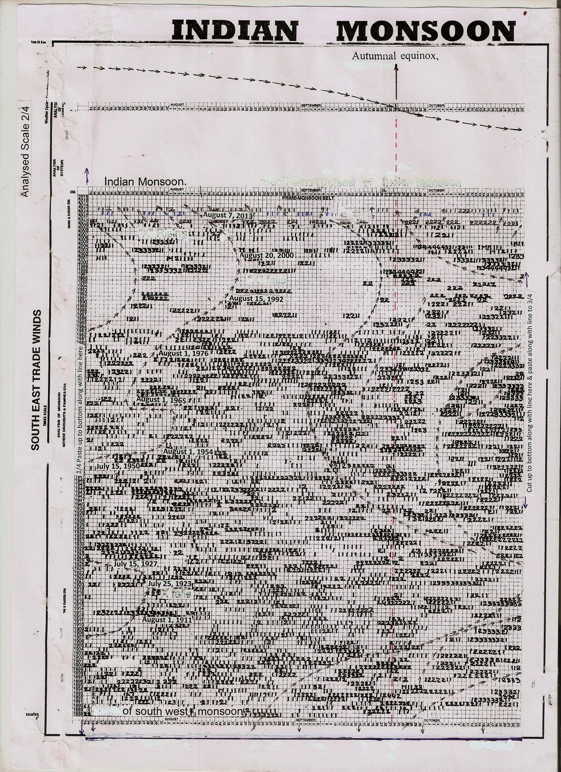
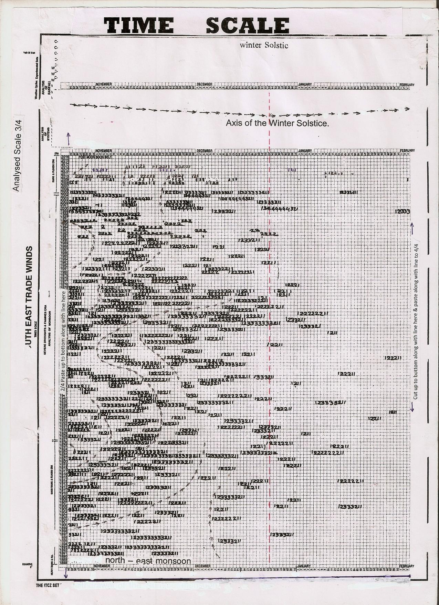
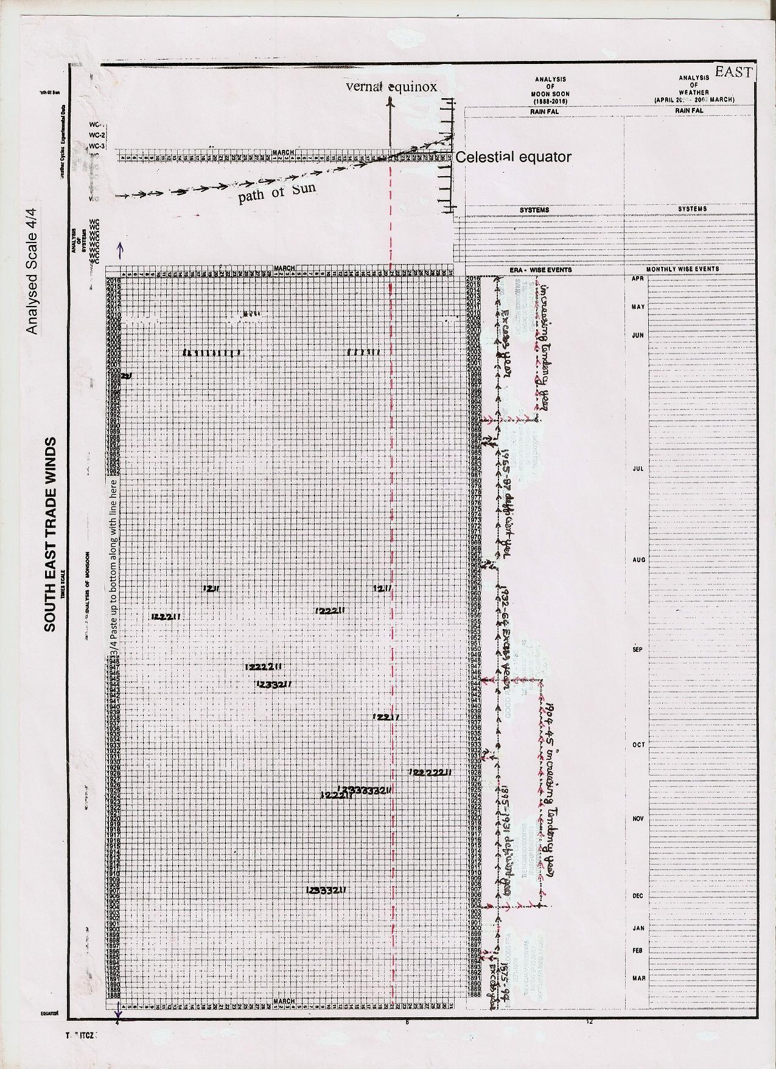
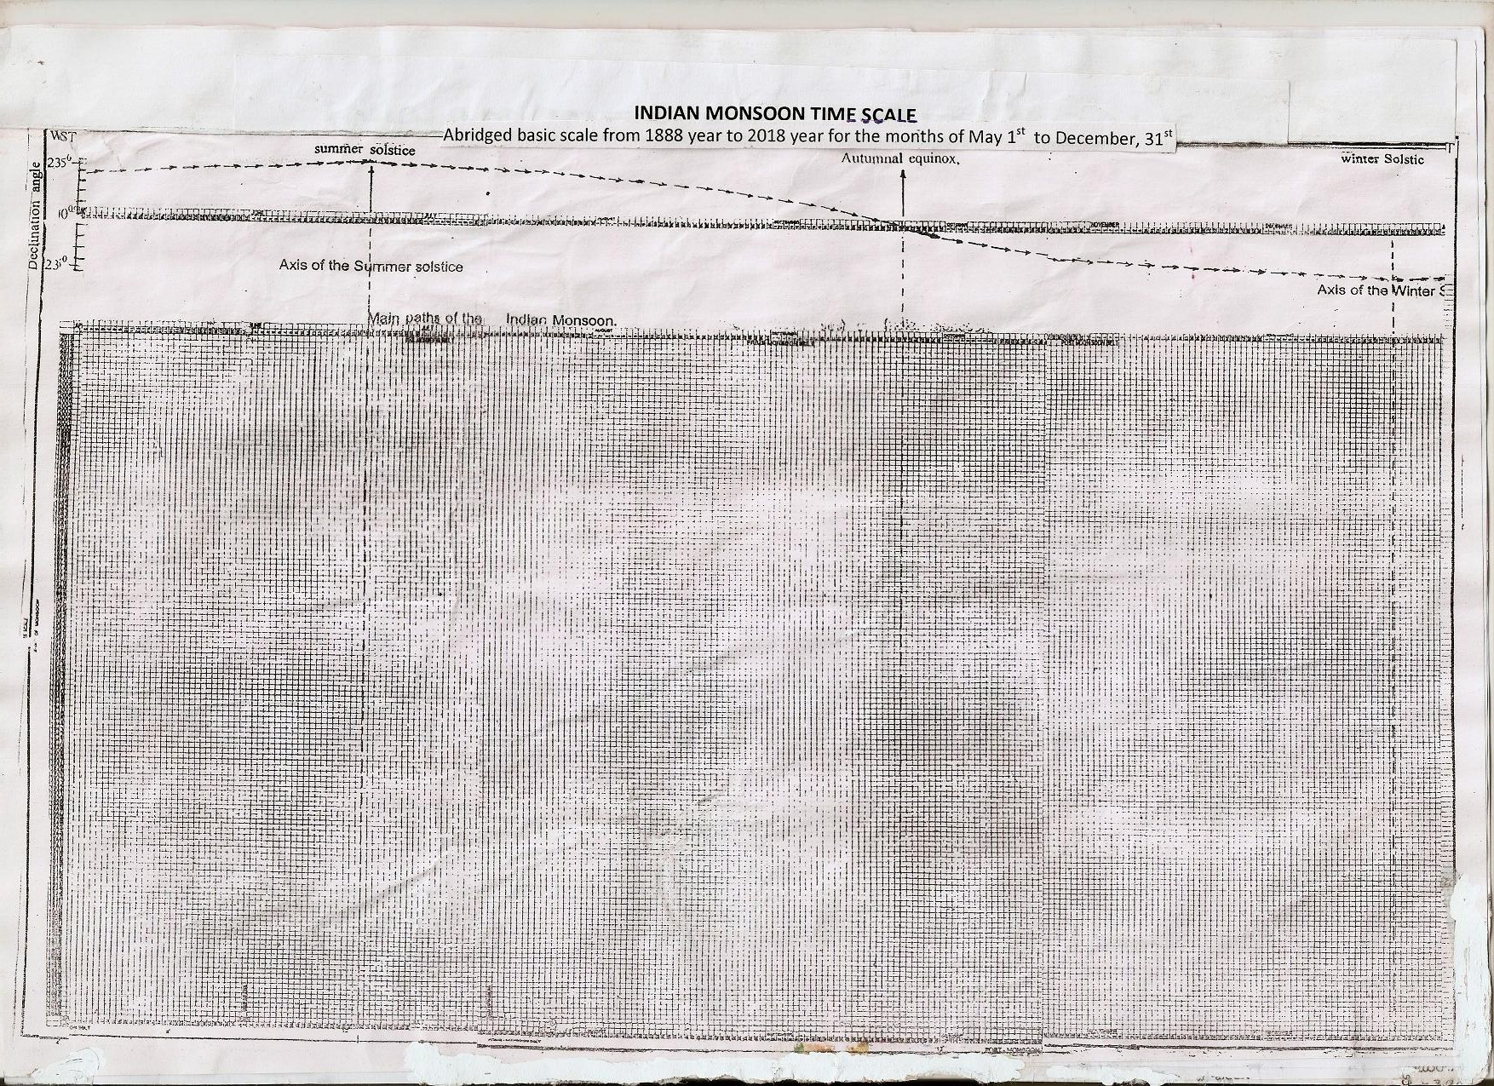
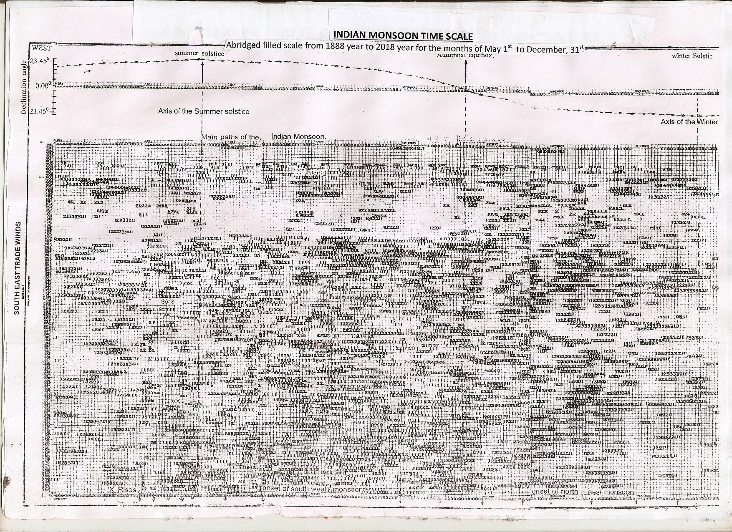
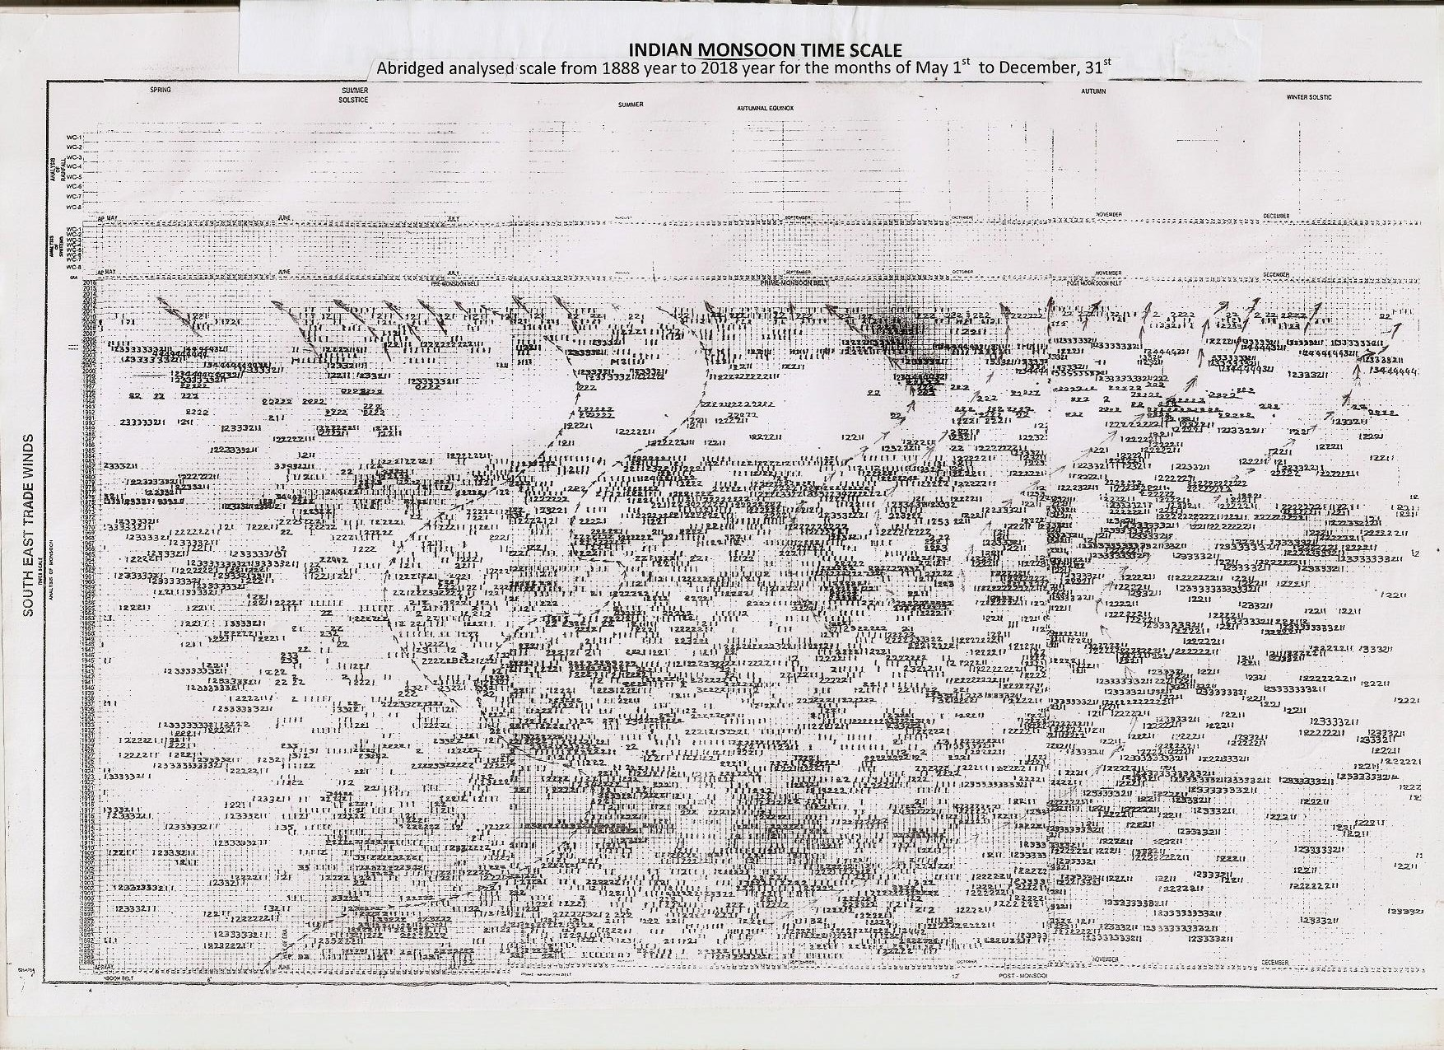
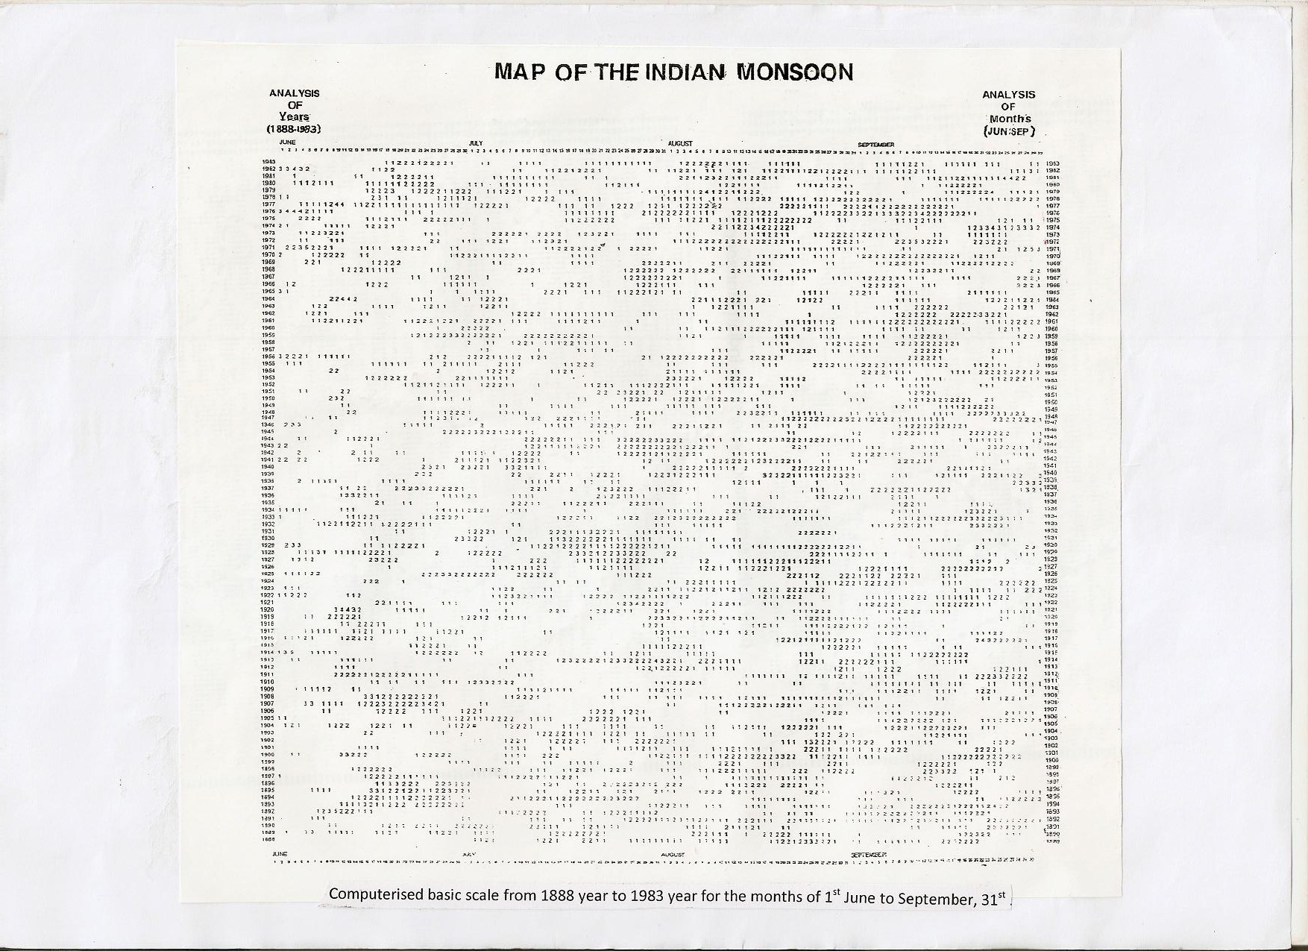

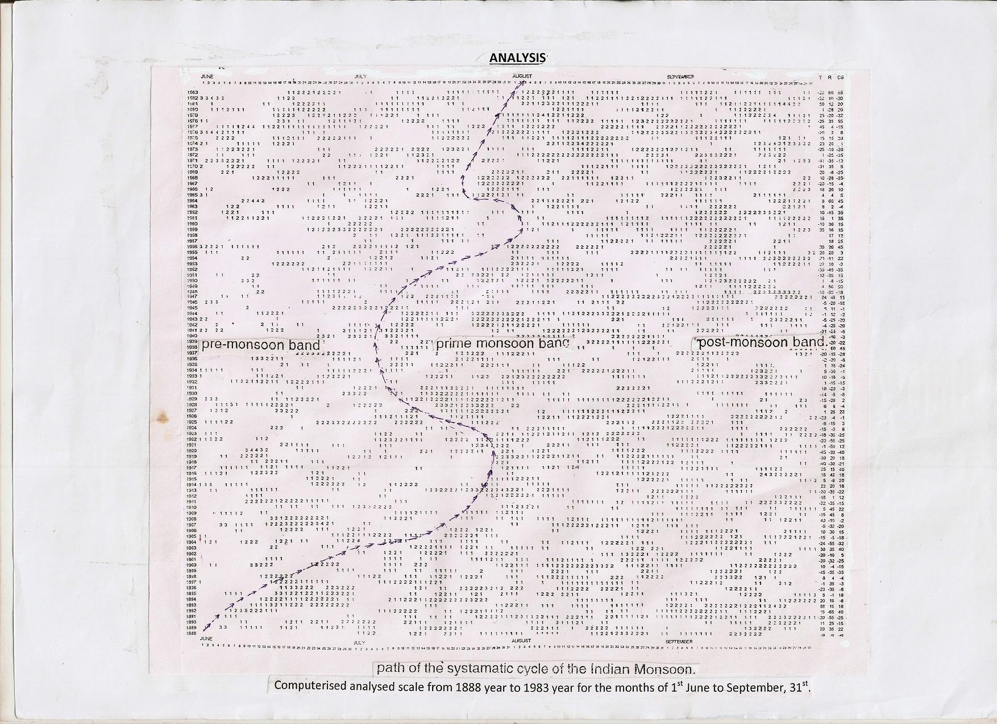

9/1/2016

