Results Of Research On Cosmology

Gangadhara Rao Irlapati

H.No.5-30-4/1, Saibaba Nagar, Jeedimetla, Hyderabad – 500 055, Telangana State, INDIA
Email ID: scientistgangadhar@gmail.com

Abstract: Cosmology is the study of the origin, evolution, mature and structure and other eventual fate of the universe, Physical cosmology is the study of the largest scale structure and dynamics of the universe. I have conducted many researches in the field of cosmology and invented some related discoveries & inventions which may also be useful in understanding the extent of the use of cosmology.
[Gangadhara Rao Irlapati. Results Of Research On Cosmology. Researcher 2016;8(1s):107-132]. ISSN 1553-9865 (print); ISSN 2163-8950 (online). http://www.sciencepub.net/researcher. 4. doi:10.7537/marsrsj0801s16.04.

Key Words: Universe, ascending order of creation, descending order of creation.

Introductionj:
I have conducted many studies on the origin, nature structure and evolution of the universe during the 1970-77 and proposed a new Hypothetical model of cosmology with hundreds or postulations. In 1977, a book was published in the name of IRLAPATISM-IRLAPTATI THEORY OF UNIVERSE on the basis of the postulations of the hypothesis by the supporters. The postulations about the universe, existence of god, theory of evolution etc in the book were exposed to the anger of fanatic people and I got into a violent altercation about these postulations of the hypothesis. As a result I was subjected to the suppressions and persecutions. I reported these suppressions and torments to the revenue divisional officer. Amalapuram on 6-7-1977 the revenue divisional officer was conducted an enquiry about this matter on forenoon, July 21st, 1977 while returning from the enquiry, I was attacked by a mob and they had taken me to the village chavadi. Followed by an altercation with tortures about the theory, they beaten and f forced me to put signatures on some false documents, and an offence falsely framed and foisted against me. After that I was sent to the taluk magistrate, kothapeta for another trial with the investigation of the superstitions, the taluk magistrate was declared me as a dangerous boy and up to anything and issued sentence to punish me and handed over to the police station, ravulapalem. The police was arrested me on July 21, 1977 registered a case and sent to remand, I was kept imprisoned some months in subjail and remaining period interrogated periodically by panatics and officers. The trials were done between April 2, 1979 to November 20,1979 after trials, the Honble Additional Judicial First Class Magistrate court was found me not guilty and acquitted on November 27,1979.
Irlapatism-A New Hypothetical Model Of Cosmology:
The cosmos is made up of universes in infinite number, having similar structure and properties, embedded one in each other and extended in ascending and descending order. To explain and justify this model, there are three universes so far known to us (a) Geo-Universe (b) Atomic-Universe (c) Energy-Universe. These three are having similar structure and properties, embedded one in each other and extended in ascending and descending order. Of these three, we known some extent about the internal structure and properties of the Geo-Universe but we do not known its external structure. We know some extent about the external structure and properties of the Energy-Universe but we do not know its internal structure. Between of these three universes, we came to know a large extent about the internal & un external structure and properties of the Atomic-Universe. Hence, I have taken the similarities of external structure & properties between the Geo-Universe & Atomic-Universe to propose that all the universes in ascending and descending order of the creation are having similar internal structure and properties. The similarities of external structure & properties between the Atomic Universe and Energy-Universe are taken to propose that all the universe in ascending and descending order of creation are having similar external structure and properties. And the manner in which of these three universes i.e., embedded one in each other, extended in ascending and descending order to propose that all the universes in ascending and descending order of the creation are embedded one in each other and extended in ascending and descending order.

Similar External Structure & Properties
According to the model, all the universes in ascending and descending order of the creation are having similar external structure and properties. To justify this, I have taken many similarities between the atom and photon.
For example:

Atomic-Universe Energy-Universe
1) The atom appearing in several forms such as 1) The particle “Photon” related to
Hydrogen to uranium etc., being due to the energy appearing in several forms such
Internal structure having different atomic particles as radio waves, gamma rays, violet rays
at various numbers. etc being may be probably due to the
internal structure having different
particles at various numbers.
2) The atom exhibiting several physical and chemical 2) The particle “photon” related to energy
Properties such as weight, colour, taste, hardness exhibiting properties such as wave length
etc being due to the internal structure having different colour, temperature etc being may be
particles at various number. Probably due to the internal structure
having different particles at various number.

Similar Internal Structure & Properties
According to the model, all the universes in ascending and descending order of the creation are having similar internal structure and properties. To explain and justify this, I have taken the many similarities between the atomic-universe and Geo-Universe.

Atomic-Universe Geo-Universe
1)Various atomic particles at different sizes in 1) Various astronomical objects at different
several numbers are present in the atom. sizes in several numbers are present in the
Geo- Universe.
2) These atomic particles having three types of 2) These astronomical objects having three
charges at negative, positive and neutral states type of charges at positive, negative and
are present in the atom. neutral states are present in the
Geo-Universe
3) Positively charged protons are present in the nucleus. 3) Stars built by atoms having positive
charged nucleus are present in centre of the Geo-Universe
4) Neutrons at neutral state are present in the Nucleus. 4) Planets at neutral state are present in
Centre of the Geo-Universe.
5) Negatively charged electrons are present at large 5) Here is a concept that anti-matter cosmic
distance of the atomic nucleus in the atom bodies built by atoms having negatively
charged nucleus are present at large
distance of the Geo-Universe.
6) Additional neutrons called isotopes are present. 6) Additional planets called satellites around
the planets are present.
7) Radiation emitting from the atom. 7) Cosmic rays emitting from the Geo-
Universe.
8) There is a property of nuclear fission is in the atom. 8) There is a property of super Nova is in the Geo- Universe.

Descending Order Of Creation: The Geo-Universe that means the Universe seen around our earth is having magnificent structure and properties such as galaxies, stars and planets and some planets such as earth having continents, countries, oceans, trees, animals. Cyclones, human beings etc. Such Geo-Universe being built by Universes of its descending order of creation that means atoms.
Atomic-Universe that means the atom present in several forms from hydrogen to uranium etc is another universe having magnificent structure and properties such as electrons, protons, neutrons, etc., and continents, countries, oceans, cyclones, trees, animals, human beings may be present on some neutrons having suitable conditions exactly similar to the earth planet resembling to the Geo-Universe. Such atomic Universe being built by universes of its descending order of creation that means energy particle ‘photons”.
The Energy-Universe that means the particle “photon” related to energy present in several forms of electromagnetic radiation is also another universe having magnificent structure and properties resembling to Geo-Universe and atom. Such Energy-Universe may also being built by Universes of its descending order of creation that is not yet known to us.
Thus the descending order of creation continuous infinitely.
Ascending Order Of Creation: The Energy-universe that means the particle related to energy “photon” having magnificent structure and properties is being as a primary syntactic unit in the universe of its ascending order of creation that means atom. All components in the atom are built by these “photons” in infinite number. Such each and every energy particle “photon” is basis to an infinite descending order of creation.
The Atomic—Universe that means the “Atom” having magnificent structure and properties is being as a primary syntactic unit in the universe of its ascending order of creation that means in our Geo-Universe. All components in the Geo-Universe such as stars, planets etc., are built by these atoms in infinite number. Such each and every atom is basis to an infinite descending order of creation.
The Geo-Universe that means the “Universe” seen around our earth having magnificent structure and properties is being as a primary syntactic unit in the universe of its ascending order of creation that is not yet known to us. All components in that Universe are built by these Geo-Universes in infinite number. Such each and every Geo-Universe in that ascending creation is basis to an infinite descending order of creation.
Thus the ascending order of creation continuous infinite.
Cosmic-Environments:The fill of structure and characteristics in the universe of the cosmos proposed as cosmic environments. For example the fill of structure and characteristics like galaxies, stars, planets etc in the Geo-Universe proposed as Geo-Environment, the fill of structure and characteristics like proton, neutrons and electrons etc in the Atomic-Universe proposed as Atomic-Environment and the fill of structure and characteristics in the Energy-Universe that means in the photon that is not yet known proposed as Energy-Environment.
Space Weather: The fill of structure and characteristics like galaxies, Stars, Planets and their orbits and other physical forces etc that surrounds in the universe proposed as space atmosphere, the state of galaxies, stars, planets, nebulas. Pulsars etc at a particular region over a long period of time proposed as space-climate, the state of characteristics of space- climate like solar wind flares, asteroids etc at a particular region during a short period of time proposed as space-weather.
Space Regions: The state of space atmosphere being in still proposed as “Inactive Space Region”, the state of space atmosphere being in active proposed as “Active Space Region” The region of space atmosphere in which the celestial bodies are more widespread areas proposed as “Space High Pressure Area” the less widespread areas proposed as “ Space Low Pressure Area”.
Space Low Pressure Systems: Some space times happens variation of differences of pressure in the space-climate, At such a juncture, the celestial bodies and other space dust present in the space high pressure area will try to occupy the space low pressure area all at once. In this attempt, they will whirl around the space low pressure. The centre of space low pressure area itself is the black-hole and the circular whirling celestial bodies & other space dust etc caused by the space low pressure area proposed as Galaxy.
Studies Carried Out: many studies were carried out on this Hypothesis and it was successfully proved out in the studies.

References
- www/en-wikipedia.org/wiki/cyclic model.
- The Steinhardt-turok model.
- The Baun-frampton model.
- Loop quantum cosmology.
- En.wikipedia.org/wiki/multiverse.
- Heliocentric model.
- Geocentric model.
- Copernican model.
- Heliocentric model vs geocentric model.
- en.wikipedia.org/wiki/big bang theory.
- en.wkipedia.org/wiki/steadystate theory.
- www.astro.ucla.edu/-wright/steady stat.

Appendicies: (A new Hypothetical Moel of Cosmology)

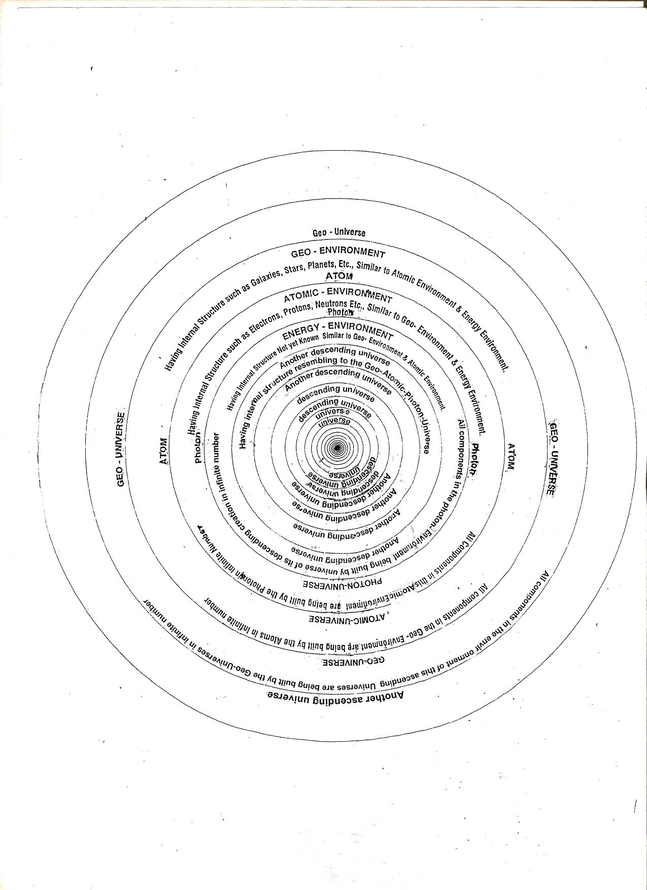
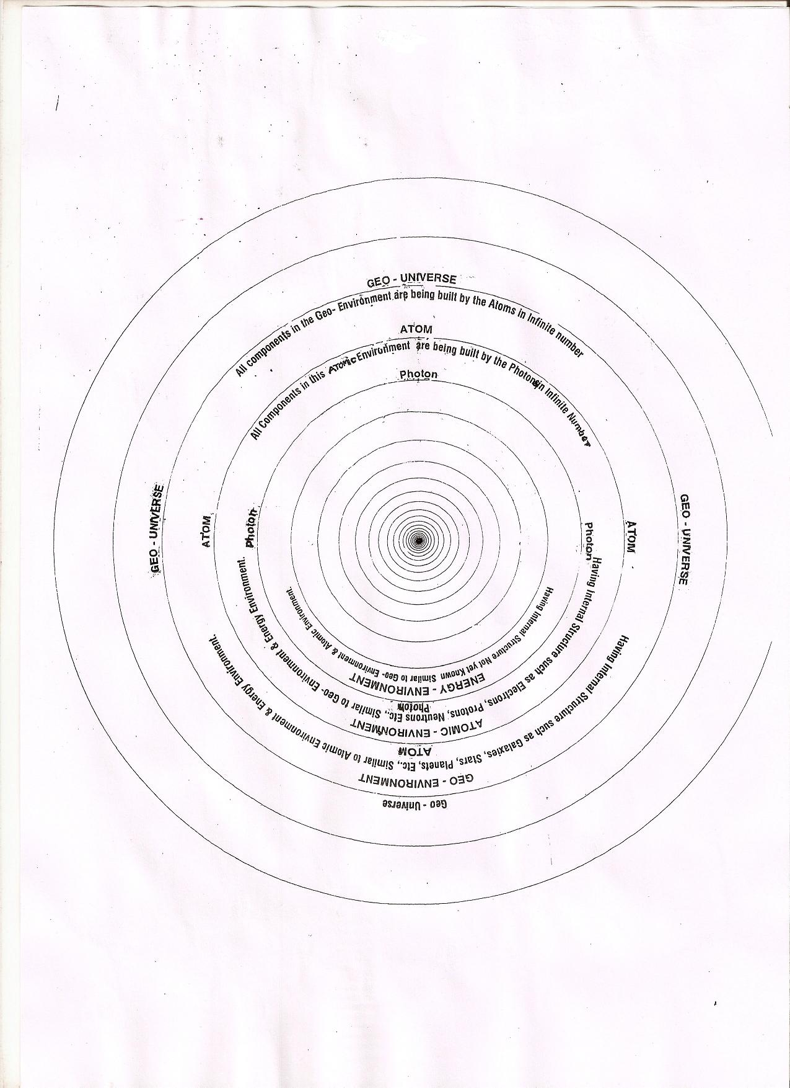

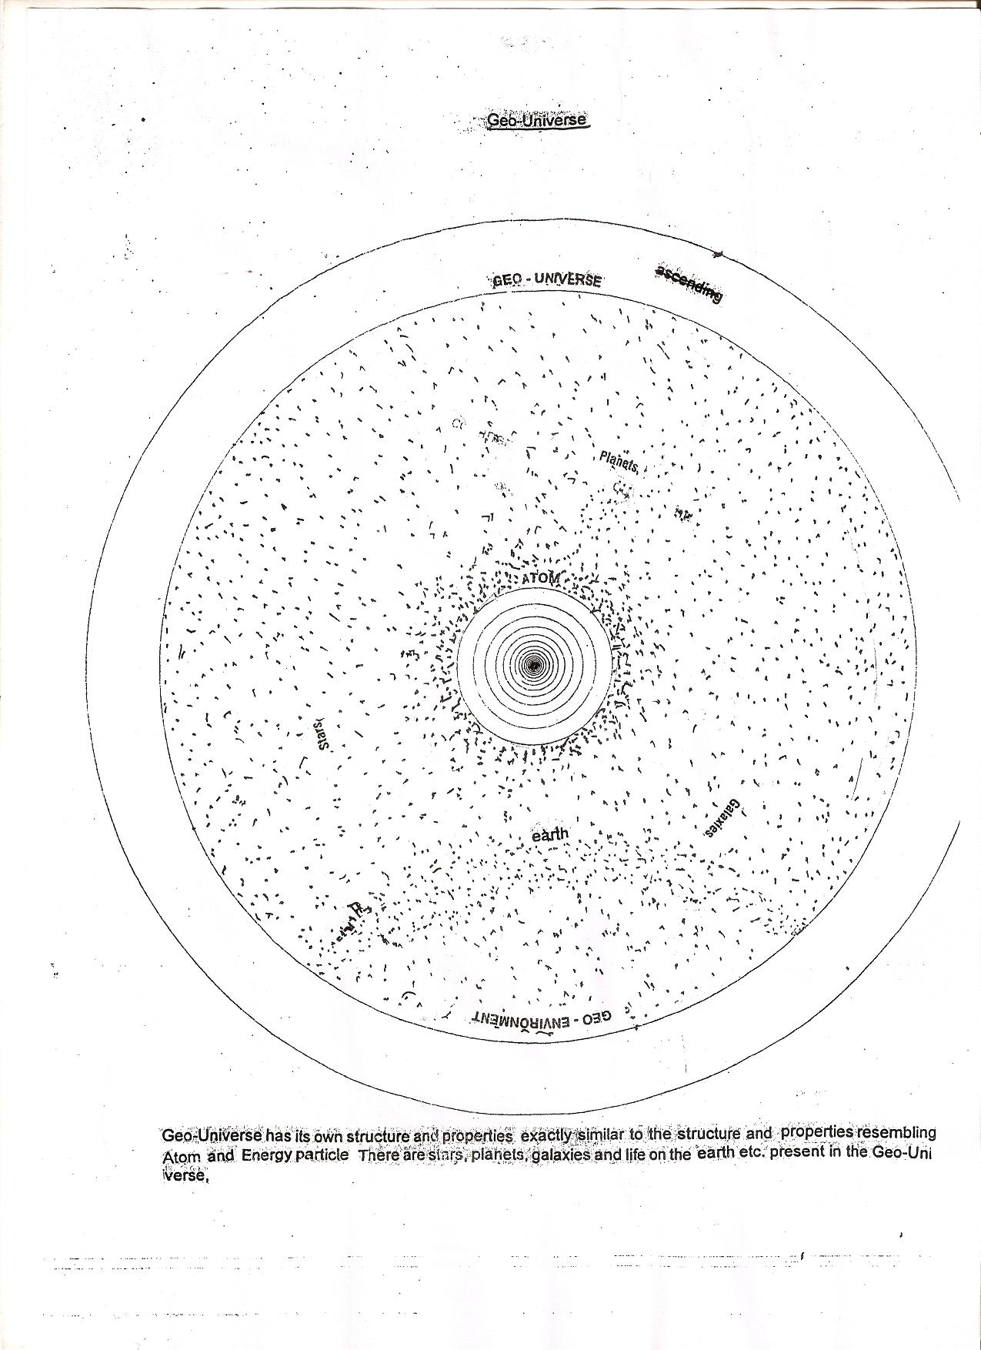

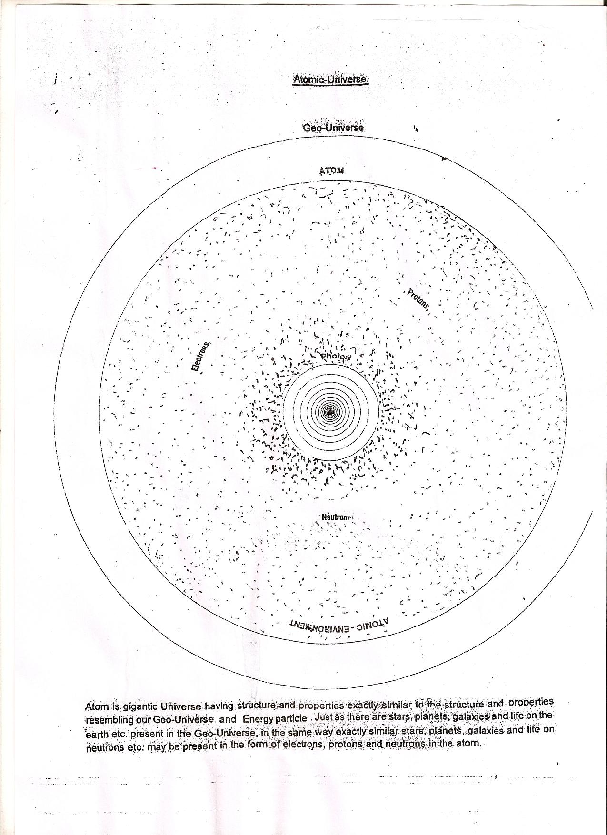

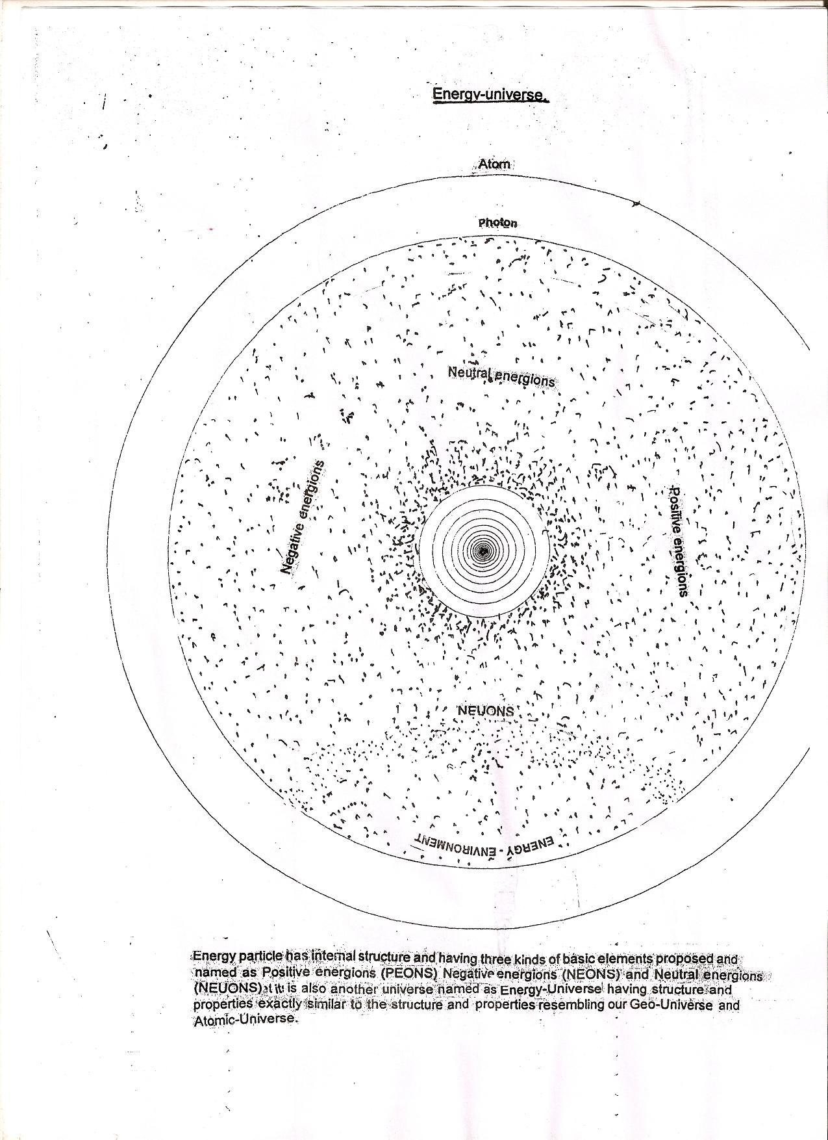

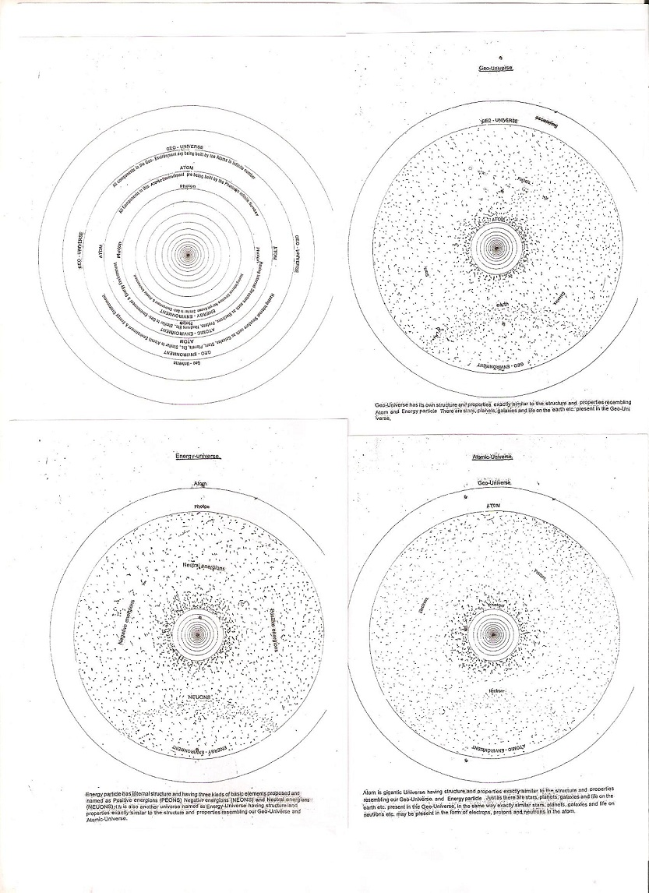

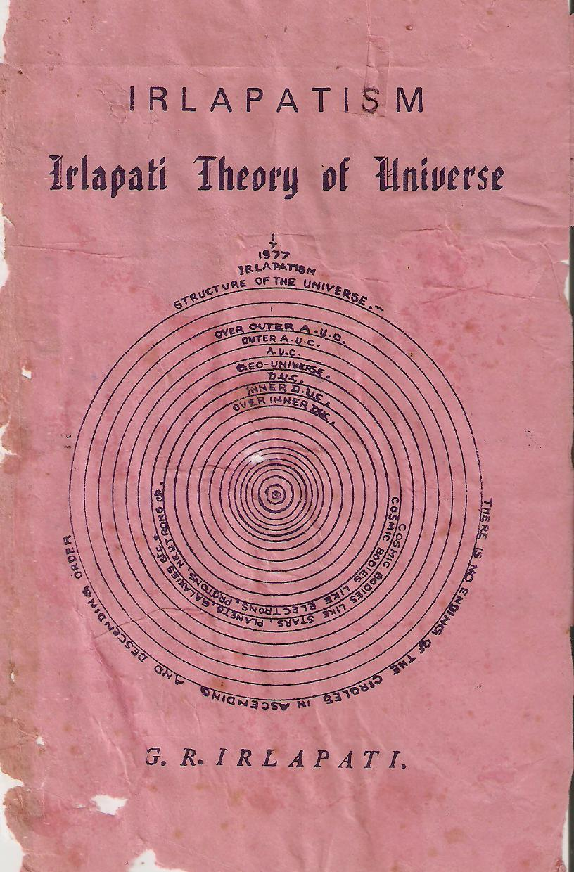
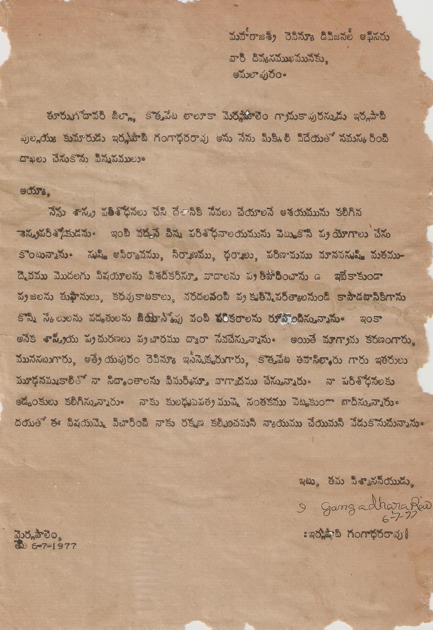
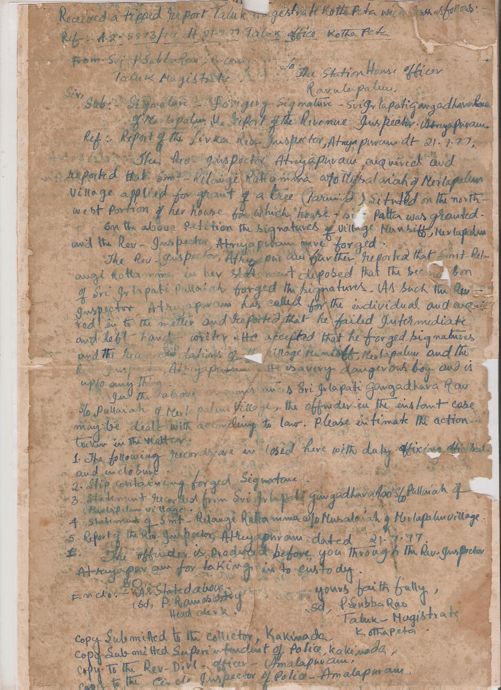

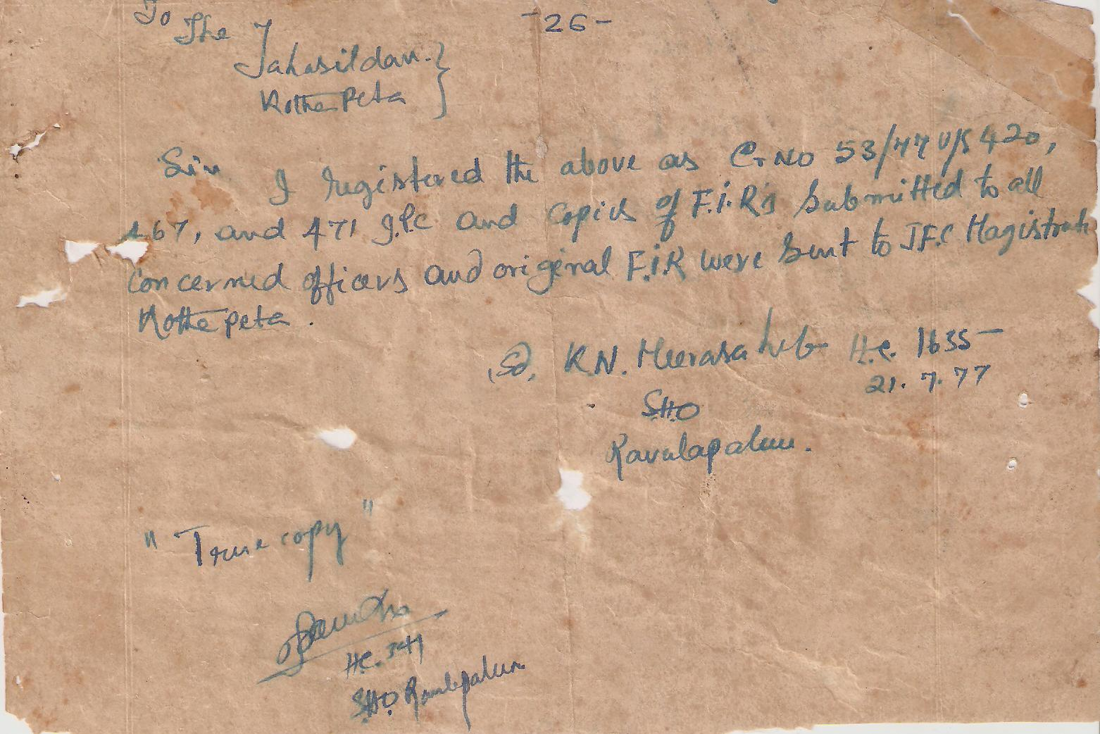

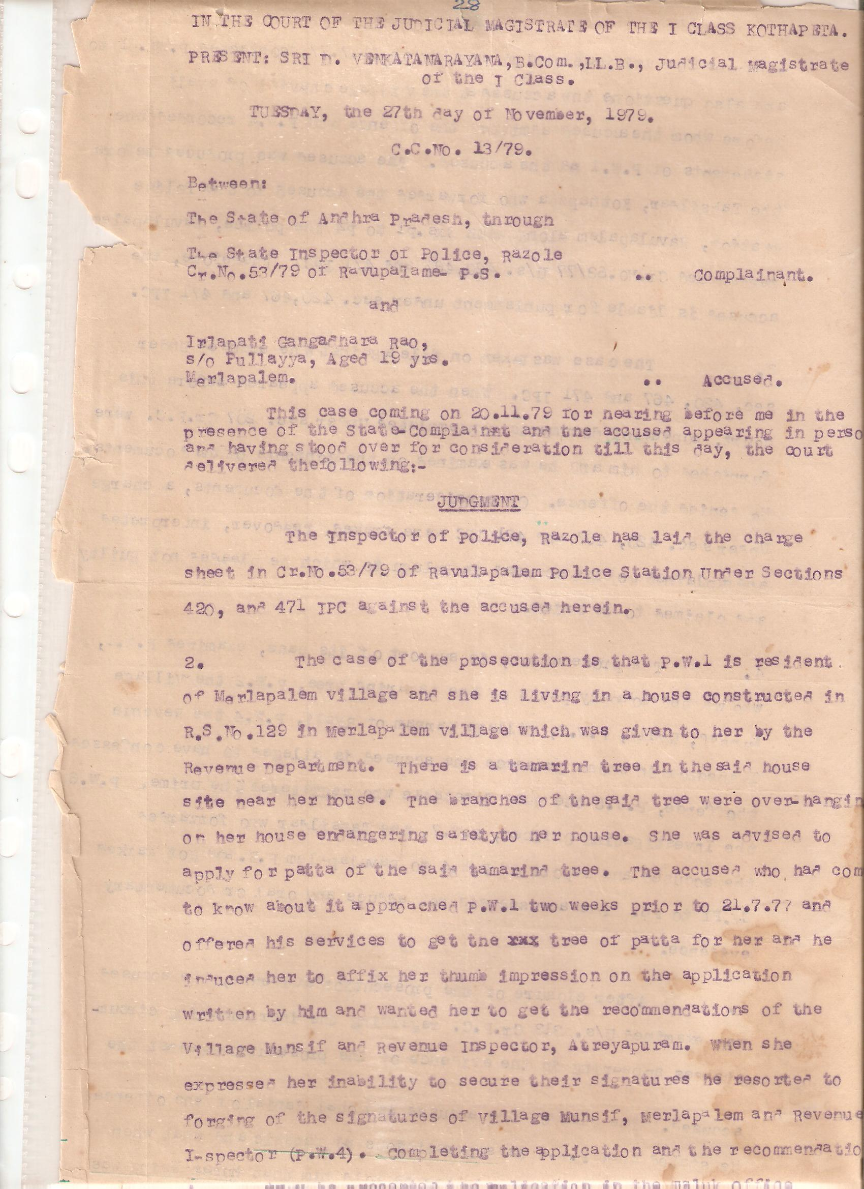

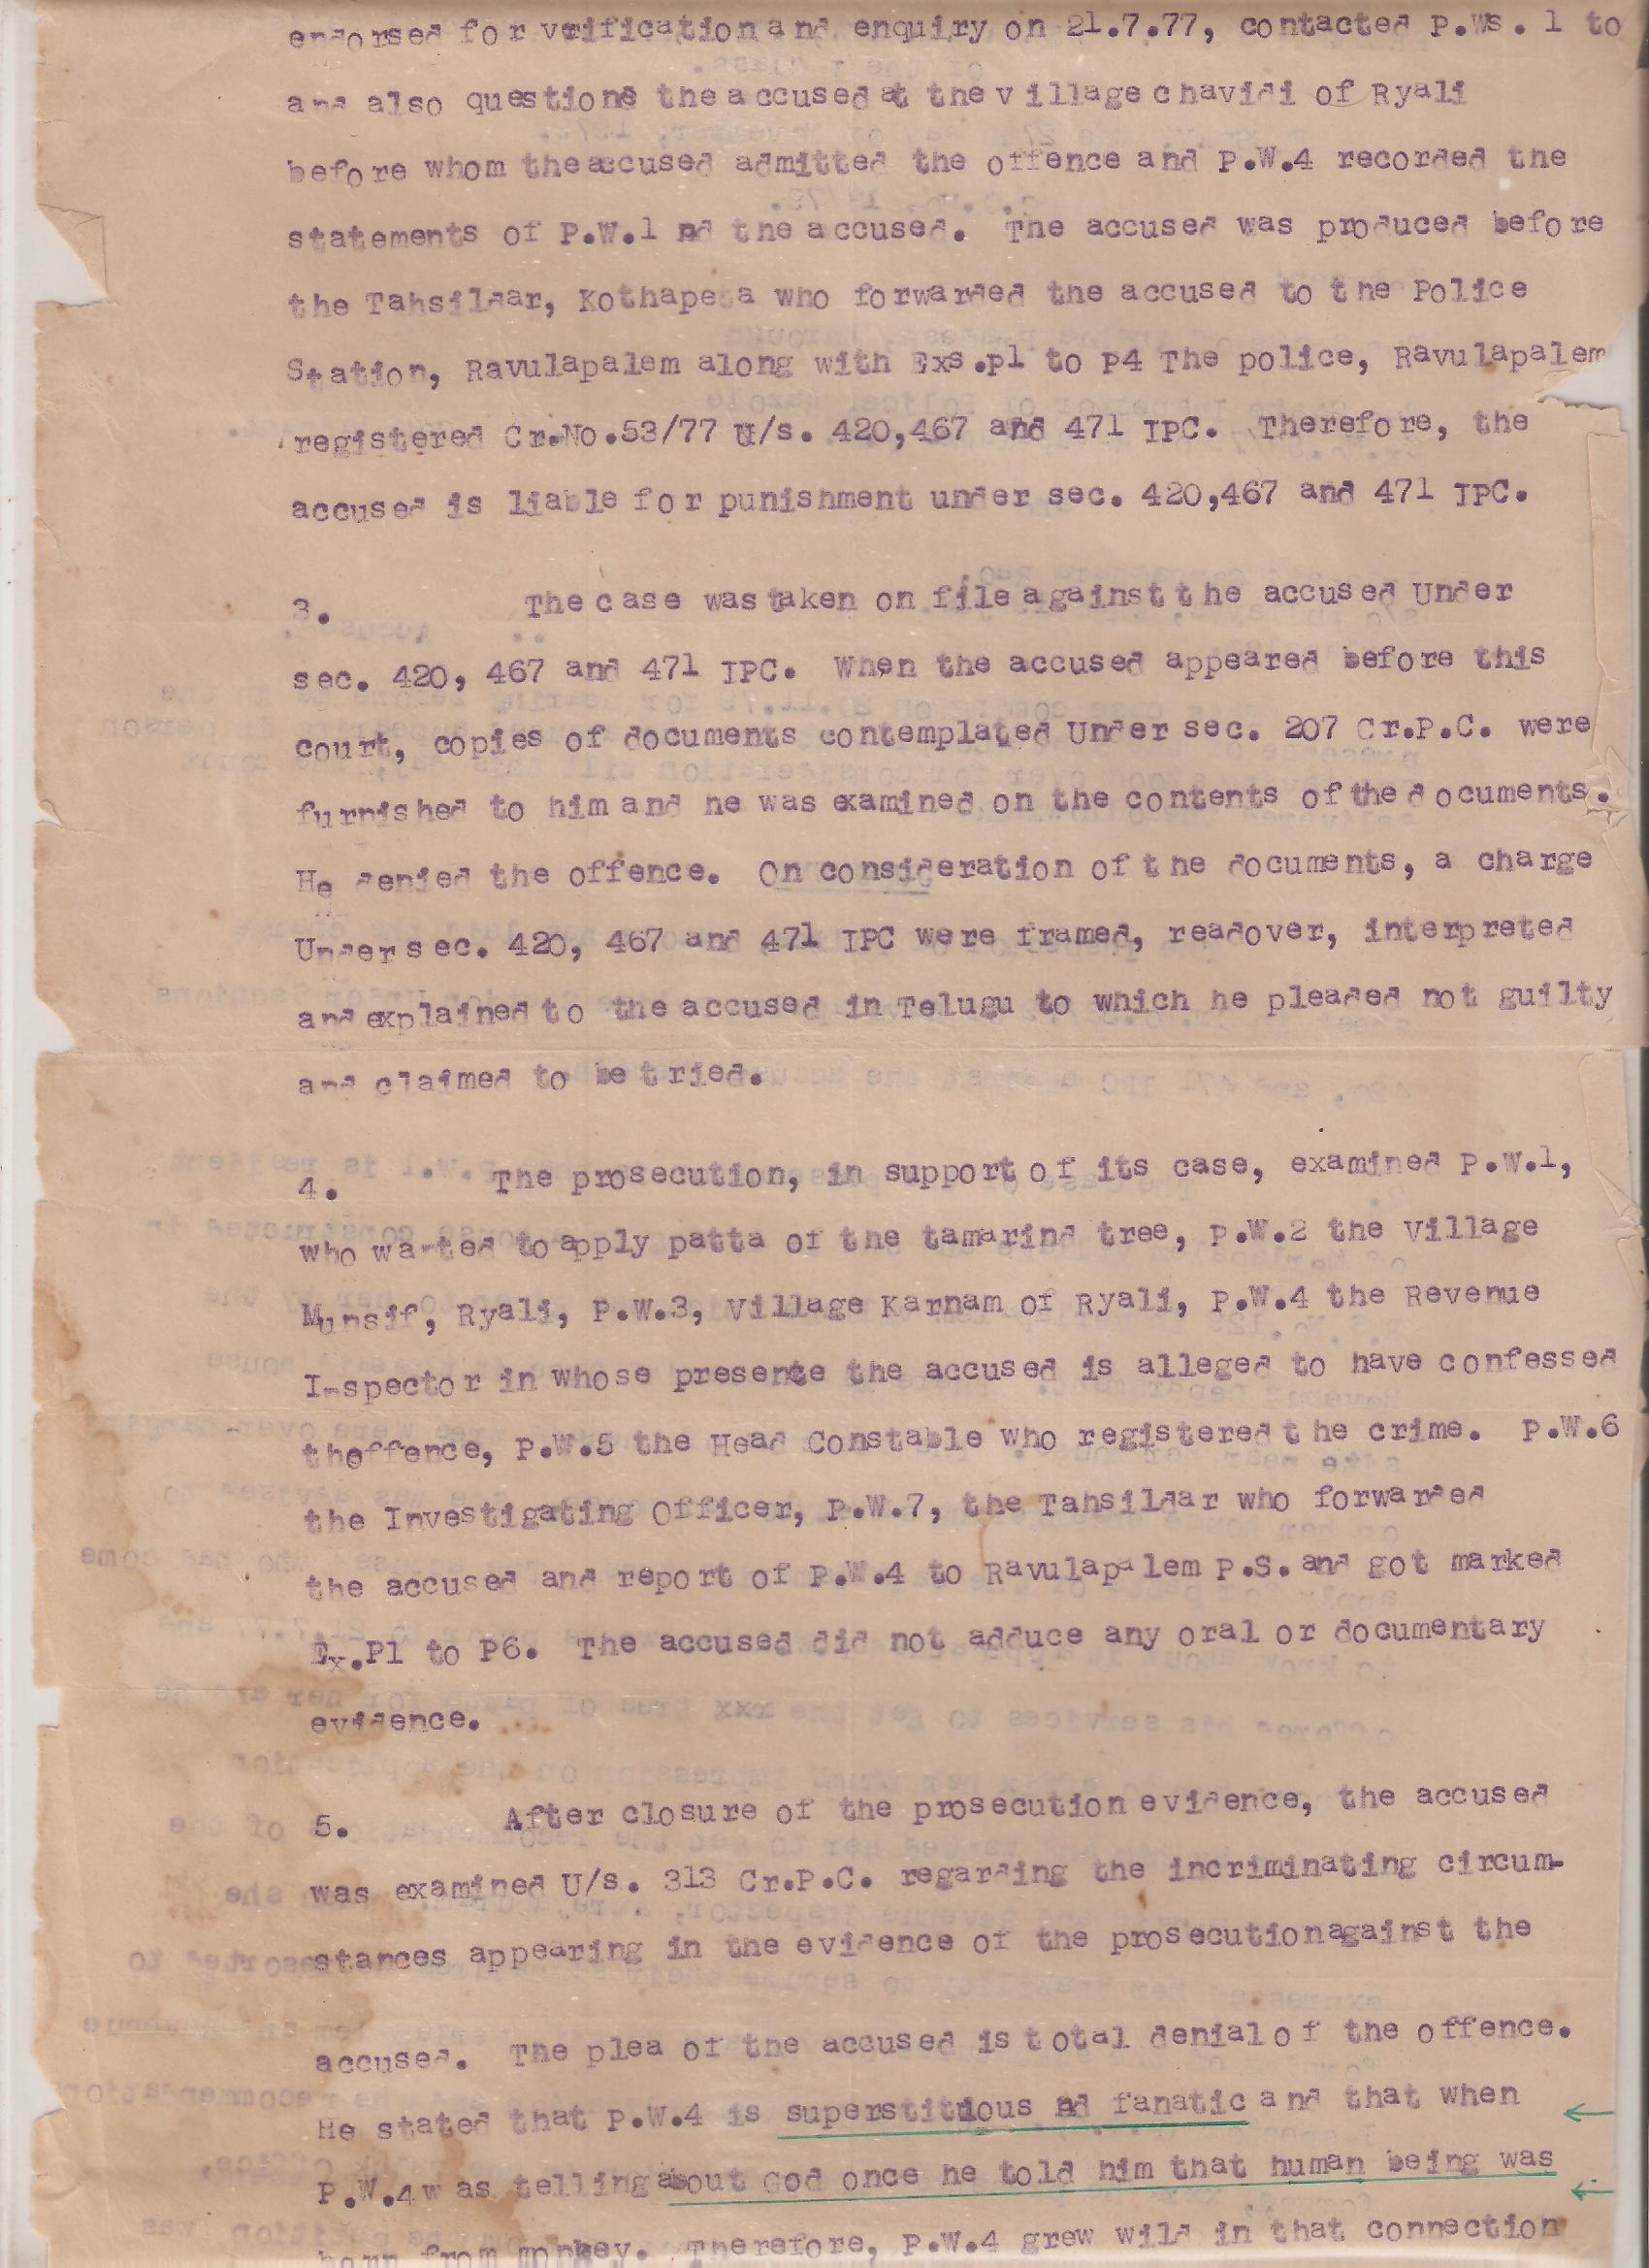
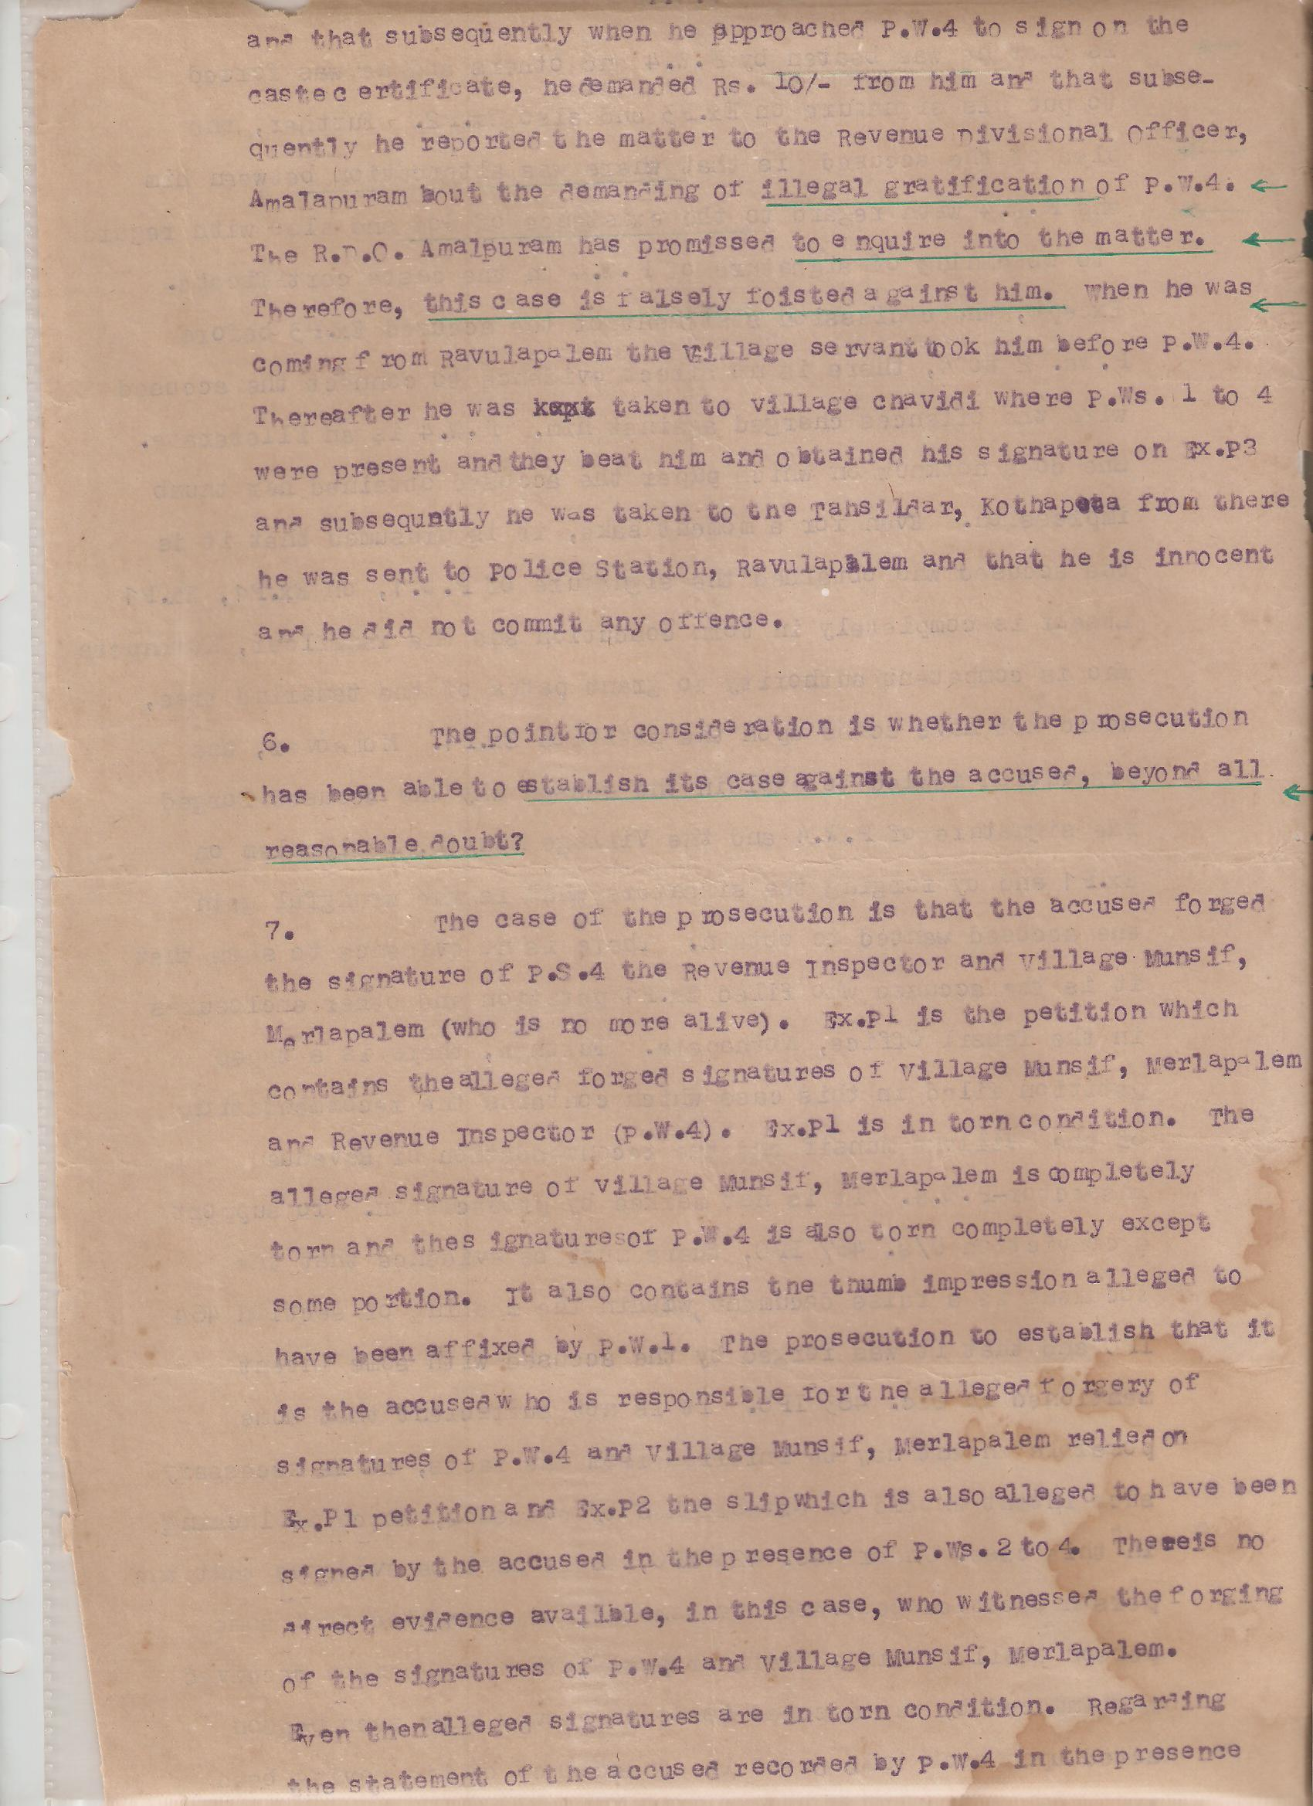
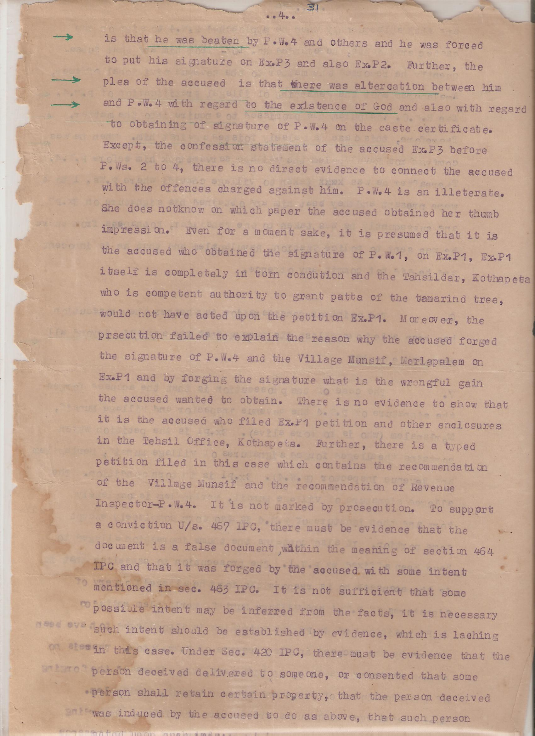

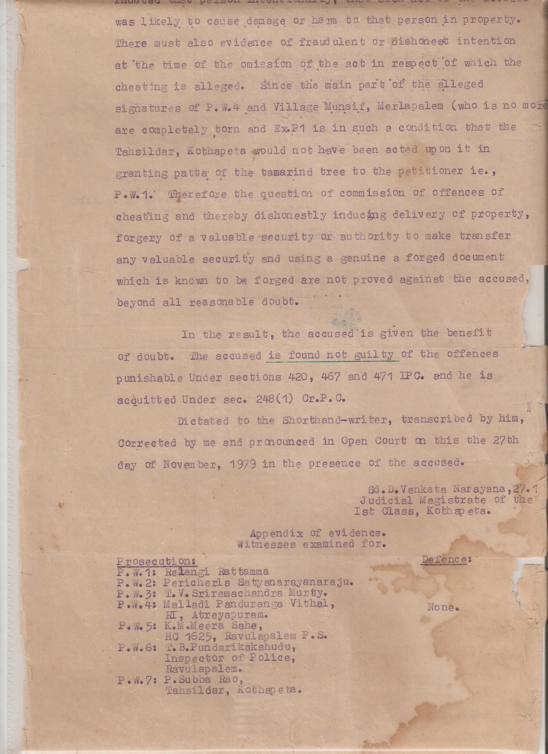

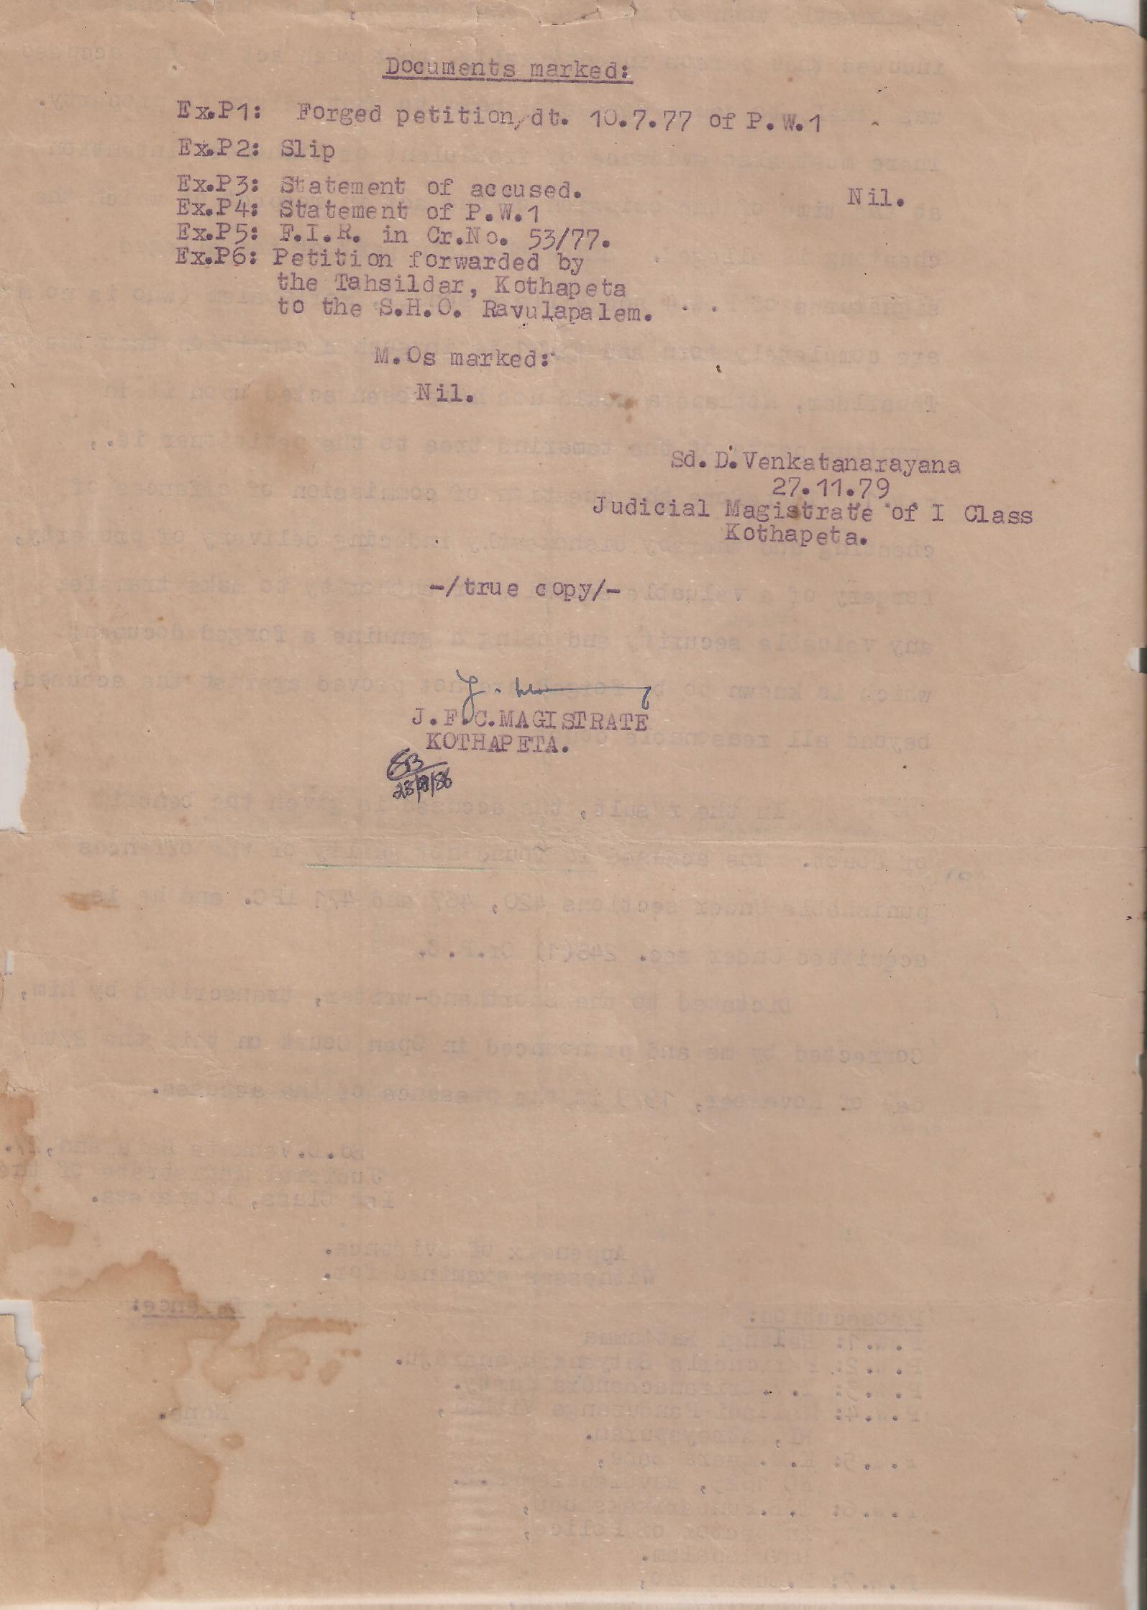
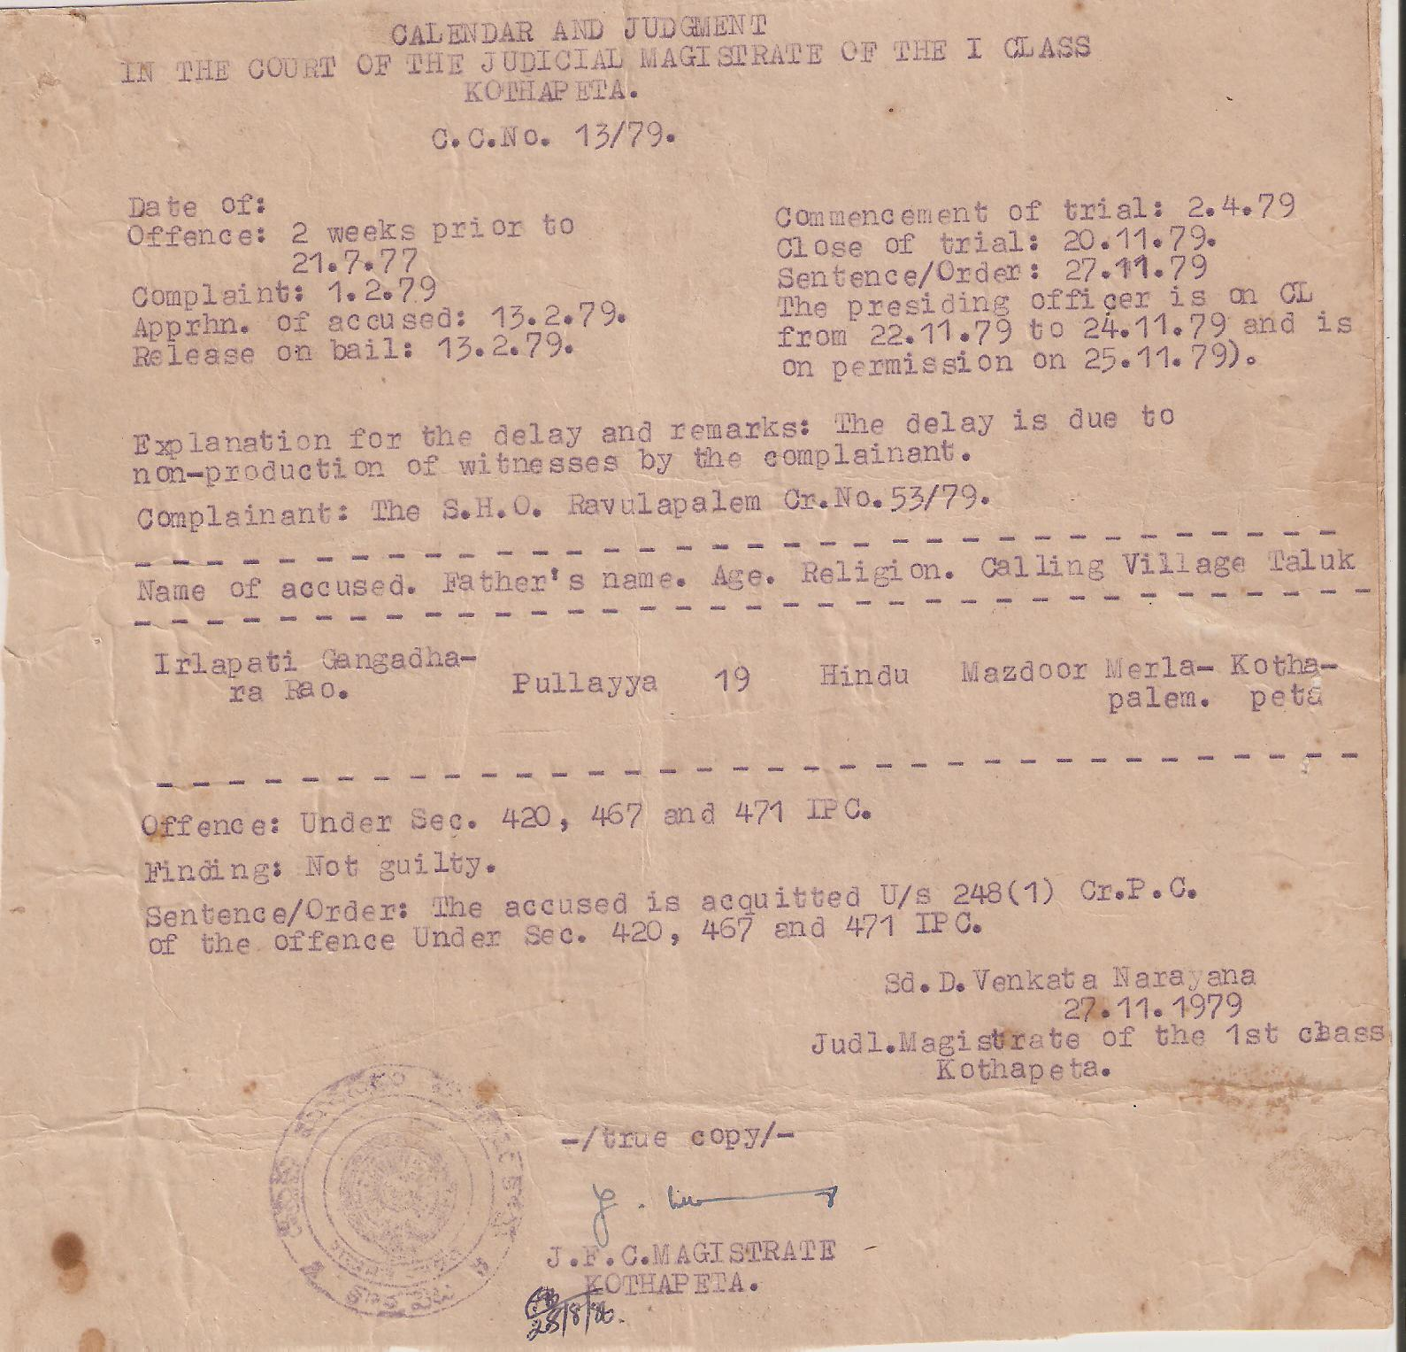

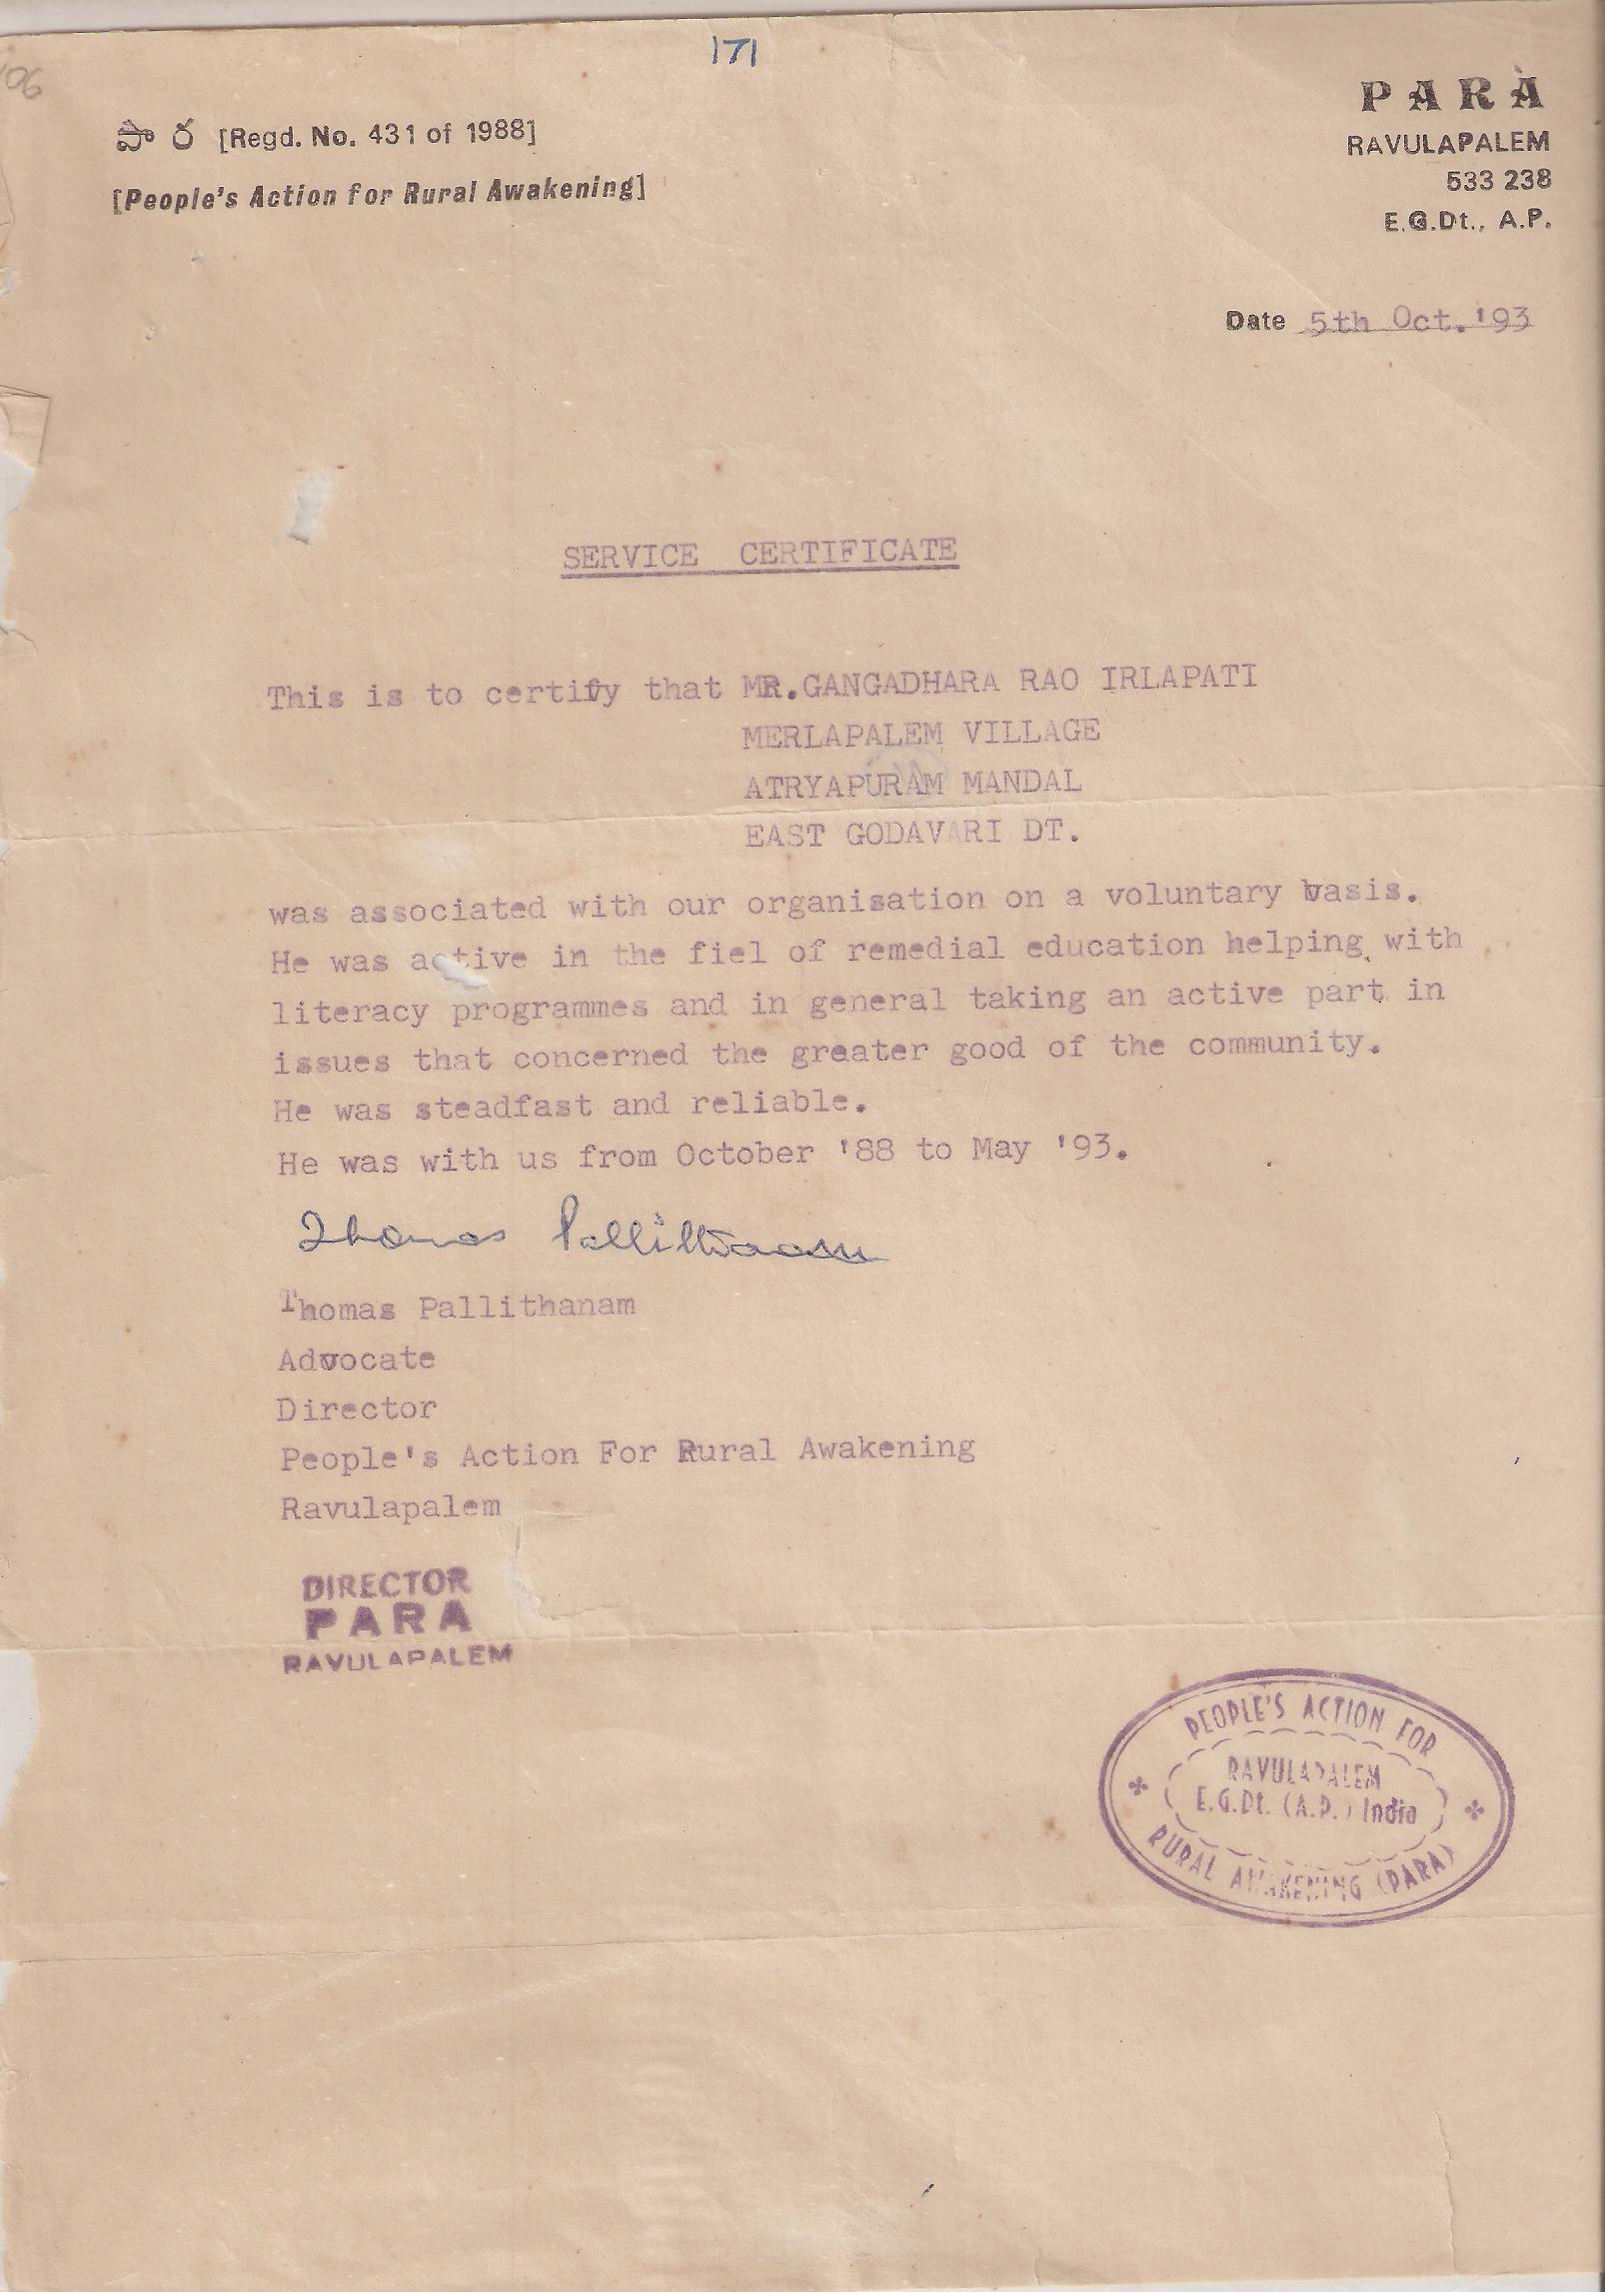
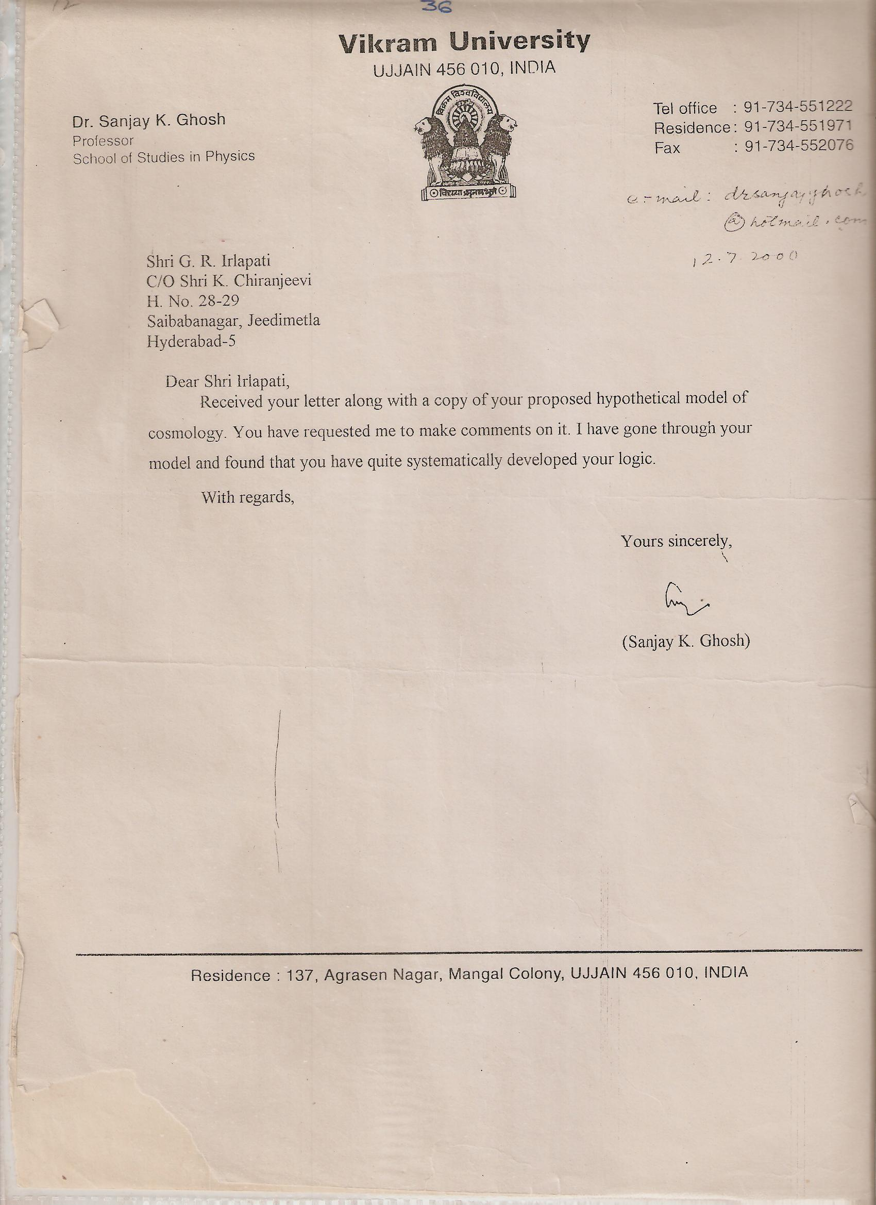
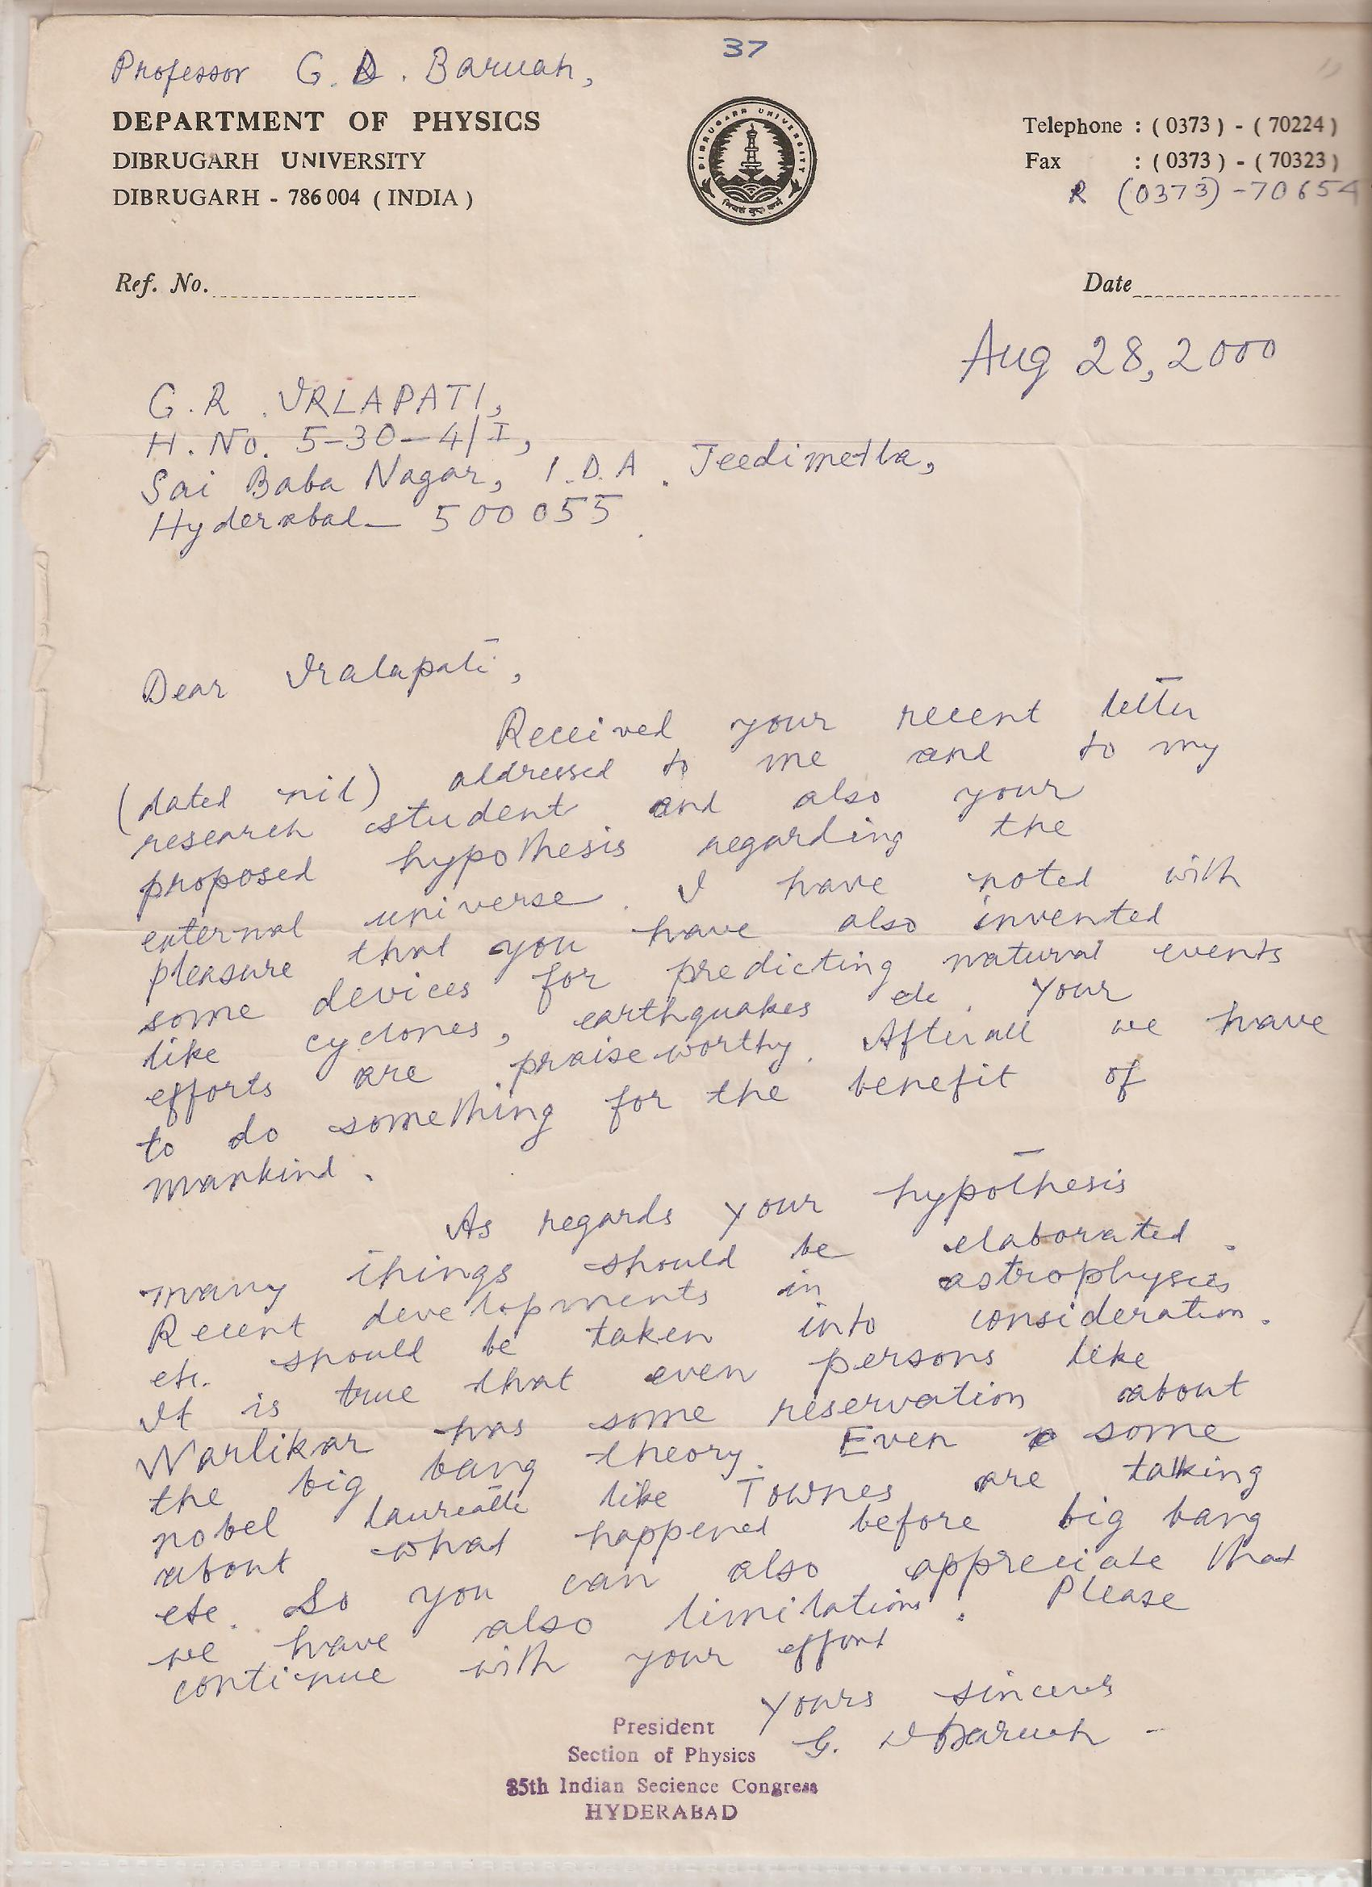

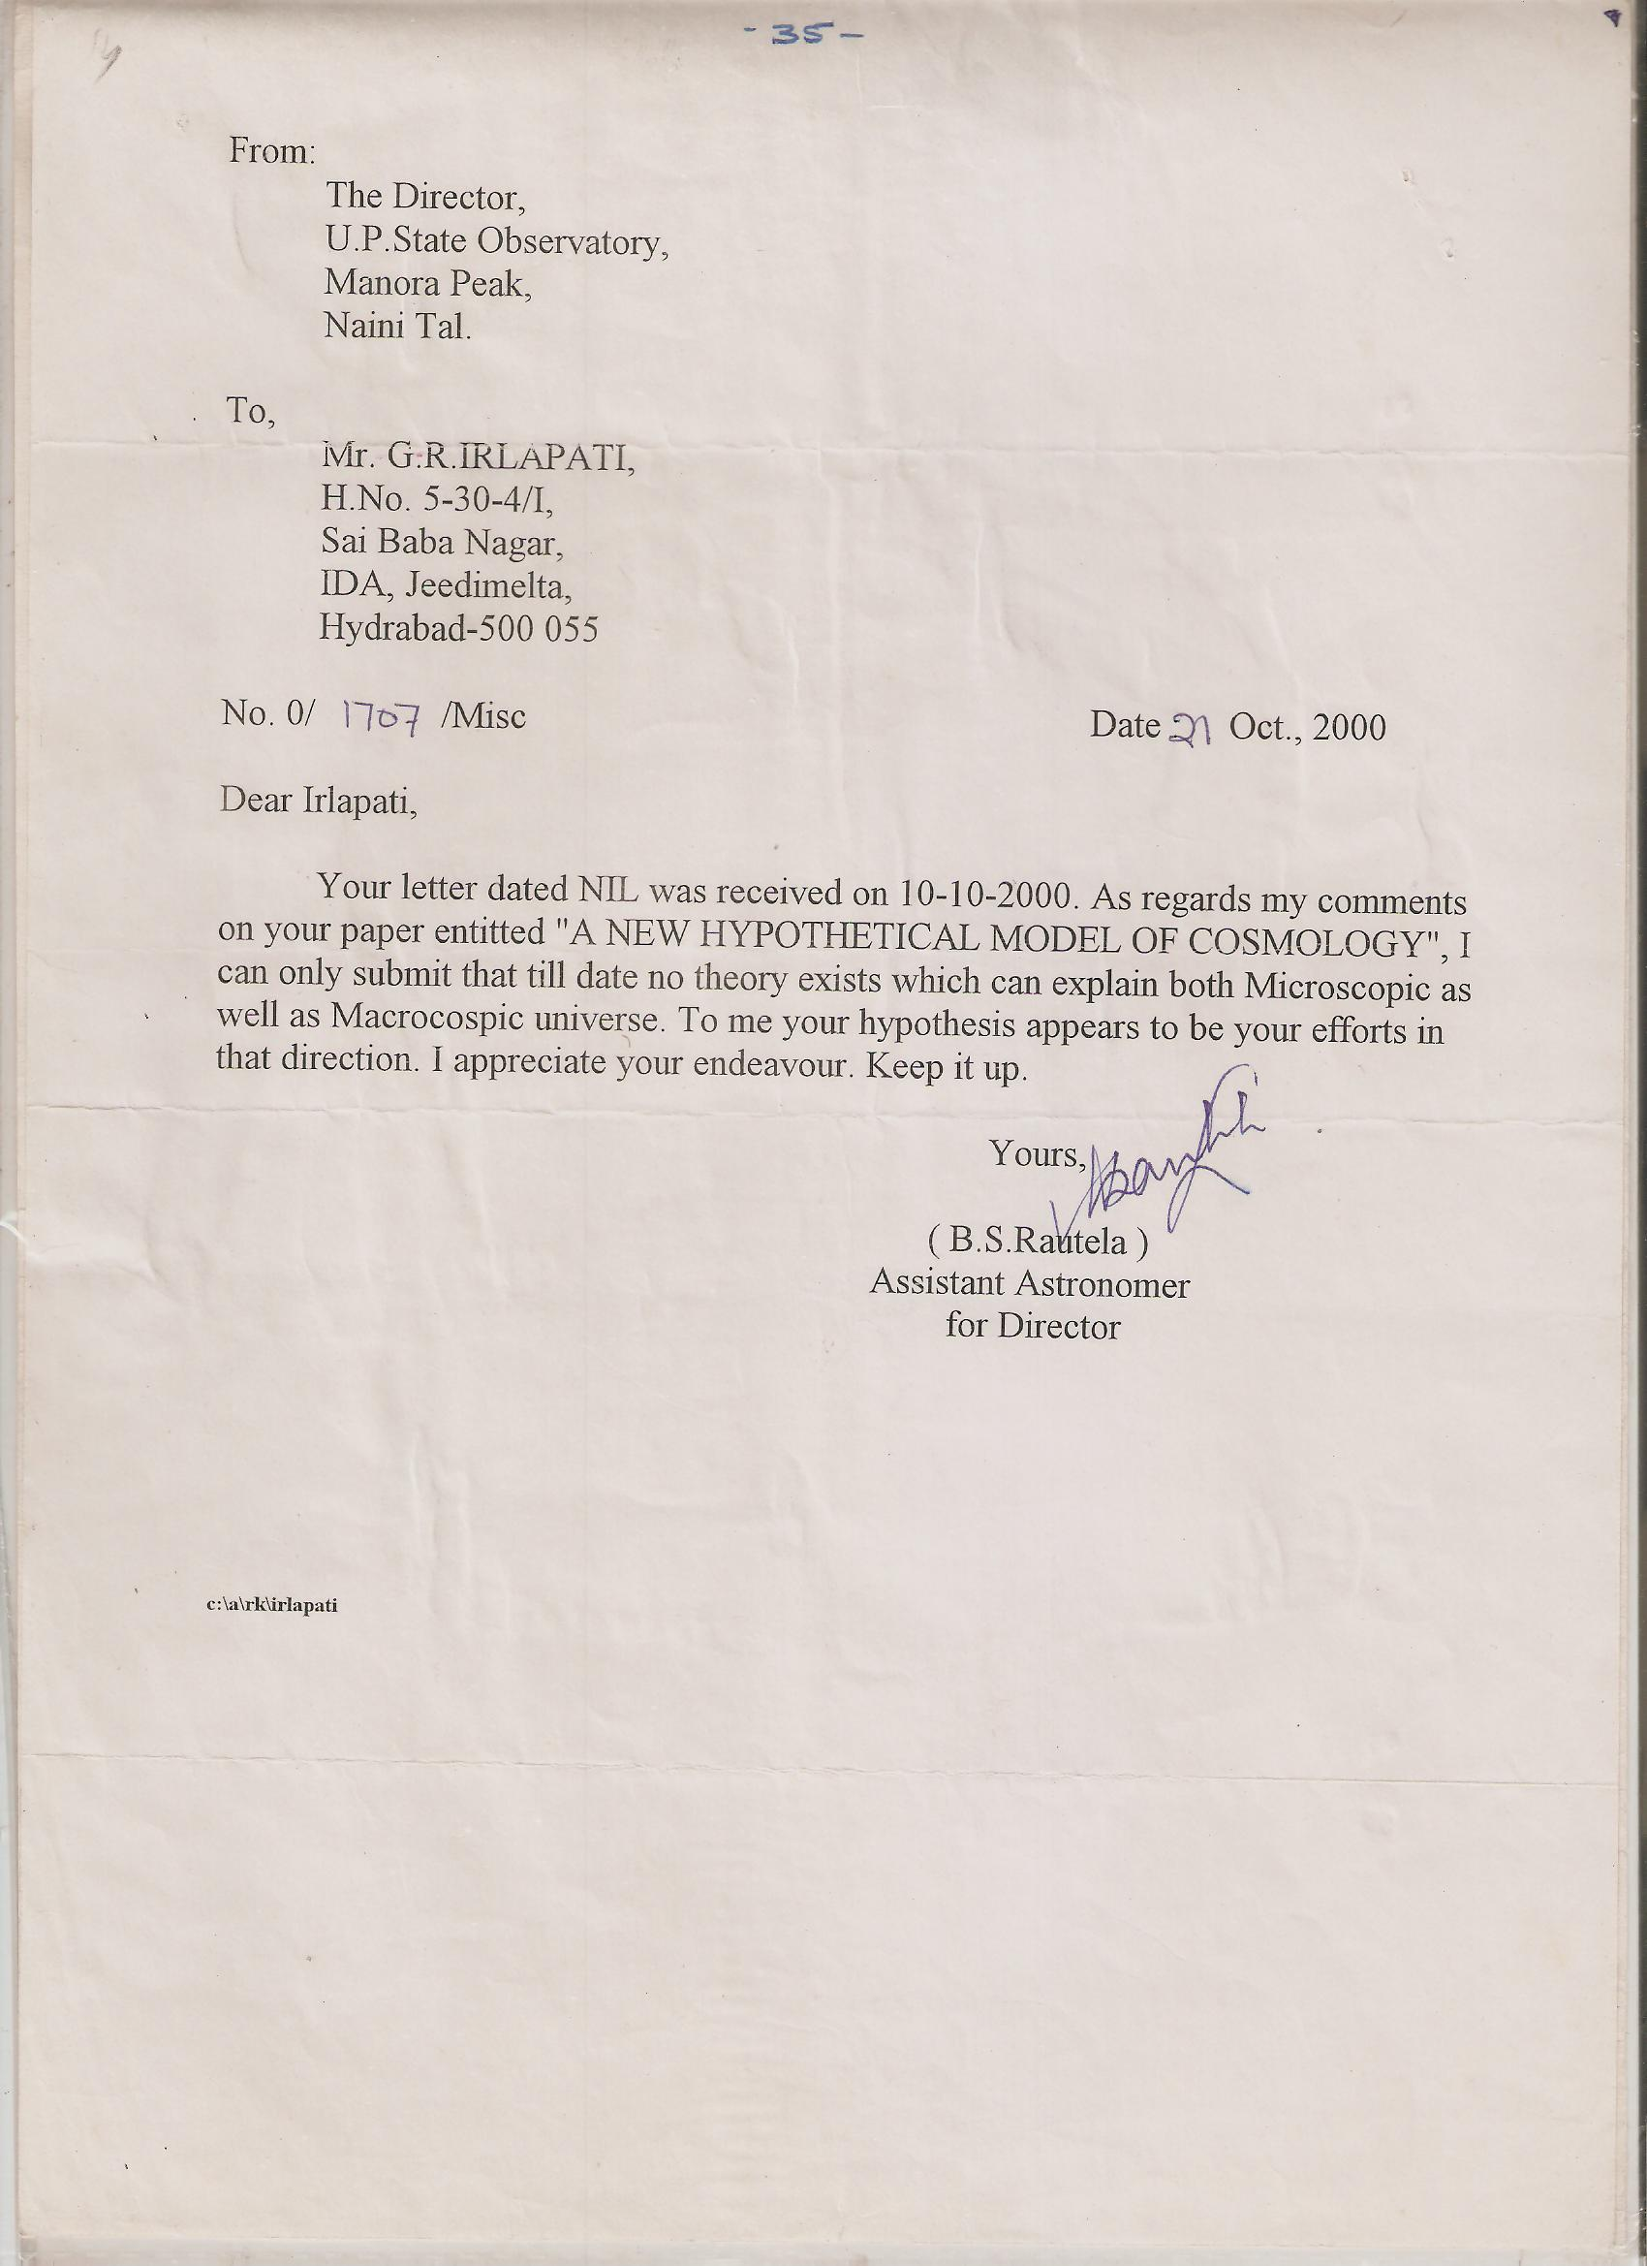

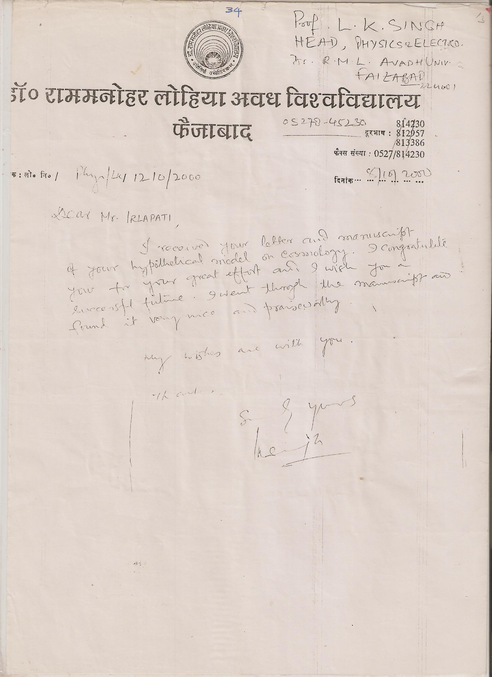

9/1/2016

