Results Of Research On Space Physics

Gangadhara Rao Irlapati

H.No.5-30-4/1, Saibaba Nagar, Jeedimetla, Hyderabad – 500 055, Telangana State, INDIA
Email ID: scientistgangadhar@gmail.com

Abstract: Space physics is the study of plasma as they occur naturally in the earths upper atmosphere. As such, it encompasses every thing above earth’s atmosphere, upto the edge of the solar system. Space physics is a fundamental part of the study of space weather. I have conducted many researches on the space physics, and invented some related discoveries & inventions which may also be useful in understanding the extent of the use of space physics.
[Gangadhara Rao Irlapati. Results Of Research On Space Physics. Researcher 2016;8(1s):40-74]. ISSN 1553-9865 (print); ISSN 2163-8950 (online). http://www.sciencepub.net/researcher. 2. doi:10.7537/marsrsj0801s16.02.

Keywords: Universe, A new hypothetical model of cosmology

Introduction:
I have conducted many scientific researches on the Indian Monsoon during the period of 1980-91, and invented the Indian Monsoon Time Scale which can help to study the past, present and future movements of the Indian Monsoon. In 1991, Sri G.M.C. Balayogi, Member of Parliament (Lok Sabha) recommended the Indian Monsoon Time Scale to the India Meteorological Department for implementation in the services of the country. In 1994, the cabinet secretary of India recommended the Indian Monsoon Time Scale to the Ministry of Science & Technology, Govt of India for implementation. In 1996, Many consultations were made with the parliament house, president of India and other VVIPS of India. In 2005, consultations were made with the India Meteorological Department about the Indian Monsoon Time Scale for further research and development in the services of the country. In 2009, the Secretary, Minister of science and technology was also recommended the Indian monsoon Time scale to the Indian Institute of tropical Meteorology for research and development.
Indian Monsoon Time Scale: The Indian Monsoon Time Scale-a chronological sequence of events arranged in between time and weather with the help of a scale for studying the past, present and future movements of monsoon of India and its relationship with rainfall and other weather problem and natural calamities.
Prepare the Indian Monsoon Time Scale having 365 horizontal days March 21st to next year March 20th of a required period comprising of a large time and weather have been taken and framed into a square graphic scale. The main weather events if any have been entering on the scale as per date and month of the each and every year. If we have been managing the scale in this manner continuously we can study the past, present and future movements of the Indian Monsoon.
For example, I have prepared the Indian Monsoon Time Scale by Preparing the Scale having 365 horizontal days from 1st April to next year March 31st of 128 years from 1888 to 2016 for the required period comprising of large time and weather have been taken and framed into a square graphic scale. The monsoon pulses in the form of low pressure systems over the Indian region have been entering on the scale in stages by 1 for low, 2 for depression, 3 for storm, 4 for severe storm and 5 for severe storm with core of hurricane winds pertaining to the date and month of the each and every year. If we have been managing the scale in this manner continuously, we can study the past’s present’s and future’s of the India monsoon and its relationship with rainfall and other weather problems & natural calamities in India.
Analysis: The Indian Monsoon Time Scale reveals many secrets of the monsoon & its relationship with rainfall & other weather problems and natural calamities. For example, some bands, clusters and paths of low pressure systems along with the main paths of the Indian Monsoon (South-west monsoon and north-east monsoon) clearly seen in the map of the Indian monsoon it have been some cut-edge paths passing through its systematic zigzag cycles in ascending and ascending order which causes heavy rains & floods in some years and droughts & famines in another years according to their travel. For example, during 1871-1990’s the main path of the Indian monsoon was rising over June, July, August and creating heavy rains and floods in most years. During 1900-1920’s it was falling over August, September and causing low rainfall in many years, During 1920-1965’s, it was rising again over July, August, September and resulting good rainfall in more years. During 1965-2004’s it was falling over September and causing low rainfall and droughts in many years. At present it is rising upwards over June, July, August, and will be resulting heavy rains & floods in coming years during 2004-2060. The tracking date of main path & other various paths such as south-east monsoon and north-west monsoon etc., of the Indian Monsoon denotes the onset of the monsoon, monsoon pulses or low pressure systems. And also we can find out many more secrets of the Indian monsoon such as droughts, famines, cyclones, heavy rains, floods, real images of the Indian Monsoon, and onset & withdrawals of south east monsoon and north-west monsoon etc. by keen study of the Indian Monsoon Time Scale.
Principle: This is an Astrogeophysical/ Astrometeorological Phenomenon of effects of astronomical bodies and forces on the earth’s geophysical atmosphere. The cause is unknown however the year to year change of movement of axis of the earth inclined at 23 ½ degrees from vertical to its path around the sun does play a significant role in formation of clusters, bands & paths of the Indian Monsoon and Stimulates the Indian weather. The inter-tropical convergence zone at the equator follows the movement of the sun and shifts north of the equator merges with the heat low pressure zone created by the rising heat of the sub-continent due to the direct and converging rays of the summer sun on the Indian Sub-continent and develops into the monsoon trough and maintain monsoon circulation.
Experiments Carriedout: Many experiments were carried out on the Indian Monsoon Time Scale and Successfully proved out in practice.
Publications: Many journals announced the Indian Monsoon Time Scale In 2004, a news commentary was published in the popular daily Vartha. The journal of environmental & ecology announced the Indian Monsoon Time Scale and Global Monsoon Time Scale in 2015.
Conclusions: We can make many more modifications thus bringing many developments in the Indian Monsoon Time Scale.

A New Hypothetical Model Of Cosmology: The cosmos is made up of universes in infinite number, having similar structure and properties, embedded one in each other and extended in ascending and descending order.
To explain and justify this model, there are three universes so far known to us (a) Geo-Universe (b) Atomic-Universe (c) Energy-Universe. These three are having similar structure and properties, embedded one in each other and extended in ascending and descending order. Of these three, we known some extent about the internal structure and properties of the Geo-Universe but we do not known its external structure. We know some extent about the external structure and properties of the Energy-Universe but we do not know its internal structure. Between of these three universes, we came to know a large extent about the internal & external structure and properties of the Atomic-Universe. Hence, I have taken the similarities of internal structure & properties between the Geo-Universe & Atomic-Universe to propose that all the universes in ascending and descending order of the creation are having similar internal structure and properties. The similarities of external structure & properties between the Atomic Universe and Energy-Universe are taken to propose that all the universe in ascending and descending order of creation are having similar external structure and properties. And the manner in which of these three universes i.e., embedded one in each other, extended in ascending and descending order to propose that all the universes in ascending and descending order of the creation are embedded one in each other and extended in ascending and descending order.
Similar External Structure & Properties
According to the model, all the universes in ascending and descending order of the creation are having similar external structure and properties. To justify this, I have taken many similarities between the atom and photon. For example:

Atomic-Universe Energy-Universe
1) The atom appearing in several forms such as 1) The particle “Photon” related to
Hydrogen to uranium etc., being due to the energy appearing in several forms such
Internal structure having different atomic particles as radio waves, gamma rays, violet rays
at various numbers. etc being may be probably due to the
internal structure having different
particles at various numbers.
2) The atom exhibiting several physical and chemical 2) The particle “photon” related to energy
Properties such as weight, colour, taste, hardness exhibiting properties such as wave length,
etc being due to the internal structure having different colour, temperature etc being may be
particles at various number. Probably due to the internal structure
having different particles at various
number.

Similar Internal Structure & Properties:
According to the model, all the universes in ascending and descending order of the creation are having similar internal structure and properties. To explain and justify this, I have taken many similarities between the atomic-universe and Geo-Universe.

Atomic-Universe Geo-Universe
1)Various atomic particles at different sizes in 1) Various astronomical objects at different
several numbers are present in the atom. sizes in several numbers are present in the
Geo- Universe.
2) These atomic particles having three types of 2) These astronomical objects having three
charges at negative, positive and neutral states type of charges at positive, negative and
are present in the atom. neutral states are present in the
Geo-Universe
3) Positively charged protons are present in the nucleus. 3) Stars built by atoms having positive
charged nucleus are present in centre of
the Geo-Universe
4) Neutrons at neutral state are present in the Nucleus. 4) Planets at neutral state are present in
Centre of the Geo-Universe.
5) Negatively charged electrons are present at large 5) There is a concept that anti-matter cosmic
distance of the atomic nucleus in the atom. bodies built by atoms having negatively
charged nucleus are present at large
distance of the Geo-Universe.
6) Additional neutrons called isotopes are present. 6) Additional planets called satellites around
the planets are present.
7) Radiation emitting from the atom. 7) Cosmic rays emitting from Geo-Universe.
8) There is a property of nuclear fission is in the atom. 8) There is a property of super Nova is in the Geo- Universe.

Descending Order Of Creation
The Geo-Universe that means the Universe seen around our earth is having magnificent structure and properties such as galaxies, stars and planets and some planets such as earth having continents, countries, oceans, trees, animals. Cyclones, human beings etc. Such Geo-Universe being built by Universes of its descending order of creation that means atoms.
Atomic-Universe that means the atom present in several forms from hydrogen to uranium etc is another universe having magnificent structure and properties such as electrons, protons, neutrons, etc., and continents, countries, oceans, cyclones, trees, animals, human beings may be present on some neutrons having suitable conditions exactly similar to the earth planet resembling in the Geo-Universe. Such atomic Universe being built by universes of its descending order of creation that means energy particle ‘photons”.
The Energy-Universe that means the particle “photon” related to energy present in several forms of electromagnetic radiation is also another universe having magnificent structure and properties resembling to Geo-Universe and atom. Such Energy-Universe may also being built by Universes of its descending order of creation that is not yet known to us.
Thus the descending order of creation continuous infinitely.
Ascending Order Of Creation
The Energy-universe that means the particle related to energy “photon” having magnificent structure and properties is being as a primary syntactic unit in the universe of its ascending order of creation that means atom. All components in the atom are built by these “photons” in infinite number. Such each and every energy particle “photon” is basis to an infinite descending order of creation.
The Atomic—Universe that means the “Atom” having magnificent structure and properties is being as a primary syntactic unit in the universe of its ascending order of creation that means in our Geo-Universe. All components in the Geo-Universe such as stars, planets etc., are built by these atoms in infinite number. Such each and every atom is basis to an infinite descending order of creation.
The Geo-Universe that means the “Universe” seen around our earth having magnificent structure and properties is being as a primary syntactic unit in the universe of its ascending order of creation that is not yet known to us. All components in that Universe are built by these Geo-Universes in infinite number. Such each and every Geo-Universe in that ascending creation is basis to an infinite descending order of creation.
Thus the ascending order of creation continuous infinite.
Cosmic-Environments
The fill of structure and characteristics in the universe of the cosmos proposed as cosmic environments. For example the fill of structure and characteristics like galaxies, stars, planets etc in the Geo-Universe proposed as Geo-Environment, the fill of structure and characteristics like proton, neutrons and electrons etc in the Atomic-Universe proposed as Atomic-Environment and the fill of structure and characteristics in the Energy-Universe that means in the photon that is not yet known proposed as Energy-Environment.
Space Weather
The fill of structure and characteristics like galaxies, Stars, Planets and their orbits and other physical forces etc that surrounds in the universe proposed as space atmosphere, the state of galaxies, stars, planets, nebulas. Pulsars etc at a particular region over a long period of time proposed as space-climate, the state of characteristics of space- climate like solar wind flares, asteroids etc at a particular region during a short period of time proposed as space-weather.
Space Regions
The state of space atmosphere being in still proposed as “Inactive Space Region”, the state of space atmosphere being in active proposed as “Active Space Region” The region of space atmosphere in which the celestial bodies are more widespread areas proposed as “Space High Pressure Area”, the less widespread areas proposed as “ Space Low Pressure Area”.
Space Low Pressure Systems
Some space times, happens variation of differences of pressure in the space-climate, At such a juncture, the celestial bodies and other space dust present in the space high pressure area will try to occupy the space low pressure area all at once. In this attempt, they will whirl around the space low pressure area. The centre of space low pressure area itself is the black-hole and the circular whirling celestial bodies & other space dust etc caused by the space low pressure area proposed as Galaxy.
Conclisions: We can make many more studies on this Hypothesis thus bringing many more mysteries of the universe.
Indian Weaqther Time Scales: I have conducted many extensive researches on the astronomical forces and its effects on the earth climate particularly on various regions of the India. The variations in the solar cycle affects and stimulate the earth climate. The moon affects and stimulate the ocean tides and atmosphere too. The movement of axis of the earth inclined at 23 ½ degrees from vertical to its path around the sun affects and stimulate the earth weather and leads to formation of monsoons and seasons etc. So the astronomical forces affect and stimulate the earth climate it may be more or less but it is true. These scales may be taken as a part of scientific study of astronomical forces & its effects on the earth climate.
In the time and scale of the universe some things from astronomy to atom including living beings have been repeating once in every certain time or period. For example, the south and north magnetic poles have been shifting in every certain period. The sun spots have been repeating once in every eleven years. The lunar and solar eclipses have also been occurring once in every 18.6 years. The seasons such as winter, autumn etc. also have been repeating once in every year in the same month of the year. The periodical menses in the females repeating once in every month.
On the basis of the said universal facts, I have prepared a time scale with 21 blocks, each block containing certain prescribed cycle of years in which similar calendar years repeating one after another that leads similar weather conditions of those previous years to future years likely repeating every year approximately. The rainfall of the years, have been entering in the scale in percentages or as it is pertaining to month, season, annual wise of the each and every year. If we managing the scale in this manner continuously, we may assuming the weather conditions of the anterior years on the basis of the posteriors years weather. On the basis of the principle, we can assume that a considerable, of course it may be little chance of predication for an ensuing years by study the data of earlier years.
I have prepared a model Indian weather time scale along with hundreds of additional scales (1617 scales, 12 months, 4 seasons, 50 regions & 150 above years were studied) in which all weather conditions such as rainfall, temperature, cyclones, river water etc of all homogeneous regions sub-divisions of India were studied and analyzed elaborately.
Studies Carried Out :
Firstly, see the Indian weather forecasting study model time scale. In this scale, the June, July, August and September months of the summer monsoon season were taken in a table in which the each month is also divided into three parts the Telangana, Rayalaseema and Coastal Andhra regions. The monthly wise rainfall data of the months of the regions from 1870 to till available years are taken in the form of percentages or as it is and entering in the scale pertaining to the region wise of the each and every year. If we managing the scale in this manner continuously, we may assuming the weather conditions of the anterior years on the basis of the posterior years weather.
Example for assuming the dry season or suppose to predict the rainfall situation in the summer season of the ensuing year 2019: study the 7th cycle in which wet conditions in 10 years and dry conditions in 14 years were occurred in the month of June : wet conditions in 2 years and dry conditions in 22 years were occurred in the month of July : wet conditions in 4 years and dry conditions in 20 years were occurred in the month of August and wet conditions in 8 years and dry conditions in 16 years were occurred in the month of September. On the whole, wet conditions in 24 times and dry conditions in 72 times repeated in the summer monsoon season of the 7th cycle (As a result, there were dry conditions occurred in the 2002 year also). Therefore it is a considerable chance to predict that a dry season will be repeated in the ensuing year of 2019.
Example for assuming the wet season or suppose to predict the rainfall situation in the summer season of the ensuing year 2022: study the 10th cycle in which wet conditions in 13 years and dry conditions in 8 years were occurred in the month of June: wet conditions in 13 years and dry conditions in 8 years were occurred in the month of July: wet conditions in 9 years and dry conditions in 12 years were occurred in the month of August and wet conditions in 19 years and dry conditions in 2 years were occurred in the month of September. On the whole, wet conditions in 54 times and dry conditions 30 times were repeated in the summer monsoon season of the 10th cycle. As a result, there were wet conditions occurred in the 2005 years also. Therefore, it is a considerable chance to predict that a wet season will be occurred in the ensuing year of 2022.
In the same manner, we can study the remaining all Indian weather time scales of all Indian Homogeneous regions and subdivisions, states and districts of India.
We can make many more modifications thus bringing many more developments in the Indian weather time scale and its all additional Indian weather time scale.
Lisposcope Experiments:I first started the researches in 1963-65 @ 5 to 7 years age with little instruments such as papers and pencils, water drop etc. and invented the light spot scope (Liposcope). Liposcope is a simple but wonderful instrument which functions with a natural doctrine hidden secretly in the function of the eye which can help to find out some inventions and discoveries like biolumicells, bioforecast effect etc, Liposcope is my first invention.
Construction: Take one small glass/steel ball or water drop on an object and stand in sun the light. Expose the ball/drop to the sun rays. As a result of the sun rays, there will be a light spot in the drop/ball. Place the light spot closely to the eye. The light spot apperars many times bigger as a circular screen. The appearance in the screen of light spot is the surface of the eyeball. This can be proved by moving eyelids, the movement of eyelids, eye water and some bioluminescent particles on the eyeball can be observed in the screen of light spot.
Principle: The principle of the lisposcope is that the eye lens changes its focal length from a minimum distance to the object at infinity and can see the object. If the distance decreases below minimum, the clarity of vision decreases. At this position, the eye lens acts as a simple microscope and form virtual images of all objects in front of it. We can see them on the screen of light spot if place just unside its minimum distance.
Biolumicells : I have discovered the biolumicells (Bioluminescentmicells) on the eyeball in 1964 in the Lisposcope experiments. These particles are a part and parcel of the human body, may be released within the human body and secreting to the eyeball through the eye water. This is my second invention.
In the lipscope observations we can see three types of bioumicells on the eyeball the first one is the most bright and active and it is seen rarely on the eyeball and this biolumicell is has high velocity, mechanical energy, spin around itself it. The second one has normal bright seen normally on the eyeball and the third and last one is bright less, it is seen frequently on the eyeball.
Bio-Forecast Effect: I have invented the bioforecast effect in 1965 by keen study and observations of the biolumicells. Although weakened by forecasting property with less successive rate, it is a primary and natural forecasting method. This is my third invention which can help to forecast the weather changes 18 days in advance.
Looking the screen of light spot and move the eyelids. We can see some biolmicells on the eyeball. After finding a number of biolumicells all at once in cloud or group, you must count them without eyelid movement. Firstly, observe with one eye two or three times. Later on another eye. As we examine one after another with both eyes, we have to take into account the greatest number of particles.
Analyze the data and make a table with the particulars-date of observation, time of observation , number of particles and weather report. Firstly we must put the date, next the time of observation, then the number of particles available in the observation. Do the observations three or four times daily in the morning & evening and record the number. At last, record the weather report of the country on the same day. If we do our observations and analyze in that manner, we can notice that there is a relation between the differences in particles number in the table and the changes in the weather after about 18 days. If the particles number is minimum the weather after 18 days will be normal. On the other hand if the particles number is at maximum there will be a change in the weather after 18 days.
Principle: The cause is unknown however it can understand that generally biolumicells secrete in less or minimum levels at normal weather conditions, but over the formation of low pressure weather conditions, biolumicells begin to secrete at maximum levels due to a fall in weather pressure on the human body.
Great Prediction: The important prediction of the bioforecast effect was proved in 1991. In 1991, the Andhra Pradesh state council of science & Technology, The Andhra Pradesh Remote Sensing Applications Centre and the Andhra Pradesh Science Centre were conducted experiments on the relationship between the biosphere and atmosphere (explore the inter-connection of earths geomagnetic field with natural calamities and their effect on human impulse). In these observations, the maximum level of the biolumicells were recorded between 7th to 11th of April, 1991. It is the sign of the ensuring cyclone of the 28th April 1991. The three directors of the said institutions were met in the Andhra Pradesh state Council of Sciences & Technology on 9TH, April 1991 and discussed about the prediction. As predicted on 9th April 1991, in the meeting a severe cyclone was formed in Bay of Bengal and struct the Bangladesh on 28th April 1991. As a result, thousands of people were killed and crores of rupees property was damaged. This is the great prediction by the bioforecast and the remaining predictions were weak.
Uses: one can observe the surface of the eyeball. One can observe the humidity on the eyeball. One can observe some new bioluminescent particles on the eyeball. One can observe physiological vessels etc through the same. One can predict the weather changes in advance etc.

References:
- Mooley DA, Shukla J(1987); Charecteristics of the west ward-moving summer monsoon low pressure systems over the Indian region and their relationship with the monsoon rainfall. centre for ocean-land atmospheric interactions, university of Maryland, college park, MD.
- All india monthly and seasonal rainfall series,18711993, B. Parthasarathy, A. AMunot, D. R. Kothawale, Theoritical and applied climatology,1994, Springer.
- Das P. K. and B. L. Bose, 1958, Numerical study of movement of monsoon depression, Ind. journal of meteor. Geophysics.
- Analysis of variability and trends of extreme rainfall events over india using 104 years of gridded daily rainfall data, M. Rajeevan, J. Bhate, A. K. Jaswal, Geophysical Research letters, 2008, online library.
- Jadhav, S. K. and A. A. Munot,2004; statistical study of the low pressure systems during summer monsoon season over the Indian region, mausam, 55,15-30.
- Clusturing of low pressure system during the Indian summer monsoon by intra seasonal oscillations, bn. goswani, rs. ajaya mohan, prince kxavier, and d. sengupta, centre for atmospheric and oceanic studies, Indian institute of science, bangolour, india.
- Composite structure of monsoon low pressure system and its relation to Indian rainfall, v. krishna murthy and rs. ajaya mohan, 2010, j. climate,23,4285-4305.
- Indian monsoon university of st Andrews www.Andrews.Ac.Uk/Dibz/Asia/Monsoon/Html.
- Indian monsoon /meteorology/britanica/.com www.britanica.com/science /indian monsoon.
- The global monsoon system : research and fore cast; caos.iisc.in/faculty/bng/iwm-iii-bng-overview.
- Climate predictron centre-global monsoon; www.cpc ncep.noaa.gov, climate.weather.
- The global monsoon system, www.wcrp-climate.org/documents/monsoon –factssheet.
- All india monthly and seasonal rainfall series, 1871-1993, b. parthasarathy, a. a munot, Drkothawale, theiritical and applied climatology, 1994, springer.
- Parthasarathy b, munot aa, kothawale dr, monthly and seasonal rainfall series for all india homogeneous regions and meteorological sub-divisions, 1871-1994, research report, iitm pune.
- Longest instrumental rainfall series of the Indian regions (1813-2006), Indian institute of tropical meteonology, pune.
- All Indian data series-(imd) pune.
- Monthly rainfall data series-ministry of earth sciences, moes. gov. in.
- 114 years rainfall in india-interactive, india environmentportal. org. in/rainfall in india.
- The Steinhardt-turok model.
- The Baun-frampton model.
- Loop quantum cosmology.
- En.wikipedia.org/wiki/multiverse.
- Heliocentric model.
- Geocentric model.
- Copernican model.
- Heliocentric model vs geocentric model.
- en.wikipedia.org/wiki/big bang theory.
- en.wkipedia.org/wiki/steadystate theory.
- www.astro.ucla.edu/-wright/steady stat.
- www.ncdc.noaa.gov/data-access/numerical-weather-prediction.
- En.wikipedia.org/wiki/numerical- weather- prediction.
- The history of numerical weather prediction –NOAA;
- Fundamentals of numerical weather prediction/ ebooks.cambridge.org.
- Ken ring,the moon and lunar science predict weather.
- Moon predict weather lore / www.almanac.com/content/moon-lore-weather.
- Climate change, sunspots activity & lunar /cosmic cycles (www.the longerview.com.au/sunmoon-climate.html).
- Nelson john H, cosmic patterns; theirs influence on man and his communications 1974 American federation of astrologers.
- Nelson j. h, RCA review, april 1951.
- Nelson J. H., J. geocosmic research, summer 1974.
- SATO live bioforecasting www.Jst.go.Jp.
- Bio weather forecast; www.weather forecasting.com/locations/bio-3/forecasts latests.

Appendices: (Indian Monsoon Time Scale)
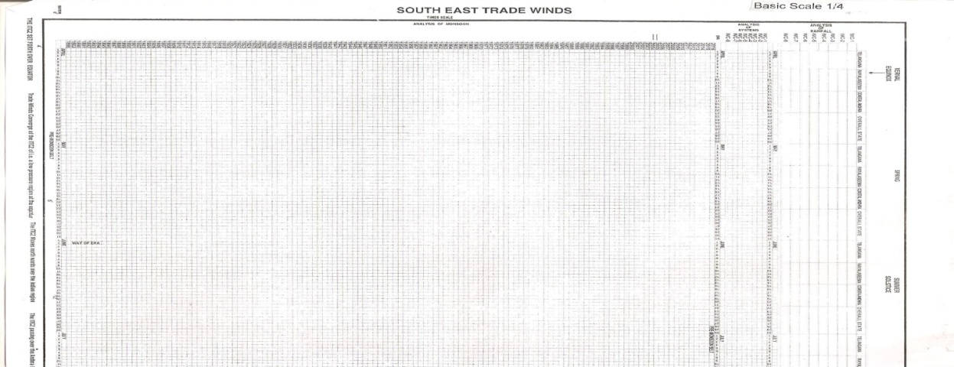

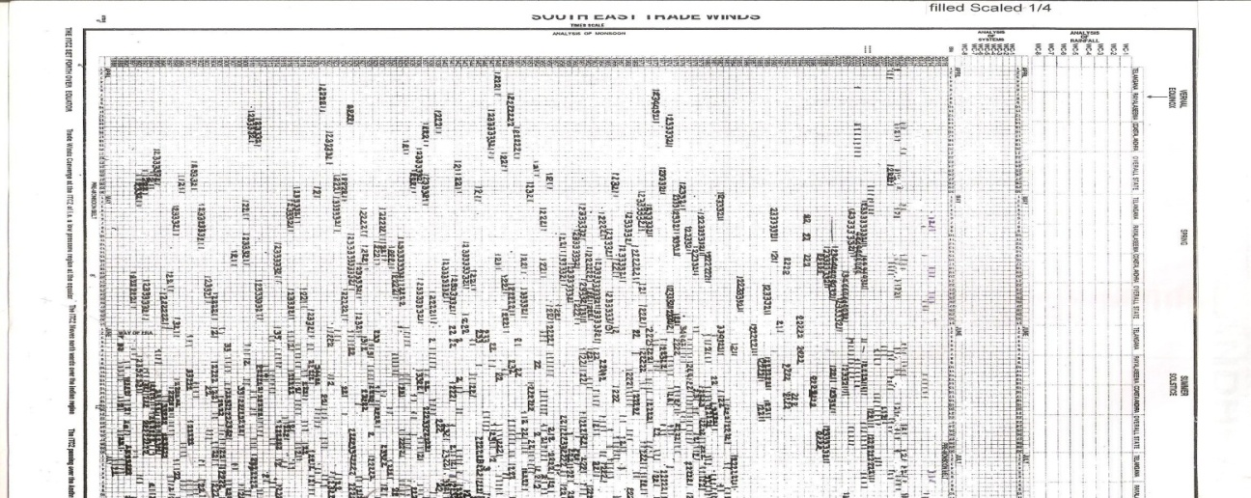
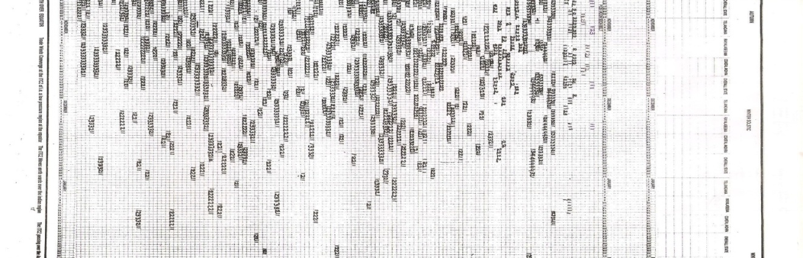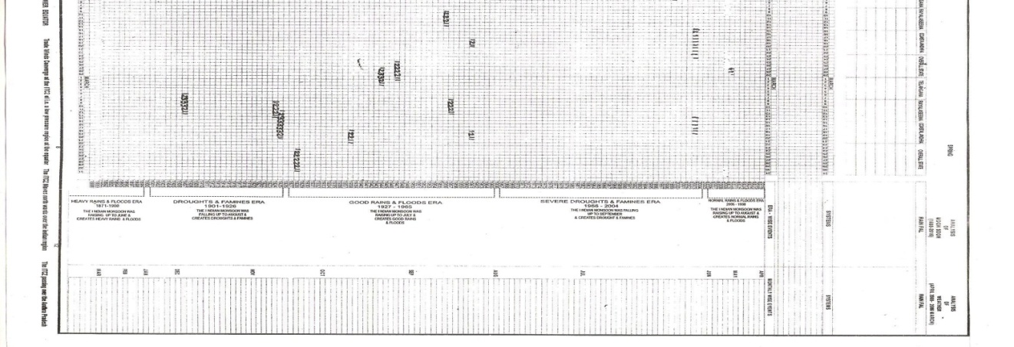

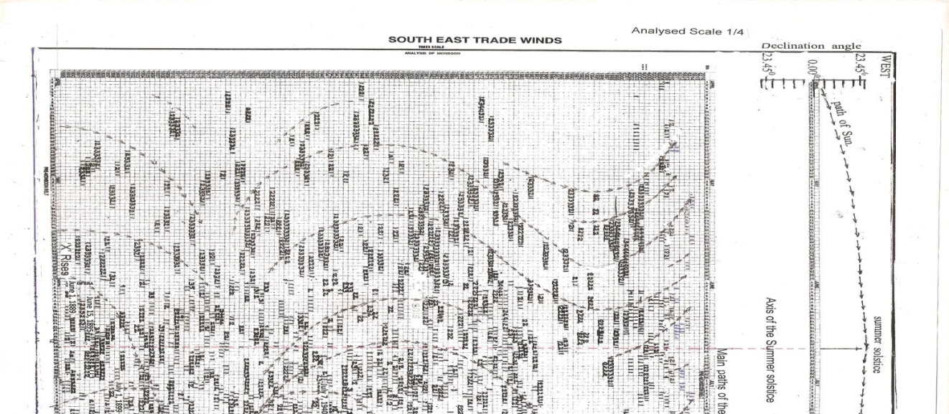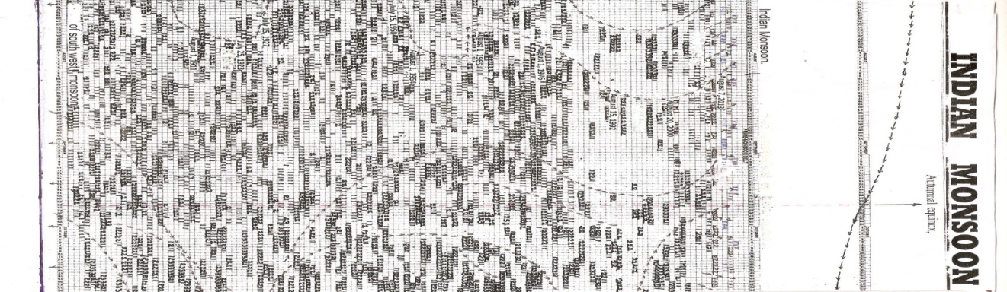
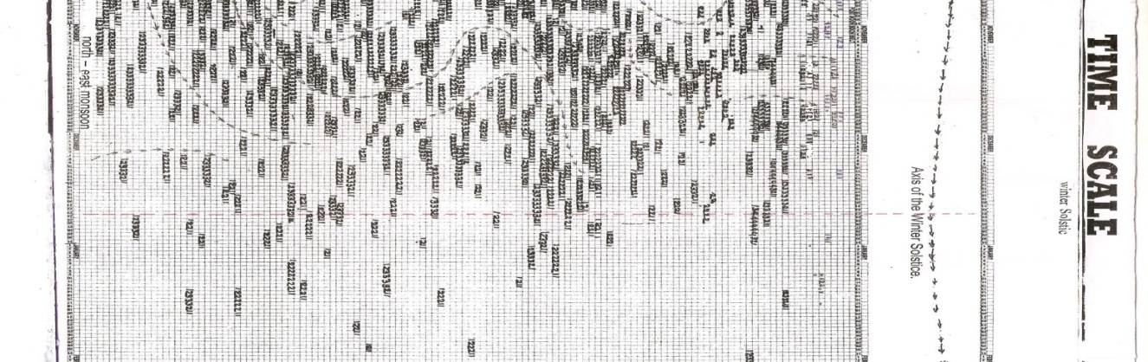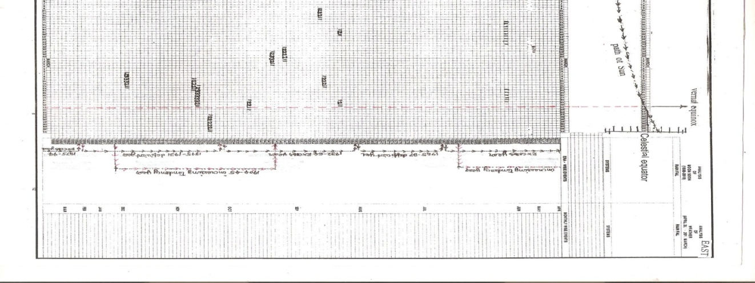

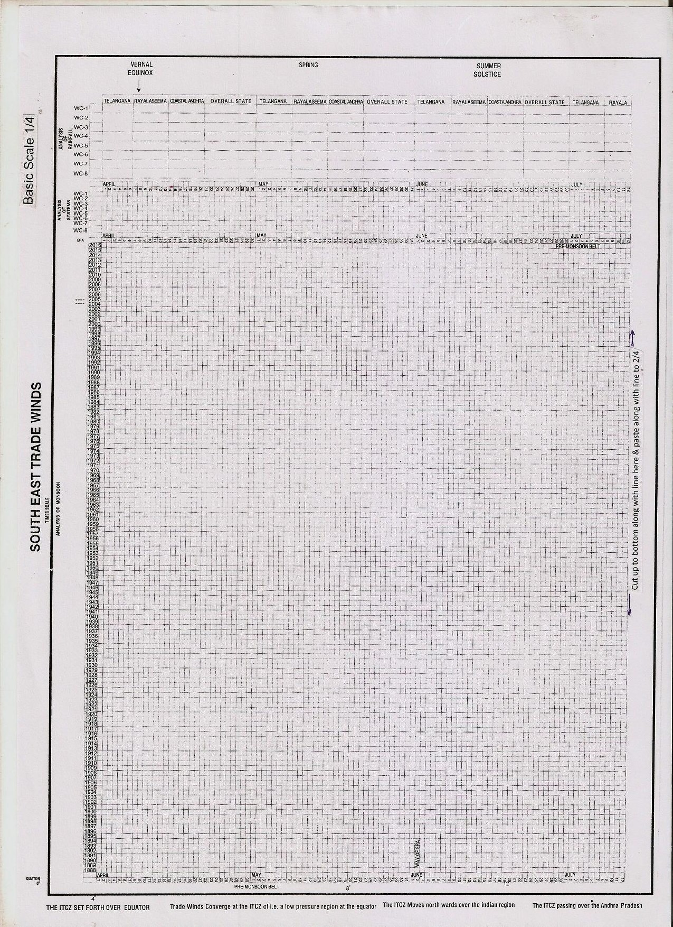
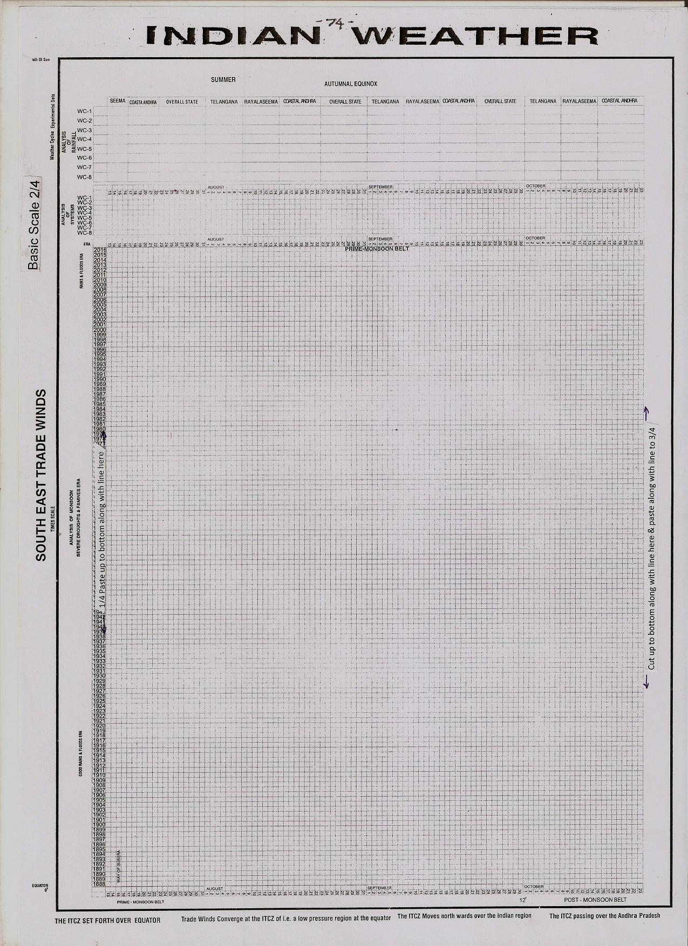
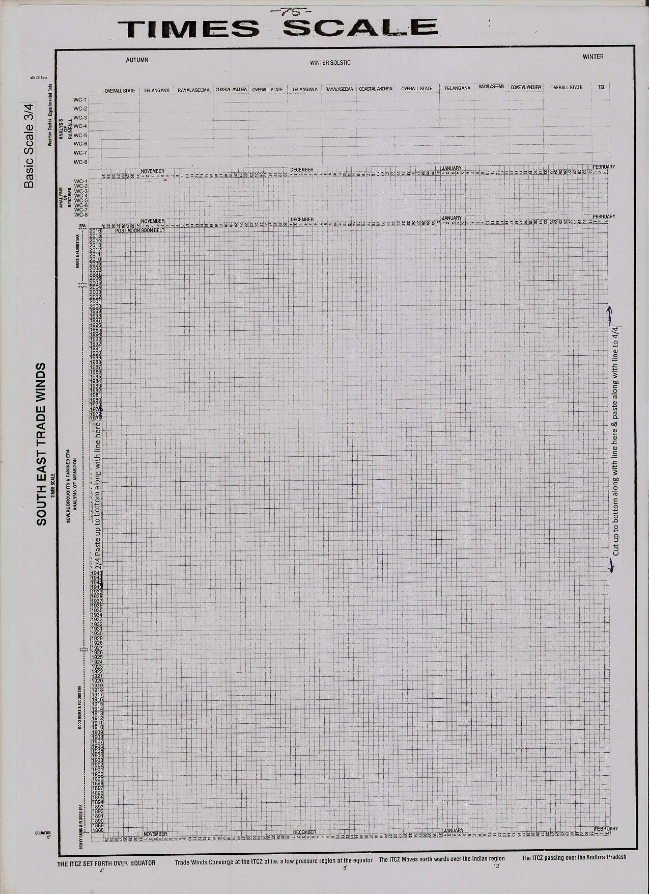
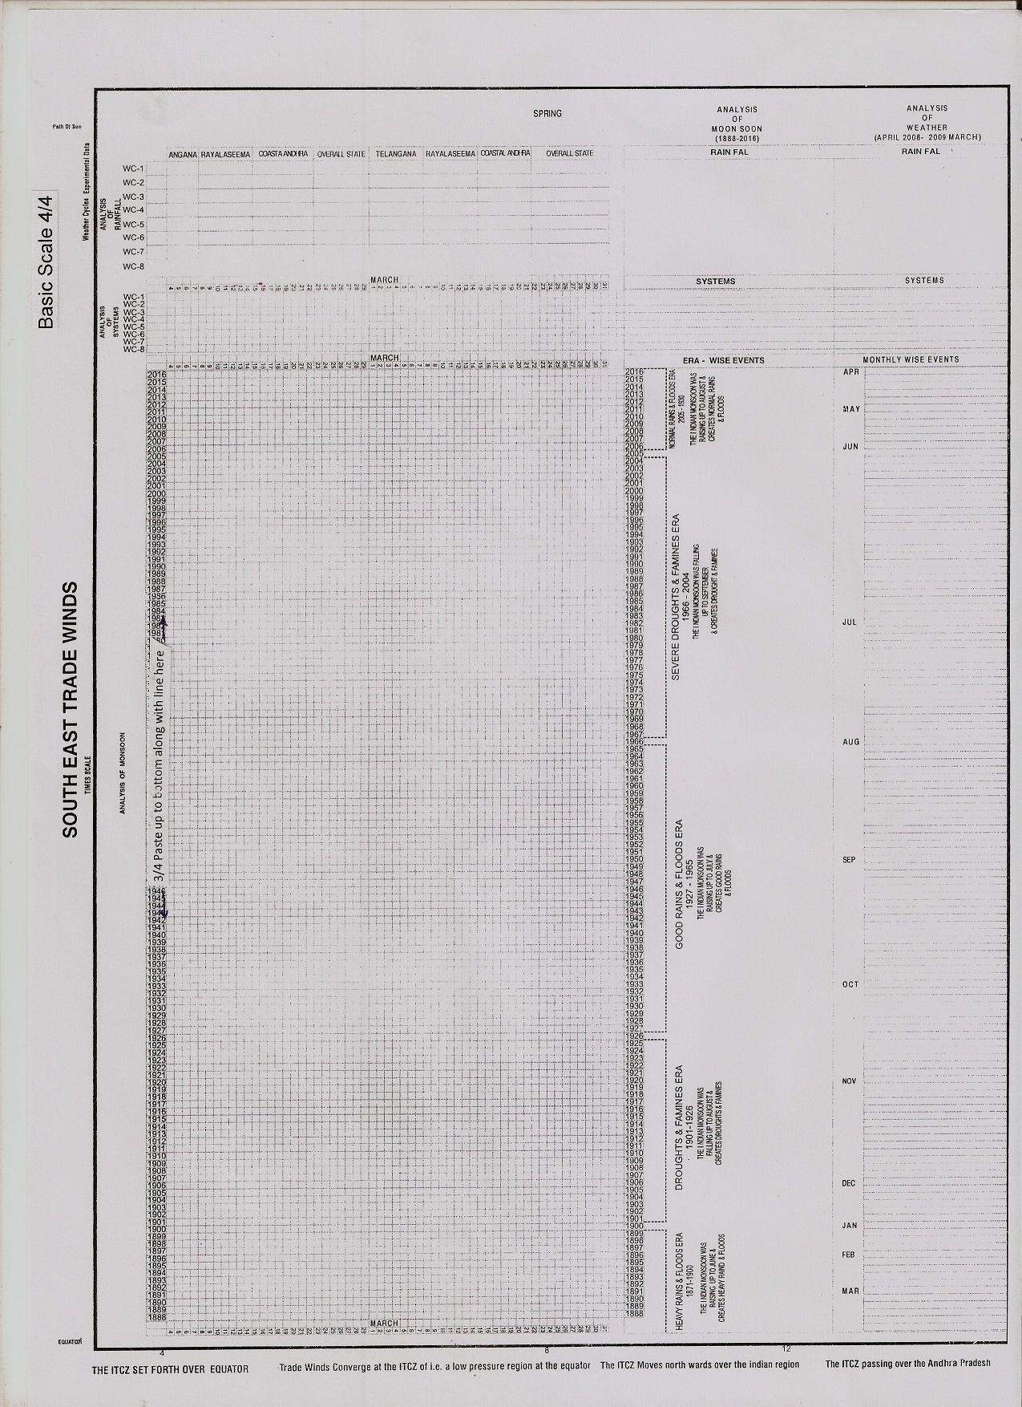
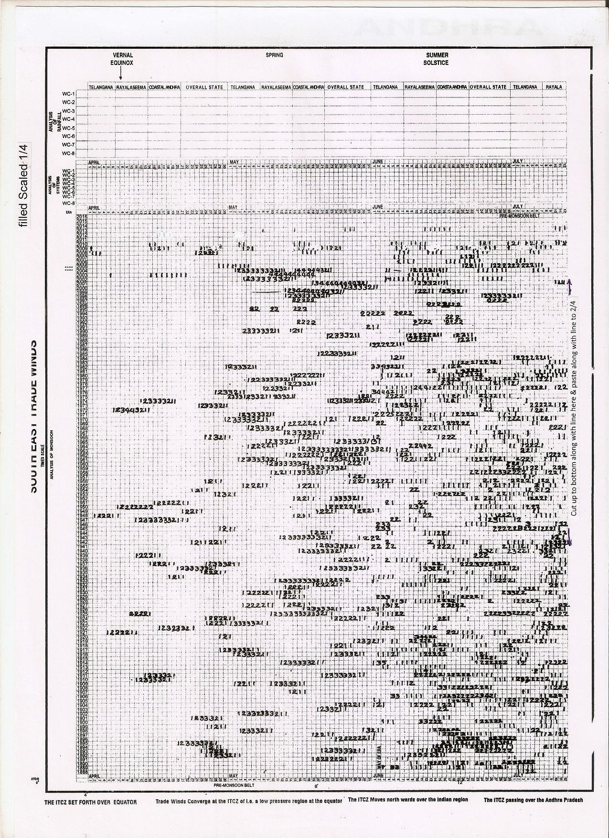
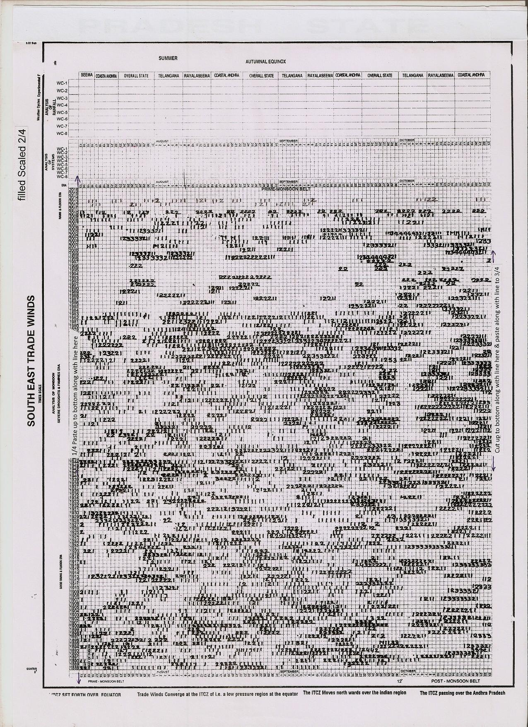
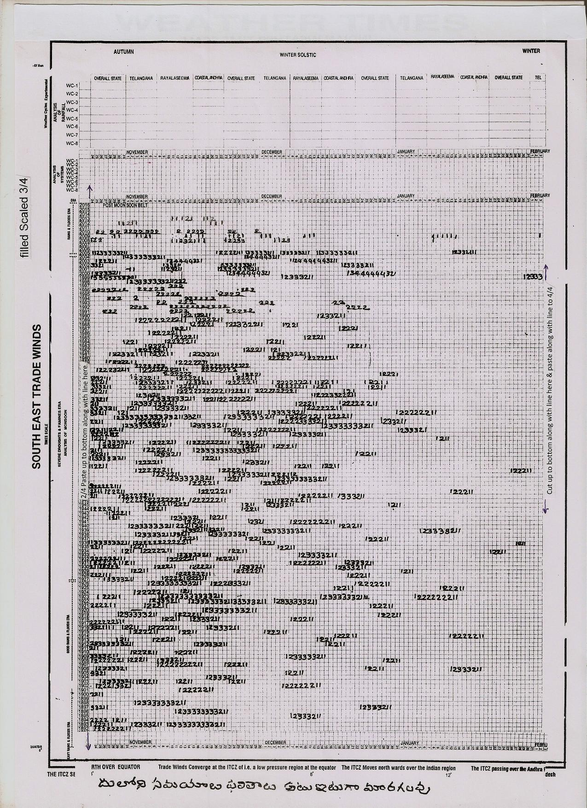
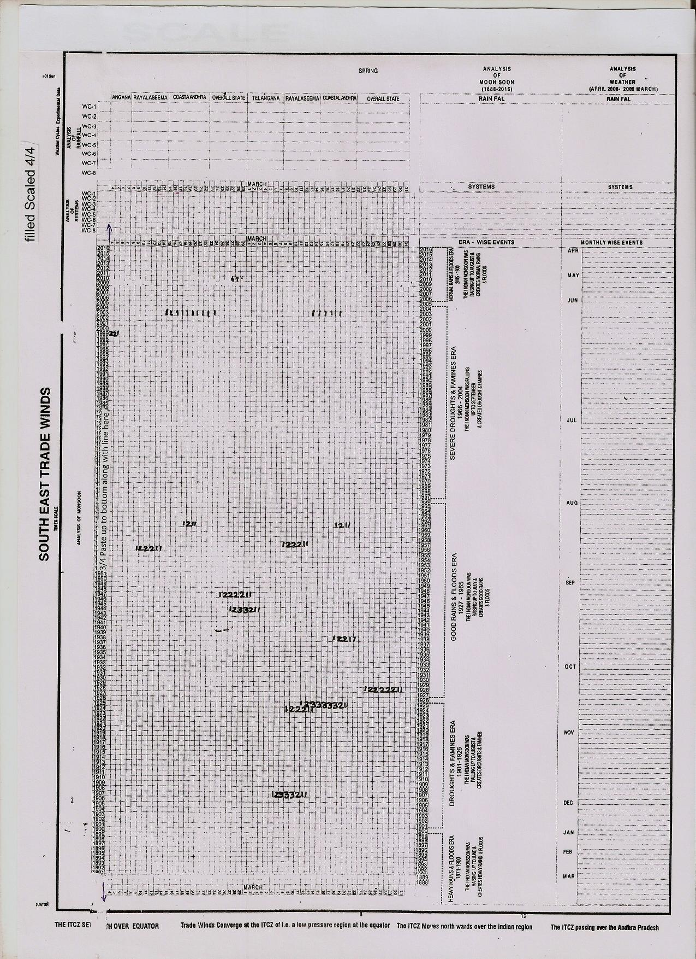
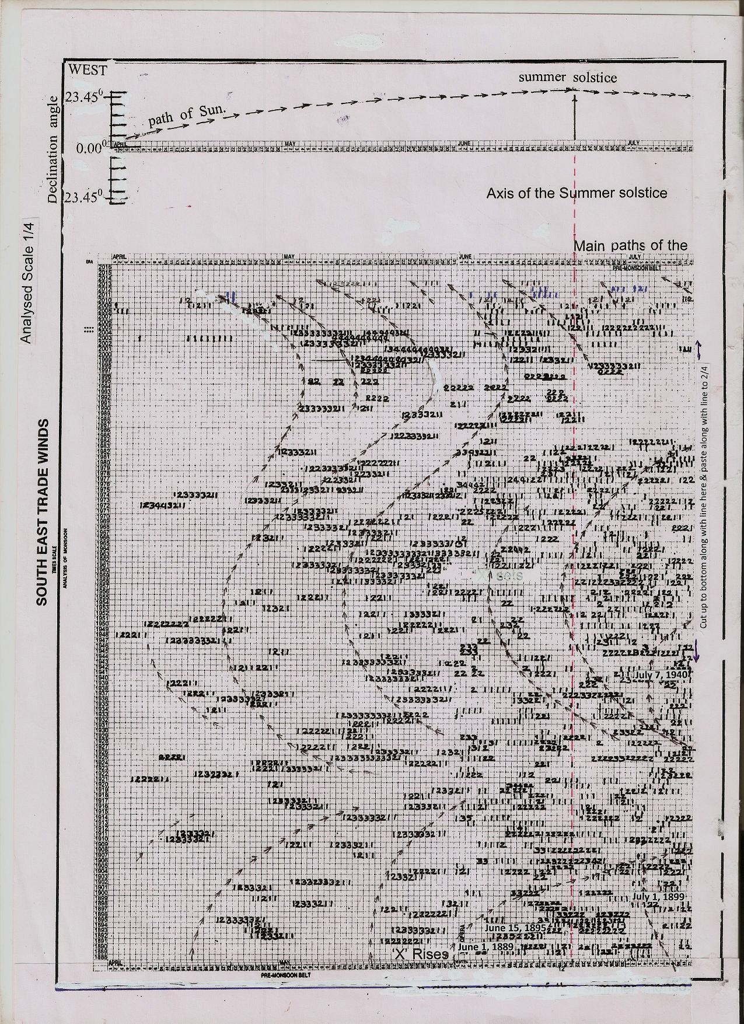
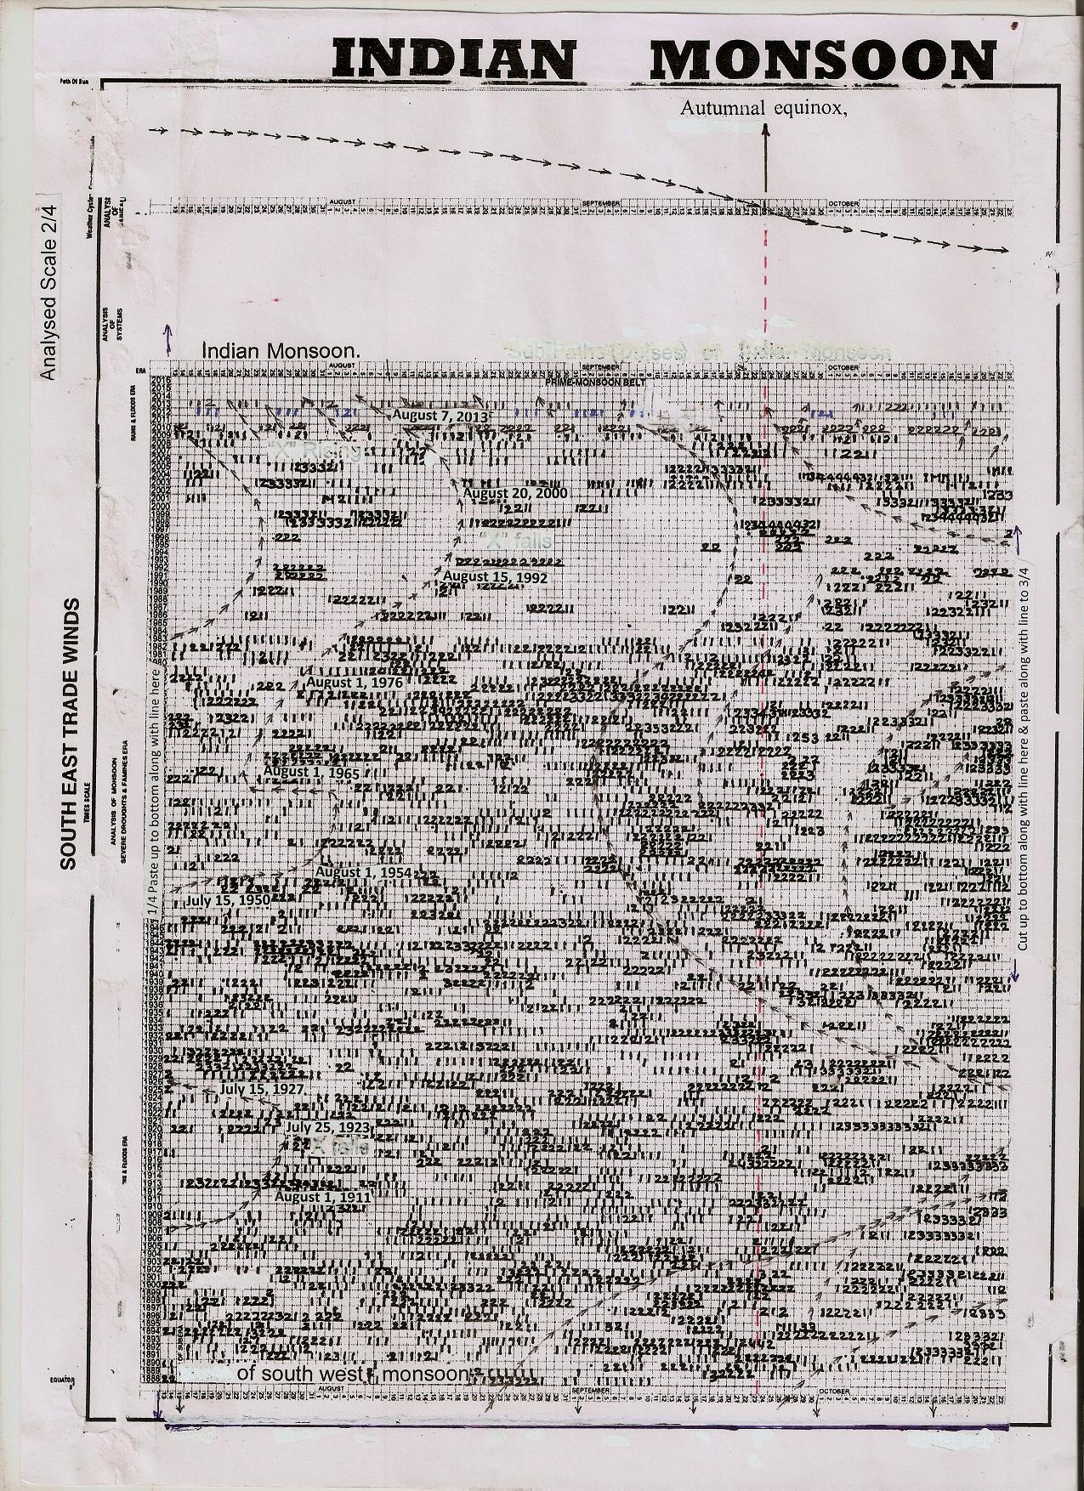
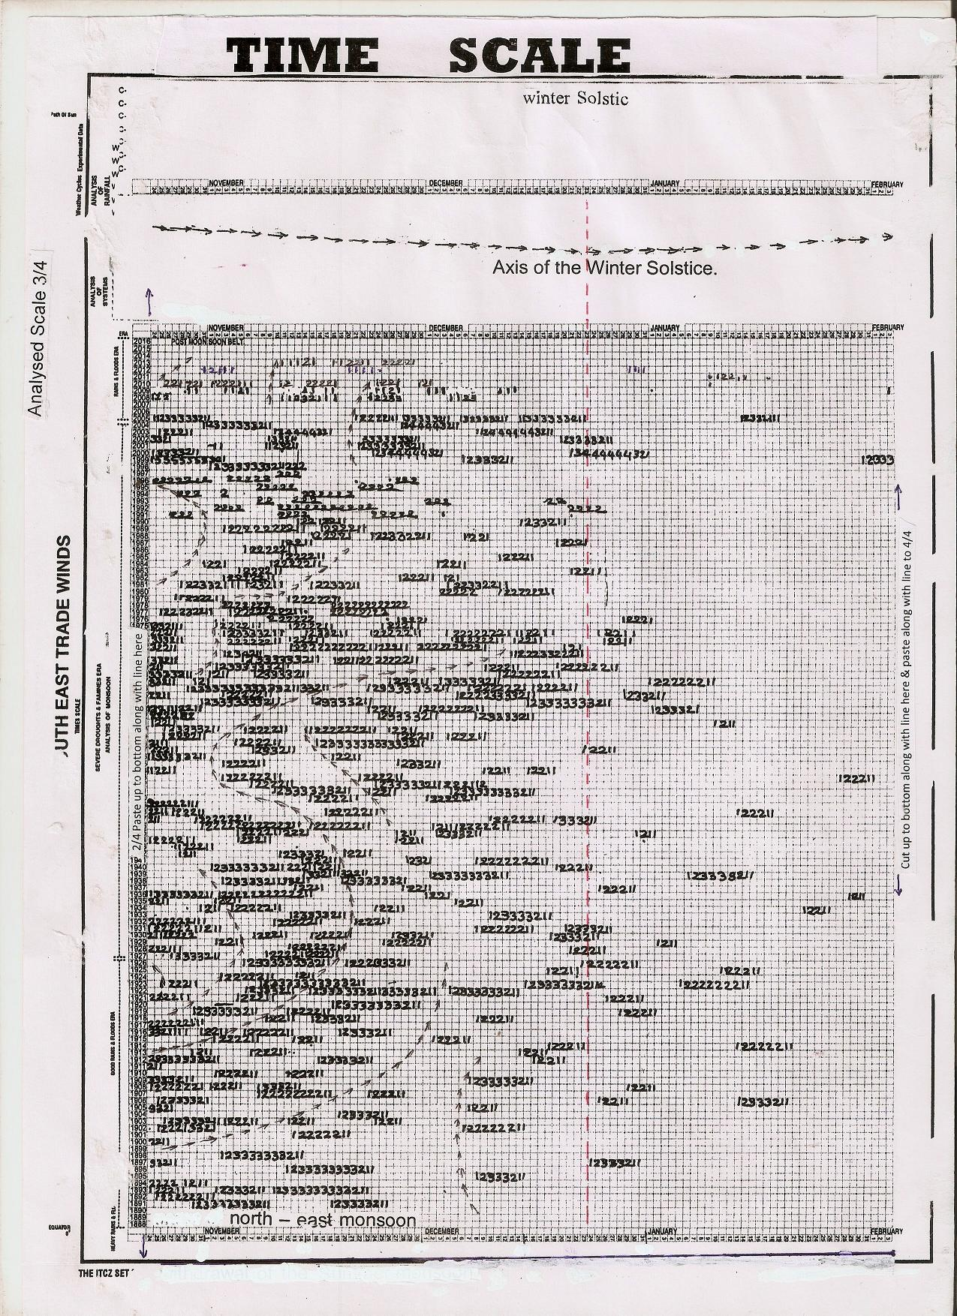
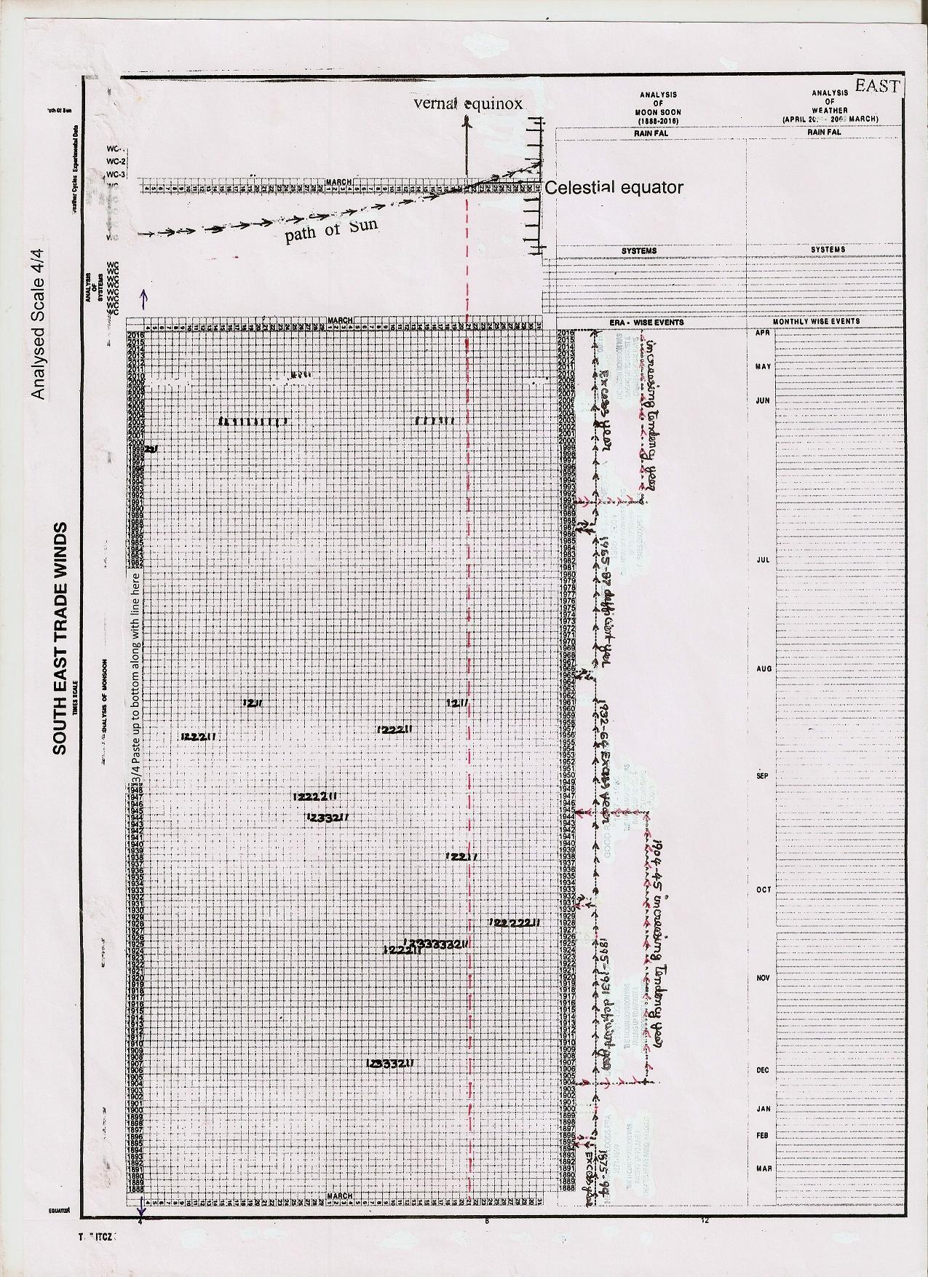
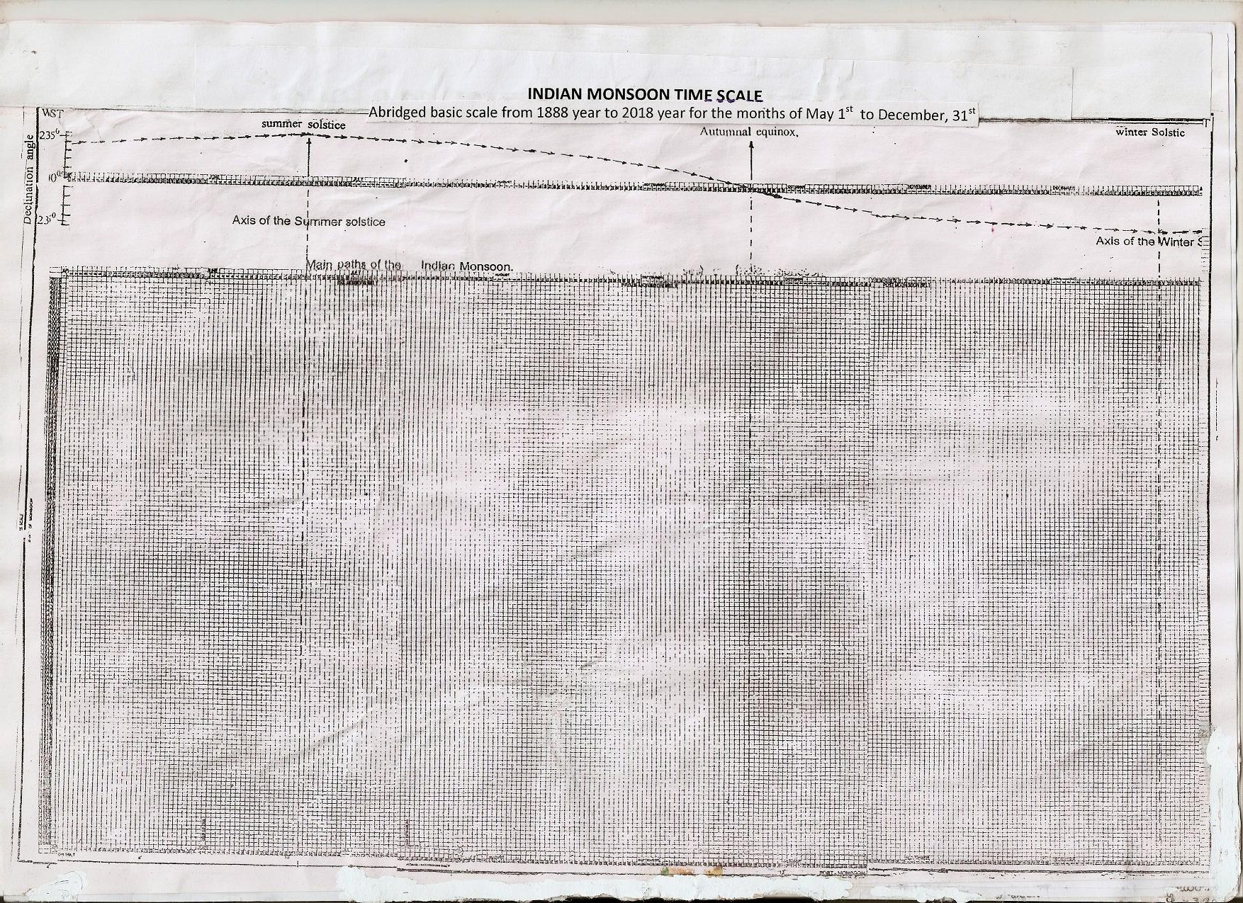
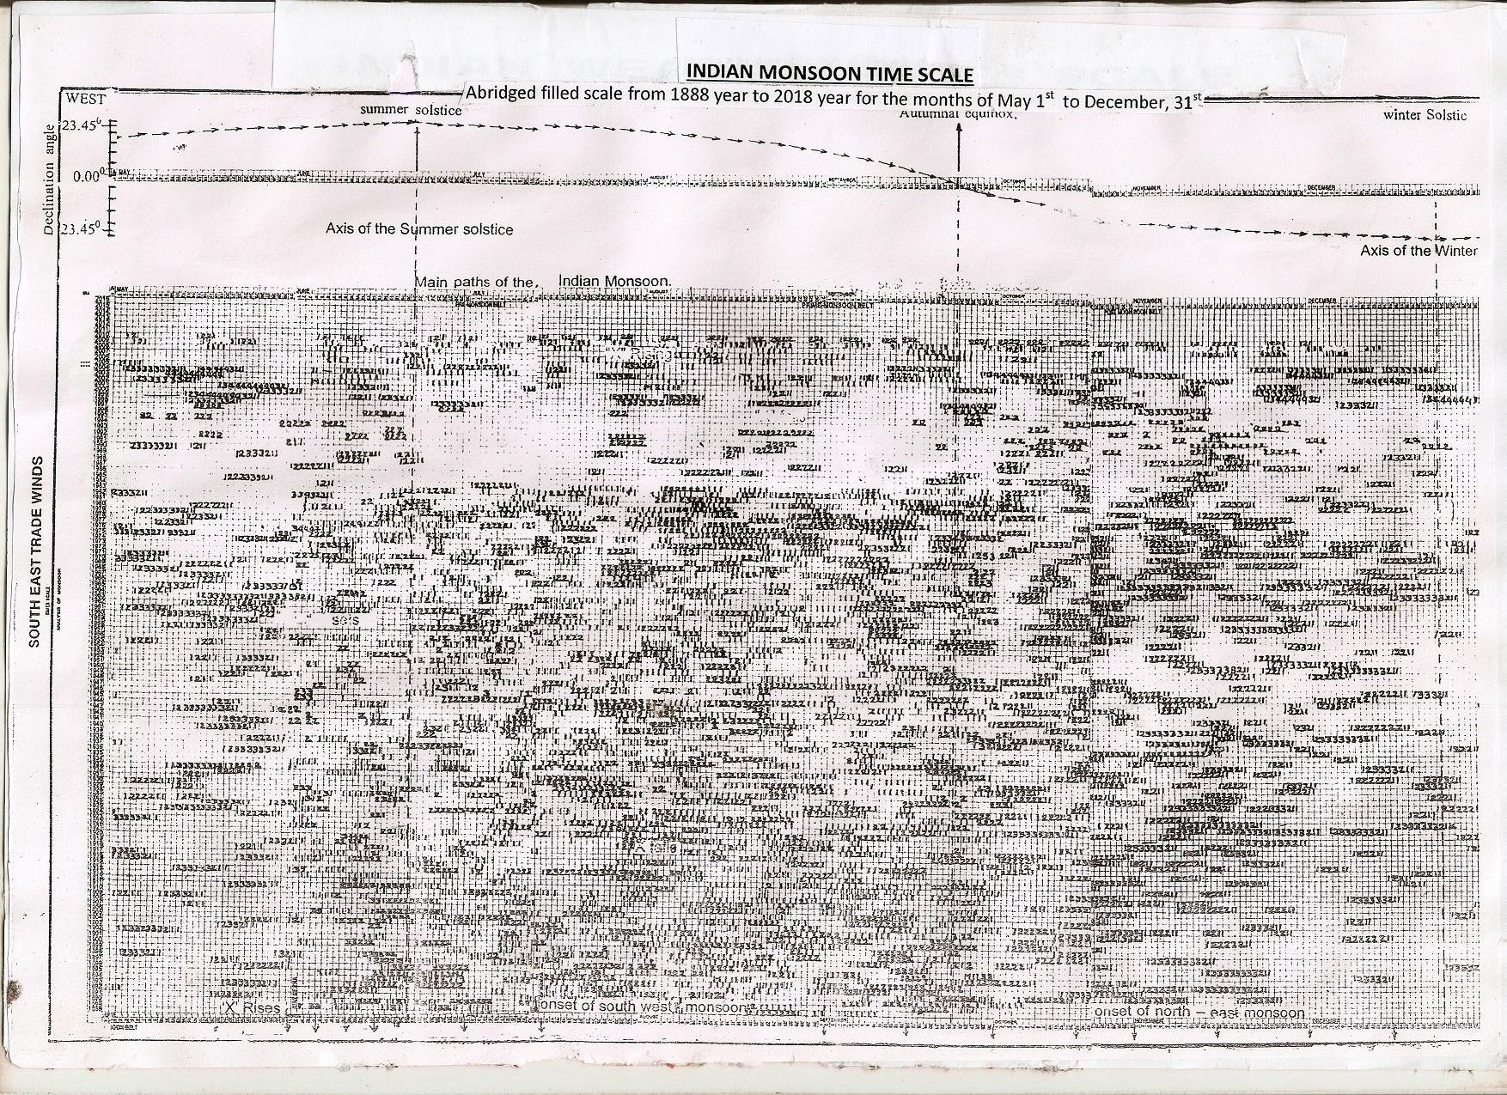
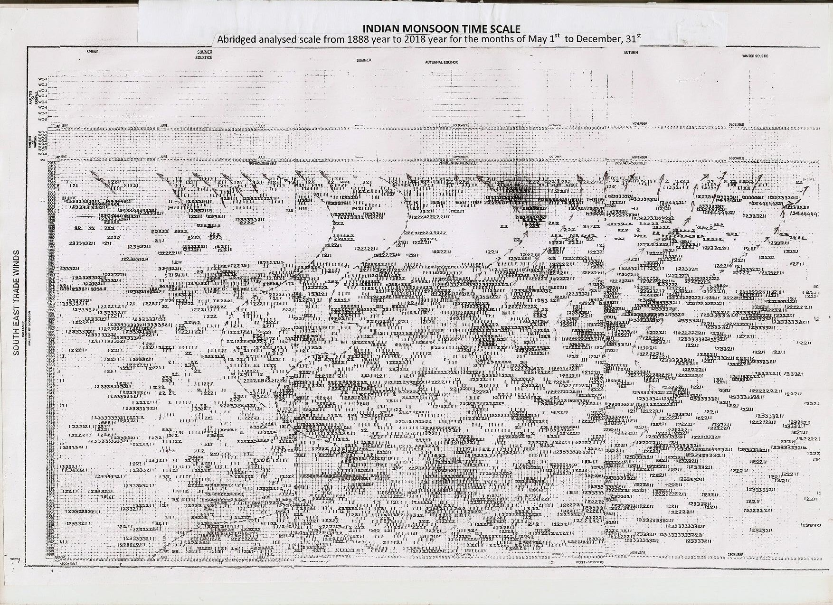
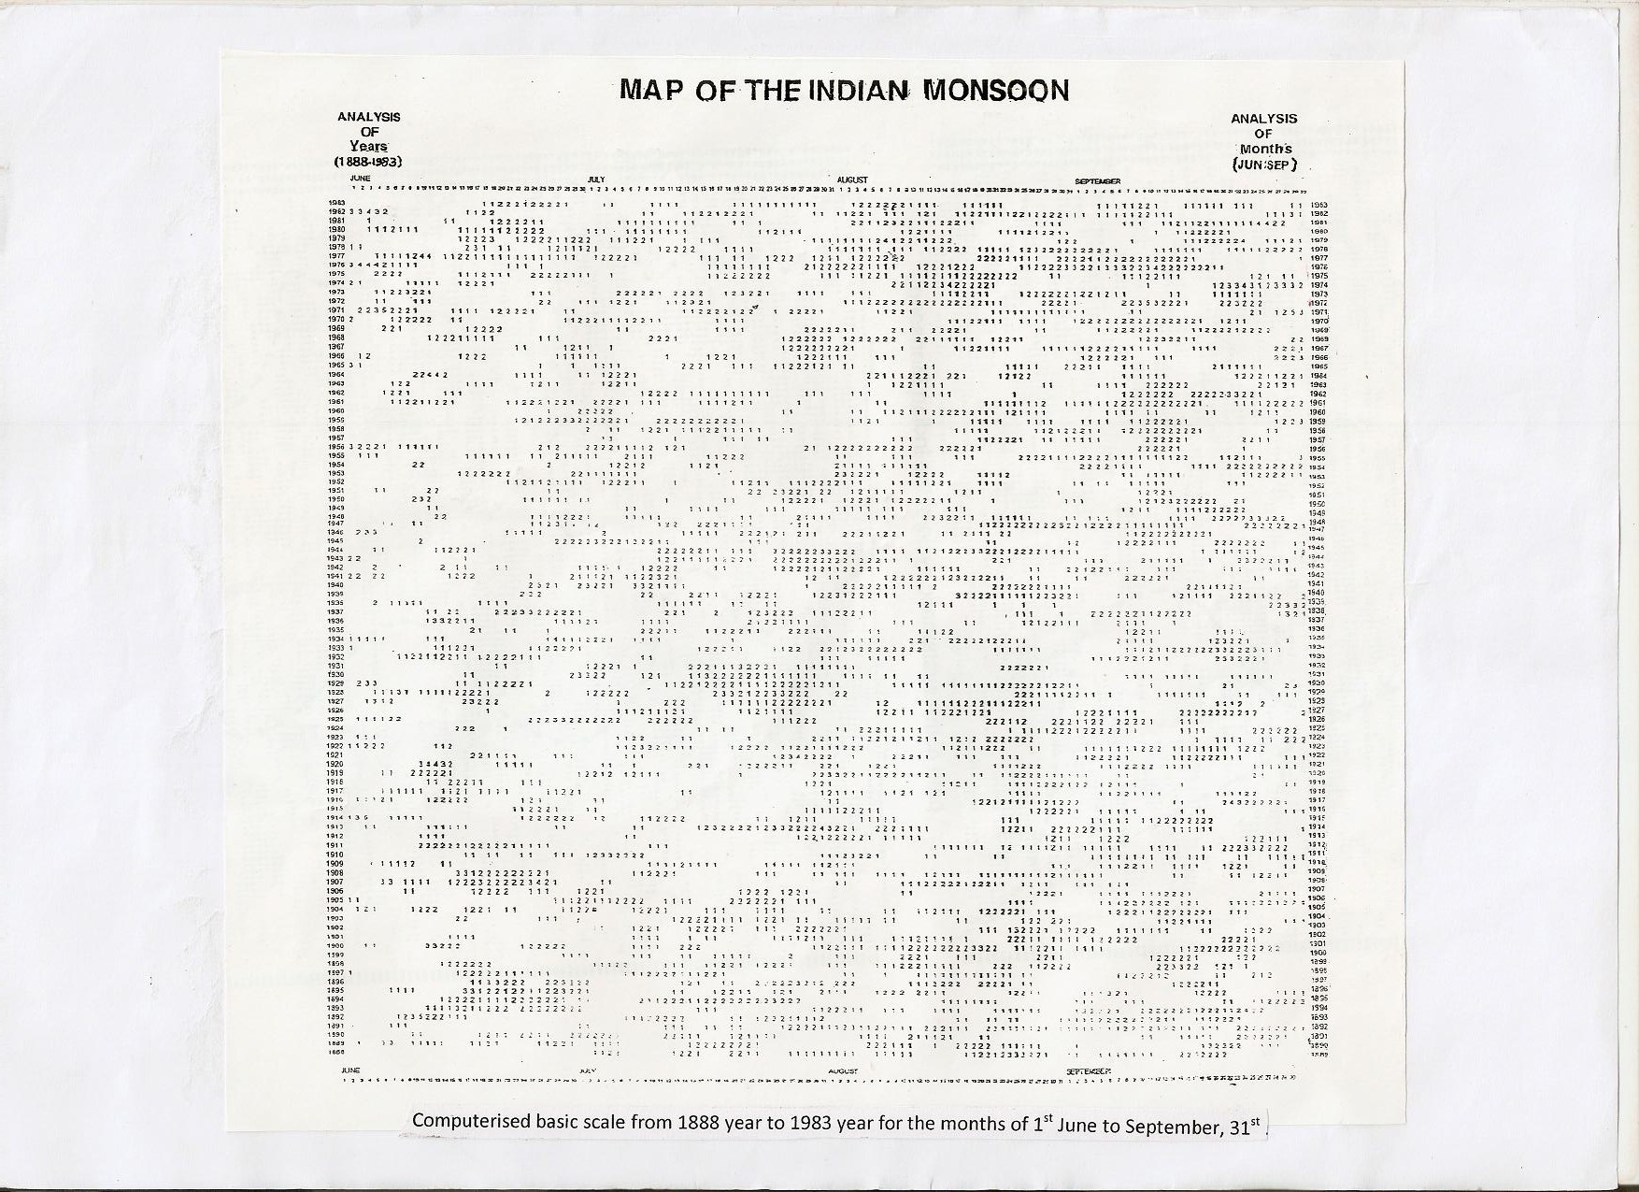

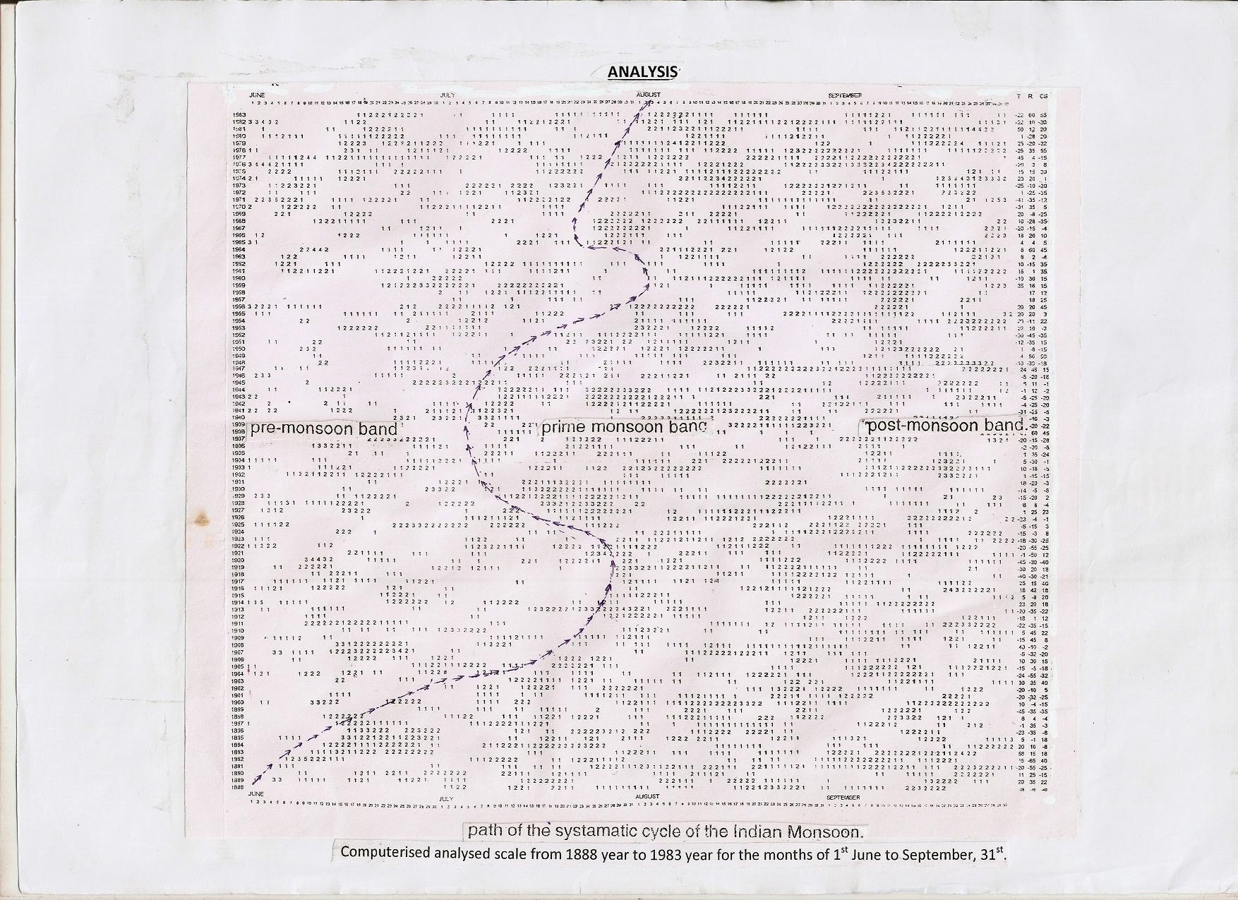

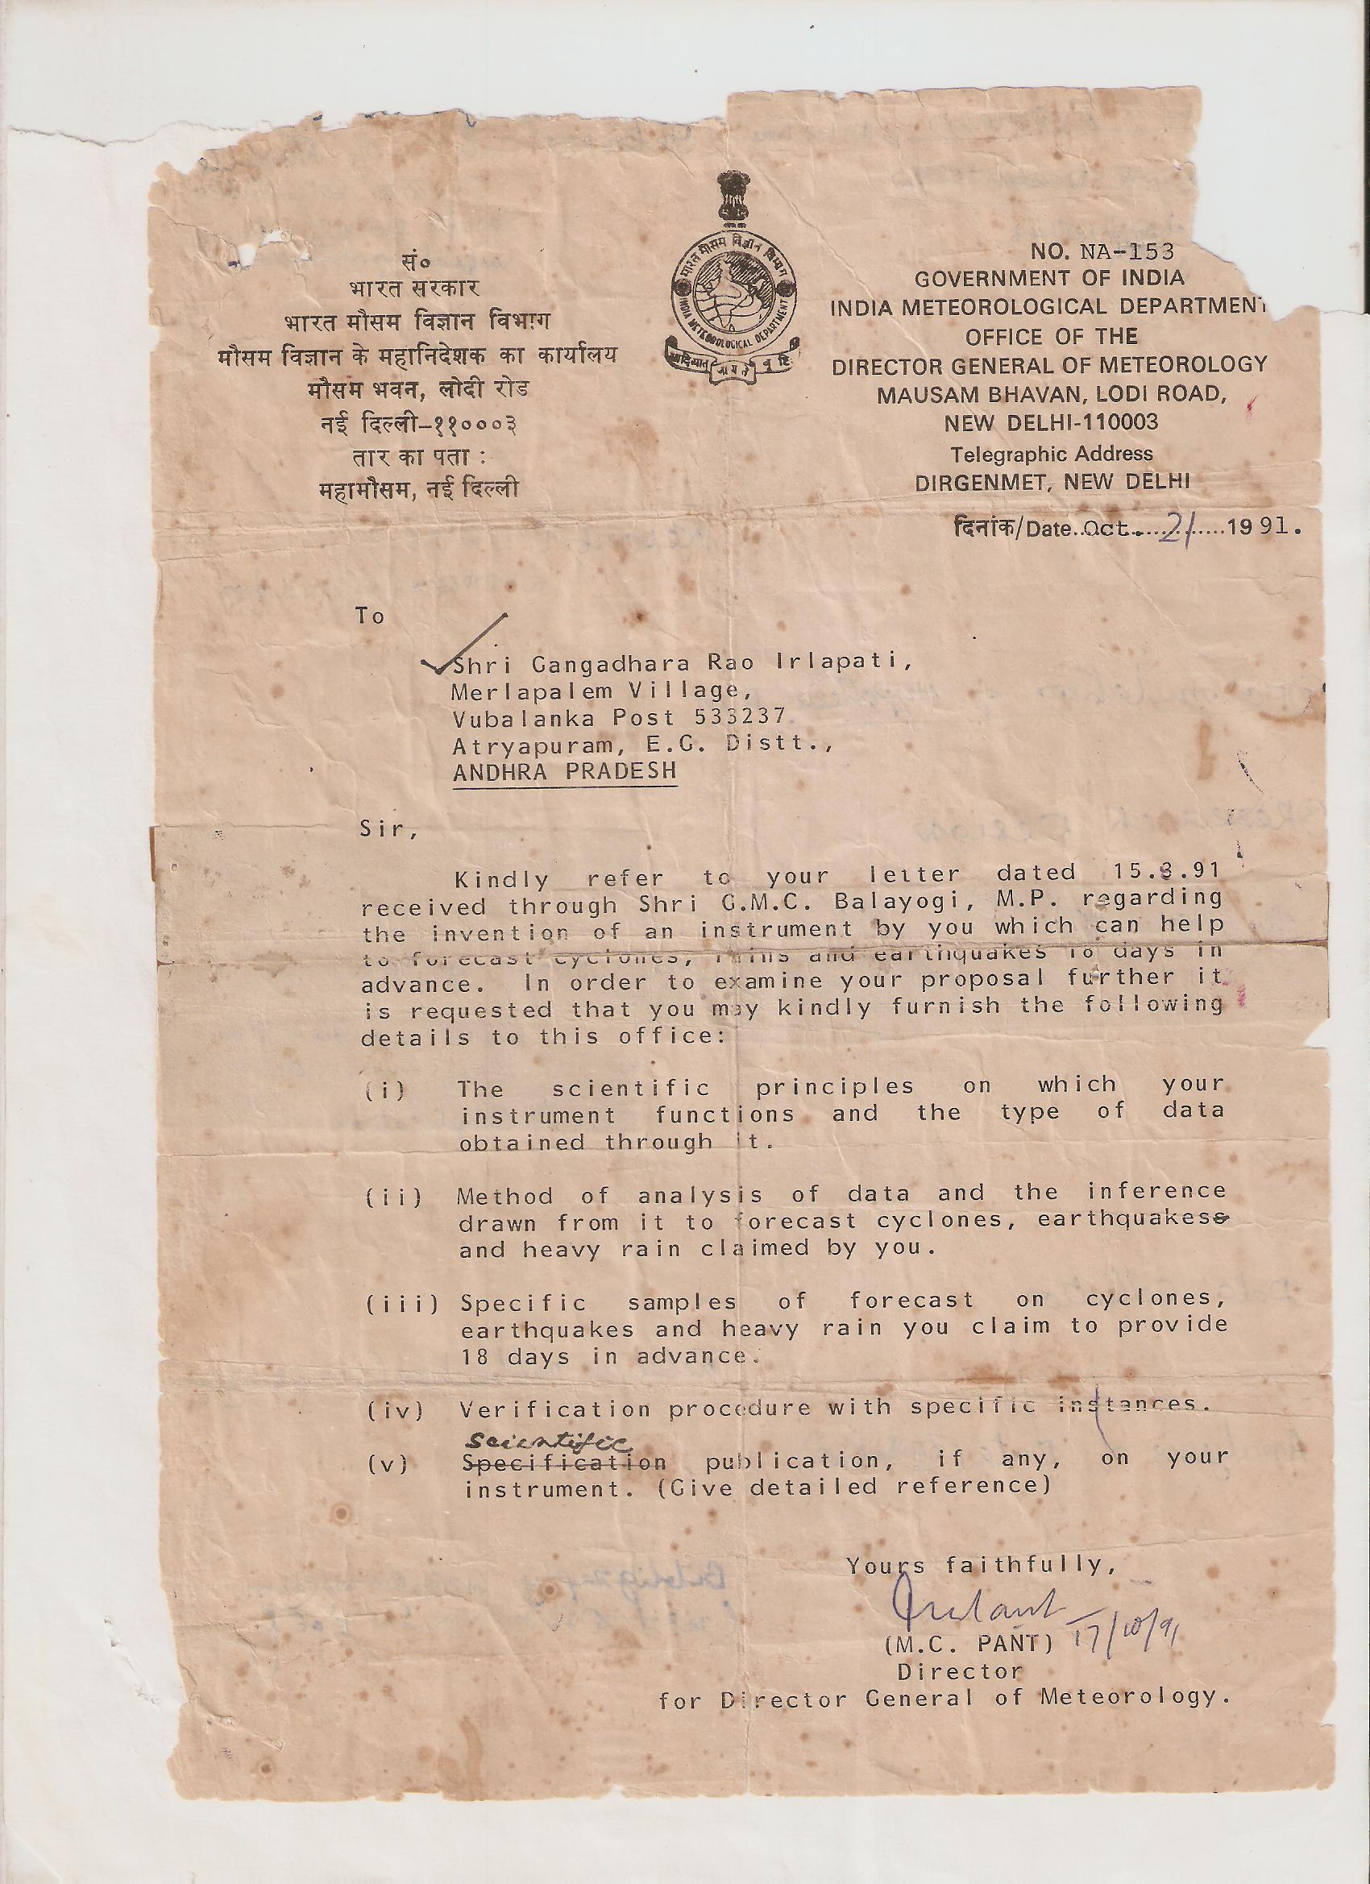
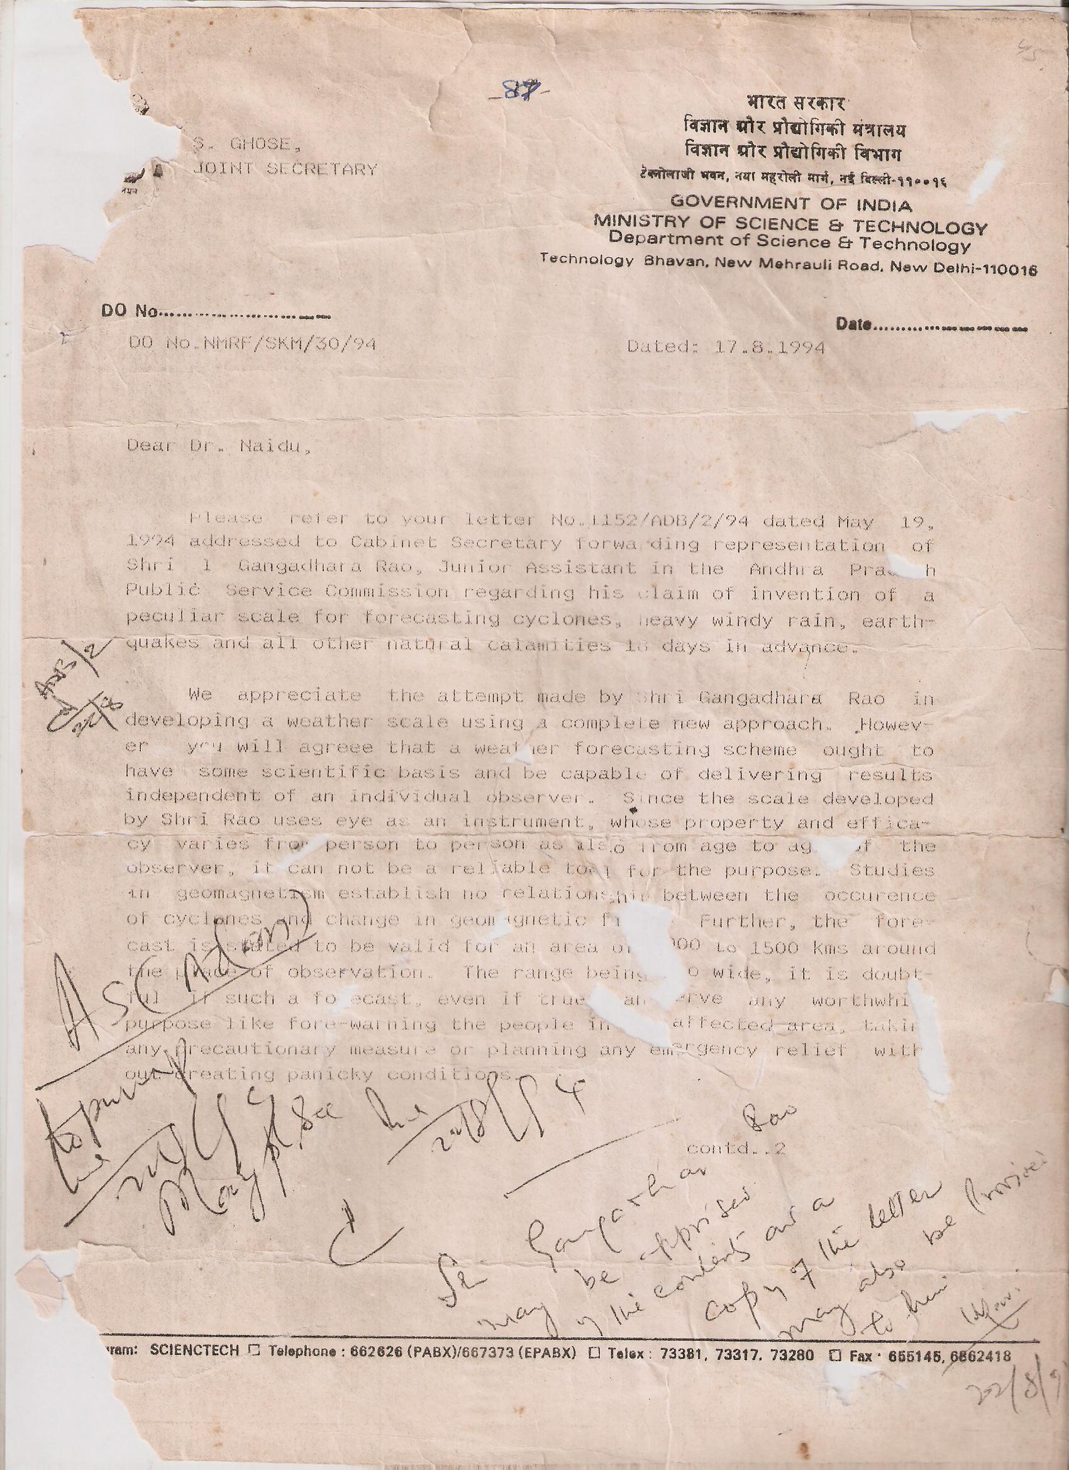
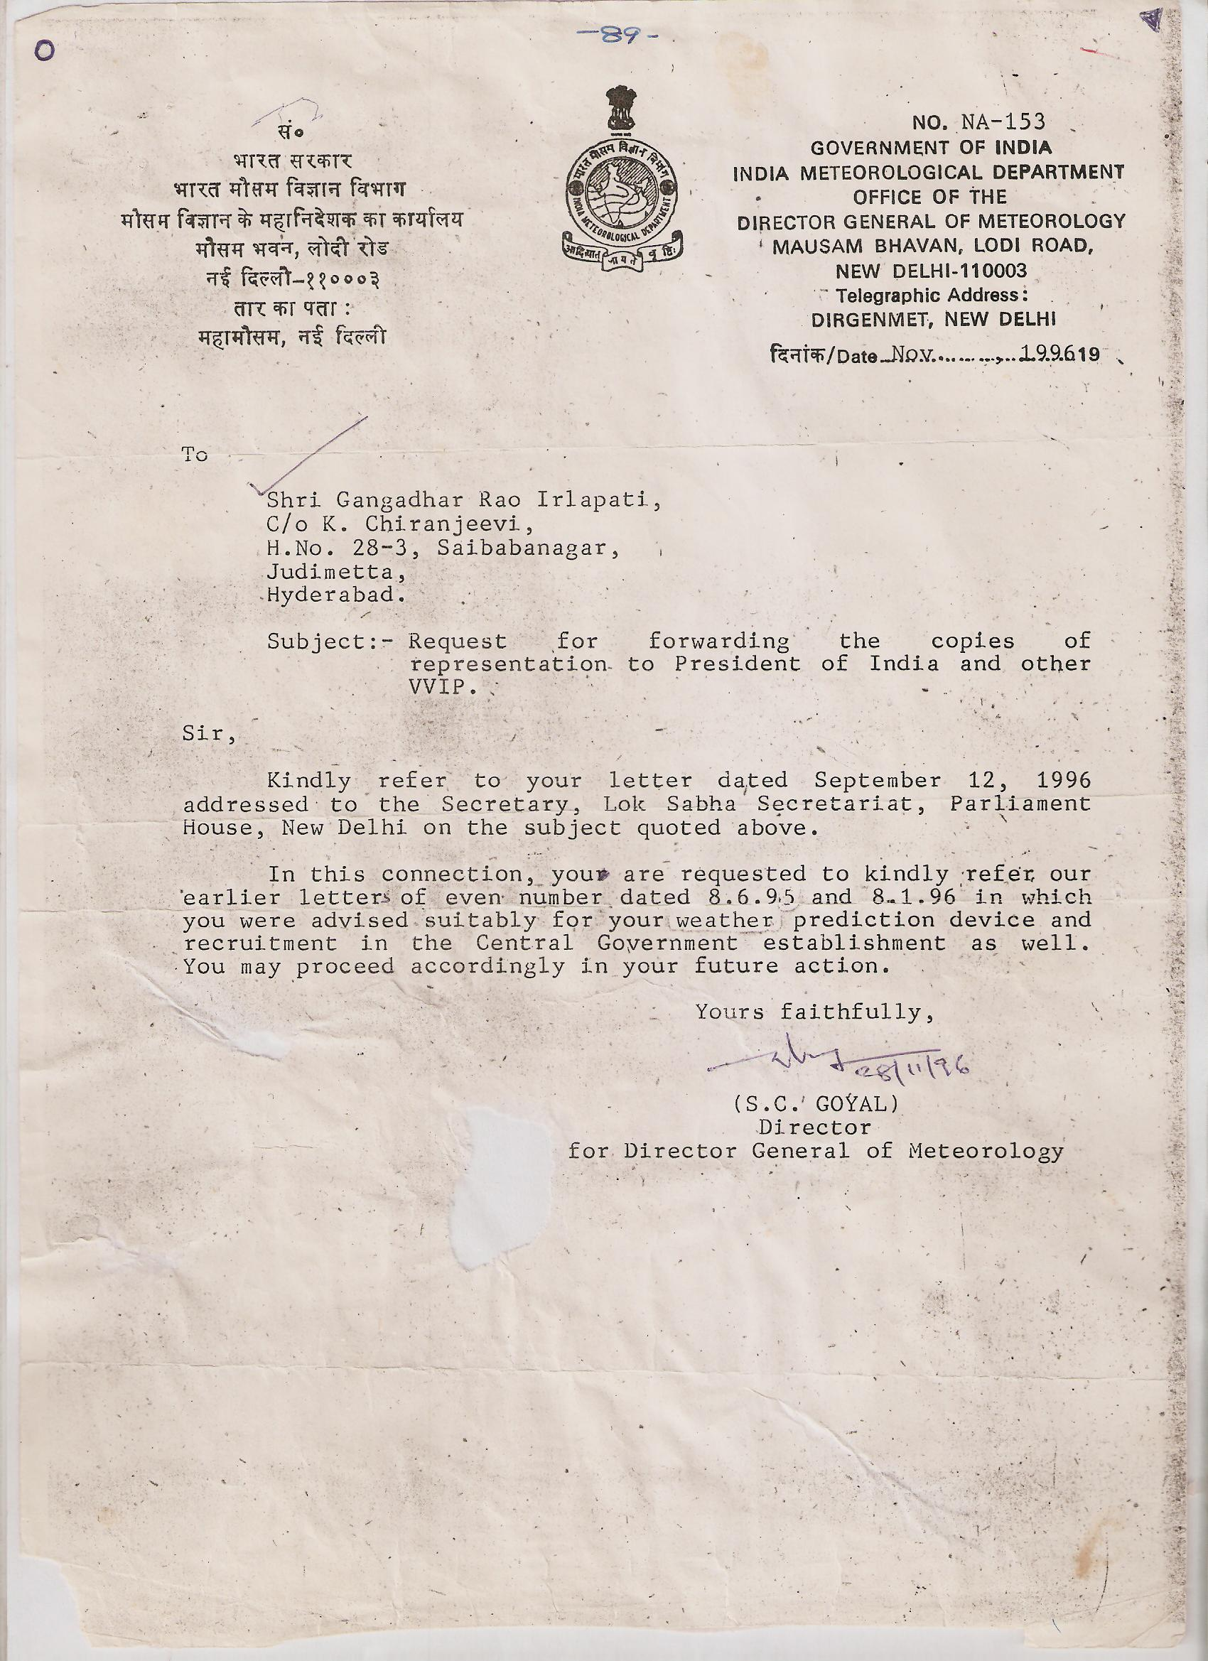
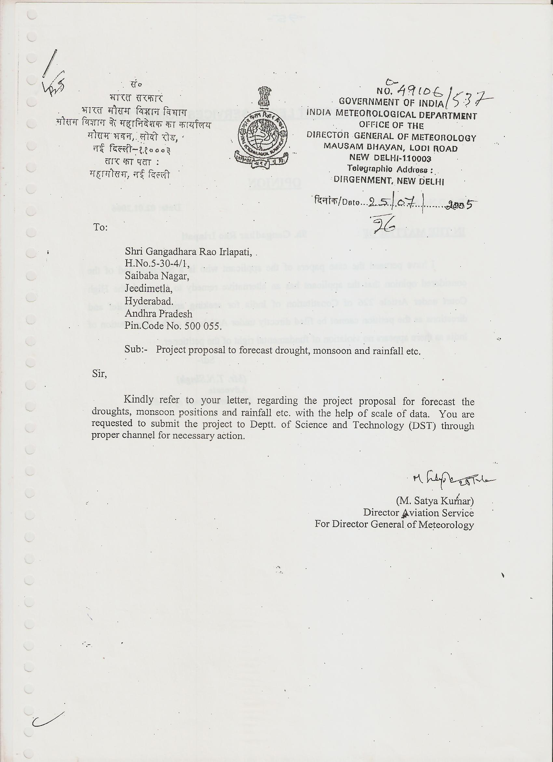
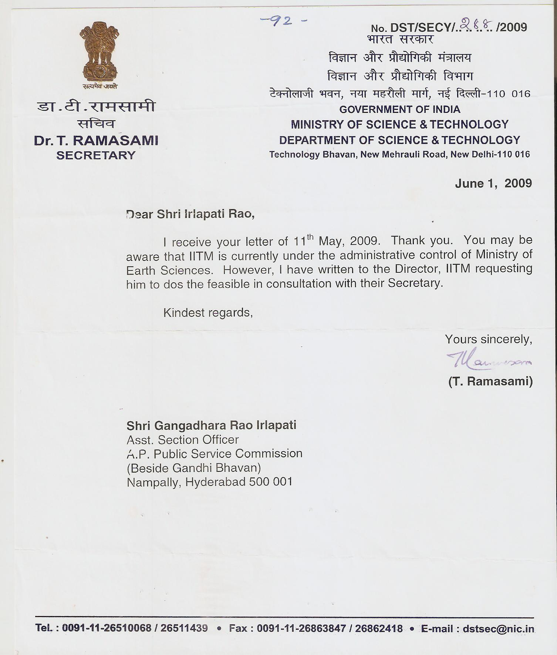

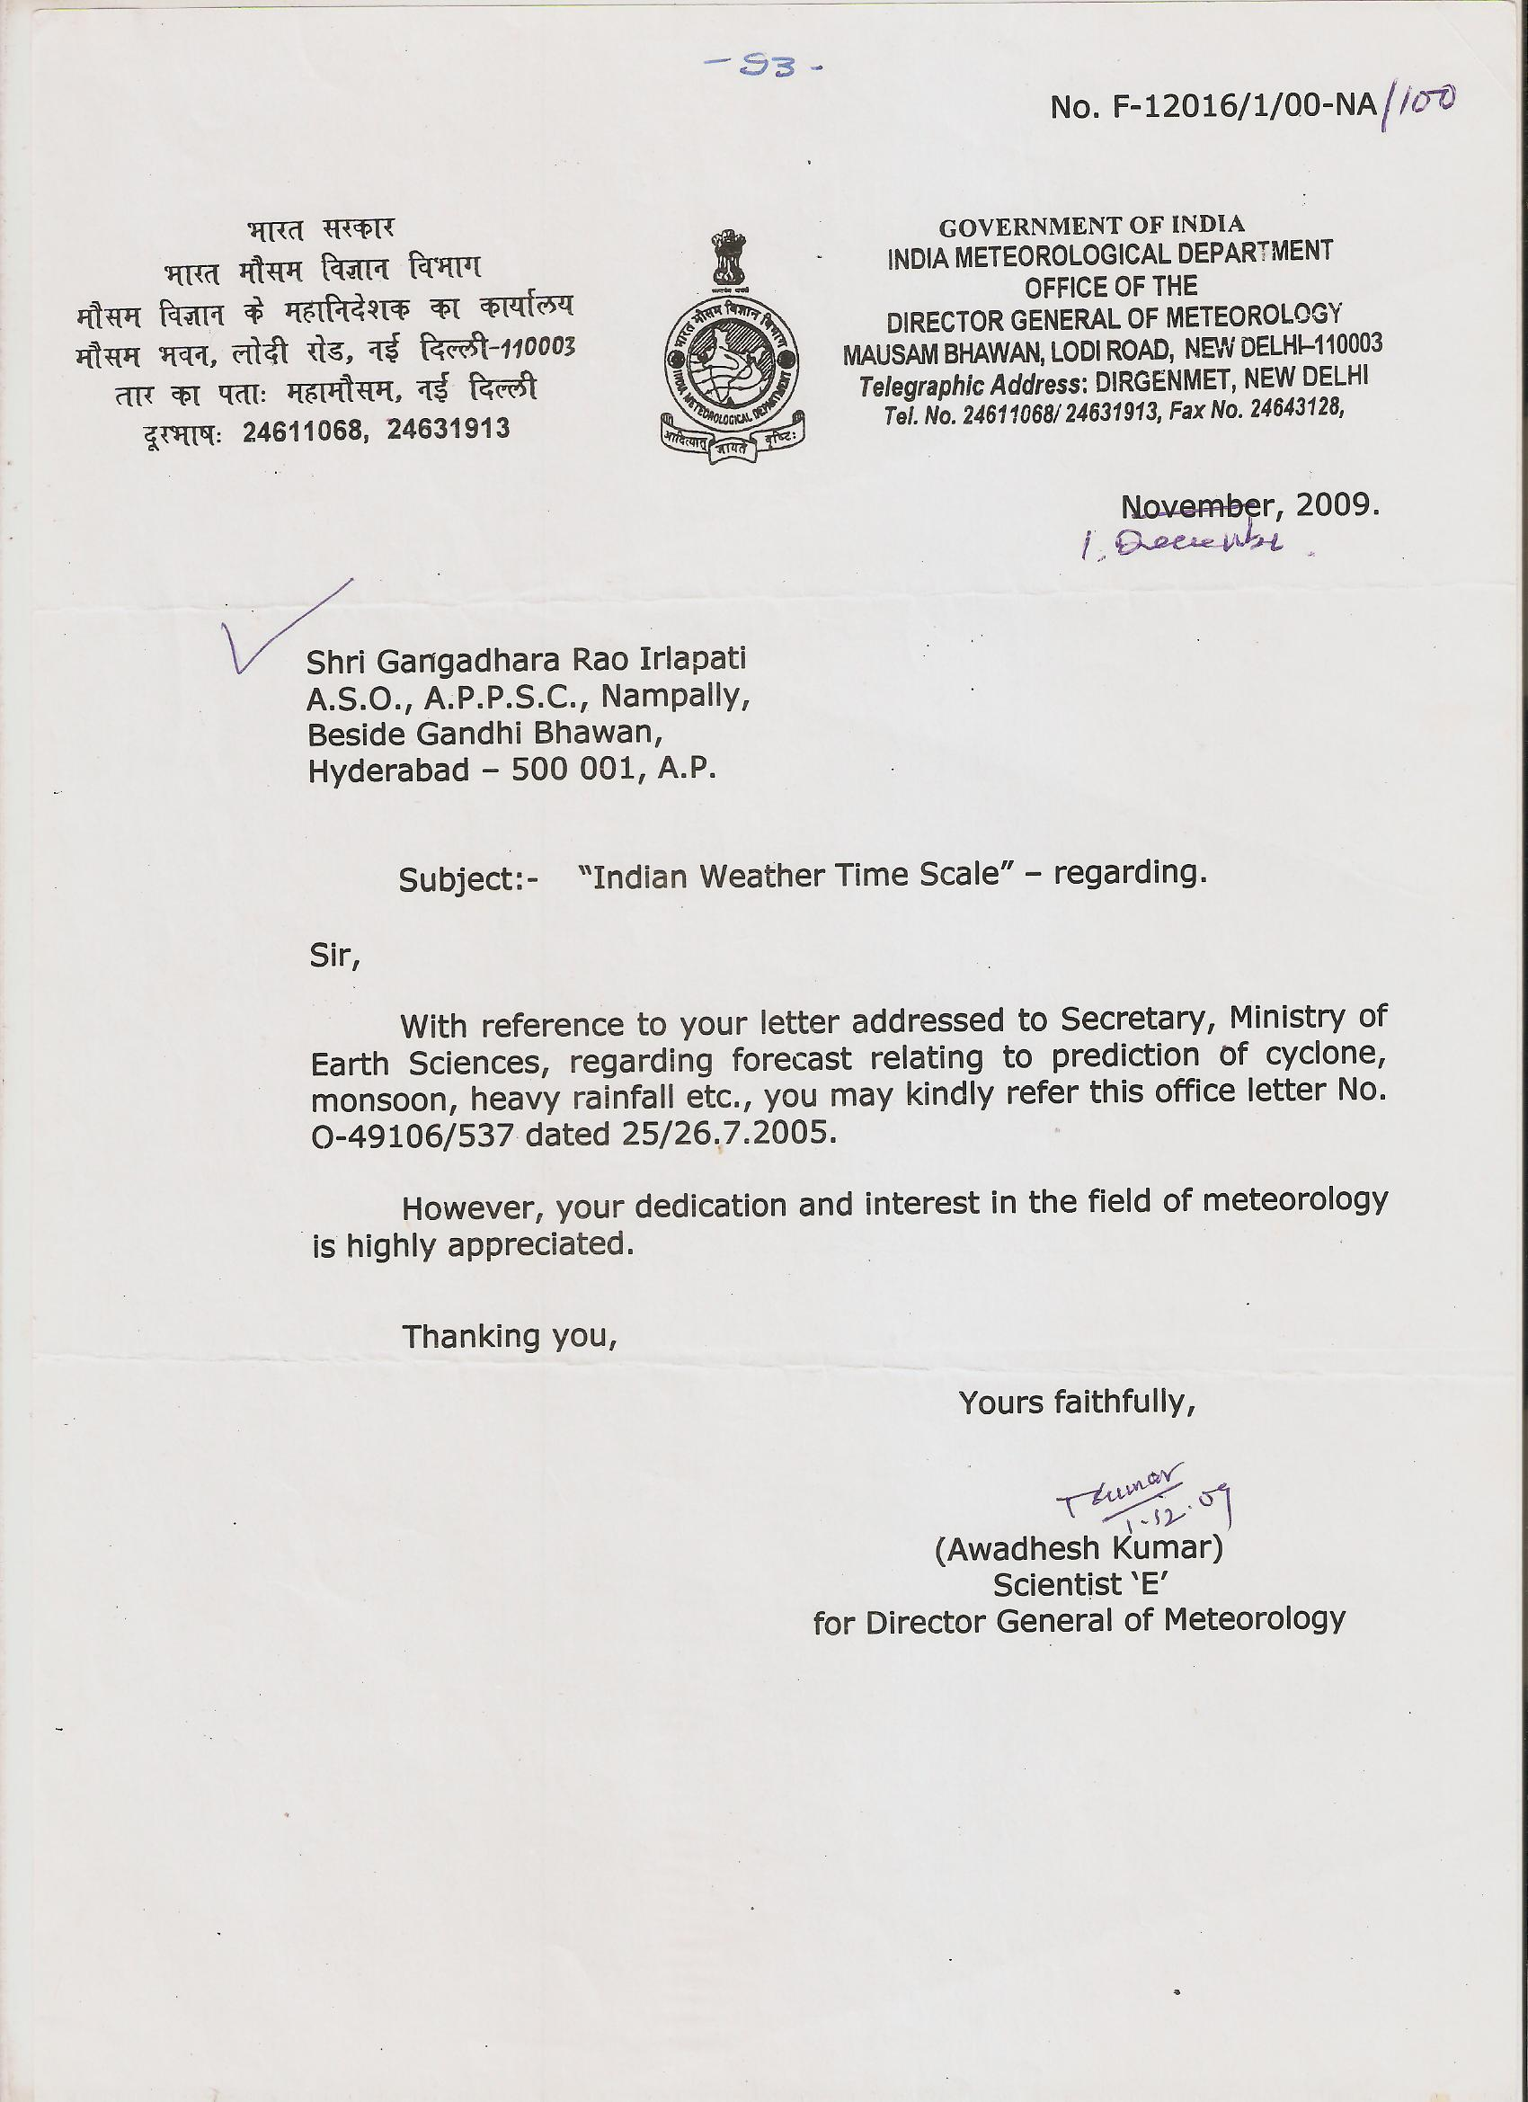

Analysis Of Data Of Bio Forecast

Date of Experiment | Number of Biolumicells | Actual Weather
1-May-1991 | 8
2-May-1991 | 14
3-May-1991 | 19
4-May-1991 | 20
5-May-1991 | 28
6-May-1991 | 22
7-May-1991 | 50
8-May-1991 | 65
9-May-1991 | 83
10-May-1991 | 89
11-May-1991 | 72
12-May-1991 | 40
13-May-1991 | 30
14-May-1991 | 14
15-May-1991 | 11
16-May-1991 | 6
17-May-1991 | 12
18-May-1991 | 3
19-May-1991 | 10
20-May-1991 | 8
21-May-1991 | 16
22-May-1991 | 9
23-May-1991 | 12
24-May-1991 | 5
25-May-1991 | 6 | Low
26-May-1991 | 10 | Low
27-May-1991 | 19 | Depression
28-May-1991 | 8 | Cyclone
29-May-1991 | 3 | Cyclone
30-May-1991 | 11 | Depression
31-May-1991 | 9 | Depression

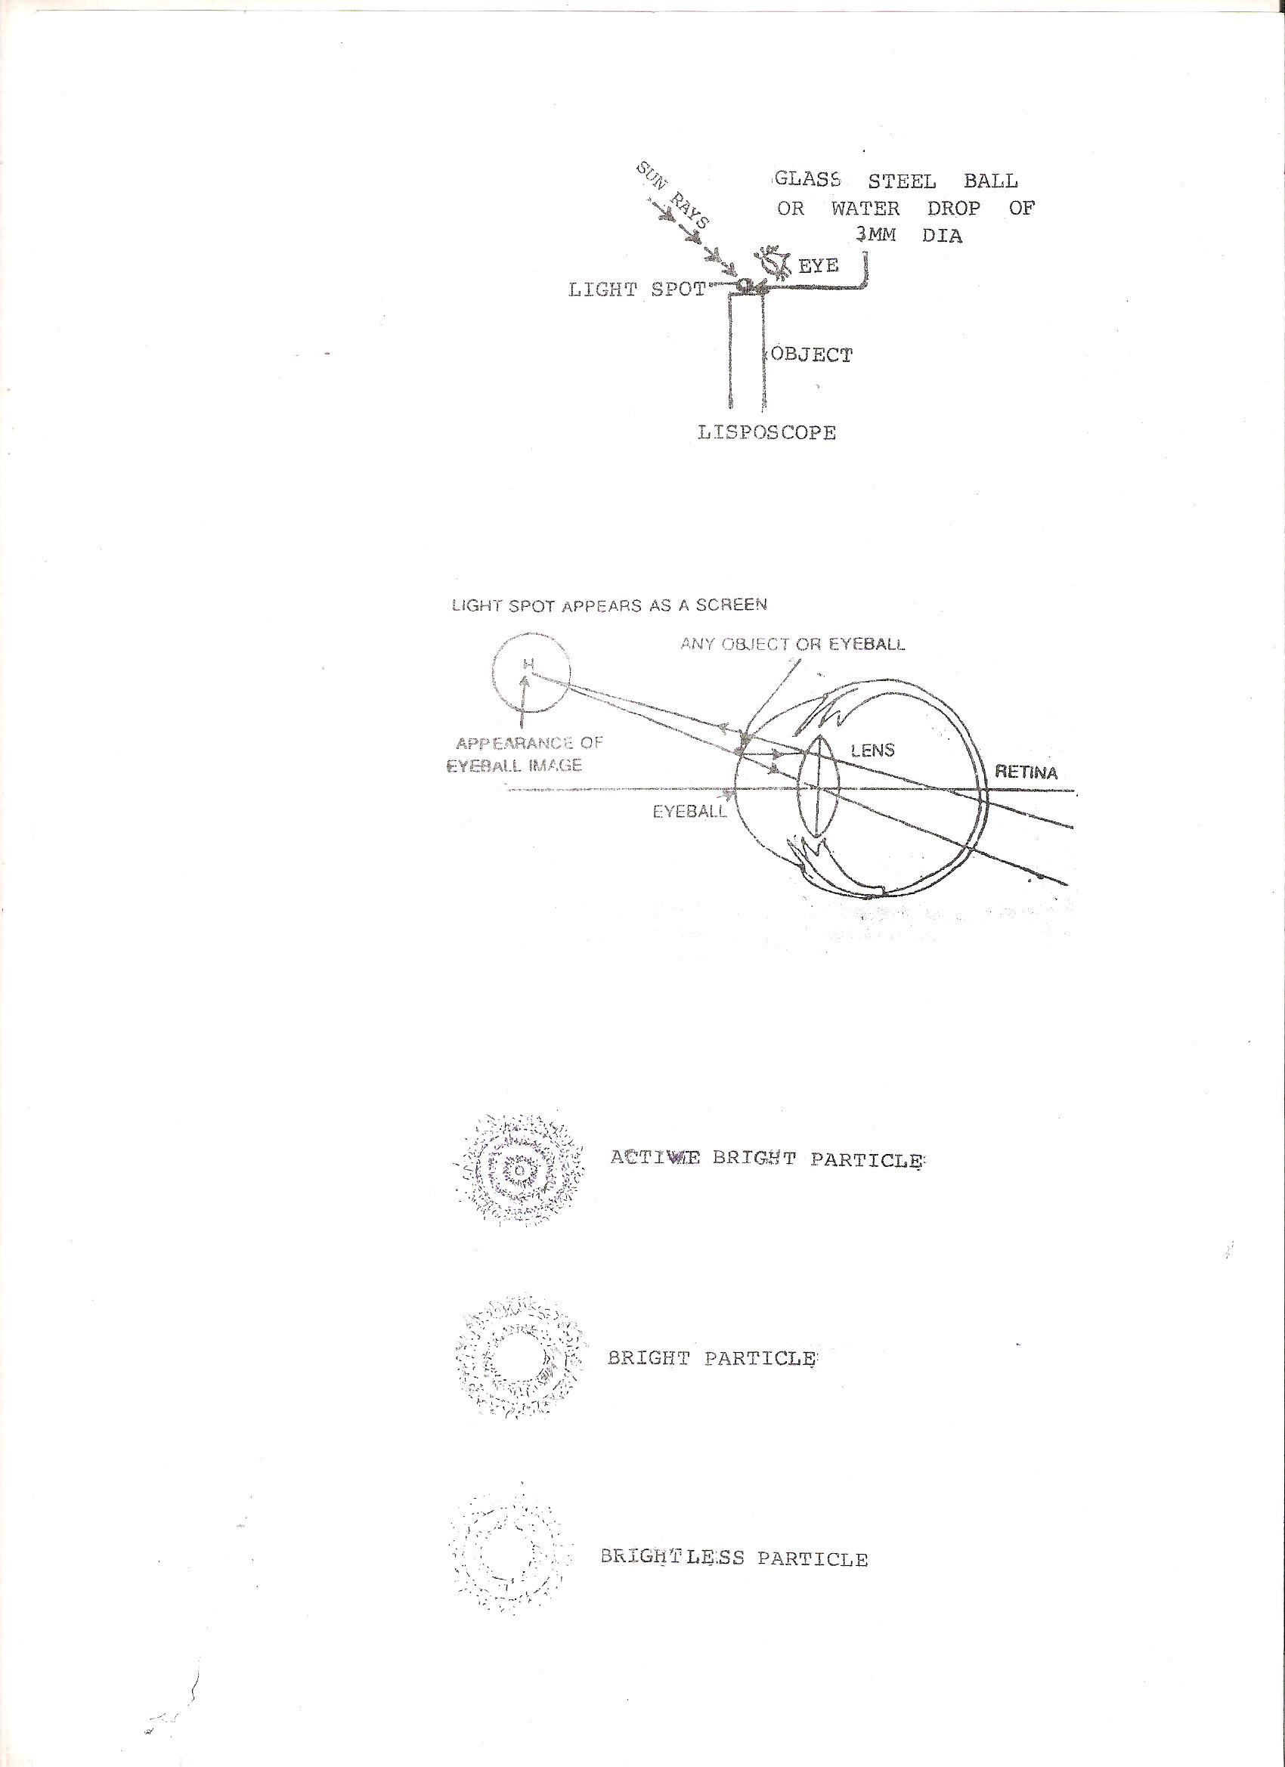
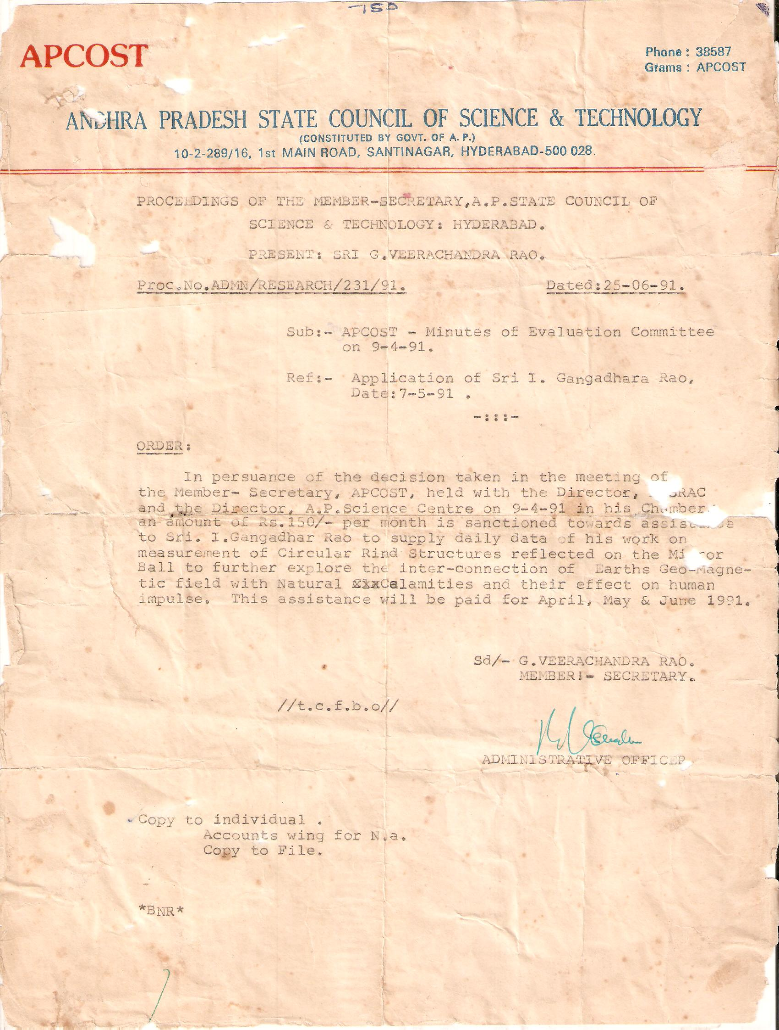

9/1/2016

