Are Mud cracks the Origin of Polygonal Faults?
(Review paper)

Mohamed M. I. Abduallah ^{A, B}, H.A. Ahmed ^{A, C} and Kabir Shola Ahmed ^{A}

^{A} China University of Geosciences, Wuhan 430074, China
^{B} Red Sea University, Sudan
^{C}MAUTECH, Yola, Nigeria
mohantoker@gmail.com, mohamedjkada@yahoo.com

Abstract: Polygonal faults are a global phenomenon found in different parts of the world. This paper aims to review polygonal faults and mud crack studies in general. Most polygonal faults studies are based on 2D/3D seismic data using different mapping methods (time coherent slice and horizon ﬂattening of high-resolution 3D seismic data, powerful fault-imaging seismic attributes, such as coherence and curvature). The orientation of the polygonal faults is isotropic, indicating a non-tectonic origin. The development of polygonal faults may be triggered by over-pressurized pore fluid which is restricted in the fine-grained sediments of bathyal facies when the sediments are compacted by the burden above. The polygonal faults are developed to balance the volumetric contraction and restricted extension. Outcropping polygonal faults show that de-watering and development of polygonal faults commenced shortly after burial. Mud cracks, on the other hand are caused by persistent desiccation and contraction of muddy sediments. These cracks form networks of interconnected tension fractures arranged in remarkable polygonal patterns. Because tensile stress due to drying declines downwards through the sediment, mud cracks have generally been theorized to nucleate near the surface, propagate downwards, and terminate at depth. Polygonal Faults may hence have originated from mud cracks. Earlier generations of mud cracks rupture the set of desiccated layers altogether, forming polygonal patterns that are similar throughout the mud sequence and polygonal faults.
[Mohamed M. I. Abduallah, H.A. Ahmed, Kabir Shola Ahmed. Are Mud cracks the Origin of Polygonal Faults? Researcher 2016;8(1):9-17]. ISSN 1553-9865 (print); ISSN 2163-8950 (online). http://www.sciencepub.net/researcher. 2. doi:10.7537/marsrsj08011602.

Key word: polygonal faults, origin, nontectonic, isotropic, fine-grained sediments. Mud crack, dewatering

1. Introduction
Polygonal fault systems are non-tectonic extensional fault systems with small throws (Cartwright 1994). Polygonal faults were ﬁrst discovered in Belgium in Lower Tertiary clay stones (Henriet, De Batist et al. 1991). Although due to the lack of 3D seismic data the polygonal shape was not initially recognized at that time. (Cartwright 1994) ﬁrst documented the polygonal fault system using the time slice technique in North Sea Basin. Since then, polygonal faults have been found in more than sixty basins world- wide. Until now, polygonal fault systems have been found in ﬁne-grained mudstone, shale or chalk only in Cretaceous and Cenozoic basins. However, polygonal faults could also have developed in pre-Cretaceous basins. Lately, many researchers have realized the importance of polygonal faults in migration, accumulation and escape of hydrocarbon and gas hydrates(Bünz, Mienert et al. 2003)(Bünz, Mienert et al. 2003) (Bünz, Mienert et al. 2003, Trincardi, Cattaneo et al. 2004, Gay, Lopez et al. 2006, Davies and Cartwright 2007, De Paola, Collettini et al. 2007). the formation of polygonal fault systems is related to fluid expulsion and sediment contraction, as they are layer-bound and not related to adjacent basement (Cartwright and Lonergan 1996). Understanding of such fault systems is important as they interact with adjacent reservoirs (Cartwright 1994), and because they might control fluid flow on a regional scale (Henriet, De Batist et al. 1991). Growth-related sedimentary successions at the top of the polygonal fault systems revealed that their development commences during early burial of the host sediments (Cartwright and Lonergan 1996, Lonergan, Cartwright et al. 1998). In addition, they have been observed as pathways for both salt intrusions and sandstone (Larter, Aplin et al. 2000, Panien, Moretti et al. 2001, Stuevold, Faerseth et al. 2003, Victor and Moretti 2006). The term polygonal is used to refer to a system of numerous multi-directional and relatively small normal faults (throw <80 m), many of which have abutting intersections. The near-isotropic structural fabric of the Lake Hope system is a characteristic of intraformational fault systems, which are often polygonal, and which clearly distinguishes them from typical tectonic fault systems (Watterson, Walsh et al. 2000). The consensus is that polygonal systems are of non-tectonic origin, they and related intraformational systems have been variously attributed to gravitational spreading/ sliding (Higgs and McClay 1993), to gravitational instability due to density inversion and associated dewatering (Henriet, De Batist et al. 1991, Verschuren 1992, Cartwright 1994) and to volumetric contraction during compactional dewatering (Cartwright and Lonergan 1996). Whatever their origin, polygonal fault systems are truly polygonal only when the regional dip is near horizontal and become less isotropic with increase in regional dip (Cartwright 1994). Many features of the fault system are consistent with it having formed in response to embryonic gravitational overturn of a relatively thin (c. 35 m), low density, gravitationally unstable, over-pressured and mobile mudstone layer which underlies the hydrostatically pressured, dominantly mudstone, faulted sequence (Watterson, Walsh et al. 2000). Polygonal fault is a network of extensional faults arranged in a polygonal structure layer-bound, mesoscale (throws from 10-100 m) (Cartwright and Dewhurst 1998).
However, formation mechanism of polygonal fault is still a disputed issue (Henriet, De Batist et al. 1991, Cartwright and Lonergan 1996). The polygonal faults firstly reported according to 3D seismic data in the Qiongdongnan basin, South China Sea, (Wu, Sun et al. 2009). The pipe attribute of the polygonal faults in the Lower Congo Basin linking the hydrocarbon source rock with the gas hydrate reservoir have been demonstrated (Gay, Lopez et al. 2006), the Norway continental margin (Hustoft, Mienert et al. 2007), the Scotian slope of the eastern Canada continental margin (Cullen, Mosher et al. 2008). Based on the literatures we went through so far, we observe that there may be a strong link between polygonal faults and mud crack.
The formation of a set of mud layers in which the grain size increases with depth is a ubiquitous phenomenon that is commonly observed on drying puddles, during droughts in river flood plains, and lake margins (Allen 1985, Weinberger 1999). Cracking of mud layers forms arrays of joints during loss of moisture, known as mud cracks or desiccation cracks. Mud cracks form remarkable polygonal patterns in plain view, that have been extensively described in the geological literature (Allen 1985). Cracking of mud, which involves a substantial volume loss, is evidently very different from cracking of ordinary rock masses. Nevertheless, the principles of fracture mechanics of solid materials apply to many cracking phenomena in mud (Müller 1998). Fine mud is not the only substance in which contraction gives rise to polygonal patterns. Such patterns also appear in other materials such as plaster, coffee-water mixtures during drying (Groisman and Kaplan 1994), and mixtures of starch-water (Walker 1986, Müller 1998) as well as in basalt flows during thermal contraction (Ryan and Sammis 1978, Aydin and DeGraff 1988, Grossenbacher and McDuffie 1995). The fact that polygonal faults are capable of focusing fluid flow implies that their properties need to be understood for assessment of reservoir leakage. As they only occur in fine-grained sediments they may also serve as a good lithology indicator (Berndt, Jacobs et al. 2012).
Since no work have been done on the relationship between polygonal fault and Mud crack to the best of our knowledge, this paper aims to illustrate the relationship that may exist between these two polygonal pattern structures.

2. The origin and evaluations of the polygonal faults in literature
Five hypotheses for the origin of polygonal faults have been discussed in the literature and were thoroughly reviewed in Cartwright et al. (2003), Cartwright (2011), and Goulty (2008). The first hypothesis is that the polygonal faulting is caused by gravitational forces along gently dipping basins floors (Watterson, Walsh et al. 2000). The problem with this hypothesis is that polygonal faults have been observed in many basins in which they are not bounded by a dipping surface at their base. Also the fact that the faults strike in many different directions and have their greatest throw in the middle of the faulted interval is not easily explained by this hypothesis. The second Hypothesis proposes the faulting to be initiated by Rayleigh Taylor instabilities due to lighter under-consolidated sediments at the base of the polygonally faulted interval. Indeed undulations of the expected wavelength are found at the top surface of a polygonal fault tier in the Y shape per Clays (Henriet, De Batist et al. 1991) and in the Faeroe Shetland Trough (Davies, Cartwright et al. 1999) that extend to the surface (Long, Bulat et al. 2004) and the total horizontal shortening seems to be small in some polygonal fault systems (Watterson, Walsh et al. 2000). However, these are exceptions among the many observed polygonal fault systems, it is very different from the structures in response to salt related density inversions, and it is difficult to conceive how these density inversions should actually lead to the observed faulting (Goulty 2008). The third hypothesis invokes syneresis of colloidal sediments to initiate the initial fracturing of the rocks (Cartwright and Dewhurst 1998, Dewhurst, Cartwright et al. 1999). This process has been observed in fine-grain sediments, but this hypothesis was questioned, as polygonal faults occur in a wide range of lithologies and syneresis should be lithology dependent. This process is occurring very fast according to Laboratory experiments (White 1961) and it is difficult to see how it can lead to long-term deformation as recorded by growth structures along polygonal faults. The fourth hypothesis invokes faulting controlled by the residual shear strength of the faulted sediments (Goulty 2001, Goulty and Swarbrick 2005, Goulty 2008). This hypothesis was questioned (Cartwright, James et al. 2003) because it requires initial weakness zones spaced at suitable intervals and on its own would not explain the polygonal pattern. Furthermore this hypothesis does not explain well how the faults propagate at larger scales (Cartwright 2011). The fifth hypothesis Instead Cartwright (2011) proposed that diagenetic processes in general are responsible for a decreased ratio of horizontal to vertical stress which may facilitate initial shear failure. This hypothesis is consistent with the laboratory results for fine grained sediments. It is also consistent with vast extent of polygonal fault systems and their organization in tiers. (Shin, Santamarina et al. 2010). The polygonal faults in the Hatton Basin extend the scale that was established for millimeter to decimeter-sized polygon patterns to the kilometer size. In this sense, it can be considered as drying of a surface layer even the development of polygonal faults in a marine environment (Berndt, Jacobs et al. 2012).
In South China Sea, the polygonal faults develop mainly in the upper Meishan Formation (upper Middle Miocene) and Huangliu Formation (Upper Miocene), and reach up to the T30 reflector (Sun, Wu et al. 2009) (Figure 1).

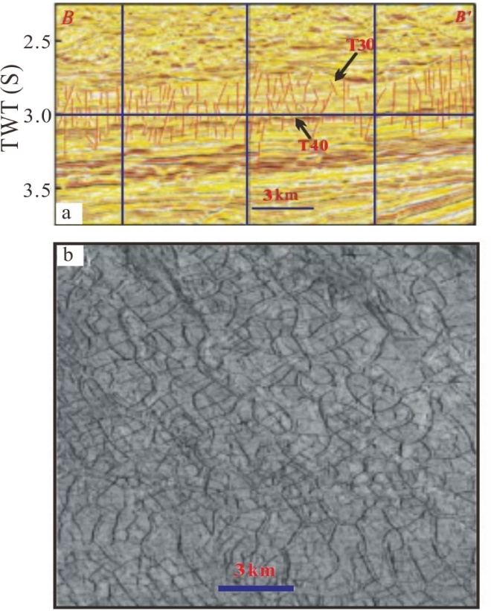
Figure 1. The polygonal faults in seismic section B–B′ (a) and plan view (b) after (Sun, Wu et al. 2009)

The above figure shows polygonal faults developed in the thick mudstone of upper Meishan Formation and Huangliu Formation. Few tectonic faults developed in the post-rifted sequences, so the lack of pathway for hydrocarbon migration in the post-rifted period is an adverse factor for the petroleum system (Wu, Han et al. 2009).
The Lake Hope faults span a limited size range with maximum throws ranging up to c. 80 m (1 ms two-way time = 1.27 m, see) and, except for some of the larger faults (throws>c. 40 m), they are restricted to the Lower Cretaceous sequence. Cross-section in Lake Hope faults Australia most of the faults with throws >30 m oﬀset all three of the main interpreted horizons while faults with maximum throws <15 m (Watterson, Walsh et al. 2000) (Figure 2).

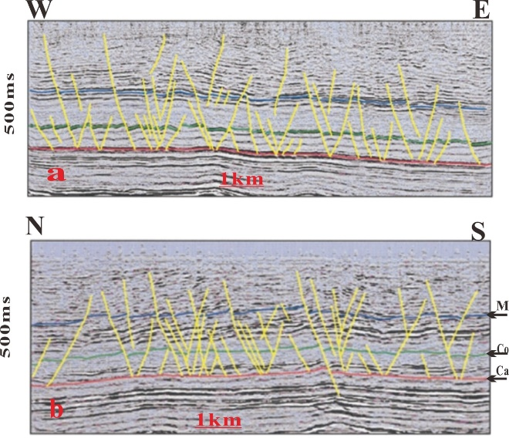
Figure 2. Seismic sections in in-line (a) and cross-line (b) directions with interpreted faults and horizons (Cadna-owie, Ca; Coorikiana, Co; Mackunda, M). Vertical exaggeration is c. 2.4. after (Watterson, Walsh et al. 2000).

Now when we look at the fracture characteristics of mud cracks mainly studied in dehydrating mud puddles in the Dead Sea region, Israel, thin-section analysis indicates that the layered mud consists of analysis indicates that the layered mud consists of clay with particles of carbonate, chart, ore, quartz, gypsum, and diatoms derived from the nearby Lisan Formation (Begin, Ehrlich et al. 1974). There is a distinct surface discontinuity between the upper desiccated layers, which tend to contract and crack, and the uncracked lower layers. This surface is hereafter referred to as the bottom of the mud. A surface discontinuity is furthermore evident between the desiccated layers (Weinberger 2001) (Figure 3). Two echelon cracks with crooked overlapping paths are most likely formed during simultaneous propagation of adjacent cracks (Pollard and Aydin 1988, Olson and Pollard 1989).
In plain view, mud cracks form spectacular polygonal patterns (Figure 4), which have been extensively described in the geological literature (e.g. Pettijohn 1957, T NEAL, Langer et al. 1968, Baldwin 1974, Leeder 1982, Allen 1985, Astin and Rogers 1991).
Mud cracks have generally been envisioned as downward propagating cracks that terminate at depth and nucleate at the surface (T NEAL, Langer et al. 1968, Allen 1985), because the rate of capillary forces and moisture loss declines downwards through the layers as do the tensile stresses. In this scenario, a newly formed crack presumably nucleates on a defect at the surface of the sediment where the tensile stress is maximal; subsequently, it propagates downwards to the level in which the horizontal stress acting within the sediments becomes compressive, as a result of the weight of the overlying sediments (Allen 1985).

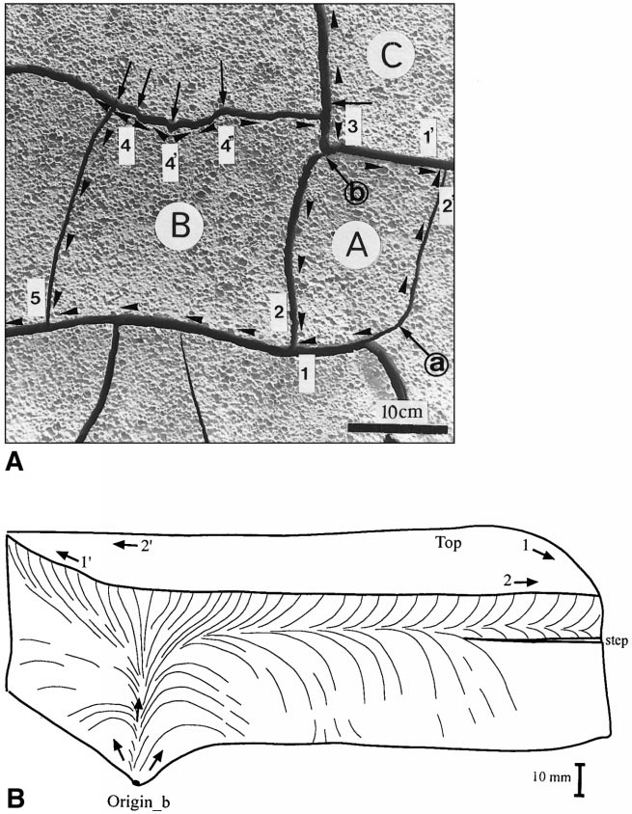
Figure 3. (A) Map view of two adjacent polygons. (B) Plumose structures observed in crack b, polygon A, that provide insight into crack evolution. After (Weinberger 2001)

In his study he took advantage of the well-developed surface morphology of natural mud cracks, which record uniquely the kinematic history of fracture nucleation and growth. This morphology, known as a plumose structure, consists of a crack origin and faint ridges or `hackles' that radiate from the origin and far away from the plume axis toward the peripheries of the crack planes (Bahat 1991) (Figure 5). For studying fracture characteristics of rocks, Plumose structures have been used as a powerful field tool (Kulander, Barton et al. 1979, DeGraff and Aydin 1987). The shape of the crack front is inferred by drawing curves normal to the hackles, which define past positions of the crack front (Kulander, Barton et al. 1979, DeGraff and Aydin 1987). The plume axis and hackles also allow us to infer the directions of the principal effective stresses (Weinberger 1999) (Figure 5).

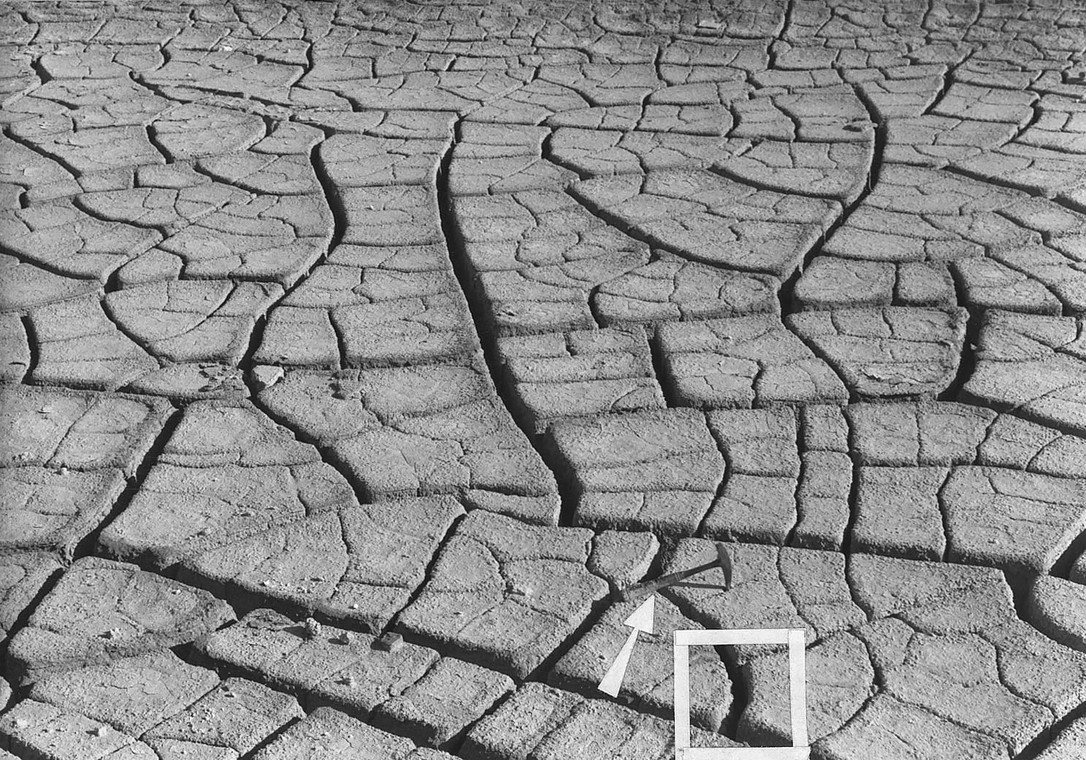
Figure 4. Mud cracks forming in a muddy sediment at the foot of Massada, Dead Sea region, Israel. Square shows a T-junction. Geological hammer indicated by an arrow provides a scale after (Weinberger 1999)

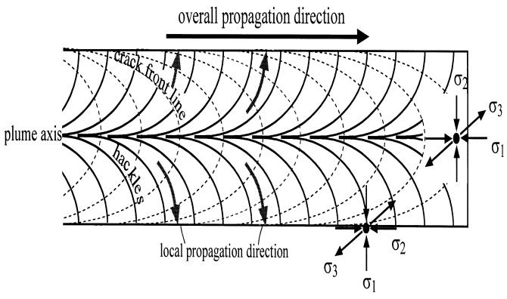
Figure 5. Symmetric plumose structure illustrating the use of hackles to interpret local propagation directions (grey solid arrows), overall propa- gation direction (solid black arrow), past crack fronts (broken lines), and fracture stress distributions. The plane containing the plumose structure is perpendicular to the least compressive principal stress (s3) and contains the greatest and intermediate compressive principal stress (s1 and s2, respectively). s3 is tensile, s1 can be compressive and is parallel to the plume axis, and s2 can be also compressive and is perpendicular to the plume axis. Crack origin is located to the left of the illustration. After (Weinberger 1999).

3. Discussion
As depositional facies determines the lithology, coarse-grained sediments were deposited in neritic facies or composite channel zone or fine-grained sediments were deposited in bathyal facies and carbonate, the distribution of polygonal faults is restricted to the area where fine-grained sediments dominate. The orientation of tectonic faults in the 3D study area of the Meishan Formation is absolutely NNW. However, the polygonal faults do not show any predominant strikes. This indicates that the development of polygonal faults was in an isotropic stress condition. In other words, the polygonal faults are non-tectonic(Sun, Wu et al. 2009). The formation of polygonal faults may be attributed to the two mechanisms combination as suggested by Cartwright and Lonergan (1996) and Dewhurst et al. (1999). The faults were restricted in mudstone, and developed in a rather flat area between two small sags (Sun, Wu et al. 2009).
The polygonal faults are inhibited by composite channels and only develop in fine-grained mudstone. The development and distribution of polygonal faults are controlled by depositional facies. In Meishan Formation most of the study area was bathyal in Middle Miocene and the maximum water depth was > 1 000 m. In Late Miocene (Huangliu Formation), nearly all the study areas entered the bathyal facies or pelagic facies, and fine-grained sediments deposited. This is a suitable, environment for the development of polygonal faults (Sun, Wu et al. 2009).
In general, the water in the fine sediments will be expelled and the horizon will extend laterally. At the beginning, the pore water will be expelled into the more porous and permeable coarse horizon below and filled composite channels. If sediments are highly permeable, then they will be compacted gravitationally in the vertical dimension more rapidly (Dewhurst, Cartwright et al. 1999). On the basis of the polygonal faults system bounding horizons, it can be seen that the polygonal faults system are located in an environment dominated mainly by volcanic ash, within which are some lime mud deposits, marine shale, and carbonate rocks (Ogiesoba, Klokov et al. 2015). Luo and Vasseur (2002) believed pore pressure itself may initiate fractures called “hydraulic fracturing” when the pore-fluid pressure in sedimentary basins override the least principal stress and the tensile strength of the host rock (Sun, Wu et al. 2009). Because the extension of the horizon is inhibited, layer-paralleled volumetric contraction will happen to adjust the lateral extension and vertical compaction. In nature, processes leading to shrinkage are known to generate approximately isotropic tensional stresses which are large enough to cause failure in rocks or sediments (Cartwright and Lonergan, 1996). Thus, the polygonal faults developed to balance the lateral extension which is limited and the over-pressure in fine-grained sediments (Sun, Wu et al. 2009) (Fig 6c).
Table 1 showing the characteristics of the polygonal faults compared in different basins worldwide (Table 1). Such characteristics include: (1) the faults have polygonal shape in plain view; (2) extensional nontectonic faults with unidirectional strike; (3) the faults are layer-Tier-bound in ﬁne-grained mudstone

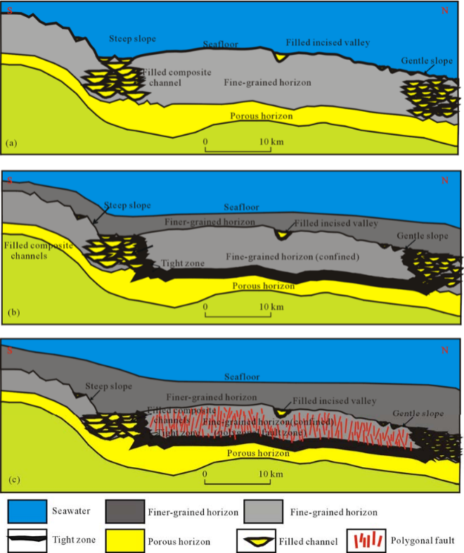
Figure 6. Schematic model of the development of polygonal faults. (a) Fine-grained sediments deposited in bathyal facies above porous horizon. Composite channels formed on steep and gentle slopes; (b) fine-grained horizon was compacted and tight zones were formed. Pressure gradually accumulated; (c) with the continuous compaction, the fine-grained sediment/mudstone was forced to extend. To balance the ex- tension, the volume would contract. When the stress exceeds the strength of the sediment/mudstone, polygonal faults will develop under the triggering of over-pressure. After (Sun, Wu et al. 2009).

In the Meishan Formation and the Huangliu Formation; (4) the faults develop over a large area, nearly the whole study area and so on(Sun, Wu et al. 2010) Many elements can inﬂuence the development of polygonal faults, such as clay mineral composition, physical properties, diagenesis and basin slope and so on (Cartwright and Lonergan 1996, Dewhurst, Cartwright et al. 1999, Gay, Lopez et al. 2004). Polygonal faults mostly form in ﬁne-grained sediments, such as shale and mudstone(Cartwright 1994). Other mechanisms for polygonal faults formation have been suggested, such as density inversion (Henriet, De Batist et al. 1991), hydro fracture and overpressure (Cartwright 1994), volumetric contraction (Cartwright and Lonergan 1996), syneresis (Cartwright and Dewhurst 1998, Dewhurst, Cartwright et al. 1999), compaction invoked by low coefﬁcient of friction of the sediments (Goulty 2001, Goulty and Swarbrick 2005). The study data show that Tier three is dominated by ﬁne-grained mud- stone which was deposited in a bathyal environment (Wei, Cui et al. 2001, YAO, YUAN et al. 2008).
It is possible that over-pressuring aﬀected a thicker layer prior to faulting when gravitational overturn began.
The experiments presented show that crack patterns in clay evolve when the clay is repeatedly wetted and dried(Goehring, Conroy et al. 2010). Experimentally induced cracks commonly originate at the top of the dehydrated layer(Weinberger 2001). This result shows exactly the opposite of the present field observations, which unambiguously indicate that cracking usually begins at the bottom of layered mud. Two differences between the natural and experimental setting should be highlighted. First, favorable flaws are concentrated at the base of natural mud, whereas inherent flaws are uniformly distributed throughout the experimental materials. Second, coherence between experimental materials and glass is higher than that between natural mud and the underlying sandy material, implying that setting the materials over a glass substance inhibits nucleation at the bottom (Weinberger 2001). The present field observations systematically show that the examined mud cracks nucleated at or near the bottom of the polygons and propagated vertically upward and laterally outward. We can gain some insight into this mode of fracturing by adopting basic concepts of fracture mechanics of brittle solids (Lawn 1993), keeping in mind that there are differences between fracturing of mud and fracturing of an ordinary solid. This result is in a marked contrast with the present field observations indicating that cracking begins at the bottom of the polygons(Weinberger 1999). Mud-crack propagation consumes energy in the form of surface energy for the creation of a new crack surface. This energy comes from the release of elastic strain energy within the drying mud. In this mechanism the only mechanical energy available to drive a crack is the elastic strain energy, which must decrease while the surface energy increases during crack growth(Engelder and Fischer 1996). Adhesive forces along the bottom of the polygons resist the horizontal contraction of the mud. This resistance gives rise to stresses along the bottom and causes the elastic strain energy to be stored. Since crack growth strongly depends on the stored energy, the boundary effect probably plays a key role not only for crack nucleation but also for crack propagation (Weinberger 1999). A plain view of figure 1 b and figure 4 show a similarity in the direction of the cracking and polygonal patterns.

Table 1. Statistical table detailing major morphological features of polygonal faults. After (Sun, Wu et al. 2010)
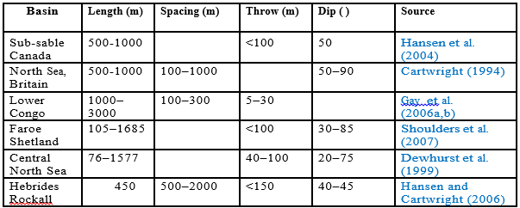

All literature studies agree that mud cracks and polygonal faults are formed by dewatering, extensions strain energy, nontectonic, isotropic orientations and grow in fine grains sediments such as mud and clay. Both are affected by extensional strain and have polygonal patterns. Since most polygonal faults do not affect the layers above or below them (Figure 1) we can deduce that; in the depositional environment, fine grain sediments such as mud and clay may be deposited. Under the favorable conditions, mud cracks may form. Deposition then resumes above the existing mud crack. Due to subjection to pressure and extensional strain, dewatering, and/or any of the above mentioned mechanisms, they result into polygonal faults.
In other words, in the burial history of a depositional environment, there may be cracking due to dewatering, burial pressure, extensional strain and so on, to form a polygonal patterns see figure 6. According to the above explanations, we can conclude that polygonal faults perhaps originate from mud cracks.

4. Conclusions
Polygonal faults and mud cracks appear linear or zigzag on plain view. The orientations of the polygonal faults are radically isotropic. This suggests that the polygonal faults and mud cracks are non-tectonic.
Polygonal faults are nontectonic faults found widely in deep water basins worldwide. Mud-crack patterns found in nature often appear to have hexagonal order, and are composed of Y-junctions with 120◦ angles. Earlier generations of mud cracks form polygonal patterns that are similar throughout the mud layers. Later generations of mud cracks fracture each mud stratum separately, forming different polygonal patterns at individual levels. Thus, polygonal faults probably originate from mud cracks. More study is required in the future about the relationship and genetic link that may exist between polygonal faults and Mud cracks.

Acknowledgments
The authors are grateful to Margaret Oloo for her comments and suggestions, and also grateful to Professor Hanming Gu

Correspondence to:
Mohamed Mohamed Ishag Abduallah,
China University of Geosciences, Wuhan 430074, China, Institute of Geophysics and Geomatics,
Tel: 0086-15549071082
Email:mohantoker@gmail.com,mohamedjkada@yahoo.com

References
- Allen, J. (1985). Physical sedimentology, Allen & Unwin.
- 2. Astin, T. and D. Rogers (1991). "Subaqueous shrinkage cracks" in the Devonian of Scotland reinterpreted." Journal of Sedimentary Research 61(5): 850-859.
- Aydin, A. and J. M. DeGraff (1988). "Evoluton of polygonal fracture patterns in lava flows." Science 239(4839): 471-476.
- Bahat, D. (1991). Tectonofractography, Springer.
- Baldwin, C. T. (1974). "The control of mud crack patterns by small gastropod trails." Journal of Sedimentary Research 44(3).
- Begin, Z., et al. (1974). Lake Lisan: the Pleistocene precursor of the Dead Sea, Ministry of Commerce and Industry, Geological Survey.
- Berndt, C., et al. (2012). "Kilometre-scale polygonal seabed depressions in the Hatton Basin, NE Atlantic Ocean: Constraints on the origin of polygonal faulting." Marine Geology 332: 126-133.
- Bünz, S., et al. (2003). "Geological controls on the Storegga gas-hydrate system of the mid-Norwegian continental margin." Earth and Planetary Science Letters 209(3): 291-307.
- Cartwright, J. (2011). "Diagenetically induced shear failure of fine-grained sediments and the development of polygonal fault systems." Marine and Petroleum Geology 28(9): 1593-1610.
- Cartwright, J. and D. Dewhurst (1998). "Layer-bound compaction faults in fine-grained sediments." Geological Society of America Bulletin 110(10): 1242-1257.
- Cartwright, J., et al. (2003). "The genesis of polygonal fault systems: a review." Geological Society, London, Special Publications 216(1): 223-243.
- Cartwright, J. and L. Lonergan (1996). "Volumetric contraction during the compaction of mudrocks: A mechanism for the development of regional‐scale polygonal fault systems." Basin Research 8(2): 183-193.
- Cartwright, J. A. (1994). "Episodic basin-wide hydrofracturing of overpressured Early Cenozoic mudrock sequences in the North Sea Basin." Marine and Petroleum Geology 11(5): 587-607.
- Cullen, J., et al. (2008). "The Mohican channel gas hydrate zone, Scotian slope: geophysical structure."
- Davies, R., et al. (1999). "Giant hummocks in deep-water marine sediments: Evidence for large-scale differential compaction and density inversion during early burial." Geology 27(10): 907-910.
- Davies, R. J. and J. A. Cartwright (2007). "Kilometer-scale chemical reaction boundary patterns and deformation in sedimentary rocks." Earth and Planetary Science Letters 262(1): 125-137.
- De Paola, N., et al. (2007). "A mechanical model for complex fault patterns induced by evaporite dehydration and cyclic changes in fluid pressure." Journal of Structural Geology 29(10): 1573-1584.
- DeGraff, J. M. and A. Aydin (1987). "Surface morphology of columnar joints and its significance to mechanics and direction of joint growth." Geological Society of America Bulletin 99(5): 605-617.
- Dewhurst, D. N., et al. (1999). "The development of polygonal fault systems by syneresis of colloidal sediments." Marine and Petroleum Geology 16(8): 793-810.
- Engelder, T. and M. P. Fischer (1996). "Loading configurations and driving mechanisms for joints based on the Griffith energy-balance concept." Tectonophysics 256(1): 253-277.
- Gay, A., et al. (2006). "Evidences of early to late fluid migration from an upper Miocene turbiditic channel revealed by 3D seismic coupled to geochemical sampling within seafloor pockmarks, Lower Congo Basin." Marine and Petroleum Geology 23(3): 387-399.
- Gay, A., et al. (2006). "Isolated seafloor pockmarks linked to BSRs, fluid chimneys, polygonal faults and stacked Oligocene–Miocene turbiditic palaeochannels in the Lower Congo Basin." Marine Geology 226(1): 25-40.
- Gay, A., et al. (2004). "Polygonal faults‐furrows system related to early stages of compaction–upper Miocene to recent sediments of the Lower Congo Basin." Basin Research 16(1): 101-116.
- Goehring, L., et al. (2010). "Evolution of mud-crack patterns during repeated drying cycles." Soft Matter 6(15): 3562-3567.
- Goulty, N. (2001). "Mechanics of layer-bound polygonal faulting in fine-grained sediments." Journal of the Geological Society 159(3): 239-246.
- Goulty, N. (2001). "Polygonal fault networks in fine‐grained sediments–an alternative to the syneresis mechanism." First Break 19(2): 69-73.
- Goulty, N. (2008). "Geomechanics of polygonal fault systems: a review." Petroleum Geoscience 14(4): 389-397.
- Goulty, N. and R. Swarbrick (2005). "Development of polygonal fault systems: a test of hypotheses." Journal of the Geological Society 162(4): 587-590.
- Groisman, A. and E. Kaplan (1994). "An experimental study of cracking induced by desiccation." EPL (Europhysics Letters) 25(6): 415.
- Grossenbacher, K. A. and S. M. McDuffie (1995). "Conductive cooling of lava: columnar joint diameter and stria width as functions of cooling rate and thermal gradient." Journal of volcanology and geothermal research 69(1): 95-103.
- Henriet, J., et al. (1991). "Early fracturing of Palaeogene clays, southernmost North Sea: relevance to mechanisms of primary hydrocarbon migration." Generation, accumulation and production of Europe's hydrocarbons 1: 217-227.
- Higgs, W. and K. McClay (1993). "Analogue sandbox modelling of Miocene extensional faulting in the Outer Moray Firth." Geological Society, London, Special Publications 71(1): 141-162.
- Hustoft, S., et al. (2007). "High-resolution 3D-seismic data indicate focussed fluid migration pathways above polygonal fault systems of the mid-Norwegian margin." Marine Geology 245(1): 89-106.
- Kulander, B. R., et al. (1979). Application of fractography to core and outcrop fracture investigations, Department of Energy, Morgantown, WV (USA). Morgantown Energy Research Center.
- Larter, S., et al. (2000). "A drain in my graben: an integrated study of the Heimdal area petroleum system." Journal of Geochemical Exploration 69: 619-622.
- Lawn, B. R. (1993). Fracture of brittle solids, Cambridge university press.
- Leeder, M. R. (1982). Sedimentology: process and product, G. Allen & Unwin.
- Lonergan, L., et al. (1998). "The geometry of polygonal fault systems in Tertiary mudrocks of the North Sea." Journal of Structural Geology 20(5): 529-548.
- Long, D., et al. (2004). "Sea bed morphology of the Faroe-Shetland Channel derived from 3D seismic datasets." Geological Society, London, Memoirs 29(1): 53-61.
- Müller, G. (1998). "Starch columns: Analog model for basalt columns." Journal of Geophysical Research: Solid Earth (1978–2012) 103(B7): 15239-15253.
- Ogiesoba, O. C., et al. (2015). "Diffraction imaging of polygonal faults within a submarine volcanic terrain, Maverick Basin, south Texas." Interpretation 3(1): SF81-SF99.
- Olson, J. and D. D. Pollard (1989). "Inferring paleostresses from natural fracture patterns: A new method." Geology 17(4): 345-348.
- Panien, M., et al. (2001). "Analogical model of the deformation of sandy submarine channels in shaly pelagic sediments." Oil & Gas Science and Technology 56(4): 319-325.
- Pettijohn, F. (1957). "Sedimentary Rocks Harper and Brothers." New York, USA.
- Pollard, D. D. and A. Aydin (1988). "Progress in understanding jointing over the past century." Geological Society of America Bulletin 100(8): 1181-1204.
- Ryan, M. P. and C. G. Sammis (1978). "Cyclic fracture mechanisms in cooling basalt." Geological Society of America Bulletin 89(9): 1295-1308.
- Shin, H., et al. (2010). "Displacement field in contraction‐driven faults." Journal of Geophysical Research: Solid Earth (1978–2012) 115(B7).
- Stuevold, L. M., et al. (2003). "Polygonal faults in the Ormen Lange field, Møre basin, offshore mid Norway." Geological Society, London, Special Publications 216(1): 263-281.
- Sun, Q., et al. (2010). "Polygonal faults and their implications for hydrocarbon reservoirs in the southern Qiongdongnan Basin, South China Sea." Journal of Asian Earth Sciences 39(5): 470-479.
- Sun, Q., et al. (2009). "Characteristics and formation mechanism of polygonal faults in Qiongdongnan Basin, Northern South China Sea." Journal of Earth Science 20: 180-192.
- T NEAL, J., et al. (1968). "Giant desiccation polygons of Great Basin playas." Geological Society of America Bulletin 79(1): 69-90.
- Trincardi, F., et al. (2004). "Evidence of soft sediment deformation, fluid escape, sediment failure and regional weak layers within the late Quaternary mud deposits of the Adriatic Sea." Marine Geology 213(1): 91-119.
- Verschuren, M. (1992). An integrated 3D approach to clay tectonic deformation and the development of a new 3D surface modelling method.
- Victor, P. and I. Moretti (2006). "Polygonal fault systems and channel boudinage: 3D analysis of multidirectional extension in analogue sandbox experiments." Marine and Petroleum Geology 23(7): 777-789.
- Walker, J. (1986). "Cracks in a surface look intricately random but actually develop rather systematically." Scientific American 255(4): 204-209.
- Watterson, J., et al. (2000). "Geometry and origin of a polygonal fault system." Journal of the Geological Society 157(1): 151-162.
- Wei, K., et al. (2001). "High-precision sequence stratigraphy in Qiongdongnan Basin." Earth Science-Journal of China University of Geosciences 26(1): 59-66.
- Weinberger, R. (1999). "Initiation and growth of cracks during desiccation of stratified muddy sediments." Journal of Structural Geology 21(4): 379-386.
- Weinberger, R. (2001). "Evolution of polygonal patterns in stratified mud during desiccation: the role of flaw distribution and layer boundaries." Geological Society of America Bulletin 113(1): 20-31.
- White, W. A. (1961). "Colloid phenomena in sedimentation of argillaceous rocks." Journal of Sedimentary Research 31(4).
- Wu, S., et al. (2009). "Petroleum system in deepwater basins of the Northern South China Sea." Journal of Earth Science 20: 124-135.
- Wu, S., et al. (2009). "Polygonal fault and oil-gas accumulation in deep-water area of Qiongdongnan Basin." Acta Petrolei Sinica 30(1): 22-26.
- YAO, G.-s., et al. (2008). "Double provenance depositional model and exploration prospect in the deep-water area of Qiongdongnan Basin." Petroleum Exploration and Development 35(6): 685-691.

1/18/2016

