**Design And Analysis Of Heavy Load Pavement For Cost Effective Port Operation Of The Nigerian West-East Coastal Shelf**

Ibrahim Tunde Yusuf

Department of Civil Engineering, University of Ilorin, P.M.B. 1515,

Ilorin, Kwara State of Nigeria (zip code: 234).

Email**:** ityusuf@yahoo.com;tunde_aroes@hotmail.com

**ABSTRACT:** The intensity of traffic and container loads in operation of ports necessitates the provision of zero or low maintenance heavy load pavements which can be in any of four main forms of pavement construction:- asphalt, concrete block, rigid concrete and reinforced concrete pavements. This paper, therefore, presents a construction/maintenance life cycle cost based pavement structure that reflects on construction materials, methods, port operational techniques and environment for the selection of the most appropriate for Nigerian coastal shelf. Primary data on cargo handling and container traffic statistics (for both export and import) were deduced from the operational and data sourced from the management of Nigerian Ports Authority and the Federal Office of Statistics in Lagos. Further, the length of the Nigerian west-east territorial costal shelf (between Lagos and Calabar), types of handling equipment available at the ports, available materials and construction technology prevailing at the ports environment were also extracted from other relevant sources. The British Ports Federation (BPF) Manual (1989) and the Nigeria Highway Design Manual (1972) were used for the design purposes. Design by Charts were employed with the aid of a Microsoft Excel software while the construction cost analysis was carried out for each pavement type at varying California Bearing Ratio (CBR) values of 1%, 3%, 5%, 10% and 30% for the possible native (subgrade) soils or as modified in bounded forms. The results of the design indicated that the rigid concrete and reinforced concrete pavements are better in technical terms since they can both be placed on soils with very low CBR values. However, the reinforced concrete pavement stands as the best choice economically with reasonably satisfactory technical capability because for all the subgrade CBR values and subbase thicknesses its construction cost is least. The cost of constructing the base course of reinforced concrete pavement on a soil of 10% CBR and 300mm thick subbase, for instance, is N5,950.00/m2 of pavement as compared to costs of asphalt, and rigid concrete pavements which are N6,800.00/m2 and N7,761.25/m2 respectively.

[Ibrahim Tunde Yusuf. Design And Analysis Of Heavy Load Pavement For Cost Effective Port Operation Of The Nigerian West-East Coastal Shelf. Researcher. 2010;2(11):62-81]. (ISSN: 1553-9865). <http://www.sciencepub.net>.

**Key words:** Ports, Container terminal, Heavy load pavement, Cargo handling operation, California Bearing Ratio, Design charts.

**1.0 INTRODUCTION**

Ports are important and intermodal transfer/operational facility for a marine transportation system. Over 96% or 3.6billion tons of international cargo moved through the ports of the world in 1978 (Bruun, 1981), which do come in various physical forms of liquid bulk, dry bulk, parcel or pseudo bulk, or containerized break bulk. Of all the componenting elements of a port, the pavement is about the most extensive in fixed land area and physical presentation. Its provision demands much heavily in investment. The terminal surface (or port pavement) constitute the base of all operations as it makes up for about 5 to 25% of the total budget (De-Heer, 1994). The marine economy is such a risky enterprise that cannot tolerate lost or idle time for frequent maintenance activities and hence the most strategic handling of the desirable pavement is for the initial construction cost to be usually very high with very low or zero maintenance cost.

Also a cost-effective pavement practice for a growing marine industry with selection of the pavement types from the list of asphalt, rigid concrete, reinforced concrete and concrete blocks shall be appropriate. The choice of the construction technology and maintenance practice of heavy load pavements is more appropriate for Nigerian ports, prevailing marine traffic and environment. Apart from traffic, the other major inputs in pavement design, construction, maintenance and operation are the physical strength and elastic properties of all the components (Yoder and Witczak (1975), Theyse et al (2007) and Jimoh (1987)).

This paper investigated the sensitivity of the performance of heavy load pavement within the Nigerian ports for changing materials, construction and maintenance options for a 25 years period, with a view to selecting the most cost effective combinations. The objectives, therefore, are (a) compilation of existing forms of pavements in Nigerian port areas, (b) development of unit cost data for construction, maintenance and replacement practices for various pavements in Nigeria, (c) compilation of a catalogue of lifespans of the various pavement structures, (d) carrying out cost-effective analysis for a 25-year construction and maintenance life, (e) selection of the most economical and cost effective heavy load pavement appropriate for Nigerian ports and hence (f) recommend a draft of design/analytical procedure for heavy load pavement in Nigerian marines.

**MATERIALS AND METHODS**

**Study Area**

The Nigerian west-east territorial costal shelf stretches from Badagry (Bight of Benin) to Calabar (Bight of Bonny) with a total length of 771.38km. Figure 1 shows the shelf while Table 1 presents the breakdown of the length of the various segments of the shelf. The coordinates of Bight of Benin is N6 01 52.9; E4 50 35.1 and that of Bight of Bonny is N4 43 37.8; E8 31 35.5 (Germin Corporation, 1995-2002). Port facility plans and development is highly dominated by non-Nigerians (foreigners) unlike the highways. There are seventeen (17) ports along the Nigerian west-east territorial coastal shelf where marine activities are in operation. The four major flagship of the port operation are Lagos Port Complex (Apapa and Tin Can Island), Portharcourt Port Complex, Bonny and the Forcados Ports where the volume of the cargoes handling are up to 15% to 56%.

Table 1: Distances Along Nigerian Territorial Coastal Shelf

|  |  |  |
| --- | --- | --- |
| LOCATION | LEG LENGTH (Km) | DISTANCE (Km) |
| INTLBR | 0 |  |
| LAGOS | 78.13 | 78.13 |
| BHTFB | 64.86 | 142.99 |
| BHGTF1 | 47.46 | 190.45 |
| 001 | 57.79 | 248.24 |
| GLFGNE | 35.71 | 283.95 |
| GLFGN1 | 52.81 | 236.76 |
| GLFGN | 50.67 | 387.43 |
| GLFGN3 | 44.87 | 432.30 |
| GLFGN4 | 29.18 | 461.48 |
| GLFGN5 | 24.48 | 485.96 |
| GLFGN6 | 26.67 | 512.63 |
| BHGTF2 | 33.33 | 545.96 |
| BHGTF3 | 38.19 | 584.15 |
| BHGTF4 | 51.19 | 635.34 |
| BHGTF5 | 35.21 | 670.55 |
| 002 | 50.49 | 721.04 |
| BHGTF6 | 18.93 | 739.97 |
| INTLB1 | 31.41 | 771.38 |

**Deskwork**

The basic method adopted for this study is in two stages: (i) capture of statistical data on the operation of marine traffic in Nigerian ports system as well as costal material properties using secondary sources and (ii) application for the design of various surface terminal pavements in relation to each container handling system, loadings and pavement materials using Microsoft Excel software and in accordance with British Ports Association analytical procedure.

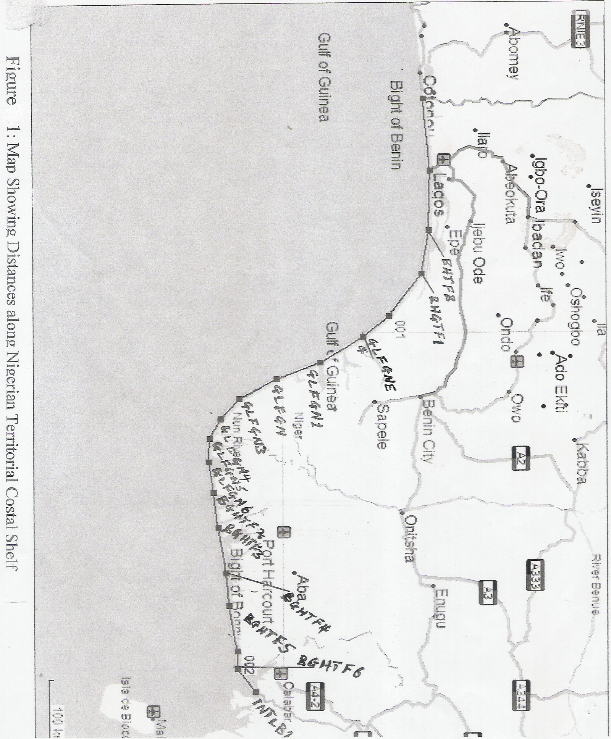

**Data Presentation**

The statistics acquired from the Nigerian Ports Authority, Apapa and Federal Office of Statistics, Lagos which reflected the desirable factors of traffic type, quantity, growth and handling technology are summarized in Tables 2, 3 and 4. Figures 2 and 3 present the ten-year (1988-1998) trend for cargo handling at the ports on the west-east territorial coastal shelf on annual basis.

Table 2 – Foreign Trade Cargo Handled at Nigerian Ports : Cargo Loaded’ 000 Tonnes

|  |  |  |  |  |  |  |  |  |  |  |  |  |
| --- | --- | --- | --- | --- | --- | --- | --- | --- | --- | --- | --- | --- |
| Ports | 1988 | % | 1989 | % | 1990 | % | 1991 | % | 1992 | % | 1993 | % |
| Apapa | 271 | 0.43 | 261 | 0.35 | 303 | 0.39 | 201 | 0.26 | 178 | 0.26 | 259 | 0.31 |
| Tin-Can Island | 179 | 0.28 | 138 | 0.18 | 155 | 0.20 | 134 | 0.17 | 192 | 0.28 | 172 | 0.20 |
| P-Harcourt | 546 | 0.87 | 361 | 0.48 | 81 | 0.10 | 113 | 0.14 | 121 | 0.18 | 65 | 0.08 |
| Okrika | 375 | 0.59 | 637 | 0.84 | 1150 | 1.47 | 1066 | 1.36 | 714 | 1.04 | 583 | 0.69 |
| Fed. Light Terminal. | 59 | 0.09 | 57 | 0.08 | 367 | 0.47 | 345 | 0.44 | 310 | 0.45 | 297 | 0.35 |
| Bonny | 18646 | 29.6 | 20212 | 26.5 | 18828 | 24.1 | 20006 | 25.5 | 20384 | 29.6 | 17439 | 20.7 |
| Brass | 5552 | 8.80 | 6844 | 9.07 | 8326 | 10.7 | 7787 | 9.95 | 7955 | 11.5 | 7417 | 8.81 |
| Warri | 283 | 0.45 | 69 | 0.09 | 71 | 0.09 | 98 | 0.12 | 1403 | 2.00 | 48 | 0.06 |
| Koko | 5 | - | 123 | 0.16 | 1 | - | - | - | - | - | - | - |
| Sapele | 3 | - | 3 | 3.00 | 8 | 0.01 | 15 | 0.02 | 18 | 0.03 | 4 | 0.01 |
| Escravos | 6396 | 10.5 | 7427 | 9.82 | 7865 | 10.1 | 8774 | 11.2 | 7411 | 10.8 | 8861 | 10.5 |
| Forcados | 16821 | 26.7 | 24543 | 32.5 | 24363 | 31.2 | 22853 | 29.1 | 24600 | 35.7 | 23915 | 28.4 |
| Pennington | 2974 | 4.72 | 3012 | 3.99 | 2791 | 3.58 | 2908 | 3.70 | 2617 | 3.80 | 3564 | 4.23 |
| Calabar | 13 | 0.02 | 10 | 0.01 | 14 | 0.02 | 14 | 0.02 | 6 | 0.01 | 3 | - |
| Qua-Ibo | 9386 | 14.9 | 10328 | 13.6 | 11423 | 14.7 | 12370 | 15.7 | 1569 | 2.28 | 19741 | 23.4 |
| Merryland (Bonny) | - | - | 376 | 0.50 | 860 | 1.10 | 825 | 1.05 | 581 | 0.84 | 668 | 0.79 |
| Antan | 1605 | 2.55 | 1138 | 1.51 | 1388 | 1.78 | 1024 | 1.36 | 895 | 1.30 | 1196 | 1.42 |
| Total | 63036 | 100 | 75429 | 100 | 77994 | 100 | 78594 | 100 | 68954 | 100 | 84232 | 100 |

|  |  |  |  |  |  |  |  |  |  |  |
| --- | --- | --- | --- | --- | --- | --- | --- | --- | --- | --- |
| Ports | 1994 | % | 1995 | % | 1996 | % | 1997 | % | 1998 | % |
| Apapa | 85 | 0.09 | 103 | 0.12 | 153 | 0.18 | 159 | 8.32 | 144 | 0.14 |
| Tin-Can Is. | 85 | 0.09 | 85 | 0.09 | 93 | 0.11 | 94 | 4.92 | 119 | 0.19 |
| P-Harcourt | 51 | 0.06 | 59 | 0.07 | 152 | 0.18 | 207 | 10.8 | 161 | 0.16 |
| Okrika | 574 | 0.67 | 2974 | 3.33 | 421 | 0.49 | 511 | 26.7 | 1094 | 1.09 |
| Fed. Light Terminal. | 261 | 0.30 | 171 | 0.19 | 146 | 0.17 | 123 | 6.43 | 338 | 0.34 |
| Bonny | 19133 | 22.2 | 17464 | 19.6 | 12398 | 14.5 | - | - | 18727 | 18.7 |
| Brass | 6849 | 7.94 | 7005 | 7.85 | 7642 | 8.95 | - | - | 6480 | 6.46 |
| Warri | 68 | 0.08 | 978 | 1.10 | 23 | 0.03 | 13 | 0.68 | 29 | 0.01 |
| Koko | 1 | - | 4 | 0.01 | - | - | - | - | - | - |
| Sapele | 3 | 0.01 | 2 | - | 7 | 0.01 | 11 | 0.58 | 11 | - |
| Escravos | 12328 | 14.3 | 10990 | 12.3 | 11676 | 13.7 | - | - | 15510 | 15.5 |
| Forcados | 22704 | 26.5 | 25719 | 28.8 | 24003 | 28.1 | - | - | 18341 | 18.3 |
| Pennington | 2832 | 3.28 | 2762 | 3.10 | 3664 | 4.29 | - | - | 2853 | 2.84 |
| Calabar | 8 | 0.01 | 9 | 0.01 | 4 | - | 1 | 0.01 | 37 | 0.00 |
| Qua-Ibo | 20377 | 23.6 | 19671 | 22.1 | 24279 | 28.5 | - | - | 29470 | 29.4 |
| Merryland (Bonny) | 120 | 0.14 | 307 | 0.34 | 273 | 0.32 | 301 | 15.7 | - | - |
| Antan | 498 | 0.58 | 617 | 0.69 | - | - | - | - | 401 | 0.40 |
| Total | 86305 | 100 | 89212 | 100 | 85350 | 100 | 1912 | 100 | 100373 | 100 |

Source: Nigerian Ports Authority

Table 3 – Foreign Trade Cargo Handled at Nigerian Ports : Cargo Unloaded’ 000 Tonnes

|  |  |  |  |  |  |  |  |  |  |  |  |  |
| --- | --- | --- | --- | --- | --- | --- | --- | --- | --- | --- | --- | --- |
| Ports | 1988 | % | 1989 | % | 1990 | % | 1991 | % | 1992 | % | 1993 | % |
| Apapa | 3050 | 46.3 | 3698 | 54.0 | 2768 | 45.8 | 4168 | 51.7 | 6082 | 55.3 | 6083 | 55.6 |
| Tin-Can Island. | 1713 | 26.3 | 1522 | 22.5 | 1659 | 27.5 | 1388 | 17.2 | 2301 | 20.3 | 1857 | 16.1 |
| P-Harcourt | 793 | 12.2 | 591 | 8.78 | 765 | 12.7 | 1144 | 14.2 | 1278 | 11.6 | 1405 | 12.8 |
| Okrika | 209 | 3.2 | 138 | 2.04 | 8 | 0.13 | - | - | 74 | 0.67 | - | - |
| Fed.Light Term. | 97 | 1.49 | 131 | 1.94 | 288 | 4.77 | 336 | 4.17 | 546 | 4.96 | 306 | 2.80 |
| Warri | 562 | 8.62 | 576 | 8.53 | 446 | 7.38 | 612 | 7.59 | 535 | 4.86 | 430 | 3.93 |
| Koko | 21 | 0.32 | 21 | 0.31 | 16 | 0.26 | 31 | 0.38 | 24 | 0.22 | 28 | 0.26 |
| Sapele | 31 | 0.48 | 46 | 0.68 | 27 | 0.45 | 35 | 0.43 | 82 | 0.75 | 107 | 0.98 |
| Escravos | - | - | - | - | - | - | - | - | - | - | - | - |
| Calabar | 78 | 1.20 | 69 | 1.02 | 48 | 0.79 | 43 | 0.53 | 29 | 0.26 | 55 | 0.50 |
| Merryland (Bonny) | - | - | 8 | 0.12 | 17 | 0.28 | - | - | 48 | 0.44 | 135 | 1.23 |
| Container Terminal |  |  |  |  |  |  |  |  |  |  | - | - |
| Roro |  |  |  |  |  |  |  |  |  |  | - | - |
| Fed. Ocean Term* |  |  |  |  |  |  |  |  |  |  | - | - |
| Total | 6517 | 100 | 6749 | 100 | 6042 | 100 | 8064 | 100 | 10999 | 100 | 10942 | 100 |

|  |  |  |  |  |  |  |  |  |  |  |
| --- | --- | --- | --- | --- | --- | --- | --- | --- | --- | --- |
| Ports | 1994 | % | 1995 | % | 1996 | % | 1997 | % | 1998 | % |
| Apapa | 4120 | 51.7 | 4786 | 51.7 | 3943 | 43.9 | 3526 | 38.1 | 5621 | 43.6 |
| Tin-Can Island. | 1528 | 19.1 | 1340 | 14.5 | 1717 | 19.1 | 1984 | 21.5 | 2791 | 21.7 |
| P-Harcourt | 776 | 9.74 | 916 | 9.89 | 1088 | 12.1 | 1064 | 11.5 | 1281 | 9.94 |
| Okrika | - | - | 27 | 0.29 | 115 | 1.28 | 66 | 0.71 | 482 | 3.74 |
| Fed.Light Term. | 146 | 1.83 | 24 | 0.26 | 442 | 4.92 | 608 | 6.58 | 306 | 2.37 |
| Warri | 266 | 3.34 | 374 | 4.04 | 335 | 3.73 | 298 | 3.23 | 344 | 2.67 |
| Koko | 26 | 0.33 | 24 | 0.26 | 31 | 0.35 | 54 | 0.58 | 90 | 0.70 |
| Sapele | 94 | 1.18 | 94 | 1.01 | 110 | 1.22 | 152 | 1.65 | 264 | 2.05 |
| Escravos | - | - | - | - | - | - | - | - | - | - |
| Calabar | 23 | 0.29 | 154 | 1.66 | 34 | 0.38 | 52 | 0.56 | 119 | 0.92 |
| Merryland (Bonny) | - | - | 198 | 2.14 | 79 | 0.88 | - | - | - | - |
| Container Terminal | 608 | 7.63 | 778 | 8.40 | 779 | 8.67 | 993 | 10.8 | 1198 | 9.29 |
| Roro | 381 | 4.78 | 325 | 3.51 | 225 | 2.51 | 239 | 2.59 | 268 | 2.08 |
| Fed. Ocean Term* | - | - | - | - | - | - | - | - | 168 | 1.30 |
| Total | 7968 | 100 | 9262 | 100 | 8982 | 100 | 9234 | 100 | 12892 | 100 |

Source: Nigerian Ports Authority

Table 4: Yearly Totals of Cargoes Handled at Nigerian Ports

|  |  |  |
| --- | --- | --- |
| Year | Total Cargo Loaded ‘000’ Tonnes | Total Cargo Unloaded ‘000’ Tonnes |
| 1998 | 63,036 | 6,517 |
| 1989 | 75,429 | 6,749 |
| 1990 | 77,994 | 6,042 |
| 1991 | 78,594 | 8,064 |
| 1992 | 68,954 | 10,999 |
| 1993 | 84,232 | 10,942 |
| 1994 | 86,305 | 7,968 |
| 1995 | 89,212 | 9,262 |
| 1996 | 85,350 | 8,982 |
| 1997 | 1,912 | 9,234 |
| 1998 | 100,373 | 12,892 |



Cargoes Loaded

Cargoes Unloaded



Cargoes Unloaded

Cargoes Loaded

**Material Characteristics**

In order to ensure the coverage of entire length of the Nigerian costal native soils, the profiles and properties of soils within the Lagos and Port Harcourt port complexes were used as representatives. These are shown in Table 5 below.

Table 5: Characteristics of Soil Materials at Lagos and Port Harcourt Ports

|  |  |  |  |
| --- | --- | --- | --- |
| Properties | Characteristic Values at | | Range (%) |
| Lagos | Port Harcourt |
| Natural Moisture Content (%) | 51 | 39.1 | 39.1 – 51.0 |
| Liquid Limit (%) | 42 | 48 | 42 - 48 |
| Plastic Limit (%) | 19 | 25.5 | 19.0 - 25.5 |
| Plasticity Index (%) | 23 | 22.5 | 22.5 – 23.0 |
| Dry Density (kN/m3) | 14.4 | 13.03 | 13.0 – 14.4 |
| Specific Gravity | 2.52 | 2.60 | 2.52 – 2.60 |
| Clay Content (%) | 36 | 33.5 | 33.5 – 36.0 |

Source: Progress Engineers (2001) and Bugo-Tech (2000).

Elastic constants (that is, elastic modulus and Poisson’s ratio) have to be assigned to the components of the pavement, that is, the subgrade, the subbase, the base and the surface. This is because the design criteria and analysis are based upon elastic theory. The strength of the subgrade is, commonly, referred to in terms of its California Bearing Ratio (CBR) and there is a relationship developed between elastic modulus, Poisson’s ratio and CBR. As advised (Overseas Road Note 31, 2003), it is false economy to minimize the extent of preliminary investigations to determine the variability in material properties. Variability in material properties is, generally, much greater than desired in design processes and must, therefore, be taken into account explicitly during pavement design. The materials characteristics for the pavement which constitutes subgrade, subbase, base and surfacing were determined and obtained as follows:

3.1 Subgrade: The subgrade strength is characterised by its California Bearing Ratio (CBR). British Ports Federation design charts are produced for CBR values of 1%, 3%, 5%, 10% and 30% which represent the likelihood of CBR values for very poor to very good subgrade which can prevail in tropical/subtropical regions. According to Heukelom and Foster (1960), the subgrade is assumed to be semi-infinite and its elastic modulus is equal to ten times its CBR value. That is,

Eg = 10 x CBR-1 (N/mm2) ……………………. (1)

CBR of deep organic clay stratum in Nigerian coasts is 5-10% (Ajayi, 1983).

Poisson’s ratio,, is calculated from = 0.82 – 0.1log Eg (Barber,1980)…………… (2)

where, Eg = elastic modulus of the subgrade (N/mm2)

3.2 Subbase: The elastic modulus the subbase is calculated from the thickness of the subbase and the elastic modulus of the subgrade (Shell Pavement Design Manual, 1978) from the expression,

Es = 0.2Hs0.45 x Eg (N/mm2)…………………….. (3)

where, Es = elastic modulus of the subbase (N/mm2), Hs = thickness of the subbase (mm) and Eg = elastic modulus of the subgrade (N/mm2).

The Poisson’s ratio for the subbase is calculated using equation (2) taken CBR value as 30% and the compressive strength as 12N/mm2 (Nigerian Highway Design Manual, 1997).

3.3 Base: The CBR, the elastic modulus and the compressive strength for the base course is taken as 80%, 1000N/mm2 and 12N/mm2 respectively. Relevant clauses of the Nigerian Specification for Construction Technology requires compaction on lifts of not more than 150mm to 200mm. Hence, the probable sizes of the subbase and base courses could be either 150mm or 200mm or any of their multiples.

**Data Analysis and Design**

The BPA manual (1990) gave a realistic method of assessing the damaging effect of container handling equipment which reflects those parameters particular to container terminal pavements as (a) very heavy wheel loads up to 25tons, (b) wide area of operation, (c) severe dynamics, (d) wide range of equipment types and sizes. For each wheel on one side of the plant, the damaging effect is calculated from equation proposed by Heukelom and Klomp, (1978):

D =  …………………………….. 4

where, D = pavement damage; W = wheel load (kg); P = tyre pressure ( N/mm2) which gives pavement damage, D, in the units of Port Area Wheel Load (PAWL).

Based on the deductions from the information in Tables 1-3, the design life of the pavement at Apapa port is 4,131,818 passes and the number of repetitions of a straddle carrier over a period of 25years is 3,888,000. This value can be halved and for a critical handling facility like the Apapa port, a value of 2,000,000 repetitions and a life of 25years are adopted for the design (BPF Manual, 1989). The use of BPF Charts was considered for the pavement design (see the Appendix for the Charts). The design approach for heavy load pavement is to compute strains resulting from a defined loading regime and to determine the permissible strains which the pavement construction materials can withstand. A pavement is deemed to be correctly designed when actual and permissible strains are similar. The allowable strain is given by:

 in microstrain……………………(5)

where, N = number of repetitions of applied load = 2 x 106; => Ev = 372microstrain.

The allowable base horizontal tensile strain is given by:

 in microstrain………………..(6)

where, for:

Asphalt Pavement :

Fc = characteristic compressive strength of base material in microstrain = 12N/mm2

(BPA Manual)

Since Fc > 7N/mm2 ; Eb = 16800 x Fc0.25 = 31268N/mm2 => Eh = 24 microstrain

Concrete Block Pavement:

Fc = characteristic compressive strength of base material in microstrain = 6N/mm2 (BPA manual)

Since Fc < 7N/mm2; Eb = 4000 x Fc0.25 = 24000N/mm2 => Eh = 16 microstrain

Rigid Concrete Pavement :

Fc = characteristic compressive strength of base material in microstrain = 18N/mm2

(BPA manual)

Since Fc > 7N/mm2 ; Eb = 16800 x Fc0.25 = 34604N/mm2 => Eh = 32 microstrain.

Reinforced Concrete Pavement:

Fc = characteristic compressive strength of base material in microstrain = 24N/mm2

(BPA manual)

Since Fc > 7N/mm2; Eb = 16800 x Fc0.25 = 37185N/mm2 => Eh = 40 microstrain.

**RESULTS**

Design by use of Charts

Asphalt Pavement with Granular Base

For an asphalt surfaced flexible pavement required to withstand 2.000,000

Effective repetitions of LCI-C plant on a subgrade of 10% CBR.

Effective depth of pavement = 2664.0mm.

Assumed thickness of subbase = 300mm.

From chart C of the Appendix, 2 x 106 repetitions correspond with a permissible compressive vertical microstrain of 375. From Chart 8 of the Appendix, 375 microstrain corresponds with granular base thickness of 500mm. The results for other CBR values for asphalt pavement as well as design output for Concrete Block, Rigid and Reinforced Concrete pavements are shown in Tables 6-9. Charts A, B, C and 6-15 used for asphalt pavement with granular base are presented in the Appendix.

Table 6: Design Output for Asphalt Pavement with Granular Base

|  |  |  |  |  |
| --- | --- | --- | --- | --- |
| Subgrade  CBR (%) | 300mm Subbase Thickness | | 600mm Subbase Thickness | |
| Chart No. | Base Thickness (mm) | Chart No. | Base Thickness (mm) |
| 1 | 6 | No practical solution | 11 | No practical solution |
| 3 | 7 | No practical solution | 12 | Not required |
| 5 | 8 | No practical solution | 13 | Not required |
| 10 | 9 | 500 | 14 | Not required |
| 30 | 10 | Not required | 15 | Not required |

Table 7: Design Output for Concrete Block Pavement

|  |  |  |  |  |
| --- | --- | --- | --- | --- |
| Subgrade  CBR (%) | 300mm Subbase Thickness | | 600mm Subbase Thickness | |
| Chart No. | Base Thickness (mm) | Chart No. | Base Thickness (mm) |
| 1 | 21 | No practical solution | 26 | No practical solution |
| 3 | 22 | No practical solution | 27 | No practical solution |
| 5 | 23 | No practical solution | 28 | No practical solution |
| 10 | 24 | No practical solution | 29 | 270 |
| 30 | 25 | No practical solution | 30 | Not required |

Table 8: Design Output for Rigid Concrete Pavement

|  |  |  |  |  |
| --- | --- | --- | --- | --- |
| Subgrade  CBR (%) | 300mm Subbase Thickness | | 600mm Subbase Thickness | |
| Chart No. | Base Thickness (mm) | Chart No. | Base Thickness (mm) |
| 1 | 36 | 325 | 41 | 290 |
| 3 | 37 | 300 | 42 | 280 |
| 5 | 38 | 275 | 43 | 270 |
| 10 | 39 | 250 | 44 | 240 |
| 30 | 40 | 100 | 45 | 0 |

Table 9: Design Output for Rigid Concrete Pavement

|  |  |  |  |  |
| --- | --- | --- | --- | --- |
| Subgrade  CBR (%) | 300mm Subbase Thickness | | 600mm Subbase Thickness | |
| Chart No. | Base Thickness (mm) | Chart No. | Base Thickness (mm) |
| 1 | 36 | 245 | 41 | 205 |
| 3 | 37 | 205 | 42 | 200 |
| 5 | 38 | 200 | 43 | 190 |
| 10 | 39 | 175 | 44 | 110 |
| 30 | 40 | 0 | 45 | 0 |

Table 10: Prices of Base Course Materials as at August, 2008.

|  |  |
| --- | --- |
| Material | Price |
| Granular Materials | N5,000.00/m3 |
| Crushed Granite | N3,500.00/ton |
| Cement | N1,800.00/bag |
| Sharp Sand | N1,845.00/m3 |
| 12mm Iron rod | N2,200.00/length |

4.2 Cost Data Collection and Analysis

Field (market) survey conducted to obtain prices of materials (Ilorin, Nigeria (2010)) required for construction, maintenance and rehabilitation of heavy load pavements are shown in Table 10. The costs of producing concrete mixes of 1:4:8 and 1:1:2 were calculated as N13,600.00/m3 and N31,045.00/m3 respectively from Table 10. Table 11 shows the cost of materials required for the base course of one square metre (1m2) spot on each pavement type at CBR values of 1%, 3%, 5%, 10% and 30%.

Table 11: Cost Analysis

|  |  |  |  |  |  |
| --- | --- | --- | --- | --- | --- |
| Pavement | Quantity(m3) for subbase thickness of | | Cost / m3  (N) | Amount (N) for subbase thickness of | |
| 300mm | 600mm | 300mm | 600mm |
| CBR = 1% | | | | | |
| Asphalt (Granular Base) | - | - | 13,600.00 | - |  |
| Concrete Blocks | - | - | 4,500.00 | - |  |
| Rigid Concrete | 0.325 | 0.290 | 31,045.00 | 10,089.63 | 9003.05 |
| Reinforced Concrete | 0.245 | 0.205 | 34,000.00 | 8330.00 | 6,970.00 |
| CBR = 3% | | | | | |
| Asphalt (Granular Base) | - | - | 13,600.00 | - | - |
| Concrete Blocks | - | - | 4,500.00 | - | - |
| Rigid Concrete | 0.300 | 0.280 | 31,045.00 | 9,313.50 | 8,694.00 |
| Reinforced Concrete | 0.205 | 0.200 | 34,000.00 | 6,970.00 | 6,800.00 |
| CBR = 5% | | | | | |
| Asphalt (Granular Base) | - | - | 13,600.00 | - | - |
| Concrete Blocks | - | - | 4,500.00 | - | - |
| Rigid Concrete | 0.275 | 0.270 | 31,045.00 | 8,537.38 | 8,382.15 |
| Reinforced Concrete | 0.200 | 0.190 | 34,000.00 | 6,800.00 | 6,460.00 |
| CBR = 10% | | | | | |
| Asphalt (Granular Base) | 0.500 | - | 13,600.00 | 6,800.00 | - |
| Concrete Blocks | - | 0.270 | 4,500.00 | - | 1,215.00 |
| Rigid Concrete | 0.250 | 0.240 | 31,045.00 | 7,761.25 | 7,450.80 |
| Reinforced Concrete | 0.175 | 0.110 | 34,000.00 | 5,950.00 | 3,740.00 |
| CBR = 30% | | | | | |
| Asphalt (Granular Base) | - | - | 13,600.00 | - | - |
| Concrete Blocks | - | - | 4,500.00 | - | - |
| Rigid Concrete | 0.100 | 0 | 31,045.00 | 3,104.50 | 0 |
| Reinforced Concrete | 0 | 0 | 34,000.00 | 0 | 0 |

**Discussions**

The results obtained for the design method and pavements using different CBR values are discussed to reveal the changes in material specification, construction technology and corresponding maintenance requirements due to the sensitivity of the performance of heavy load pavement. Charts were employed in the design of the component layers for the four pavements under consideration. The design results show that asphalt pavement on granular base with subgrade CBR values of 1%, 3% and 5% and subbase thickness of 300mm and also with CBR value of 1% and subbase thickness of 600mm did not produce any thickness of base course. This is because asphalt surfacing on such soils and thicknesses are not practical solutions. Asphalt pavement placed on soils of 30% CBR and 300mm thick subbase and on soils of 3%, 5%, 10% and 30% and 600mm thick subbase will not require the provision of a base course (see Table 6).

The results also show that it will not be practically wise to construct a concrete block pavement on all the five sugrade CBR values and 300mm thick subbase as well as soils with CBR values of 1%, 3% and 5% and 600mm thick. However a soil of 30% CBR and subbase thickness of 600mm will not require a base course to carry a concrete block pavement (Table 7). In the case of rigid concrete pavement, with subbase thicknesses of 300mm and 600mm and for all CBR values, its construction is practically possible with resulting base thicknesses reducing with increase in subgrade CBR values (Table 8). Table 9 shows that reinforced concrete pavement is an improvement over the rigid concrete pavement as the resulting base thicknesses in the former are less than those of the latter for all CBR values and subbase thicknesses.

Tables 12 and 13 presented graphically in Figures 4 and 5 also show clearly that for all pavements, the base course thicknesses decrease with increase in the subgrade CBR values, thickness of subbase course not withstanding. This implies that a better subgrade will require a less pavement thickness. It is also evident that concrete block and reinforced concrete will produce pavements of least thicknesses.

The traditional approach adopted for the design in this paper involves selecting a container handling equipment (in this case a straddle carrier) according to operational requirements, then design a pavement system to withstand the damage afflicted by the selected equipment. The choice will be a compromise between the technicality and economy of the design method. The most important thing is to be aware of the available choices of the relevant factors and adopt them appropriately.

Table 12: Design Results by Analysis Technique

|  |  |  |
| --- | --- | --- |
| Pavement Type | Base Thickness(m) for 300 mm subbase | Base Thickness(m) for 600 mm subbase |
| CBR = 1% | | |
| Asphalt (Granular Base) | - | - |
| Concrete Blocks | - | - |
| Rigid Concrete | 0.325 | 0.290 |
| Reinforced Concrete | 0.245 | 0.205 |
| CBR = 3% | | |
| Asphalt (Granular Base) | - | - |
| Concrete Blocks | - | - |
| Rigid Concrete | 0.300 | 0.280 |
| Reinforced Concrete | 0.205 | 0.200 |
| CBR = 5% | | |
| Asphalt (Granular Base) | - | - |
| Concrete Blocks | - | - |
| Rigid Concrete | 0.275 | 0.270 |
| Reinforced Concrete | 0.200 | 0.190 |
| CBR = 10% | | |
| Asphalt (Granular Base) | 0.500 | - |
| Concrete Blocks | - | 0.270 |
| Rigid Concrete | 0.250 | 0.240 |
| Reinforced Concrete | 0.175 | 0.110 |
| CBR = 30% | | |
| Asphalt (Granular Base) | - | - |
| Concrete Blocks | - | - |
| Rigid Concrete | 0.100 | 0 |
| Reinforced Concrete | 0 | 0 |

Table 13: CBR Values versus Base and Subbase Thicknesses

|  |  |  |
| --- | --- | --- |
| Asphalt Pavement with Granular Base | | |
| CBR (%) | Base Thickness(m) for 300 mm subbase | Base Thickness(m) for 600 mm subbase |
| 1 | - | - |
| 3 | - | - |
| 5 | - | - |
| 10 | 0.500 | - |
| 30 | - | - |
| Concrete Block Pavement with Lean Concrete Base | | |
| CBR (%) | Base Thickness(mm) | Subbase Thickness(mm) |
| 1 | - | - |
| 3 | - | - |
| 5 | - | - |
| 10 | - | 0.270 |
| 30 | - | - |
| Rigid Concrete Pavement | | |
| CBR (%) | Base Thickness(mm) | Subbase Thickness(mm) |
| 1 | 0.325 | 0.290 |
| 3 | 0.300 | 0.280 |
| 5 | 0.275 | 0.270 |
| 10 | 0.250 | 0.240 |
| 30 | 0.100 | 0 |
| Reinforced Concrete Pavement | | |
| CBR (%) | Base Thickness(mm) | Subbase Thickness(mm) |
| 1 | 0.245 | 0.205 |
| 3 | 0.205 | 0.200 |
| 5 | 0.200 | 0.190 |
| 10 | 0.175 | 0.110 |
| 30 | 0 | 0 |



B

Rigid Concrete Pavement

Rigid Concrete Pavement

Reinforced Concrete Pavement



B

Reinforced Concrete Pavement

Rigid Concrete Pavement

**CONCLUSIONS**

The following conclusions can be made from this study:- The results indicate that rigid concrete and reinforced concrete pavements are better practically than other types of pavements. However, the reinforced concrete pavement stands as the best choice economically. This is because for all the subgrade CBR values and subbase thicknesses its construction cost is least. For instance, the cost of constructing the base course of reinforced concrete pavement on a soil of 10% CBR and 300mm thick subbase is N5,950.00/m2 of pavement as compared to costs of asphalt, and rigid concrete pavements which are N6,800.00/m2 and N7,761.25/m2 respectively. In addition reinforced concrete pavement on a subgrade CBR of over 30% and for 300mm and 600mm subbase thicknesses will not require the provision of a base course. This implies that a better subgrade will require less pavement thickness.

Cost analysis shows that all pavement types are cheaper to build on subgrades with CBR values of 30% and for all the CBR values, reinforced concrete pavement is the best choice economically having met all safety conditions. The ideal pavement for marine traffic does not require maintenance or repair and it must be cheap. In real life, a sound compromise has to be found both in the technical and economic fields. An unsuitable pavement will have a negative impact on terminal operations. Hence, selection of suitable and economically feasible pavement is of utmost importance.

**RECOMMENDATIONS**

The economically and cost effective, fortified pavement for marine operation at the coastal areas is the reinforced concrete pavement with the least construction costs for all subgrade CBR values and subbase thicknesses. It is advisable that reinforced concrete pavement be adopted for Nigeria Port Pavements because of the justifiable cost effectiveness.

AKNOWLEDGEMENTS

This paper cannot be put together without the tremendous background information made available by various research workers, authors of excellent books and articles which have been referred to and listed in my references. I thank them. My special thanks to Dr. Y.A. Jimoh, a senior lecturer in the Civil Engineering Department, University of Ilorin, Ilorin, Nigeria for his immense contribution to this paper.

**REFERENCES**

1. Bruun, P. and Frankel, E.G. (1981), “Port Engineering”,3rd Edition, Gulf Publishing Company, Book Division, Houston.
2. Federal Ministry of Works and Housing, Lagos, Nigeria (2003), “General Specifications for Roads and Bridges”, Volumes 1 and 2.
3. Federal Ministry of Works and Housing, Lagos, Nigeria (1972), “Nigerian Highway Design Manual Part I (Design) and Part II (Maintenance)”.
4. Heukelom, W. and Foster, C.R. (1960), “Dynamic Testing of Pavements”, Journal of the Soil Mechanics and Foundation Divisions, ASCE, Vol. 86, No. 5MI, Proc. Paper 2368.
5. Jimoh, Y.A. (1987), “Evaluation of Some Aspects of Flexible pavement Design Practice in Nigeria”, M.Eng. Degree Thesis presented to the Department of Civil Engineering, University of Ilorin, Ilorin, Nigeria, unpublished.
6. Knapton, J. (1989), “The Structural Design of Heavy Duty Pavement for Ports and Other Industries”, 2nd Edition, British Ports Federation, Commonwealth House, 1-19 New Oxford Street, London.
7. Meletiou, M. and Knapton, J. (1994) “Container Terminal Pavement Management”, Published by Nigel Nixon, Knapton and Partners, London.
8. National Ports Council, Annual Design of Ports Statistics, Vol. 1, 1971 – 1976, HMSO, London.
9. Ola, S.A. (1983), “Tropical Soils of Nigeria in Engineering Practice”, Published by A.A. Balkema/Rotterdam.
10. Overseas Road Note No. 31 (1993), 4th Edition, “A Guide to the Structural Design of Bitumen-Surfaced Roads in Tropical and Sub-Tropical Countries, Published by Transport Research Laboratory, Crowthorne, Berkshire, U.K.
11. Shell Pavement Design Manual, Shell International Petrol Company Limited, 1978.
12. UNCTAD (1987), “Container Terminal Pavement Management Monograph No. 5”, UNCTAD Mongraphs on Port Management, UNCTAD, United Nations.
13. UNCTAD (1990), “Container Terminal Pavement Management Monograph No. 5”, UNCTAD Monographs on Port Management, UNCTAD, United Nations.
14. U.S. Department of Transportation, Federal Highway Administration (FHWA), “Public Roads”, (July/August, 2002), Vol. 66, No. 1.
15. Yoder, E.J. and Witczak, M.W. (1975), “Principles of Pavement Design”, 2nd Edition, Wiley-Interscience Publications, Chapters 14 and 16.
16. Yusuf, I.T. (2005), “Cost Based Design of Heavy load Pavement for Nigerian Ports”, M.Eng. Degree Thesis presented to the Department of Civil Engineering, University of Ilorin, Ilorin, Nigeria, unpublished.

**APPENDIX**

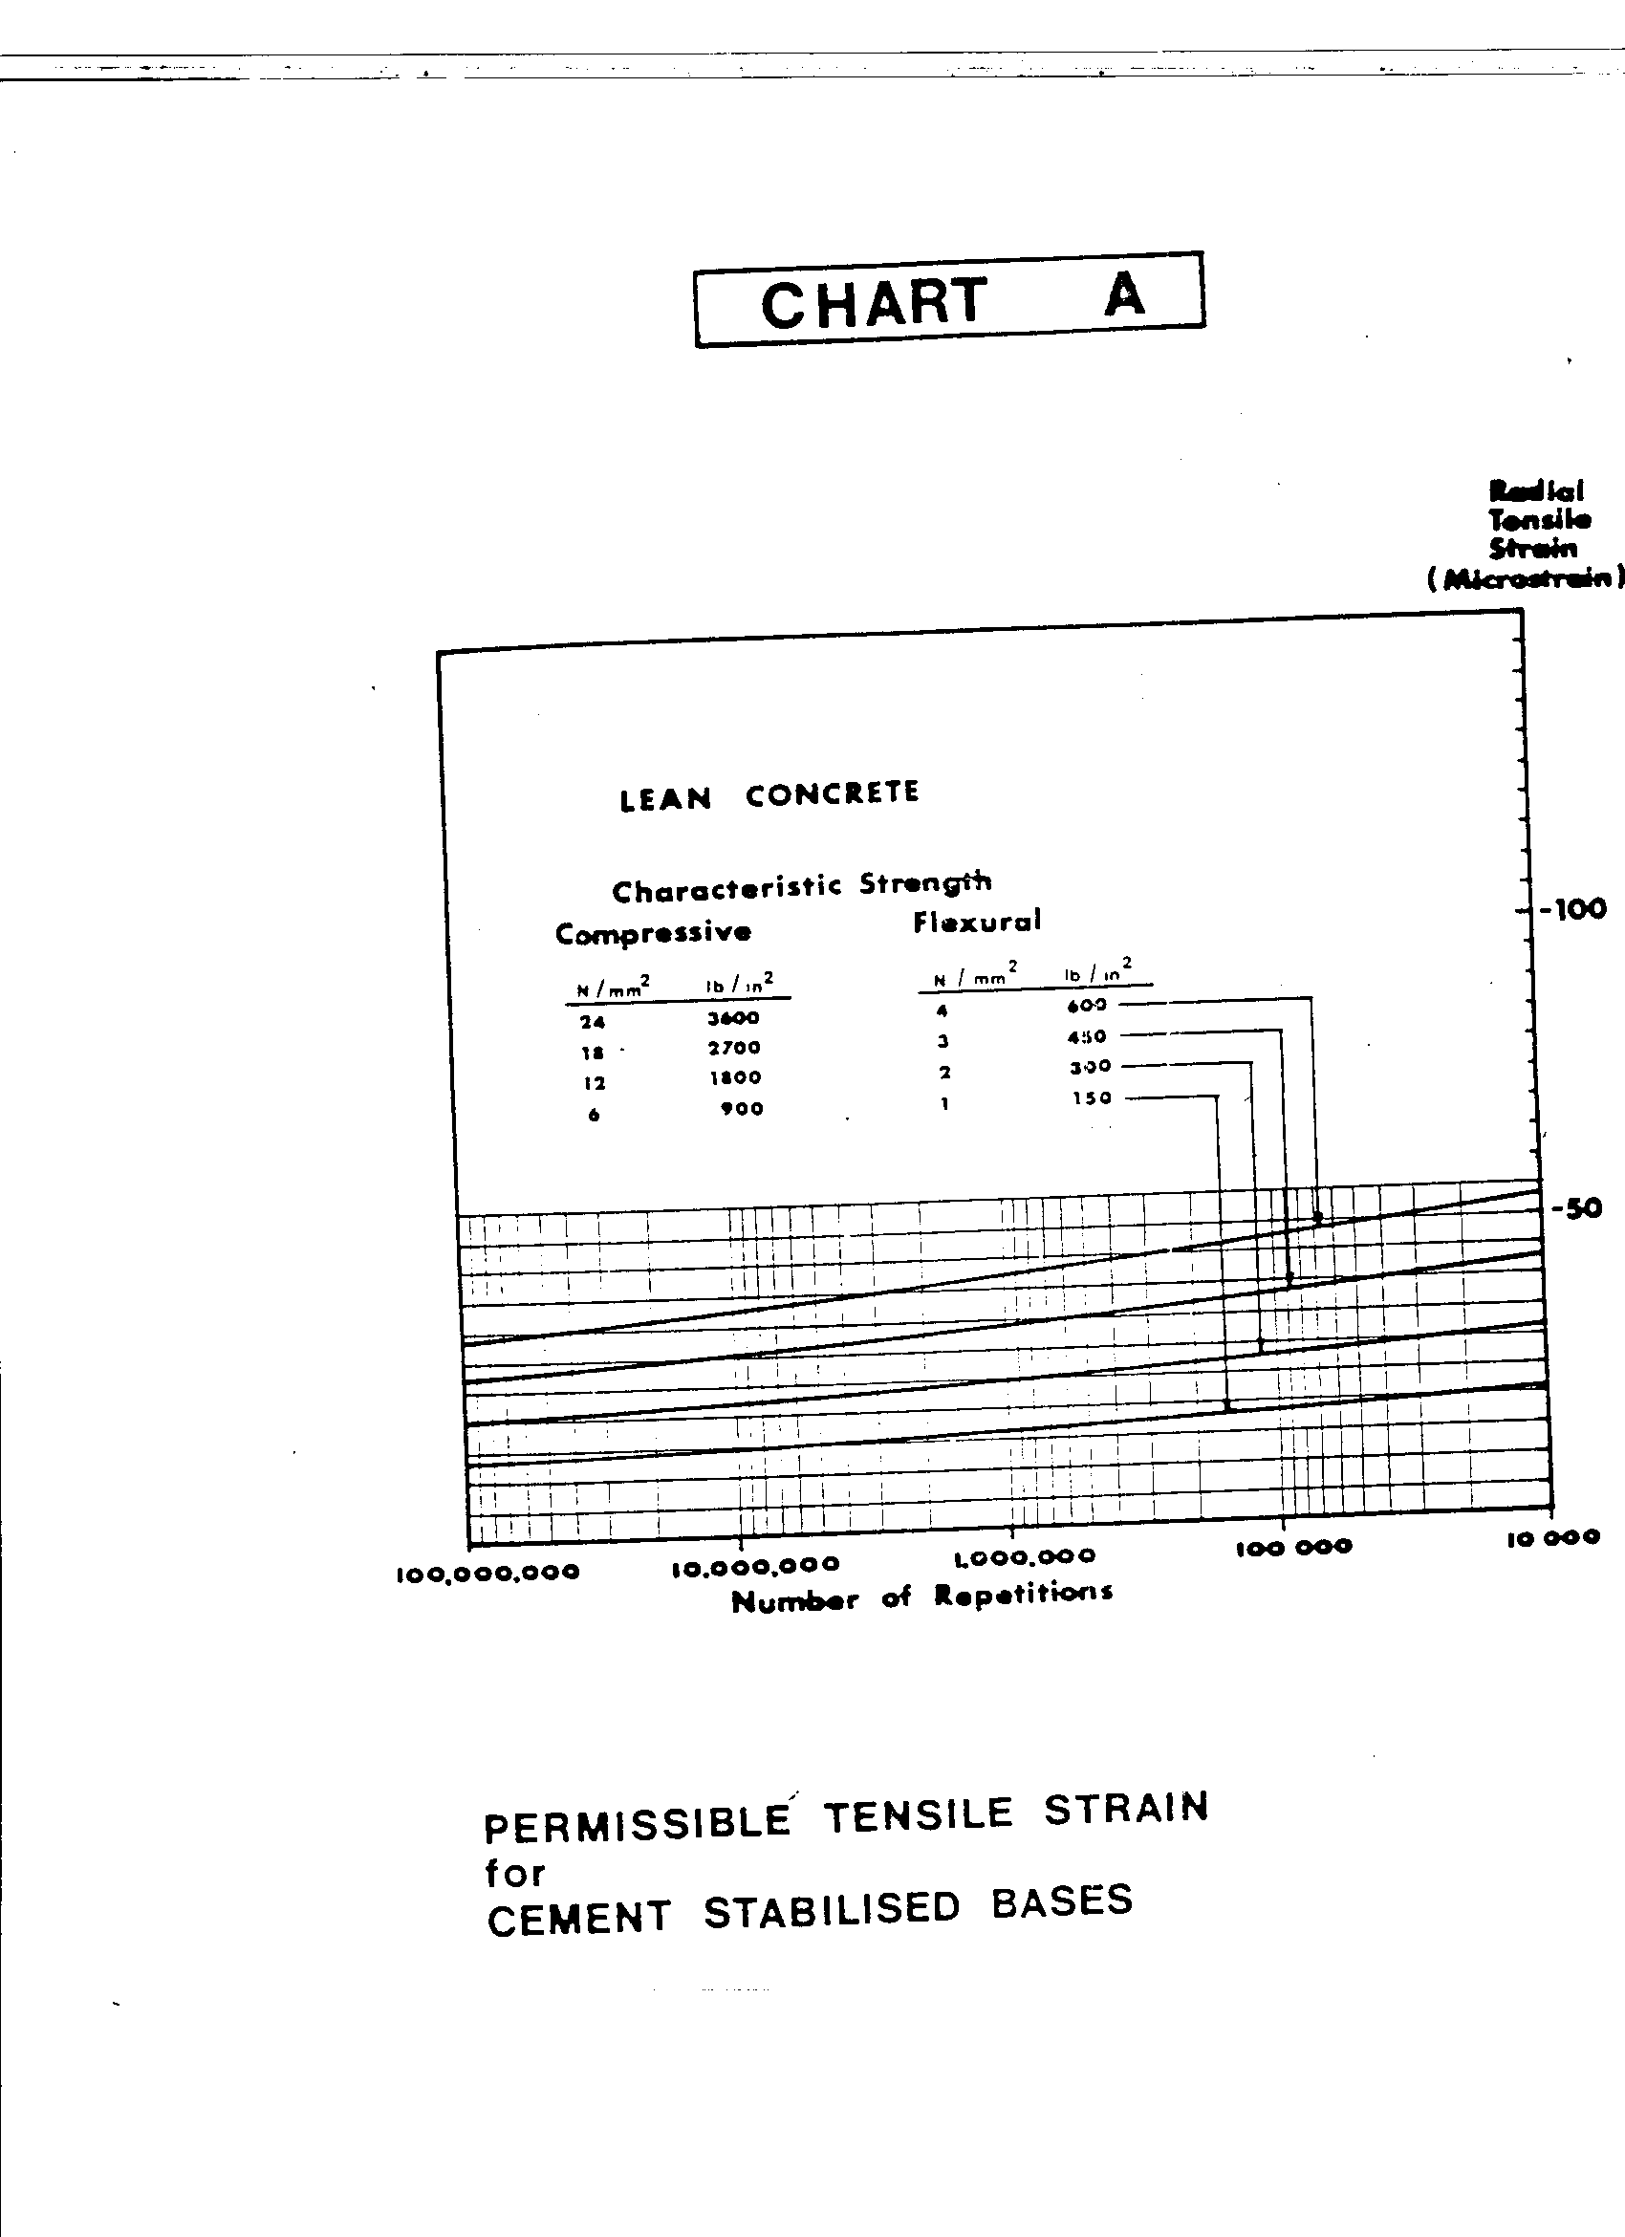

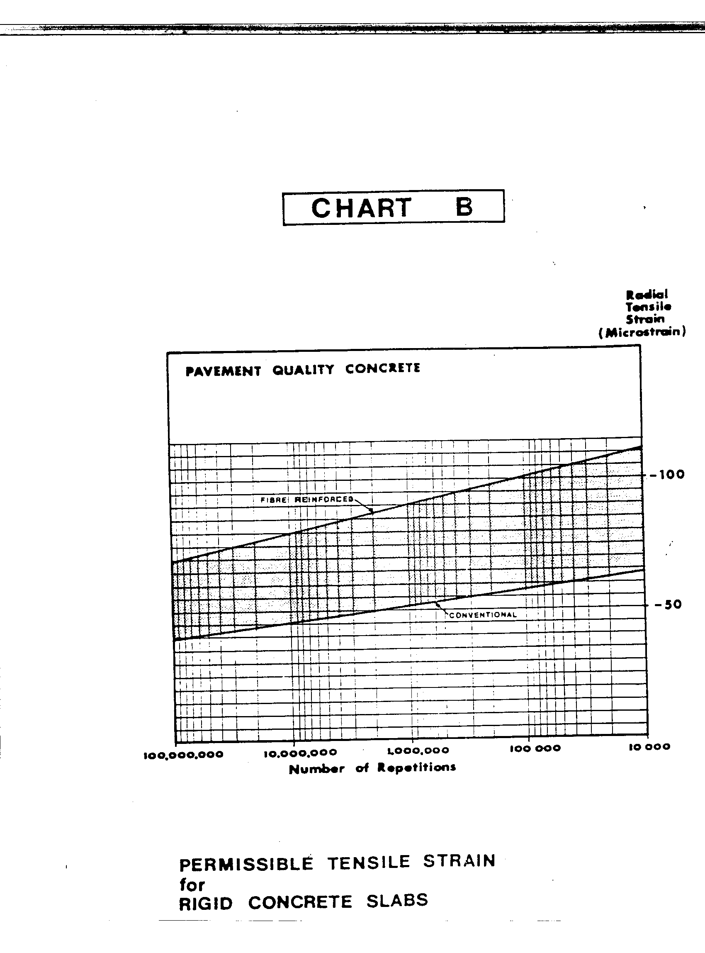

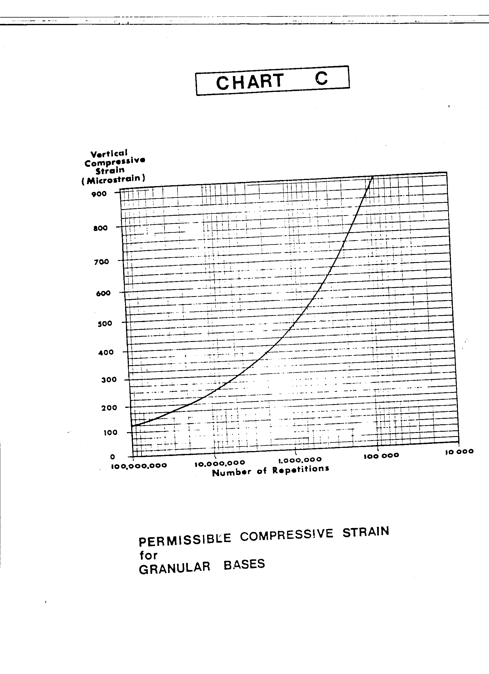

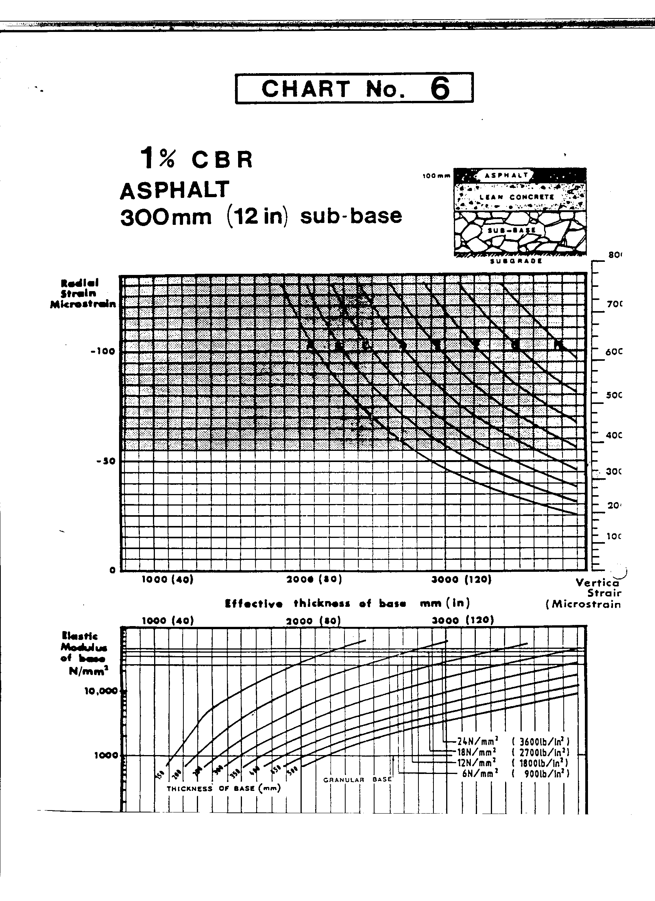

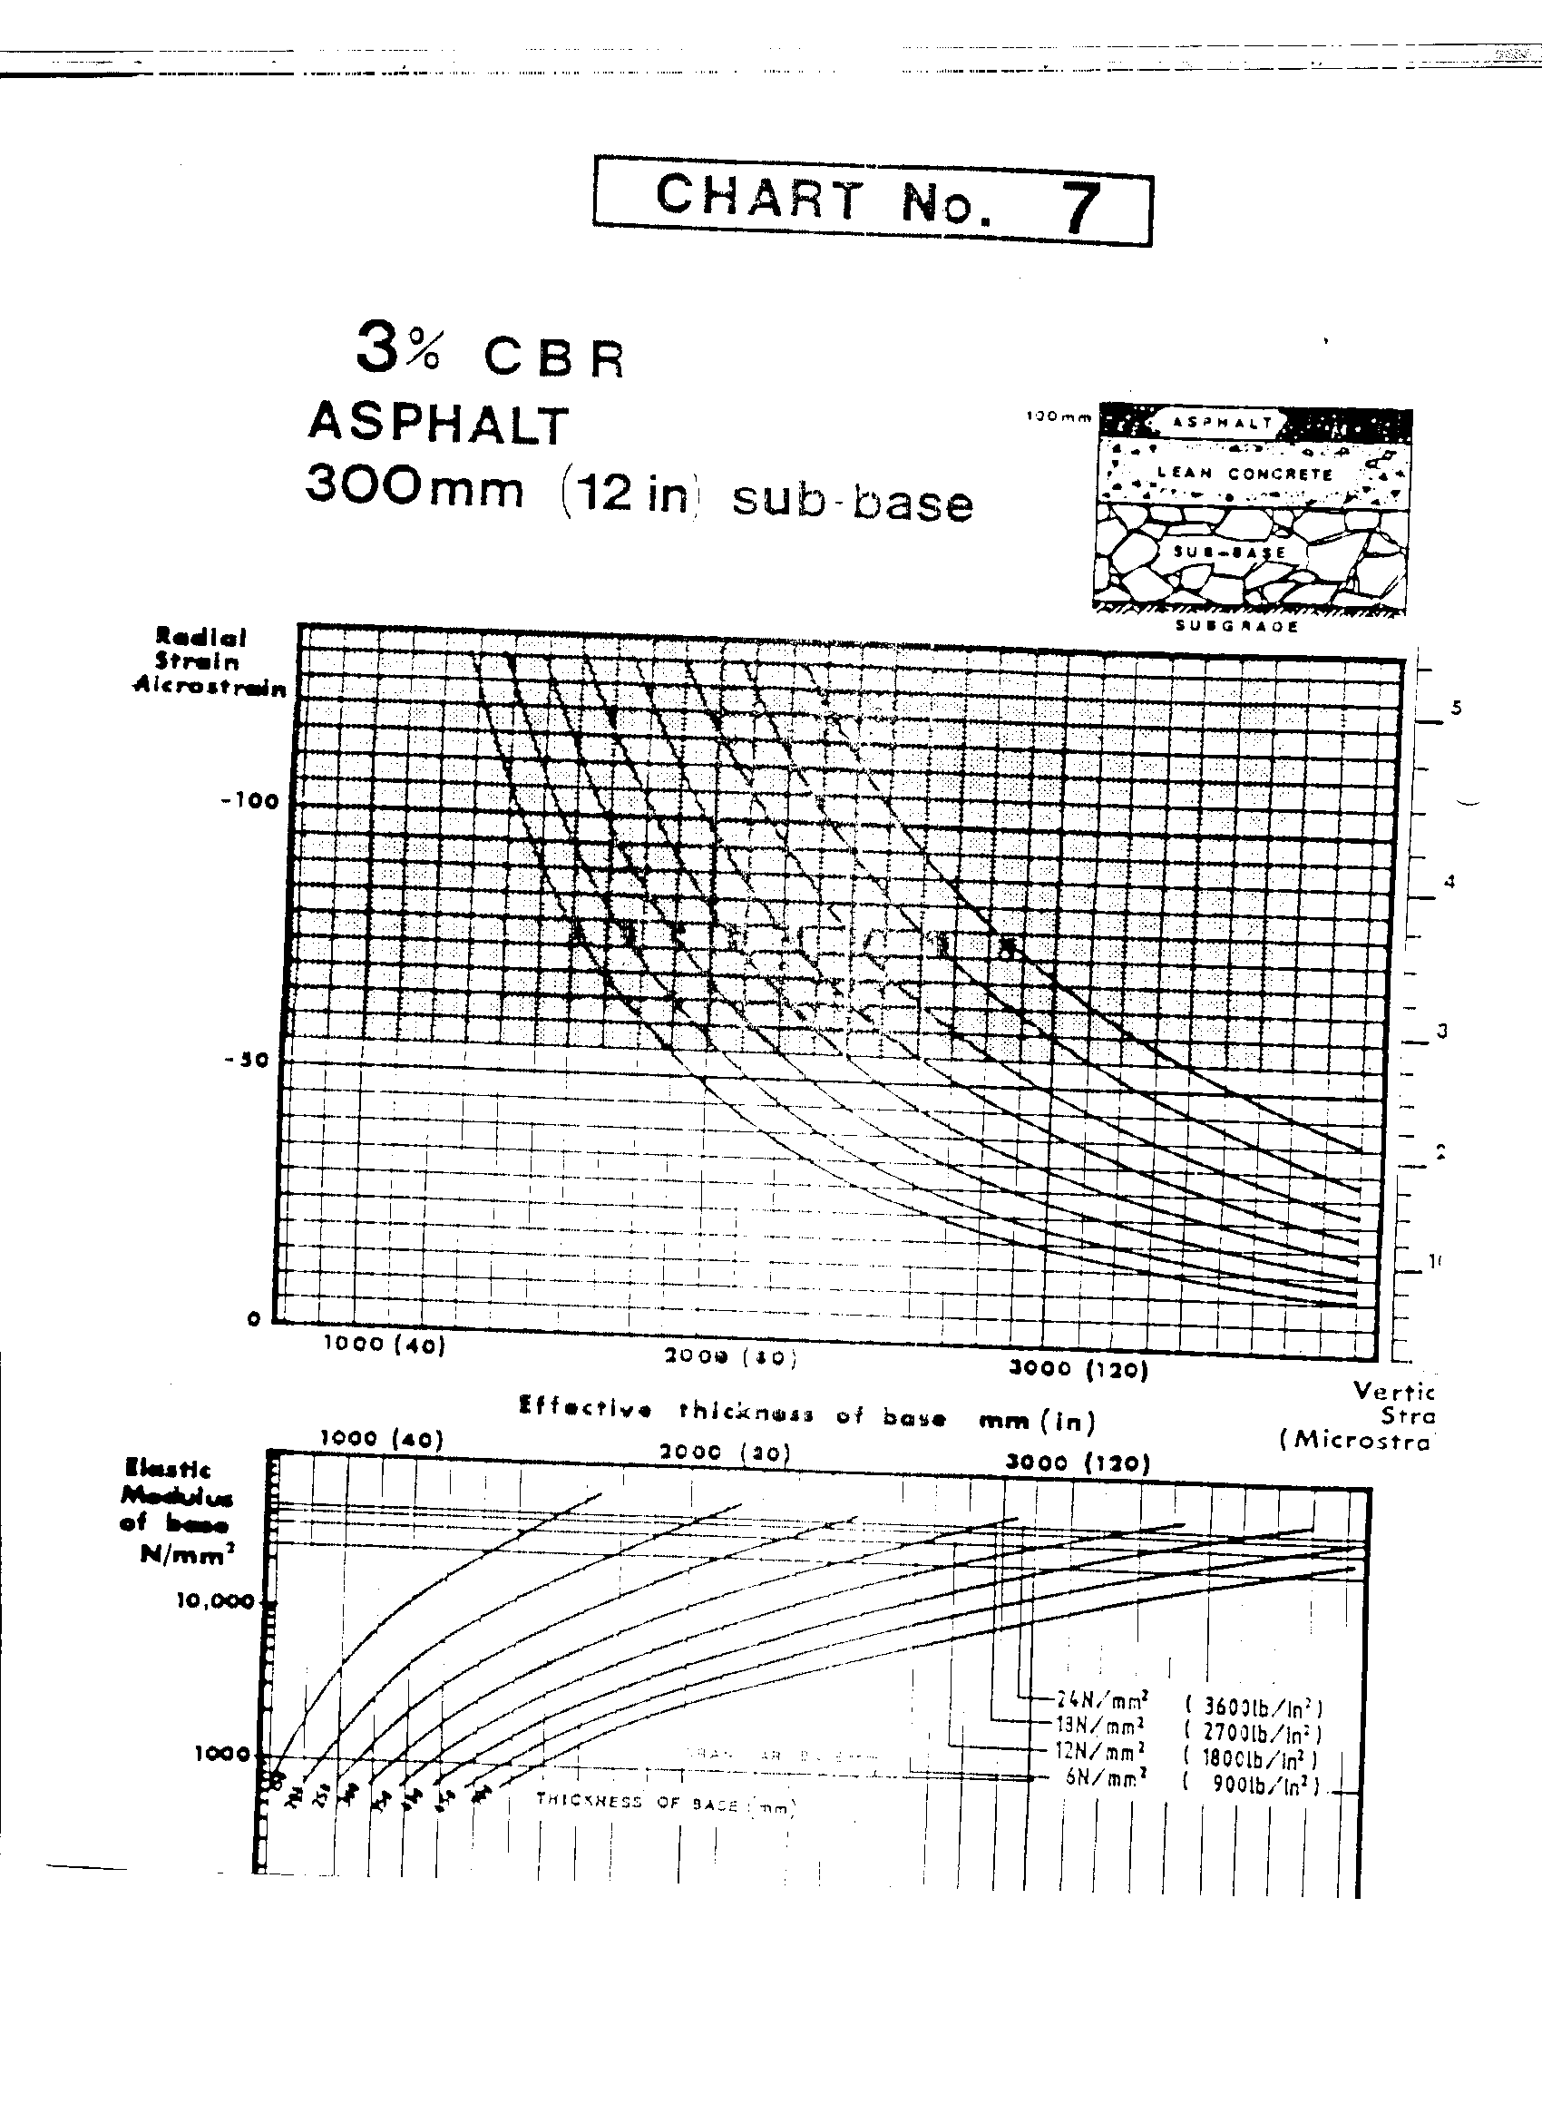

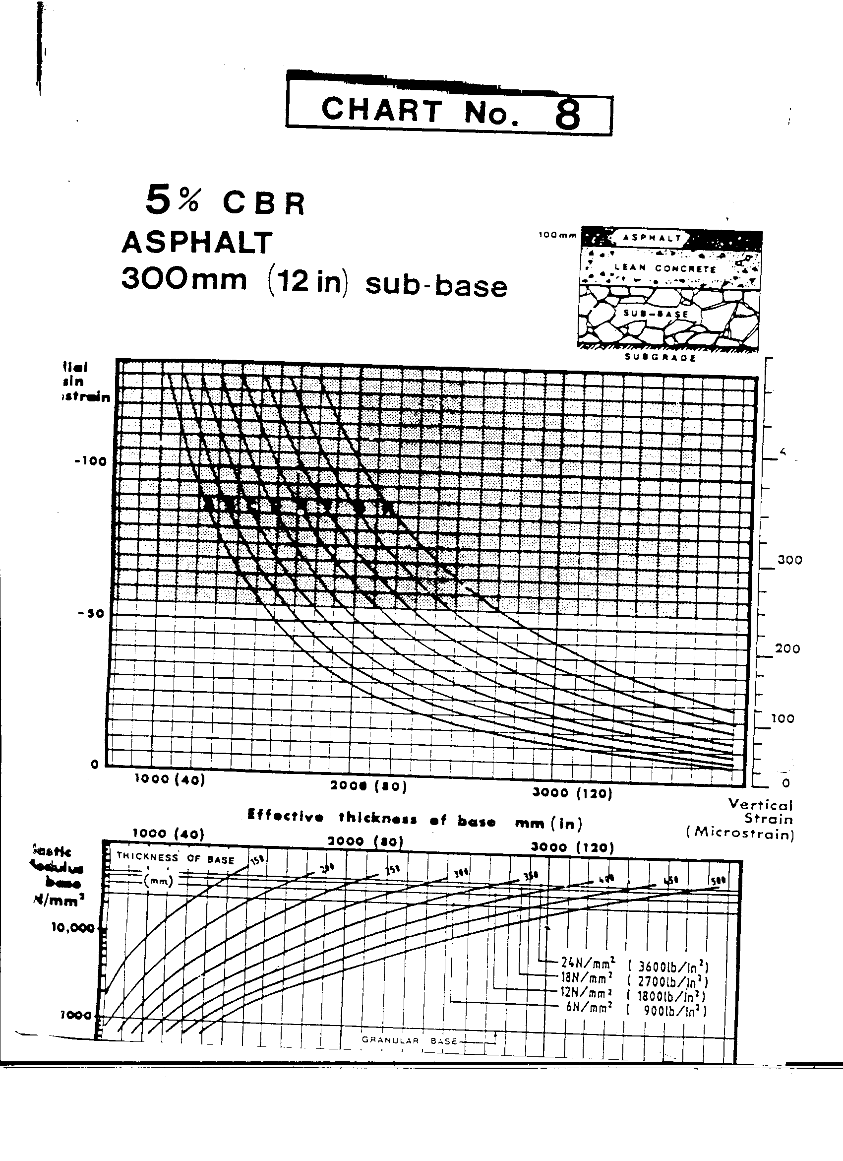

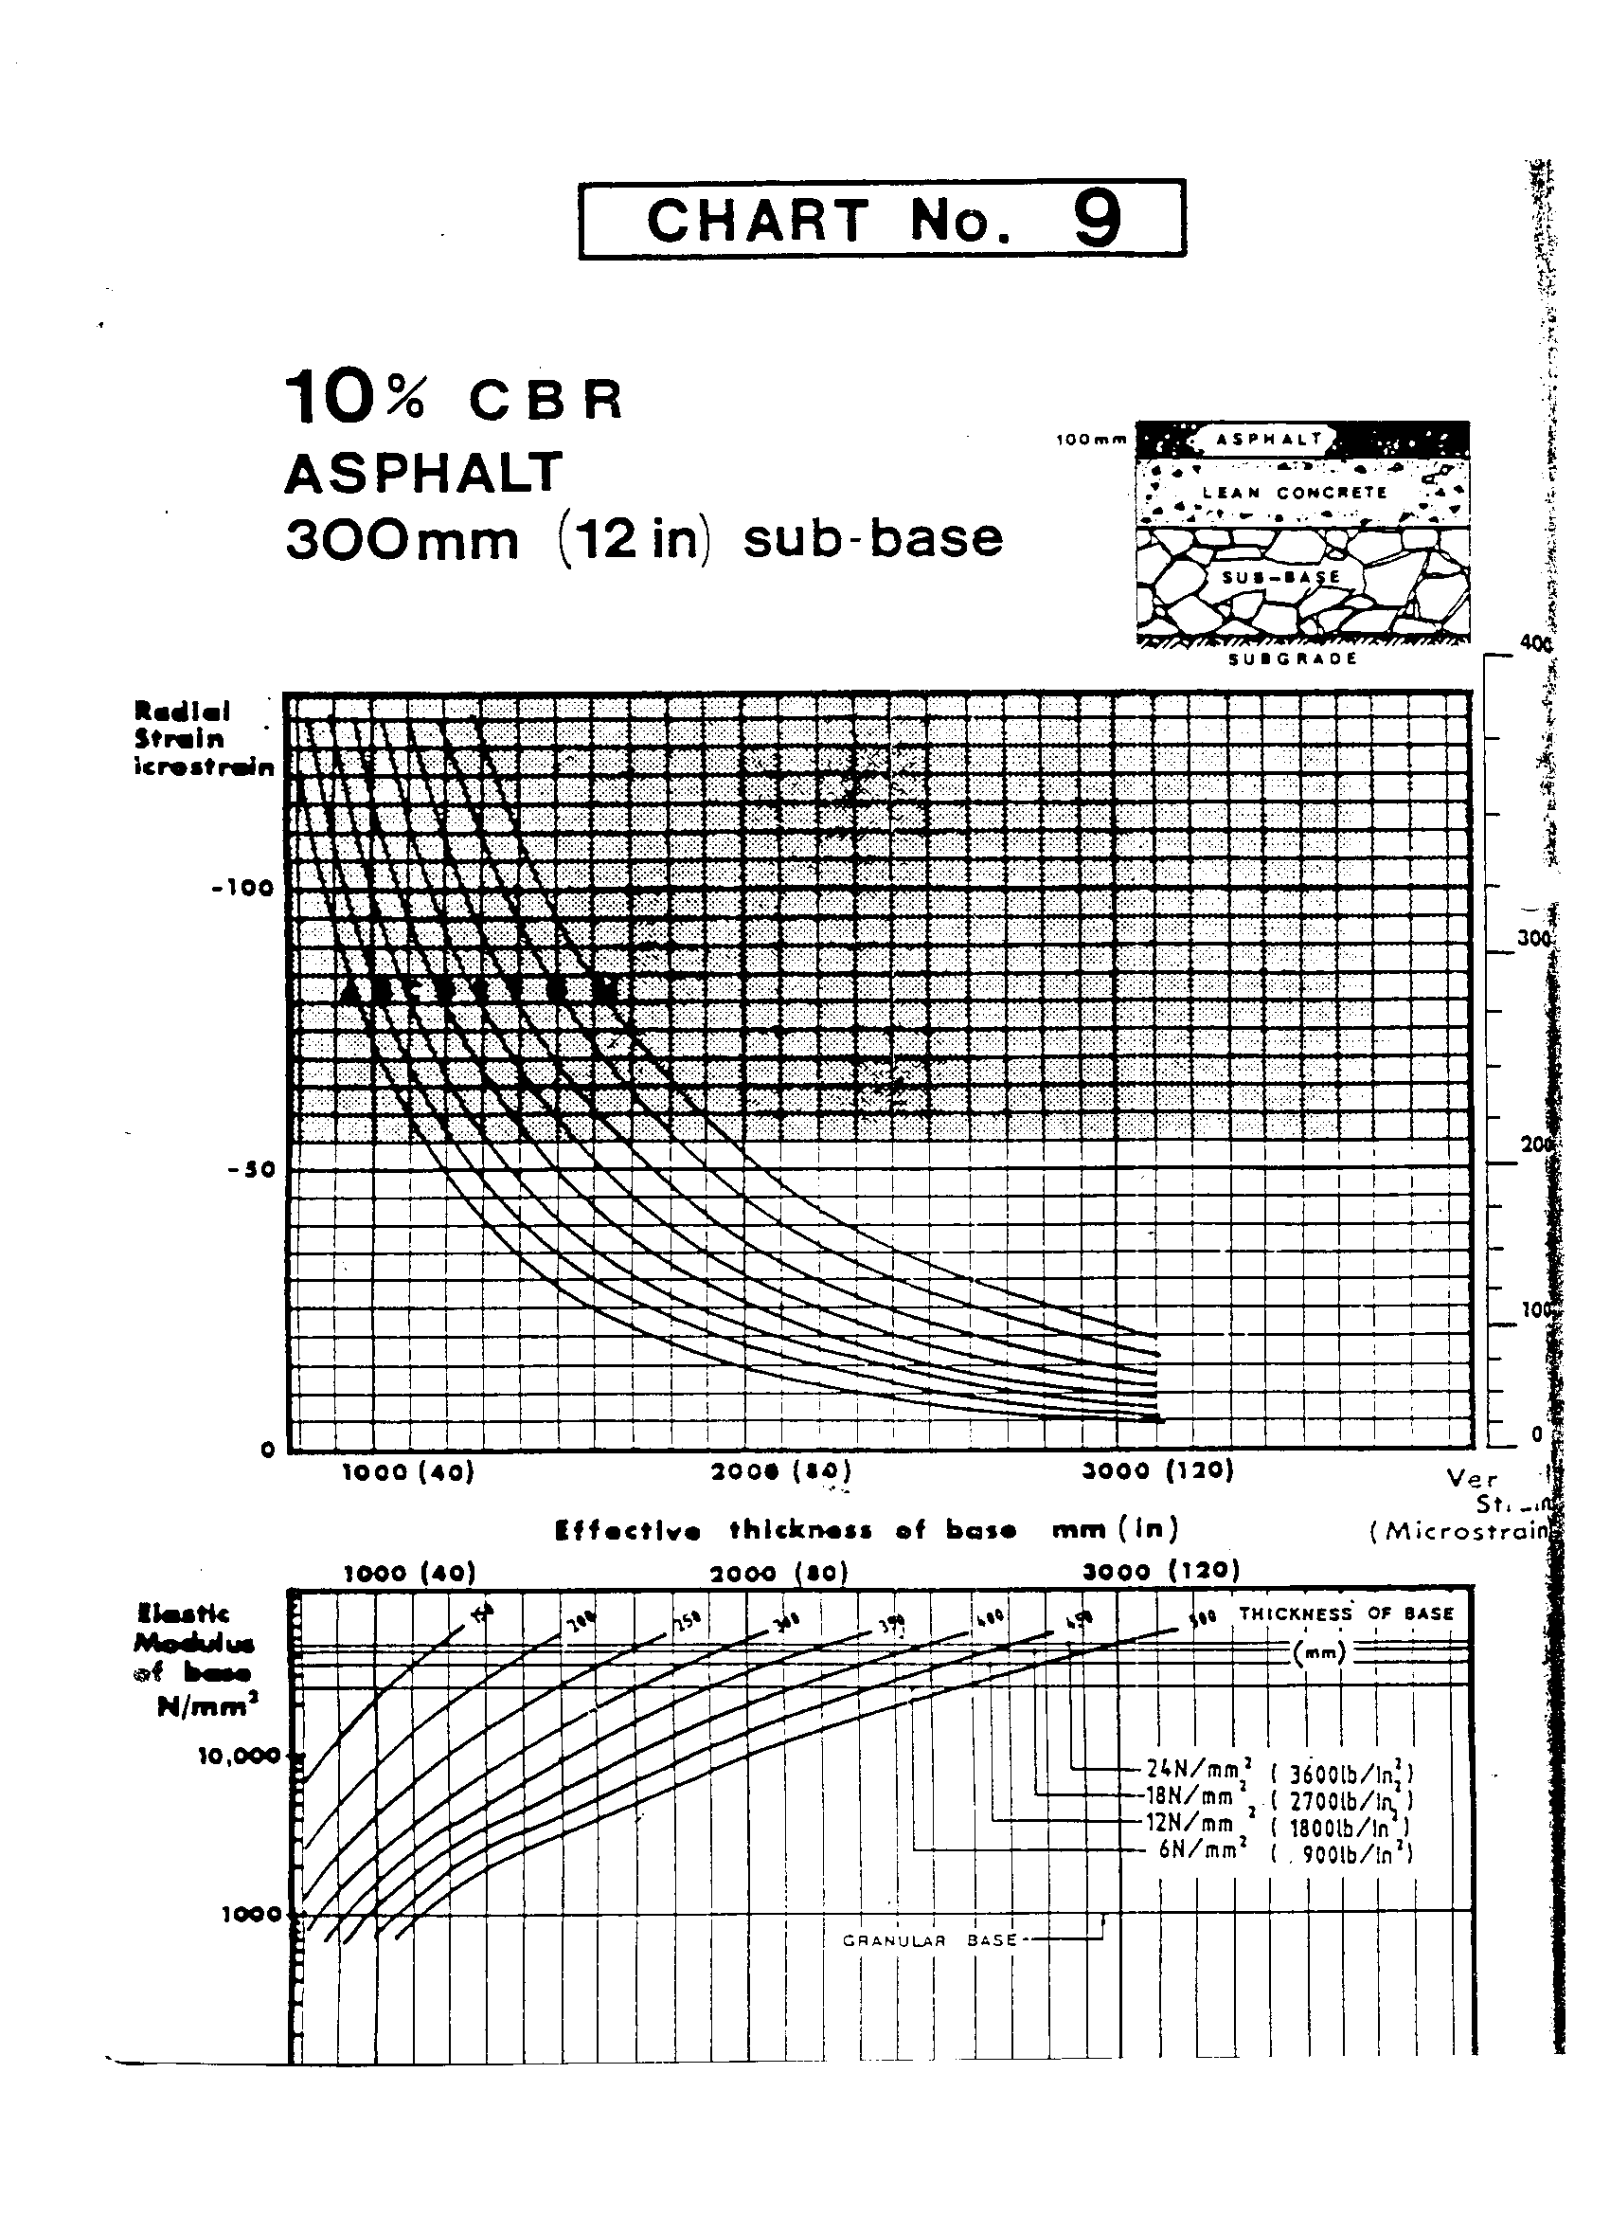

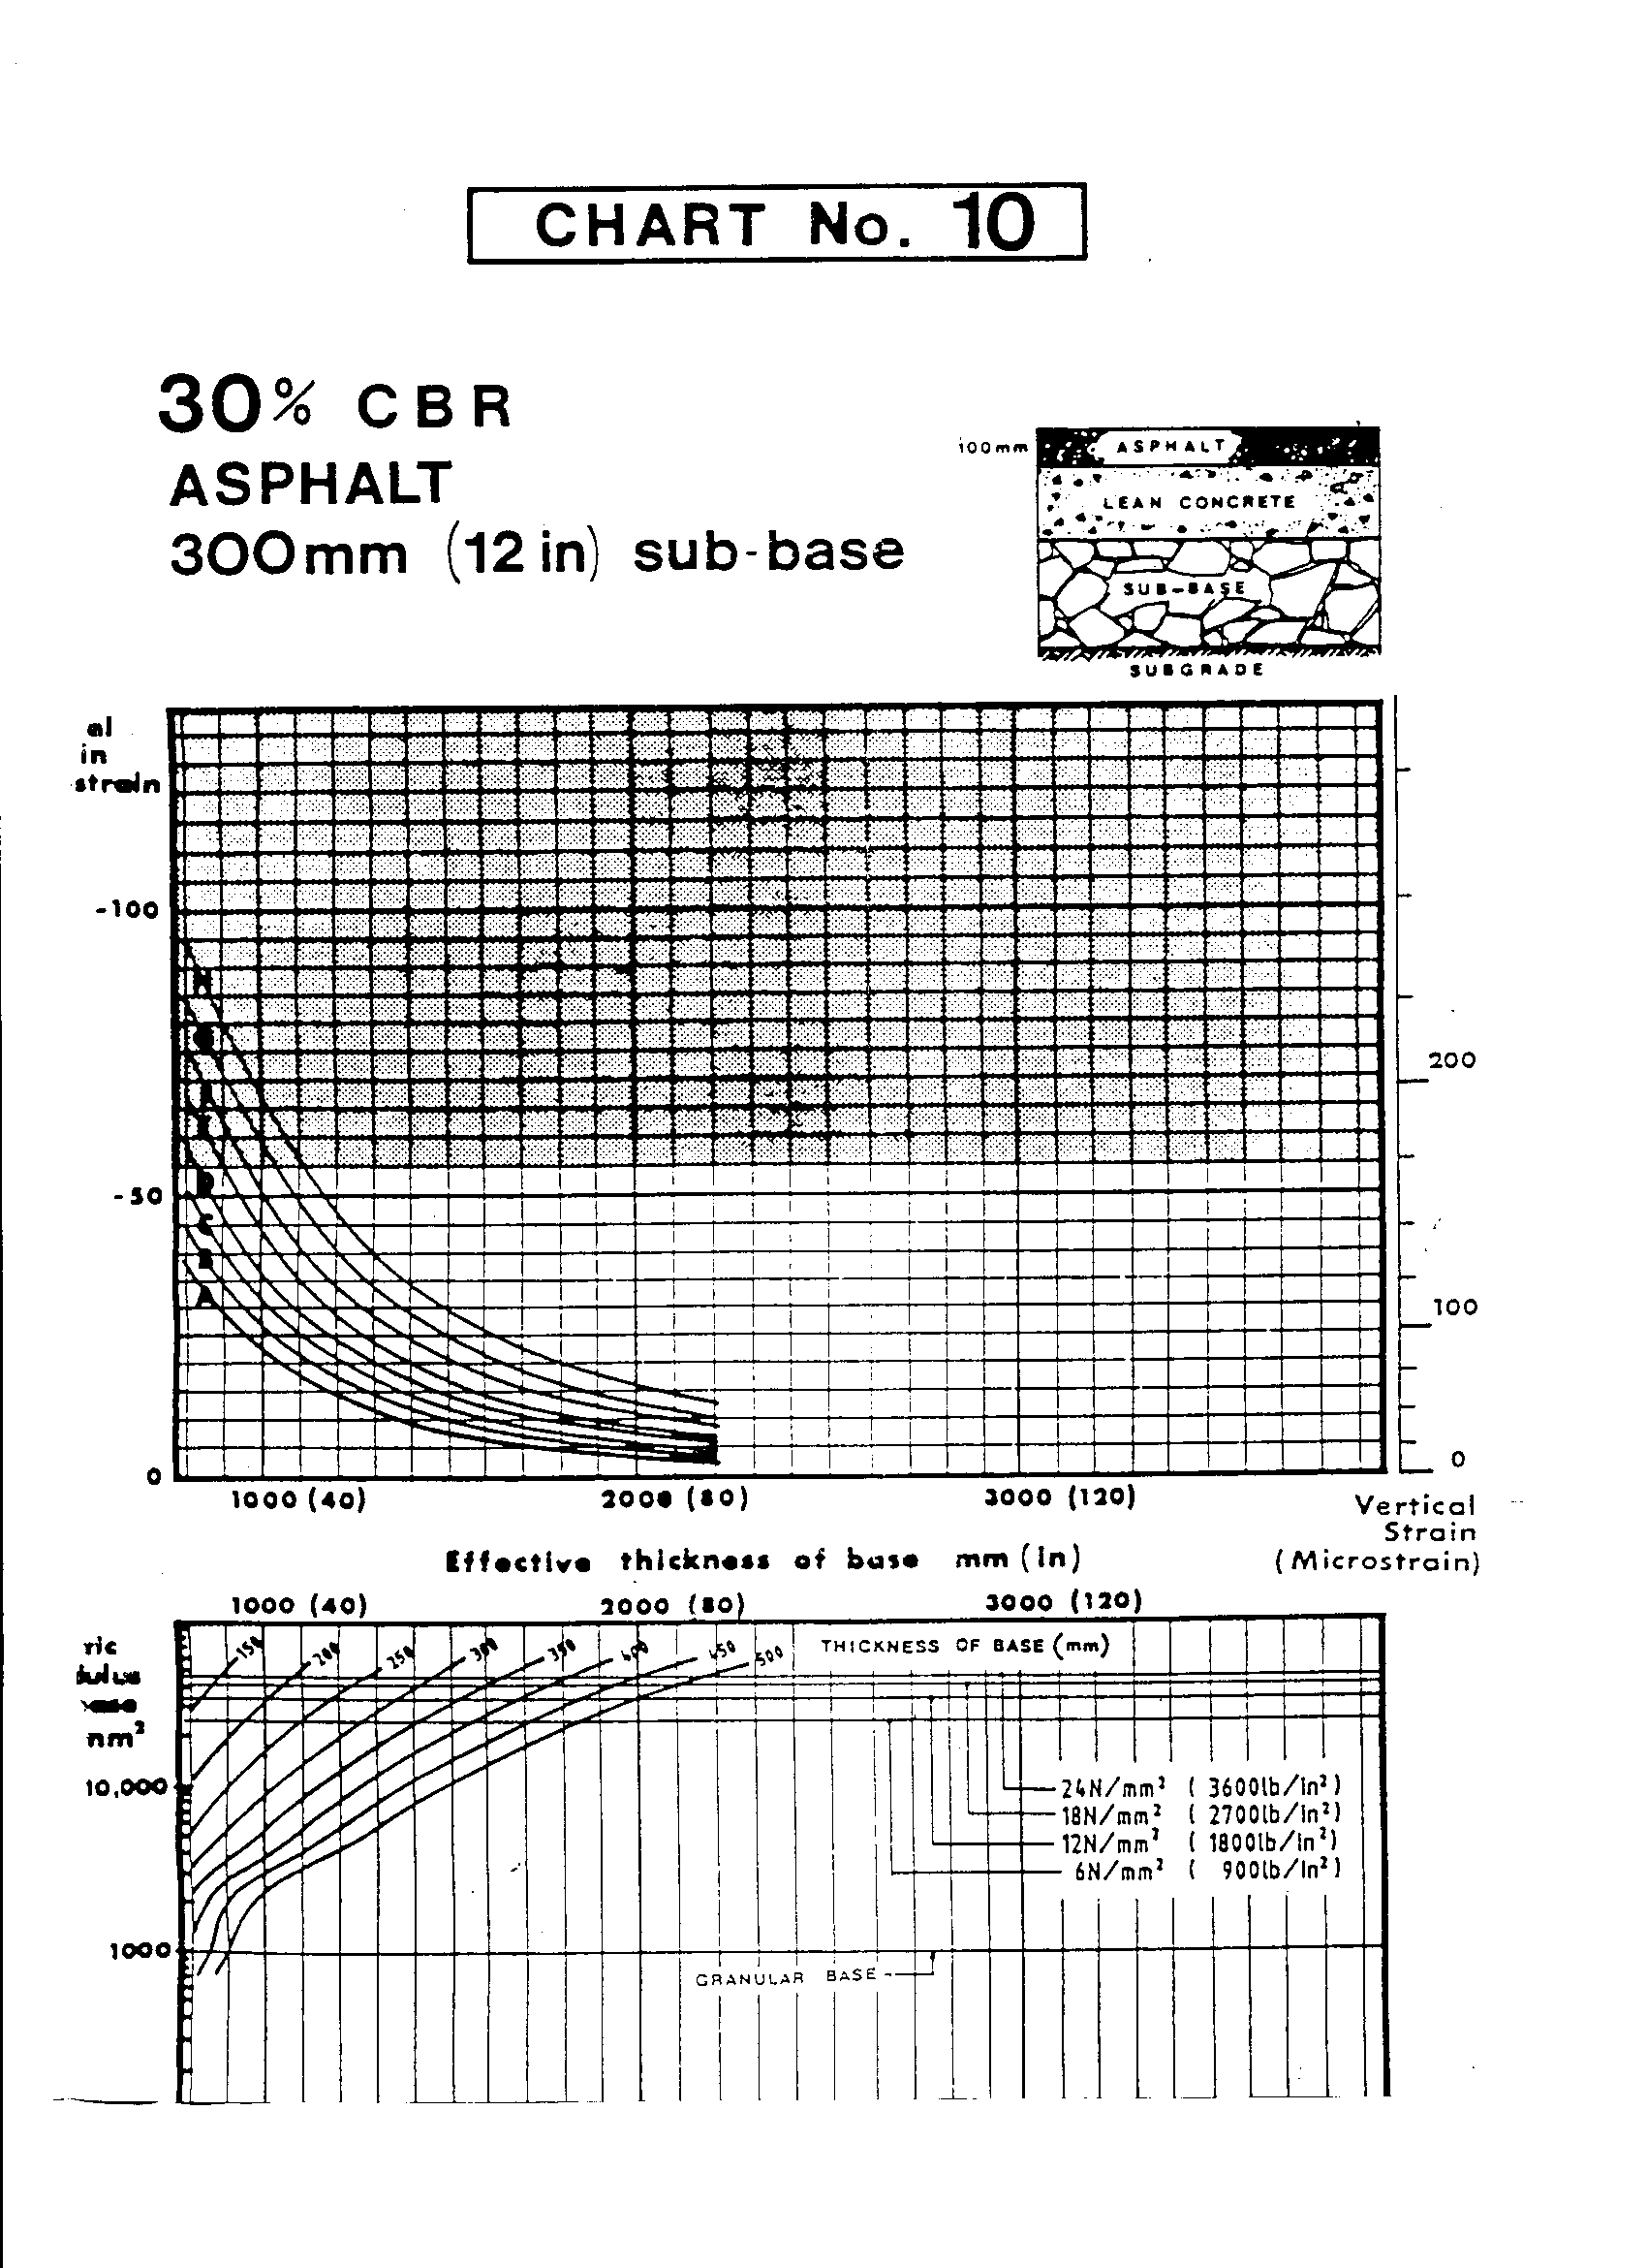

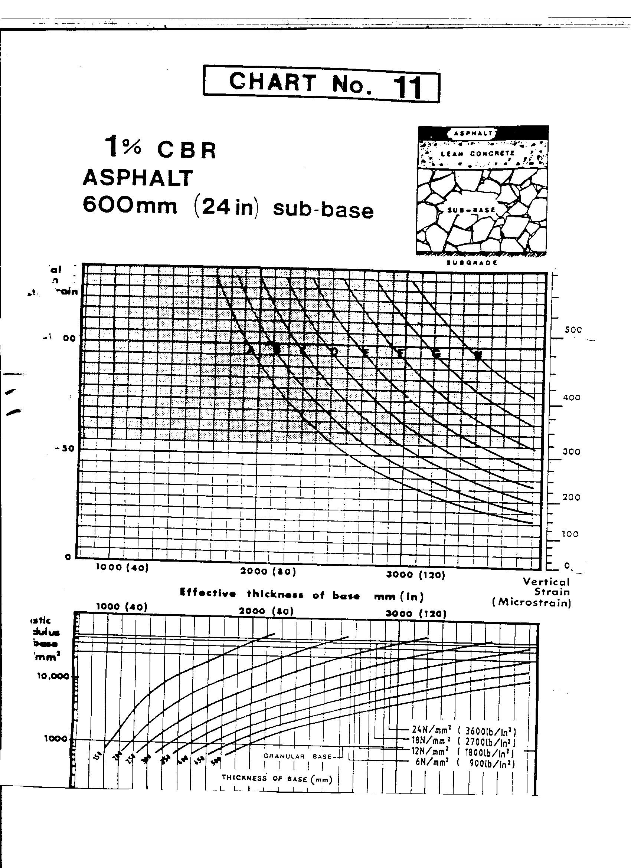

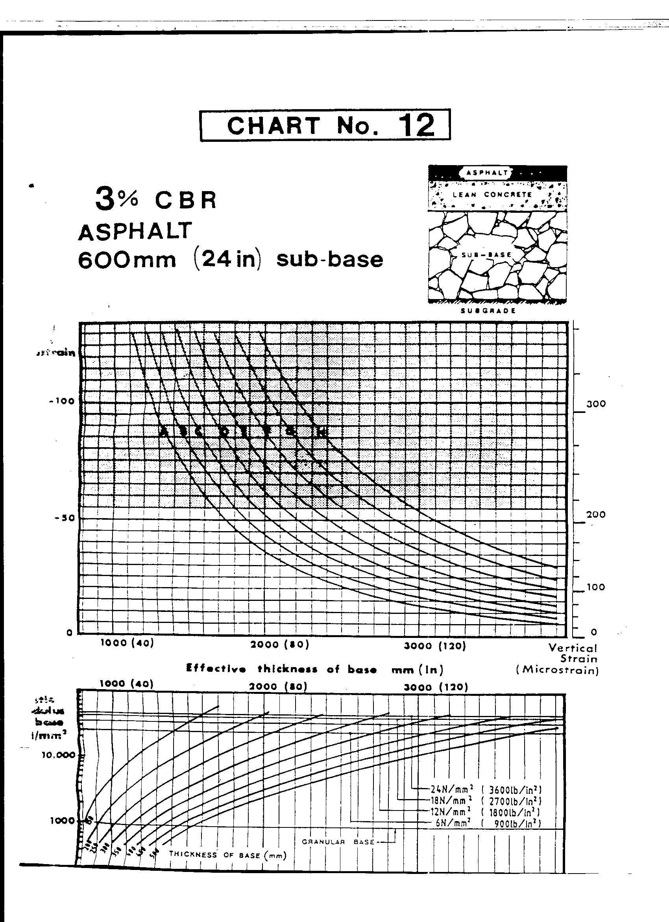

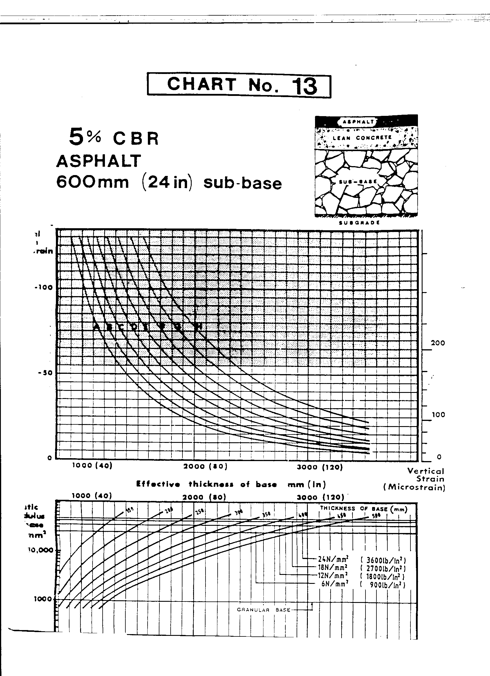

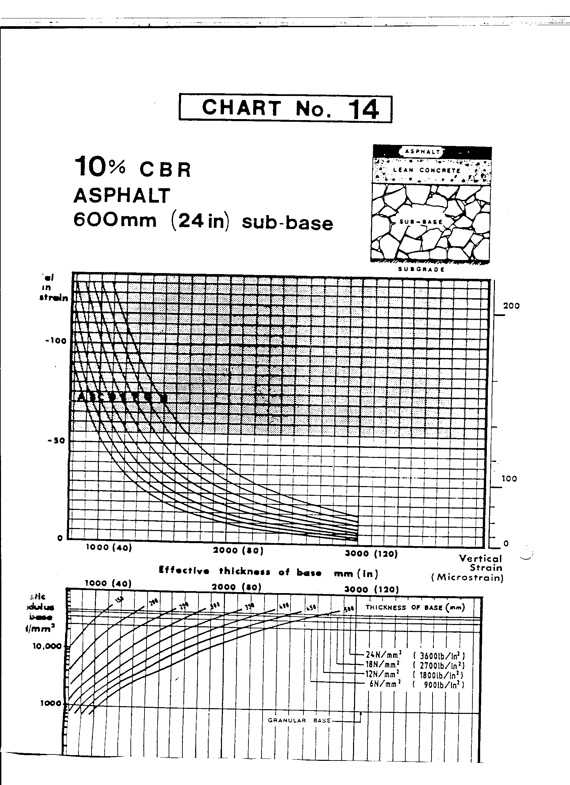

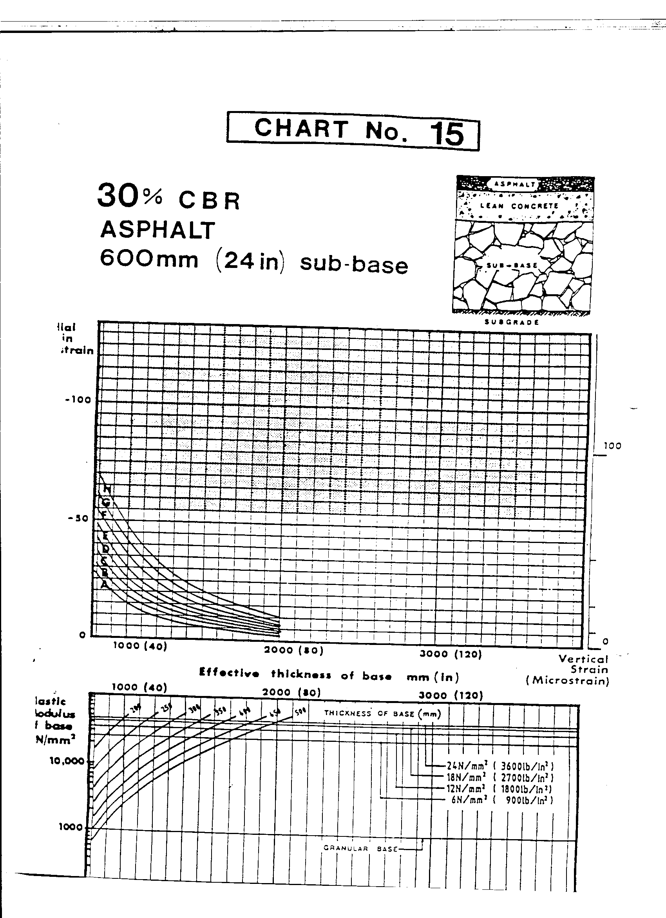

**Author’s information**

Age: 47

Sex: Male

Height: 1.6m

Hobby: Reading



Submission date: 24th October, 2010.