Effects of Seasonal variability on the Performance of Long Cayenne Pepper Collected from Southwestern Nigeria.

Idowu- Agida,O.O¹, Adetimirin, V.O², Nwanguma, E.I³ and Makinde, A.A.⁴

^{13&4}National Horticultural Research Institute, Ibadan, Nigeria

²Department of Agronomy, University of Ibadan, Nigeria

Corresponding author. E-mail: hakmak4u@yahoo.com. Tel.:+234-803-8570-500, +234-702-5935-636.

Abstract: Six weeks old long cayenne pepper seedlings were transplanted to the field on 6th of June,2008 for the early season and 11th of September, 2008 for the late season on beds measuring 3.6m by 2.4m. Experimental design was randomized complete block design with three replications. The result showed that the mean maximum and minimum temperature of 35ºC and 25 ºC respectively during late season enhanced the attainment of days to 50% flowering and 50% fruiting by 35days earlier in all the accessions than the early season with 34 ºC and 24 ºC. Also the rainfall for the period between 50% flowering and 50% fruiting was 464.9mm in the early season whereas the corresponding value for late season was 97.2mm, hence this could be said to have been responsible for over 50% reduction in the fruit weight per plant across all the 31 accessions during early season due to flower abortion, stem lodging and high fruits loses.
[Idowu- Agida,O.O, Adetimirin, V.O, Nwanguma, E.I and Makinde, A.A. Effects of Seasonal variability on the Performance of Long Cayenne Pepper Collected from Southwestern Nigeria. Researcher. 2010;2(10):85-92]. (ISSN: 1553-9865).

Key words: Long cayenne pepper, Agroclimatogical indices,flowering,accessions

INTRODUCTION
Climate is interrelated with other production factors and should be understood either as a resource to be managed or a factor that needs to be manipulated. Sustainable use of soil, capital and labour should be balanced with use of climate and weather information. The response of the crop to climate depends on the physiological make up of the hybrid/variety being grown. Yield differences are the result of the genetic composition of the hybrid, the environmental conditions under which the crop is grown, and the infestation by crop pests’ diseases, insects and weeds. In this context the present study sort to investigate the effects of seasonal variability on the performance of long cayenne pepper collected from Southwestern Nigeria.
The long cayenne pepper is characterized by slender foliage which have a greenish-white corolla, it appear singly or in clusters of 2 or more at each node. The pedicel is erect at anthesis. The fruit is a berry, which frequently has a soft, very pungent and aromatic flesh (mesocarp).It varies in shape but most often it is elongated or ovoid with 2-16cm long. It is usually red but sometimes orange or yellow at maturity. The fruit wall is smooth or slightly wrinkled. Seeds are orbicular and flattened in shape with pale yellow and a diameter range of 3-5.5mm. This is the most common hot pepper type for fresh consumption or for drying. (Romain,2001; Grubben and Tahir, 2004). Aside tomato and onion, peppers take the lead among vegetables (Fawusi ,1978; Erinle, 1989). Peppers (Capsicum spp.) are widely cultivated crop in Nigeria. Pepper is utilized mostly for culinary purposes and seasonings. It also has medicinal uses; internally as a stimulant and carminative and externally as a counter-irritant (Tindal 1987, Grubben and Tahir 2004).
Exportation of pepper in Nigeria has once been reported as a lucrative business (Erinle, 1989, Adigun, 2001). Nigeria being the largest producer of pepper in Africa, accounted for about 50% of the African production (Erinle, 1989). Although, pepper is widely cultivated throughout Nigeria, yields obtained by peasant farmers are often very low (Adigun, 2001). Production constraints such as unpredictable weather pattern, low soil fertility, weeds and diseases are the major problems. Comparatively, the yield in the developing countries is about 10 – 30% of that in developed countries (Erinle, 1989; Grubben and Tahir, 2004). Therefore, there is need for further work on how to achieve improve pepper yield in developing countries like Nigeria, to enhance the income and well being of resource poor farmers, hence conducting crop and weather related researches should be continuous to put out dearth of information on weather management strategy for optimum yield. The objective of this study was therefore to evaluate the effects of weather variability on the performance of long cayenne pepper collected from Southwestern Nigeria.

MATERIALS AND METHODS
The experiment was carried out at the National Horticultural Research Institute (NIHORT) vegetable experimental field in Ibadan (Lat. 7° 22’N, Long. 3° 50’E). The field use had been under continuous cultivation for over thirty years. The study area is in the Tropical wet and dry climate with a bimodal rainfall pattern having long rainy season which usually starts in late March while the short rainy season extends from September to early November after a short dry spell in August. Mean monthly minimum and maximum temperatures ranged from 21 to24°C and from 27 to 37°C respectively, and annual rainfall of about 1100 to 1500mm.
Data were collected on environmental conditions (Agroclimatological Indices) and on some important growth parameters and yield characters. In order to relate the climatic attributes of the study area to the growth of long cayenne pepper from transplanting to harvesting, agroclimatological indices for the crop growth were measured according to phenological stages of the crop. During the phenological stages mentioned, daily observation of minimum and maximum temperature (T, °C), wind speed (Ws at a height of 2m (ms⁻¹)), and rainfall ( P, mm) were observed at a meteorological enclosure about 120meters from the experimental field.
Six weeks old seedlings were transplanted to the field on 6th of June, 2008 for the first season and 11th of September, 2008 for the second season on beds measuring 3.6m by 2.4m. Experimental design was randomized complete block with three replications. Each of the trays of seedlings in the nursery was used to establish each replicate. Plants were spaced 0.6m in four rows spaced 0.6m apart. There were 28 plants per plot. Sprinkler irrigation was used to supply water to field capacity twice a week when rainfall stopped at the end of October 2008 for the second season evaluation. Weeds were removed manually. To meet the nutrient requirement of 130kg/ha N, 80kg/ha P and 110kg/ha K (Grubben and Tahir, 2004), fertilizer was compounded from NPK 20:10:10, single superphosphate and muriate of potash. These fertilizers were applied at the rate of 5.85g, 5.92g and 1.01g per plant of the respective fertilizers at first at 3 weeks after transplanting and thereafter at 3weeks interval until 12 weeks after transplanting.
Data were collected on the 10 plants that were bordered on other sides. Fruit and plant characteristics for both seasons were recorded according to the Capsicum Descriptor (IBPGR, 1995).
The data collected were subjected to analysis of variance (SAS Institute). Data were analysed first for each season, and then across seasons and differences between means tested by the least significant difference (Lauckner & Fielding, 1988). Correlation coefficient analysis was performed to determine the relationship between the seasons for traits with significant season by accession interaction.

Result and Discussion
Rainfall, temperature and relative humidity for early season were related to the main phases of vegetative growth and reproductive development of long cayenne pepper in Fig 1. The peak rainfall (196.2mm) was observed at about 17weeks after transplanting and this period coincided with the 50% flowering stage of long cayenne pepper plants revealing that moisture was not limiting at these critical stages of plant life though there were lots of flower abortions due to heavy rainfall. Another lesser peak of 102.7mm was also observed at about 3weeks after transplanting which also showed that at the early stage of the pepper plants life moisture stress was also not pronounced. The cumulative amount of rainfall for the period between transplanting and 50% flowering was 1002.2mm; accordingly the rainfall for the period between 50% flowering and 50% fruiting was 464.9mm in the first season. Generally, the pattern of rainfall that characterized early season can simply refer to as near flood scenario because of the spread and amount. The pattern was also an indication of high cloud cover which reduces the rate of photosynthesis with its resultant effect on yield and yield characteristics.
Temperature also differed slightly during long cayenne growth stages in the first cropping season of 2008. Minimum and maximum temperature varied between 22 – 24ºC and 27 - 34ºC respectively. Temperature was higher from 50% fruiting stage (31ºC –34ºC) than during the first flowering and 50% flowering stage of long cayenne pepper in the first cropping season (27ºC-31ºC). Minimum and maximum temperature of 23ºC and 32ºC were recorded in the early season at planting.
Figure 1 also shows the trend of relative humidity (%) for the early seasons of 2008 cropping season. The result revealed that the relative humidity ranged between 92% (6,9,12 and17WAT ) and 87% (21 and 23 WAT) indicating that more perceptible atmospheric moisture at 6,9,12 and 17WAT than at 21 and 23WAT.

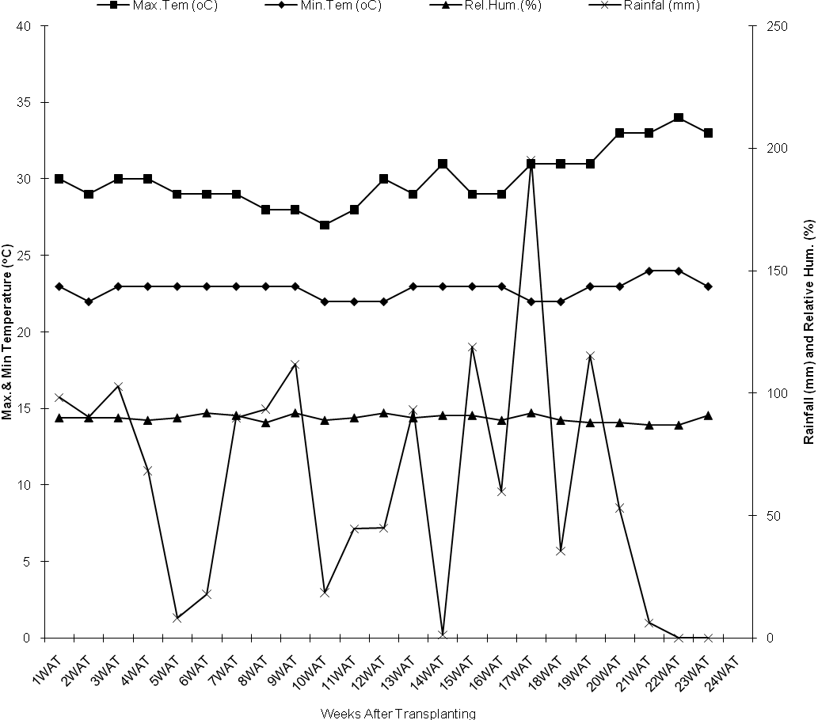
Figure 1 : Minimum & Maximum Temperature, Relative Humidity and Rainfall during the growth of Long cayenne Pepper at NIHORT, Ibadan in the Early season of 2008.

As showed in Figure 2 late season rainfall trends revealed lowest rainfall amount was observed at 8weeks after transplanting (0.5mm) with peak rainfall at 3weekss after transplanting (136.5mm) with no rainfall for about twenty-five percent of the entire duration in the second season . This implies that moisture stress at the later part of plants life was a bite pronounced than that at the initial stage of plants life. At this time little flowers were aborted, hence more fruits were harvested as rainfall at this was not too heavy to cause to plant damage. The amount of rainfall for period between transplanting and 50% flowering was 632.1mm. Accordingly, the rainfall for the period between 50% flowering and 50% fruiting was 97.2mm. Rainfall was therefore much higher during the early stage of transplanting than at 50% flowering and 50% fruiting stages of second season. The late season can be typified as being dryer, since no rainfall was experience in about twenty-five percent of the entire plant growth.
Temperature differed slightly in the late cropping season. Minimum and maximum temperature varied between 19ºC-25ºC and 30 ºC -35 ºC respectively. Temperature was lower between 1weeks after transplanting to 10weeks after transplanting than between 15weeks after transplanting to 24weeks after transplanting, i.e 30ºC -33 ºC and 34ºC – 35 ºC respectively. The minimum and maximum temperatures at planting in the late-season were 23ºC and 32ºC respectively.
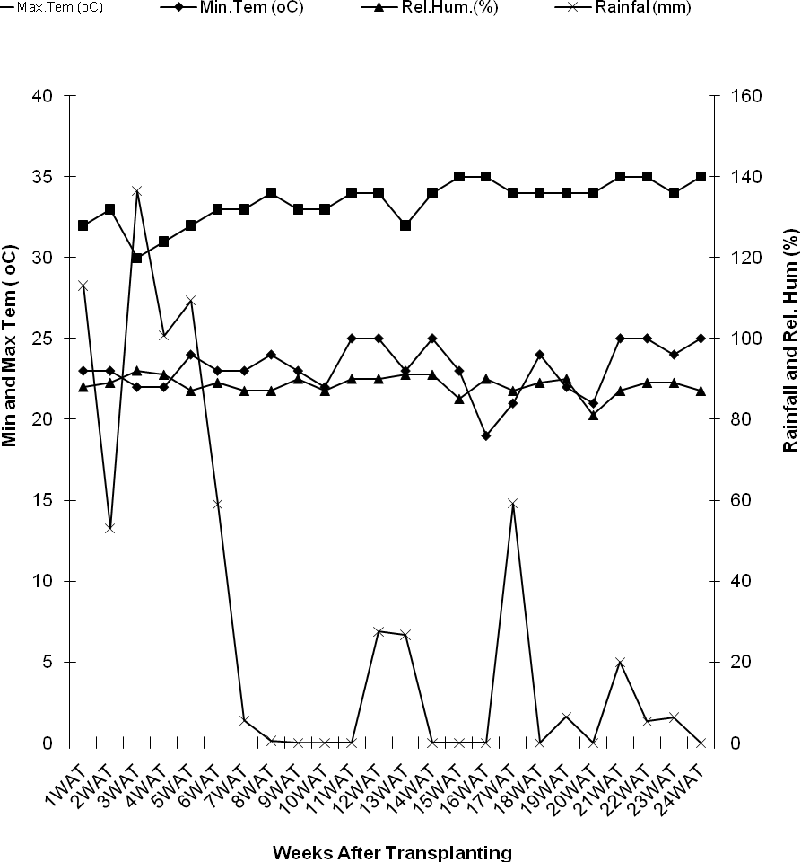

Figure 2: Minimum & Maximum Temperature, Relative Humidity and Rainfall during the growth of Long cayenne Pepper at NIHORT, Ibadan in the Late season of 2008.

Fruit Length, fruit width and fruit pedicel
Table 1 shows fruit characteristics of 31 accessions of Long Cayenne pepper from southwestern Nigeria.
Average fruit Length was statistically significant (P<0.05) among the accessions as shown in Table 1. Accession from Otta had the longest fruit length of 11.1cm followed by Shagamu (11.0cm) and Ado-Ekiti (10.6cm) while Sango had the lowest value of 8.3cm.
Fruit width ranged from 3.9cm to 6.3cm with Igbaja accession having the highest width of 6.3cm, followed by Offa accession with 5.9cm, then Otta and Ilorin (5.8cm) while Abeokuta had the least width of 3.9cm. The fruit width was statistically significant across the seasons.
Fruit pedicel mean length was statistically significant (P<0.05) across the seasons. It ranged between 0.8 to 2.6cm, with Offa accession having the highest value of 2.6cm, followed by Ikare with 1.8cm while Agowoye and Aramoko had the least value of 0.8cm.
Fruit wall thickness was not significant (P<0.05) among the accessions. Fruit wall thickness ranged from 1.5 to 2.7cm with Offa having the highest of 2.7mm, followed by Oshodi and Odo-oba with 2.5mm while Sango and Ado-Ekiti had the least value of 1.5mm.
Table 2 shows fruit weights of 31 accessions of Long Cayenne pepper from southwestern Nigeria. Average fruit weight was statistically significant (P<0.05) among the accessions in both early and late season at the study area as shown in Table 2. Fruit weight ranged from 26.0g to 118.7g with for early season while it range from 70.7 to 207.5 for late season planting season. During the early season Akure accession had the highest fruit weight of 118.7g, followed by Aramoko (90.9g) then Offa accession (84.7) while Sango accession had lowest value of (26.0g). Late season on the other hand Ifon accession had the highest of 207.5g, followed by Bodija accession with 178.1g, then Oja-Oba accession with 170.6g while Sango accession again had the lowest value of 70.7g.

Table 1. Effects of Seasons on Fruits characters of 31 accessions of Long Cayenne pepper at NIHORT, Ibadan during 2008 cropping season
Accessions | Average fruit  length (cm) | Average fruit  width (cm) | Fruit wall thickness (mm) | Fruit pedicel length (cm)
Sango | 8.3 | 5.1 | 1.5 | 1.4
Saasa | 9.7 | 4.1 | 1.7 | 1.0
Oja-oba | 8.5 | 4.9 | 2.0 | 1.2
Bodija | 9.1 | 4.9 | 2.0 | 1.1
Ogbomoso | 8.1 | 5.2 | 1.7 | 1.1
Odo-oba | 8.9 | 5.0 | 2.5 | 1.2
Saki | 8.8 | 5.2 | 2.0 | 1.2
Ikire | 7.1 | 4.8 | 1.7 | 1.0
Ile-ife | 8.4 | 4.9 | 1.7 | 1.2
Osogbo | 9.6 | 5.0 | 2.0 | 1.0
Ikirun | 9.7 | 4.9 | 1.8 | 1.6
Ado-ekiti | 10.6 | 5.1 | 1.5 | 1.0
Ikole | 9.0 | 4.7 | 2.3 | 1.4
Aramoko | 9.0 | 4.0 | 1.7 | 0.8
Ifaki | 8.4 | 5.1 | 2.0 | 1.0
Otta | 11.1 | 5.8 | 1.7 | 1.1
Abeokuta | 9.9 | 3.9 | 1.7 | 1.4
Sagamu | 11.0 | 5.3 | 1.8 | 1.2
Ago-iwoye | 7.8 | 5.3 | 2.0 | 0.8
Offa | 8.7 | 5.9 | 2.7 | 2.6
Ilorin | 10.6 | 5.8 | 2.3 | 0.9
Igbaja | 9.2 | 6.3 | 1.7 | 1.0
Omu-aran | 9.8 | 4.3 | 2.0 | 1.3
Ikorodu | 9.0 | 4.4 | 2.0 | 1.3
Ipaja | 8.7 | 4.4 | 1.7 | 1.1
Oshodi | 9.9 | 4.9 | 2.5 | 1.2
Agege | 11.0 | 5.6 | 1.7 | 1.1
Akure | 9.9 | 4.3 | 1.8 | 1.1
Ore | 8.4 | 6.1 | 2.2 | 1.1
Ikare | 10.1 | 4.7 | 1.8 | 1.8
Ifon | 8.2 | 4.2 | 2.2 | 1.3
LSD(0.05) | 2.5 | 1.2 | Ns | 0.9

Table 3 showed that the difference in days to 50% flowering and 50% fruiting was not significant across the seasons in all the sampling occasions. Early season days to 50% flowering ranged from 126.3 (Abeokuta) to 129(Omu Aran) days while late season ranged from 84(Agege) to 92( Offa) days .Again days to 50% fruiting during early season ranged from 144 (Odo-Oba) to 151( Ifon) days while late season on the other hand ranged from 87.7 (Ipaja) to 113(Ilorin) days after transplanting. Though the differences were not statistically significant, all accessions planted during late season attained 50% flowering and 50% fruiting in average of about 35days earlier than their counterpart planted in the early season.

Table 2. Effects of Seasons on Fruit weight of 31 accessions of Long Cayenne pepper at NIHORT, Ibadan during 2008 cropping season
Accessions | Fruit weight/plant (g)  Early season Late season
Sango | 26.0 | 70.7
Saasa | 60.6 | 136.1
Oja-oba | 68.0 | 170.6
Bodija | 75.0 | 178.1
Ogbomoso | 46.6 | 118.7
Odo-oba | 51.5 | 100.9
Saki | 66.0 | 144.4
Ikire | 58.0 | 159.3
Ile-ife | 65.2 | 104.8
Osogbo | 76.4 | 92.4
Ikirun | 46.9 | 82.3
Ado-ekiti | 84.6 | 77.7
Ikole | 79.1 | 80.6
Aramoko | 90.9 | 86.3
Ifaki | 54.2 | 73.0
Otta | 47.7 | 91.0
Abeokuta | 57.7 | 110.7
Sagamu | 34.9 | 98.2
Ago-iwoye | 40.2 | 116.5
Offa | 84.7 | 60.8
Ilorin | 58.3 | 78.5
Igbaja | 43.6 | 93.5
Omu-aran | 45.0 | 142.3
Ikorodu | 59.3 | 88.0
Ipaja | 51.7 | 97.8
Oshodi | 59.1 | 100.4
Agege | 57.7 | 105.8
Akure | 118.7 | 104.6
Ore | 75.2 | 157.3
Ikare | 57.0 | 108.1
Ifon | 54.3 | 207.5
LSD(0.05) | 39.9 | 39.9

Table 3: Effects of seasons on days to 50% flowering and 50% fruiting of long cayenne pepper at NIHORT, Ibadan during 2008 cropping season

Accession | 50% flowering  Early season Late season |  | 50% fruiting  Early season | Late season
Sango | 127.3 | 90.0 | 148.0 | 105.7
Saasa | 127.0 | 90.7 | 146.7 | 103.7
Oja Oba | 127.7 | 85.3 | 147.7 | 103.3
Bodija | 127.7 | 88.0 | 147.0 | 104.7
Ogbomoso | 128.0 | 89.3 | 147.0 | 105.3
Odo Oba | 126.3 | 88.0 | 144.3 | 103.7
Saki | 127.7 | 89.7 | 145.0 | 103.7
Ikire | 128.3 | 88.7 | 148.0 | 107.0
Ile-Ife | 127.0 | 89.7 | 146.7 | 104.3
Osogbo | 127.0 | 92.3 | 145.0 | 98.7
Ikirun | 127.0 | 86.0 | 145.0 | 103.3
Ado-Ekiti | 127.0 | 86.7 | 146.0 | 107.7
Ikole | 128.3 | 85.0 | 148.0 | 103.0
Aramoko | 127.0 | 87.3 | 145.3 | 102.3
Ifaki | 127.0 | 86.7 | 145.0 | 103.3
Otta | 127.0 | 89.3 | 145.0 | 103.7
Abeokuta | 126.3 | 90.3 | 144.0 | 107.7
Sagamu | 127.7 | 90.7 | 146.3 | 105.3
Ago-Iwoye | 128.3 | 85.7 | 149.0 | 105.0
Offa | 127.0 | 92.7 | 145.0 | 108.7
Ilorin | 127.7 | 87.3 | 146.3 | 113.7
Igbaja | 127.0 | 88.7 | 145.0 | 105.3
Omu-Aran | 129.0 | 87.0 | 147.0 | 100.7
Ikorodu | 127.0 | 88.3 | 147.0 | 108.3
Ipaja | 128.3 | 90.3 | 147.7 | 87.7
Oshodi | 127.0 | 91.7 | 145.0 | 103.3
Agege | 127.0 | 84.3 | 145.3 | 101.0
Akure | 127.0 | 90.0 | 145.0 | 100.7
Ore | 127.0 | 90.7 | 145.0 | 103.3
Ikare | 127.7 | 89.7 | 148.0 | 106.0
Ifon  LSD | 127.0  Ns | 91.0  ns | 151.0  ns | 103.0  Ns

Ns : Not signigficant

CONCLUSION
The present study agreed with Ayotamuno et al. (2000) that though many factors serve to limit crop growth including soil types, nutrient contents, but weather has been observed to be the principal yield limiting factor. Temperature as an important factor affects plants growth and is directly related to solar radiation. Temperature affects the plants growth by influencing root growth and metabolism, modifying the production of the growth promoters of the aerial parts and nutrient uptake. The germination and seedling establishment phase of plants growth is especially sensitive to temperatures (Tiryaki and Andrews, 2001). As observed from this study all the 31 pepper accessions planted in late season when temperature was higher attained phenological stages earlier than their counterparts planted during the early season when temperature was lower. This was simply due to the facts stated above that the higher the temperature the more growth promoters were produced which accelerate the growth process. Again the study also affirm that the more the rainfall the lower the fruit weight per plant as lots of the fruits would be lost to dampness and decay, a scenario that occurred during the early season but contrary was the case for late season.. The early season rainfall amount was higher across most of the phenological stages than their corresponding amount recorded during the late season trial. This pattern was not too favourable to all accessions as they do not require high humidity for optimal performance; this is in agreement with the work of Larkcom (1991).

REFERENCES
- Adigun, J.A. 2001. Influence of intra-row spacing and chemical weed control on the growth and yield of chilli pepper (Capsicum frutescens L.) in the Nigerian Northern Guinea Savannah. Nigerian Journal of Horticultural Science 5:67-73.
- Ayotamuno, Akor , Teme , Essiet , Isirimah and Idike (2000). Relating corn yield to water use during the dry season in Port Harcourt area, Nigeria. Agricultural Mechanization in Asia, Africa and Latin America, 31(4): 47-51.
- Erinle I.D. 1989. Present status and prospect of increased production of tomato and pepper in Northern Nigeria, In: Tomato and Pepper Production in the tropics. Proceedings of the International Symposium on Integrated Management Practices. Asian Vegetable Research and Development Centre Pp 543 – 546.
- Fawusi, M.O.A. 1978. Emergence and seedling growth of pepper as influenced by soil compaction, nutrient status and moisture regime: Scientia Horticulture 9(4) 329-335.
- Grubben, G.J.H and Tahir, I.M., 2004 Capsicum species, In: Grubben, G.J.H. and Denton, O.A. (Editors). Plant Resources of Tropical Africa 2. Vegetables PROTA Foundation, Wageningen, Netherlands/Backhugs Publishers, Leiden, Netherlands/ICTA, Wageningen, Netherland, Pp 154 – 163.
- IPGRI, 1995. Descriptors for Capsicum (Capsicum Spp.), IPGRI, ISBN 92-9043- 216-0, Viadelle Sette Chiese, 142,00145 Rome, Italy.
- Larkcom J (1991). Oriented vegetables: the complete guide for garden and kitchen . London John Murray p. 232.
- Lauckner, F.B. and Fidding, W.J., 1988. Biometric Notes for Agricultural Research in the Caribbean. Second Edition. Library of Congress Catalogue in Publication Data ISBN 976-617-0002. CARDI, UWI Campus, St. Augustine, Trinid.
- Romain H.R. (editor) 2001. Crop production in Tropical Africa. Directorate General for International Co-operation (DGIC), Karmelietenstraat 15-Rue des Petits carmes 15, B-1000 Brussels, Belgium, Pp 449-453.
- SAS Institute Inc., 1990. SAS/STAT User’s Guide. Vers. 6, fourth edition, Vol I, SAS Institute Inc., Cary, NC.
- Tindall H.D., 1987. Vegetable in the Tropics Macmillan Press pp 347 – 354.
- Tiryaki, I., Andrews, D.J. 2001: Germination and Seedling Cold Tolerance in Sorghum: I. Evaluation of Rapid Screening Methods. Agronomy Journal. 93: 1386-1391.

5/5/2010

