Mother-To-Child Transfer Of Measles Antibody Among Patients Attending University Of Maiduguri Teaching Hospital, Borno State, Nigeria.

¹Haruna S.B, ¹ BukBuk D.N, ¹Dawurung J.S.
¹Department of Microbiology, University of Maiduguri, Nigeria
Email: dawurungj@yahoo.com
ABSTRACT: The transfer of Measles specific IgG antibody was assessed in 128 sera of infants and 30 sera of mother-child pairs at delivery. The 158 infants were within the age range of birth to 9 months. Of the 30 serum samples of mother to child pairs, 30(100%) of the mothers had the antibody but only 28(93.3%) passed the antibody to their newborn which means 2(6.7%) of the infants did not acquire the antibody. In the 158 serum samples of infants tested 44.8% (71) were seropositive which means they acquired the antibody while 55.1% (87) were susceptible to measles virus. The result indicates that with increase in age, the percentage susceptibility of infant increases. The antibody level is high (77.8%) in one day olds and none (0%) in 9 months infants. This shows that infants at late ages before vaccination are susceptible to the measles virus. In conclusion, the result shows that infants within the age of 0 to 3 months have a higher level of antibody than other ages. Hence, susceptibility to measles virus in infants within the ages of 7 to 9 months is high. [Researcher. 2010;2(8):36-42]. (ISSN: 1553-9865).
Keywords: Mother- to- Child, Transfer, measles, antibody.

1. INTRODUCTION
Measles is an infection of the respiratory system caused by a virus, specifically a paramyxovirus of the genus Morbillivirus. Morbilliviruses, like other paramyxoviruses, are enveloped, single-stranded, negative-sense RNA viruses. Symptoms include fever, cough, runny nose, red eyes and a generalized, maculopapular, erythematous rash.
Measles (sometimes known as English Measles) is spread through respiration (contact with fluids from an infected person's nose and mouth, either directly or through aerosol transmission), and is highly contagious—90% of people without immunity sharing a house with an infected person will catch it. The infection has an average incubation period of 14 days (range 6–19 days) and infectivity lasts from 2–4 days prior, until 2–

5 days following the onset of the rash (i.e. 4–9 days infectivity in total). ("Measles". http://www.patient.co.uk/showdoc/40000391/.)
Measles remains a significant public health problem, killing one million people worldwide each year (Ovsyannikova et al, 2004). Although the number of reported cases has dramatically decreased in many countries since the widespread use of the licensed vaccine, outbreaks occur not only in unvaccinated subjects but also in highly vaccinated populations.(Cutts et al, 1999 and Poland et al, 1994) The introduction of the measles vaccine in the 1960s led to a substantial reduction in the incidence rates of measles and its complications in developed countries. (Gdalevich et al, 2002), Nevertheless, measles continues to cause significant morbidity even in areas where the vaccine is available,mostly because of incomplete coverage, which combined with the high infectivity of thevirus, allows for its continuing spread, sometimes in epidemic proportions (Bilkis et a,l 2000 and CDC, 2000)
Measles is a relatively new disease of humans and probably evolved from an animal morbilivirus. Like many other diseases, measles started as an animal disease, probably related to distemper (a dog disease). Because people lived with dogs, at some point it evolved to attack people as well. (http://medicine-history.blogspot.com/2008/12/measles-history of discovary.htm).
An alternative name for measles in English-speaking countries is rubeola, which is sometimes confused with rubella (German measles); the diseases are unrelated. (Merriam-webster: Rubeola, 2009).
The earliest mention of measles may be the plague of Athens of 430BC described by Thucydides, although some people think that was more likely to be typhoid fever. These were outbreaks of measles in the Roman Empire too the first may be in 165AD. There was a serious outbreak of seems to be measles that began in Carthage (in North Africa) in 251AD, which is described by the Roman doctor Galen. By the 1500’s, most grown people in Europe, Asia, and North Africa had already had measles, and so they were immune to it. So measles became a sickness that mainly children got in those places.
The worst measles plague was when European traders and explorers gave measles (along with smallpox) to the people of North and South America in 1500’sAD. Because this was a disease that nobody in America has ever had before, nobody had any resistance to it. Measles gradually killed nine out of every ten people living in North and South America. In 1950’s John Enders of Boston succeed in making a vaccination against measles, and, beginning in 1960’s, nearly every child in North America and Europe was vaccinated against measles. (http://medicine-history.blogspot.com/2008/12/measles-history of discovary.htm).
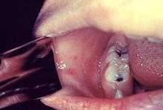
Figure.
This patient above presented on the third pre-eruptive day with “Koplik spots” indicative of the beginning onset of measles.The classical symptoms of measles include four day fevers, the three Cs—cough, coryza (runny nose) and conjunctivitis (red eyes). The fever may reach up to 40 °C (104 °F). Koplik's spots seen inside the mouth are pathognomonic (diagnostic) for measles but are not often seen, even in real cases of measles, because they are transient and may disappear within a day of arising.The characteristic measles rash is classically described as a generalized, maculopapular, erythematous rash that begins several days after the fever starts. It starts on the head before spreading to cover most of the body, often causing itching. The rash is said to "stain", changing colour from red to dark brown, before disappearing (T. E. C. Jr., 1972)
Complications with measles are relatively common, ranging from relatively mild and less serious diarrhea, to pneumonia and encephalitis (subacute sclerosing panencephalitis), corneal ulceration leading to corneal scarring (T. E. C. Jr., 1972) Complications are usually more severe amongst adults who catch the virus.
The fatality rate from measles for otherwise healthy people in developed countries is 3 deaths per thousand cases, or 0.3%. In underdeveloped nations with high rates of malnutrition and poor healthcare, fatality rates have been as high as 28%.In immunocompromised patients (e.g. people with AIDS) the fatality rate is approximately 30%( Perry et al, 2004)
There is no specific treatment for measles. Most patients with uncomplicated measles will recover with rest and supportive treatment. It is, however, important to seek medical advice if the patient becomes more unwell as they may be developing complications.
Some patients will develop pneumonia as a sequel to the measles. Other complications include ear infections, bronchitis, and encephalitis. Acute measles encephalitis has a mortality rate of 15%. While there is no specific treatment for measles encephalitis, antibiotics are required for bacterial pneumonia, sinusitis, and bronchitis that can follow measles.
All other treatment is symptomatic, with ibuprofen, or acetaminophen (also called paracetamol) to reduce fever and pain and, if required, a fast-acting bronchodilator for cough. Note that young children should never be given aspirin without medical advice due to the risk of inducing a disease known as Reye's syndrome. (Perry et al., 2004).
The use of Vitamin A in treatment has been investigated. A systematic review of trials into its use found no significant reduction in overall mortality, but that it did reduce mortality in children aged under 2 years.( D'Souza and D'Souza, 2002).
According to the World Health Organization (WHO), measles is a leading cause of vaccine-preventable childhood mortality. Worldwide, the fatality rate has been significantly reduced by a vaccination campaign led by partners in the Measles Initiative: the American Red Cross, the United States Centers for Disease Control and Prevention (CDC), the United Nations Foundation, UNICEF and the World Health Organization (WHO). Globally, measles fell 60% from an estimated 873,000 deaths in 1999 to 345,000 in 2005. ( Parker et al, 2006). Estimates for 2008 indicate deaths fell further to 164,000 globally, with 77% of the remaining measles deaths in 2008 occurring within the South-East Asian region. (Merck.com)
Five out of six WHO regions have set goals to eliminate measles, and at the 63rd World Health Assembly in May 2010, delegates agreed a global target of a 95% reduction in measles mortality by 2015 from the level seen in 2000, as well as to move towards eventual eradication. However, no specific global target date for eradication has yet been agreed as of May 2010.(WHO, 2009).
3. MATERIALS AND METHODS
3.1 STUDY AREA
The study was carried out among children of the out patients and those on admissions at the University Of Maiduguri Teaching Hospital Borno State.
It is a tertiary institution situated in the state capital and serves as a referral centre to the entire state, including the North estren states of Nigeria (Adamawa,Bauchi, Gombe,Taraba and Yabe), it also serve some countries( Cameroon,Niger and Chad).
3.2 STUDY POPULATION
In the study 188 sera were tested consisting of 30 mother-child pairs and 128 infants. The infants are between the ages of 0 to 9 months and assayed for measles specific IgG antibody using an Enzyme-Linked Immuno-Sorbent Assay (ELISA). They have no signs and symptoms of clinical measles.
3.3 SAMPLE COLLECTION AND STORAGE
After collecting verbal and written consents from the parents of the subjects. To those that consented about 2mls of whole blood was collected by venepuncture, into a sterile, plain bottle and teh blood was allowed to clot. The Blood was then spun at 1500 rpm for 5 minutes. The serum was aspirated with a sterile pipette tips into a clean vial and store at -20ºC until needed.
2.SAMPLE PROCESSING
In this study, the Measles IgG ELISA kit was used. The ELISA technique was performed according to the instruction provided by the kits manufactures Demedtec Diagnostics GmbH, Germany (Catalogue No DEMASO1).
2.1 DATA ANALYSIS
The data generated was entered and analysed using SPSS version 15.0 for windows software. Simple frequencies, figures were generated, while categorised variables were compared using chi square test, A P-value less or equal to 0.05 (P≤0.05) was considered as statistically significant.

4. RESULTS

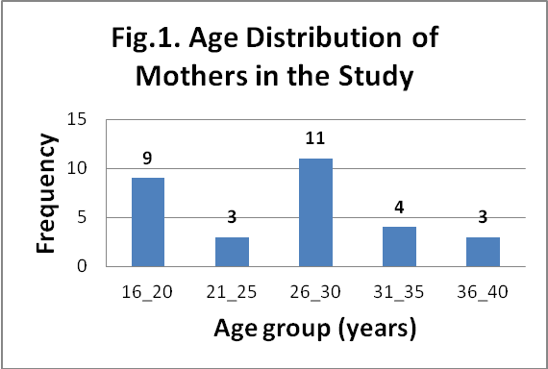

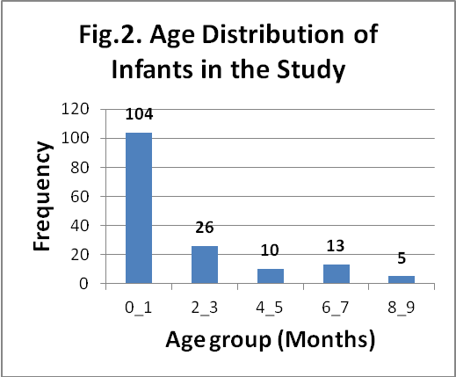

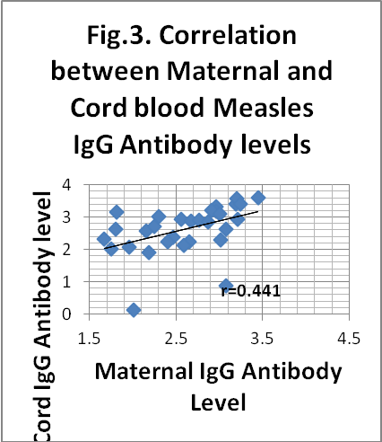

Fig.4. The decay of Measles IgG antibody with age of infants

4. DISCUSSION
Figures 1 and 2 shows the age distribution of study population. A total of 188 sera samples were tested for Measles virus specific-IgG antibody. This consisted of 30 mother-child pairs and 128 infants. The mothers were in the age group of 16 to 40 years with mean (±SD) age of 27(±6.9) years. Most, 36.7% (11 out of 30) of the mothers were in the age group of 26 to 30 years, followed by age group of 16 to 20 years with 30% (9 out of 30), with the least 10%(3 out of 30) each in age groups of 21 to 25 and 36 to 40 years (Fig.1).
The overall prevalence of measles specific IgG antibody in the study population is 101 (53.7%), which means that 53.7% are immuned compared with 43.3% non-immune subjects.
The 158 infants tested were from birth to 9 months of age (0.03 - 9.0), with mean (±SD) age of 1.6 (±2.3) months. Most, 65.8% (104 out of 158) infants were below 1 month of age, followed by the age group of 2 to 3months with 16.4% (26 out of 158). The infants in the age group of 8 to 9 months were the least, 3.2% (5 out of 158) (Fig.2). The infants consisted of 75 (47.5%) females and 83 males (52.5%) with a female: male ratio of 1:1.1.
All the 30 (100%) mothers had measles specific-IgG antibody. While 28 (93.3%) out of the 30 infants acquired measles specific-IgG antibody from their mothers. Therefore, 2 (6.7%) out of the 30 mothers did not pass measles antibody to their newborns.
The mean (±SD) optical density (OD) Units for IgG for Mothers and their newborns were 2.61(±0.52) and 2.62 (±0.76) respectively. This showed a positive (y=0.6463x + 0.936, r=0.441) and significant (p=0.015) correlation between antibody levels in mothers and their newborns (Fig.3).
About 44.9% (71, 31 females and 40 males) of the 158 infants were seropositive for Measles IgG antibody, while 55.1% (87, 44 females 43 males) are susceptible. There was however no significant difference in the seropositivity rate according to sex (p=0.426).
Figure 4 shows the decay of measles antibody with the age of infants, there is a negative (r=-0.404) and significant (p=0.000) correlation between the antibody level with the age of infants in the study. A total of 35 (77.8%) out of 45 one day old infants were seropositive. The seropositivity reduced with age up to the age of 8 months, by 9 months none of the infants were seropositive.
In the study 188 sera were tested consisting of 30 mother-child pairs and 128 infants.
The 30 (100%) mothers tested all had measles IgG antibody. This implies that all the mothers have acquired immunity either from past measles infection or have been vaccinated against the measles virus. Out of the 30 mothers, 28 (93.3%) passed the antibody to their newborns and 2 (6.7%) did not acquire the antibody which means they are susceptible to the measles virus infection. The correlation shows that cord blood IgG antibody level increases with increase in maternal. This indicates that as maternal antibody increase, the cord blood antibody level also increases. From this, the newborns have acquired a higher immunity than their mothers.
In the 158 sera of infants tested, 44.9% (71 out of 158) had the measles IgG antibody and 55.1% (87 out of 158) are susceptible. This shows that not up to half of the infants tested are protected from the measles virus infection. The study showed no significant difference in immunity according to gender (sex). It also showed that the antibody in the infants decay as they increase in age with 77.8% (35 out of 45) one day old infants immune and 0% (0 out of 3) of 9 months without immunity to the infection.
This study generally suggests that most of the mothers that have the measles IgG antibody passed it to their newborns and only few newborns don’t acquire the measles IgG antibody and are therefore susceptible to the infection by measles virus. It also showed that there is a significant correlation between the maternal and cord blood IgG levels. In conclusion, the study clearly indicates that the maternally derived measles antibody decays with increase in age of the infants. Hence, susceptibility to the measles infection in infants gets higher with increase in their age.

ACKNOWLEGDEMENT
We wish to acknowledge the entire staff of the peadiatircs dept UMTH and WHO Polio lab for providing all the necessary supports for the research work.
Corresponding author:
Dawurung Joshua Shehu. Department Of Microbiology University of Maiduguri,
Borno state, Nigeria dawurungj@yahoo.com

References
- "Measles".http://www.patient.co.uk/showdoc/40000391/
- Ovsyannikova I.G., Jacobson R.M., Vierkant R.A.,(2004) Associations between human leukocyte antigen (HLA) alleles and very high levels of measles antibody following vaccination. Vaccine ;22:1914-20.
- Cutts F.T., Henao-Restrepo A., Olive J.M.,(1999);Measles elimination: progress and challenges. Vaccine ;17(Suppl 3):S47-52.
- Poland G.A., Jacobson R.M.,(1994) Failure to reach the goal of measles elimination. Apparent paradox of measles infections in immunized persons. Arch Intern Med ;154:1815-20.
- Gdalevich M., Robin G., Mimouni D.,(2002);. Measles antibody prevalence rates among young adults in Israel. Am J Infect Control;30:165-9.
- Bilkis M.D., Barrero P.R., Mistchenko AS.(2000) Measles resurgence in Argentina: 1997-8 outbreak. Epidemiol Infect;124:289-93.
- Centers for Disease Control and Prevention (CDC),(2000). Measles
- http://medicine-history.blogspot.com/2008/12/measles-history of discovary.htm
- Perry, Robert T.; Halsey, Neal A., (2004). "The Clinical Significance of Measles: A Review of infectious Diseases (Infectious Diseases Society of America) 189 (S1): 1547–1783. doi:10.1086/377712. PMID 15106083.
- D'Souza R.M, D'Souza R., (2002). "Vitamin A for treating measles in children". Cochrane Database Syst Rev (1): CD001479. doi:10.1002/14651858.CD001479. PMID 11869601.
- Parker A, Staggs W, Dayan G., (2006). "Implications of a 2005 measles outbreak in Indiana for sustained elimination of measles in the United States". N Engl J Med 355 (5): 447–55. doi:10.1056/NEJMoa060775. PMID 16885548.
- Merck.com
- WHO Weekly Epidemiology Record, 4th December 2009 WHO.int
- outbreak–Netherlands, April 1999-January 2000.MMWR Morb Mortal Wkly Rep;49:299-303.
- Merriam-webster:Rubeola. Retrieved 2009-09-20 and T. E. C. Jr. Letters to the editor Pediatrics Vol. 49 No. 1 January 1972, pp. 150-151).

8/10/2010

