Influence of growth regulators on the explants of Commiphora mukul (Hook. ex Stocks) Engl. under in vitro conditions

Narender Singh*, Amrita Garg, Kuldeep Yadav and Suman Kumri

Department of Botany, Kurukshetra University Kurukshetra 136119 (India)
*Email: nsheorankuk@yahoo.com

Abstract: Commiphora mukul, popularly known as “Guggul”, is an important endangered medicinal plant. Various explants type (shoot tips, nodal, internodal and leaf segments) of C. mukul were cultured on Murashige and Skoog medium supplemented with various concentrations ( 0.5 – 2.0 mg/l) of auxins and cytokinins individually and in various combinations. The result showed that BAP was found to be more effective than Kn for bud break (90%) and shoot length (1.5 cm) from nodal explants. In combination, the medium supplemented with 2.0 mg/l BAP + 0.5 mg/l IAA responded better than all other media combinations from nodal explants. MS half strength medium supplemented with 2.0mg/l IBA proved best with eighty per cent rooting after 20 days of implantation. Most of the roots were long and healthy. The micropropagated plantlets were hardened and acclimatized. They were successfully transferred in pots containing sterilized soil and sand mixture (3:1) with 60% survival rate under field conditions. [Researcher. 2010;2(7):41-48]. (ISSN: 1553-9865).

Key words: Single shoot, Nodal segments, Commiphora mukul , Auxins, Cytokinins.

Abbreviations : BAP-6-benzylamino purine, Kn-Kinetin, IAA-indole-3-acetic acid, 2,4-D- 2,4-dichlorophenoxy acetic acid, NAA-á-naphthalene acetic acid, IBA-indole butyric acid.

1. Introduction
Commiphora mukul (Hook. ex Stocks) Engl. (Burseraceae), popularly known as “Guggul”, is an important endangered medicinal plant species. It is widely distributed in tropical regions of Africa and Asia. It grows wild in the arid, rocky tracts of north- western regions of India (Wealth of India, 1950).
The plant exudes a medicinal oleo-gum resin (‘Guggul’) from incisions made on the bark in cold season. The latex oozes out through the wound as a yellow fluid which slowly hardens to form the oleo-gum resin (Atal et al., 1975). Gum is bitter, acrid, aromatic, pungent, carminative and stomachic stimulating the appetite and improving digestion. It is astringent, expectorant, anthelmintic, antispasmodic, anti-inflammatory (Arora et al., 1971; Sosa et al., 1993), diuretic, depurative, anodyne, vulnerary, themogenic, antiseptic, nervine tonic, aphrodisiac, stimulant, emmenagogue and diaphoretic. It also posseses strong purifying and rejuvenating properties and is said to be a uterine stimulant.
The main constituents of guggul include phytosterols, gugulipids and the ketonic steroid compound (guggulsterones) mainly E & Z gugguisterones (Patil et al., 1972). These are responsible for the lipid lowering effects of guggul (Singh et al., 1997).
It is an important component of antiarthritic drugs in Ayurvedic medicine (Singh et al., 2003). It is an effective lipid lowering agent (Malhotra et al., 1977). Historically, guggul has been used in connection with a wide variety of conditions including rheumatism, obesity, arthritis and lipid disorders. Today guggul is most commonly used to lower cholesterol, decrease high blood pressure and platelet aggregation and to decrease inflammation associated with arthritis (Mester et al., 1979). Guggul was even used as a mouthwash or rinse for dental carries and spongy gums. The resin is used in the form of a lotion for indolent ulcers and as a gargle in chronic tonsillitis, pharyngitis and ulcerated throat (Nadkarni, 1954). It also had some use in infectious conditions including bronchitis, lymphadenitis as well as skin disorders and diabetes. Twigs are used as herbal tooth brush.
Due to the commercial importance, extensive use in medicine, faulty and unscientific techniques of tapping employed by local inhabitants, over-exploitation for gum-resin, slow growth and lack of organized or systematic cultivation, the wild population has declined fast and this species has been listed as threatened by Botanical Survey of India (Dalal, 1995). The conventional methods of propagation by seeds are very slow. Fruit set and yield of fruits per plant are very low in natural conditions. Poor seed set, very poor seed germination (5%) and harsh arid conditions are responsible for complete failure of plant establishment from seed in nature. Moreover, the plant is slow growing. Normally it is propagated vegetatively by stem-cuttings. However, such methods are not suitable for large scale multiplication as stock material with sufficient biomass is not as well as percentage response of cuttings is variable and affected by seasons. Therefore, there is an urgent need to conserve this species ex situ through in vitro method and to develop reliable and rapid protocol for its micropropagation.

2. Materials and Methods
Various explants like shoot tips, nodal, internodal and leaf segments were excised from the plants growing in polyhouse of Botany Department, Kurukshetra University, Kurukshetra. All the explants were washed with liquid detergent under running tap water to remove dust particles. The explants were then treated with 0.1% (w/v) mercuric chloride for 3-5 minutes under aseptic conditions. After this these explants were then thoroughly washed 4-5 times with sterilized double distilled water to remove the traces of mercuric chloride. The nodal segments were inoculated on MS medium supplemented with various concentrations (0.5-2.0 mg/l) of auxins (IAA, NAA, 2, 4-D and IBA) and cytokinins( BAP and Kn) alone and in various combinations for shoot regeneration and callus induction.
The cultures were incubated at a temperature of 25±2ºC and a photoperiod of 16hrs light (intensity of 2000 lux) and 8 hrs of dark.
Visual observations like callus induction, growth of callus, number of days taken for bud break, percentage of bud break and number of shoots regenerated per explants were recorded regularly. A mean of 20 replicates was taken per treatments.
The in vitro developed single/multiple shoots (2.5 – 3.0 cm long) were excised and implanted in culture tubes containing full and half strength MS medium fortified with IBA and IAA under aseptic conditions for rooting.
After development of sufficient roots, the plantlets were gradually pulled out from the medium and immersed in water to remove agar-agar particles sticking to the root system by using a fine brush. These plantlets were planted in pots with sterilized soil and sand mixture (3:1). Each pot was covered with a polythene bag to maintain high humidity around the plants. The pots were supplied with MS (half strength) salt solution on alternate days. After about two weeks the polythene bags were removed for 3-4 hrs daily to expose the plants to the conditions of natural humidity. After about 4 weeks these plants were transferred to bigger pots and were maintained under natural conditions of day length and temperature.

3. Results and Discussion

3.1 Direct regeneration:
The medium devoid of growth regulators failed to initiate callus or bud break from any of the explant. Similarly in Peganum harmala (Saini and Jaiwal, 2000) and Crataeva nurvala (Walia et al., 2003), no shoot buds developed on MS basal medium.
In case of nodal explant, cytokinins were reported to promote early bud initiation. Of the two cytokinins (BAP and Kn) tested, BAP was more effective than Kn as bud inducer. The medium supplemented with 1.0 mg/l BAP supported ninety per cent bud break (Figure-1a). This medium also resulted in the early bud-break. Similar observations have been made in many plants like Momordica charantia (Agrawal and Kamal, 2004) and Chlorophytum borivillianum (Sharma and Mohan, 2006). Single shoot formation was recorded in all concentrations of BAP whereas in case of Kn, it occurred only in 1.5 and 2.0 mg/l treated MS medium. The combination of BAP (2.0mg/l) with IAA (0.5mg/l) induced maximum per cent bud break per nodal explant.
Bud-break was not observed on the media supplemented with auxins 0.5, 1.0 and 2.0 mg/l NAA and 2, 4-D whereas the medium with IAA resulted in bud break from nodal segments (Table-1). The development of axillary shoot from nodal explants was accompanied by basal and nodal region callus formation. Among all the auxins, IAA was found to be more effective in terms of shoot induction (Figure-1b), as also reported by Sudhadevi and Nataraja (1987) in Dalbergia latifolia.
Though there are reports on organogenesis from internodal explants of some species like Citrus sinensis (Duran-Vila et al., 1991) and Cephalis ipecacunha (Yamuna et al., 1993), but in the present study, internodal explants failed to respond when cultured on MS medium in presence of BAP or Kn or both. Similarly shoot apex did not respond to any of the growth regulators used.

Table 1. Effect of cytokinins and auxins supplemented individually and in various combinations on different explants of Commiphora mukul.

Auxins/ cytokinins  (mg/l) | Explant | Concentration  of growth regulators (mg/l) | Number of days required for bud break | %age of bud break | Number of shoots (Mean±SE) | Shoot Length  (cm)  (Mean ± SE)
BAP | Nodal  Segments | 0.5  1.0  1.5  2.0 | 12  10  09  09 | 60  90  90  70 | Single shoot  Single shoot  Single shoot  Single shoot | 1.2 ±0.07  1.5 ±0.06  1.4 ±0.09  1.3 ±0.09
BAP | Internodal  Segments | 0.5  1.0  1.5  2.0 | –  –  –  – | 0  0  0  0 | 0  0  0  0 | –  –  –  –
BAP | Shoot tip | 0.5  1.0  1.5  2.0 | –  –  –  – | 0  0  0  0 | 0  0  0  0 | –  –  –  –
Kn | Nodal  Segments | 0.5  1.0  1.5  2.0 | 14  13  11  15 | 60  70  80  70 | –  –  Single shoot  Single shoot | –  –  1.0 ±0.26  1.2 ±0.07
Kn | Internodal  Segments | 0.5  1.0  1.5  2.0 | –  –  –  – | 0  0  0  0 | 0  0  0  0 | –  –  –  –
Kn | Shoot tip | 0.5  1.0  1.5  2.0 | –  –  –  – | 0  0  0  0 | 0  0  0  0 | –  –  –  –
IAA | Nodal  Segments | 0.5  1.0  1.5  2.0 | 12  10  11  12 | 50  80  60  70 | Single shoot  Single shoot  Single shoot  Single shoot | 0.5 ±0.10  1.5 ±0.05  1.4 ±0.22  1.3 ±0.57
IAA | Internodal  Segments | 0.5  1.0  1.5  2.0 | –  –  –  – | 0  0  0  0 | 0  0  0  0 | –  –  –  –
IAA | Shoot tip | 0.5  1.0  1.5  2.0 | –  –  –  – | 0  0  0  0 | 0  0  0  0 | –  –  –  –
BAP+IAA | Nodal  Segments | 2.0+0.5  2.0+1.0  2.0+2.0 | 10  12  15 | 100  70  60 | Single shoot  Single shoot  Single shoot | 1.7 ±0.40  1.4 ±0.50  1.3 ±0.57
BAP+IAA | Internodal  Segments | 2.0+0.5  2.0+1.0  2.0+2.0 | –  –  – | 0  0  0 | 0  0  0 | –  –  –
BAP+IAA | Shoot tip | 2.0+0.5  2.0+1.0  2.0+2.0 | –  –  – | 0  0  0 | 0  0  0 | –  –  –
(–) No Response
*Data based on 20 explants per treatment and taken after 28 days of culture

3.2 Indirect regeneration:
All the explants except internodal segments induced calli on MS medium fortified with 2, 4-D and NAA. A significant growth of callus was obtained at the concentration of 2.0mg/l 2, 4-D and 1.0mg/l and 2.0mg/l NAA (Figure-1c). 2, 4-D was found to be more effective in terms of days required for callus induction as compared to NAA (Table-2). Similar observations were also made by Harikrishan and Hariharan (1996) in Plumbago rosea and Zeng et al. (1999) in Ixora coccinea that nodal segments were better for callus formation.
No callus initiation was observed from leaf segments on MS medium containing BAP and Kn even after 30 days of inoculation. Supplementation

of auxins except IAA in different concentrations (0.5, 1.0 and 2.0 mg/l) to the medium showed callus initiation. Hundred per cent callus induction was observed in leaf segments inoculated on MS medium having 2.0mg/1 of NAA (Figure-1f). 2, 4-D and NAA were found to be equally effective in terms of callus growth (Figure-1e). The callus was brownish in colour. Presence of 2,4-D has been shown to be essential for callus formation in Vernonia cinerea (Baig and Shahzad, 2003) and Momordica charantia (Agrawal and Kamal, 2004). while NAA played an important role in callus formation in Actinida deliciosa (Kumar et al., 1998) and Withania somnifera (Kannan et al., 2005).

Table 2. Effect of cytokinins and auxins supplemented individually and in various combinations on callus formation on different explants of Commiphora mukul.

Auxins/ cytokinins  (mg/l) | Explant | Concentration  of growth regulators (mg/l) | Number of days required for callus induction | %age  callus induction | Visual growth of callus | Colour and texture of callus
2, 4-D | Nodal  Segments | 0.5  1.0  2.0 | 16  15  11 | 30  70  70 | C+  C+  C++ | Light Brownish  Light Brownish  Light Brownish
2, 4-D | Internodal  Segments | 0.5  1.0  2.0 | –  –  – | 0  0  0 | –  –  – | –  –  –
2, 4-D | Leaf  Segments | 0.5  1.0  2.0 | 16  13  12 | 40  70  90 | C+  C++  C+++ | White and soft  White and soft  White and soft
NAA | Nodal  Segments | 0.5  1.0  2.0 | 17  15  12 | 60  90  90 | C+  C+++  C+++ | Brownish  Brownish  Brownish
NAA | Internodal  Segments | 0.5  1.0  2.0 | –  –  – | 0  0  0 | –  –  – | –  –  –
NAA | Leaf  Segments | 0.5  1.0  2.0 | 18  14  10 | 40  90  100 | C+  C+++  C+++ | Brownish  Brownish  Brownish
Kn+ NAA | Nodal  Segments | 2.0+0.5  2.0+1.0  2.0+2.0 | 16  11  – | 30  90  – | C+  C+++  – | Whitish  Whitish  Whitish
Kn+ NAA | Internodal  Segments | 2.0+0.5  2.0+1.0  2.0+2.0 | –  –  – | 0  0  0 | –  –  – | –  –  –
Kn+ NAA | Leaf  Segments | 2.0+0.5  2.0+1.0  2.0+2.0 | 17  15  12 | 30  40  40 | C+  C+  C+ | Brownish  Brownish  Brownish
(–) No Response, (C+) Poor growth, (C++) Moderate growth, (C+++) Good growth.
*Data based on 20 explants per treatment and taken after 28 days of culture

Callus initiated from the cut ends of the leaf explants and finally whole surface of the explant was involved. Similar observations have been made by Guo et al. (2007) in Saussurea involucrate and also by Singh and Lal (2007) in Leucaena leucocephala. This may be obviously due to the production of endogenous auxins from the damaged cells of cut surface which triggered the cell division as found in Ornithogallum (Hussey, 1976) where active cell division was observed at cut ends of tissue.
In the nodal explants, callus formation initiated at nodal region and soon entire surface was involved. Highest per cent (ninety per cent) of callus induction was supported by the media with 2.0 mg/l NAA (Figure-1b). The lowest concentration of 2,4-D (0.5 mg/l) could support only thirty per cent callus induction. The calli was brownish in colour. Among the various combinations, 2.0 mg/l Kn + 1.0 mg/l NAA fortified medium was found best for callus induction as well as for callus growth (Figure-1d). Other combinations of growth regulators also supported callus growth though it was not comparable to this medium.
Leaf and nodal explants responded for induction and growth of callus but differentiation of shoots via callus could not be achieved from any of the explants. Callus was subcultured for regeneration on the same medium or on the medium containing 2.0 mg/l BAP but, it started turning brown without further growth. The browning of the calli could be due to the production of certain oxidatory products or phenols from the cells, which retard the growth of callus (Kiran, 1992).

3.3 Rooting of in vitro regenerated shoots
The shoots regenerated from nodal segments were excised aseptically and implanted on half strength MS media fortified with IAA, IBA (0.5, 1.0 and 2.0mg/l) or without IAA and IBA (Table-3). The medium without growth regulator failed to initiate roots. Better root formation was supported by the half strength MS medium supplemented with 2.0mg/l IBA. The enhancing effect of IBA for root formation was also observed in Chlorophytum borivillianum (Sharma and Mohan, 2006), Prosopis cineraria (Kumar and Singh, 2009), Celastrus paniculatus (Lal and Singh, 2010 ).
3.4 Acclimatization and transfer of plantlets to the soil
After development of sufficient roots, the plantlets were taken out from the medium and transferred in the sterilized soil and sand mixture (3:1) in pots. Each pot was covered with a polythene bag to maintain high humidity. The plantlets were irrigated with half strength MS salt solution on alternate days. The plantlets after gradual acclimatization were transferred to the natural conditions (Figure-1f). Sixty per cent of the plants survived well. Successful acclimatization and field transfer of the in vitro regenerated plantlets have also been reported in Terminalia arjuna (Kumari et al., 1998), Peganum harmala (Goel et al., 2009).

Table 3. Root formation on different media composition in Commiphora mukul.

Media composition (mg/l) | Days required  for root  induction | % age of Responce | Remarks
MS full strength without growth regulators | – | – | –
MS half strength without growth regulators | – | – | –
MS half strength +0.5 mg/l IBA | 23 | 50 | Short, Healthy
MS half strength +1.0 mg/l IBA | 22 | 70 | Long, Thin
MS half strength +2.0 mg/l IBA | 20 | 80 | Long, Thin
MS half strength +0.5 mg/l IAA | 24 | 30 | Short, Healthy
MS half strength +1.0 mg/l IAA | 21 | 60 | Short, Healthy
MS half strength +2.0 mg/l IAA | 23 | 70 | Short, Healthy
(- ) No Response
*Data based on 20 explants per treatment and taken after 28 days of culture

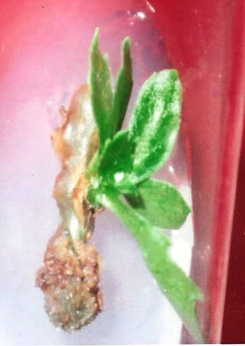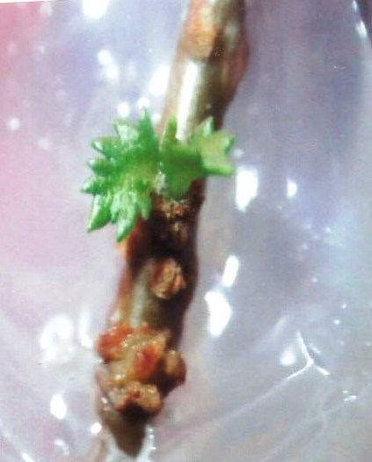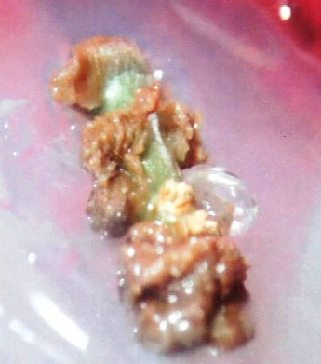
c
b
a

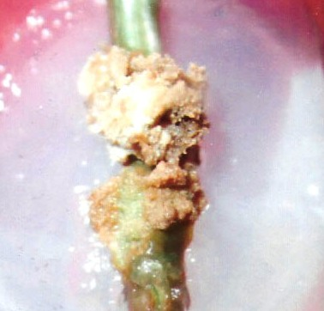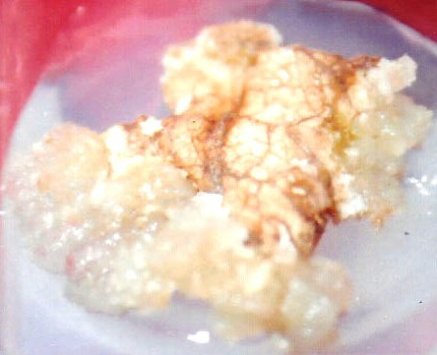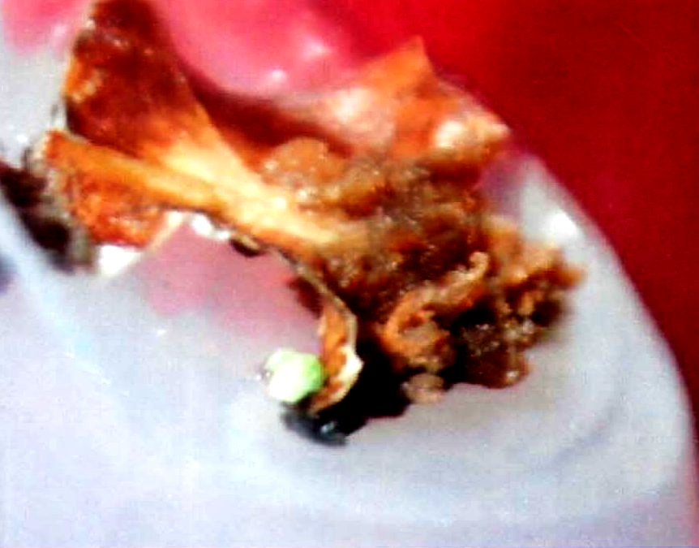
e
d
f

Figure 1(a-f): In vitro regeneration of Commiphora mukul a, Shoot regeneration from nodal explant on MS medium + BAP (1.0mg/l) ; b, Bud initiation from nodal explant on MS medium supplemented with IAA (1.0mg/l); c, Callus growth from nodal explant on MS medium supplemented with NAA (2.0mg/l);d, Callus growth from nodal segment on MS medium supplemented with Kn (2.0mg/l) + NAA (1.0mg/l); e, Callus formation from leaf explants on MS medium + 2,4-D (2.0mg/l); f, Callus formation from leaf explants on MS medium + NAA (2.0mg/l)

Acknowledgement:
The authors are grateful to Kurukshetra University, Kurukshetra for providing laboratory facilities to carry out the work.

Corresponding Author:
Dr. Narender Singh
Associate Professor,
Department of Botany,
Kurukshetra University,
Kurukshetra, Haryana 136119,India.
E-mail: nsheorankuk@yahoo.com

References

- Agarwal M, Kamal R. In vitro clonal propagation of Momordica charantia L. Ind. J. of Biotech. 2004; 3:426-430.
- Arora RB, Kapoor V, Gupta SK, Sharma R C. Isolation of crystalline steroidal compound from Commiphora mukul and its anti-inflammatory activity. Ind. J Exp Biol. 1971; 9: 403-404.
- Atal CK, Gupta OP, Afaq SH. Commiphora mukul, source of guggul in Indian systems of medicine, Economic Botany. 1975; 29: 208—218.
- Dalal K C. All about Guggulu. Amruth. 1995; 4. Feb.
- Duran-Vila N, Gogorcena Y, Ortega V, Ortiz J, Navarro L. Morphogenesis and tissue culture of sweet orange (Citrus sinensis (L.) Osb.): Effect of temperature and photosynthetic radiation. Plant Cell, Tissue and Organ Culture. 1991; 29: 11-18.
- Goel N, Singh N, Saini R. Efficient in vitro multiplication of Syrian Rue (Peganum harmala L.) Using 6- benzylaminopurine pre-conditioned seedling explants. Nature and Science 2009; 7:129-134.
- Guo B, Gao M, Liu CZ. In vitro propagation of an endangered medicinal plant Saussurea involucrata Kar. et kir. Plant Cell Rep. 2007; 26:261-265.
- Harikrisharn HN, Hariharan M. Direct shoot regeneration from nodal explant of Plumbago rosea L., a medicinal plant. Phytomorphol. 1996; 46:53-58.
- Hussey G. 1976. Planlets regeneration from callus and parent tissue in Ornithogalum thyrsoides.J. Exp.Bot. 27:375-382.
- Kannan P, GAI Ebenezer G, Dayanandan P, Abraham GC, Igancimuthu S. Large scale production of Withania somnifera (L.) Dunal using in-vitro techniques,. Phytomorphol. 2005;55: 259-266.
- Kumari N, Jaiswal V, Jaiswal VS. Induction of somatic embryogenesis and plant regeneration from leaf callus of Terminalia arjuna Bedd. Curr. Sci. 1998; 75:1052-1055.
- Kumar S, Singh N. Micropropagation of Prosopis cineraria(l.) Druce – a multipurpose desert tree. Researcher. 2009;1: 28-32.
- Kumar S, Chander S, Gupta H, Sharma D R. Micropropagation of Actinidia deliciosa from axillary buds, Phytomorphol. 1998; 43: 303-307.
- Lal D, Singh N. Mass Multiplication of Celastrus paniculatus Willd - AnImportant Medicinal Plant Under In Vitro Conditions using Nodal Segments. J. of American Sci. 2010; 6: 55-61.
- Malhotra SC, Ahuja MMS, Sundarum KR. Long-term clinical studies on the hypolipidemic effect of Commiphora mukul (guggul) and clofibrate. Ind J Med Res. 1977; 65:390–5.
- Mester L, Mester M, Nityanand S. Inhibition of platelet aggregation by guggulu steroids. Planta Med. 1979; 37:367–9.
- Nadkarni AK. Indian Materia Medica. Popular Prakashan, Bombay, India. 1954; 3rd Ed.
- Patil VD, Nayak UR, Sukh Dev. Chemistry of ayurvedic crude drugs-1, Guggul (Resin from Commiphora mukul)-1, steroidal constituents. Terrabydron. 1972; 28: 2341- 2352.
- Saini R, Jaiwal PK. In vitro multiplication of Peganum harmala – an important medicinal plant. Ind. J. Exp. Biol. 2000; 38:499-503.
- Sharma U, Mohan JSS. In vitro clonal propagation of Chlorophytum borivillianum Sant. et Rernand., a rare medicinal herb from immature floral buds along with inflorescence axis. Ind. J. Exp. Biol. 2006; 44:77-82.
- Singh BB, Aquilina N, Mishra LC, Kohlbeck F. The Usefulness of Commiphora Mukul for Osteoarthritis of the Knee: An Experimental Case Study. Alt. Ther Health & Med. 2003; 7: 120 & 112-114.
- Singh K, Chander R, Kapoor NK. Guggulsterone, a potent hypolipidaemic, prevents oxidation of low density lipoprotein. Phytother Res. 1997; 11:291–4.
- Singh N, Lal D. Growth and Organogenesis potential of calli from some explants of Leucaena leucocephala (lam.) de wit. Int. J. of tropical Agriculture. 2007; 25:389-399
- Sosa S, Tubaro A, Delia-Loggia R, Bombardelli E. Anti-inflammatory activity of Commiphora mukul extracts. Pharmacological Research. 1993; 27:89-90.
- Sudha Devi AM, Natraja K. In vitro regeneration and establishment of plantlets in stem cultures of Dalbergia latifolia Roxb. Indian Forester. 1987; 113:501-506.
- The Wealth of India. Raw Materials. C.S.I.R, New Delhi. 1950; Vol. II : 313
- Walia N, Sinha S, Babbar S B. Micropropagation of Crataeva nurvala. Biol. Plant. 2003; 46:181–185.

- Yamuna P, Bose I, Jha, TB, Jha S. Direct organogenesis from internodal segments of in vitro grown shoots of Ipecac, Cephaelis ipecacuanha Rich. Ind. J. Exp. Biol. 1993; 31: 926-929.
- Zeng S, Guo S, Peng X, Zhang J, Zhao F (1999) Tissue culture and rapid propagation of Ixora coccinea L. J. of Plant Resources and Env. 8: 37-41.

07/03/2010

