Photocatalytic Degradation of Monoazo and Diazo Dyes in Wastewater on Nanometer-Sized TiO₂
S.A. Abo-Farha

Chemistry Department, Faculty of Science, Al-Azhar University (Girls), Naser City, Cairo, Egypt
E-mail address: samiaelhosieny@yahoo.com

Abstract: Advanced oxidation processes (AOPs) have proved very effective in treatment of the various hazardous organic pollutants in water. The photocatalytic degradation of two azo dyes, monoazo dye Acid Orange 10(AO10) and diazo dye Acid Red114(AR114) present in wastewater were studied. Homogeneous photocatalytic degradation of the two azo dyes with UV/H₂O₂ process was investigated. The rates of disappearance of the two azo dyes were monitored spectrophotometrically at the visible maximum absorption wavelengths. It was found that the rate of decolorization rises by increasing the initial dosage of H₂O₂ up to a “critical” value at which it is maximum and beyond which it is inhibited. The rates of reactions follow pseudo-first-order kinetics. Also heterogeneous photocatalytic degradation of the two azo dyes with UV/TiO₂ (titanium dioxide) interface was investigated. The photocatalytic degradation rate depends on dye structure, dye concentration, TiO₂ concentration and pH of the medium. The mechanism of the photodegradation process under UV-visible light illumination involves an electron excitation into the conduction band of the TiO₂ semiconductor leading to the generation of very active oxygenated species that attack the dye molecules leading to photodegradation. Photocatalytic activity of TiO₂ was examined by focusing on its enhancement by electron scavengers in the photocatalytic decomposition of the two azo dyes. The electron scavengers employed was inorganic oxidant such as H₂O₂, adequate dose of H₂O₂ led to a faster degradation of the two azo dyes in the TiO₂ photocatalytic system. The fast decolorization of monoazo dye (AO10) than diazo dye (AR114) is an indication that, the number of azo and sulphonate groups in the dye molecule may be a determining factor for increasing the degradation rates. [Researcher. 2010;2(7):1-20]. (ISSN: 1553-9865).
Keywords: Azo dyes; UV/H₂O₂ oxidation, Titanium dioxide; Photodegradation; Semiconductor.

1- Introduction
Environmental pollution on a global scale, as well as the lack of sufficient clean energy sources, have drawn much attention to the need for developing ecologically clean chemical technology, materials, and process [1-4]. Azo dyes, being the largest group of synthetic dyes, constitute up to 70% of all the known commercial dyes produced. Highly substituted aromatic rings joined by one or more azo groups characterize their chemical structures. These substituted ring structures make the molecules recalcitrant which the conventional wastewater treatment processes do not degrade. Being released into the environment, these dyes not only impart colors to water sources but also damage living organisms by stopping the reoxygenation capacity of water, blocking sunlight, and therefore disturbing the natural growth activity of aquatic life [5,6]. Thus, the color removal of textile wastewater is a major environmental concern [7].
In recent years, research in new non-biological methods has led to processes which actually destroy these pollutants in stead of simply extracting them from water (e.g., adsorption by active carbon, air stripping, etc.). It has been shown that the use of TiO₂, O₃, H₂O₂, and Fenton (a mixture of ferrous ion with H₂O₂) are more efficient in the photodegradation of organic pollutants in comparison to that of direct photolysis [8-10]. Among them, one of the common observations is that the enhancement of organic decomposition is due to the generation of powerful non-selective hydroxyl radical (●OH ) produced in the process of photodegradation.
The efficiency of advanced oxidation processes for the degradation of recalcitrant compounds has been extensively studied [11-16]. Photocatalytic process, which utilizes TiO₂ semiconductor photocatalyst, has received increasing attention because of its low cost, non-toxicity, relatively high chemical stability of the catalyst, and the possibility of using sunlight as a source of irradiation [5,8,11,14]. However, it has a limitation that the quantity of ●OH radicals cannot be increased infinitely because overdosing of TiO₂ scatters the light in the solution [8,17]. Therefore, new developments of these technologies have focused on searching for better oxidants to increase the generation of radicals or to optimize the photodegradation process.
It was reported that the use of inorganic oxidants, such as H₂O₂, ClO₃– BrO₃– , and S₂O₈– –, in TiO₂ system increased the quantum efficiencies either by inhibiting electron-hole pair recombination through scavenging conduction band electrons at the surface of TiO₂ or by offering additional oxygen atom as an electron acceptor to from the superoxide radical ion () [8, 18]. According to the investigation on H₂O₂, adequate dose of H₂O₂ led to a faster degradation of organic compounds in the TiO₂ photocatalytic system [8, 19]. However, the degradation was suppressed if excess H₂O₂ was used. This is due to the undesirable consumption of ●OH radical that was previously formed in the solution by H₂O₂, leading to generation of less-reactive HO●₂ radicals [8, 20]. Enhancement of TiO₂-catalyzed photodegradation of organic compounds by several inorganic oxidants was mainly attributed to the increased electron scavenging from the extra oxidant sources [8,21].
Several studies of photocatalytic degradation of dyes have been reported [8,22,23]. Factors influencing the photodegradation rate of aqueous system have been studied in the subjects such as the initial concentration of dyes, the effect of pH values, dissolved oxygen contents and amounts of photocatalyst added to the aqueous solution [24,25].
This paper describes the kinetics of the color removal for two dyes, monoazo dye Acid Orange 10 (AO10) and diazo dye Acid Red 114(AR114) by homogeneous photocatalytic degradation in presence of (UV/H₂O₂) by Homogeneous which is a ‘friendly’ oxidant and by heterogeneous photocatalytic degradation in presence of (UV/TiO₂) and enhancing the photocatalytic activity of TiO₂ by employing electron scavenger such as H₂O₂. Variable factors such as the initial dyes concentration, H₂O₂ does, TiO₂ loading and pH values have been studied.
2. Experimental
2.1. Materials
Two azo dyes, monoazo dye Acid Orange 10 (AO10) and diazo dye Acid Red 114(AR114) were obtained from Lingxian Shine Coating and auxilaries Co. LTD. were used without further purification. Their structure are depicted below.

(Mol. wt. 452.376 g and λ_{max} 478 nm) (Mol. wt. 830.8308g and λ_{max} 514 nm)

Hydrogen peroxide (30% w/w) was obtained from Merck. Titanium dioxide P-25 from Degussa Corporation (70% anatase. 99.8% purity, average particle size 30 nm and specific surface of 50 m²/g). It was dissolved in deionised water using (New water purification system, Human RO 180. RO, product).
2.2. Physical measurements
For the UV/H₂O₂ and UV/TiO₂ processes, irradiations were performed in a batch photoreactor. All experiments were conducted in a batch microsol light tester equipped with a pre-settable timer and water-cooling jacket (BS 1006 UK-TN) fitted with 400 W MB/U lamp show in Fig. (1) (made in England).
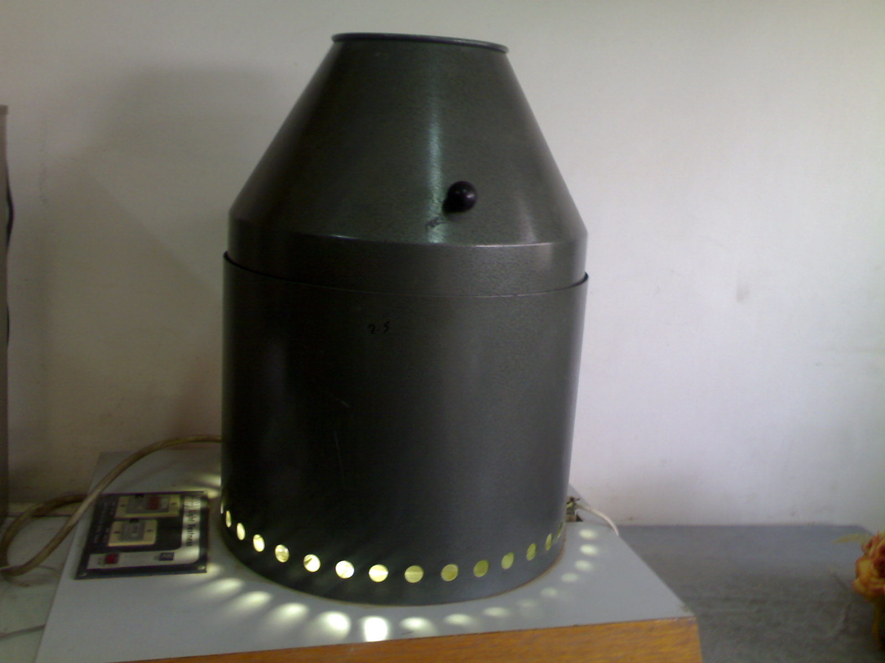

Fig. (1) : Batch microsol photoreactor light tester
The pH values of the solution were adjusted, using microcomputer pH-vision DATALOGGER 6209; JENCO ELECTRONICS-LTD (made in U.S.A.). PH adjusted using dilute hydrochloric acid and sodium hydroxide solutions. Hydrochloric acid was chosen because its effected on the adsorption surface properties of the TiO₂ is negligible [26]. The absorption spectra were recorded with JENWAY-6300 UV-Visible spectrophotometer. The absorbance of solutions measured using a 1cm quartz cell (made in U.K.).
Centrifug model 800 of a maximum speed 4000r/min is used for complete separation for the semiconductor particles used (TiO₂) from the sample solution. Scanning electron microscope (SEM) analysis is performed to identify the catalyst surface morphology using a JEOL-JSM-5400S scanning electron microscope (made in Japan). The SEM is measured in National Center for Radiation Research and Technology.
2.3. SEM analysis
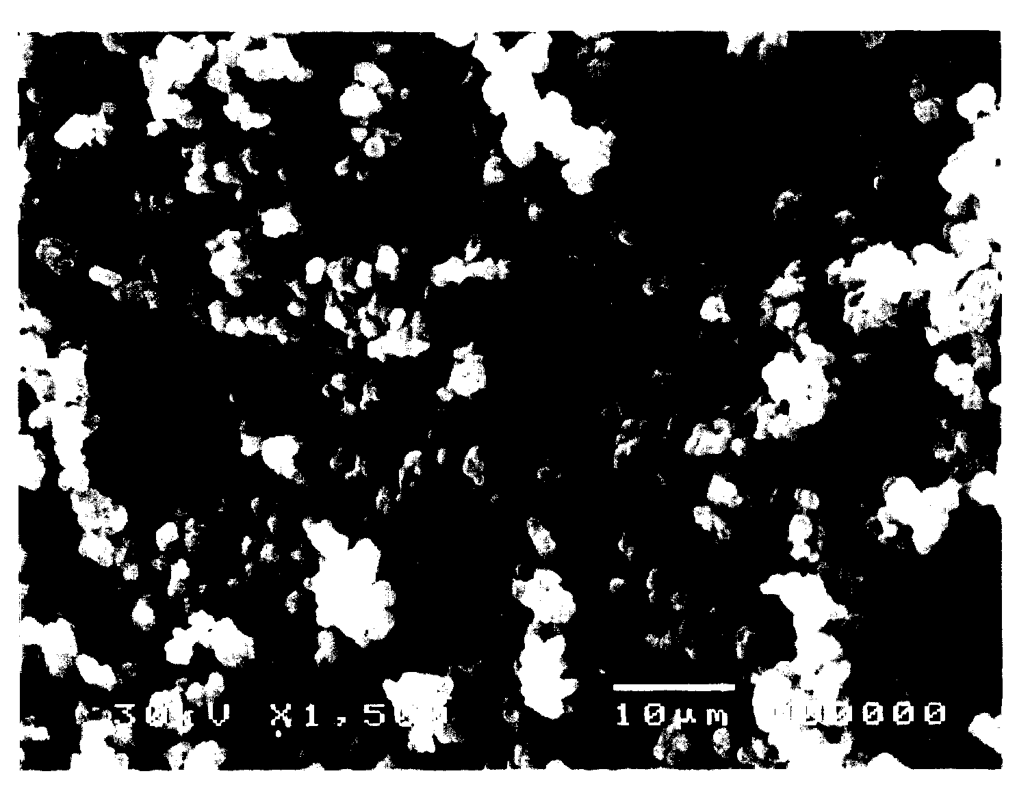
(a)
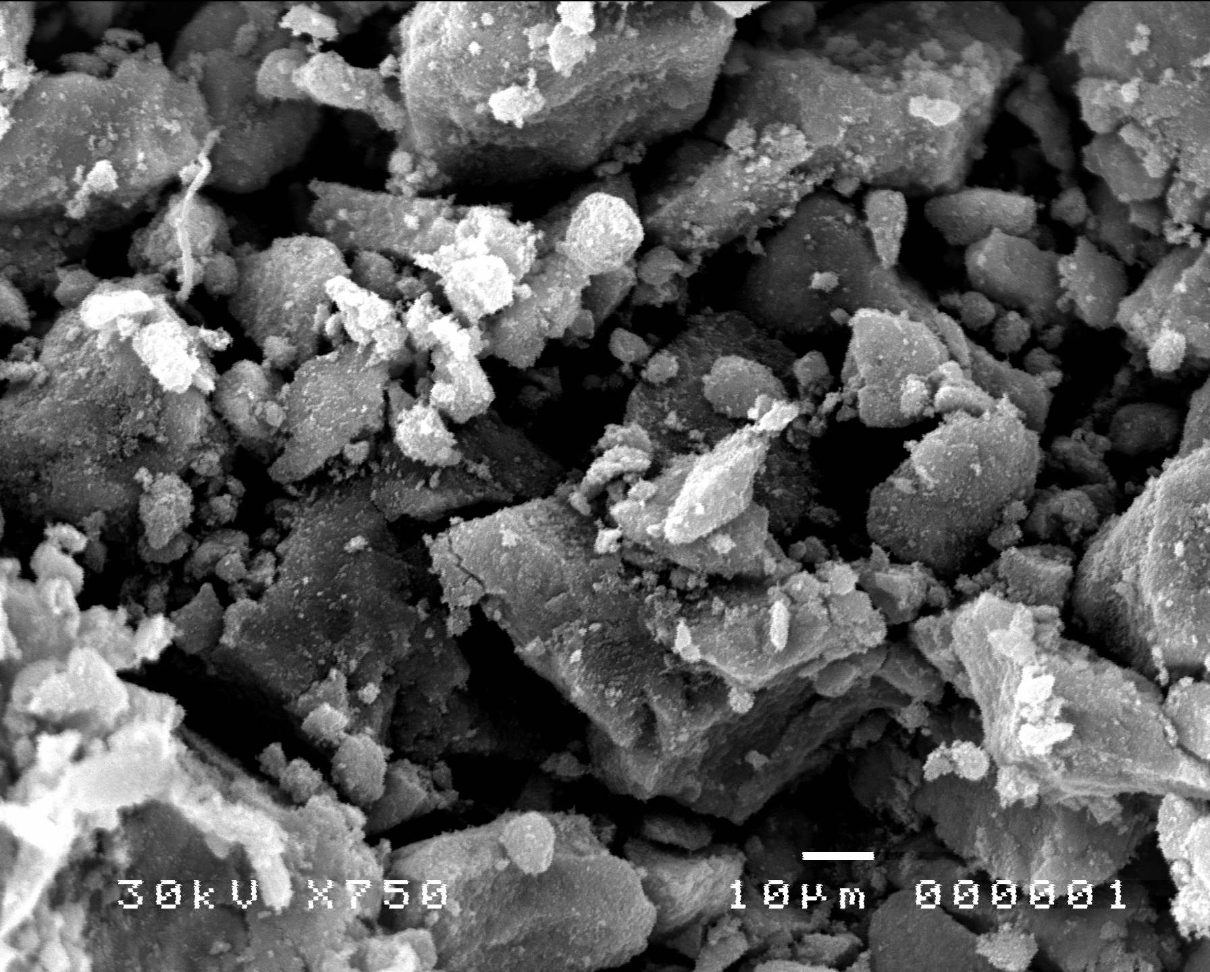  (b) | 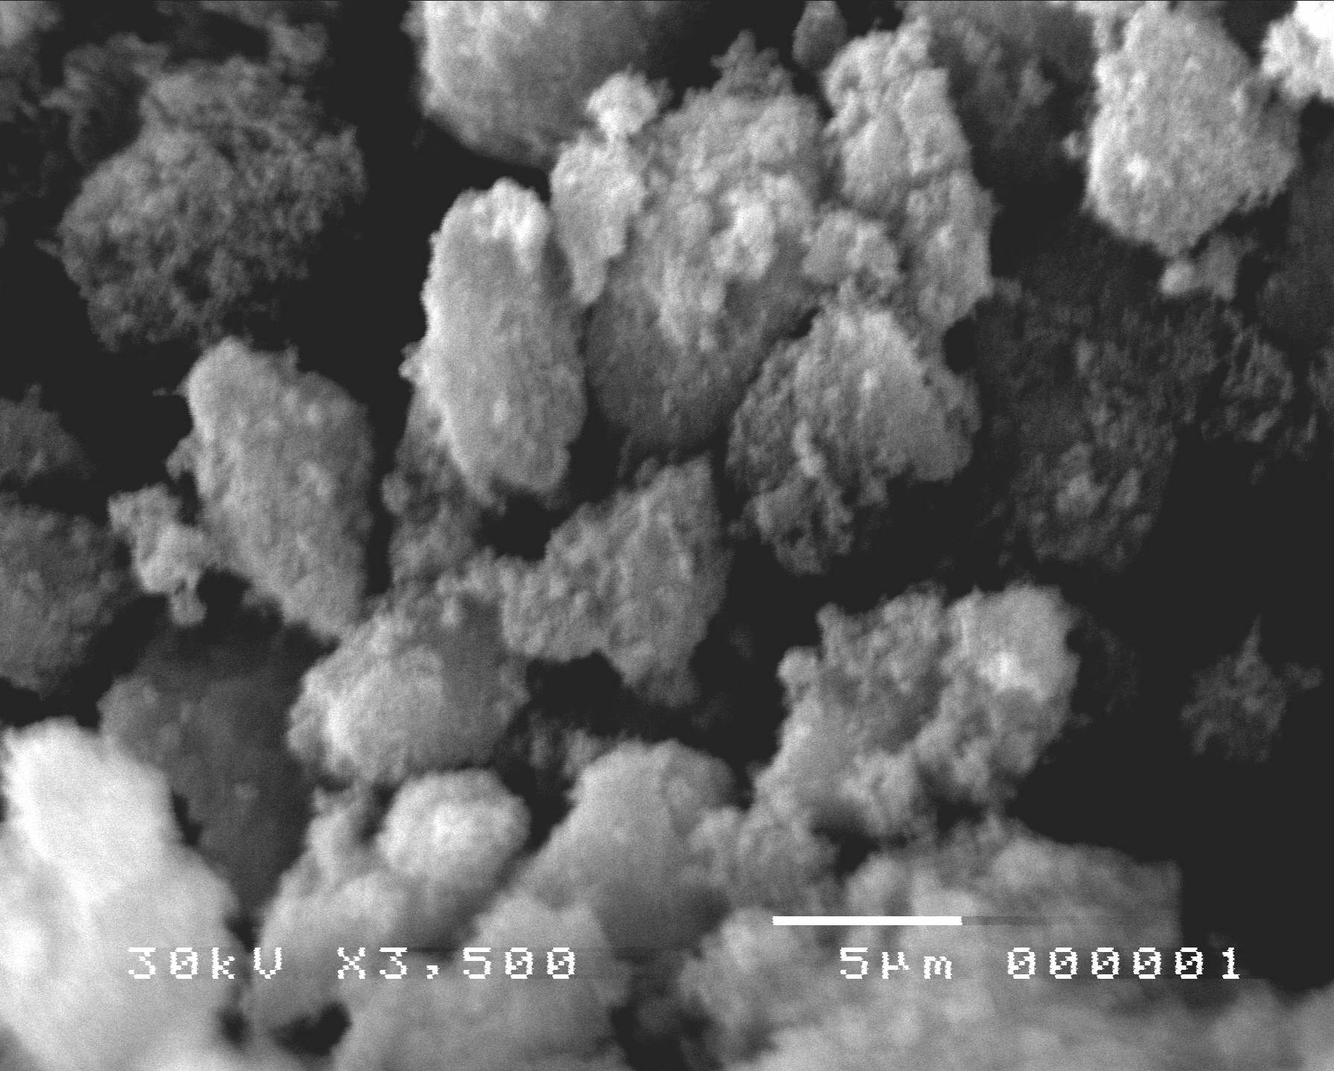  (c)

Fig. (2): SEM micrograph of (a) TiO₂ and (b) (AO10) adsorbed on TiO₂ (c) (AR114) adsorbed on TiO₂

The SEM picture of pure TiO₂ and (AO10) and (AR114) adsorbed on TiO₂ are shown in Fig. (2). The SEM picture of pure TiO₂ Fig. 2a shows that the size of titanium dioxide particles are uniform and needle-like particles [9]. In case of (AO10) and (AR114) agglomeration (particle-particle interactions) is observed. The distribution of dye on the surface of TiO₂ is not uniform and SEM pictures Fig. 2b,c shows that, dyes contain irregular shaped particles which are the aggregation of tiny crystals. However, it cannot be ruled out, that some dye particles are too small to be observed at the resolution of the used microscope [4,18]. The image from Fig. 2b , c reveals that, the presence of great agglomerates with particle size of monoazo dye (AO10) than diazo dye (AR114). From this result, it is clear that the morphology has been strongly influenced by the type of acid dye [27].
2.4. Photocatalytic degradation experimentals
2.4.1. Homogeneous photocatalytic degradation
The experiments are carried out in a batch – type photoreactor. H₂O₂ is acts as photocatalyst and UV light as illuminating light source. Reaction system is setup by adding the photocatalysts into 250 ml dye solutions prepared in appropriate concentrations using deionized water. The pH is adjusted to the desired values with HCl and NaOH. The dye solutions are stirred and 5 ml samples are withdrawn at regular time intervals and the dye concentrations are measured spectrophotometrically.
2.4.2. Heterogeneous photocatalytic degradation
Also the experiments are carried out in the same batch photoractor. Pure TiO₂ powder adding into 250 ml dye solutions prepared in appropriate concentrations using deionized water. The pH also is adjusted to the desired values. The dye solutions are stirred and 5 ml samples are withdrawn at regular time intervals and centrifuged the dye concentrations are measured spectrophotometrically.

3. Results and discussion
3.1. Homogeneous photocatalytic degradation with H₂O₂
Advanced oxidation processes (AOPs); such as O₃ , UV/O₃ and UV/H₂O₂ are widely used to decompose organic products in industrial wastewater and groundwater [28]. The extensive literature in this filed has been reviewed [11]. These processes have the potential ability to mineralize most of the organic contaminants into carbon dioxide and water. In aOPs system, the free radicals (●OH ) are the dominant species contributing to the degradation of organic in wastewater. These processes comprise the activation of hydrogen peroxide, or ozone, with UV light to produce hydroxyl radicals which have a higher oxidation potential (2.8V) than that of hydrogen peroxide (1.78 V). During the last decade, some investigations has been reported about the successful application of UV/H₂O₂ process for dye wastewater treatment [8,10,19,29].
It is indisputable that degradation of the dye is due to the hydroxyl radicals generated upon photolysis of hydrogen peroxide [30], following the reaction:
H₂O₂ + hv 2 ●OH (1)
This radical is a very powerful oxidizer, able to react with inorganic [31] as well with aliphatic [32] or aromatic organic compounds [33]. According to the results of Shu et al., [28] the photooxidation reaction is pseudo-first-order with respect to azo dye concentration. This frequently occurs when the contaminant is very dilute in solutions. The kinetic constant can also be linked to the dye concentration by Eq. (2).
ln$\frac{C}{C_{o}} = −\text{Kt}$ (2)
C_{o} : dye concentration at t =0
C : concentration at time t.
3.1.1. Effect of initial dye concentration
Initial dye concentrations C_{o} were set in the range 1.0 x 10^{–5} to
1.0 x 10^{–4} M for both two azo dyes Acid Orange 10 and Acid Red 114. Photocatalysis were compared in presence of 5mM H₂O₂ for both two azo dyes and pH 3.0. Initially, a large degree of removal is observed. This is due to fast decomposition of H₂O₂ producing the hydroxyl radicals. Moreover, decolorization of dye is mainly due to hydroxyl radicals generated. Azo bonds are more active: AO10 contain one azo bond and AR114 contain two azo bonds and degradation of this dyes are due to the initial electrophilic cleavage of its chromphoric azo (–N=N–) bond attached to naphthalene ring [34].
The values of photodegradation pseudo first order rate constants for different concentrations of dyes calculated from the linear plots of ln A/A_{o} against irradiation time Fig. (3). Taking into account that, the life-time of hydroxyl radical is very short (only few nanoseconds), they can only react where they are formed [35]. Increasing the concentrations of AO10 and AR114 lead to decrease in the degradation rate see Fig. 4. However, the molar extinction coefficient of two dyes are high (ε=16.9 x 10³ and 18.3 x 10³ liter mole^{–1} cm^{–1}) for AO10 and AR114 respectively, so that a rise in its concentration induce an inner filter effect, i.e., incident light would largely be wasted for dye excitation rather than for the hydroxyl radical precursor excitation. Consequently, the solution becomes more and more impermeable to UV radiation. As the rate of hydrogen peroxide photolysis directly depends on the fraction of incident light absorbed by H₂O₂ molecules, the degradation rate slows down.
3.1.2. Effect of initial H₂O₂ concentration
The effect of varying the initial H₂O₂ concentration increase from 5mM to 100 mM for dye concentration 1.0 x10^{–5}M at pH 3.0 for both the two azo dyes AO10 and AR114. A very large excess of H₂O₂ in comparison to the dye was introduced in the solutions. Fig. 5, shows that, the initial hydrogen peroxide concentration strongly modifies the rates of degradation of the two azo dyes, Acid Orange 10 and Acid Red 114 in the UV H₂O₂ processes [19,29].
An increase of the hydrogen peroxide concentration up to 50 mM leads to an important rise in the solution discolouration rate. On the other hand, further increase in the H₂O₂ concentration partly inhibits the oxidation rate. This hehaviour is proof of the existence of an optimal dosage in H₂O₂.
We must underline the fact that hydroxyl radicals produced upon photolysis of hydrogen peroxide can react with dye molecules, but also with an excess of H₂O₂.
(3)
At low hydrogen peroxide concentrations, formation of is the kinetic determining step. H₂O₂ cannot generate enough hydroxyl radicals and the oxidation rate is logically slow. Further, most of free radicals are directly consumed by the dye. In the presence of high concentration of peroxide, we could expect that more radicals would be produced. However these radicals preferentially react with the excess of H₂O₂. This undesirable reaction competes with the destruction of the dye chromophore [36,37].
3.1.3. Effect of initial pH
To study the effect of pH on photodegradation, experiments are conducted at 1.0 x 10^{–5}M dye concentration for the two azo dyes Acid Orange 10 and Acid Red 114 in presence of 50mM H₂O₂ dose at different initial pH values ranges from 1.0 to 11.0, the calculated pseudo first-order rate constants show from Fig. (6). The results show that, high degradation rate constant values are observed at pH 3.0 for both two azo dyes and decrease significantly in alkaline media. Similar results have already been reported for azo dyes [35,36].
The high rate constant value observed at lower pH can be explained by the change in the molecule structure. The presence of labile H atom makes the molecule of dye especially vulnerable toward attack of radicals [36].
In alkaline medium, hydrogen peroxide undergoes decomposition leading to dioxgen and water rather than producing hydroxyl radicals under UV irradiation [38]. Therefore the instantaneous concentration in is lower than expected. The base – catalyzed decomposition involves the HO₂– anion: the conjugated base of H₂O₂ reacts with non-dissociated molecule of H₂O₂ according to Eq. (4).
HO₂– + H₂O₂ H₂O + O₂ + (4)
Furthermore, the deactivation of is greater when the pH of the solution is high (the reaction of with HO₂– being approximately 100 times faster than its reaction with H₂O₂ [30,38].
+ HO₂– H₂O + (5)
H₂O₂ + H₂O + H (6)
The reactivity of Hand its basic form with organic compounds is very weak. They preferentially disproportionate producing some hydrogen peroxide and oxygen, according to the Eq. (7).
H+ + H₂O H₂O₂ + O₂ + (7)
3.2. Heterogeneous photocatalytic degradation
A wide variety of organics are introduced into the environment through various sources such as industrial effluents, agricultural runoff and chemical spills. Industrial effluents contain several non-biodegradable substrates that can be harmful to the environment [3,4]. One major source of these effluents is the waste a rising from the industrial process, which utilizes dyes to color paper, plastic and natural and artificial fibers [39]. A substantial amount of dyestuff is lost during the dyeing process in the textile industry, which poses a major problem for the industry as well as a threat to the environment [39], and decolorization of dye effluents has therefore acquired increasing attention. During the past two decades, photocatalytic process involving TiO₂ semiconductor particles under UV light illumination has been shown to be potentially advantageous and useful in the treatment of wastewater pollutants.
3.2.1. Photocatalysis of TiO₂ suspension containing azo dyes
3.2.1.1 Photodegradability of the dyes
Initial control experiments are carried out in order to evaluate the photocatalysis viability in the degradation of the azo dyes AO10 and AR114 under the following conditions : (i) self photolysis of dye solution with UV light; (ii) dye solution with catalyst in dark and (iii) under irradiation of UV light with photocatalyst Fig. (7) shows the change in absorption intensity on irradiation of an aqueous solutions of AO10 and AR114, in the presence and absence of titanium dioxide.
From the above results it is clear that the dyes are remarkable decolorization to (i) direct photolysis of UV light and (ii) in the presence of TiO₂ alone. Simultaneous irradiation and aeration in the presence of TiO₂ caused excellent decolorisation of the dyes [40]. This suggested that the photocatlytic activity of TiO₂ degussa P-25 is remarkable, and the photocatalytic degradation of these dyes under UV light are possible[41-43]. This is due to the fact that when TiO₂ is illuminated with the light of λ<390nm conduction band electrons (e– ) and valence band holes (h⁺) are generated. TiO₂ suspension is irradiated with light energy greater than its band gap energy (Eg, 3.2 eV). The photogenerated electrons could reduce the dyes or react with electron acceptors such as O₂ adsorbed on the Ti(III) surface or dissolved in water, reducing it to superoxide radical anion . The photogenerated holes can oxidize the organic molecule to form R⁺, or react with OH– or H₂O oxidizing them into radicals. Together with other highly oxidant species (peroxide radicals) they are reported to be responsible for the heterogeneous TiO₂ photodecomposition of organic substrates as dyes. According to this, the relevant reactions at the semiconductor surface causing the degradation of dyes can be expressed as follows:
TiO₂ + hv (UV) TiO₂ (e_{CB}– + h_{VB}+) (8)
TiO₂ (h_{VB}+) + H₂O TiO₂ + H⁺ + (9)
TiO₂ (h_{VB}+) + OH– TiO₂ + (10) TiO₂ (e_{CB}–) + O₂ TiO₂ + (11)
+ H⁺ H (12)
Dye + degradation products (13)
Dye + h_{VB}+ oxidation products (14)
Dye + e_{CB}– reduction products (15)
The resulting radicals, being a very strong oxidizing agent can oxidize most of azo dyes to the mineral end-products. Substrates not reactive toward hydroxyl radicals are degraded employing TiO₂ photocatalysis with rates of decay highly influenced by the semiconductor valence band edge position [44]. The role of reduced pathway (Eq. (15) ) in heterogeneous photocatalysis has been investigated also in the degradation of several dyes but in a minor extent than oxidation [43,45].
3.2.1.2. Factors influencing the photocatalytic degradation
3.2.1.2.1 Effect of initial dye concentration
The effect of initial concentration of the dye on the rate of degradation was performed by varying the initial dye concentration from 1.0 x 10^{–3} to 1.0x10^{–4}M (pH = 3.0) with constant loading (0.2 g/l TiO₂) for both two azo dyes AO10 and AR 114.
The values of the calculated first order rate constants Fig. (8) were calculated. It is generally noted that the degradation rate increases with the increase in dyes concentrations to a certain level [1.0 x 10^{–5}M] for bothy two azo dyes and a further increase in dyes concentrations lead to decrease the degradation rate of the dyes [46,47]. The rate of degradation relates to the probability of radicals formation on the catalyst surface and to the probability of radicals and reacting with dye molecules. As the initial concentrations of the dye increase the probability of reaction between dye molecules and oxidizing species also increases, leading to an enhancement in the decolorization rate. On the contrary, the degradation efficiency of the dye decreases as the dye concentration increases further. The presumed reason is that at high dye concentrations the generation of radicals on the surface of catalyst is reduced since the active sites are covered by dye ions. Another possible cause for such results is the UV-screening effect of the dye itself. At a high dye concentration, a significant amount of UV may be absorbed by the dye molecules rather than the TiO₂ particles and that reduce the efficiency of the catalytic reaction because the concentrations of and decrease [40,48].
The major portion of degradation occurs in the region near to the irradiated side (termed as reaction zone) where the irradiation intensity is much higher than in the other side [49]. Thus at higher dye concentration, degradation decreases at sufficiently long distances from the light source or the reaction zone due to the retardation in the penetration of light.
Hence, it is concluded that as initial concentration of the dye increases, the requirement of catalyst surface needed for the degradation also increases [50].
3.2.1.2.2. Effect of TiO₂ loading
TiO₂ dosage is an important parameter that can affect the degradation rate. The initial reaction rates were found to be directly proportional to catalyst concentration indicating the heterogeneous regime. However, it was observed that above a certain level of concentration the reaction rate decreases and becomes independent of the catalyst concentration.
In this work, the effect of TiO₂ loading on the photodegradation rate of the two azo dyes AO10 and AR114 have been examined by varying its amount from 0.05 to 0.2 g/l ([AO10]=[AR114]= 1.0x 10^{–5}M, pH = 3.0 for both two azo dyes). The calculated linear plots of ln A/A_{o} against irradiation time Fig. (9) and photodegradation rate constants for both two azo dyes are given in Fig. (10). Fig. (10) shows that, the rate of photodegradation increase with catalyst loading up to 0.2 g/l. Above this loading, increase in turbidity of the solution reduces the light transmission through the solution. While below this level, it is assumed that the catalyst surface and absorption of light by the catalyst are the limiting factors. Many authors have investigated the reaction rate as a function of catalyst loading under different experimental conditions [51]. The enhancement of the removal rate is due to (i) the increase in the amount of catalyst weight which increases the number of dye molecules adsorbed (ii) the increase in the density of particles in the area of illumination [34]. Thus higher amount of the catalyst may not be useful both in view of possible aggregation as well as reduced irradiation field due to increase in light scattering [52] Wei and Wan have reported that, the catalyst amount has both positive and negative impact on the photodecomposition rate. Furthermore, rate may decrease as a result of loss in surface area available for light-harvesting occasioned by agglomeration (particle-particle interactions) at high solid concentration.
3.2.1.2.3. Effect of pH
The interpretation of pH effects on the efficiency of dye photodegradation process is a very difficult task because of its multiple roles. First, is related to the ionization state of the surface according to the following reactions,
TiOH + H⁺ TiOH₂⁺ (16)
TiOH + OH– TiO– + H₂O (17)
as well as to that of reactant dyes and products such as acids and amines. pH changes can be thus influence the adsorption of dye molecules onto the TiO₂ surfaces, an important step for the photocatalytic oxidation to take place [53]. Bahnemann et al. [54] have already reviewed that acid-base properties of the metal oxide surfaces can have considerable implications upon their photocatalytic activity. The point of zero charge (PZC) of the TiO₂ (Degussa P-25) is at pH 6.8 [55]. Thus, the TiO₂ surface is positively charged in acidic media (pH<6.8), whereas it is negatively charged under alkaline conditions (pH> 6.8).
Second, hydroxyl radicals can be formed by the reaction between hydroxide ions and positive holes. The positive holes are considered as the major oxidation species at low pH whereas hydroxyl radicals are considered as the predominant species at neutral or high pH levels [48]. It was stated that in alkaline solution are easier to be generated by oxidizing more hydroxyle ions available on TiO₂ surface, thus the efficiency of the process is logically enhanced [42]. Similar results are reported in the photocatalysed degradation of acidic azo dyes and triazine containing azo dyes [50], although it should be noted that in alkaline solution there is a coulombic repulsion between the negative charged surface of photocatalyst and the hydroxide anions. This fact could prevent the formation of and thus decrease the photoxidation. Very high pHs have been found favorable even when anionic azo dyes should hamper adsorption on the negatively charges surface [56]. At low pH, reduction by electrons in conduction band may play a very important role in the degradation of dyes due to the reductive cleavage of azo bonds.
Third the TiO₂ particles tend to agglomerate under acidic condition and the surface area available for dye adsorption and photon absorption would be reduced [53]. Hence, pH plays an important role both in the characteristics of textile waters and in the reaction mechanisms that can contribute to dye degradation, namely, hydroxyl radical attack, direct oxidation by the positive hole and direct reduction by the electron in the conducting band.
The wastewater from textile industries usually has a wide range of pH values. Generally, pH plays an important role both in the characteristics of textile wastes and generation of hydroxyl radicals [50]. Hence, attempts have been made to study the influence of pH in the degradation of the two azo dyes AO10 and AR114. the photocatalytic reactions are conducted at different pH values its rang from 1.0 to 11.0 and two dyes concentration [1.0 x 10^{–5}M) at catalyst loading of 0.2 g/l. All reactions followed an apparent first-order kinetics confirmed by the linear transform of ln (A/A_{o}) = f(t). the rate constants of disappearance k in min^{–1} for two azo dyes AO10 and AR114 are illustrated in Fig. (11).
The results obtained in Fig. (11) indicated that, at pH<6 a strong adsorption of the two azo dyes on the TiO₂ particles is observed as a result of the electrostatic attraction of the positively charged TiO₂ with the dyes. At pH>6.8 as two azo dyes molecules are negatively charged in alkaline media, their adsorption is also expected to be affected by an increase in the density of TiO– groups on the semiconductor surface. Thus, due to coulombic repulsion the dyes are scarcely adsorbed [42]. For the above reasons the photocatalytic activity of anionic dyes (mainly sulphonated dyes) reached a maximum in acidic conditions followed by a decrease in the pH range 7-11 [40,43,47].
(dye–SO₃Na) (dye–SO₃)– + Na⁺ (18)
Moreover, the higher degradation rate at acid pH is seen also for vis/TiO₂ experiments due to the efficient electron-transfer process due to strong surface complex bond formation. This effect is less marked in neutral/basic pH solutions [57]. The inhibitory effect seems to be more pronounced in the alkaline range (pH=11-13). At high pH values the hydroxyl radicals are rapidly scavenged and they do not have the opportunity to react with dyes [58].
Since the influence of the pH is dependent on dye type and on properties of TiO₂ surface his effect on the photocatalytic efficiency must be accurately checked before any application.
3.2.2. Photcatalysis of TiO₂ suspension with H₂O₂ containing azo dyes
It was observed that H₂O₂ addition was beneficial for the photoxidation of the two azo dyes AO10 and AR114 [46]. The reactive radical intermediate formed from H₂O₂ by reactions with the photogenerated electrons can exert a dual function : as strong oxidant themselves and as electron scavengers, thus inhibiting the electron-hole recombination the semiconductor surface [59] according to the following equations :
H₂O₂ + +OH– + O₂ (19)
H₂O₂ + hv 2 (1)
H₂O₂ + e_{CB}– +OH– (20)
Moreover, the solution phase may at times be oxygen starved, because of either oxygen consumption or slow oxygen mass transfer. Peroxide addition thereby increases the rate towards what it would have been an adequate oxygen supply. However, H₂O₂ can also become a scavenger of valence band holes and , when present at high concentration, [40].
H₂O₂ + 2 h_{VB}⁺ O₂ +2H⁺ (21)
H₂O₂ + H₂O + H (6)
H + H₂O + O₂ (22)
As both h_{VB}⁺ and are strong oxidants for dyes, the photocatalytic oxidation will be inhibited when H₂O₂ level gets too high. Furthermore, can be adsorbed onto TiO₂ particles to modify their surfaces and subsequently decrease its catalytic activity.
In this work, the effect of varying dose of H₂O₂ [5mM-100mM] in presence of constant weight of TiO₂ (0.05 g/l) were also studied in the presence of the two azo dyes [AO10 and AR114] = 1.0 x 10^{–5}M at constant pH=3.0 Fig. (12). The results demonstrate that the rate of photodegradation enhances from 50mM H₂O₂ without TiO₂ to 10mM H₂O₂ in presence of 0.05 g/l TiO₂ for AO10, while the rate of photodegradation was fixed at 50 mM H₂O₂ for AR 114 without TiO₂ and in presence of 0.05 g/l TiO₂ Fig. (13).
On the other hand, the effect of TiO₂ loading on the photodegradation rates of AO10 and AR114 has been examined by varying its amount from 0.05 to 0.20 g/l, ([AO10] = [AR114]= 1.0 x 10^{–5}M), pH= 3.0, [H₂O₂]=10mM-50mM for AO10 and AR114 respectively. The calculated photodegradation rate constants are given in Fig. (14), the results, demonstrate that the rate of photdegradation increase with catalyst loading up to [0.05 g/l TiO₂] and in presence of 10 mM H₂O₂ for AO10 while the catalyst loading was [0.20 g/l TiO₂] without H₂O₂ for the same dye Fig. (10). Also the rate of photodegradation of AR114 increases to 0.20 g/l TiO₂ without H₂O₂ Fig. (10), while in presence of 50 mM H₂O₂ the catalyst loading was enhances to 0.15 g/l TiO₂ Fig. (14).
Also the concentrations of the two azo dyes were enhanced to (5.0 x 10^{–5}M) for (AO10) and (1.0 x 10^{–4}M) for (AR114) in presence of 0.05 g/l TiO₂ with 10 mM H₂O₂ for (AO10) and 0.15 g/l TiO₂ with 50mM H₂O₂ for (AR114) at pH 3.0. The photodegradation rates reached to maximum at 75.4x10^{–3} (min^{–1}) for (AO10) and 42.9x10^{–3} (min^{–1}) for (AR114) Fig. (15). The effect of use TiO₂ with H₂O₂ on the pH values was fixed at pH 3.0 for both two azo dyes [1.0 x 10^{–5}M].
From the above results it were found that, there were optimum conditions for each process to obtain excellent degradation for each dye. Effect of use UV/H₂O₂ and UV/TiO₂ on (AO10) and (AR114) was 50 mM H₂O₂ and 0.20 g/l TiO₂ for both two azo dyes. The effect enhances in presence of UV/H₂O₂/TiO₂ and becomes 10mM H₂O₂ and 0.05 g/l TiO₂ for (AO10) and 50 mM H₂O₂ and 0.15 g/l TiO₂ for (AR114) Fig. (16).
3.2.3 Efficiency of the recyled catalyst
Photocatalysis is a clean technology, which normally dose not involve any waste disposal problem. The catalysts can be recycled. TiO₂ can be used at least twice without significant change in the efficiency [60]. The economy of the photocatalytic process depends upon how many times a catalyst can be reused without sacrificing its efficiency and the type of regeneration it requires.
The photodegration rates of the two recycled catalysts RC-1 and RC-1 and RC-2 were examined . RC-1 achieves 50.4 x 10^{–3} (min^{–1}) for (AO10) and RC-2 achieved 43.8 x 10^{–3} (min)^{–1} for (AR114) compared to 73.2 x 10³ and 42.9 x 10^{–3} (min)^{–1} for (AO10) and (AR114) respectively obtained with the fresh catalyst under the same experimental conditions. The used catalyst was regenerated to get RC-1 first by treating with boiling distilled water till a colorless wash liquid was obtained and then by drying it in a hot air oven at a temperature of 90 to 100°C. RC-1 was heated in a muffle furnate at about 600°C to yield RC-2.
The decrease in the efficiency of the recycled catalyst may be attributed to the deposition of photoinsensitive hydroxides (Fouling) on the photocatalysts surface blocking its active sites.

Fig. (3): Kinetics of photodegradation of (AO10) at different initial dye concentrations in presence of 5mM H₂O₂ and pH 3.0.

Fig. (4). Plot of k (min^{–1}) vs. [dye] for (––) [AO10] and (---) [AR 114] in presence of [5mM H₂O₂] for both (AO10) and (AR114) at pH 3.0.

Fig. (5). Plot of k (min^{–1}) vs. [H₂O₂] for (––) [AO10] and (---) [AR 114]
=1.0 x 10⁻⁵M at pH3.0.

Fig. (6). Plot of k (min^{–1}) vs. pH for (––) [AO10] and (---) [AR 114] =1.0 x 10⁻⁵M in presence of 50mM H₂O₂ for both (AO10) and (AR114).

Fig. (7). Plot of absorbance at λ_{max} (478, 514 nm) vs. time for [AO10(––) and AR114 (---)] = 1.0 x 10^{–5} M at pH3.0.

Fig. (8). Plot of k (min^{–1}) vs. [dye] for (––) [AO10] and (---) [AR 114]
in presence of 0.2 g/l TiO₂ for both two azo dyes at pH3.0.

Fig. (9). Kinetics of photodegradation of [AO10] = 1.0 x 10^{–5}M
at different TiO₂ loading at pH 3.0.

Fig. (10). Plot of k (min^{–1}) vs. [TiO₂] for (––) [AO10] and (---) [AR 114]
=1.0 x 10⁻⁵M at pH3.0.
Fig. (11). Plot of k (min^{–1}) vs. pH for (––) [AO10] and (---) [AR 114]
=1.0 x 10⁻⁵M in presence of 0.2 g/l TiO₂ for both two azo dyes.

Fig. (12). Kinetics of photodegradation of [AO10] = 1.0 x 10^{–5}M
at different H₂O₂ concentrations in presence of 0.05 g/l
TiO₂ at pH 3.0.

Fig. (13). Plot of k (min^{–1}) vs. [H₂O₂] for (––) [AO10] and (---) [AR 114] =1.0x10^{–5}M in presence of 0.05 g/l TiO₂ at pH3.0.
Fig. (14). Plot of k (min^{–1}) vs. [TiO₂] for (––) [AO10] and (---) [AR 114]
=1.0 x 10⁻⁵M in presence of 10 mM H₂O₂ for (AO10) and 50mM for
(AR114) at pH3.0.

Fig. (15). Plot of k (min^{–1}) vs. [dye] for (––) [AO10] and (---) [AR 114]
in presence of 0.05 g/l TiO₂ and 10mM H₂O₂ for (AO10) and 0.15 g/l
TiO₂ and 50mM H₂O₂ for (AR114) at pH3.0.

Fig. (16). Plot of k(min^{–1}) vs(AO10) and (AR114) at the best conditions for each process to obtain degradation at pH 3.0

4. Conclusion
The impact of H₂O₂ initial concentration in color removal kinetics under UV/H₂O₂ process for two azo dyes monozo dye (AO10) and diazo dye (AR114) was investigated. The results prove that the pseudo-first order kinetic model is in good agreement with the experimental data. A set of parameters for the model depicting this degradation were determined. These parameters, will naturally vary with the operating conditions, such as (dye concentration, H₂O₂ dose, pH values). An increase in H₂O₂ dose leads to a faster degradation up to a critical value; at a higher ratio the degradation process become slower.
The photodegradation of two azo dyes catalyzed by UV/TiO₂ was carried out in good results. Various parameters such as (dye concentration, TiO₂ leading, pH values) were tested. The photocatalytic degradation rate was enhanced in presence of UV/H₂O₂/TiO₂.
It may be postulated that, the dye color removal and degradation rates are proportional to the number of azo and sulphonic groups present in their molecules.
In summary, this work demonstrates that photocatalysis is a very effective technology for degrading Acid dyes with azo and sulphonic groups. Moreover, this technology can be utilized directly in dye baths before they are mixed with other textile effluents, which make their treatment difficult and costly due to dilution.
References
- K. Iino, M. Kitano, M. Takeuchi, M. Matsuoka, M. Anpo, Design and development of second generation titration oxide photocatalyst materials operating under visible light irradiation by applying advanced ion-engineering techniques. Curr. Appl. Phys. 6 (2005) 982.
- F.L. Toma, G. Bertrand, S.O. Chaw, D. Klein, H. Liao, C.Meunier, C.Coddet, Microstructure and photocatalytic properties of nanostructured TiO₂ and TiO₂-Al coating elaborated by HVOF spraying for the nitrogen oxides removal. Mater Sci. Eng. A 417 (2006) 56.
- G. Corro, C. Odilon Vazquz, J. L. G. Fierro, Strong improvement on CH₄ oxidatoin over Pt/γ-Al₂O₃ catalysts Catal. Commun. 6(2005) 287.
- O.Vazquez – Cuchillo, A. Cruz-Lopez, L. M. Bautista- Carrillo, A. Bautista-Hernandez, L. M. Torres Martinez, S. Wohn Lee, Synthesis of TiO₂ using different hyrolysis catalysts and doped with Zn for efficient degradation of aqueous phase pollutants under UV light. Res. Chem. Intermed. 36 (2010) 103.
- Ya-Li Song, Ji-Tai. Bo Bai, TiO₂ –assisted photodegradatoin of Direct Blue 78 in aqueous solution in sunlight. Water Air Soil Pollut. (2010).
- S. Wang, A comparative study of Fenton and Fenton-like reaction kinetics in decolourization of wastewater. Dyes and Pigments 76(3) (2008) 714.
- M.S. Khehra, H.S. Saini, D.K. Sharma, B.S. Chadha, S.S. Chimni, Comparative studies on potential of consortium and constituent pure bacterial isolates to decolorize azo dyes. Water Res. 39(20) (2005) 5135.
- A. Syoufian, K. Nakashima, Degradation of methyelen blue in aqueous dispersion of hollow titania photocatalyst : Study of reaction enhancement by various electron scavengers. J. Coll. and Inter. Sci. 317(2008) 512.
- L.Ge, M. Xu, H. Fang, Synthesis of titanium oxide layers on glass substrates with aqueous refluxed sols (RS) and photocatalytic activities J. Mater. Sci. 42 (2007) 4926.
- S. Irmak, E.Kusvuran, O. Erbatur, Appl. Catal. B. Environ. 54(2004) 85.
- Q. Zhange, L. Gao, Preparation of nanocrystalline TiO₂ powders for photocatalytic oxidation of phenol. Res. Chem. Intermed. 35 (2009) 281.
- S. Merabet, D. Robert, J. Victor Weber, M. Bouhelassa, S. Benkhanouche, Photocatalytic degradation of indole in UV/TiO₂: optimization and modeling using the response surface methodology (RSM). Environ. Chem Lett 7(2009) 45.
- M. Leticia, T. Martinez, I. J. Ramirez, K. Del. Angel – Sanchez, L. Garza–Tovar, A. Gruz–Lopez, G. Del Angel, Rietveld refinement of sol–gel Na₂ Ti₆O₁₃ and its photocatalytic perfor-mance on the degradation of methyelen blue. J. Sol. Gel. Sci. Technol. 47 (2008) 158.
- I. Ming Hung, Y. Wang, L. Ting Lin, C. Fa Huang, Preparation and characterization of mesoporous TiO₂ thin film. J. Porous. Mater. (2009).
- M. Abu Tariq, M. Faisal, M. Saquib, M. Munner, Heterogeneous photocatalytic degradation of an anthraquinone and a triphenylmethane dye derivative in aqueous suspensions of semiconductor. Dyes and Pigments 76 (2008) 358.
- E. Du, Y. Xian Zhang, L. Zheng, Photocatalytic degradation of dimethyl phthalate in aqueous TiO₂ suspension: modified Langmuir – Hinshelwood model. React Kinet Catal Lett 97 (2009) 83.
- Z. Jian Chen, B. Zhou Lin, B. Huan Xu, X. Lili, Q. Qin Wang, K. Zhi Zhang, M. Can Zhu, Preparation and characterization of mesoporous TiO₂-pillared titanate photocatalyst. J. Porous Mater. (2010).
- I.A. Salem, Kinetics and mechanism of the color removal from congo. Red with hydrogen peroxide catalyzed by supported zirconium oxide. Transition Metal Chemistry 25 (2000) 599.
- L.I. Min, L.I. Yuexiang, PENG. Shaoqin, L.U. Gongxuan, L.I. Shuben, Photocatalytic hydrogen generation using glycerol wastewater over Pt/TiO₂. Front. Chem. China 4(1) (2009) 32.
- W.K. Choy, W. Chu, Chemosphere 66(2007) 2106.
- C.Hu, J. C. Yu, Z. Hao, P.K. Wong, Effect of acidity and inorganic ions on the photocatalytic degradation of different azo dyes, Applied catalysis B: Environmental 46(2003) 35.
- T. Oncescu, M. I. Stefan, P. Oancea, Photocatalytic degradation of dichlorovos in aqueous TiO₂ suspensions. Environ. Sci. Pollut. Res. (2010).
- C. WenHai, G. NaiYun, L. Chong, C. Jing, Photochemical degradation of typical halogenated herbicide 2,4-D in drinking water with UV/H₂O₂/micro. aeration. Science in China series B: Chemistry 52(12) (2009) 2351.
- X. Bingbing, C. Zhonglin, Q. Fei, S. Jimin, W. Fengchang, Factors influencing the photodegradation of N-nitrosodimethylamine in drinking water. Front. Environ. Sci. Engin. China 3(1) (2009) 91.
- B. Wang, F. Wu, P. Li, N. Deng, UV-light induced photodegradation of bisphenol in water: kinetics and influencing factors. React kinet catal. Lett. 92 (1) (2007) 3.
- T. Sauer, G. Cesconeto Neto, H. J. Jose, R.F.P.M. Moreira, Kinetics of photocatalytic degradation of reactive dyes in TiO₂ slurry reactor. J. Photochem. Photobiolo. A: Chemistry 149 (2002) 147.
- J. Marugan, P. Christensen, T. Egerton, H. Purnama, Influence of the synthesis Ph of the properties and activity of sol-gel TiO₂ photocatalysts. Int. I. Photoenergy. Doi. 10.1155 (2008) 759561.
- H.Y. Shu, M.C. Chang, H.J. Fan, Decolorization of azo dye acid black 1 by the UV/H₂O₂ process and optimization of operating parameters. J. Hazard. Mater 113(1-3) (2004) 203.
- M. Neamtu, I. Siminiceanu, A. Yediber, A. Kettrup, Kinetics of decolorization and mineralization of reactive azo dyes in aqueous solution by UV/H₂O₂ oxidation. Dyes and Pigments 53(2002) 93.
- J.H. Baxendale, J.A. Wilson, Trans Faraday Soc. 53(1957) 344.
- E.D. Black, E.J. Hayon, J. Phys. Chem. 47 (1970) 3199.
- M.N.M. Schuchmann, C.V. Sonntag, J. Phys. Chem. 83 (1979). 780.
- O.Volker, D. Schultc – Frohlinde, Tetrahedron Letters, 17(1968) 2151.
- M. Murugandham, M. Swaminatham, Photochemical oxidation of reactive azo dye with UV-H₂O₂ process. Dyes and Pigments 62 (2004) 269.
- C. Galindo, P. Jacques, A. Kalt, J. Photochem. and Photobiol. A.: Chem. 141 (2001) 47.
- C. Galino, A. Kalt, UV-H₂O₂ oxidation of monoazo dyes in aqueous media: a kinetic study. Dyes and Pigments 40 (1998) 27.
- H.Y. Shu, C.R. Huang, M. C. Chang, Declorization of Mono-azo dyes in wasterwater by advanced oxidation process : a case study of Acid Red 1 and Acid Yellow 23. Chemosphere 29(12) (1994) 2597.
- I. Iisz, Z. Iaszro, A. Dombi, Appl. Catal. A: General 180 (1999) 25.
- H. Zollinger, Color chemistry – synthesis, properties and applications of organic dyes and pigments, VCH publishers, New York (1987).
- N. Daneshvar, D. Salari, A. R. Khataee, Photocatalytic degradation of azo dye Acid Red 14 in water on ZnO as an alternative catalyst to TiO₂ J. Photochem. Photobiol. A : Chem. 162 (2004) 317.
- I.K. Konstantinou, T.A. Albanis, TiO₂ – assisted photocatalytic degradation of azo dyes in aqueous solution : kinetic and mechanistic investigations. Applied catalysis B: Environmental 49 (2004) 1.
- C. Galindo, P. Jacques, A. Kalt, Photodegradation of the aminoazo benzene Acid Orange 52 by three advanced oxidation processes : UV/H₂O₂, UV/TiO₂ and VIS/TiO₂ comparative mechanistic and kinetic investigations. J. Photochem, Photobiol. A: Chem. 130 (2000) 35.
- K. Tanaka, K. Padermpole, T. Hisanaga, Photocatalytic degradation of commercial azo dyes. Water. Res. 34(2000) 327.
- V. Maurino, C. Minero, E. Pelizzetti, M. Vincenti, Coll. Surf. A. 151 (1999) 329.
- K. Vinodopal, D.E. Wynkoop, P.V. Kamate, Environmental photochemistry on semiconductor surfaces : photosensitized degradation of a textile azo dye, Acid Orange 7, on TiO₂ particles using visible light, Environ. Sci, Technol 30 (5) (1996) 1660.
- M. Saquib, M. Muneer, TiO₂ – photocatalytic degradation of a triphenyl methane dye (gentian violet), in aqueous suspensions. Dyes and Pigments 56 (2003) 37.
- S. Sakthivel, B. Neppolian, M.V. Shankar, B. Arabindoo, M. Palanichamy, V. Murugesan, Solar, Photocatalytic degradation of azo dye: comparison of photocatalytic efficiency of ZnO and TiO₂ Solar Energy Mater. Solar Cells 77 (2003): 65.
- W.Z. Tang, H. An, UV/TiO₂ photocatalytic oxidation of commercial dyes in aqueous solutions. Chemospehre 31(1995) 4158.
- L. Zang. C.Y. Liu, X. M. Ren., J. Photochem. Photobiol A. 85 (1995) 239.
- B. Neppolian, H.C. Choi, S. Sakthivel, B. Arabindoo, V. Murugesam, Solar/UV-induced photocatalytic degradation of three commercial textile dyes. Hazard. Mater 80 (2002): 303.
- R.W. Matthews, Water Res. 24(1990) 653.
- T.Y. Wei, C.C. Wan, Ind. Eng. Chem. Res. 30(1991) 1293.
- M.A. Fox, M.T. Dulay, Heterogeneous photocatalysis-Chem. Rev. 93(1993) 341.
- D.W. Bahnemann, J. Cunningham, M.A. Fox, E. Pelizzetti, P. Pichat, N. Serpone, in: R.G. Zepp, G.R. Heltz, D.G. Crosby (Eds.), Aquatic surface photochemistry, Lewis Publishers, Boca Raton, (1994) 261.
- I. Poulios, I. Tsachpinis, J. Chem. Technol. Biotechnol. 71 (1999) 349.
- A. Mills, R.H. Davis, D. Worsley, Chem. Soc. Rev. 22(1993) 417.
- J. Bandara, J.A. Mielczarski, J. Kiwi, Langmuir 15(1999) 7680.
- A.P. Davis, C.P. Huang, Wat. Sci. Technol. 21(1990) 455.
- C.K. Gratzel, M. Jirousek, M. Gratzel, J. Mol. Catal. 60 (1990) 375.
- S. Chakrabarti, B.K. Dutta, Photocatalytic degradation of model textile dyes in wastewater using ZnO as semiconductor catalyst. J. Hazard. Mater (2004).

10/8/2009

