Energy Integration Of Crude Distillation Unit Using Pinch Analysis

K.R. AJAO (Ph.D)
Department of Mechanical Engineering, University of Ilorin, Ilorin, Nigeria
e-mail: ajaomech@unilorin.edu.ng

H. F. Akande (M.Eng.)

Principal Consultant, Softech Ideas Resources Limited, AH7, Gamagira Road,
Polytechnic Road Round About, Kaduna, Nigeria
email: akandehf@yahoo.com

ABSTRACT: Energy Integration of Crude Pre-Heat Train of CDU I of Kaduna Refinery and Petrochemicals Company was carried out using Pinch Technology. Optimum minimum approach temperature of 15 ºC was obtained for a total cost index of 0.208 Cost/s. The pinch point temperature was found to be 220 ºC. The utilities targets for the minimum approach temperature were found to be 1.112 x 10⁸ kJ/hr and 1.018 x 10⁸ kJ/hr for hot and cold utilities respectively. A total number of heat exchangers required for maximum energy recovery is 38. Pinch analysis as an energy integration technique saves more energy and utilities cost than the traditional energy technique. [Researcher. 2009;1(2):54-66]. (ISSN: 1553-9865).

Keywords: Pinch Analysis, CDU, Energy Target, Maple, Composite Curve

1. INTRODUCTION

Pinch technology is a complete methodology derived from simple scientific principles by which it is possible to design new plants with reduced energy and capital costs as well as where the existing processes require modification to improve performance. An additional major advantage of the Pinch approach is that by simply analyzing the process data using its methodology, energy and other design targets are predicted such that it is possible to assess the consequences of a new design or a potential modification before embarking on actual implementation.

Pinch analysis originated in the petrochemical sector and is now being applied to solve a wide range of problems in mainstream chemical engineering.

Wherever heating and cooling of process materials take place, there is a potential opportunity. The technology, when applied with imagination, can affect reactor design, separator design and the overall process optimization in any plant. It has been applied to process problems that go far beyond energy conservation. It has been employed to solve problems as diverse as improving effluent quality, reducing emission, increasing product yield and debottlenecking, increasing throughput and improving the flexibility and safety of the process (Akande, 2008).

Energy saving in the Nigerian industrial sector has several possibilities, due to the fact that, almost all the industrial equipment stock in Nigeria were imported during the era of cheap energy. Consequently, they are inherently energy inefficient. Furthermore, given the fact that energy prices had been kept at a low level up to 1985, energy cost has not been a significant fraction of total production cost even for energy intensive industry like refineries in Nigeria. The improvement of energy efficiency can provide substantial benefit in general to all the sectors of the economy (Dayo, 1994).

The Crude Distillation Unit is a unit in Fuels section of Kaduna refining and Petrochemical Company (KRPC) where distillation of local crude into Naphtha, gasoline, kerosene, diesel and bottom residue is carried out.

Process integration using Pinch Technology offers a novel approach to generate targets for minimum energy consumption before heat recovery network design. The Pinch design can reveal opportunities to modify the core process to improve heat integration. Pinch Analysis is used to identify energy cost and heat exchanger network (HEN) capital cost targets for a process and recognizing the pinch point. The procedure first predicts, ahead of design, the minimum requirements of external energy, network area, and the number of units for a given process at the pinch point. Next a heat exchanger network design that satisfies these targets is synthesized. Finally the network is optimized by comparing energy cost and the capital cost of the network so that the total annual cost is minimized. Thus, the prime objective of energy integration is to achieve financial savings by better process heat integration (maximizing process-to-process heat recovery and reducing the external utility loads).

1.1 Pinch Technology
Most processes need to consume energy at one temperature level and reject it at another level. This is achieved using utilities. Energy is provided to a process using such utilities as steam, hot water, flue gas etc. it is rejected to cooling water, air, refrigerant or in heat recovery steam rising.

Heat recovery is used to reduce the utility cost of a process. Evaluation of heat recovery involves a balancing of utility against the capital cost of the heat recovery system. The utility cost not only depends upon the amount of energy consumed and rejected but on the utility actually used. Cooling water is cheaper than refrigerant, low pressure steam is cheaper than high pressure steam (Adefila, 2002).

1.2 Principle of pinch technology
Pinch analysis is a rigorous, structured approach that can be used on a wide range of process and site utility related problems. Such as lowering operating costs, de-bottlenecking processes, raising efficiency and reducing capital investment.

Looking at its application in terms of energy improvement, we start by considering the heat and material balance, of the process in question. The majority of processes consist of streams that need to be heated up and streams that need to be cooled down. For each stream that requires heating or cooling, there are two basic choices. The heat can either be exchanged between two process streams or it can be exchanged between the process and the utility system. A fundamental strength of pinch analysis is that it determines the most appropriate set of heat exchange matches. In doing so, it reduces the cost of hot and cold utilities by minimizing the cascade of heat from the expensive, high temperature region down to ambient and also from ambient down to expensive, sub ambient temperatures.

The power of pinch technology lies in two factors:
- Its ability to quickly evaluate the economics of heat recovery for a given process.
- The guidance it provides regarding how a process can be modified in order to reduce associated utility needs and costs.

It is these two factors that attract the use of pinch technology to analyze and design the heat exchanger network of any system. Here, only the source and target temperature, heat capacity and mass flow rates of the process streams are required to carry out the analysis and it works on certain established principles or concepts such as Problem Table Calculation, Composite Curve, Grand Composite Curve, Super Target, Grid representation etc.

Targets
Targets are theoretical values that represent the ideal or perfect situation. They are very important as an analysis tool as it provides a comparison for how close the current design is to the optimal design.

Energy Targets
Energy targets are the minimum amount of utilities needed to satisfy the process stream requirements (Linnhoff and Parker, 1984). In pinch software, the energy target values are calculated depending on the Utility Load Allocation Method and pinch temperature. The hot and cold utility energy targets are both displayed.

Pinch Temperature
The pinch temperature is used in designing the optimal HEN by identifying the following:
- Impossible heat transfer between streams when the temperature difference between streams is equal or less than the pinch temperature.
- Unnecessary use of cold utility, when a cold utility is used to cool hot streams in the region above the pinch.
- Unnecessary use of hot utility, when a hot utility is used to heat cold streams in the region below the pinch.

Plots
Plots provide a visual analysis of key variables and trends for the heat integration in a given stream data. pinch software has a wide variety of plots available.

Composite Curve
A Composite Curve is a graphical combination (or composite) of all hot or cold process streams in a heat exchange network (Linnhoff and Vredeveld, 1984). The Composite Curve plot displays both the hot composite curve and cold composite curve on the same plot. The closest temperature difference between the hot and cold composite curves is know as the minimum approach temperature, ΔT_{min}. The composite curves are moved horizontally such that the minimum approach temperature on the plot equals the minimum approach temperature you specified.

Figure 1: Composite Curve

Shifted Composite Curve
The Shifted Composite Curve is constructed the same way as the Composite Curve (Linnhoff et. al. 1982). However, the Hot Composite Curve (HCC) is shifted down by ΔT_{min/2} and the Cold Composite Curve (CCC) is shifted up by ΔT_{min/2}. The following equations show how the shifted temperatures are calculated:
(1)

(2)
The result is that the hot and cold composite curves meet at the pinch location.
The figure below displays the unshifted and shifted composite curves. It can be observed that the two curves are shifted vertically.

Grand Composite Curve
The Grand Composite Curve is a plot of shifted temperatures versus the cascaded heat between each temperature interval (Linnhoff and Hindmarch, 1983). It shows the heat available in various temperature intervals and the net heat flow in the process (which is zero at the pinch). A grand composite curve sample is displayed in the figure below.

Figure 2: Grand Composite Curve

Degrees of Freedom
The value of the degrees of freedom indicates whether the HEN design can be controlled or not:
- N_{DoF} < 0 indicates that there is not enough manipulated variables in the HEN design and it is not possible to control all target temperatures.
- N_{DoF} = 0 indicates that there is enough manipulated variables in the HEN design to control the target streams' temperatures.
- N_{DoF} > 0 indicates that there is enough manipulated variables in the HEN design and you can implement more sophisticate control structures. The number of degrees of freedom is calculated using the following equation:

(3)

Area Targets
The area targets are the minimum amount of heat transfer area required for the hot and cold streams in a heat exchanger network (HEN) to achieve their specified temperature values. This equation is also known as the Uniform BATH Formula. The basic equation used to calculate the area target is:

$A=\sum{{\left(\frac{1}{F_{l}×{ΔT}_{\text{LM}}}\right)}_{i}}\sum{\left[\left({\text{dT}}_{h}×\sum_{\text{jh}}{{\left(\frac{{\text{MC}}_{p}}{h}\right)}_{\text{jh}}+{\left({\text{dT}}_{c}\right)}_{i}\sum_{\text{jc}}{{\left(\frac{{\text{MC}}_{p}}{h}\right)}_{\text{jc}}}}\right)\right]}$ (4)

Number of Units Targets
Unit and shell targeting involve the calculation of the minimum number of units and shells in the heat exchanger network. The calculation is based on Euler's Network Theorem (Linnoff, 1983).
$N_{u\text{,min}}=N_{i}+N_{l}−N_{i}$ (5)
Equation (6.26) is the minimum number of units in the heat exchanger network, not considering the existence of the pinch. The primary reason for calculating subsets is to simplify networks with a large number of streams. The minimum overall unit target can be expressed as:
$N_{u\text{,min}}=N_{s}−1$ (6)
Equation (6.27) is the minimum number of units in the heat exchanger network, not considering the existence of the pinch. In order to consider maximum energy recovery in the calculation of the minimum number of units in the heat exchanger network, the existence of the pinch must be considered.
The minimum number of units considering the pinch is calculated as follows:
$N_{u\text{,min}}=\left(N_{A}−1\right)+\left(N_{B}−1\right)$ (7)

Cost Targets
The total annual cost of a heat exchanger network (HEN) is comprised of two parts: the capital cost and the operating cost.
- The operating cost network is the cost required to operate the process ($/yr).
- The capital cost of the network is a single investment required to build the heat exchanger network ($).
The target capital cost depends largely on how the area targets were calculated and what heat exchanger configurations are used in the HEN design.

2. METHODOLOGY
This section presents all the steps involved in the analysis, designing and optimization of Heat Exchangers Network of Thermal Hydrodealkylation Unit (CRU) of Kaduna Refining and Petrochemical Company. The procedures involved data extraction, process simulation and pinch analysis which are shown under Figure 3. The procedure involved analyzing of the existing Heat Exchangers Network of the Preheat train of the unit in order to extract all the necessary information required for the analysis. As mentioned earlier, the use of pinch technology in the energy conservation area remains the focus of this work.
Pinch Analysis
Data Extraction
Process Simulation

Figure 3: Steps involved in the energy integration of CRU unit of KRPC

2.1 Data Extraction
In the analysis of the existing network, a thorough study of the Process Flow Diagram (PFD) as shown in figure 8, Piping and Instrumentation Diagram (P&ID) and Laboratory analysis of the CDU feed and Products (Heavy Naphtha (VGO) and Atmospheric Gas Oil (AGO)) of CRU were carried out in order to extract all the necessary and available information require to carry out the process simulation of the CRU plant. The feed and product compositions of the laboratory analysis were used in carrying out the process simulation. The stream temperatures, mass flow rates, pressures were also extracted from PFD and P&ID for carrying out the pinch analysis as shown in Table 1, 2 and 3.
Feed and Product Compositions from the Laboratory Data

Streams Temperatures, Pressures, Flow rates from PFD and P&ID

Figure 4: Data Extraction Steps

2.2 Process Simulation Procedure
Hysys Process Simulator was used for the process simulation of the plant streams. The source and target temperatures of all the streams, mass flow rates, feed and product compositions of the feed and product of the plant were used for obtaining the specific heat capacities and enthalpies of the streams.
Component Selection
Chemical Reaction
Thermodynamic Selection (Fluid Package)
Feed and Product Specification (Feed Condition and Composition)
Process Flow Diagram
Simulation Results
Hysys Spreadsheet

Figure 5: Process Simulation Steps using HYSYS

2.3 Maple Simulation Procedure
Maple procedure for carrying out pinch analysis is shown in figure 6.

Initialization of Minimum Temperature Approach (dTmin)
Generation of Composite Curve

Stream Data Specification (Cold and Hot Streams)
Stream Grid
Generation of Grand Composite Curve

Economic Trade-off between Operating Costs and Capital Cost
Utility Data
Capital Cost Data
Capital Cost Plot
Utility Cost Plot
Optimization of Minimum Temperature Approach (dTmin)
Minimum Temperature Approach Optimization Plot
Generation of Composite Curve

Generation of Grand Composite Curve

Figure 6: Pinch Analysis Simulation Procedure

3. RESULTS AND DISCUSSION

3.1 Data Extraction
Heat loads and temperatures for all the streams in the process are required for the heat integration carried out in this project. The Target and supply temperatures for the streams involved were identified as shown in Table 3. A furnace provides utility heating in the Crude Pre-Heat Train of CDU I Unit. The furnace design which was represented for fired heaters for the Pinch analysis as a heat sources as a single temperature that is hot enough to satisfy any anticipated heat load in the Unit. The air-cooling and water-cooling likewise can each be represented as heat sinks at a single temperature

3.2 Minimum Temperature Approach
In order to generate targets for minimum energy targets the ΔT_{min} value was set for the problem.
Table 2: Energy Target Results of Crude Pre-Heat Train of CDU I of Kaduna Refinery and Petrochemicals
Company

Stream Name | Inlet Temperature | Inlet Temperature | Enthalpy
PA_3_Draw_To_PA_3_Return@COL1 | 319.4142597 | 244.0858396 | 36926963
WasteH2O_To_Cooled WasteH2O | 73.23927034 | 40 | 819313.4
lowtemp crude_To_Preheat Crude | 30 | 232.2222222 | 2.72E+08
Residue_To_Cooled Residue | 347.2838075 | 45 | 2.15E+08
PA_2_Draw_To_PA_2_Return@COL1 | 263.5060272 | 180.1524082 | 36926963
PreFlashLiq_To_HotCrude | 232.2225073 | 343.3333333 | 1.95E+08
AGO_To_Cooled AGO | 297.3541067 | 110 | 13977836
Diesel_To_Cooled Diesel | 248.0178225 | 50 | 45034887
Naphtha_To_Cooled Naphtha | 73.23927034 | 40 | 6903304
Kerosene_To_Cooled Kerosene | 231.7660237 | 120 | 19522251
PA_1_Draw_To_PA_1_Return@COL1 | 167.060092 | 69.55312558 | 58028085
To Condenser@COL1_TO_OffGas@COL1 | 146.6656862 | 73.23927034 | 65759664
KeroSS_ToReb@COL1_TO_Kerosene@COL1 | 226.1574774 | 231.7660237 | 7912951
TrimDuty@COL1 | 345.5907121 | 351.5295488 | 33391352
ΔT_{min}, or minimum temperature approach, is the smallest temperature difference that was allowed between hot and cold streams in the heat exchanger where counter-current flow was assumed.
This parameter reflects the trade-off between capital investment (which increases as the ΔT_{min} value gets smaller) and energy cost (which goes down as the ΔT_{min} value gets smaller). For the purpose of this project, typical ranges of ΔT_{min} values that have been found to represent the trade-off for each class of process have been used. Figure 8 shows the plot of total cost index against minimum temperature approach for Crude Pre-Heat Train of CDU I Unit. The plot shows that optimum minimum temperature approach desired is 15ºC. This value of MTA was determined by parametric optimization.

Table 3: Energy Targets of Crude Pre-Heat Train of CDU I of Kaduna Refinery and Petrochemicals
Company
Hot Utility (kJ/hr) | Cold Utility (kJ/hr)
1.12 x 10⁸ | 1.018 x 10⁸

Table 4: Pinch Analysis Targets of Crude Pre-Heat Train of CDU I of Kaduna Refinery and Petrochemicals
Company
Pinch Analysis Targets
Cost Index Targets | Values
Capital Cost (N) | 9537410
Operating Cost (N/s) | 0.112005
Total Annual Cost (N/s) | 0.209418
Number of Unit Targets | Values
Total Minimum | 19
Minimum for Maximum Energy Recovery | 38
Shells | 61
Energy Targets | Values
Heating | 1.11E+08
Cooling | 1.02E+08

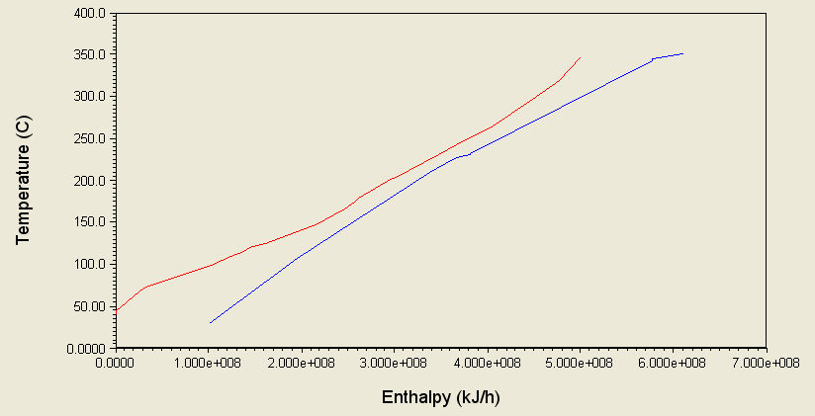

Figure 7: Shifted Composite Curve of Crude Pre-Heat Train of CDU I of Kaduna Refinery and Petrochemicals Company

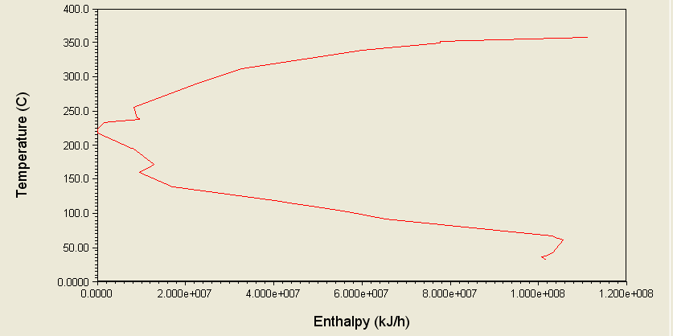

Figure 8: Grand Composite Curve of Crude Pre-Heat Train of CDU I of Kaduna Refinery and Petrochemicals Company

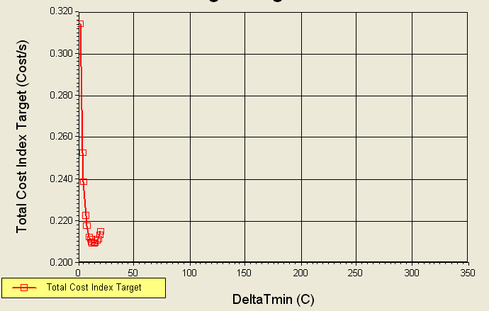

Figure 9: The Plot of Minimum Temperature Approach against Total Cost Index for Crude Pre-Heat Train of CDU I of KRPC.

3.3 Pinch Analysis Target Results
Figure 7 is the composite curve (temperature-enthalpy) profile of heat availability in the process (the “hot composite curve”) and heat demands in the process (the “cold composite curve”) together in a graphical representation. Figure 7, Table 2 and Table 3 shows that the heat available in the process is 1.12 x 108 kJ/hr while the heat demand in the process is 1.02 x 108 kJ/hr.. This shows that more heat is to be removed from the process than heat to be supplied to the system. Figure 8 (Grand composite Curve) shows that the Pinch temperature of the process is 370 ºC.
The results show that the utility heating of the plant is slightly higher than the utility cooling of the plant. Therefore any utility cooling supplied to the process above the pinch temperature cannot be absorbed and will be rejected by the process to the heating utility, increasing the amount of heating utility required, hence waste of energy (hot utilities) by the Crude Pre-Heat Train of CDU I of Kaduna Refinery and Petrochemicals Company.
Table 4.3 shows that capital cost target of N 9,537,410 was obtained for the pinch analysis. Operating cost and total annual cost of N 0.112005/s and N 0.209418/s respectively were obtained for the energy target. The Heat Exchanger target shown in Table 3 also shows that total minimum number of heat exchangers required to meet the energy target is 19 while the minimum heat exchangers required for maximum energy recovery is 38.

4. CONCLUSIONS

The following conclusions may be drawn from the result of the analysis.

- Minimum approach temperature 15 ºC was used to determine the energy target.
- The pinch point was found to be 220 ºC.
- The utilities targets for the minimum approach temperature were found to 1.12 x 108 kJ/hr and 1.02 x 108 kJ/hr for hot and cold utilities respectively.
- Pinch analysis as an energy integration technique saves more energy and utilities cost than the traditional energy technique

5. REFERENCES
- Adefila S. S. (1994). Heat Recovery System: theory and practice, NSChE International Workshop on Industrial Energy Management
- Akande H. F. (2007). Energy Integration of Thermal Hydro-dealkylation Plant, M. Eng. Thesis, FUT Minna, Minna, Nigeria. Pp.2.
- Chiyoda (1985). Thermal Hydrodealkylation of Toluene Manual, Chiyoda Engineering Design Comapany, Japan. Pp. 46.
- Dayo F.B. (2000). Auditing Energy Use in an Operating Plant, Industrial Energy Management. Pp.34.
- Linnhoff B. (1983). New Concept of Thermodynamics for better Chemical Process Design, Royal Society Esso Energy Award Lecture, Chemical Research and Development. 61: 207-223.
- Linnhoff B. and Hindmarch E. (1983). Pinch Design Method of Heat Exchanger Network, Chemical Engineering Science 38: (5) Pp. 745-763
- Linnhoff B. and Parker S. (1984). Heat Exchanger Network with Process Modification, International Chemical Engineering annual research meeting, Bath UK
- Linnhoff B. and Vredeveld D. R. (1984). Pinch Technology has come of Age. Chemical Engineering Progress 33-40.

NOMENCLATURES
CRU Thermal Hydro-dealkylation Unit
ΔT_{min} Minimum Temperature Approach
HEN Heat Exchanger Network
N_{DoF} Number of Degree of Freedom
N_{ts} the number of target streams
A the target area
F_{i} the correction factor accounting for non-
counter current flow
${ΔT}_{\text{LM}}$ The logarithmic mean temperature
difference at each interval
i denotes the i-th enthalpy internal
j denotes the j-th stream
dT_{h} The temperature change for the hot stream at
each enthalpy interval
M The mass flow rate of the stream
C_{p} The specific heat capacity of the stream
h The heat transfer of the stream
dT_{c} The temperature change for the cold stream
at each enthalpy interval
N_{u,min} The unit target
N_{s} The number of process and utility streams
N_{mv} The number of manipulated variables
N_{l} The number of heat exchanger loops
N_{i} The number of independent systems
N_{s} The number of process and utility streams
N_{A} The number of process and utility stream
above the pinch
N_{B} The number of process and utility streams
below the pinch
PFD Process Flow Diagram
CDU 1 Crude Distillation Unit 1
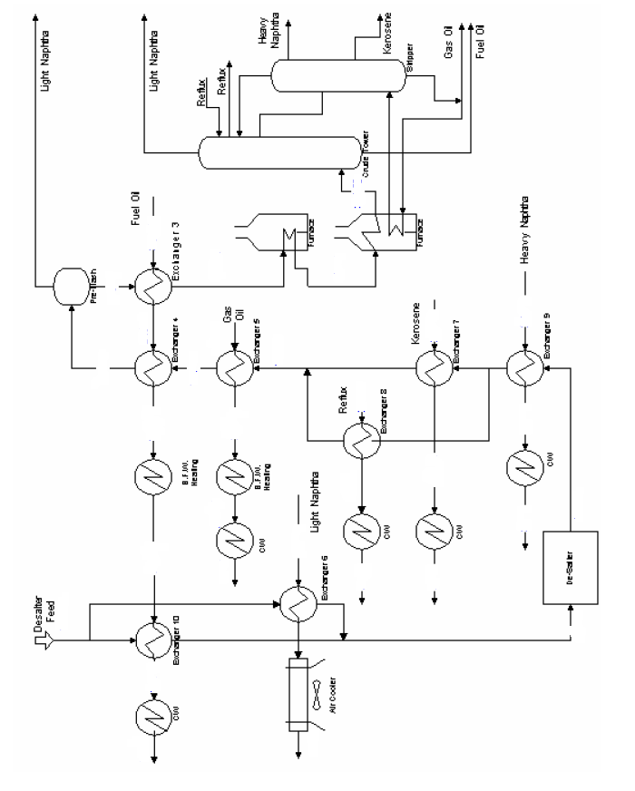

3/10/2009

