**The importance of applying wasfty to the residents of the holy city of Mecca**

Obied M. Alsaab (1), Salem T. Alharbi, Turky M. Al Harthy, Hasan S. Alshughaybi, Nawaf A. Alshamrani, Saeed H. Alsuhimi, Hussam M. Alowaydhi, Ali. D. Algarni, Sayyaf K. Almabadi.

Pharmacy Technician at Ibn Sina Hospital for long-term care, Ministry of Health, Mecca, Saudi Arabia (1)

Pharmacy Assistant, Ibn Sina Hospital, Ministry of Health, Mecca, Saudi Arabia

Pharmacist Technician, Ibn Sina Extended Care Hospital, Mecca, Saudi Arabia

Pharmacist, Ibn Sina Extended Care Hospital, Mecca, Saudi Arabia

Pharmacist, Ibn Sina Hospital, Mecca, Saudi Arabis

Pharmacist, Hadaa Primary Health Care Center

Pharmacist Technician, Ibn Sina Hospital, Mecca, Saudi Arabia

Pharmacist, Health Affairs Compliance Department, Jeddah, Saudi Arabia

Pharmacist Technician, Compliance Control Department, Mecca, Saudi Arabia

Oalsaab@moh.gov.sa

**Abstract**: the aim of the study is to find out the importance of the application of wasfty for the population of Mecca (Holy city), whether for Health centers or Hospitals, to know their opinions and impressions in terms of ease of use and download, and the quantity and variety of medicines for them. The reaction to this application or the decision makers by the male reviewers or female reviewers in Mecca on the extent to which they accept the application or not. An electronic questionnaire was created through the Google Drive application, where this questionnaire was distributed to social networking WhatsApp groups, where 750 responses were obtained from those (residents of the city of Mecca), out of a total of 900 questionnaires.

[Obied M. Alsaab, Salem T. Alharbi, Turky M. Al Harthy, Hasan S. Alshughaybi, Nawaf A. Alshamrani, Saeed H. Alsuhimi, Hussam M. Alowaydhi, Ali. D. Algarni, Sayyaf K. Almabadi. **The importance of applying wasfty to the residents of the holy city of Mecca.** *N Y Sci J* 2025;18(2):6-9]. ISSN 1554-0200 (print); ISSN 2375-723X (online). <http://www.sciencepub.net/newyork>. 02. [doi:10.7537/marsnys180225.02](http://www.dx.doi.org/10.7537/marsnys180125.02)

**Keywords:** wasfty; electronic; application; dispensing; medicine; male; female; reviewer

**Introduction:**

My Wasfty service is one of the services of the National Company for the Unified Purchase of Medicines, Devices, and Medical Supplies “Nupco” under the supervision of the Ministry of Health in the Kingdom of Saudi Arabia. Preliminary in community pharmacies so that the medicine is available everywhere and at any time for free (https://wasfaty.sa/about/).Similar information technology systems that facilitated the electronic transfer of registrations have been used in several countries around the world, including Sweden, Italy, the United States, and England (Goundrey-Smith,2018). For example, the National Health Services (NHS) in England incorporated community pharmacies in providing health services to the public by linking them with general practitioners (GPs) (primary healthcare centers). NHS contracts with local pharmacies for three levels of service: essential, advanced, and enhanced. The basic essential contract involves dispensing NHS prescriptions written by GPs; this is considered the main role of community pharmacies. The Electronic Prescription Service (EPS) allows the electronic transfer of prescriptions from GP surgeries to community pharmacists (Saramunee,2011). Community pharmacies are responsible for the medication supply, so patients with acute or chronic conditions can obtain their medications free of charge or incur a co-payment charge. NHS repays community pharmacies for the medication costs, as well as dispensing charges. Electronic submission of reimbursement is enabled through EPS to the NHS Business Service Authority (Goundrey-Smith, 2018). Several benefits of using EPS have been identified, including the fact that it is electronic prescriptions are accurate, complete, and legible, reducing the chance of being dispensed with errors and omissions. Provides higher levels of security, and regulates redundant distribution A workload that enables patients to receive their medication on time is a relief for patients because they don't have to wait for the paper prescription to be dispensed, and it opens up two-way communication between the prescriber and the pharmacist, allowing pharmacists to be more involved in patient-centered care. On the other hand, EPS is also correlated with delays in receiving prescriptions and inaccurate prescriptions. That the overwhelming number of prescriptions with unclear information may lead to delays in taking their release (Odukoya,2012).

**2-Material and Methods:**

This study was started in (the holy city of Mecca in Saudi Arabia), begin writing the research and then recording the questionnaire in January 2023, and the study ended with data collection in July 2023. The researcher used the descriptive analytical approach that uses a quantitative or qualitative description of the social phenomenon (The importance of applying wasfty to the residents of the holy city of Mecca). This kind of study is characterized by analysis, reason, objectivity, and reality, as it is concerned with individuals and societies, as it studies the variables and their effects on the health of the individual, society, and consumer, the spread of diseases and their relationship to demographic variables such as age, gender, nationality, and marital status. Status, occupation (Alserahy,2008), And use the Excel 2010 Office suite histogram to arrange the results using: Frequency tables Percentages (Al Zoghbi,2000). A questionnaire is a remarkable and helpful tool for collecting a huge amount of data, however, researchers were not able to personally interview participants on the online survey, due to social distancing regulations at the time to prevent infection between participants and researchers and vice versa (not coronavirus participation completely disappearing from society). He only answered the questionnaire electronically, because the questionnaire consisted of thirteen questions, all of which were closed. The online approach has also been used to generate valid samples in similar studies in Saudi Arabia and elsewhere (Kadasah, 2020).

**3- Results:**

As for the age of the participants in the questionnaire, their percentage was as follows: 0% from 16-23 years, 0% from 24-31, 52% from 32-39, 36% from 40-47 years, 8% from 48-55 years, over 65 years old, their percentage is 4%. With regard to gender, the percentage of male participants in the questionnaire was 84%, and the percentage of females was 16%. As for the nationality of the participants, 92% were Saudis and 8% were non-Saudis. As for their occupations, they were government sector employees 92%, employers 4%, freelancers 4% 0% private sector, and 0% students. With regard to the first question, is the application easy to download and install, 60% of the participants answered yes, 24% answered no, and 16% did not know. Regarding the second question, it was about whether the application connects you to the nearest pharmacy to dispense medicine. 65% answered yes, 28% no, and 16% did not know, the third question: Does the application reduce the health waste of medicines? 56% answered yes, 32% no, 12% do not know, The fourth question does the application lead to improving pharmaceutical services 40% yes and 44% no, 16% do not know, the fifth question does improving the efficiency of health expenditure for medicines 50% yes and 33.3% no, 16.7% do not know, the sixth question does the application reduce drug waste? 48% yes, 24% no, 28% don't know, the seventh question: Does the application enhance the availability of medicines? 24% yes, 60% no, 16% don't know. The eighth question was about whether the application leads to improving patients' treatment and consultation? 32% yes, 52% no, 16% do not know, while the ninth question does the application help in preventing medication errors? 40% yes, 32% no, 26% don't know. The tenth question is, does the application have all the information you need? 12% Yes, 64% No, 24% I don't know. The eleventh question: Does the application have all the medicines needed by the attending physician easily and easily? 20% yes, 60% no, 20% don't know, the twelfth question: Is the application easy to dispense medicines from the pharmacist easily and easily? 36% yes, and 56% no, 8 do not know. The last question was about whether the application made it easier for the attending physician to choose between medications for you? 36% yes, 52% no, 12% don't know. (Figure No.1).

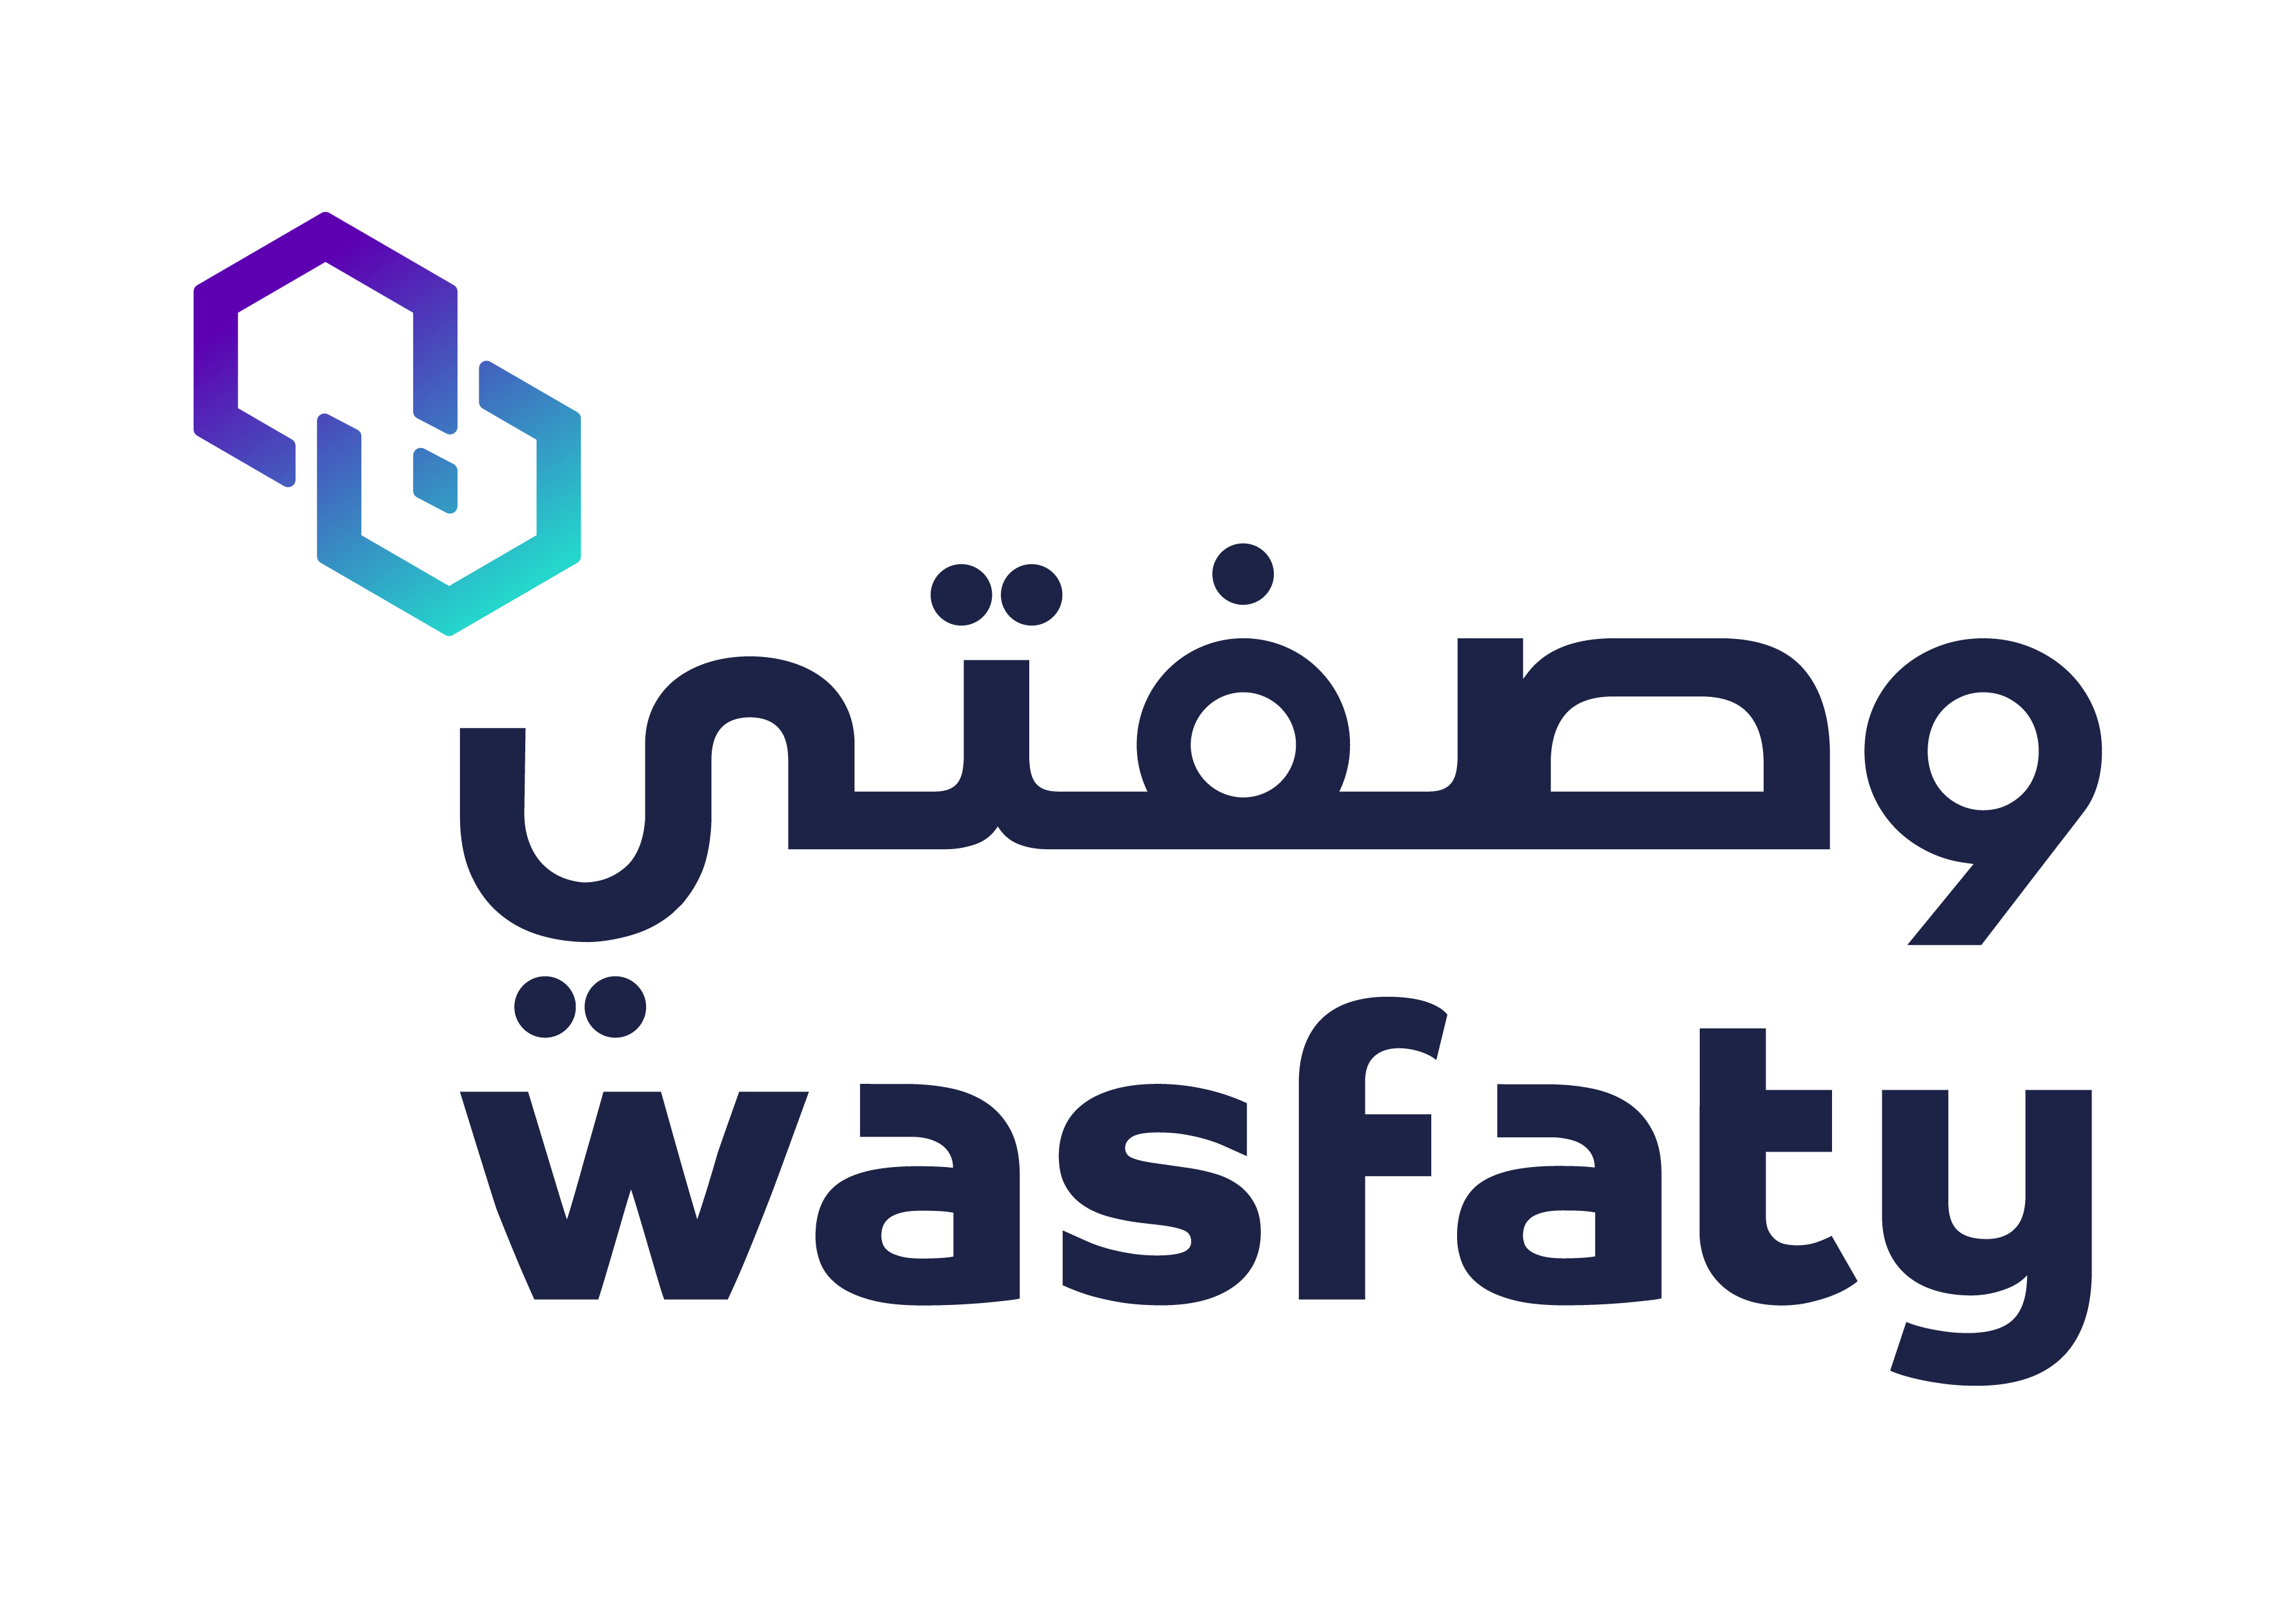

Figure No.1: My wasfty app logo

**4-Discussion:**

Through the response of the participants in the questionnaire, it was found that the Wasfaty application is easy to load and download by 60% and that it gives me the nearest pharmacy to dispense medicine by a percentage, which reduces health waste by the same percentage of 56%, and the percentage of improving pharmaceutical services by 40% (less than half), while the efficiency of health spending 50% while reducing drug waste 48%, slightly less than half, and the participants did not like the application in terms of the availability of medicines in it 24%, (while the majority of them said no 60%), the application did not improve patients’ treatment and counseling by 32%, it did not help prevent medication errors by 40%, and there are not all the medicines they need in the application for the participants 12%, and it does not provide the treating doctor with all the medicines they need It is needed by the patient by 20%, and the application did not facilitate the dispensing of medicines through the pharmacist by 36%, While the application did not facilitate for the treating doctor the freedom to choose between medicines for patients by 52%, which is more than half, through the participants’ answers, we find that the reviewers did not understand or understand this application, because they are used to dispensing medicines manually in the past, and they quickly get tired of the waiting time for dispensing medicines from Pharmacies accredited by the Ministry of Health. The new method (the application of my recipe) always takes time for people to understand and assimilate it by patients or reviewers.

Table No.1: The extent of satisfaction and impressions of the reviewers about the application of wasfty

|  |  |  |  |
| --- | --- | --- | --- |
| **Questions** | **Yes** | **No** | **I do not know** |
| is the application easy to download and install? | 60% | 24% | 16% |
| Whether the application connects you to the nearest pharmacy to dispense medicine? | 56% | 28% | 16% |
| Does the application reduce the health waste of medicines? | 56% | 32% | 12% |
| does the application lead to improving pharmaceutical services? | 40% | 44% | 16% |
| does improving the efficiency of health expenditure for medicines? | 50% | 33.3% | 16.7% |
| does the application reduce drug waste? | 48% | 24% | 28% |
| Does the application enhance the availability of medicines? | 24% | 60% | 16% |
| whether the application leads to improving patients' treatment and consultation? | 32% | 52% | 16% |
| does the application help in preventing medication errors? | 40% | 32% | 26% |
| does the application have all the information you need? | 12% | 64% | 24% |
| Does the application have all the medicines needed by the attending physician easily and easily? | 20% | 60% | 20% |
| Is the application easy to dispense medicines from the pharmacist easily and easily? | 36% | 56% | 8% |
| whether the application made it easier for the attending physician to choose between medications for you? | 36% | 52% | 12% |

This current study was conducted to find out the extent to which people accept dispensing medicines electronically through the Wasfaty application. From the participants’ answers, it was found that they do not accept this new application (people’s dissatisfaction is less than 50% in this study), maybe the reason that they are tired of waiting, and prefer to dispense medicines On paper without trouble, and perhaps if they had a delegate or a relative who would help them dispense the medicine on their behalf, their satisfaction with the application would improve, and this point differed with the study of (Almaghaslah, 2022) in that the level of satisfaction among people is average, on the other hand, the lack of availability and diversity of medicines in the application, both studies agreed on it in people's dissatisfaction.

**Acknowledgment:**

To start with, I would like to Praise God and thank Dr. Anas S. Dablool, from Umm Al-Qura University (Public Health Department, Faculty of Health Sciences Al-leeth), Mecca, Saudi Arabia. And the researchers who make the project comes to light.

Corresponding Author:

Mr. Obied Mohammed Ali Alsaab

Pharmacist, Long-Term care

Ibn Sina Hospital

Hadaa, Mecca, Saudi Arabia

Mobile Phone: 00966506873792

Email: [Oalsaab@moh.gov.sa](mailto:Oalsaab@moh.gov.sa)

**References:**

1. Alserahy, Hassan Awad, et al (2008), The thinking and scientific research, Scientific Publishing Center, King Abdul-Aziz University in Jeddah, the first edition.
2. Al Zoghbi, Muhammad and Al Talvah, Abas (2000), Statistical system understanding and analysis of statistical data, first edition, Jordon- Amman.
3. Kadasah, N.A.; Chirwa, G.C.; et al. Knowledge, Attitude, and Practice Toward COVID-19 Among the Public in the Kingdom of Saudi Arabia: A Cross-Sectional Study. Front. Public Health 2020, 8, 217.
4. Wasfty (<https://wasfaty.sa/about/).(Accessed> on 20-6-2023)
5. Goundrey-Smith, S. The Connected Community Pharmacy: Benefits for Healthcare and Implications for Health Policy. Front. Pharm. 2018, 9, 1352. [CrossRef]
6. Saramunee, K.; Chaiyasong, S.; Krska, J. Public health roles for community pharmacy: Contrasts and similarities between England and Thailand. Isan J. Pharm. Sci. IJPS 2011, 7, 1–11. [CrossRef]
7. Odukoya, O.K.; Chui, M.A. Relationship between E-Prescriptions and Community Pharmacy Workflow. J. Am. Pharm. Assoc. 2012, 52, e168–e174. [CrossRef]
8. Almaghaslah. Dalia 1, Alsayari, Abdulrhman, Almaghaslah. Sokinh and Alsanna. Haytham : Patients’ Satisfaction with E-Prescribing (Wasfaty) in Saudi Arabia: A Survey of Country-Level Implementation: A Survey of Country-Level Implementation. Healthcare 2022, 10, 806. https://doi.org/10.3390/healthcare10050806.

1/5/2025