**NaOH-Modified Plantain Stalk (nMPS) Biomass as Adsorbent for Methylene Blue from Aqueous Solution**

B.I. Nwabueze1, W.C. Chiagoziem2, I. O. Eboh-Ajoku1, B.O. Isiuku2, V.O. Njoku2 and O.O. John-Dewole3 and T.I. Akinkuotu 4

1Kingsley Ozumba Mbadiwe University, Ideato

2Department of Chemistry, Imo State University, Imo

3Department of Chemical Sciences, Lead City University, Ibadan

4Department of Chemistry, Sikiru Adetona College of Education Science and Technology, Omu Ajose

[johndewole.olusegun@lcu.edu.ng](mailto:johndewole.olusegun@lcu.edu.ng)

**Abstract**: Adsorptive removal of environmental contaminants, using agricultural wastes, have proved to be cost-effective, sustainable and ecofriendly. This study experimented the biosorption of methylene blue dye (MBD) from aqueous solution using a treated plantain stalk biomass as adsorbent. 300 g of powdered plantain stalk biomass was treated with 1.0 M NaOH which was used as the experimental adsorbent in the batch studies. The surface area characterization of the NaOH-modified plantain stalk (nMPS) biomass was studied using Fourier Transform Infrared Spectroscopy (FTIR) and Scanning Electron Microscopy (SEM) both before adsorption and after adsorption. The effects of contact time, adsorbent dosage, initial dye concentration, and pH on the adsorption efficiency were examined. The result of the batch adsorption revealed that the optimal adsorption temperature is 30 0C, beyond which the adsorption efficiency drops considerably. The increased in pH from 4 to 10 favored increased adsorption, suggesting that alkaline media best facilitate nMPS adsorptive capacity. The adsorption was favored by high concentration of MBD. The FTIR surface area analysis of the nMPS suggested the presence of functional groups like; -OH, C-O, CN, C=O, N=C=O, O-H, C-C and C=C. The presence of these functional groups was afforded by the NaOH modification of the adsorbent material which gave an adsorption efficiency of 94 %. The SEM results also revealed changes in surface area structures before and the adsorption experiment. Thus, the findings demonstrate the potential of NaOH-modified plantain stalk biomass as a sustainable and efficient adsorbent for textile wastewater treatment.

[B.I. Nwabueze, W.C. Chiagoziem, I. O. Eboh-Ajoku, B.O. Isiuku, V.O. Njoku and O.O. John-Dewole and T.I. Akinkuotu. **NaOH-Modified Plantain Stalk (nMPS) Biomass as Adsorbent for Methylene Blue from Aqueous Solution.** *N Y Sci J* 2025;18(1):15-25]. ISSN 1554-0200 (print); ISSN 2375-723X (online). <http://www.sciencepub.net/newyork>. 03. [doi:10.7537/marsnys180125.03](http://www.dx.doi.org/10.7537/marsnys180125.03)

**Keywords:** Activated Carbon; Functional Groups; FTIR; Surface Area; Water Pollution; Waste Recycle

**1.0 Introduction**

Environmental pollution and water contamination have increasingly become pressing global issues, necessitating the developments of effective and sustainable methods for wastewater treatment (Njoku et al., 2023). One promising approach is biosorption, which involves the use of naturally occurring materials on adsorbents to remove pollutants from aqueous solutions (Yigit et al., 2022). Biosorption is a physiochemical process that occurs naturally in certain biomass which allows it to passively concentrate and bind contaminants onto its cellular structure (Mousavi et al., 2022; Marrium et al., 2020 and Aniagor et al., (2024). Though using biomass in environmental cleanup has been in practice for a while, scientists and engineers are hoping this phenomenon will provide an economical alternative for removing dyes from industrial wastewater and aid in environmental pollution remediation (Njoku et al., 2021 and Abuzerr et al., 2018).

Pollutant removal capability of activated carbon in drinking water treatment plants has reported for more than fifty years (Ahmed and Dhedan 2010). This has successfully removed taste and odour-causing compounds, along with most synthetic organic chemicals like; pesticides and trihalo-methane precursors. Disinfection bye-products have also been removed from drinking water by granular activated carbon (GAC) (Marrium et al., 2020). The biosorption phenomenon appears to involve both surface adsorption and absorption into the cell interior. (Ding and Li 2020). Adsorption is the adhesion of atoms, ions, or molecules from a gas, liquid or dissolved solid to a surface (Muhammad et al., 2021). Both solids and liquids adsorb most effectively when they are in a form in which a relatively small amount of matter presents a large amount of surface area. Finely divided solids, like clay and porous solids, such as charcoal, are the good adsorbents. Fine liquid droplets also like those that occur in sprays are also good adsorbents (Zi-Jun et al., 2021 and Patra et al., 2021).

Activated carbon has proven to be a very effective adsorbent for many type of inorganic and organic compounds because of its high surface area and unique chemical properties, including the polarity and nature of surface functional groups. The surface chemistry of these carbons and the chemical characteristics of adsorbate, such as polarity, ionic nature, functional groups, and solubility, determine the nature of the adsorption mechanism as well as the extent and strength of adsorption (Abdelfattah et al., 2016; Abdulhameed et al., 2021 and Yagub 2012). Moreover, the porous structure of activated carbon consists of a network of interconnected macropores, mesopores, and micropores that provide a good capacity for the adsorption of organic molecules. Thus it is expected that various mechanisms and forces, such as ion exchange, covalent bonding, van der Waals forces, H-bonding, dipole-dipole interactions, and carbon-and water-bridging can be responsible for adsorption of organic compounds in activated carbon. Despite its many advantages, though, the production and regeneration of activated carbon is very expensive with higher grades commanding even higher costs (Mallakpour and Rashidimoghadam 2019). In an attempt to find alternative, more economic techniques, many researchers have exploited the use of other sorbents (Sun and Yang 2003) with varying degrees of success (Hameed and Ahmad 2019). Alternative, activated carbons can be prepared from inexpensive and plentiful raw materials which have proved to be affordable and very effective solution. Activated carbon from agricultural sources, usually wastes, can be prepared either by physical activation, which involves primary carbonization (below 700 oC) followed by controlled gasification under the action of oxidizing gases at high temperature (up to 1,100 oC) (Blaga et al., 2022), or chemical activation where the precursor is mixed with a chemical that restricts the formation of tars (e.g., nitric acid, phosphoric acid and hydrogen peroxide).

Dyes are widely used in industries such as textiles, rubber, printing, lather and cosmetics to add color to their products. As a result, they generate a considerable amount of colored wastewater. There are more than 10,000 commercially available dyes (Jia, 2018).

In this study, we investigate the potential of NaOH-modified plantain stalk (nMPS) biomass as an adsorbent for removal of methylene blue dye from wastewater. Plantain stalk, an agricultural waste material, is abundant in the southwestern region of Nigeria. The unmodified biomass of this perennial agricultural waste has proven to possess a significant adsorptive capacity (Nwabueze et al., 2024). Consequently, this could offer an efficient, environmentally friendly and cost-effective alternative for wastewater treatment. By exploring the biosorption capabilities of nMPS, we aim to provide valuable insights into the feasibility and effectiveness of this novel adsorbent for removal of methylene blue dye (MBD). Through a detailed analysis of adsorption process, kinetics and mechanisms, we seek to contribute to sustainable wastewater treatment technologies and the utilization of plant-based materials for environmental remediation.

**2.0 Material and Methods**

**2.1 Preparation of the Adsorbent and its Characterization**

A matured plantain stalk was collected from Akuma Oru-East Local Government Area of Imo State, after the ripe edible part has been harvested. The sample was duly identified by Prof. Mbagwu who is a renowned botanist, in the Department of Botany, Imo State University Owerri. The plantain stalk was cut into smaller cubes and washed thoroughly with distilled water to remove dirt and other impurities. It was oven dried for 18 hours at the temperature of 60 oC. The dried sample was ground using manual grinder to increase the surface area and sieve to obtain 0.5 – 2 mm particle size. 300 g of plantain stalk powder is immersed in 1.0 M NaOH solution in a ratio of 1:10 w/v and stir continuously for 3 hours at room temperature. The treated plantain stalk powder is separated from the mixture by decantation. Excess NaOH and soluble impurities were remove by several washing with distilled water till the treated biomass becomes neutral (pH = 7). The neutralized treated biomass was dried in oven at 110 oC for 18 hours to obtain modified plantain stalk adsorbent (Nwabueze et al., 2024).

Surface area analysis was performed using Fourier Transform Infrared Spectroscopy (FTIR) and Scanning Electron Microscopy (SEM) to confirm the activation and assess the surface properties, functional groups and morphology of the adsorbent.

**2.2 Preparation of Adsorbate Solutions**

The MBD stock solution was prepared by dissolving 1 g of methylene blue in distilled water and making the solution up to 1,000 cm3 in volumetric flask (i.e. 1,000 mg/l). The working solutions were freshly prepared by dilution of the stock solution with distilled water when needed, using the formula

$C_{1}V_{1}=C_{2}V_{2}$………… eqn.1

Where

$C_{1}V_{1}$ = Conc and Vol. of the stock solution. $C_{2}V_{2}$ 
 = Conc and Vol of requires working solution

**2.3 Percentage MBD Removal**

100 cm3 of MBD concentration batches of 25, 50, 100, 150, 200 and 250 mg/l was prepared in a 250 cm3 conical flask. The pH of each solution was adjusted to 5. 1 g batch of nMPS was added into each flask. The temperature was set at 30 oC. Absorbance of clear liquid from each batch experiment was read from the spectrophotometer. Percentage removal of MBD was calculated using

$\% R=\frac{C_{0}-C_{t}}{C_{0}} × \frac{100}{1}$…… eqn.2

Biosorption isotherm models was plotted from the results of these batch experiments.

**2.4 Experimental Methods and Measurements**

Biosorption experiments was carried out in a reagent bottle containing 100 ml of MBD solutions at different concentrations and initial pH values. The initial pH values of the solution were previously adjusted with 0.1 M HCl or NaOH using pH metre. 1 g of nMPS was added to a reagent bottle containing 100 ml of 25 mg/l MBD concentration and sealed to prevent any change in volume during the experiments. This was shaken for 5 minutes in a water bath shaker. A small sample was collected with a syringe and analyzed in a UV-Spectrophotometer using wavelength of 668 nm. The batch experiment was also carried out at various contact time of 5, 10, 15, 30, 60, 90, 120, 150, 180, 210 and 240 minutes. pH 4, 5, 6, 7, 8, 9 and 10 were used for pH batch experiment. While batch temperature of 25, 30, 35, 40, 45 and 50 oC was used for the experiment. Similarly, batch concentration experiment was carried out at 50, 100, 150, 200 and 250 mg/l concentrations. The results obtained from the spectrophotometer was recorded using:

$Slope= \frac{Absorbance}{Concentration}$…… eqn. 3

Where

$Conc= \frac{Absorbance}{Slope}$…….….. eqn. 4

$q_{t}= \frac{\left(C_{0}-C_{t}\right)V}{m}$……….. eqn. 5

$q_{t}$ = biosorption capacity at a given time at mg/l.

Where;

$C_{0}$*= Initial Conc of Methylene Blue in mg/l*

$C_{t}$*= Methylene Blue conc at time t.*

*m = Mass of biomass used in g/l.*

*V = Volume of the solution in litres (l).*

**3.0 Results and Discussion**

**3.1 Results**

**Figure 1: Spectrophotometer Calibration graph of MBD Concentrations**

**Table 1: Effect of Contact Time at 250 mg/l MBD Conc, 30 0C, pH 5 using 1 g of nMPS**

|  |  |  |  |  |
| --- | --- | --- | --- | --- |
| Time (mins) | 100 ml of 250 mg/l Conc | Ct (mg/l) | qt (mg/g) | % R |
| 5  10  15  30  60  90  120  150  180  210  240 | 0.119  0.1195  0.115  0.100  0.075  0.050  0.036  0.029  0.022  0.0145  0.0075 | 239.60  239.000  230.000  200.000  150.000  100.000  72.000  58.000  44.000  29.000  15.000 | 1.040  1.100  2.000  5.000  10.000  15.000  17.800  19.200  20.600  22.100  23.500 | 4.160  4.400  8.000  20.000  40.000  60.000  71.000  76.000  82.000  88.000  94.000 |

**Figure 2: Effect of Contact Time at various Concentrations of Methylene blue at 300C and pH = 5 using 1g of nMPS**

**Figure 3: Effect of Temp at 200 mg/l Conc of MBD at pH 5 using 1g of nMPS**

**Figure 4: Effect of pH at 200 mg/l Conc of MBD using 1g of nMPS**

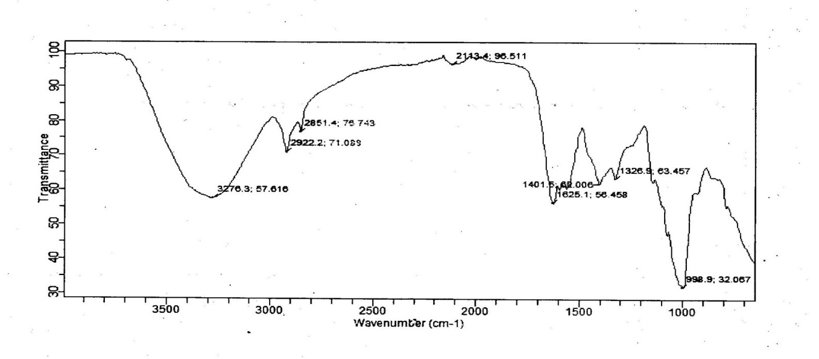

**Figure 5: FTIR Spectra of nMPS before Adsorption**

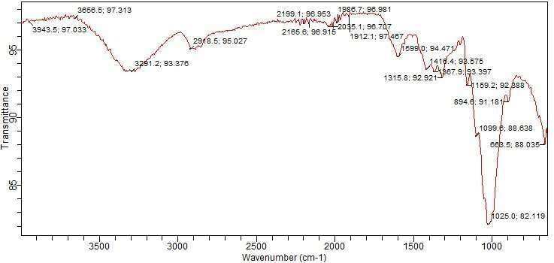

**Figure 6: FTIR Spectra of nMPS after Adsorption using 250 mg/L Conc of MDB at 30 oC**

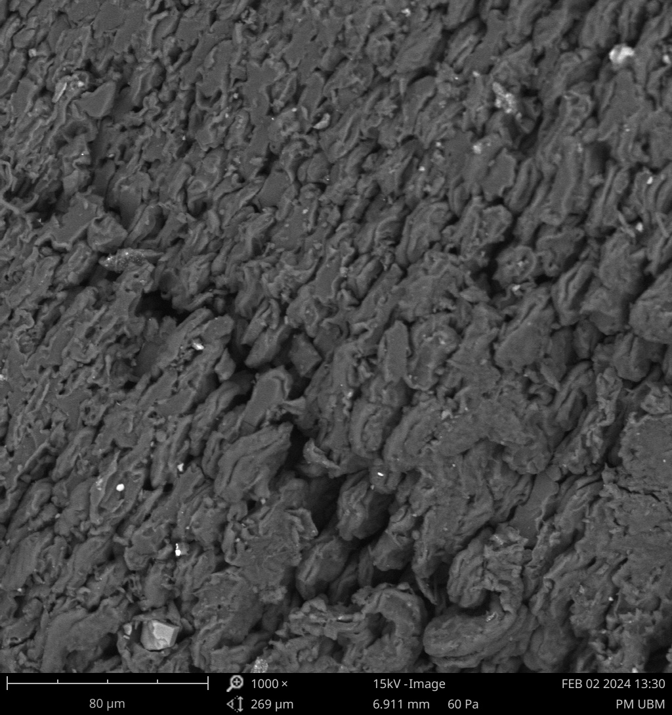

**Figure 7: SEM of nMPS before Adsorption**

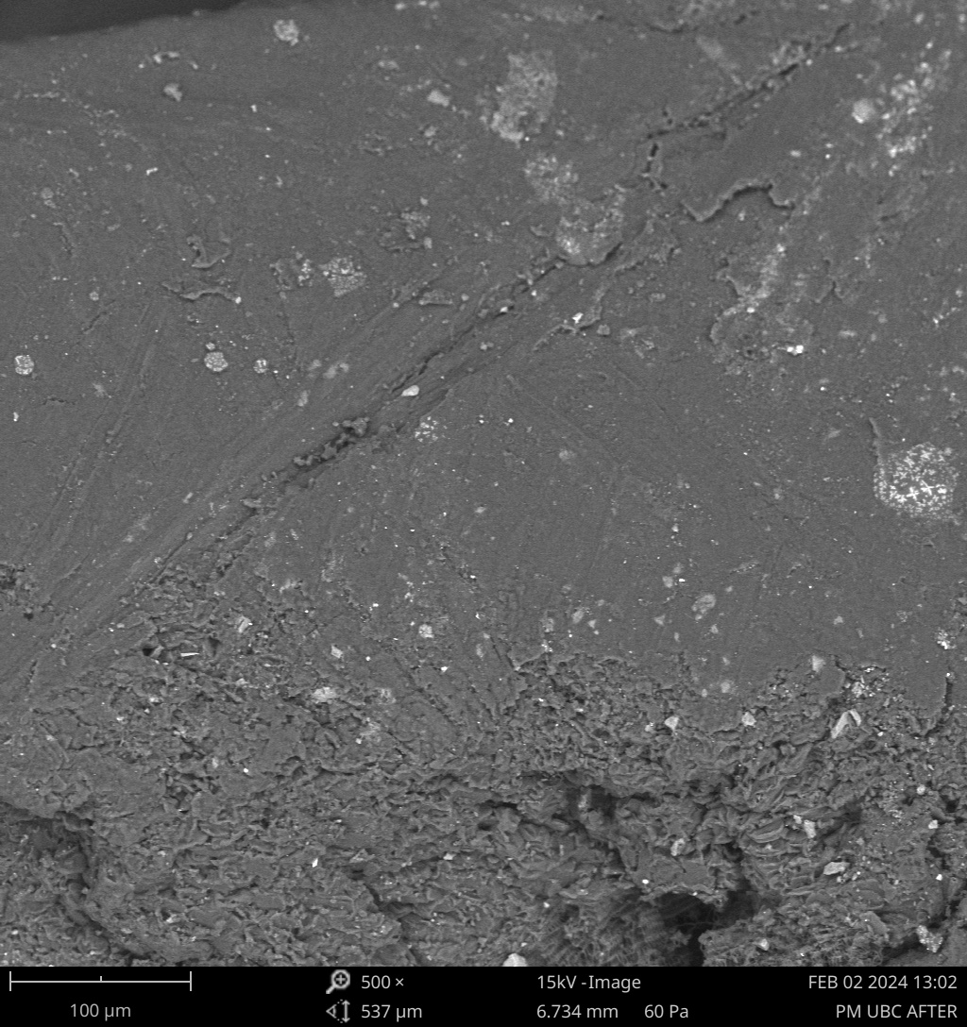

NaOH MPS BEFORE

**Figure 8: SEM of nMPS after Adsorption using 250 mg/l conc of MBD at 30 oC**

**4. Discussion**

**Effect of Contact Time on Adsorption Efficiency**

The batch removal of MBD was investigated at time intervals of 5, 10, 15, 30, 60, 90, 120, 150, 180, 210, 240 min from initial time respectively. The results showed (Table 1 and Figure 2) that the removal percentage increased with increasing contact time and reached optimal point at 240 min. At that point, the highest removal percentage of 94 % was achieved for 250 mg/l concentration of MBD using constant 1 g of nMPS. This showed a strong relationship between contact operation time with adsorptive capacity of nMPS at high concentration of MBD. The result was similar to what was obtained by Ai-Ghouti, M.A. and Al-Absi, 2020; Shelke et al., 2022 and Aniagor et al., 2024. This could be attributed to longer contact time which gives more opportunities for the dye molecule to interact with the adsorbent material, thereby increasing the adsorption chance. In another view, the MBD molecules have more time to diffuse into the pores of the adsorbent as the contact time increases, leading to more effective pollutant removal. Longer contact times can facilitate stronger chemical bonds between MBD molecules and the function groups of the active bonding site on the nMPS surface (Bencheikh et al., 2020 and Hamed 2019). The 94 % MBD removal can also be attributed to the modification of adsorbent’s surface area, because such high value was not achieved for unmodified plantain stalk adsorbent (Nwabueze et al., 2024).

**Effect of Temperature on Adsorption Efficiency**

Temperature-dependent adsorption efficiency is an important factor to consider while designing a suitable solid-state adsorbent material for any pollutant removal. From the result (Figure 3) the MBD percentage removal increased until the applied temperature reached 30 oC, beyond which the nMPS started to adsorbed poorly at every heat gained. It was also observable that equation plotted on the graph gave R2 = - 3.909, indicating a strong negative correlation. Similar condition was also reported by Lavin-Lopez et al., 2019; Essomba et al., 2022 and Mattioli et al., 2022. Ordinarily, increase in temperature enhances kinetic energy, since the higher temperatures provide more energy for the dye molecules to move and interact with nMPS material, thereby increasing adsorption efficiency. Warmer temperatures were expected to facilitate faster diffusion of MBD molecules into the pores of the nMPS; leading to higher removal rates (Yagmur and Kaya 2021). Additionally, elevated temperatures can weaken the intermolecular forces between the dye molecules and the solvent, making it easier for the dye to adsorb onto the adsorbent. The optimal temperature range for adsorption efficiency may vary depending on the specific properties of the adsorbent material (Wang and Guo 2020). Low temperatures (e.g., 20 – 30 oC) may result in lower adsorption efficiency due to reduced kinetic energy and slower diffusion rates. Moderate temperatures e.g. 30 – 35 oC) may provide optimal adsorption efficiency, as the kinetic energy and diffusion rates are balanced. High temperatures (e.g. 35 – 45 oC) may lead to decreased adsorption efficiency due to the potential degradation of the adsorbent or the dye (Singha et al., 2018 and Singh et al., 2021).

**Effect of pH on Adsorption Efficiency**

The pH of the solution plays a significant role in determining the adsorption efficiency of nMPS for MBD. Figure 4 showed that there was a steep increase in adsorption capacity as pH increases from 4 to 8, after which the curve increases gently to pH 10. This result is in concordance with Muthukumaran et al., 2016 and Nguyen and Sharma 2018. The effect of pH on adsorption efficiency can be attributed to several factors like; the surface charge of the adsorbent material, ionization state and solubility of methylene blue dye in aqueous state. At higher pH values (alkaline media), the surface charge of the adsorbent material becomes more negative, which can enhance the adsorption of positively charged methylene blue dye molecules. The negatively charged surface of the nMPS at higher pH values can attract the positively charged MBD molecules, increasing the adsorption efficiency. The relationship is similar to the adsorption efficiency dependence on the ionization state of the methylene blue dye. At lower pH values (acidic media), the dye molecules are more positively charged, which can enhance their adsorption onto the negatively charged adsorbent surface. The third factor which is the solubility of methylene blue dye in water also varies with pH. At higher pH values (alkaline media), the dye becomes more soluble, which can reduce its adsorption onto the adsorbent (Njoku et al., 2021 and Mitrogianniset al.,2019).

**Characterization of nMPS Surface Area**

Figure 5 and 6 revealed the FTIR spectra of the surface morphology of the plantain stalk biomass before modification and after modification. The FTIR spectra ascertained the possible involvement of the functional groups on adsorption properties of the surface area of nMPS. From the FTIR result both before and after adsorption it suggested that the major functional groups responsible for adsorption was OH with peaks of 3276.3 cm-1 before surface modification and 3291.2 cm-1, 3656.5 cm-1, 3943.5 cm-1 respectively after modification. The vibrational mode was obviously O-H stretching (i.e. hydrogen-bonded). There were also peak values of 2918.5 which indicate an alkyl functional group, with vibrational mode of C-H stretching (i.e. asymmetric) on the nMPS. The modified adsorbent biomass also has FTIR peak at 2199.1cm-1 which indicate a possible functional group of nitrile (CN) or isocyanate (N=C=O). Another conspicuous peak on the modified adsorbent biomass was 1599.0 cm-1, which in the indicate the functional group presence of either Carbonyl (C=O) or aromatic ring (C=C). this suggests the presence of lignin or other aromatic compounds in the biomass material. Other carbonyl-containing compounds like hemicellulose or cellulose derivatives might also be present. The peak at 1315.8 cm-1 indicate a functional group of either hydroxyl (-OH) or C-O stretching. The peak at 1025 on the nMPS is also suggesting the presence of C-O functional group. The hydroxyl groups can form hydrogen bonds with adsorbate molecules, enhancing the adsorption efficiency (Santhi et al., 2018). The hydroxyl groups can also increase the surface polarity of the adsorbent, allowing it to interact more effectively with polar adsorbate molecules (Santu et al., 2022). The carbonyl groups can provide electron-rich sites for adsorbate molecules to interact with facilitating adsorption. Carbonyl groups can also participate in complexation reactions with metal ions or other adsorbate molecules, enhancing adsorption efficiency. Aromatic ring (C=C) vibrations can help in π-π interactions with adsorbate molecules containing aromatic rings. Aromatic rings can delocalize electrons on the surface of the adsorbent thereby increasing its reactivity and adsorption capacity (Singha et al., 2018).

Figure 7 and 8 revealed the surface morphology of the plantain stalk biomass before modification and after modification. It is evident that the plantain stalk biomass adsorbent is porous and has an agglomerated rough surface, as well as an irregular particle shape. This signifies that physical adsorption of MBD may occur on its surface (Patra et al., 2021a). A noticeable textural structure is found after MBD adsorption on to the surface of the nMPS adsorbent. Scanning electron microscopy (SEM) is a powerful tool for characterizing the surface morphology and structure of nMPS biomass adsorbent. The SEM images revealed the porosity of the biomass surface which has tendencies to increase adsorption efficiency due to removal of impurities and breakdown of lignin (Patra et al., 2021b). The surface roughness is also evident in figure 8. The improved fiber structure has capacity to increase the surface area of nMPS thereby providing more active sties for adsorption, since a higher surface area allows for better interaction between the adsorbent and the adsorbate (Parvin et al., 2019b and Sanchez et al., 2021). The fiber structure can also improve the accessibility of the adsorbent’s surface. A more open fiber structure can facilitate easier diffusion of the adsorbate molecules, increasing the adsorption rate.

**Declaration of Competing Interest**:

The authors declare that they have no conflict(s) of interest. All authors have read, understood, and have complied as applicable with the statement on "Ethical Responsibilities of Authors" as found in the Instructions for Authors in this journal.

**Corresponding Author**

Olusegun Onimisi, John-Dewole

Department of Chemical Sciences

Lead City University, Ibadan

Tel: +2348034968640

Email: [johndewole.olusegun@lcu.edu.ng](mailto:johndewole.olusegun@lcu.edu.ng)

ORCID 0000-0003-4883-7750

**References**

1. Abdelfattah, I.; Ismail, A. A; Sayed, F.A.; Almedolab, A. and Aboeloghait, K.M. (2016): Biosorption of heavy metals ions in real industrial wastewater using peanut husk as efficient and cost effective adsorbent. Environ. Nanotechnol. Monit. Manag. **6**:176-183.
2. Abdulhameed, A.S., Hum, N.N.M.F., Rangabhashiyam, S. Jawad, A.H., Wilson, L.D., and Yaseen, Z.M. (2021). Statistical Modelling and Mechanistic Pathway for Methlyene Blue Dye Removal by High Surface Area and Mesoporous Grass-based Activated Carbon using K2CO3 Activator. Journal of Environmental Chemical Engineering. 9(4), 105530.
3. Abuzerr, S., Darwish, M., and Mahvi, A. H. (2018). Simultaneous removal of cationic methylene blue and anionic reactive red 198 dyes using magnetic activated carbon nanoparticles: equilibrium, and kinetics analysis. Water Science and Technology, 2017(2), 534–545.
4. Ahmed M.J, and Dhedan S K. (2010) Equilibrium isotherms and kinetics modeling of methylene blue adsorption on agricultural wastes-based activated carbons. Fluid Phase Equilib. 317:9-14.
5. Ai-Ghouti, M.A. and Al-Absi, R.S. (2020) Mechanistic Understanding of the Adsorption and Thermodynamic Aspects of Cationic Methylene Blue onto Cellulosic Olive Stones Biomass from Wastewater. Scientific Reports. 10(1),.1-18.
6. Aniagor, C.O., Aly, A.A., Mohamed, L.A. and Hashem, A. (2024). Removal of Methylene Blue Dye from Contaminated Wasterwater using lignocellulosic biomasses: A Comparative Study. Waste Management Bulletin. Vol.2. Iss.2. 213-225.
7. Bencheikh, I., Azoulay, K., Mabrouki, J., El Hajjaji, S., Dahchour, A., Moufti, A., and Dhiba, D. (2020). The adsorptive removal of MB using chemically treated artichoke leaves: parametric, kinetic, isotherm and thermodynamic study. Scientific African, 9, e00509.
8. Blaga, A. C., Tanasă, A. M., Cimpoesu, R., Tataru-Farmus, R.-E., & Suteu, D. (2022). Biosorbents based on biopolymers from natural sources and food waste to retain the methylene blue dye from the aqueous medium. Polymers, 14(13), 2728.
9. Ding, S. and Li, Z. (2020). Overview of Dyeing Wastewater Treatment Technology. Water Resources Protection2673-78 (in Chinese).
10. Essomba, J. P. Alla, P. D. B. and Belibi, N. N. (2022). Clay/polymer nano-composite material: a sustainable approach of leather industries wastewater treatment. International Journal of Environmental Science and Technology, *19*(6), 5181-5194.
11. Hamed, B. H. (2019). Grass waste: A novel sorbent for removal of basic dye from aqueous solution*. Journal of Hazardous Materials.* 166: 233-238.
12. Hameed, B. H., and Ahmad A. A. (2019). Batch Adsorption of Methylene Blue from Aqueous Solution by Garlic Peel, An Agricultural Waste Biomass. J. Hazard. Mater.164:870-875.
13. Jia, H. (2018). Application of SBR in Dyeing Wastewater Treatment. *Environmental Review* 16: 23-26.
14. Lavin-Lopez, A. Patón-Carrero, N. Muñoz-Garcia, V. Enguilo, J. L. Valverde, A. Romero. (2019). The Influence of Graphite Particle Size on The Synthesis of Graphene-based Materials and Their Adsorption Capacity. Colloids and Surfaces A: Physicochemical and Engineering Aspects*.* *582*, 123935.
15. Mallakpour, S. and Rashidimoghadam, S. (2019). 9-Carbon Nanotubes for Dyes Removal, Elsevier Inc.
16. Marrium A, Dutt, Muhammad A. H., Farwa N., and Haq N B. (2020) A review of advances in engineered composite materials popular for wastewater treatment. *Journal of Environmental Chemical Engineering*, *8*(5) , 104073.
17. Mattioli, D.; Malpei, F.; Bortone, G. &Rozzi A. (2022). Water minimization and reuse in the textile industry. Water Recycling and resource, recovery in industry
18. Mousavi, S.A., Mahmoudi, A., Amiri, S., Darvishi P. and Noori, E. (2022). Methylene Blue Removal Using Grape Leaves Wastes: Optimization and Modelling. Applied Water Science. 12(5), 1-11.
19. Muhammad S. H., Rabia R., and Muhammad I., (2021) Isothermal and Kinetic Investigation of Exploring the Potential of Citric Acid-Treated Trapanatans and Citrulluslanatus Peels for Biosorptive Removal of Brilliant Green Dye from Water. *Journal of Chemistry*, 1-23.
20. Muthukumaran, C. Sivakumar, V.M. and Thirumarimurugan, M. (2016) Adsorption Isotherms and Kinetic Studies of Crystal Violet Dye Removal from Aqueous Solution using Surfactant Modified Magnetic Nano-adsorbent, Journal of the Taiwan Institute of Chemical Engineers, 63,354–362.
21. Nguyen, N.P. and Sharma, D.C. (2018). Recycling of wastewaters of textile dyeing industries using advanced treatment technology and cost analysis—Case studies. Resources, Conservation and Recycling. 50. 306–318.
22. Njoku.V.O, Ibe .C., Iheanatu .S., (2021). Application of Assessment Models for Health Risk and Pollution from Surface Water from Okumpi Rivers in Nwangele, Imo State, Nigeria: World news of Natural science 38 (2021) 20-26.
23. Njoku.V.O, Ibe ..C. Iheanatu . S. Ahamed. A.S, and Bello. Y. (2023). Physcochemical, Pollution, Health Risk, & Irrigation Quality Evaluation of some surface water Sources in Nwangele, Southeastern, Nigeria: International Journal of Energy and Water Resources.
24. Nwabueze, B.I., Nwabueze,O.O, Isiuku,B.O., Njoku, V.O., Adindu, C.B. and John-Dewole, O.O.(2024). Biosorption of Methylene Blue from Aqueous Solution using Unmodified Plantain Stalk (UPS) Biomass.Life Sci J;21(10):8-14.
25. MitrogiannisGonzatez, M.V. and Salgnero, J.F. (2019). Novel Tannin based Adsorbent in removing cationic dye (Methylene Blue) from aqueous solution. Kenetic and equilibrium studies. Journal of Hazardous Material. 174(1-3):9-16.
26. Patra, B.R., Mukherjee, A., Nanda, S. and Dalai, A.K. (2021). Biochar Production, Activation and Adsorptive Applications: a Review. Environmental Chemistry Letters. 19(3), 2237-2259.
27. Patra, B.R., Nanda, S. Dalai, A.K. and Meda, V. (2021a.) Slow Pyrolysis of Agro-food Wates and Physicochemical Characterization of Biofuel Products. Chemosphere.285, 131431.
28. Patra, B.R., Nanda, S. Dalai, A.K. and Meda, V. (2021b.) Taguchi-based Process Optimization for activation of Agro-food Waste Biochar and Performance Test for Dye Adsorption. Chemosphere. 285. 131531.
29. Parvin, S., Rahman, M.W., Saha, I., Alam, M.J. and Khan, M.M.R (2019b). Coconut tree bark as a potential low-cost adsorbent for the removal of methylene blue from wastewater. Desalination wat. Treat., 146: 385 – 392.
30. Sanchez, J. M.; Gonzatez, M.V. and Salgnero, J. F. (2021). Novel Tannin-based Adsorbent in Removing Cationic Dye (Methylene Blue) From Aqueous Solution. Kinetic and Equilibrium Studies. Journal of Hazardous Material. 174(1-3):9-16.
31. Santhi . Naz, A., Kishore K, (2018) Assessment of the aerobic glass beads fixed biofilm reactor (GBs-FBR) for the treatment of simulated methylene blue wastewater. Scientific Reports 10 (1).
32. Santu Kumar S., Barun M., and TridibT. (2022). Sodium alginate‐cl‐poly (N, N‐dimethyl acryl amide‐co‐2‐acrylamino‐2‐methyl‐1‐propane sulphonic acid)/titanium dioxide nano composite hydrogel: An efficient dye‐removing agent. Journal of Applied Polymer Science, 139 (26).
33. Shelke, B.N. Jopale, M.K. and Kategaonkar, A.H. (2022). Exploration of Biomass Waste as Low-Cost Adsorbents for Removal of Methylene Blue Dye: A Review. Journal of Indian Chemical Society**.** 100530.
34. Singha, N.B., Nagpal, G., Agrawala, S. and Rachna. (2018) Water purification by using Adsorbents: A Review. Environmental Technology & Innovation, 11, 187-240.
35. Singh, A., Nanda, S., Guayaquil-Sosa, J.F. and Berruti, F. (2021). Pyrolysis of Miscanthus and Characterization of Value-Added Bio-oil and Biochar Products. The Canadian Journal of Chemical Engineering. 99, S55-S68.
36. Sun, Q. and Yang, L. (2003). The adsorption of basic dyes from aqueous solution on modified peat–resin particle, Water Research, 37, 1535–1544.
37. Wang, J. and Guo. X. (2020). Adsorption Kinetics Models: Physical Meanings, Applications and Solving Methods.J. Hazard. Mater., 390, 122156.
38. Yagmur, H.K. and Kaya. I. (2021). Synthesis and Characterization of Magnetic ZnCl2-activated Carbon Produced from Coconut Shell for the Adsorption of Methylene Blue.Journal of Molecular Structure. 1232, 130071.
39. Yagub, M.T., Sen, T.K., and Ang, H.M. (2012). Equilibrium, kinetics and thermodynamics of methylene blue adsorption by pine tree leaves. Water Air Soil Pollut., 223(8): 5267 – 5282.
40. Yigit K, Melisa A, Selin H, LaleYildiz A. (2022). In situ Green Synthesis of Cellulose based Silver Nanocomposite and its Catalytic Dye Removal Potential against Methylene Blue. Journal of Cluster Science 233 (4), 1623-1633.
41. Zi-Jun N, Quan-Fen G, Hesheng X, Meng-Meng S, Zhen-Jiang Q, Shu-Ting F Zhi-Hui Chen, S, and Sheng Z, (2021) Cyclodextrin self-assembled graphene oxide aerogel microspheres as broad-spectrum adsorbent for removing dyes and organic micropollutants from water. Journal of Environmental Chemical Engineering. 9 (2), 104749.

12/2/2024