

**Morphometric and Allometric study of *Nerium oleander* Species Collected from Gilgit-Baltistan, Pakistan**

Tajidar Ali Taj*, Issar Karim, Ghazala Shaheen, Shahida, Hira Batool,Noreen Fatima, Fozia Jamal,Tika Khan

Department of Plant Sciences, Karakorum International University, Konodas Gilgit, 15100

[tajidaralitaj22@gmail.com](mailto:tajidaralitaj22@gmail.com)

**Abstract:** Nerium oleander L. is a shrub. It remains evergreen and cultivated around the globe. It belongs to family Apocynaceae. It is grown for being highly medicinal, toxic and ornamental in nature. It is effective for cardiovascular, cancers, hyperglycemia, scabies and pathogenic disorders. Commonly used as rat poison and insecticidal. Consumption of any part becomes fatal for animals and humans. It is highly drought resistant and cultivated across all ecological zones of Pakistan. Current study attempted to explore different morphometric and allometric growth (leaves, sepals, petals, stamens and carpels) and relational parameters in plants collected from different altitudinal zones with varied climatic factors. Samples were collected from Yasin valley in Ghizer, Gilgit and Sonikot. Genes controlling number of sepals (#5), petals (#5), stamens (#5) and carpels (#5) found consistent and constant in their expression irrespective of their agro-ecological and climatic conditions. Mean area of petals recorded was 1.39 mm2 (R2 = 0.32) followed by sepals with 0.343 mm2 (R2 = 0.0019). Similarly, mean area of stamens was 0.73 mm2 (R2 = 0.0914) and carpels was 0.21 mm2 (R2 = 0.2615). Moreover, mean area of leaves was recorded 8.52 mm2 (R2 = 0.2404). Length and width of each floral part and leaves showed that their gene co-expression is highly significant. This is assumed to be either controlled by a single gene or in case of involvement of multiple genes, they are highly corelated in their expression. Whereas different parts of the plant showed dependency on the climatic variation. Therefore, the number of floral parts is a reliable characteristic to consider for systematics. Whereas their length, width and sizes cannot be considered for taxonomic categorizations.

[Tajidar Ali Taj, Issar Karim, Ghazala Shaheen, Shahida, Hira Batool,Noreen Fatima, Fozia Jamal,Tika Khan. **Morphometric and Allometric study of *Nerium oleander* Species Collected from Gilgit-Baltistan, Pakistan.** *N Y Sci J* 2024;17(11):27-34]. ISSN 1554-0200 (print); ISSN 2375-723X (online). <http://www.sciencepub.net/newyork>. 05 doi:[10.7537/marsnys171124.05](http://www.dx.doi.org/10.7537/marsnys171124.05)

**Key words:** Morphometry; Allometry; Nerium oleander; Medicine; poison; Ornamental

1. **Introduction:**

Nerium oleander L., an Apocynaceae member with evergreen medium height (~4 m) shrub. It is native to the Mediterranean region but cultivated worldwide for ornamentation (Sharma, R., Singh, S., Tewari, N., & Dey, P., 2023; Hardin JW and Arena JM. 1974). The leaves and the flowers are used for cardiac, diaphoretic, diuretic, anti-cancer, antibacterial (Nayar. S. L. and Chopra (1986), anti-fungal (Wang, XM; Plomley, JB; Newman, RA; Cisneros, A. 2000) and expectorant.

The plant is used as a rat poison and an insecticide (Kirtikar,K.R. and Bassu, B.D. 1999). Decoction extracted from leaves been applied externally to treat scabies and to reduce swellings. It is considered good to apply with water on ulceric leisons on the penis (Marchioni, A.R. and F. CalioDistefano, 1989).

Apart from medicinally importance, it possesses a wide range of healing properties including viz. anti-inflammatory, larvicidal, antidiabetic, cellular immune response, hepatic protective, wound healing, anti-microbial, antioxidant, antinociceptive, locomotor, diuretic, and anti-leukemic (Pandey, A., Usmani, S., Wahab, S., & Khatoon, S. 2023).

Nerium oleander exhibits diverse biological activities, such as cardiotonic, anti-inflammatory, antibacterial, anticancer, cytotoxic, antiplatelet aggregation, and central nervous system depressant effects. Erdemoglu et al. (2003)

Nerium oleander is drought and pest resistant. Despite its widespread cultivation across the globe, there has been a knowledge gap on the performance of different genotypes regarding growth and yield (Manjula et al., 2024). These plants produces terminal flower heads, usually pink or white (Kiran and Prasad, 2014). It is a very desirable ornamental plant with a longer flowering period (Argiropoulos & Rhizopoulou 2013).

1. **Material and Methods**

**Location**: Research was carried out in the administrative districts of Gilgit and Ghizer (Yaseen valley). Coordinates of the sapling are given in the table below (Table 1). The area ranges from 4500 feet above sea level to 8000 feet (see figure 1).

Table 1. Coordinates of the sapling

|  |  |  |  |
| --- | --- | --- | --- |
| **Locations (Sample Sites)** | **Longitude** | **Latitude** | **Height (MASL)** |
| Gilgit | 74 18 44 82 E | 35 55 7.28 N | 4921ft |
| Yasin valley | 73.3326 E | 36.3694 N | 8000 ft |
| Sonikot area | 74.34 37 E | 35 .91 81 N | 4905 ft |

**Sampling**: Three different sample sites were identified i.e. Sonikot Gilgit, Gilgit City and Yaseen. From each sample site, one hundred plants were assessed (See figure 2).

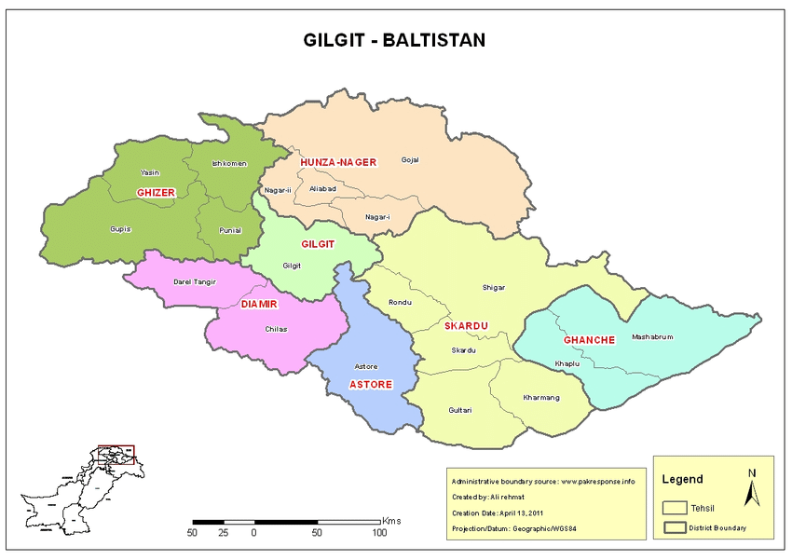

Figure 1. Research area shown in the red circles on the map of Gilgit-Baltistan

**Research parameters:** Each plant was examined and measured with length and width calculating the area of leaves, sepals, petals, stamens and carpels.

**Data processing and Analysis**: Measurements were made precisely and recorded on the data sheet physically. Digitization was carried out following physical measurements and statistical analysis was made using relevant tests. Descriptive and inferential statistical analysis revealed differential significance levels.

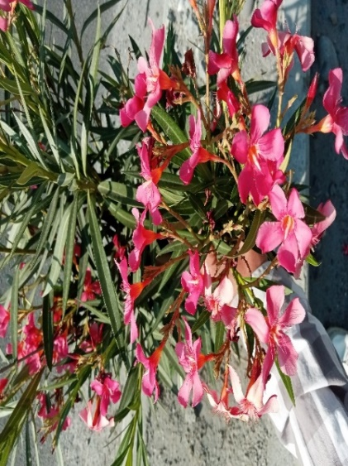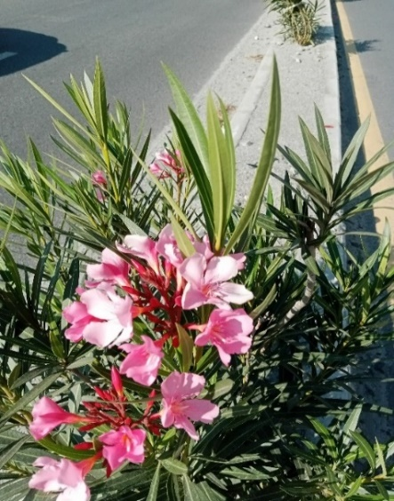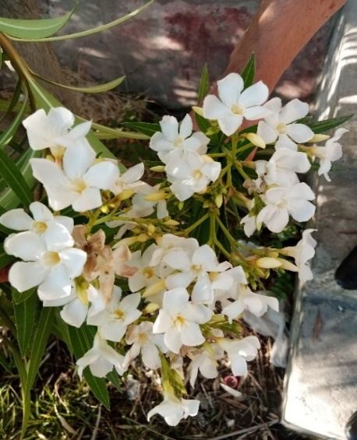

Figure 2. *Nerium oleander* samples collected showing variation in color and other floral parts. Photographs by Tajidar Ali

1. **Results and Discussion**

Following meticulous and precise measurements of sepals, petals, leaves, stamens, and carpels revealed that mean length of sepals recorded is0.53 mm (R2 = 0.0146), followed by width of 0.156 mm (R2 = 0.0505) and the mean area calculated was 0.343 mm (R2 = 0.0019). The range between maximum and minimum for the length and width was 0.62-0.46 followed by 0.26– 0.1mm respectively (Figure 3). No variation in the number of sepals across the altitudinal gradient was observed in our findings. Each sample collected from a different site has 5 sepals. It shows little impact of change in slop, water availability, temperature altitude.and soil type.

There were 5 petals recorded in all samples taken from different sites. Mean length for petals was recorded was 1.79 mm (R2 = 0.2776). Mean width was 0.75 mm and its (R2 = 0.1866). The mean area calculated was 1.39 mm its (R2 = 0.3221). The maximum and minimum range for the length and width recorded were 2.15 –1.38 mm respectively (Figure 4). Petal parameters were found more responsive towards, climatic conditions i.e altitude, soil type , average temperature.

There are 5 stamens in each flower, its fixed. The mean length of the stamen recorded was 0.20 mm its (R2 = 0.009) with a width of 0.32 mm its ( R2 = 0.4008). The mean area recorded was 0.73 mm its (R2 = 0.0914) the range between maximum and minimum for the length and width 0.32 - 0.73 mm and 1.04-1.59 mm (see figure 5).

The mean length of carpels recorded was 2.48 mm its (R2 = 0,0089) with a width of 0.21 mm its (R2 = 0.0243).the mean area calculated was 0.21 mm its ( R2  = 0.2615). see in figure 6.

The mean length of leaves was 10.09 mm (R2 = 0.1983) followed by mean width 0.83 mm (R2 = 0.3436). Similarly, their mean area observed was 8.52 mm2 (R2 = 0.2404). Leaves data reveals a greater influence of climatic conditions (see figure 7). There is a direct correlation between slop, sunlight and temperature with the size of the leaves. As Sonikot has lower altitude, higher temperature and longer sunlight showed larger leaf size as compared to other

From growth perspective figure 8 showed a higher level of growth in sonikot ,where climatic conditions are better, temperature water availability and sunlight duration are good .whereas yasin valley showed poor growth ratios having higher altitude and temperature less then the remaining locations.

Study revealed that different parts controlling genes express themselves independently. However, within each part of the plant, length and width controlling gene might be a single gene or if multiple genes involved, they must be highly dependent on each other (+ significantly correlated = 0.000, see in the correlational table 2 below)

| **Table 2 Coefficientsa** | | | | | | | | | | |
| --- | --- | --- | --- | --- | --- | --- | --- | --- | --- | --- |
| Model | | Unstandardized Coefficients | | Standardized Coefficients | t | Sig. | Correlations | | |
| B | Std. Error | Beta | Zero-order | Partial | Part |
| 1 | (Constant) | 1.286 | .492 |  | 2.611 | .010 |  |  |  |
| Petal.W | -1.620 | .073 | -1.187 | -22.175 | .000 | .126 | -.884 | -.636 |
| Petal.S | .941 | .033 | 1.619 | 28.420 | .000 | .646 | .925 | .815 |
| Stamen.L | -.034 | .027 | -.063 | -1.256 | .211 | .353 | -.107 | -.036 |
| Stamen.W | -.022 | .036 | -.038 | -.606 | .545 | .151 | -.052 | -.017 |
| Stamen.S | .006 | .007 | .071 | .915 | .362 | .174 | .078 | .026 |
| Sepal.L | .349 | .454 | .059 | .769 | .443 | .166 | .066 | .022 |
| Sepal.W | 1.003 | 1.881 | .192 | .533 | .595 | -.001 | .046 | .015 |
| Sepal.S | -1.912 | 3.201 | -.220 | -.597 | .551 | .019 | -.051 | -.017 |
| Carpal.L | .109 | .169 | .071 | .646 | .519 | .030 | .055 | .019 |
| Carpal.W | .892 | 1.950 | .112 | .458 | .648 | -.055 | .039 | .013 |
| Carpal.S | -.357 | .760 | -.127 | -.469 | .640 | -.041 | -.040 | -.013 |
| a. Dependent Variable: Petal. L | | | |  |  |  |  |  |  |

Our investigation reveals that all parts of samples collected from different sites showed no variation in their number but there was negligible variation in their length, width and area.petals and leaves were observed to be more responsive towards climatic conditions. Whereas sepals ,stamens and carpels also also showed no variation in number, little difference in length width and area was observed in all parts .samples from lower altitude sites blooms better in comparison to those collected from higher altitude.

Farmers and plant lovers are recommended to cultivate Nerium oleander in sunny, warm temperatures and well irrigated soils are preferred for its best growth.

**Project Funding:** This research was self-funded by the investigator, who bore all expenses personally, without any external financial support .  
  
**Author competing interests**

Authors declare that there is no competing interest.

**Acknowledgement**

This research by Tajidar Ali Taj consists upon semester research project. It was supervised by Dr Tika Khan and Ms Nasreen (PhD scholar). Mr. Issar Karim, Ms.Noreen Fatima, Ghazala Shaheen, Hira Batool and Fozia jamal has helped in data collection, processing and its presentation.

**References**

1. Manjula, B. S., Karunya, Balaji, S., & Shreedhar, Kulkarni, S., & Patil, S. (2024). Evaluation of the agronomic performance of nerium genotypes (Nerium oleander L.) under the Eastern dry zone of Karnataka. Journal of Applied and Natural Science, 16(3), 964-968
2. Kiran, C. D and N. Prasad. 2014. A Review on: Nerium oleander Linn. (Kaner).IJPPR, 6(3):593-597
3. Argiropoulos, A., & Rhizopoulou, S. (2013). Morphological features of petals of Nerium oleander L. Plant Biosystems - An International Journal Dealing with All Aspects of Plant Biology, 147(3), 638–644. <https://doi.org/10.1080/11263504.2013.763863>
4. Sinha, S.N. Biswas, K. (2016). A concise review on Nerium oleander L. - An important medicinal plant.Tropical Plant Research. 3(2): 408-412.
5. Chaudhary, K., Kushwaha, V. B., & Srivastav, S. (2024). A review: Nerium indicum or Nerium oleander and its toxicity in vertebrates. World Journal of Pharmaceutical Research, 13(6), 794-806. <https://doi.org/10.20959/wjpr20246-31728>
6. Farkhondeh, T., Kianmehr, M., Kazemi, T., Samarghandian, S., & Khazdair, M. R. (2020). Nerium oleander toxicity: A review. Human and Experimental Toxicology, 39(6), 773–784. <https://doi.org/10.1177/0960327120901571>
7. Pandey, A., Usmani, S., Wahab, S., & Khatoon, S. (2023). Phytochemical and Pharmacological Attributes of Nerium oleander: A Review. Current Nutrition & Food Science, 19(5). DOI: 10.2174/1573401319666230522160742
8. Erdemoglu N, Küpeli E, Yeşilada E. Anti-inflammatory and antinociceptive activity assessment of plants used as remedy in Turkish folk medicine. J Ethnopharmacol 2003; 89(1):123-129
9. Kingsbury JM .(1964) .Poisonous plants of the United States and Canada. Englewood Cliffs, NJ Prentice Hall.
10. Hardin JW and Arena JM. (1974). Human poisoning from native and cultivated plants, 2nd ed. Kingsport, Tennessee, Duke University Press.
11. Sabira Begum, Bina S. Siddiqui, Razia Sultana, Atiya Zia and Amin Suria. (1999). Phytochemistry Volume 50, Issue 3, 10: pp. 435-438
12. Goetz, Rebecca. J. "Oleander".(2005). Indiana Plants Poisonous to Livestock and Pets.Cooperative Extension Service, Purdue University. : pp.10-23.
13. Kirtikar,K.R. and B.D.Bassu .(1999).Indian medicinal plants. International book distributors, Dehradun, India Chopra.
14. R. N., Nayar. S. L. and Chopra. (1986). I. C. Glossary of Indian Medicinal Plants.Council of Scientific and Industrial Research, New Delhi.
15. Wang, XM: Plomley, JB: Newman, RA: Cisneros, A: (2000).Anal. Chem. 2000: 72 (15) pp. 3547 – 3552.
16. Marchioni, A.R. and F. CalioDistefano. (1989). Nerium oleander L.LepiantemedicinalidellaSardegna-Guidapratica per ilriconoscimento di 102 specie (in Italian).(Medicinal plants of Sardinia-practical guide-book for 102 species recognition). Ed.della Torre: pp.156-157.
17. Abe, F.and T. Yamauchi. (1992). Phytochemistry 31 (7): pp. 2459-2463. Valnet, J. (1976). Oleandro, Fitoterapia-curadellemalattie con le piante (in Italian).(Oleander, phytotherapy-diseases cure with plants). Aldo Martello-Giunti, Firenze, Italy: pp. 332-333.

11/5/2024