

**Delineation of Leachate at Oko-Filling Dumpsite Igando, Lagos, Nigeria Using Electrical Resistivity Methods**

Ogungbe, A. S*, Hotonu E.O, Onori, E.O

Department of Physics, Lagos State University, Lagos, Nigeria

[abiola.ogungbe@lasu.rdu.ng](mailto:abiola.ogungbe@lasu.rdu.ng), [ogungbea@yahoo.co.uk](mailto:ogungbea@yahoo.co.uk)

**Abstract:** Detailed knowledge of delineation of leachate at Oko-Filling dumpsite is crucial for improved groundwater quality management that serves the adjoining communities. The electrical resistivity methods were applied toinvestigate the extent at which contaminants from the dumpsite have infiltrated the subsurface lithology and the groundwater in the neighboring communities. Oko-Filling is situated between latitudes 6° 33’ 43’’ N and 6° 33’ 58’’ N and longitudes 3° 15’ E and 3° 15’ 20’’ E, in Alimosho Local Government Area of Lagos State, Southwest, Nigeria. Fifteen (15) vertical electrical soundings (VES) were carried out using Schlumberger array, while 2D electrical resistivity survey using Wenner array was conducted along five profiles for the survey. The VES data were interpreted using partial curve matching and computer iteration techniques and the pseudo section contouring method was used to plot the data from the 2D resistivity survey. The results of the VES showed that the subsurface of the area can be characterized into five different layers: topsoil, clay, sandy clay, clayey sand and sand. Resistivity of the study area varied between 3.7 and 1874 Ωm. The subsurface is also characterized by occurrence of near horizontal layering that typifies a sedimentary environment. The very low resistivity (<25 Ωm) portion of the clay layer in profile 2 may be due to leachate. The basal part of the clay unit in profile 3 is defined by an anomalously low resistivity zone (<30 Ωm), suggestive of contaminated zone. The obvious anomalously low resistivity units that occupy most part of the 2D sections of profiles 4 and 5, is a clear indication of a contaminated zone. The water bearing units of the subsurface serving the nearby communities is contaminated to depths of about 42 m, which could pose serious health challenges to neighboring communities.

[Ogungbe, A. S, Hotonu E.O, Onori, E.O. **Delineation of Leachate at Oko-Filling Dumpsite Igando, Lagos, Nigeria Using Electrical Resistivity Methods.** *N Y Sci J* 2024;17(11):14-22]. ISSN 1554-0200 (print); ISSN 2375-723X (online). <http://www.sciencepub.net/newyork>. 03. [doi:10.7537/marsnys171124.03](http://www.dx.doi.org/10.7537/marsnys171124.03)

**Keywords:** Leachate, Dumpsite, Electrical Resistivity, Groundwater, Contaminants

**1. Introduction**

Open dumping of waste poses a risk to the quality of the ecosystem, especially surface and groundwater. The scale of this menace depends upon the composition, extent of leachate present and the distance between landfill and water sources (Slomczynska and Slomczynski, 2004). Open dumping of waste is a common practice in most developing countries, as there is often unavailability of efficient solid waste disposal system.

This practice constitutes the main source of pollution to the soil, surface water and ultimately to the groundwater (Martinho and Almeida, 2006). The most serious environmental concern of this practice is the movement of impurities to the water table, which may subsequently contaminate the groundwater, especially in built up residential areas in towns and cities (Keller, 2000). This has necessitated the need for several studies, most of which are based on chemical analyses of nearby soils and water samples obtained from nearby streams, wells and boreholes, to determine the nature and extent of the pollutants in the surrounding areas (Al-Khashman and Shawabkeh, 2006; Okunowo *et al.,* 2020).

Geophysical methods offer an efficient means of imaging the subsurface. They have demonstrated to be peculiar in providing unique information to the study of subsurface contamination (Uchegbulam and Ayolabi, 2014). Application of geophysical methods draws inferences from identified contrasts in several physical properties that typically make up the component of an area or medium of interest. In general, the presence of leachate pollutants, which is inherently composed of soluble ions will facilitate the flow of electrical current, hence, lowering the electrical resistivity of the contaminated subsoil or lithology (Aristodemou and Thomas-Betts, 2000). This fact makes the electrical resistivity method of geophysical prospecting to be particularly suitable for delineating contaminated zones within the subsurface, including the groundwater (Fetter, 1993; Reynolds, 1998).

Concentration and spread of leachate vary with many interacting factors like composition, age, nature of the soil, volume of waste, degree of moisture and availability of oxygen. Others are landfill design and mode of operation (Reinhart and Grosh, 1998). Leachate composition primarily depends on how old the landfill and the degree of waste stabilization (Pohland and Harper, 1985).

Several studies (Adeoti *et al.,* 2011; Ogungbe et al., 2012; Ayolabi *et al.,* 2013; Ariyo *et al.,* 2013 ; Odukoya *et al.,* 2013; Olorode and Alao 2013; Coker *et al.,* 2019) have been carried out at different dumpsites in Lagos State, and have contributed significantly to the understanding of flow of leachates from dumpsites into the groundwater through seepage.

Studies involving application of electrical resistivity method of geophysical prospecting for determining groundwater contamination at Oko-Filling Igando dumpsite appears to be very few or not in-depth. The desire of wellness and healthiness of the inhabitants of the study area, who depend on groundwater for their water supply needs also spur the need to assess the level of contamination arising from the dumpsite.

This study, therefore, aims at investigating the extent at which contaminants have infiltrated the subsurface lithology and the groundwater in the adjoining communities, with the objective of identifying the leachate at the dumpsite environment.

**1.1 Location and Accessibility of the Study Area**

The Oko-Filling Igando dumpsite is one of the major dumpsites that is approved by the Lagos State Government. The dumpsite is, however, not engineered to prevent groundwater pollution. The dumpsite is situated between latitudes 6° 33’ 43’’ N and 6° 33’ 58’ N and longitudes 3° 15’ E and 3° 15’ 20’’ E. It is in Alimosho Local Government Area of Lagos State, Southwestern Nigeria and along LASU-Isheri expressway. It is surrounded by residential, commercial and industrial set-ups and has witnessed rehabilitation which consisted of reclamation of land, construction of accessible road for ease of tipping, spreading and compaction of waste since inception. The dumpsite receives waste from entire Lagos metropolis. It is accessible by tarred roads.

**1.2 Hydrogeology and Geology of the Study Area**

Two principal climatic seasons can be easily distinguishable; the dry season which is usually from November to March and the wet season which starts from April and ends in October, with a short dry spell in August. Average annual precipitation is put at about 1,700m3 and serves as a major source of groundwater recharge (Jeje, 1983). The hydrogeological condition of the landfill site is consistent with the regional hydrogeological setting of Lagos area as depicted by Longe et al. (1987). The study area is within the Coastal Plain Sands of the Mesozoic-Cenozoic Dahomey basin (Figure 1), which comprises of Abeokuta, Oshosun, Ilaro, and Benin as major stratigraphic formations. The sub-surface geology of the landfill consists of clay intercalated with lateritic clay which is capable of protecting underlying confined aquifers but not water table aquifers from leachate contamination (Longe et al., 1987).

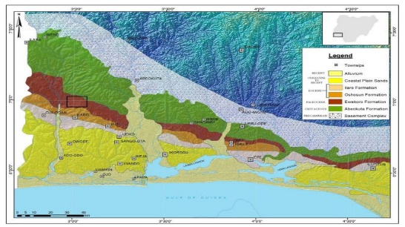

Figure1: Geological Map of Eastern Dahomey Basin Indicating the Study Area (in red dot) (Bolaji, *et al.,* 2020).

**2. Material and Methods**

**2.1 Geophysical Survey Data Acquisition**

Two electrical resistivity arrays were employed for the survey; Schlumberger array for vertical electrical sounding (VES) and Wenner array for two-dimensional (2D) electrical resistivity survey.

Fifteen VES data were obtained, which were used to investigate the vertical variation in electrical properties of the subsurface. The Schlumberger array was carried out by expanding the electrodes linearly about a fixed central position whose variation in vertical electrical resistivity is sought. At each expansion of the current electrodes, the resistance was measured.

The terrameter (PASI Model 16 GL) with terminals P1 and P2 (Figure 2), which is positioned between the potential electrodes, were connected to potential electrodes by means of potential cables. In the same way, the current cables were connected to the terminal C1 and C2. However, the cable of electrical wires were run parallel to each other on adjacent sides of the terrameter to avoid interference, especially where there is a long distance between the current electrodes. When all connections have been made, an input voltage level is chosen and the terrameter switched on to give the value of average resistance, R of the individual layer of the subsurface.

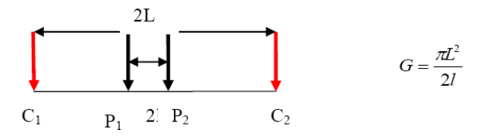

Figure 2: Schlumberger electrode configuration (Ahzegbobor 2010)

The resistance obtained is converted to apparent resistivity by applying the geometric factor which is a function of the electrode spacing. Electrode spread of AB/2 varied from 1 to a maximum of 100 m was employed. Acquired data were presented as sounding curves by plotting apparent resistivity against AB/2 on a log-log paper.

2D electrical resistivity survey using Wenner array was conducted along five profiles, which was conducted by moving the electrodes linearly along the profile with fixed electrode spacing and is expanded at different levels to determine horizontal as well as vertical variation in electrical resistivity (Figure 3). At each mid-point of the spread, the resistance was measured. The resistance obtained is converted to apparent resistivity by applying the geometric factor which is a function of the electrode spacing.

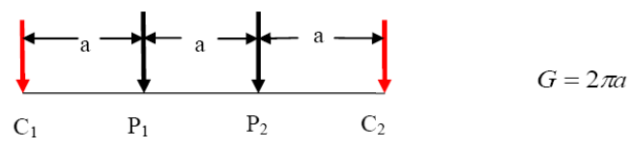

Figure 3: Conventional Wenner electrode configuration (Ahzegbobor 2010)

**2.2 Data Processing and Inversion**

Two methods of interpretation were employed in interpreting vertical electrical sounding; these include partial curve matching and computer iteration techniques. In partial curve matching techniques, the VES curve was obtained by plotting the apparent resistivity value against electrode spacing on transparent double logarithm paper superimposed on a set of two layers master curves with the same modulus and moved around until the field curve matched one of the model curves. While doing this, the axis of the two samples are kept parallel. The two types of layer master curve: the ascending type (where p1<p2), and the descending type (where p1;>p2) were used. Similarly, the auxiliary curves: the minimum type (H) where p1>p2<p3; the double ascending type (A) where p1<p2<p3; the maximum type (K) where p1<p2>p3; and the double ascending type (Q) where p1>p2>p3 were also employed.

When the field curve was matched, the origin of the coordinate of the master was then traced on the transparent sheet containing the field curve. The coordinates of the origin give the resistivity and thickness of the first layer respectively. The resistivity ratio (K1) value of the matched model curve was noted. Resistivity of the second layer was obtained from the product of the resistivity of the first layer and the resistivity ratio (K1).

To obtain the resistivity of the third layer and other layers, the field curves were superimposed on the appropriate auxiliary point chart with the marked first origin of the field coinciding with the origin of the auxiliary point chart. The auxiliary curve with resistivity ratio was traced from the field curve. Having done this, the field curve was again superimposed on the master curve while ensuring that the auxiliary curve pass through the master curve origin. The field curve was moved around until the second segment matched one of the master curves. This process was continued until the whole field curve was completely matched.

The second technique is ID forward modelling (1DF), which is a computer program that provides a way for the user to interactively model vertical electrical sounding data, by changing the geologic conditions and parameter that control earth resistivity responses. The method provides a comparison of real resistivity data to synthetic data, which assist in making geologic interference from the features observed in the real data. WINRESIST version 1.0 Program was adopted for the VES interpretation.

The pseudo section contouring method was used to plot the data from the 2D imaging survey. The horizontal location of the point is placed at the mid-point of the set of electrodes used to make the measurement. The vertical position of the plotting point is set at the median depth of investigation (Edwards, 1977) of the array. The pseudo section plot obtained by contouring the apparent resistivity gives a very approximate picture of the true subsurface resistivity distribution. However the pseudo section produces a distorted picture of the subsurface since the shapes of the contours depend on the type of array employed and the true subsurface resistivity.

**3. Results and Discussion**

The results obtained from the analyses of VES and 2D electrical resistivity data are presented, interpreted and discussed. The discussion is based mainly on the variation of electrical resistivity, which informed the identification of the various geo-electric units and contaminated zones.

**3.1 Vertical Electrical Sounding Data**

Table 1 presents a summary of the geo-electric parameters obtained after partial curve matching and computer iteration of the VES data. Four to five geo-electric layers were captured by the VES survey, and the curve types are mainly KH and KAK with lesser occurrence of AK, indicating that K curve is the dominant type.

Table 1: Summary of Geo-electric Parameters obtained from VES 1 – 15

|  |  |  |  |  |  |
| --- | --- | --- | --- | --- | --- |
| **Ves No.** | **Layers** | **Resistivity(Ωm)** | **Thickness (m)** | **Inferred Lithology** | **Curve Type** |
|  |  |
| 1 | 1 | 32.9 | 0.5 | Topsoil | KH |
| 2 | 118.6 | 3 | Clay |
| 3 | 11.8 | 5.9 | Clay (contaminated) |
| 4 | 127.2 |  | Clay |
|
| 2 | 1 | 45.4 | 0.6 | Topsoil | KAK |
| 2 | 231 | 1 | Sandy Clay |
| 3 | 85.1 | 3.5 | Clay |
| 4 | 837.3 | 9.9 | Sand |
| 5 | 5.3 |  | Clay (contaminated) |
|
| 3 | 1 | 24.3 | 0.6 | Topsoil | AK |
| 2 | 84.6 | 5.6 | Clay |
| 3 | 347.4 | 19.4 | Clayey Sand |
| 4 | 5.1 |  | Clay (contaminated) |
|
| 4 | 1 | 58.8 | 0.6 | Topsoil | KAK |
| 2 | 303.1 | 1 | Clayey Sand |
| 3 | 109.9 | 3.5 | Clay |
| 4 | 1097.5 | 10 | Sand |
| 5 | 5.8 |  | Clay (contaminated) |
|
| 5 | 1 | 78.9 | 0.6 | Topsoil | AK |
| 2 | 272.8 | 4.1 | Clayey Sand |
| 3 | 694.1 | 37.3 | Sand |
| 4 | 9.3 |  | Clay (contaminated) |
|
| 6 | 1 | 99.4 | 0.6 | Topsoil | KAK |
| 2 | 509.9 | 1 | Sand |
| 3 | 185.4 | 3.5 | Sandy Clay |
| 4 | 1874.7 | 9.9 | Sand |
| 5 | 3.6 |  | Clay (contaminated) |
|
| 7 | 1 | 81.1 | 0.6 | Topsoil | KAK |
| 2 | 420.2 | 1 | Sand |
| 3 | 151.2 | 3.5 | Clay |
| 4 | 1532.5 | 9.9 | Sand |
| 5 | 3.7 |  | Clay (contaminated) |
| 8 | 1 | 57.3 | 0.6 | Topsoil | AK |
| 2 | 204.5 | 5.5 | Sandy Clay |
| 3 | 807.8 | 20.2 | Sand |
| 4 | 8.9 |  | Clay (contaminated) |
| 9 | 1 | 98.2 | 0.6 | Topsoil | KAK |
| 2 | 510.2 | 1 | Sand |
| 3 | 182 | 3.5 | Clay |
| 4 | 1848.1 | 9.9 | Sand |
| 5 | 3.7 |  | Clay (contaminated) |
| 10 | 1 | 52.8 | 0.5 | Topsoil | KH |
| 2 | 209.9 | 2.5 | Sandy Clay |
| 3 | 26.2 | 8.3 | Sandy Clay (contaminated) |
| 4 | 203.8 |  | Sandy Clay |
| 11 | 1 | 66.3 | 0.5 | Topsoil | KH |
| 2 | 235.2 | 3 | Clayey Sand |
| 3 | 23.9 | 5.9 | Clayey Sand (contaminated) |
| 4 | 254.6 |  | Clayey Sand |
| 12 | 1 | 26.3 | 0.6 | Topsoil | KH |
| 2 | 104.5 | 2.5 | Sandy Clay |
| 3 | 13.4 | 8.7 | Sandy Clay (contaminated) |
| 4 | 105.4 |  | Sandy Clay |
| 13 | 1 | 40.0 | 0.5 | Topsoil | KH |
| 2 | 133.5 | 3.3 | Clay |
| 3 | 15.3 | 7.3 | Clay (contaminated) |
| 4 | 222.1 |  | Clayey Sand |
| 14 | 1 | 47.5 | 0.5 | Topsoil | KH |
| 2 | 170.5 | 3 | Sandy Clay |
| 3 | 17.1 | 6 | Sandy Clay (contaminated) |
| 4 | 189.0 |  | Sandy Clay |
| 15 | 1 | 60.6 | 0.5 | Topsoil | KH |
| 2 | 217.9 | 3 | Clayey Sand |
| 3 | 21.8 | 5.9 | Clayey Sand (contaminated) |
| 4 | 235.5 |  | Clayey Sand |

The resistivity graphs of VES of the study area are presented in Figure 4 – 18.

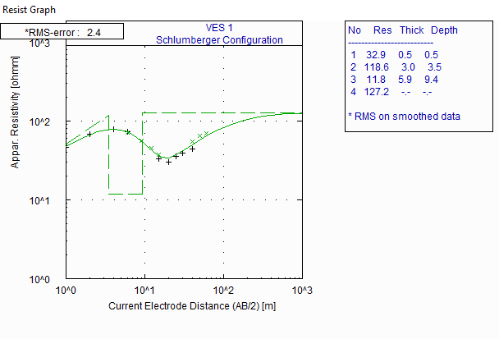**Figure 4: Resistivity Curve of VES 1**

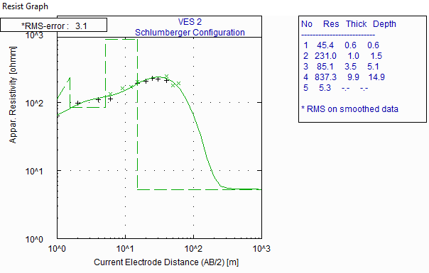

**Figure 5: Resistivity Curve of VES 2**

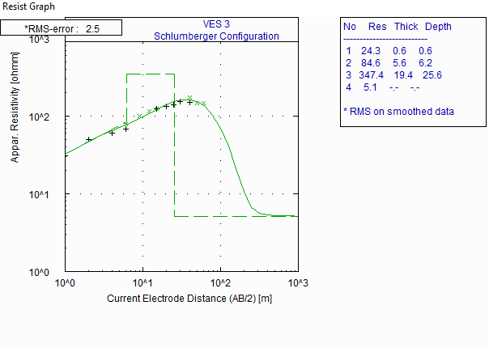

**Figure 6: Resistivity Curve of VES 3**

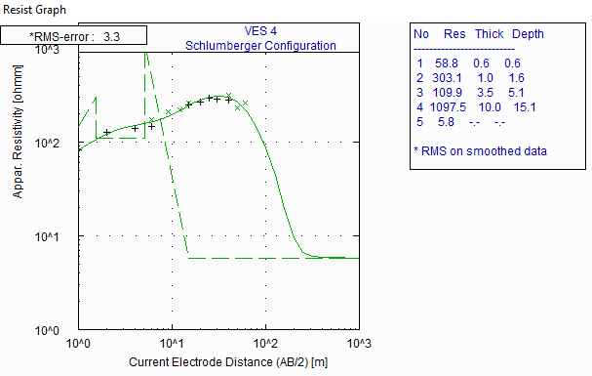

**Figure 7: Resistivity Curve of VES 4**

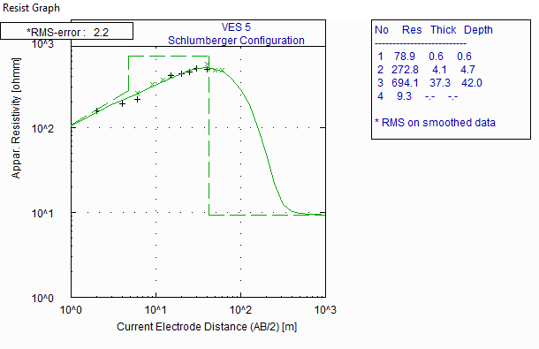

**Figure 8: Resistivity Curve of VES 5**

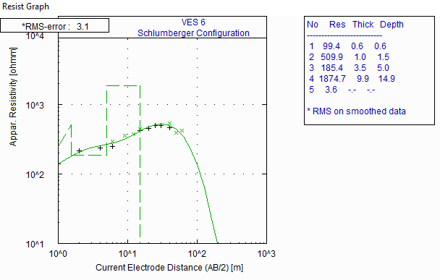

**Figure 9: Resistivity Curve of VES 6**

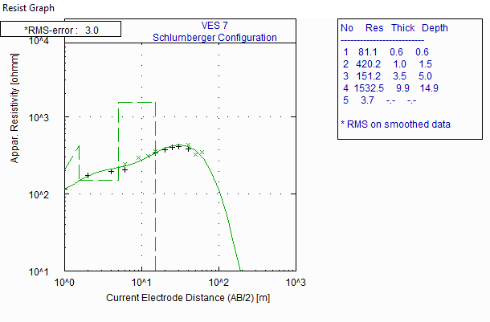

**Figure 10: Resistivity Curve of VES 7**

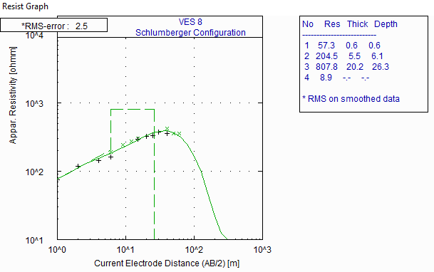

**Figure 11: Resistivity Curve of VES 8**

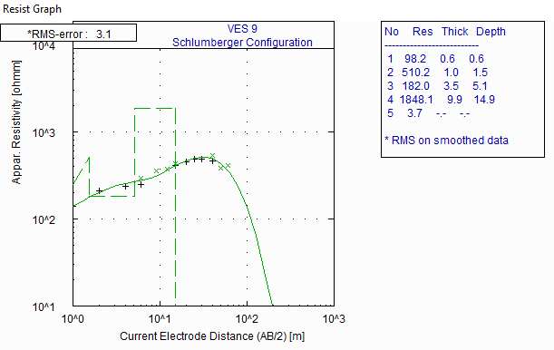

**Figure 12: Resistivity Curve of VES 9**

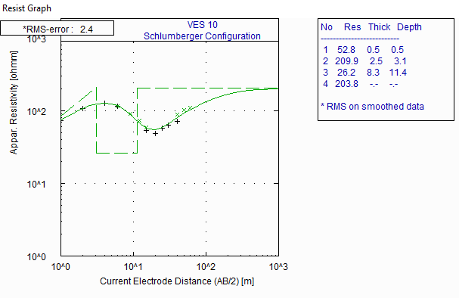

**Figure 13: Resistivity Curve of VES 10**

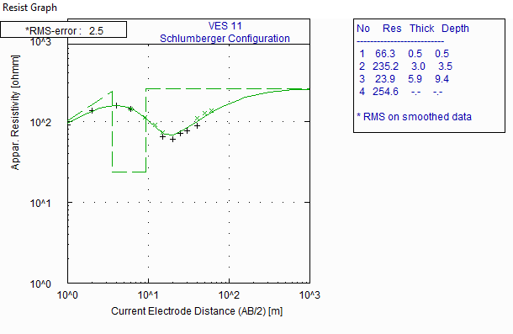

**Figure 14: Resistivity Curve of VES 11**

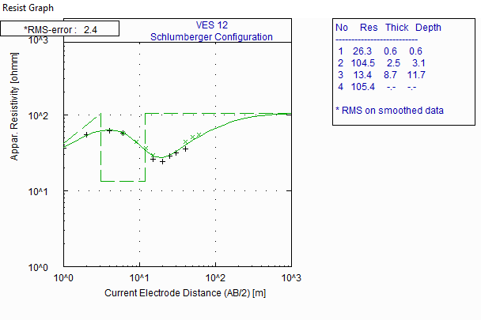

**Figure 15: Resistivity Curve of VES 12**

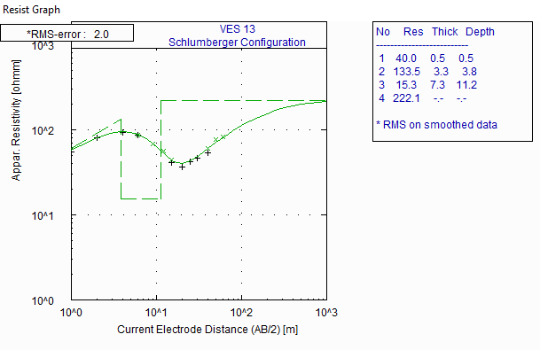

**Figure 16: Resistivity Curve of VES 13**

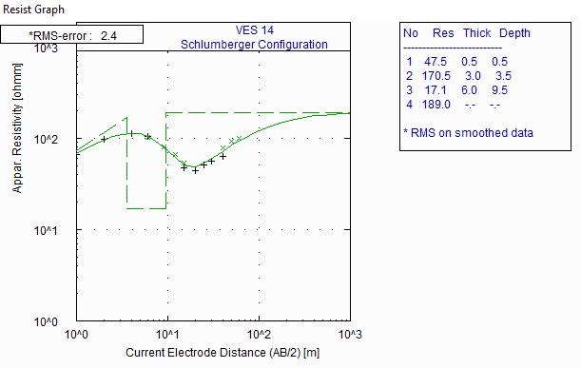

**Figure 17: Resistivity Curve of VES 14**

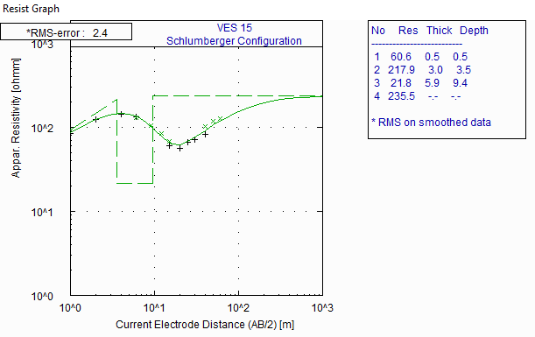

**Figure 18: Resistivity Curve of VES 15**

Results of the VES survey show that the subsurface of the area can be characterized into five different geo-electric layers: topsoil, clay, sandy clay, clayey sand and sand. Resistivity values of the topsoil layer tends to be constrained between 24.3 and 99.4 Ωm, and the thickness values are between 5 and 6 m. This furnishes the conception that the topsoil of the study area is clayey and, with higher probability of elevated levels of contaminants.

Clay, with resistivity ranges between 84.6 Ωm at VES 3 and 182 Ωm at VES 9, tends to be present in the subsurface of every part of the study area, with thickness varying between 3 m at VES 1 and 5.6 m at VES 3, which does not include the anomalously low resistivity layers (identified as contaminated clay) with resistivity values varying from 3.6 – 11.8 Ωm, occurring between VES 1 and VES 9, and VES 13. This is observed to occur at varying depths of 3.5 to 42 m. Other geo-electric units that are indicative of contaminated zones lie within sandy clay (13.4 – 26.2 Ωm) and clayey sand (21.8 – 23.9 Ωm), with thicknesses varying between 5.9 and 8.7 m, at depths of 3 – 3.5 m, between VES 10 and VES 15.

At other VES points, where the resistivity values of sandy clay are not indicative of contaminants or leachates, the resistivity ranges between 104.5 and 231 Ωm. It is thickest at VES 8 with value of 5.5 m and its least thickness (1.0) is observed at VES 2. Based on resistivity values, thickness and depth of occurrence, notably at VES 3, clayey sand may be serving as a fairly good aquifer within the subsurface of the study area. Hence, occurrence of contaminants in clayey sand shows that the groundwater of the area has been contaminated beyond 26 m due to leachate down flow, as depicted in VES 3 and Table 1.

Sand occurs between VES 2 and VES 9. Its resistivity values vary widely between 420.2 and 1874.7 Ωm, and thickness from 1 – 37.3 m. It is observed to be thickest at VES 5 where its resistivity is 694.1 Ωm. This indicates that sand is the main aquiferous unit in the area. Its occurrence as the layer directly overlying contaminated units between VES 2 and VES 9 may imply that it is contaminated.

**2D Electrical Resistivity Data**

The results of the 2D electrical resistivity imaging are presented as contoured pseudo and inverted sections. A contoured pseudo section conveys qualitative two-dimensional variation of resistivity within the subsurface (Dahlin, 2000). The subsurface of the study area is characterized by occurrence of near horizontal layering that typifies a sedimentary environment (Figures 19-23). From the inverted sections, the resistivity value varies from about 3 to 3000 Ωm, with maximum depth of 15.9 m.

Sandy clay (< 240 Ωm) is the dominant lithology unit in the subsurface along profile 1 (Figure 19). It is underlain by clayey sand/sand unit (>260 Ωm). It however seems to be contaminated up to depths of 13 m.

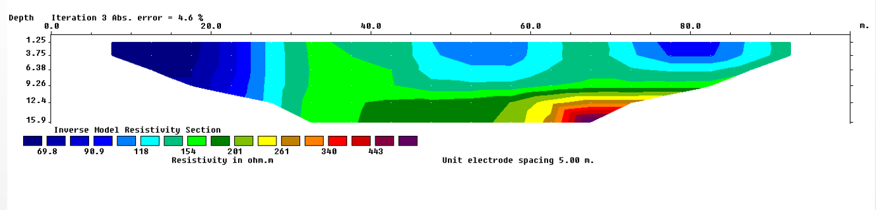

**Figure 19: Interpreted 2D Section of Profile 1**

At profile 2, the dominant feature is a laterally extensive layer which occupies the basal part of the section (Figure 20). This layer is identified as sand based on its resistivity values that range from about 300 – 500 Ωm. Depth to top of the layer varies from 4 – 8 m. This layer is overlain by a relatively thin sandy clay unit due to resistivity values of 150 – 280 Ωm. The uppermost layer has resistivity value of 60 – 130 Ωm, which depicts is clay. The very low resistivity (<25 Ωm) portion of the clay layer may probably be due to leachate.

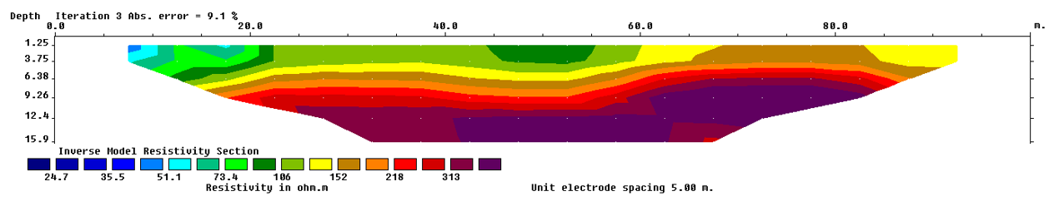

**Figure 20: Interpreted 2D Section of Profile 2**

The inverted section of profile 3 is presented in Figure 21. The portion of the study area represented by this profile is dominated by clay (60 – 180 Ωm), with thickness varying from 7 -16 m. This layer is underlain by a small actuate high resistivity (>500 Ωm) zone, and it is flanked towards the starting point of the profile by a fairly high resistivity unit (sandy clay). The basal part of the clay unit is defined by an anomalously low resistivity zone (<30 Ωm), suggestive of contaminated zone.

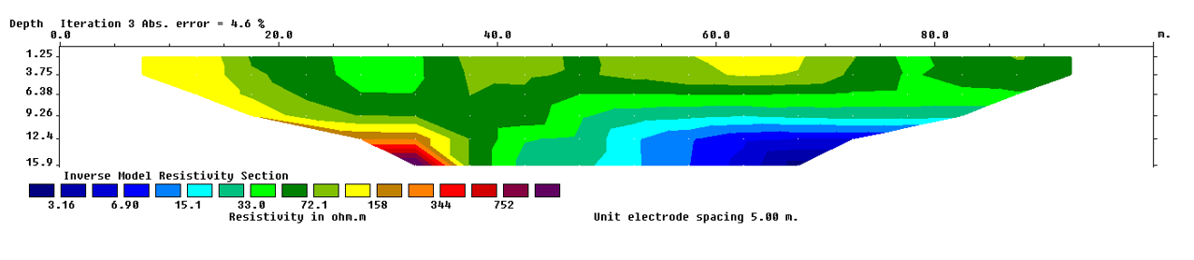

**Figure 21: Interpreted 2D Section of Profile 3**

The 2D section of profile 4 is shown in Figure 22. The profile shows an anomalously low resistivity (5 – 25 Ωm) unit that occupies most part of the profile. This is an indication of a contaminated zone. Effect of the contamination tends to extend to depths beyond 16 m and thickness of 11 m along the profile. It’s directly underlain by a sand unit with resistivity value of between 400 – 2000 Ωm.

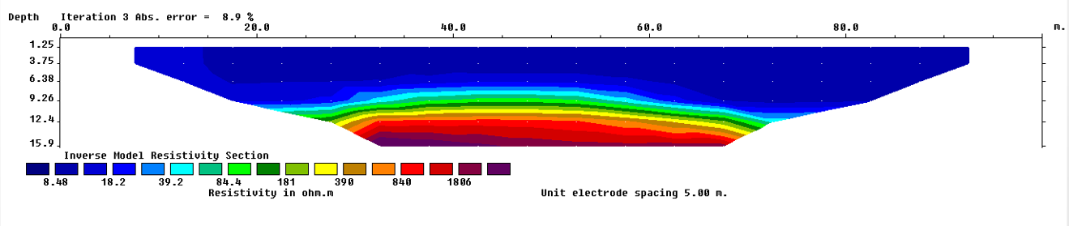

**Figure 22: Interpreted 2D Section of Profile 4**

The results of the 2D electrical resistivity imaging for profile 5 is depicted in Figure 23. The profile shows low resistivity (10.6 – 23.4 Ωm) unit that occupies most part of the profile. This is an indication of a contaminated zone. Effect of the contamination tends to extend to depths beyond 16 m and thickness of 11 m along the profile. It’s directly underlain by a sand unit with resistivity value of between 251 – 2696 Ωm, indicating an uncontaminated zone.

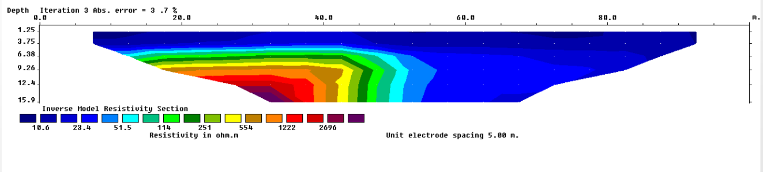

**Figure 23: Interpreted 2D Section of Profile 5**

**4. Conclusion**

The electrical resistivity methods were applied toinvestigate the extent at which contaminants from the dumpsite at Oko-Filling in Alimosho Local Government Area of Lagos State have infiltrated the subsurface lithology and the groundwater in the neighboring communities using Schlumberger and Wenner arrays.

The results of the VES showed that the subsurface of the area can be characterized into five different layers: topsoil, clay, sandy clay, clayey sand and sand. Resistivity of the study area varied between 3.7 and 1874 Ωm. The subsurface is also characterized by occurrence of near horizontal layering that typifies a sedimentary environment. The very low resistivity (<25 Ωm) portion of the clay layer in profile 2 may be due to leachate. The basal part of the clay unit in profile 3 is defined by an anomalously low resistivity zone (<30 Ωm), suggestive of contaminated zone. The obvious anomalously low resistivity units that occupy most part of the 2D sections of profiles 4 and 5, is a clear indication of a contaminated zone. The image of the subsurface presented in the 2D sections further corroborated the findings presented by VES.

The water bearing units of the subsurface serving the nearby communities is contaminated to depths of about 42 m, which could pose serious health challenges to neighboring communities.

**References**

1. Adeoti, L., Oladele, S. and Ogunlana, F.O. (2011): Geo-electrical investigation of Leachate Impact on Groundwater: A Case Study of Ile-Epo Dumpsite, Lagos, Nigeria. J. Appl. Sci. Environ. Manage Vol. 15 (2) 361 – 364.
2. Ahzegbobor P.A (2010). Acquisition geometry and inversion of 3D geo-electrical resistivity imaging data for environmental and engineering investigations. PhD Thesis Covenant University Otta, Ogun State, Nigeria.
3. Al-Khashman, O.A. and Shawabkeh, R.A. (2006): Metals distribution in soils around the cement factory in Southern Jordan. Environ. Pollut., 140:387-394
4. Aristodemou, e. and Thomas-Betts, A. (2000): DC resistivity and induced polarization investigations at a waste disposal site and its environments. J. Applied Geophys., 44:275-302
5. Ariyo, S.O., Omosanya, K. O. and Oshinloye, B. A. (2013): Electrical resistivity imaging of contaminant zone at Sotubo dumpsite along Sagamu-Ikorodu Road, Southwestern Nigeria. African Journal of Environmental Science and Technology. Vol. 7(5), pp. 312-320. DOI: 10.5897/AJEST2013.1479
6. Ayolabi, E.A., Folorunso, A.F. and Kayode, O.T. (2013): Integrated methods for environmental Assessment of municipal dumpsite system. Int J Geosci 4(5):850–862
7. Bolaji, T.A., Ndukwe, O.S., Oyebamiji, A.R. and Ikegwuono, O.N. (2020). Palynological Age Control and Paleoenvironments of the Paleogene Strata in Eastern Dahomey Basin, Southwestern Nigeria. Scientific Reports. *10:8991* | <https://doi.org/10.1038/s41598-020-65462-7>
8. Coker, J.O., Alausa, S.K., Odunaike, R.K., Alabi, A.A. and Ogunpola, A.E. (2019): The impact assessment of solid waste on groundwater quality in Olusosun dumpsite, Lagos Nigeria. J Nig Geophys Soc 2(1):1–1
9. Edwards, L. S., (1977): A modified pseudo section for resistivity and induced-polarization.  
   Geophysics, 42, 1020-1036.
10. Fetter, C.W. (1993): Contaminant Hydrogeology. Prentice-Hall, Inc., Upper Saddle River.
11. Jeje, LK.. Aspects of Geomorphology in Nigeria. In. Geography of Nigeria. Heinemann Educational Books, Nigeria. 1983; 17-44.
12. Keller, E.A. (2000): Environmental Geology. 5th Ed. Merrill Publishing Co., Ohio, USA
13. Longe EO, Malomo S, Olorunniwo MA. Hydrogeology of Lagos metropolis. J. Afr. Earth Sci. 1987; 6(3):163-174
14. Martinho, E. and Almeida, F. (2006): 3D behaviour of contamination in landfill sites using 2D resistivity/IP imaging: Case studies in Portugal. Environ. Geol., 49: 1071 – 1078.
15. Odukoya, A.M., Folorunso, A.F., Ayolabi, E.A. and Adeniran, A.E. (2013) Groundwater quality and identification of hydro geochemical processes within University of Lagos, Nigeria. J Water Resour Prot 5(10):930–940
16. Ogungbe A.S, Ogabi C.O and Umar A.A (2012) Assessment of the Impact of Municipal Solid Waste Landfill on Groundwater using Neighbouring, Opposite and Cross Methods of Electrical Impedance Tomography (EIT): Case study of Solous III, Lagos, Nigeria. New York Science Journal ;5(9)
17. Okunowo, O.O., Adeogun, O.Y., Ishola, K.S. and Alli, S. (2020): Delineation of leachate at a dumpsite using geo‑electrical resistivity method: a case study of Abule Egba, Lagos, Nigeria. SN Applied Sciences 2:2183 | https://doi.org/10.1007/s42452-020-03573-6
18. Olorode, D.O. and Alao, A.O. (2013) Geo-electrical investigation of underground water contamination by solid waste: Case study of Solous III Dumpsite, Oko-Filling Igando, Lagos, Nigeria. Adv Appl Sci Res 4(4):420–431
19. Pohland, F.G. and Harper, S.R. (1985): Critical Review and Summary of Leachate and Gas Production from landfills, US Environmental Protection Agency, Cincinnati; EPA/600/2-86/073
20. Reinhart, R.D. and Grosh, C.J. (1998): Analysis of Florida Municipal Solid Waste Landfill Leachate Quality, Report #97-3, Florida Centre for Solid and Hazardous Waste Management.
21. Reynolds, J. (1998): An Introduction to Applied and Environmental Geophysics. John Wiley & Sons Ed., New York.
22. Slomczynska, B. and Slomczynski, T. (2004): Physicochemical and toxicological characteristics of leechate from MSW landfills. Polish J. Environ. Stud. 13(6):627-637.
23. Uchegbulam, O. and Ayolabi, E.A. (2014): Application of Electrical Resistivity Imaging in Investigating Groundwater Pollution in Sapele Area, Nigeria. Journal of Water Resource and Protection 6, 1369-1379 <http://dx.doi.org/10.4236/jwarp.2014.614126>

11/2/2024