**Study on reproductive and breeding biology of Sambar (*Cervus unicolor*)**

1Manoj Kumar Tekaria and 2Dr. Ajay Kumar Verma

1,2Department of Zoology, Raj Rishi Govt. Autonomous College, Alwar, Rajasthan, India

Email:[manojkumar2015tekaria@gmail.com](mailto:manojkumar2015tekaria@gmail.com)

**Abstract:** Rusa unicolor (Kerr, 1792), or sambar, is the largest Oriental deer. Seven subspecies occur in varied habitats and elevations from India and Sri Lanka throughout southeastern Asia. Body mass and antler length decrease from west to east. R. unicolor is considered ancestral relative to the form of its male-only antlers and social behavior. Populations are vulnerable because of overexploitation for subsistence and markets in meat and antlers. R. unicolor was elevated by the International Union for Conservation of Nature and Natural Resources from no status in 2006 to ‘‘Vulnerable’’ in 2008 because of .50% decline in many populations over the past 3 generations. It is well represented in zoos and private collections and is introduced in Australia, New Zealand, South Africa, and the United States. Sambar (Cervus unicolor) is the largest deer species native to South and South-East Asia. Adult sambar stags weigh between 225 and 320 kg. Sambar hinds are smaller and weigh between 135 and 225 kg (Lydekker 1916, Crandall 1964, Downes 1983). It is closely related to the red deer (C. elaphus elephus) of Asia and Europe, the Rusa deer (C. timorensis) of Asia, and the Rocky Mountain elk (C.e. nelsoni) of North America (Whitehead 1972).

[Manoj Kumar Tekaria; Ajay Kumar Verma. **Study on reproductive and breeding biology of Sambar (*Cervus unicolor*).** *N Y Sci J* 2024;17(11):1-7]. ISSN 1554-0200 (print); ISSN 2375-723X (online). <http://www.sciencepub.net/newyork>. 01. [doi:10.7537/marsnys171124.01](http://www.dx.doi.org/10.7537/marsnys171124.01)

**Keywords**: Breeding behavior; Sambar (*Cervus unicolor*); Nidani Reserve Forest Alwar; Rajasthan

**Introduction:**

Deer farming as a specific component of agroforestry system is only recently introduced in tropical regions. Research on production will provide useful information for sustain ability of agroforestry system and native wild deer species conservation. Most silvopastoral research was conducted in temperate forest (Lehmkuhler et al. 2003; Husheer et al. 2006; Akashi et al. 2011). Studies showed that economic returns are higher with silvopastoral systems compared to either timber or livestock system alone (Pearson and Whitaker 1974; Clason andSharrow2000; Frey et al. 2012). The impacts of temperate deer species such as sika and red deer on forest regeneration in temperate countries were studied by many researchers (Husheer et al. 2006; Lovari et al. 2007; Kamler et al. 2008; Bocci et al. 2010). Despite this, few studies in tropical forests have considered the impacts of deer browsing on forest plantation. Sambar deer (Cervus unicolor) are indigenous animals to tropical Southeast Asia. Reproductive performance of For mosan sambar deer in semidomesticated herds was reported by Chan et al. (2009). Numerous studies compiled by Chardonnet (1993), Semiadi et al. (1994), and Hall and Gill (2005) indicated that countries like Australia, New Caledonia, New Zealand, and Papua New Guinea have successfully set up commercial deer farming and hunting using sambar deer. Bennett et al. (1995) indicated that wild sambar deer population was badly depleted especially in Sarawak, Borneo. Basiuk (1986) reported that deer are well suited to secondary forest and indeed thrive in these conditions, thus providing an excellent alternative for agroforestry schemes. Dahlan et al. (1993) reported that most of undergrowth vegetation in oil palm plantations was suitable for ruminants such as cattle, sheep, goat, and deer. These vegetations are similarly found in Sarawak. Dahlan (2005) reported that tropical deer species such as sambar deer (C. unicolor) and rusa deer (Cervus timorensis) were suitable in acacia plan tation although rusa deer like to debark the trunk of acacia trees (Dahlan and Jiwan 2003).

Sambar are essentially a non-social species. No Indian ungulate has adapted itself to a wider variety of forest types and environmental conditions than the sambar (Schaller 1967). It has an exceedingly wide geographical distribution that includes India, Myanmar, Sri Lanka, extending through the Malay countries, and eastward to the Philippines and beyond (Prater 1971). The Indian sub-species C.u.niger is confined to India. Within India sambar occur in the thorn forests of Gujarat and Rajasthan, in the moist deciduous forests throughout peninsular India, in the pine and oak forests at the Himalayan foothills, and in the evergreen and semi-evergreen forests of north-eastern India.

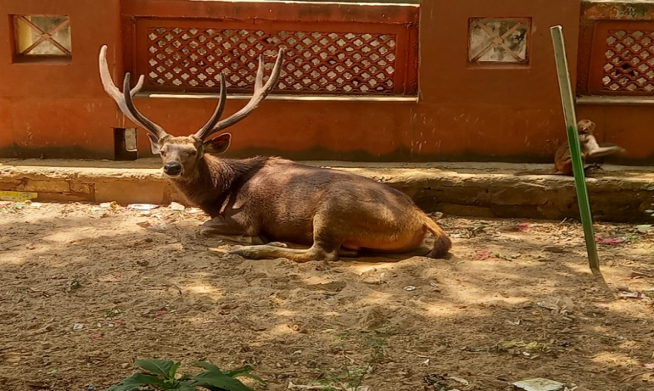

Rest by Sambar at Nidani Reserve Forest, Alwar

In sambar the typical group is small, numbering fewer than six individuals (Schaller 1967). The characteristic social unit is one hind and one fawn or one hind, one yearling and one fawn (Schaller 1967, Kelton 1981, Downes 1983). Family groups usually travel in a single file led by the adult female (Kelton 1981). During the rut, dominant stags are frequently seen with hinds and occasionally with other stags who -may challenge the dominant stag for breeding opportunities (Lewis eta!. 1990). Average group size of sambar is reported to be 4 to 5 individuals (Jerdon 1874 and Prater 1971). Khan et al. (1995) observed sambar group sizes ranging from one to five individuals in Gir. In Nagarahole more than 95 % of sambar sightings were that of solitary individuals, pairs, or family associations, and a mean group size of 1.7 was recorded (Karanth and Sunquist 1992). In Sariska the average group size of sambar was about four individuals (Sankar 1994). More than 85 percent of the sambar groups were observed with 1 to 5 individuals. Mean group size of sambar in Pench, in central India, was 1.7 (Biswas and Sankar 2002) and in Ranthambore, the mean group size was 3.7 (Bagchi et a!. 2004).

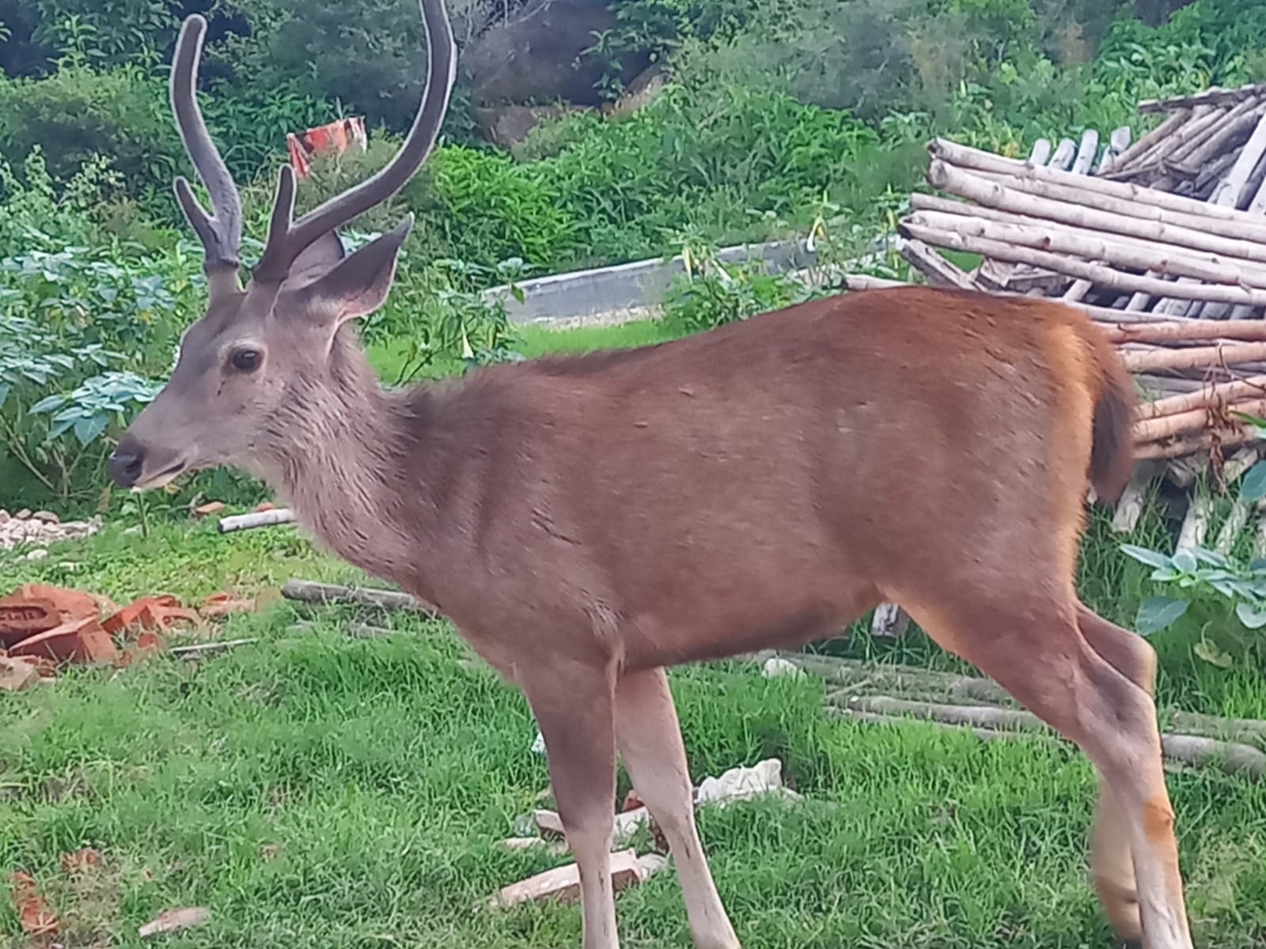

The period of breeding (rut) of sambar is determined by the annual antler cycle of antler development, the frequency of sexual behaviour, and, in a way, the time of fawning. Sambar stags exhibited a distinct antler cycle in Sariska (Sankar 1994). Hard altlers were shed during the summer, followed by emerging and velvet antlers during monsoon months. During the remaining part of the year, sambar remained in hard antler stage. In Bandipur sambar stags in hard antlers were observed largely between November and April and most males had shed their antlers by May (Johnsingh 1983).

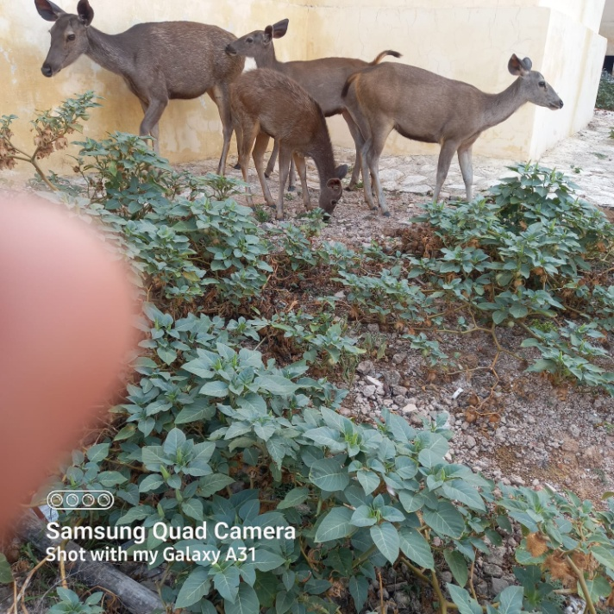

Herds of Sambar at Nidani Reserve Forest, Alwar

In St. Vincent Islands, Florida, during July and August 98 to 100 % of all sambar stags were in velvet antlers and most stags shed their antlers between April and June (Shea et al. 1990). In India the peak rut of sambar occurs between October and December (Lydekker 1916, Schaller 1967). Schaller (1967) reported that in Kanha the rut spreads over a period of at least seven months with a peak in November-December. In Sariska the peak rutting season was in winter when almost all stags were carrying hard antlers (Sankar 1994). The main rut of sambar in New Zealand was in June and July with a small peak occurring in November (Kelton 1981).

**Sex ratios**

Schaller (1967) estimated a sex ratio of 0.2 males : 1 female in Kanha. In Bandipur the average male : female ratio was 0.3 : 1, and the female: fawn ratio was 1 : 0.3 (Johnsingh 1983). The male : female ratio in Nagarahole (Karanth and Sunquist 1992) was 0.4 : 1. In Sariska the estimated average male: female ratio was 0.1 : 1 and the average female: fawn ratio was 1 : 0.2 (Sankar 1994). In Gir, the average male : female ratio was 0.5 : 1, and the female : young ratio was 1 : 0.1 (Khan et a!. 1995). Flynn eta!. (1990) recorded the male : female : fawn ratio as 0.7 : 1 : 0.2 in Florida, USA. Richardson (1972) recorded a 1 : 1 male-female ratio, and 1 : 0.2 female-fawn ratio in Texas, USA. The relatively low male numbers may be either due to selective predation, or sambar stags may be more vulnerable to stress conditions.

**Breeding Biology**

Though they mate and reproduce year-round, sambar calving peaks seasonally. [Oestrus](https://en.wikipedia.org/wiki/Oestrus" \o "Oestrus) lasts around 18 days. The male establishes a territory from which he attracts nearby females, but he does not establish a harem. The male stomps the ground, creating a bare patch, and often wallows in the mud, perhaps to accentuate the colour of his hair, which is typically darker than that of females. While they have been heard to make a loud, coarse bellow, rutting stags are generally not vocal. Large, dominant stags defend nonexclusive territories surrounded by several smaller males, with which they have bonded and formed alliances through sparring. When sparring with rival males, sambar lock antlers and push, like other deer, but uniquely, they also sometimes stand on their hind legs and clash downward into each other in a manner similar to species of [goat-antelope](https://en.wikipedia.org/wiki/Goat-antelope). Females also fight on their hind legs and use their fore legs to hit each other in the head.

[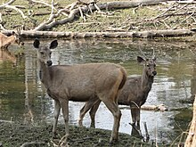](https://en.wikipedia.org/wiki/File:Sambar_deers.jpg)

A sambar hind with a young stag at Nidani Reserve Forest, Alwar

Courtship is based more on tending bonds rather than males vocally advertising themselves. Females move widely among breeding territories seeking males to court. When mounting, males do not clasp females. The front legs of the male hang loosely, and intromission takes the form of a "[copulatory jump](https://en.wikipedia.org/wiki/Copulatory_jump)".

[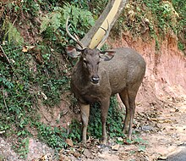](https://en.wikipedia.org/wiki/File:Sambar_deer_in_the_Nilgiris.jpg)

Sambar deer in the at Nidani Reserve Forest, Alwar

Gestation probably lasts around 8 months, although some studies suggest it may be slightly longer. Normally, only one calf is born at a time, although twins have been reported in up to 2% of births. Initially weighing 5 to 8 kg (11 to 18 lb), the calves are usually not spotted, although some subspecies have light spots which disappear not long after birth. The young begin to take solid food at 5 to 14 days, and begin to ruminate after one month. Sambar have lived up to 28 years in captivity, although they rarely survive more than 12 years in the wild.

**ONTOGENY AND REPRODUCTION**

In the wild, female Rusa unicolor probably experience puberty at 18–24 months (Plotka 1999; Sheng and Ohtaishi 1993). Age of sexual maturity of 7 captive female R. unicolor in New Zealand was 7–19 months; mean (6 SE) length of the luteal cycle was 17.2 6 3 days; 6 of the 7 females were anestrus in November–February; and they displayed no seasonal patterns in prolactin secretion, suggesting little to no response to photoperiod (Asher et al. 1997). Mean birthing interval was 329 days 6 29.7 SD for 6 captive females in New Zealand (Semiadi et al. 1994b). A captive female in India reached sexual maturity at 18 months of age and gave birth at 26 months of age (Acharjyo and Misra 1971). Despite translocation of R. unicolor from its native tropical latitudes to temperate latitudes, lack of seasonal reproduction is demonstrated by births throughout the year (Asher et al. 1997; Duke of Bedford and Marshall 1942; Lao 1968; Zuckerman 1953).

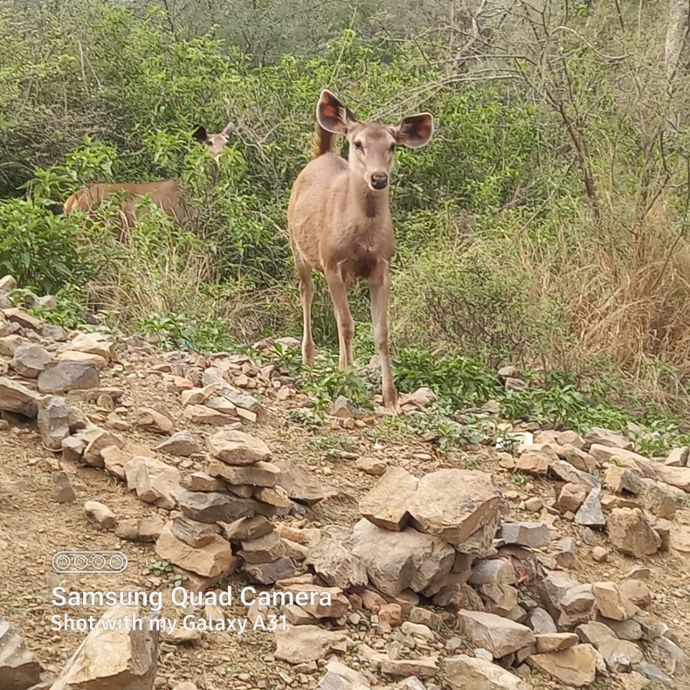

Gestation is about 8 months (Brand 1963; Hayssen et al. 1993), although some reports suggest that it can be longer (Plotka 1999; Sheng and Ohtaishi 1993). Among 525 birth records from 210 semidomesticated adult female R. unicolor in Taiwan, mean length of the estrous cycle was 18.2 days 6 0.5 SE (n 5 56), mean length of gestation was 258.6 days 6 0.3 SE (n 5 160), and mean birth interval was 369.9 days 6 2.3 SE (n 5 122—Chan et al. 2009). Estimates of productivity suggest that either females bred every other year, as was reported in Sri Lanka (Eisenburg and Lockhart 1972), mortality of young is high (Berwick 1974), low observability of offspring (Fig. 2) biases estimates of productivity (Shea et al. 1990), or some combination of all 3 (Schaller 1967). In Perak, Malaysia, only 9 of 23 females were pregnant when collected throughout the year (Khan and Khan 1968). The number of young-of-the-year per 100 females is typically, 50:100, even where introduced: 11–44:100 (Johnsingh 1983), 16 43:100 (Berwick 1974), 17–24:100 (Varman and Sukumar 1993), 33.7:100 (Schaller 1967), 38.2:100 (Bagchi et al. 2008), and 55:100 (Berwick and Jordan 1971) in India; 50:100 in Nepal (Seidensticker 1976b); 43.3:100 in Thailand (Ngam pongsai 1977); and 22.3:100 in Florida (Flynn et al. 1990). Female offspring may remain with their mothers as yearlings, but males leave their mothers after about 1 year (Lewis et al. 1990). Timing of the breeding and birthing seasons of R. unicolor has been discussed widely because of the variability in parturition dates and antler growth and shedding across the species’ substantial latitudinal and longitudinal range (Baker 1898; Fletcher 1911; Lydekker 1898; Schaller 1967). To explain variable antler growth throughout the year, Comber (1904) suggested that 2 distinct breeding seasons occurred in India, but such variation more likely represents an opportunistic strategy, perhaps based on nutrient availability in varied locations across the species’ range relative to antler growth, changing hormone levels, and photoperiod. In Chitwan National Park, Nepal, male R. unicolor can be observed in hard antler during any month of the year, reaching a low of 12–14% in July–August and a maximum of 81–92% in December–March; males without antlers occur in December and February–August (Mishra 1982 [not seen, cited in Putman 1988]). Similar patterns of variable antler development have been noted among captive males in New Zealand (Semiadi et al. 1994b). Twining in R. unicolor is uncommon, although Evans (1912:144) stated ‘‘sometimes two at birth.’’ Hayssen et al. (1993) give the average litter size of R. unicolor as 1.05. Only 2 (0.6%) of 320 births were twins among semidomesticated R. unicolor in Taiwan (Chan et al. 2009); only 1 (2.4%) of 41 births was twins at the New York Zoological Park (Crandall 1964); and only 1 (1.5%) of 66 births was twins among introduced R. unicolor in Florida (Flynn et al. 1990). Neonates in Australia are 5–6 kg at birth (Slee 1984). Measurements of 8 R. unicolor born in captivity throughout the year in New Zealand were: mass, 5.5–8.5 kg; body length, 36.0–43.1 cm; shoulder height, 44.4–55.0 cm; and body circumference, 44.2–54.3 cm (Semiadi et al. 1993); birth weights did not differ between sexes (Semiadi et al. 1994b). A near-term female fetus from the San Diego Zoo weighed 8.3 kg with a crown-to-rump length of 66 cm (Benirschke 2002). In captivity, neonates lick soil at 2–5 days, nibble on dead forage at 5–14 days, eat fresh forage at 13 23 days, browse lightly at 16–26 days, defecate without stimulation at 4–7 days, and begin to ruminate at 30–42 days (Semiadi et al. 1993).

**References:**

1. Ables , E.D., and Ramsey, C.W. 1974. Indian mammals on Texas rangelands. J. Bombay Nat. His. Soc. 71: 18-25.
2. Bagchi , S., Goyal, S.P., and Sankar, K. 2003. Prey abundance and prey selection by tigers (Panthera tigris) in a semi-arid , dry deciduous forest in western India. Journal of Zoology 260:285-290.
3. Bagchi , S., Goyal , S.P., and Sankar , K. 2004. Herbivore density and biomass in a semi-arid tropical dry deciduous forest of western India. Journal of Tropical Ecology 20:475-478.
4. Bentley, A. 1978. An introduction to the deer of Australia. Koetong ed. Koetong Trust Service, Victoria, Australia.
5. Biswas, S., and Sankar, K. 2002. Prey abundance and food habit of tigers (Panthera tigris tigris) in Pench National Park, Madhya Pradesh, India. Journal of Zoology 256:411-420.
6. Crandall, L. 1964. The management of wild animals in captivity. University of Chicago Press, Chicago. Dinerstein, E. 1979. An ecological survey of the Royal Karnali-Bardia Wildlife Reserve, Nepal. Part Il:Habitat/animal interactions. Biolo. Conserv. 16:265-300.
7. Downes, M. 1983. The forest deer project 1982. Australian Deer Research Foundation Ltd., Melbourne, Australia.
8. Eisenberg, J. F., and Lockhart, M. 1972. An ecological reconnaisance of Wilpattu National Park, Ceylon. Smithsonian Contributions to Zoology. 101:1-118.
9. Estes, R.D. and Goddard, J. 1967. Prey selection and hunting behaviour of the African wild dog. J.Wildl.Manage. 31: 52-70.
10. Flynn, L.B., Shea,S.M., Lewis, J.C. and Marchinton, R.L. 1990. Population, status, health and habitat use. In: Ecology of sambar deer on St. Vincent National Wildlife Refuge, Florida. Bull. No. 25. Tall timber research station, Talloahassee, Florida. 63-96 Pp.
11. Hornocker, M. 1970. An analysis of mountain lion predation upon mule deer and elk in Idaho primitive area. Wildl. Monogr. 21. The wildlife Society, Washington, D.C.
12. Jerdon, T.C. 1874. The mammals of India . London. Johnsingh, A.J.T. 1983. Large mammalian prey- predators in Bandipur. J. Bombay Nat. Hist. Soc. 80(1):1-57.
13. Johnsingh, A. J. T., and Sankar, K. 1991. Food plants of chital, sambar and cattle on Mundanthurai plateau, Tamil Nadu, South India. Mammalia 55:57-66.
14. Johnsingh, A.J.T., Goyal, S.P., Rawat, G.S. and Mukherjee, S. 1993. Food habits of tiger and leopard in Rajaji, north west India. Abstracts. International symposium on the tiger, Delhi. 22nd to 24th February. Ministry of Environment & Forests, Government of India.
15. Karanth, K. U., and Sunquist, M.E. 1992. Population structure, density and biomass of large herbivores in the tropical forests of Nagarahole, India. Journal of Tropical Ecology 8:21-35.
16. Karanth, K. U., and Sunquist, M.E. 1995. Prey selection by tiger, leopard and dhole in tropical forests. Journal of Animal Ecology 64:439-450.
17. Kelton, S.D. 1981. Biology of sambar deer (Cervus unicolor Kerr, 1972) in New Zealand with particular reference to diet in a Manuwata flax swamp. Master's Thesis, Massey University, Palmerston North, New Zealand.
18. Kelton, S.D. and Skipworth, J.P. .1987. Food of sambar deer (Cervus unicolor) in a Manawatu (New Zealand) flax swamp. New Zealand Journal of Ecology. 10:149-152.
19. Khan, J. A., Chellam, R. and Johnsingh, A. J. T. 1995. Group size and age-sex composition of three major ungulate species in Gir Lion Sanctuary, Gujarat, India. J. Bombay Nat. Hist. Soc., 92:295-302.
20. Lever, C. 1985. Naturalized mammals of the world. Longman, London. 467 pp.
21. Lewis, J.C., Flynn, L.B., Marchinton, R.L., Shea, S.M. and Marchinton, E.M. 1990. Part I : Introduction, study area description and Literature review. Pp 1-12. In: Ecology of sambar deer on St. Vincent National Wildlife Refuge, Florida. Bull. No. 25. Tall Timbers Research Station, Tallahassee, Florida.
22. Lydekker, R. 1916. Wildlife of the world. Vol.11. Rowland Ward Ltd., London, U.K. Martin , C. 1977. Status and ecology of the Barasingha ( Cervus duvauceli branders) in Kanha National Park (India). J. Bombay Nat.Hist.Soc. 74:60-132.
23. Ngampongsai, C. 1987. Habitat use by the sambar (Cervus unicolor) in Thailand: A case study for Khao-Yai National Park. Pp 289-298. In: C.M.Wemme (Ed.). Biology and management of the Cervidae. Smithsonian Institution Press, Washington D.C.
24. Prater, S.H. 1971. The book of Indian animals. Bombay Natural History Society, Bombay. Richardson, W. A. 1972. A natural history survey of sambar deer (Cervus unicolor) on the powerhorn ranch calhoun country, Texas. M.Sc., Thesis. Texas A & M University, Texas. 76 Pp.
25. Sankar, K. 1994. The ecology of three large sympatric herbivores (chital, sambar and nilgai) with special reference for reserve management in Sariska Tiger Reserve, Rajasthan. Ph.D. Thesis. University of Rajasthan, Jaipur.
26. Schaller, G.B. 1967. The Deer and the Tiger. A study of Wildlife in India. The University of Chicago Press, Chicago. 370 Pp.
27. Shea, S.M., Flynn, B.L., Marchinton, R.L. and Lewis, J.C. 1990. Social behaviour, movement ecology, and food habits. In: Ecology of sambar deer on St.Vincent National Wildlife Refuge, Florida. Bulletin no.25, Tall timbers research station, Tallahesse, Florida.
28. Slee, K.J. 1984. The sambar deer in Victoria. Pp 559-72. In: "Deer". Post Grad.Comm.Vet.Sci., Proc. 72. Univ. of Sydney. Sydney.
29. Whitehead, G.K. 1972. Deer of the world. Constable and Co., Ltd., London, U.K.

10/22/2024