**Assessment of the impact of climate change on public health**

**(in the Kashkadarya region).**

Zukhrakhon Tillyakhodjaeva1, Zulfiya Kuranboeva2,Nargiza Khursandova 3

1. Scientific secretary of Hydrometeorology Research Institute, Tashkent,Uzbekistan,  [tilla.79@mail.ru](mailto:Uzbekistan.tilla.79@mail.ru)

2. Hydrometeorological sientific research institute Department of Climatology and Climate Change, junior researcher, [zulfiyamarsova9@gmail.com](mailto:zulfiyamarsova9@gmail.com)

3.PhD candidate of Hydrometeorology Research Institute, Tashkent, Uzbekistan, [rashidovnan1307@gmail.com](mailto:rashidovnan1307@gmail.com)

**Annotation.** We all know that climate change is one of the global problems today, which is being discussed by all world meteorological organizations. In the last 20-30 years, the consequences of climate change are clearly visible. Climate change is manifested not only in the increase of air temperature on a global scale, increase in precipitation, as well as in the observation of various weather anomalies that are not typical for the climate of a certain region, but also affects agriculture and human health. Currently, one of the important issues is the study of the influence of the population on the weather and the level of sensitivity, in this issue the population has been studied on heart, blood vessels and circulatory system diseases throughout the Republic of Uzbekistan over the past 10 years. According to the results, the population by the territory of Uzbekistan is noted that all diseases are different among the regions, and their indicators are growing.

[Zukhrakhon Tillyakhodjaeva, Zulfiya Kuranboeva,Nargiza Khursandova. **Assessment of the impact of climate change on public health (in the Kashkadarya region).** *N Y Sci J* 2024;17(6):17-22]. ISSN 1554-0200 (print); ISSN 2375-723X (online). <http://www.sciencepub.net/newyork>. 04.doi:[10.7537/marsnys170624.04](http://www.dx.doi.org/10.7537/marsnys170624.04).

**Key words:** climate change, weather, population, health, air temperature.

**Materials and methods.**

Often, when the weather changes, people are bothered by headaches or stomachaches, and sometimes a slight rise in body temperature for no apparent reason. But it should be noted that when the weather changes, people's blood pressure often increases.

Among the many factors that affect the weather outside the window, one of the most important is atmospheric pressure. With this, cyclones and anticyclones are formed, which often appear in the forecast, and before going out, we may need to take out an umbrella or sunglasses.

Influence of the atmosphere on the weather: the changing nature of atmospheric pressure is associated with the formation and movement of large air masses that directly affect the weather. Air vortices with a low pressure in the center and a radius that can reach thousands of kilometers in length are called cyclones. They are divided into two types. Tropical cyclones are formed near the equator due to intense heating and moist air rising over the hottest parts of the oceans, and usually have a radius of several hundred kilometers. In their center there is low pressure, and due to the rapid rise of air, the wind on the surface can reach very high speeds, and the cyclone turns into a hurricane. Extratropical cyclones occur in temperate and polar latitudes, and their sizes reach several thousand kilometers in diameter. Unlike tropical cyclones, which are homogeneous in terms of temperature, extratropics usually have clear sectors of warm and cold air, at their boundaries (atmospheric fronts) precipitation, strong winds and thunderstorms are often observed.

It is clear that anticyclone affects health. High atmospheric pressure is accompanied by dry, cloudless weather. People with hypertension are more sensitive to anticyclone.

Deterioration of well-being leads to the appearance of the following symptoms:

• sudden increase in pressure;

• pain and heaviness in the heart area;

• difficulty in breathing;

• rapid heartbeat;

• noise in the ears;

• increased anxiety;

• weakness.

These symptoms may indicate a serious threat to the patient's health. They indicate a condition characteristic of a hypertensive crisis.

If you have weather-related high blood pressure, it is recommended that you first take blood pressure medications and sedatives as prescribed by your doctor.

If such measures do not help, you should consult a doctor. Such symptoms should not be ignored, because they pose a serious threat to health and life.

The reaction of healthy people: The negative effects of atmospheric fluctuations are felt not only by those who are exposed to changes in blood pressure. There is a category of people who react to an increase in pressure in atmospheric layers and do not suffer from hypotension or hypertension.

The effect of atmospheric pressure on a person's blood pressure is accompanied by a set of negative symptoms that appear not only in hypotensive or hypertensive patients, but also in healthy people.

The optimal pressure value at which a person does not experience discomfort is considered to be 760 mmHg. A change of only 10 mm up or down will have a negative effect on well-being.

Changes in atmospheric pressure have a significant effect on the human body. Deviation up or down disrupts the normal functioning of some systems and organs. This leads to the deterioration of general health and the need to seek help from medicines. This reaction of the body is called meteorological dependence.

Patients with diseases of the heart, blood vessels and circulatory system are particularly sensitive to changes in atmospheric pressure. A special category includes people with high meteorological sensitivity.

The relationship between the ratio of mercury pressure and the deterioration of health can be observed during weather changes caused by the shift of one atmospheric layer to another - a cyclone or an anticyclone.

Impact of underperformance. Along with low atmospheric pressure, a lot of precipitation and gloomy weather, there is a worsening of the condition in people with low blood pressure - hypotension.

They are sensitive to this state of the environment. They experience a decrease in blood pressure, a decrease in the tone of blood vessels, and an increase in the symptoms of hypotension. Among them:

• oxygen starvation;

• dizziness;

• weakness;

• "flies" flashing in the eyes;

• nausea.

Some even experience fainting and loss of consciousness. Such demonstrations need urgent correction. Blood pressure stabilizers are used for first aid.

Can use:

• Take Citramon, Farmadol tablets;

• drink a cup of strong tea or coffee;

• Take 30-35 drops of pharmaceutical tincture of ginseng, it has a beneficial effect.

**Discussions.** It is also recommended to have a good rest, even sleep. For hypertensive patients, the low pressure level in atmospheric layers does not cause discomfort. In such a situation, they rarely experience a deterioration in their well-being.

Sudden changes in the weather can become a serious stress for people with cardiovascular diseases, because changes in atmospheric pressure and air temperature can cause circulatory disorders, which increases the risk of vascular complications. The effect of weather changes is also felt for patients suffering from diabetes and vegetative-vascular diseases. There is evidence that in some people, the production of insulin by the pancreas can be impaired, so it is advisable to have it under control in people with diabetes who have sudden spikes in blood sugar. Also, if we talk about the rise or fall of blood pressure in hot weather, it has been observed that a person's blood pressure rises in hot weather. During heat, especially if it comes suddenly, the elasticity of the walls of blood vessels decreases, which leads to a lack of oxygen in a person, as well as a worse adaptation to high air temperatures in a person. In hot weather, the body dehydrates and this leads to an increase in blood viscosity. Hot weather can often result in a sharp and sudden rise in blood pressure, a sore throat, or simply nausea and dizziness.

Below, the effect of air temperature on the health of the population in the conditions of climate change in Kashkadarya region was studied:

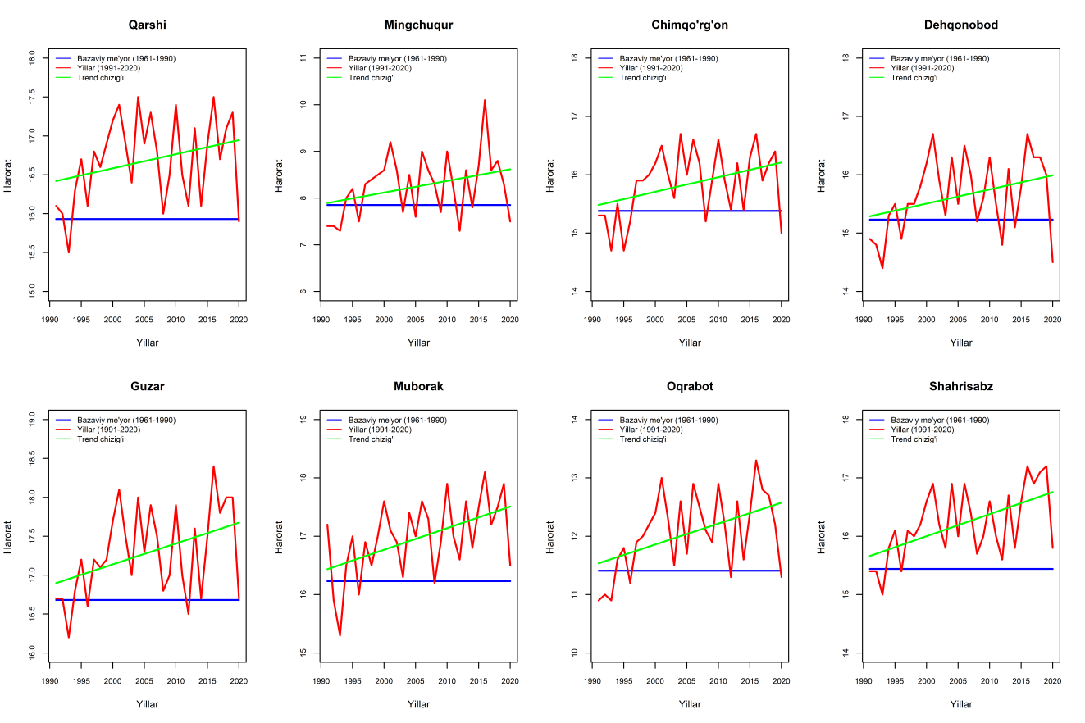

**Figure 1. The increase of the air temperature of the current climate period (1991-2020) compared to the base climate period (1961-1990) at the meteorological stations located in the Kashkadarya region**

As can be seen from the diagram above, the air temperature in Kashkadarya region is constantly increasing. In this region, the temperature has increased by 0.6 ºC on average compared to the base climatic period. High air temperature, as well as atmospheric air pollution with various harmful substances, damage to the ecological environment, food products grown under the influence of various chemicals, etc. We all know that factors have a negative impact on human health.

Currently, among the population, diseases associated with high blood pressure, diseases of the nervous system, respiratory system, infertility, the number of various diseases is increasing (pictures2-3)

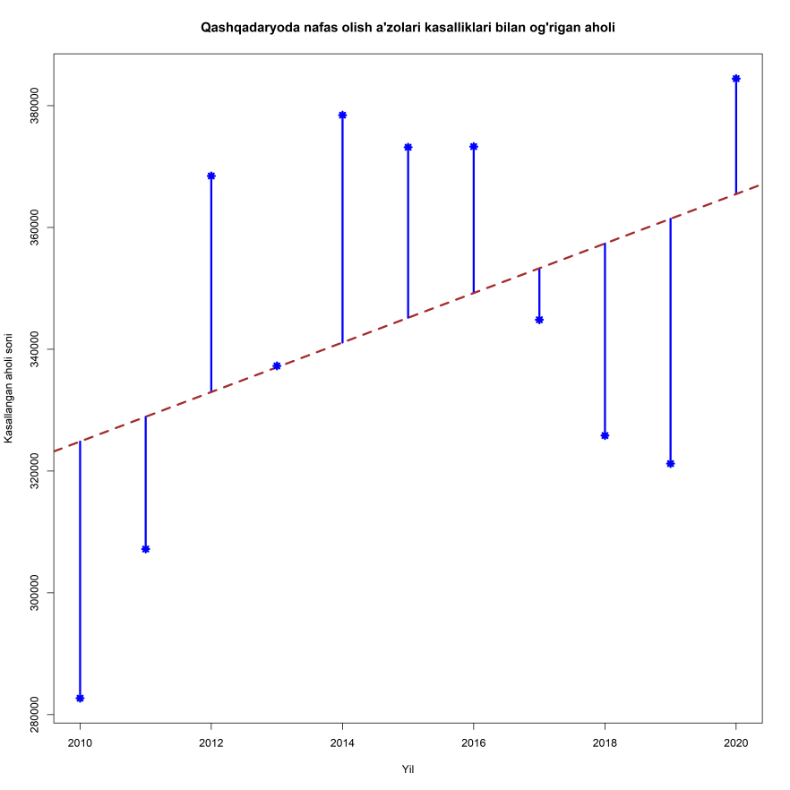

**Figure 2. The number of people suffering from respiratory diseases in Kashkadarya region 2010-2020 year.**

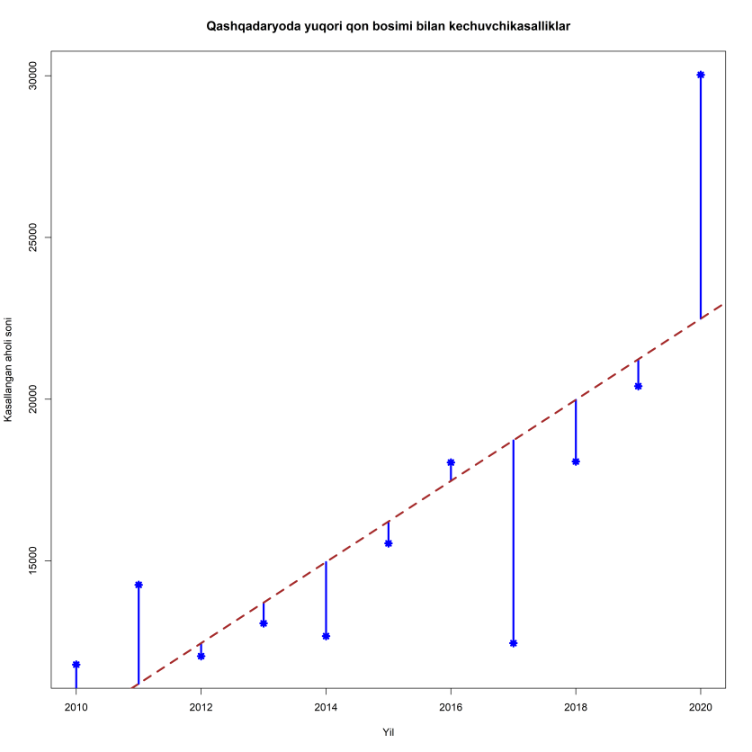

**Figure 3. The number of people suffering from high blood pressure diseases in Kashkadarya region, 2010-2020.**

Of course, the causes of meteorological dependence are different, and the absence of blood pressure deviation from the norm (120/80) in healthy people does not guarantee a good condition during changes in atmospheric pressure. This has a negative impact on their well-being.

In many people, adaptation to its changes is accompanied by the appearance of negative symptoms. The main reason for this phenomenon is the tendency to high sensitivity, which is called atmospheric pressure dependence.

The thyroid gland plays an important role in the body's adaptation to frequent changes in weather conditions. Blood pressure increases in response to increased atmospheric pressure and hyperthyroidism. The opposite is observed in hypothyroidism, blood pressure decreases.

This leads to the following conclusion: dysfunction of the thyroid gland is an important factor in the manifestation of meteodependence.

The manifestation of the body's reaction to weather factors is typical for many categories of people:

1. People over 40 years old are most prone to weather dependence.

2. Patients with weak immunity, diseases of the nervous system and thyroid gland.

3. Emotional natures.

4. People with vegetative-vascular dystonia (VSD).

5. The lack of the necessary level of physical activity leads to weakening of the vascular tone and, as a result, causes poor health with an increase or decrease in atmospheric parameters.

Depression, neuroses and stress significantly increase the risk of negative symptoms due to changes in the atmospheric factor.

Lack of vitamins, poor nutrition, lack of the necessary amount of important micronutrients and indulgence in fashionable starvation diets have a negative impact on the human condition during the change of cyclones and anticyclones.

**Result.** the impact of climate change and environmental damage on human health is increasing in the last 10 years.

Therefore, experts recommend using the following treatment methods to alleviate the severity of symptoms and prevent the number of diseases from increasing.

1. Regular intake of off-season vitamin complexes and immune-boosting drugs.

2. Hypo- and hypertensive manifestations are corrected using the right approach to nutrition, physical activity and proper rest.

3. It is recommended to use sedatives. If there are serious deviations in blood pressure, especially according to high values, the therapist prescribes drugs that reduce it. In this case, the treatment regimen includes the constant use of drugs, regardless of the patient's condition.

There is no universal medicine for weather dependence. Treatment includes an individual approach in each individual case.

Doctors emphasize that you should not try to solve the problem yourself. They say that this approach hides the symptoms, but does not eliminate the cause of meteosensitivity, so they recommend to go to a general doctor to eliminate the disease and to pay more attention to one's health.

**References**

IPCC Sixth Assessment Report, Climate Change 2022: Impacts, Adaptation and Vulnerability <https://www.ipcc.ch/report/ar6/wg2/>

Myagkov S. V., Zadorozhnaya O., Dergacheva I. V., Tillyakhodzhaeva Z., Assessment of the impact of changes in weather and climate factors on the risk of population morbidity growth//Climate change, causes, impacts, and responses. Bulletin-No. 10, Tashkent, 2016, pp. 78-84.

3. World Meteorological Organization (WMO) https://public.wmo.int/en

4. Hoppe P. Aspects of human biometeorology in past, present and future //Int J Biometeorol. – 1997. – Feb; 40 (1): 19–23.: pubmed.ncbi.nlm.nih.gov.

5. <https://www.gazeta.uz/oz/2023/08/09/population/>

6.Tillyakhodjaeva Z., Myagkov S.V., Risk assessment of diseases in the conditions of climate change // , “European Science Review, Scientific journal, # 3-4 – Austria, 2019. –P. 15-18.

7.Fitzgerald, F.T., and C. Jessop, 1982: Accidental hypothermia: a report of 22 cases and review of the literature. Advanced Internal Medicine, 27, 127-150.

8.Lewin, S., L.R. Brettman, and R.S. Holzman, 1981: Infections in hypothermia inpatients. Archives of Internal Medicine, 141, 920-925.

9.Hudson, L.D., and R.D. Conn, 1974: Accidental hypothermia: associated diagnoses and prognosis in a common problem. Journal of the American Medical Association, 227, 37-40.

10.Bristow, G., R. Smith, J. Lee, et al., 1977: Resuscitation from cardiopulmonary arrest during accidental hypothermia due to exhaustion and exposure. Canadian Medical Association Journal, 117, 247-248.

11.Kalkstein, L. S., and K. M. Valmont. 1987. Climate effects on human health. In Potential effects of future climate changes on forests and vegetation, agriculture, water resources, and human health. EPA Science and Advisory Committee Monograph no. 25389, 122-52. Washington, D.C.: U.S. Environmental Protection Agency.

6/22/2024