2022 Updated Report of Monsoons and Indian Monsoon Time Scale

Gangadhara Rao Irlapati

H.No.5-30-4/1, Saibabanagar, Jeedimetla, Hyderabad, India-500055
Email: gangadhar19582058@gmail.com
Google/Phone pay A/C No. +91 630 557 1833

Abstract: Indian monsoon is a key system in global monsoon systems. I have conducted many scientific researches on this monsoon system and as a part these researches, I proposed and designed the Basics of Indian Monsoon Time Scale which can help to study the past, present and future movements & conditions of the Indian monsoon. In the current year 2022, the pre-path of Indian summer monsoon was traveling upwards and reached to the 29th June. Below this, the main-path of Indian summer monsoon also traveled upwards parallel to the pre-path of Indian summer monsoon with a difference of about 30 days and reached to the 29th July, As it moves further up, changes in the climate are likely increasing and there are more chances of heavy rains and floods in the coming years.
[Gangadhara Rao Irlapati. 2022 Updated Report of Monsoons and Indian Monsoon Time Scale. N Y Sci J 2024;17(4):22-135]. ISSN 1554-0200 (print); ISSN 2375-723X (online). http://www.sciencepub.net/newyork. 04. doi:10.7537/marsnys170424.04.

Keywords: Global Monsoons Time Scales, North American Monsoon Time Scale, North African Monsoon Time Scale, Indian Monsoons Time Scale, East Asian Monsoon Time Scale, Western North Pacific Monsoon Time Scale, South American Monsoon Time Scale, South African Monsoon Time Scale, Australian Monsoon Time Scale, European Monsoon Time Scale.

Introduction:
Monsoon means a seasonal reversing wind accompanied by its corresponding weather changes and natural calamaties in precipitation. We cannot be said that a monsoon especially to be relevant to a particular continent, country or a region. Each and every continent or region or country has its own monsoon winds. By establishing the global monsoon time scale and manage , a country can be estimated the impending weather conditions and natural calamities such as rains, floods, landslides, avalanches, blizzard and droughts, extreme winter conditions, heavy rainfall, mudflows, extreme weather, cyclones, cloud burst, sand storms, hails and winds etc in advance. Surface water resources can still be found.
The major monsoon systems in the world consist of the west Africa and Asia -Australian monsoons. The inclusion of the North and South American monsoons with incomplete wind reversal has been debate. Monsoons can also be divided by Southern monsoon and Northern monsoons, Summer monsoons and Winter monsoons, Continental monsoons and Regional monsoons etc. A monsoon is also served with different names by region and place. For example, the North American monsoon is named after the name of Arizona monsoon and Mexican monsoon. There are also two or three or more branches of one monsoon. Monsoon is also called upon by geographical areas. For example, the Indian monsoon has its two branches, the Arabian branch and Bay of Bengal branch. Each and every continent, region or country has its own monsoonal winds. On the whole, 1.North American monsoon, 2.North African monsoon, 3.Indian Monsoon, 4.East Asian monsoon, 5.Western North Pacific monsoon, 6.South African monsoon, 7.South African monsoon, 8.Australian Monsoon are the main regional monsoons according to Prof Bin Wang. I agree with the opinion of Prof Bin Wang.
Global Monsoon Time Scales:
By establishing the Global Monsoon Time Scale and maintain, a country can be estimated the impending weather conditions and natural calamities such as monsoon movements, rains, floods, landslides, avalanches, blizzard, droughts, famines extreme winter conditions, heavy rainfall, mudflows, extreme weather, storms, cloud burst, sand storms, hails and winds etc all climate, meteorological and weather related conditions & natural calamities in advance. Surface water resources can also still be found. I have conducted many scientific researches on the global monsoon systems and designed the Basics for Global Monsoon Time Scales including Regional Monsoon Time Scales, Sub-Regional Monsoon Time Scales, Country-Wise Monsoon Time Scales, Northern Monsoon Time Scales, Southern Monsoon Time Scales, Summer Monsoon Time Scales, Winter Monsoon Time Scales for all regions and countries to study the past’s, present and future movements of the global monsoon systems and its relationship with rainfall and other weather problem and natural calamities. We can make separate monsoon time scales per each and every individual country. As a part of this, I have proposed and designed Basics of Global Monsoon Time Scales for all countries separately.
Regional monsoons and their monsoon time scales:
Therefore, the main regional Monsoons are eight. Those are 1.North American monsoon, 2.North African monsoon, 3.Indian Monsoon, 4.East Asian monsoon, 5.Western North Pacific monsoon, 6.South African monsoon, 7.South African monsoon, 8.Australian Monsoon. So, first of all I proposed and designed the monsoon time scales for all these regional Monsoon systems.
North American Monsoon Time Scale
North African Monsoon Time Scale
Indian Monsoon Time Scale
East Asian Monsoon Time Scale
Western North Pacific Monsoon Time Scale
South American Monsoon Time Scale
South African Monsoon Time Scale
Australian Monsoon Time Scale
Associated monsoons and their monsoon time scales:
There are some associated monsoons such as South Asian monsoon, North East Monsoon, East Africa monsoon, West Africa monsoon. I also proposed and designed monsoon time scales for them.
South-Asian Monsoon Time Scale
North-East Monsoon Time Scale
East-African Monsoon Time Scale
Indo-china Monsoon Time Scale
South East Asian Monsoon Time Scale
Indian Indochina Monsoon Time Scale
West African Monsoon Time Scale
East African Monsoon Time Scale
South East African Monsoon Time Scale
North West Africa Monsoon Time Scale
Major monsoons and their monsoon time scales:
There are some major or continental monsoons such as South west monsoon, Indo-australian monsoon, Asian-australian monsoon, Malasian-australian monsoon, Australian-indonesian monsoon etc. I also proposed and designed monsoon time scales for them.
South-West Monsoon Time Scale
Indo-Australian Monsoon Time Scale
Asian-Australian Monsoon Time Scale
Malasian-Australian Monsoon Time Scale
Northern-Australian Monsoon Time Scale
Australian-Indonesian Monsoon Time Scale
Borneo Australian Monsoon Time Scale
Maritime Continental Monsoon Time Scale
Some monsoons have branches. For example Indian monsoon has two branches that are Arabian monsoon and Bay of Bengal monsoon. I also proposed and designed monsoon time scales for them.
Arabian Monsoon Time Scale
Bay of Bengal Monsoon Time Scale
In some regions the same Monsoon goes by different names depending on the place. I also proposed and designed monsoon time scales for them.
New Mexican Monsoon Time Scale
Central American Time Scale
Gulf of California Monsoon Time Scale
South West Monsoon Time Scale
Arizona Monsoon Time Scale
Some regions have different type of Monsoons from regional Monsoons such as European monsoon. I also proposed and designed monsoon time scales for them.
European Monsoon Time Scale
Global Monsoon Time Scale – a chronological sequence of events arranged in between time and weather with the help of a scale for studying the past’s, present and future movements of monsoon of a country and its relationship with rainfall and other weather problem and natural calamities.
Prepare a global monsoon time scale having 365 horizontal days from March 21st to next year March 20th of a required period comprising of a large time and weather have been taken and framed into a square graphic scale. The main weather events if any of the country’s weather have been entering on the scale as per date and month of the each and every year. If we have been managing the scale of a region or country in this manner continuously, we can study the past, present and future movements of the monsoon of a region or country. We can make separate monsoon time scales per each and every individual country. I have invented the following global monsoon time scales. All researchers of those countries need to learn about their regional monsoons. Construct their countrie’s monsoon time scales
Indian monsoon time scale
Australian monsoon time scale
North-american monsoon time scale
South-am,erican monsoon time scale
Western north pacific monsoon time scale
East-asian monsoon time scale
North-african monsoon time scale
South-african monsoon time scale
European monsoon time scale
South-asian monsoon time scale
North-east monsoon time scale
South-west monsoon time scale
East-african monsoon time scale
West-african monsoon time scale
Indo-australian monsoon time scale
Asian-australian monsoon time scale
Malasian-australian monsoon time scale
Northern-australian monsoon time scale
Australian-indonesian monsoon time scale
Basics of Monsoon Time Scales:
After much research, I have proposed some basics regarding method and design of the Global Monsoon Time Scales for study the global monsoon systems. Global Monsoon Time Scale is a chronological sequences of events arranged in between the Time and Climate with the help of a scale for studying the past’s, present and future movements of monsoon systems and its relationship with rainfall and other weather conditions& natural calamities.
Method and Design:
Design: Prepare a Global Monsoon Time Scale having 365 horizontal days from April 1st to next year March 31st (or January 1st to December 31st or March 21st to next year March 20th or according to the chronology of a country’s Time and Climate) of 139 year from 1880 to 2027 comprising of a large Time and Climate should be taken and framed into a square graphic scale.
This scale should be designed in three ways i.e Basic scale, Filled scale, Analyzed scale;
Basic Scale: The first one is preliminary basic scale, it explains the structure of the scale.
Filled Scale: This is the second scale that is filled with data and explains how to fill or manage the scale.
Analyzed Scale: And the third one is scientifically analyzed the filled scale by data, it explains monsoon patterns weather conditions of the scale.
Method: There are two methods in formation and process of the Global Monsoon Time Scales. The first one is in the single form and next one is designed in four parts.
Single& Full length Scale: Prepare the Global Monsoon Time Scale having 365 horizontal days from April 1st to next year March 31st (or January 1st to December 31st or March 21st to next year March 20th or according to the chronology of a country’s Time and Climate) of 139 year from 1880 to 2027 comprising of a large Time and Climate should be taken and framed in a single and full length type square graphic scale. It can be formed on a Paper or a Wall or a Table.
Parts & paste Scale: The single and full length square graphic scale is to be long. So that it is divided into four parts easy to carry and keep and suitable for publication. I designed to make it into 4 parts and then pasted it into one scale.
The first part is beginning from 1st April to July 12th.
The second part is from 13 July to October 23rd.
The third part is from 24th October to February 3^{rd.}
And the fourth part is 4th February to March 31st ending.
These separate scales can be pasted into one scale as explained below.
Cut along the edges of dates on the right side of the first part and paste it to along the edges of date of 13th July on left side of the second part.
Cut along the edges of dates on the right side of the second part and paste it to along the edges of date of 24th October on left side of the third part.
Cut along the edges of dates on the right side of the third part and paste it to along the edges of date of 4th February on left side of the fourth part .
When paste this manner, we get long full-length Indian Monsoon Time Scale. .
Computer Model:
Global Monsoon Time Scales can also be established as a computer model. Besides rather than in manual type scale, if we are able to create a computer model scale which to be the most obvious.
Material and Data:
Construction of the Global Monsoon Time Scales requires enormous data of low pressure systems, depressions tropical cyclones/storms (and also sand storms etc) that formed over and affecting a region should be taken as data to prepare the Global Monsoon Time Scale. An accurate scale is available if we can collect and analyze the exact climate data.
Management:
The main weather events such as monsoon pulses in the form of low pressure systems if any of a monsoon region formed over a region or country have been entering on the scale in stages by 1 for low, 2 for depression, 3 for storm, 4 for severe storm and 5 for severe storm with core of hurricane winds should be entered on the Global Monsoon Time Scales as per date and month of each and every year. If we can managing the scale in this manner continuously, we can study the past, present and future movements of monsoons of a region or country. I took the numbers to analysis the variations in data. Researchers have to decide what kind of data to take and how to analyze the data.
Researches &results:
The research and study should be done in the same way as described below in the Indian Monsoon Time Scale and the results should be obtained.
Study & discussion:
The obtained results should be studied and analyzed in the same way as described below in the Indian Monsoon Time Scale.
Model scale: Before proposed and designed the Basics of Monsoon Time Scale, I have undertaken the Indian Monsoon Time Scale as the model research project following all the rules to be followed in formulating the basics of Basics of Global Monsoon Time Scales. The reason I took the Indian Monsoon Time Scale as the model research project was because I was in the Indian monsoon region. I know the information and data about Indian monsoon very well. Hence a comprehensive study of Indian monsoon incorporating the rules of model research project and I have proposed the basics of the Basics of Global Monsoon Time Scales. The following is the summary of the model research project, how the project was implemented, how I did the research, how I analyzed the data and how I obtained results etc. I designed the Indian Monsoon Time Scale as a model scale for Global Monsoon Time Scales and successfully proved out in practice. Hence, we can take this Indian Monsoon Time Scale as a model scale to design and innovate the Monsoon Time Scale. Based on this the scientists design the Monsoon Time Scale.
Study of Indian Monsoon:
The phenomena of Indian Monsoon is global in character, affecting a large portion of Asia, parts of Africa (sahel) and Northern Australia and other parts of the world. Monsoon is originally winds prevailing in the Indian Ocean, which blow South.West from October to April now generally winds which blow in opposite directions at different seasons of the year. Similar in origin to land and sea breezes, but on well developed over southern and eastern Asia, where the wet summer monsoon from the South West is the outstanding feature of the climate.
The Indian monsoon is often referred to seasonal reversal of winds over the Indian ocean especially in the Arabian sea, that blow from the south-west during one half of the year and form the north-east during the other. Almost all the eastern hemisphere of the tropics has a monsoon climate. Summer monsoon is a regular phenomena only in the sense that it comes every year. But its onset, its activity during the season, and its withdrawal are subject to variation that sometimes are large
Monsoon winds are most pronounced in the summer season of either hemisphere that is during June to September in the northern hemisphere and in January and February in southern hemisphere. Monsoon circulations are mainly owing to: Differential heating of land and ocean. The deflection of wind due to the rotation of earth. The Indian ocean is locked by land to the north by the Asian continent. This geographical feature gives rise to extreme thermal contrast between the land in ther north and ocean in the south in both summer and winter which is the crucial factor in the development of the most pronounced circulation in this part of the globe, while the large scale features of the monsoon are repetitive from year to year; large anomalies occur in both in circulation as well as in rainfall. The monsoon region includes almost half of the African continent, South and East Asia and northern Australia.
Normal dates of onset of monsoon: Summer monsoon of the northern hemisphere has two components. Indian summer monsoon and East Asian summer monsoon. The Indian summer monsoon is characterized by south westerly flow in the Arabian seas and south Bay of Bengal and the East Asian monsoon by southerly or south easterly or south easterly flow in the lower troposphere. The onset of summer monsoon takes place over the main land of India by 1st June. It gradually proceeds northward and by the middle of July whole of the India comes under the grip of monsoon currents. The onset and progress of monsoon show considerable inter-annual variability. The standard deviation of the dates of onset along the south coast of India, south of 20⁰ N is 6-7 days, whereas, it is 7-8 days over North India. The mean date of onset of monsoon over southern Kerala is 2nd June and standard devotion is 8days. At Mumbai, the onset date of 10th June, over Delhi it varies from 15 June, over Delhi it varies from 15 June to 20 July. The mean date of onset over Delhi is 5 July..
The northward advance of monsoon is usually associated with disturbances. There is a pronounced tendency for the formulation of low pressure system at the leading edge o the monsoon current. It was found that in about 75% of occasion’s advance of monsoon associated with some synoptic systems. A feeble trough in the low level depression and the cyclonic storms, it is termed as onset vortex.
The advance of monsoon towards the month the north is not always a steady march, the activity of monsoon weakens after an advance of 500km and a fresh pulse is needed to advance the monsoon further. This fscientistgangadhar1ally in the form of low pressure system like a depression over the Bay of Bengal. Over North India, monsoon generally advances from east to west along with the monsoon easterlies which is known as a bay current. A late onset is more harmful over northern India than similar delayed onset of monsoon by more than 10 days over Himachal Pradesh. Jammu and Kashmir in North India and West Rajasthan and Gujarat in North West and western India is likely to cause deficient rainfall over these areas.
Withdrawal:
The normal date of withdrawal of south-west monsoon from a station is taken as middle date of 5day period. Such dates of withdrawal are obtained for all the stations and map showing the isoclines of normal dates of withdrawal from western most parts of West Rajasthan commences by 1st September.
North – East Monsoon:
Onset of north –east monsoon: The onset of northeast monsoon normally takes place over South Peninsula (Tamil Nadu, South Costal Andhra Pradesh, Rayalaseema and interior south Karnataka) at about 15 October. The onset does show some variability from year to year. Withdrawal of northeast monsoon from south peninsula is almost complete by Mid-December. Northeast monsoon rainfall is important for the growth of rabi crops in south peninsula. .
Western Disturbances:
Primary mid-latitude depressions move across Europe and North Asia. Secondaries and territories of these forms in lower latitudes. The territories affect north and central India during the period Mid-November to about end of April. They generally move from west to east. In winter these come to the lowest latitude. These systems which affect the Indian weather have been termed as western disturbances.
A western disturbance is defined as a low or a trough of low pressure at the surface, or a trough or cyclonic circulation in the wind above the surfaResultsMember to March is the main period when these affect Indian weather. On an average about 2 such per month may affect the Indian weather during this period. The frequency may be one each in November and April.
The approach of a western disturbance is heralded by high clouds. As the system approaches, the clouds thicken and lower and start giving precipitation which may be drizzle or light to moderate rain. After some time the rainfall would cease. Later a thundershower may occur the thereafter little clouding or cloud –free skies would be observed. In the rear of these disturbances, cold wave may abate after a couple of days.
Basics of Indian Monsoon Time Scale:
Keeping in view of study of the aforesaid Indian monsoon thoroughly, I have proposed some basics regarding method and design of the Indian Monsoon Time Scale. The Indian Monsoon Time Scale is a chronological sequence of events arranged in between time and weather with the help of a scale for studying past’s, present and future movements of the monsoon of India and its relationship with rainfall and other weather problems and natural calamities. From where to wherever to be taken the time and weather data to analyze, the researcher can decide on his discretion according to available weather data.
Method and design:
Design: In order to design the Basics of Monsoon Time Scale, I continued my researches based on the setting up of the Indian Monsoon Time Scale. The Indian Monsoon Time Scale is a chronological sequence of events arranged in between time and climate with the help of a scale for studying the past’s, present and future movements of the Indian monsoon and its relationship with rainfall and other weather problems and natural calamities.
For this, I took a period of 365 horizontal days from April 1st to next year March 31st (or January 1st to December 31st or March 21st to next year March 20th or according to the chronology of India’s as the time and the data of monsoonal low pressure systems, depressions and storms of 139 years from 1880 to 2027 that were formed over the Indian region taken as the climate, on the whole comprising of a large time and climate took and framed into a square graphic scale. I designed this scale in three ways i.e Basic scale, Filled scale, Analyzed scale as described below.
Basic Scale: The first one is preliminary basic scale, it explains the structure of the scale.
Filled Scale: The second one is filled by data scale, it explains how to fill or manage the scale.
Analyzed Scale: And the third one is filled and analyzed by data, it explains monsoon patterns of the scale.
Method: There are three methods used to design this scale. The first one is the single and full length scale and second one is parts & past scale. The last one is computer model made entirely by computer system.
Single& Full length Scale: I prepared the Indian Monsoon Time Scale having 365 horizontal days from April 1st to next year March 31st (or January 1st to December 31st or March 21st to next year March 20th or according to the chronology of India’s time and climate) of 139 year from 1880 to 2027 comprising of a large time and climate was taken and framed in a single and full length type square graphic scale. It can be formed on a paper, board, wall or table.
Parts & Paste Scale: The single and full length square graphic scale is to be long. So that it is divided into four parts easy to carry and keep and suitable for publication. I designed to make it into 4 parts and then pasted it into one scale.
The first part is from 1st April to July 12th.
The second part is from 13 July to October 23rd.
The third part is from 24th October to February 3^{rd.}
And the fourth part is 4th February to March 31st ending.
These separate scales are pasted into one scale as described below below.
Cut along the edges of dates on the right side of the first part and pasted it to along the edges of date of 13th July on left side of the second part.
Cut along the edges of dates on the right side of the second part and pasted it to along the edges of date of 24th October on left side of the third part.
Cut along the edges of dates on the right side of the third part and pasted it to along the edges of date of 4th February on left side of the fourth part .
When pasted in this manner, we get long full length Indian Monsoon Time Scale
Computer model scale:
Besides this above manual scale, I have prepared a computer Indian Monsoon Time Scale generated by the system from the year 1888 to 1983 for the period of 1st June to September 30th. If we are able to create a computer model scale which to be the most obvious.
Material &data: The monsoon pulses in the form of low pressure systems over the Indian region have been taken as the data to the construction of this scale. For this, a lot of enormous data of low pressure systems, depressions and cyclones that formed over the Indian region were taken as the climate from many resources just like Mooley DA,Shukla J(1987); characteristics of the west ward-moving summer monsoon low pressure systems over the Indian region and their relationship with the monsoon rainfall. Centre for Ocean-land Atmospheric interactions, University of Maryland, college park, MD., and from many other resources and from many other resources just like The world’s 7 Tropical Cyclone seasons around the world etc.
Management:
The monsoon pulses in the form of low pressure systems over the Indian region are taken and entered on the scale in stages by 1 for low, 2 for depression, 3 for storm, 4 for severe storm and 5 for severe storm with core of hurricane winds pertaining to the date and month of the each and every year. How the Indian monsoons have been travelling for the last 140 years since 1880 onwards are recorded on the Indian Monsoon Time Scale. I took the numerical/statistical method to analysis the variations in data. If we have been managing the scale in this manner continuously, we can study the past, present and future movements of monsoon of India. Researchers have to decide what kind of data to take and how to analyze the data.
Results&analysis:
I did comprehensive researches on the Indian Monsoon Time Scale and analyzed many key mysteries related to the monsoonal system. The Indian Monsoon Time Scale reveals many secrets and mysteries of the Indian monsoon and its relationship with movement of axis of the Earth around the Sun in the universe & its influences on the Earth’s atmosphere. Let's study the mystery of the Indian monsoon and discuss the rest of other features of the Indian Monsoon Time Scale later.
When examine the scale, I noticed that several passages or path-ways of monsoon pulses it have been some cut-edge paths and splits passing through its systematic zigzag cycles in a systematic manner in parallel and stacked next to each other in ascending and ascending order clearly seen on the Indian Monsoon Time Scale. If the thin arrows along the passages identified on the Indian Monsoon Time Scale are drawn from 1880 to the current year, then the monsoon paths appears. Many other methods can analyze the Indian Monsoon Time Scale. In my researches I have noticed that depending on the incidence of heavy rains & floods in some years and droughts & famines in another years were happened according to the travel of monsoon path. The path of monsoon when travelling over four months from June to September good rainfall or heavy rains and floods were occured. And the path when travelling over last months i.e July or August or September, low rainfall and droughts were occured. Particularly, there are two main passages. The first one is main path or passage of the Indian monsoon(Southwest monsoon) and the second one is path or passage of the north-east monsoon. The first one is on the left side over the months of June, July, August, September(southwest monsoon) and another path on the right side over the months of October, November, December are visible in the Indian Monsoon Time Scale
Pre-path of Indian monsoon:
Keep track the Indian Monsoon Time Scale carefully. When we look at the Indian Monsoon Time Scale, several paths appears. Two of these are important. These can be called main path of the Indian monsoon and pre-path of the main passage of the Indian monsoon. The main path appears clear and its pre-path appears unclear.Due to unavailability of data, it is not known how the pre-path of the Indian monsoon traveled before 1888. But according the studies-
Between 1727-1751 years, it traveled in the shaped of concave direction for about 24 years and caused low rainfall and droughts in many years.
Between 1752-1811 years, it trtraveled in the shape of convex direction for about 60 years and caused good rainfall and floods in many years.
Between 1812-1835 years, it traveled in the shape of concave direction for about 25 years and caused low rainfall and droughts in many years.
Between 1836-1895 years, it traveled in the shaped of convex direction for about 60 years and caused good rainfall and floods in many years.
Between 1896-1919 years, it traveled in the shape of concave direction for about 24 years and caused low rainfall and droughts in many years.
Between 1920-1981 years, it traveled in the shape of convex direction for about 62 years and caused good rainfall and floods in many years.
Betwhen 1982-2009 years, it traveled in the shape of concave direction for about 27 years and caused low rainfall and droughts in many years.
From 2010, it is going to travel upwards in the shape of convex direction for 56 years that's until 2056 and will be resulting good rainfall and floods in the coming years.
Main-path of Indian monsoon:
Keep track the Indian Monsoon Time Scale carefully. During the 1865-1895’s, the main path-way of the Indian monsoon was rising over June, July, August. During 1896-1920’s, it was falling over August, September. During 1920-1965’s, it was rising again over July, August, September. During 1965-2020s, it was falling over September. From 2020, it is now rising upwards and estimated traveling over the months of June, July, August by the 2060.
Due to unavailability of data, it is not known how the main path of the Indian monsoon traveled before 1888. But according the studies, it is known that it traveled in the shape of convex direction for 56 years between 1865-1897 and caused good rainfall in many years. During this 4 months period of (June,July,August,September) of Indian monsoon season, the line of path of the monsoon was travelled over all these four months. As a result, there were heavy rains and floods in most years.
From 1898 to 1920, the line of path of the Indian monsoon was travelled over the months of August and September in the shape of concave direction. In this 4 months Between 1797-1836 years, it traveled in the shaped of concave direction and caused low rainfall and droughts in many years.
Between 1837-1860 years, it traveled in the shape of convex direction and caused good rainfall and floods in many years.
Between 1861-1882 years, it traveled in the shape of concave direction and caused low rainfall and droughts in many years.
Between 1883-1901 years, it traveled in the shaped of convex direction and caused good rainfall and floods in many years.
Between 1902-1928 years, it traveled in the shape of concave direction and caused low rainfall and droughts in many years.
Between 1929-1950 years, it traveled in the shape of convex direction and caused good rainfall and floods in many years.
Betwhen 1950-1965 years, it traveled in the shape of concave direction and caused low rainfall and droughts in many years.
Between 1965-1981 years, it traveled in the shape of convex direction and caused good rainfall and floods in many years.
Betwhen 1982-2020 years, it traveled in the shape of concave direction and caused low rainfall and droughts in many years.
From 2020, it is going to travel upwards in the shape of convex direction for 56 years that's until 2056 and will be resulting good rainfall and floods in the coming years.
Study&discussion:
The results obtained as above are studied and discussed as follows.
The Indian Monsoon Time Scale reveals many other secrets of the monsoon & its relationship with rainfall & other weather problems and natural calamities. Some bands, clusters and paths of low pressure systems clearly seen in the Indian Monsoon Time Scale, it have been some cut-edge paths passing through its systematic zigzag cycles in ascending and ascending orders which causes heavy rains & floods in some years and droughts & famines in another years according to their travel. And also we can find out many more secrets of the Indian monsoon such as droughts, famines, cyclones, heavy rains, floods, onset & withdrawal of monsoon etc. by keen study of the Indian Monsoon Time Scale. The passages clearly seen in the Indian Monsoon Time Scale are sources of monsoon pulses. The tracking date of main path & other various paths of monsoon etc., of the Indian Monsoon denotes the onset of the monsoon, monsoon pulses or low pressure systems. These observations can mean that pulses of the monsoon are repeatedly determined by the number of repeats.
Furthermore example, the main passage of line of monsoon travel from June to September and September to June are also signs to impending weather conditions of a country. For example, during 1865-1895’s, the main path-way of the Indian monsoon was rising over June, July, August. During 1896-1920’s, it was falling over August, September. During 1920-1965’s, it was rising again over July, August, September. During 1965-2020s, it was falling over September. From 2020, it is now rising upwards and estimated traveling over the months of June, July, August by the 2066.
(There may be a difference of 5 to 10 or more years between those periods. This is because currently it can not be estimated with certainty that the respective period will start or end in the ruling period.)
The tracking date of main path & other various paths of the Indian Monsoon denotes the onset of the monsoon, monsoon pulses or low pressure systems, storms and its consequent secondary hazards and storms etc.. And also we can find out many more secrets of the Indian monsoon such as droughts, famines, cyclones, heavy rains, floods, real images of the Indian Monsoon, and onset & withdrawals of the monsoon etc. by keen study of the Indian Monsoon Time Scale.
For example, the date of tracking ridge of path is the sign to the impending cyclone and its secondary consequent hazard floods, storm surges etc.,
Another example, the thin and thick markers on the upper border line of the Indian Monsoon Time Scale are the signs to the impending heavy rains & floods and droughts & floods. The thick marking of clusters of low pressure systems on the Indian Monsoon Time Scale is the sign to the impending heavy rains and floods and the thin marking of clusters of low pressure systems on the Indian monsoon time scale is the sign to the impending droughts and famines.
These are just some studies of the Indian monsoon. There are many more secrets in the Indian monsoon. Indian scientists should get rid of them. We can find out many more secrets of weather conditions by keen study of the Indian Monsoon Time Scale.
Researches&results:
The study should be done in the same way as described in the Indian Monsoon Time Scale and the results should be obtained. \
Study & discussion:
The obtained results should be studied and analyzed in the same way as described below in the Indian Monsoon Time Scale.
Evidences that strengthened the Global Monsoon Time Scales:
1.Historical evidences that strengthened the Global Monsoon Time Scales:
Many historical texts in the scriptures such as the Bible and the Quran’s also reinforce the Global Monsoon Time Scales. For example, the text in the Genesis, chapter 41 similar to that on the Global Monsoon Time Scales it was reported that in the past centuries, the monsoons have been going up and down (Rise and Fall )in ordinary English “ there comes seven years of great heavy rains and floods throughout the land of Egypt. And there shall arise after them seven years droughts and famines “. These scriptures reinforce the basic principle of Global Monsoon Time Scales.
2.The IIT’S Study of 100 years of Indian monsoon that strengthened the Global Monsoon Time Scales:
Deficient rainfall led to the collapse of the Mansabdari system, started by Mughal emperor Akbar, in the late 17th century. Similarly, drought interspersed with violent monsoon rains sounded the death knell for the Khmer empire of south-east Asia in the 15th century. A recent study by researchers at Indian Institute of Technology, Kharagpur(IIT-KGP) has revealed that abrupt changes in the Indian monsoon strengthen duting last 900 years and their linkages to socio-economic conditions in the Indian subcontinent by nil K. Gupta, Professor at the geology and geophysics, Department of IIT-KGP, highlights that decline of Indian dynasties was linked to weak monsoon and reduced food production.
Rise and fall: Several dynasties, such as the Sena in Bengal, Solanki in Gujarat in the mid-13 th century and Paramara and Yadav in the early to mid-14th century- all of which flourished during the dry phases of Indian summer monsoon suggesting role of the climate in the sociopolitical crisis, the study revealed.
The paper published in international journal PALEO 3 highlights three phases in the 900 years stretch- Medieval climate from 950 CE to 1350 CE, Little Ice Age from 1350 CE to 1800 CE and Current Warm Period and phases from 1800 CE till today. The paper highlights strong monsoon during Medieval Climate Anomaly and Current Warm Period and phases of weak. There can be no doubting the profound impact of the abrupt shifts of rainfall on human history-a fact we need to constantly remind ourselves in this day and age of irretrievable climate change.Abrupt shifts in the ISM precipitation has similarly impacted history in India, Prof.Gupta said.
For the study on long-term spatio temporal variability of the ISM, a group of researchers, which also included experts from Wadia Institute of Himalayan Geology, looked at palaeoclimatic records using oxygen isotope proxy record from speleothems(a structure formed in a cave by deposition of minerals from water) at the Wah Shikar cave Meghalaya.
We took samples from every half millimeter or sometimes even one-third of a mm, and we dated using uranium-thorium time series. Such fime sampling of less time interval means we were covering data at two-three years’ interval while most researches collect data 20-30 years’ interval. We even captured the drought events of last few centuries, Prof Gupta said. The results showed abrupt shifts in the ISM, he added.
For more recent phases of human history the study suggests that from the beginning of the 19 century, the changes in the ISM became more abrupt with a rise in atmospheric temperature that coincides with the dawn of the Industrial Revolution.
An increase in the frequency of abrupt shifts in the ISM during the last centuries, coincidental with a rise in atmospheric temperature, suggests occurrence of more climatic surprises in future consequent to future rise in the global temperature and subsequently more precipitation in the form of rain at higher altitudes.”the paper said.
Prof.Gupta said that they were doing similar work extending their palaeoclimatic study to 6000 years ago to see the impact of climatic change on Indus Valley civilization and on population migrations.
3.Studies of the Indian Institute of Tropical Meteorology, Pune that strengthened the Global Monsoon Time Scales:
The All-India area-weighted mean summer monsoon rainfall, based on a homogeneous rainfall data set of 306 raingauges in India, developed by the Indian Institute of Tropical Meteorology, is widely considered as a reliable index of summer Monsoon activity over the Indian region.
Studies of long time series of the Index since 1871 have revealed several interesting aspects of the interannual and decadal scale variations in the monsoon as well as it regional and global teleconnections strengthened the Global Monsoon Time Scales.
All-India Summer Monsoon Rainfall (AISMR) Anamolies during 1871-2015.
FLOOD YEARS: During the period of 1871-2015, there were 19 major flood years, defined as years with AISMR in excess of one standard deviation above the mean (I.e., anomaly exceeding +10%).
1874, 1878, 1892, 1893, 1894, 1910, 1916, 1917, 1933, 1942, 1947, 1956, 1959, 1961, 1970, 1975, 1983, 1988, 1994.
DROUGHT YEARS: During the period of 1871-2015, there were 26 major drought years defined as years with AISMR less than one standard deviation below the mean (ie., anomaly below -10%).
1873, 1877, 1899, 1901, 1904, 1905, 1911, 1918, 1920, 1941, 1951, 1965, 1966, 1968, 1972, 1974, 1979, 1982, 1985, 1986, 1987, 2002, 2004, 2009, 2014, 2015.
Depending on the data mentioned above, it is interesting to note that there have been alternating periods extending to 3-4 decades with less and more frequent weak monsoons over India.
For example, the 44-year period 1921-64 witnessed just three drought years and happened good rainfall in many years. This is the reason that when looking at the Indian Monsoon Time Scale you may note that during 1920-1965’s, the passage of the Indian monsoon had been rising over July, August, September in the shape of concave direction and resulting good rainfall in more years..
During the other periods like that of 1965-87 which had as many as 10 drought years out of 23, This is the reason that when looking at the Indian Monsoon Time Scale you may note that during 1965-2004’s the path of the Indian monsoon had been falling over the September in the shape of convex direction and causing low rainfall and droughts in many year.
4.Studies by the Massachusetts Institute of Technology, Cambridge, National Research Foundation, Singapore, Singapore-MIT Alliance for Research and Technology(SMART) that strengthened the Global Monsoon Time Scales:
A study of the Massachusetts Institute of Technology, Cambridge supported and in part by the National Science Foundation, the National Research Foundation of Singapore, and the Singapore-MIT Alliance for Research and Technology(SMART) founds that the Indian monsoons, which bring rainfall to the country each year between June and September, have strengthened since 2002. Between 1950 and 2002, they found that north central India experienced a decrease in daily rainfall during the monsoon season. To their surprise,, they discovered that since 2002, precipitation in the region has revived, increasing daily rainfall. That heightened monsoon activity has reversed a 50-year drying period during which the monsoon season brought relatively little rain to northern and central India. Since 2002, the researchers have found, this drying trend has given way to a much wetter pattern, with stronger monsoons supplying much-needed rain, along with powerful, damaging floods, to the populous north central region of India.
A shift in Indian Monsoon Time Scale may explain this increase in monsoon. Consistent with the studies of the above research institutions, this is the reason that when looking at the Indian Monsoon Time Scale you may note that between 1950-2002, the path of the Indian monsoon had been falling over the July and August in the shape of convex direction and decreasing rainfall and since 2002, the Indian monsoon has been rising over July, August, September in the shape of concave direction and precipitation in the region has revived, increasing daily rainfall.
5. Global Monsoon Time Scales strengthens global researches such as Milankovitch cycles etc that Earth spin on it’s axis around the Sun is the root cause of variations in monsoons ,seasons and other climate changes:
Earth has seasons because its axis of rotation is tilted at an angle of 23.5 degrees relative to our orbital plane-the plane of Earth’s orbit around the sun. The collective effects of changes in the Earth’s rotation around its axis and revolution around the Sun such as axial tilt etc may be influenced climatic patterns on the earth. When examining the Global Monsoon Time Scales/ Indian Monsoon Time Scale closely from 1880 to the present, there are many ups and downs in the monsoon cycles. This is the reason for the ups and downs with the monsoons is that the climate changes on the earth forms along the Earth’s spin on its axial tilts around the sun. When the Global Monsoon Time Scales/ Indian Monsoon Time Scale is being examined it is known that there are many unknown mysteries in the Earth’s spin on its axial tilts around the Sun. Astrophysicists discover the mysteries of the Earth’s spin on its axial tilts around the Sun based on the Global Monsoon Time Scales/ Indian Monsoon Time Scale. Global researches around the world such as Milankovitch cycles etc strengthened that the Earth’s spin on its axis around the Sun is the root cause of the variations in the monsoons.
Applications:
Updated report of monsoons:
While examining the Indian Monsoon Time Scale, it appears that the summer Monsoon is traveling in the upper direction.
For example, the pre-path of monsoon was at its lowest point on July 25th, 2000 slowly moved up and reached July 11th, 2010 after 10 years. And the main-path of the monsoon was at its lowest point on August 17th, 2000 slowly moved parallel to the pre-path with a difference of about 30 days and reached August 12, 2010 after 10 years.
When the same monsoon is seen after 10 years, the pre-path of monsoon was at July 11th, 2010 slowly moved further up and reached July 4th, 2020 after 10 years. And the main-path of the monsoon was at on August 12th, 2010 slowly moved parallel to the pre-path with a difference of about 30 days and reached August 02, 2020 after 10 years.
In the current year 2022, the pre-path of Indian summer monsoon was traveling upwards and reached to the 29th June. Below this, the main-path of Indian summer monsoon also traveled upwards parallel to the pre-path of Indian summer monsoon with a difference of about 30 days and reached to the 29th July, As it moves further up, changes in the climate are likely increasing and there are more chances of heavy rains and floods in the coming years
Although these reports were revealed by the Indian Monsoon Time Scale, they reflect the upcoming global climate changes. However, if we set up separate Monsoon Time Scales for the respective monsoon systems & countries and analyze the data of their monsoon systems and countries, accurate results will be obtained for the respective countries and monsoons.
Future of rivers:
A River is a natural flowing water course. Water generally collects in a river from precipitation and other sources such as groundwater recharges, springs, natural ice snow packs. In the recent decades, monsoon or climate is weakening and rains are shrinking. Rivers, reservoirs, ponds are falling and drying. Some rivers are extinct. Some rivers may have dried up or water flowing in the river may have reduced. Due to these climate changes, monsoon failures and drought conditions, water catchment areas are becoming villages and towns as people made houses with a feeling that the rains do not come and the rivers are not inundated with waters. However, governments should consider one important thing. Perhaps sometime in the coming years and decades, the monsoon repeats as early as previous years and decades, there heavy rains and floods are going to happen in. The rivers, reservoirs and ponds will be filled with waters. People who live in those water catchment areas are trapped in the heavy rains and floods as the river flow into the towns and villages in their former way. Or the rivers that are still flowing in abundance will cause even more abundant floods in the future. Due to all of these, some advantages and disadvantages are going to happen in future. As a result massive loss of life and property is going on. According to the study of Indian Monsoon Time Scale described below, it is known that during the next 50 years there will be changes in the monsoons climate and heavy rains will flood the rivers in the coming years including the above river. Monsoon Time Scale will be used to study the past, present and future movements of climate and monsoon and its rainfall conditions and assess & evaluate the upcoming conditions of the above river and taking necessary precautions on the basis of those parameters. So, scientists around the world need to develop Monsoon Time Scales to analyze the climate changes affecting their countries' rivers. Through them, the climate changes and flow of the rivers of the respective countries can be predicted about 50 years in advance and measures can be taken accordingly. So the governments and the people take this into consideration and pretend. Let’s discuss this issue now.
Keep track the Indian Monsoon Time Scale carefully. When we look at the Indian Monsoon Time Scale, several paths appears. Two of these are important. These can be called main path of the Indian monsoon(second one-right side) and pre-path of the main passage of the Indian monsoon(first one-left side). Due to unavailability of data, it is not known how these passages of the Indian monsoon traveled before 1888. But according to the study of records of droughts, famines and floods-
Main-path of the Indian monsoon:
Between 1727-1751 years, it traveled in the shaped of concave direction for about 24 years and caused low rainfall and droughts in many years.
Between 1752-1811 years, it trtraveled in the shape of convex direction for about 60 years and caused good rainfall and floods in many years.
Between 1812-1835 years, it traveled in the shape of concave direction for about 25 years and caused low rainfall and droughts in many years.
Between 1836-1895 years, it traveled in the shaped of convex direction for about 60 years and caused good rainfall and floods in many years.
Between 1896-1919 years, it traveled in the shape of concave direction for about 24 years and caused low rainfall and droughts in many years.
Between 1920-1981 years, it traveled in the shape of convex direction for about 62 years and caused good rainfall and floods in many years.
Betwhen 1982-2009 years, it traveled in the shape of concave direction for about 27 years and caused low rainfall and droughts in many years.
From 2010, it is going to travel upwards in the shape of convex direction for 56 years that's until 2056 and will be resulting good rainfall and floods in the coming years.
Main-path of Indian monsoon:
Between 1797-1836 years, it traveled in the shaped of concave direction and caused low rainfall and droughts in many years.
Between 1837-1860 years, it traveled in the shape of convex direction and caused good rainfall and floods in many years.
Between 1861-1882 years, it traveled in the shape of concave direction and caused low rainfall and droughts in many years.
Between 1883-1901 years, it traveled in the shaped of convex direction and caused good rainfall and floods in many years.
Between 1902-1928 years, it traveled in the shape of concave direction and caused low rainfall and droughts in many years.
Between 1929-1950 years, it traveled in the shape of convex direction and caused good rainfall and floods in many years.
Betwhen 1950-1965 years, it traveled in the shape of concave direction and caused low rainfall and droughts in many years.
Between 1965-1981 years, it traveled in the shape of convex direction and caused good rainfall and floods in many years.
Betwhen 1982-2020 years, it traveled in the shape of concave direction and caused low rainfall and droughts in many years.
From 2020, it is going to travel upwards in the shape of convex direction for 56 years that's until 2056 and will be resulting good rainfall and floods in the coming years.
As discussed above, the convex period of pre-path which traveled between 1918-1981 will be traveled between 2010-2060 and the convex period of the main-path which traveled between 1926-1981 will be traveled between 2020-2075. As result, heavy rains and floods are going to occur all over the world in the coming seasons. Therefore, heavy rains will occur all over the world and flood all rivers of the world including the above mentioned river. People who live in those water catchment areas may be trapped in the heavy rains and floods as the water flow into the towns and villages in their former way. As a result massive loss of life and property is going on. So the scientists establish the Monsoon Time Scales that affected the above river.
Here is an important point to be grasped that the Indian Monsoon Time Scale's analysis is concerned with the Indian monsoon region but it reflects and informs the climate changes of all the countries of the world. In that case the aforesaid Monsoon Time Scale must reflect the climate changes of rivers, which is close to the North American monsoon. Monsoon Time Scale gives accurate results if it is related to the climate of the river basin catchment areas where the river concerned is located.
Scientific theorem:
This is a phenomenon of Earth and space sciences and effect of astronomical bodies and forces on the earth’s geophysical atmosphere. The cause is unknown however the year to year change of movement of axis of the earth inclined at 23½ degrees from vertical to its path around the sun does play a significant role in formation of the monsoon.
Everything in the universe just like oceans, solid earth, biological, atmosphere, geomagnetism, global and regional geophysical systems and sun, moon, planetary, solar-terrestrial astrophysical systems have many different types of interactions with each other. Many combinations of these simple interactions can lead to surprising emergent phenomena and play a key role in creation of monsoons and other weather changes and natural calamities on the earth.
Monsoon is traditionally defined as a seasonal reversing winds. The primary cause of monsoons is the difference between annual temperature trends over land and sea. In winter the land is colder than the sea. Most of the time during the summer the land is warmer than the ocean. This causes air to rise over the land and air to blow in from the ocean to fill the void left by the air that rose. However, the physical factors of these monsoon are mainly influenced by the rotations and revolutions of the earth around the sun.
Earth rotates or spins on its axis and it also orbits or revolves west to eastward around the sun. Rotation and revolution are two motions of the Earth. Rotation of the Earth is its turning on its axis. Revolution of Earth is the movement of the Earth around the sun. The Earth rotates about an imaginary line that passes through the North and South poles of the planet. This line is called axis of rotation. Earth rotates about this axis once each day approximately 24 hours. The earth’s axis of rotation is tilted by 23.5 degrees from the plane of it’s orbit around the sun. The cause is unknown but the year to year change of movement of axis of the earth inclined at 23½ degrees from vertical to its path around the sun does play a significant role in formation of clusters, bands & paths of the Indian Monsoon and stimulates the Indian weather. The inter-tropical convergence zone at the equator follows the movement of the sun and shifts north of the equator merges with the heat low pressure zone created by the rising heat of the sub-continent due to direct and converging rays of the summer sun on the India Sub-Continent and develops into the monsoon trough and maintain monsoon circulation.
Conclusion:
We can make many more modifications thus bringing many more developments in the Indian Monsoon Time Scale. I urge world scientists to establish, implement and make further researches on this scale. Indian Monsoon Time Scale I invented was a basic invention. I have worked hard to design in manual. It’s construction requires a lot of data of low pressure systems, depressions and cyclones since 1880. But such a large amount of data is not available to me. Scientists and research institutes may have the information. Hence, scientists should take the initiative and establish the Indian Monsoon Time Scale. Researchers have to do more researches on this scale and create it through computer systems.
Acknowledgement:
In this research, many consultations were made with professors and scientists of various research institutes for their valuable suggestions and advices. There was also taken some information from the Wikipedia. I am grateful to all of them. India Meteorological Department, Indian Institute of Tropical Meteorology and Indian Institute of Science etc. were provided a lot of valuable information and data in making this scale. These are my acknowledgements to them.
Auther bio:
I'm an unfortunate Indian scientist, born on May 25, 1958 in India to a poor depressed community family. The governments did not encourage and provide research opportunities and the society threw away me. They ridiculed and humiliated me when I asked to provide research opportunities. After many rejections and humiliations, I built a small lab in my house and made more than 1000 researches, studies and postulates on the earth and space science from my childhood 1965 to old age 2022. Among them, Bio-forecast(1965-70), Irlapatism-A New Hypothetical Model of Cosmology(1970-77), Inquest and imprisonment(1977-79), Geoscope(1980-87), Basics of Monsoon Time Scales(1987-91), Indian Monsoon Time Scale(1991), Disaster management prevention and mitigation policies(2000-10), Global Monsoon Time Scales(2010-2022) etc. were important and successfully completed. However, Artificial rains for creating normal rains, Artificial storms for pouring heavy rains, Artificial underground waters for increasing ground waters, Time-Travel-Machine for traveling into the past, present future, Geo-machine for re-creating humans of past, Earth-machine for re-creating the another earth in the space, Inventing the life, Microcosm project for connecting and entering the worlds of micro organs, atomic-worlds, Macrocosm project for connecting and entering the worlds of space and outer space worlds and postulates like "photon is a gigantic universe as same as our universe and atom in which there are galaxies, stars, planets similar as in our universe and/or electrons, protons, neutrons similar as in atom; atom is a gigantic universe as same as our universe in which there are galaxies, stars, planets in the form of electrons, protons and neutrons and there are continents, oceans, countries, living beings on some neutrons similar as on the earth; the universe seen around our earth is a tiny atom in another ascending world etc. remains uncompleted due to lack of support and opportunitieopportunities
Many researches are being conducted by me on the global monsoon systems from 1980 to till date with an ideal to invent the mysteries of the Indian monsoon systems. In 1991, I submitted a research report to Sri G.M.C. Balayogi, Member of Parliament (Lok Sabha) on the importance and necessity of establishing the Indian Monsoon Time Scale along with other Global Monsoon Time Scales for studying the monsoon systems. Sri G.M.C. Balayogi recommended that research report to the India Meteorological Department for implementation in the services of the people. In 1994, The Cabinet Secretariat of India recommended this Indian Monsoon Time Scale to the Ministry of Science & Technology, Govt of India for further research and implementation. In 1996, many consultations were made with the Parliament House, President of India and other VVIPS. In 2005, consultations were made with the India Meteorological Department about the Indian Monsoon Time Scale for further research and development in the services of the people. In 2009, The Secretary, Minister of Science and Technology was also recommended the Indian Monsoon Time Scale to the Indian Institute of Tropical Meteorology for further research and development. But nobody provide me research opportunities. At last, I built a small lab at my house with home-made apparatus, books and other research materials and conducted researches on global monsoon systems. I have proposed and designed basics of Global Monsoon Time Scales including other Global Monsoon Time Scales for all the monsoon regions of the world to study the past, present and future movements of the global monsoons and predict it’s related weather conditions and natural calamities in advance.
However, much efforts and sacrifice did tho, I could not get government recognition and social support. My researches were ignored and darkened. I am a victim of racism and discrimination, negligence and jealousy. Throughout my life I have experienced hardships all my life. I was abused, humiliated and beaten when I asked to provide research opportunities. I was pushed out of the gate, when I asked to provide research opportunities. I was insulted by my caste/race. I was tied to a pole and beaten.My thoughts and researches were subjected to the wrath of racists, casteists and fanatics as well as fellow scientists and resulted into oppression on me. My lab was invaded laboratory. Illegal cases were framed and foisted against me. I faced trials, handcuffed and led through streets police enquiries and court trials/hearings, and imprisoned. Political recommendations and officials support, cash and caste, region and religion may play a key role in giving support and opportunities, awards and rewards, respect and recognition to depressed communities. But I have no of them. I am now making my life's last journey due to disregard and despair and serious illness and severe poverty that's no food to eat, no fabrics to put on and no money to take treatment.
Appeal:
However, much efforts and sacrifice did tho, I could not get government recognition and social support. My researches were ignored and darkened. I am a victim of racism and discrimination, negligence and jealousy. Throughout my life, I have experienced hardships all my life. I was abused, humiliated and beaten when I asked to provide research opportunities. I was pushed out of the gate, when I asked to provide research opportunities. I was insulted by my race. I was tied to a pole and beaten.My thoughts and researches were subjected to the wrath of racists, casteists and fanatics as well as fellow scientists and resulted into oppression on me. My lab was invaded. Illegal cases were framed and foisted against me. I faced trials, handcuffed and led through streets police enquiries and court trials/hearings, and imprisoned. Political recommendations and officials support, cash and caste, region and religion may play a key role in giving support and opportunities, awards and rewards, respect and recognition to depressed communities. But I have no of them. I am now making my life's last journey due to disregard, despair and serious illness, severe poverty that's no food to eat, no fabrics to put on and no money to take treatment.
Kindly find out my researches in all social networking websites or can obtain by sending your email to me. These findings are very helpful for research institutions, universities researches. And also these findings can be very helpful for Ph.D students, Postdocs, professors, seniors, scientists and science enthusiasts who want to innovate. I will send them the valuable information I have.
For example, those who want to design Monsoon Time Scales for their regional or country' Monsoons and conduct weather predictions have trouble in making the Monsoon Time Scales, kindly contact me at my email id gangadhar19582058@gmail.com and take my suggestions and assistance. I will send you complete details of the Monsoon time scalesi. Further if you want, I will create a manual Monsoon Time Scale and send the same to you for study and research. However for this, data of list of monsoon pulses in the form of monsoonal low pressure systems, depressions and storms formed over their monsoon region or country last 100 and above years since 1880 as cited in the Reference-1 (i.e Mooley DA,Shukla J(1987);Characteristics of the west ward-moving summer monsoon low pressure systems over the Indian region and their relationship with the monsoon rainfall. centre for ocean-land atmospheric interactions, university of Maryland, college park, MD.,). I will make and send it to you. If you have kind heart send an amount as you like in the form of bank cheque or to my Google/Phone pay A/C No. +91 630 557 1833 because I have no food to eat, no fabrics to put on and no money to buy medicines. So, researchers send Monsoon data of their region or country, I will make and send Monsoon Time Scales for their region or country. These monsoon time scales are very helpful for research institutions, universities researches and also these can be very helpful for Ph.D students, Postdocs, professors, seniors, scientists and science enthusiasts who want to conducting researches and studies on climate changes there. Because, through these Monsoon Time Scales iit is known in advance that what kind of climate changes have occurred in your country in the past 100 years and what kind of climate changes are going to happen in the coming 100 years.
I am now making my life's last journey in serious illness and poverty with no food to eat, no fabrics to put on and no money to take treatment for cardiovascular asthma. Illness weakening the health and mind slows down and forgetfulness is coming. It is not known how long I will live and when I will die, but I know my time is near. Hence, I humbly request that if world scientists have invented any technology in future that re-create humans of past, kindly remember and re-create me to complete my uncompleted researches as attendant in your research laboratory.
GANGADHARA RAO IRLAPATI

Corresponding Author:
Gangadhara Rao I rlapati
H.No.5-30-4/1,
Saibabanagar, Jeedimetla
Hyderabad, Telangana-500055, India
Google/Phone pay A/C No. +91 630 557 1833
Kotak Bank A/C No. 8447 502 446
IFSC Code No. KKBK 000 7453
E-mail: gangadhar19582058@gmail.com

References:
- Cover page of the book Irlapatism,-Irlapati Theory of Universe was published on 1st july,1977 by the supporters.
- Report to the Revenue Divisional Officer. Amalapuram on 6-7-1977 about persecutions and torments of the fanatic people.
- Orders of the Taluk Magistrate, kothapeta A-2-5873/77 Dt. 21-07-77 Taluk Office, Kothapeta declared him as a dangerous boy and up to anything and issued sentence to punish him and handed over to the police station, Ravulapalem.
- Arrested by the police on July 21, 1977. A case was registered C.No.53/77 and he was remanded.
- The Judgment of the Hon’ble Additional Judicial First Class Magistrate Court, Kothapeta C.C.No. 13/79 in which he was found not guilty and acquitted on November 27,1979.
- Calendar and Judgment C.C.No. 13/79 of the Court of the Judicial Magistrate of the 1 Class,Kothapeta.
- Aithabathula Jogeswara Venkata Buchi Maheswara Rao, Member of Parliament (Loksabha), Amalapuram letter dt:08/12/1987. In 1987, Sri A.J.V.B.M. Rao Hon’ble Member of Parliament was recommended the Geoscope proposals to Sri K.R.Narayanan, Union Minister of Science& Technology, New Delhi. (became the then President of India) for further research and development in the services country.
- In 1988, Sri K.R.Narayanan was recommended the Geoscope project proposals to the Council of Scientific & Industrial Research in the capacity of Vice-President, Council of Scientific & Industrial Research for further research and implementation.
- In 1989, As per the directions of the Council of Scientific & Industrial Research, a detailed report on the Geoscope project was submitted to the National Geophysical Research Institute for further research and implementation.
- In 1989, The Hon’ble High-Court of Andhra Pradesh was also issued orders to the Government of India, Council of Scientific & Industrial Research, New Delhi, National Geophysical Research Institute, Hyderabad for provision of research facilities to carry out scientific investigations on the Geoscope Project Proposals. When I met the N.G.R.I, they are insulted, refused to provide research facilities and pushed out to the gate.
- G.S.Rao, MLA letter dt:1988.
- N.T. Rama Rao, Chief Minister of Andhra Pradesh, letter dt:30/01/1989.
- Order, Hon’ble High Court of Andhra Prades W.P. No.12355/1989, dt:06/09/1989.
- Supreme Court Legal Services Committee dt:02/01/2006.
- India Metrological Department, letter No.S-01416/ prediction dt:11/12/200
- Letter No. NA-153 Date. October 21,1991 of the Shri G.M.C. Balayogi Member of Parliament to the India Meteorological Department for further research and development of the Global Monsoon Time Scales/ Indian Monsoon Time Scale in the services of welfare of the people
- D.O. No. NMRF/SKM/30/94 Dated; 17-08-1994 of the Government of India , Minitry of Science & Technology, Department of Science & Technology, New Delhi Cabinet Secretary correspondences about further research and development of the Global Monsoon Time Scales/ Indian Monsoon Time Scale in the services of welfare of the people.
- Letter No. NA-153 Dated; 28-11-1996 of the Government of India , India Meteorological Department about the correspondence with the Parliament, President of India and other VVIP’s of India pertaining to further research and development of the Global Monsoon Time Scales/ Indian Monsoon Time Scale in the services of welfare of the people.
- Letter No. NA-49106/537 Dated; 25-07-2005 of the Government of India , India Meteorological Department about the correspondence about further research and development of the Global Monsoon Time Scales/ Indian Monsoon Time Scale in the services of welfare of the people.
- Letter D.O.No. 209/MOS(M)/PS/2008 Date. October 21,1991 of the Shri Dr.T.Subbarami Reddy Hon’ble Union Minister of State for India to the India Meteorological Department for further research and development of the Global Monsoon Time Scales/ Indian Monsoon Time Scale in the services of welfare of the people
- Letter No. GT-021(MISC)/6675 Dt: 13-08-2008 NA-49106/537 of the Government of India , India Meteorological Department about the correspondence for further research and development.
- Letter No.DST/SECY/288/2009 Dated;June 1,2009 of the Secretary, Minister of Science and Technology recommendation to the Indian Institute of Tropical Meteorology for further research and development of the Global Monsoon Time Scales/ Indian Monsoon Time Scale.
- Letter No. F-12016/1/00-NA/100 Dt: 01-12-2009 of the Government of India , India Meteorological Department about the correspondence for further research and development of the Global Monsoon Time Scales/ Indian Monsoon Time Scale.
- Letter No. F-12016/1/00-NA/100 Dt: 09-07-2010 of the Government of India , India Meteorological Department about the correspondence for further research and development of the Global Monsoon Time Scales/ Indian Monsoon Time Scale.

BIOBIBLIOGRAPHY
The major events in my life and references of some important research publications are also listed below along with supported documents in a chronological order. The only important ones are given below. Many more publications and services that are done but not listed in the references below.

1 | 25th May, 1958 | Born in a group of lowest social caste system( ranked as Mala in scheduled caste) traditionally to be untouchable in India.
 | May25,1958 | I, Gangadhara rao irlapati, an unfortunate Indian scientist born on 25th May,1958 in a group of lowest social caste system( ranked as Mala in scheduled caste) traditionally to be untouchable in India. Parents: Pullaiah Irlapati(father),Manikyam Irlapati(mother); Brothers&Sisters:Sampath Rao Irlapati(brother),Saroja Irlapati(sister),Bhagyam Irlapati(sister), Gangadhara Rao Irlapati(self), Kalavathi Irlapati(sister), Balaji Irlapati(brother); Spouse: Satyavathi Irlapati; Children: Pullaiah Naidu Irlapati(son), Prudhvi Irlapati(son), Saroja(daughter); My wife and childrens are argumentative, negative and ill-tempered who vehemently opposed my researches and they were mentally torturing me.
 | Education | I acquired scientific interest and conscious inherently by birth. I did primary education from 1 to 5 th classes in Government Elementary High School, Merlapalem(1963-1968); 6th & 7th classes in Government Upper Primary School, Vubalanka(1969-1971); 8TH to 10TH classes at Government High School, Ravulapalem (1971-74); Intermediate 11+12 classes at M.G.Jr. College, Atreyapuram(1974-76). I studied graduation B.A. degree in Andhra University(1985-89) and obtained post-graduation M.Sc degree in disaster mitigation sciences from Sikkim Manipal University(2001-03).
 | Researches | With an ideal to serve the people from weather problems and natural calamities through scientific researches, I went around governments and organizations for research support and opportunities. But the Governments and councils did not encourage and provide opportunities; officials & researchers ridiculed me and pushed out. My thoughts angered the fundamentalists and superstitious. Despite being oppressed and not getting research opportunities, I built a small lab at my house with availabl resources and mathematical instruments, drawings, designs, home-made apparatus, scrap reference books and did many researches and studies on anticipating weather changes and natural calamities that can be performed either in easy methods or at complicating infrastructure; either with big amount or at no cost; either by common researchers or by great researchers from 1965 to present. But the governments did not encourage and provide research opportunities and the society threw away me. They ridiculed and humiliated me when I asked to provide research opportunities. After many rejections and humiliations, I built a small lab in my house and made more than 1000 researches, studies and postulates on the earth and space science from my childhood 1965 to old age 2022. Among them, Bioforecast(1965-70), Irlapatism-A New Hypothetical Model of Cosmology (1970-77), Inquisition(1977-79), Basics of Geoscope (1980-87), Basics of Monsoon Time Scales (1987-91), Indian Monsoon Time Scale(1991), Researches on Earth and space related issues(1991-2000), Numerical Weather Periodic Tables2000-10), Designs of Geoscope projects (2010-20), Designs of Global Monsoon Time Scales (2020-) etc. were important and successfully completed. However, Artificial rains for creating normal rains, Artificial storms for pouring heavy rains, Artificial underground waters for increasing ground waters, Time-Travel-Machine for traveling into the past, present future, Geo-machine for re-creating humans of past, Earth-machine for re-creating the another earth in the space, Inventing the life, Microcosm project for connecting and entering the worlds of micro organs, atomic-worlds, Macrocosm project for connecting and entering the worlds of space and outer space worlds and postulates like "photon is a gigantic universe as same as our universe and atom in which there are galaxies, stars, planets similar as in our universe and/or electrons, protons, neutrons similar as in atom; atom is a gigantic universe as same as our universe in which there are galaxies, stars, planets in the form of electrons, protons and neutrons and there are continents, oceans, countries, living beings on some neutrons similar as on the earth; the universe seen around our earth is a tiny atom in another ascending world etc. remains uncompleted due to lack of support and opportunitieopportunities. In addition, I tried to find out some inventions on the basis of some super research ideas/proposals but could not do further researches on those research ideas due to lack of opportunities. Besides these, I have done also various other services and play active role in many fields science popularization programmes, modern scientific ideas of hierarachical, infinite and innumerable universes, mysteries and rational thoughts of the creation and cosmo and general taking an active part in issues such as literacy programmes, remedial programmes, rationalize programmes, etc that concerned greater good of the community associated with many organizations like Peoples Action For Rural Awakening, Ravulapalem. Apart from these,
2 | 1965-70 | Started little experiments at the age of 7th year, with home-made apparatus, mathematical box and pencils etc and invented the Lisposcope(1965) Discovered some bubble like objects later named as Biolumucells (Boiluminiscent micells(1966)). I found the relationship between the weather changes and the number of micells later it was named as Bio-forecast effect(1969).
 | Bioforecast | From 1965 to 1970, I started doing researches and studies around 10th year of my childhood. Organisms such as animals, fish, birds, reptiles, and insects etc have a biological genetic forecasting system that predics weather changes and disasters in advance. Many researches and studies did on this biological genetic forecasting system between 1965 to 1970, and invented Lisposcope in 1965, Biolumicells (Bioluminescent micells) in 1966, and “Bioforecast effect” in 1969. These are my first inventions which can help to forecast the weather changes 18 days in advance. I tried to break the mystery of how organisms can detect weather changes and disasters in advance.  This system was efficiently conducted and proved in the presence many researchers and institutions. Although weakened by forecasting property with less successive rate, it is a primary and natural biological genetic forecasting method.The important prediction of the Bio-forecast was proved in 1991. In 1991, the Andhra Pradesh State Council of Science & Technology, The Andhra Pradesh Remote Sensing Applications Centre and the Andhra Pradesh Science Centre were conducted experiments on the relationship between the biosphere and atmosphere (explore the inter-connection of earths geomagnetic field with natural calamities and their effect on human impulse). In these observations, the maximum level of the Biolumicells were recorded between 7th to 11th of April, 1991. It is the sign of the ensuring cyclone of the 28th April 1991. The three directors of the said institutions were met in the Andhra Pradesh State Council of Sciences & Technology on 9TH, April 1991 and discussed about the prediction. As predicted on 9th April 1991, in the meeting a severe cyclone was formed in Bay of Bengal and strike the Bangladesh on 28th April 1991. As a result, thousands of people were killed and crores of rupees property was damaged. This is the Great prediction by the Bio-forecast and the remaining predictions were weak. Global researchers can do more research and develop on this natural biological genetic forecasting method and use it for the welfare of global humanity.
3 | 1970-77 | Built a small lab with home-made apparatus, small telescope, mathematical instruments, collected a number of books relating to the cosmology along with sacred books and did immense chapters on the origin, structure. nature and evolution of the creation. Discussed the same with professors&lecturers and taken their views. Finally, I proposed a hypothesis with several postulations and proposals. In 1977 on 1st july, A book was published in the name of Irlapatism-Irlapati Theory of Universe.The proposals in the book were instantly repulsed by the superstitious. As a result I was subjected to the anger of fanatic people and officials. My lab was destroyed and copies of the books of my theory were burned.
 | Irlapatism | Between 1970-77 years I have done extensive researches and studies on the origin, nature, structure and evolution of the creation and proposed basics of creation. Based on those basics, A New Hypothetical Model of Cosmology was proposed in 1977. A book was also published and released on 1st july,1977 in the name of Irlapatism-Irlapati Theory of Universe by the supporters. All matters pertaining to the cration such as Origin, Structure, Nature and Evolution were widely discussed in this hypothesis. According to this Hypothesis “Irlapatism” the creation is made up of universes in infinite number that are having similar structure and properties, embedded one in each other and extended in ascending and descending order in the form of a super fluid substance amalgamation. To explain and justify this model, there are three universes so far known to us (a) Geo-Universe (b) Atomic-Universe (c) Photon-Universe. These three are having similar structure and properties, embedded one in each other and extended in ascending and descending order.
 | Inquisition | These Basics of creation particularly my views on underground can be controlled by a system named National Geoscope System, artificial rains can be poured, artificial storms can be created, artificial underground waters can be increased, time-machine, space-machine, geo-machine, images of living beings living on earth are preserved in the earth’s magnetic field and they can be created by a machine named geo-machine and most important of all the atom has a gigantic internal structure similar to our universe and there are worlds, continents, seas, countries, humans on the neutrons and our gigantic universe seen around oetc restore and recreate people in past by images that are preserved in the earth’s magnetic field by new technologies just like Geo-Machine; establishment of human habitations on inter-planets; to have relationship with living beings on the Neutrons; to have relationship with living beings on the planets in the outside worlds of our Geo-universe etc were instantly traduced, exposed to the anger of fanatic people and got into violent altercations. As a result, I was subjected to the anger of fanatic people and officials. My lab was destroyed and the copies of books of the hypothesis were burned. I reported these persecutions and torments to the Revenue Divisional Officer. Amalapuram in july,1977. The Revenue Divisional Officer was conducted an enquiry about this matter. While returning from an enquiry, on forenoon, July 21st, 1977, I was attacked by a mob and they had taken me forcely to the Village Chavadi, Ryali, there superstitious people were met and where I was beat up. Followed by an altercation about the basics and ideas of the book, they beaten and forced me to put signatures on some prepared documents, and an offence falsely framed and foisted against me. After intense tortures, I was sent to the Taluk Magistrate, Kothapeta and persuaded to renounce my views and ideas. The superstitious people succeeded me in sentencing. The Taluk Magistrate was declared me as A dangerous boy and up to anything and issued sentence to punish and handed over to the Police Station, Ravulapalem. I was arrested on July 21, 1977. A case was registered and I was kept remand for some months in sub-jail and remaining period interrogated periodically. I had been driving with chains through the streets of Kothapeta from Sub-jail to Court during the timings of presenting to court. The trials were done from April 2, 1979 to November 20,1979. After many trials and arguments, the Hon’ble Additional Judicial First Class Magistrate Court was found me not guilty and acquitted on November 27,1979.
4 | Petition Dated:6th july,1977 | I submitted a petition to the Revenue Divisional Officer. Amalapuram about these torments after publication of my theory of creation.
5 | July,1977 | While returning from the enquiry, I was attacked by a mob and they had taken me forcely to the Village Chavadi, Ryali, there superstitious people were met and where I was beat up. Followed by an altercation about the ideas of my hypothesis, they beaten and forced me to put sign on some prepared documents, and an offence falsely framed and foisted against me.
6 | Taluk Magistrate Report,  Report No.A-2-5873/77.Dt. July 21st A.N 1977 | After tortures, I was sent to the Taluk Magistrate, Kothapeta.. The superstitious succeeded me in sentencing. The Taluk Magistrate was declared me as A Dangerous Boy and Upto Anything and issued sentence to punish me and handed over to the police station.. .
7 | 53/77  July,22^{nd,} F.N 1977. | A case was registered against me. I was kept remanded in sub-jail. I had been driving with chains through the streets of Kothapeta from Sub-Jail to Court during the timings of presenting to court.
8 | Additional Judicial  First Class Magistrate Court  Judgment&judgment. C.C.No.13/79, | The trials were done from April 2, 1979 to November 20,1979.
9 | Additional Judicial  First Class Magistrate Court  Judgment.No.13/79,  Dt.27th November,1979  Page No.1 | Judgment
10 | Additional Judicial  First Class Magistrate Court  Judgment.No.13/79,  Dt.27th November,1979  Page No.2, para-5,lines 5-9, | The thing that came up in the inquest was that the superstitious and fanatic people grew wild on the logic of the Creation&God issue in my hypothesis of creation I published and distributed.
11 | Additional Judicial  First Class Magistrate Court  Judgment.No.13/79,  Dt.27th November,1979  Page No.3, para-5,lines 10-12 | The thing that came up in the inquest was that an enquiry was conducted by the Revenue Divisional Officer
12 | Additional Judicial  First Class Magistrate Court  Judgment.No.13/79,  Dt.27th November,1979  Page No.3, para-5, line-13 | The thing that came up in the inquest was that a case was falsely framed and foisted against him.
13 | Additional Judicial  First Class Magistrate Court  Judgment.No.13/79,  Dt.27th November,1979  Page No.3, para-6, line 14-19 | Taken, beaten and obtained his signatures forcely; produced before the Tahsildar and handed over to the police station.
14 | Additional Judicial  First Class Magistrate Court  Judgment.No.13/79,  Dt.27th November,1979  Page No.3, para-6, | The thing that came up in the inquest was that establishing a case against him, beyond all reasonable doubt ?
15 | Additional Judicial  First Class Magistrate Court  Judgment.No.13/79,  Dt.27th November,1979  Page No.4, para-7, line-1 | The thing that came up in the inquest was that he was beaten
16 | Additional Judicial  First Class Magistrate Court  Judgment.No.13/79,  Dt.27th November,1979  Page No.4, para-7, line 3&4 | The thing that came up in the inquest was that there was a altercation regarding the existence of God(Theory of creation)
17 | Additional Judicial  First Class Magistrate Court  Judgment.No.13/79,  Dt.27th November,1979 | The thing that came up in the inquest was that the Hon’ble Additional Judicial First Class Magistrate Court was found me not guilty and acquitted me on 27th,November 1979.
18 | 1980-82 | 1980-82: I suffered serious financial problems; I did not have food to eat, fabrics to put on and there was no house to live. However I built a small lab with home-made apparatusn and did immense many studies and experiments to propose a revolutionary architecture in the name of Geoscope.
19 | 1982-87 | Joined in the Gram Panchayat Forest Scheme(1982-87) to contend financial difficulties. I made that opportunity favorable to researches and played active role in the fields of social forest schemes, environmental protection programmes, urban forestry and other awareness programmes of environmental protection under the Gram Panchayat, Merlapalem and made many studies in the fields of Agricultural meteorology, climate and crops, farming systems, weather & its effects on environment, interactions of weather with grasses, trees, agro-ecosystems, yield forecasting, disaster management, environmental pollutions, climate change etc that concerned greater good of the nature and environment.
 | 1980-87 | From 1980, I started working out t Geoscope and designed the Basics of Geoscope for all world countries
 | Basics of Geoscope | Between 2000-10, I conducted many researches and studies on the world geological regions and applied them to the Geoscope and proposed and designed the Geoscopes for all world regions and countries with many proposals such as studying all over earth system dealing with the physical and chemical composition and it’s atmosphere including geological hazrds; breaking the underground mysteries; searching&exploring the underground resources; predicting&mitigating the geological hazards; attracting the deep underground/sea waters to the areas of deserts and rain shadow areas through the layers by electro-ionization and increase the underground waters; attracting the vaporized atmosphere/sea waters to the desert/rainshadow areas through the sky by electrically geo-magnetized atmosphere when the weather is surrounded by water molecules during the trough or low pressure areas; creating artificial storms and making them to our control by moving desert/rainshadow areas and pour rains; restoring and recreating people in past by images that are preserved in the earth’s magnetic field by new technologies just like Geo-Machine etc. These are not what Buckminster had proposed Geoscope in 1962. Geoscope proposed by me is completely different intended to study the earth’s underground&surfaceground for public purposes.  The Geoscope is a geological system that studies the underground by setting up a number of Geoscopes in different locations and analyzing the data in a coordinated manner. For example, to study earthquakes one or more required number of Geoscopes should be established in the expected earthquake zones. The observation personnel in the respective Geoscopes should watch the onset of earthquakes day and night. There should be established a Regional Geoscope Centre at every expected quake zone to co-ordinate and codify the information supplied by the local Geoscope Centers of the zone. There should be established a central processing centre to co-ordinate and codify the information supplied by the local geoscope centres from all over country in a coordinated manner. Whenever a local geoscope centre sends warning about the onset of earthquakes, the observation personal should immediately send the information to its centralrocessing centre. The central processing center should analyze the information supplied by the local geoscope centre and estimates the epi-centre, time, area to be affected urban places etc., details of the impending earthquake and send to the authorities, and media and warnings in advance to take precautions.  In 2003, The Secretary, Andhra Pradesh Public Service Commission was forwarded a research project to the Chief Minister’s Office for implementation of a drought combat poroject. .
20 | A.J.V.B.M. Rao  Hon’ble Member  ofParliament Lr. Dated:3rd, December,1987 | Sri A.J.V.B.M. Rao Hon’ble Member of Parliament was recommended the Geoscope proposals to Sri K.R.Narayanan, Union Minister of Science& Technology, New Delhi. (became the then President of India) for further research and development in the services country.
 | 1987-91 | Between 1980-87, I proposed and started making Basics of Monsoon Time Scales for all world local, regional, and global monsoon
 | Basics of Monsoon Time Scales | Monsoons are crucial in the climate system; a seasonal reversing wind accompanied by its corresponding weather changes and natural calamities in precipitation and moves according to the gravitational forces. We cannot be said that a monsoon especially to be relevant to a particular continent, region or country. Each and every continent, region or country has its own seasonal monsoonal winds. So monsoon system is spread all over the globe. Between 1987-91, many researches were conducted by me on the world local, regional and global monsoon systems and proposed Basics for Monsoon Time Scales to study the past’s, present and future movements of monsoon systems and its relationship with rainfall and other weather problem and natural calamities.  In 1991, A detailed report on the Global Monsoon Time Scales (Indian Monsoon Time Scale) was submitted to the Director General of Meteorology, India Meteorological Department for further research and implementation.  In 1991, Shri G.M.C. Balayogi, Hon’ble Member of Parliament was forwarded the Global Monsoons Time Scales (Indian Monsoon Time ScalE) to the Indian Meteorological Department for implementation in services of the nation.
21 | DalitVoiceJournal PageNo.20,21,June&July,1988 | The Dalit Voice Journal published a story on the inventions&discoveries Lisposcope, Geoscope and A New Hypothetical Model of Cosmology etc and its consequences.
22 | Minister,State,  Science&Technology,  Government of India,  No.401/VIP/MOS/88  1988 Dated 9th, December, 1988 | Sri K.R.Narayanan was recommended the Geoscope project proposals to the Council of Scientific & Industrial Research in the capacity of Vice-President, Council of Scientific & Industrial Research for further research and implementation.
23 | Dated:03rd, June,1989 | As per the directions of the Council of Scientific & Industrial Research, a detailed report on the Geoscope project was submitted to the National Geophysical Research Institute for further research and implementation.
24 | GramPanchayat,  Melapalem,P.R.No1988, 13th,December,1988. | Gram Panchayat, Merlapalem Village was sent a resolution to the Government to approve his inventions and discoveries just like Theory of creation, Monsoons Time Scale etc.
25 | Hon’ble High-Court of Andhra Pradesh.  Writ Petition No.12355,  Dated: 6th September,1989 | The Hon’ble High-Court of Andhra Pradesh was also issued orders to the Government of India, Council of Scientific & Industrial Research, New Delhi, National Geophysical Research Institute, Hyderabad for provision of research facilities to carry out scientific investigations on the Geoscope and Monsoon Time Scales Project Proposals. When I met the N.G.R.I, they are insulted, refused to provide research facilities and pushed out to the gate.
26 | 1988 | Shri G. Surya Rao, Hon’ble M.L.A was forwarded the Monsoons Time Scales projects to the Chief Minister of Andhra Pradesh for implementation in the welfare of the people.
27 | Chief Minister,  Andhra Pradesh,  CMP No.17/Rev/L/89.  Dated:30th January,1989 | Sri N.T.Rama Rao, The Chief Minister of Andhra Pradesh was issued orders for implementation of th Monsoons Time Scales in the welfare of the people.
28 | 1989 | I went to Coconut Research Institute as per orders of the A.P.Agricultural University to conduct of fundamental experiments on some research projects by predicting climate changes through Monsoon Time Scales, attracting the sea waters to the underground areas of deserts through the layers by electro-ionization; attracting the vaporized sea waters to the desert areas through the sky by electrically geo-magnified atmosphere when the weather is surrounded by water molecules during the trough of low pressure areas. During this researches, I was man-handled.
29 | 1989-90 | I conducted some experiments on Monsoon Time Scales, magnetic waters and research projects that attract the vaporized sea waters to the desert plains through the sky by geo-magnetizing atmosphere when the atmosphere is surrounded by the water molecules during the low pressure areas and also conducted fundamental experiments on a research project by which attracting the sea waters to the underground areas of deserts through the layers by electro-ionization; at Central Tobacco Research Institute, Rajamundry.
 | 1991 | In 1991 I proposed Indian Monsoon Time Scale.
30 | Lr.Dated:15thAugust, 1991 | A detailed report on the Monsoon Time Scales was submitted to the Director General of Meteorology, India Meteorological Department through Shri G.M.C. Balayogi, Hon’ble Member of Parliament for further research and implementation..
31 | Indian Meteorological  Department  Lr.No.NA-153,  Dated:21st October,1991 | Shri G.M.C. Balayogi, Hon’ble Member of Parliament was forwarded these Monsoons Time Scales to the Indian Meteorological Department for implementation in welfare of the nation.
32 | Lr.Dated:1st November,1991 | According to the Indian Meteorological Department , I was sent a detailed report about the Global Monsoons Time Scales including Indian Monsoon Time Scale to the Indian Meteorological Department for implementation in welfare of the nation.
 | 1991-2000 | Between 1991-2000, I researched on the relationship among the earth and space related issues and discovering many mysteries.
33 | Andhra Pradesh  StateCouncil Science&Technology,  Proc.No.ADMN/RESEARCH/231/’91 25TH June,1991 | A Project was jointly had been organized by Andhra Pradesh State Council Science & Technology, Andhra Pradesh State Remote Sensing Applications Centre and Andhra Pradesh Science Centre on the inter-connection of Earth’s Geomagnetic field with natural calamties and their effect on human impulse and also to prepare a project that attract the vaporized Sea waters to the desert plains through the sky of geo-electromagnetizing atmosphere when the atmosphere is surrounding by the water molecules during the low pressure times and attracts the sea/undergroung waters to the desert underground areas through the layers by electro-ionization; During that research, The Director shouted biggerly and insulted among the staff for asking some money for food at that time I had no food to eat and no fabrics to put on.
 | 1991-2000 | There are many myths, mysteries, truths, beliefs in the cosmology that current theories can not explain. Some issues in the cosmology are theoretical, meaning that existing theories seem incapable of of explaining a certain observed phenomenon or experimental result. The others are experimental, meaning that there is a difficulty in creating an experiment to test a proposed theory or investigate a phenomenon in greater detail. Some pertain to one-off events, unusual occurrences that have not repeated and whose causes therefore remain unclear. Between 1991-2000, I conducted many researches and studies on the relationships between the space and the earth proposed many things for studying the structure and properties of the cosmos; unraveling the mysteries of the cosmos and exercising the benefits of mankind and development of the astronomy. This theory led to many discoveries of the cosmology and many mysteries regarding the cosmology can be answered based on these as that all things in the creation which may be photon to atom, and cyclone to galaxy have the similar basic principles.
35 | People’s Action  for Rural Awakening.  5TH October,1993 | I joined in the People’s Action for Rural Awakening. I played active role in remedial and rationalize programmes and general taking an active part in issues such as literacy programme, science popularization programmes, remedial programmes, rationalize programmes,modern scientific ideas, ideas of hierarachical, infinite and innumerable universes, mysteries and rational thoughts of the cosmos etc that concerned greater good of the community associated with the organization of People’s Action for Rural Awakening,Ravulapalem.
36 | 1993 | I joined as Junior Assistant in A.P.P.S.C, Hyderabad. Financially convenient.
43 | Cabinet Secretariate of India  DO.No.NMRF/SKM/30/94,Dated:17th August,1994 | Consultations were made with The Cabinet Secretary of India for implementation of the Global Monsoons Time Scales including Indian Monsoon Time Scale.
48 | India  Meteorological Department,  No.NA-150,  Dated:28th November,1996 | Consultations were made with the President of India and other VVIP through the Lok Sabha Secretariat for further research and implementation of the Indian Monsoon Time Scale(Global Monsoons Time Scales)
49 | 2000 | Many Universities had expreesed their complements on the Irlapatism-A New Hypothetical Model of Cosmology.
 | 2000-10 | Between 2000-10, I did many researches regarding the Designs of Numerical Weather Periodic Tables for all world countries.
 | Numerical Weather Periodic Tables | Astro-Meteorology or Meteorological Astronomy is a pseudoscience that attempts to forecast the weather changes and natural calamities. It is fact that the postion and motion of celestial objects can be used to predict both seasonal climate and weather.. Between 1991-2000 years, I conducted many researches and studies on the relationship between weather changes and gravitational forces and designed the Numerical Weather Periodic Tables on the basis of Metonic cycle.  I designed the Numerical Weather Periodic Tables with 21 blocks, each block containing certain prescribed cycle of years in which similar calendar years repeating one after another that leads similar weather conditions of those previous years to future years likely repeating every year approximately to study the monsoon and it’s weather conditions and natural calamities. Numerical Weather Periodic Tables are very useful in estimating climate many years in advance.  Many Consultations were made with the Directorate of Statistics and Economics regarding implementation of the Weather Periodic Time Scales. In 2005, Consultations were made with the Indian Meteorological Department for implementation of the Weather Periodic Time Scales. In 2006, Sri D. Sambaiah, Hon’ble M.L.A was forwarded the Weather Periodic Time Scales to the Chief Minister of Andhra Pradesh for implementation in the welfare of the people. Consultations were made with the Commissioner for Disaster Management for implementation of Weather Periodic Time Scales. In 2009, Consultations were made with the Addl. Commissioner for Disaster Management for implementation of Weather Periodic Time Scales. In 2009, The Secretary, Andhra Pradesh Public Service Commission was forwarded Weather Periodic Time Scales to the Commissioner for Disaster Management for implementation. In 2010, A detailed research project on the Weather Periodic Time Scales was submitted to the Indian Meteorological Department for further research and development. In 2010, Negotiations with the A.P State Council of Science & Technology are conducted related to implementation of Weather Periodic Time Scales.
59 | Directorate of Statistics and Economics Lr.No.2851.plg.X1/A2/2004-4 Dated:15th October,2004 | Consultations were made with the Directorate of Statistics and Economics regarding implementation of the Astro-Climatic Weather Time Scales.I collected a lot of rainfall & systems data and assess, assimilate, analyze the data and carried out many studies and prepared hundreds of numerical weather forecasting scales. Each scale containing certain prescribed cycle of years in which leads similar calendar years repeating one after another, the same repeating years leads similar weather conditions of those years also likely repeating each and every year of the same cycle approximately.
60 | India Meteorological Department No.49106 Dt: 25th July,2005 | A detailed research project on the Indian Monsoon Time Scale was submitted to the Indian Meteorological Department for further research and development.
61 | Commissioner for Disaster Management, 2008 | Consultations were made with the Commissioner for Disaster Management for implementation of a disaster management project.,
62 | 2005 | Consultations were made with the Secretary, Ministry of Science & Technology for further research and implementation of Geoscope and Indian Monsoon Time Scale.
63 | A.P. State  LegalServices Authority, ROCNo.7387/LSA/2OO5 Dated:26th November, 2005 | I was proposed a project which can help to forecast the cyclones in advance. The A.P. State Legal Services Authority was forwarded that project proposals to the Chief Minister of Andhra Pradesh for implementation through the Disaster Management Department.
64 | 2005 | Consultations were made with the Indian Meteorological Department for implementation of the Weather Time Scales and Indian Monsoons Time Scales. Collected a lot of rainfall & systems data and assess, assimilate, analyze the data and carried out many studies and prepared hundreds of numerical weather forecasting scales. Each scale containing certain prescribed cycle of years in which leads similar calendar years repeating one after another, the same repeating years leads similar weather conditions of those years also likely repeating each and every year of the same cycle approximately.
65 | Supreme Court  LegalServices Authority,ROCNo.8664/2OO5 Dated:2nd june, 2006 | Consultations were made with the Hon’ble Supreme Court Legal Services Committee to implement the Geoscope in the services of welfare of the people.
66 | A.P State Council of Science & Technology,Lr.No.0393/S&T/2006-1,Dated:19th January, 2006 | Negotiations were made with the A.P State Council of Science & Technology for implementation of a research project to recreate artificial rains and cyclones.
67 | D. Sambaiah, Hon’ble M.L.A  Dated:15th April,2006 | Sri D. Sambaiah, Hon’ble M.L.A was forwarded the Indian Monsoons Time Scales and Weather Time Scales to the Chief Minister of Andhra Pradesh for implementation in the welfare of the people.
74 | Commissioner for  Disaster Management, Lr.No:6524/DM-111, Dated:19th February,2008 | Consultations were made with the Commissioner for Disaster Management for implementation of a disaster management project.,
75 | Minister of State for Mines  Lr.No.209/MOS/PS/2008 | I presented preliminary findings from my study about the world global monsoon systems and its effects on the Indian monsoon to sri Dr.P.Subbarami Reddy. Sri Dr.P.Subbarami Reddy, Hon’ble Minister of State was forwarded these project proposals to the Indian Meteorological Department for implementation.
76 | India Meteorological  Department  No.GT-02(MISC)/6675  Dt:8th August,2008 | Consultations were made with the Indian Meteorological Department for implementation of the Indian Monsoon Time Scale/Global Monsoons Time Scales. .
77 | Asst.Commissioner  Disaster Manasgement  25241/8th july, 2009 | The Andhra Pradesh State Weather Time Scale Project was sent to the Times Foundation for offer their remarks Indian Weather Time Scales are containing certain prescribed cycle of years in which leads similar calendar years repeating one after another, the same repeating years leads similar weather conditions of those years also likely repeating each and every year of the same cycle approximately.
78 | 6655/Dt: 13-8-2008 | Indian Weather Time Scale was submitted to the India Meterological Department. A lot of rainfall & systems data and assess, assimilate, analyze the data and carried out many studies and prepared hundreds of numerical weather forecasting scales. Each scale containing certain prescribed cycle of years in which leads similar calendar years repeating one after another, the same repeating years leads similar weather conditions of those years also likely repeating each and every year of the same cycle approximately.
79 | Secretary, Ministry of Science & Technology, Lr. No. 2009 | The secretary for the Department of Science & Technology was sent the Indian Monsoon Time Scale to the Indian Institute of Trophical Meterology
80 | Asst.Commissioner  Disaster Manasgement  25241/8th july, 2009 | Consultations were made with the Addl. Commissioner for Disaster Management for implementation of a project.
81 | Indian Meteorological Department, No.S-01416/Prediction. Dated:9th December,2009 | A detailed research project on the Indian Monsoon Time Scale was submitted to the Indian Meteorological Department for further research and development.
82 | Indian Meteorological Department, No.S-01416/Prediction. Dated:9th December,2009 | A detailed research project on the Geoscope was submitted to the Indian Meteorological Department for further research and development.
83 | DisasterMangementDepartment, Lr.No.25241/DM.111(3)/2009Dt:8-7-2009 | A seminar was conducated in the Disaster Mangement on 13-7-2009 regarding the Indian monsoon movements and its weather changes and natural calamities
84 | 869/Dt: 15-7-2009 | The Secretary, Andhra Pradesh Public Service Commission was forwarded a research project to the Commissioner for Disaster Management for implementation.
85 | India Meteorological Department No.F12016 Dt: 1-12-2009 | Some experiments & studies were conducted on the Indian Weather Time Scale and submitted to the India Meteorological Department
86 | India Meteorological Department No.S-01416 Dt: 9-12-2009 | Some experiments & studies were conducted on Geoscope and submitted to the India Meteorological Department
 | 2010 | From 2010 I started making Designs of Geoscope projects for all world countries.
87 | Indian Meteorological Department, No.F-12016/1/00-NA  Dt: 9-7-2010 | Many studies were carried out on the Indian weather chronologically and formulated the Indian Weather Time Scale in which collected a lot of rainfall & systems data and assess, assimilate, analyze the data and carried out many studies and prepared hundreds of numerical weather forecasting scales. Each scale containing certain prescribed cycle of years in which leads similar calendar years repeating one after another, the same repeating years leads similar weather conditions of those years also likely repeating each and every year of the same cycle approximately and sent the same to the India Meteorological Department
88 | Andhra Pradesh State council of Science & Technology Lr.No.1/APCOST/NRDMS-Dt:16-7-2010 | Negotiations with the A.P State Council of Science & Technology are conducted related to implementation of the A.P State Weather Time Scale.
 | 2010-20 | Between 2010-20 I designed several Geoscope projects to all world countries.
 | Designs of Geoscope | Between 2000-10, I conducted many researches and studies on the world geological regions and applied them to the Geoscope and proposed and designed the Geoscopes for all world regions and countries with many proposals such as studying all over earth system dealing with the physical and chemical composition and it’s atmosphere including geological hazrds; breaking the underground mysteries; searching&exploring the underground resources; predicting&mitigating the geological hazards; attracting the deep underground/sea waters to the areas of deserts and rain shadow areas through the layers by electro-ionization and increase the underground waters; attracting the vaporized atmosphere/sea waters to the desert/rainshadow areas through the sky by electrically geo-magnetized atmosphere when the weather is surrounded by water molecules during the trough or low pressure areas; creating artificial storms and making them to our control by moving desert/rainshadow areas and pour rains; restoring and recreating people in past by images that are preserved in the earth’s magnetic field by new technologies just like Geo-Machine etc. These are not what Buckminster had proposed Geoscope in 1962. Geoscope proposed by me is completely different intended to study the earth’s underground&surfaceground for public purposes.  The Geoscope is a geological system that studies the underground by setting up a number of Geoscopes in different locations and analyzing the data in a coordinated manner. For example, to study earthquakes one or more required number of Geoscopes should be established in the expected earthquake zones. The observation personnel in the respective Geoscopes should watch the onset of earthquakes day and night. There should be established a Regional Geoscope Centre at every expected quake zone to co-ordinate and codify the information supplied by the local Geoscope Centers of the zone. There should be established a central processing centre to co-ordinate and codify the information supplied by the local geoscope centres from all over country in a coordinated manner. Whenever a local geoscope centre sends warning about the onset of earthquakes, the observation personal should immediately send the information to its centralrocessing centre. The central processing center should analyze the information supplied by the local geoscope centre and estimates the epi-centre, time, area to be affected urban places etc., details of the impending earthquake and send to the authorities, and media and warnings in advance to take precautions.  In 2003, The Secretary, Andhra Pradesh Public Service Commission was forwarded a research project to the Chief Minister’s Office for implementation of a drought combat poroject. .
89 | 2020 | From 2020, I started making Designs of Monsoon Time Scales for all world local, regional and global mo
 | Designs of Monsoon Time Scales | Monsoons are crucial in the climate system; a seasonal reversing wind accompanied by its corresponding weather changes and natural calamities in precipitation and moves according to the gravitational forces. We cannot be said that a monsoon especially to be relevant to a particular continent, region or country. Each and every continent, region or country has its own seasonal monsoonal winds. So monsoon system is spread all over the globe. From 2020, many researches were conducted by me on the world local, regional and global monsoon systems and proposed basics for local, regional and global monsoon time scales including regional monsoon time scales, sub-regional monsoon time scales, northern monsoon time scales, southern monsoon time scales, summer monsoon time scales, winter monsoon time scales and country-wise monsoon time scales for all regions and countries to study the past’s, present and future movements of the global monsoon systems and its relationship with rainfall and other weather problem and natural calamities.  At present, many researches are being conducted on the global monsoon systems with an ideal to invent the mysteries of the world global monsoon systems and formulating the Basics of the Global Monsoons, Regional Monsoons, Sub-Regional Monsoons and Country-wise local Monsoons, Northern, Southern, Summer and Winter wise Monsoons to predict the weather changes and natural calamities in advance and to take mitigation measures.
 | Uncompleted missions | There are some unsolved inventions in the field of scientific researches. World scientists should pay attention to the failures. I started basic level researches on more than 100 such ideas and prepared research notes but could not complete due to lack of support and opportunities. I am placing these before the world scientists. I hope these inspire the world scientists and carry out researches in that direction.  I tried to find out many inventions on the basis of some super research ideas. The proposals for these researches are placed before the respective research Institutes described above. But I am not giving research facilities and could not do further researches on those research ideas due to lack of opportunities. My goal is keeping the entire underground under into the control of Geoscope to study the underground mysteries, exploring underground resources; predicting geological hazards; attracting sea waters to the underground areas of deserts through the layers by electro-ionization; attracting the vaporized sea waters to the desert areas through the sky by electrically geo-magnified atmosphere when the weather is surrounded by water molecules during the trough of low pressure areas, creating storms and making our control by moving them to desert areas and pour rains; creating artificial rains; travelling into the past by using new technologies just like Time-machine; restoring and recreating people in the past by using new biotechnologies just like Bio-machine; restoring and recreating people in past by images that are preserved in the earth’s magnetic field by new technologies just like Geo-machine; establishing of human habitations on inter-planets; having relationship with living beings on the Neutrons; having relationship with living beings on the planets in the outside worlds of our Geo-universe; creating another similar earth worlds by tracing out images of earth of previous years or centuries by space-machine etc but couldn’t complete due to lack of support and opportunities.  Artificial rains: Artificial rains has proposed&designed me through this it is possible to pour rains in required desert and rain prone areas to save people from droughts and famines. Artificial Rains Research Proposal is proposed and designed by me and prepared a scientific methodology with some clues and ideas to create artificial rains and also keep them under our control and pour rains in the required desert and rain-prone areas and tried to conduct researches . I have prepared the necessary research basic notes for this but uncompleted due to lack of support&opportunities.I call on world scientists to do researches that create Artificial rains.  Artificial cyclones: Artificial storms has proposed and designed by me with a scientific methodology with some clues and ideas hrough this it is possible to pour rain waters in required desert and rain prone areas to save people from droughts and famine. I have prepared the necessary research basic notes for this but uncompleted due to lack of support&opportunities. I call on world scientists to do researches that create Artificial storms.  Artificial underground waters: Artificial underground waters has proposed and designed by me with a scientific methodology with some clues and ideas through it is possible to increase underground waters in required desert and rain prone areas to save people from droughts and famines. I have prepared the necessary research basic notes for this but uncompleted due to lack of support&opportunities. I call on world scientists to do researches that create Artificial underground waters.  Invention of life: Invention of life has proposed and designed by me to invent life with a scientific methodology with some clues and ideas through this it is possible to revive living beings. I have prepared the necessary research basic notes for this but uncompleted due to lack of support&opportunities. I call on world scientists to do researches that invent life.  Super-human: Super-human has proposed and designed by me with a scientific methodology with some clues and ideas which we can create super humans by ….he has super strength, super speed, super agility, super reflexes, super dexterity, super levitation, super flight, super invulnerability, super stamina, super jumping, super healing factor, super longevity, super immortality, super senses, super hearing, super olfaction, super telescopic vision, super x-ray vision, super microscopic vision, super eidetic memory or photographic memory, super genius level intellect, super solar energy absorption, super heat vision, super breath, super freeze breath, super dexterity, super invisibility and intangibility by vibrate his molecules, super outer space travel and super inner atomic space travel. He could fly so fast he could travel through time, his strength was enough to move the planet, his invulnerability became pretty much absolute, and he was given a raft of sensory powers-heat vision and even super ventriloquism. I have prepared necessary research basic notes for this but uncompleted due to lack of support&opportunities. I call on world scientists to do researches that invent Super-human..  Re-creation of humans of past: Re-creation of humans of past has proposed and designed by me with a scientific methodology with some clues and ideas to re-create humans of past through this it is possible to humans of the past can be re-created. I have prepared the necessary research basics notes for this but uncompleted due to lack of support&opportunities. I call on world scientists to do researches that re-creation of humans of past.  Bio-machine: Bio-Machine Research Project Proposal is proposed and designed by me with a scientific methodology with some clues and ideas to binvent it to create humans of past. I have prepared the necessary research basics notes for this but uncompleted due to lack of support&opportunities. I call on world scientists to do researches that re-create humans of past..  Time-machine project: Time-machine project I has proposed and designed by me with a scientific methodology with some clues and ideas through this it is possible to we travel to past and live. I have prepared the necessary research basic notes for this but uncompleted due to lack of support&opportunities. I call on world scientists to do researches that invent Time-machine..  Geo-machine project: Geo-machine has proposed and designed by me with a scientific methodology with some clues and ideas through this it is possible to re-create humans of past who are embedded in the earth magnetic layers. I have prepared the necessary research basic notes for this but uncompleted due to lack of support&opportunities. I call on world scientists to do like Geo-machine.  New-Earth-machine project: New-Earth-machine project has proposed and designed by me with a scientific methodology with some clues and ideas through this it is possible to re-create siresearchesmilar earth of past in the space which is embedded in the gravitational layers. New Earth Research Project Proposal was proposed and designed by me with methodology to binvent it and go back into past time I have prepared the necessary research basic notes for this but uncompleted due to lack of support&opportunities. I call on world scientists to do researches that Earth-machine project.  Microcosm project: Microcosm project has proposed and designed by me with a scientific methodology with some clues and ideas through this means connecting inner worlds of the atom directly in microscopic ways or entering into the atom microscopic foms. (Here is a very important point to be grasped that one second of us equal to is an era in the atom world world people.). Mission Travel into Atom Research Project Proposal was designed by me with methodology to binvent it and go back into past time.I have prepared the necessary research basic notes for this but uncompleted due to lack of support&opportunities. I call on world scientists to do researches that Microcosm project .  Macrocosm project: Microcosm project has proposed and designed by me with a scientific methodology with some clues and ideas that means connecting Outer-Geo-Worlds directly in macroscopic ways or entering into the Outer-Geo-Worlds in macroscopic forms. (Here is a very important point to be grasped that our one era is equal to a second in that outer-geo-worlds.). Travel Outer-worlds Project Proposal was designed by me with methodology to binvent it and go back into past time. I have prepared the necessary research basic notes for this but uncompleted due to lack of support&opportunities. I call on world scientists to do researches that Macrocosm project.
90 | Appeal | However, much efforts and sacrifice did tho, I could not get government recognition and social support. My researches were ignored and darkened. My researches such as Irlapatism-A New Hypothetical Model of Cosmology, the existence of God in the gigantic universe is questionable, Artificial rains for creating normal rains; Artificial storms for pouring heavy rains and floods; Artificial underground waters for increasing ground waters; Time-Travel-Machine for traveling into the past, present future; Geo-machine for re-creating humans of past from the images of past eras embedded in the layers of earth's magnetic field; Earth-machine for re-creating another earth in the space; Inventing the life; Microcosm project for connecting and entering the worlds of micro organs, atomic-worlds; Macrocosm project for connecting and entering the worlds of space and outer space worlds etc. were subjected to the wrath of racists, casteists, fanatics as well as fellow scientists and resulted into the oppression and humiliations on me. My lab was invaded. Illegal cases were framed and foisted against me. I was faced trials, handcuffed and led through streets during the police enquiries and court hearings and imprisoned. I am a victim of racism and discrimination, negligence and jealousy. Political recommendations and officials support, cash and caste, region and religion may play a key role in giving support and opportunities, awards and rewards, respect and recognition to depressed communities. But I have no of them. At last, I am now making my life's last journey due to disregard and despair with illness and poverty. Illness weakening the health and mind slows down and forgetfulness is coming. It is not known how long I will live and when I will die, but I know my time is near. I humbly request the world scientists that if world scientists have invented any technology in future that re-create humans of past, kindly remember and re-create me to complete my uncompleted researches.

APPENDICES:
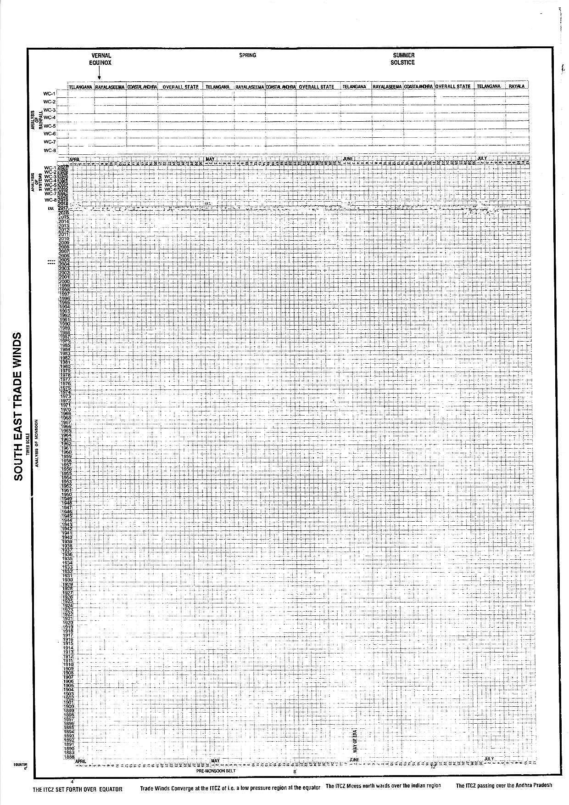
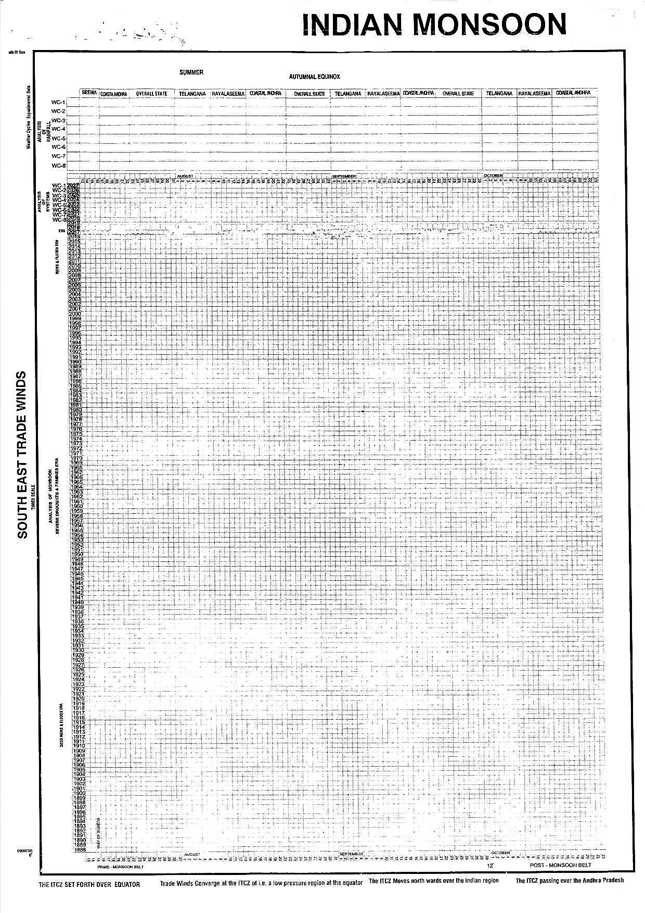
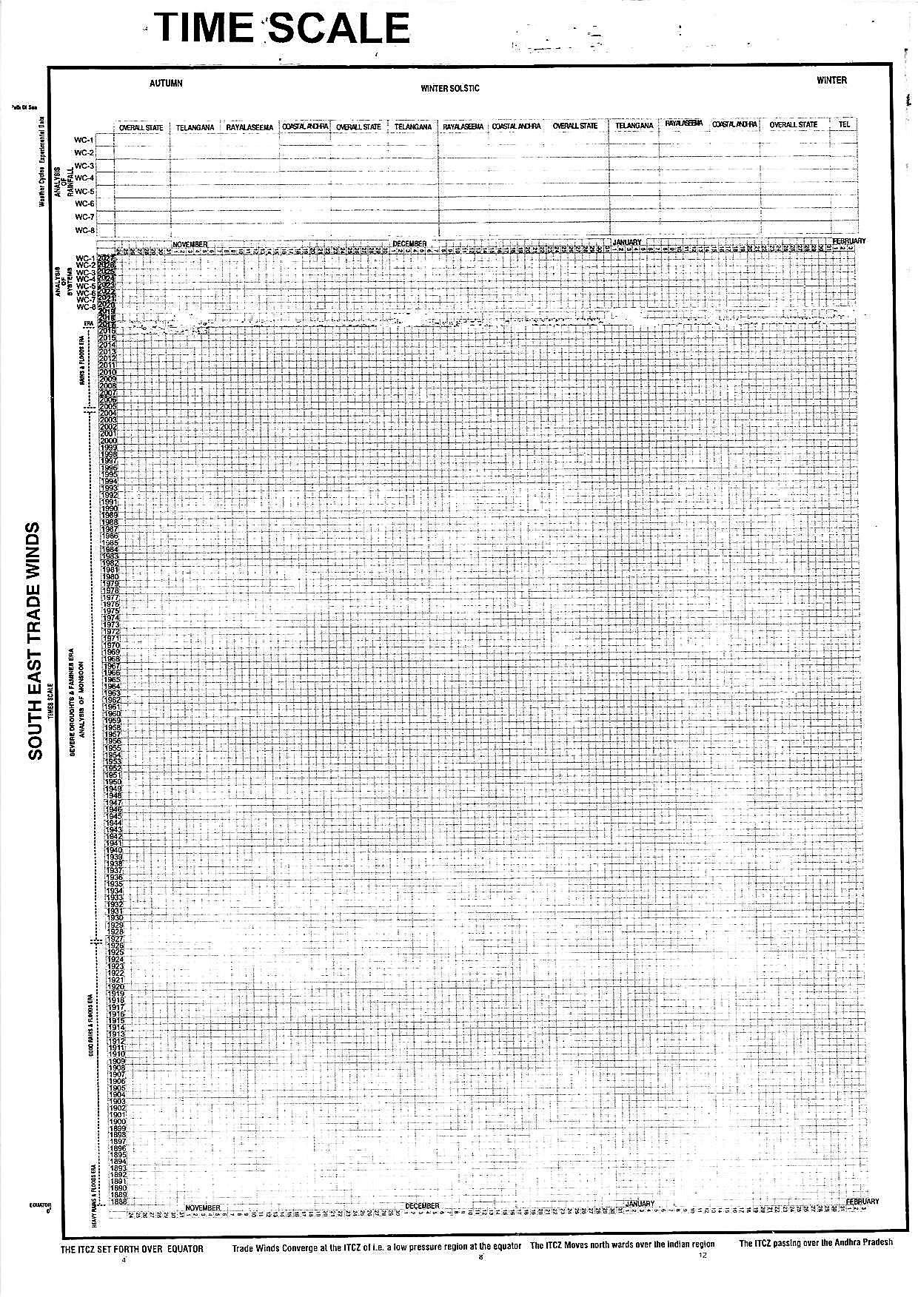
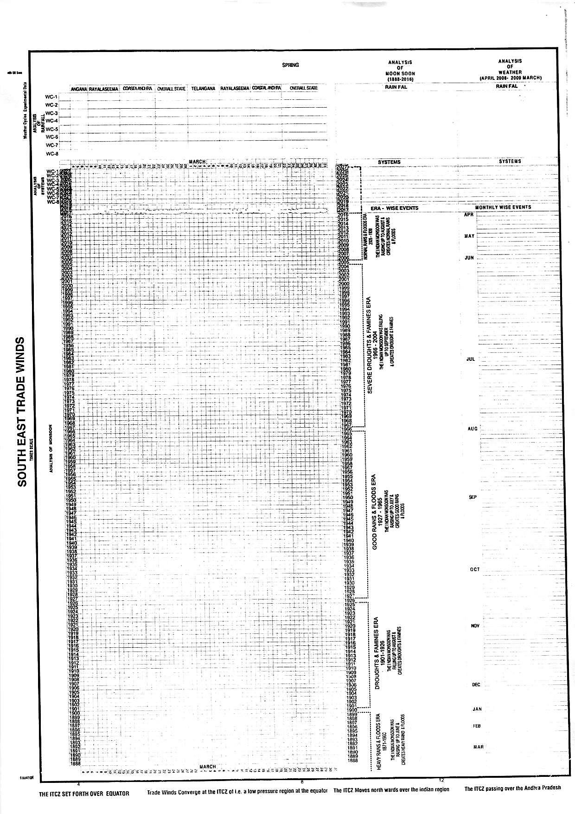
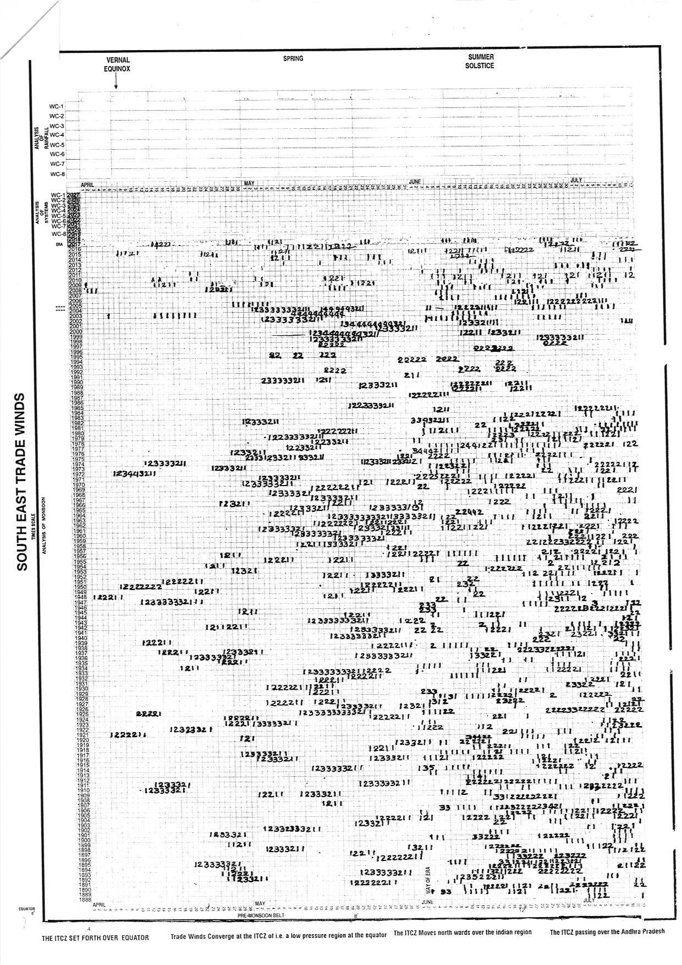
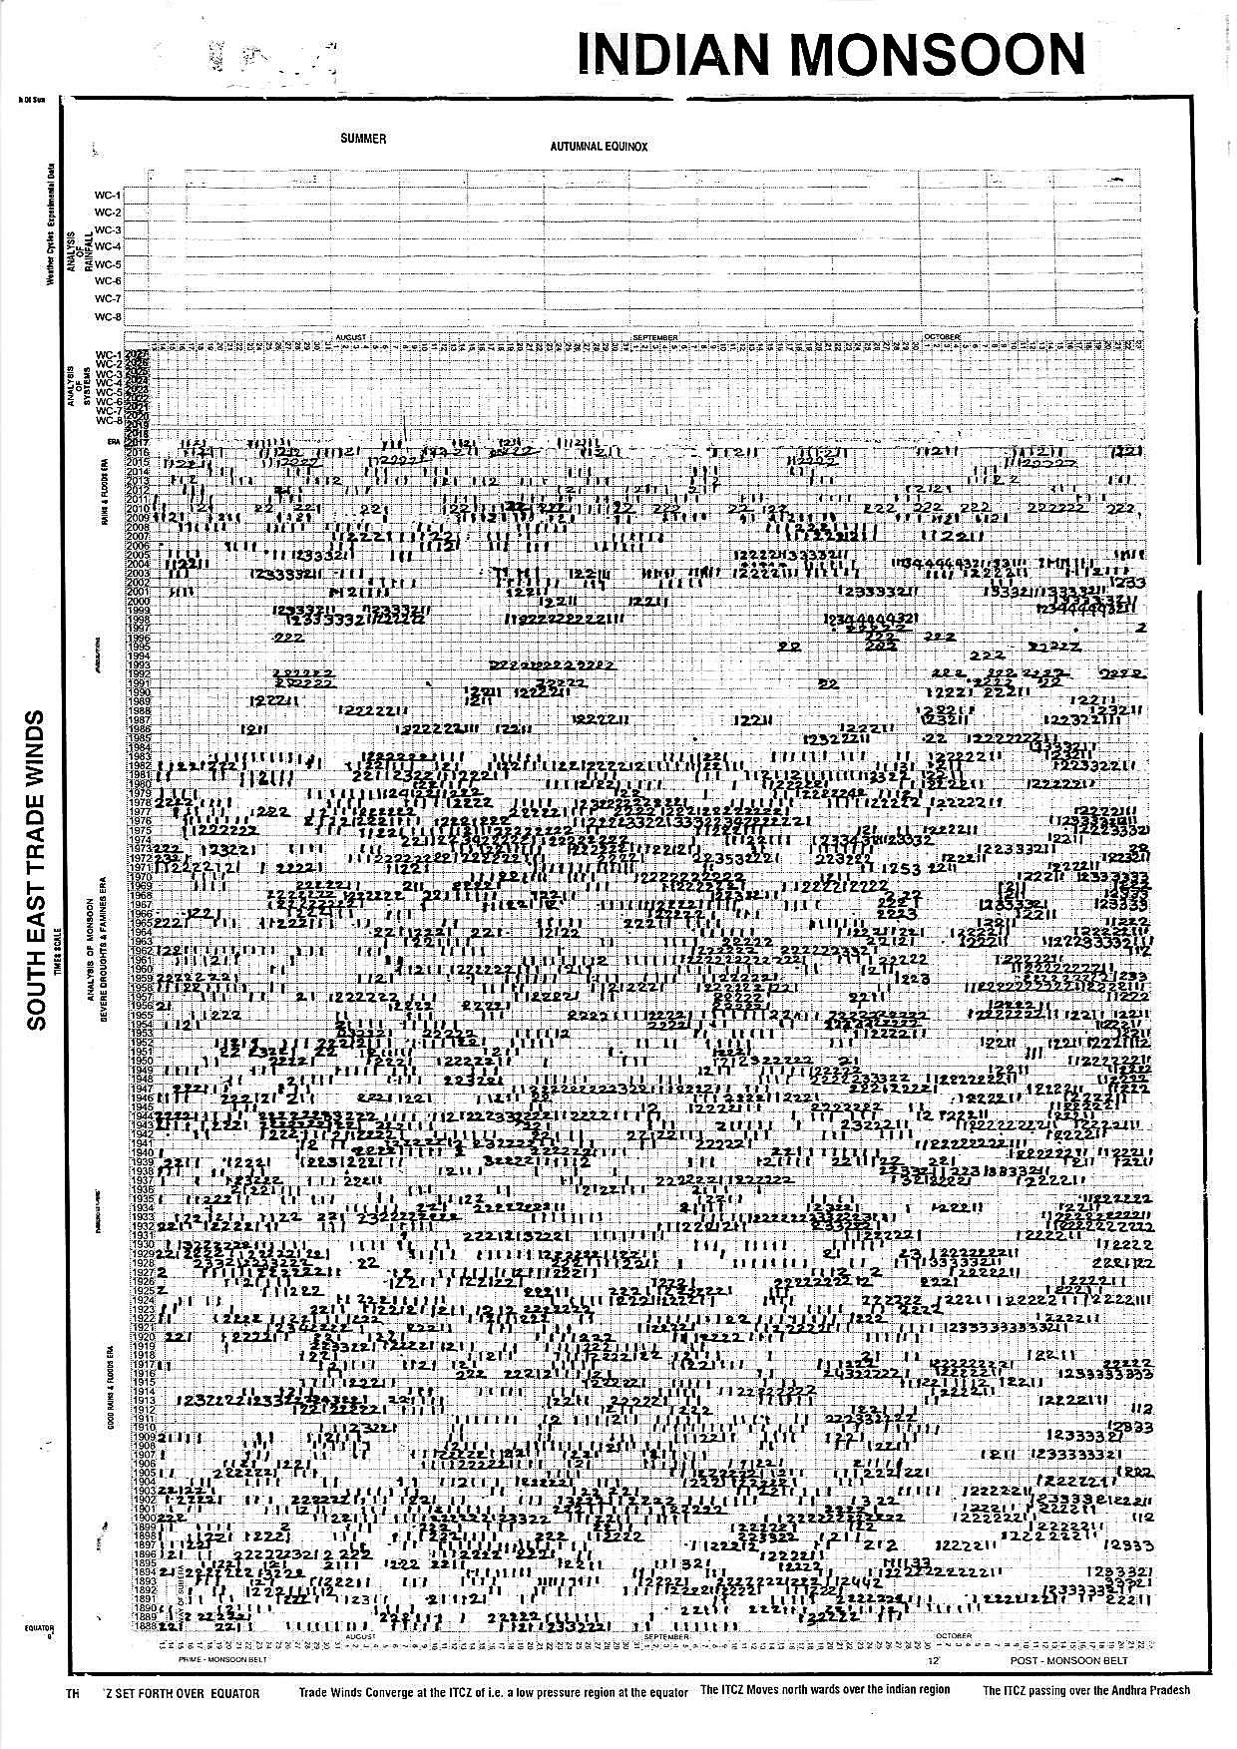
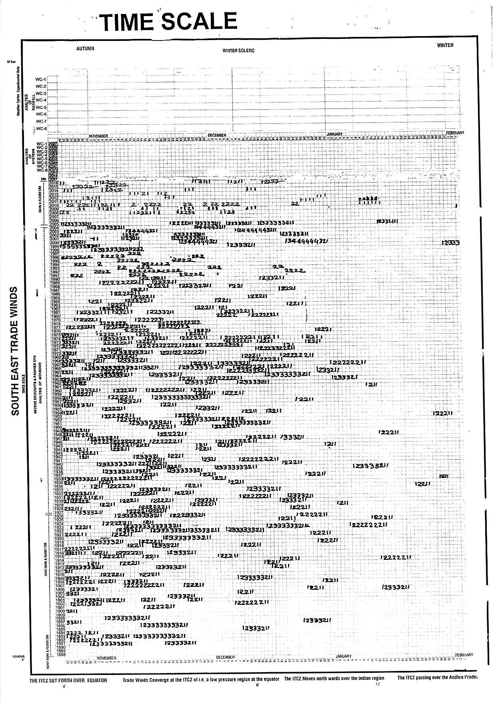
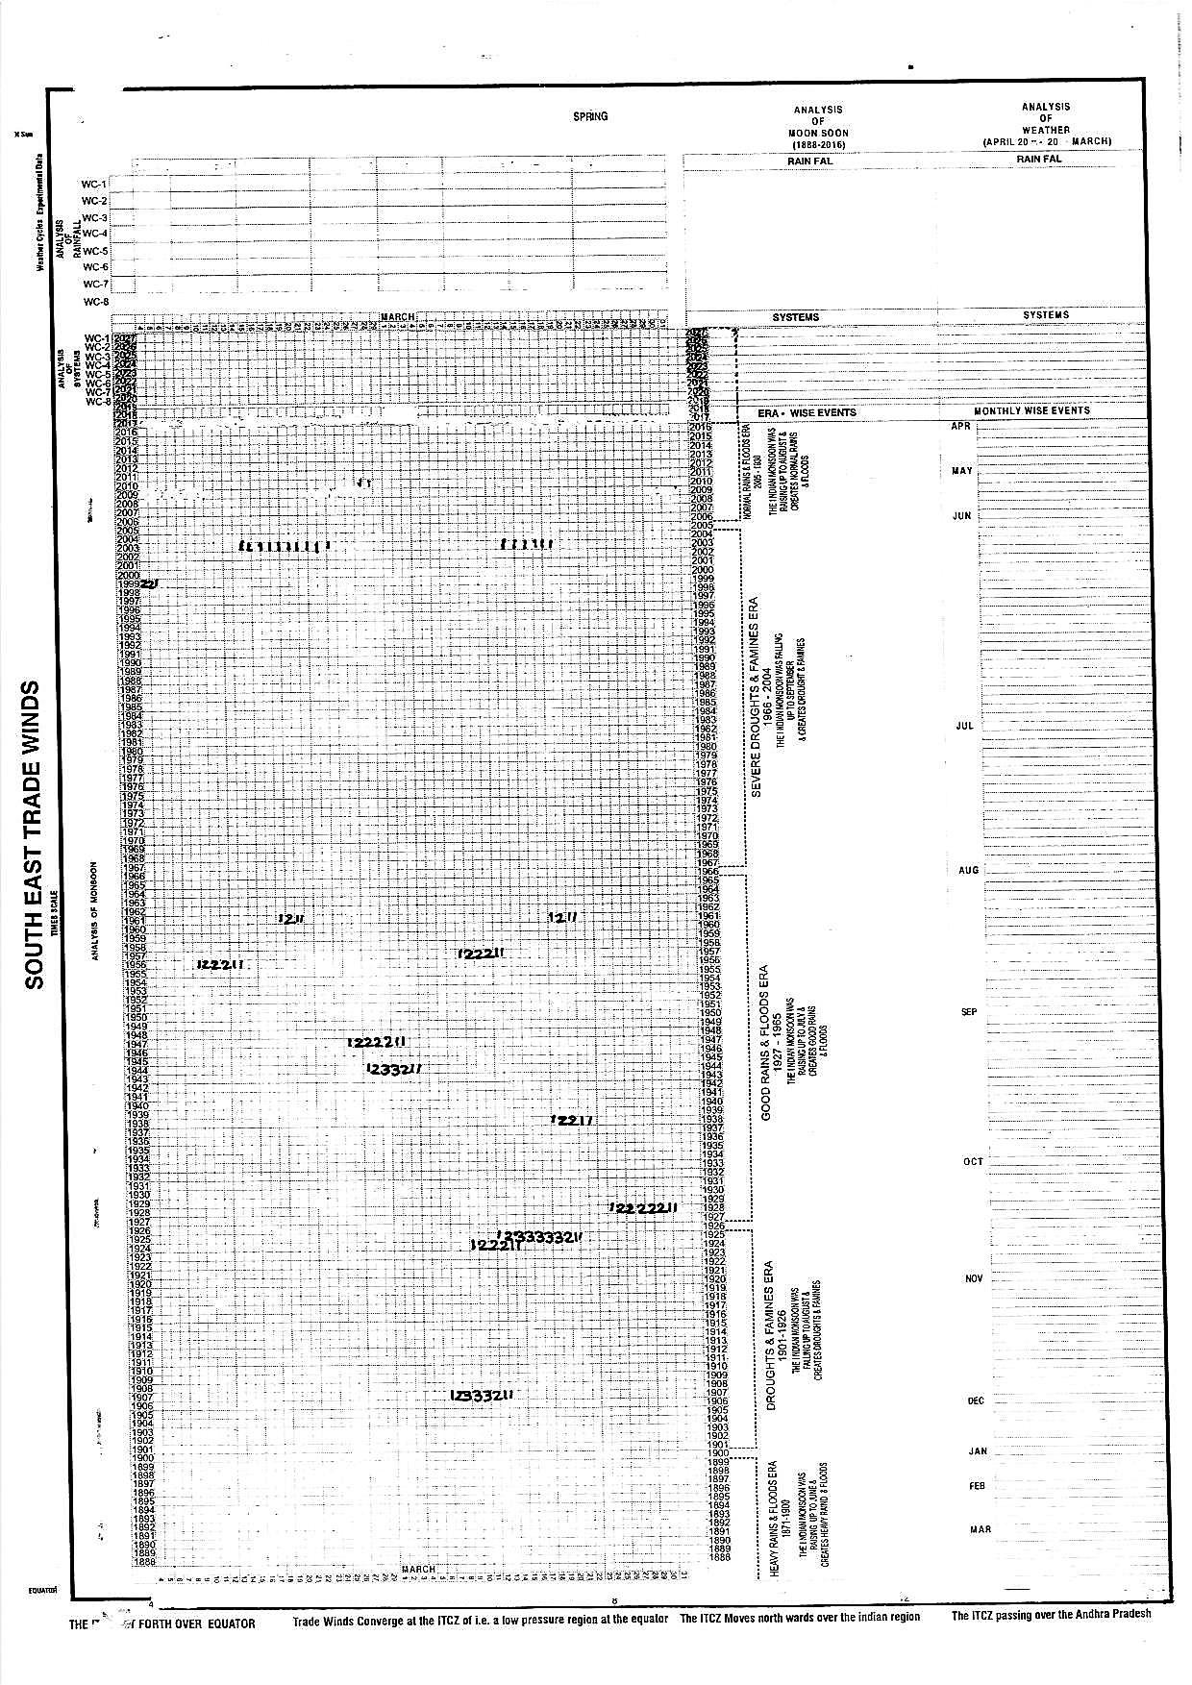
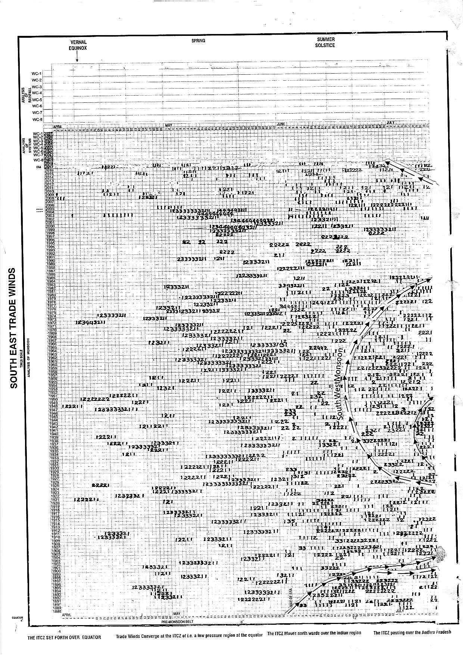
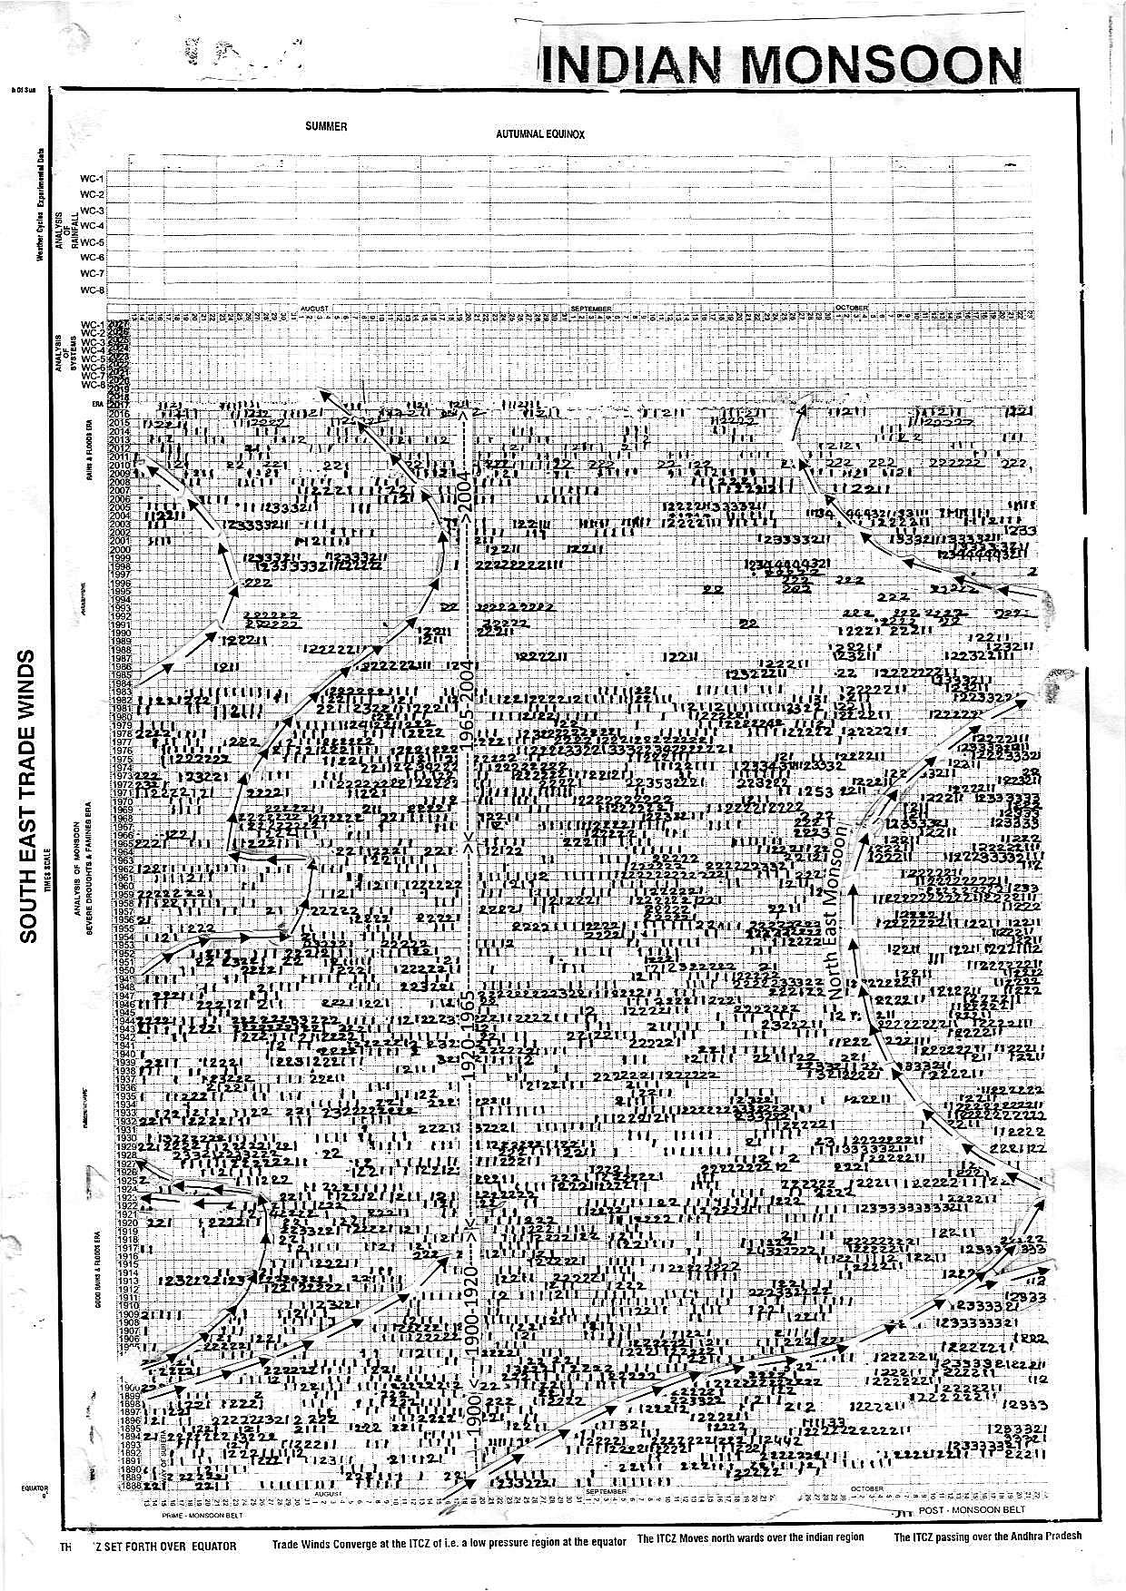
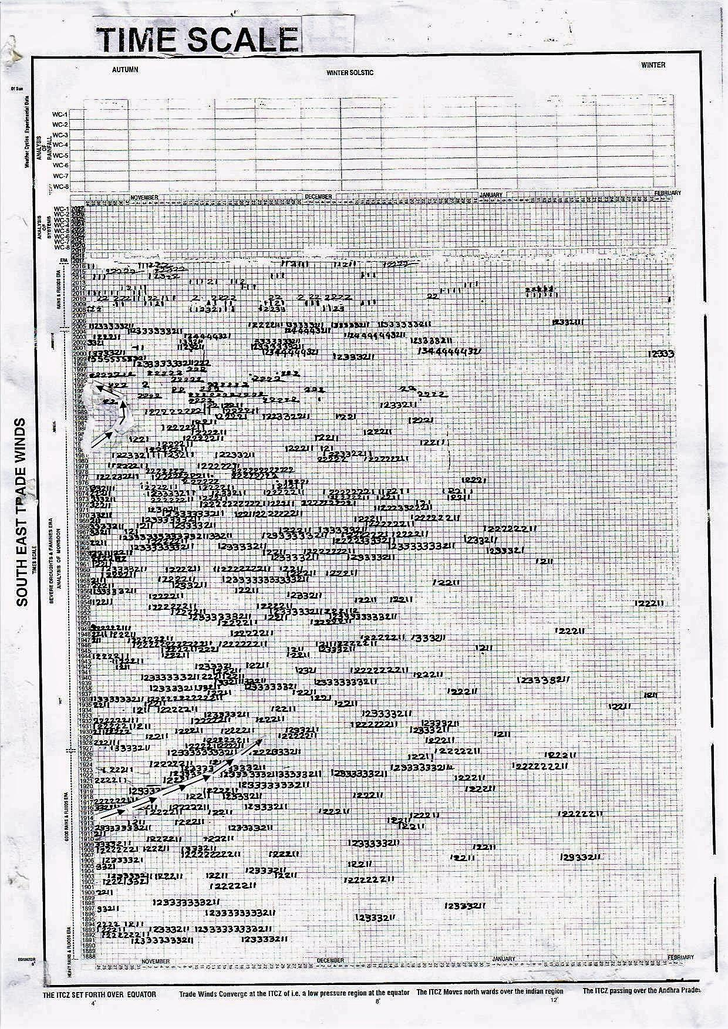
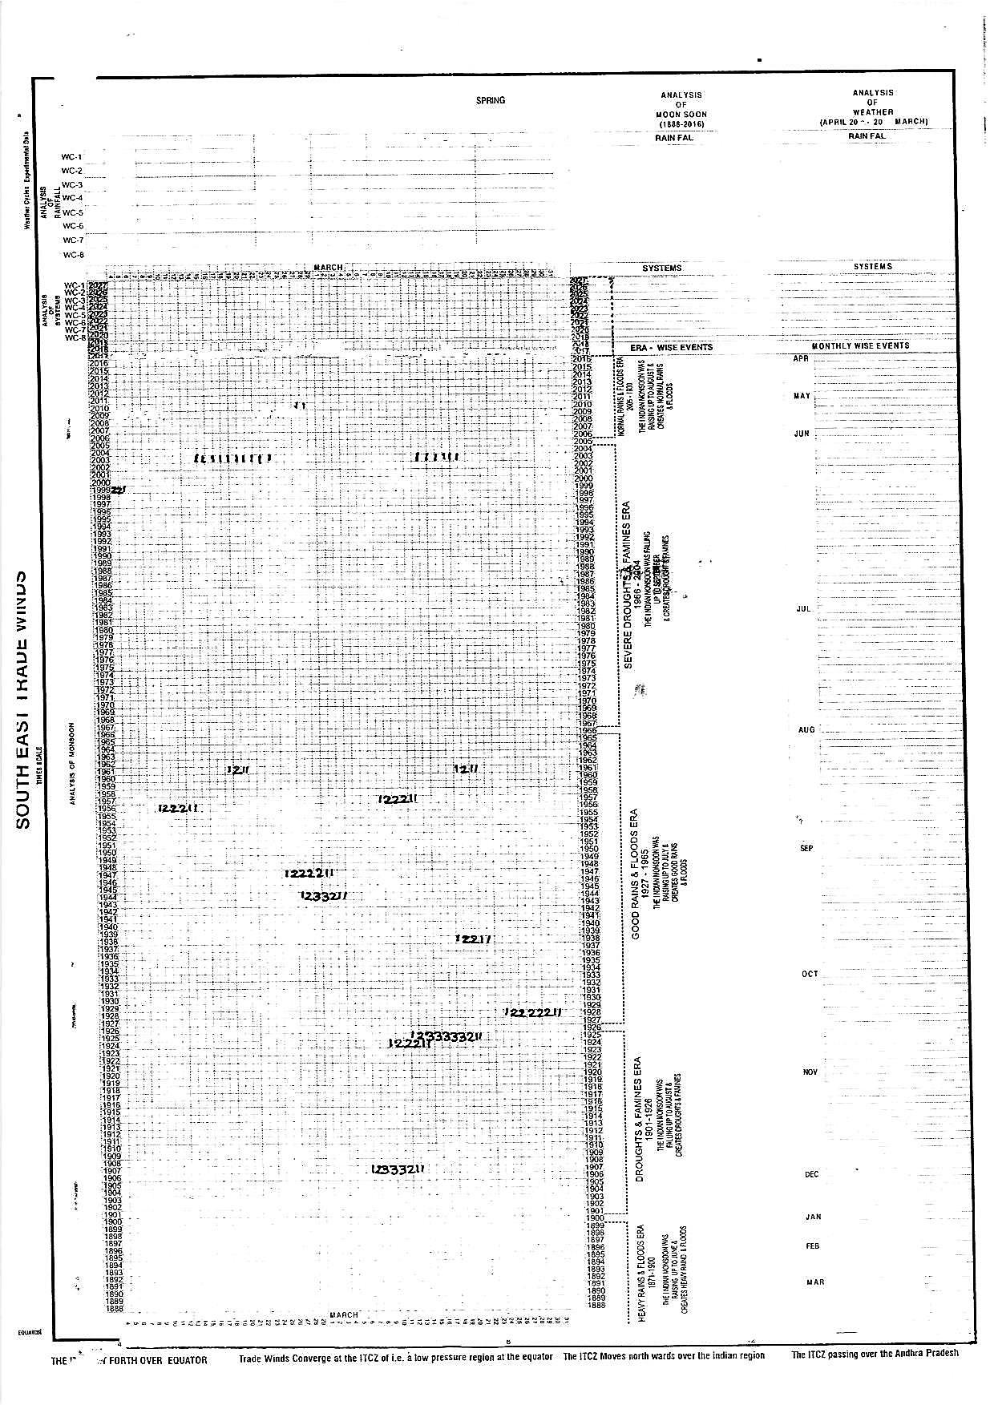
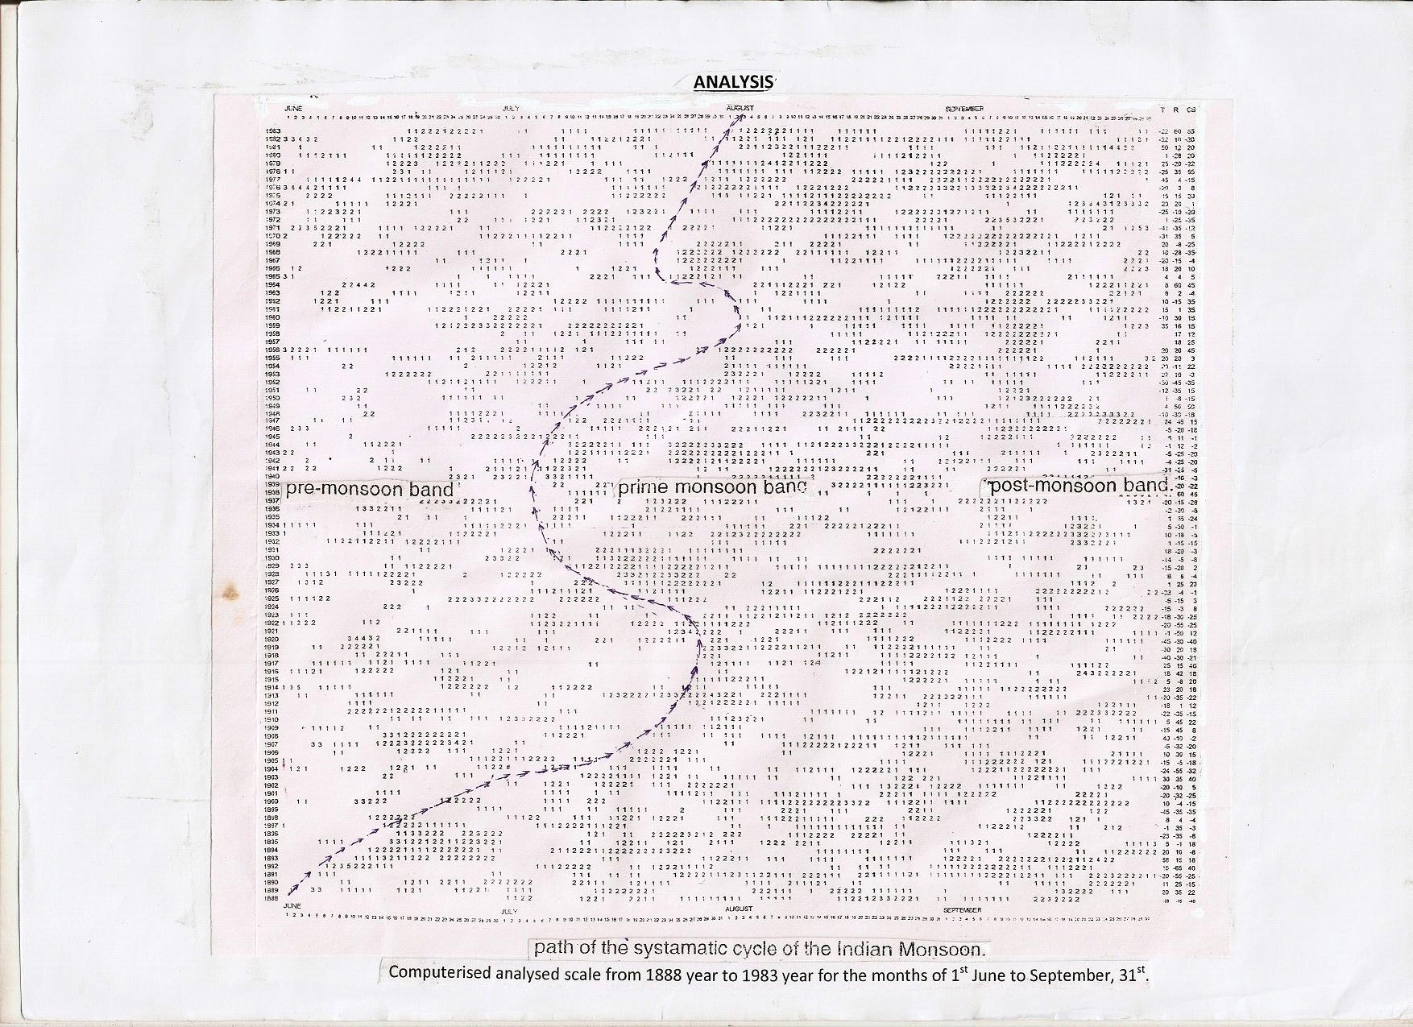
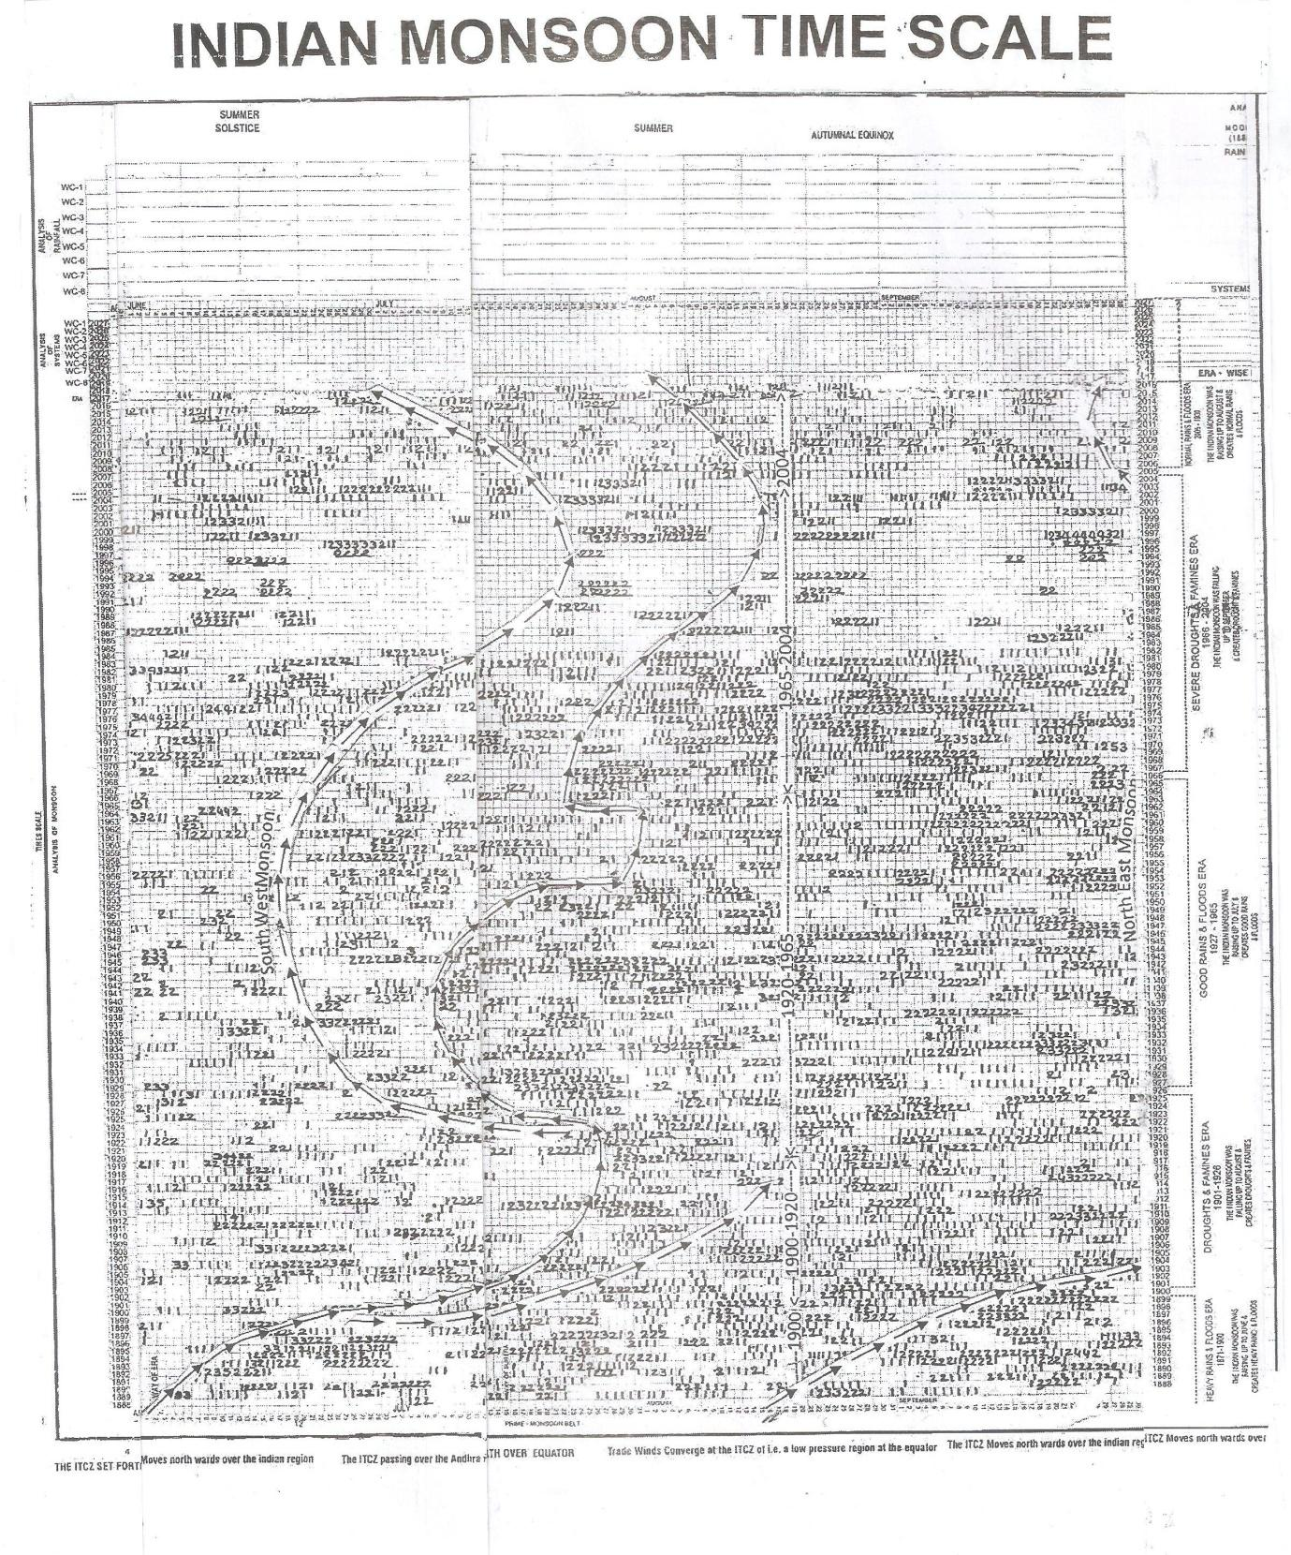

Indian monsoon time scales(when four parts are pasted)
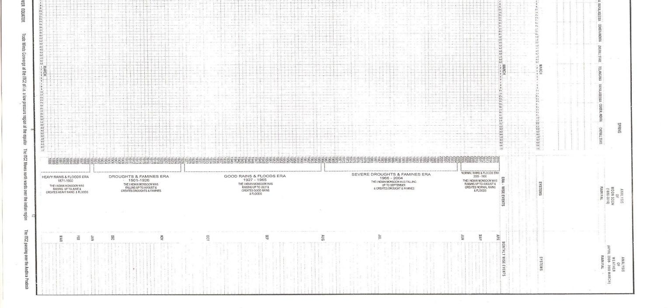 FILLED SCALE

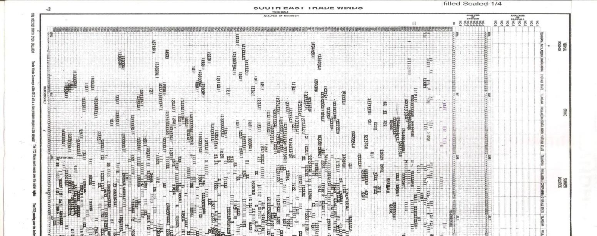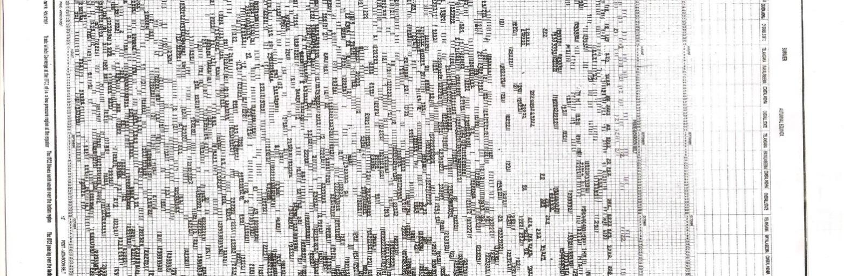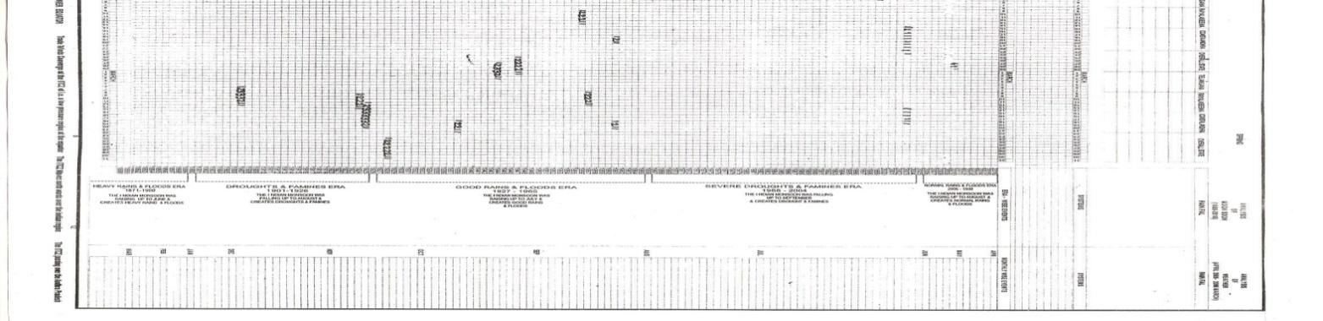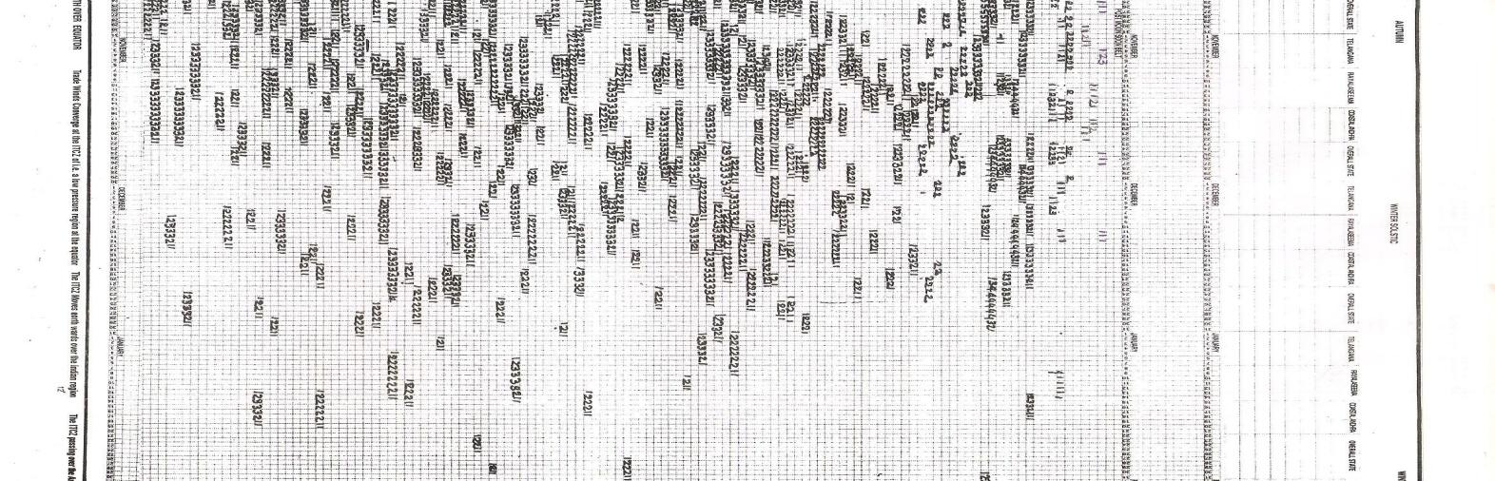
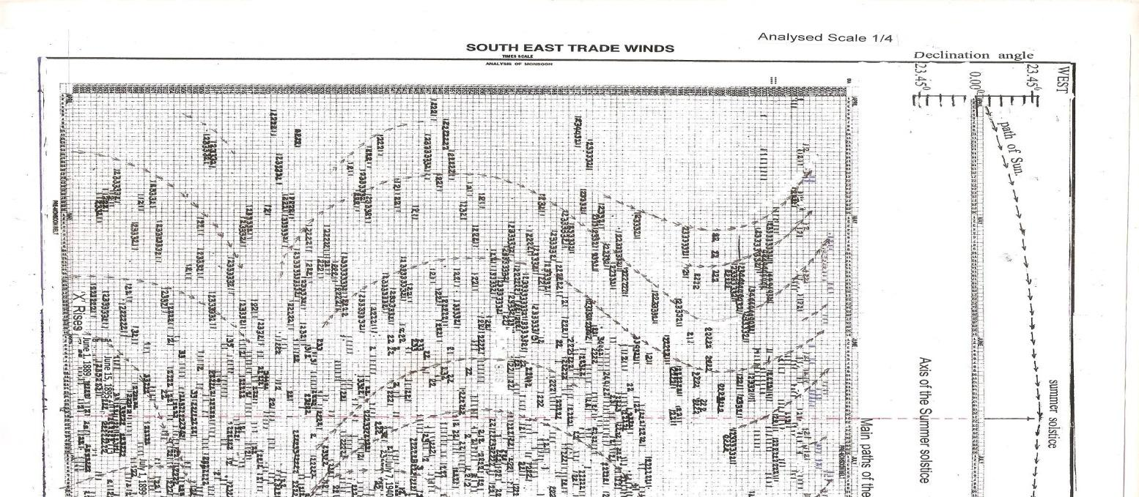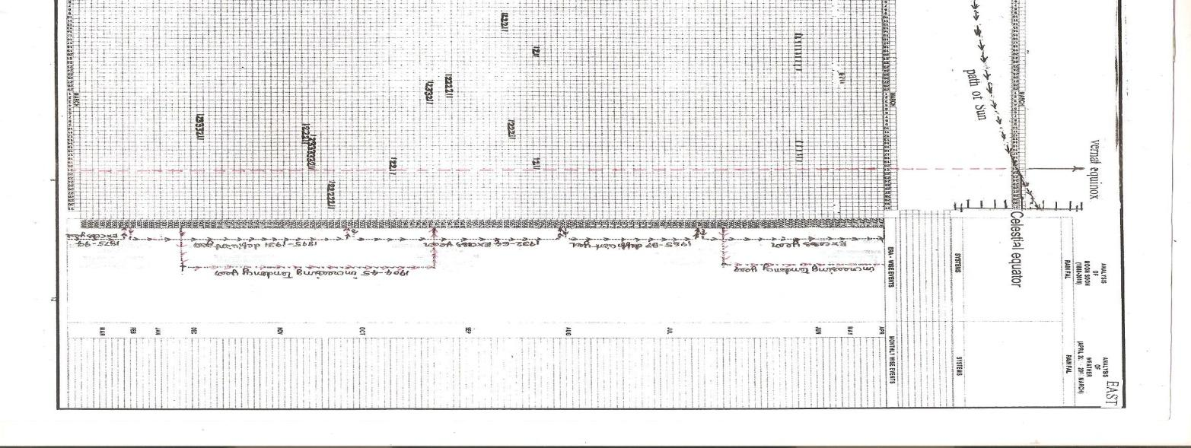

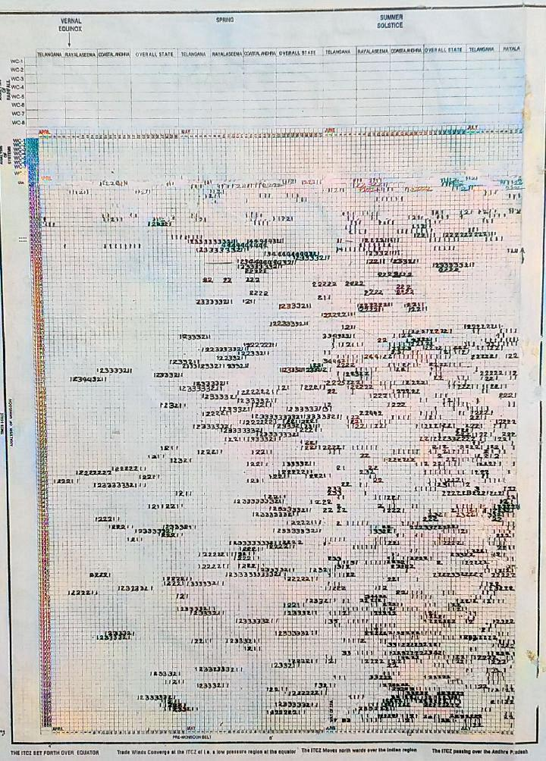

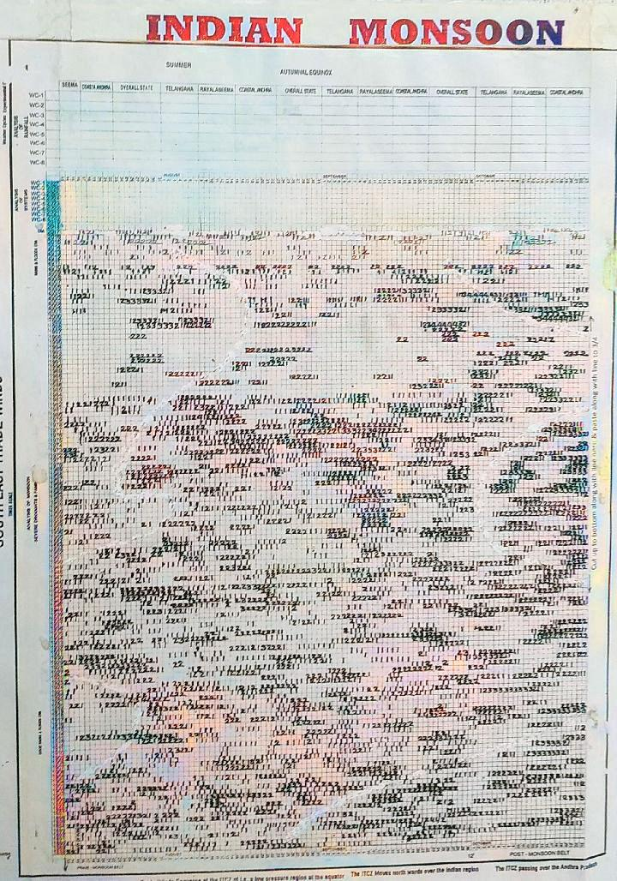

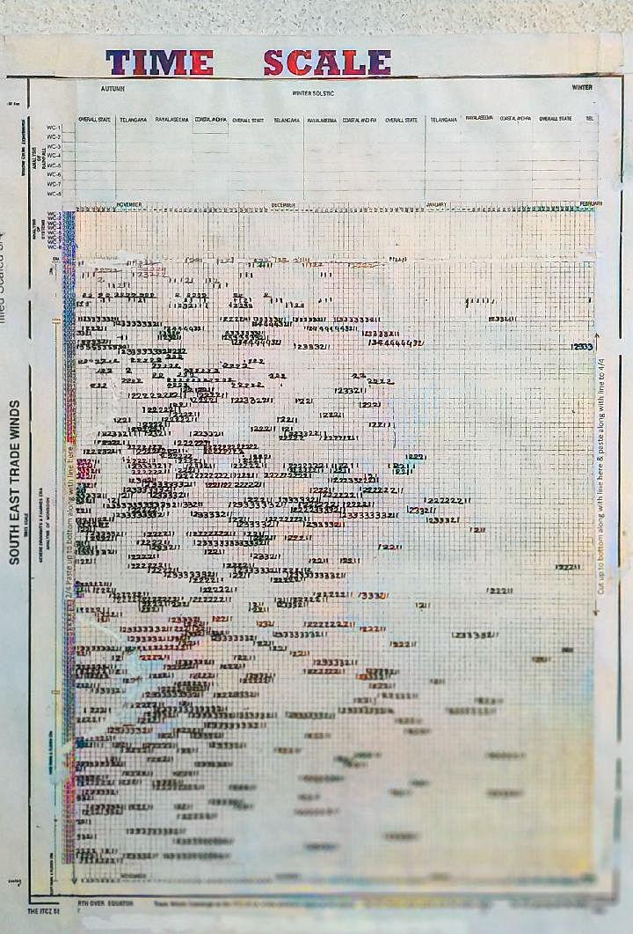

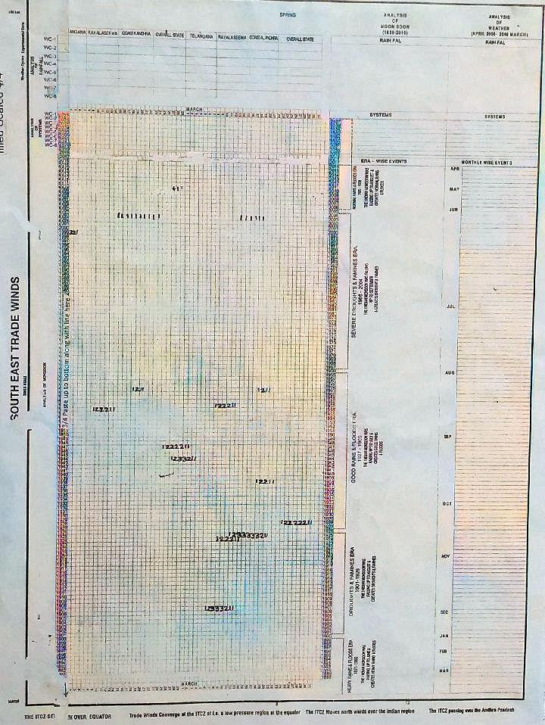

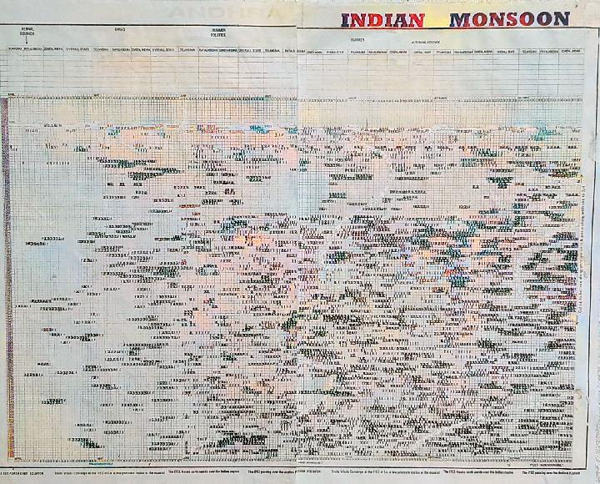

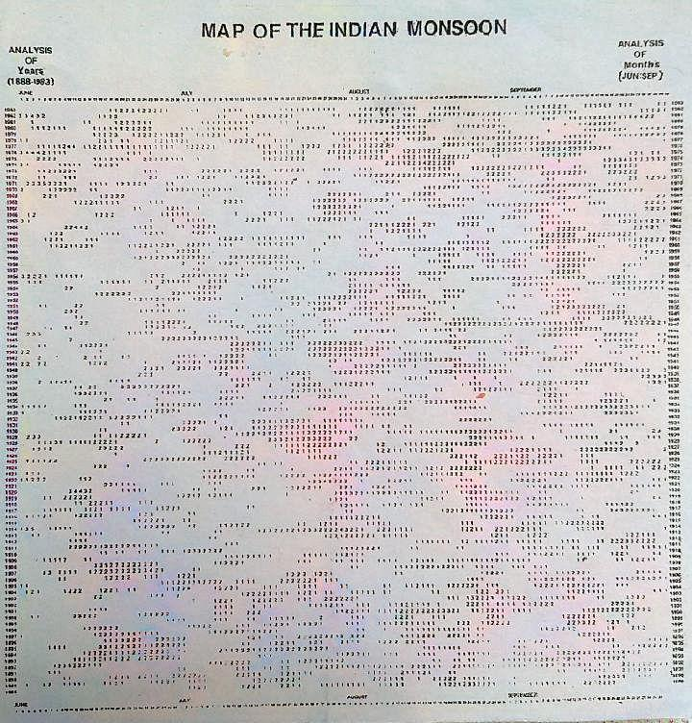
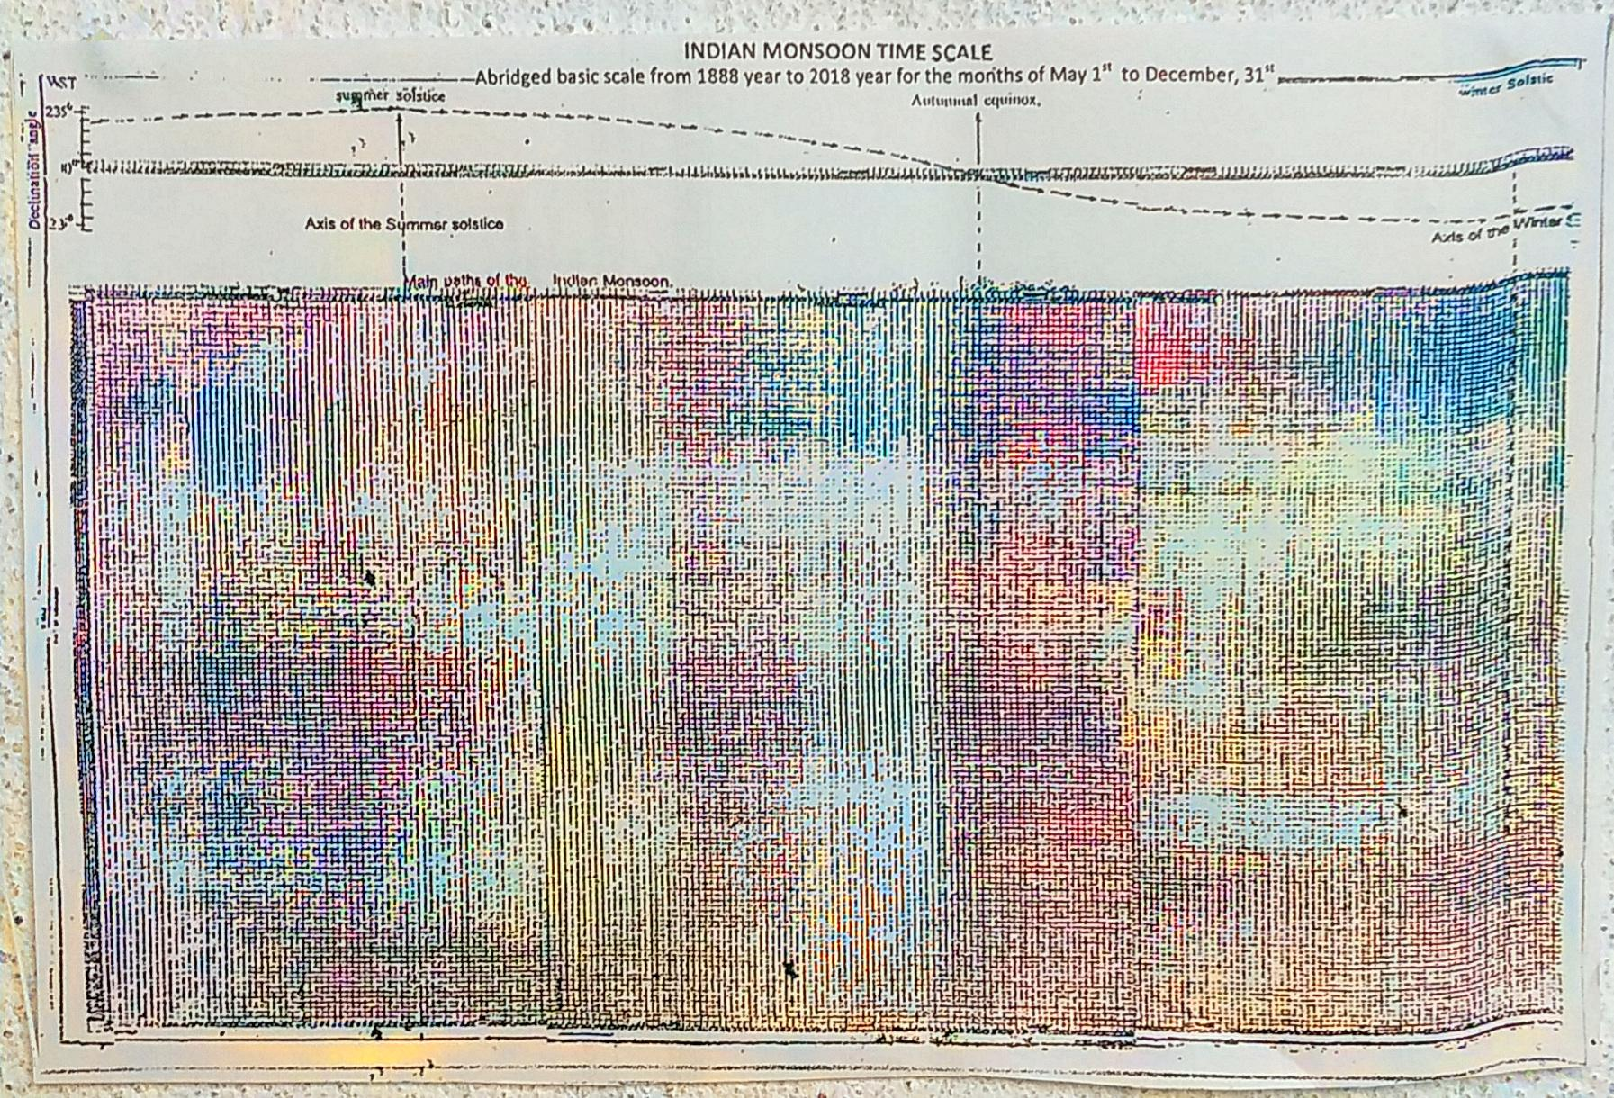

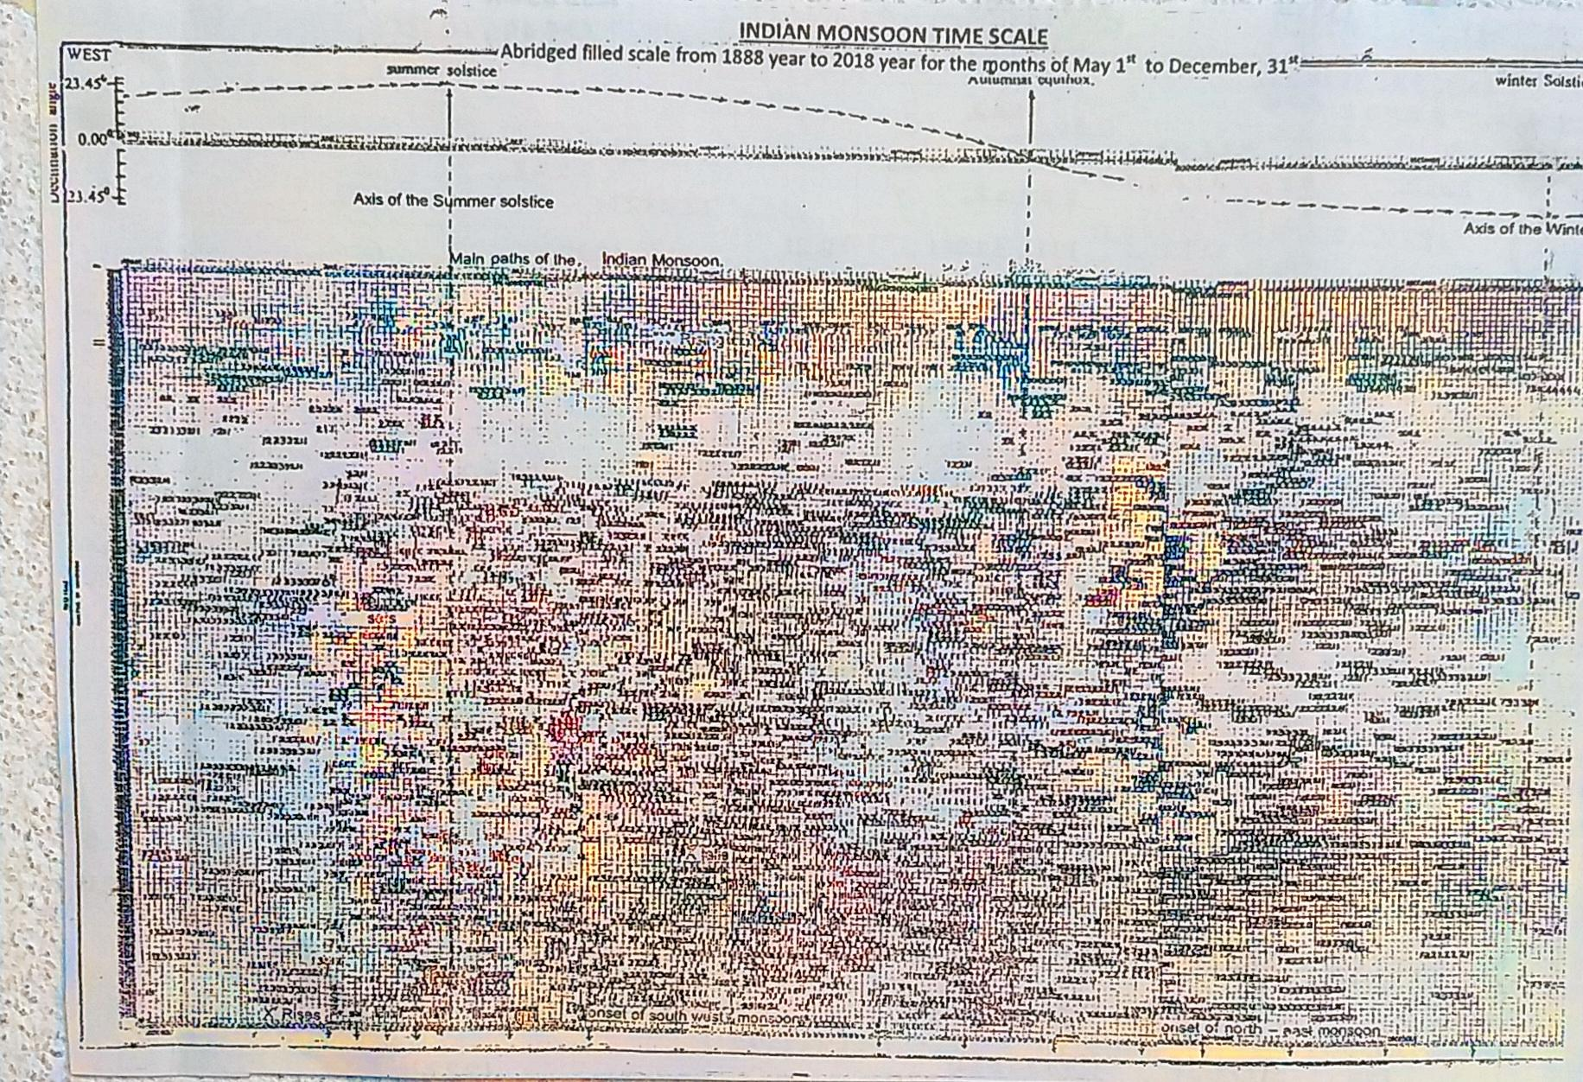
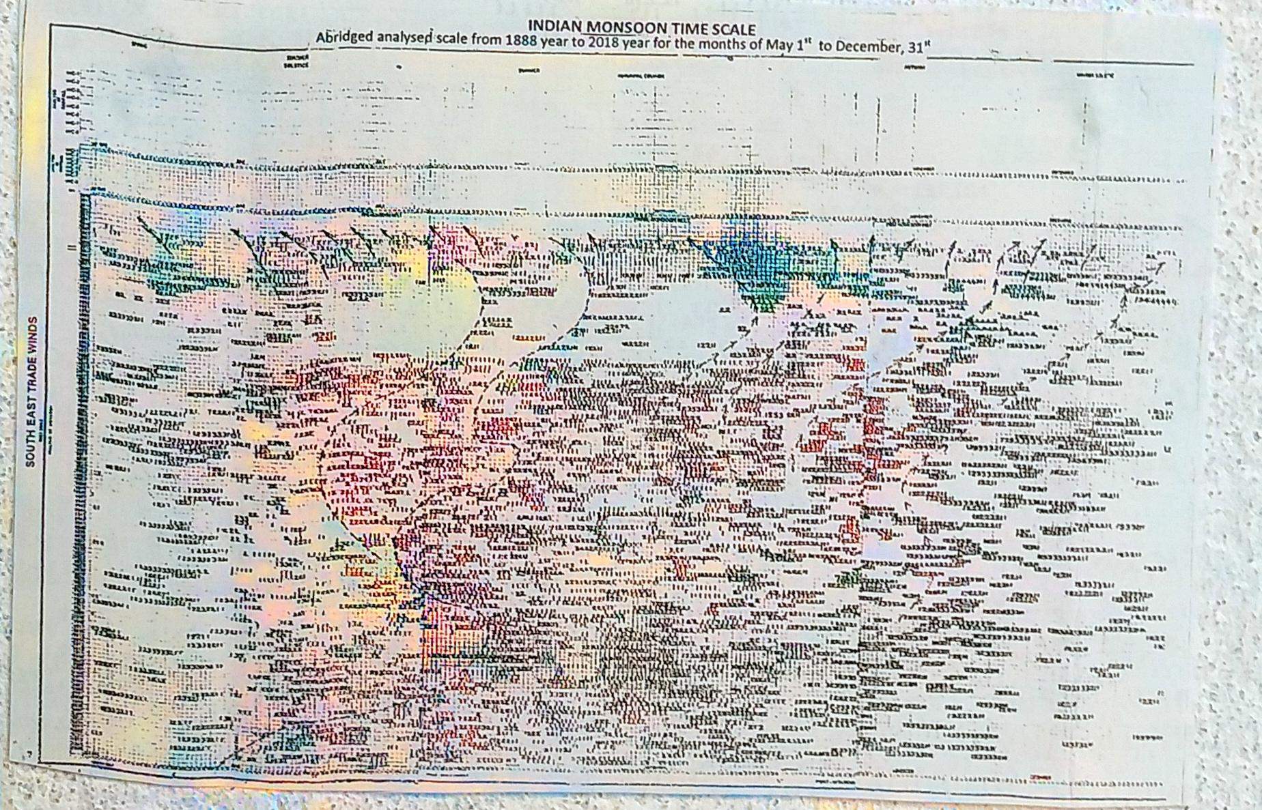

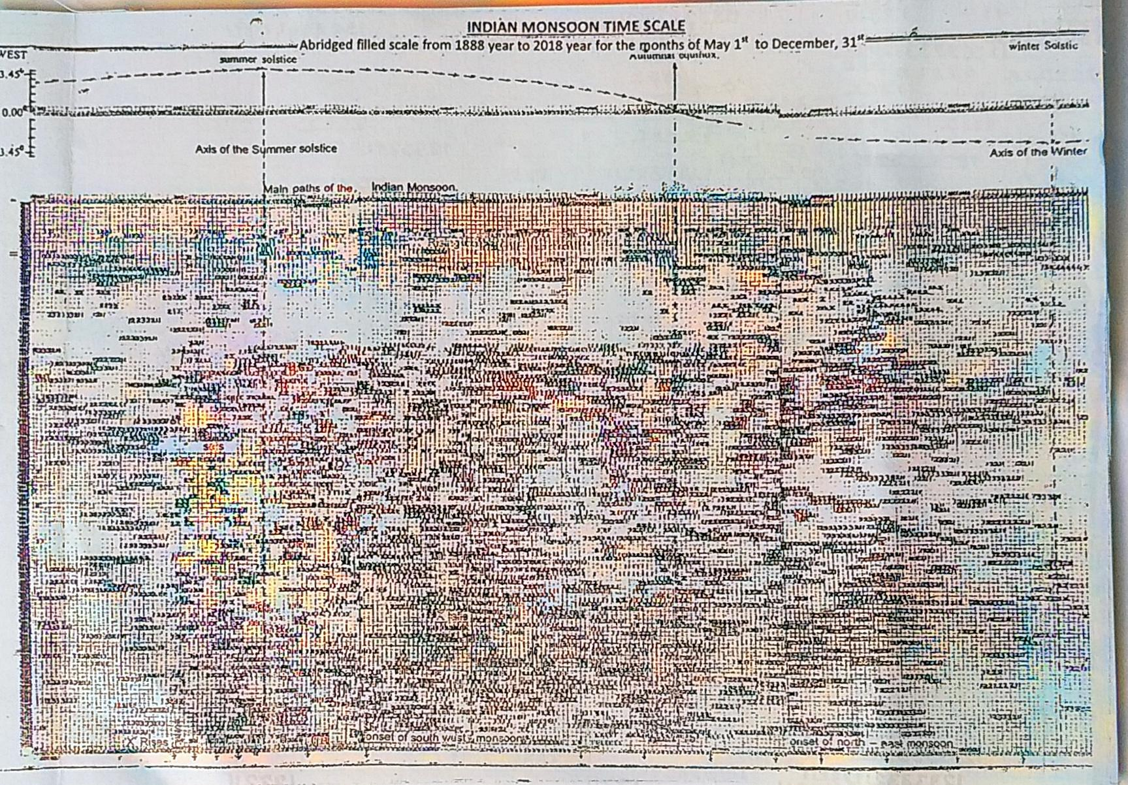
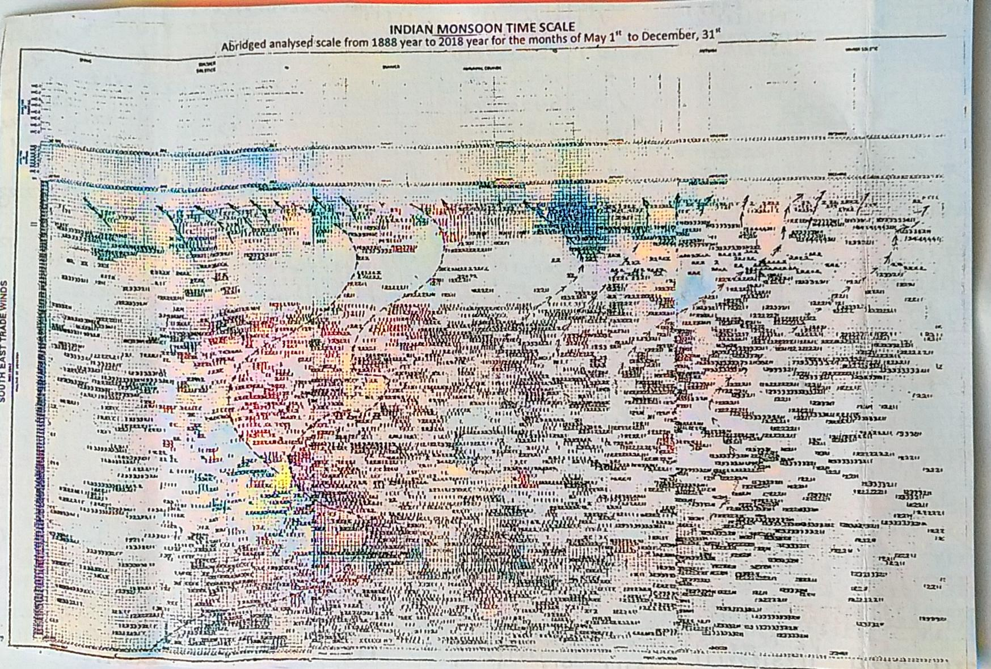

F

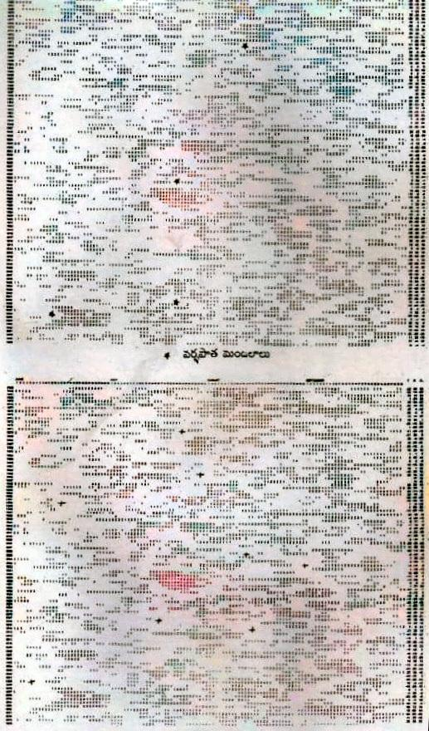

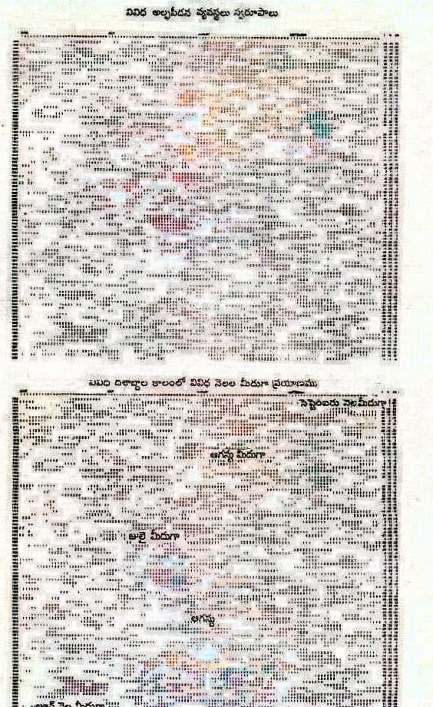

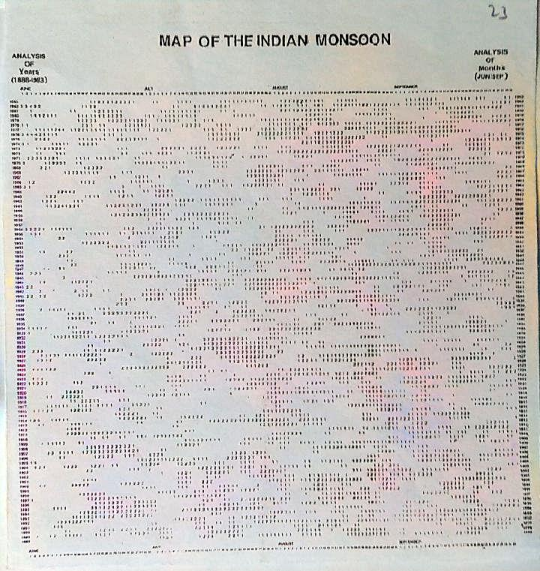

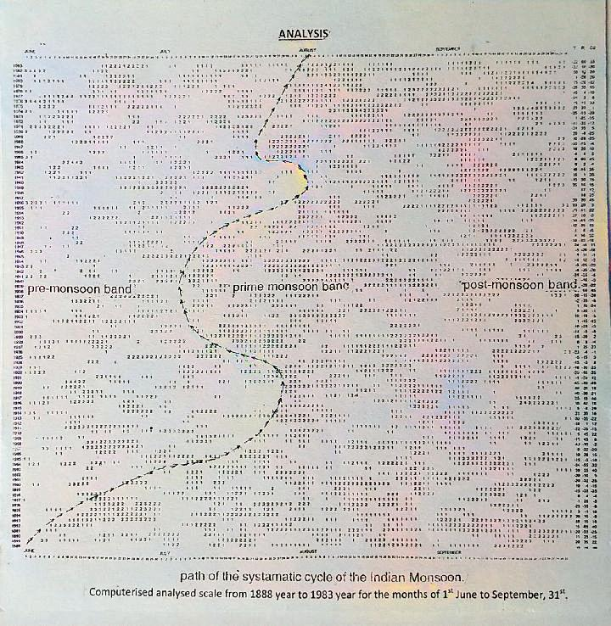

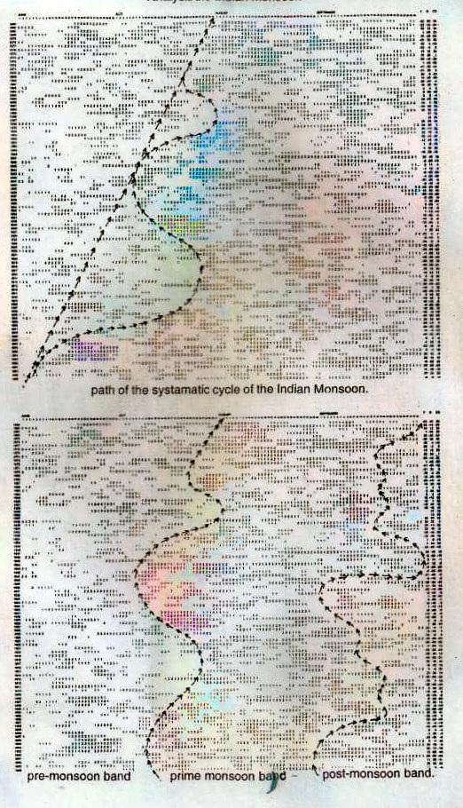

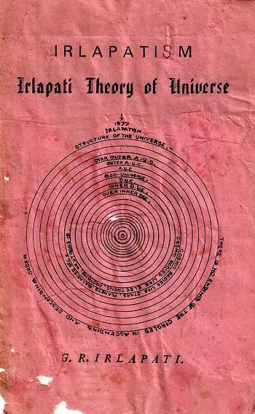
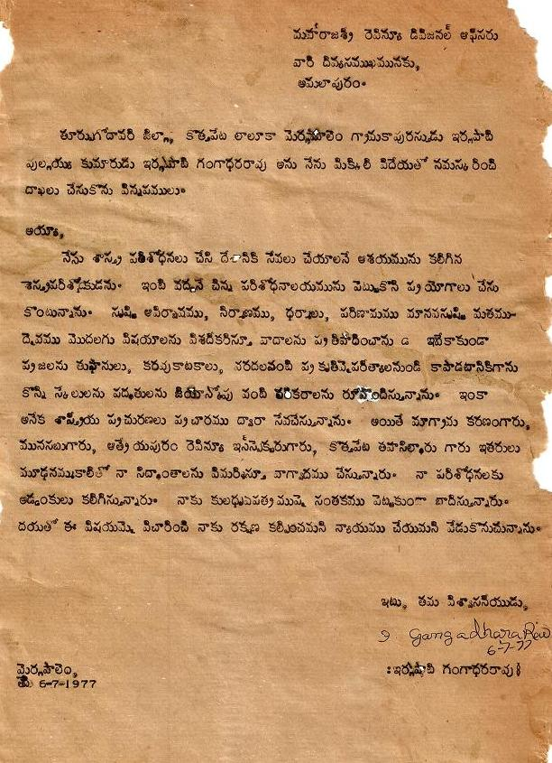
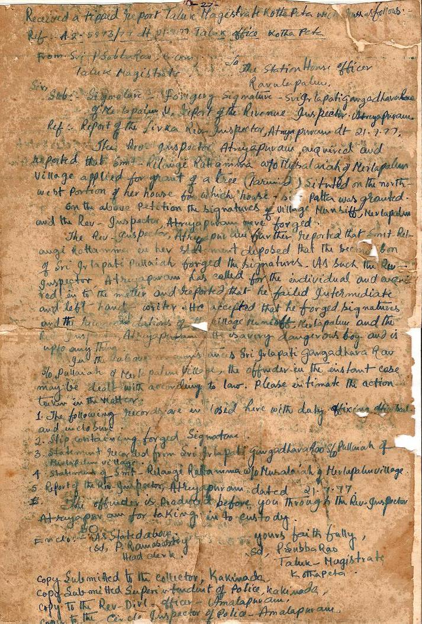
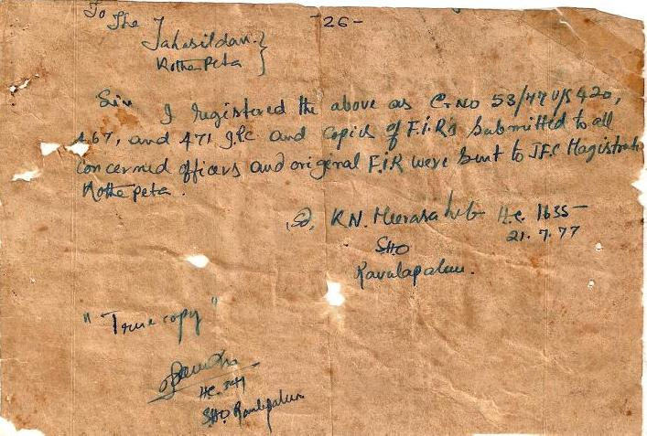
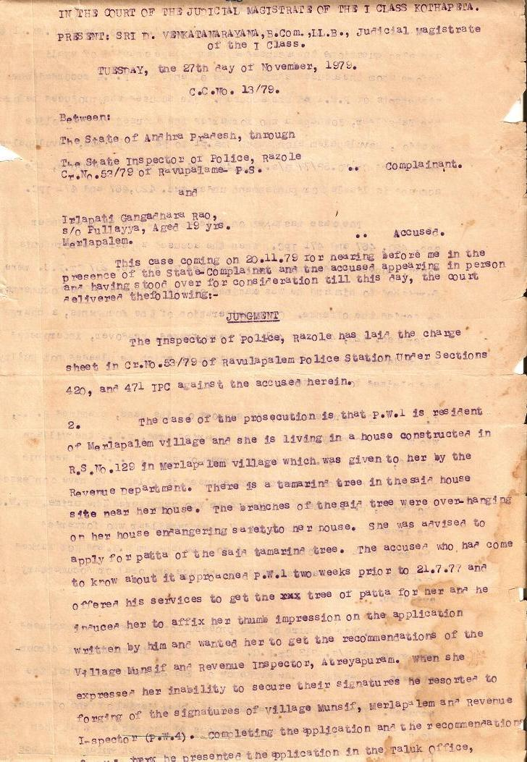
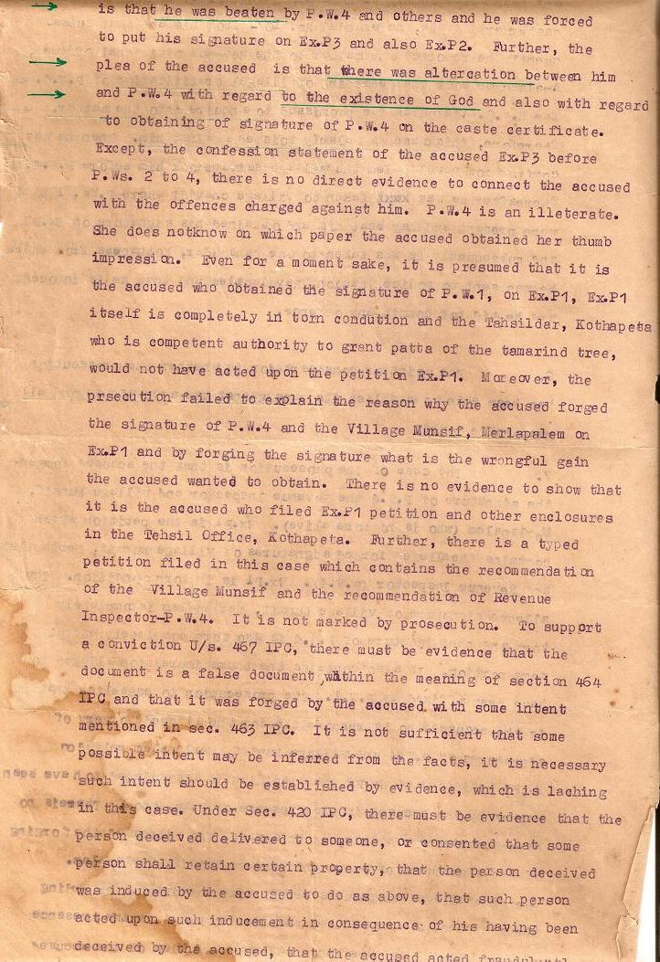
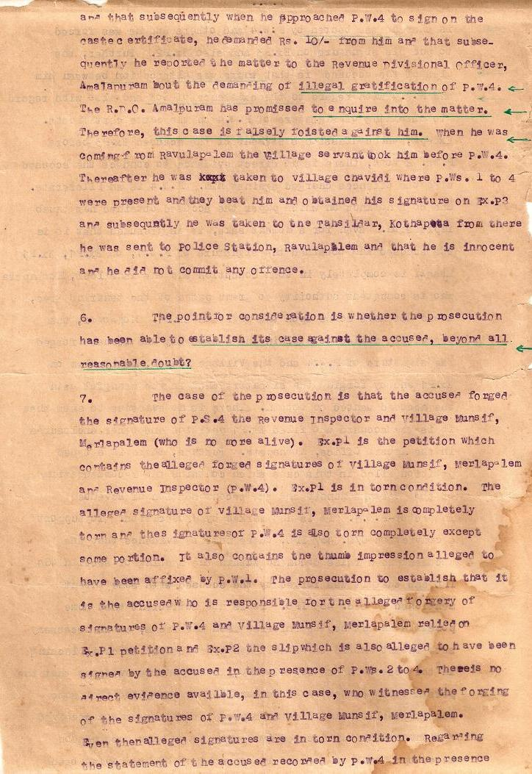
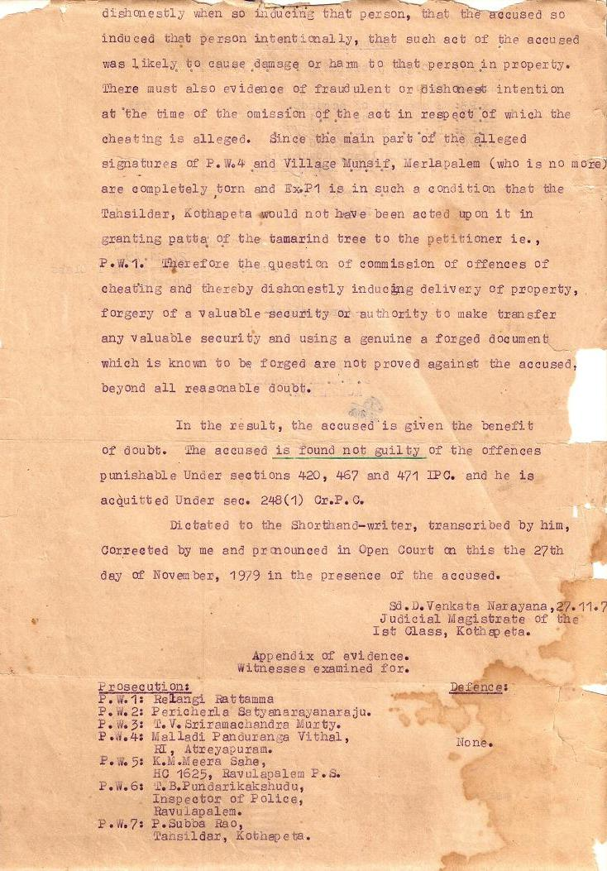
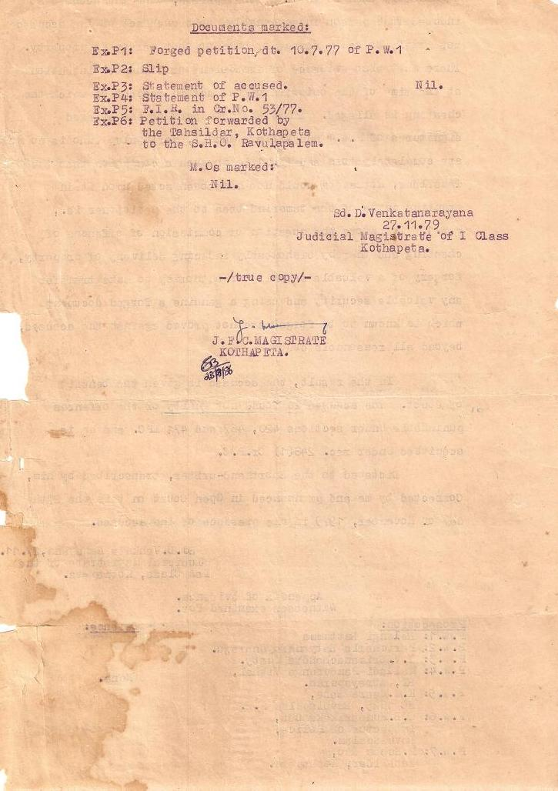
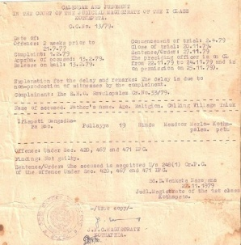
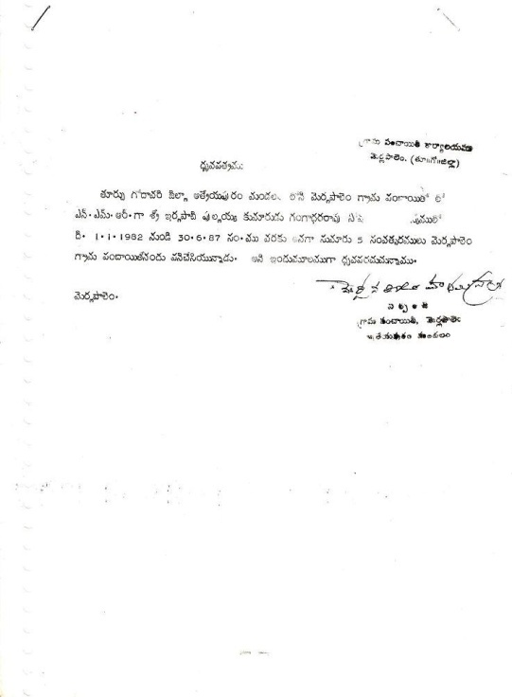
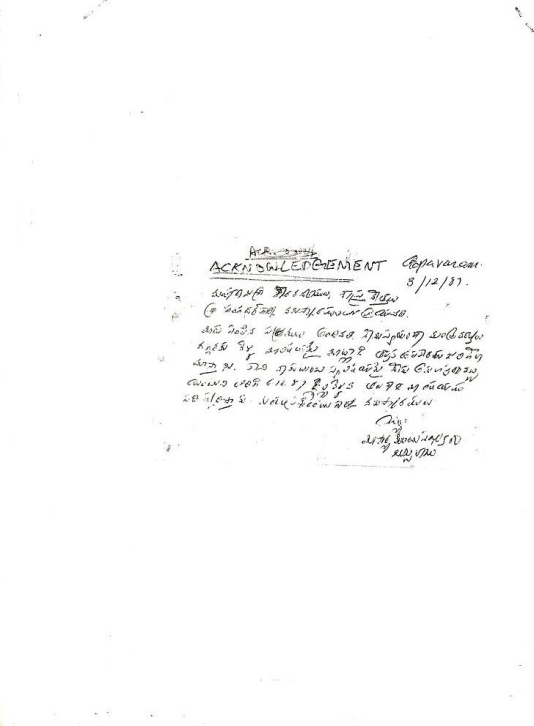
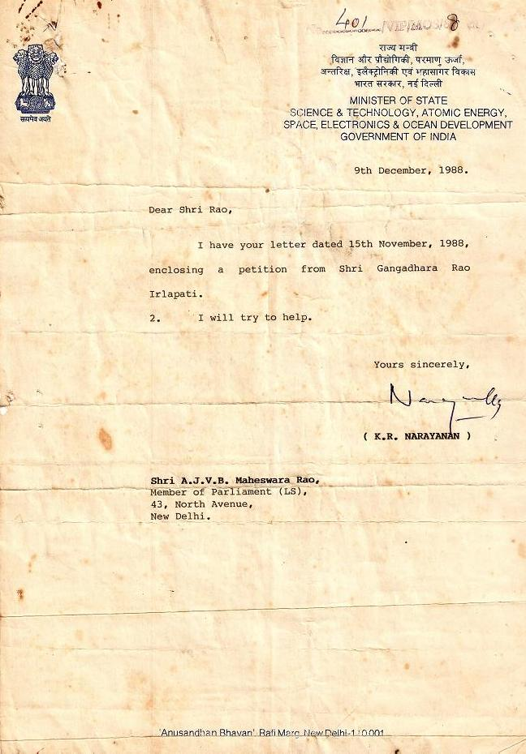

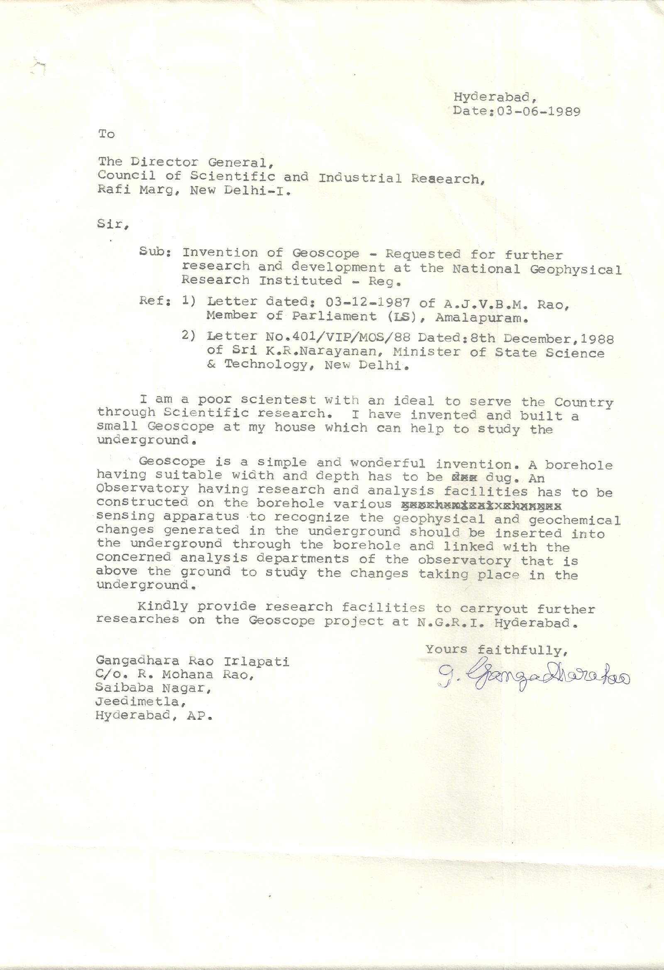
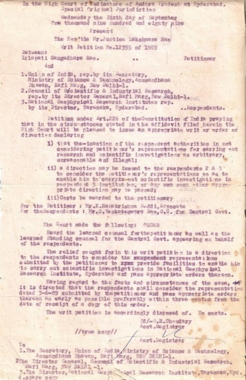
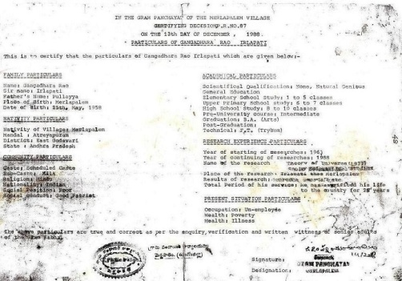
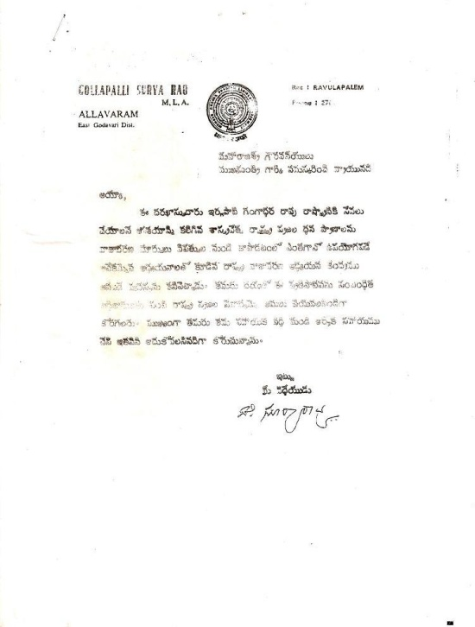
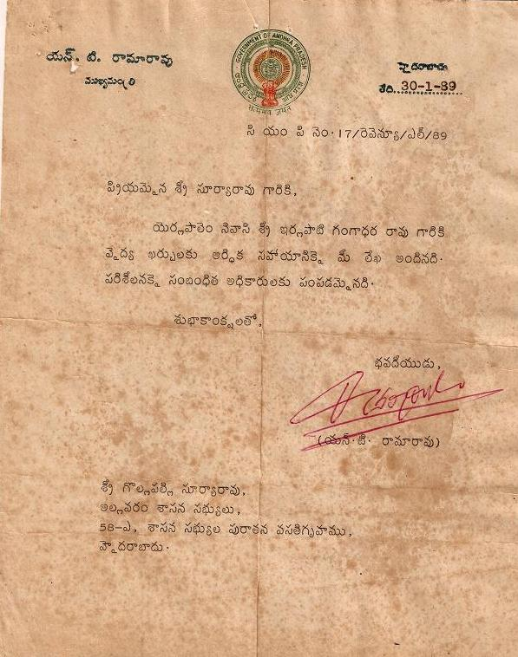

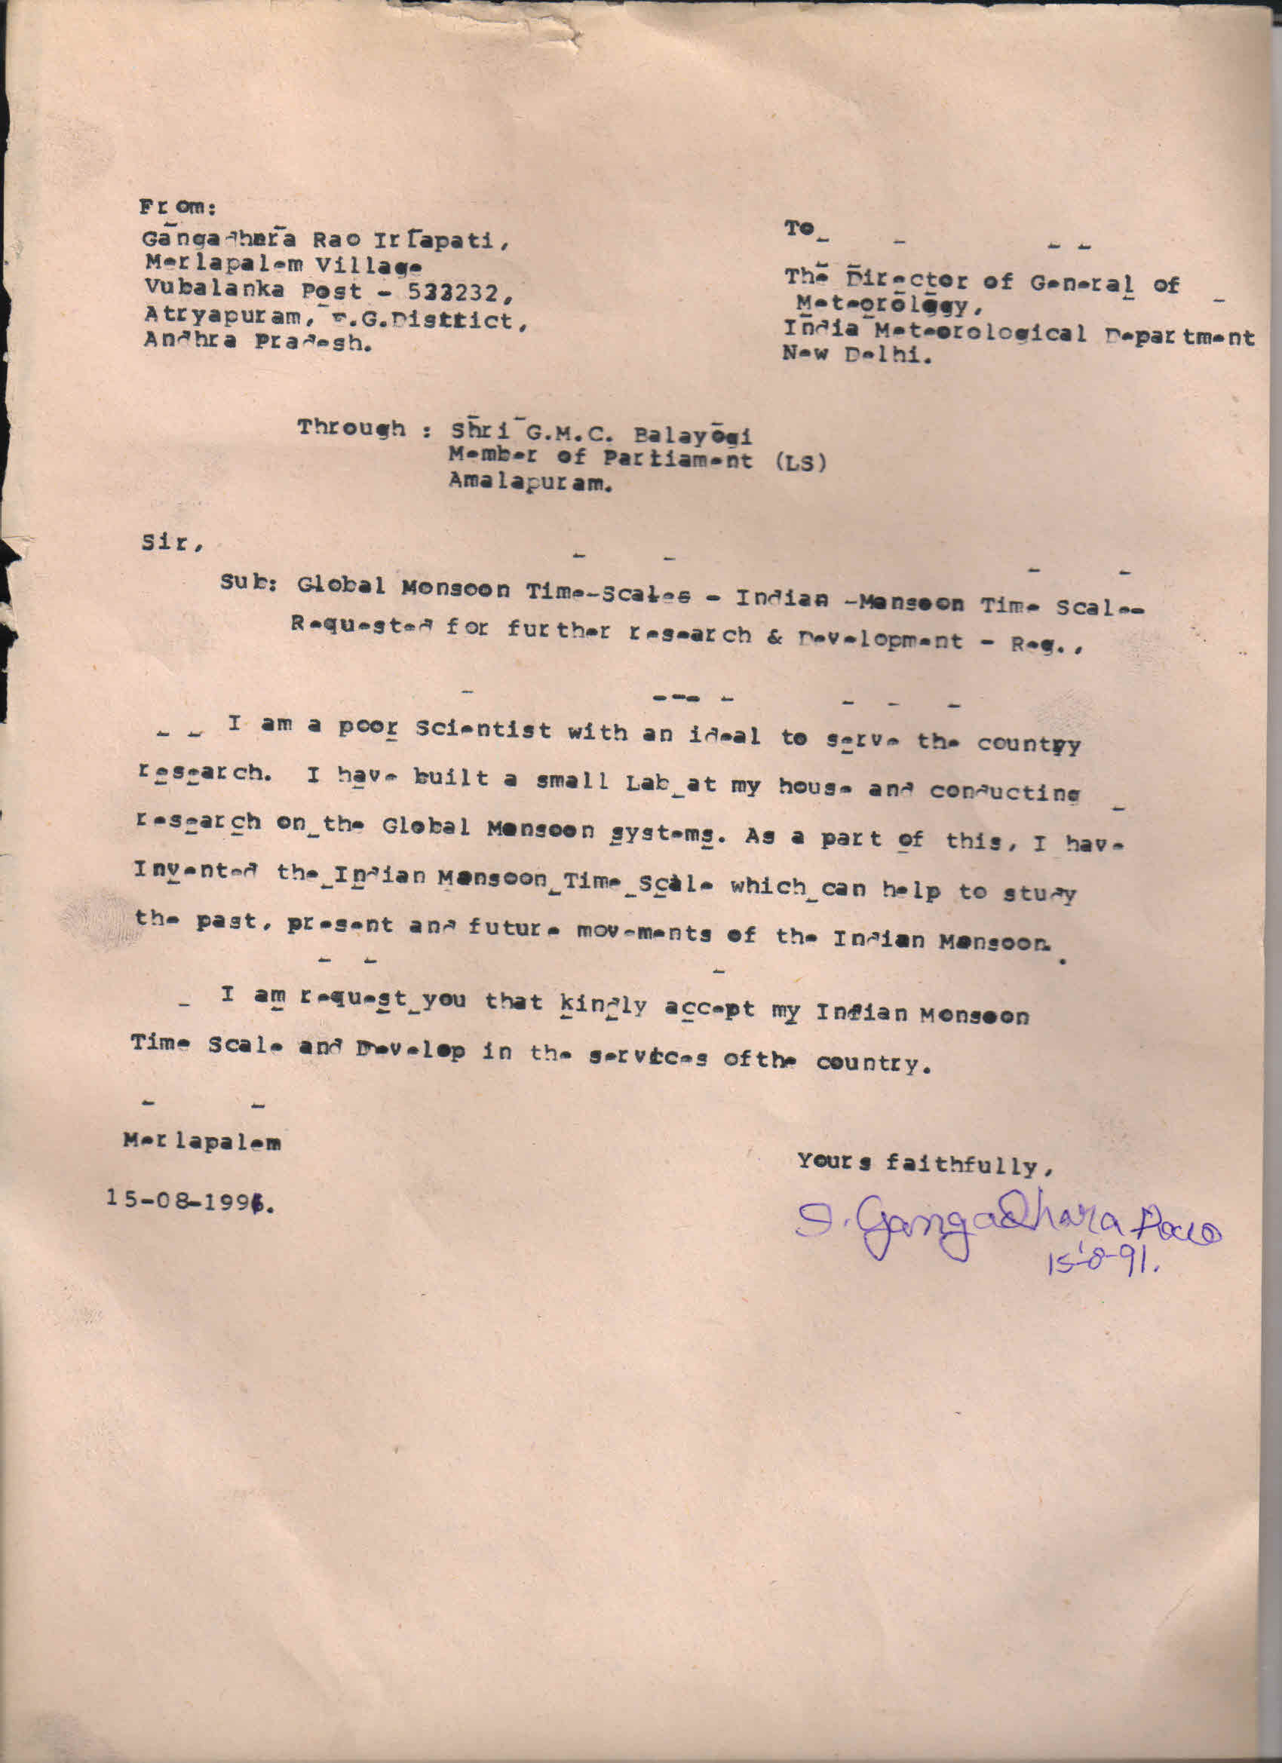
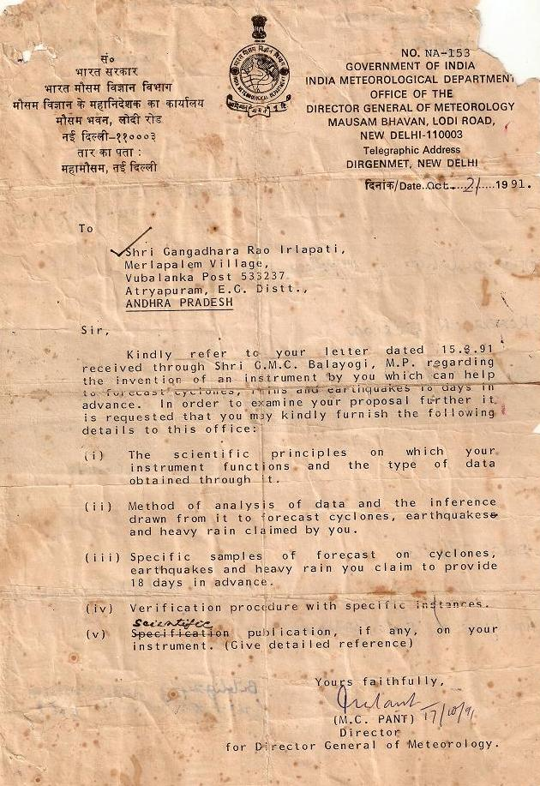
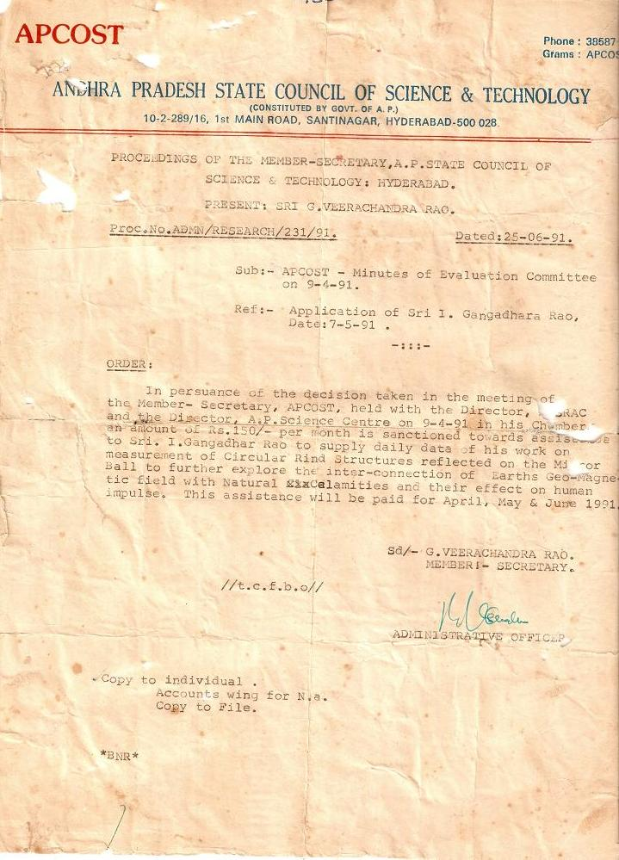

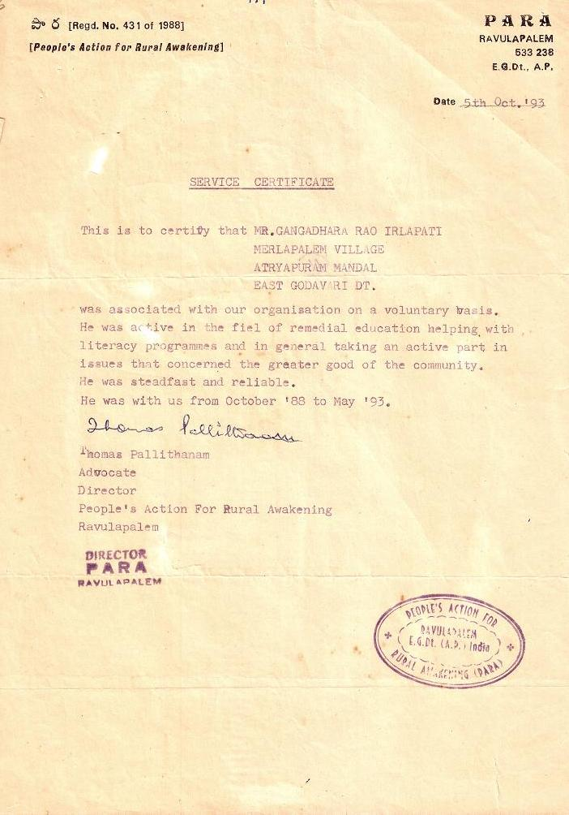
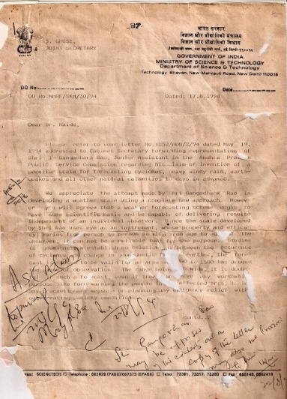
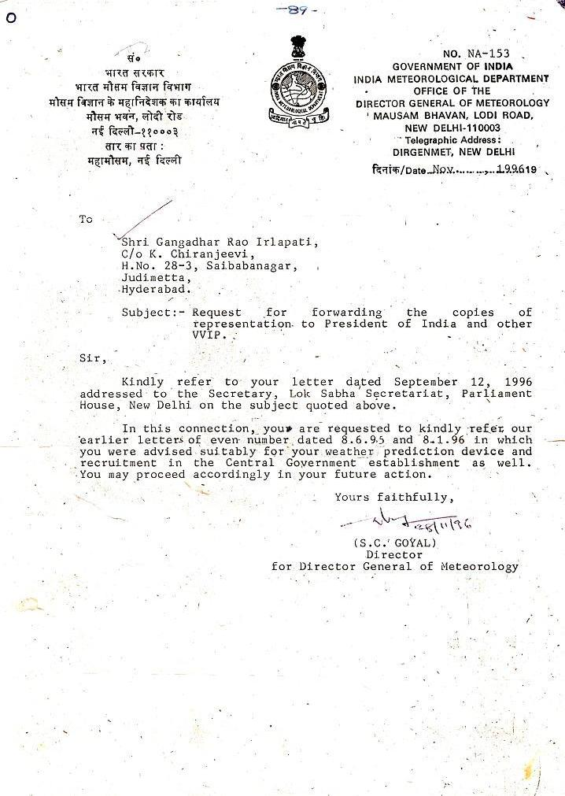
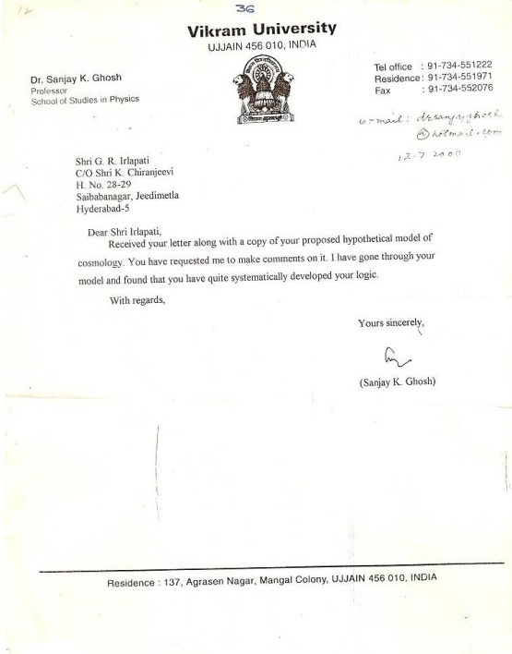
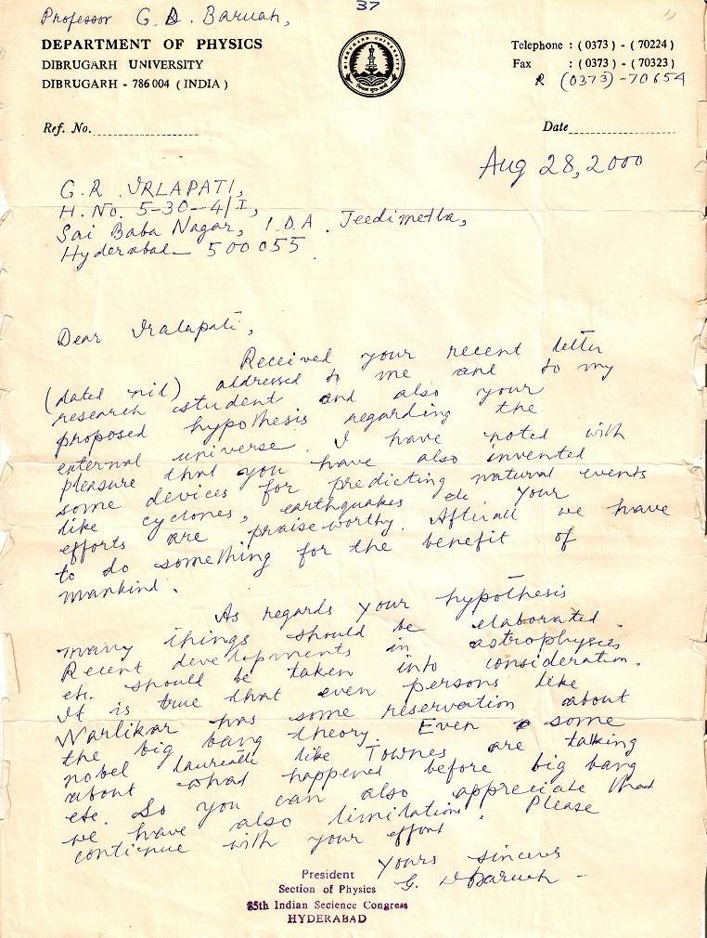
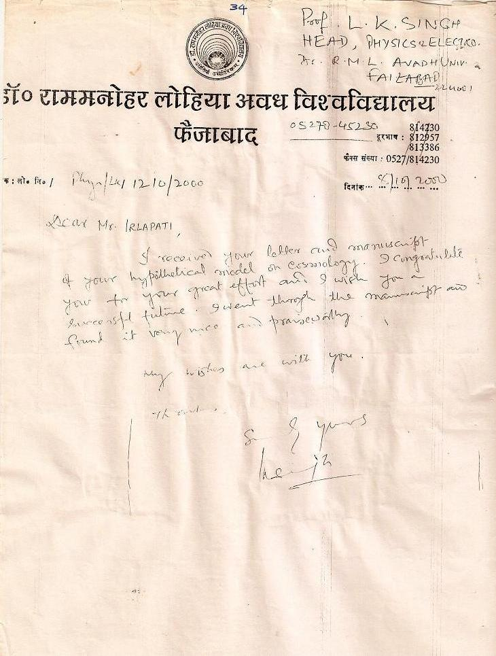
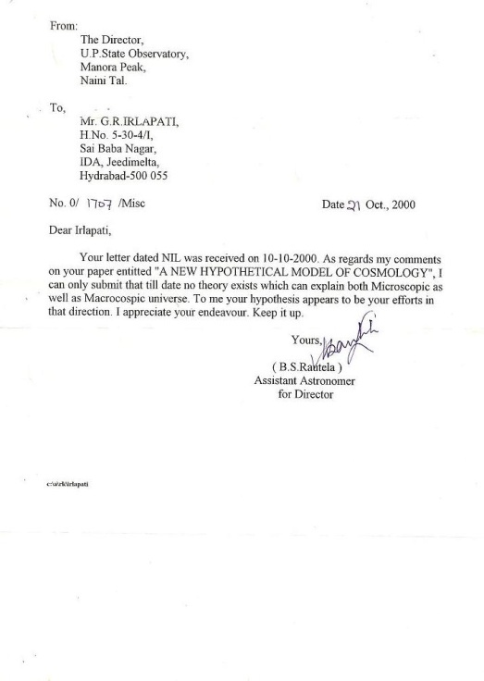

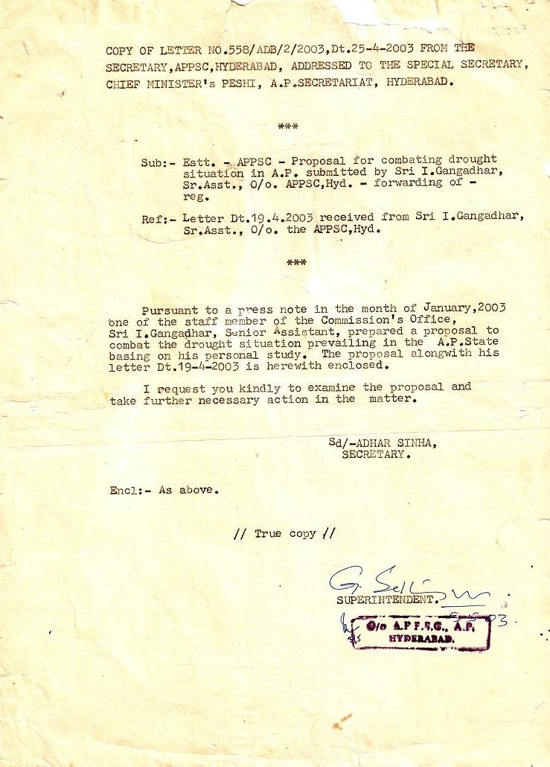
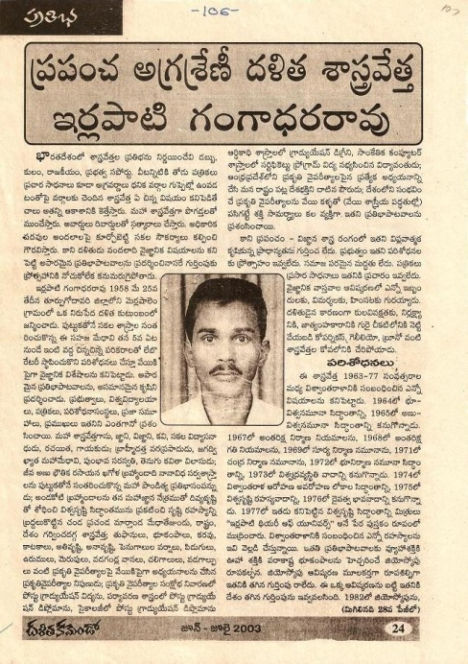
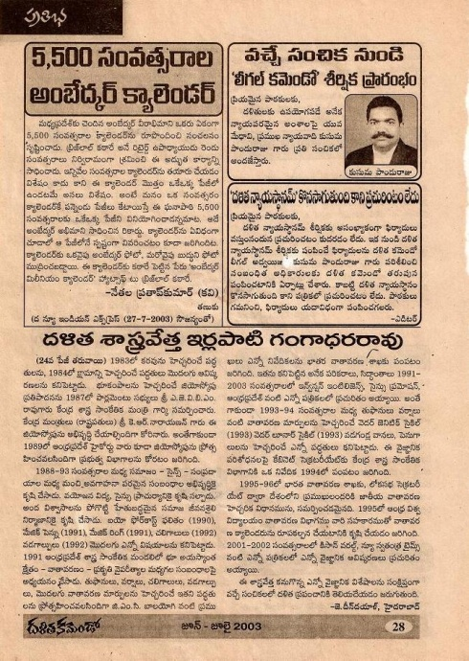
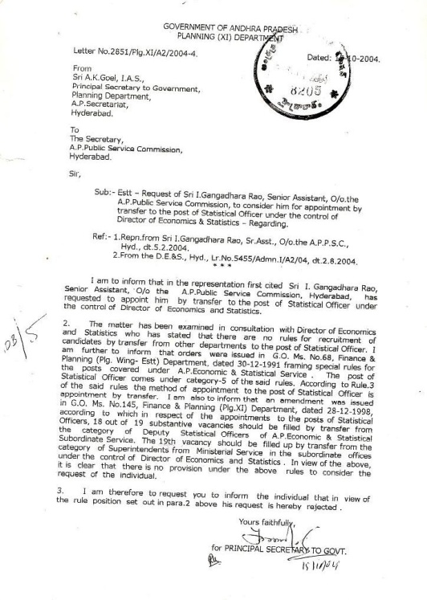
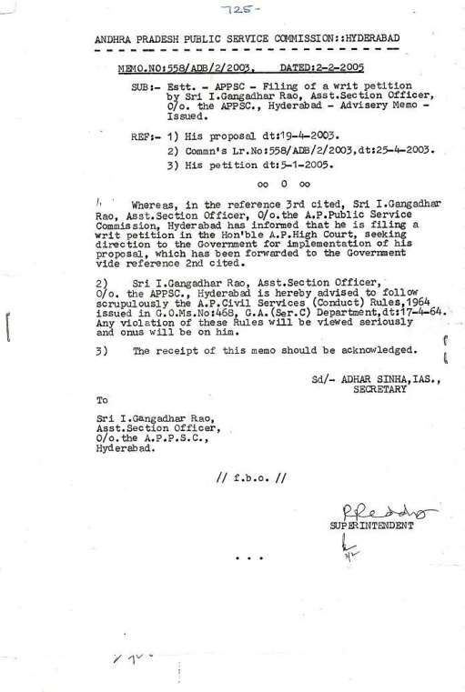
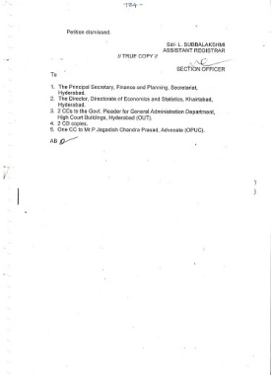
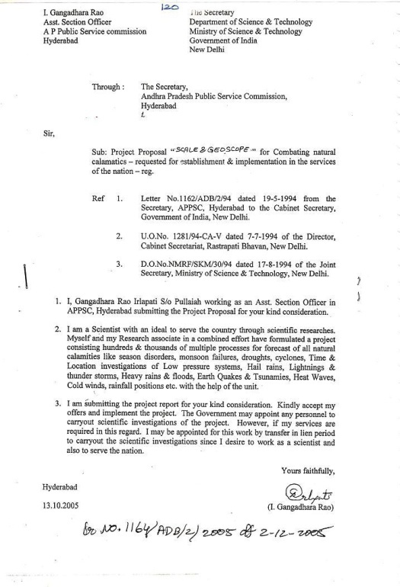
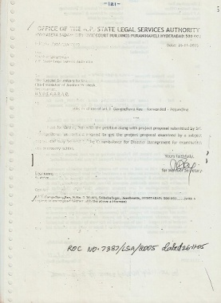
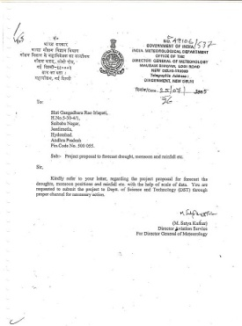
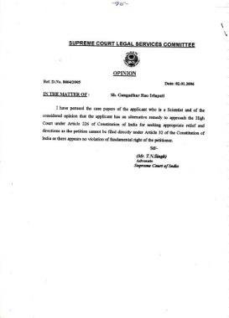
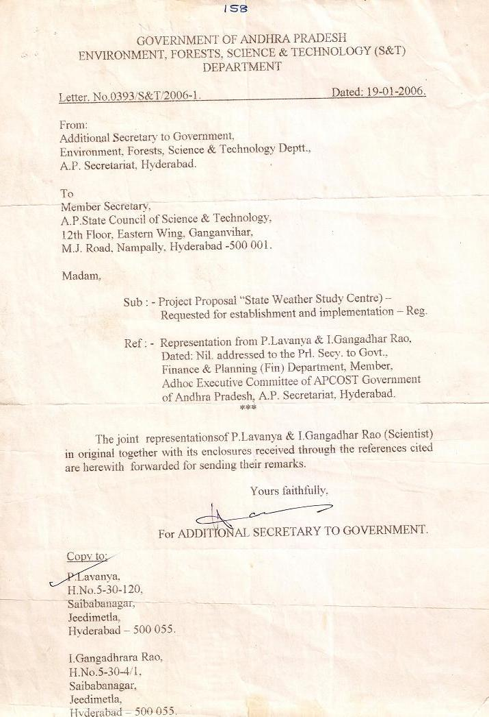
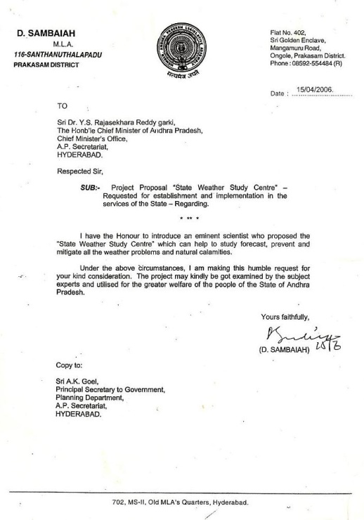

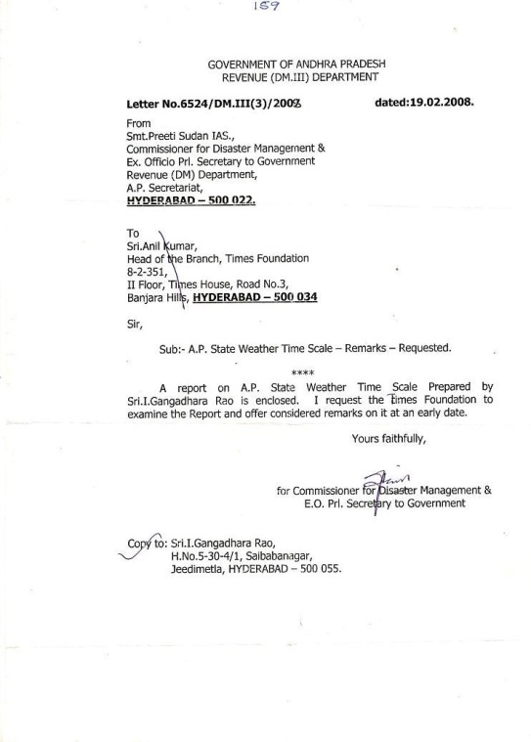
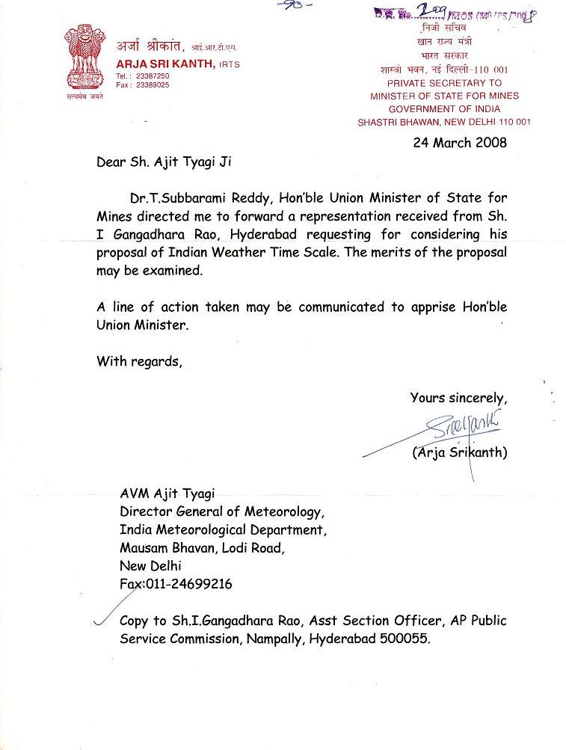
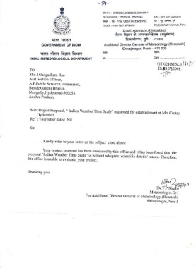
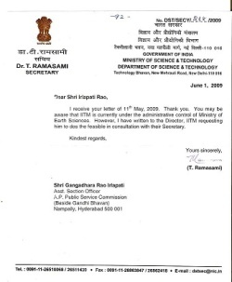
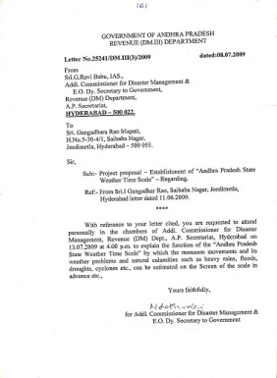
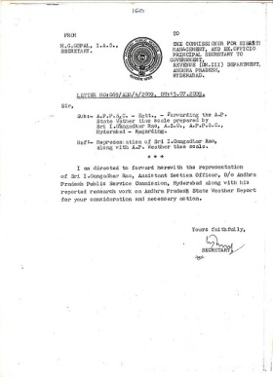
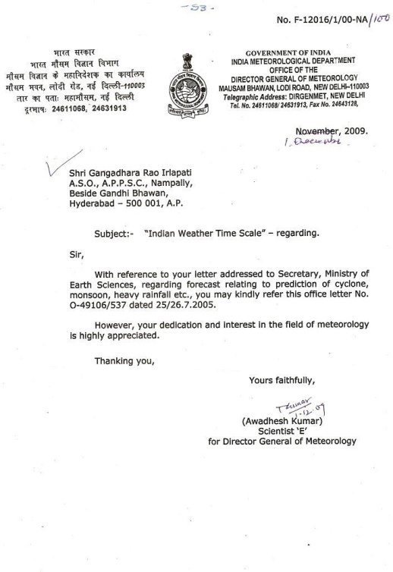
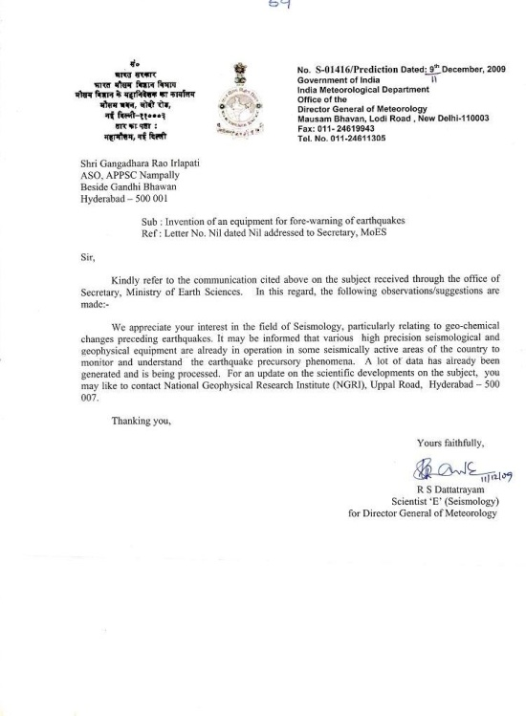
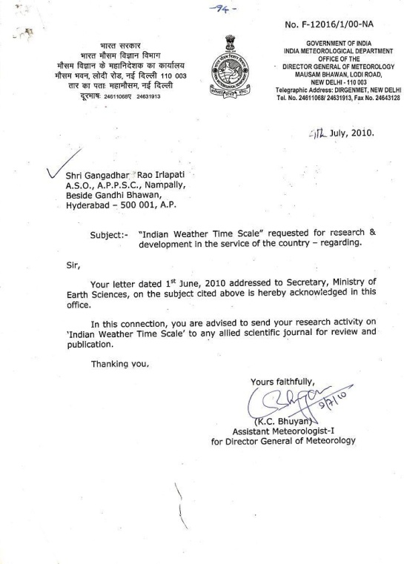
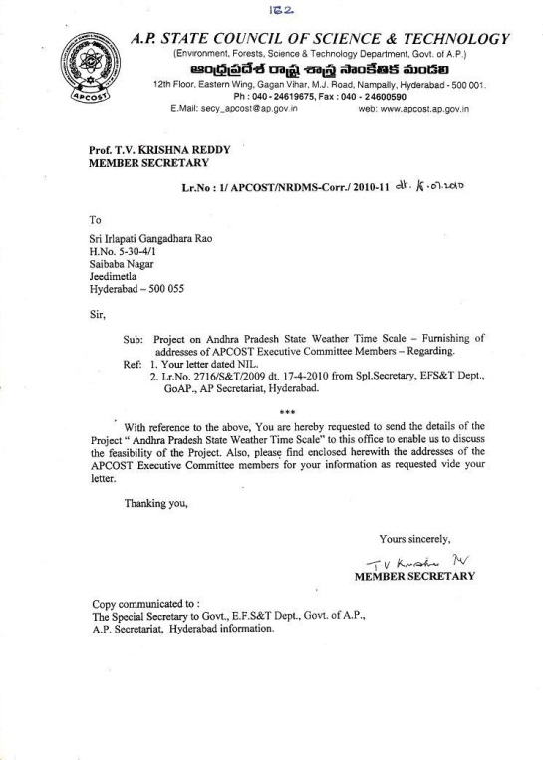
…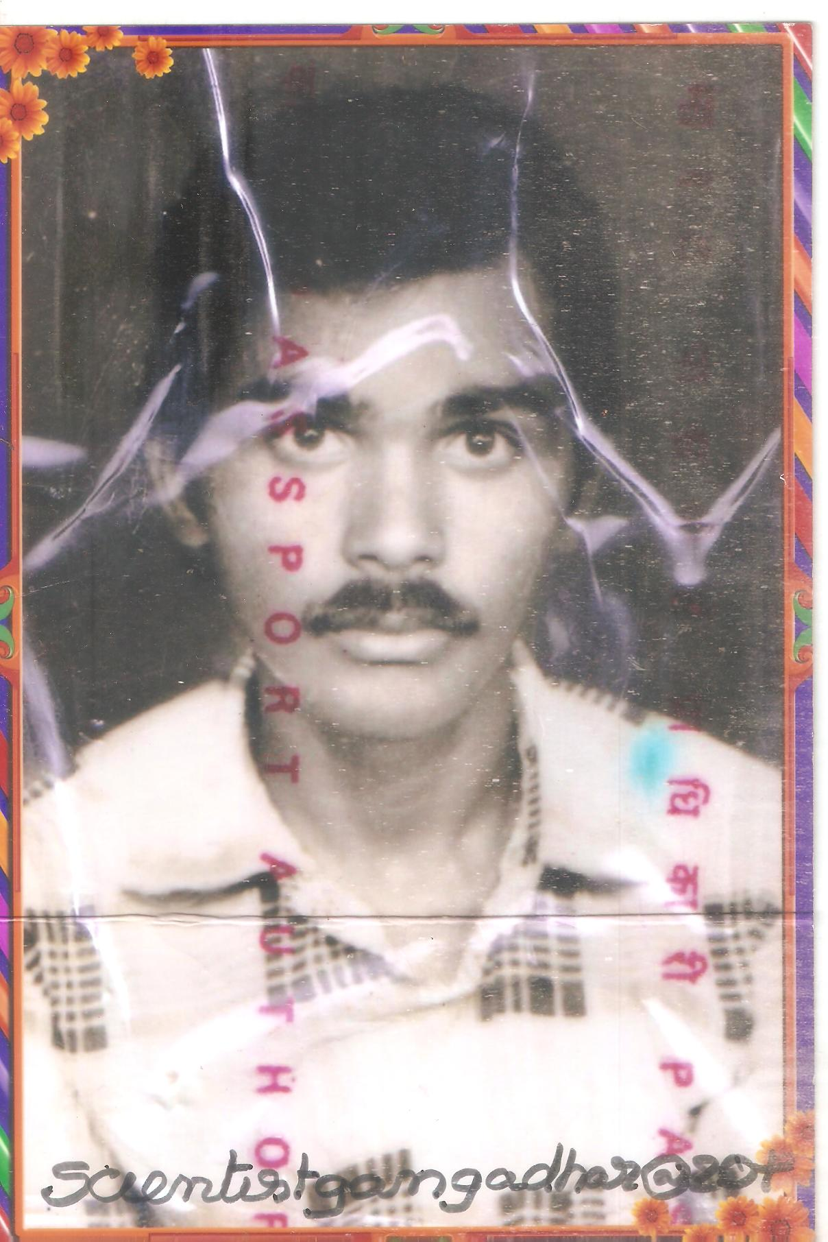 . 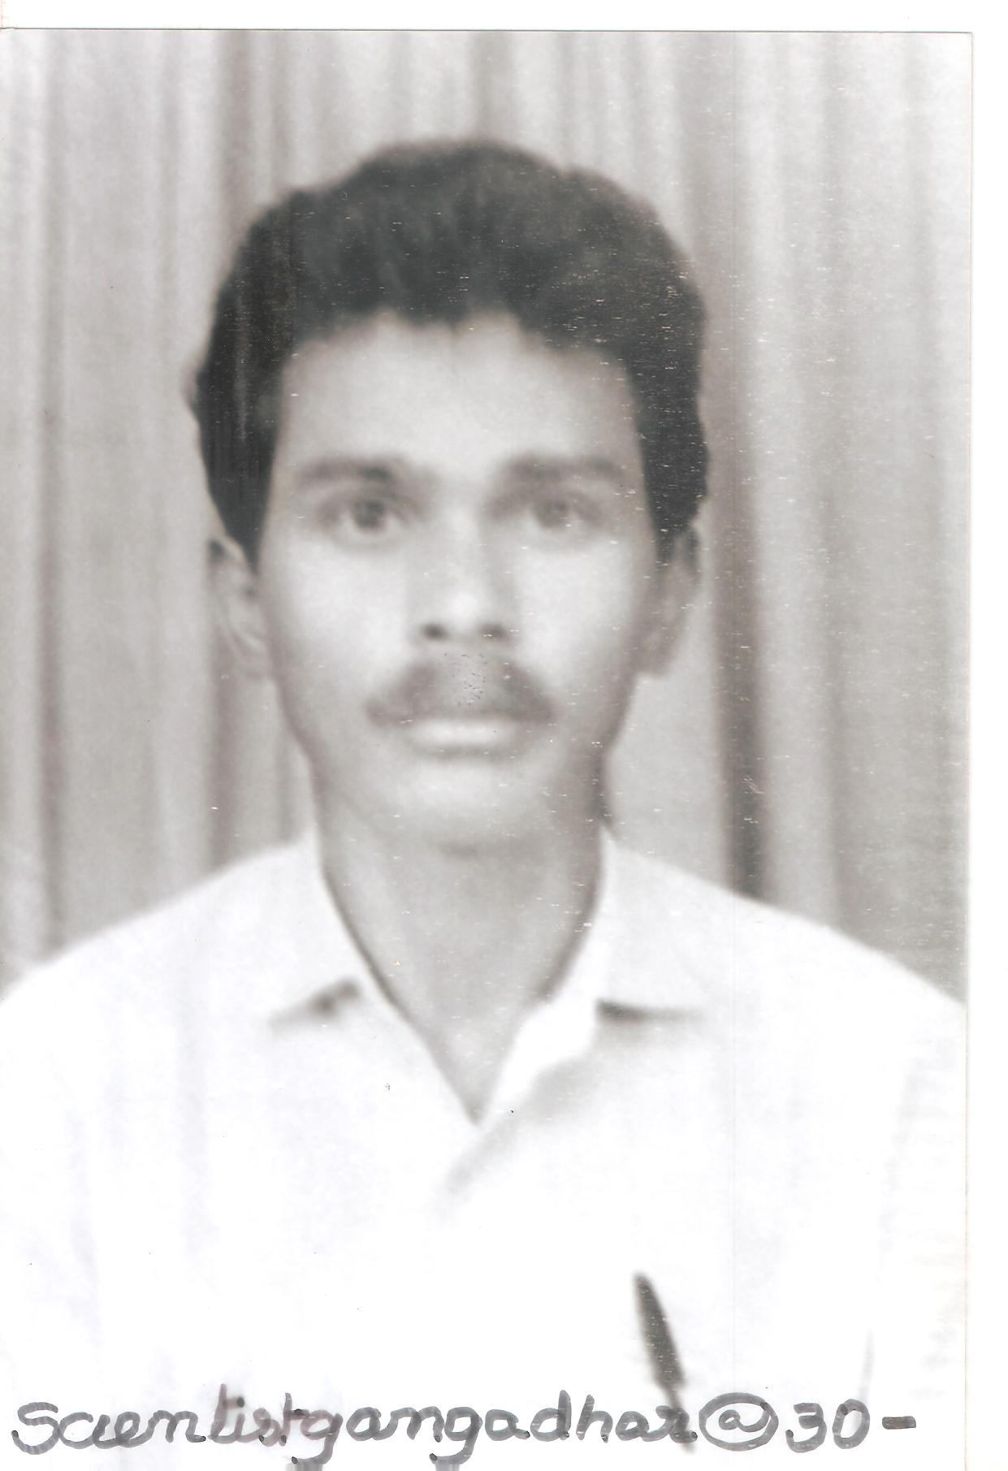
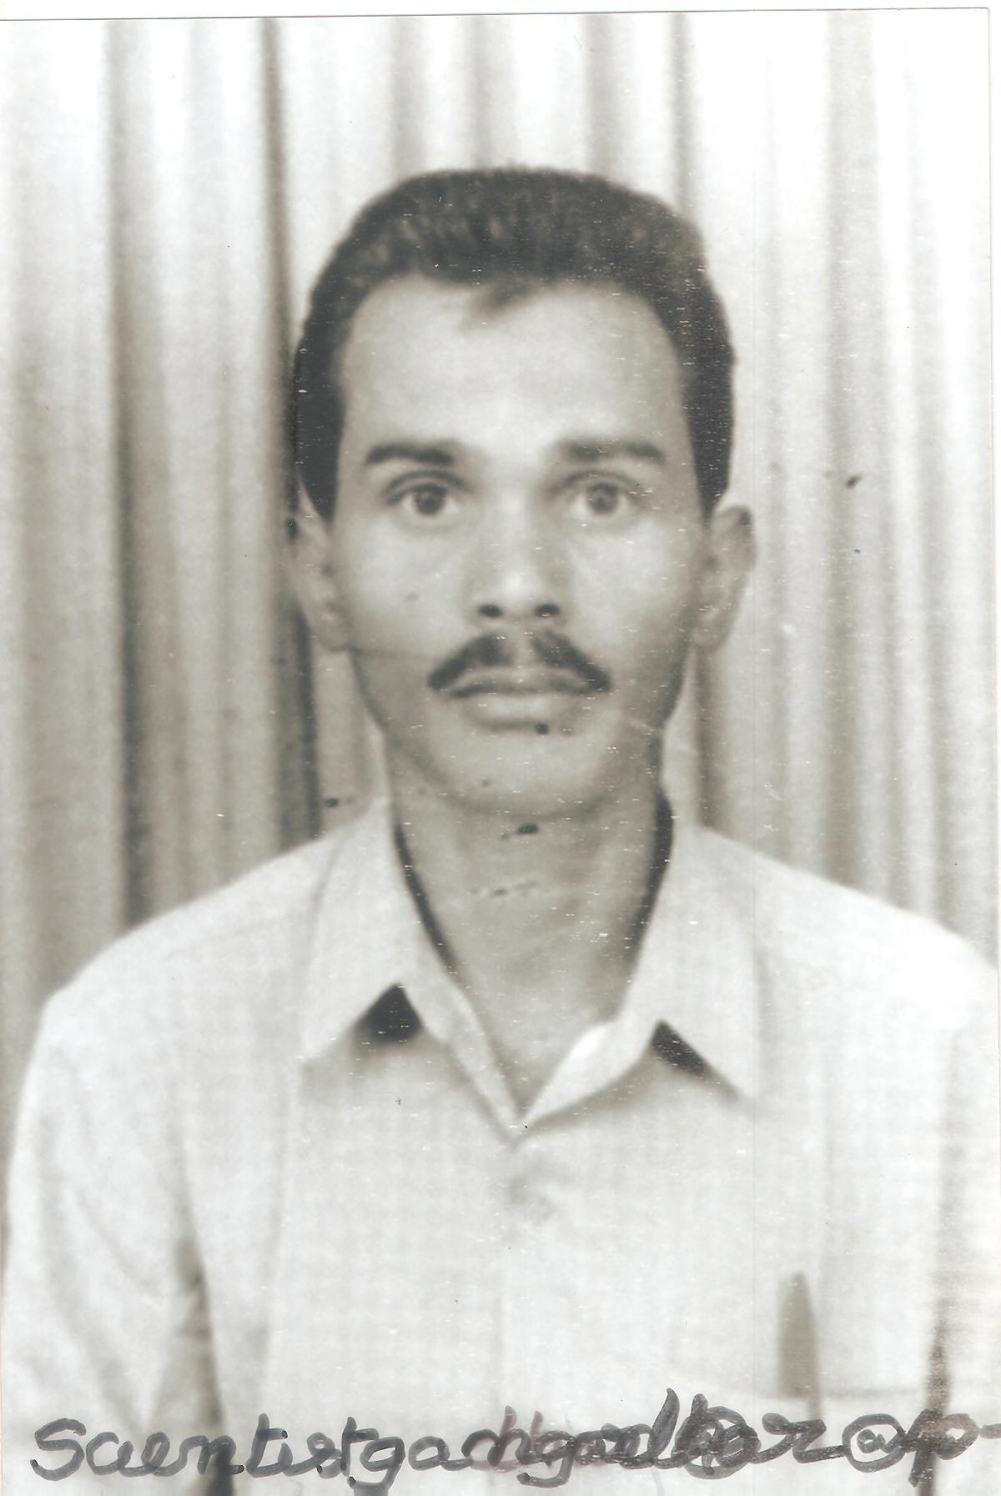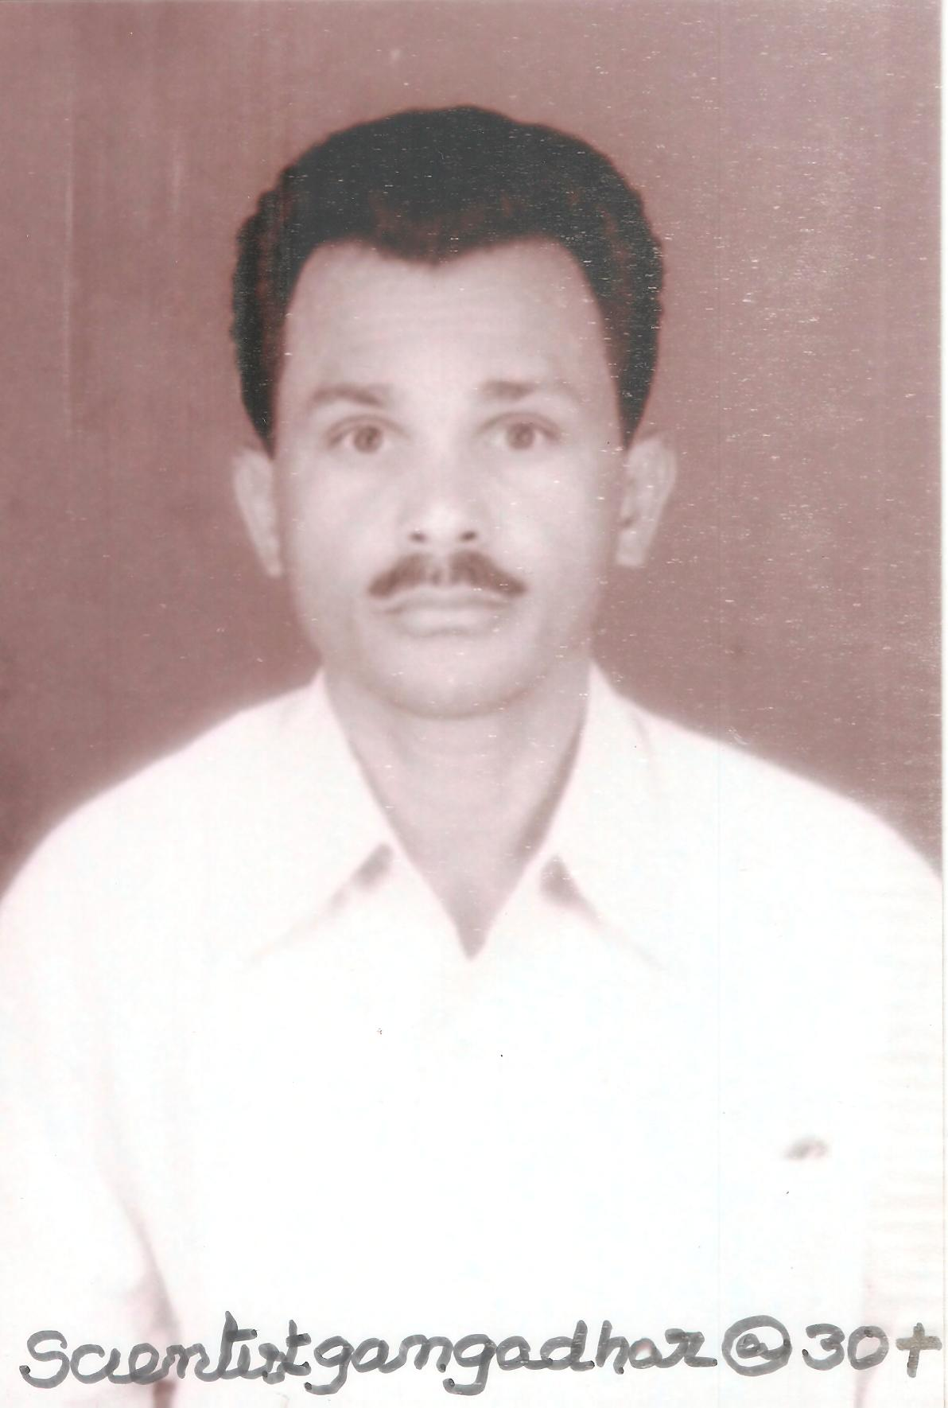

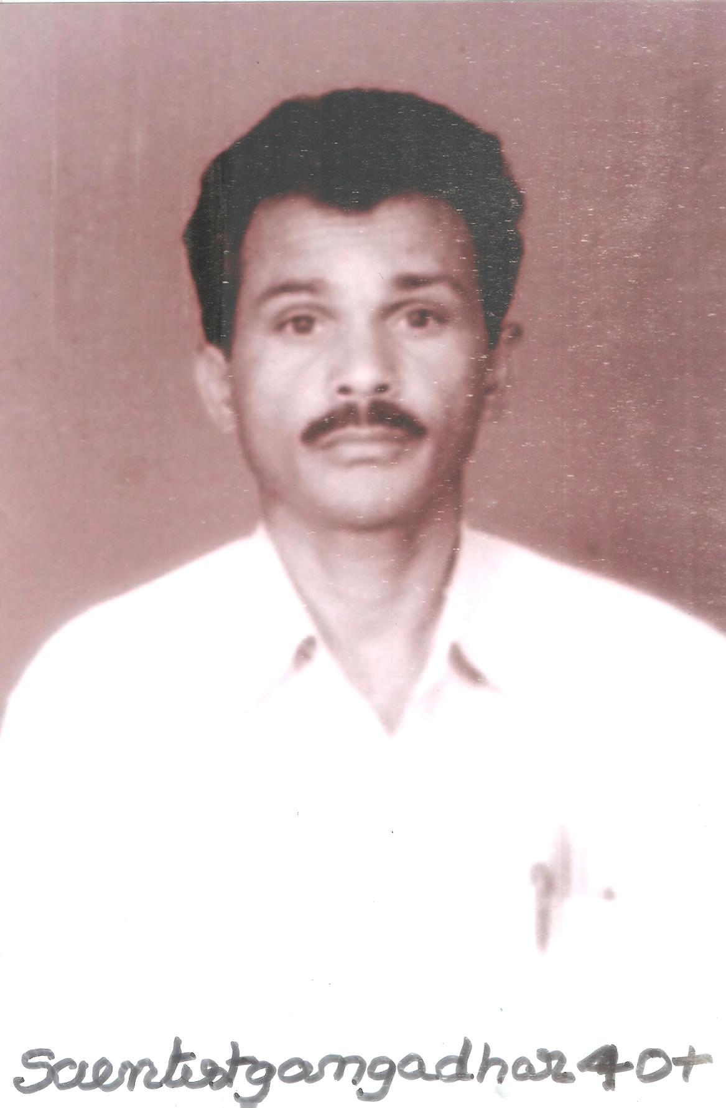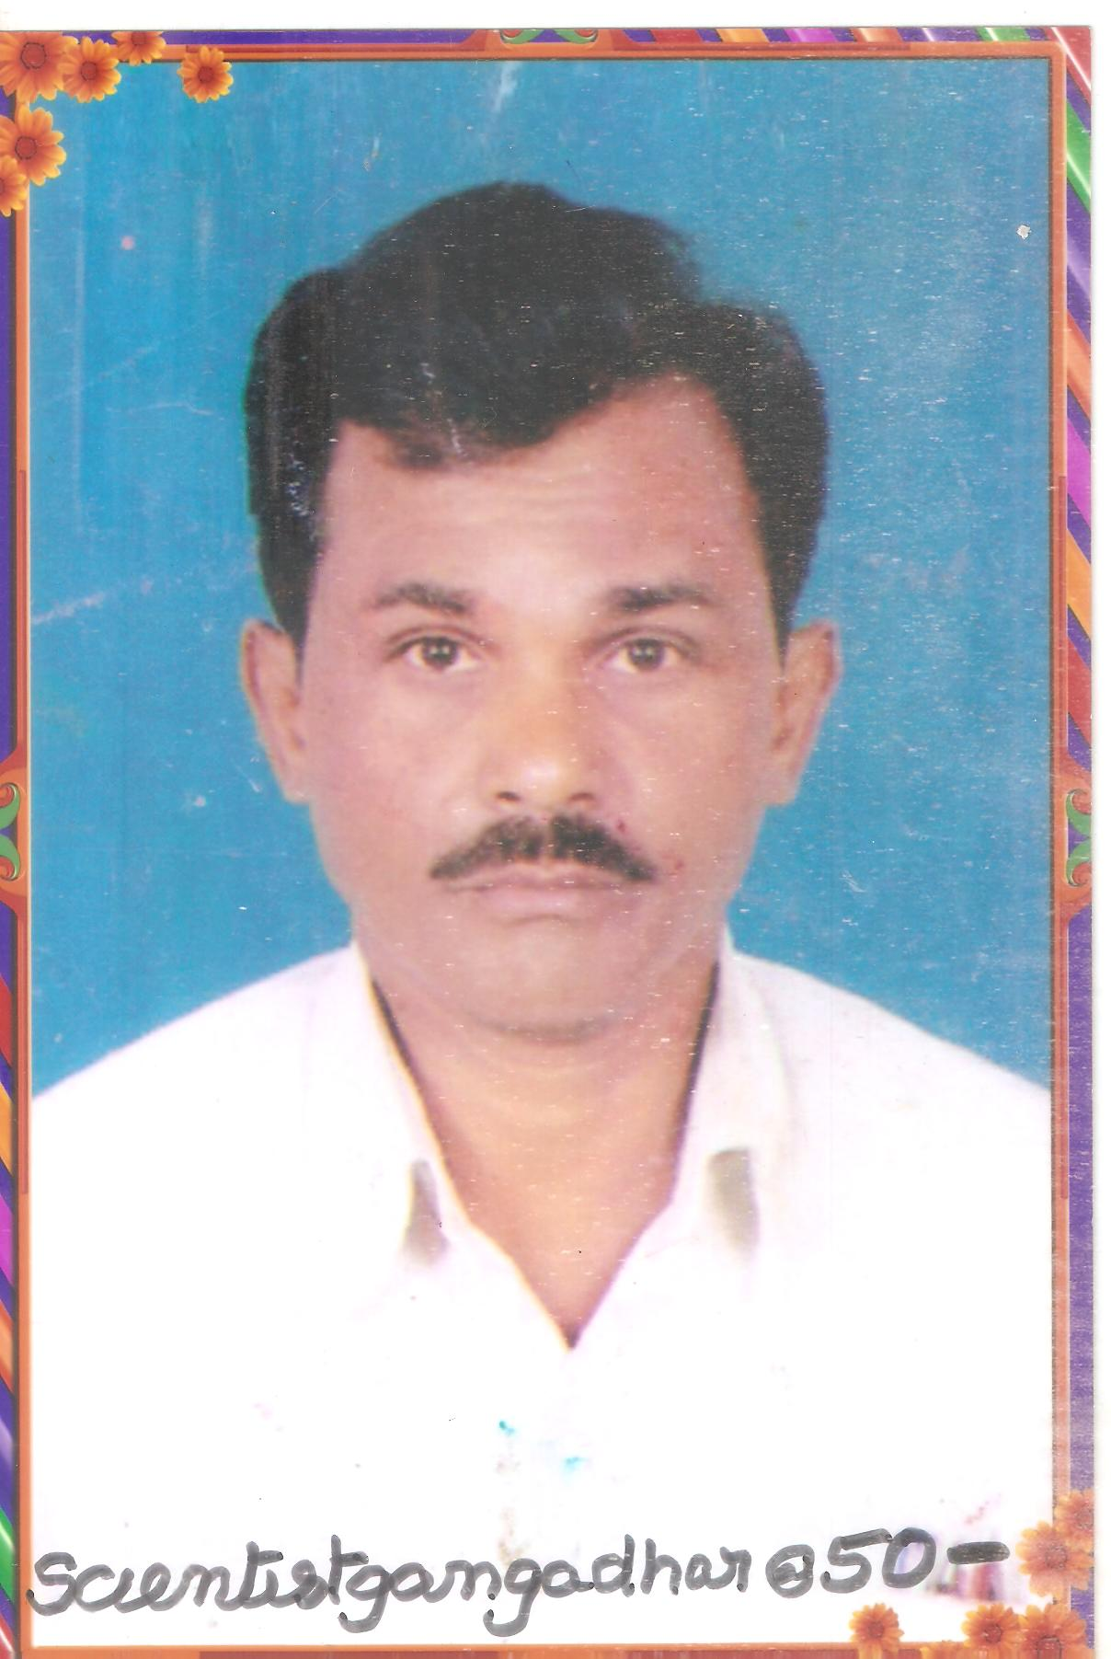

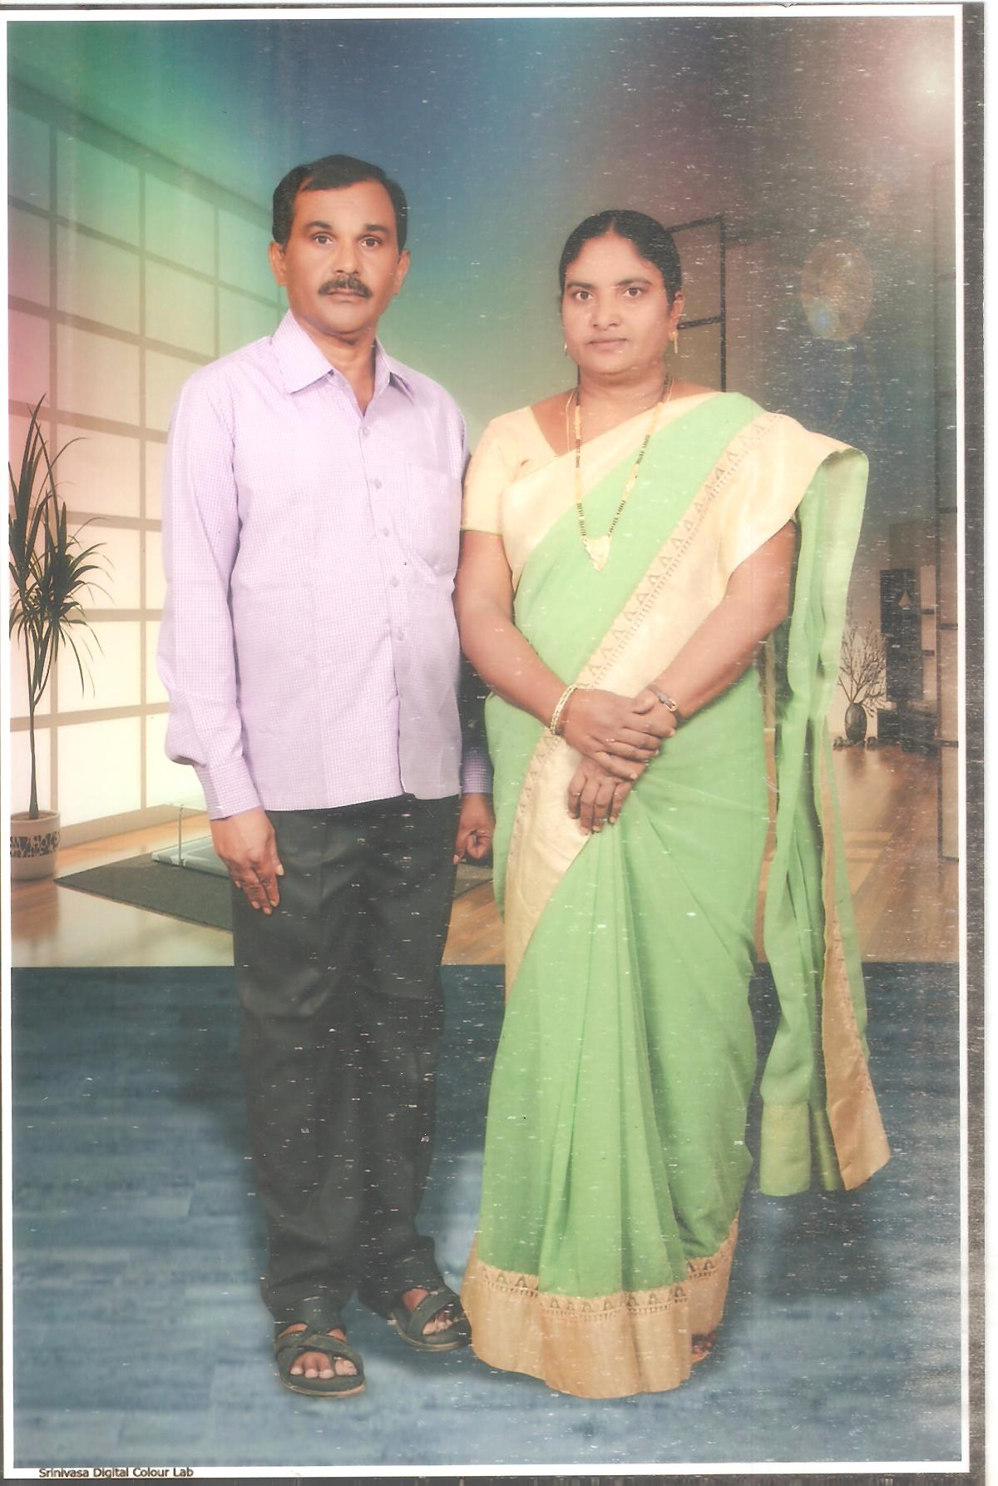

4/2/2024

