Evidence of alien or human presence and clandestine activity for colonization of the South Pole of the Moon

Hari Mohan Saxena¹* and Jag Mohan Saxena²

¹Flat no. 105, Rajmahal Apartments, D 253, Devi Marg, Bani Park, Jaipur 302016 India;
²House no. 1-E-20, Jai Narayan Vyas Colony, Bikaner 334001 (Rajasthan), India.
*Correspondence: drhmsaxena@gmail.com

Abstract: We have discovered a possible electricity producing unit comprising of a generator and a transformer like objects at the rim of the Shackleton crater (Lat. -89.63068, Lon. 92.77928) on the South Pole of the Moon which suggests an alien activity or presence of a hitherto unknown organized human lunar base on the Moon.
[Hari Mohan Saxena and Jag Mohan Saxena. Evidence of alien or human presence and clandestine activity for colonization of the South Pole of the Moon. N Y Sci J 2024;17(4):18-20]. ISSN 1554-0200 (print); ISSN 2375-723X (online). http://www.sciencepub.net/newyork. 03.doi:10.7537/marsnys170424.03.

Keywords: Lunar base, South Pole of the Moon, The Moon, Aliens, Extraterrestrial life.

Introduction:
We had reported earlier (Saxena & Saxena, 2023) an opaque, giant metallic structure at the rim of the Shackleton crater overlying a major part of the crater on the South Pole of the Moon. From a distant view, the object appeared to be an opaque fan like structure with four equal sized blades placed at equal distances from each other. It covered the view of a major part of the crater as if superimposed on the crater. The structure appeared to be a huge solid metallic structure. The sharp and straight edges and vertical slits visible on the metallic blades were clearly machine built and indicative of advanced science, precision engineering and extraordinary skill. We now report visual proof of a possible electricity unit on the same site confirming alien activity or presence of an unknown organized lunar base on the Moon.

Materials and methods:
The study is based on the images of the lunar surface taken by the NASA Lunar Reconnaissance Orbiter Camera (LROC) available in public domain on the LROC website. The detailed methodology has been reported earlier (Saxena & Saxena, 2023).

Results and discussion:
We have discovered a large solid structure (possibly metallic) composed of multiple rectangular panels similar in shape to big photo frames superimposed on each other (Fig. 1) just above a cave on the rim of the Shackleton Crater (Lat. -89.63068, Lon. 92.77928) near the site where the gigantic fan like structure was found as described earlier (1). This could possibly be some kind of transformer. We have also sighted a strange object inside the cave. This is a big cylindrical, shiny metallic object lying horizontally with respect to the lunar surface and standing on metallic legs or a stand. The anterior part of the cylindrical structure has a round hole or opening with a circular metallic rim (Fig. 2). The appearance of this object is comparable to that of an LPG cylinder placed parallel to the surface and resting on four legs. This object could possibly be a power generator as it seems to be connected with an appendage hanging vertically and perpendicular to the cylindrical structure. The entire assembly of the transformer – like structure and the generator – like object could possibly be a unit for electricity generation for a hidden lunar base or a colony of aliens in caves on the Moon. Since there is no published report till date of any construction or parts of any spacecraft or probe left by any nation on or near the Shackleton crater, our discovery of this mysterious structure adjacent to the crater on the South Pole may be the first unequivocal evidence of presence of aliens or a clandestine human attempt of colonization of the South Pole of the Moon.
Corresponding Author:
Dr. Hari Mohan Saxena,
Professor of Immunology (retd.), GADVASU, Ludhiana, India 141004.
Flat no. 105, Rajmahal Apartments, D 253, Devi Marg, Bani Park, Jaipur 302016, India.
Correspondence: drhmsaxena@gmail.com

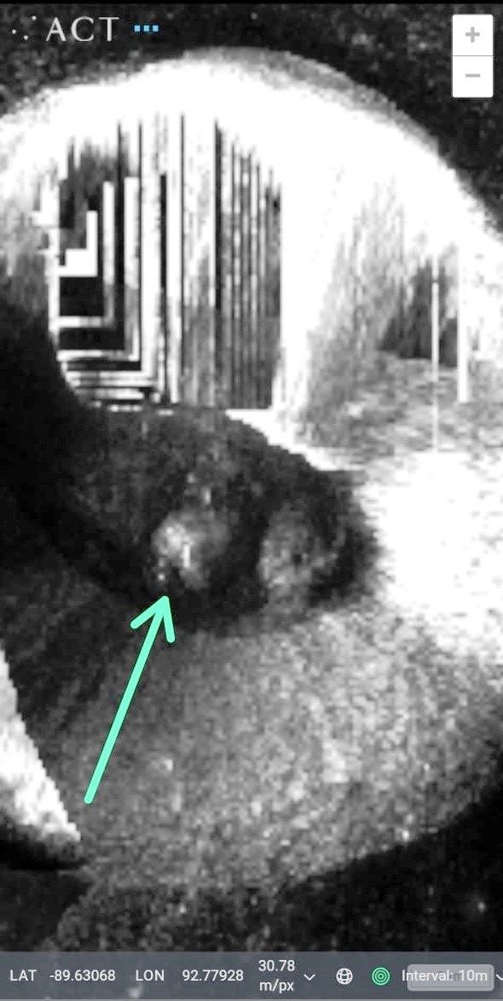
Fig. 1. A transformer - like structure (top) above a cave and a generator like object (arrow, bottom) inside a cave on the South Pole of the Moon.
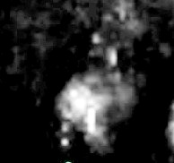
Fig. 2. Enhanced view of the generator - like object inside a cave on the Moon.

References:
- Hari Mohan Saxena and Jag Mohan Saxena (2023). Discovery of a Sri Yantra – like structure on the Moon. Nature and Science 21(3): 30-38.

4/2/2024

