A Study on Monitoring Models for Big-Data Traffic Analysis and Utilization

Bong-Hwa Hong¹, Hae-Jong Joo², Moon-Taek, Cho³

¹Dept. of Digital and Media technology, Kyung Hee Cyber University,1 Hoegi-Dong, dongdaemun-Gu, Seoul, 130739, Korea
²Dept. of LINC, Dongguk University, #9112, 30 Pil-dong 1-gil, Jung-gu, Seoul, 100715, Korea

³Dept. of Electrical & electric Engineering, Daewon University College, 316, Daehak Road, Jechen-si, Chungbuk Province, 390-702, Korea,

bhhong@khcu.ac.kr

Abstract: The recent expansion of new service platforms such as smart media at home and abroad demands Internet traffic analysis and predictive information with public confidence that can be applied to policies for increased big-data Internet traffic, network QoS (quality of service), etc. according to the implementation of new network services such as LTE. Therefore, in this paper, overseas Internet traffic monitoring and its policies are analyzed, monitoring models focusing on the structures for monitoring big-data Internet traffic and the measurement positions adequate for the domestic circumstances in South Korea are proposed, and such monitoring models are compared and analyzed. The models proposed in this paper provide traffic status analyses and predictive information to the traffic monitoring participants (business providers, institutions, enterprises, and ordinary users) and the government, and are likely to be utilized in promoting the investments for improving the QoS, including traffic management, enhancement, etc.
[Bong-Hwa Hong, Hae-Jong Joo, Moon-Taek, Cho. A Study on Monitoring Models for Big-Data Traffic Analysis and Utilization. N Y Sci J 2023;16(10):94-99]. ISSN 1554-0200 (print); ISSN 2375-723X (online). http://www.sciencepub.net/newyork. 05.doi:10.7537/marsnys161023.05.

Keywords: Big-data traffic analysis, Internet traffic monitoring, network QoS, traffic monitoring model

1. Introduction

The tendency of traffic increase due to the expansion of new service platforms such as the smart phone and the integration of new network services such as LTE based on Internet protocols (IPs) demand Internet traffic analysis and predictive information with public confidence that can be applied to policies for network QoS (quality of service) according to the implementation of new network services (1, 2).
Overseas, agencies organized by government institutions, business providers, governments, or research groups conduct regular monitoring, facilitate results analyses and prediction reports in providing policies, analyze and announce the trend of Internet traffic increase and its traffic types in their own countries, and apply them as basic data for the development of communication industries or for providing information to the users. In addition, they publish the Internet traffic trends and status analyses reports through ITU, etc., and facilitate them for marketing. Such tendency is being popularized in most Organisation of Economic Co-operation and Development (OECD) countries using their own impartial institutions or industries (3-10).
Under these circumstances, South Korea needs a regular Internet traffic monitoring status and prediction report system to help understand the country’s Internet traffic status. Further, it is required to provide data that can maintain impartiality and resolve disputes when service problems occur among Internet service providers (ISPs). Accordingly, South Korea has to investigate its entire Internet traffic volume and to analyze and manage the traffic increase by the services and users.
In this paper, the overseas Internet traffic monitoring and its policies are described in Chapter 2, the monitoring models focused on the structure for big-data Internet traffic monitoring and its measurement points are presented in Chapter 3, such monitoring models are compared and analyzed in Chapter 4, and a conclusion is drawn in Chapter 5.

2. Related Studies

2.1. Internet traffic monitoring and its policy in the U.S.
In the U.S., Internet traffic monitoring and analyses are being promoted, led by private industries and research institutions, and the government provides support to technology monitoring researches to promote the traffic monitoring and analyses of industries and private organizations.
The promotion system consists of the management and announcements of monitoring analyses and prediction results led by private industries and research institutions, and the traffic monitoring is facilitated for the communication and network enhancement policies through research institutions such as CAIDA and business providers’ reports, including SANDVINE, CISCO VNI, etc.
The control of Internet traffic monitoring through autonomous activities, etc. by consultative groups consisting of ISPs, equipment manufacturers, and research institutions rather than by the government is supported.

2.2. Internet traffic monitoring and its policy in Norway
Norway established six units of IP exchange points, Norwegian Internet eXchange (NIX), to exchange and analyze open-type IP traffic, monitors the Internet traffic, and utilizes the results of its monitoring activities [2].
The promotion system focuses on maintaining the network impartiality by making IP traffic exchange mandatory through NIX established by the government’s lead agency, continuously monitors the local and overseas traffic, secures objectivity through management by NIX, and reflects the realities in the communication service policies established based on the research activities of business providers.
NIX constructed an environment for exchanging IP traffic among communication business and service providers through a third party, rather than establishing an Internet access structure through a particular business provider, and makes the IP traffic exchanges through NIX compulsory for various types of businesses, including ISPs, contents businesses, Web hosting companies, wireless businesses, VoIP businesses, portals, etc.

2.3. Internet traffic monitoring and its policy in Japan
Japan constructed consultative bodies such as the Internet Study Committee led by the Ministry of Internal Affairs and Communications to study Internet traffic monitoring methods and to announce and utilize such traffic statistical data.
The promotion system consists of research institutions (WIDE, etc.) led by the government, ISP business providers, equipment manufacturers, university research institutes, etc. who supervise Internet traffic monitoring and conduct regular researches and reports on the current status and prediction data. Such research institutions secured user information protection and objectivity, and presented information through international technology and standardization organizations such as ITU. In particular, the MAWI working group conducts studies on monitoring and analysis methods, reflects the traffic status report data in policies, and facilitates their use for local communication industry and network enhancements.

2.4. Structure of Traffic Analysis and Quality Measurement System
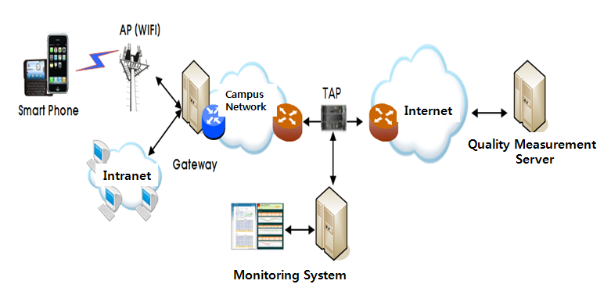
Figure 1. System Structure

Figure 1 shows the structure of the entire system for the traffic analysis and speed measurements in smart devices.
•Quality measurement server : Use the server, and measure downloading, uploading and delays in order to measure the quality linked to smart devices
•TAP : Device designed to gather data flowing between the school network and the Internet
•Monitoring system: The system designed to analyze data flowing in through TAP and to monitor the performance of network

2.4. Behavior of the Quality Measurement System

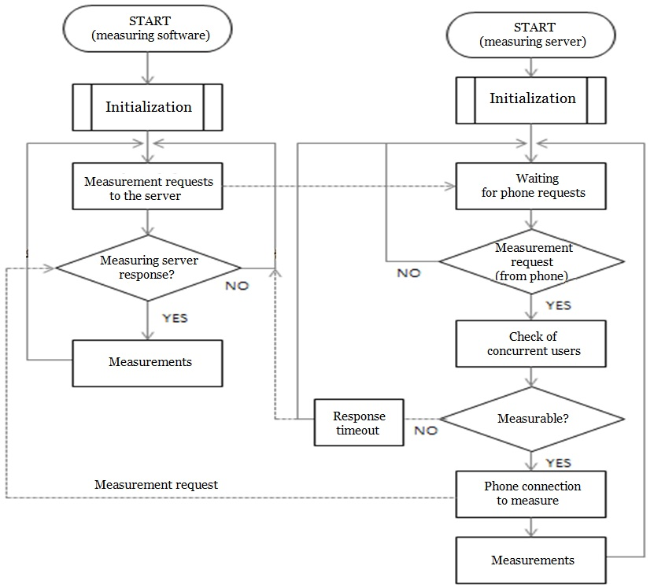
Figure 2. Quality Measurement Operation Flow

When the measurement button is pressed, the Start_down() function is called and displays the measurement process on UI while a download test is executed for ten seconds; when the download process is completed, the result is displayed and executes upload test as Start_up() function is called. It displays the result when the upload process is completed, and executes a latency test as the Start_ping() function is called. When download, upload, and latency processes are completed, the Send_Post() function is called and stores a measurement log after sending the measurement result to a collection server. The measurement server creates one management port and multiple measurement ports that are pre-defined during the initial process and configures TCP socket options by port. When quality measurement software requests quality measurement to the measurement server management port, the system checks measurement availability of a number of concurrent users; if measurement can be carry out, the measurement port information is registered to a measurement-in-progress state and transfers to the quality measurement software. The quality measurement software is reconnected to the measurement server through the received measurement port and conducts actual measurement. When measurement is completed, the measurement server registers the corresponding port as a useable state and be on standby for the next measurement request.

3. Big-Data Internet Traffic Monitoring Models
The big-data Internet traffic monitoring models can be classified into the ISP-based model (proposal 1), use-based model (proposal 2), and mixed model (proposal 3) depending on the user institutions, households, and measurement points of the hotspots (i.e., the positions of the measurement points at a low hierarchy). All the models are assumed to have the same measurement points for mobile users (mobile communication service providers) and Internet exchange points (IXPs) basically under common conditions.

3.1. ISP-based monitoring model(Proposal 1)
The ISP-based monitoring model (proposal 1) is a model based on an ISP in which all households, hotspots, companies, and institutions measure the traffic at the subscriber access nodes of ISPs.

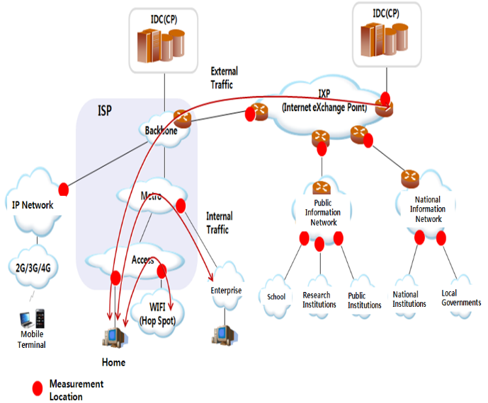
Figure 3. Monitoring model (proposal 1) : ISP-based

3.2. User-based monitoring model(Proposal 2)
The user-based monitoring model (proposal 2) is a model in which the household subscribers measure the traffic at their home G/W; hotspots, at the uplink G/W of a hotspot; and companies and institutions, at the G/W level connected to ISPs.

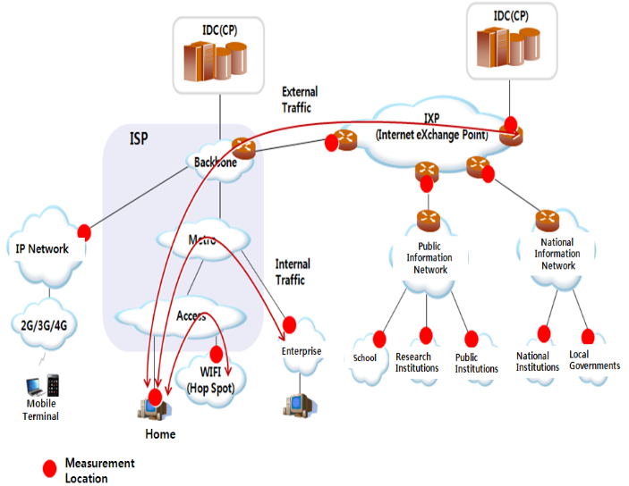
Figure 4. Monitoring model (proposal 2) : User-based

3.3. Mixed monitoring model(Proposal 3)
The mixed monitoring model (proposal 3) is a model in which households and hotspots measure the traffic at the subscriber access nodes of ISPs; and companies and institutions, at the G/W level connected to ISPs.
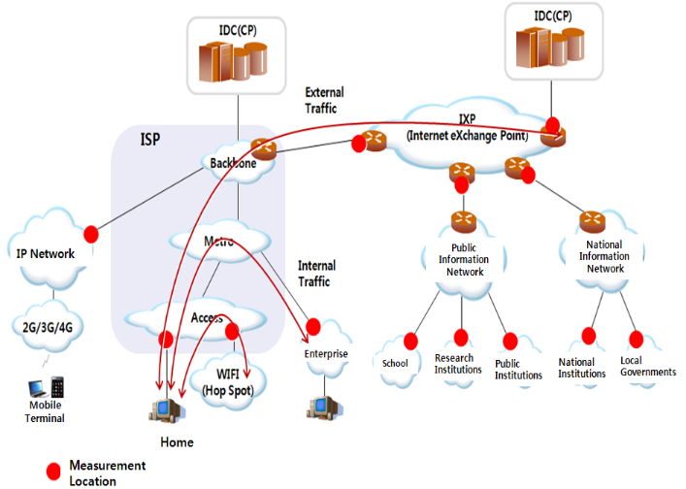
Figure 5. Monitoring model (proposal 3) : Mixed

4. Comparison and Analysis of Monitoring Models
The ISP-based monitoring model is structured in such a way that user institutions that monitor traffic flow situations have relatively small numbers of objects to be discussed. It is comparatively difficult to apply, however, as it requires close cooperation with ISPs.
The user-institution-based monitoring model is structured for monitoring a relatively small amount of traffic distribution situation. It therefore takes a considerably longer time as it should invite many participants through the cooperation of user institutions.

Table 1. Comparison/analysis of monitoring model
Classification | ISP-based Model  (Proposal 1) | User-institution-based Model (Proposal 2) | Mixed Model  (Proposal 3)
Institution | Subscriber access node (ISP) | User institution G/W | User institution G/W
Company | Subscriber access node (ISP) | Company G/W | Subscriber access node (ISP)  or user institution G/W
Household | Subscriber access node (ISP) | Subscriber home G/W | Subscriber access node (ISP)
Hotspot | Access network (ISP) | Hotspot G/W | Access network (ISP)
Mobile  (Mobile Communication Company) | Backbone of mobile communication company | Backbone of mobile communication company | Backbone of mobile communication company
Internet Exchange (IX) | Internet exchange node | Internet exchange node | Internet exchange node
Traffic Monitoring Volume | Large | Small | Medium
Discussion Objects | Small | Large | Medium
Review Result | The burden to ISPs is high due to the many measurement points for monitoring all traffic.  Therefore, close cooperation is required with ISPs. | Needs to invite many participants through the cooperation of user institutions | The burden to ISPs is low, and the number of user institutions to be discussed is relatively small.

Therefore, the mixed monitoring structure, in which ISPs (for households) and user institutions participate, reduces the burdens of ISPs and has a relatively low number of user institutions to be discussed. It is thus recommendable for monitoring traffic.

5. Conclusion
The models proposed in this paper provide traffic status analysis and predictive information to the traffic monitoring participants (business providers, institutions, enterprises, and normal users) and the government, and are likely to be utilized for promoting the investments for traffic management, sophistication, etc.
The government can utilize the analysis information in connection with the domestic traffic status analysis information, traffic prediction analysis information, and quality data, and can facilitate the use of such information and data as the bases for establishing policies that actively respond to the network sophistication, quality deterioration, etc.
Communication service providers can provide predictive data to devise methods that can effectively accept the traffic increase deduced from a traffic prediction in advance. If detailed traffic statuses and prediction data, including the users’ traffic use characteristics by media, etc., are provided to communication service providers, it can devise a communication sophistication method that can respond to the traffic increase. In addition, it can induce the advanced preparation of alternative methods for increased traffic.
User institutions can apprehend in advance the traffic-related issues distributed to communication links and equipment, etc. that are currently being used, by understanding the service use status. They can establish methods that can actively manage the traffic against such traffic issues and problems. Besides solving the traffic-related problems, preparations can be made by understanding the accelerated access time of Internet links in the future. Further, such service use status can be utilized by user institutions to establish communication strategies in preparation for the future traffic increase.
The users are likely to actively use the Internet and express opinions based on a high recognition of the domestic Internet service situation, including the service use status, QoS level, etc.

Acknowledgements
“This research was supported by the Kyung Hee Cyber University a sabbatical
Year in 2013.”

Corresponding Author:
Prof. Hae-Jong Joo,
Dept. of LINC, Dongguk University, #9112, 30 Pil-
dong 1-gil, Jung-gu, Seoul, 100715, Korea
E-mail: hjjoo@dongguk.edu

References
- Haejong Joo, Bonghwa Hong, Sangsoo Kim, “A Study on the Internet Traffic Prediction Analysis Model,” FTRA AIM 2013, (2013), Feb., pp. 207-208
- Sandvine Incorporated, “Global Internet Phenomena Report 2011,” March 2011, <www.sandvine.com>.
- G. Maier, F. Schneider, and A. Feldmann, “A First Look at Mobile Hand-held Device Traffic”, Passive and Active Measurement, Zurich, Switzerland, Apr. 7-9, 2010, pp.161-170.
- WAN and Application Optimization Guide , chatper 5 'Traffic classification'
- National IT Industry Promotion Agency, Weekly Technical Trends, April 11, 2012.
- ITU-T Recommendation I.350 "General aspects of quality of service and network performance in digital networks, including ISDNs",Mar. 1993.
- ITU-T Recommendation Y.1541 "Network Performance Objectives for IP-Based Services" Feb. 2003.
- ITU-T Recommendation Y.1543 "Measurements in IP networks for inter-domain performance assessment", Nov. 2007.
- Daesun Kim, Everything on the Wireless Network(WIFI), midasbook. Inc., 2011
- A. Takahashi, D. Hands, V. Barriac, “Standardization Activities in the ITU for a QoE Assessment of IPTV,” IEEE Communications Magazine, Vo.46, No.2, pp.78-84, Feb. 2008
- ITU-R Rec. BT.500-11, “Methodology for the Subjective Assessment of the Quality of Television Pictures,” ITU-R, Dec. 2002
- ITU-T Rec. P.910, “Subjective video quality assessment methods for multimedia applications,” ITU-T, Sep. 1999
- R. Shumeli, O. Hadar, R. Huber, M. Maltz, M. Huber, “Effects of an Encoding Scheme on Perceived Video Quality Transmitted Over Lossy Internet Protocol Networks,” IEEE Tr. Broadcasting, Vol.54, No.3, pp.628-640, Sept. 2008
- H. Kim, S. Choi, “A Study on a QoS/QoE Correlation Model for QoE Evaluation on IPTV Service,” IEEE ICACT’2010, Feb. 2010
- Q. Dai, R. Lehnert, “Impact of Packet Loss on the Perceived Video Quality,” IEEE INTERNET’2010, Sept. 2010
- ITU-T J.143 User Requirements for Objective Perceptual Video Quality Measurements in Digital Cable Television Series J: Transmission of Television, Sound Programme and Other Multimedia Signals Measurement of the Quality of Service, May 2000
- K. Yamagishi, T. Hayashi, “Parametric Packet-Layer Model for Monitoring Video Quality of IPTV Services,”, IEEE ICC’2008, May 2008
- Hurricane WAN Emulation & Network Simulation, PacketStorm Communications, Inc., 2008

9/22/2023

