Dinosaur eggs with fossilized embryos on the Moon

Hari Mohan Saxena^{1*} and Jag Mohan Saxena²

¹Flat no. 105, Raj Mahal Apartments, D 253, Devi Marg, Bani Park, Jaipur 302016 India.
²House no. 1 E 19, Jai Narayan Vyas Nagar, Bikaner 334003 Rajasthan, India.
*Correspondence: drhmsaxena@gmail.com

ABSTRACT
We have discovered from NASA LROC images two dinosaur eggs on the Moon containing fossilized embryos. One egg (Lat. 38.39144, Lon. 321.00588) is oval with a thin double layered crystalline shell. The embryo has a big head with orbital socket, a beak and body with long limbs and pointed sharp claws. The neck, thorax and lumbar regions and limbs are articulated. Second egg on the South Pole (Lat. -72.86305, Lon. 29.77745) is round and large head of the embryo has a beak, orbital socket and large limbs with pointed sharp claws. This is possibly the first evidence of extraterrestrial life.
[Hari Mohan Saxena and Jag Mohan Saxena. Dinosaur eggs with fossilized embryos on the Moon . N Y Sci J 2023;16(8):17-20]. ISSN 1554-0200 (print); ISSN 2375-723X (online). http://www.sciencepub.net/newyork. 03.doi:10.7537/marsnys160823.03.

Keywords: Dinosaur Fossil, Dinosaur eggs, Dinosaur embryo, The Moon, Lunar South Pole

Introduction: Although it has been speculated for long (Aron, 2014) that fossils may be found on the Moon, there is no convincing evidence in the published literature in this regard till date. We have reported earlier (Saxena and Saxena, 2023a) that some small and shallow pits on the lunar surface at the South Pole of the Moon, which are different from natural craters, carry alien skull -or animal skull – like objects (without the rest of the body) in the centre placed on a scarf -like structure, made of fine meshwork or a barcode like pattern of regularly placed equidistant bands, stretching across the diameter of the pit. The scarf is present in the middle of the pit under the skull along one axis only and covers only a part of the pit. The scarf is not a natural structure or formation as apparent from its uniform design, remarkable symmetry and position in the pit.We speculated that such pits could have been dug by humans or aliens or they could have used existing craters to bury the dead or killed aliens or animals on the Moon. We now present here the first direct images of two possible dinosaur eggs containing fossilized embryos present on the surface of the Moon.
Materials and Methods: The images were obtained using special filters and settings (Saxena and Saxena, 2023b) from the lunar imagery taken by the NASA Lunar Reconnaissance Orbiter Camera (LROC) available in the public domain on the LROC website.
Results and discussion: We have found two objects on the surface of the Moon resembling dinosaur eggs. One object (Location: Lat. 38.39144, Lon. 321.00588) is oval in shape and is completely intact and has a thin outline resembling an egg (Fig. 1). The outer wall of the object appears to have a structure similar to the double layered crystalline structure of the egg shell of a dinosaur. The embryo inside the egg is well preserved having bony structure. It has a large head with discernible beak and the body with long limbs and pointed sharp claws. A big hole on the head appears to be the orbital socket for the eye. The thin neck and lumbar region are intact and articulated with each other and the limbs. There is no debris inside the oval object and it contains only the intact embryo indicating that it could be an intact egg. The size of the egg is so big that it could possibly be the egg of a dinosaur. The small beak on a large head and bird like structure of limbs and claws suggestthat this could possibly be the embryo of an Ornithischian dinosaur.
The other round egg – like object also has a fossilized embryo inside it (Fig. 2). The outer margin of the egg – like object is thin but intact and comparable to the egg shell of a dinosaur egg. The large head of the embryo has a clearly discernible beak and a big hole resembling an orbital socket of the eye. Large limbs with pointed sharp claws attached to the skeleton are conspicuous. The location of this egg (Lat. -72.86305, Lon. 29.77745) indicates that it is present on the South Pole of the Moon. Some eggs with undifferentiated embryos were also seen (Fig. 3).
The two fossils of dinosaur embryos described here have not been reported anywhere so far and may belong to different genera and species than the known dinosaurs of the Earth. We tentatively name them as Lunasaurussaxenaii (Gen. novelsi, Spp. novelsi) and Chandrasauruspolaris(Gen. novelsi, Spp. novelsi) (‘Chandra’ is a Sanskrit word, meaning the Moon), respectively for reference.
The images presented here could be the first direct evidence of presence of higher form of life on the Moon during some stage of its evolution and example of extraterrestrial life answering the Fermi Paradox (Sandberg et al., 2018). Since dinosaurs became extinct at the Cretaceous – Tertiary boundary period coinciding with a massive asteroid impact on the Earth, it may be possible that a few dinosaur eggs and fossils and other animal fossils may have been ejected from the Earth along with rocks and debris due to the impact and could have reached the Moon due to the huge force of the collision and pulled towards the Moon due to the lunar gravity. However, in that case, the eggs would have not remained intact. Alternatively, there could have been life on the Moon in various forms during its evolutionary history and large animals may have persisted for some time on the Moon after its separation from the Earth but vanished later on due to unfavourable ecological and atmospheric conditions and hostile climate on the Moon.
Corresponding author:
Dr. Hari Mohan Saxena
Professor of Immunology (Retd.), GADVASU, Ludhiana.
Flat n. 105, Raj Mahal Apartments, D 253, Devi Marg, Bani Park, Jaipur 302016 India.
Email: drhmsaxena@gmail.com

References:
- Jacob Aron (2014) Ancient Earth fossils could be found on the Moon.https://www.newscientist.com/article/dn25961-ancient-earth-fossils-could-be-found-on-the-moon/
- Saxena HM, Saxena JM. ‘Burial pits’ with animal and alien skull – like structures present on the South Pole of the Moon suggest humans and / or aliens might have existed on the Moon at some time. New York Science Journal2023;16(7):34-37
- Saxena HM, Saxena JM.Discovery of a Sri Yantra – like structure on the Moon. Nature and Science 2023(b);21(3):30-38.
- Sandberg A, Drexler E, Ord T. Dissolving the Fermi Paradox.2018; https://arxiv.org/pdf/1806.02404.pdf

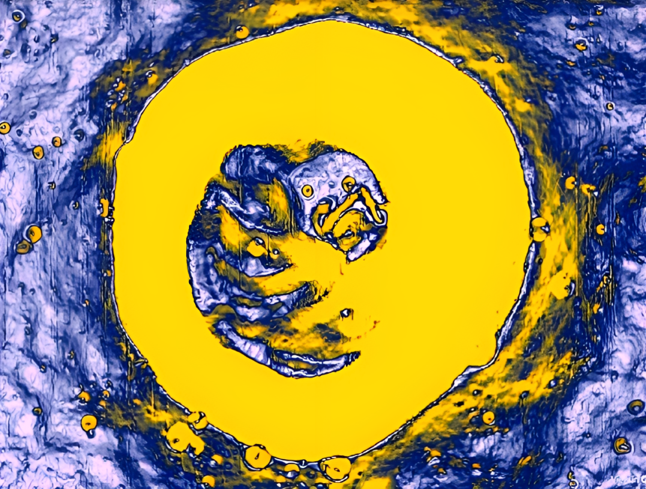
Fig. 1. Fossilized embryo of a dinosaur inside the egg on the Moon
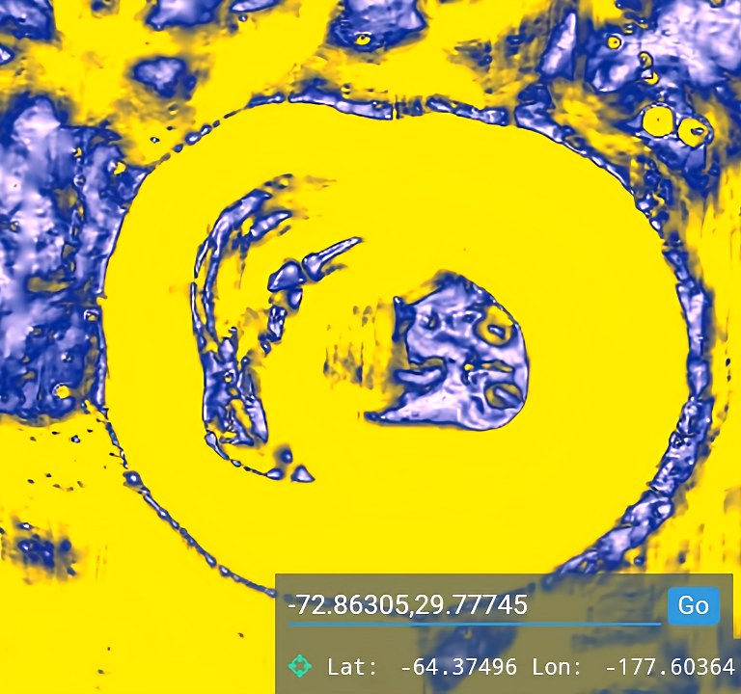
Fig. 2. Fossilized embryo of a dinosaur inside the egg on the South Pole of the Moon
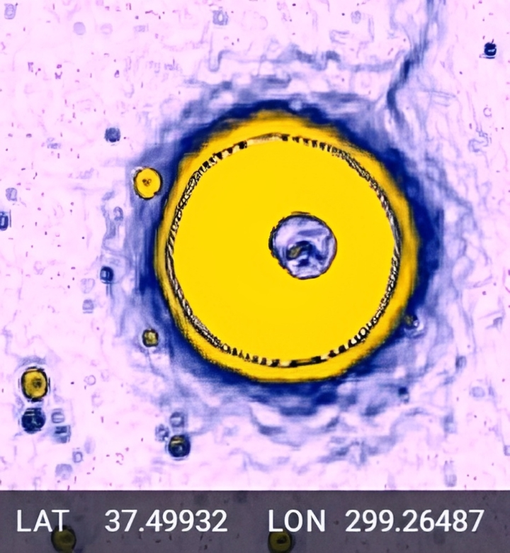
Fig. 3. Egg of a dinosaur without a fully developed embryo on the Moon

6/22/2023

