**‘Burial pits’ with animal and alienskull – like structures present on the South Pole of the Moon suggest humans and / or aliens might have existed on the Moon at some time**

Hari Mohan Saxena1*, Jag Mohan Saxena2

1Flat no. 105, Raj Mahal Apartments, D 253, Devi Marg, Bani Park, Jaipur 302016 India

2House no. 1-E-19, Jai Narayan Vyas Nagar, Bikaner 334003, Rajasthan, India

*Correspondence: [drhmsaxena@gmail.com](mailto:drhmsaxena@gmail.com)

**Abstract:** We have discovered some small and shallow pits on the lunar surface at the South Pole of the Moon which are different from natural craters. Each of these pits carry alien skull -or animal skull – like object (without the rest of the body) in the centre placed on a scarf -like structure, made of fine meshwork or a barcode like pattern of regularly placed equidistant bands, stretching across the diameter of the pit. The scarf is present in the middle of the pit under the skull along one axis only and covers only a part of the pit. We have not found any pit containing scarf without skull or at a different position with respect to skull. The scarf is not a natural structure or formation as apparent from its uniform design, remarkable symmetry and position in the pit. In normal craters, debris scatters radially all around. Such pits could have been dug by humans or aliens or they could have used existing craters to bury the dead or killed aliens or animals following a particular ritual or a protocol. This could probaly be the first report of evidence of ancient human or alien activity on the Moon.

[Hari Mohan Saxena, Jag Mohan Saxena. **‘Burial pits’ with animal and alienskull – like structures present on the South Pole of the Moon suggest humans and / or aliens might have existed on the Moon at some time.** *N Y Sci J* 2023;16(7):34-37]. ISSN 1554-0200 (print); ISSN 2375-723X (online). <http://www.sciencepub.net/newyork>. 06. doi:[10.7537/marsnys160723.06](http://www.dx.doi.org/10.7537/marsnys160723.06).

**Keywords:** Aliens, lunar crater, South Pole of the Moon, Lunar South Pole, Extraterrestrial Life, Fermi’s Paradox, Extraterrestrial intelligence.

**1. Introduction:**

Extraterrestrial life, and in particular, life on the Moon has been elusive till date despite numerous efforts by the mankind. It has been speculated since times immemorial that aliens or extraterrestrial intelligent life forms may exist and ultimately we may find it. However, nothing tangible has emanated in this regard. We present here our findings that could reveal the existence of aliens or humans on the Moon at some stage in the lunar history, if not presently.

**2. Materials and methods:**

Images of the lunar surface from the South Pole of the Moon taken by the NASA Lunar Reconnaissance Orbiter Camera (LROC) were scanned using appropriate filters to locate the pits. The settings and filters employed to obtain images of the mysterious pits from the LROC imagery have been described earlier (Saxena & Saxena, 2023).

**3. Results and discussion:**

We have discovered some small and shallowpits on the lunar surfaceat the South Pole of the Moon (Latitude: -68.39728, Longitude: 25.31785) which are different from natural craters formed by meteorites or debris from asteroids. Unlike the abundant craters, these few pits reveal different composition. Each pit carries an object resembling the skull of an animal (Fig. 1) or aliens (Figs. 2& 3), in the centre and a scarf – like structure made of fine meshwork under the skull, stretching across the diameter of the pit. The scarf is present along one axis only and is clearly distinguishable from the debris of meteorites which is scattered radially on all sides in a normal lunar crater. The scarf does not seem to be a natural lunar structure or arrangement of debris because it looks like a fine meshwork of some fibrous material. It gives the appearance of a regularly interspaced barcode pattern. The width of the scarf is uniform throughout its length and it barely covers the height of the skull – like object. The length of the scarf spans the diameter of the pit. The band was always found placed under the skull but never lying away from the skull or in irregular shape or different position or without the skull in the pit in any of the pits examined.

A possible explanation for the existence of such pits could be that they might have been specially dug on the lunar surface to bury the remains of some creatures died or killed by humans or aliens visiting or living on the Moon. Alternatively, existing small and shallow craters could have been used for the burial.

The skull – like structures present in these pits were found to be of two different shapes – some appear to be the skulls of human – like creatures (but not identical to humans)or aliens while others resemble skulls of animals. Interestingly, only the skulls were present in the pits but not the skeletons of the remaining parts of the bodies of the creatures.

The peculiar way the skull – like structures were buried along with the unique scarfs suggests that these creatures might have been killed or sacrificed and buried according to some protocol or ritual. Such evidence strongly suggests that the perpetrators of such activity could have been either humans or intelligent alien creatures. We have not found any previous published report on the finding of such structures on the Moon. We offer this as a possible solution to the Fermi’s Paradox (Sandberg et al., 2018).

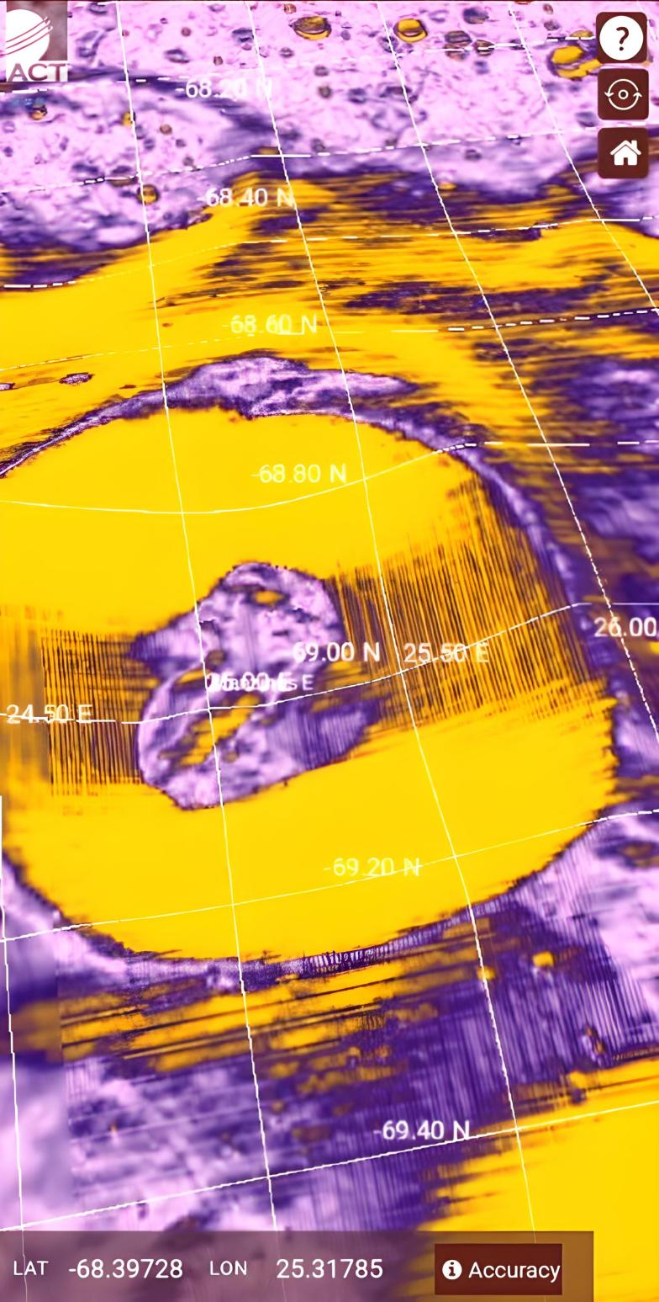

Fig. 1. Animal skull – like structure in a pit on the Moon

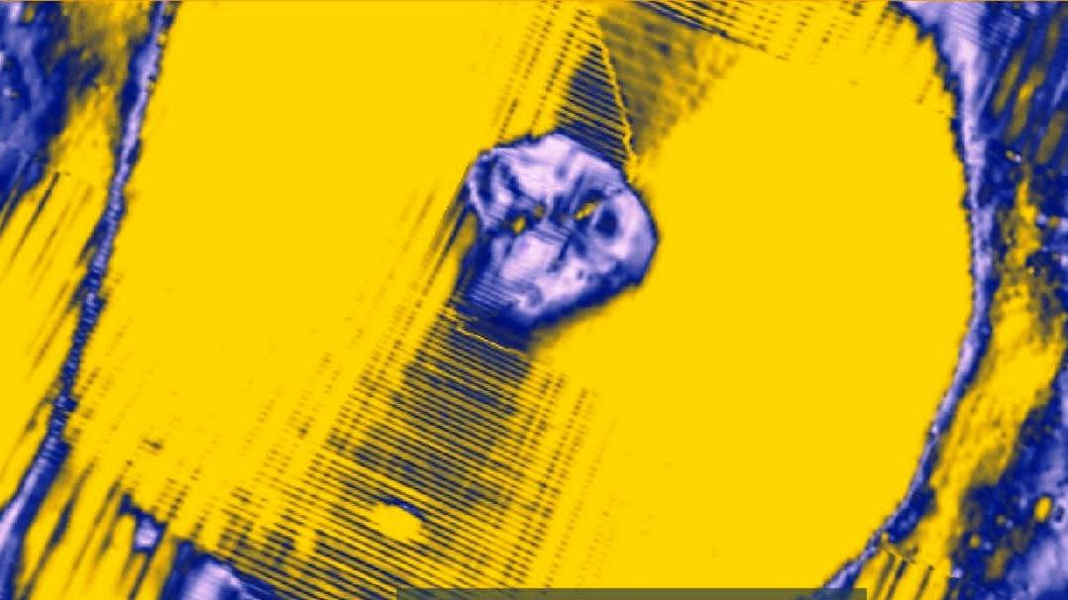

Fig. 2. Alien skull – like structure in a pit on the Moon

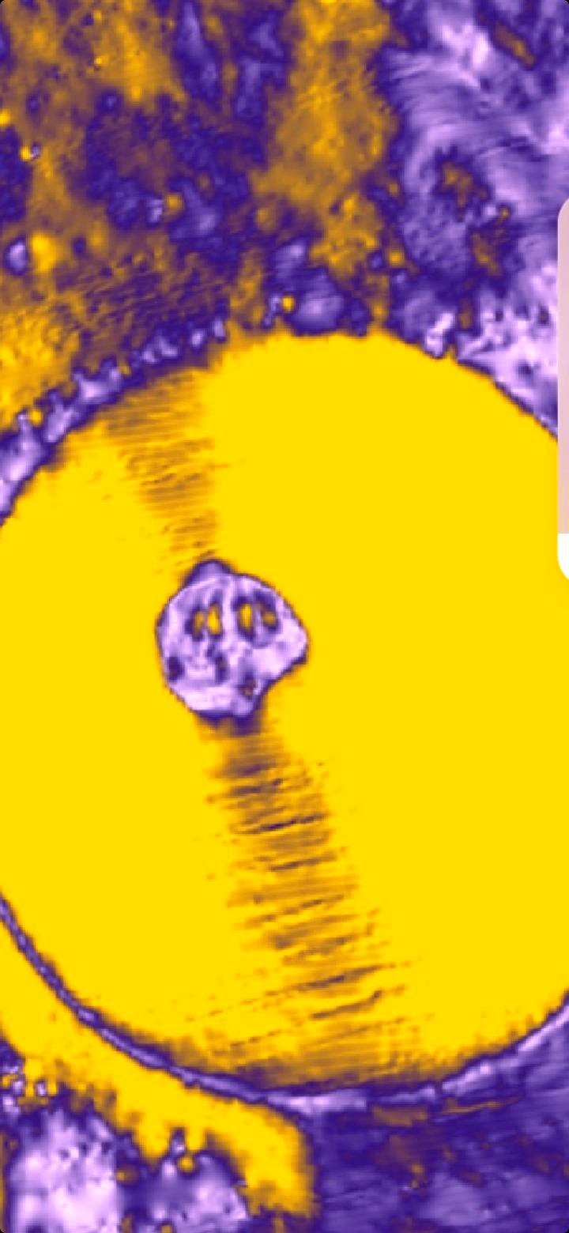

Fig. 3. Alien skull – like structure

**Corresponding author:**

Dr. Hari Mohan Saxena

Professor of Immunology (Retd.)

GADVASU, Ludhiana.

Mobile: +91 9417147813

E-mail: drhmsaxena@gmail.com

**References:**

1. Saxena HM, Saxena JM. Discovery of a Sri Yantra – like structure on the Moon. Nature and Science 2023;21(3):30-38.
2. Sandberg A, Drexler E, Ord T. Dissolving the Fermi Paradox.2018; <https://arxiv.org/pdf/1806.02404.pdf>

7/5/2023