C₂₀ and C₂₁ Tricyclic Terpanes in Niger Delta Crude Oils 1: Unusual Distribution and Characterization

Mark Obinna Onyema*, Michael Junior Ajie

Petroleum and Environmental Geochemistry Research group, Department of Pure and Industrial Chemistry, University of Port Harcourt, Port Harcourt, River State 500001, Nigeria
onyemark@yahoo.com

Abstract: C₂₀ and C₂₁ tricyclic terpanes in Niger Delta crude oils were investigated and characterized. From comparison of the partial m/z 191 mass chromatograms of two crude oil samples (RV-35 and DT-80) to that of related literatures, 12 peaks which eluted from the gas chromatography (GC) at a given retention time, were designated as C₂₀ (TR20a-e) and C₂₁ (TR21a-g) tricyclic terpane isomers. This reveal an unusual distribution of the C₂₀ and C₂₁ tricyclic terpanes in Niger Delta crude oils. Total abundance of the C₂₀ and C₂₁ tricyclic terpanes suggest RV-35, with considerably higher abundance, was more mature than DT-80 and that the C₂₀ tricyclic terpanes were generated more than C₂₁ tricyclic terpanes with increase in crude oil maturity. Individual C₂₀ and C₂₁ tricyclic terpane abundances were mostly higher in RV-35, except TR20c and TR21g which were slightly higher in DT-80. Similarities in the profiles of abundance, composition and ratios of C₂₀ and C₂₁ tricyclic terpanes indicate that the Niger Delta crude oils are derived from terrigenous Tertiary deltaic petroleum system. However, some C₂₀ and C₂₁ tricyclic terpane ratios permitted differentiation of the oil samples and are suggestive as indicator of maturity and source/depositional environment. Multivariate plot showed moderate similarities in paths followed by both oil samples suggesting the Niger Delta crude oils were derived from the same terrestrial source, with input from a different source/depositional environment, marine, to one of the crude oils.
[Mark Obinna Onyema, Michael Junior Ajie.C₂₀ and C₂₁ Tricyclic Terpanes in Niger Delta Crude Oils 1: Unusual Distribution and Characterization. N Y Sci J 2023;16(5):49-55]. ISSN 1554-0200 (print); ISSN 2375-723X (online). http://www.sciencepub.net/newyork. 05.doi:10.7537/marsnys160523.05.

Keywords: Tricyclic terpane; characterization; Niger Delta; correlation; crude oil

1. Introduction
Tricyclic terpanes are hydrocarbon compounds made up of three fused 6-carbon rings with an alkyl side chain. The most common tricyclic terpanes are cheilanthanes (13-methyl, 14-alkylpodocarpanes), which are generated from cheilanthatriol, a natural product of the plant Cheilanthes farinose (Khan et al., 1971). Other sources of tricyclic terpanes include bacteria, tasmanite algae which they have been discovered to occur frequently with, and the thermal breakdown of triterpanes in kerogen, where they are cogenerated with related monoaromatic to triaromatic tricyclic hydrocarbons (Tissot and Welte, 1984; Revill et al., 1994; Greenwood et al., 2000).
Tricyclic terpanes are frequently found in the saturated hydrocarbon fraction of petroleum oils and source rock extracts. They are determined using gas chromatography-mass spectrometry (GC-MS) by utilizing the mass to charge (m/z) 191 fragment ion. The C₁₉ to C₂₉ homologous series are often observed in the m/z 191 mass chromatogram, with the higher members up to C₅₄ obscured by the abundance of hopanes (Moldowan et al., 1983; de Grande et al., 1993). C₁₉ to C₂₄ tricyclic terpanes usually show a single peak on the mass chromatogram and a pair of peaks for C₂₅ and higher (Peters, 2000; Younes, 2001; Wang et al., 2006). This is due to the presence of a chiral centre at C-22 in C₂₅ and higher tricyclic terpanes, resulting in two peaks, R and S isomers (Ekweozor and Strausz, 1983).
Tricyclic terpanes have been used to successfully correlate crude oils and source-rock extracts, predict source-rock characteristics, and assess thermal maturity and biodegradationb (Seifert and Moldowan, 1981; Zumberge, 1987; Peters and Moldowan, 1993). Crude oils from the Niger Delta region of southern Nigeria have been characterized and correlated using their bulk properties, light hydrocarbons, aliphatic hydrocarbons, triterpanes, alkylated polycyclic aromatic hydrocarbons (Alkyl-PAHs) and aromatic steranes (Ekweozor et al., 1979; Eneogwe, 2004; Sonibare et al., 2008; Onyema, and Osuji, 2015; Onyema et al., 2018; Okoroh et al., 2020). This study investigates the occurrence and distribution of C₂₀ and C₂₁ tricyclic terpanes in Niger Delta crude oils. Furthermore, the C₂₀ and C₂₁ tricyclic terpanes will be characterized with a view to providing another geochemical means for crude oil correlation studies.

2. Material and Methods
2.1. Sample collection
The Niger Delta region is located in southern Nigeria at the apex of the Gulf of Guinea between longitudes 5°- 8° E and latitudes 3° - 6° N. The region covers an area of about 75,000 km² and was formed from the late Cretaceous to Recent age with depositions of sediments south westward into the Gulf of Guinea (Short and Stauble, 1967). Crude oil samples (one each) were obtained from oil producing fields (onshore) in Rivers and Delta states, both located in the Niger Delta region. The crude oil samples were obtained with the assistance of field technicians, labelled appropriately (RV-35 and DT-80, respectively) and taken to the laboratory for analysis.

2.2. Crude oil fractionation
50 mg of each crude oil sample was weighed into a labelled centrifuge tube and excess pentane added. The mixture was allowed to stand for three hours to precipitate the asphaltenes, and centrifuged for 30 minutes to coalesce the precipitated asphaltenes. The pentane soluble fraction was decanted, concentrated with nitrogen gas at 40°C, and put on top a glass column (30 cm x 1 cm) packed with silica and stuffed with glass wool at the bottom. n-hexane was poured into the packed column to elute the saturates. The eluent (n-hexane and saturates) was concentrated using nitrogen gas at 40°C.

2.3. Gas Chromatography-Mass Spectrometry (GC-MS) Analysis
The saturate fraction of the crude oil samples were analyzed on an Agilent 7890A gas chromatograph (GC) system equipped with a HP-5 silica capillary column (50 m x 320 μm i.d and 0.25μm film thickness) and an Agilent 5975 mass selective detector (MSD). An automatic liquid sampler (G4513A) was used to inject 1 microliter of the saturate fraction into the GC capillary column in splitless mode. The GC oven was set to an initial temperature of 80°C for 5 min., then ramped to 300°C at a rate of 4°C /min. and held at this temperature for 30 min. The GC analyses of the samples were monitored at the mass to charge (m/z) 191 fragmentation ion. Quantification of each peak was obtained by area integration which was processed by Chemstation OPEN LAB CDS software.

3. 3. Results and Discussion
3.1. Distribution of C₂₀ and C₂₁ Tricyclic Terpanes
Comparing the mass chromatograms (m/z 191) of the oil samples to that of related literatures, twelve (12) peaks were selected as C₂₀ and C₂₁ tricyclic terpanes (figs 1 and 2). The 12 peaks selected were well-resolved and eluted from the GC between 21 and 25 minutes.

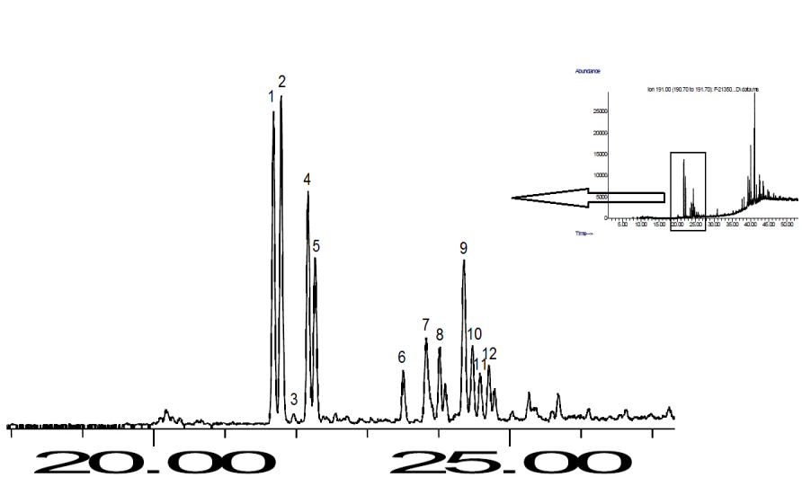
Figure 1. Partial m/z 191 mass chromatogram of Niger Delta crude oil sample RV-35 showing the selected C₂₀ and C₂₁ tricyclic terpane peaks

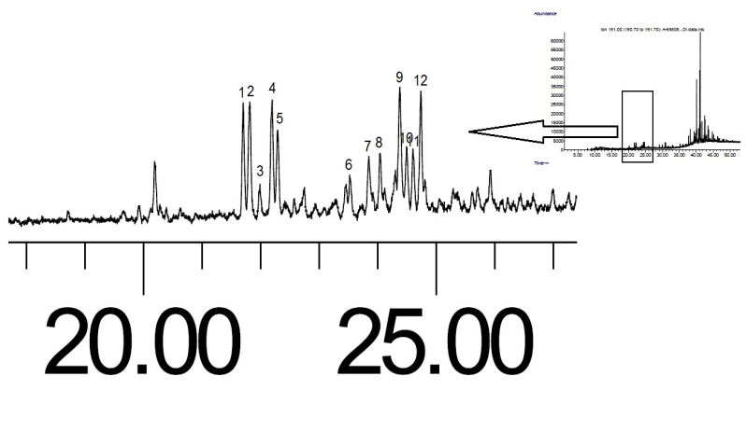
Figure 2. Partial m/z 191 mass chromatogram of Niger Delta crude oil sample DT-80 showing the selected C₂₀ and C₂₁ tricyclic terpane peaks

The 12 selected peaks of C₂₀ and C₂₁ tricyclic terpanes occurred in both crude oil samples (figures 1 and 2). Generally, the mass chromatograms of tricyclic terpanes show a single peak each for C₂₀ and C₂₁ (Peters, 2000; Younes, 2001). From the comparisons to related literatures, this C₂₀ and C₂₁ tricyclic terpane distribution is uncommon in crude oils and the distribution in the Niger Delta crude oils is unusual. From figures. 1 and 2, the 12 peaks separated into two groups. Peaks 1 - 5 were tightly clustered and eluted from the GC about 22 minutes, whereas peaks 6 - 12 were loosely clustered and eluted from the GC about 24 minutes. The mass chromatogram of an ion (m/z) at a given GC retention time is often indicative of a class of homologous compounds with similar carbon numbers but different structures and isomerism (Wang et al., 2006). This suggest peaks 1 - 5 as C₂₀ tricyclic terpane isomers and peaks 6 - 12 as C₂₁ tricyclic terpane isomers.
C₂₀ tricyclic terpane peaks 1, 2, 4 and 5 were more prominent than peak 3 in both mass chromatograms, and also were more prominent in RV-35 (figure 1) than in DT-80 (figure 2). Peaks 1, 2 and 4, 5 were also tightly clustered and nearly equal in height. C₂₁ tricyclic terpane peaks 7, 8 and 10, 11 in both oil samples and 9, 12 in DT-80, were closely clustered and nearly equal in heights. The most common C₂₀ and C₂₁ tricyclic terpanes discovered in crude oil and source rock samples include 13α(H), 14α(H) and 13β(H), 14α(H) isomers, as well as the ββ and αβ isomers (Chicarelli et al., 1988). These isomers often occur in almost equal abundance (Ekweozor and Strausz, 1983). This suggest C₂₀ tricyclic terpane peaks 1, 2 and 4, 5 as well as C₂₁ tricyclic terpane peaks 7, 8 and 10, 11 are isomers with different isomerism possibly derived from similar source/depositional environment. Peak 3 was considerable diminished in height compared to peaks 1, 2, 4 and 5, with which it is clustered (figures 1 and 2), suggesting isomers possibly derived from different source/depositional environment. Peaks 9 and 12 in DT-80 have nearly equal heights, but differ in RV-35, suggesting they are C₂₁ tricyclic terpane isomers possibly derived from different source/depositional environment.

3.2. Abundance and Composition Profiles
Abundances of the C₂₀ and C₂₁ tricyclic terpane isomers were calculated by area integration of the selected peaks. Table 1 shows the selected peaks for the C₂₀ and C₂₁ tricyclic terpane isomers, labels and abundances.

Table 1. Peak labels and abundances of C₂₀ and C₂₁ tricyclic terpane isomers in crude oil samples from Niger Delta, Nigeria
Peak No. | Tricyclic Terpanes (TR) | Code | Abundance
 |  |  | RV-35 | DT-80
1 | C₂₀ tricyclic terpane (a) | TR20a | 366,124 | 93,621
2 | C₂₀ tricyclic terpane (b) | TR20b | 391,817 | 110,218
3 | C₂₀ tricyclic terpane (c) | TR20c | 16,020 | 28,941
4 | C₂₀ tricyclic terpane (d) | TR20d | 275,646 | 103,863
5 | C₂₀ tricyclic terpane (e) | TR20e | 202,053 | 71,337
6 | C₂₁ tricyclic terpane (a) | TR21a | 69,523 | 38,008
7 | C₂₁ tricyclic terpane (b) | TR21b | 150,939 | 42,236
8 | C₂₁ tricyclic terpane (c) | TR21c | 93,007 | 51,410
9 | C₂₁ tricyclic terpane (d) | TR21d | 252,643 | 126,261
10 | C₂₁ tricyclic terpane (e) | TR21e | 105,559 | 55,733
11 | C₂₁ tricyclic terpane (f) | TR21f | 67,180 | 47,132
12 | C₂₁ tricyclic terpane (g) | TR21g | 72,831 | 81,286
 | Total C₂₀ tricyclic terpanes |  | 1,251,660 | 407,980
 | Total C₂₁ tricyclic terpanes |  | 811,682 | 442,066
 | Total Tricyclic Terpanes |  | 2,063,342 | 850,046

The total abundance of C₂₀ and C₂₁ tricyclic terpanes in RV-35 was 2.43 times more than the total abundance in DT-80 (table 1). During the transformation of organic matter to crude oil, high molecular weight hydrocarbons are thermally cracked to low molecular weight hydrocarbons (Waples, 1985). As a result, sesterterpanes and triterpanes in kerogen are thermally cracked to tricyclic terpanes, which are always abundant in high maturity crude oils regardless of the organic matter source (Farrimond et al., 1999). This suggest oil sample RV-35 was significantly more matured than DT-80. From table 1, the total abundance of C₂₀ and C₂₁ tricyclic terpanes is 3.07 and 1.84 times more in RV-35 than DT-80, respectively. Furthermore, the total abundance of C₂₀ tricyclic terpane isomers (TR20a - TR20e; see peak labels in table 1) was 1.54 times more than total abundance of C₂₁ tricyclic terpane isomers (TR21a - TR21g; see peak labels in table 1) in RV-35, but was slightly lower (0.92 times) in DT-80. This suggests that the C₂₀ tricyclic terpanes are generated more than the C₂₁ tricyclic terpanes as crude oils mature.
Individual C₂₀ and C₂₁ tricyclic terpanes were generally more abundant in RV-35 than DT-80, except TR20c and TR21g which were slightly more abundant in DT-80 than RV-35. TR20a, TR20b, TR20d and TR21d were the most abundant C₂₀ and C₂₁ tricyclic terpanes in both oil samples. TR20b, TR20a, TR20d, and TR21d were the most abundant in RV-35, constituting 18.99%, 17.74%, 13.36% and 12.24% of total C₂₀ and C₂₁ tricyclic terpane abundances, while TR21d, TR20b, TR20d, and TR20a were the most abundant in DT-80, constituting 14.85%, 12.97%, 12.22% and 11.01% of total C₂₀ and C₂₁ tricyclic terpane abundances, respectively. TR20c was the least abundant in RV-35 and DT-80 constituting 0.78% and 3.40%, respectively (table 1). Terpanes derived from different sources have distinct compositions and their characteristic profiles are employed as fingerprints for crude oil correlation and/or differentiation (Peters et al., 2005). The degree of similarity in the abundance profile and compositions of C₂₀ and C₂₁ tricyclic terpanes indicates that the Niger Delta crude oils are not distinct but rather are predominantly derived from the same source organic matter/depositional environment. The slightly more abundance of TR20c and TR21g in DT-80 than RV-35 suggest contribution from a different source/depositional environment to the DT-80 crude oil.

3.3. Correlation of Niger Delta Crude oils
From the abundances of C₂₀ and C₂₁ tricyclic terpanes in RV-35 and DT-80, 66 ratios were derived and calculated. Majority of the derived ratios exhibited little/no difference in their calculated values which did not allow for clear differentiation of the crude oil samples. Crude oils which show little variation in tricyclic terpane distributions and derivable ratios are mostly from terrigenous Tertiary deltaic petroleum systems (Samuel et al., 2010). The little/no difference in the values of majority of the calculated C₂₀ and C₂₁ tricyclic terpane ratios indicate the Niger Delta crude oil samples are from terrigenous Tertiary deltaic petroleum systems. However, some of the calculated C₂₀ and C₂₁ tricyclic terpane ratios gave values that permit differentiation of the oil samples (table 2).

Table 2. C₂₀ and C₂₁ tricyclic terpanes ratios that permit differentiation of the crude oil samples, Niger Delta, Nigeria

Ratios | RV-35 | DT-80
TR20a/TR20c | 22.85 | 3.23
TR20a/TR21g | 5.03 | 1.15
TR20b/TR20c | 24.46 | 3.81
TR20b/TR21g | 5.38 | 1.36
TR20c/TR20d | 0.06 | 0.28
TR20c/TR20e | 0.08 | 0.41
TR20c/TR21b | 0.11 | 0.69
TR20c/TR21d | 0.06 | 0.23
TR21b/TR21g | 2.07 | 0.52
* see peak labels in table 1

Table 2 shows nine (9) ratios with values that differentiated the Niger Delta crude oil samples. TR20a/TR20c and TR20b/TR20c ratios had considerably high values of 22.85 and 24.46 for RV-35 and low values of 3.23 and 3.81 for DT-80, respectively. Inversely, TR20c/TR20d, TR20c/TR20e, and TR20c/TR21d ratios had relatively low values of 0.06, 0.08 and 0.06 for RV-35 compared to values of 0.28, 0.41, and 0.23 for DT-80, respectively. These ratios indicate that TR20a, TR20b, TR20d, TR20e and TR21d were predominant in RV-35 (which is more matured) than DT-80, suggesting these ratios for use as maturity indicators. Ratios of TR20a/TR21g, TR20b/TR21g, TR20c/TR21b and TR21b/TR21g also showed values that differentiated the crude oil samples. TR20a/TR21g, TR20b/TR21g and TR21b/TR21g ratios had high values of 5.03, 5.38 and 2.07 for RV-35 and low values of 1.15, 1.36 and 0.52 for DT-80, respectively. Inversely, TR20c/TR21b ratio had a low value of 0.11 for RV-35 and a high value of 0.69 for DT-80. These ratios indicate TR20a, TR20b and TR21b were more abundant in RV-35, whereas TR20c and TR21g were more abundant in DT-80, suggesting these ratios for use as for source/depositional environment indicators

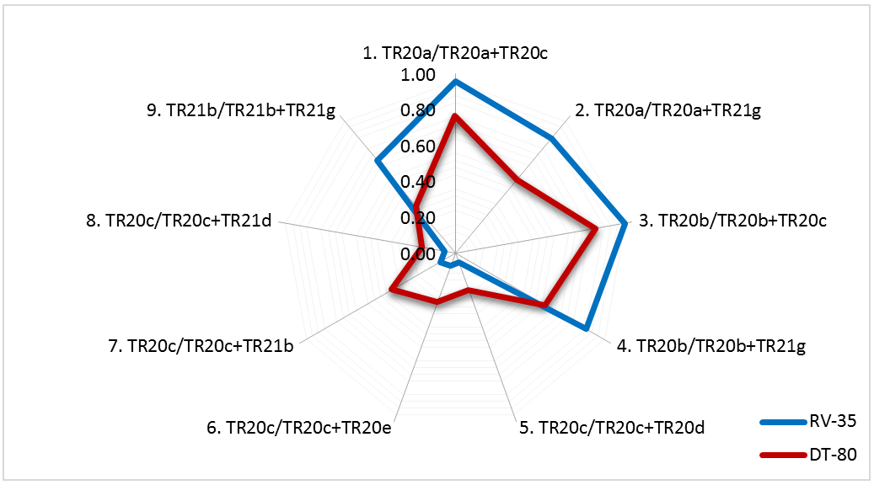
Figure 3. Plot of C₂₀ and C₂₁ tricyclic terpane ratios used for multivariate correlation of the Niger Delta crude oil samples

The C₂₀ and C₂₁ tricyclic terpane ratios that differentiated the oil samples (table 2) were normalized and put in a multivariate plot with nine (9) axis for comparison (figure 3). Multivariate plots are based on recognition of hydrocarbon compositional similarities that discriminate a homologous suit of oils from a different source (Halpern, 1995; Onyema and Manilla, 2010). They are used to complement correlation studies of crude oils (Ali et al., 2002; Volk et al., 2005). From figure 3, the multivariate plot showed that the shapes formed from the paths followed, from axis-1 to -9, by both oil samples were not completely different. The crude oil samples followed similar paths on axis-1, -3, -5, -6, -7 and -8. Axis-1 and -3 of RV-35 were enhanced, while axis-5, -6, -7 and -8 of DT-80 were amplified. Differences were observed in the paths followed on axis-2, -4 and -9, with RV-35 more enhanced than DT-80. This showed that the paths followed by both crude oil samples on their multivariate plots were mostly similar and reveal a strong genetic relationship between the oils with minor differences in the paths followed suggesting input from a different source/depositional environment. The multivariate plots of both samples suggest that the Niger Delta crude oils are predominantly derived from the same source, terrestrial organic matter (Ekweozor and Udo, 1988; Eneogwe and Ekundayo, 2003), with input from a different source organic matter/depositional environment, marine.

4. Conclusion
12 peaks which eluted from the GC, at a given retention time, were selected from the mass chromatogram (m/z 191) of two Niger Delta crude oils and identified as C₂₀ and C₂₁ tricyclic terpane isomers. Total abundance suggest that the C₂₀ tricyclic terpanes were generated more than the C₂₁ tricyclic terpanes as the crude oils mature. Individual C₂₀ and C₂₁ tricyclic terpanes were generally more abundant in RV-35, except TR20c and TR21g which were slightly more abundant in DT-80. Similarities in the abundances and compositions of the C₂₀ and C₂₁ tricyclic terpanes indicate that the Niger Delta crude oils are not distinct, but derived from terrigenous Tertiary deltaic petroleum source. Multivariate plot of the normalized ratios showed reasonable similarity in paths followed by both oil samples suggesting the Niger Delta crude oils are predominantly derived from terrestrial organic matter source. Minor differences observed on the multivariate plot suggest one of the Niger Delta crude oil received input from a different source/depositional environment, marine.

Acknowledgements:
The authors are grateful to Rofnel Energy Limited for permitting us use their facilities for analyses. We are equally grateful to Prof. Leo C. Osuji and Dr. Chidi I. Eneogwe for introducing us to petroleum hydrocarbon research and Mrs Nneka C. Ofodu for her proficiency.

Corresponding Author:
Mark O. Onyema
Petroleum and Environmental Geochemistry Research group
Department of Pure and Industrial Chemistry
University of Port Harcourt
Choba, Port Harcourt, 500001,
Rivers State, Nigeria
Telephone: +234 803 041 5230
E-mail: onyemark@yahoo.com

References
- Khan H, Zaman A, Chetty GL, Gupta AS and Dev S. Cheilanthatriol a new fundamental type in sesterterpenes. Tetrahedron Letters, 1971; 12: 4443-4446.
- Tissot BP and Welte DH. Petroleum formation and occurrence, a new approach to oil and gas exploration. 2nd ed; Springer-Verlag: Berlin, 1984.
- Revill AT, Volkman JK, O’Leary T, Summons RE, Boreham CJ, Banks MR and Denwer K. Depositional setting, hydrocarbon biomarkers and thermal maturity of Tasmanite oil shales from Tasmania, Australia. Geochimica et Cosmochimica Acta, 1994; 58: 3803–3822.
- Greenwood PF, Arouri KR and George SC. Tricyclic terpenoid composition of Tasmanites kerogen as determined by pyrolysis GC–MS. Geochimica et Cosmochimica Acta, 2000; 64: 1249-1263.
- Moldowan JM, Seifert WK and Gallegos EJ. Identification of an extended series of tricyclic terpanes in petroleum. Geochimica et Cosmochimica Acta, 1983; 47: 1531-1534.
- de Grande SMB, Aquino Neto FR and Mello MR. Extended tricyclic terpanes in sediments and petroleum. Organic Geochemistry, 1993; 20: 1039-1047.
- Peters KE. Petroleum tricyclic terpanes: Predicted physicochemical behavior from molecular mechanics calculations. Organic Geochemistry, 2000; 31: 497-507.
- Younes MA. Source-rocks dependent biomarker properties and stable carbon isotopes composition of crude oils from West Bakr Fields, Onshore Gult of Suez, Egypt: A case study. Petroleum Science and Technology, 2001; 19: 1197-1218.
- Wang Z, Stout A and Fingas M. Forensic fingerprinting of biomarkers for oil spill characterization and source identification. Environmental Forensics, 2006; 7 (2): 105-146.
- Ekweozor CM and Strausz OP. 18,19-Bisnor-13βH, 14αH-Cheilanthane: A novel degraded tricyclic sesterterpenoid-type hydrocarbon from the Athabasca oil sands. Tetrahedron Letter, 1983; 23: 2711-2714.
- Seifert WK and Moldowan JM. Paleoreconstruction by biological markers. Geochimica et Cosmochimica Acta, 1981; 45: 783-794.
- Zumberge JE. Terpenoid biomarker distributions in low maturity crude oils. Organic Geochemistry, 1987; 11: 479-496.
- Peters KE and Moldowan JM. The biomarker guide: Interpreting molecular fossils in petroleum and ancient sediments. Prentice-hall: New Jersey, 1993.
- Ekweozor CM, Okogun JI, Ekong DEU and Maxwell JR. Preliminary organic geochemical studies of samples from the Niger Delta, Nigeria I: Analysis of crude oils for triterpanes. Chemical Geology, 1979; 27 (1 and 2): 11-28.
- Eneogwe CI. The invariance ratio in isoheptanes: A powerful tool for oil-oil correlation in the tertiary Niger Delta, Nigeria. Organic Geochemistry, 2004; 35: 989-992.
- Sonibare O, Alimi H, Jarvie D and Ehinola OA. Origin and occurrence of crude oil in the Niger Delta, Nigeria. Journal of Petroleum Science and Engineering, 2008; 61 (2-4): 99-107.
- Onyema, M. O. and Osuji, L. C. (2015). Gas chromatography-mass spectrometry (GC-MS) compositional analyses of aromatic hydrocarbons in Niger Delta crude oils. Petroleum and Coal, 57 (5): 526-531.
- Onyema MO, Okoroh NC, Okorie IH and Osuji LC. Geochemical characterization of two Niger Delta crude oils and their mixtures I: Bulk properties and aliphatic hydrocarbon distributions. Modern Chemistry, 2018; 6 (3): 39-43.
- Okoroh NC, Onyema MO and Osuji LC. Aromatic hydrocarbons as indicators of maturation and source: correlative geochemical evaluation of commingled Niger Delta crude oils. Petroleum and Petrochemical Engineering Journal, 2020; 4 (2): 1-9.
- Short KC and Stauble AJ. (). Outline of the Geology of Niger Delta. American Association of Petroleum Geologists Bulletin, 1967; 51: 761 -799.
- Chicarelli MI, Aquino Neto FR and Albrecht P. Occurrence of four stereoisometric tricyclic terpanes series in immature Brazilian shales. Geochimica et Cosmochimica Acta, 1988; 52: 1955-1959.
- Waples DW. Geochemistry in Petroleum Exploration. International Human Resources Development Corporation: Boston, 1985.
- Farrimond P, Bevan CJ and Bishop AN. Tricyclic terpane maturity parameters: Response to heating by an igneous intrusion. Organic Geochemistry, 1999; 30: 1011–1019.
- Peters KE, Walters CC and Moldowan JM. The biomarker guide: Biomarkers and isotopes in petroleum exploration and earth history. 2nd ed; Cambridge University Press: England, 2005.
- Samuel OJ, Kildahl-Andersen G, Nytoft HP, Johansen JE and Jones M. Novel tricyclic and tetracyclic terpanes in Tertiary deltaic oils: Structural identification, origin and application to petroleum correlation. Organic Geochemistry, 2010; 41: 1326-1337.
- Halpern HI. Development and applications of light-hydrocarbon-based star diagrams. American Association of Petroleum Geologists Bulletin, 1995; 76: 801-815.
- Onyema M O and Manilla PN. Light hydrocarbon correlation of Niger Delta crude oils. Journal of American Science, 2010; 6(6): 82-88.
- Ali FM, Al-Khadrawi RM, Perzanowski H and Halpern HJ. Central Saudi Arabia crude oil: A geochemical investigation. Petroleum Science and Technology, 2002; 20: 633-654.
- Volk H, George SC, Middleton H and Schofield S. Geochemical comparison of fluid inclusion and present-day oil accumulations in the Papuan Forland -Evidence for previously unrecognized petroleum source rocks. Organic Geochemistry, 2005; 36: 29-51.
- Ekweozor CM and Udo OT. The oleananes: Origin, maturation and limits of occurrence in southern Nigeria’s sedimentary basins. Organic Geochemistry, 1988; 13(1-3): 131-140.
- Eneogwe CI and Ekundayo O. Geochemical correlation of crude oils in the NW Niger Delta, Nigeria. Journal of Petroleum Geology, 2003; 26: 95-103.

5/20/2023

