Dickkopf-1 Prognostic value in Newborn with Hypoxic- Ischemic Encephalopathy

Abdalmoktader, A.M., Yousef, A.T., Alkassem Algameel, Karam, D.M.
Pediatrics Department- Faculty of Medicine, Fayoum University, Egypt
drahmed@fayoum.edu.eg, ashraftalaat1@yahoo.com, a_algameel@yahoo.com, dina_adham79@yahoo.com

Abstract: Hypoxic ischemic encephalopathy is an important cause of brain injury in the newborns and can result in devasting consequences. The principle mechanism underlying neurological damage in Hypoxic-Ischemic Encephalopathy HIE resulting from hypoxemia and or ischemia is deprivation of glucose and oxygen supply which cause energy failure. DKK-1 is a secreted protein involved in embryonic development and known as a potent inhibitor of the Wnt signaling pathway, which plays a critical role in cell pattering, proliferation and cell determination during embryogenesis. Therefore, this study aimed to measure serum dickkopf-1 level in neonates with HIE and to compare it with healthy infants, also to compare it within different grades of hypoxic ischemic encephalopathy, and to study the relation between dickkopf-1 and mortality of newborns. The present study was carried on 40 full term newborns in the neonatal intensive care units (NICU) in Fayoum general hospital, from May 2018 to August 2019. Who were grouped into two groups, group I (full term HIE neonates) includes 20 full term ≥ 37 weeks neonates with hypoxic ischemic encephalopathy (15 males, 5 females), group II (full term healthy neonate) includes 20 full term ≥ 37 weeks neonates who apparently healthy (11 males, 9 females). Apgar score was done at 1 minute and 5 minutes after delivery for all studied neonates. Both groups were subjected to full medical history, clinical examination and laboratory investigations in form of complete blood count (CBC) and measurement of serum dickkopf-1 level on the first day of admission. Our study reported that there was high statistical significant difference between both groups as regards apgar score at 1 and 5 minutes after delivery which accompanied by a significant negative correlation between serum DKK-1 and apgar score. Also, it revealed that dickkopf-1 level had higher levels in neonates with HIE compared with healthy ones. Moreover dickkopf-1 level was significant positively correlated with grades of HIE. We reported also that DKK-1 was significant negatively correlated with Hgb, WBC and platelets counts. In our study, we found that DKK-1 was significant positively correlated with poor neurodevelopmental outcome and mortality among HIE neonate All these results recommend the use of Dickkopf-1 as a predictor for diagnosis and prognosis of HIE neonates.
[Abdalmoktader, A.M., Yousef, A.T., Alkassem Algameel, Karam, D.M. Dickkopf-1 Prognostic value in Newborn with Hypoxic- Ischemic Encephalopathy. N Y Sci J 2023;16(3):47-54]. ISSN 1554-0200 (print); ISSN 2375-723X (online). http://www.sciencepub.net/newyork. 08.doi:10.7537/marsnys160323.08.

Key words: Dickkopf-1 - Hypoxia ischemia –Newborns- Encephalopathy

1-Introduction:
Neonatal hypoxic ischemic insults are a significant cause of neonatal encephalopathy, developmental delays, and spastic cerebral palsy. Although the developing brain spasticity allows for remarkable self-repair, sever disruption of normal myelination and cortical development up on neonatal brain injury are likely to generate life persisting sensory-motor and cognitive deficits in the growing child (1). Neonatal hypoxic ischemic encephalopathy is one of the most common causes of cerebral palsy and other sever neurological deficits in children, it is caused by inadequate blood flow and oxygen supply to the brain resulting in focal or diffuse brain injury (2). HIE has an incidence of 3 to 5 per 1000 live births in the developed world and remains associated with significant mortality and neurodevelopment sequel (3). The incidence in developing countries range from 2.3-26.5 per1000 live births (4).
Human dickkopf-1 is a member of dickkopf gene family which is composed of dickkopf-1, dickkopf-2, dickkopf-3 and dickkopf-4 (5). Among the members of the dickkopf family, dickkopf-1 is a secreted protein involved in embryonic development and known as potent inhibitor of the Wnt signaling pathway, which plays a critical role in cell patterning proliferation and fate determination during embryogenesis (6)).DKK-1 binds to low density lipoprotein (LDL)-receptor related protein5 (LPR5) OR LPR6 which functions as a wnt coreceptor therapy suppressing the B-catenin pathway (7).In the embryonic brain, wnt signaling induces self renewal of radial glia progenitors and differentiation but not proliferation of intermediate progenitor (8).Recent findings have pointed to an increased expression of Dkk1-1 causally related to neurodegenerative processes associated with Alzheimer’s disease or brain ischemia (9).The canonical Wnt signaling pathway, which induces cell proliferation, is utilized for tissue repair processes, and a Wnt antagonist might inhibit or delay such events in chronic inflammatory diseases (10).The inhibition of canonical Wnt pathway activation by DKK-1 is achieved by its competitive binding of the receptor LRP (low-density lipoprotein receptor)-5 and 6 complex with markedly higher affinity than its counterpart agonist Wnt3a (11). A recent literature review has reported the rate of individual long term neurodevelopment outcome after HIE: 45% of squeals were represented by cognition and developmental delay or learning difficulties, 29% by cerebral palsy, 26% by blindness or vision defects, 17%by gross motor and coordination problems, 12%by epilepsy,9% by hearing loss or deafness, and1% by behavioral problems (12).In fact mild forms of HIE are associated with better intellectual, educational and neuropsycological outcomes when compared with sever forms. However, more subtle cognitive deficits and behavioral alterations have been revealed through long term evaluation, even in mild forms of HIE (13).

2. Methodology and patients:
I. Study design:
This study is a comparative study, a case-control study which carried out in the neonatal intensive care units (NICU) of General Fayoum hospital during period from May 2018 to August 2019 after approval from ethics committee (no. 45)-faculty of medicine- Fayoum university in January/ 2018 – (D143) and a written informed consent was obtained from all caregivers/parents of the involved neonates in accordance with the Declaration of Helsinki.
II. Patients selection:
The study included 40 full term ≥ 37 gestational weeks' newborns; studied neonates were divided into two groups:
Group I: (Case group) full term HIE neonates included 20 full term more than or equal to 37 weeks, with hypoxic ischemic encephalopathy satisfied the following inclusion criteria.
Group II: (Control group) full term healthy neonates included 20 apparently healthy full term neonates
Inclusion criteria
Hypoxic full term neonates were 20 newborns, their gestational ages ranged from 37 to 42 weeks, delivered by cesarean section or vaginally, they diagnosed according to Saranat criteria and they fulfilling at least two of the clinical findings listed down
(1) Apgar score <5 at 5 min
(2) Fetal acidosis, (as umbilical cord pH below 7.2 or in neonatal blood samples obtained on the first day of life)
(3) Fetal distress (such as abnormal fetal heart rate and meconium stained amniotic fluid)
(4) Fetal asphyxia required resuscitation as need for assisted ventilation (mask/balloon or intubation)
(5) Encephalopathy (lethargy/ stupor, hypotonia and abnormal reflexes including an absent or weak suck)
(6) Presence of convulsions in the first 24 h of life
(7) Multiple organ dysfunctions (encephalopathy and the involvement of at least one organ).
Controls were 20 healthy neonates, their gestational ages ranged from 37 to 42 weeks delivered by cesarean section or vaginally and discharged from the hospital with their mothers fulfilling the criteria of no maternal illness, no signs of fetal distress, Apgar score at 1 and 5 minutes >7
Exclusion criteria
Infants were excluded from the study if they met any of the following conditions:
(a) Cases with sever sepsis or congenital brain infection
(b) Full term newborn with major congenital or chromosomal anomalies,
(c) Inborn errors of metabolism
III. Diagnosis:
- Compelet medical history
Full maternal and prenatal, natal, postnasal history of diseases and medications was obtained for all cases.
- Thorough clinical examination
Full neurological examination was done during the first 24 hour with stress on signs of encephalopathy in the form of
- according to sarnat classification of HIE
- level of consciousness (alert, lethargy, or coma),
- Abnormal neuromuscular control in form of abnormal muscle tone, abnormal posture, abnormal stretch reflexes and presence or absence of segmental myoclonus
- Abnormalities in complex reflexes in the form of (suckling, moro, oculovestibular and tonic neck.
- Abnormal autonomic function.
- Abnormal pupil size.
- Abnormal respiration.
- Abnormal heart rate
- Abnormal GIT motility.
- Presence or absence of seizures (14)
B)Apgar score <6 at 5 minutes (15).
IV. Laboratory methods:
Sampling
4ml of venous blood was drawn from each neonate of both groups and was divided as follow:
- 2ml blood was added to EDTA tube for CBC.
- 2ml blood was added to another plain tube; stand for 30minutes, centrifuged at 3000rpm for 10minutes, supernatant serum was separated in isolated eppendofs tube and preserved at -20c until time of assay of DKK-1.
These laboratory investigations include the followings:
Complete blood count (CBC): using automated cell counter (coulter), Mindry BC 3600 China
Measurement of serum DKK-1 level: using Human Dickkopf-1 ELISA Kit NEW TEST SUPPORT CO. Toronto, Canada.
Serum Dickkopf1 level assay
Assays for DKK-1 were done in the first 24 hour of age.
Principle of test
The kit is for the quantitative level of DKK-1 in the sample, use sandwich-ELISA as the method, reaction is terminated by the addition of stop solution and the color change is measured spectrophotometrically at a wavelength of 450 nm. The concentration of DKK-1 in the samples is then determined by comparing the optical density (OD) of the samples to the standard curve.
Calculation
First, the mean OD value was calculated for each standard and sample, all OD values, are subtracted by the mean value of zero standard before result interpretation, the standard curve was constructed using graph paper where the standard concentration was taken as the horizontal and the OD value was taken for the vertical, then the corresponding concentration was find out according to the sample OD value by the sample curve.
V. Statistics:
The collected data were organized, tabulated and statistically analyzed using SPSS software statistical computer package V. 22 (SPSS Inc, USA). For quantitative data, the mean, median, standard deviation (SD), and Inter-quartile range (IQR) were calculated. Kolmogorov-Smirnov test (KS) test was performed as a test of normality. If variables were not normally distributed, either Mann-Whitney-U test or Kruskal-Wallis test was used while comparing between any two or three groups, respectively. Otherwise, Independent t-test was used. Qualitative data were presented as number and percentages, chi square (χ2) was used as a test of significance. Spearman correlation was run to identify relation between Dickkopf-1 and several parameters among HIE cases. ROC curve was used to determine the cut-off point in which highest sensitivity and specificity of Dickkopf-1 as predictors in differentiating between different classifications. For interpretation of significance, significance was adopted at P ≤ 0.05.

3. Results:
A total of 40 neonates were studied and divided into:
Group I (case group) full term HIE neonates included 20 full term more than or equal to 37 weeks, with hypoxic ischemic encephalopathy (15 males, 5 females).
Group II (Control group) full term more than or equal to 37 weeks healthy neonates included 20 apparently healthy full term neonates (11 males, 9 females).
Table (1) showed that as regarding studied HIE neonates a total of 7 (35%) showed mild grade HIE, 11(55%) showed moderate, 2 (10%) showed sever grade. Regarding oxygen support facility, 13 of them (65%) need nasal oxygen, while remaining 7(35%) were ventilated.
Regarding convulsion, 17 of them (85%) show convulsion, while remaining 3(15%) didn’t show, and accordingly 4 of them (23.5%) need one anticonvulsant, 9(52.9%) need two medication and 4(23.5%) need three medication to arrest convulsions.

Table (1): Clinical characteristics of HIE cases (Group I)
Variable | N | %
Grade
Mild | 7 | 35.0%
Moderate | 11 | 55.0%
Severe | 2 | 10.0%
Oxygen support
Ventilated | 13 | 65.0%
Oxygen support | 7 | 35.0%
Convulsions
Yes | 17 | 85.0%
No | 3 | 15.0%
Anticonvulsant
1 | 4 | 23.5%
2 | 9 | 52.9%
3 | 4 | 23.5%

Figure (1) show a total of 7(35%) died before discharge and remaining 13 (65%) was survived. Among the survived diseased neonates, 8(61.5%) had abnormal neurological examination and 5(38.5%) had normal neurological examination.
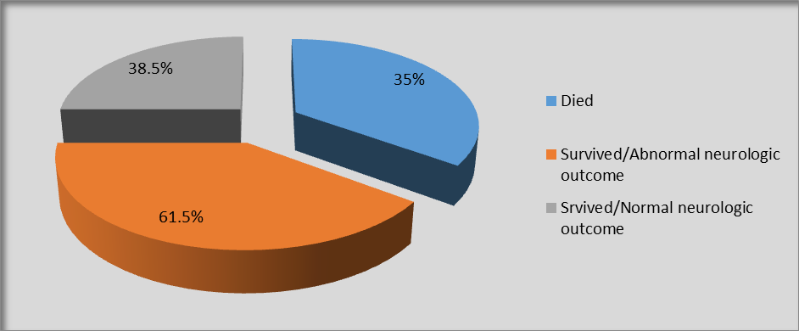
Figure (1) Frequency distribution of outcome among studied cases
Figure (2 a, b, c ) showed that there was a significant difference as regard hemoglobin level, WBCs count and platelets between HIE neonates and controls.

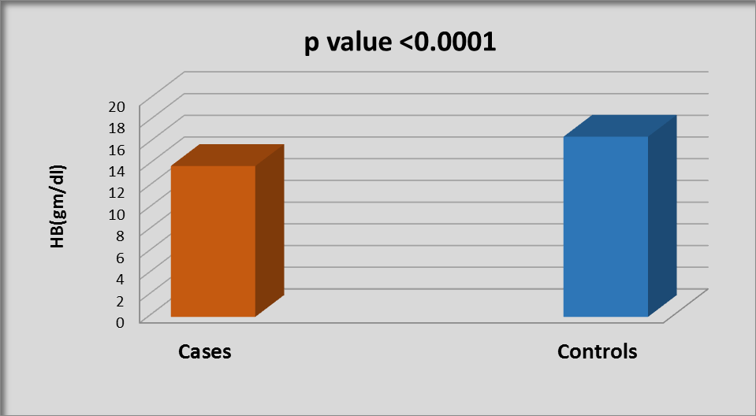
Figure (2a) Comparison of mean hemoglobin concentration between cases and controls

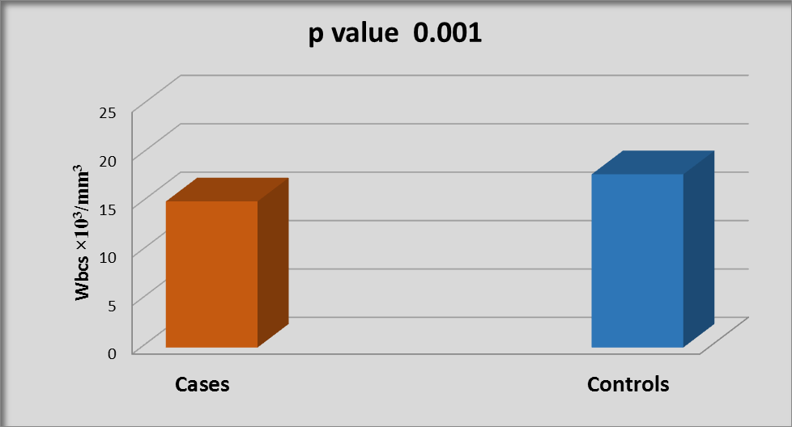Figure (2b) Comparison of mean WBCs count between cases and controls
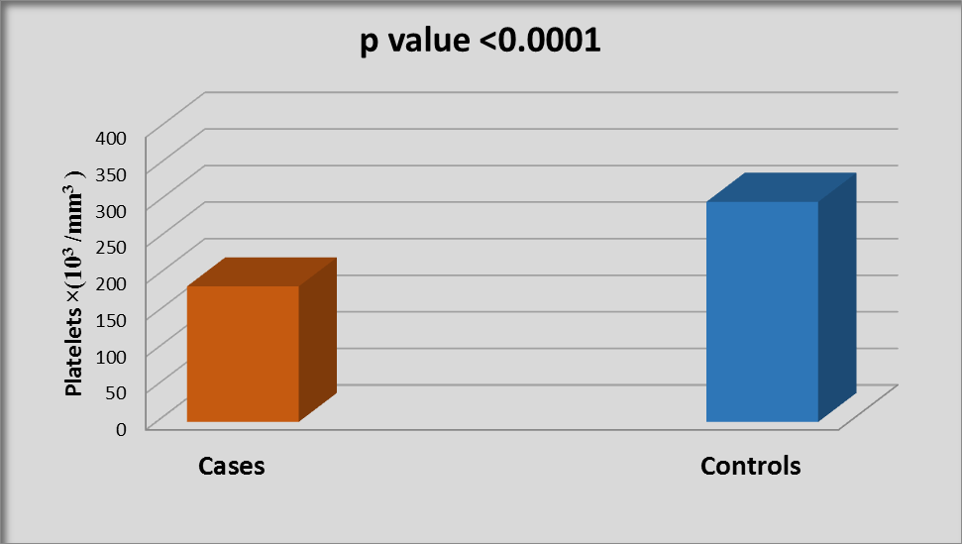
Figure (2c) Comparison of mean platelets count between cases and controls

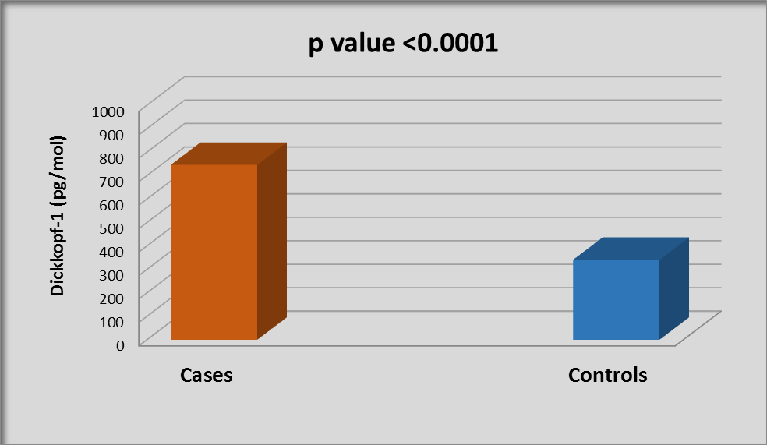
Figure (3) Comparison of mean Dickkopf-1 level between cases and controls
Showed that there was a significant difference as regard serum DKK-1 level between HIE neonates and controls.

Table (2): Correlation between Dickkopf-1 and several parameters among cases
 | Dickkopf-1
 | r | P-value
Gestational age | 0.250 | 0.288
Birth weight | 0.194 | 0.412
HIE grades | 0.875 | <0.0001*
WBCs | -0.757 | <0.0001*
HB | -0.802 | <0.0001*
Platelets | -0.890 | <0.0001*

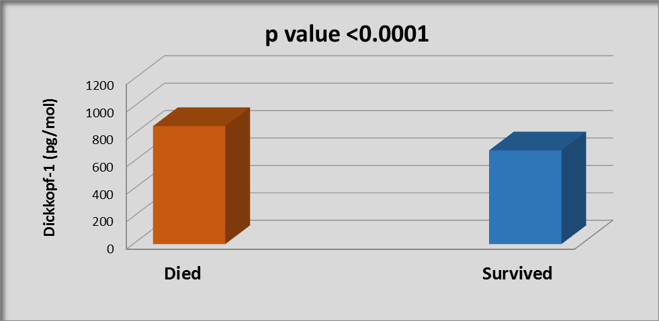
Figure (4) Comparison of mean Dickkopf-1 level between died and survived among studied cases.
Showed that there was a significant positive correlation between mortality and serum DKK-1 level.

Table (3) there was a statistically significant positive correlation between mortality and all of grades of hypoxia

Table (3): Relation between mortality and clinical hypoxia grades among cases
 | Died  (N=7) |  | Survived  (N=13)
Variable | N | % | N | % | P-value#
Grade
Mild | 0 | 0.0% | 7 | 53.8% | 0.018*
Moderate | 5 | 71.4% | 6 | 46.2%
Severe | 2 | 28.6% | 0 | 0.0%

Table (3) showed that using the ROC curve, serum DKK-1 level >551 pg/mol in neonates with HIE could significantly deforest ate cases from controls with a sensitivity of 100% and a specifity of 100% as shown in figure (5a).
But serum DKK-1 level >762 pg/mol in neonates with HIE could significantly predict mortality of these studied HIE with a sensitivity of 85.7% and a specifity of 100% as shown in figure (5b).

Table (4): Accuracy of Dickkopf-1
Condition | AUC | P-value | Cut-off point | Sensitivity% | Specificity %
Deforestation cases from control | 1.000 | <0.0001* | 551 | 100.0 | 100.0
Prediction of mortality among cases | 0.954 | 0.001* | 762 | 85.7 | 100.0
*Significant

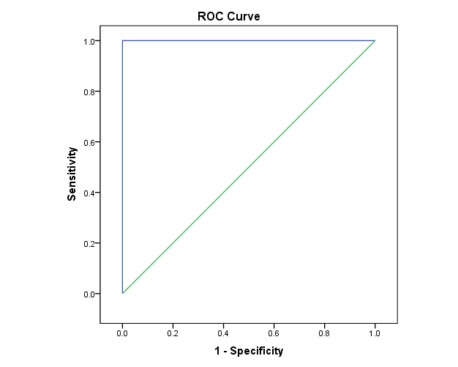
Figure (5a) ROC curve of Dickkopf-1 for differentiating cases from controls curves

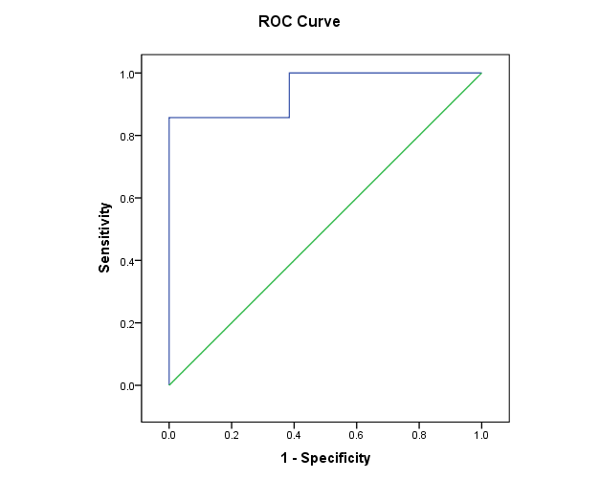
Figure (5b) ROC curve of Dickkopf-1 for predicting mortality among cases

4. Discussion:
Neonatal encephalopathy is a heterogeneous, clinically defined syndrome characterized by disturbed neurologic function in the earliest days of life in an infant born at or beyond 35 weeks of gestation, manifested by a reduced level of consciousness or seizures, often accompanied by difficulty with initiating and maintaining respiration, and by depression of tone and reflexes (16).HIE has tremendous detrimental effects on the developing brain and is among the leading causes of death among infants, as well as the major underlying cause of seizures in term infants (17).Dickkopf-1 (DKK-1), a secretory glycoprotein discovered for ‘inducing generation of head’, is an endogenous inhibitor of the canonical Wnt/β-catenin signaling pathway. In recent years, a large number of studies have shown that it plays an important role in embryonic development, neural regeneration, synaptogenesis and so on. Therefore, its role in neuropsychiatric disorders, such as neurodysplasia, cognitive impairment and emotional disorder, has attracted increasing attention (18). There are few studies on DKK-1 level as marker for hypoxic ischemic encephalopathy and evaluation of its level in different HIE clinical stages caused by perinatal asphyxia. The present study was conducted on forty full term newborns with gestational age ≥ 37 weeks, divided into two groups ,group I (20 cases); 75% (15) were males and 25% (5) were females; 60% (12) delivered vaginally and 40% (8) delivered by CS; with a mean weight of 3.2±0.4 kg and mean age of 38.5 ± 1.3 gestational weeks. Group II (20 controls), 55% (11) were males and 45%(9) were females; 50% (10) delivered vaginally and 50% (10) delivered by CS; with a mean weight of 3.2± 0.3 kg and mean age of 38.3 ± 0.9 gestational age. Group I who diagnosed as HIE, they show the clinical characteristics that distribute as follows; Out of 20 cases, a total of 7 (35%) showed mild grade HIE, 11(55%) showed moderate HIE, and 2 (10%) showed sever grade. Regarding oxygen support facility, 13 of them (65%) need nasal oxygen, while remaining 7(35%) were ventilated (Table 1). Regarding convulsions, a total of 17 neonates (85%) show convulsion, while remaining 3(15%) didn’t show, and accordingly 4 of them (23.5%) need one anticonvulsant, 9(52.9%) need two medication and 4 (23.5%) need three medications to arrest convulsions as shown in (Table 1). So those studied HIE neonates showed death in total of 7(35%) before discharge and remaining 13 (65%) were survived. Among the survived diseased neonates 8(61.5%) had abnormal neurological examination and 5(38.5%) had normal neurological examination as shown in (Figure 1). In our study there was no significant difference among all studies HIE neonates and controls as regard gestational age, sex, mode of delivery and birth weight As regard apgar score, in our study, we found that apgar score at 1 and 5 min were significantly lower in all HIE neonates in comparison to controls. This is in agreement with (19, 20, 21). The current study showed that there was a statistical significant difference as regard hemoglobin level, WBCs count and platelets between HIE neonates and controls ( Figure 2a, 2b, 2c). Also, there is a statistically significant negative correlation between serum DKK-1 and laboratory parameters of WBCs count, hemoglobin and platelets among HIE cases, which could be explained by inhibition effect of DKK-1 on canonical wnt pathway which considered having a role in regulation of hematopoiesis as shown in study of (22). In our study, the mean hemoglobin concentration was significantly lower in HIE neonates (13.9gm/dl) in comparison to the control group (16.6gm/dl) (figure 2a); this result was in agreement with (23,24). Also, the mean platelets count was significantly lower in HIE neonates(185.3×10³/mm³) in comparison to the control group(301×10³/mm³) (Figure 2c);this result was in agreement with (23,25). Moreover, the mean WBC counts was significantly lower in HIE neonates (15.1×10³/mm³) in comparison to the control group (17.9×10³/mm³) (figure 2b). This is in agreement with (26,27) but not in agreement with (28) who found negative correlation in WBCs count between healthy and diseased newborn but it was not statistically significant. All these hematological findings could be attributed to the effect of hypoxia on bone marrow and pathophysiology of the disease. In the present study, we found a highly significant increased levels of mean DKK-1in the HIE neonates group (745pg/mol) compared with the control group (340pg/mol) (Figure 3). This is in accordance with (23) whose study was circulating Dickkopf-1 in hypoxic ischemic neonates, the result of his study identified DKK-1 as a novel marker in the diagnosis of HIE. We studied the correlation between serum DKK-1 level and HIE different grades, and we found that mean serum levels of DKK-1 was significantly higher in severe HIE (1062pg/mol) as compared to moderate HIE neonates (732pg/mol) as compared to mild HIE neonates (645pg/mol) (Table 3). This is in agreement with (23), so they suggested that DKK-1 is useful prognostic factor as its level was higher in sever HIE neonates as compared to moderate and mild HIE neonates. On the other hand, there was no significant correlation between serum DKK-1 and gestational age, sex and birth weight among the studied HIE neonates (Table 2).Our study Showed that there was a significant positive correlation between mortality and serum DKK-1 level which revealed that HIE neonates with mean DKK-1level of (860 pg/mol) have mortality than mean level of (683pg/mol) (Figure 4), and accordingly, the outcome was recorded to be poor in cases with high DKK1 level among studied HIE cases with neurodevelopment sequel, this is in agreement with (23).Our study compared between survived and died cases among diseased group as regard grade of hypoxia and found there was a statistically significant positive correlation between mortality and all of hypoxia degrees Table (3). This is indicate that patient who show high grade of encephalopathy end with higher risk for mortality than others. In our study, Cut- off value of serum DKK1 level of (551pg/mol ) could significantly deforestate cases from controls with a sensitivity of 100% and a specifity of 100% as shown in ( Figure 5a).While serum DKK-1 level of (762 pg/mol) could significantly predict mortality of the HIE neonates with a sensitivity of 85.7% and a specifity of 100% as shown in (Figure 5b).

5. Conclusion:
DKK-1 is a novel marker in the diagnosis and prognosis of hypoxic ischemic encephalopathy. Because of high positive correlation detected between serum Dickkopf-1 and different grades of HIE, also between DKK-1 level in correlation with worse outcome among HIE. Which suggest the use of Dickkopf-1 as a predictor for HIE grading.

Limitations:
This study couldn’t compare between different grades of hypoxia with long term sequel over long period of time also couldn’t include brain CT or MRI findings among variant degrees of hypoxic ischemic encephalopathy.

Funding and conflict of interest:
This research did not receive any specific grant from funding agencies in the public, commercial, or not-for-profit sectors. Authors want to declare no conflict of interests.

Availability of Data:
The datasets generated and analyzed during the current study are available from the corresponding author on reasonable request.

Disclosure statement:
This research did not receive any specific grant from funding agencies in the public, commercial, or not-for-profit sectors. Authors want to declare no conflict of interests.

List of abbreviations:
AED: Antiepileptic Drug
CBC: Complete blood count
CS: Cesarean section
CVD: Cerebral Vascular Dynamics
DKK-1: Dickkopf-1
EEG: Electroencephalographic
HB: Hemoglobin
HIE: Hypoxic-Ischemic Encephalopathy
HII: Hypoxic-Ischemic Injury
MRI: Magnetic Reasoning Image
PVL: Periventricular Leukomalacia
US: Ultrasound
WBCs: White Blood Cells

References:
- Chicha L, Smith T, Guzman R. Stem cells for brain repair in neonatal hypoxia-ischemia. Childs Nerv Syst, 2014; 30(1):37-46.
- Bano S, Chaudhary V, Garga U. Neonatal hypoxic-ischemic encephalopathy: A radiological review. J Pediatr Neurosci. 2017;12(1):1.
- Natarajan G, Laptook A, Shankaran S. Therapeutic Hypothermia: How Can We Optimize This Therapy to Further Improve Outcomes? Clin Perinatol, 2018; 45(2): 241–255.
- Horn AR, Swingler GH, Myer L, Harrison MC, Linley LL, Nelson C, et al. Defining hypoxic ischemic encephalopathy in newborn infants: benchmarking in a South African population. J Perinat Med. 2013 Mar;41(2):211–7.
- Katoh Y, Katoh M.Comparative genomics on DKK2 and DKK4 orthologs. Int J Mol Med 2005; 16(3):477-481.
- Ogoshi K, Kasamatsu A, Iyoda M, Sakuma K, Yamatoji M, Sakamoto Y, Ogawara K, Shiiba M, Tanzawa H, Uzawa K. Dickkopf-1 in human oral cancer. Int J Oncol, 2011; 39(2):329-336.
- Ahn VE, Chu ML, Choi HJ, Tran D, Abo A Weis WI. Structural basis of Wnt signaling inhibition by Dickkopf binding to LRP5/6. Dev Cell, 2011; 21(5):862-873.
- Munji RN, Choe Y, Li G, Siegenthaler JA, Pleasure SJ. Wnt Signaling Regulates Neuronal Differentiation of Cortical Intermediate Progenitors. Journal of Neuroscience. 2011 Feb 2;31(5):1676–87.
- Rosi MC, Luccarini I, Grossi C, Fiorentini A, Spillantini MG, Prisco A, Scali C, Gianfriddo M, Caricasole A, Terstappen GC, Casamenti F. Increased Dickkopf-1 expression in transgenic mouse models of neurodegenerative disease.J Neurochem, 2010; 112(6):1539-1551.
- Pulendran B, Artis D. New paradigms in type 2 immunity. Science, 2012; 337:431–435.
- Joiner DM, Ke J, Zhong Z, Xu HE, Williams BO. LRP5 and LRP6 in development and disease. Trends Endocrinol Metab, 2013; 24:31–39.
- Mwaniki MK, Atieno M, Lawn JE, Newton CR. Long-term neurodevelopmental outcomes after intrauterine and neonatal insults: a systematic review. Lancet, 2012; 379(9814):445-452
- de Vries LS, Jongmans MJ.Long-term outcome after neonatal hypoxic-ischaemic encephalopathy. Arch Dis Child Fetal Neonatal Ed, 2010; 95(3):220-224.
- Sarnat HB. Neonatal Encephalopathy Following Fetal Distress: A Clinical and Electroencephalographic Study. Arch Neurol. 1976 Oct 1;33(10):696.
- American College of Obstetrics and Gynecology. Task Force on Neonatal Encephalopathy; American Academy of Pediatrics. Neonatal Encephalopathy and Neurologic outcome, 2nd edition. Washington, DC: American College of Obstetricians and Gynecologist. Pediatrics, 2014; 133 (5) 1482-1488
- Wu Y. Introduction and definition. In: Clinical features, diagnosis, and treatment of neonatal encephalopathy. USA: Wolters Kluwer; 2021.
- Dixon BJ, Reis C, Ho WM, Tang J, Zhang JH. Neuroprotective Strategie after Neonatal Hypoxic Ischemic Encephalopathy. Int J Mol Sci, 2015; 16(9):22368-22401
- Ren C, Gu X, Li H, Lei S, Wang Z, Wang J, Yin P, Zhang C, Wang F, Liu C. The role of DKK1 in Alzheimer's disease: A potential intervention point of brain damage prevention? Pharmacol Res, 2019; 144:331-335
- American Academy of Pediatrics. Use and Abuse of the Apgar Score. Committee on Fetus and Newborn, American Academy of Pediatrics and Committee on Obstetric Practice, American College of Obstetricians and Gynecologists. Pediatrics, 1996; 98 (1) 141-142.
- Zubcevic S, Heljic S, Catibusic F, Uzicanin S, Sadikovic M, Krdzalic B. Neurodevelopmental Follow Up After Therapeutic Hypothermia for Perinatal Asphyxia. Med Arch, 2015; 69(6):362-366.
- Barrois M, Patkai J, Delorme P, Chollat C, Goffinet F, Le Ray C. Factors associated with neonatal hypoxic ischemic encephalopathy in infants with an umbilical artery pH less than 7.00. Eur J Obstet Gynecol Reprod Biol, 2019; 236:69-74.
- Undi RB, Gutti U, Sahu I, Sarvothaman S, Pasupuleti SR, Kandi R, Gutti RK. Wnt Signaling: Role in Regulation of Haematopoiesis. Indian J Hematol Blood Transfus, 2016; 32(2):123-34.
- Albanna EAM, Ahmed HS. Circulating Dickkopf-1 in hypoxic ischemic neonates. The Journal of Maternal-Fetal & Neonatal Medicine. 2016 Jul 2;29(13):2171–5
- Kalteren WS, Ter Horst HJ, den Heijer AE, de Vetten L, Kooi EMW, Bos AF. Perinatal anemia is associated with neonatal and neurodevelopmental outcomes in infants with moderate to severe perinatal asphyxia. Neonatology, 2018; 114(4):315-322.
- Wayock CP, Meserole RL, Saria S, Jennings JM, Huisman TAGM, Northington FJ, et al. Perinatal risk factors for severe injury in neonates treated with whole-body hypothermia for encephalopathy. American Journal of Obstetrics and Gynecology. 2014 Jul;211(1):41.e1-41.e8.
- Engle WD, Rosenfeld CR. Neutropenia in high-risk neonates. The Journal of Pediatrics. 1984 Dec;105(6):982–6.
- Jenkins DD, Lee T, Chiuzan C, Perkel JK, Rollins LG, Wagner CL, Katikaneni LP, Bass WT, Kaufman DA, Horgan MJ, Laungani S, Givelichian LM, Sankaran K, Yager JY, Martin R. Altered circulating leukocytes and their chemokines in a clinical trial of therapeutic hypothermia for neonatal hypoxic ischemic encephalopathy. Pediatr Crit Care Med, 2013; 14(8):786-95.
- Brucknerová I, Ujházy E, Dubovický M, Mach M. Early assessment of the severity of asphyxia in term newborns using parameters of blood count. Interdiscip Toxicol, 2008; 1(3-4):211-213.

3/25/2023

