**The Mystery of the Successful of Saudi Arabia Projects through Applying OGSM framework**

Eng. Waleed Akhtar M. Sultan, Ph.D.

Researcher, DBA Candidate, MBA. PfMP, PgMP, PMP, PMI-RMP, PMI-ACP, PMI-PBA, PMO, FMP, AVS, KPI-P, P3O, MoP, CP3P, CE, CSS, CMAIS, Saudi Arabia, Riyadh, MOMRAH

[wsultan2030@gmail.com](mailto:wsultan2030@gmail.com)

**Abstract:** This research explores the OGSM framework's effectiveness in project success in Saudi Arabia. The study utilized a theoretical method and carried out a literature review to examine the OGSM framework. It examined its application in project management, and the success factors of Saudi Arabia's projects. The research questions focused on the OGSM framework, its effectiveness in achieving project success in Saudi Arabia, and recommendations for future implementation. The literature review covered various topics such as KPIs, Risk Management, VRIO analysis, Agile Management, BRM, CX, Governance & Compliance, Big Data, and AI. The study analyzed examples of how Saudi Arabia applied the OGSM framework in its projects and initiatives, including Solidifying the Kingdom's Position as a Leader in the Construction and Building Components and Services for the Real Estate Sector and Supporting the Growth of the Metals and Mining Sector. The findings indicate that the OGSM framework is effective for achieving project success in Saudi Arabia. The framework provides a clear understanding of the project's goals and objectives, facilitates effective communication among project stakeholders, and enables effective decision-making. The study recommends the implementation of the OGSM framework in future projects in Saudi Arabia and other countries. In conclusion, this research provides insight into the successful application of the OGSM framework in project management in Saudi Arabia. The study highlights the importance of the framework in achieving project success and recommends its adoption in future projects. OGSM's 25 mysteries demonstrate its effectiveness in a variety of industries and types of projects through the application of the framework in Saudi Arabia.

[Eng. Waleed Akhtar M. Sultan, Ph.D. **The Mystery of the Successful of Saudi Arabia Projects through Applying OGSM framework.** *N Y Sci J* 2023;16(3):32-46]. ISSN 1554-0200 (print); ISSN 2375-723X (online). <http://www.sciencepub.net/newyork>. 07.doi:[10.7537/marsnys160323.07](http://www.dx.doi.org/10.7537/marsnys160323.07).

Keywords: OGSM (objective, goals, strategies and measures)- Net Promoter Score (NPS) Return on Investment (ROI)- VRIO (value, rarity, imitability, and organization)- Artificial Intelligence (AI)- Big Data (BD)- Customer Experience (CX).

**Introduction**

Saudi Arabia has been able to achieve remarkable success in executing various projects, including mega-projects such as NEOM and the Red Sea Project. One possible explanation for their success is the implementation of the OGSM (Objectives, Goals, Strategies, and Measures) framework (Fischer, 2022). This research aims to explore the mystery behind the success of Saudi Arabia's projects through applying the OGSM framework. Saudi Arabia's recent focus on diversifying its economy and reducing its dependence on oil has led to the development of numerous ambitious projects across various sectors, including energy, transportation, and tourism (Alsufyani et al., 2020). These projects have attracted significant international attention and investment, as well as being critical for the country's long-term economic growth and development. The success of these projects has been attributed to various factors, including the country's political stability, strong financial resources, and effective project management practices. However, the specific frameworks and methodologies used in project management, such as the OGSM framework, have not been extensively studied in the context of Saudi Arabia's project management success (Lu et al., 2022). Therefore, this research aims to fill this gap in the literature by examining the application of the OGSM framework in Saudi Arabia's successful project management practices. By analyzing the success factors and effectiveness of the OGSM framework, this research aims to provide valuable insights for project managers and organizations looking to improve their project management practices and achieve success in their projects.

**Research Objectives**

1. To understand the OGSM framework and its application in project management.
2. To examine the success factors of Saudi Arabia's projects.
3. To evaluate the effectiveness of the OGSM framework in achieving project success in Saudi Arabia.
4. To identify any limitations or challenges in applying the OGSM framework in the Saudi Arabian context.
5. To provide recommendations for the implementation of the OGSM framework in future projects in Saudi Arabia and other countries.

**Research Problem**

Numerous project management specialists have been perplexed by the success of Saudi Arabia's projects because they overcame several difficulties and roadblocks to execute their dreams. How the OGSM framework has aided Saudi Arabia's projects in their success, and its applicability in other contexts to produce comparable outcomes are the issues that this research attempts to address. Another problem this research aims to address is the need for comprehensive studies on the OGSM framework's application in project management. Although the OGSM framework has been adopted by numerous businesses and organizations worldwide, more is needed to know about its efficacy and drawbacks in project management, particularly in the Middle East. To successfully align projects with the OGSM framework, it is also necessary to comprehend the specific strategies and measures employed. Project managers can use the OGSM framework to their advantage by understanding the critical success factors and how they align with them. This research will shed light on this matter.

Additionally, this research aims to identify any potential limitations or challenges in implementing the OGSM framework in the Saudi Arabian context. This includes cultural and organizational barriers, resource constraints, and other factors that may hinder the effective implementation of the OGSM framework. Understanding these challenges can help project managers develop strategies to overcome them and maximize the benefits of the OGSM framework.

Research Questions

1. What is the OGSM framework, and how is it applied in project management?
2. What are the success factors of Saudi Arabia's projects, and how do they align with the OGSM framework?
3. How effective is the OGSM framework in achieving project success in Saudi Arabia?
4. What are the limitations or challenges of applying the OGSM framework in the Saudi Arabian context?
5. What recommendations can be made for the implementation of the OGSM framework in future projects in Saudi Arabia and other countries?

Research Importance

For a number of reasons, this study is significant. First, it offers perceptions into the project success factors in Saudi Arabia, which can be helpful for project managers in other nations. It also assesses how well the OGSM framework works, which can help businesses decide if it's appropriate for their projects. Third, it identifies any restrictions or difficulties in using the OGSM framework in the Saudi Arabian context, which can assist organizations in avoiding potential pitfalls. Finally, it offers suggestions for putting the OGSM framework into practice, which can aid organizations in enhancing their project management procedures and obtaining better outcomes.

Research Methods

The research methodology for this study will be based on a theoretical approach, utilizing a literature review of relevant scholarly articles, books, and other sources. The literature review will focus on the OGSM framework, its application in project management, and the success factors of Saudi Arabia's projects.

Research Value

The expected value of this research lies in its contribution to the understanding of the application and effectiveness of the OGSM framework in project management, particularly in the context of Saudi Arabia's successful project management practices. Through the literature review, this study will identify and analyze the existing research on the OGSM framework's application and its effectiveness in project management. This will provide a theoretical foundation for the study and enable a critical assessment of the framework's suitability for Saudi Arabia's projects.

Research limitation

The primary limitation of this study is that it will rely on secondary data sources, such as academic articles, reports, and project documents, to collect data. While these sources provide valuable insights into the application and effectiveness of the OGSM framework in Saudi Arabia's projects, there may be limitations in terms of the availability, reliability, and completeness of the data. For example, some project documents may not be publicly available, which could limit the scope of the study. Additionally, the accuracy and reliability of the data may be impacted by factors such as the quality of the project documentation, the consistency of data collection practices, and the biases of the authors of the sources.

Litteratrice review

OGSM definition

OGSM is a framework used in project management to help organizations set and achieve strategic goals. The acronym stands for Objectives, Goals, Strategies, and Measures. The framework was initially developed by Japanese organizations in the 1970s and has since been adopted by many organizations worldwide (Chaffey, 2021).

The OGSM framework is a total game-changer for organizations looking to smash their strategic goals. This approach, as cited by (Chaffey, 2021), is an amazing way to get everyone on the same page through aligning objectives, mapping out goals, and tracking progress. Objectives create the ultimate purpose of the organization, goals set measurable targets, strategies outline the tactics and actions needed to reach goals, and measures keep tabs on how the organization is performing (Sharan et al., 2023). With the OGSM framework, everything is integrated, and everyone knows exactly how to reach the desired outcomes. Not to mention, this framework provides unparalleled visibility into organizational performance and progress, so companies can always stay on track. To summarize, (Bostyn et al., n.d.), (Sharan et al., 2023), the OGSM framework is the bomb for creating a comprehensive and unified business strategy(OGSM Framework, n.d.).

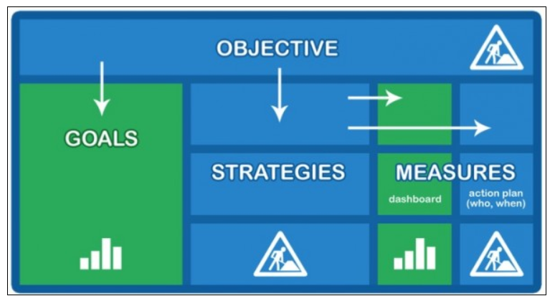

Source: [www.12manage.com](http://www.12manage.com)

A structured method for developing and achieving strategic goals is provided by the OGSM framework (Sharan et al., 2023). Utilizing the framework, organizations can make sure that their objectives are in line with their overall goals and that the strategies and tactics they employ are suitable for achieving those objectives. The OGSM framework can be used in various contexts and industries, including business, healthcare, education, and government, according to (Lafley and Martin, 2013). It is advantageous to businesses that are expanding or going through change because it makes sure they are headed in the right direction and making progress toward their objectives. For organizations looking to enhance their strategic planning and goal-setting processes, the OGSM framework is helpful overall. It offers a straightforward and organized method for establishing and achieving objectives, goals, strategies, and measurements, and it can aid organizations in enhancing their general performance and achieving their desired results (Chaffey, 2021).

The Value of OGSM

The OGSM framework provides significant value to organizations in several ways:

1. Clear goal-setting: OGSM provides a clear and structured approach to setting goals that are aligned with an organization's overall objectives. By setting clear and measurable goals, organizations can focus their efforts and resources towards achieving those goals (Niessen et al., 2023).
2. Alignment: OGSM helps to align an organization's goals with its overall strategy. This ensures that the organization is moving in the right direction and making progress towards achieving its desired outcomes. (Sharan et al., 2023).
3. Focus: The framework helps organizations to prioritize their goals and focus their efforts and resources on the most critical areas. This helps to ensure that resources are used efficiently and effectively (Lehtimäki, 2016; Niessen et al., 2023).
4. Measurability: OGSM provides a clear and measurable approach to setting goals and tracking progress towards achieving those goals. This helps organizations to evaluate their performance and make adjustments as necessary (Chaffey, 2021).
5. Communication: OGSM provides a structured approach to communicating goals and objectives throughout an organization (Lafley & Martin, 2013).This ensures that everyone is working towards the same goals and understands how their work contributes to the organization's overall success (Lafley & Martin, 2013),(Sharan et al., 2023).

Overall, the value of OGSM lies in its ability to provide a clear, structured, and measurable approach to setting and achieving strategic goals. By using the framework, organizations can align their goals with their overall strategy, focus their efforts and resources on critical areas, and measure their progress towards achieving their desired outcomes (Chaffey, 2021).

Example one of applying the concept of OGSM

|  |
| --- |
| **Objectives**: The company's objective is to increase its market share and profitability by expanding its customer base and improving customer loyalty.  **Goals**: The company's specific goals include increasing sales by 10%, increasing customer satisfaction scores by 5%, and increasing customer retention by 3%.  **Strategies**: To achieve these goals, the company has developed several strategies, including expanding its online presence, introducing new products and services, and improving the in-store experience for customers.  **Measures**: The company measures its progress towards achieving its goals through various measures, such as sales figures, customer satisfaction scores, and customer retention rates. The company tracks these measures regularly and adjusts its strategies as necessary to ensure that it stays on track towards achieving its goals.  By using OGSM, the company is able to set clear and measurable goals, align its strategies with its overall objectives, and track its progress towards achieving its desired outcomes. This helps the company to focus its efforts and resources on critical areas, prioritize its goals, and improve its overall performance. |

Example Two of applying the concept of OGSM

|  |
| --- |
| **Objective**: Increase sales revenue by 20% within the next 12 months.  **Goals**:   * Increase customer acquisition by 15% through targeted advertising campaigns and referral programs. * Improve customer retention rate by 10% by offering loyalty programs and personalized customer service. * Expand product line by introducing three new product categories that complement our existing offerings. * Increase average order value by 5% through upselling and cross-selling strategies.   **Strategies**:   * Launch targeted digital advertising campaigns to reach potential customers. * Partner with complementary businesses to offer joint promotions and referral programs. * Offer personalized customer service by training sales associates on product knowledge and customer engagement skills. * Develop loyalty programs that reward repeat purchases and referrals. * Conduct market research to identify new product categories that align with our existing offerings. * Implement upselling and cross-selling tactics, such as recommending related products and offering bundle deals.   **Measures**:   * Monitor monthly sales revenue and track progress towards the 20% increase target. * Analyze customer acquisition and retention rates to determine the effectiveness of advertising and loyalty programs. * Evaluate the success of new product categories by tracking sales and customer feedback. * Measure the impact of upselling and cross-selling tactics on average order value. |

The difference between KPIs and OGSM

OGSM and KPI are both important tools used in project management to set objectives, measure progress, and achieve desired outcomes. However, they differ in their focus and purpos. (Hristov & Chirico, 2019). OGSM is a strategic planning tool that helps organizations set clear objectives, develop strategies, and track progress towards achieving desired outcomes. It stands for Objectives, Goals, Strategies, and Measures. The OGSM framework is used to align an organization's efforts with its overall vision and goals. It provides a structured approach to strategic planning and enables organizations to focus on the most critical aspects of their operations. (Chaffey, 2021), (*OGSM Framework*, n.d.), (Sultan W. A., 2023).

On the other hand, According to (Ntshwene et al., 2022), the KPIs (Key Performance Indicators) are specific metrics that are used to measure the performance of an organization or project against predefined targets (Sena Ferreira et al., 2012). KPIs are used to track progress towards achieving specific goals and objectives. They are typically quantitative and can be used to monitor various aspects of an organization's operations, such as financial performance, customer satisfaction, and employee productivity.(Ntshwene et al., 2022).There are many different types of key performance indicators (KPIs) that can be used to track progress towards achieving the objectives, goals, strategies, and measures set out in the OGSM framework. Here are a few examples of KPIs that can be used to track progress in different areas of the business (Ntshwene et al., 2022; Hristov & Chirico, 2019).

1. Financial KPIs: These are metrics that track the financial performance of the company, such as revenue growth, profit margins, and return on investment (ROI). Financial KPIs are often used to measure progress towards financial objectives and goals in the OGSM framework (Sultan W. A., 2023).
2. Customer KPIs: These are metrics that track customer behavior and satisfaction, such as customer retention rate, customer lifetime value, and net promoter score (NPS). Customer KPIs are often used to measure progress towards customer-focused objectives and goals in the OGSM framework (Wannes & Ghannouchi, 2019; Sultan, 2023).
3. Operational KPIs: These are metrics that track the efficiency and effectiveness of the company's operations, such as cycle time, inventory turnover, and defect rate. Operational KPIs are often used to measure progress towards operational objectives and goals in the OGSM framework (Sultan, 2023).
4. Employee KPIs: These are metrics that track employee performance and engagement, such as employee turnover rate, employee satisfaction score, and training hours per employee. Employee KPIs are often used to measure progress towards objectives and goals related to human resources in the OGSM framework (Hristov & Chirico, 2019).

By using KPIs to measure progress towards achieving the objectives, goals, strategies, and measures set out in the OGSM framework, companies can ensure that they are on track to achieve their strategic goals. KPIs can help to identify areas of the business that require improvement, and can also provide valuable insights into the company's overall performance. This information can be used to adjust strategies and measures as needed to ensure that the company is achieving its objectives and goals (Wannes & Ghannouchi, 2019; Sultan, 2023).

In summary, OGSM is a strategic planning tool that helps organizations align their efforts with their overall vision and goals, while KPIs are specific metrics used to measure performance against predefined targets. While OGSM provides a structured approach to strategic planning, KPIs provide a way to measure progress and ensure that organizations are on track towards achieving their desired outcomes (Sultan, 2023).

The relationship between OGSM and Risk Management

OGSM and risk management are closely related, as the OGSM framework provides organizations with a structure to define goals, objectives, strategies and measures that can help manage risk effectively.

When setting goals within OGSM, organizations must identify potential risks that may affect their ability to achieve those goals. For example, if an organization sets a goal of increasing customer acquisition by 15%, it must consider possible risks, such as insufficient marketing budget or increased competition in the market. Once risks are identified, strategies can be developed to mitigate those risks (Algahtany et al., 2016). For instance, if an organization identifies a risk of limited marketing budget, they can develop a strategy to maximize the effectiveness of their marketing campaigns by targeting specific audience segments and using cost-effective marketing channels (Algahtany et al., 2016).

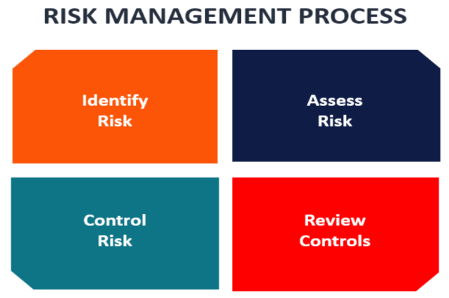

Source: <https://corporatefinanceinstitute.com>

Additionally, OGSM can help associations prioritize risks based on their likely influence on reaching purposes. By designating specific activities to each goal, associations can monitor improvement toward those goals and identify potential risks that could impede their progress. For example, suppose an organization needs to meet expected customer acquisition rates. In that case, it can identify the cause of the problem and take corrective actions to reduce risk and get back on track (Algahtany et al., 2016; Hoang et al., 2022).

The relationship between OGSM and VRIO analysis

The relationship between OGSM and VRIO analysis lies in their complementary nature, as they serve different but equally important purposes in helping organizations achieve their strategic objectives. OGSM is a strategic planning framework that helps organizations set objectives, define goals, develop strategies, and monitor progress towards achieving those goals. VRIO analysis, on the other hand, is a tool for assessing a firm's resources and capabilities, which are essential to the development and implementation of effective strategies (Murcia et al., 2022).

The VRIO analysis evaluates resources and capabilities based on four criteria: value, rarity, inimitability, and organization. It helps organizations identify their competitive advantage by assessing whether their resources and capabilities meet these criteria. For example, if a company has a unique patent for a technology that is highly valued by customers and difficult to imitate by competitors, it can be considered a valuable and rare resource, providing a sustainable competitive advantage (Lopes et al., 2018; Sultan, 2023).

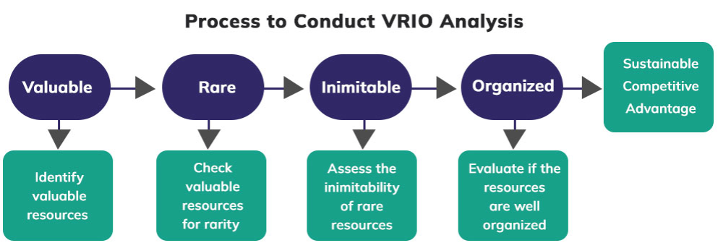

Source: Source: https://crowjack.com/guide/vrio-analysis

OGSM, on the other hand, helps organizations define their strategic direction and develop goals and strategies to achieve it (*OGSM — Objectives, Goals, Strategies, Measures*, n.d.) It provides a structured approach to aligning resources and capabilities with the overall strategic objectives of the organization. By setting specific objectives and goals, organizations can identify the resources and capabilities needed to achieve them. Then, by developing and implementing strategies that leverage those resources and capabilities, organizations can create a competitive advantage that is sustainable over time (Lu et al., 2022).

The VRIO analysis can help organizations identify their resources and capabilities that can be leveraged to create a competitive advantage (Azevedo et al., 2022) .OGSM can help organizations define their strategic direction and develop goals and strategies to leverage those resources and capabilities. Together, these two tools provide a comprehensive approach to strategic planning and execution, helping organizations achieve their desired outcomes in a sustainable and competitive manner. In summary, the VRIO analysis and OGSM are complementary tools that can be used together to develop effective and sustainable strategies for organizational success (Lehtimäki, 2016; Sultan, 2023).

The relationship between OGSM and Agile Management

OGSM and Agile Management are related because they both provide frameworks for managing projects and achieving organizational goals. OGSM is a strategic planning framework that provides a structured approach to defining objectives, setting goals, developing strategies, and measuring progress towards achieving those goals. It is typically used in a top-down approach, where senior leaders set objectives and goals for the organization, and these goals are then cascaded down to individual teams and departments (Lu et al., 2022; Fischer, 2022).

According to Giacosa et al, (2022), Agile Management, on the other hand, is an iterative approach to project management that emphasizes flexibility, adaptability, and continuous improvement. It is often used in software development, but can be applied to any project or initiative. Agile management emphasizes collaboration, customer feedback, and continuous delivery of small, incremental improvements (Wiechmann et al., 2022). When implementing Agile Management, organizations often focus on delivering incremental value in short cycles, or sprints (Sreenivasan & Suresh, 2023). OGSM can help ensure that these sprints are aligned with the organization's overall objectives and goals. For example, if the organization's objective is to increase market share, they can set goals for each sprint that contribute to achieving that objective, such as launching new features that differentiate their product from competitors or improving customer satisfaction to increase customer retention rates (Marnada et al., 2022).

Despite their differences, OGSM and Agile Management can be complementary. For example, an organization might use OGSM to define high-level objectives and goals, and then use Agile Management to implement projects and initiatives that help achieve those goals. The iterative and collaborative nature of Agile Management can help teams respond quickly to changing conditions and adapt their strategies as needed to achieve their goals(Sreenivasan & Suresh, 2023).

Additionally, OGSM can help ensure that Agile Management efforts are aligned with the organization's overall objectives and goals. By setting clear objectives and goals, and monitoring progress towards achieving those goals (Giacosa et al., 2022).

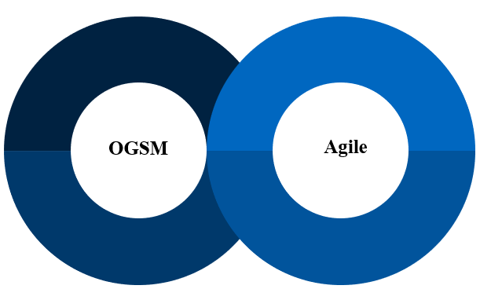

Source: Made by the Author

The relationship between OGSM and Benefits Realization Management (BRM)

OGSM and Benefits Realization Management (BRM) are two essential systems that cooperate to guarantee firms accomplish intended goals and optimize return on investment. An organized methodology for specifying objectives, establishing goals, devising strategies, and following improvement toward those goals is provided by OGSM. The BRM framework, on the other hand, enables the delivery of benefits through an investment or change program (Fischer, 2022).

BRM aims to ensure that the benefits identified in the business case are actually realized by the organization (Farida & Setiawan, 2022).It does this by developing a plan for how the benefits will be delivered, identifying the measures that will be used to track progress towards achieving those benefits, and monitoring progress against those measures. By doing this, BRM ensures that the organization maximizes the value of the investment or change initiative (Marnewick & Marnewick, 2022).

Benefits realization management is a process that aims at identifying, planning, and delivering benefits realized through a project. It is an essential aspect of project management because it ensures that the project's benefits are clearly defined, measured, and achieved. (Marnewick & Marnewick, 2022).

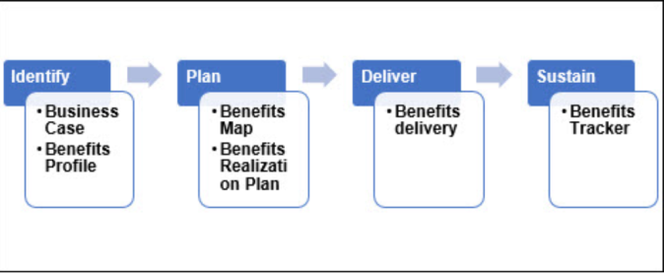

**Source:** (*Benefits Realization and Benefits Management*, n.d.)

OGSM can be used in conjunction with BRM to ensure that the benefits delivered through the investment or change initiative are aligned with the organization's overall strategic objectives. By setting clear objectives and goals, and monitoring progress towards achieving those goals, organizations can ensure that their BRM efforts are focused on delivering value that is aligned with their strategic direction (Chaffey, 2021).

**For example,** if an organization's objective is to increase revenue, they can use OGSM to set specific goals for revenue growth, and then use BRM to identify the specific benefits that will contribute to achieving those goals. By monitoring progress towards achieving those benefits, and making adjustments to the investment or change initiative as needed, the organization can ensure that they are on track to achieve their revenue growth goals.(Fischer, 2022).

In addition, OGSM can provide a framework for evaluating the success of the BRM efforts. By setting specific measures for each goal, organizations can track progress towards achieving those goals and determine if their BRM efforts are delivering the expected benefits. If the results are not meeting expectations, they can adjust their BRM approach to address the underlying issues.

Therefore, firms can combine OGSM and BRM to maximize their return on investment and achieve their goals. While BRM ensures benefits are delivered methodically, OGSM establishes goals and targets in a strategic manner. In addition to helping firms meet their goals, they provide an in-depth process for strategic planning and implementation (Fischer, 2022).

The relationship between OGSM and Customer Experience (CX)

OGSM is a management tool used to help businesses set clear and measurable objectives, goals, strategies, and measures (Chaffey, 2021). These elements are designed to guide the organization towards achieving its goals, including improving the overall customer experience (CX) (Popli & Rishi, 2021).

CX, on the other hand, refers to the overall perception a customer has of a company or brand, based on their interactions and experiences with that company (Popli & Rishi, 2021).A positive customer experience is essential for business success, as it can lead to increased customer loyalty, positive word-of-mouth recommendations, and ultimately, higher revenue.(Manthiou et al., 2020).

By using the OGSM framework, businesses can establish clear objectives and goals related to improving the customer experience. Strategies can be developed to achieve these goals, such as improving customer service, streamlining processes, or investing in new technologies. Measures can also be established to track progress and ensure that the organization stays on track towards achieving its CX-related objectives (Bhatia & Priya, 2021).

In short, the OGSM framework can be used as a tool to help businesses improve their customer experience by setting clear goals and objectives, developing strategies, and measuring progress towards achieving those goals (Popli & Rishi, 2021).

|  |
| --- |
| Example of the relationship between OGSM and Customer Experience (CX)  Let's say a company wants to improve its overall customer satisfaction rating from 80% to 90% within the next year. The company can use the OGSM framework to develop a strategy to achieve this goal.  **Objectives**: The company's objective is to improve customer satisfaction rating from 80% to 90%.  **Goals**: The company's goal is to increase the number of positive customer feedback responses by 50% within the next year.  **Strategies**: The company's strategy to achieve this goal is to invest in additional customer service training for employees, improve the company's online support channels, and increase the frequency of customer surveys to gain more feedback.  **Measures**: The company will measure progress towards achieving this goal by tracking the number of positive customer feedback responses, conducting regular customer satisfaction surveys, and monitoring social media channels for customer feedback.  By setting clear objectives, goals, strategies, and measures using the OGSM framework, the company can focus on improving its customer experience to achieve its target customer satisfaction rating of 90%. With a 50% increase in positive customer feedback responses, the company can be confident that it is making progress towards its CX-related objectives. |

The relationship between OGSM and Governance & Compliance

The OGSM framework and governance & compliance are also closely related, as both are paramount to a business roadmap (Chaffey, 2021). Governance refers to the rules, practices, and processes by which a company is directed and controlled. Compliance, on the other hand, refers to adherence to laws, regulations, and industry standards. Corporate governance is a system of rules, practices, and processes that govern how a company is directed and controlled. It confines the mechanisms by which a company's objectives are set and pursued in the context of social, regulatory, and market environments. The four pillars of corporate governance are accountability, fairness, transparency, and responsibility (Sarhan & Ntim, 2018). Accountability, fairness, openness, and responsibility are the four cornerstones of corporate governance. Although integrity guarantees that all stakeholders are treated fairly and with respect, accountability entails holding those in leadership positions and responsibility accountable for their deeds (Kaufmann & Kock, 2022).

Giving stakeholders accurate and timely information about a company's activities, financial performance, and management procedures is crucial to transparency. Regarding accountability, one must consider how an organization's actions affect its stakeholders and the environment. Building trust, defending stakeholders' interests and preserving the company's long-term success all depend on effective corporate governance (Konadu et al., 2021; Konadu et al., 2021).

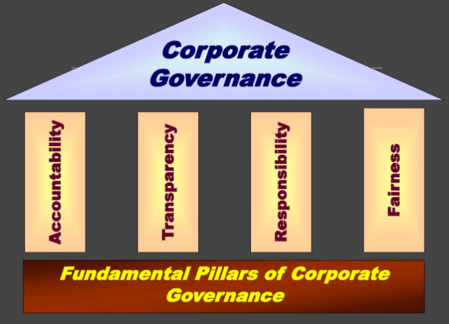

Source: (Dhawan, 2022)

The OGSM framework can be used as a tool to ensure that a company's governance and compliance objectives are aligned with its overall strategic goals. By setting clear objectives related to governance and compliance, companies can develop strategies and measures to ensure that they are meeting their legal and regulatory obligations. (O’Neill, 2014).

|  |
| --- |
| **For** **example**, a company is looking to expand its operations to a new geographic region where there are specific regulatory requirements for operating in that region. The company can use the OGSM framework to develop a strategy to meet these compliance requirements while still achieving its overall strategic goals.  **Objectives**: The company's objective is to ensure compliance with the regulatory requirements of the new geographic region.  **Goals**: The company's goal is to achieve 100% compliance with all relevant regulatory requirements within the first year of operating in the new region.  **Strategies**: The company's strategy to achieve this goal is to invest in additional resources and training for employees to ensure that they are familiar with the regulatory requirements of the new region, conduct regular audits to ensure compliance, and establish a system for reporting and addressing any compliance issues that may arise.  **Measures**: The company will measure progress towards achieving this goal by conducting regular audits to ensure compliance with regulatory requirements, monitoring any compliance-related issues, and tracking the number of reported compliance violations.  By setting clear objectives, goals, strategies, and measures using the OGSM framework, the company can ensure that it is meeting its compliance obligations while still achieving its overall strategic goals. This can help to minimize legal and regulatory risks, as well as promote good governance practices within the company. |

The relationship between OGSM and Big Data (BD)

OGSM and Big Data (BD) can have a complementary relationship (Ciampi et al., 2020). OGSM provides a framework for organizations to define their strategic objectives, goals, strategies, and measures, while Big Data can provide insights and information to support decision-making and performance evaluation related to those objectives. For instance, by using Big Data analytics, an organization can track the progress of their initiatives against their set goals and objectives, and make data-driven adjustments to their strategies and measures. Big Data can also help identify potential opportunities, challenges, and risks that may impact the success of the initiatives, enabling the organization to make informed decisions and optimize their resources (Nisar et al., 2020).

On the other hand, OGSM can also help guide the use of Big Data. It can provide a structured approach for organizations to identify the most relevant data to collect, analyze, and use in support of their strategic objectives (Ciampi et al., 2020). OGSM can also help ensure that the insights gained from Big Data analysis are aligned with the organization's overall goals and strategies. Overall, the integration of OGSM and Big Data can enhance an organization's strategic planning and performance management processes, allowing them to better track progress, optimize resource allocation, and make data-driven decisions(Dagilienė & Klovienė, 2019).

|  |
| --- |
| **Example** of how an organization can use OGSM and big data (BD) is to set strategic goals for data-driven decision-making. The objectives could be to increase revenue or reduce costs by leveraging big data insights. The goals could be to improve customer satisfaction or optimize supply chain management using BD analytics. The strategies could involve investing in data collection, storage, and processing infrastructure, as well as hiring skilled data analysts to extract insights from the data. Finally, the measures could be to track key performance indicators (KPIs) such as customer retention rates, sales growth, and cost savings achieved through BD analytics. By using OGSM to set goals and measure progress, organizations can leverage big data to drive strategic decision-making and gain a competitive advantage. |

The relationship between OGSM and Artificial Intelligence (AI)

OGSM and Artificial Intelligence (AI) are both tools that can be used in strategic planning to achieve organizational goals. OGSM provides a framework for setting objectives, defining goals, determining strategies, and establishing measures. AI, on the other hand, is a technology that enables machines to perform tasks that would typically require human intelligence, such as learning, reasoning, and problem-solving. (Sultan W. A., 2022).

AI can be utilized in the implementation of an organization's strategies, specifically in the development of measures and the evaluation of progress towards goals. AI can provide insights and analytics that can help organizations to make data-driven decisions, identify patterns and trends, and adjust strategies accordingly. For example, AI-powered predictive analytics can be used to forecast market demand, optimize production processes, and enhance customer experiences. Moreover, AI can also be used in the formulation of strategies by analyzing large amounts of data and identifying patterns and insights that human analysts may have missed. This can assist organizations in identifying opportunities and risks, as well as developing innovative solutions to complex problems. Finally, while OGSM provides a framework for strategic planning, AI can be used as a tool to support the implementation and evaluation of strategies, as well as to provide insights for the development of effective strategies (Sultan, 2022).

|  |
| --- |
| **Example**: The **objective** of Saudi Arabia's investment in AI projects is to diversify its economy and counter the impact of falling crude prices. The **goals** of this investment are to contribute to the growth of the country's economy and to capitalize on the potential benefits of AI. To achieve these goals, the **strategies** employed include investing $20 billion in AI projects by 2030 and developing a robust AI ecosystem. Additionally, the country aims to attract foreign investment and partnerships to foster innovation and accelerate AI development. To **measure** the success of these efforts, Saudi Arabia will track the contribution of AI to its economy and monitor the growth of its AI ecosystem. The projected contribution of AI to the economies of the Middle East, including Saudi Arabia, UAE, and Egypt, provides an indication of the potential impact of AI investment and development in the region. An analysis by PwC indicates that AI will contribute over $135.2 billion to Saudi Arabia's economy by 2030, which represents 2 percent of the total global benefits of AI. (*Saudi Bets Big on AI Developing Local Capabilities to Disrupt Economy*, n.d.). |

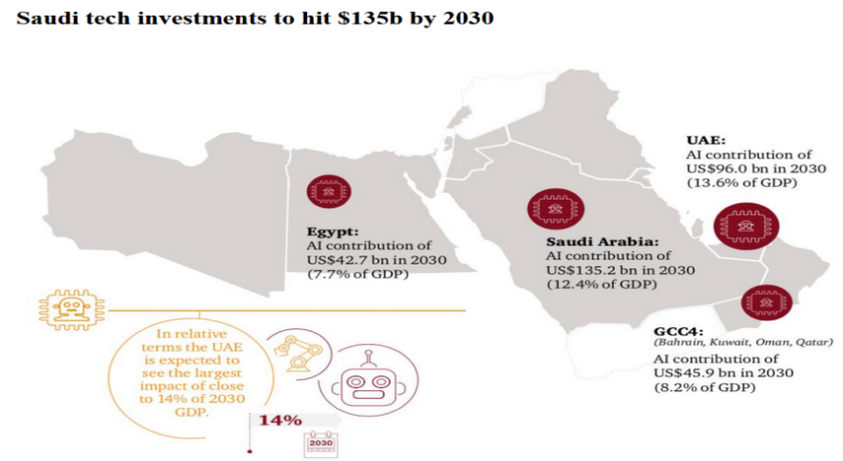

*Source: Saudi Arabia Investment in AI*

*Source:* (saudigazette, 2022 )

How the Saudi Arabia Applied OGSM framework in its projects & Initiatives

The application of OGSM framework in project management has been a key factor in the success of Saudi Arabia's projects. By using this structured approach to goal setting and strategy development, Saudi Arabian organizations have been able to align their goals with their overall strategies and focus their efforts and resources on critical areas (Kaufmann & Kock, 2022).

One of the key success factors in Saudi Arabia's projects has been the clear and measurable objectives that have been set using the OGSM framework (Klingmann, 2022). These objectives are aligned with the overall strategies of the organizations, ensuring that they are moving in the right direction and making progress towards achieving their desired outcomes. The OGSM framework has also helped to prioritize the goals of the projects, enabling organizations to focus their efforts and resources on the most critical areas (Baghdadi & Kishk, 2015; Fischer, 2022).

In addition, the OGSM framework assisted the Saudi Arabian association to recognize and address any restrictions or issues that might arise during project execution. By using a structured approach to setting goals and developing strategies, organizations can anticipate potential gaps and develop contingency plans to mitigate their impact (Kayed & Kabir Hassan, 2011). This aids in ensuring that projects in Saudi Arabia are completed on time, within budget, and to the required standard. In addition, the OGSM approach helps improve communication and collaboration within the Saudi institution. By specifying precise and measurable goals, institutions can effectively communicate those purposes. This guarantees that everyone performs towards the same goal and comprehends how their work contributes to the project's success (AlArjani et al., 2021).

In conclusion, the success of Saudi Arabia's projects can be attributed, in part, to the application of the OGSM framework in project management. By setting clear and measurable goals, aligning their strategies with their overall objectives, and focusing their efforts and resources on critical areas, Saudi Arabian organizations have been able to achieve their desired outcomes and improve their overall performance. The OGSM framework has helped to prioritize goals, identify potential pitfalls, improve communication and collaboration, and ultimately, contribute to the success of Saudi Arabia's projects (Klingmann, 2022).

**Example; Solidify the Kingdom’s Position as a Leader in The Construction and Building Components and Services for the Real Estate Sector**

In the context of OGSM, the initiative aims to achieve the objective of solidifying the Kingdom's position as a leader in the construction and building components and services for the real estate sector, which aligns with the vision of diversifying the Saudi economy. The goals are to secure the supply chain of real estate projects by focusing on strategic products and services, such as heavy machinery, concrete, cement, tiles, and others. The strategy is to invest SAR ~3 billion in the next 10 years to achieve this objective. The measure to track progress towards this goal is to launch several new real estate development companies, establish a JV with "Katerra" to transfer offsite construction technology in Saudi Arabia, and acquire a 40% stake in Aramco-Jacobs JV "Jasara."

**The components of OGSM in this initiative are as follows:**

**Objective**: Solidify the Kingdom's position as a leader in the construction and building components and services for the real estate sector. **Goals**: Boost local content in non-oil sectors, develop non-oil exports and local content, and invest in potential opportunities in heavy machinery, elevators, windows, doors, construction chemicals, etc. **Strategies**: Invest 3 billion SAR to secure the supply chain of priority products and services in the next 10 years. Launch new real estate development companies, establish a JV with "Katerra" to transfer offsite construction technology in Saudi Arabia, and acquire a 40% stake in Aramco-Jacobs JV "Jasara."**Measures**: ensuring the above objectives have been achieved using checklist and PMIS (project management information system). (*V2030_pif_2025_en. Pdf*, n.d.), (Kayed & Kabir Hassan, 2011).

**Support the Growth of the Metals and Mining Sector; a key Enabler of the Kingdom’s Vision 2030**

In the context of OGSM, the initiative to increase the economic contribution of the metals and mining sector in Saudi Arabia is aligned with the Vision 2030 objective of diversifying the economy. The initiative aims to make mining the third pillar of industry alongside oil and gas and petrochemicals. PIF will enable the goals of the sector through Ma'aden (Saudi Arabian Mining Company) and contribute to NIDLP's objective of making Saudi Arabia a leading producer and exporter of fertilizer.(*V2030_pif_2025_en.Pdf*, n.d.).

|  |
| --- |
| The **objective** of Saudi Arabia's Vision 2030 initiative is to increase the economic contribution of the metals and mining sector and make it the third pillar of industry alongside oil and gas and petrochemicals. To achieve this, the initiative has set specific **goals**, such as increasing mineral exploration activities and achieving commercial operation of new projects in the fertilizer, aluminum, and gold sectors through Ma'aden, as well as developing future growth projects in various mining sectors. The **strategies** to achieve these goals include implementing structural reforms to facilitate private sector investment, tapping into the size and attractiveness of the global mining sector, and leveraging Saudi Arabia's healthy mineral reserves. To **measure** and ensure the success of the initiative, regular reviews and auditing measures will be implemented to monitor progress and ensure that the mineral exploration activities are in line with the latest digital technologies. . |

**The Mystery of the Successful of Saudi Arabia Projects through Applying OGSM framework**

Throughout the literature, Saudi Arabia is a country that possesses **25** mysteries that have fascinated people around the world. Below the 25 Saudi mysteries in applying OGSM:

1. Clear Objectives: Saudi Arabia's success in implementing its projects is partly due to its clear objectives that align with its vision for the future (Niessen et al., 2023).
2. Well-Defined Goals: The Kingdom has established well-defined goals that serve as milestones for its projects and help measure their success (Fischer, 2022).
3. Effective Strategies: Saudi Arabia has developed effective strategies that enable it to achieve its goals and objectives in a timely and efficient manner.
4. Focused Measures: The country has implemented focused measures to monitor and evaluate the progress of its projects, which helps ensure their success.
5. Collaborative Efforts: Successful projects in Saudi Arabia have been achieved through collaborative efforts between different government agencies, private sector partners, and international organizations (Fischer, 2022).
6. Innovative Approaches: The Kingdom has employed innovative approaches and technologies to ensure the success of its initiatives.
7. Strong Leadership: The country's strong leadership has played a crucial role in driving the success of its projects (Fischer, 2022).
8. Robust Planning: Saudi Arabia's projects are well-planned and executed with a high degree of precision and attention to detail (Niessen et al., 2023).
9. Effective Communication: The Kingdom's projects benefit from effective communication between all stakeholders, which helps ensure their success (Klingmann, 2022).
10. Continuous Improvement: Successful projects in Saudi Arabia are constantly evaluated and improved to ensure they meet the evolving needs of the country.
11. Data-Driven Decision Making: The Kingdom relies on data-driven decision making to ensure the success of its projects.
12. Risk Management: Saudi Arabia has established effective risk management processes that enable it to identify and mitigate potential risks to its projects.
13. Skilled Workforce: The country's skilled workforce plays a critical role in driving the success of its projects.(Tlaiss & Elamin, 2015).
14. Effective Resource Allocation: The Kingdom's projects benefit from effective resource allocation, which helps ensure their success.
15. Transparent Processes: Saudi Arabia has established transparent processes that enable stakeholders to monitor the progress of its projects and hold decision-makers accountable.
16. Stakeholder Engagement: The Kingdom actively engages with stakeholders to ensure their feedback is considered in the planning and execution of its projects.
17. Aligned Incentives: The country's projects benefit from aligned incentives that encourage all stakeholders to work together towards a common goal. (Fischer, 2022).
18. Comprehensive Planning: Saudi Arabia's projects are planned comprehensively, taking into account all relevant factors that may impact their success.
19. Agility: The Kingdom has demonstrated agility in responding to unexpected challenges or changes in the external environment. (Giacosa et al., 2022), (Sreenivasan & Suresh, 2023).
20. Effective Governance: The country's effective governance structures and processes help ensure the success of its projects (Klingmann, 2022).
21. Resourceful Partnerships: Successful projects in Saudi Arabia have been achieved through resourceful partnerships with other countries and organizations.
22. Sustainability: The Kingdom's projects prioritize sustainability, ensuring they have long-term benefits for the country and its people.
23. Results-Oriented: Saudi Arabia's projects are results-oriented, with a clear focus on achieving their objectives and goals (Niessen et al., 2023).
24. Continuous Learning: The country's projects benefit from a culture of continuous learning and improvement, ensuring they stay relevant and effective over time (Fischer, 2022).
25. Public-Private Collaboration: The Kingdom's public-private collaboration has been key to the success of its projects, leveraging the strengths and resources of both sectors.

**Conclusion**

The purpose of the study is to investigate the success secret of a project in Saudi Arabia using the OGSM system in project management. The purpose of the study is to understand the OGSM framework and its implementation in project management, explore the Saudi project success factors, evaluate the effectiveness of the OGSM framework in achieving project success, identify any limitations or challenges in the Saudi context, and provide recommendations. Implement the OGSM framework in future projects in Saudi Arabia and other countries. The research methodology included a literature review of relevant academic articles, books and other sources to identify and analyze existing research on the application of the OGSM framework and its effectiveness in project management. The value of this study is that it contributes to the understanding of the application and effectiveness of the OGSM system in project management, particularly in relation to successful project management practices in Saudi Arabia. The literature review will provide the theoretical basis for the study and allow a critical assessment of the system's applicability to the Saudi Arabian project. The literature review also examines the relationship between OGSM and various other concepts such as risk management, VRIO analysis, agile management, revenue realization management, customer experience, governance and compliance, big data and artificial intelligence. In addition, the study looks at specific examples of how Saudi Arabia has applied the OGSM framework to its projects and initiatives, such as strengthening the Kingdom's leadership in building and construction components and services, and supporting the development of the metals and mining sector, an important enabler of the Kingdom's Vision 2030.

**References**

1. AlArjani, A., Modibbo, U. M., Ali, I., & Sarkar, B. (2021). A new framework for the sustainable development goals of Saudi Arabia. Journal of King Saud University - Science, 33(6), 101477. https://doi.org/10.1016/j.jksus.2021.101477
2. Algahtany, M., Alhammadi, Y., & Kashiwagi, D. (2016). Introducing a New Risk Management Model to the Saudi Arabian Construction Industry. Procedia Engineering, 145, 940–947. https://doi.org/10.1016/j.proeng.2016.04.122
3. Alsufyani, A. M., Alforihidi, M. A., Almalki, K. E., Aljuaid, S. M., Alamri, A. A., & Alghamdi, M. S. (2020). Linking the Saudi Arabian 2030 vision with nursing transformation in Saudi Arabia: Roadmap for nursing policies and strategies. International Journal of Africa Nursing Sciences, 13, 100256. https://doi.org/10.1016/j.ijans.2020.100256
4. Azevedo, A., Jugdev, K., & Mathur, G. (2022). The impact of organizational support for the project management process on project and firm performance. International Journal of Managing Projects in Business, 15(7), 1013–1031. https://doi.org/10.1108/IJMPB-05-2022-0114
5. Baghdadi, A., & Kishk, M. (2015). Saudi Arabian Aviation Construction Projects: Identification of Risks and Their Consequences. Procedia Engineering, 123, 32–40. https://doi.org/10.1016/j.proeng.2015.10.054
6. Benefits Realization and Benefits Management. (n.d.). Techno PM - Project Management Templates Download. Retrieved January 7, 2023, from https://shop.techno-pm.com/blogs/news/benefits-realization-management
7. Bhatia, M., & Priya, P. (2021). The Business Case for Customer Experience: Ignoring Customer Experience Is an Expensive Mistake. In S. Popli & B. Rishi (Eds.), Crafting Customer Experience Strategy (pp. 155–174). Emerald Publishing Limited. https://doi.org/10.1108/978-1-83909-710-220211009
8. Chaffey, D. (2021, January 29). OGSM model: A strategic framework for top-down vision realization. Smart Insights. https://www.smartinsights.com/marketing-planning/marketing-models/ogsm-model-framework/
9. Ciampi, F., Marzi, G., Demi, S., & Faraoni, M. (2020). The big data-business strategy interconnection: A grand challenge for knowledge management. A review and future perspectives. Journal of Knowledge Management, 24(5), 1157–1176. https://doi.org/10.1108/JKM-02-2020-0156
10. Dagilienė, L., & Klovienė, L. (2019). Motivation to use big data and big data analytics in external auditing. Managerial Auditing Journal, 34(7), 750–782. https://doi.org/10.1108/MAJ-01-2018-1773
11. Dhawan, G. (2022, July 7). PRINCIPLES OF CORPORATE GOVERNANCE. Gagan Dhawan. https://gagandhawan.me/principles-of-corporate-governance/
12. Farida, I., & Setiawan, D. (2022). Business Strategies and Competitive Advantage: The Role of Performance and Innovation. Journal of Open Innovation: Technology, Market, and Complexity, 8(3), 163. https://doi.org/10.3390/joitmc8030163
13. Fischer, A. (2022, May 16). GOST Framework: Goals, Objectives, Strategies, and Tactics Explained with an Amazon Example. StrategyKiln. https://www.strategykiln.com/post/gost-busters-goals-objectives-strategies-and-tactics-explained-with-an-amazon-example
14. Giacosa, E., Culasso, F., & Crocco, E. (2022). Customer agility in the modern automotive sector: How lead management shapes agile digital companies. Technological Forecasting and Social Change, 175, 121362. https://doi.org/10.1016/j.techfore.2021.121362
15. Hoang, P. D., Ta, T. D., & Bui, H.-Y. T. (2022). Exploring the effects of brand risk management activities on brand security: A perspective from innovation stimulus as a moderator. Journal of Contemporary Marketing Science, 5(3), 266–290. https://doi.org/10.1108/JCMARS-10-2021-0034
16. Hristov, I., & Chirico, A. (2019). The Role of Sustainability Key Performance Indicators (KPIs) in Implementing Sustainable Strategies. Sustainability, 11(20), Article 20. https://doi.org/10.3390/su11205742
17. Kaufmann, C., & Kock, A. (2022). Does project management matter? The relationship between project management effort, complexity, and profitability. International Journal of Project Management, 40(6), 624–633. https://doi.org/10.1016/j.ijproman.2022.05.007
18. Kayed, R. N., & Kabir Hassan, M. (2011). Saudi Arabia’s economic development: Entrepreneurship as a strategy. International Journal of Islamic and Middle Eastern Finance and Management, 4(1), 52–73. https://doi.org/10.1108/17538391111122203
19. Klingmann, A. (2022). Rescripting Riyadh: How the capital of Saudi Arabia employs urban megaprojects as catalysts to enhance the quality of life within the city’s neighborhoods. Journal of Place Management and Development, 16(1), 45–72. https://doi.org/10.1108/JPMD-06-2021-0062
20. Konadu, R., Ahinful, G. S., & Owusu-Agyei, S. (2021). Corporate governance pillars and business sustainability: Does stakeholder engagement matter? International Journal of Disclosure and Governance, 18(3), 269–289. https://doi.org/10.1057/s41310-021-00115-3
21. Lafley, A. G., & Martin, R. (2013). Instituting a company‐wide strategic conversation at Procter & Gamble. Strategy & Leadership, 41(4), 4–9. https://doi.org/10.1108/SL-04-2013-0023
22. Lehtimäki, H. (2016). How is Organization Strategic? In The Strategically Networked Organization (pp. 7–33). Emerald Group Publishing Limited. https://doi.org/10.1108/978-1-78635-292-720161002
23. Lu, F., Guo, Y., Zhao, B., Jiang, X., Chen, B., Wang, Z., & Zhongyun, X. (2022). OGSM: A Parallel Implicit Assembly Algorithm and Library for Overlapping Grids. Applied Sciences, 12, 7804. https://doi.org/10.3390/app12157804
24. Manthiou, A., Hickman, E., & Klaus, P. (2020). Beyond good and bad: Challenging the suggested role of emotions in customer experience (CX) research. Journal of Retailing and Consumer Services, 57, 102218. https://doi.org/10.1016/j.jretconser.2020.102218
25. Marnada, P., Raharjo, T., Hardian, B., & Prasetyo, A. (2022). Agile project management challenge in handling scope and change: A systematic literature review. Procedia Computer Science, 197, 290–300. https://doi.org/10.1016/j.procs.2021.12.143
26. Marnewick, C., & Marnewick, A. L. (2022). Benefits realisation in an agile environment. International Journal of Project Management, 40(4), 454–465. https://doi.org/10.1016/j.ijproman.2022.04.005
27. Murcia, N. N. S., Ferreira, F. A. F., & Ferreira, J. J. M. (2022). Enhancing strategic management using a “quantified VRIO”: Adding value with the MCDA approach. Technological Forecasting and Social Change, 174, 121251. https://doi.org/10.1016/j.techfore.2021.121251
28. Niessen, L., Bocken, N. M. P., & Dijk, M. (2023). The impact of business sufficiency strategies on consumer practices: The case of bicycle subscription. Sustainable Production and Consumption, 35, 576–591. https://doi.org/10.1016/j.spc.2022.12.007
29. Nisar, Q. A., Nasir, N., Jamshed, S., Naz, S., Ali, M., & Ali, S. (2020). Big data management and environmental performance: Role of big data decision-making capabilities and decision-making quality. Journal of Enterprise Information Management, 34(4), 1061–1096. https://doi.org/10.1108/JEIM-04-2020-0137
30. Ntshwene, K., Ssegawa, J. K., & Rwelamila, P. D. (2022). Key Performance Indicators (KPIs) for measuring PMOs Services in selected Organisations in Botswana. Procedia Computer Science, 196, 964–972. https://doi.org/10.1016/j.procs.2021.12.098
31. OGSM — Objectives, Goals, Strategies, Measures. (n.d.). Retrieved March 7, 2023, from https://www.greatgame.com/blog/ogsm
32. OGSM Framework: How To Use It To Improve Strategic Planning. (n.d.). Indeed Career Guide. Retrieved March 7, 2023, from https://www.indeed.com/career-advice/career-development/ogsm-framework
33. O’Neill, A. (2014). An action framework for compliance and governance. Clinical Governance: An International Journal, 19(4), 342–359. https://doi.org/10.1108/CGIJ-07-2014-0022
34. Popli, S., & Rishi, B. (2021). The What, Why and How of Customer Experience. In S. Popli & B. Rishi (Eds.), Crafting Customer Experience Strategy (pp. 1–20). Emerald Publishing Limited. https://doi.org/10.1108/978-1-83909-710-220211001
35. Saudi bets big on AI developing local capabilities to disrupt economy. (n.d.). Retrieved March 7, 2023, from https://www.arabnews.com/node/2066621/business-economy
36. Sena Ferreira, P., Shamsuzzoha, A. H. M., Toscano, C., & Cunha, P. (2012). Framework for performance measurement and management in a collaborative business environment. International Journal of Productivity and Performance Management, 61(6), 672–690. https://doi.org/10.1108/17410401211249210
37. Sharan, K., Dhayanithy, D., & Sethi, D. (2023). Interrelationship between strategic factors, technology and organizational learning: A systematic literature review. Journal of Knowledge Management, ahead-of-print(ahead-of-print). https://doi.org/10.1108/JKM-09-2022-0706
38. Sreenivasan, A., & Suresh, M. (2023). Agile readiness for sustainable operations in start-ups. International Journal of Innovation Science, ahead-of-print(ahead-of-print). https://doi.org/10.1108/IJIS-08-2022-0164
39. Tlaiss, H. A., & Elamin, A. M. (2015). Exploring organizational trust and organizational justice among junior and middle managers in Saudi Arabia: Trust in immediate supervisor as a mediator. Journal of Management Development, 34(9), 1042–1060. https://doi.org/10.1108/JMD-10-2014-0129
40. V2030_pif_2025_en.pdf. (n.d.). Retrieved March 7, 2023, from https://www.vision2030.gov.sa/media/mdppqvmv/v2030_pif_2025_en.pdf
41. Wannes, A., & Ghannouchi, S. A. (2019). KPI-Based Approach for Business Process Improvement. Procedia Computer Science, 164, 265–270. https://doi.org/10.1016/j.procs.2019.12.182
42. Wiechmann, D. M., Reichstein, C., Haerting, R.-C., Bueechl, J., & Pressl, M. (2022). Agile management to secure competitiveness in times of digital transformation in medium-sized businesses. Procedia Computer Science, 207, 2353–2363. https://doi.org/10.1016/j.procs.2022.09.294

3/25/2023