**Patent Right in the Indian Legal System**

Monika Panwar

H. No. 581 L Behind Model Towen, Panipat, Haryana (India)

E-mail- [monapanwar9813023230@gmail.com](mailto:monapanwar9813023230@gmail.com)

**Abstract** Under the provisions of section 159 of the Patents Act, 1970 the Central Government is empowered to make rules for implementing the Act and regulating patent administration. Accordingly, the Patents Rules, 1972 were notified and brought into force w.e.f. 20.4.1972. These Rules were amended from time to time till 20 May 2003 when new Patents Rules, 2003 were brought into force by replacing the 1972 rules. These rules were further amended by the Patents (Amendment) Rules, 2005 and the Patents (Amendment) Rules, 2006. The last amendments are made effective from 5 th May 2006. The patentee’s rights have been clearly enshrined under the Patents Act, 1970. Despite that, there are numerous cases of patent infringement. The violation of patentee’s rights can be resolved only when the laws are suitably placed, and the laws changes with the time, adjusting to the changing situations. Patentees have the exclusive right to move to the court in case of infringement of their patent rights. But the rights of the patentee should be exercised within the prescribed limits of the law. It is crucial to be fully aware of your rights and enforce them to reap the maximum benefits. In addition, patentees must also be aware of the limitation of these rights, as well as obligations required to be fulfilled. Since understanding all of this can be a difficult task for anyone, it is always advisable to avail services of a reliable third party in such matters.

[Panwar, M. **Patent Right in the Indian Legal System.** *N Y Sci J* 2023;16(3):1-7]. ISSN 1554-0200 (print); ISSN 2375-723X (online). <http://www.sciencepub.net/newyork>. 01.doi:[10.7537/marsnys160323.01](http://www.dx.doi.org/10.7537/marsnys160323.01).

**Keywords:** Patent, Right, Legal system, India.

**Introduction**

The first legislation in India relating to patents was the Act VI of 1856. The objective of this legislation was to encourage inventions of new and useful manufactures and to induce inventors to disclose secret of their inventions. The Act was subsequently repealed by Act IX of 1857 since it had been enacted without the approval of the British Crown . Fresh legislation for granting ‘exclusive privileges’ was introduced in 1 859 as Act XV of 1859. This legislation contained certain modifications of the earlier legislation, namely, grant of exclusive privileges to useful inventions only and extension of priority period from 6 months to 12 months. This Act excluded importers from the definition of inventor. This Act was based on the United Kingdom Act of 1852 with certain departures which include allowing assignees to make application in India and also taking prior public use or publication in India or United Kingdom for the purpose of ascertaining novelty.

In 1872, the Act of 1859 was consolidated to provide protection relating to designs. It was renamed as “The Patterns and Designs Protection Act” under Act XIII of 1872. The Act of 1872 was further amended in 1883 (XVI of 1883) to introduce a provision to protect novelty of the invention, which prior to making application for their protection were disclosed in the Exhibition of India. A grace period of 6 months was provided for filing such applications after the date of the opening of such Exhibition.

This Act remained in force for about 30 years without any change but in the year 1883, certain modifications in the patent law were made in United Kingdom and it was considered that those modifications should also be incorporated in the Indian law. In 1888, an Act was introduced to consolidate and amend the law relating to invention and designs in conformity with the amendments made in the U.K. law.

The Indian Patents and Designs Act, 1911, (Act II of 1911) replaced all the previous Acts. This Act brought patent administration under the management of Controller of Patents for the first time. This Act was further amended in 1920 to enter into reciprocal arrangements with UK and other countries for securing priority. In 1930, further amendments were made to incorporate, inter-alia, provisions relating to grant of secret patents, patent of addition, use of invention by Government, powers of the Controller to rectify register of patent and increase of term of the patent from 14 years to 16 years. In 1945, an amendment was made to provide for filing of provisional specification and submission of complete specification within nine months.

After Independence, it was felt that the Indian Patents & Designs Act, 1911 was not fulfilling its objective. It was found desirable to enact comprehensive patent law owing to substantial changes in political and economic conditions in the country. Accordingly, the Government of India constituted a committee under the Chairmanship of Justice (Dr.) Bakshi Tek Chand, a retired Judge of Lahore High Court, in 1949 t o review the patent law in India in order to ensure that the patent system is conducive to the national interest. The terms of reference included —

* To survey and report on the working of the patent system in India;
* To examine the existing patent legislation in India and to make recommendations for improving it, particularly with reference to the provisions concerned with the prevention of abuse of patent rights;
* To consider whether any special restrictions should be imposed on patent regarding food and medicine;
* To suggest steps for ensuring effective publicity to the patent system and to patent literature, particularly as regards patents obtained by Indian inventors;
* To consider the necessity and feasibility of setting up a National Patents Trust;
* To consider the desirability or otherwise of regulating the profession of patent agents
* To examine the working of the Patent Office and the services rendered by it to the public and make suitable recommendations for improvement; and
* To report generally on any improvement that the Committee thinks fit to recommend for enabling the Indian Patent System to be more conducive to national interest by encouraging invention and the commercial development and use of inventions.

The committee submitted its interim report on 4th August, 1949 with recommendations for prevention of misuse or abuse of patent right in India and suggested amendments to sections 22, 23 & 23A of the Patents & Designs Act, 1911 on the lines of the United Kingdom Acts 1919 and 1949. The committee also observed that the Patents Act should contain clear indication to ensure that food and medicine and surgical and curative devices are made available to the public at the cheapest price commensurate with giving reasonable compensation to the patentee.

Based on the above recommendation of the Committee, the 1911 Act was amended in 1950(Act XXXII of 1950) in relation to working of inventions and compulsory licence/revocation. Other provisions were related to endorsement of the patent with the words ‘licence of right’ on an application by the Government so that the Controller could grant licences. In 1952 (Act LXX of 1952) an amendment was made to provide compulsory licence in relation to patents in respect of food and medicines, insecticide, germicide or fungicide and a process for producing substance or any invention relating to surgical or curative devices. The compulsory licence was also available on notification by the Central Government. Based on the recommendations of the Committee, a bill was introduced in the Parliament in 1953 (Bill No.59 of 1953). However, the Government did not press for the consideration of the bill and it was allowed to lapse.

In 1957, the Government of India appointed Justice N. Rajagopala Ayyangar Committee to examine the question of revision of the Patent Law and advise government accordingly. The report of the Committee, which comprised of two parts, was submitted in September, 1959. The first part dealt with general aspects of the Patent Law and the second part gave detailed note on the several clauses of the lapsed bills 1953. The first part also dealt with evils of the patent system and solution with recommendations in regards to the law. The committee recommended retention of the Patent System, despite its shortcomings. This report recommended major changes in the law which formed the basis of the introduction of the Patents Bill, 1965. This bill was introduced in the Lok Sabha on 21st September, 1965, which however lapsed. In 1967, again an amended bill was introduced which was referred to a Joint Parliamentary Committee and on the final recommendation of the Committee, the Patents Act, 1970 was passed. This Act repealed and replaced the 1911 Act so far as the patents law was concerned. However, the 1911 Act continued to be applicable to designs. Most of the provisions of the 1970 Act were brought into force on 20 th April 1972 with publication of the Patent Rules, 1972.

This Act remained in force for about 24 years without any change till December 1994. An ordinance effecting certain changes in the Act was issued on 31 st December 1994, which ceased to operate after six months. Subsequently, another ordinance was issued in 1999. This ordinance was subsequently replaced by t he Patents (Amendment) Act, 1999 that was brought into force retrospectively from 1 st January, 1995. The amended Act provided for filing of applications for product patents in the areas of drugs, pharmaceuticals and agro chemicals though such patents were not allowed. However, such applications were to be examined only after 31-12-2004. Meanwhile, the applicants could be allowed Exclusive Marketing Rights (EMR) to sell or distribute these products in India, subject to fulfilment of certain conditions.

The second amendment to the 1970 Act was made through the Patents (Amendment) Act, 2002 (Act 38 0f 2002). This Act came into force on 20 th May 2003 with the introduction of the new Patent Rules, 2003 by replacing the earlier Patents Rules, 1972

The third amendment to the Patents Act 1970 was introduced through the Patents (Amendment) Ordinance, 2004 w.e.f. 1 st January, 2005. This Ordinance was later replaced by the Patents (Amendment) Act 2005 (Act 15 Of 2005 ) on 4 th April, 2005 which was brought into force from 1-1-2005.

## Patents Act in India – Overview

**What is a patent?**

A patent is an exclusive right granted for an invention, which is a product or a process that provides, in general, a new way of doing something, or offers a new technical solution to a problem. To get a patent, technical information about the invention must be disclosed to the public in a patent application.

* The history of Patent law in India starts from 1911 when the Indian Patents and Designs Act, 1911 was enacted.
* The Patents Act, 1970 is the legislation that till date governs patents in India. It first came into force in 1972.
* The Office of the Controller General of Patents, Designs and Trade Marks or CGPDTM is the body responsible for the Indian Patent Act.
* The Patent Office has its headquarters in Calcutta and has branches in New Delhi, Chennai and Mumbai. The office of the CGPDTM is based in Mumbai. Nagpur hosts the office of the Patent Information System and also the National Institute for Intellectual Property Management.
* The Controller General supervises the Act’s administration and also offers advice to the government on related matters.
* The Patents Act has been repeatedly amended in 1999, 2002, 2005, 2006 respectively. These amendments were required to make the Patents Act TRIPS compliant. TRIPS stands for Trade-Related Aspects of Intellectual Property Rights.
* The major amendment in the Patent Act was in 2005, when product patents were extended to all fields of technology like food, drugs, chemicals and microorganisms. The Rules under Patent Act were also amended in 2012, 2013, 2014.

### Patent Law Amendment Act 2005

Salient features of the Patents (Amendment) Act 2005 related to product patents:

1. Extension of product patent protection to products in sectors of drugs, foods and chemical.
2. Term for protection of product patent shall be for 20 years.
3. Introduction of a provision for enabling grant of compulsory license for export of medicines to countries which have insufficient or no manufacturing capacity; provided such importing country has either granted a compulsory license for import or by notification or otherwise allowed importation of the patented pharmaceutical products from India (in accordance with the Doha Declaration on TRIPS and Public Health)
4. Section 3 (d) regarding patentability.

#### Effects of Patent Amendment Act 2005

1. Due to the new patent regime, increased prices of products was considered to be a major hindrance during the time. However, the government has taken proactive measures to ensure low prices for essential drugs, and has used compulsory licensing as a tool to keep exorbitant prices under check.
2. The amendment intended to make Indian drug and pharmaceutical industries competitive at par with multinational companies.
3. Despite initial reservations, Indian pharmaceutical companies manufacturing generic drugs have flourished in the last decade.
4. Also, MNCs have opened Research and Development Centres in India.

## Why is it Important to Have an Invention Patented?

The patent enforcement ensures that the inventor’s intellectual property rights are duly protected. It confers exclusive rights to the patent holder regarding the sale and manufacture of the patented product. This right empowers the inventor to regulate the users regarding how it can be used, and to what extent it can be applied. To enforce these rights, an inventor must apply for a patent grant for the invention. After the completion of formal processes and considerations, the exclusive rights are granted to the inventor. Four critical points that make it important for an invention to be patented are listed below:

* Protection from theft
* Ensured exclusivity
* Commercialization
* Increased brand and money value to the invention

Once a patent is granted, the patentee is immediately assigned rights enforceable in a court of law. In the next section, we will discuss the rights of a patent holder.

## What are the Rights of a Patent Holder?

The patent holder enjoys various privileges, including assigning licenses to other persons and authorizing them to sell and manufacture the patented item. However, it is important to note that these are not absolute rights and are subject to various constraints and limitations.

In the global context, Trade-Related Aspects of Intellectual Property Rights (TRIPS) agreement that came into effect on 1 January, 1995 is the most holistic multilateral agreement on intellectual property. The areas of intellectual property covered under it are:

* Copyright and related rights (i.e. the rights of producers of sound recordings, performers, and broadcasting organizations)
* Trademarks, including service marks
* Geographical indications, including appellations of origin
* Industrial designs
* Patents covering the protection of new types of plants
* The layout designs of integrated circuits
* Unrevealed information, including trade secrets and test data

Article 28 of the TRIPS Agreement ensures the following for patent holders:

* Where the subject matter of a patent is a product, it prohibits third parties from the acts of using, making, offering for sale, selling, or importing that product without the patent holder’s consent.
* Where the subject matter of a patent is a process, it prohibits third parties from the act of using the process, offering for sale, selling, or importing without the owner’s consent.

Patent owners shall also have the right to assign the patent, transfer by succession, and conclude licensing contracts. In addition, under the Indian Patent Act, the patentee also enjoys certain rights as mentioned in Figure 1 below:

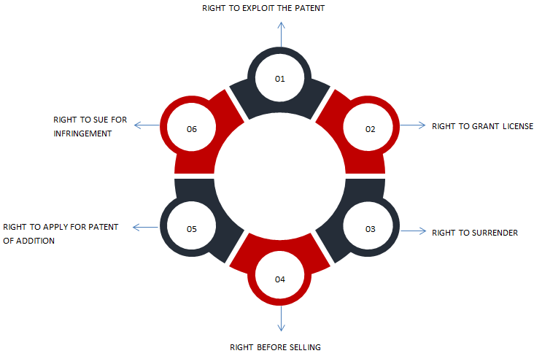**Figure 1: Rights of patent holder/patentee under the Patents Act, 1970**

1. **Right to Exploit the Patent**

In India, the patent holder is honored with the right to use, sell, manufacture and distribute the patented product. In case the invention is a production process, the owner of the patent reserves the right to share the procedure with another person. Moreover, the agent of the patent holder can also enforce this right.

If a new invention is a product, the patentee gets the exclusive right to produce, use, and distribute an invention in India for specific applications. On the other hand, if the invention covers the manufacturing process or process of some substance or article, the right to exploit includes the sole right to practice or utilize the manufacturing process or system in the territory of India. The Indian patent law also considers a patentee’s exclusive right to seek market advantages from the invention. It encourages artists to invest in their creative actions, realizing that their inventions would be protected by statute and no one else can replicate their innovations within a certain amount of time (mostly 20 years).

2. **Right to Grant or Assign Licenses**

The patent holder enjoys the right to assign or grant licenses for manufacturing and distributing the patented products to other parties. In instances where there are co-owners of the patented product, all the patent owners must collectively grant the license to a third party. The license is considered to be granted only after the Controller has duly authorized the request. Therefore, to be legal and lawful, the assignment or license must be in writing and should be documented with the Patent Controller.

3. **Right to Surrender the Patent**

The patent owner possesses the right to surrender the patent after seeking due permission from the Controller. Then, the Controller advertises this surrender as per the rules laid down in the Indian Patent Act. The parties interested in getting the ownership of the patent can directly approach the Controller. Afterward, the Controller examines the party’s claims and grants the ownership. The transfer happens only if the owner is willing to surrender the patent.

The patentee has the right to forfeit a patent at any point and their initiative by sending notice in a specified manner. This includes publishing ads in the journal with an offer to surrender the patent.

4. **Right before Selling**

As per Section 24 of the Indian Patents Act, a patent is sealed from the date of notification for acceptance to the date of acceptance of the notification. The patentee’s right comes into play after the notification for acceptance is presented.

5. **Right to Apply for the Patent of Addition**

Section 54 to 56 of the Patents Act, 1970 provides for this provision. The provision allows for modifications in the existing invention. In such instances, the patent holder is granted the right to the modified invention once the notification of acceptance comes out. After the notification is presented, the owner is granted the same rights as the previous patent.

6. **Right to Sue in Case of Infringement**

When any patent holder’s rights are violated, it is termed as patent infringement. A patentee can approach either a district court or a high court for the redressal of any grievance arising out of the violation of rights. If the defendant is found guilty of infringement, the courts will either grant a permanent injunction or award the plaintiff damages it sees fit.

Patentees are also responsible to fulfill certain obligations once the patent and the related rights are granted. In the next section, we will discuss the myriad obligations that every patentee in India must fulfill.

## What are the Obligations of Patentees?

Obligations of patentees can be broadly covered under five points as shown in Figure 2 below:

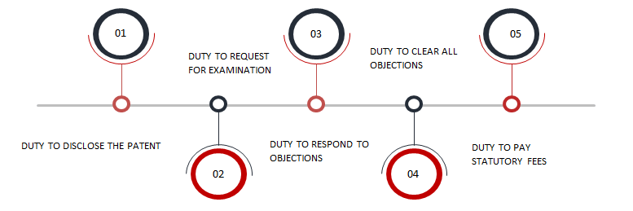**Figure 2: Obligations of Patentees**

1. **Duty to Disclose the Patent:**Section 8 of the Patent Act, 1970 requires the applicant to disclose the invention to the public. Section 8(1) of the Patent Act, 1970 categorically states that the patentee is obligated to disclose all necessary data concerning the remote application of identical or near-identical invention documented, at the time of filing patent application or within six months of applying. It is also required that the patentee record all the listed specifications in the applications. Besides, the patentee should also endeavor to disclose any points of interest in the subsequent applications that may be documented in the future.

Section 8(2) of the Patent Act, 1970 states that the patentee is obligated to furnish all the data needed by the Controller concerning the invention’s within six months of raising the request.

2. **Duty to Request for Examination:**Unlike other intellectual property rights, the patent registration process does not leave space for any kind of programmed examination for the grant of a patent application. Section 11(B) of the Patents Act, 1970 clearly lays the obligation on the patentee themselves to request the Controller to have a look at the development or growth of the patent.

3. **Duty to Respond to Objections**: Before permitting the examination request, the Patent Controller shares it with an analyst who assesses the growth and forwards the report, known as First Examination Report (FER), to the Patent Controller. In certain instances, some objections will be brought up in the First Examination Report. Patentees are obliged to reply to such opposition complaints. They are also required to correspond within a year of the issuance of FER. The failure to do so will lead to the automatic surrender of the patentee’s application.

4. **Duty to Clear all Objections:**The patent owner must reply to all opposition and clear all objections raised against their invention. In case the Patent Controller has not fulfilled their duty, a meeting may also be required. If the applicant fails to address the objections, the Patent Controller has the right to assign the patent rights to any objecting party.

5. **Duty to Pay Statutory Fees**: The patentees are also obliged to bear all the statutory expenses needed in the registration process to receive the patent grant. The failure to make the payment will lead to the non-consideration of the patent for the grant. Sec 142 of the Patent Act, 1970 is related to the payment provisions of necessary charges and the ramifications for non-payment of prescribed fees.

Although patent rights may seem very comprehensive, it has their limitations. In the next section, we will discuss the same.

## What are the Limitations of Patent Rights?

Figure 3 below shows the four main limitations of patent rights.

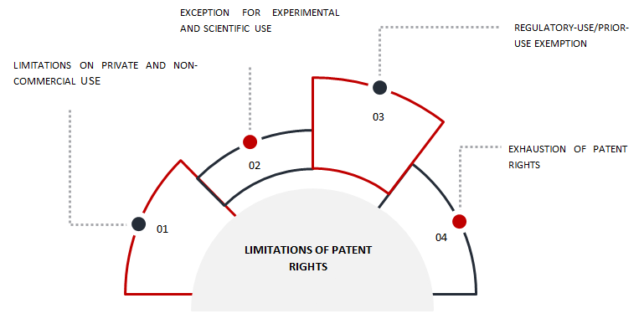**Figure 3: Four Main limitations of Patent Rights**

1. **Limitations on Private and Non-Commercial Use**

Under this limitation, the patentee is curtailed from utilizing the invention for private purposes or imposing a monopoly over commercial activity. If the government thinks that the patent holder is not leveraging the patented invention for commercial purposes, then it has the right to grant a compulsory license to a third party. Section 84 and Section 92 of the Patents Act, 1970 lay out the need for a mandatory license. It can be invoked if the patented item is not available to the general public for use at affordable prices. It is generally observed in cases of pharmaceutical drugs. Another provision in the patents act relates to the limitations on private and commercial use which is covered in Section 85 of the act. It talks about the revocation of patents by the Controller in case of non-use.

2. **Exception for Experimental or Scientific use**

This limitation is covered under sub-section 3 of Section 47 of the Indian Patent Act. The exception states that any individual can utilize the patented process or product to undertake any scientific experiment or conduct research. This exception to patent rights was introduced to protect those conducting bona fide research works and experiments. It allows the third parties to conduct research using the patented material without being accused of infringing on the patent holder’s rights.

3. **Regulatory-Use/Prior-Use Exemption**

Although providing patent rights to the patentees encourages new inventions, it can also lead to monopolies and strictly private use of the patented products. Because of this fear, Section 107 A was added to the law through the Indian Patents Amendment Act, 2005. The provision provides an exemption to the manufacturers of generic drugs to use the patented product for research and development purposes, and therefore enables them to seek marketing approval beyond the country’s boundaries. It is also known as the Bolar provision or Bolar exemption in India. However, the manufacturers can only manufacture, use, and sell the product in the market after the patented products’ expiry date, i.e., 14 years from filing the patent application.

4. **Exhaustion of Patent Rights**

This provision states that the inventor’s patent rights get exhausted once the patented product is sold in the market. As per this limitation, the patent holder loses control over the product once the first unrestricted sale of the invention is observed. The logic behind the formulation of this constraint was that once a patent holder sells the invention in the market, the objective behind granting a patent for the particular product is lost. It implies that the patent holder has provided the right to manufacture, use, and sell the patented product to another individual, losing the exclusive rights.

Notwithstanding its few limitations, enforcement of patent rights comes in extremely handy in cases related to patent infringement. The next section elaborates on the remedies available for patentee against patent infringement.

**Conclusion:** As part of the three-stage frame to comply with TRIPS, India passed the Patents (Amendment) Ordinance, 2004. In section 2 of the Patents Act, 1970 definition and interpretation of Budapest Treaty was included. It means the Budapest Treaty on International recognition of the deposition of microorganisms for the purposes of patent procedure done at Budapest on April 28, 1977, as amended and modifi ed from time to time. Section 3 of the Patents Act, 1970 relating to inventions where only methods or processes of manufacture patentable are omitted. The Act gave provisions for patenting a process as well as a product.

**References:**

1. History of Patent System, India: Intellectual Property India, Ministry of Commerce and Industry; c2004-2008 [cited 2008 Apr 2] Available from: http://www.patentoffi ce.nic.in/ipr/patent/history.htm.
2. Joshi M, Leela G. International Treaties and Conventions on IPR. Hyderabad: NALSAR Proximate Education, NALSAR University of Law; p.7-13.
3. Convention Establishing the World Intellectual Property Organization Geneva: World Intellectual Property Organization; c2005 [cited 2005 Jan 20], Available from: http://www.wipo.int/treaties/en/convention/pdf/ trtdocs_wo029.pdf.
4. Dunkel. General Agreement on Tariffs and Trade, Final Act of Uruguay Round in Marrakesh. New Delhi: Vidhi Publishing. p. 1-4.
5. The Concept of Intellectual Property. Geneva: World Intellectual Property Organization; c2005 [cited 2005 Jan 20] Available from: http:// www.wipo.int/about-ip/en/iprm/pdf/ch1.pdf.
6. Summary of the Convention Establishing the World Intellectual Property Organization [Internet]. Geneva. World Intellectual Property Organization; c2005 [cited 2005 Jan 15] Available from: http://www. wipo.int/treaties/en/convention/summary_wipo_convention.html
7. World Intellectual Property Organization. J Intellect Prop Rights 1998;3:27-8. 8. Grag RA, editor. The Patents Act, 1970. Delhi: Commercial Law Publishers Pvt. Ltd; 1970.

3/16/2023