Effect of some petrophysical and environmental properties on Gargaresh calcarenite used in Sabratha ancient site NW Libya

Khaled Alsagheir Abulqasem shwaya¹ Najat AlMabrouk Owen Ibrahim²

¹Geology Department, Faculty of science, Sabratha University
²Ecology Department Faculty of science, Sabratha University
chkhaled9@gmail.com, najatowen@gmail.com

Abstract: The purpose of the study was to determine the properties affecting porosity and permeability and their effect on weathering and deterioration in some Roman and Byzantine Calcarenite monuments in Sabratha. A comparison of qualitative fabric observations in petrographic thin sections and quantitative measurements of physical properties, including porosity, permeability, grain density and bulk density distribution. The results suggest that the mercury intrusion porosimetry data and qualitative fabric analysis related to petrophysical properties distribution indicated that the Calcarenite is characterized by low unit weight, high porosity, and large permeability especially in weathered samples, the degree of cementation of the Calcarenite was between weak and medium.
[Khaled alsagheir abulqasem shwaya and Najat ALMabrouk Owen Ibrahim Effect of some petrophysical and environmental properties on Gargaresh calcarenite used in Sabratha ancient site NW Libya. N Y Sci J 2023;16(2):1-9]. ISSN 1554-0200 (print); ISSN 2375-723X (online). http://www.sciencepub.net/newyork. 01.doi:10.7537/marsnys160223.01.

Keywords Calcarenite, porosity, Permeability, Petrophysical properties, and weathering.

1. Introduction
The coastal town Sabratha, situated on north west Libya about 63 km west of capital Tripoli, was the westernmost of the three major cities Sabratha, Oea and Leptis Magna of ancient Tripolitania at Coordinates: 32°47′32″N 12°29′3″E. Fig(1). Sabratha was together with Lepits magna and Oea one of three cities in Tripolitania during the 2nd century which originally Phoenician town during the seventh century BC (Matthews and Cook 1975) became part of the short-lived Numidian Kingdom before being romanized near the end of the first century B.C. The city was badly damaged by earthquakes, particularly that of AD 365 (DiVita1995). At 534 AD Byzantine armies reclaimed Sabratha from the Vandals. (El-Shahat et al., 2014) The growing attention to the cultural value and the potential touristic attraction of the historic towns has led to increasing activities of rehabilitation and conservation on the historical heritage (Calia et al., 2012).

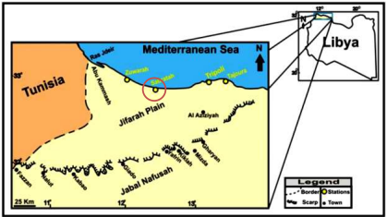
Fig (1): Location map of the study area

Sabratha's climate is a Mediterranean with mild, relatively wet winters and hot, dry summers. The average precipitation per year is between 200 and 230 mm. The temperature is reaches more than 40 °C in summer months, during winter, it drops to an average minimum of 20 °C. The annual mean humidity varies between 70 and 80% (Abu-Ellam, 2006). In summer the strong southerly winds called Gibli, transported amounts of sand and dust to the coastal plain (El-Tantawi, 2005).
Most of the historical buildings that make up the cultural heritage of cities are made of stone so that it can be considered the most important building material throughout the history of architecture and civil works. The durability of building stone is a measure of its ability to resist weathering and retain its original shape, size, strength and aesthetic properties. (Unesco, 2021)
Porous sedimentary stones have been used as building materials throughout history. They are easy to work, are readily available on the earth’s surface and have a high aesthetic value at a relatively low cost. However, when exposed to the environment they frequently perform worse than crystalline stones with low porosity (Siegesmund and Snethlage, 2011). This is largely due to their petrography (mineralogy and texture) and especially to their porous system. It is therefore very important to find out how these characteristics affect stone decay, so that we can reasonably predict how each stone will perform when used in construction (Hemeda, 2019).
Gargaresh Calcarenite formation was used widely as a building stone in many historical sites situated along the coast of northwest Libya (Ilich and Smykatz-Kloss, 1980; Cultrone et al., 2008). Many of the monuments in the ancient buildings of Sabratha were built mainly of Gargaresh Calcarenite initially obtained from the local coastal quarries to the southeast of Sabratha (Matthews and Cook, 1975).
Unfortunately, such monuments are often affected by different alteration and degradation processes mostly attributable to salt crystallization phenomena (Belfiore et al., 2012), which is considered to be one of the most powerful weathering agents in porous materials, particularly limestone rocks.
The weathering response of calcarinite is quite pronounced due to its low compressive strength, moderate to high porosity and high carbonate content (Ilich and Smykatz-Kloss, 1980). It has been claimed that porosity increases the solubility rates of carbonate rocks (Sadeghi and Khosravi, 2003). The life of stone monuments is often related to the rock ability to prevent the penetration of aggressive agents (water, humidity, acid rain, salt) in its porous structure (Cnudde et al., 2009). The capacity of the rock surface to resist to the degradation is determined by the petrophysical properties (porosity, permeability, thermal conductivity, diffusivity, pore shape, distribution of access rays and transfer processes (Benavente et al., 2004). Consequently, the characterization of pore space in the sedimentary rocks is an important step to understand and predict fluid flow in porous network.
The rate of salt crystallization depends on the flow of the water and the permeability of the substrate, which allows the salt to move. The crystallization of salt crystals is accompanied by an increase in volume, which produces internal stresses (Benavente et al., 2007) While the liquid phase allows salt to be transported, evaporation, which can occur outside (efflorescence) or inside the material (subefflorescence).
The present study is to provide a preliminary evaluation the effect of porosity and permeability in weathering and damage on some Roman and Byzantine Calcarenite monuments at Sabratha ancient site.

Geologic settings
The term Gargaresh Formation was introduced by (Lipparini, 1940) who was the first to describe the Tyrrhenian coastal deposits from the Tripolitania area.
Gargaresh Formation represents a characteristic geological and geomorphologic feature of the western coastal plain of Libya. It occurs as a ridge along the Mediterranean coast; rising 4-60m above sea level (Ilich and Smykatz-Kloss, 1980). The type section (14m thick) has been described along the shore line west of Tripoli by El Hinnawy and Cheshitev (1975). They mention that the formation may be underlain by Cenomanian dolostone Sidi As Sid Formation and/or Middle Miocene limestone Al Khums Formation. The studied formation provide useful information on reconstructions of Late Pleistocene Holocene history of NW Libya and new insights on palaeogeography. The cliffs continuously attached to the sea tide, and occasionally interrupted by broad wadis or deep-cut embayment. The outcrops Gargaresh Formation of Late Pleistocene-Holocene were divided by into eolian upper Kaam Member consists of shoreline dune and lower Karrot Member backshore foreshore environment represented by prominent carbonate aeolianite exposed in extensive outcrops (Minas, 2003).
The sediments of Gargaresh Formation are dominated by Calcarenite with skeletal marine fauna and non-skeletal grains of lithoclasts, aggregate, with oolites. In addition, these rocks are characterized by very well Aeolian controlling factors represented by wind sediments such as large-scale cross bedding and lamination (aeolianite) Fig (2). The majority of palaeocurrent direction was to SE, on the other hand the dune migration was SE also (Hlal and Bennur, 2014).

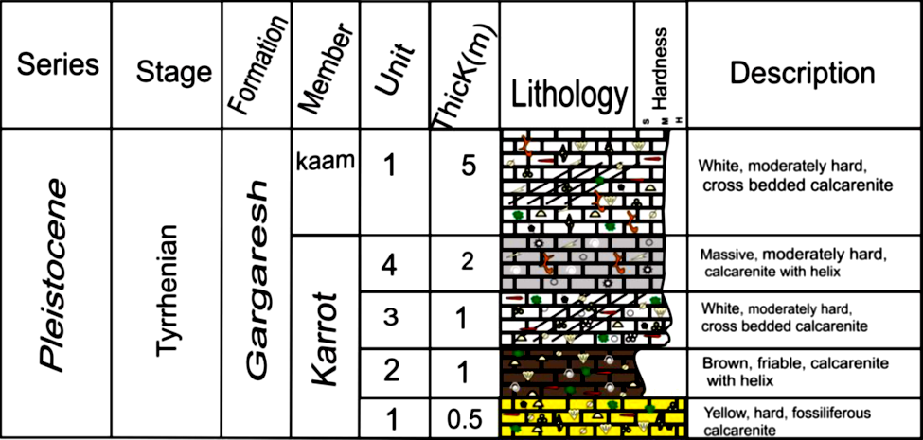
Fig (2): Generalized lithostratigraphic column of the Gargaresh Formation at Sabratha after (Buazza 2009)

2. Materials and methods
Ten fresh Calcarenite samples were obtained from recent coastal quarry southeast of Sabratha ancient site, these samples represent two elevations of the studied quarry table (1).Four weathered representative pieces of stones samples were carefully selected to avoid the damage from ancient quarry of the Sabratha building stones only to evaluate the petrographic deference between fresh and weathered samples table (2). The petrographic analysis by polarizing microscope and 35 mm camera was performed to obtain a description of texture , mineral composition and porosity for the fresh samples Fig(3-4).and weathered samples Fig(5-6).The total carbonate content was determined by acid insoluble residue using 10% HCL. The samples experimented as procedure to measure porosity, permeability, grain density and bulk density distribution by using the mercury intrusion porosimetry technique (MIP) to determined pore size distribution.

Petrographic properties
Gargaresh Calcarenite stones are mined from coastal quarries southeast of ancient Sabratha composed of carbonates about 85% with an insoluble residue consists of quartz, feldspars and phyllosilicates in traces according to Petrographic analysis. Calcarenite allochems are composed of pellets, fossils and shell fragments with few intraclasts, characterized by medium to coarse, rounded and moderately sorted. Subrounded quartz grains coated by micrite are observed. The occurrence of quartz grains in this unit may point to an intermittent seaward wind blowing. The fossil contents are shells of bivalve, land snail, foraminifera, echinoid spines and plates, bryozoans and algae. This type is generally weakly cemented by isopachous and meniscus cement and intergranular and vuge porosity. Some fossils are partially bound by sparry calcite with fabrics suggesting meteoric water cementation, several types of pore spaces were recognized, and Primary macropores between grains represent the original spaces between the individual bioclastic particles. Primary porosity due to intergranular pores which is represents the void space between the grains, particles or fragments of clastic material. It is formed during clastic sedimentation and depends on grain size, sorting of grains, grain sphericity and roundness, intragranular porosity or intercrystalline porosity is partially filled by calcite cement, the residual macropores represent the main interconnected reason that provide water flow into the rock texture. Primary micropores occur between and within the biological skeletons Fig (3-4), Secondary porosity includes dissolution macropores which represent sites originally occupied by fossils and micropores due to dissolution of sparite cement. Developed values of total porosity in weathered samples are estimated as some of the bioclasts have been leached and dissolution of calcite cement Fig (5-6). So, the fresh sampled quarry stone is similar to the stone monuments being studied except the amount and the shape of pores effected by weathering.

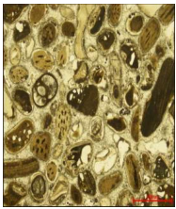
Fig. (3.a): Photomicrograph showing Biosparite microfacies association (Intragranular and intergranular porosity) consist mainly of allo- chemical constituents cemented by sparry calcite cement. The allochems are represented by fossil tests and shell fragments. Quartenary Fresh sample. S. No. 1). polarized, X.500.
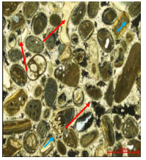
Fig. (3.b): Photomicrograph showing Biosparite microfacies association Intragranular porosity (Blue, short arrow) and intergranular porosity (Red, long arrow) consist mainly of allo- chemical constituents cemented by sparry calcite cement. The allochems are represented by fossil tests and shell fragments Quartenary Fresh sample No. 1) X. Nicols, X 500.

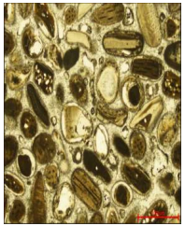
Fig. (4.a): Photomicrograph showing Biosparite microfacies association (Intragranular and intergranular porosity) consist mainly of allo- chemical constituents cemented by sparry calcite cement. The allochems are represented by fossil tests and shell fragments. Quartenary Fresh sample No. 2) polarized, X 500.
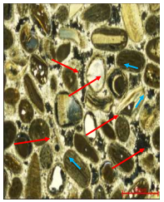
Fig. (4.b): Photomicrograph showing Biosparite microfacies association Intragranular porosity (Blue, short arrow) and intergranular porosity (Red, long arrow) consist mainly of allo- chemical constituents cemented by sparry calcite cement. The allochems are represented by fossil tests and shell fragments. . Quartenary Fresh sample No. 2)X. Nicols, X 500.

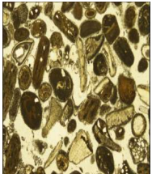
Fig. (5.a) Photomicrograph showing Biosparite microfacies association (Intragranular and intergranular porosity) consists mainly of allo- chemical constituents cemented by sparry calcite cement. The allochems are represented by fossil tests and shell fragments. Quartenary weathered sample. S. No. 3). polarized, X.500.
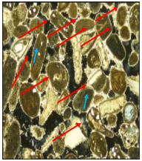
Fig. (5.b): Photomicrograph showing Biosparite microfacies association Intragranular porosity (Blue, short arrow) and intergranular porosity (Red, long arrow) consist mainly of allo- chemical constituents cemented by sparry calcite cement. The allochems are represented by fossil tests and shell fragments. Quartenary weathered sample No. 3) X. Nicols, X 500.

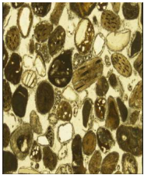
Fig (6.a) Photomicrograph showing Biosparite microfacies association (Intragranular and intergranular porosity) consist mainly of allo- chemical constituents cemented by sparry calcite cement. The allochems are represented by fossil tests and shell fragments. Quartenary Fresh sample. S. No. 4). polarized, X.500.

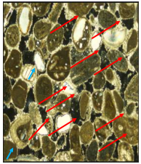
Fig. (6.b): Photomicrograph showing Biosparite microfacies association Intragranular porosity (Blue, short arrow) and intergranular porosity (Red, long arrow) consist mainly of allo- chemical constituents cemented by sparry calcite cement. The allochems are represented by fossil tests and shell fragments. Quartenary Fresh sample No. 4) X. Nicols, X 500.

Table (1): Petrophysical parameters of the studied Calcarenite Fresh samples
Sample No. | Permeability |  | Porosity |  | Grain Density |  | Bulk Density
 | Base | Upper | Base | Upper | Base | Upper | Base | Upper
1 A | 4214 | 31476 | 33.9 | 34.4 | 2.75 | 2.74 | 1.82 | 1.79
2 A | 5166 | 18431 | 34.1 | 32.5 | 2.76 | 2.74 | 1.82 | 1.85
3 A | 7340 | 27129 | 35.3 | 34.2 | 2.75 | 2.72 | 1.78 | 1.79
4 A | 3555 | 38773 | 33.0 | 34.9 | 2.76 | 2.74 | 1.85 | 1.79
5 A | 5796 | 27978 | 34.4 | 32.8 | 2.74 | 2.72 | 1.80 | 1.83

Table (2): Petrophysical parameters of the studied Calcarenite weathered samples
Sample No. | Permeability | Porosity | Grain Density | Bulk Density
1 C | 14305 | 39.7 | 2.71 | 1.63
2 C | 15122 | 40.2 | 2.73 | 1.63
3 C | 9619 | 38.6 | 2.72 | 1.67
4 C | 18256 | 40.3 | 2.72 | 1.63

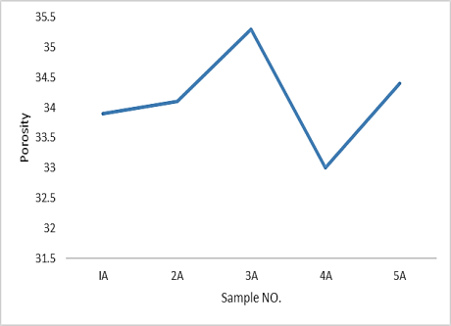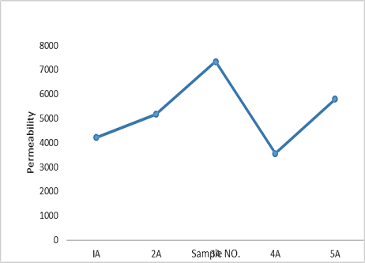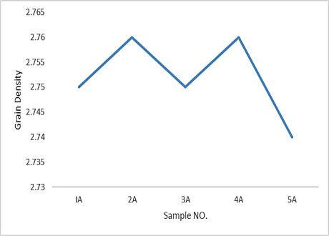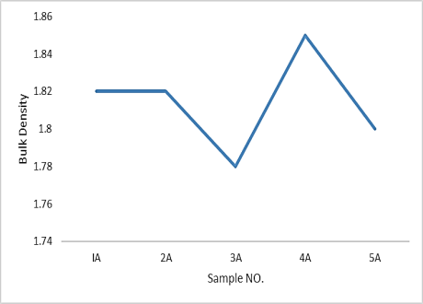
Fig (7): Binary relationship between sample no. and different computed Petrophysical parameters.

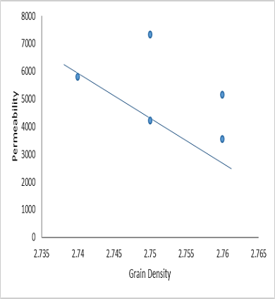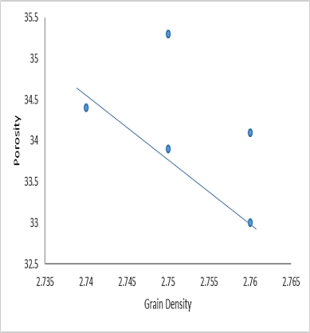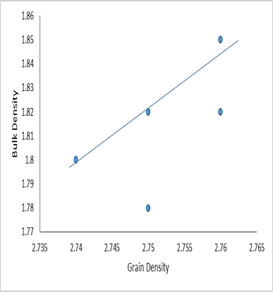
Fig (8): Binary relationship between grain density and different computed Petrophysical parameters.

Mercury intrusion porosimetry (MIP)
Mercury intrusion porosimetry is considered as the basis of all microstructural characterization to evaluate the material durability. It gives an overall idea on the total porosity and the pore access ray.
Unaltered and altered samples total porosity measurements are performed by mercury injection on cylindrical samples.
The resent quarry samples were cored from an un weathered block (fresh samples taken from the quarry) named (A) and (B) were the weathered samples taken from an altered ancient quarry named (C). Total porosity of fresh samples (A) are ranged between 33.00%and 35.3%, total porosity of fresh samples (B), are ranged between 32.8%and 34.9%, total porosity of weathered samples (C), are ranged between 38.6%and 40.3%.In the microporosity and macroporosity interval (A),(B) fresh sample has low porosity compared to weathered sample (C). For the altered sample we observe a strong increase in porosity. This can be attributed to a partial dissolution of the intergranular and intragranular space. and related to a broadening and increase of the number of cavities with the alteration. This may be due to the absence of accessible porosity in this class (unaltered zone). Consequently, the mercury porosity analysis shows several porosity classes which present different behaviors according to the ratio between pour volume and bulk volume. This result is perfectly correlated with the petrographic observations.
The geotechnical characteristics of the stone used in the construction of the monuments, with, relatively low specific weight, and high porosity caused low mechanical resistance and make the materials especially vulnerable to environmental conditions of high relative humidity, strong salinity, and persistent moist and dry winds.

3. Results and Discussion
The investigated samples of Quaternary Limestone can be described as soft and almost pure Calcarenite with a pale cream–yellow color. They are sand size grains and homogenous. In thin sections, it was confirmed that in both types large concentrations of randomly distributed to orientated microfossils, the loosely packed fabric due to the absence of well-developed cement can be attributed to the age and lack of unsuitable geological condition which may indicate that this unit was deposited under wet condition. However, few quartz grains suffered from percussion probably during transportation. The transporting agent is possibly wind that could have blown seaward, bringing quartz grains to the site of deposition especially near shore which is otherwise quartz-free. Meniscus and isopachous cements are found in this unit which indicates vadose and phreatic zones precipitation.
In agreement with Ilich and Smykatz-Kloss (1980), El-Shahat et al. (2014). The deterioration of the observed monuments can be related to the properties of the Calcarenite Due to low compressive strength, medium to coarse grain texture, moderate to high porosity and chemical composition dominated by calcium carbonates.
Furthermore, according to (El-Baruni, 2003) the environmental conditions seem to have a leading role in stone deterioration. Due to its location on the Mediterranean coast at low elevation, most of the monuments are heavily affected by salt-rich marine spray especially during windy and/or stormy conditions. In addition to falling salty marine spray, rising saline water by capillarity through the stone monuments is expected, since most of ancient Sabratha was built on a Quaternary coastal limestone ridge which consists of porous biocalstic calcarenite (Fig.3).
This “foundation” rock is normally influenced by seawater encroachment. Salinization of the shallow coastal aquifer in northwest Libya has been attributed to marine intrusion as a result of excessive extraction… Also due to the proximity of Sabratha to the marine environment, (Abd El-Tawab, 2012) mention that wetting/drying processes especially during windy and/or stormy conditions may induce moisture condensation in the stones’ pore system.
And according to (Benavente et al., 2001) the dissolution-crystallization cycles produce loss of stone material, splitting and changes in size of grains and pores, loss of stone material is more pronounced in the monuments located at low elevation above sea level, suggesting that marine spray is one of the primary agents of stone damage at Sabratha. Evaporation of saline water, especially in limestone monuments near the ground, causes a loss of coherence between calcarenite grains and binding cement. This is according to (Charola, 2000) normally attributed to physical stress resulting from salt crystallization in porous limestone.
Also the poor mechanical characteristics, the low material displays, low durability with remarkable salt crystallization not only mainly due to the type of The higher porosity and surface roughness but also due the mineral composition, particularly in the Sabratha variety, through a process of dissolution of calcite The decay develops mainly through detachment of the crust which is also confirmed by (Rescic et al., 2010).
On the other hand, evolution of the mercury intrusion data of samples after weathering showed clearly that the porosity is the most changed. Most of the time, a peak result appears on weathered stones due to visible cracks, dissolution, leaching due to chemical composition and temperature changes or by anisotropic pressure release. Adsorption/desorption effects and capillary forces due to evaporation and condensation of liquids in the fissures might enhance effects of dilatation and contraction due to temperature changes.

Conclusions
The materials used in this study are sedimentary rocks composed of Quaternary limestones (bioclastic Calcarenite) extracted from the Gargaresh Formation SE of Sabratha ancient site represent the main used building stones. Laboratory measurements of the petrophysical properties were carried out and their relationships were discussed. The above-mentioned petrophysical properties of rocks, such as permeability, porosity, pore size distributions and bulk density are very important characteristics. The low quality building stones used in the construction and restoration are characterized by high porosity reached ( 40.3%) representing porous networks area resulting from the relation between the cement with the arrangement and organization of the grains, the analysis of altered and unaltered samples shows a difference between the pore volumes for samples This result confirms that Calcarenite stones are anisotropic materials ,low geotechnical properties and chemical composition dominated by calcium carbonate, which give the rock a high susceptibility to weathering processes represent the main interconnected avenues that provide rapid water flow and soluble salts into the rock. The marine environment, with characteristic and its rough surface allows a high accessibility to the atmospheric gaseous pollutants and to hydrous marine sprays charged with various salts, humidity.
To obtain more information on the damage processes, further research is necessary to emulate the site loading and its relation to the stone fabric.

References
- Abd El-Tawab, N. A. (2012). Degradation and conservation of marble in the Greek Roman Hadrianic baths in Leptis Magna, Libya. International Journal of Conservative Science, 3, 163–178.
- Abu-Ella, N. A. (2006). Sedimentological, mineralogical and geomorphological studies on the Quaternary sediments, west Tripoli, Libya. Unpublished PhD thesis, Cairo University.
- Belfiore C.M., Fichera G.V., La Russa M.F., Pezzino A. and Ruffolo S.A. (2012) The Baroque architecture of Scicli (south-eastern Sicily): Characterization of degradation materials and testing of protective products. Periodico di Mineralogia, 81, 19-33.
- Benavente, D., Garcia del Cura, M. A., Bernabeu, A., & Ordonez, S. (2001). Quantification of salt weathering in porous stone using an experimental continuous partial immersion method. Engineering Geology, 59, 313–325.
- Benavente, D. Garcia, A. Del Cura, M. Fort R. Ordonez,S. (2004) Durability estimation of porous building stones from pore structure and strength”, Engineering Geology, , 74, 113.
- Benavente D, Martı´nez Martı´nez J, Cueto N, Garcı´a del Cura MA (2007) Salt weathering in dual-porosity building dolostones. Eng Geol 94:215–226
- Buazza M.M.O. (2016) M.Sc. Geology Petrography and Geochemistry of Gargaresh Formation from Tajoura to Ras Jdeir, Jifarah plain, NW Libya University of Benghazi Faculty of Sciences Department of Earth Sciences
- Calia Angela, lettieri mariateresa, matera loredana, sileo maria the assessment of protection treatments on highly porous stones with relation to the sustainabilty of the interventions on the historical built heritage 28 th intern. bcongress scienza e beni culturali. la conservazione del patrimonio architettonico all'aperto: superfici, strutture, finiture e contesti, bressanone, 10 - 14 luglio 2012, 477-48
- Charola, E. A. (2000). Salts in the deterioration of porous material: An overview. Journal of the Institute of American Conservators, 30, 327–343.
- Cnudde V., Cwirzen A., Masschaele B., Jacobs P.J.s., (2009). Porosity and microstructure characterization of building stones and concretes”. Engineering Geology, 103(3-4), 76.
- Cultrone G, Russo LG, Calabro C, Urosevic M, Pezzino A. (2008) Influence of pore system characteristics on limestone vulnerability: a laboratory study. Environ Geol; 54:1271–81.
- Di Vita, A. (1995) Archaeologists and Earthquakes: The Case of 365 A.D. Annali di Geofisica, 38, 971-976.
- El-Baruni, S. S. (2003). An evaluation study of the water resources in the Jifarah plain. In M. J. Salem, K. H. Oun, & H. M. Seddiq. (Eds.). The geology of northwest Libya (vol. 3, pp. 299-310). Second Symposium on the Sedimentary Basins of Libya, November 6-8, 2000. Tripoli: Earth Science Society of Libya
- El Hinnawy, M. and Cheshitev, G. (1975). Geological map of Libya. 1:250,000 Sheet: Tarabulus NI33-13 Explanatory Booklet. Industrial Research Centre, Tripoli, 66 pp. Estban, M. (1976). Vadose pisolite and calich. American Association of Petroleum Geologists Bulletin, vol. 60, p. 2048- 2057.
- El-Shahat Adam, Minas Haithem, Khomiara Sadek. (2014) Weathering of Calcarenite Monuments at Roman and Byzantine Archaeological Sites at Sabratha, Northwestern Libya: A Pilot Study Afr Archaeol Rev 31:45–58 DOI 10.1007/s10437-014-9153-8
- El-Tantawi, A. M. M. (2005). Climate change in Libya and desertification of Jifara Plain using geographical information system and remote sensing techniques. Published PhD thesis, Johannes Gutenberg University.
- Hemeda, S. (2019), "Geotechnical and geophysical 1/22/2023investigation techniques in Ben Ezra Synagogue in Old Cairo area, Egypt" Heritage Science (2019) 7:23 https://doi.org/10.1186/s40494-019-0265-y
- Hlal, O., Bennur,S. (2014) .Sedimentology and Stratigraphy Architecture of the late Pleistocene-Holocene Succession of the Gargaresh Formation, Subratah Basin, NW Libya Geophysical Research Vol. 16, EGU2014-14321.
- Ilich, M., & Smykatz-Kloss, W. S. (1980). A contribution to the study of the Gargaresh calcarenite, NW Libya. In M. J. Salem & M. T. Busrewil (Eds.), The geology of Libya. Second Symposium on the Geology of Libya (vol. 3, pp. 1013-1015). Tripoli, September 16-21, 1978.
- Lipparini, T. (1940): Tettonica e Geomorfologia della Tripolitania. Boll. Soc. Geol. Ital., Vol. LIX, pp. 221-301, Roma (English translation: Tectonics and Geomorphology. Min. of Industry, Geol. Sec. Bull., No. 4. 1968).
- Matthews, K. D., & Cook, A. W. (1975). Cites in the sand: Leptis Magna and Sabratha in Roman Africa. Philadelphia: University of Pennsylvania Press.
- Minas, H. A.; 2003: Palaeoenvironmental Reconstruction of The Gargaresh Formation, NW Libya, The geology of northwest Libya (sedimentary basins of Libya), Vol. II, pp.39-49.
- Rescic S., Fratini F.and Tiano P.limestone and their relationship with the physical characteristics On-site evaluation of the ‘mechanical’ properties of Maastricht Geological Society, London, Special Publications 2010; v. 331; p. 203-208
- Sadeghi, H. and Khosravi, F., 2003- A study on the effect of wave velocity on solubility of limestone and chalk. In: Deformation Characteristics of Geomaterials: Proceedings of the Fifth Inmternational Symposium of Deformation Characteristics of Geomaterials, IS-Seoul 2011, 1-3 September 2003, Lyons, France. Benedetto, D., Doanh, T., Geoffroy, H., and Sauzeat, C. eds., 1433 p.
- Siegesmund, S. Snethlage R. (2011). Stone in architecture. Springer; https://sn.pub/extras.
- Unesco, (2021). Conservation issues presented to the World Heritage Committee in 2021 https://whc.unesco.org/en/list/184/documents/.

1/22/2023

