USE OF GNSS TO IMPROVE THE ACCURACY OF THE COORDINATES OF GEODETIC NETWORK POINTS IN THE SURROUNDING OF THE MURUNTAU QUARRY (UZBEKISTAN)

Vohidjon Niyazov ¹, Gulsara Tleumuratova ²

¹SamSACEI, Samarkand State Architectural and Civil Engineering Institute, 140147 Samarkand, Uzbekistan vohid85-85@mail.ru
²NUU, National University of Uzbekistan, 100104 Tashkent, Uzbekistan

Abstract. This article presents the results of GNSS measurements at GGS points in the vicinity of the Muruntau quarry. These observations were processed in order to clarify the coordinates of the points of the geodetic network in the SK42 and WGS84 systems. The coordinates of the points and the length of the initial basis "Sar-Dzhan" are calculated from the results of measurements using the Trimble R4 GNSS receiver. A graphical analysis of baseline PDOP values is presented in this paper. A digital model of the geoid deviation relative to the ellipsoid has been developed for the vicinity of the quarry. A spatial model of the relief was built using the “Surfer” software package.
[Vohidjon Niyazov, Gulsara Tleumuratova. USE OF GNSS TO IMPROVE THE ACCURACY OF THE COORDINATES OF GEODETIC NETWORK POINTS IN THE SURROUNDING OF THE MURUNTAU QUARRY (UZBEKISTAN) . N Y Sci J 2023;16(1):27-33]. ISSN 1554-0200 (print); ISSN 2375-723X (online). http://www.sciencepub.net/newyork. 06.doi:10.7537/marsnys160123.06.

Keywords: quarry, map, GNSS, coordinates, accuracy, basis, DEM

1. Introduction
It is generally known that local deformation processes must be taken into consideration when reducing linear-angular data in reference geodetic networks to a specific epoch using specific formulas and techniques [1]. If industrial facilities (quarries) exist nearby, their function takes on a special character and necessitates a thorough analysis of all measurement procedures. As a result, using electronic digital technologies and geographic information systems (GGS), a planned and high-altitude geodetic network is built during the construction of a mining complex.
In Uzbekistan, there are a number of sizable quarries that are crucial components of the nation's mining industry and its national economy. Therefore, before beginning engineering and construction work, it is advisable to study the physical-geographical, geological, and geodynamic properties of these locations. First and foremost, a topographic survey of the area is required as part of the complex of tasks involved in designing a geodetic network. The configuration, accuracy of the state geodetic network (GGS), measurement and calculation procedures, and the location of the quarry all have a role in determining the precise coordinates of the points of geodetic networks of thickening [2]. The geodetic coordinates of the GGS points are often listed in a unique catalog, however they can be roughly identified on a topographic map in relation to the coordinate grid. The coordinate grid of the cartographic projection of topographic maps, however, deforms with time as a result of many natural and man-made processes. The trustworthiness of the GGS point coordinates, which were established by optical theodolites and levels, determines the precision of the projection. It should be noted that an aerogeodetic company conducted the initial prospecting and reconnaissance work in the quarry region between 1960 and 1970. Based on revised cartographic materials from 1979–1983 and 1:200,000 scale topographic maps that were created in 1956–1958, the last 1:500,000 scale topographic maps for this region were published in 1989. (Fig. 1). Naturally, such a region requires ongoing updating of the geodetic network's reference points' coordinates [3]. Additionally, a geodetic network must be effectively designed in order to facilitate later network thickening and DEM development. This indicates that a series of actions must be taken to update topographic maps and clarify the coordinates of geodetic network locations using current geoinformation and digital technologies.

Figure 1 A fragment of a topographic map with "Muruntau" quarry

Traditionally, topographic or mine surveying is done during building such facilities using high-precision tacheometers with references to GGS points. Since they were warped and some of the signals lacked higher reference elements, traditional geodesic signs and pyramids [4] were discovered during the investigation of the area around the Muruntau quarry.
The requirements for coordinate precision have changed with the advent of contemporary satellite navigation systems that use the geocentric coordinate system (X, Y, and Z) and map projection (UTM). As a result, the technique for processing measurement data has advanced technologically, which also has an impact on the mathematical foundation of digital topographic maps. High-precision navigation satellite measurements are the greatest technique to increase the accuracy of the coordinates of the points in the absence of digital maps and densification points of the geodetic network.
This effort aims to improve the geodetic network point coordinates near the Muruntau quarry and create a digital elevation model using historical and contemporary data. At geodetic locations, reconnaissance work and GNSS measurements were done for this.
2. Material and Methods
For the goals of geodesy and mapping, the method of satellite measurements and calculations has been created in the form of instructions that are frequently employed in all optical and radio observations. The global navigation satellite system (GNSS), where multiple modes of operation have been devised depending on the physical and geographical characteristics of the location, has recently emerged as the most well-liked and promising system. The region around the Muruntau quarry, which is surrounded by small, hilly hills and desert, serves as an emblematic example. Naturally, due to the Republic of Uzbekistan's agency for geodesy and cartography's reorganization, no repeated geodetic measurements were conducted in these locations.
Only in 2017 were Trimble Dini4 level, Trimble M3 total station, and Trimble R8 GNSS professionals from Ellips LLC used to make topographic and geodetic measurements. The precision of the coordinates of the spots, which ranged from 2 to 5 mm [5], was assessed based on the measurements' findings. These projects allowed for the restoration of the traditional geodetic network and a two-order boost in accuracy. The design of the geodetic basis, which is crucial in the calculation and adjustment of the geodetic network, was not given any consideration despite the relevance and importance of the measurements that were made. The National University of Uzbekistan (NUU) staff, doctorate students from the Samarkand Architecture and Construction Institute (SAMACI), and Termez State University (TSU) attempted to use 2 points for the line basis as a result.
From 2019 through 2022, absolute and differential approaches were used in a variety of signal acquisition modes to make navigation measurements with the Leica GS10 and Trimble R4 GNSS receivers. The configuration of the satellites and their height above the horizon, which has an impact on the PDOP quality criterion, received the majority of attention. A number of GGS locations close to the quarry were chosen, and their preliminary coordinates were taken from a topographic map scaled to 1: 100,000 in order to properly answer the problem [6]. Two geodetic network points, Sardara and Janakhmed, were suggested to be used as a baseline for computational work from the GGS's chosen points (Fig. 2). Given that the same observational conditions and navigation receiver were employed, GNSS measurements can be regarded as being equally accurate [7]. The point coordinates' external and internal correctness was determined for each measurement session.

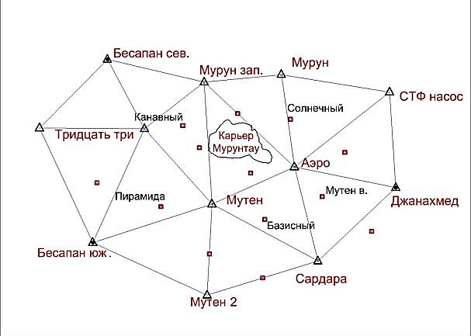
Figure 2. Scheme of a geodetic network in the vicinity of the “Muruntau” quarry

These measurements were also connected to Uzbekistan's ZAR and NAV GNSS stations, which were situated 30 kilometers away from the geometric center of the quarry (Fig. 3). During the course of the observations, the coordinates of the GGS points in the WGS84 system as well as the separations between the points for additional geodetic network thickening were determined. The geoid height and transition parameters between two coordinate systems must be understood in order to properly reduce data to one coordinate system [8]. It is common practice to do a preliminary adjustment of the measurement findings, which involves minimizing the residual values between the theoretical and measured values as well as assessing the accuracy of the coordinates using the covariance matrix's elements.

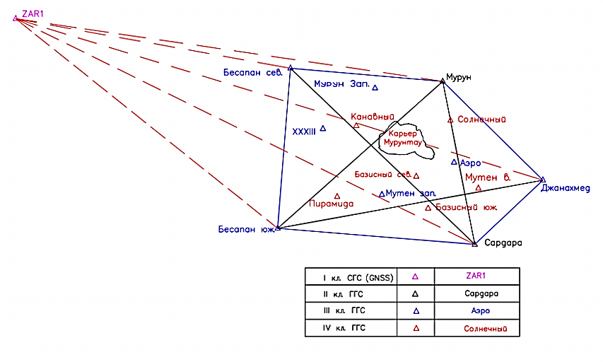
Figure 3. Geodetic reference

3. Results
Rectangular coordinates in the Gauss-Kruger projection, geodetic coordinates in the system of the reference ellipsoid and the global ellipsoid WGS84, as well as the heights of points relative to the Baltic height system (BSV -77) and the mean sea level surface (MSL) were all obtained on the basis of navigation measurements. For each measurement session, the root-mean-square errors (RMS σ), coordinates (B,L,H), and components of the covariance matrix were determined using the TBC software.

Table 1. Coordinates of GGS points near the quarry in the WGS84 system
No | Item names | Coordinates |  |  | RMS
 |  | B | L | H | σ
1 | Kanavny | 41°30'17.82" | 64°32'19.98" | 588.523 | 0.008
2 | Murun (zap.) | 41°31'57.58" | 64°33'22.79" | 811.592 | 0.010
3 | Solar | 41°30'33.53" | 64°37'26.79" | 581.710 | 0.010
4 | Aero | 41°28'51.28" | 64°37'33.77" | 432.541 | 0.013
5 | Besapan (south) | 41°26'12.02" | 64°29'11.40" | 423.396 | 0.019
6 | Murun | 41°32'09.33" | 64°37'00.14" | 786.503 | 0.015
7 | Sardara | 41°25'32.01" | 64°38'44.13" | 383.179 | 0.006
8 | Janakhmed | 41°28'09.83" | 64°42'22.36" | 350.039 | 0.006
9 | Zarafshon (ZAR1) | 41°34'56.62" | 64°12'32.44" | 397.231 | 0.011
10 | Navoiy (NAVD) | 40°07'28.69" | 65°22'19.54" | 329.582 | 0.013
11 | Uchkuduk (UCH1) | 42°09'30.06" | 63°33'29.12" | 189.909 | 0.012
12 | Gijduvon (GJDD) | 40°06'08.82" | 64°41'04.02" | 228.323 | 0.014
The base length and geocentric distances of the "Sardara" and "Janahmed" points were determined in addition to connecting the calculated coordinates of the geodetic network points to the GNSS network of Uzbekistan. The majority of measurements are in good agreement, and the highest difference in results is less than 1 cm, proving the accuracy of GNSS measurements (Fig. 4). PDOP values that didn't surpass 2.0 were obtained for the same sites (Fig. 5).
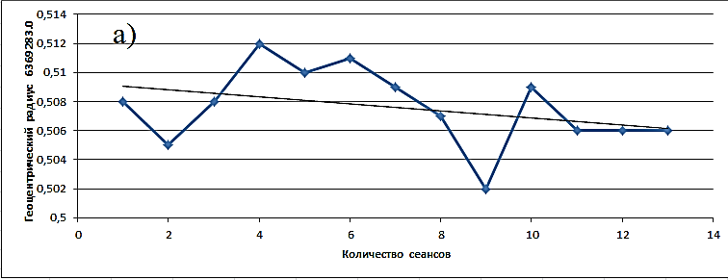
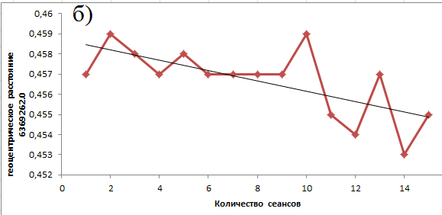
Figure 4. Change in the geocentric distance value depending on the observation session for points a) “Sardara” and b) “Janakhmed”

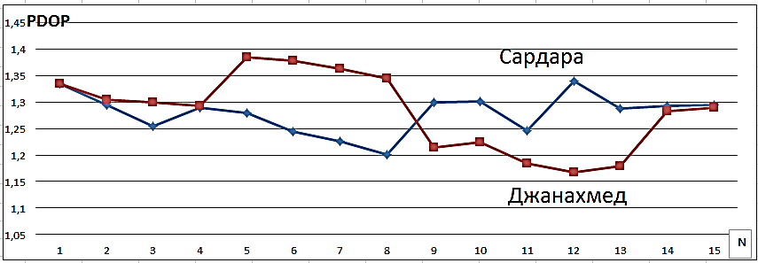
Figure 5. Changing the value of PDOP for the geodetic basis “Sar-Jan”

It can be seen from Figure 5 that the PDOP value does not exceed 2.0 and indicates good physical and geographical conditions of the area and the absence of the influence of external factors on the reception of signals from satellites. For other GGS points, measurements and calculations of coordinates were also performed with an accuracy estimate [10]. As for orthometric heights, the deviations between the geoid and ellipsoid were calculated for points in the vicinity of the quarry with an interval of 30 arc seconds in latitude and longitude [11]. Although the quarry area is small, there is still a certain difference between the two surfaces, which reaches about 38m (Fig.6).

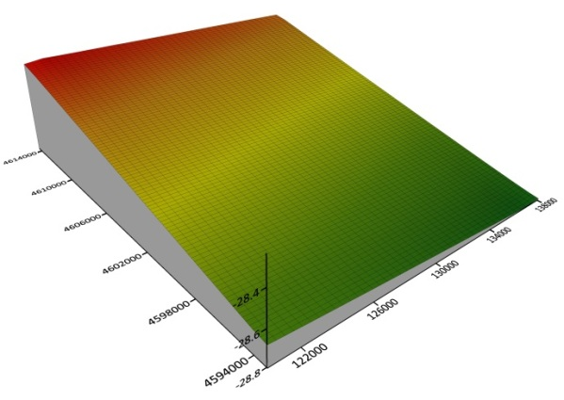
Figure 6. Deviation of the geoid from the ellipsoid in the vicinity of the “Muruntau” quarry

4. Discussions
The issue of creating new techniques for analyzing a digital relief model surrounding a quarry [12] arises at the current stage of GGS development and spatial data display because there is no cartographic data and topographic maps created from aerial photography and field measurements are out of date and do not adhere to current standards. The construction of engineering structures is made more challenging by the lack of precise maps of these regions.
Despite accurate assessments of accuracy and attaining acceptable values for the root mean square error of the unit weight, the aforementioned studies do not provide a conclusive response to the question of improving the accuracy of the coordinates of geodetic network points because of the short time interval. Even though the arrangement of the points does not quite meet the criteria for geodetic network optimization, some navigation measures and computations can still be employed for the initial repositioning of the original geodetic network. This is true in particular for the baseline measurement that will provide the basis for all geodetic work done around the quarry and for the execution of the ensuing thickening of the geodetic network [13].
Since the precise value of the local quasi-geoid of the quarry should be built not only from satellite data, but also from ground-based gravimetric measurements, it is advisable to take into consideration the difference between the geoid and the ellipsoid when computing the normal heights of GGS points. First of all, it is important to take accurate measurements of the gravitational force at each end of the geodetic basis' length.
The resulting GNSS measurement results do, however, suggest that a more thorough program is needed to enhance the geodetic network's structure, taking into consideration all contemporary observational and computational techniques, including the study of the higher mantle layers. Here, in addition to gravimetric measures, geophysical studies [14], where local tectonic changes brought on by mining and variations in the level of the groundwater should be discovered. As a result, the geometric dimensions of the surface as well as its interior structure are altered [15]. The construction of a spatial digital model of the relief (Fig. 7) and the development of geo-modeling processes related to a change in the quarry volume are prompted by these variations in the size of the quarry in its three components.

Figure 7. DEM "Muruntau" quarry

Conclusions
As a result, it should be emphasized that the GNSS measurements will strengthen the precision of the geodetic network surrounding the quarry and so create a new, high-precision planned-altitude basis.
The local geoid, which is the geopotential surface of the area under study, will be developed using the discovered corrections to the coordinate axes and the distinction between the geoid and the ellipsoid. The measurement results will also hold the answer to understanding how deformation processes in the mantle's top layers operate. A unified coordinate system [16], which will act as the mathematical foundation for digital maps, will be implemented as a result of the joint processing of measurements taken from the ground and from satellites. The DEM makes it feasible to view the terrain and carry out engineering calculations for things like calculating the quantity and area of soil taken out of the quarry.

Acknowledgements:
The authors express their gratitude to Toshonov B.Sh. for assistance in GNSS measurements and Tastemirova M.G. for providing the values of the deviation of the geoid from the ellipsoid in the vicinity of the Muruntau quarry.

Corresponding Author:
Niyazov Vokhidjon Ruzievich¹, Gulsara Tleumuratova ²
¹SamSACEI, Samarkand State Architectural and Civil Engineering Institute, 140147 Samarkand, Uzbekistan vohid85-85@mail.ru
²NUU, National University of Uzbekistan, 100104 Tashkent, Uzbekistan

References
- Mashimov M.M. Uravnivaniye geodezicheskikh setey. M.:Nedra,1979. - 367s.
- Provorov K.L. O postroyenii sploshnykh setey triangulyatsii. M. Geodezizdat, 1957. 56 s.
- Mirmakhmudov E.R., Kovalev N.V., Niyazov V.R., Rakhimova M.KH. Nekotoryye trebovaniya po proyektirovaniyu opornoy geodezicheskoy seti sgushcheniya vblizi karʹyera. Vestnik nauki. Nauchnyy zhurnal.. 2021. №6-1(8).S. 259-269.
- Vremennaya instruktsiya po obsledovaniyu i vosstanovleniyu punktov i znakov gosudarstvennoy geodezicheskoy i nivelirnoy setey.-M.: RIO VT·S, 1970. - 23s.
- Mirmakhmudov E.R., Kadyrov F.T., Niyazov V.R. Rekognostsirovka geodezicheskikh punktov v okrestnosti karʹyera “Muruntau” / Fundamentalʹnyye i prikladnyye nauchnyye issledovaniya: Aktualʹnyye voprosy sovremennoy nauki, dostizheniya i innovatsii. Sbornik statey po materialam V - Mezhdunarodnoy nauchno-prakticheskoy konferentsii. Ufa, 29 yanvarya 2021.S. 159-168.
- Topograficheskiye karty masshtaba 1:100000 (www.google.ru, data obrashcheniya 10.07.2022)
- Bolʹshakov V.D., Gaydayev P.A. Teoriya matematicheskoy obrabotki geodezicheskikh izmereniy. M.:Nedra,1977. – 368s.
- Antonovich K.M. Ispolʹzovaniye sputnikovykh radionavigatsionnykh sistem v geodezii. - M.: Kartgeotsentr, 2005. T.1. - 334s.
- Hofmann-Wellenhof B. Global Positioning System. Theory and practice. – Fifth, revised edition / B. Hofmann-Wellenhof, H. Lichtenegger, and J. Collins – Wienn, New-York: Springer. 2001. – 384 p.
- Zakatov P.S. Kurs Vysshey geodezii. M.:Nedra, 1976. – 512s.
- Mirmakhmudov E.R. , Tastemirova M.G. Ob ispolʹzovanii sputnikovoy alʹtimetrii v geodezii Uzbekistana // Vestnik nauki. Innovatsionnyye nauchnyye issledovaniya. Nauchnyy zhurnal, g. Ufa. №12-2(14), dekabrʹ 2021. S.146-161.
- Lurʹye I.K. Geoinformatsionnoye kartografirovaniye. Metody geoinformatiki i tsifrovoy obrabotki kosmicheskikh snimkov. M.: Izd-vo KDU, 2008. 424s.
- Pellinen L.P. Vysshaya geodeziya. M.:Nedra, 1978. -264s.
- Atabayev D.KH.,Khusanbayev D.D.,Goipov A.B.,Atabayeva N.E. Opredeleniye razlomov i razryvnykh narusheniy geofizicheskimi metodami v pribortovoy poverkhnosti karʹyera Muruntau // Nauchno-tekhnicheskiy i proizvodstvennyy zhurnal . Gornyy vestnik Uzbekistana. 2021, №1(84). S.59-63.
- Pankrushin V.K. Matematicheskoye modelirovaniye i identifikatsiya geodinamicheskikh sistem. Novosibirsk. 2002. - 424s.
- Markuze YU.I. Algoritm obʺyedineniya nazemnykh i sputnikovykh geodezicheskikh setey // Geodeziya i kartografiya. 1997. №9. S.23-29.

1/22/2023

