Study on the Parameters related to Molar volumes at different temperatures of tert-butyl methyl ether (1) + propyl amine (2) mixtures

* Manmohan Singh and **Dr. Naresh Pratap

*Research Scholar, Department of Chemistry, SunRise University, Alwar, Rajasthan (India)
**Associate Professor, Department of Chemistry, SunRise University, Alwar, Rajasthan (India)
Email: radhaintercollege@gmail.com

Abstract: The negative values of V_{m}^{E} for tert-butyl methyl ether (1) + amine (2) can be compared with negative V_{m}^{E} values of tert-butyl methyl ether + 1-alkanol mixtures which is due to different effects like specific interactions due to formation of multimers of alkanol and ether molecules; possible breaking of hydrogen bonded alkanol structure; and geometrical fitting of ether into remaining alkanol structure. The mixing of ether with amine would induce mutual dissociation of hydrogen bonded structures, that is, O-H-O and N-H-N present in pure liquids with subsequent formation of new N-H-O bonds between proton acceptor nitrogen atoms of amine and hydrogen atom of the –OH group of the ether molecule. Equally important is the formation of H-bond of the type N-H-O between the hydrogen atoms of the –NH group of amine and oxygen atoms of the -OH groups of ether molecule leads to contraction in volume which should result in negative V_{m}^{E}values.In case of positive values of tert-butyl methyl ether (1) + dipropyl amine (2) mixtures, the breaking up of associated structures present in pure liquids leads to expansion in volume. The V_{m}^{E} values change from negative to positive as we move from propyl amine to dipropylamine. This change may be due to increase in steric hindrance with increase in one propyl group which lead to decrease in hydrogen bonding. The behaviour of V_{m}^{E}has been found to be consistent with values of Δκ_{S} for tert-butyl methyl ether (1) + propyl amine (2) mixures. Negative values of Δκ_{S} mean that mixture is less compressible than corresponding ideal mixture suggesting that strong intermolecular hydrogen bonding with amine molecule.
[Singh, M. and Pratap, N. Study on the Parameters related to Molar volumes at different temperatures of tert-butyl methyl ether (1) + propyl amine (2) mixtures . N Y Sci J 2023;16(1):1-7]. ISSN 1554-0200 (print); ISSN 2375-723X (online). http://www.sciencepub.net/newyork. 01.doi:10.7537/marsnys160123.01.

Keywords: Tert-butyl methyl ether (1), Binary Liquid, Different Temperature.

Introduction:
In recent years, there has been considerable interest in the theoretical and experimental investigation of the excess thermodynamic properties of binary liquid mixtures as the composition dependence of the thermodynamic properties of binary liquid mixtures has proved to be a useful indicator of the existence of the significant effects resulting from intermolecular interactions between the various species present in the liquid mixture. The theoretical values of excess thermodynamic functions depend critically on the assumption about the depth of their interactions and size. For examples, mixtures of molecules of the same size with different depth of interaction have quite different properties from the mixtures of the molecules differing mainly in size. However, if there is identical interaction, then differences in masses are responsible for the characteristic deviations from the ideality of the solutions. The extreme sensitivity of the excess functions due to size, shape and interaction has shown that important information about differences in the intermolecular forces may be obtained from the study of suitable mixtures. The current theories of solution and their results, which are expressed in terms of excess thermodynamic functions, can be successfully checked, if the experimental data for excess functions of suitably selected items are available. Therefore it is important to have available experimental information of mixtures which can be used as evidence either directly for process design, or for the development of empirical correlations or for the improvement of theoretical knowledge.
Thermodynamics is the basis of experimental science. Thermodynamics is therefore concerned with macroscopic properties, the properties of systems containing many millions of molecules. And, the thermodynamic properties of liquid mixtures has relevance in understanding the nature and extent of the molecular interaction between the components of mixtures, in developing the new theoretical models, and also in carrying out engineering applications in the process industry. The ultimate goal of thermodynamics of mixtures is to predict excess properties from the pure component properties without any experimental knowledge of the actual system itself. Our knowledge about molecular size, molecular structure, and polarity allows us to make some qualitative predictions about the behavior of such molecules in mixtures. However, the progress in the field of molecular theory has not reached that stage where we can directly predict the properties of a mixture from the nature of its constituents. The main problem is the non-availability of data to understand the nature of interactions amongst the constituents. Such types of interactions are involved in the formation of complicated chemical complexes in the binary liquid mixtures and are also responsible for the non-ideal thermodynamic behavior of systems. Pandharinath S. Nikam et al., (2003) have studied the densities and viscosities of binary mixtures of N, N-dimethylformamide with benzyl alcohol and acetophenone at different 18 temperature. Using this experimental data, excess molar volume and deviation in viscosity have been fitted to the Redlich-kister polynomial equation. Mc Allisters three body interaction model has been used to correlate the kinematic viscosities of binary liquid mixtures with mole fractions.
Ali et al., (2004) had calculated the densities and ultrasonic speeds in the binary liquid mixtures of acetonitrile (ACN) with 1-hexanol, 1-octanol and 1-decanol, and in the pure components, as a function of composition at 25, 30, 35, 40 and 450C. The deviations in isentropic compressibility, excess molar volume, deviations in ultrasonic speed, apparent molar compressibility, apparent molar volume, partial molar compressibility and partial molar volume of 1-alkanols in ACN have been evaluated from the experimental data of densities and ultrasonic speeds. The variations of these parameters with composition of the mixtures indicate that the structure-breaking effect dominates over that of the hydrogen-bonding effect between unlike molecules, suggesting that ACN-alkanol interaction is weaker than ACN-ACN and alkanol-alkanol interactions, and that the interaction (ACN-alkanol) follows the order: 1-hexanol > 1-octanol > 1- decanol. The excess molar volume data have been analysed by using Flory and 19 Prigogine-Flory-Patterson theories. Further, the ultrasonic speeds in these mixtures were theoretically calculated with the help of several theories and empirical relations using the pure component data. The validity and relative merits of these theories and relations have been eventually discussed.
Anuradha et al., (2005) have determined densities and ultrasonic velocities at 299K for the binary mixtures of acetonitrile (ACN) with acetone/ ethyl methyl ketone/ Methyl isobutyl ketone and acetophenone over entire composition range. From these, isentropic compressibility, intermolecular free length and their deviations namely excess isentropic compressibility and excess intermolecular free length have been calculated and interpreted in terms of intermolecular interactions. Further theoretical values of ultrasonic velocity in the four binary liquid mixtures are calculated using two different theoretical models. The relative merits of these theories and relations have also been discussed. Prabakar et al., (2005) have been measured ultrasonic velocity and density for binary liquid mixtures of acetone + acetophenone, ethyl methyl ketone + acetophenone and acetone + ethyl methyl ketone at 308.15K. The experimental data have been used to calculate the acoustical parameters namely adiabatic compressibility, free length, free volume 20 and internal pressure. The excess values of the above parameters are also evaluated. The experimental results were compared with those predicted by empirical relations.
Prasad et al., (2006) have determined excess volume of five ternary mixtures at 301.15 K. The mixture includes acetophenone and 1-propanol as common components. The non- common component are benzene, toluene, chlorobenzene, bromobenzene and nitrobenzene. The measured excess volume data are found to be negative over the entire composition range in the mixtures containing chlorobenzene, bromobenzene and nitrobenzene.

Materials and Methods:
The experimental work carried out during the present investigations consists of measurements of density and speed of sound of the following liquid mixtures at T = (288.15, 293.15, 298.15, 303.15 and 308.15) K and atmospheric pressure over the entire range of composition
Propylamine
Tert-butyl methyl ether +
Dipropylamine

Results:
, it is observed that V_{m}^{E} values for tert-butyl methyl ether (1) + propyl amine (2) shows negative and positive deviations. On the other hand V_{m}^{E} values are positive for tert-butyl methyl ether (1) + dipropyl amine (2) mixtures at all temperatures. The magnitude of V_{m}^{E} values decrease with increase in temperature for all mixtures studied.
From Figures 4.3 and 4.4, it is observed that deviations in speeds of sound Δu shows negative deviations for tert-butyl methyl ether (1) + propyl amine (2) but negative and positive deviations are observed for tert-butyl methyl ether (1) + dipropyl amine (2) at all temperatures and whole composition range. Again magnitude of Δu increases with increase in temperature.
Deviations in isentropic compressibility Δκ_{S} for tert-butyl methyl ether (1) + propyl amine (2) shows negative deviations but it changes sign at high mole fraction of ether as evident from figure 4.5. Behaviour opposite to the Δu is observed in case of deviations in isentropic compressibility Δκ_{S} values for tert-butyl methyl ether (1) + dipropyl amine (2) mixtures as shown in figure 4.6. With increase in temperature, the magnitude of Δκ_{S} values increase for the mixtures studied.

Table 3.2: Sources and grades of chemicals.
Chemical | Source | Grade
Propylamine | Merck-Schuchardt, Germany | zur-Synthese GC> 99 %
Dipropylamine | Merck-Schuchardt, Germany | zur-Synthese GC> 99 %
Tert-butyl methyl ether | Fluka | GC > 99 %
Cyclohexane | S.D. Finechem., Mumbai | HPLC and Spectroscopic grade, min. assay (GLC) 99.7 %
Benzene | S.D. Finechem., Mumbai | HPLC and Spectroscopic grade, min. assay (GLC) 99.8 %
Molecular Sieves | S.D. Finechem., Mumbai

The negative values of V_{m}^{E} for tert-butyl methyl ether (1) + amine (2) can be compared with negative V_{m}^{E} values of tert-butyl methyl ether + 1-alkanol mixtures which is due to different effects like specific interactions due to formation of multimers of alkanol and ether molecules; possible breaking of hydrogen bonded alkanol structure; and geometrical fitting of ether into remaining alkanol structure. The mixing of ether with amine would induce mutual dissociation of hydrogen bonded structures, that is, O-H-O and N-H-N present in pure liquids with subsequent formation of new N-H-O bonds between proton acceptor nitrogen atoms of amine and hydrogen atom of the –OH group of the ether molecule. Equally important is the formation of H-bond of the type N-H-O between the hydrogen atoms of the –NH group of amine and oxygen atoms of the -OH groups of ether molecule leads to contraction in volume which should result in negative V_{m}^{E} values.
In case of positive values of tert-butyl methyl ether (1) + dipropyl amine (2) mixtures, the breaking up of associated structures present in pure liquids leads to expansion in volume. The V_{m}^{E} values change from negative to positive as we move from propyl amine to dipropylamine. This change may be due to increase in steric hindrance with increase in one propyl group which lead to decrease in hydrogen bonding. The behaviour of V_{m}^{E}has been found to be consistent with values of Δκ_{S} for tert-butyl methyl ether (1) + propyl amine (2) mixures. Negative values of Δκ_{S} mean that mixture is less compressible than corresponding ideal mixture suggesting that strong intermolecular hydrogen bonding with amine molecule.

Figure 1 Excess molar volumes for tert-butyl methyl ether (1) + propyl amine (2) mixtures at different temperatures.

Figure 2 Excess molar volumes for tert-butyl methyl ether (1) + dipropyl amine (2) mixtures at different temperatures
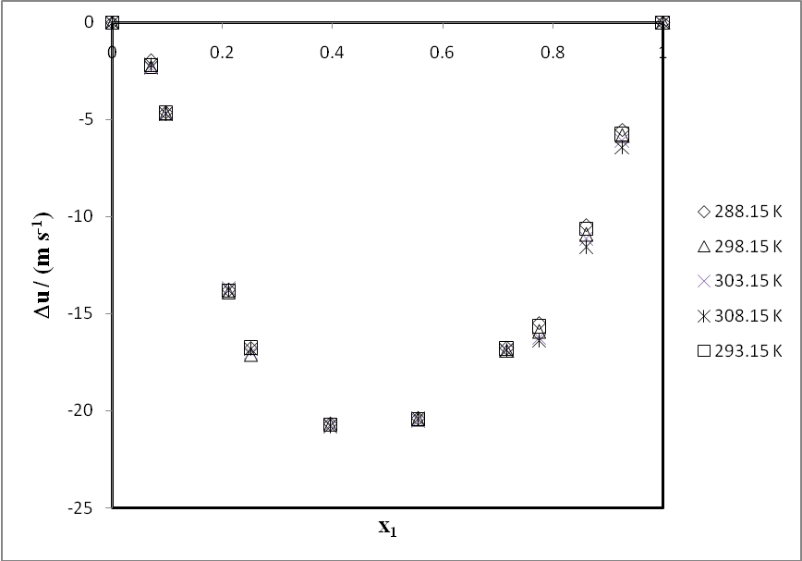
Figure 3 Deviations in speeds of sound Δu for tert-butyl methyl ether (1) + propyl amine (2) mixtures at different temperatures

Figure 4 Deviations in speeds of sound Δu for tert-butyl methyl ether (1) + dipropyl amine (2) mixtures at different temperatures.
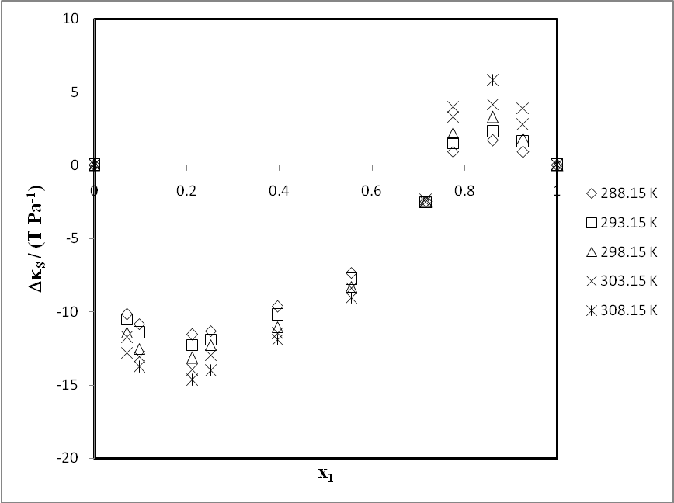
Figure 5 Deviations in isentropic compressibility Δκ_{S} for tert-butyl methyl ether (1) + propyl amine (2) mixtures at different temperatures.

Figure 6 Deviations in isentropic compressibility Δκ_{S} for tert-butyl methyl ether (1) + dipropyl amine (2) mixtures at different temperatures.

References:
- Bhandakkar V. D. & Shweta S. Rode, Advances in Applied Science Research, 2012, 3 (5), pp 3223.
- Bhandakkar V. D. and Asole A. W. Ultrasonic study of hydrogen bonded complexes in benzene solution ,Pelagia Research Library, Advances in Applied Science Research, 2013, 4(4): 207-213, ISSN: 0976-8610.
- Bhandakkar V. D. and Sweta S. Rode Acoustical studies on molecular interactions in binary liquid mixtures at 303K, Pelagia Research Library, Advances in Applied Science Research, 2012, 3 (5):3223-3229, ISSN: 0976-8610.
- Bhandakkar V. D., Bhat V. R., Chimankar O. P. and Asole A. W., Thermo acoustical study of Tetrahydrofuran with ethanol using ultrasonic technique at 323K, Pelagia Research Library, Advances in Applied Science Research, 2014, 5(2):80- 85, ISSN: 0976-8610,
- Bhandakkar V.D., IOSR Journal of Applied Physics, 1(5), 2012, pp 38.
- Bloomfield, V. A.; Dewan, R. K. J. Phys. Chem. 1971, 75, 3113.
- Boadman, N. K.; Dorman, F. H.; Heymann, E. J. Phys. Chem. Ithaca 1949, 53, 375.
- Boublik, T.; Nezbeda, I.; Hlavaty, H. “Stastistical Thermodynamics of Simple Liquids and Their Mixtures”, Elsevier: 1980.
- Brandani, V.; Prausnitz, J. M. Fluid Phase Equilib. 1981, 7, 233.
- Brown and J. E. Lane, Pure and Appl. Chem., 45, 1 (1976).
- Burton CJ., J Acoust. Soc.America.20, 1948, pp 186.
- Cezary M.Kinart& Magdalena Klimczak, J of Mol Liq, 148,(2–3),2009,pp 132.
- Chandra Mohan Saxena, Archna Saxena, Ashok Kumar Srivastava & and Naveen Kumar Shukla, American Chemical Science J, 3(4), 2013 pp 468.
- Chandra Mohan Saxena, Archna Saxena, Ashok Kumar Srivastava & Naveen Kumar Shukla1, American Chemical Science J, 3(4), 2013, pp 468.
- Chimankar O.P, ShriwasRanjeeta, Tabhane V.A, Intermolecular Hydrogen bonding formation in aqueous D-Mannitol, Archives of Applied Science Research, 2010, Vol.2, Issue 6, p 285.
- Chiou, D. –R.; Chen, L. –J. J. Chem. Eng. Data2001, 46, 1530.
- Chunping Li, Jianbin Zhang, Tong Zhang, Xionghui Wei, Enqi Zhang, Na Yang, Nana Zhao,MinSu, & Hui Zhou, J. Chem. Eng. Data, 55, 2010, pp 4104.
- Cobos, J. C.; Villa, S.; Riesco, N.; Garcia de la Fuente, I.; Gonzalez, J. A. Fluid Phase Equilib.2001, 113.
- Cobos, J. C.; Villa, S.; Riesco, N.; Garcia de la Fuente, I.; Gonzalez, J. A. Fluid Phase Equilib. 2002, 198, 313
- Cobos, J.C.; Villa, S.; Riesco, N.; Garcia de la Fuente, I.; Gonzalez, J. A.J. Solution Chem. 2003, 32, 179.
- Coivie, J.M.G.; Toporowski, P. M. Can. J. Chem. 1961, 39, 2240.Contreras-Srotosch, M. Afindad1989, 46, 519.
- Conway, B. E.; Laliberte, L. H. “Hydrogen-Bonded SolventSystems”,Edn. Lovington, A. K.; Jones, P.; Taylor; F. London. 1968, p. 139.
- CRC Hand Book of Chemistry and Physics, 60th Ed. (CRC Press, Boca Raton, Florida, 1980)
- Cummings, P. T.; Evans, D. J. Ind. Eng. Chem. Res. 1992, 31, 237.
- D. F. Shirude,Thermo physical and thermodynamic properties of binary and ternary liquid mixtures of toluene with alkanols (C6- C10) at 298.15 to 313.15 K, Doctoral Thesis, PuneUniversity, Pune, Feb. 2006
- D. M. Swamy and K. L. Narayana, Speed of sound and ratio of heat capacity in 1-nonanol, 1-undecanol, and 1-dodecanol, Journal of Chemical and Engineering Data, 38, 617 (1993).
- Danusso F, RC AcdNasLincei, 17, 1954, pp 114, 234 & 370.
- Davis, M.I.; Douhéret, G. Thermochim. Acta1991, 190, 267.
- Davis, M.I.; Douhéret, G. Thermochim. Acta 1991, 190, 267.
- de Schaefer, C. R.; Davolio, F.; Katz, M. J. Solution Chem. 1990, 19, 289.
- Del Grosso, V. A.; Mader, C. W. J. Acoust. Soc. Amer. 1972 52, 1442.
- Diojoputro H &Ismadji S., J.Chem. Eng. Data, 50, 2005, pp 2003.
- Dominguez, M.; Lopez, M. C.; Santafe, J.; Royo, I. M.; Urieta, J. S. J. Chem. Thermodyn.1997, 29, 99.
- Douhéret, G.; Davis, M. I. Chem. Soc. Rev. 1993, 22, 43
- Douhéret, G.; Davis, M. I.; Høiland, H. J. Mol. Liqs. 1999, 80,
- Douhéret, G.; Davis, M. I.; Reis, J. C. R.; Fjellanger, I. J.; Vaage, M. B.; Høiland, H. Phys. Chem. Chem. Phys. 2002, 4, 6034.
- Douhéret, G.; Moreau, C.; Viallard, A. Fluid Phase Equilib. 1985, 22, 289, 1985, 22, 277.
- Douhéret, G.; Pal, A.; Davis, M.I.; J. Chem. Thermodyn. 1990, 22, 99.
- Douhéret, G.; Reis, J. C. R.; Davis, M. I.; Fjellanger, I. J.; Høiland, H. Phys. Chem. Chem. Phys.2004, 6, 784.
- Douhéret, G.; Salgado, C.; Davis, M.I.; Loya, J. Thermochim. Acta1992, 207, 313.
- Douhéret, G.; Viallard, A. J. Chem. Phys. 1983, 80, 809.
- Dubey G.P.& Krishan Kumar, J. Mol. Liq. 180, 2013, pp 164.
- Dymond, J. H. Chem. Soc. Rev. 1985, 14, 317.

1/2/2023

