An International Journal

New York Science Journal
(N Y Sci J)
ISSN 1554-0200 (print); ISSN 2375-723X (online), Monthly
Volume 15 - Number 9 (Cumulated No. 163); September 25, 2022

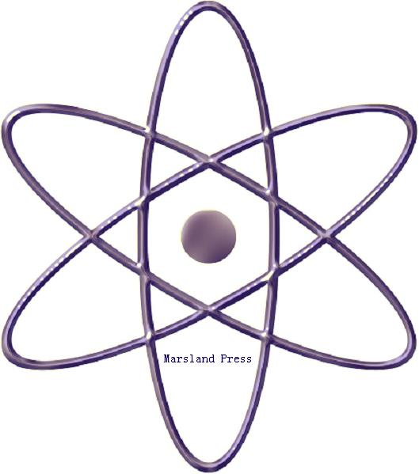

Marsland Press

310 West 18th Street, New York, NY 10011, USA

http://www.sciencepub.net
http://www.sciencepub.net/newyork
editor@sciencepub.net
naturesciencej@gmail.com
(718) 404-5362

New York Science Journal
(N Y Sci J)

ISSN 1554-0200 (print); ISSN 2375-723X (online); Monthly

New York Science Journal is and peer reviewed international journal published with English for the scientists and Engineers. The journal aims to present experimental and theoretical findings of science and engineering and to report on advances in technologies of multidisciplinary subjects. The journal was founded in 2008 by Marsland Press. The Editor-in-Chief, Deputy Editor and editors have backgrounds in Philosophy, Science, Technology and Engineering, etc. This interdisciplinary team is ultimately suited for facilitating the publication of the best of your research work. The journal welcomes manuscripts from all fields in science and engineering research. Papers submitted could be reviews, objective descriptions, research reports, opinions/debates, news, letters, and other types of writings that are nature and science related. Manuscripts submitted will be peer reviewed and the valuable papers will be considered for the publication after the peer review. Authors are responsible to the contents of their articles.

Journal Address:
Marsland Press
310 West 18th Street, New York, NY 10011, USA.
Telephone: (347) 321-7172; (718) 404-5362
E-mail: editor@sciencepub.net; sciencepub@gmail.com;
Websites: http://www.sciencepub.net/newyork

ISSN 1554-0200

© 2022 Marsland Press

