Feeding Habits of Rhesus Monkey, Macaca Mulatta (Zimmermann, 1780)

*Rekha Verma and Dr R K Agarawal

*Research Scholar, Department of Zoology in Kalinga University, Raipur (Chhattisgarh)
**Associate Professor, Department of Zoology in Kalinga University, Raipur (Chhattisgarh)
*Email: Soni.soni1979@gmail.com

Abstract: Food preference of Rhesus Macaques (Macaca mulatta) in the wild was studied in semi-deciduou s and tropical semi-evergreen forest of Pakhui Wildlife Sanctuary in East Kameng District of Arunachal Pradesh, India during the pre-monsoon and monsoon seasons. A group of 25 Rhesus Macaques of different age and sex classes was observed. Data was collected using group scan method. Rhesus Macaques ate 28 plant species, with a preference for 10 species and the order of preference varied in different months. Highly preferred plant species were Udal (Sterculia villosa), Pipal (Ficus religiosa), Jutali (Altingia excelsa), Panijamun (Syzygium syzygioides) and climbers. The monkeys primarily fed on young leaves, mature leaves, fruits, flowers, flower buds, petioles and seeds during study.
[Verma, R. and Aggarwal, R.K.. Feeding Habits of Rhesus Monkey, Macaca Mulatta (Zimmermann, 1780). N Y Sci J 2022;15(6):16-23] ISSN 1554-0200 (print); ISSN 2375-723X (online) http://www.sciencepub.net/newyork. 3. doi:10.7537/marsnys150622.03.

Keywords: Rhesus Monkey, Feedings, Bir Bara, Preferred, Tree species.

Introduction:
Rhesus Monkey (Macaca mulatta) is the well known species among the old world Monkeys. The mega-biodiversity country, India supports eight species of macaques (out of the total ten species) found in South-Asia. Rhesus Macaques are found throughout mainland of Asia; from Afghanistan to India and Thailand to southern China. In India the sub-species of Rhesus Macaques are Macaca mulatta villosa and Macaca mulatta mulatta. The Macaca mullatta villosa is found in the Kashmir and Punjab region of India (the northern part of the country), Pakistan, and Afghanistan. Whereas, Macaca mulatta mulatta is found in India, Bhutan, Burma, Nepal, Bangladesh, Thailand, Laos, and Vietnam.
The endangered and 22 charismatic primate species of the region like Hoolock gibbon (Hoolock hoolock and Hoolock leuconedys) and Golden langur (Trachypithecus geei) have got maximum attention in all the recent distributional and demographic studies.Yet, there is very few information available about the status of the Rhesus Macaques in various protected areas of India. The Rhesus Macaque which is a “Least Concern” species has been put in the Schedule-II category by the Wildlife Protection Act of India, 1972 (amended in 2002). Less and scanty information are available on various aspects feeding habits of rhesus monkey. Hence, the present study was planned to record the ecological studies on Food items preferred for feeding by Rhesus Monkey, Macaca Mulatta (Zimmermann, 1780) in Bir Bara Ban Conservation Reserve Forest in district Jind, Haryana (India)

Study area:
Bir Bara Ban Conservation Reserve Forest (29º17' N latitude and 76°16' E longitude) is located on 5 Km away from Jind city on Jind-Hansi road in the district Jind of Haryana (India) (Fig. 3.2). It is also known as Bihad which is spread over an area of 419.26 hectares. Haryana government notified this area as conservation reserve forest on dated October, 2007. Dominant animal species, namely, Neelgai or Blue bull (Boselaphus tragocamelus), Jackel (Canis aureus), Hanuman Langur (Presbytis entelles) and Rhesus Monkey (Macaca mullata); dominant birds species, namely, Blue peafowl (Pavo cristatus), Rufous treepie (Dendrocitta vagabunda), Greater coucal (Centropus sinensis), Indian grey hornbill (Ocyceros birostris) and Jungle babbler (Turdoides striata); dominant tree species, namely, Kikar (Acasia nilotica), Neem (Azadirachata indica), Shisham (Dalbergia sissoo) and Safeda (Eukalyptus hybrid) and dominant herbs and shrubs species, namely, Bansa (Adhatoda vasica), Kandai (Aegemone maxicana), Kair (Capparis desidua) and Bathua (Chenopodium album) are major supported in Bir Bara Ban Conservation Reserve Forest in district Jind, Haryana (India).

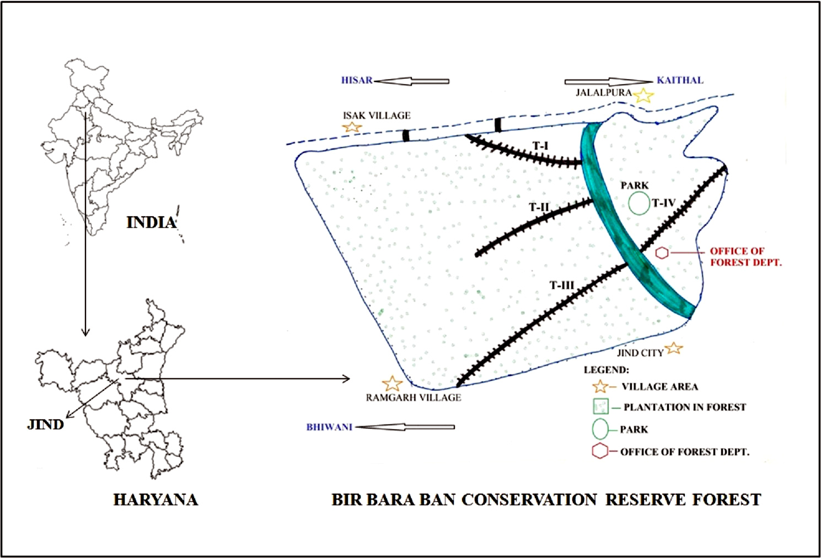
Fig.1 Bara Ban Conservation Reserve Forest in district Jind of Haryana (India).

Methodology:
Point count method (Blondel et al., 1981; Chopra and Kumar, 2009), Scan sampling method (Altman, 1974; Kumar, 2014) and Direct contact method (Barwer, 1971; Chopra and Kumar, 2102) were used to record the food and feeding habits of Rhesus Monkey. Whenever, individuals or troops of Rhesus Monkey were encountered feeding, it was photographed by 3300 D Nikon camera. Those sites where the individual or troops of Rhesus Macaques were observed feeding on particular part of the plant such as seeds/flowers/leaves/bark/gum/stem of tree species, herbs and shrubs were visually scanned and these plants materials were photographed or collected and later identified in the laboratory. Food preference(s) by Rhesus Monkeys were recorded on the basis of the number of instances during which the individuals or troops were founded feeding on the particular food items. Food offered by the local people in the study areas as well as its nearby areas were also observed.

Results and Discussion:
Rhesus macaque depends directly as well as indirectly, on parts of their diet from human activities (Southwick et al., 1985; Richard et al., 1989; Southwick and Siddiqi, 1994). Some of the most common food is given to the rhesus macaques in temples include bread, bananas, peanuts, seeds, fruits, vegetables, assorted miscellaneous foods like ice creams and fried bread (Wolfe, 1992). In less human influenced areas, they focus on fruits, flowers, leaves, seeds, gums, buds, clover, roots, bark and they supplement their food diet with termites, grasshopper, ants, beetles and mushrooms and they also eat birds eggs, shellfish and fish (Fooden, 2000). Rhesus monkey was observed to fed on different parts of 13 species of trees, 2 species of shrubs and 7 species of herbs in Saraswati Plantation Wildlife Sanctuary (SPWS), Haryana (India) (Chopra and Kumar, 2012).
Similarly, in the present study, rhesus macaques was found to feed on 19 species of trees, namely, Acasia nilotica, Acasia Leucopholia, Albizza lebbek, Azadirachata indica, Bauhinia variegate, Cordea dichtoma, Crataeva nurvala, Dalbergia sissoo, Eukalyptus hybrid, Ficus glomerata, Ficus religiosa, Ficus rumphi, Morus alba, Parkinsonia aculeate, Prosopis cineraria, Prosopis juliflora, Salvadora oleoides, Tamarise aphylla and Zizyphus mauritiana in Bir Bara Ban Conservation Reserve Forest (BBBCRF) of district Jind. In present study, rhesus monkey was also found to feed on 9 species of herbs, shrubs and grasses, namely, Ziziphus nummularia, Capparis separia, Brassica compestris, Oryza sativa, Triticum aestivumv, Saccharum officinarum, Trifolium alexandrium, Cheanopodium album and Cynodon dactylon in Bir Bara Ban Conservation Reserve Forest.
Chopra and Kumar (2012) observed that rhesus macaques was used maximum amount of leaves and seed of trees as compared inflorences, seed, gum, bark of stem in Saraswati Plantation Wildlife Sanctuary (SPWS), Haryana (India). Earlier coworkers like Goldstein and Richard 1989; Richard et al., 1989; Southwick and Siddiqi, 1994; Hauser, 1999; Wolfe, 2002; Menon, 2003; Mendiratta et al., 2007; Chopra and Kumar, 2012 was recorded that maximum amount of leaves and seed of trees used by rhesus macaques.
In present study, rhesus macaques was used preferred of plants parts as food items in maximum amount of pod/fruit (26%) and inflorences (26%) followed by seed (19%), gum (13%), leaf (8%), bark (6%) and least amount of stem (2%) in Bir Bara Ban Conservation Reserve Forest (BBBCRF). Also, rhesus macaques was used preferred of herbs/shrubs parts as food items in maximum amount of leaf (32%) followed by pod/fruit (18%), seed (18%), stem (18%) and least amount of inflorences (14%) in Bir Bara Ban Conservation Reserve Forest. Earlier coworkers observed that rhesus macaques also found to feed on fruits, and they supplement their food diet with ants, beetles, termites, grasshopper, mushrooms, birds eggs, shellfish and fish (Fooden, 2000; Sarker et al., 2008; Chopra and Kumar, 2012; Tomar and Sikarwar, 2014).
Similarly, in the present study, rhesus macaques was also found to feed on insect species, namely, termites (Microtermes sp.), leaf hopper (Graphocephala sp.), spotted bollworm (Earias sp.), dung beetle (Sisyphus sp.) and ant (Anoplolepis sp.) in study area. Rhesus macaques was also found to feed on various food items (mainly fruits) such as gram (Cicer arientinum), banana (Musa sp.), watermelon (Citrullus lanatus), groundnut (Arachis hypogaea), apple (Malus sp.) and roti/chapatti, gurh provided by human in both study areas.

Table 1: Tree species used for feeding by rhesus monkey, Macaca mulatta (Zimmermann, 1780) in Bir Bara Ban Conservation Reserve Forest (BBBCRF) of district Jind.
Sr. No. | Tree species | Common name | Order | Plant parts
 |  |  |  | L | I | P/F | B | G | SM | S
1 | Acasia nilotica | Kikar | Fabales | + | + | + | + | + | - | +
2 | Acasia Leucopholia | Nimber | Fabales | + | - | - | + | - | - | +
3 | Albizza lebbek | Siris | Fabales | - | + | + | - | + | - | +
4 | Dalbergia sissoo | Shisham | Fabales | - | + | + | + | + | - | -
5 | Bauhinia variegate | Kachnar | Fabales | - | + | + | - | + | - | -
6 | Eukalyptus hybrid | Safeda | Fabales | - | + | - | - | - | - | -
7 | Prosopis cineraria | Jand | Fabales | - | + | + | - | + | - | +
8 | Prosopus juliflora | Walayti jand | Fabales | - | + | + | - | + | - | +
9 | Syzygium cumini | Jamun | Myrtales | + | + | + | - | + | - | +
10 | Tamarise cumini | Frash | Myrtales | - | + | - | - | - | - | -
11 | Ficus glomerata | Gular | Rosales | - | - | + | - | - | - | -
12 | Ficus religiosa | Peeple | Rosales | - | + | + | + | - | - | +
13 | Morus alba | Sahtut | Rosales | + | + | + | - | + | - | +
14 | Ziziphus mauritinia | Beri | Rosales | - | + | + | - | - | - | +
15 | Crataeva nurvala | Barna | Brassicales | - | + | + | - | - | - | +
16 | Salvadora oleoides | Jaal | Brassicales | - | + | + | - | - | - | +
17 | Ficus rumphi | Pilkhan | Urticales | - | - | + | - | - | - | -
18 | Azadirachata indica | Neem | Spindales | - | - | + | - | - | - | -
19 | Cordea dichtoma | Lasura | Unplaced | + | + | + | - | - | + | +
L- Leaves, I- Inflorences, P/F- Pod/Fruit, B-Bark, G-Gum, SM-Stem, S-Seed, + Present, - Absent

Fig: 2 Part of tree species preferred for feeding by rhesus monkey, Macaca mulatta (Zimmermann, 1780) in Bir Bara Ban Conservation Reserve Forest (BBBCRF) of district Jind.

Table 2: Herb, shrub and grasses species used for feeding by Rhesus Monkey, Macaca mulatta (Zimmermann, 1780) in Bir Bara Ban Conservation Reserve Forest (BBBCRF) of district Jind.
Sr. No. | Tree species | Common name | Order | Plant parts
 |  |  |  | L | I | P/F | SM | S
1 | Ziziphus nummularia | Jhar ber | Rosales | - | - | + | - | +
2 | Capparis separia | Caper bushes | Brassicales | + | - | - | - | -
3 | Brassica compestris | Mustered | Brassicales | + | + | + | + | +
4 | Oryza sativa | Paddy | Poales | + | + | + | - | +
5 | Triticum aestivumv | Wheat | Poales | + | + | + | + | +
6 | Saccharum officinarum | Sugarcane | Poales | - | - | - | + | -
7 | Trifolium alexandrium | Barseem | Fabales | + | - | - | + | -
8 | Cheanopodium album | Amaranths | Caryaphylalles | + | - | - | - | -
9 | Cynodon dactylon | Grass | Poales | + | - | - | - | -

Fig:3 Herb, shrub and grass species part preferred for feeding by rhesus monkey, Macaca mulatta (Zimmermann, 1780) in Bir Bara Ban Conservation Reserve Forest (BBBCRF) of district Jind.

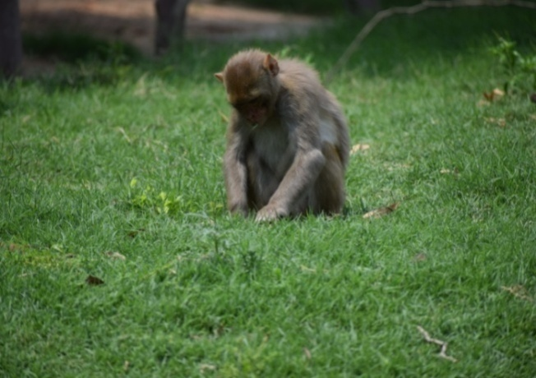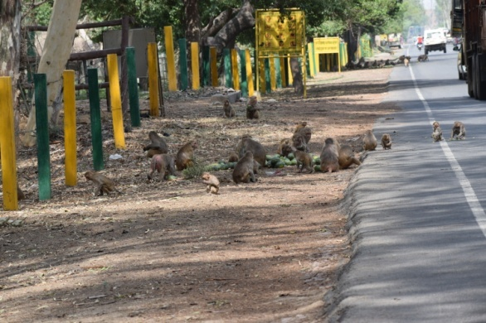
- (b)

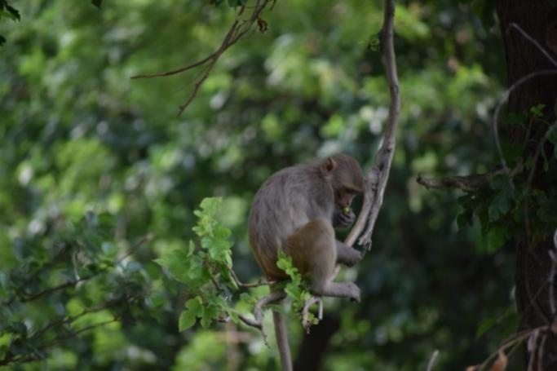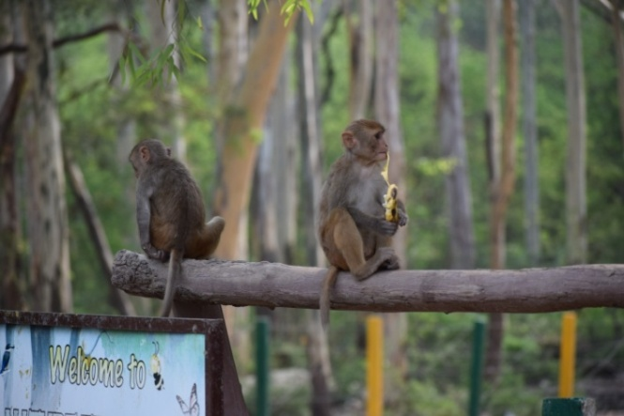
(c) (d)

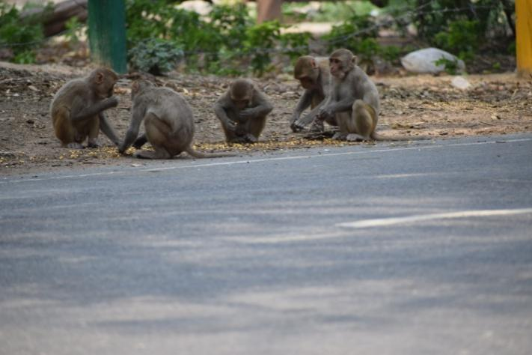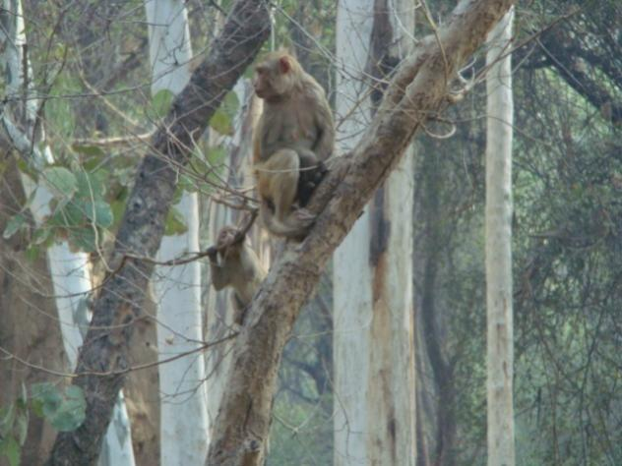
(e) (f)
Fig. 4: Various activity performed by Rhesus Monkey in study area.

Table 3: Insects species used as food by rhesus monkey, Macaca mulatta (Zimmermann, 1780) in Bir Bara Ban Conservation Reserve Forest (BBBCRF) of district Jind.
S.N. | Insects Species |  |  | Food items offered by human being
 | Scientific Name | Common Name | Order | Food items | Scientific name
1 | Microtermes sp. | Termites | Blattodea | Gram | Cicer arientinum
2 | Graphocephala sp. | Leaf Hopper | Hemiptera | Banana | Musa sp.
3 | Earias sp. | Spotted Bollworm | Lepidoptera | Watermelon | Citrullus lanatus
4 | Sisyphus sp. | Dung Beetle | Coleoptera | Groundnut | Arachis hypogaea
5 | Anoplolepis sp. | Ant | Hymenoptera | Apple | Malus sp.
6 | - | - | - | Roti/ Chapati | -
7 | - | - | - | Gurh | -
+ Present, - Absent

Conclusion
Differences in ecological variables such as food provisioning, absence of predators, and restricted home ranges between the Cayo Santiago macaques and their wild counterparts are associated with differences in the demographic structure of the populations, which in turn, may affect social dynamics and behavior. In addition, the ecological characteristics of the Cayo Santiago population affect the time budgets of rhesus macaques and increase the time available for social activities with conspecifi cs. Consequently, the frequencies of affi liation, aggression, and other social interactions, both within and between groups, may be much higher on Cayo Santiago than among macaques living in Asian forests. Food provisioning in itself can be associated with increased between- and within-group aggression. The presence of supernumerary adult males on Cayo Santiago, their limited opportunities for dispersal, and the tense and competitive nature of male–male relationships may result in potential alterations in the patterns of mating behavior within groups and in the mechanisms by which adult males rise in rank. Finally, the large size of groups and matrilines on Cayo Santiago may be associated with differences in female social networks, the benefi ts and costs of high versus low rank, and differences in maternal behavior and social development. Although Cayo Santiago represents in many ways an ideal site for studies of social dynamics and behavior, the unique ecological and demographic characteristics found on this island suggest that caution should be used when extrapolating fi ndings from this population to other populations of the same or other primate species. The same caution should also be used in studies of other primate species, as differences between populations in predation pressure, food availability, or demographic structure could result in signifi cant differences in behavior and social dynamics.

References:
- Altamann J. (1974). Observational study of behaviour: Sampling methods. Behave, 49: 227-267.
- Devi O.S. and Saikia P.K. (2008). Human-Monkey Conflict: A Case study at Gauhati University Campus, Jalukbari, Kamrup, Assam. Zoos' Print,2: 15-18.
- Gupta R.C. and Kumar S. (1991). The feeding habits of free ranging rhesus monkeys, Macaca mulatta (Zimmermann). Geobios, 19: 226-230.nd Jolly A. (1985). The Evolution of Primate Behaviour, 2 Edition, Macmillan, New York.
- Lindburg D.G. (1976).Dietaryhabits ofrhesusmonkeys (MacacamulattaZimmermann) in Indian Forest. J.Bombay Nat.Hist.Soc.,73:261-269.
- Lindburg D.G. (1977). Feeding behavior and diet of Rhesus macaques (Macaca mulatta) in a Siwalik forest in north India. In: Primate Ecology (T.H. Clutton-Brock Ed.), Academic Press, London, pp.223-249.
- Makawana S.C. (1979). Field ecology and behaviour of the Rhesus macaque (Macaca mulatta): Food, feeding and drinking in Dehradun forests. Indian forester, Indian Jr. of Forestry, 23 : 242-253.
- Malik I. (1983). A study of selected behavioral traits of Rhesus monkeys (Macaca mulatta) in free ranging environments. Ph.D. Thesis,University of Meerut.
- Malik I. (1986). Time budgets and activity patterns in free ranging rhesus monkeys. In: Primate Ecology and Conservation (Else, J.G. and Lee, P.C. Eds.), Cambridge University, Yew York, pp.105-114.
- Malik I., and Southwick D.H. (1988). Feeding behavior and activity patterns of rhesus monkeys (Macaca mulatto) at Tughlaqabad, India. In:Ecology and Behavior of Food-Enhanced Primate Groups (Fa, J.E., and Southwick, C.H. Eds.) Alan Liss, New York, pp. 95–112.
- Pelaez F., Gil-Burmann G. and Sanchez S. (2000). Feeding tactics in juvenile rhesus monkeys (Macaca mulatta). Am. J. Primatol., 51:147-152.
- Pirta R.S., Gadgil M. and Kharshikar A.V. (1997). Management of the Rhesus Monkey Macaca mulatta and Hanuman Langur Presbytis entellus in Himachal Pradesh, India. Biological Conservation, 79: 97-106.
- Seth P.K. and Seth S. (1986). Ecology and Feeding behaviour of the free ranging rhesus monkeys in India. Indian Anthropologist., 15: 51-62.
- Siddiqi M.F. and Southwick C.H. (1980). Feeding Behavior of rhesus monkeys (Macaca mulatta) in the North Indian plains. Proceedings of Zoological Society, Calcutta, 31: 53-61.
- Siddiqi M.F. and Southwick C.H. (1988). Food habits of rhesus monkeys (Macaca mulatta) in the north Indian plains. In: Ecology and Behavior of Food-Enhanced Primate Groups (Fa, J.E., and Southwick, C.H. Eds.), Alan Liss, New York, pp.113–124.
- Wolfe L.D. (1992). Feeding habits of the rhesus monkeys (Macaca mulatta) of Jaipur and Galta, India.Hum. Evol.,7 (1): 43-54.

6/6/2022

