Signal Generation Using Micro Ring Resonators for Long Distance Communication

A. Nikoukar, T. Anwar

Faculty of computing, Universiti Teknologi Malaysia (UTM), 81300 Johor Bahru, Malaysia
nikookar7@gmail.com
Abstract: The min idea of this study is to generate soliton signals and transmit over various distances. Optical solitons can be formed when a balance has been established between self-phase modulation and group velocity dispersion within the regime of anomalous dispersion. The consequent governing wave equation is of the nonlinear Schrodinger (NLS) type for long-distance communication systems. The use of soliton transmission is an interesting method due mainly to its potential capability to overcome the effect of fiber dispersion and to provide all optical transmission systems. In this work, series of (MRRs) connected is presented as a soliton pulse generator. The system uses chaotic signals generated by a bright soliton pulse propagating inside a nonlinear MRR system. The chaotic signals can be generated via a set of MRRs. The nonlinear behavior of light within a nonlinear MRR is investigated. Travelling of light inside an MRR system is analyzed by manipulating the variable parameters such as radius, nonlinear refractive index and coupling coefficient of the MRR. In this paper, we investigate the results based on the generation of chaotic signals within nonlinear fiber ring resonator. The mathematical equation of the ring system is solved using the Z-transform method.
[A. Nikoukar, T. Anwar, Signal Generation Using Micro Ring Resonator for Long Distance Communication. N Y Sci J 2022;15(5):47-53] ISSN 1554-0200(print);ISSN 2375-723X (online) http://www.sciencepub.net/newyork. 8. doi:10.7537/marsnys150522.08.

Keywords: Nonlinear fiber optic, Ring Resonator, Soliton, Long distance communication.

1.0 Introduction
Optical soliton can be defined as a single self-reinforcing wave (Shahidinejad et al. 2013) which is able to maintain the signal shapes while traveling with a stable speed (Ali Nikoukar 2014). The Idea of optical soliton incorporates its nonlinearity feature and aims to eliminate and replace fiber optic. Therefore, optical solitons are pulses that travel without distortion because of dispersion or other agents (Amiri et al. 2014).
There are several problems that limit the distance of radio over fiber data transmission (Sauer et al. 2007). The major sources of such problems include dispersion and distortion of the signals (Sharma et al. 2012). If a non-monochromatic light impulse is transmitted through an optical fiber (Yang et al. 2012), its shape changes along the fiber as a consequence of light wave speed dependence on various factors (Banta et al. 2011). The pulse width gradually increases and the peak power of the impulse is reduced (Geng et al. 2011). Dispersion reduces the effective bandwidth and at the same time it escalates the error rate due to an increasing inter (Jin et al. 2011) symbol interference. Distortion is a phenomenon that occurs in fiber optics and some other similar waveguides. Distortion causes the signal to be spread over time (Karel et al. 2010) because of the various propagation velocities of the optical signals for different modes (Nikoukar et al. 2012).
The first wave guide in the world was proposed by J. J. Thomson in 1893 (Rankin and Tirkel), and it was experimentally verified by O. J. Lodge in 1894. Analysis of the propagating modes was done mathematically by Lord Rayleigh in 1897 (Packard 1984) within a hollow metal cylinder. Placing two mirrors in a Fabry-Perot interferometer structure, Gordon Gould (an American physicist credited with the invention of the laser) in November 1957 fabricated a suitable optical resonator (Perrone et al. 1993).
MRR has many interesting and effective applications because of its own nature (Amiri et al. 2012). The first application which comes to mind is the use of MRR in optical delay circuits (Johnson and Huber 2011). Another important field is the use of MRR for dispersion compensation (Amiri et al. 2013b). A single ring resonator integrated with a photo diode could be used, for example, to stabilize a laser diode emitting at a specific wavelength (Carlborg et al. 2010).

2.0 Theoretical Modeling
MRR consists of a single coupler and a single ring. Light of appropriate (Shahidinejad et al. 2012) wavelength is injected into the loop by the input waveguide. Over multiple round trips, the intensity will build up due to constructive interference. Since only some wavelengths resonate within the loop, it functions as a filter (Nikoukar et al. 2013a).

The nonlinearity of fibre MRR is of the Kerr-type wherein the refractive index of nonlinear is given by Equation (1)
(1)
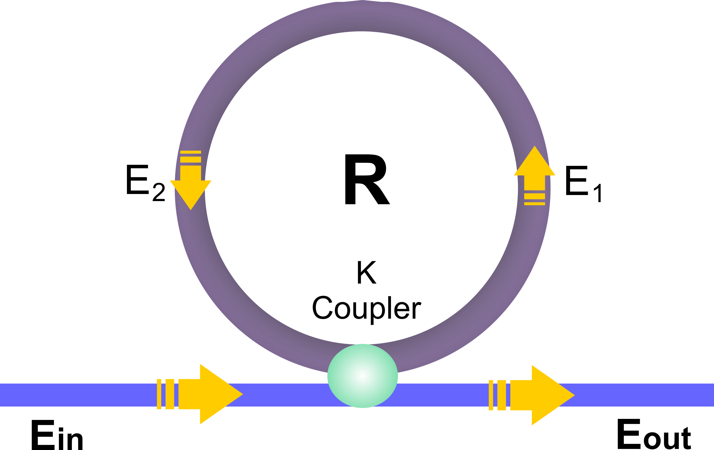
Figure (1) Schematic illustration of a single MRR connected to a fiber coupler.

The relation between the electric fields E1 and E2 can be expressed using the nonlinear form as:
(2)
whereand are expressed as linear and nonlinear phase shifts, is a wave number and L is the circumference of the MRR. represents a round trip loss for the input pulse propagating inside the MRR; the subsequent Equations of the round trip within the system is given by Equation
(3)
where the subscript “n” denotes the number of round trips inside the MRR. Equation (3) has to be satisfied with boundary conditions appropriate to MRR. For the sake of deﬁniteness, we consider an MRR connected to a single coupler that extracts light from the ring into the output waveguides, as schematically shown in Figure (1). For more simplicity, we consider that the coupler device is ideal, where it simply splits the input fields without internal losses at the operating wavelength. We also ignore reflectivities at the coupler–waveguide interface, which is usually a good approximation due to the same structure of the output waveguides and the coupler. With regards to the steady situation of the Equation (4), the output field can be expressed as:
(4)
Thus, the output power of the light field from Equation (4) is given by Equation (5).
(5)

Equation (4) is a mathematical relation used for characterizing the nonlinear effects of the ring resonator system(Amiri et al. 2013a). Optical fields of dark and bright soliton pulse can be inserted into the input port of the multi-stage MRR system expressed by: (6)
(7)
where A is the amplitude of optical fields and z is the distance of propagation, respectively, while t is the soliton phase shift time, and the carrier frequency of the signal is ω₀. T is the required time of a soliton pulse to propagate. The dispersion length of the soliton pulse is described by L_{D} = T²₀/|β₂|I where β₂ is a propagation constant. Optical beams have an internal tendency to spread as they propagate in a homogeneous medium. An optical waveguide is an important device to present a balance between chromatic dispersion and phase shift modulation where the medium is uniform in the direction of propagation. With the MRR device, a balance should be achieved between the dispersion length (L_{D}) and the nonlinear length (L_{NL}) (Dudley et al. 2013) for the temporal soliton pulse, while the spatial soliton can be formed when the balance is established between the diffraction and the nonlinear effect. The nonlinear length can be described by the relation (L_{NL} = (1/γϕ_{NL}), where γ and ϕ_{NL} are the coupling losses of the field amplitude and nonlinear (Nikoukar et al. 2013b) phase shift, respectively.

3.0 Proposed System
Optical soliton is a powerful laser pulse used to expand the optical signal transmission while it propagates within the nonlinear MRR. Additionally, the large output gain is obtained by the soliton self-phase modulation.

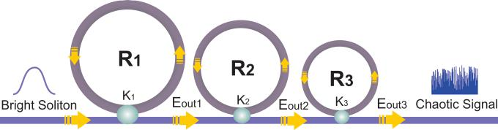
Figure 2. A schematic of the proposed MRR system

Figure (2) shows the different stages of chaotic signal generation. As can be seen in the figure (2) consecutive MRRs have been employed to generate a single trapped peak of the Soliton pulse. The bright soliton pulses input to the first ring resonator have the power of 1 mw. Figure (3) presents the corresponding graphs of the input signal as well as the output at each stage of resonance. As seen in Figure (2), the output of each MRR is used as the input to the next one. The suitable ring radii and coupling coefficients are heuristically calculated as R₁=15µm, R₂=9µm, R₃=7µm, K₁=0.96, K₂=0.94, and K₃=0.92 .The used semiconductor waveguide is InGaAsP/InP, where the effective core areas range fromto 50 μm². The nonlinear refractive index is n₂=2.2 10⁻¹⁷m²/W.

4.0 Result and Discussion
It can be observed from the graphs of the signals that at output of each MRR, the amplitude of the signal has been enhanced and the signal has been sharpened and the corresponding Full width at half maximum (FWHM) (Afroozeh et al. 2012) has been decreased. This results in a single trapped peak at the output of the last MRR as illustrated in Figure (3) and (4).
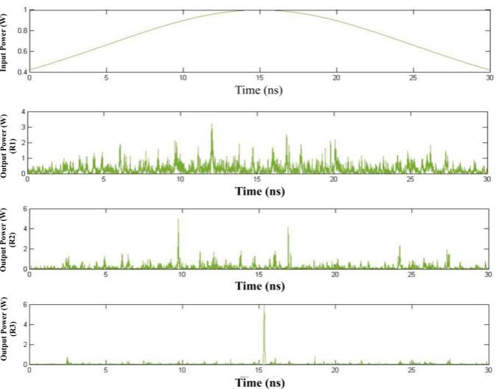
Figure 3. Results of chaotic signal generation with centre wavelength of the trapped peak in the time domain of 15ns (a): input bright soliton, (b): intensity power from R_{1.}
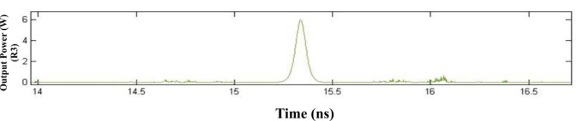
Figure 4. Output of the proposed series of ring resonators with centre wavelength of approx. 15 ns to be transmitted in long distance optical fiber.

The theoretical equations of the presented systems are based on the quantum theory which can be solved using the Z-transform method. In most cases of the chaotic carrier signal generation, quantum theory is necessary for the description of the pulse behavior.
Using the OptiSystem software simulation program (Richards 2012) with similar signal generating components and fiber material and settings, it has been attempted to evaluate the performance of the proposed system in delivering the generated trapped peak of both Soliton and laser pulses over various long distances. The signal at destinations set at distances 0, 20, 50, 100, and 200 km from the generation point has been plotted for the two types of pulses.

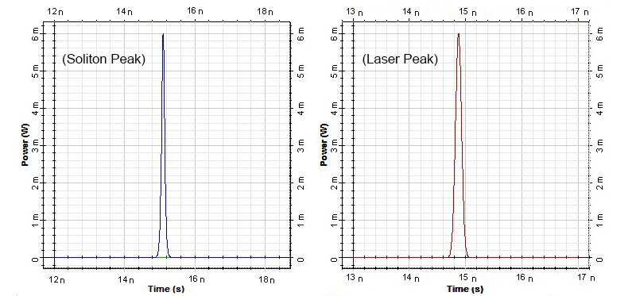
(a1) (a2)
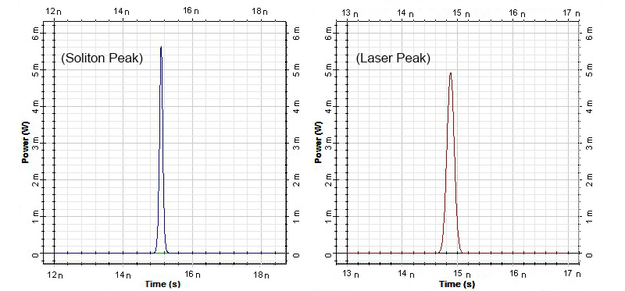
(b1) (b2)
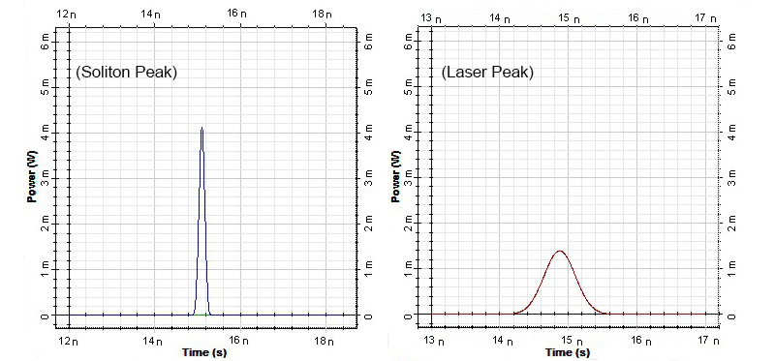
(c1) (c2)
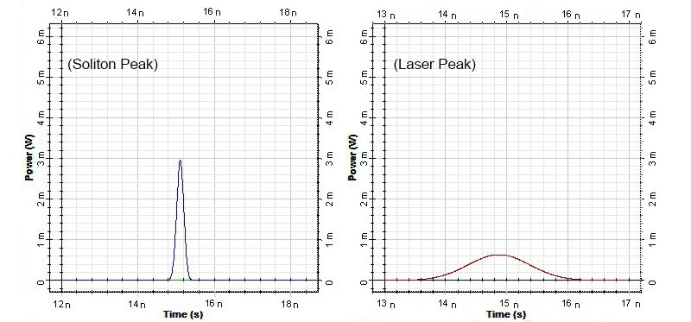

(d1) (d2)
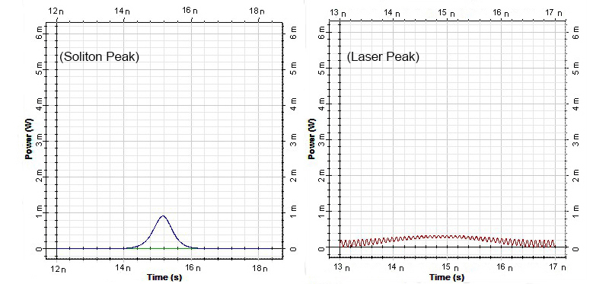
(e1) (e2)
Figure 5. Transmitted signals at the destination for Soliton and corresponding Laser signal: (a1) and (a2) at 0 km, (b1) and (b2) at 20km, (c1) and (c2) at 50km, (d1) and (d2) at 100km, (e1) and (e2) at 200km.

It is evident from the graphs that at longer distances, the Soliton pulse is much sharper and more readable than the laser counterpart. At 200 km, the laser signal is practically lost and almost fades out making it totally unreadable by photo detectors. However, the Soliton signal has the capability of retaining its shape and power with the use of amplifiers although it experiences similar fading and signal loss phenomenon over long distances. This outstanding feature of Soliton pulse makes it ideal for long distance signal transmission.

5.0 Conclusion
A system incorporating multiple MRRs has been proposed to generate a Soliton peak with the feature of providing longer signal transmission while keeping its shape and power allowing overcoming the signal loss problems such as dispersion and diffraction which cause signal loss in conventional laser systems over long distances.

Acknowledgements:

The authors would like to thank Universiti Teknologi Malaysia (UTM) and Faculty of Computing (FC) for providing the research facilities.

Corresponding Author:

Ali Nikoukar
E-mail: nikookar7@gmail.com
Faculty of computing, Universiti Teknologi Malaysia (UTM), 81300 Johor Bahru, Malaysia
References
- Afroozeh, A., Amiri, I., Ali, J., Yupapin, P., Determination of Fwhm for solition trapping. Jurnal Teknologi 2012; 55(1): 77–83.
- Ali Nikoukar, I.S.A.: Soliton and Radio over Fiber (RoF) Applications. LAP LAMBERT Academic Publishing, (2014)
- Amiri, I., Nikoukar, A., Ali, J., GHz frequency band soliton generation using integrated ring resonator for WiMAX optical communication. Optical and Quantum Electronics 2013a: 1-13.
- Amiri, I., Nikoukar, A., Ali, J., Yupapin, P., Ultra-short of pico and femtosecond soliton laser pulse using microring resonator for cancer cells treatment. Quantum Matter 2012; 1(2): 159-165.
- Amiri, I., Nikoukar, A., Shahidinejad, A., Anwar, T., Ali, J., Quantum Transmission of Optical Tweezers Via Fiber Optic Using Half-Panda System. Life Science Journal 2013b; 10(12s).
- Amiri, I.S., Nikoukar, A., Shahidinejad, A., Anwar, T., The Proposal of High Capacity GHz Soliton Carrier Signals Applied for Wireless Communication. Reviews in Theoretical Science 2014; 2(4): 320-333.
- Banta, R.M., Senff, C.J., Alvarez, R.J., Langford, A.O., Parrish, D.D., Trainer, M.K., Darby, L.S., Michael Hardesty, R., Lambeth, B., Andrew Neuman, J., Dependence of daily peak O< sub> 3</sub> concentrations near Houston, Texas on environmental factors: Wind speed, temperature, and boundary-layer depth. Atmospheric environment 2011; 45(1): 162-173.
- Carlborg, C.F., Gylfason, K.B., Kaźmierczak, A., Dortu, F., Polo, M.B., Catala, A.M., Kresbach, G., Sohlström, H., Moh, T., Vivien, L., A packaged optical slot-waveguide ring resonator sensor array for multiplex label-free assays in labs-on-chips. Lab on a Chip 2010; 10(3): 281-290.
- Dudley, J.M., Cherif, R., Coen, S., Genty, G.: Ultrafast Nonlinear Fibre Optics and Supercontinuum Generation. In: Ultrafast Nonlinear Optics. pp. 177-193. Springer, (2013)
- Geng, J., Wang, Q., Jiang, Z., Luo, T., Jiang, S., Czarnecki, G., Kilowatt-peak-power, single-frequency, pulsed fiber laser near 2 μm. Optics letters 2011; 36(12): 2293-2295.
- Jin, X., Hugues-Salas, E., Giddings, R., Wei, J., Groenewald, J., Tang, J., First real-time experimental demonstrations of 11.25 Gb/s optical OFDMA PONs with adaptive dynamic bandwidth allocation. Optics express 2011; 19(21): 20557-20570.
- Johnson, C., Huber, D., OPTICAL INFORMATION SCIENCE. 2011.
- Karel, W., Ghuffar, S., Pfeifer, N., Quantifying the distortion of distance observations caused by scattering in time-of-flight range cameras. International Archives of Photogrammetry, Remote Sensing and Spatial Information Sciences 2010; 38(Part 5).
- Nikoukar, A., Amiri, I., Ali, J., Generation of Nanometer Optical Tweezers Used for Optical Communication Networks. 2013a.
- Nikoukar, A., Amiri, I., Ali, J., Generation of nanometer optical tweezers used for optical communication networks. Int. J. Innov. Res. Comput. Commun. Eng 2013b; 1(1).
- Nikoukar, A., Amiri, I., Shahidinejad, A., Shojaei, A., Ali, J., Yupapin, P.: MRR quantum dense coding for optical wireless communication system using decimal convertor. In: Computer and Communication Engineering (ICCCE), 2012 International Conference on 2012, pp. 770-774. IEEE
- Packard, K.S., The origin of waveguides: A case of multiple rediscovery. Microwave Theory and Techniques, IEEE Transactions on 1984; 32(9): 961-969.
- Perrone, M.R., Piegari, A., Scaglione, S., On the super-Gaussian unstable resonators for high-gain short-pulse laser media. Quantum Electronics, IEEE Journal of 1993; 29(5): 1423-1487.
- Rankin, G., Tirkel, A., HYBRID MODES ON A SINGLE CONDUCTOR WAVEGUIDE.
- Richards, D.H.: Commercial Optical Communication Software Simulation Tools. In: WDM Systems and Networks. pp. 189-232. Springer, (2012)
- Sauer, M., Kobyakov, A., George, J., Radio over fiber for picocellular network architectures. Journal of Lightwave Technology 2007; 25(11): 3301-3320.
- Shahidinejad, A., Nikoukar, A., Amiri, I., Ranjbar, M., Shojaei, A., Ali, J., Yupapin, P.: Network system engineering by controlling the chaotic signals using silicon micro ring resonator. In: Computer and Communication Engineering (ICCCE), 2012 International Conference on 2012, pp. 765-769. IEEE
- Shahidinejad, A., Nikoukar, A., Anwar, T., Selamat, A., Optical wireless quantum communication coding system using decimal convertor. Optical and Quantum Electronics 2013; 45(5): 449-457.
- Sharma, V., Singh, A., Sharma, A.K., Challenges to radio over fiber (RoF) technology and its mitigation schemes–a review. Optik-International Journal for Light and Electron Optics 2012; 123(4): 338-342.
- Yang, P., Law, M., Sirbuly, D.J., Johnson, J.C., Saykally, R., Fan, R., Tao, A.: Nanowires and nanoribbons as subwavelength optical waveguides and their use as components in photonic circuits and devices. In. Google Patents, (2012)

5/22/2022

