**Study Of New Pile Geometry To Reduce Negative Skin Friction On Single Driven Pile And Pile Groups Subjected To Lateral Loads**

Omar shawky1, Ayman I. Altahrany2 and Mahmoud M. Elmeligy3

1 Engineer Omar Shawky, Msc of structural engineering, Faculty of engineering, Mansoura University, Egypt.(eng_omarshawky@hotmail.com)

2 Ass. Professor Dr. Ayman Altahrany, Ass.Professor of geotechnical engineering, Faculty of engineering, Mansoura University, Egypt.(atahrany@hotmail.com)

3 Professor Dr. Mahoumd Elmeligy, Professor of geotechnical engineering, Faculty of engineering, vice president of Mansoura University, Egypt. (M.Meligy@mans.edu.eg)

**Abstract:** Negative skin friction on piles represents a severe problem when piles were installed in soft clay due to consolidation process. It reduces the bearing capacity of piles by adding additional load due to drag load developed on piles. Additional settlement due to negative skin friction might produce threatening consequences such as differential settlements or cracks and can cause failure. This study investigates new techniques to construct piles either single or in groups to reduce NSF developed on the pile surface when the pile is subjected to lateral loads at its top. This study was made for both circular pile and square pile. First technique is to surround the pile by a sand socket along pile length from the ground surface till the neutral plan (NP) location. Second technique depended on changing the geometry of pile surface by adding ridges at equal spaces along pile length. Another change was made by creating equally spaced grooves on the pile surface. It was concluded that all the three techniques were effective in reducing NSF induced in the pile surface. For both circular and square piles when subjected to lateral loads NSF was reduced with ratio of (30%) in case of sand socket and ratio of (97%) for ridged and grooved piles. Also, it should be noted that the effect of lateral loads on the values of NSF has no literature.

[Omar shawky, Ayman I. Altahrany and Mahmoud M. Elmeligy. **Study Of New Pile Geometry To Reduce Negative Skin Friction On Single Driven Pile And Pile Groups Subjected To Lateral Loads.** *N Y Sci J* 2022;15(3):9-27] ISSN 1554-0200(print);ISSN 2375-723X (online) <http://www.sciencepub.net/newyork>. 2. doi:[10.7537/marsnys150322.02](http://www.dx.doi.org/10.7537/marsnys150322.02).

Key words: Lateral load, Pile group, Negative skin friction, drag load, consolidation, soft clay, ABAQUS

**Introduction**

When piles are installed in soft clay, they were subjected to upward shear stress called positive skin friction (PSF) along the pile surface enforces the pile to move downward. Due to soil consolidation the soil moves downward with respect to pile (Fellenius, 1988). For soft clay soil settlement will be larger than pile settlement. In this case the shear stress along the pile will act downward and results in decreasing the pile capacity by increasing the load and the pile is called to be subjected to negative skin friction (NSF) (Indraratna et al., 1992). NSF causes an additional settlement of pile called down drag of pile (Abdrabbo & Ali, 2015). The axial force acting on pile due to NSF represented an additional load on the pile known as drag load (Poulos & Davis, 1972). NSF is time dependent action (Chen et al., 2009) it proceeds with the progress of consolidation process. NSF can affect the pile foundation severely (Chan, 2006). It is common to use piles in group not individually so the group action subjected to effect of NSF is essential to pay attention. When piles are used in groups an influence called shielding effect occurred. That shielding sustains protection to centre piles reducing the NSF on them and sacrificing the outer piles as they are subjected to larger NSF than the centre (Saha, 2015). The shielding effect is prominent by the decreasing of the drag load on piles. Shielding effect directly proportionate with the group size (it increases with the increase of number of piles). This paper is dedicated to study the effect of the lateral loads of the values of the NSF induced along the pile length and the consequent drag load on both circular piles and square piles either on individual piles and pile group.

**Numerical ABAQUS model**

A 3D model will be created using ABAQUS for simulating the behaviour of the single pile and pile groups. Piles were assumed to be in complete contact with the adjacent soil. In this study 2 types of elements (C3D8R and C3D8RP) were used to simulate Concrete piles and soil respectively. These elements are 8-node reduced integration with hourglass control quadratic element, 8-nodetrilinearreduced integration displacement and pores water pressure quadratic element respectively (ِABAQUS, 2014).

**Contact elements**

ABAQUS program has the capability of creating zero thickness contact element between these two elements interface to allow friction stress to be generated between the soil and pile surface. The program uses Coulomb friction theory which determines the frictional response by specifying the coefficient of friction at interface in association of limiting displacement value (γcritical) with a limiting displacement of shear = 5 mm to reach the case of interface friction movement as shown in figure. (1).



Figure 1 Performance of interface element (Lee & Ng, 2004).

**Boundary conditions**

For the vertical sides of model, they should be allowed to move vertically but not allowed to move horizontally so the boundaries should be considered fixed in the horizontal direction and the vertical direction will be free. For the bottom of the model, it is not allowed to move in any direction so the boundaries at bottom will be considered as fixed vertically and horizontally.

**Constitutive models**

Cam-clay model was used to simulate the behaviour of soft clay. The model was designed to simulate the characteristics of normally consolidating clay. The model was induced for completely saturated clay and the stress value is the defined effective stress. Also, Cam clay model has the capability to compute the soil volumetric change that will appear due to consolidation process.

For the bearing layer the Mohr- Coulomb model was used to simulate the behaviour of sand soil located beneath the clay soil to support the pile tip. It is one of the most powerful models used the elastic – perfectly plastic concept to represent such soils with acceptable accuracy and easy to use with few parameters.

**Analysis of circular pile without lateral load**

This investigation will be executed on a circular concrete pile considering its diameter (D) = 0.5 m. The pile length (L) will be taken (L = 20.0 m). It will be installed into consolidated clay layer and the pile should be modelled as full contact with the adjacent clay soil. Taking into consideration the accuracy requirements the dimensions of the model will be presumed as pursued:

At the end of the clay layer beneath the pile tip the bearing sand layer starts and continues to depth (H = 0.7L) which gives depth (H= 20.0 m) for the sand layer. This assumption provides total depth of the soil = 34.0 m. To determine the half width of the soil (W) it will be presumed to be (W = 25D) which makes (W= 12.5m) and the total width becomes 2W= 25.0 m. The full dimensions of the model are illustrated in figure. (2). the surface loading will be taken 100 KN/m2 distributed uniformly on the entire area of clay. The ground water level is considered to be at the ground level this should impose consolidation of soil due to self-weight of soil in addition to surface load employed over the ground surface, and in consequence it will develop NSF and down-drag forces on the pile surface. The time of consolidation (T) is presumed to be enough to let soil settles and NSF to occur from which T will be considered as 5 years. As mentioned previously a zero-thickness contact interaction element is created to present the pile-soil interface. It used 2 characteristics of interaction built-in the finite element software (one called tangential and the other is called normal) to allow friction stress to develop on the pile perimeter. These data are summarized as shown in table (1) & (2) and (3).

Table (1) clay layer properties were chosen for analysis (El-Meligy, Mahmoud Ayman I and Mohamed, 2016)

|  |  |
| --- | --- |
| Material | Clay |
| Density γ (KN/m3) | 18 |
| eo | 1.6 |
| κ | 0.012 |
| λ | 0.14 |
| M | 0.98 |
| Poisson Ratio | 0.35 |
| Elastic modulus (MN/m2) | 5.0 |
| Permeability coefficient  K (m/s) | 1*10-8 |

Table (2) Sand layer properties were used in analysis.(El-Meligy, Mahmoud Ayman I and Mohamed, 2016)

|  |  |
| --- | --- |
| Material | sand |
| Density γ (KN/m3) | 20 |
| eo | 0.90 |
| Cohesive strength C (KPa) | 0.0 |
| Friction angle φ | 35o |
| Poisson Ratio | 0.33 |
| Elastic modulus (MN/m2) | 50 |
| Permeability coefficient  K(m/s) | 1*10-5 |

Table (3) Concrete model properties were used in the analysis.(El-Meligy,Mahmoud, Ayman I and Mohamed, 2016)

|  |  |
| --- | --- |
| Material | Concrete |
| Density γ (KN/m3) | 25 |
| Pile Diameter (m) | 0.5 |
| Pile length (m) | 20 |
| Elastic modulus (KN/m2) | 2.1*107 |
| Poisson Ratio | 0.33 |

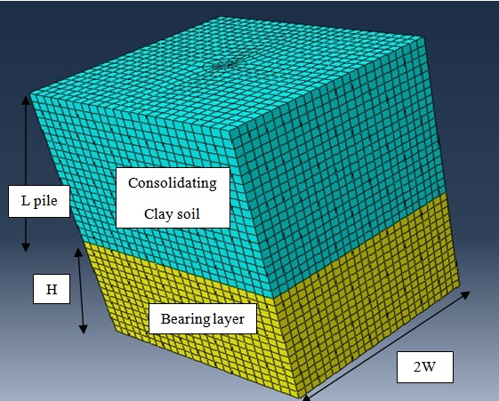

Figure. 2 Geometry and mesh of model.

**4. Analysis of circular pile with lateral load**

Model will be executed to investigate the influence of the lateral load on the value of NSF developed on the pile. The horizontal value was chosen to be (10KN) acting at the top of pile.

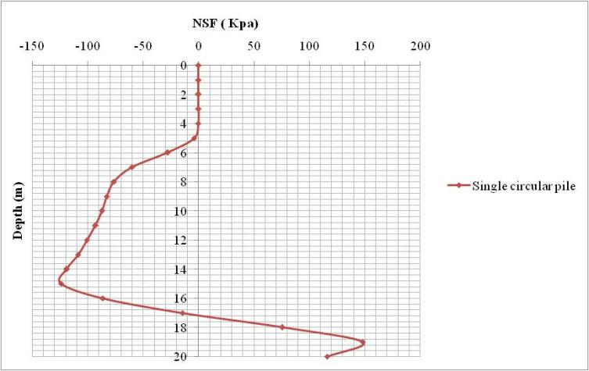

Figure. 3 Distribution of NSF on circular pile with horizontal load.

Figure.(3) illustrated the distribution of NSF along the pile length due to the pile exposure to lateral load at the top. The calculated NSF distribution along the pile shows large reduction of the NSF values from the top of pile till it reach depth of (5.0) m. The values are very small approach to zero then they gradually increased to reach the maximum value of NSF. This result was matching with the prediction concluded from the settlement of pile and soil shown in figure.(4). This result was due to the lateral resistance of soil developed from the lateral load and increase of soil stress. It is known that when piles are horizontally loaded the response process is to carry the horizontal load to the surrounding soil by soil lateral resistance as illustrated in figure (5). The upper part of piles tends to move horizontally in the same direction of load. This resulted in developing rotation and bending moment or complete shift of the piles.

The piles will push soil ahead of their surface in the direction of load which creates a compression stress and shear stress inside the soil layer that will resist the pile shift. Hence the equilibrium condition should be between the applied horizontal loads against the resistance of soil developed on full piles surfaces. The curve indicated that the effect of the horizontal load continues along pile surface till the depth 4.0 m. then it decreased gradually from which the value of NSF began to increase.

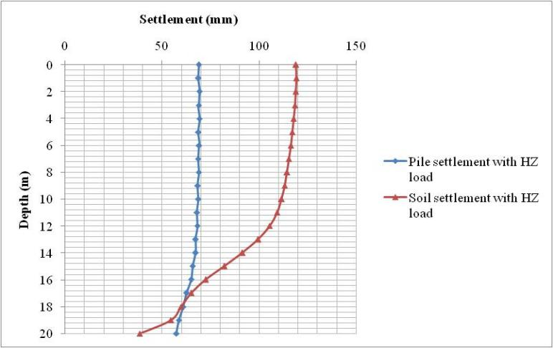

Figure. 4 Settlement of pile and soil with lateral load.

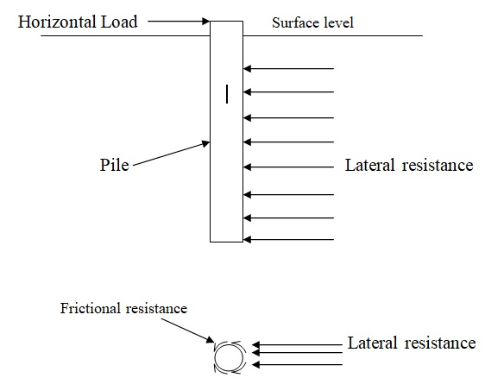

Figure. 5 Soil resistance of lateral load on piles.

Figure (6) shows the distribution of drag load along the pile surface.

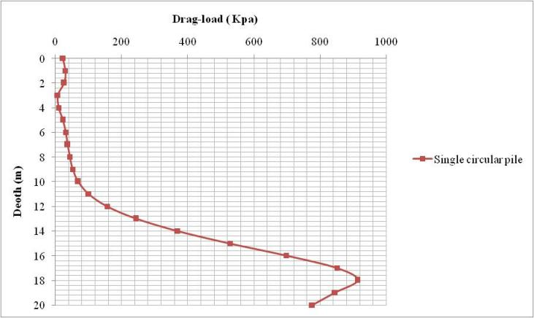

Figure. 6 Drag load distribution along the circular pile surface with lateral load.

The result of the drag load illustrated that drag force at the top of pile was slightly small and decreased to be marginally above zero at depth (3.0 m) and started to increase gradually beneath (depth 4.0 m). These findings of drag load are matching the conclusion from NSF curve as the effect of lateral load decreased beneath depth of (1/5 of pile length) of pile length. The resulted drag load showed an agreement with the prediction concluded from settlement.

**5. Analysis of square pile with lateral load**

A new model was created to simulate a square pile with equivalent perimeter to the circular pile. The side length was taken (40 cm) to give the same pile surface area in contact with soil. The model used same parameters and load values applied on the circular pile model. The pile was subjected to lateral load (10 KN) at the top to investigate the behavior of the square piles compared to circular ones. Figure.(7) Shows the distribution of NSF on square pile with lateral load.

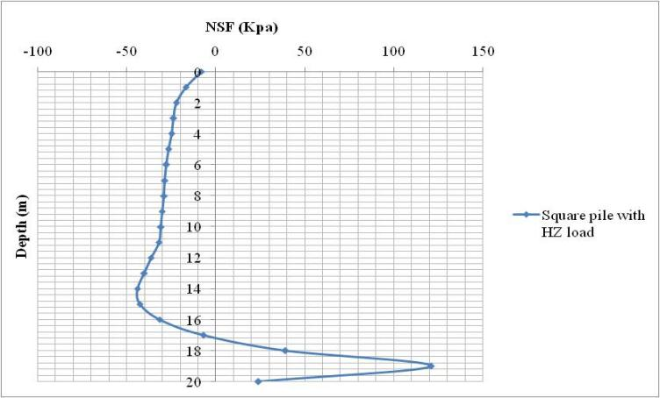

Figure. 7 NSF distribution along square due to lateral load.

It is clear that maximum value of NSF for square pile is less than NSF developed on circular pile. Circular pile provided better behaviour at the top of pile where the NSF is approaching to zero at the first 3 meters then it was gradually increased due to the action of horizontal load on the pile. In the case of the square pile the behaviour of NSF on the pile surface did not have been influenced by subjecting to horizontal load. Figure. (8) Showed the drag load distribution on the square pile surface when subjected to lateral load. It was observed that the value of the drag load of square pile is (10.5%) less compared to the circular pile under horizontal load. This result agrees with computed NSF previously figure. 7.

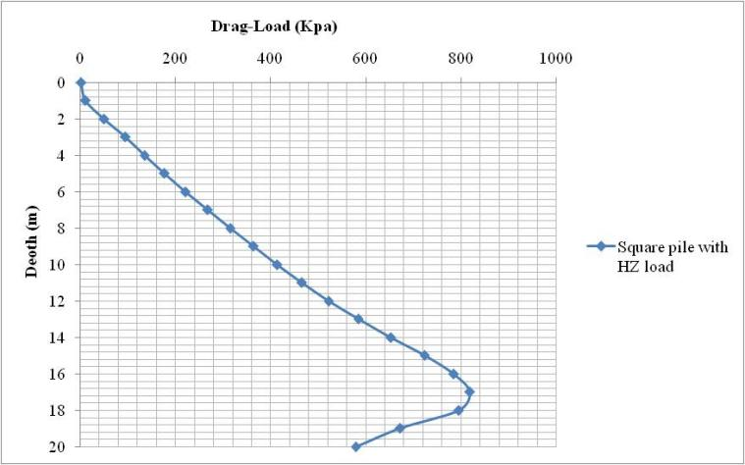

Figure. 8 Distribution of drag load along square pile subjected to horizontal load.

The NSF distribution of the square pile was largely influenced due to the existence of horizontal load on the pile and the values were more than the circular pile on the top 6.0m of pile. Then the maximum NSF was reduced from this point to be less than the NSF developed on the circular pile to reach about (73.3 % less). It is clear from these findings that square piles provide better behaviour for developed NSF under lateral loads.

**6. Analysis of laterally loaded circular pile inside sand socket**

The problem of NSF induced along pile surface resulted from the relative displacement between soil and pile. NSF is increasing the settlement on the pile and reducing the bearing capacity of pile. To overcome that problem many concepts were discussed before. Researchers suggested increasing pile length, increase diameter, and the most common solution was the bituminous coating of the pile surface.

In this research a new concept of wrapping the pile with sand was discussed. The mean idea is to replace the longitudinal layer of clay just in contact with pile with thin layer of sand. The layer of sand should be thick enough to isolate the pile movement from the soil movement and not thick enough to act as sand drain. Existence of sand around pile should change the nature of NSF behaviour along the pile surface. It is known that pile loads are distributed in sand using arch trajectory which helped to dissipate the loads into soil which may influence on the clay layer behind sand and decrease the clay settlement. In addition, the high friction of sand will affect the pile settlement inside soil reducing the relative displacement between pile and soil which should reflect on the values of NSF and drag loads developed on pile.

The concept of sand socket is to set out an area (1.0 m *1.0 m) around the pile with depth of the neutral plan (18.0 m) to cover all the depth of NSF and replace the clay in this volume with sand. According to these dimensions the thickness of socket will be (0.25 m). The properties of replacing sand will be as determined in the previous table of sand properties.

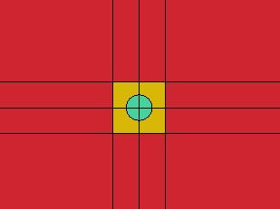

Sand socket

Clay layer

Pile

Figure. 9 Plan of pile inside sand socket.

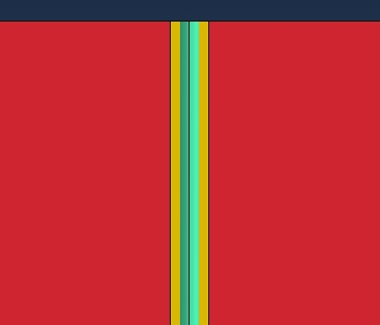

Sand socket

Pile

Clay layer

Figure. 10 Longitudinal section of pile inside sand socket.

Figure. 11 showed the NSF along the pile inside the sand socket compared to the NSF of pile inside the clay layer. The NSF developed on the pile inside sand socket was less than the NSF developed along the pile in clay. The reduction is about 25% of the NSF and the NP was moved upward and its new. location was determined to be at depth (16.5 m) inside the socket.

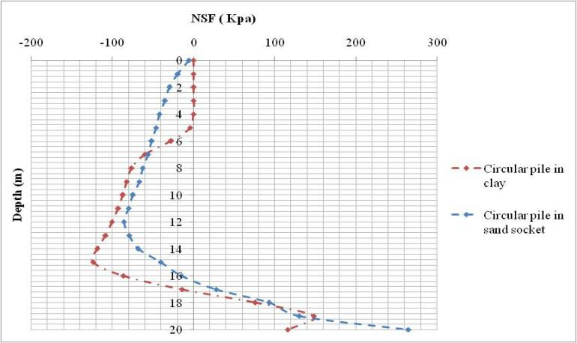

Figure. 11 NSF distribution along laterally loaded circular pile in clay and inside sand socket.

The reason for this decrease was the reduction of the relative displacement between soil and pile as predicted. The relative displacement was calculated to be (8.172 mm). The relative displacement of pile and soil the case of clay soil was computed to be (59 mm) which indicated the significantly reduction occurred due to the sand socket influence on the movement of the pile. Relative displacement was changed as a result of increase in pile settlement and decrease in soil settlement. In consequence of that reduction NSF along the pile surface was decreased.

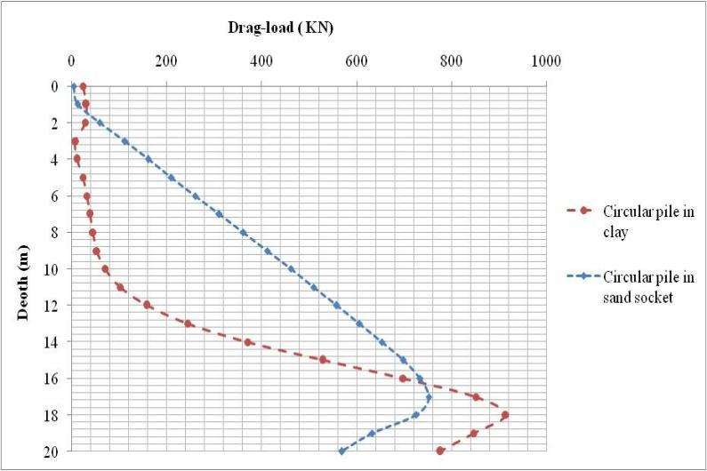

Figure. 12 Drag load distribution along laterally loaded circular pile in clay and inside sand socket.

**6.1 Installation of pile**

To execute this technique of piling a different procedure should be used. Steps of that procedure can be pointed as follows:

1- Excavate the area surrounding the pile (i.e 1x1 m2) with the total length of pile.

2- Fill the total excavation area with clean pure sand till the ground surface.

3- prepare the upper surface of sand by levelling the surface.

4- Piles must be lifted from the stacking locations only at the designed points.

5- A helmet and its packing should be carefully centred over the pile.

6- Hammer location should be tested to ensure that it gives a concentric push.

7- Hammer should preferably weigh not less than the pile as per BS-8004.

8- Power of the hammer should be sufficient to reach a penetration distance of about 5mm per blow.

9- Drop should be limited to 300 mm for sand soil as per BS-8004.

**7. Analysis of laterally loaded square pile inside sand socket**

Same analysis was repeated on the square pile with same parameters to investigate the effect of sand socket on the square pile. In the previous analysis square pile subjected to lateral load provided better results of NSF and drag loads compared to circular pile.

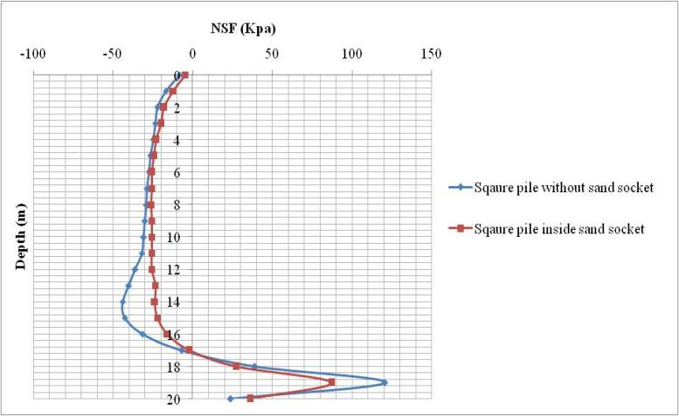

Figure. 13 NSF distribution along laterally loaded square pile in clay and pile inside sand socket.

Figure. 13 illustrated the NSF along the square pile inside clay and inside the sand socket. Maximum NSF on the pile sand socket is less than the NSF developed on the pile in clay with about (20 %). The NP location almost did not change. These results support the claim that square piles can provide better values of NSF when subjected to lateral loads. The behavior of square pile in sand socket can be more clearly noticed from the drag load result. Figure. 14 showed that drag load due to sand socket was less with (210 KPa) (20 %) than the pile in clay.

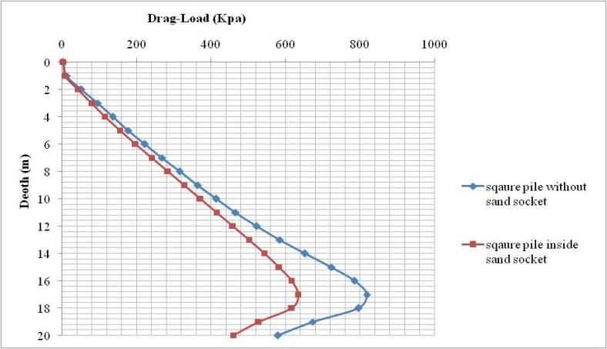

Figure. 14 Drag load distribution along laterally loaded square pile in clay and inside sand socket.

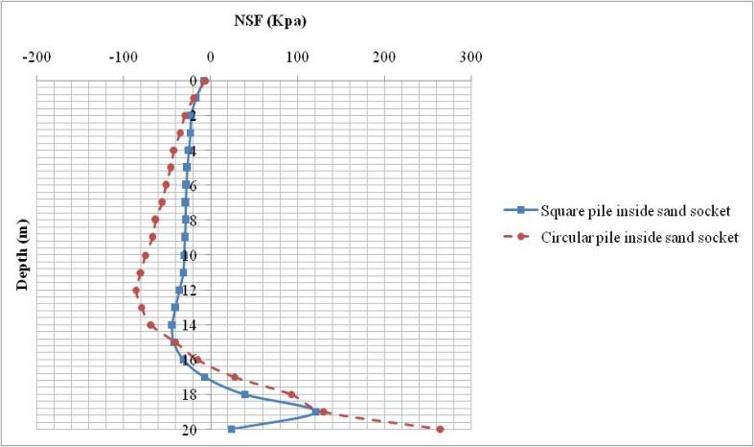

Figure. 15 NSF distribution along laterally loaded square and circular pile inside sand socket.

Also, it is noted that NSF on square pile in sand socket is less than NSF on circular pile in sand socket with (75%) as shown in figure. 15.

**8. Analysis of laterally loaded pile groups inside sand socket**

Circular pile group and square pile group sized (3x3) were created in sand sockets. Depth of sand socket was taken at depth (17.0 m) for all piles. Same parameters were repeated in the pile group analysis. The lateral load is (10 KN) on all piles in the two groups. This analysis was run to investigate if the sand sockets will be effective when they were executed in pile groups.

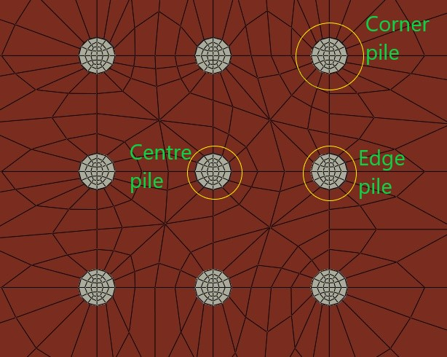

Figure. 3 Classification of piles in group (3x3).

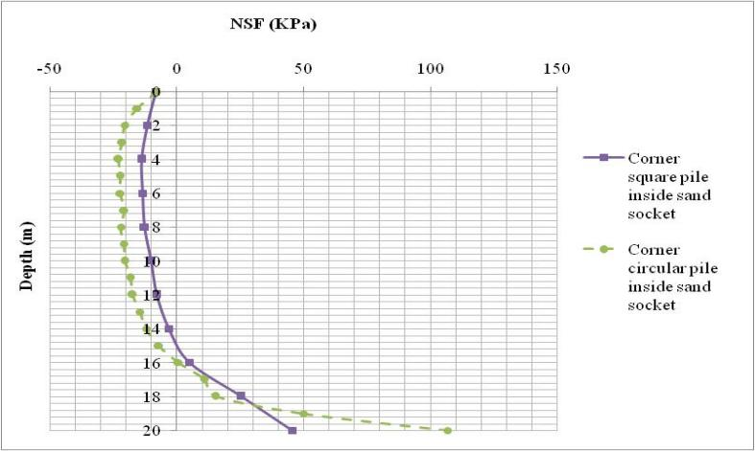

Figure. 17 NSF distribution along laterally loaded corner square pile compared to corner circular pile inside sand socket.

Figure. 17 shows the NSF distribution on the corner piles in the circular pile group against the corner pile in the square pile group. It is obvious that square pile provided NSF value less than the NSF developed on the circular corner pile. This outcome actively demonstrated that sand socket around pile in groups is effectively working. The NSF developed on the corner piles which considered the lowest protected piles in the group is less than NSF induced on the single piles either square or circular. Also, it is clear that the square pile inside sand socket provided better behavior than circular pile in sand socket same as single pile did.

Figure.18 showed matching outcome. It could be noticed from the results of drag loads of square corner pile which is largely less than drag load developed on the corner circular pile due to the existence of sand socket around the piles.

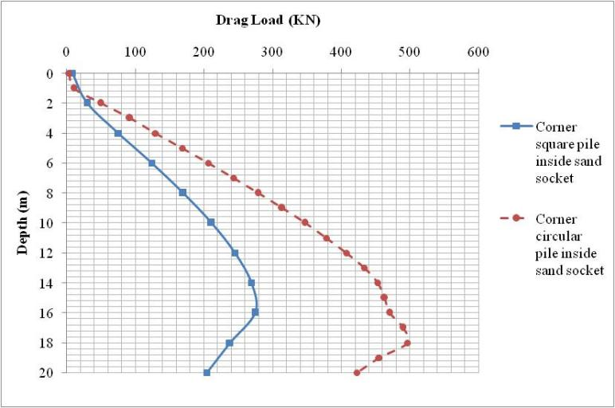

Figure. 18 Drag load distribution along laterally loaded corner square pile compared to corner circular pile inside sand socket.

The findings of the edge piles and center piles were emphasizing on the same conclusion as shown in the following figures.

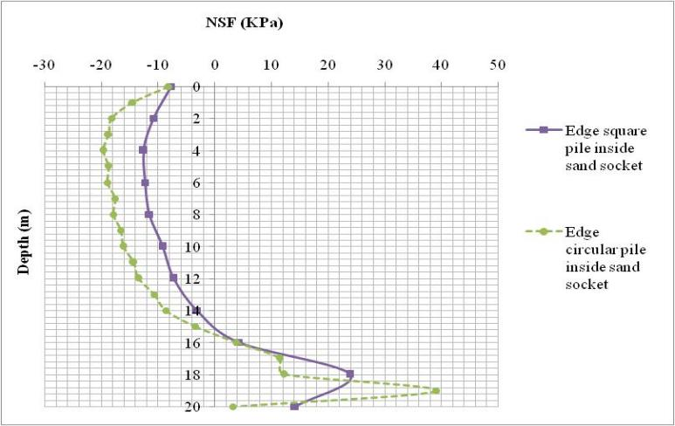

Figure. 19 NSF distribution along laterally loaded edge square pile compared to edge circular pile inside sand socket.

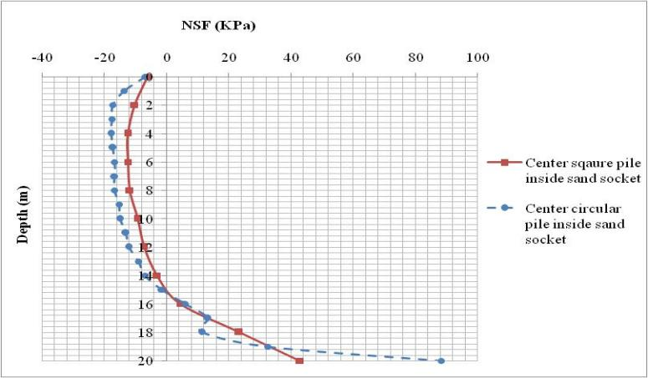

Figure. 20 NSF distribution along laterally loaded center square pile compared to center circular pile inside sand socket.

It was clarified from the previous analysis that sand socket around piles has enhanced the behavior of laterally loaded piles. It worked as an isolation zone surrounding the piles from the clay layer. The sand layer reduced the settlements and as consequence NSF and drag load have been largely decreased for both cases single pile and pile groups.

**9. Analysis of new ridged circular pile**

New concept was discussed in this search to reduce NSF on piles. The common solution for this problem is bituminous coating of pile. Coating is effective in reduction of NSF but it is not cheap solution to be used. As the piles are used in groups not individually the cost of coating all piles in site will be highly expensive. The new concept is depending on changing the pile surface to decrease the settlement of pile and soil. When settlement is decreasing the relative settlement between pile and soil should be decreased and NSF will be reduced in consequence.

The New shape is formed by adding ridges around the pile at constant spacing along the pile length. These ridges will be formed by increasing the diameter of pile to be (60 cm). The depth of the ridge is (10 cm). Spacing between ridges is taken (100 cm). Figure. 21 illustrated the pile in new shape.

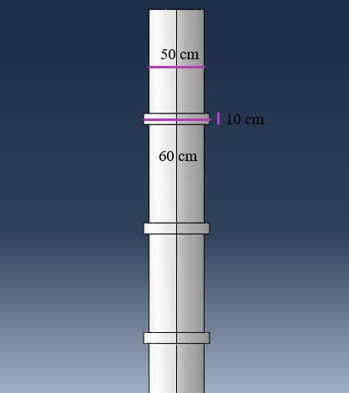 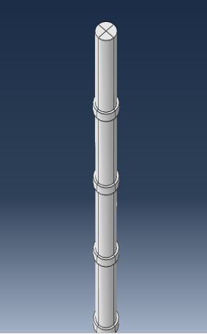

Figure. 21(a) Dimensions of the ridges (b) 3D view of ridged pile.

Model has been executed with the same soil parameters. Pile length and clay soil depth was (20.0 m) sand layer was (14.0 m) using the same geotechnical parameters.

This change of shape should increase the surface roughness and as consequence it was supposed to reduce soil movement which could enhance the behaviour of the NSF on pile surface and decrease the drag load and increase the group efficiency.

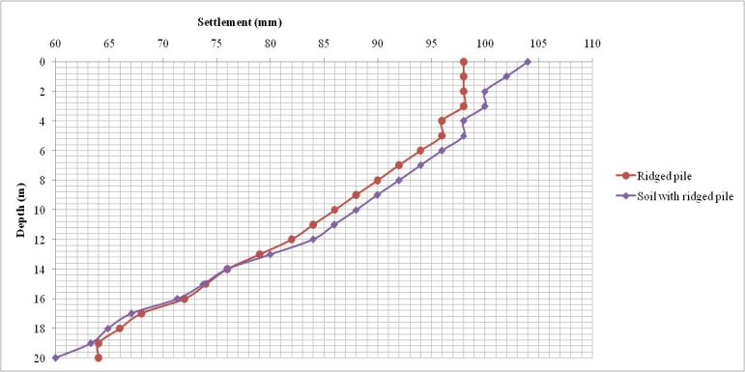

Figure. 22 Settlement of ridged pile and surrounding soil.

Figure. 22 showed the settlement of pile and soil under surcharge loading. It was illustrated clearly that the settlement of soil was substantially reduced (about 90 mm) as it was believed to happen. The pile settlement was also slightly reduced compared to normal pile settlement. From the figure it is noticed that the point of intersection of the two lines was raised up to the mid pile which give the location of the NP. The location of the NP could indicate that NSF would be decreased and limited above the mid pile then it will turn to the other side to become PSF. The intersection of the two lines was observed at depth (14.0 m) which determines the location of NP.

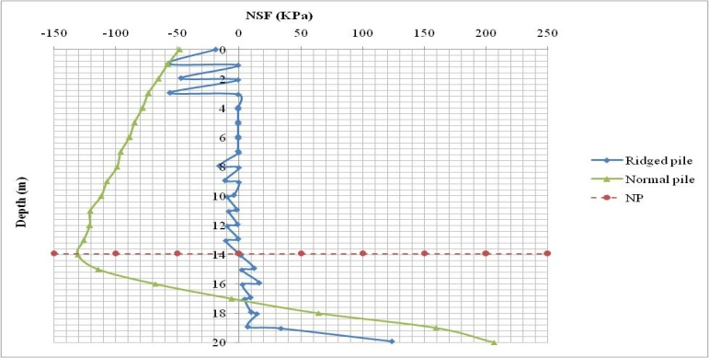 Figure. 23 NSF distribution along ridged pile.

Figure. (23) Showed the distribution of NSF on pile surface. It clarified that at the interval points on pile (0,1,2,3,…..) NSF values developed substantial reduction in comparison with normal pile. In the distance between segmental points the values of the NSF were changed horizontally the change represented the stresses developed over the horizontal ridge that was created to reduce soil settlement. This horizontal stress zones indicated that the ridges may act in bearing and this can be accepted as the horizontal zone ridges could not handle friction stress. At depth (14.0 m) the location of NP became clearly noticed as the stress at segmental pints transferred to the other side induced the path of PSF till the tip of the pile. If the horizontal stress on ridge were ignored and taking into consideration only the stresses at segmental points figure. (23) Should be changed to figure (24) shown below.

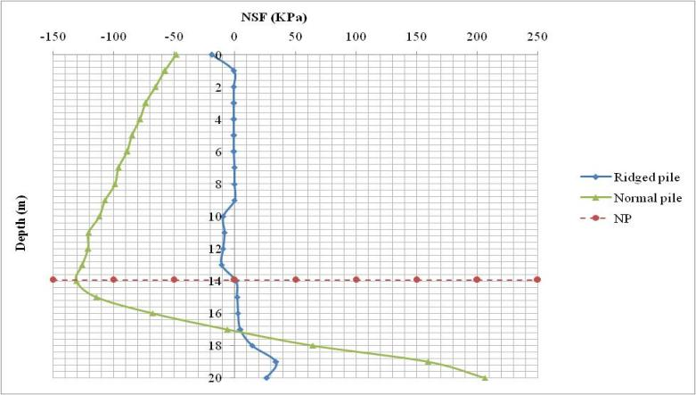

Figure. 23 Modified NSF distribution along ridged pile.

Those results illustrated that the new suggested ridge created every (1.0 m) along the pile was very beneficial and allowed the values of NSF to decrease, the location of NP was raised up (17.8 %) compared to the normal pile.

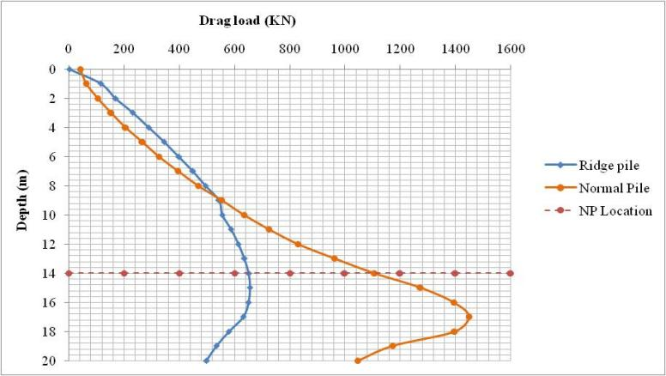

Figure. 24 Modified drag load distribution along ridged pile.

Figure. (24) Illustrated the drag load on the ridged pile compared to drag load on normal pile. The values of drag load were found to be divided into two portions. The values above NP were close to the values of normal pile and the differences are small in a range of (30-50) KN. When crossing the NP, the values of ridged pile drag load were substantially reduced and when compared to the values of normal pile it will be noticed that the reduction was (57.1%). Results of the drag loads support the prediction of the ridged pile efficiency to enhance the values of NSF and drag load through the ridges were created along the pile.

**10. Analysis of new ridged circular pile subjected to lateral load.**

Next analysis was to apply the lateral load (10 KN) at the top of the pile. The analysis aimed to investigate the influence of ridges on the behaviour of the lateral loaded pile. Previous analysis illustrated that lateral load can reduced the NSF and drag load on piles and also ridges caused plenty amount of reduction of NSF values. Predictions of this analysis results lead to large decrease of the NSF value.

Figure. 25 Showed the NSF distribution along the ridged pile length for both cases non-laterally loaded pile and the laterally loaded pile. Obviously values of NSF along ridged laterally loaded pile were substantially reduced. Maximum values of NSF were less than (-4.0 KPa) at mid length of pile and all other values were less than (-1.0 KPa). The location of NP was raised to appear at depth of (11.5 m).

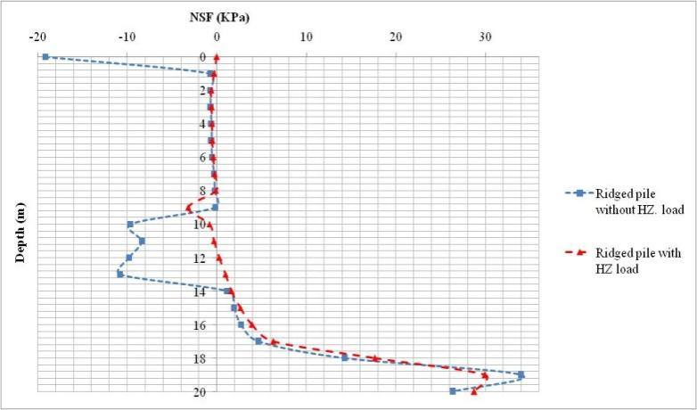

Figure. 25 Distribution of NSF along ridged circular pile with HZ load compared to ridged pile without HZ load.

Results clarified that ridges were of great influence on the behaviour of laterally loaded piles. The concept of ridges was effective and reduced the values of NSF more than (98 %). This concept could be a significant replace of the bituminous coating as which is highly expensive.

**11. Analysis of new ridged square pile**

Same concept of ridges was applied on the square pile. Ridges with (10.0 cm) width were added at equal spaces (1.0 m) along the pile length. Depth of ridges was (10.0 cm).

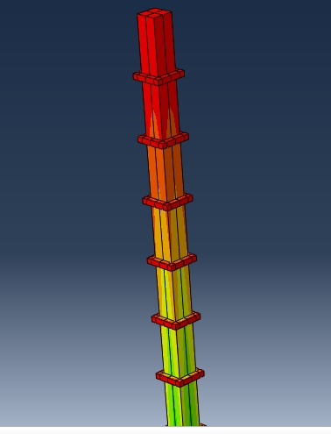

Figure. 26 3D view of square ridged pile.

Analysis of ridged square pile was executed after applying the surface surcharge (100 KPa) above the ground surface same as the load on the normal square pile. The results of analysis for NSF are shown in figure.27.

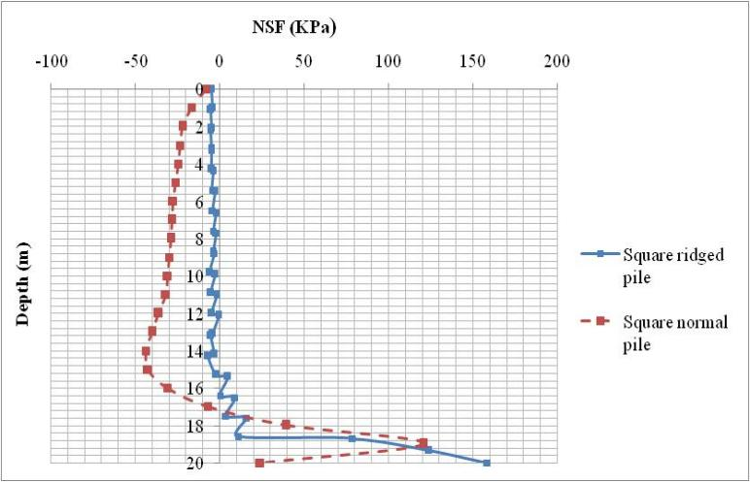

Figure. 27 Distribution of NSF along square ridged pile compared to normal square pile.

Figure. 27 clarified the NSF distribution on square ridged pile against the normal square pile. Ridges around the pile caused high reduction of the NSF due to the decrease of soil settlement and as consequence the relative displacement between soil and pile as shown in figure. 28, figure. 29.

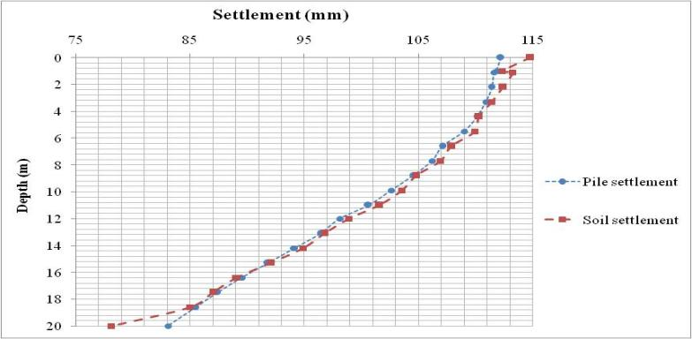

Figure. 28 Settlement of ridged square pile and adjacent soil.

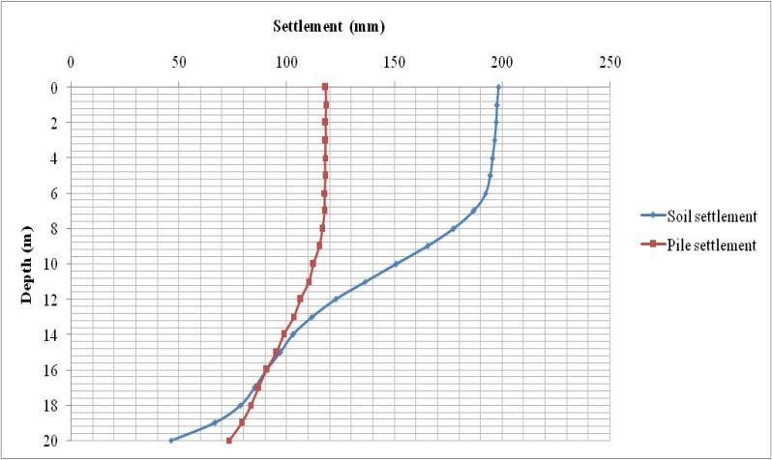

Figure. 29 Settlement of normal square pile and adjacent soil.

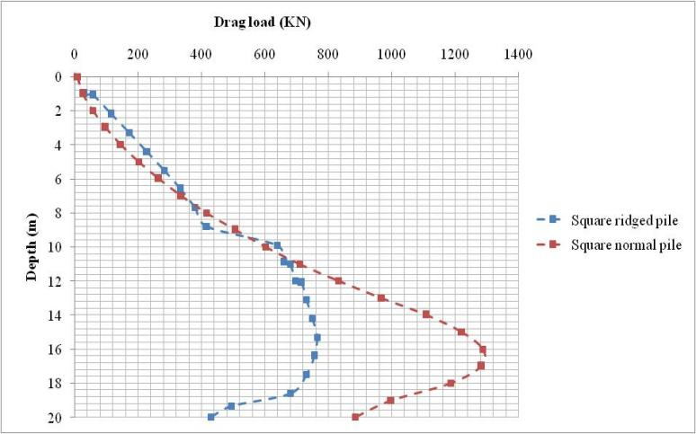

Figure. 30 Drag load distribution along square ridged pile compared to square normal pile.

The drag load distribution along the pile indicated the effect of ridges on drag load values. Reduction of (40 %) was noticed due to existence of ridges surroundings the square pile. Although the normal square pile induced enhanced values of NSF compared to the normal circular pile findings of ridged circular pile and ridged square pile (without lateral load) did not show large difference between the two piles either in NSF or drag load. That notice pointed that the influence of ridges on circular piles was larger than influence of them on square piles.

**12. Analysis of new ridged square pile subjected to lateral load.**

The previous analysis was rerun after adding lateral load at the top of pile. The NSF developed on the pile surface was anticipated to decrease as induced on ridged circular pile when subjected to lateral load.

Figure. 31 showed the distribution of NSF along the square ridged pile subjected to lateral load versus the induced NSF along square ridged pile without lateral load. It was noticed that no difference of values detected along the pile. The maximum value of NSF was the same in both cases and at the same location (15.0 m depth). Also, the drag load was similar to the developed drag load on square ridged pile without lateral load as shown in figure. 32. From this analysis it is obvious that ridges have the same effect on the square ridges pile either they were subjected to lateral loads or without lateral loads.

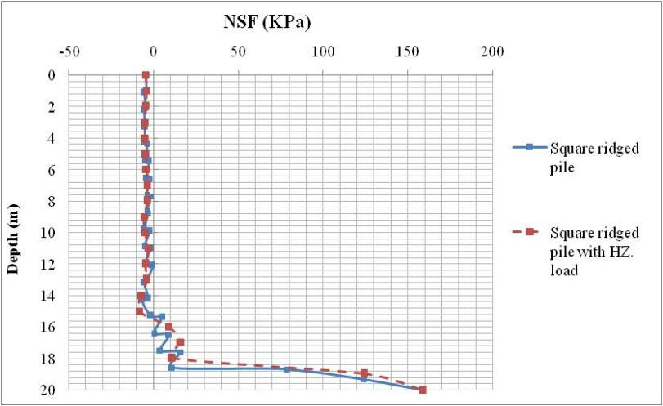

Figure. 31 Distribution of NSF along square ridged pile with lateral loads compared to pile without lateral loads.

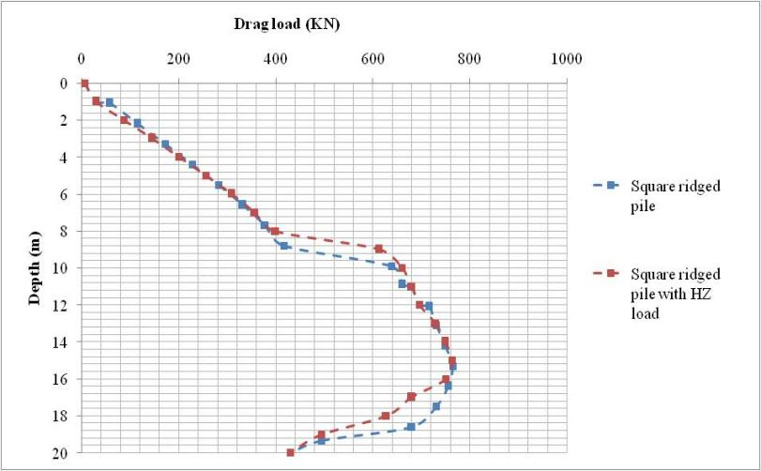

Figure. 32 Distribution of drag load along square ridged pile with lateral loads compared to pile without lateral loads.

**13. Analysis of new grooved circular pile**

In the second technique the main objective was to increase the pile settlement relative to the soil settlement. The grooves were created in pile to keep soil inside them and form an obstacle ahead of the pile to settle slowly and allow it to move with soil. If this condition took place the relative displacement between pile and soil will be reduced and the NSF should be decreased. The geometry of the grooved pile is shown in figure. 32. Grooves were formed by decreasing the diameter of pile to be (40.0 cm) at equal intervals (1.0 m)

Figure. 33 showed the settlement of grooved pile and settlement of surrounding soil. It showed that the soil settlement is moderately larger than the pile settlement till the depth of (17.0 ms) when the relative displacement between them became zero. This was the condition of NSF to be developed and the NP appears at depth (17.0 m).

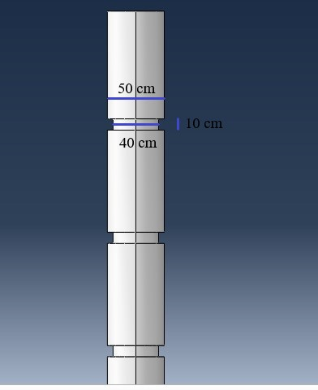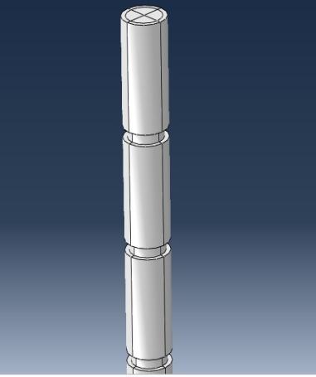

Figure. 32(a) Dimensions of the grooved pile, (b) 3D view of grooved pile.

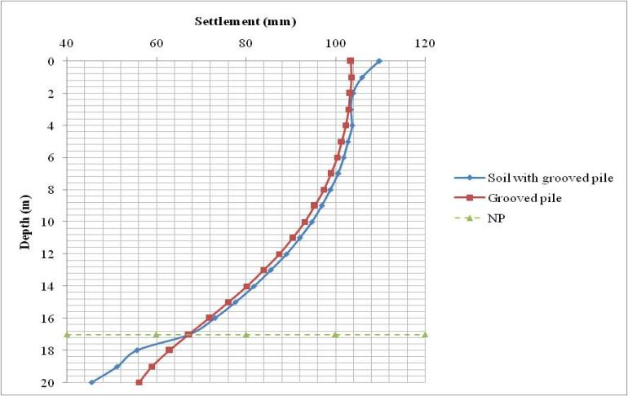

Figure. 33 Settlement of grooved circular pile and adjacent soil.

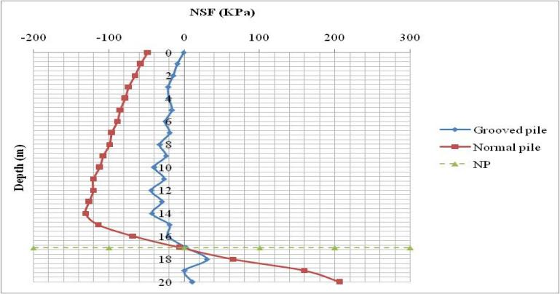

Figure. 34 NSF distribution along circular grooved pile compared to normal pile.

Figure. 34 showed the distribution of the NSF along the grooved pile compared to normal pile. It was noticed that the values of NSF have been reduced about (60 %) this reduction was due to the decrease of the soil settlement shown in figure. 33. although the pile settlement did not largely have been affected by the grooved pile as was it meant to be but the larger influence was on soil. The relative displacement between the soil and grooved pile was reduced from which the resulted NSF was decreased in consequence. It was also observed that the location of the NP was not largely affected. It moved downward only (15 cm) for the grooved pile.

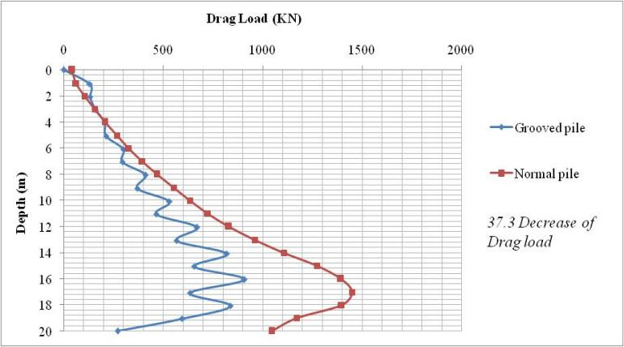

Figure. 35 drag load distribution along circular grooved pile compared to normal pile.

Figure. 35 showed the distribution of the drag load on the grooved pile compared the drag load on the normal pile. It can be noticed that the drag load decreased about (37.3 %). This reduction was due to the large decrease in NSF. The drag load line was curved between points due to the existence of the grooves on pile surface these grooves caused those ups and downs in the drag load curve. The result of the NSF and drag load indicated that the grooved pile could enhance the behaviour of the NSF on piles.

**14. Analysis of new grooved circular pile subjected to lateral load.**

In this section the grooved pile was subjected to the same value of horizontal load on the top of single pile to investigate its behaviour under lateral load.

In the previous study of piles under horizontal loads it was deduced that the lateral loads can produce better effect on the NSF of piles and can cause large reduction of the drag load. That was due to the movement of the pile towards soil making pushing effect over the soil mass from which resulted in decreasing soil settlement.

As the grooved piles had better influence on the behaviour of NSF and drag loads it was expected to have a moderate enhancement on the behaviour of pile groups when applying horizontal forces on the top of piles because horizontal forces resulted in reduction in NSF and drag load on normal piles.

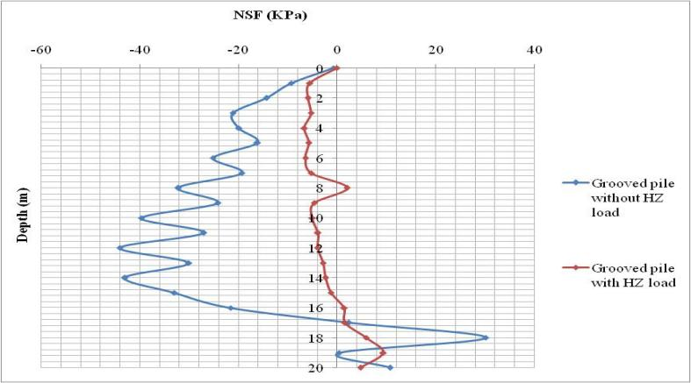

Figure. 36 NSF distribution along circular grooved pile subjected to lateral load compared to pile without lateral load.

Figure. 36 clarified that the calculated NSF was agreed with the predictions to be small due to the effect of horizontal load acting on the pile top and was very close the NSF of the grooved pile without horizontal force. The part of the PSF also was extremely smaller than the other pile. This result indicated that the horizontal force largely influenced the behaviour of the single pile. It can be noticed that also the location of the NP has moved downward to depth (15 m) at the point of equality of the two settlements of pile and soil.

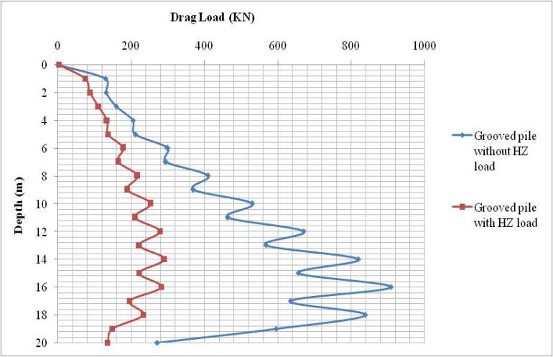

Figure. 37 Distribution of drag load along circular grooved pile with lateral loads compared to pile without lateral loads.

Figure. (37) showed the drag load distribution on the grooved pile subjected to horizontal force compared to the drag load on the grooved pile without horizontal force. Results clarified that the drag load developed on the pile subjected to horizontal load was less than the previous drag load due to the influence of the horizontal load but the value of the reduction was not large. This result has good agreement with the previous deductions that the difference between the NSF and drag load should be small as according to the settlement result.

**15. Analysis of new grooved square pile**

The technique f grooving pile surface will be executed on the square pile to explore the difference in values of NSF developed on the grooved pile and the normal square pile. To form the groove a decrease in the square length (10 cm) at fixed spacing (1.0 m). The ABAQUS model was run using all the previous geometrical and geotechnical parameters.

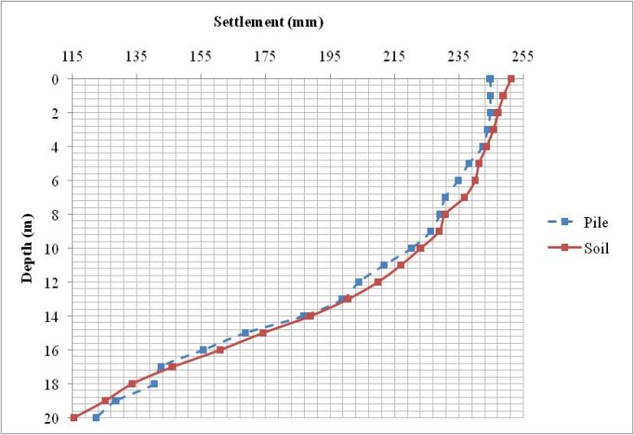

Figure. 38 Settlement of grooved square pile and adjacent soil.

Figure. 38 displayed the settlement of pile and soil for the square grooved pile. Curves illustrated increase in the soil settlement as well as pile settlement also compared to normal square pile figure. 29. The particular reason for that increase is that soil filled the grooves of pile forming extra weight and then the settlement was increased for both soil and pile. Even though, it was noticed that the relative displacement between soil and pile was reduced to be (16.0 mm). It was (90.0 mm) for normal square pile. The intersection of the two lines appeared at depth (17.0 m) which determined the location of NP.

Figure. 39 Showed distribution of NSF along the square grooved pile surface compared to square normal pile. It clarified that large reduction was appeared due to the grooves on pile. Maximum value of NSF on grooved pile was (40 KPa). This indicated that (60 %) reduction noticed for this pile. The point of transition from NSF side to PSF side appeared at depth (18.0 m) which agreed with settlement results.

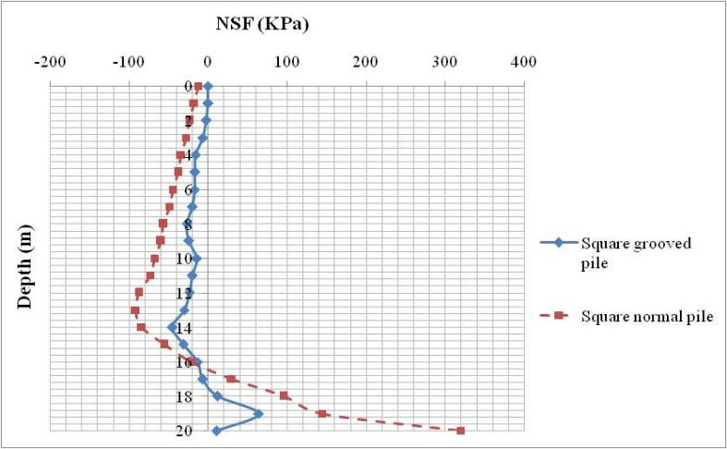

Figure. 39 NSF distribution along square grooved pile compared to square normal pile.

**16. Analysis of new grooved square pile subjected to lateral load.**

Last model was run for square grooved pile when subjected to lateral load to compare the behaviour NSF developed on pile to the square grooved pile not subjected to lateral load.

Results did not show large difference between the two piles for the NSF developed on the piles surfaces. Only the location of NP was moved upward to appear at depth (17.0 m) as shown in figure.40. Small difference in drag load induced on the pile subjected to lateral load as shown in figure.41.

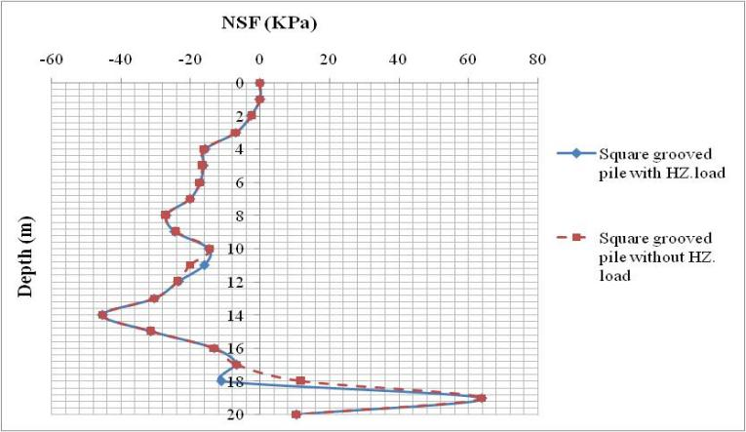 Figure. 40 NSF distribution along square grooved pile subjected to lateral load compared to pile without lateral load.

These readings illustrated that lateral load has no effect on the square grooved pile and it means that soil surrounding pile provided the pile with more resistance to lateral displacement due to groove filing with soil particles and increased its settlement. This case was the opposite side of the circular grooved pile.

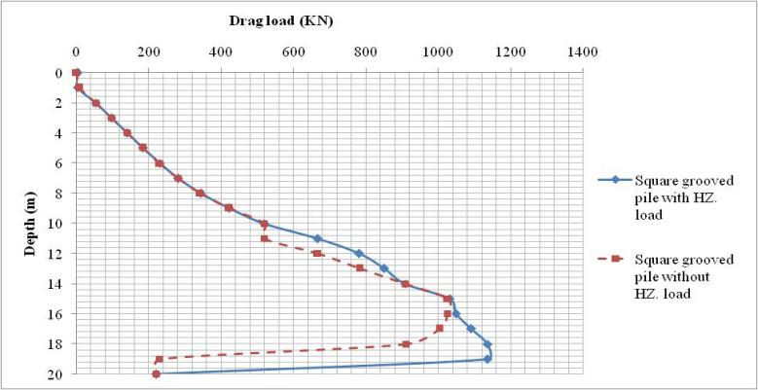

Figure. 41 Distribution of drag load along square grooved pile with lateral loads compared to pile without lateral loads.

The particular reason for that was the smooth circular surface of the pile which allowed the lateral load to influence on the pile decreasing the NSF on the contrary of folded sharp edge surface of square pile.

**17. Analysis of ridged pile groups subjected to lateral loads**

After demonstration of single piles analysis outcomes, it was clear that these two techniques were effective reduction of NSF along piles surfaces. In construction sites piles were used in groups so these techniques should be investigated using the previous group sized (3*3) to detect whether the same effect would occur along pile groups or not. Two sets of piles models were executed (circular piles and square piles) as ridged piles groups. Comparisons were formed between the results and illustrated consecutively.

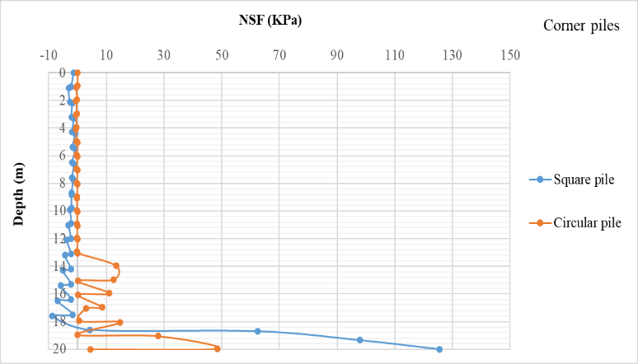

Figure. 42 Distribution of NSF along Corner square ridged pile compared to circular ridged pile.

Figure. 42 showed the NSF distribution along corner square ridged pile against corner circular ridged pile. Results showed that NSF values were very close approaching zero at the top half of the pile then at depth (13.0 m) circular pile changed to develop PSF while square pile continued till depth (18.0 m) with NSF values less than (10 KPa) then went to PSF. Difference of NSF between the two piles was due to the increase of soil settlement around square pile more than soil adjacent circular pile while piles settlements were very close.

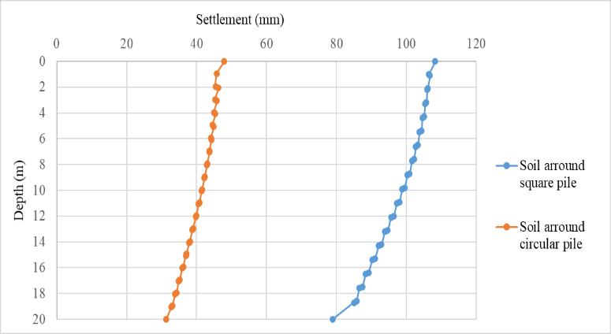

Figure. 43 Settlement of soil adjacent to circular pile against soil adjacent to square pile.

Settlement results indicated that effect of ridges on the behaviour of circular pile is better than the effect on square pile in pile group and in consequence ridged circular piles provided better behaviour for NSF than ridged square piles when subjected to lateral loads.

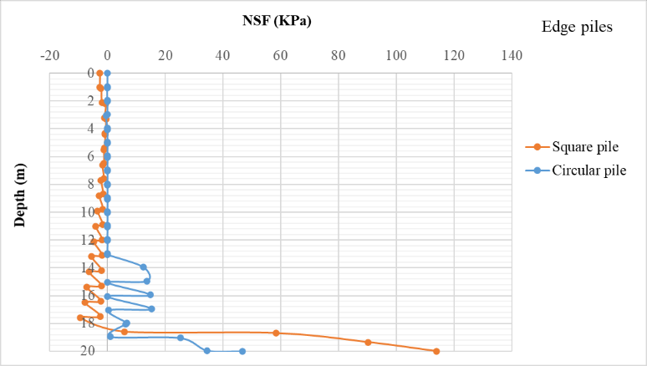

Figure. 44 Distribution of NSF along Edge square ridged pile compared to circular ridged pile.

Similar pattern of NSF values could be found from the readings of edge piles and centre piles as shown in figure. 44 and figure.45 and drag load distribution shown in figure.46

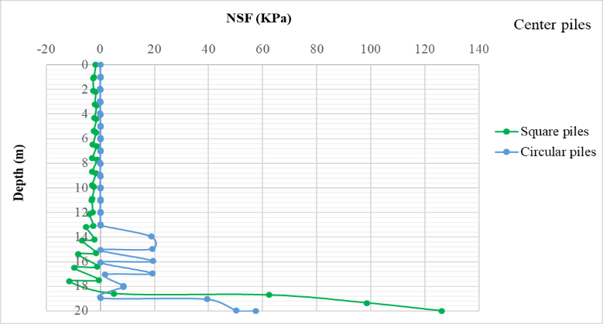

Figure. 45 Distribution of NSF along Centre square ridged pile compared to circular ridged pile.

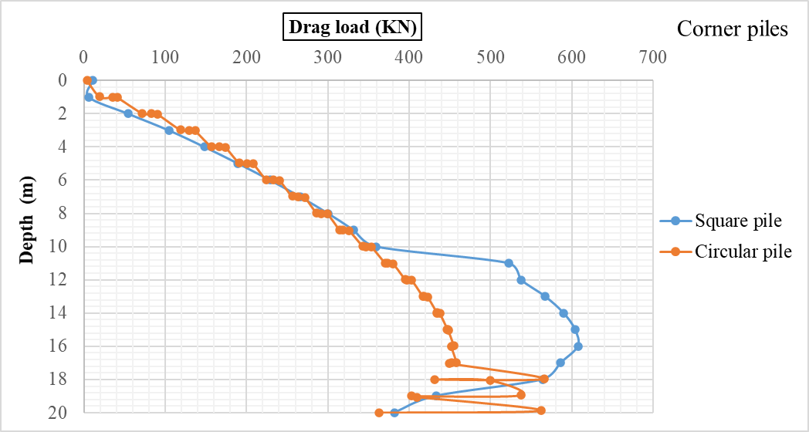

Figure. 46 Distribution of NSF along Corner square ridged pile compared to circular ridged pile.

**18. Analysis of grooved pile groups subjected to lateral loads**

Analysis of grooved pile groups was executed to recognize the difference of NSF behaviour when piles installed in groups. It was not difficult to assume that grooved square piles should develop better NSF compared to circular piles in all three positions of piles in group. That assumption depended on the results of single square grooved pile subjected to lateral load which did not show major change from single pile without lateral load which induced NSF (60%) less than the circular pile.

Figure. 47 showed the distribution of NSF along the corner square grooved pile compared to corner circular grooved pile. The values of NSF were noticed to be close to each other with some points reaching zero NSF on both lines. Drag load curve clarified that square grooved pile enhanced the behaviour with (26%) reduction of drag load as shown in figure. 48

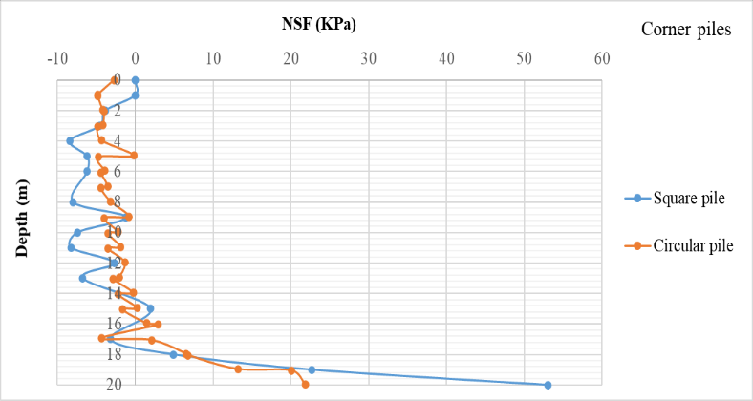

Figure. 47 Distribution of NSF along Corner square grooved pile compared to circular grooved pile.

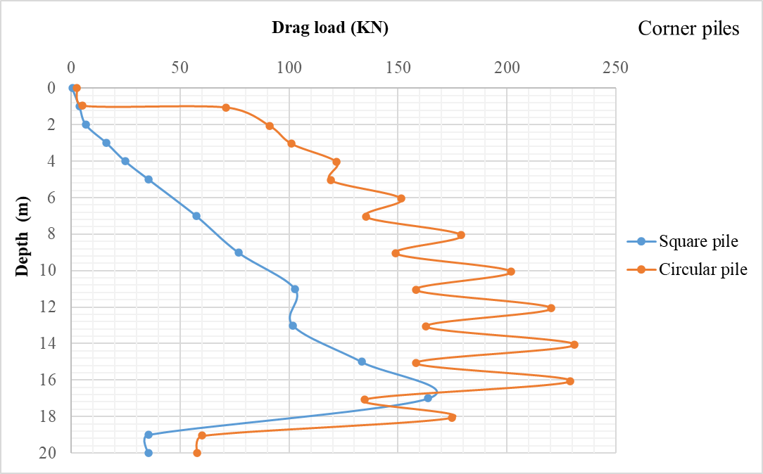

Figure. 48 Distribution of drag load along Corner square grooved pile compared to circular grooved pile.

The direct cause of this finding was the similarity between the relative displacement for both square pile and circular pile as the settlements of piles and soils were the same for both piles. The difference in drag load values was occurred as a result of variation of pile cross section area. Square pile cross section area was less than circular pile and it is known that drag load was calculated from the summation of the vertical stress in the pile element. Drag load is function of cross section area.

Drag load = (Ap*σz) (Alonso et al., 1984) where Ap is pile cross section and σz is vertical stress.

The same results were found for the edge piles and centre piles in (3*3) group. Drag loads shown in figure. 49 and figure. 50 illustrated that drag loads values decreased from edge piles to centre piles for square piles and circular piles. Square grooved piles provided drag loads values less than circular grooved piles while NSF values were close either for edge piles or centre piles.

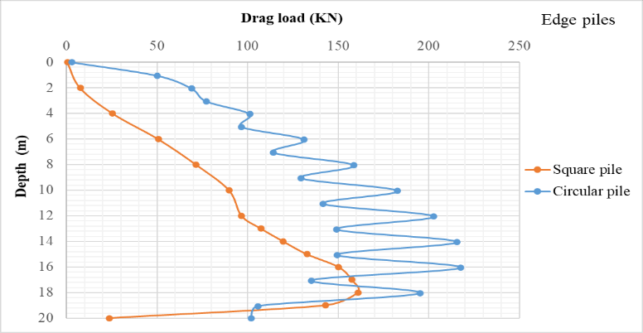

Figure. 49 Distribution of drag load along Edge square grooved pile compared to circular grooved pile.

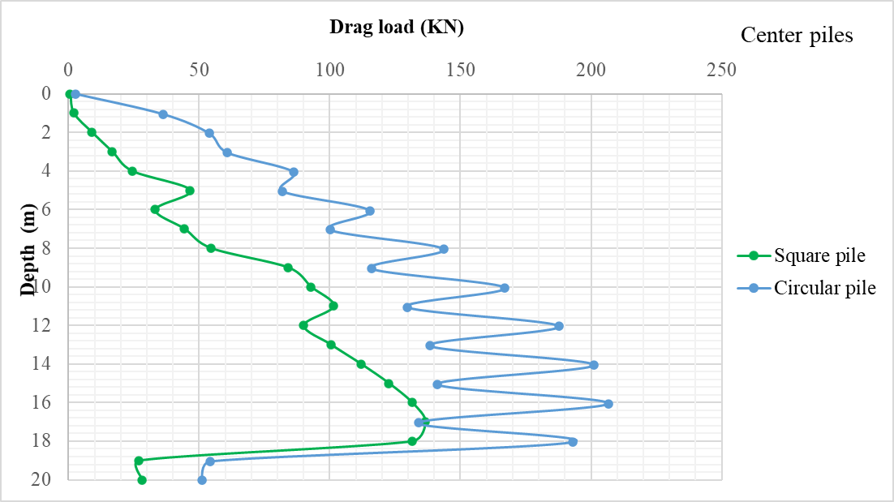

Figure. 50 Distribution of drag load along Centre square grooved pile compared to circular grooved pile.

Finally, if a comparison was made between normal circular pile, ridged circular pile, and grooved circular pile to discuss the most suitable case to decrease the NSF and drag loads in case of pile groups the result showed that ridged pile, grooved piles enhanced the behaviour of NSF of piles compared to normal piles (95 %) reduction of NSF. Their results were very close and ridged pile results were the lowest values of NSF.

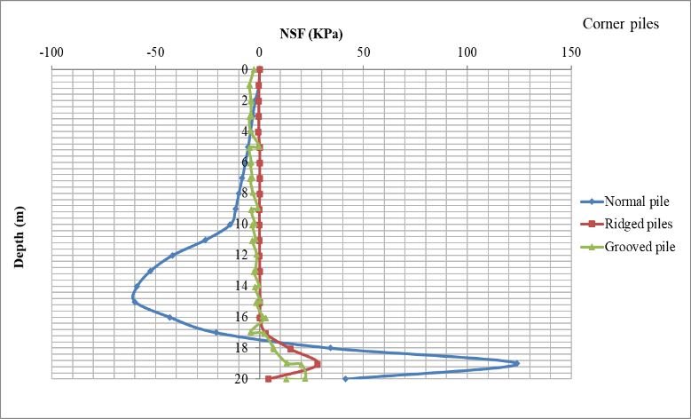

Figure. 51 Distribution of NSF along corner **circular** normal, ridged, and grooved piles.

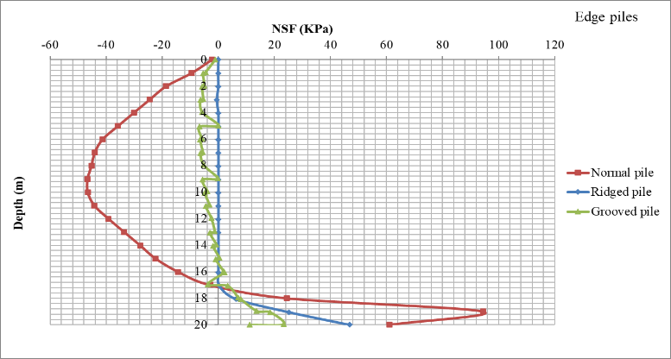

Figure. 52 Distribution of NSF along edge **circular** normal, ridged, and grooved piles.

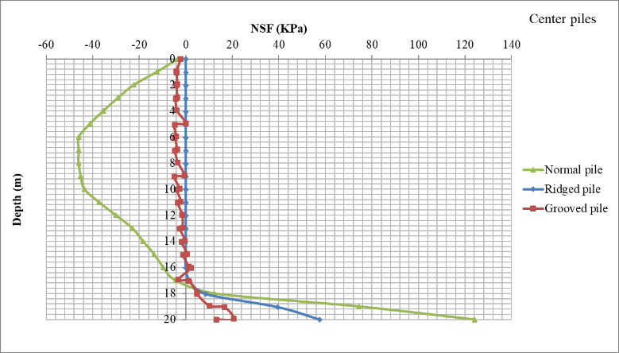

Figure. 53 Distribution of NSF along centre **circular** normal, ridged, and grooved piles.

Edge piles and centre piles provided similar results as corner piles as shown in figure.52, figure. 53.

Same comparison was made for square normal piles, ridged piles, and grooved piles. It can be noticed that ridged and grooved piles provided the better values of NSF compared to normal pile with (97%) reduction of NSF. On the other hand, both ridged and grooved piles provided close results compared to each other and no one has the superiority.

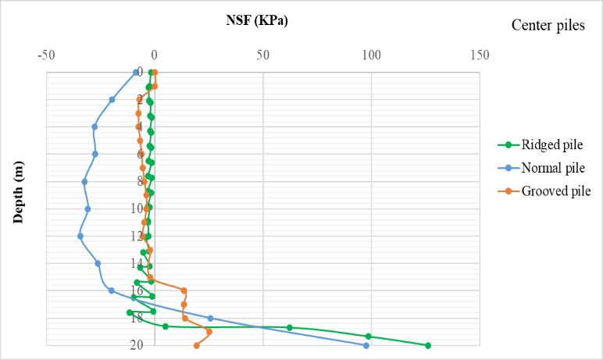

Figure. 54 Distribution of NSF along centre **square** normal, ridged, and grooved piles.

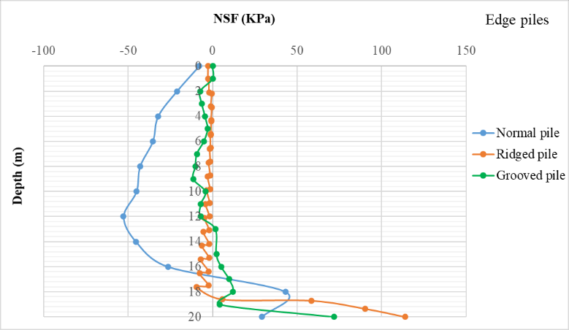

Figure. 55 Distribution of NSF along edge **square** normal, ridged, and grooved piles.

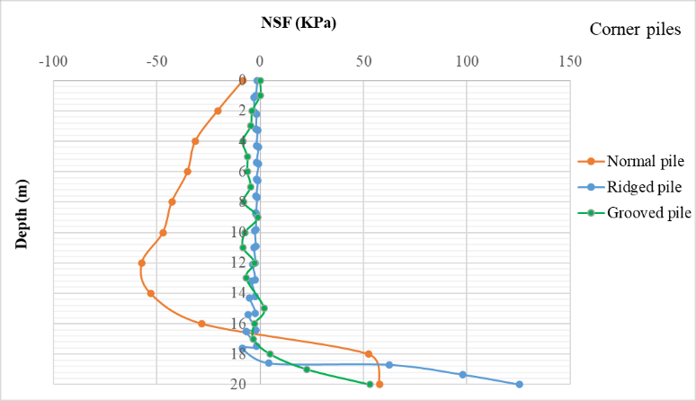

Figure. 56 Distribution of NSF along corner **square** normal, ridged, and grooved piles.

To sum up everything that has been investigated so far it can be stated that when driven piles were installed in soft clay were subjected to **lateral load** a reduction of NSF values occurred. Changing pile cross section from circular to square section reduced the NSF value with (60%). First technique was wrapping the pile with sand layer extended from ground surface till the depth of NP it was called here as sand socket. When single circular pile was installed in sand socket NSF reduced by (20%) compared to the single circular pile without sand socket. While single square pile inside sand socket developed reduced NSF by (67%) compared to single square pile without sand socket. Comparison between circular piles and square piles inside sand sockets showed that NSF induced on corner square pile was less than corner circular pile with (50%). NSF on edge square pile was less than edge circular pile with (52%). Centre square pile developed NSF with ratio (51%) less than centre circular pile.

Second technique was to form the pile surface to create ridges at equal distances along pile length. Single ridged circular pile showed reduction of NSF by (97%) compared to normal circular pile. While single ridged square pile developed NSF value less than normal square pile by (96.2%). Values of both single circular ridged pile and single square ridged pile were highly close. Then two groups of piles with size (3*3) were created to compare the values of NSF developed on circular piles to their matching square piles. Readings of pile groups showed that NSF values for corner, edge, and centre piles were almost similar for circular and square shapes but the rag load value difference was clear. Circular corner pile developed drag load less than square pile with (25%). Edge circular pile drag load was (27%) less than edge square pile. Centre circular pile induced drag load less than centre square pile with (27%).

Third technique was to create grooves on the pile surface on equal distances. Single circular grooved pile developed reduction of NSF with (84%) compared to normal circular pile. Single square grooved pile induced NSF less than normal square pile with (80%). Comparison between piles in groups showed that both circular ridged piles and square ridged piles in groups have extremely small similar values of NSF but the drag load made the difference. On the contrary of the ridged piles square grooved piles enhanced the behaviour of drag load in groups. It was clarified that corner square grooved pile developed drag load less than corner circular grooved pile by (28%). Edge square grooved pile developed drag load less than edge circular grooved pile by (28%) while centre square grooved pile was less than centre circular pile by (36%).

Comparison between the three cases of circular piles indicated that ridged pile showed best results for NSF and drag load. Observations on square piles three cases showed that grooved piles and ridged piles developed best results equally and no superiority was appeared for them.

**Conclusion**

This search was dedicated to numerically investigate the effect of new techniques to reduce the NSF values developed on driven circular and square piles when subjected to lateral loads. Sand socket was used to wrapping the pile. Then geometry of circular and square piles was changing by forming ridges around pile surface along pile length at equal spacing as the second technique. The third technique was forming grooves around pile surface along pile length at equal spacing. ABAQUS software was used to model the simulation of piles and soil with (FEM).

The objective was to create condition of settlement that can decrease the relative displacement between soil and pile which represent the critical condition to induce the NSF on pile. The three techniques were effective and showed large influence on the values of NSF and drag loads developed on piles and the reduction in some cases reached (98%).

The numerical analysis provided the following conclusions:

1- New ridged and grooved piles showed large enhancement of the values of NSF on the single pile compared to normal pile.

2- Single square ridged pile provided NSF values better than single circular ridged pile.

3- Single square grooved pile provided NSF values better than single circular grooved pile.

4- Circular ridged piles in group were developing drag load values better than square ridged pile in groups.

5- Square grooved piles in group induced drag load values less than drag load of circular grooved piles in groups.

6- Single piles either circular or square installed in sand socket provided NSF and drag loads less than piles installed directly in soft clay soil.

7- Square pile group installed in sand sockets enhanced the values of NSF and drag load compared to circular pile group installed in sand sockets.

**REFERENCES**

1. ABAQUS. (2014). Abaqus 6.14. Abaqus 6.14 Analysis User’s Guide, 14.
2. Abd-Rabbo, F. M., & Ali, N. A. (2015). Behaviour of single pile in consolidating soil. Alexandria Engineering Journal, 54(3), 481–495. https://doi.org/10.1016/j.aej.2015.05.016
3. Alonso, E. E., Josa, A., & Ledesma, A. (1984). Negative skin friction on piles: A simplified analysis and prediction procedure. Geotechnique, 34(3), 341–357. https://doi.org/10.1680/geot.1984.34.3.341
4. Chan, S. H. (2006). Negative Skin Friction on Piles in Consolidation Ground. 827–836.
5. Chen, R. P., Zhou, W. H., & Chen, Y. M. (2009). Influences of soil consolidation and pile load on the development of negative skin friction of a pile. Computers and Geotechnics, 36(8), 1265–1271. https://doi.org/10.1016/j.compgeo.2009.05.011
6. El-Meligy, M. M., Mahmoud, A. I., & Mohamed, S. M. (2016). Studying the Effect of Pile-Soil Interface Properties on Piles Subjected To Negative Skin Friction. New York Science Journal, 9(3), 103–115. https://doi.org/10.7537/marsnys09031617
7. Fellenius, B. H. (1988). Unified design of piles and pile groups. Transportation Research Record, 1169, 75–82.
8. Indraratna, B., Balasubramaniam, A. S., Phamvan, P., & Wong, Y. K. (1992). Development of negative skin friction on driven piles in soft Bangkok clay. Canadian Geotechnical Journal, 29(3), 393–404. https://doi.org/10.1139/t92-044
9. Lee, C., & Ng, C. W. W. (2004). Development of Down-drag on Piles and Pile Groups in Consolidating Soil. Journal of Geotechnical and Geo-environmental Engineering - J GEOTECH GEOENVIRON ENG, 130. https://doi.org/10.1061/(ASCE)1090-0241(2004)130:9(905)
10. Poulos, H. G., & Davis, E. H. (1972). Development of Negative Friction with Time in End-Bearing Piles. Aust Geomechanics J, G2(1), 11–20.
11. Saha, A. (2015). The Influence of Negative Skin Friction on Piles and Pile Groups & Settlement of existing Structures. International Journal on Emerging Technologies, 6(2), 53–59.

3/21/2022