Numerical Study On The Performance Of A Four Stroke Injector Type Spark Ignition Engine At Varying Butterfly Valve Angle.

K FASOGBONa,b,c, Patrick M. AJAEROad, * ,Vincent N. UGWAa  and Abiodun D. OLORUNFEMIa

aDepartment of Mechanical Engineering, University of Ibadan, Ibadan, 900001 Nigeria

bCentre for Petroleum, Energy Economics and Law, University of Ibadan, Ibadan, 900001 Nigeria

cDepartment of Mechanical Engineering, Lagos State University Epe Campus, Lagos, Nigeria

dOperation Department, Transit Support Services Assembly Plant, Plots 9/10, Emene Industrial Layout Enugu, Nigeria

**Abstract:** The induction system of the internal combustion (I.C) engine has great influence on air-fuel mixture, fuel consumption, combustion, and exhaust gases formation which made it a vital part of the IC engine. Engine parameters like the butterfly valve angle variation, poppet valve number /lift variation and discharge coefficient parameters are critical in the overall performance of the I.C engine. For instance, while the butterfly valve plays a great role in controlling the quantity of mass of air flowing into the intake manifold of an I.C engine, the timing and quantity of gas or vapour flowing into the engine is controlled by the poppet valve. This work employed the power of GT-Power Suite V16 to numerically study the impact(s) of butterfly valve on the performance of a four stroke injector type (gasoline) spark ignition (S.I) engine by varying the opening /intake angle of the butterfly valve from 00 to 90 0. Engine output parameters: Brake Torque (BT), Brake Power (BP), Brake Specific Fuel Consumption (BSFC), Indicated Mean Effective Pressure (IMEP), Flows, Thermal / Energy and Emission parameters were varied as a function of throttle position (butterfly valve opening angle) for different engine speed from 1000 RPM to 6000 RPM at an interval of 500RPM. The results show that engine performs optimally at engine speed of 3000RPM and 80 o throttle position. Thus the work concludes that for improved engine efficiency and fuel economy, engine speed should be maintained at 3000 rpm and 80 o throttle position.

[K FASOGBON, Patrick M. AJAERO ,Vincent N. UGWA and Abiodun D. OLORUNFEMI. **Numerical Study On The Performance Of A Four Stroke Injector Type Spark Ignition Engine At Varying Butterfly Valve Angle**. N Y Sci J 2021;14(12):23-35] ISSN 1554-0200 (print); ISSN 2375-723X (online)

<http://www.sciencepub.net/newyork>. 4. doi:[10.7537/marsnys141221.04](http://www.dx.doi.org/10.7537/marsnys141221.04).

**Keywords:** Throttle body, Butterfly valve, IC engine, induction system

**Introduction**

In the 18th century, there are many claims concerning the invention of the internal combustion (IC) engine however, among them all only, Nikolaus Augustus Otto(a German Engineer) has the patent for the four stroke operation sequence. He developed the four-stroke "Otto" cycle in the year 1867. His sequence is widely used in transportation even till date. He was aged 34 at the time when he developed the four-stroke sequence. Rudolph Diesel, another German engineer invented the Diesel Engine in the year 1892. Diesel engine is more powerful than petrol engines. It uses oil (diesel) as fuel hence the reason while thy are designed heavier. Diesel engines are commonly used in heavy duty machineries such as:- locomotives, ships, and automobiles. The basic principles of operation of the IC engines have been in existence for over a century nevertheless, and they are still in place. A lot of people become confused when they look undereath the burnet of their car and does not understand a thing.. However, it is noteworthy that right under those wires and sensors lies an engine that operates with the same principles as the "Otto" engine over a hundred years ago [1-2].

The efficiency of an I.C engine and its improvement have been of great concern to engine manufacturers and researchers and a lot of research on how to improve it has been going on [2] Researchers and auto manufactures have been working tirelessely from years ago till date on the improvement of induction system of the I.C engine due to its impacts on the performance especially on emission output of the IC engine. Researches have been ongoing on every single system / component of the IC engine that can inflict significant influence on the induction system, these include:- the modification of intake geometry (example the inlet manifold), and by applying different strategies of valve timing. Inlet Manifolds with various geoetry are available in the market and they are designed to improve induction efficiency of the IC engine [3-6].

The performances and the efficiency of the combustion process of the I.C engine is greatly determined by the breathing efficiency.

Engine power, torque, and other performance parameters at any given speed, improves as the mass air flowing into the combustion chamber increases [7-8]. Nowadays, fluid dynamic characterization of the behavior of IC engines during the induction process has become necessary in order design, develop, and optimize new and improved automobile engines [9]. consequently, several investigation tools, based on Computational Fluid Dynamics (CFD) approach as well as experimental approaches are available to study the induction system of the IC engine. The quest to provide more susbtantial information on the engine head breathebility in the last few years, has led researchers to conduct host of experimental investigations adopting dimensionless discharge and flow coefficients. [10]. There are few literature about engine breathability and butterfly valve’s influence in the overall engine performance hence the present work aims at investigating the performances of an injector type gasoline four-stroke spark ignition engine at different butterfly valve angles using GT-Power engine simulation.

Nowadays, power upgrade of the I.C engine is a quantitative feature. Different methods are being used for this measure; in fact these different methods consider air/fuel inflow into the combustion chamber [11]. By varying each one of these parameters (either of air or fuel input into the engine cylinder) and by varying the strategies of fuel injection into the intake system, there is a possibility of power variation (power increase or decrease). Therefore, many parameters of fuel or air intake systems have significant effect on combustion parameters and engine output power [12]. Among the intake systems, volumetric efficiency is one of the most important parameter on the output power of the I.C engine because it is related to the amount of air/fuel inflow into the engine cylinder [13] Different methods such as: - geometrical changing (swirl and tumble motion), turbo charging, and supercharging etc are used to increase the amount of inflow into the engine cylinder [14]. One of the crucial sub-systems of the I.C engine is the intake system. This can cause significant impact on the mixing efficiency of air/fuel ratio, fuel consumption and exhaust gas formation [15]. Improvement of the engine system is of paramount importance and as such has pressured engine producers to embark in thorough research on every factor that can contribute to the development of efficient engine. Otimization of the intake system is deemed as one of the contributing Factors , in order to reduce fuel consumption and optimize engine performance, [16]. An analysis of the performance of a four-stroke motorcycle engine at a steady flow rig for the purpose of characterization of the fluid dynamic behavior of the engine head brathability during the induction phase was undertaken by Sergio Bova et al., 2015. They adopted a two fold approach:- namely: dimensionless flow coefficient: utlised in studying the global breathability of the intake manifold, and the Laser Doppler Anemometry (LDA) technique: utilised in defining the flow structure in the combustion chamber. Their study showed two opposing rotating vortices with axes parallel to that of the engine cylindr and showed variations in the flow structure when exiting the engine head. The study further revealed great influence of the butterfly valve on the efficiency of the head fluid dynamic and how this effects varies with valve lift. The findings were compared and validated with experimental data by a single curve adopting a new dimensionless plot. Moreover, LDA measurements were used to evaluate the angular momentum of the flux and an equivalent swirl coefficient, and to copare them with previous global swirl characterization carried out on the same engine head using an impulse swirl meter [17].

**Materials and methods**

**Model Setup**

Simulation was done using GT-Power under GT-ISE environment. Click on the program icon on the desktop, once the program is opened/activated, a blank window opens. Then select file -> go to “new” and click GT project map (.gtm**)**. -> document creation wizard will appear which allows you to select any application to model. This research however, adopted the SI_4cyl_VariableValveLift' template from GT-library and the objects and cases were redefined to suite the specific research objectives.

**About GT-Power**

GT-POWER, an industrial standard tool for engine performance simulation and analysis. It has been widelyused by both engine manufacturers and vehicle operators globally**. Largely because of its** capacity to predict most of engine performance quantities like:- engine power, torque, air-flow, volumetric efficiency, fuel consumption, turbocharger performance, matching, and pumping losses, air condition system etc at a very high degree of acuracy. GT-Power prediction is not limited to only predicticting engine performance, it can also be used to study physical models for extending the predictions to include cylinder and tailpipe emissions, intake and exhaust manifold systems, acoustic characteristics (level and quality), in-cylinder and pipe/manifold structure temperature, cylinder pressure analysis, and control system modelling. This is primarily because standard GT-POWER models can be converted easily to real-time models**.** These models may also be included in a full system level simulation within GT-SUITE to provide accurate and physically based engine boundary conditions to the rest of the vehicle. In this work, the GT-Ise Huge v16 version (one of the suites in GT-POWER package) was used to study / analyse engine performance at varying throttle angle position.

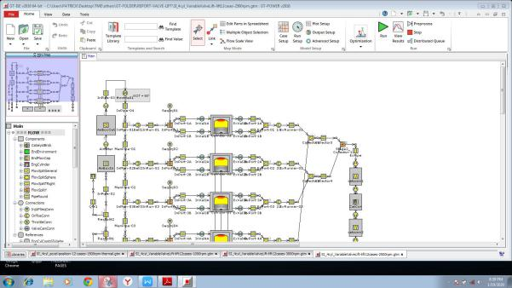

Fig.1fully developed engine model

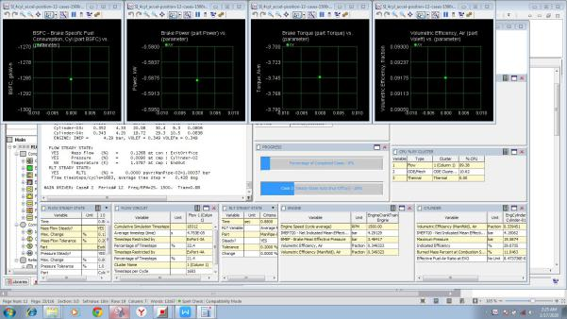

Fig. 2 simulation in progress

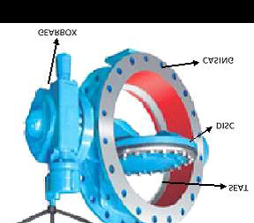

Fig. 3 Throttle body

(source: Raj Kumar et al, 2015

**Theoretical Background**

Several forms of equations to study steady state flow of gas in the manifolds of the I.C engines is available, this study nevertheless, adopts the Navier Stokes equations of motion as follows:-

Navier Stokes equation of motion

1. Continuity Equation

 (1)

1. Reynolds averaged momentum equation

 (2)

Kinetic energy dissipation equation

 (3)

We introduce two new variables. C and K are model constan in this systems of equation, K values comes directly from the differential transport equations for turbulence kinetic energy and turbulence dissipation rate.

 (4)

 (5)

 (6)

Table 1: k-ɛ model constants

|  |  |  |  |  |  |
| --- | --- | --- | --- | --- | --- |
| symbol |  |  |  |  |  |
| values | 0.09 | 1.44 | 1.92 | 1.00 | 1.30 |

**Boundary Conditions**

The simulation type of this numerical solution is steady state and the initial boundary conditions of the fluid domain is defined below:-

1. The fluid (air) is idealised to be ideal gas with initial temperature 298 K and imposed pressure of 0.7bar. This is to create the necessory depression to enable fluid to flow through the throttle valve from the inlet boundary at pressure of 1.0 bar. Table 1 above shows Specifications for boundary conditions for the analysis . The flow is subsonic at the inlet with 1.0 bar prescribed relative pressure. The turbulence intensity at the center of a fully developed flow through a duct can be computed using the formula derived from the empirical comparison of pipe flows: For example, in an internal flows, the intensity of turbulence at the inlets depends totally on the history of the upstream flow. That means, in the absence of information of the turbulence at the inlet, the turbulence intensity is therefore defined as: *I* = 5 % and the viscosity ratio as:

 = 10 (7)

k and  can therefore be calculated using the formula:

K = (Iu)2 (8)

=  (9)

Where D = 55 mm = 0.055 m The outlet has an open boundary condition, this can be specified as a relative pressure with value as 0.7 bar (P spec = 0.7 bar). This value could be regarded as inflow relative pressure (total) and relative static pressure for outflow. The normal symmetry plane boundary condition imposes a constraints which reflects the flow in either side of the duct hence, the normal velocity component at the symmetry plane boundary is assume to be zero: Vn=0., so also the scalar variable gradients normal to the boundary:

Where;

( ) =0 (10)

There is no heat transfer at the wall of the pipe, (adiabatic) (q w=0) and no-slip boundary condition is assumed for the stationary solid wall therefore,

U w=0 (11)

In the k- model, the k equation was resolved in the whole domain which includes the wall-adjacent cells. The boundary condition for k at the wall is given as:

= 0 (12)

N = local coordinate perpendicular to the wall.

The produced rate of energy dissipation (), and kinetic energy (Pk) at the cells of adjacent wall are computed based on the local equilibrium theory. Under this theorem, the kinetic energy produced (Pk) and its rate of dissipation  is considered to be equal in the wall facing the control volume. For the average folw and the equation of turbulent transport, the near-wall boundary condition is analysed by the wall-function approach..

**Model of the Isentropic Compressible Flow**

**(Saint Venant Model)**

Please note that the throttle body is not a 1-D orifice hence, to correctly mimic this kind of flow by the application of 1-D model, other attributes of 3-D effects must be integrate into the discharge coefficient (CD). This equation is the valve and air-mass flow rate equations in the air induction model, 1-D isentropic analysis and ideal gas state equation are utilized to compute the mass of inducted air and the pressure of the intake manifold. After establishing the upstream stagnation temperature and pressure, the flow through the throttle body becomes a function of two independent parameters namely: the angle of the throttle and the pressure ratio across the throttle body [17]. Many control systems of the engine need to predict the mass flow (ṁ) of the intake manifold pressure (Pm) or manifold vacuum measurement and throttle air with throttle angle (θ). T o correctly predict the mass flow of any given throttle, the upstream pressure (P0) and upstream temperature (T 0) measurements or prediction are essential. A standard formula for mass flow of gas through a general passage was stated by Taylor, 2005. He arrived at the fuction by simplifying the below assumptions;

1. The flowing fluid is gas which obey the ideal gas law, and has constatnt specific heat:

P V=n R T (13)

1. Gas is in equilibrium state meaning no heat gained or lost at every stage.
2. There is uniform velocity distribution and the streamlines are parallel, thus a vena contracta.
3. Uniform velocity distribution across conduit, that is, no shear stress, nor friction between gas and the wall.
4. Upstream and downstream temperature and pressure were measured at points where the gas kinetic energy is negligible.

Usually, for a compressible flow, standard orifice flow can be used to calculate the mass flow rates through the throttle valve.

Pressure ratio across the throttle body was varied between the ambient (upstream) pressure P0 and the intake manifold (downstream) pressure Pm and for which the critical ratio is given as;

Pm/P0=0.528 =1.4 (14)

If the pressure ratio is more than the critical pressure the;

 (15)

Mass flow rate will be given as;

ṁ=CD.A(θ) (16)

For pressure ratios less than the critical pressure;

 (17)

Note that the mass flow rate is dependent on the pressure ratio and it’s given by;

ṁ=CD.A(θ). (18)

And discharge coefficient CD becomes;

 (19)

Where:

 = specific heat ratio,

ṁ = mass flow rate

CD = Coefficient of Discharge

A(θ) = passage flow area

R = gas constant

T0 = upstream temperature ambient temperature.

In the past, the throtle chamber has been modeled as 1-D isentropic compressible flowacross an orifice of an emperically derived coefficient of discharge (C D) by researchers. CD however, the ability to calculate he discharge coefficient (C D) depends on proper characterization of the flow area profile as a function of throttle angle. Consequently, the flow area and the coefficient of discharge are combined into a single term called “effective area” Ae

Hence;

 (20)

From the mass flow rate, Ae could be calculated using:-

For non-choked flow:

 (21)

And for choked

 (22)

The throttle pedal is used to regulate the engine power by the driver. The pressing of the throttle pedal opens the butterfly valve proportionally to the force applied by the driver. Two equations are usually used to calculate the effective area of the throttle body. Harington et al proposed a the formular below which could be used to calculate the effective area of a throttle body as a function of the opening angle as;

 (23)

Where:

A = d/D (24)

d = throttle shaft diameter,

D = throttle bore diameter

0 = Angle of the throttle plate when tightly closed against the throttle bore.

The throttle-effective area reaches its maximum at a specified angle, therefore;

for;

 Equation below is used to calculate effective area;

 (25)

**Results and discussion**

**Throttle valve and regulating throttle**

The butterfly valve impacts the quantity of air that is drawn into the engine cylinder in petrol engines. More or less air-fuel mixture or freh air flows into the engine cylinder according to how wide the throttle valve is. This position directly determines engine performance. The accelerator position is directly transmitted to the throttle valve electronically or via cable. It is important to note that while throttle valves regulates air-fuel mixyure flow into the cylinder of a petrol engine, regulating throttles regulates air flow into the cylinder of a diesel engine. GT-Power, a CFD tool was used to analyse air flow through the throttle valve into the engine cylinder. The throttle body was optimised as a hexagonal shaped throttle body. The flow rate of the air was adjusted by flow control valve and measured with the help of GT-Power (CFD tool). Initial throttle position correspond to engine idling conditions. The test pressure is set and flow through the throttle valve is measured. Thereafter, angles of the throttle valve were set at 50, 100, 200, 300, 400, 500 600, 70, 800 and 900 throttle opening positions and flow rates measured. Optimum angle of the throttle body for air and fuel equivalent ratio and engine speed, were determined by studying / engine performance at every throttle valve position (throttle angle). Engine performance parameters which consist of :- Air-Fuel Ratio, Indicated Mean Effective Pressure (IMEP), Brake Specific Fuel Consumption (BSFC), Brake Mean Effective Presure (BMEP), Throttle Efficiency, Carbon Dioxide Emission and Brake Specific Hydrocarbon Emission were studied.

**Air Fuel Induction**

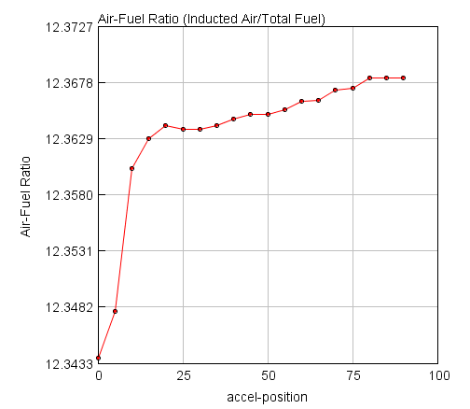

Fig 4: Graph of air fuel mixture against throttle angle (position)

The cumbustibility of the mixture and the amount of energy to be released is determined by how close air and fuel mixture is to the stoichiometric mixture . From fig 4: above it is clear that the more the opening the closer test engine approach stoichiometric mixture.Between 00 and 250, the throttle opening is not wide enough to allow for the induction of more air. The wider the throtle angle, the more it allows more air flow and at 800 the butterfly valve is wide enough to allow inflow of enough air to achieve a better air - fuel ratio (stoichiometic mixture). Opening the butterfly valve beyound 80 0 is immaterial as the excess air will have no significant effect and can cause drop in engine performance due to excess air.

**Brake Mean Effective Pressure (BMEP)**

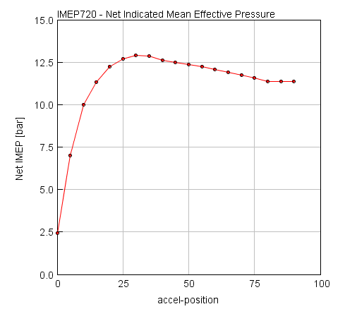

Fig 5: Indicated mean effective pressure against throttle Position

The measure of the theoretical frictionless power also known as indicated horsepower. This is the measure of actual pressure that occure in the cylinder during combustion. To introduce air into the cylinder of an engine, the vortex area of flow is not supposed to be too large. Too large vortex area will cause a drop in flow pressure, this explain the slight drop of Indicated Mean Effective Preasure at 40 0 throttle angleand beyound (fig 5).

**Brake Specific Fuel Consumption (BSFC)**

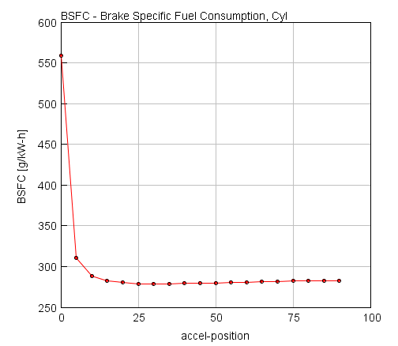

Fig 6: Brake specific fuel consumption against throttle position

This is the meassure of how well the engine converts the chemical energy stored in fuel to useful shaft work. Engine consumption is usually high when there is little or no air inflow. At stoichiometric mixture point, engine fuel consumption is lowest and performance highest fig 6. However, throttling beyound 800 will cause significant increase in fuel consumption and drop in performance.

**Brake Mean Effective Pressure (BMEP)**

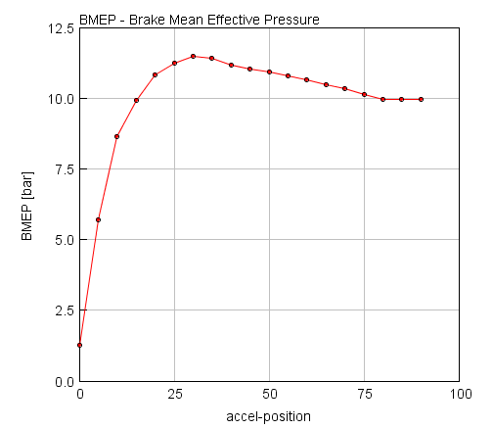

Fig 7: Brake mean effective pressure against throttle position

The mean pressure which if imposed uniformly from top to bottom of the piston in each cycle would be the measure of the brake power output. This increases with the opening of the throttle until 30 0 thereafter, it decreases a little. This little decrease is an indication of decrease in velocity of incoming air due to wide opening (fig 7)

**Throttle effeciency**

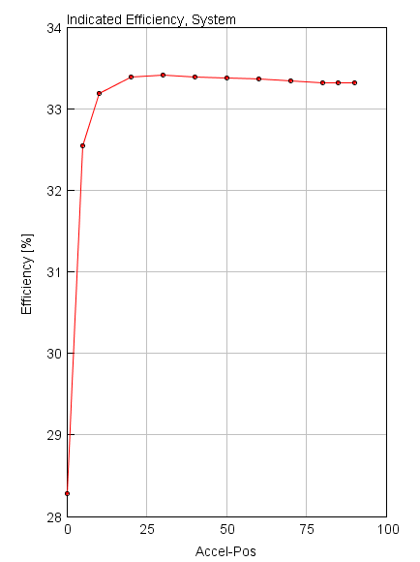

Fig 8: System indicated efficiency against throttle position

The amount of work produced at the flywheel per amount of fuel conversion in each cycle increases with the throttle opening and become stable form 30 0 (fig 10). The wider the throttle angle the more the induction of of air to enable complete combustion to produce more shaft work.

**Carbon Dioxide emissin**

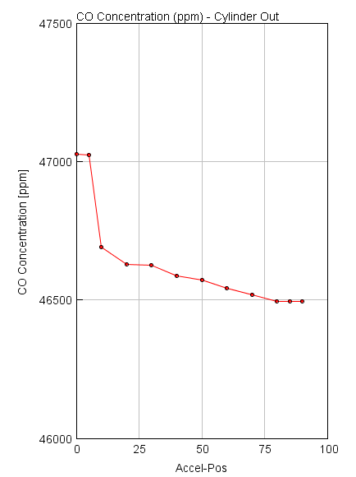

Fig 9: carbon monoxide concentration in part per million (ppm) against throtle angle. Combustion in the absence of air produces more toxic emission at the exhaust but, with the introduction of air, the harmful emission delines. At stoichiometric point, the production of toxic emissions is minimum.

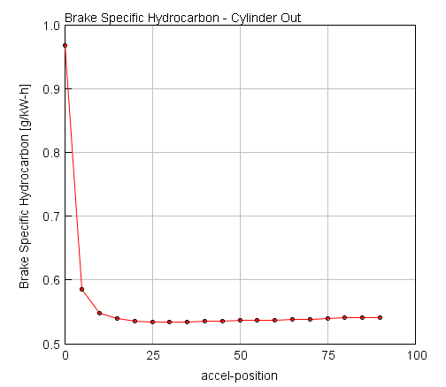

Fig 10: Brake specific hydrocarbon emission against throttle angle Unbunrt hydrocarbon is a result of poor air/fuel mixture. Fig11 above shows that with more stoichiometric air, thecombustion process improves and reduces the amount of unburnt hydrocarbon emission. From the above analysis, the velocity of different throttle opening positions (throttle angles) shows the eddy current of the air flow into the engine cylinder. At the varoius throttle angles (throttle opening) through the flow velocity of the throttle valve. In order to induce air into the engine cylinder at a moderate speed, the vortex area cannot be too wide, otherwise it will cause uneven air-fuel mixture. Uneven air-fuel mixture will result to the emission of excess hydrocarbon (HC), Carbon Monoxide (CO) and particulate) from the exhaust. Therefore, in order to achieve good exhaust discharge and better engine performance, and fuel economy, 80 0 throttle angle and 3000 RPM of the engine is highly recommended. Further study of throttle opening positions shows that, when the angle is between 00, to 450 degrees, the resulting wake area, which inducts air into the engine is very small, resulting in uneven mixing of air and fuel, leading to incomplete oxidation. At 60 0, though there is wide enough area for air flow however, the pressence of wake (probably caused by the flapper position), affects the flow rate negetively hence the air-fuel mixture is also uneven. This wake at 60 0 throttle opening disappears between 700 to 80 0 hence the reason for better performance at 80 0.

**Conclusions**

This research focused on the impact(s) of the butterfly valve angle variation on the overall performance of an injector type spark ignition engine. In order to analyse the system, analysis was done by employing the GT-Power engine simulation software to investigate the performance conditions. Fluid flow across the throttle valve is not isentropic nor 1-D flow. Therefore, to correctly predict this kind of flow by the use of 1-D model, other properties like the 3-D effects, need to be put into consideration in the discharge coefficient formulation. This ability to correctly calculate this parameter greatly depends on proper characterization of the profile of flow area as a function of throttle angle opening [19]. By studying the turbulence of the flowi caused by different throttle opening positions of 0 to 90 degrees in relation to engine performance(s), we observe that it is directly proportional to the throttle opening from 0 to 35 degrees, however, there is better mixture of air and fuel at 80 degrees throttle angle whichis vital in emission reduction and energy conversion hence 80 0 throttle angle is hereby recommended. At smaller throttle valve opening, the engine performance parameters like:- Net Indicated Mean Effective pressure (NIMEP), Brake Specific Fuel Consumption (BSFC), Brake Mean Effective Pressure (BMEP), Induced Air-Fuel ratio, Volumetric Efficiency air-fuel vapor (VE) , Emissions, Brake Specific Carbon monoxide production and Brake specific hydrocarbon production are low. This is because of the resistance to air flow due to the flapper of the throttle valve’s body. As the valve continue to open, it allows for greater induction of air which causes increase in the engine performance. At maximum opening of the throttle, the engine system produced maximum performance(s) except for mixing efficiency which is maximum at 80 0. This is because, the restriction to air flow is low at larger valve opening.

**Recommendations**

In summary, consequent from the analysis and observation of this research the following are hereby recommended for optimum engine performance:-

1. At optimum speed and load condition, the throttle angle should be maintained at 80 0 throttle position.
2. For improved engine efficiency and fuel economy, engine speed should be maintained at 3000rpm on load.

**References**

[1] C. Arcoumanis, J.H. Whitelaw, “Fluid mechanics of internal combustion engines - a review”, Proceedings of the Institution of Mechanical Engineers, Part C, Journal of Mechanical Engineering Science, Volume 201, n°1, pp. 57-74, 1987

[2] S.K Fasogbon, “Melon oil methyl ester: an environmentally friendly fuel” Journal of Natural Resources and Development 2015;05:47-53

[3] A. Chow, M.L. Wyszynski, , “Thermodynamic modelling of complete engine systems - a review”, Proceedings of the Institution of Mechanical Engineers, Part D, Journal of Automobile Engineering, Volume 213, n°4, pp. 403-425, 1999

[4] D. Chalet, P. Chesse, “Analysis of unsteady flow through a throttle valve using CFD”, Engineering Applications of Computational Fluid Mechanics, Volume 4, n°3, pp. 387-395, 2010

[5] P. Ross, A.J. Kotwicki, S. Hong, “Throttle flow characterization”. SAE 2000 World Congress, 2000- 01-0571, Detroit, Michigan, 2000

[6] M.R. Gharib, M. Moavenian, “A new generalized controller for engine in idle speed condition”, Journal of Basic and Applied Scientific Research, Volume 2, n°7, pp. 6596-6604, 2012

[7] J.J. Moskwa, “Automotive engine modeling for real time control” PhD Thesis, Massachusetts Institute of Technology, 1988

[8] D.E. Winterbone, R.J. Pearson, “Design techniques for engine manifolds - Wave action methods for IC Engines”, Professional Engineering Publishing Limited London and Bury st Edmunds, UK, 1999.

[9] M. Bordjane, D. Chalet, M. Abidat, P. Chesse, “Inertial effects on fluid flow through manifolds of Internal Combustion Engines” Proceedings of the Institution of Mechanical Engineers, Part A, Journal of Power and Energy, Volume 225, n 6, pp. 734-747, 2011

[10] D.E. Winterbone, R.J. Pearson, “Theory of engine manifold design - Wave action method for IC Engines, rofessional Engineering Publishing Limited London and Bury st Edmunds, UK,

[11] D.C. Wilcox, “Turbulence modeling for CFD”, DCW Industries, 2006

[12]J. Tu, G.H. Yeoh, C. Liu, “Computational Fluid Dynamics: a practical approach”, Butterworth-Heinemann, 2012

[13] B.E. Launder, D.B. Spalding, “The numerical computation of turbulent flows”, Computer Methods in Applied Mechanics and Engineering, Volume 3, n°2, pp. 269-289, 1974

11/12/2021