Identification of Fractured Well using Ensemble Kalman Filter

Ghodratollah Faryabi, Abdolnabi Hashemi, and Mehdi Shahbazian

Faculty of Petroleum Engineering, Petroleum University of Technology (PUT), Ahwaz, Iran
ghodrat.faryabi@gmail.com

Abstract: This paper demonstrates the potential and advantages of the Ensemble Kalman filter (EnKF) as a tool for assisted history matching, based on its sequential processing of measurements, its capability of handling parameter set, and on the fact that it solves the combined state and parameter estimation problem. The EnKF is a Monte Carlo method for data assimilation that uses an ensemble of reservoir models to represent and update the covariance of variables. Formation properties are one of the key factors in numerical modeling of flow and transport in geologic formations in spite of the fact that they may not be completely characterized. The incomplete knowledge or uncertainty in the description of the formation properties leads to uncertainty in simulation results. In this study, the ensemble Kalman filter (EnKF) approach is used for continuously updating model parameter such as fracture length in a fracture well and model variable such as pressure while simultaneously providing an estimate of the uncertainty through assimilating dynamic and static measurements. The proposed algorithm uses an ensemble data assimilation approach to provide stochastic characterization of reservoir attributes by conditioning individual prior ensemble members on dynamic production observations at wells. The prior sample mean and covariance are derived from nonlinear dynamic propagation of an initial ensemble of reservoir properties.
[Ghodratollah Faryabi, Abdolnabi Hashemi, and Mehdi Shahbazian. Identification of Fractured Well using Ensemble Kalman Filter. N Y Sci J 2021;14(11):42-48] ISSN 1554-0200 (print); ISSN 2375-723X (online) http://www.sciencepub.net/newyork. 6. doi:10.7537/marsnys141121.06.

Keywords: Ensemble Kalman Filter; history matching; Monte Carlo; data assimilation.

1. Introduction
The Ensemble Kalman Filter (EnKF) was introduced by Evensen (1994) for updating non-linear ocean models. It is a Monte Carlo approach where errors are represented by an ensemble of realizations. The model parameters and state variables are updated sequentially in time, as new measurements become available. The result is an updated ensemble of realizations, conditioned to all production data, which provides an improved estimate of the model parameters, the state variables, and their uncertainty. Since its first application within the pertroleum industry, several publications have discussed the use of the EnKF for parameter estimation in oil reservoirs, and have shown promising results. Nevertheless, most published papers present synthetic cases (e.g. Nævdal et al., 2002, Gu and Oliver , 2005), while real field applications have only recently been considered. Previous works that demonstrate the capability to use the EnKF for history matching real reservoir models are Skjervheim et al. (2005), Haugen et al. (2006), Bianco et al. (2007), and Evensen et al. (2007). All these studies conclude that the EnKF is able to significantly improve the match of production data compared to manual history matching, and to provide improved estimate of model parameters. Previously, the focus has mainly been on the estimation of porosity and permeability fields in the simulation models. In Evensen et al. (2007), parameters such as initial fluid contacts, and fault and vertical transmissibility multipliers, are included as additional uncertain parameters to be estimated.
In this paper, the EnKF is presented as a method for history matching reservoir simulation models and discussed in relation to traditional methods where a cost function is minimized. The EnKF history matching workflow for applications in reservoir management projects is described in some detail. The properties of the EnKF are demonstrated in a real field application where it is illustrated how a large number of poorly known parameters can be updated and where the uncertainty is reduced and quantified through the assimilation procedure. It is shown that introduction of additional model parameters such as the relative permeability leads to a significant improvement of the results when compared with previous studies. Finally, the updated ensemble is used to predict the uncertainty in future production.

2. Background and Methodology
This section briefly discusses the EnKF formulation and the implementation of the proposed hybrid EnKF for nonlinear dynamics. We first review the classical EnKF formulation and introduce the relevant terminologies. We then present the modifications and the enhancements proposed in this paper, specifically coupling of the non-linear inversion and the coarse scale constraint on the ensemble members.

3. EnKF Formulation
The EnKF introduced by Evensen (1994; 2003) is a sequential Monte Carlo technique for data assimilation where an ensemble of model states is recursively conditioned to dynamic data as it becomes available. The mean of the ensemble is assumed to be the most representative estimate of the true, but unknown, reservoir state while the spread of the ensemble around the mean represents the associated uncertainty and is quantified by the ensemble-derived state covariance matrix. The initial ensemble can be generated using any of the standard geostatistical techniques such as sequential Gaussian simulation or indicator simulation that utilize static data derived from well logs, cores and seismic surveys, as well as geologic interpretation studies (Deutsche and Journel 1992). The prior ensemble of model realizations is then combined with available observations using Kalman filter equations to obtain a corrected ensemble.
In the EnKF formulation, each realization is represented by its corresponding state vector, $y_{k}^{p}$ at time ‘k’, and it includes the vector of static variables $m_{k}^{s}$ (e.g. permeability, porosity) of length Ns, the vector of dynamic variables $m_{k}^{d}$ (e.g. pressure, phase saturations) of length N_{d}, and the vector of model predictions $d_{k}$ (e.g. bottom-hole pressure, water-cut and gas-oil ratio at the wells) of length M as follows. Number of columns of this matrix is Ne and Number of rows of the matrix is proportional to the numbers static, dynamic and prediction or observations variables.
$$y_{k}^{p}=\left[\begin{matrix}m_{k}^{s} \\ m_{k}^{d} \\ d_{k}\end{matrix}\right] (1)$$
The superscript ‘p’ denotes the prior model. The model predictions at time ‘k’ is related to the state vector through the use of a measurement matrix, H as follows:
$$d_{k}=Hy_{k}^{p} (2)$$
Thus, the mapping matrix H is a trivial matrix given by Eq. 3 where I is the identity matrix as follows:
$$H=\left[0_{N_{s}} 0_{N_{d}} I_{M}\right] (3)$$
The EnKF works with an ensemble of model realizations denoted as:
$$φ_{k}^{p}=\left\{y_{k,1}^{p} y_{k,2}^{p} … y_{k,N_{e}}^{p}\right\} (4)$$
Where Ne is the ensemble size. Each state vector represents an individual member of an infinite ensemble of possible states that are consistent with the initial measurements from cores, well-logs, and seismic surveys and geologic interpretation studies.
EnKF Forecast and Update. The EnKF comprises of two main steps: a forecast step and an update step. The forecast step can be written as:
$\left\{\begin{matrix}m_{k}^{d} \\ d_{k}\end{matrix}\right\}=g\left(m_{k-1}^{s},m_{k-1}^{d}\right) (5$)
where the forward model operator g (○) represents a numerical solution of the porous media fluid flow equations moving forward from time ‘k-1’ to time ‘k’ when new observations become available. At this time, the update step modifies the reservoir state vector using the well-known Kalman update equation as follows (Evensen, 2003):
$y_{k,j}^{u}=y_{k,j}^{p}+K_{k}\left(d_{obs,j,k}-Hy_{k,j}^{p}\right) (6$)
For each model, j=1, 2,…, Ne. The superscript ‘u’ denotes the updated model. The matrix K_{k} is known as the Kalman gain and relates the data misfit to the changes required in the reservoir state vector. In Eq. 6, $d_{obs,j,k}$ represents a vector of perturbed observations as defined by the following equation:
$$d_{obs,j,k}=d_{obs,k}+ε_{j} (7)$$
And $ε_{j}$ represents the noise in the observation for the ensemble member ‘j’. The noise associated with the measurements, ε, is assumed to be Gaussian with a zero mean and covariance, C_{D}. The Kalman gain matrix K_{k} is expressed as follows (Evensen, 2003):
$$K_{k}=C_{φ,k}^{p}H^{T}{(HC_{φ,k}^{p}H^{T}+C_{D})}^{-1} (8)$$
Where C represents an estimate of the state vector covariance matrix at time ‘k’ and can be computed from the ensemble using the following expression:
$$C_{φ,k}^{p}=\frac{1}{N_{e}-1}\sum_{t,j=1}^{N_{e}}{(y_{k,j}^{p}-{\overline{y}}_{k,j}^{p}){(y_{k,j}^{p}-{\overline{y}}_{k,j}^{p})}^{T}} (9)$$
Where
${\overline{y}}_{k}^{p}=\frac{1}{N_{e}}\sum_{j=1}^{N_{e}}{y_{k,j}^{p}} (10$)
Eq. 9 calculates the prior state-covariance matrix from the individual ensemble members. The posterior covariance can also be estimated in a similar manner using the updated realizations. An equivalent expression for the posterior covariance is provided in Eq. 11 below.
$C_{φ,k}^{u}=C_{φ,k}^{p}-H^{T}{\left(HC_{φ,k}^{p}H^{T}C_{D}\right)}^{-1}H^{T}C_{φ,k}^{p} (11)$

4. Invers problem in well testing
In this section, a brief overview of the governing equations in reservoir simulation and well testing are presented (Bourdet, 2002; Horne, 1995). These equations will be referred as dynamic forward models in describing the data assimilation algorithm. The equation governing the flow is normally written in terms of the pressure. Since we assume radial symmetry, the pressure P depends only on the radius r and time t, the equation is as following:

$\frac{1}{r}\frac{∂}{∂r}\left(r\frac{∂P}{∂r}\right)=\frac{1}{η}\frac{∂P}{∂t} (12$)

Here, $η$ is diffusivity constant and is equal to $η=0.0002637k/φμc$ and r (ft), P (psi), $φ$
(fraction), $μ$ (cp), c (psi-1), k (md), t (hr) are the radius from well center, reservoir pressure, porosity, total compressibility, permeability and time, respectively.
This is the so-called diffusivity equation and it is considered one of the most important mathematical expressions in petroleum engineering. This equation is derived under the assumption that the permeability and viscosity are constant over pressure, time and distance ranges. The fluid is assumed to be slightly compressible, like, say, oil. The notation $\frac{∂P}{∂r}$ and $\frac{∂P}{∂t}$ means partial derivative with respect to r and t respectively. The solution of the diffusivity equation for a fracturing well is given by the expression:

$P_{i}-P_{wf}=4.064\frac{qB}{hx_{f}}{\left(\frac{μB}{kφc_{t}}\right)}^{\frac{1}{2}} (13)$

Perhaps the most common inverse problem in fracture well is to infer length of fracture from a well test. In this problem measurement of pressure d={p1,p2,…,pn}^{T} are taken during initial shut in or drawdown period . It is assumed the pressure at the wellbore can be modeled using the well-known radial solution of the diffusivity equation, This is our forward model d=g(m) If enough information is provided one should be able to easily solve for the model parameter m={x_{lf}} fracture length using the set of equations (12, 13) .

$$x_{f}=4.064\frac{qB}{h(P_{i}-P_{wf})}{\left(\frac{μB}{kφc_{t}}\right)}^{\frac{1}{2}} (14)$$

Equation 14 is the solution for a very simplified version of an inverse problem. It was solved without considering noise in the observation and without considering any prior information. For instance if the model parameters interest are now permeability, skin factor and porosity m={$x_{f}$}^{T} then there is not an unique solution for m. Summarizing, the inverse problem theory refers as the family of techniques that allows us to determine a plausible set of values for the model parameter m, given an optional prior description of the model parameters prior, some inexact observed data d_{obs} and an assumed theoretical relationship between the data and the model parameters:

d=g(m) (15)

5. EnKF Algorithm
The main idea to bear in mind is that the EnKF is a Monte Carlo Kalman filter. Simultaneous state vectors are simulated, advanced in time, and updated for each time an observation arrives. The statistics of the forecast step are not available explicitely, as in the linear case. In Ensemble Kalman filter probability density of the state is represented by a finite number N_{e} of randomly generated system state vectors called realization.
The filter procedure for integration consists of two steps: a forecast step and an update step. Forecast step is to evolve the state vector forward in time between two consecutive measurement times and update step is to assimilate states of system with observed well bottom-hole pressure data. The two-step procedure is repeated at each measurement time till the last measurements are assimilated into model.
for the initial guess, we assume that the length of fracture changes 100ft ta 600ft. 100 realizations is selected for it .i.e. we have 100 values in interval of [100-600] with the mean of 347.5230ft and standard deviation of 142.2707ft, uniformly.
In the prediction step, equation (13) is used for model dynamic to predict fracture length.
In the assimilation step, first, we must estimate the mean ensemble, predicted covariance matrix and Kalman gain from equations 10, 9, 8, respectively. Each realization and state error covariance matrix are updated by arriving the observation $d_{obs}$, from equations 6,11. If we receive a new observation, we go to the prediction step.

6. Results
We know from rock properties literatures, usual fracture wells have fracture length within range of 100 to 600 ft. based on type of sedimentation process. So, our prior quantitative knowledge is that unknown fracture length is distributed uniformly in the range of [100-600] ft. i.e. $p(x_{f0})\sim U(100,600)$. Here, U stand for uniform distribution.
Figures 1,2,3,4 show histograms of x_{f} during the data assimilation. Analysis of these Figures show that range of data for x_{f} is reduced from [100-600] with the mean of 357.7070 and standard deviation of 143.4537 in initial guess to [160.4 - 461.48] with the mean of 254.8322 and standard deviation of 58.9142 in the second step (after assimilation of second measurement) to [192-242] with the mean of 209.1953 and standard deviation of 13.3513 in the seventh step (after assimilation of seventh measurement) to [199.5-202.5] with the mean of 201.3403 and standard deviation of 1.8643 in the last step (after assimilation of last measurement).
In Figure 5, 30 measurement data were assimilated. This figure shows that the ensemble mean fracture length is approaching to a constant value (true value 200 ft.).Figure 6 shows ensemble mean pressure and observation pressure. From these Figures we understand that after 20th time step, model and observation data match from each other and mean fracture length converges with time.
Figures 7 and 8 represent standard deviation of fracture length and pressure evolution through time respectively. We understand from this Figure that the standard deviation in initial time steps is high and with passing time this value is low and tends to zero.

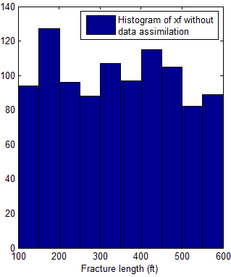
Figure 1. Histogram of x_{f} without data assimilation (initial guess)

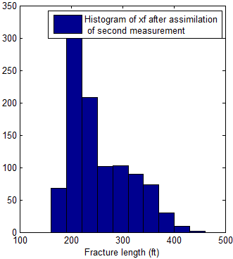
Figure 2. Histogram of x_{f} after assimilation of second measurement

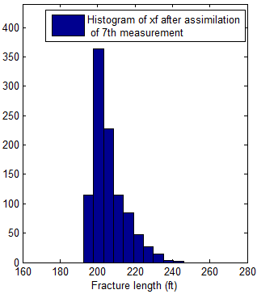
Figure 3. Histogram of x_{f} after assimilation of 7th measurement

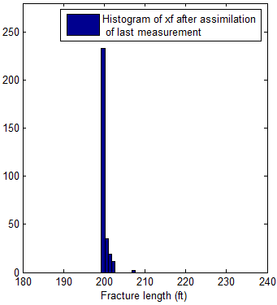
Figure 4. Histogram of x_{f} after assimilation of last measurement

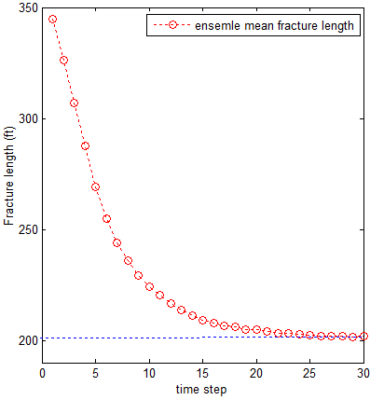
Figure 5. Ensemble mean fracture length through time

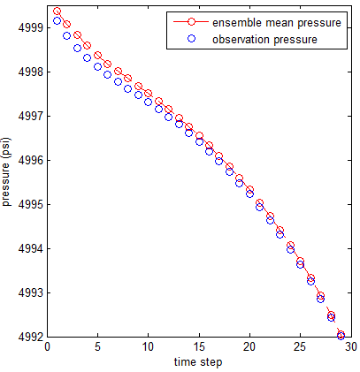 Figure 6. Ensemble mean pressure with observation pressure through time

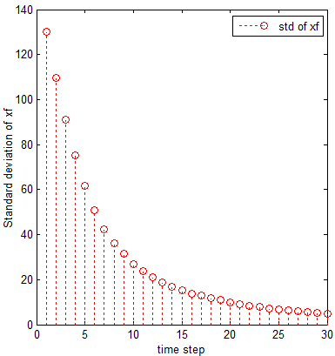
Figure 7. Standard deviation of fracture length through time

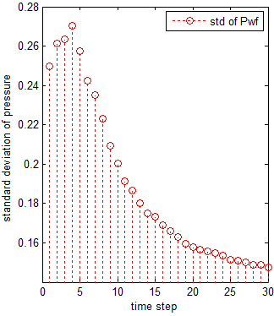
Figure 8. Standard deviation of pressure through time

7. Conclusions
We have demonstrated that the ensemble Kalman filter is an algorithm that is well suited for producing forecasts with uncertainty. It is observed that the forecasts are improved after assimilation of production data.
Through this research, we found that the EnKF is suitable for data from time series when the changes made to the model parameters and state variables are both small at every measurement time.
The well can be monitored online and any change in fracture length in any time can easily be identified. Uncertainty of prediction is always up-to-date and directly computed from the ensemble.

References
1. Bourdet, D. 2002, Well test analysis: the use of advanced interpretation models, Elsevier Amsterdam.
2. Evensen, G. 1994. Sequential Data Assimilation With a Nonlinear Quasi-geostrophic Model Using Monte Carlo Methods to Forecast Error Statistics. Journal of Geophysical Research 99 (C5): 10143-10162.
3. Evensen, G. 2003. The Ensemble Kalman Filter: theoretical formulation and practical mplementation. Ocean Dynamics 53 (4):343-367.
Evensen, G., Hove, J., Meisingset, H., Reiso, E., Seim, K., and Espelid, 2007. Using the EnKF for Assisted History Matching of a North Sea Reservoir Model. Paper SPE 106184 presented at the SPE Reservoir Simulation Symposium, Woodlands, 26-28 February.
4. Deutsch, C.V., Journel, A., 1992. GSLIB Geostatistical Software Library and User’s Guide, New York, Oxford University Press.
5. Haugen, V., Natvik, L.-J., Evensen, G., Berg, A., Flornes, K., and Nævdal, G., 2006. History Matching using the Ensemble Kalman Filter on a North Sea Field Case. Paper SPE 102430 presented at the SPE Annual Technical Conference and Exhibition, San Antonio, 24-27 September.
6. Horne, R.N. 1995, Modern Well Test Analysis: A Computer-Aided Approach, Petro Way; 2nd edition.
7. Nævdal, G., Mannseth, T., and Vefring, E.H. 2002. Near-Well Reservoir Monitoring Through Ensemble Kalman Filter. Paper SPE 75235 presented at the SPE/DOE Improved Oil Recovery Symposium, Tulsa, 13-17 April. DOI: 10.2118/75235-MS.
8. Gu, Y. and Oliver, D.S. 2005. History Matching of the PUNQ-S3 Reservoir Model Using the Ensemble Kalman Filter. SPE J 10 (2): 217- 224. SPE-89942-PA. DOI: 10.2118/89942-PA.
9. Skjervheim, J.-A., Evensen, G., Aanonsen, S. I., Ruud, B. O., and Johansen,T. A. 2005. Incorporating 4D Seismic Data in Reservoir Simulation Models Using Ensemble Kalman Filter. SPE journal, 12(3):282–292.
10. Oliver, D. S., He N., and Reynolds A. C. 1996. Conditioning permeability fields to pressure data, Paper presented at the 5th European Conference for the Mathematics of Oil Recovery, Leoben, 3-6 September.
11. Bianco, A., Cominelli, A., Dovera, L., Naevdal, G. and Valles, B. 2007. History Matching and Production Forecast Uncertainty by means of the Ensemble Kalman Filter: a Real Field Application. Paper SPE 107161 presented at the SPE Europec/EAGE Annual Conference and Exhibition, London, 11-14 June.
12. Burgers, G., van Leeuwen, P. J., and Evensen, G. 1998. Analysis scheme in the ensemble Kalman filter, Mon. Weather Rev., 126: 1719–1724.
13. Ghafoori, M. R., Roostaeian, M. , ajadian, V. A. 2008, A State-of-the-Art ermeability Modeling Using Fuzzy logic in a Heterogeneous Carbonate (An Iranian Carbonate Reservoir Case Study), SPE 12019.
Vazquez, A., Syversveen, A. R. ,2006, The Ensemble Kalman Filter theory and applications in oil industry, Technical Report, Norwegian Computing Center.

2/3/2021

