The Prevalence of Addiction Among Students in Dire Dawa University Ethiopia

Mustefa JIBRIL

School of Electrical & Computer Engineering, Dire Dawa Institute of Technology, Dire Dawa, Ethiopia
mustefa.jibril@ddu.edu.et

Abstract: This study was carried out to determine the prevalence of, and reasons for the various forms of addictive use among the students of the University of Dire Dawa. The research system is used, cross-sectional, questionnaire-question. This study has been carried out, including the first-and second-year students at the University of Dire Dawa. The study included 164 students who have completed a structured questionnaire. The Data was analyzed on SPSS version 16. The prevalence of addictive use was 20.7%, with 64.7% of the male students are dominating. It is the most common addiction among students was that the Chewing of Chat (38.2%), followed by cigarette smoking (23.5%), marijuana smoking (17.6%), shisha smoking (8.8%), alcohol (6%), and 5.9% were of other addiction. The most important factor appears to be the pleasure to compete and not being able to love. The vast majority of addictive users of the students (47.1%) were motivated by the friends of the start of an addiction. addictive usage among university students, even though they are well known about their dangers, a cause for concern. Education, training, counseling, and proper training can help prevent the dependency of prospective students, who are expected to serve the community.
[Mustefa JIBRIL. The Prevalence of Addiction Among Students in Dire Dawa University Ethiopia. N Y Sci J 2021;14(11):16-20] ISSN 1554-0200(print); ISSN 2375-723X(online) http://www.sciencepub.net/newyork. 4.
doi:10.7537/marsnys141121.04.

Keywords: Addiction, Prevalence, Dire Dawa, Dominating

1 Introduction:

Addiction is a global concern. This does not just affect the individual's mental, physical, and social well-being, but also to their social surroundings, and still is, the first case. The distribution of students may be different from that of the general population, particularly among the university students who have to cope with the various stresses of their education and training.
The student will undergo dramatic changes as they leave the safety and security of their family and arrive at college. Upon arriving on campus, they can expect to gain independence, expand their knowledge, and progress to adulthood. Despite these opportunities, however, college students face many challenges including expanded courses, new space, and, at least initially, a small support network. Also, they have the challenge to complete their education while alcohol and other addictions are readily available.
Although addiction use is a concern for all ages and demographics, it is especially true for adult students in college. The country is experiencing some very high levels of addiction use, which can disrupt college knowledge and lead to addiction.
The most common use of addiction among university students has been tobacco, Chewing Chat, and Shisha smoking. In some studies, it has been found that they are the most addictive, starting at the age of 18, when students take this addiction to school, and they think it depends on who the source is among their friends.
College addiction use may be as prevalent as it is due to the new freedom offered by the college environment. As a young person approaches the college campus, students are accountable for their decisions and behavior without parental guidance, for the first time in many cases.
In Ethiopia, some studies have been done based on the addiction of university students. This study was carried out to determine the prevalence and reasons for the various forms of addiction among Dire Dawa university students.

Materials and Methods:
This study was carried out at the University of Dire Dawa among the first-and second-year students. 164 the volunteers, the students completed a self-administered survey at the end of the lecture, explaining, their goals, learning, and filling in the questionnaire. The students were assured of confidentiality and are asked not to write their names will remain anonymous.
If it is assumed that the prevalence of addictive uses among students, 16% of the previous studies, the sample is designed in the shape of 149, with a 95% confidence level of alpha= 0.05. The request for information, which contains the general information of the students (age, sex, place of residence), addictive dependence (a type of addictive dependence, frequency of use, age of initiation, the cause, the beginning, and the continuance, of the important factors, and financial resources to purchase it, it's dangerous influence, and ready to stop the addiction, and the information from the non-addicted individuals.
The Data were analyzed using the Statistical Packages for the Social Sciences (SPSS) version 16. The proportion/ percentage and chi-square criteria were used for statistical analysis. An R-value less than 0.05 is considered to be significant.

Result and Discussion
Among 164 participants, 72 were male (43.9%) and 92 female (56.1%). The mean age of the participants was 18.6 years. The average age of onset of addiction was 14.05 years. The overall prevalence of addiction use was 20.7%, with 64.7 % of the male students is dominating compared to 35.3% of the female students (p<0.05)

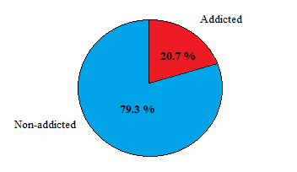
Figure 1 The overall prevalence of addiction

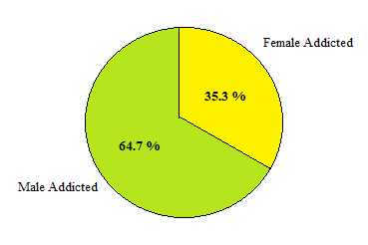
Figure 2 Male female addiction percentage

Addiction use was higher among students who live in their own homes (51.5%), based on discrimination, as part of a university dormitory (39.4%), and that the lease of private housing (6.1%) and with their relatives (3%). The most common addiction among students was that the Chewing of Chat (38.2%), followed by cigarette smoking (23.5%), marijuana smoking (17.6%), shisha smoking (8.8%), alcohol (6%), and 5.9% were of other addiction.

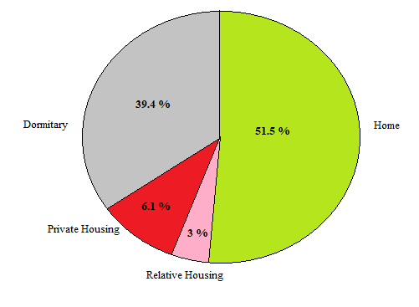
Figure 3 Students addiction based on living

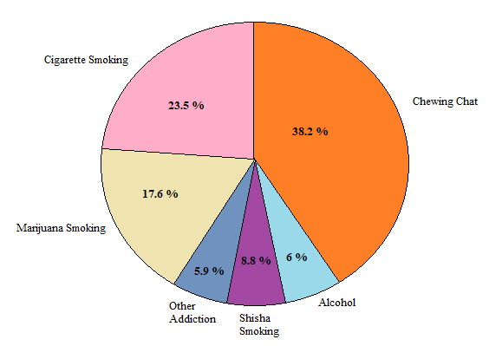
Figure 4 Types of students addiction

Table 1: Factors that initiate addiction among university students.
Causes Of Initiation for Addiction (N= 164)
CAUSE | Frequency | Percentage
Curiosity | 5 | 2.9%
Pleasure | 53 | 32.4%
Failure in love | 19 | 11.8%
Maturity | 5 | 2.9%
Unintentional | 14 | 8.8%
Friends company | 10 | 5.9%
Impersonating others | 39 | 23.5%
Release of tension | 5 | 2.9%
High society trend | 5 | 2.9%
Other | 9 | 5.9%

The most important factors for the occurrence of the addiction, to enjoy, to compete with friends, and not to be in love (see Table 1). The vast majority of addiction users of the students (47.1%) were motivated by the friends of the start of an addiction. 59.4 % of the students think, to enjoy, to continue to be the cause of the addiction, while 21.9% thought the continuation of the addiction and 18.9% think that it is desirable for a short rest.
66.7% of the adductors believe that their addiction is dangerous for their health, while 33.3 % believe that it is not harmful in any way. 50% of students showed a desire to quit smoking. The main reasons for absenteeism among the students, the non-adductors of the knowledge of the harmful effects of the (77.9%), social exclusion, and the reprehensibility (9.1%), and female (1.5%), and in 11.5% of it was for a different reason.

Discussion:
In particular, the large-scale use of the addiction in our study was 20.7%, which is relatively lower than that of western African countries. A variety of studies in the United States from 1973 to 2013, has shown that the dependence of the various topics among the students is quite common, rather than their abusing marijuana, alcohol, tobacco, and cocaine. In our study, we found that the most common addiction is chewing Chat consumption, followed by smoking Tobacco. In our case, none of the students reported a dependency on a Smelling Benzine or Shoe Glue (Mastish). This may be due to the differences in the culture, the favorability of the element, and the small studies carried out in Ethiopia, compared to other countries.
It is important to take note of the fact that the average age for the onset of the addiction, which was found in our study is more around the age of 14, indicating that the majority of the beginning of his addiction at the school. This suggests that advice the student at school, since most of the students are not aware of the adverse effects of the addiction, and the like have already been taken to medical institutions, they are subject to such addictions.
It should also be noted that the majority of the students who had been influenced by their friends to start an addiction, which suggests that the parents of control children, their friendships, can also prevent a child from becoming addicted.

Conclusion:
The high prevalence of addiction among university students is alarming. Although college students are aware of the hazardous effects of addictive substances, despite that, these future persons had less concern over their health. As the majority of them begin addiction during school age, it is important that proper counseling and preventive as well therapeutic programs should be planned and made effective at schools, colleges, and higher institutions.

Reference
- Caamano-Isorna, F., Adkins, A., Moure-Rodríguez, L., Conley, A. H., & Dick, D. (2021). Alcohol use and sexual and physical assault victimization among university students: Three years of follow-up. Journal of interpersonal violence, 36(7-8), NP3574-NP3595.
- Năsui, B. A., Ungur, R. A., Talaba, P., Varlas, V. N., Ciuciuc, N., Silaghi, C. A., ... & Pop, A. L. (2021). Is alcohol consumption related to lifestyle factors in Romanian university students?. International journal of environmental research and public health, 18(4), 1835.
- Caamano-Isorna, F., Adkins, A., Moure-Rodríguez, L., Conley, A. H., & Dick, D. (2021). Alcohol use and sexual and physical assault victimization among university students: Three years of follow-up. Journal of interpersonal violence, 36(7-8), NP3574-NP3595.
- Alves, R., Precioso, J., & Becoña, E. (2021). illicit Drug Use among College Students: The Importance of Knowledge about Drugs, Live at Home, and Peer Influence. Journal of psychoactive drugs, 1-10.
- Mohammed Al Ghafri, J. S., SS, J. A. S., & Shaikh, J. (2021). Prevalence of Substance Abuse among Omani Population in two Governorates in Sultanate of Oman. Madridge J Nurs, 5(1), 167-172.
- Essam Eldin, R., Othman, H., & Salah Eldin, H. (2021). Evaluation of Substance Abuse Cases Admitted in ICU of Poison Control Center-Ain Shams University Hospitals by Certain Clinical Scoring Systems. Ain Shams Journal of Forensic Medicine and Clinical Toxicology, 36(1), 90-97.
- Heradstveit, O., Skogen, J. C., Brunborg, G. S., Lønning, K. J., & Sivertsen, B. (2021). Alcohol-related problems among college and university students in Norway: extent of the problem. Scandinavian journal of public health, 49(4), 402-410.
- Graupensperger, S., Jaffe, A. E., Fleming, C. N., Kilmer, J. R., Lee, C. M., & Larimer, M. E. (2021). Changes in college student alcohol use during the COVID-19 pandemic: Are perceived drinking norms still relevant?. Emerging Adulthood, 2167696820986742.
- Schilling, L., Zeeb, H., Pischke, C., Helmer, S., Schmidt-Pokrzywniak, A., Reintjes, R., ... & Schneider, S. (2017). Licit and illicit substance use patterns among university students in Germany using cluster analysis. Substance abuse treatment, prevention, and policy, 12(1), 1-11.
- El Mhamdi, S., Lemieux, A., Bouanene, I., Salah, A. B., Nakajima, M., Salem, K. B., & Al'absi, M. (2017). Gender differences in adverse childhood experiences, collective violence, and the risk for addictive behaviors among university students in Tunisia. Preventive medicine, 99, 99-104.

10//25/2021

