An Impact Assessment of Tunnel Technology Transfer Project in Punjab, Pakistan

Muhammad, S. A., A. Saghir, I. Ashraf, M. Amjad, and M. J. Alvi

Institute of Agriculture Extension & Rural Development, University of Agriculture, Faisalabad, Pakistan
Corresponding Author: aqeelasaghir@uaf.edu.pk

Abstract: Vegetables have a great importance in agriculture sector. These crops share a great contribution to agriculture in national economy. There are many vegetables which can be grown in Pakistani climate and soil. Tunnel farming is a new technology for growing vegetables due to increase in population and small land for agricultural use. Government of Punjab is doing its effort to disseminate this technology among the farmers to enhance their vegetable production. Fruit and Vegetable Development Project (F&VDP) was also started by the Punjab government in 20 districts of the Punjab. The study was done in Faisalabad district of Punjab, Pakistan. In Faisalabad, there were 12 Farmer Field Schools (FFSs) under F&VDP, out of which six FFSs were randomly selected for the collection of data through interview schedule. From each selected FFS, 20 respondents were selected randomly making sample of 120 respondents. The data were analyzed through the computer software Statistical Package for Social Sciences (SPSS). Based on the findings of the present study, it was assessed that respondents got benefits from the project in term of increase in their income and their area under vegetable cultivation also increases. Similarly, farmers knowledge about plants growth also enhanced, quality of produce increased. It is suggested that the time period of the project should be extended and there should be facility of small credit schemes for poor farmers to ensure the timely availability of quality seeds, pesticides and fertilizers. It is proven that project has enhanced livelihood assets to sustain the family lives of farming community.
[Muhammad, S. A., A. Saghir, I. Ashraf, M. Amjad, and M. J. Alvi. An Impact Assessment of Tunnel Technology Transfer Project in Punjab, Pakistan. N Y Sci J 2021; 14(9):11-17] ISSN 1554-0200 (print); ISSN 2375-723X (online). http://www.sciencepub.net/newyork. 2. doi:10.7537/marsnys140921.02.

Key words: Impact, assessment, Tunnel technology, Technology transfer

- Introduction
Vegetables have a great importance in agriculture sector and a source of sustainable livelihood to secure food (Adeoti et al., 2011). These crops share a great contribution to agriculture in national economy. In Pakistan among 23.40 million hectare cropped area vegetables conclude 0.41 million hectares to produce 13.67 million tons of fresh produce annually, divided into vegetables 54% and fruits 46%. Pakistan export 150.2 million kg of vegetables and earned $180.2 million in fiscal year 2011-12 (Govt. of Pakistan, 2012a).
Globally, vegetable production has grown widely especially on a per capita basis, which increased 60 percent over the last 20 years. This trend is predominantly strong in developing countries (FAO, 2010). Vegetables are highly beneficial for health and prevention from diseases, these are also acts as source of income and important for food security of the people of Pakistan. Our country exports vegetables to other countries for earning foreign exchange. Vegetables buyers’ countries from Pakistan are India, Dubai, United Kingdom, Saudi Arabia, Sri Lanka, USA, Iran, Kuwait, Canada, UK, Malaysia and Afghanistan (Govt. of Pakistan, 2012b).
Vegetables are the best source of food nutrients needed for the balanced human diet. These are not only providing macro food nutrients but also micro ones like minerals and vitamins which make the balanced diet with combination of cereals (Govt. of Punjab, 2013).
Vegetables may be classified into three categories, namely: a) herbage vegetables, b) underground vegetables and c) fruit vegetables. Spinach, cabbage, lettuce, cauliflower etc. are taken as herbage vegetables due to nutrient material stored in the above ground part of the plant, carrot, beet root, sweet potato, potato and yams etc. are underground vegetables and these are also further divided into two parts: roots and underground stem and similarly tomato, melons, brinjal, bottle gourds, okra, chilli, and pepper are called fruit vegetables because their edible portion is fruit (Pradhan, 2003). There is a long list of winter and summer vegetables being produced in Pakistan (Mahmood, et al. 2011).
There are many vegetables which can be grown in Pakistani climate and soil (Mahmood, 2012). Tunnel farming is a new technology for growing vegetables due to increase in population and small land for agricultural use (Thakur, 1994). For off-season vegetable production tunnel farming is very suitable technology (Singh, 1998). Winter and summer vegetables both can be grown-up under tunnel out of their normal growing season (Pradhan, 2003). The production of winter vegetables in summer season by creating artificial environment involves a large investment but the production of summer vegetables in winter by developing optimum temperature in tunnels by using plastic sheets is very economical. Plastic sheet provides warmth temperature by saving the energy of the sun through the absorption of sunlight and do not allowing them to go back to the atmosphere. This technology suits to the farmers having small land holding. Producing vegetables on small land under tunnels can meet dietary requirements of the country and become able to export these vegetables (Rafique, 2011).
Three types of tunnel used in Punjab Low Tunnel, Walk-in Tunnel and High Tunnel. Crops grown in tunnels are chillies, bottle gourd, bitter gourd, tomatoes, cucumber, sweet pepper and pepper (Khan, 2000). Tunnel farming is gaining popularity, and being practiced in many areas of province Punjab like Faisalabad, Mamokanjan, Gujranwala, Okara and Sahiwal. But still their cultivation is not at a level to be exported. Farmers are also unaware of their potential. Awareness programmes are helpful as Punjab government is already doing its effort to introduce this technology (Mahmood, et al. 2011).
Fruit and Vegetable Development Project (F&VDP) was also launched by the Govt. of Punjab in July, 2005 in 12 districts of Punjab to facilitate the vegetables and fruit growers for enhancing their production, this project successfully completed its phase-I in June, 2010. For its successful completion the Govt. of Punjab has extended Fruit and Vegetable Development Project phase-II from August, 2010 to June, 2013 and expanded to 20 districts. In second phase the twelve districts Shiekhupura, Okara, Kasur, Sialkot, Attock, Rawalpindi, Hafiz Abad, Pakpattan, Sahiwal, Gujranwala, Faisalabad and Lahore for off season vegetable production of while other eight distrit were selected for mango and citrus production (Government of Punjab, 2012).
Under F&VDP, Farmer Field School (FFS) approach is being used to impart training to the farmers by the field staff. In this approach training of facilitator’s is conducted and FFSs are start over the whole crop season. The Agriculture Officers (AOs) which are training facilitator attends meeting with Center for Applied Biosciences International (CABI) in office of District Implementation Unit (DIU) on first day of the week and in other days of the week every AO carry out four FFS in consecutive days. Each FFS has 25 farmers, they select a field area and observe it by doing Agro-Eco System Analysis (AESA) and discussion are held on what they have observe in the field, on the basis of this discussion further actions are decided. Due to this approach farmers become confidant and organized to work in the community. Farmers get knowledge about vegetable production and solve their conflicts by themselves. To ensure the farmers participation in the FFS, incentives has been paid to the farmers by the project (Government of Punjab, 2012).
As vegetable intake requirement in our country is 400g/day/person as recommended by World Health Organization. Similarly, it is recommended to intake 0.38kg of tomatoes, 0.83kg of onion and 1.54kg of other vegetables per capita on monthly basis (Govt. of Pakistan, 2012c). Our country is able to meet only very small amount of that intake requirement. Therefore, there is need of planned development in the field of vegetable production to improve the nutritional requirement for masses and also to meet the challenge of sufficient food supply to the growing population in Pakistan. For creating awareness and dissemination of improved tunnel technology among farming community to meet the country’s requirement of vegetable production, F&VDP was launched by the Punjab Government in different districts of the country. As the project was highly funded by the Government of Punjab to increase vegetables production in the project areas and to fulfill the demand of vegetables of the local market through the dissemination of modern production technologies of the vegetable crops by using FFS approach among the farming community. It seems to be important to analyze the fruits of the project. Therefore, the current study was planned to explore the advantages taken by the vegetable growers of district Faisalabad through F&VDP Punjab, Pakistan. The main objectives of the study were a) to identify the benefits obtained by the vegetable growers, b) to determine the increase in the area under vegetable farming and c) to find out increase in the income of the vegetable growers.

- Material and methods
Faisalabad is the important district of Punjab, Pakistan where F&VDP were running, six FFSs were selected randomly out of 12 Farmer Field Schools (FFSs) in present study for collecting the data by using interview schedule. From every selected FFS, 20 respondents were selected randomly making sample of 120 respondents. All of the respondents were vegetable growers and were getting training from F&VDP for off-season vegetable production, information’s regarding education, age, increased the area under vegetable and increase in the income of the respondents were collected. The data collected was transferred on an excel sheet to facilitate tabulation. The analysis of the data was done through the computer software Statistical Package for Social Sciences (SPSS). The mean and standard deviation was computed, frequencies and percentages were calculated. Whereas, Chi-square was also applied to draw the conclusions. The qualitative data were also discussed and interpreted to manipulate the results.

- Results and discussion
Demographic characteristics of the respondents like age and education plays a significant role in gathering the information about increase in area under vegetable farming and increase in the income of the respondents. In the present study benefits of F&VDP were estimated through increase in income and increase in the area under vegetable farming of the respondents.

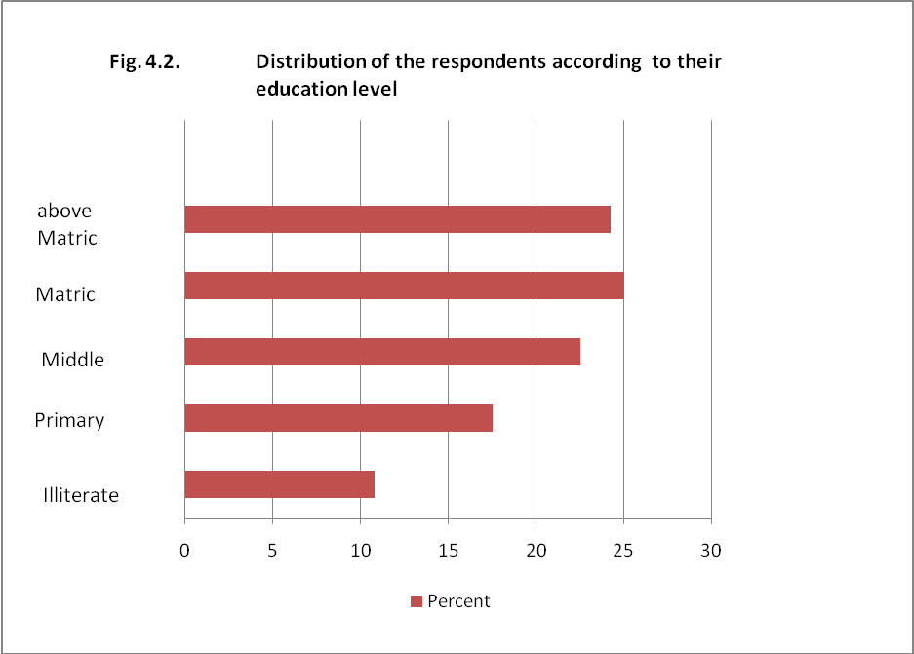

Fig 1: Distribution of the respondents according to their education

The data shown in Fig. 1 indicat that one fourth (25, 24.2%) of the respondents got education up to matriculation and above matriculation respectively. More than one fifth (22.5%) were up to middle and 17.5% were upto primary whereas one thenth (10.8%) were illiterate. These results more or less similar to Munawar (2012) who reported that one forth of the respondents (30.5%) got education upto matric, 20% were upto primary level and 18.4% were illiterate. It can be deduced from the above results that most of the respondents were educated which interprete their interest in getting training and high participation in training sessions.

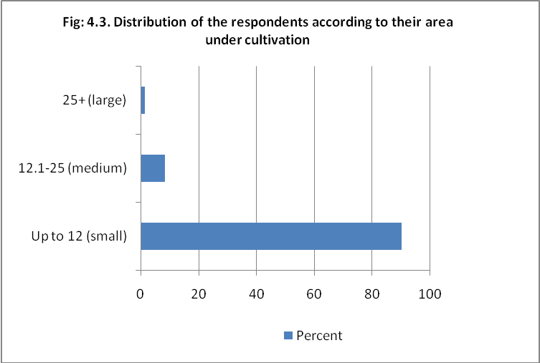

Fig 2: Distribution of the respondents according to their land holding

The data shown in the Fig. 2 reveal that overwhelming majority (90%) of the respondents had small land (up to 12 acres), followed by about one tenth (8.3%) and 1.6% had medium land holdings (12.1-25 acres) and large (more than 25 acres) respectively.
These results are similar to that of Sadaf (2005) who reported that overwhelming majority (80%) of the respondents were small farmers cultivating land up to 5 acres followed by about one tenth (12%) and about one tenth (8%) were medium and large farmers respectively.
Table 1 highlights that majority (97.5, 95.8, 94.1, 93.3, 91.6, 89.1 and 81.7%) of the respondents obtained benefits from F&VDP through increase in quality of produce, knowledge about plants growth, increase income from vegetable crop, attitude change, their knowledge level, crops outlook and area under vegetable production increased.

Table 1. Distribution of the respondents according to benefits obtained from F&VDP
Benefits | F | %
Knoweldge level increased | 110 | 91.6
Attitude change | 112 | 93.3
Knowledge about plants growth | 115 | 95.8
Quality of produce increased | 117 | 97.5
Crops outlook | 107 | 89.1
Increase income from vegetable crop | 113 | 94.1
Area increased in vegetable production | 98 | 81.7

Table 2. Distribution of the respondents according to income increased
Income increased (Rs.) | F | %
Upto 25000 | 48 | 40.0
25001 – 50000 | 39 | 32.5
50001 – 100000 | 8 | 6.7
100001+ | 25 | 20.8
Total | 120 | 100

Table 2 depicts that income of less than half (40%) of the respondent increased upto Rs. 25000 through the F&VDP. Income of about one third (32.5%) respondents increased between Rs. 25001 to 50000. Similarly, raise in the income of one fifth (20.8%) of the respondents was more than Rs. 100000 and few (6.7%) of the respondents raised their income between Rs. 50001 to 100000.

Table 3. Distribution of the respondents according to area increased under vegetables
Area increased under vegetables (in acres) | F | %
<= 1.0 | 70 | 58.3
1.1 - 2.0 | 34 | 28.3
2.1 - 3.0 | 11 | 9.2
3.1+ | 5 | 4.2
Total | 120 | 100

Table 3 represents that more than half (58.3%) of the respondents increased their area under vegetables up to 1acre. More than one fourth (28.3%) of the respondents increased their area under vegetables from 1 to 2 acres. About one tenth (9.2%) number of respondents increased their area under vegetables from 2 to 3 acres. Similarly, few (4.2%) of the respondents increased their area under vegetables more than 3 acres. Results of present study are more or less similar with those of Lekunze et al.,(2013).

Table 4. Relationship between increase in income of the respondents and size of land
Income increased | Size of land |  |  |  |  |  |  |  | Total
Income increased | <= 3.0 |  | 3.1 – 6.0 |  | 6.1 – 9.0 |  | 9.1 +
 | No. | % | No. | % | No. | % | No. | % | No. | %
<= 20000 | 15 | 12.5 | 16 | 13.3 | 3 | 2.5 | 5 | 4.2 | 39 | 32.5
20001-40000 | 7 | 5.8 | 7 | 5.8 | 6 | 5.0 | 12 | 10.0 | 32 | 26.7
40001-60000 | 5 | 4.2 | 2 | 1.7 | 2 | 1.7 | 10 | 8.3 | 19 | 15.8
60000 + | 3 | 2.5 | 12 | 10.0 | 6 | 5.0 | 9 | 7.5 | 30 | 25.0
Total | 30 | 25.0 | 37 | 30.8 | 17 | 14.2 | 36 | 30.0 | 120 | 100

Relationship was drawn between increase in income of the respondents and number of training attended by the respondents. The data shown in the Table 4 show a significant positive relationship between increase in income of the respondents and size of land of the respondents. It indicates that there is interaction between increase in income of the respondents and size of land of the respondents. As the respondents which had larger area were also grown vegetable on large area which results increase of production of vegetables and ultimately leads to increase in the income of the respondents.

Table 5. Relationship between increase in income of the respondents and Area under vegetable
Income increased | Area under vegetable |  |  |  |  |  |  |  | Total
Income increased | <= 1.0 |  | 1.1 – 2.0 |  | 2.1 – 3.0 |  | 3.1 +
 | No. | % | No. | % | No. | % | No. | % | No. | %
<= 20000 | 29 | 24.2 | 8 | 6.7 | 2 | 1.7 | 0 | 0 | 39 | 32.5
20001-40000 | 3 | 2.5 | 15 | 12.5 | 9 | 7.5 | 5 | 4.2 | 32 | 26.7
40001-60000 | 1 | 0.8 | 6 | 5.0 | 5 | 4.2 | 7 | 5.8 | 19 | 15.8
60000 + | 0 | 0 | 0 | 0 | 5 | 4.2 | 25 | 20.8 | 30 | 25.0
Total | 33 | 27.5 | 29 | 24.2 | 21 | 17.5 | 37 | 30.8 | 120 | 100

Relationship was drawn between increase in income of the respondents and area under vegetable of the respondents. The data shown in the Table 5 show a highly significant positive relationship between increase in income of the respondents and area under vegetable of the respondents. It indicates that there is interaction between income of the respondents and area under vegetable of the respondents. The respondents which grown vegetable on larger area also got more profit by selling massive quantity of vegetable due to larger production. So, the income of the respondents increased who had grown vegetable on larger area.

- Conclusion
The project left a significant positive impact on the farm families as majority of the vegetable growers got benefits from the project in term of increase in their income and their area under vegetable growing also increases. Similarly, after getting training from the project farmers knowledge about plants growth also enhanced, quality of produce increases. It is recommended that recent interventions in tunnel farming should be introduced to farmers and there should be facility of small credit schemes for poor farmers to ensure the timely availability of quality seeds, pesticides and fertilizers. So that famers interest towards vegetable growing could be enhanced and the production of vegetable per acre could also be increases.

Corresponding Author:
Aqeela Saghir
Institute of Agriculture Extension & Rural Development, University of Agriculture, Faisalabad, Pakistan
E-mail: aqeelasaghir@uaf.edu.pk

References
- Adeoti A.I, Oladele O.I, Cofie O. 2011. Sustainability of livelihoods through Urban Agriculture: Gender dimensions in Accra, Ghana, Life Science Journal, 8(2): 840-848
- Food and Agric. Organization, 2010. Statistical Year book of the Food and Agricultural Organization. FAO, Rome, Italy.
- Government of Pakistan. 2012.a. Pakistan Bureau of Statistics, Agriculture Statistics.
- Government of Pakistan. 2012.b. Trade development authority.
- Government of Pakistan. 2012.c. Economic Survey of Pakistan. Economic Advisor’s Wing, Finance Division, Islamabad.
- Government of Punjab. 2012. Fruit and Vegetable Development Project in Punjab. Directorate General Agriculture (Ext, & AR), Punjab.
- Government of Punjab. 2013. Vegeatble Research Institute, Ayub Agriculture Resarch Institute, Faisalabad.
- Khan, I. A. 2000. Introduction In Malik, M. N. (Ed.) Horticulture. Biotech Books. Delhi, India, 3-53.
- Lekunze J N Antwi, M.A Oladele O.I., 2013. Market Analysis: The Case of Mahikeng Forestry Nursery and Vegetable Project, Life Science Journal: 10(2) 548-554.

- Mahmood, C. K. 2012. Kitchen Gardening Scheme to Benefit Poor. “The Nation” January 03, 2012.
- Mahmood, N., Anees, M., Ahmad, S. and Zakaullah. 2011. Effect of mulching on vegetables production in tunnel farming. Mycopath 9(1):21-24.
- Munawar, M. 2012. Action Research Concerning Women Empowerment in Union Council No. 133, Faisalabad. M.Sc (Hons) Thesis, Institute of Agri. Extension and Rural Development Univ. of Agri., Faisalabad.
- Pradhan, S. 2003. Vegetable Growing: Status, Future, and Issues. Birla Publications, New Delhi, India.
- Pradhan, S. 2003. Vegetable Growing: Status, Future, and Issues. Birla Publications, New Delhi, India.
- Rafique, M. R. 2011. Off-Season Vegetable Production. Pakistan’s First Science and Technology Blog, dated: 28-12-2011.
- Sadaf, S. 2005. Need for Agricultural Extension Services for Rural Women in Tehsil Faisalabad. M.Sc (Hons.) thesis, Department of Agri. Extension, Univ. of Agri., Faisalabad.
- Singh, B. 1998. Vegetable production under protected conditions: Problems and Prospects. Indian Soc. Veg. Sci. Souvenir: Silver Jubilee, National Symposium Dec. 12-14, 1998, Varanasi, U.P. India pp. 90.
- Thakur, D. S. 1994. High Stakes for Banks in Off-season Vegetables Production and Marketing. Bihar J. Agric. Mgt. 2 (1): 89-95.

9/6/2021

