Finite element analysis of a field load test on stone columns group in clayey soil in Egypt

Eng. Fayrouz Yasser, Ass. Prof. Ayman Altahrany, Prof. Mahmoud Elmeligy

Structural Engineering Department, Faculty of Engineering, Mansoura University, Mansoura, Egypt
Email: fayrouzyasser14@mans.edu.eg

Abstract: With stone columns credibility as a soil improvement technique being validated through time, it has been used in many sites in Egypt. This paper presents a 3D finite element analysis using the finite element code PLAXIS 3D of a load test conducted on stone columns as a part of a project in Egypt. The present study aims to investigate the soil properties in the present area in conjunction with the suitable constitutive models for the composite system that can be later used for further investigations and parametric studies. Three constitutive models (MC-HS-HSS) were studied besides the thickness change of the cushion layer placed on top of the stone columns. Results show that the cushion presence reduced settlement and that increasing its thickness helps in the lateral deformation of stone columns.
[Fayrouz Yasser, Ayman Altahrany, Mahmoud Elmeligy Finite element analysis of a field load test on stone columns group in clayey soil in Egypt. N Y Sci J2021;14(9):1-10] ISSN 1554-0200(print);ISSN 2375-723X (online)
http://www.sciencepub.net/newyork. 1. doi:10.7537/marsnys140921.01.

Keywords: Finite; element; analysis; field; load; test; stone; column; group; clayey; soil; Egypt

1. Introduction
Utilizing numerical methods especially through the software packages available for researchers has given a great validity for studying and analyzing lots of data, extracting many results and performing parametric studies. These huge options provide efficient methods for thorough studies of the behavior of stone columns system. That eventually allows for further design methodologies to be adopted for geotechnical projects. Throughout time, many finite element studies: e.g. [1], [2], and [3] have been conducted considering the “unit cell” geometrical model when large numbers of uniformly distributed columns exist within a wide area subjected to uniform loading, like embankments, rafts, and tanks. Only vertical displacements are allowed with restrained horizontals movement of boundaries as can be seen in figure 1. Yet, one noticeable shortcoming of this model is not accounting for the change in lateral confinement for small group of columns and also settlement prediction as reported by [4]. Fewer studies are common for limited area loading like isolated footings loading cases, e.g. [5], [6],and [7]
Selection of input data and suitable mathematical modelling for simulating the actual behavior is the core of geotechnical finite element analyses. Many constitutive models have been adopted by authors to simulate stone columns system as presented in table 1, where compromising is always a matter of concern between the required accuracy, model complexity, cost, and time consumption.

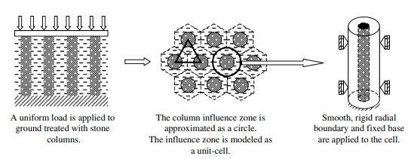
Figure 1 Unit cell model idealization [8]

2. Field load test on stone columns group

2.1 Site description
Located in Egypt, a project has been constructed over an improved soil site of top- feed stone columns system. Crushed aggregate of dolomite was used as the backfill material of the stone-columns and the cushion layer placed on top of columns. The cushion layer is 0.75m thick that works as a drainage layer and stress distribution platform as reported by many authors e.g. [9], [10],and [11]. Stone columns are 1m in diameter and 6m in length, arranged in a triangular pattern with spacing of 2.2 m. Figure 2 illustrates the column dimensions.

Table 1 Summary of adopted constitutive models by different authors from year 2010 to present
Reference | Constitutive Model
 | Native Clay Soil | Column | Geosynthetic
[12] | MCC | MC | LE
[13] | HS | HS | N/A
[14] | CC | MC | N/A
[15] | MC | MC
[16] | MC | MC
[17] | MCC | MMC | LE
[18] | MC | MC | LE
[19] | MC / DP | MC /MCC | LE
[20] | MC | MC | N/A
[21] | MC | SSC | LE
[22] | MC | MC | LE
[23] | MC | MC | LE
[24] | SS / HS | HS | N/A
[4] | SS / HS / MC | MC | LE
[25] | Soft Soil | MC | N/A
[26] | MC | MC | N/A
[27] | HS / MC | MC | N/A
[28] | LE | MC | N/A
[29] | LE / MC | LE / MC | N/A
[30] | MC | MC | N/A
[31] | HS | HS | N/A
[32] | MC | MC | N/A
[33] | MC | MC | N/A
[34] | MC | MC | N/A
LE: Linear Elastic  MC: Mohr-Coulomb  MMC: Modified Mohr-Coulomb  HS: Hardening Soil |  | SS: Soft Soil  SSC: Soft Soil Creep  DP: Dracker Prager  CC: Cam Clay  MCC: Modified Cam Clay

Figure 2 Stone columns system configuration

2.2 Field load test
The design of stone-columns has aimed to increase the native soil bearing capacity up to 100 kPa. The geotechnical consultant recommended confirming the validity of this assumption by performing a load test on a group of three columns where a concrete footing is constructed on top of the replacement layer. The footing is loaded to 150% of the allowable working bearing capacity. Load was applied in increments.

3. Analysis of field load test:

3.1. Geometrical model
The load test was simulated through a three-dimensional model with PLAXIS 3D finite element code as illustrated in figure 4 where medium coarse mesh was used with local refinement at the zones expected to have high stresses or deformation.

3.2. Constitutive modeling
Due to lack of accurate measured soil properties either on site or in the laboratory, two steps were adopted. The first was investigating previous studies and soil reports around the zone of interest. In general, soil around site can be divided into two main types; the deep clay deposits that are mainly from the Nile river sedimentation while the surficial layers are sediments of successive and alternative sand/silt/clay [35]. The second step was going through the available correlations of soil properties stated in soil literature to obtain initial estimate for soil properties to assess building the closest simulation of field tests.
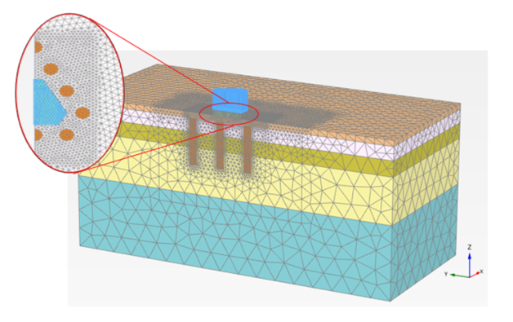
Figure 3 3D model geometry and mesh

Literature values have showed a large degree of uncertainty, so several trials to assess the most representative values were performed. Based on the preceding steps, an initial set -table 3- of the native soil parameters has formed the basis of the finite element analysis for three different constitutive models; Mohr-Coulomb (MC), Hardening Soil (HS) and Hardening Soil Small-Strain (HSS) models. The set is referred to as (S_{o}).

4. Results and discussion

4.1. Constitutive model suitability
The first simulation was conducted with the initial set of parameters (S_{o}) for the native soils, results are shown in figures 4 & 5. A clear overestimation of the system settlement and stiffness underestimation is apparent, pointing that the HSS model yielded a closer simulation compared to HS and MC models. It can be observed from the field test results that the initial tangent system deformation modulus (E) is relatively high which resulted in small strains; indicating the apparent small strain stiffness effect in the field behavior, which can also be attributed to the relatively rapid loading in undrained conditions. Based on, focus was given to modeling using the HSS constitutive model.

Table 3 Initial set of native material parameters for numerical modeling (So)
Soil |  | Silty Clay | Silty Fine sand | Medium sand | Medium to soft Clay | Crushed aggregate stones
General
Drainage type | - | Undrained (A) | Drained | Drained | Undrained (A) | Drained
γ | (KN/m3) | 17 | 18 | 18 | 17 | 20
e_{o} |  | 1.3 | 0.5 | 0.5 | 1.6 | 0.5
Parameters
C' | (KPa) | 6 | 0.1 | 0.1 | 3.5 | 7
ϕ | (^{O}) | 34 | 38 | 40 | 26 | 50
E' | (MPa) | 15 | 30 | 50 | 30 | 120
υ' | - | 0.4 | 0.3 | 0.3 | 0.4 | 0.3
ѱ | - | 0 | 8 | 10 | 0 | 20
E₅₀^{ref} | (MPa) | 4.5 | 30 | 50 | 6.3 | 120
E_{oed}^{ref} | (MPa) | 3 | 30 | 50 | 5.25 | 90
E_{ur}^{ref} | (MPa) | 40 | 90 | 150 | 37.8 | 360
G_{o}^{ref} | (MPa) | 70 | 119 | 165 | 70 | 280
_{γ0.7}^{ref} | - | 4.00E-04 | 3.50E-04 | 3.50E-04 | 4.00E-04 | 3. 0E-04
Groundwater
K_{x}=K_{y} | (m/d) | 2.00E-04 | 0.08 | 0.8 | 2.00E-05 | 80
Kz | (m/d) | 1.00E-04 | 0.08 | 0.8 | 1.00E-05 | 80
Initial conditions
Ko | - | 1.5 | 1.5 | 1.5 | 0.56 | 0.23

Several finite element models were performed to assess the best adjusted values of the HSS additional parameters G_{o}^{ref} and γ_{0.7} for a better simulation of the initial high stiffness (field-curve slope), considering two main proposed factors affecting the current deviation from field behavior. The first is regarding the uncertainty in the initial estimate of HSS parameter values and the reported differences usually found between different geotechnical methods compared to the field actual values. Related observations were stated by [36] and [37], The second is including modified soil values.

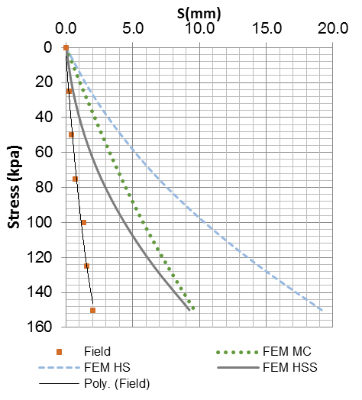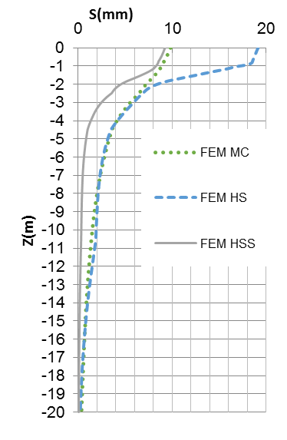

Figure 4 FEM results for Initial Set (S_{O} Vs Field results for ZLT) Figure 5 Settlement variation for initial set (S_{O}) with depth

A simple rough methodology was adopted for the values adjustment into the actual field behavior. On direct observation of the field stress-settlement curve, its stiffness can be roughly approximated by about 1.5 that of the FEM results using the initial parameter set (S_{o}) of HSS model so, as a first step the G_{o}^{ref} values for the native soils were increased by an average ratio of 150%. The second step was incrementally increasing the properties of soft clay and silty fine sand layers based on the previously mentioned improvement effect. The final adopted values are given in table 4 with the simulation results compared to the field presented in figure 6.

4.2. Behavior of group of stone column
The lateral stone column group deformation was apparent for the loaded columns in addition to the first surrounding row of columns as illustrated in figure 7. Non equal lateral deflections are more dominant that the bulging deformation exhibited in single stone column or large stone columns groups which is related to what [38] presented. It can also be seen in the present case analyzed that the second surrounding columns showed negligible deformation. This implies that only one surrounding row of columns can be simulated for the small stone columns group thus reducing the model size and leading to less time and cost consumption. A comparison between stone column rows number was conducted to study the effect of modeling outer columns. Two cases were investigated: a) no external columns R0, b) single external column row R1 in addition to the base case of two external rows R2. Figure 8 shows the stone columns arrangement for three cases. Lateral deflection results showed almost identical values for R1 case with no notable deformation in the R2 case. The lateral deflection in R1 case was large compared to the R0 case which implies the insufficiency of simulating only the loaded stone columns and the at least one external column surrounding the loaded columns is required for actual behavior simulation. The settlement results for the three cases comparison are shown in figure 9, and as it can be seen further settlement is noticed for the R0 case that asserts preceding results.

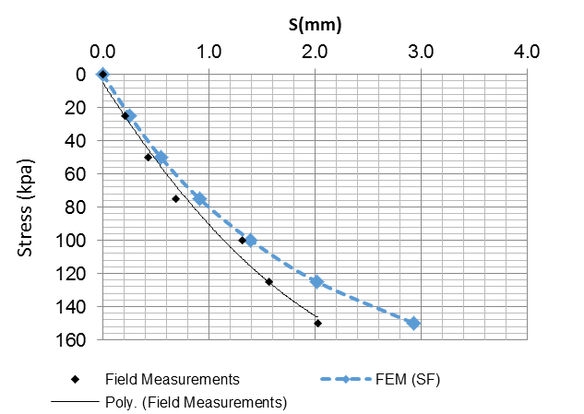

Figure 6 FEM results for final Set (S_{F}) Vs Field results

Table 4 Final model parameters for numerical modelling (S_{F})
Model  Parameter | C' | ϕ | υ' | ѱ | E₅₀^{ref} | E_{oed}^{ref} | E_{ur}^{ref} | G_{o}^{ref} | γ_{0.7} | K
 | (Kpa) | (^{O}) | - | - | (Mpa) | (Mpa) | (Mpa) | (Mpa) | - | -
Crushed Stone Aggregate | 7 | 50 | 0.3 | 20 | 120 | 90 | 360 | 420 | 3.0e-4 | 0.23
Silty Clay | 8.4 | 34 | 0.4 | 0 | 7.875 | 5.25 | 52.5 | 175 | 4.0e-4 | 2.5
Silty Fine sand | 0.1 | 38 | 0.3 | 8 | 45 | 45 | 135 | 180 | 3.5e-4 | 2.5
Medium Sand | 0.1 | 40 | 0.3 | 10 | 50 | 50 | 150 | 270 | 3.5e-4 | 2
Soft to medium stiff Clay | 3.5 | 26 | 0.4 | 0 | 6.3 | 5.25 | 37.8 | 105 | 4.0e-4 | 0.56

Figure 7 a) Deformed shape of stone columns, b) lateral deformation X-direction, and c) lateral deformation Y- direction

Figure 8 Stone columns configuration: a) R2, b) R1, and c) R0

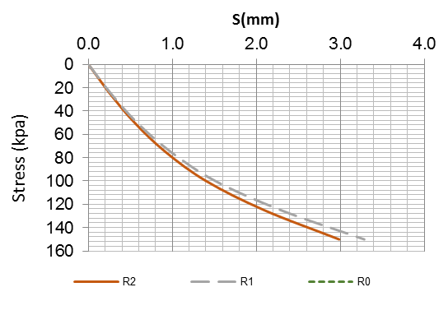
Figure 9 Stress settlement results for different stone columns rows

4.3. Cushion thickness study
A parametric study on the cushion thickness has been conducted. Results show settlement reduction with cushion thickness increase up to a thickness of about 1D where D is the stone column diameter as presented in figure 10. The stress settlement curve -figure11- shows almost identical values for all the cushion thickness values at stress levels up to 80 KPa which can show the insignificance to the cushion thickness when working at these stress level and that a minimum thickness could be used.

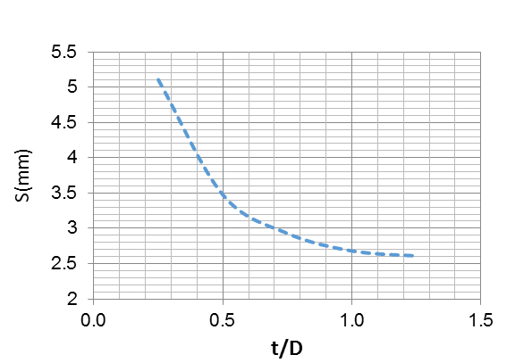
Figure 10 Variation of settlement with normalized cushion thickness

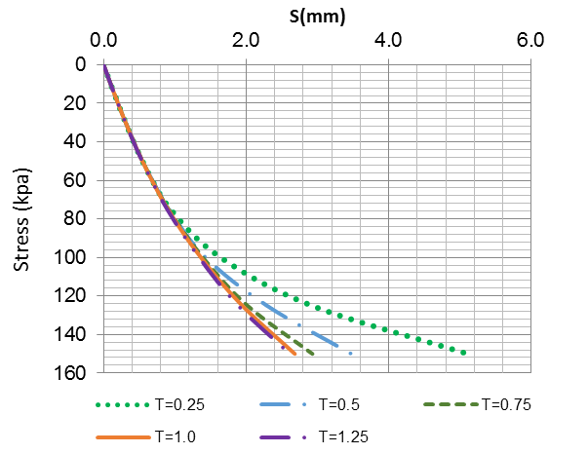
Figure 11 Stress – Settlement for different cushion thickness

5. Conclusion
A three-dimensional finite element analysis was conducted as a back calculation of a field load test on stone columns group in Egypt. Three constitutive models were investigated to represent the site properties and system behavior. The change of cushion layer thickness was studied. The min findings can be concluded as follows:
1- Adopting soil properties from literature or previous investigations in similar sites showed a notable underestimation of the short-term system stiffness and settlement overestimation compared to the field case.
2- The hardening soil small strain model was the most representative to short-term system behavior compared to MC and HS models, which has been attributed by authors to the very small strain stiffness (G_{o}^{ref}) that's embedded in the model parameters to account for small strain cases which is often present in field cases compared to the laboratory experiments or analytical solutions, yet soil field experiments need to performed to compare the actual measured values with the back calculated values.
5- For short-term behavior, small groups of stone columns show dominant outward lateral deformation in the loaded columns and external columns surrounding them on contrary to wide loading areas where stone columns bulging is most dominant.
4- The increase of cushion layer thickness showed better short-term settlement behavior to a limited value of (1D) where D is the column diameter. In addition to the stone columns lateral deformation reduction with thickness increase.

6. References:
[1] M. Elsawy, K. Lesny, and W. Richwien, “Behavior of ordinary and encased stone columns studied by FEM analysis,” Proc. 17th Int. Conf. Soil Mech. Geotech. Eng. Acad. Pract. Geotech. Eng., vol. 3, pp. 2350–2353, 2009, doi: 10.3233/978-1-60750-031-5-2350.
[2] B. G. Sexton, B. A. McCabe, and J. Castro, “Appraising stone column settlement prediction methods using finite element analyses,” Acta Geotech., vol. 9, no. 6, pp. 993–1011, 2014, doi: 10.1007/s11440-013-0260-5.
[3] K. S. Ng and S. A. Tan, “Stress Transfer Mechanism in 2D and 3D Unit Cell Models for Stone Column Improved Ground,” Int. J. Geosynth. Gr. Eng., vol. 1, no. 1, pp. 1–9, 2015, doi: 10.1007/s40891-014-0003-1.
[4] A. L. Fayed, T. M. Sorour, and H. F. Shehata, “Study of the Behavior of Floating Stone Columns in Soft Clay Formations Using Numerical Modeling,” vol. 2, 2018, doi: 10.1007/978-3-319-61902-6.
[5] M. M. Killeen and B. A. Mccabe, “Settlement performance of pad footings on soft clay supported by stone columns: A numerical study,” Soils Found., vol. 54, no. 4, pp. 760–776, 2014, doi: 10.1016/j.sandf.2014.06.011.
[6] S. A. Tan, K. S. Ng, and J. Sun, “Column group analyses for stone column reinforced foundation,” Geotech. Spec. Publ., no. 233, pp. 597–608, 2014, doi: 10.1061/9780784413265.048.
[7] B. A. McCabe and M. M. Killeen, “Small stone-column groups: Mechanisms of deformation at serviceability limit state,” Int. J. Geomech., vol. 17, no. 5, 2017, doi: 10.1061/(ASCE)GM.1943-5622.0000700.
[8] J. Gniel and A. Bouazza, “Improvement of soft soils using geogrid encased stone columns,” Geotext. Geomembranes, vol. 27, no. 3, pp. 167–175, 2009, doi: 10.1016/j.geotexmem.2008.11.001.
[9] K. Deb, N. K. Samadhiya, and J. B. Namdeo, “Laboratory model studies on unreinforced and geogrid-reinforced sand bed over stone column-improved soft clay,” Geotext. Geomembranes, vol. 29, no. 2, pp. 190–196, 2011, doi: 10.1016/j.geotexmem.2010.06.004.
[10] P. Maheshwari and S. Khatri, “A nonlinear model for footings on granular bed-stone column reinforced earth beds,” Appl. Math. Model., vol. 35, no. 6, pp. 2790–2804, 2011, doi: 10.1016/j.apm.2010.11.075.
[11] P. Debnath and A. K. Dey, “Bearing capacity of reinforced and unreinforced sand beds over stone columns in soft clay,” Geosynth. Int., vol. 24, no. 6, pp. 575–589, 2017, doi: 10.1680/jgein.17.00024.
[12] C. Yoo and A. M. Asce, “Performance of Geosynthetic-Encased Stone Columns in Embankment Construction : Numerical Investigation,” no. August, pp. 1148–1160, 2010.
[13] B. G. Sexton, B. A. Mccabe, and J. Castro, “Appraising stone column settlement prediction methods using finite element analyses,” pp. 993–1011, 2014, doi: 10.1007/s11440-013-0260-5.
[14] J. T. Shahu and Y. R. Reddy, “Clayey Soil Reinforced with Stone Column Group : Model Tests and Analyses,” no. December, pp. 1265–1274, 2011, doi: 10.1061/(ASCE)GT.1943-5606.0000552.
[15] K. S. Ng, “Numerical study on bearing capacity of single stone column,” pp. 1–10, 2018, doi: 10.1186/s40703-018-0077-z.
[16] S. Pamangattu, M. Renjitha, M. Varghese, and J. Joseph, “Numerical Simulation of the Response of Geosynthetic Encased Stone Columns Under Oil Storage Tank,” Int. J. Geosynth. Gr. Eng., vol. 0, no. 0, p. 0, 2018, doi: 10.1007/s40891-017-0122-6.
[17] S. R. Lo, R. Zhang, and J. Mak, “Geotextiles and Geomembranes Geosynthetic-encased stone columns in soft clay : A numerical study,” Geotext. Geomembranes, vol. 28, no. 3, pp. 292–302, 2010, doi: 10.1016/j.geotexmem.2009.09.015.
[18] S. (2018) Lajevardi, S. H., Shamsi, H. R., Hamidi, M., & Enami, “NUMERICAL AND EXPERIMENTAL STUDIES ON SINGLE STONE COLUMNS,” vol. 55, no. 5, pp. 340–345, 2018, doi: 10.1007/s11204-018-9546-9.
[19] L. Keykhosropur, A. Soroush, and R. Imam, “Geotextiles and Geomembranes 3D numerical analyses of geosynthetic encased stone columns,” Geotext. Geomembranes, vol. 35, pp. 61–68, 2012, doi: 10.1016/j.geotexmem.2012.07.005.
[20] M. Y. Fattah and Q. G. Majeed, “Finite Element Analysis of Geogrid Encased Stone Columns,” pp. 713–726, 2012, doi: 10.1007/s10706-011-9488-8.
[21] M. B. D. Elsawy, “Behaviour of soft ground improved by conventional and geogrid-encased stone columns , based on FEM study,” no. 4, pp. 276–285, 2013.
[22] A. J. Choobbasti and H. Pichka, “Improvement of soft clay using installation of geosynthetic-encased stone columns : numerical study,” pp. 597–607, 2014, doi: 10.1007/s12517-012-0735-y.
[23] P. Andreou and V. Papadopoulos, “Factors Affecting the Settlement Estimation of Stone Column Reinforced Soils,” pp. 1175–1185, 2014, doi: 10.1007/s10706-014-9788-x.
[24] M. Ali, Behavior of Ordinary and Encased Stone Columns End-Bearing and Floating in Soft Clay ( Numerical Model ), no. 2009. Springer International Publishing, 2019.
[25] E. Journal et al., “Performance Analysis of Reinforced Stone Columns Using Finite Element Method Performance Analysis of Reinforced Stone Columns Using Finite Element Method,” no. January, 2013.
[26] A. J. C. A. Z. R. Noorzad, “Performance of Stone Columns in Soft Clay : Numerical Evaluation,” pp. 675–684, 2011, doi: 10.1007/s10706-011-9409-x.
[27] S. Ellouzea and Z. B. and M. N. Z. , Mounir Bouassidaa, “Numerical analysis of the installation effects on the behaviour of soft clay improved by stone columns Geomechanics and Geoengineering Numerical analysis of the installation effects on the behaviour of soft clay improved by stone columns,” no. April, 2016, doi: 10.1080/17486025.2016.1164903.
[28] V. S. H. Mroueh and I. S. M. Bouassida, “Numerical Analysis of Elastoplastic Behavior of Stone Column Foundation,” pp. 813–825, 2012, doi: 10.1007/s10706-012-9500-y.
[29] J. Castro, “Consolidation and deformation around stone columns : Numerical evaluation of analytical solutions,” no. March, 2011, doi: 10.1016/j.compgeo.2010.12.006.
[30] C. Paper, G. S. Publication, K. Shien, N. Universiti, T. Mara, and P. Pinang, “Column Group Analyses for Stone Column Reinforced Foundation,” no. February 2014, 2016, doi: 10.1061/9780784413265.048.
[31] C. Paper, K. Shien, N. Universiti, T. Mara, and P. Pinang, “Concentric Ring Approach in Stone Column Foundation Analysis,” no. DECEMBER 2011, 2016.
[32] K. S. Ng and S. A. Tan, “Settlement Prediction of Stone Column Group,” Int. J. Geosynth. Gr. Eng., vol. 1, no. 4, 2015, doi: 10.1007/s40891-015-0034-2.
[33] A. Zahmatkesh, “Settlement evaluation of soft clay reinforced with stone columns using the equivalent secant modulus Settlement evaluation of soft clay reinforced with stone columns using the equivalent secant modulus,” no. January, 2012, doi: 10.1007/s12517-010-0145-y.
[34] M. Yildiz, “Determination Of Stress Concentration Factor In Stone Columns By Numerical Modelling,” School of Natural and Applied Sciences, vol. Master of, no. August. p. 95, 2013, [Online]. Available: internal-pdf://108.56.47.52/4-DETERMINATION OF STRESS CONCENTRATION FACTOR.pdf.
[35] N. Smith, D. Welch, and L. Tunbridge, “Investigation of the Properties of Recent Nile Delta Deposits , Port Said , Egypt,” no. 2, 2015.
[36] M. Asslan, “Factors Influencing Small-Strain Stiffness of soils and its Determination,” Term Pap. Bauhaus …, p. 70, 2008.
[37] J. Erik Loehr, A. Lutenegger, B. Rosenblad, and A. Boeckmann, “Geotechnical Site Characterization,” Geotech. Eng. Circ. No.5, vol. FHWA NHI-1, no. 132031, 2017.
[38] R. . Barksdale and R. C. Bachus, “Design and Construction Columns,” no. December 1983, 1983.

9/6/2021

