Employee Retention through Kaizen Culture - A Case study of an Automobile Workshop Company

Muhammad Saleem, Dr Nawar Khan, Dr Mehmood Anwar Khan, Dr Syed Waheed ul Haq

Engineering Management Department NUST College of Electrical & Mechanical Engineering (EME) Peshawar Road Rawalpindi, Pakistan
Tel # + 92-051-5803835, Fax # 92-051-9278048

Abstract: This paper discusses a case study, development of kaizen culture in automobile service provider organization of Pakistan to reduce high turnover rate of its employee’s. Kaizen is small continuous improvement technique involving employees of the organization, resulting development of human resource, increasing quality of the service and reduction of waste in processes of the organization Different causes of high turnover rate in the organization were identified through employee’s interviews and survey. Asking why, 5 times technique was used to carry out further deep analysis of each root cause of high turnover rate. The main focus was to introduce changes in a corporate culture of the organization by involving employees of the organization in decision making, to reduce high turnover rate through involvement of all the stake holders. Employee survey regarding different causes of employee’s low morale / high turnover rate was carried out and solution to highly recommended causes was finalized through brain storming and discussion with higher and middle management of the organization. Different weigh tags were given to employees recommended solution. Company viability in (%) to act upon the given solution was solicited from the management. Ease for implementation of recommended solution for the company was calculated through multiplication of the weight age and percentage viability of the company. Option with maximum value to all was incorporated in company and reduction of 26% in overall turnover rate of the employees was observed.
[Muhammad Saleem, Dr Nawar Khan, Dr Mehmood Anwar Khan, Dr Syed Waheed ul Haq. Employee Retention through Kaizen Culture - A Case study of an Automobile Workshop Company. N Y Sci J 2021;14(8):22-27] ISSN 1554-0200 (print); ISSN 2375-723X (online) http://www.sciencepub.net/newyork.4. doi:10.7537/marsnys140821.04.

Key worlds: Kaizen Culture, Continuous Improvement, Brain Storming, Employee’s Turnover Rate

- Introduction
Employees are the most valuable asset for any organization and their retention/availability is a guarantee for success of the organization ("Employee Involvement, Workplace Organization, Kaizen," 2006). There is a dire need for maintaining and developing corporate Kaizen culture in an organization for continuous improvement of its quality of service, development of human resource and reduction of waste in processes so as to bind the employees together as a team to move along with the company goals and objectives. Corporate culture is a collective programming of the mindset of its employees (Hofstede, 2003). It is a belief and ideas of employees about their goals, objectives and the ways/standards adopted to achieve them within the organization. Each organization has its own norms and values. From these values organizational guidelines are developed, which further describe appropriate kind of behavior expected from the employees in particular situations Harles W. L. Hill, and Gareth R. Jones, (2001). Researcher asserts the need to maintain control over behavior of employees towards one another. Success of Kaizen culture in manufacturing organizations is well known and established around the world. However, the use of Kaizen culture in service provider’s organization aiming at reduction in turnover is a new domain. Corporate Kaizen culture is one of the most strategic elements essential for continuous improvement of performance and success of the organizations(Mishra & Gupta, 2010). Employees have a tendency to maintain the status quo and resist change in general and corporate culture in particular(Recht & Wilderom, 1998). Employee’s daily pattern of behavior and attitudes are interwoven with organization policies, practices and top management attitude (Harles et al, (2001). Organizations introduce Kaizen culture in their approaches as per their business requirements. The organizations which do not change their culture with the passage of time cannot cope up with change in external environment.
In this paper the focus will remain on how to reduce organization’s employee’s turnover rate through evolving a corporate Kaizen culture. Involving employees of the organization in the policy decision making as part of Kaizen implementation in an automobile service provider organization would certainly help in reducing the turnover rate. The aspects of Kaizen culture under specific attention were noticed in bringing improvement in the organization. For this particular case study, a service provider organization named XYZ in Pakistan, currently lacking a corporate Kaizen culture of continuous improvement through involvement of it employees at all level, was selected. An informal survey of selected organization revealed that the employer has gained the reputation of a learning institute rather than an employee’s developing organization. Mostly employees come, learn and leave the organization. An analysis of employees views on corporation reveal that the employees feel acute deficiency of homeliness, their involvement in policy decision making for continuous improvement of the organization, good salary package and perquisite beside job security and terminal benefits. The organization has expressed a serious concern on high turnover rate of employees. XYZ Company and is trying to improve its corporate kaizen culture of leaving the organization due to non involvement of its workforce continuous improvement decision making. Fusion of Kaizen with organizational culture is of sole importance here. We can either make Kaizen part of the organizational culture to develop a corporate culture or we can evolve a weak organizational culture into a corporate culture using the Kaizen tools and techniques.

2. Purpose
The purpose of this research was to trace the causes of high turnover rate of the employees and to recommend best viable solution of the problem to a service providing organization through employee’s suggestion. The implementation of employee’s devised solution in the case study organization would increase the corporate cultural values and hence reduce high turnover rate of the employees of the company. Employees suggestions are owned by the organization and are given weight age in decision making policy of the organization which can further improve the confidence level of the employees on their own organization and hence reduces the employee’s turnover rate.

3. Literature Review
Corporate culture is a complex construct. Various researchers have tried to encompass the construct by identifying factors that constitute it. Major characteristics of a corporate culture as highlighted by Harles et al, (2001) are as under:-
- Employees’ contributions to enhance the company’s performance are regarded properly and all employees are treated equally.
- All employees are given equal opportunities to exercise their full potential within the organization to enhance the performance.
- Full respect and reward is given in the organization to the employees for their contribution in development of Kaizen culture in the organization.
- Company policies and procedures must be communicated to all and there should be no communication barrier among the employees and top management within organization
- Company leaders and top management must be strong enough with excellent sense of direction, purpose and moral character.
- Company must have competitive advantage among other organization regarding price, quality and service provided to their customers.
- Company must like and appreciate diversity in job. Employees from different sections should be made part of kaizen team members.
- Healthy culture within organization always lowers the employee’s turnover rate.
- Company must ensure learning & training of its employees for their carrier and future enhancement.
Kaizen is a technique of continuous improvement of organization through the involvement of workforces at all levels (Imai, 1986b). Continuous improvement means an ongoing effort to improve the product processes, work area and culture of the organization. Kaizen is implemented in the form of small continual incremental changes, known as kaizen events through involvement of its employee(Singh & Singh, 2009). A cross functional team of 3 -5 members from company employees work together on a pre selected improvement activity suggested by the employees in a targeted work area/ department for a limited time frame (Farris, Van Aken, Doolen, & Worley, 2009).
The concept of Kaizen originated in Japan in 1950, when existing confrontational management was acknowledged as a problem both at government as wells as management level. Japan has a severe shortage of manpower after World War II. Japanese have decided to manage this problem with existing workforce through the implementation of Kaizen. New labor contracts sponsored by the government, governing life time job security of employees and guideline for distribution of benefits achieved through company development were made by the organizations (Imai, 1986b). These contracts became the background for all Kaizen activities in Japan and provided security and confidence to the workforce(Brunet, 2000). Through implementation of Kaizen culture in the organization, loyalty and oneness of the workers has been increased toward their organization(Stone, 2010). Kaizen culture was initially introduced in Toyota Motor Company to improve quality, productivity, corporate culture and competitiveness of its product in the wake of increasing competition and globalization(Smalley & Katō, 2010). Since then, Kaizen has contributed enormously to the success of Japan and became a part of country’s manufacturing system (Ashmore, 2001). Now concept of Kaizen is gaining popularity in service organization as well. Kaizen is implemented through Kaizen events dealing with small issues related to corporate functioning. Success of each event increases employees morale (Imai, 2007). After successful implementation of Kaizen in Japan now this philosophy is widely acknowledge throughout the world and being implemented in service organizations as well. Employees use different tools and techniques, e.g brainstorming, PDCA Cycle, 7 Basic QC Tools etc to solve the small issues related to corporate functioning. Kaizen umbrella presented by Imai (1986) showing varieties of problem solving tools and techniques is reproduced below:

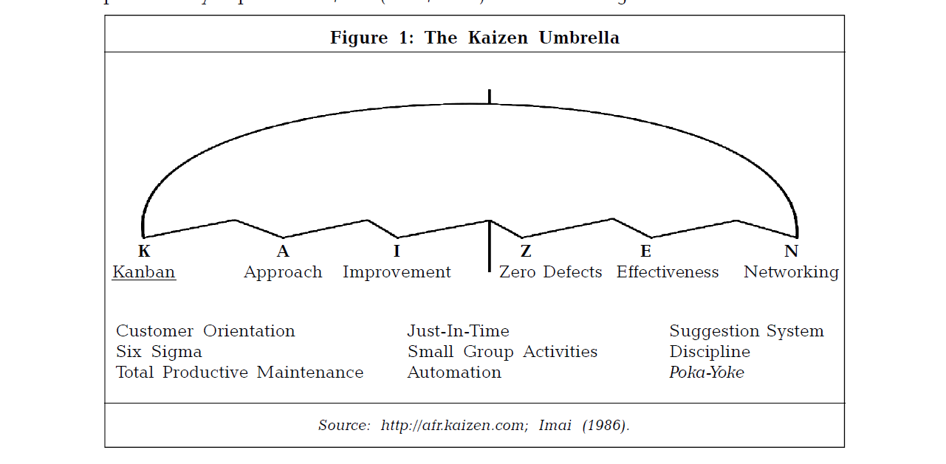

Fig 1: Tools & techniques under the umbrella of Kaizen

4. Brief history of selected company

The selected company was established in 1991 and having 3-S dealership of an automobile manufacturing organization in Pakistan. It has vision to be most respected and successful organization, delighting internal as well as external customers with a solution in automobile industries with best people and best technology. The selected company has mission to provide means for safe and sound journey to its internal as well as external customers. The selected company has 112 sq yards of company area and total of 130 employees including 16 certified technicians 3 service advisors. Selected company is well organized and best located service providing organization among many other private sectors organizations which are providing automobile repair services in Pakistan. The selected company had problems of high turnover rate of employees from 2006 to 2011. It has lost its 22 valuable internal customers each year. Causes of loss of internal customers come through brain storming of kaizen team were the Lack of salary, lack of training, Hr Policies, Lack of documented process work diversity and non involvement of employee in decision making policies of the organization. The Management has decided to satisfy internal customers through development of Kaizen culture in the company. The selected company has targeted to decrease turnover rate of its employees up to 30% in one year through involvement of its internal customers in decision making policies of the company. For this purpose, a cross functional kaizen team was formulated from different sections of the workshop. Company management has set objectives for kaizen team to suggest measures in order to decrease turnover rate of internal customers up to 30% by 2012.
5. Research Methodology

5.1 Sample Selection
The selected organization was having a total of 130 employees in different categories and sections. Out of these 130 employees a sample of 60 employees from different categories and from different sections were randomly selected for survey/ interviews. The questionnaire was served by the researcher in person along with pre selected kaizen team of the company. The employees were briefed about the idea behind the survey and filling the questionnaire. To ascertain the response, selected employees were interviewed after the survey through questionnaire. The data was quantified and analyzed accordingly.
5.2 Data Collection and Analysis
Mostly tools and techniques used in Kaizen concept are quantitative in nature; hence the results are also quantitative. But when it comes to dealing with the intangibility of services industries and particularly constructs like moral value of an employee, the problems and answers become more often of descriptive nature (Lee, Dugger, & Chen, 1999). So in this research survey technique was applied to get the data for analysis and for the solution of problem. In service providing company, Problems are usually in texts forms and the probable remedies are also intangible. This makes the fusion a bit more difficult than in manufacturing process. Literature review and survey technique has been applied to analyze the case study. The data for this purpose has been collected through survey of employees of the selected company on single point questioner. Employee Survey regarding different causes of employee’s low morale / high turnover rate was carried out. Different solutions to highly recommended causes were finalized through brain storming and discussions with higher and middle management of the company. Different weigh tags were given to employees recommended solution. Company viability (in percentage) to act upon the given solution was also asked from the management. Ease of implementation of recommended solutions for the company was calculated through multiplication of the weight age and percentage viability of the company. Option with maximum value to all was incorporated in organizational culture.

6. Results & Discussions
It was noted that change in corporate culture is a very difficult process as it involves changing of the very mindsets of people. To identify the different causes of high turnover rate of employees in XYZ Company, for this purpose tool “Ask 5 times why this happen” was used from Kaizen umbrella. (Imai, 1986a; Lander & Liker, 2007; Lee, Dugger, & Chen, 1999) and a brain storming were conducted from selected 2-3 representative from each department and middle management of the company. The results of the survey question “In your opinion what are the causes of high turnover rate of employees in your organization” are shown below:-

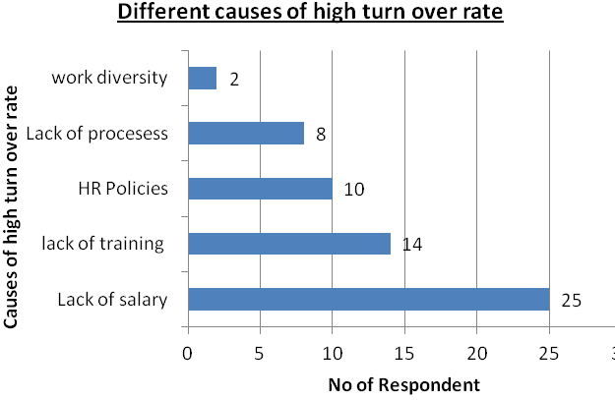

Figure 2: Different causes of high turnover rate of employees in XYZ Company

The main causes were lack of salary, less chance of enhancing their skill level due to lack of employees training in the organization, non involvement of employees in decision making policies of HR department, lack of standard working procedures and diversity of job in the order of priority of question asked. Again these causes of high turnover rate of employees were reconfirmed through survey carried out from 60 employees of the company. Pareto analysis was carried out to accord priority to problems highlighted by the employees in the survey. Pareto analysis indicate those 20% causes which are influencing 80% on employee’s turnover rate are low salary and lack of training in company. The Pareto analysis of the survey results are shown in figure-3:-

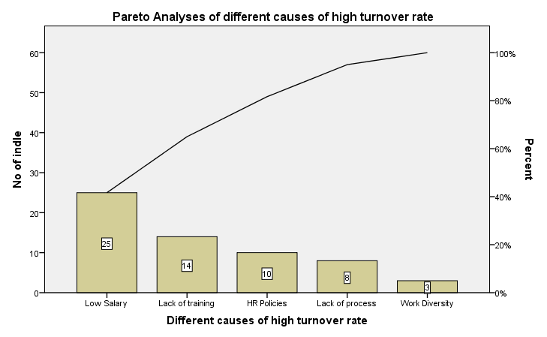
Fig 3: Pareto analyses of different causes of high turnover rate

The Pie chart shows almost 42% employees are of the opinion that the salary structure is the main cause of high turnover rate of employee in XYZ Company. Focusing mainly on this can remove half of the complaints of the employees and has the potential to reduce this high turnover rate of the company.

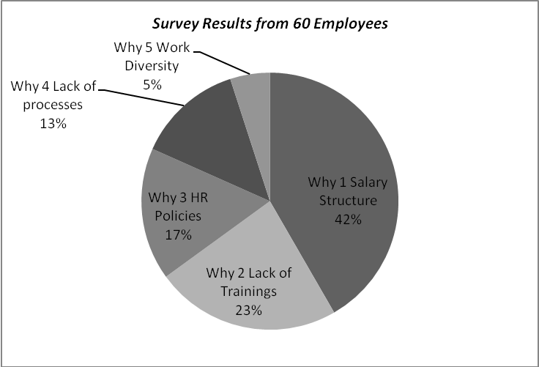
Fig 4: Percentage Breakdown of Survey Result
Critically analyze the problem

Select the best one
Implement the best
Solution
Identify the root causes
Identify different possible solution through brain storming
Identify/ Define problem

Review situation
Problem Solving Technique through kaizen tteam
Fig 5: Problem solving procedure at XYZ Company

Possible solutions were discussed with higher authority of the company. Increase in salary was identified as a prime issue for management. A small company having almost 130 (one hundred and thirty) employees cannot afford to raise the salaries of all employees. The problems related with salary structure was a tedious and controversial one as reconsidering the structure for even one person’s salary may instigate a chain reaction in all other employees. For an alternate solution another survey from 60 selected employees was carried out, asking for alternate solution of problem and to give weight age in percentage to each alternate solution. They were also given an option to grade recommended option for ease of implementation for company administration. Involvement of the company employees in decision making policy is always appreciated by lower and middle level workers of the company which is basic philosophy of Kaizen(Cho, 1995). Survey for alternate solutions that can have remedial effect on the employee’s turnover rate was carried out. The result of the survey along with the implementation viability for the organization is given below.
5Why | Alternates | Employee Weight-age | Implementation Ease | Viability
Why- 1 | High level Training of workers | 70% | 90% | 63%
Why- 2 | Designation Promotion | 40% | 60% | 24%
Why-3 | Interest Free Loans | 50% | 30% | 15%
Why- 4 | Clubs Memberships on Subsidized Rates | 30% | 20% | 6%
Why- 5 | Fuel Allowance | 80% | 5% | 4%
Table 1: Survey Result for alternate solution to salary structure issue

It can be concluded from the above table that high level workers training through involvement of employees in continuous improvement activities and foreign training tour is the best temporary remedial solution to cater for the salary issue with employees. The viability is high as selected organization purchases a lot of equipment / spare parts from its OEM operating abroad and in different cities of the country, has been happy to offer trainings free of cost. There is a need to develop sustained mechanism for proper training of employees inside the country as well as from abroad. With the implementation of employees suggested solution in the workshop company turnover rate of employees was decreased up to 26 %.

7. Recommendations
The solution proposed is of temporary nature. Though there is a need for proper salary structure revision which is a long term and tedious process and needs to be address in near future. Employees should be involved in all policy making decisions of the company. Open communication among the management and shop floor workers must be ensured. All decisions about the routine functioning of the organization must be communicated to all workers at all levels as early as possible. Involvement of employees in small incremental projects known as Kaizen event must be ensured so that Kaizen culture can be introduced in the organization Kaizen technique can also be applied to solve the small issues related to corporate functioning and developing Kaizen culture in the organization.

8. Conclusion
The case study has provided answer to the employee’s retention problem currently being faced by the selected XYZ automobile workshop company through the development of Kaizen culture in the organization. The solution derived, have yielded desired result i-e increase in the morale of employees and reduce the turnover rate by 26%. But the sustainability remain may remain an issue since the pay package and the terminal benefits which are more serious and long term concerns could not be addressed. The result however, confirms that the employee’s involvement can be effectively applied to any management/service process improvement and desired result can be achieved.

Acknowledgements:
Authors are grateful to the Department of Engineering Management College of EME Rawalpindi Pakistan for financial support to carry out this work.

Corresponding Author:
Muhammad Saleem Scholar PhD Engineering Management Department NUST College of EME Rawalpindi Pakistan
E-mail: ranasaleem096@yahoomail.com

References
- Ashmore, C. (2001). Kaizen-and the art of motorcycle manufacture. Engineering Management Journal, 11(5), 211-214.
- Brunet, P. (2000). Kaizen: from understanding to action.
- Cho, F. (1995). Toyota production system. Principles of Continuous Learning Systems.
- Employee Involvement, Workplace Organization, Kaizen. (2006). Portal to Lean Production: Principles and Practices for Doing More with Less, 233-249.
- Farris, J. A., Van Aken, E. M., Doolen, T. L., & Worley, J. (2009). Critical success factors for human resource outcomes in Kaizen events: An empirical study. International Journal of Production Economics, 117(1), 42-65.
- Hofstede, G. H. (2003). Culture's consequences: Comparing values, behaviors, institutions, and organizations across nations: Sage publications.
- Imai, M. (1986a). Kaizen: The key to Japan's success: New York: Random House.
- Imai, M. (1986b). Kaizen: the key to Japan’s competitiveness: McGraw-Hill Publishing Company, New York.
- Imai, M. (2007). Gemba Kaizen. A commonsense, low-cost approach to management. Das Summa Summarum des Management, 7-15.
- Lander, E., & Liker, J. K. (2007). The Toyota Production System and art: making highly customized and creative products the Toyota way. International journal of production research, 45(16), 3681-3698.
- Lee, S. S., Dugger, J. C., & Chen, J. C. (1999). Kaizen: An Essential Tool for Inclusion in. Industrial Technology Curricula. Journal of Industrial Technology, 16(1), 1-7.
- Mishra, S., & Gupta, A. (2010). Kaizen Culture: Enabling Organizational Change Management For Sustainable Competetive Advantage. Global Journal of Enterprise Information System, 2(2).
- Recht, R., & Wilderom, C. (1998). Kaizen and culture: on the transferability of Japanese suggestion systems. International Business Review, 7(1), 7-22.
- Singh, J., & Singh, H. (2009). Kaizen Philosophy: A Review of Literature. Journal of Operations Management, 8(2), 51-73.
- Smalley, A., & Katō, I. (2010). Toyota Kaizen Methods: Six Steps to Improvement: Productivity Pr.
- Stone, K. B. (2010). Kaizen Teams: Integrated HRD Practices for Successful Team Building. Advances in Developing Human Resources, 12(1), 61-77.

