Nonlinear Active Suspension System Control using Fuzzy Model Predictive Controller

Mustefa Jibril, Messay Tadese, Nuriye Hassen

Msc, School of Electrical & Computer Engineering, Dire Dawa Institute of Technology, Dire Dawa, Ethiopia
mustefa.jibril@ddu.edu.et

Abstract：Recent years, active suspension system has been widely used in automobiles to improve the road holding ability and the riding comfort. This article presents a new fuzzy model predictive control for a nonlinear quarter car active suspension system. A nonlinear dynamical model of active suspension is established, where the nonlinear dynamical characteristic of the spring and damper are considered. Based on the proposed fuzzy model predictive control method is presented to stabilize the displacement of the active suspension in the presence of different road profiles. Parameters of the model predictive and Fuzzy logic control laws are designed to estimate the (Bump and Sinusoidal) road profile input in the active suspension. At last, the reliability of the fuzzy model predictive control method is evaluated by the MATLAB simulation tool. Simulation result shows that the fuzzy model predictive control method obtained the satisfactory control performance for the active suspension system.
[Mustefa Jibril, Messay Tadese, Nuriye Hassen. Nonlinear Active Suspension System Control using Fuzzy Model Predictive Controller. N Y Sci J 2021;14(7):1-10]. ISSN 1554-0200(print);ISSN 2375-723X(online). http://www.sciencepub.net/newyork. 1. doi:10.7537/marsnys140721.01.

Keywords: Active suspension system, Fuzzy model predictive control, Nonlinear dynamical

Introduction
When we refer to a traditional or conventional suspension system, we mean a system that comes "as is". In other words, a conventional system is a passive system. Once installed in the car, its character hardly changes. This has certain advantages and disadvantages. On the positive side, the system is very predictable over time and over time you will develop a familiarity with the suspension of your car. You will understand your abilities and your limits. On the other hand, once the system has reached these limits, it no longer has the ability to compensate for situations that go beyond its design parameters. Springs react slowly, torsion bars appear. An active suspension system, on the other hand, can continuously adapt to changing road conditions.
It "artificially" expands the design parameters of the system by constantly monitoring and adapting itself, thus continuously changing its character. With advanced sensors and microprocessors that keep you constantly informed. their identity remains fluid, contextual, amorphous. By changing character to respond to different road conditions, the active suspension provides superior handling, feel, responsiveness and safety. Before we dive into active suspension systems though, a word on why this should be the case. It is true that this type of technology is often expressed in very expensive cars. But as with any new technology, there is a "trickle-down" effect. Rapid advances in microprocessor research will soon make these functions available for an entirely new range of vehicles. This includes family sedans, minivans, pickups, SUVs, and even small cars.
Active suspension systems (also known as computerized driving control) consist of the following components: one or two computers (sometimes called an electronic control unit or ECU for short), adjustable shock absorbers and springs, a number of sensors in every wheel and everywhere in the car, and an actuator or Servo over each shock absorber and spring. Components can vary slightly from manufacturer to manufacturer, but these are the basic parts of an active suspension system.
An active suspension is a sort of automobile suspension on an automobile. It makes use of an onboard gadget to manage the vertical motion of the automobile’s wheels relative to the chassis or automobile frame in place of the passive suspension furnished via way of means of huge springs where the motion is decided absolutely via way of means of the street surface. So-known as active suspensions is divided into 2 classes: actual active suspensions, and adaptive or semi- active suspensions. While adaptive suspensions most effective range surprise absorber firmness to suit converting street or dynamic conditions, active suspensions use a few sorts of actuator to elevate and decrease the chassis independently at each wheel.
These technologies allow vehicle producers to reap an extra degree of trip pleasant and vehicle handling via way of means of retaining the tires perpendicular to the street in corners, permitting better traction and manage. An onboard pc detects frame motion from sensors during the automobile and, the use of that data, controls the movement of the active and semi- active suspensions. The gadget truly gets rid of frame roll and pitch version in lots of riding conditions inclusive of cornering, accelerating, and braking.
Active suspensions, the primary to be introduced, use separate actuators which will exert a freelance force on the suspension to boost the riding characteristics. The drawbacks of this style are high cost, intercalary complication and mass of the apparatus, and therefore the want for frequent maintenance on some implementations. Maintenance can need specialized tools, and a few issues will be troublesome to diagnose.
Adaptive or semi-active systems can solely amendment the viscous damping constant of the shock absorber, and don't add energy to the suspension system. whereas adaptive suspensions have usually a slow time response and a restricted range of damping coefficient values, semi-active suspensions have time response on the brink of a couple of milliseconds and may offer a large vary of damping values. Therefore, adaptative suspensions usually only propose completely different riding modes (comfort, normal, sport...) similar to different damping coefficients, while semi-active suspensions modify the damping in real time, counting on the road conditions and therefore the dynamics of the car. tho' limited in their intervention (for example, the management force will ne'er have completely different direction than the present vector of rate of the suspension), semi-active suspensions are less costly to style and consume so much less energy. In recent times, analysis in semi-active suspensions has continuing to advance with regard to their capabilities, narrowing the gap between semi-active and absolutely active suspension systems.

Mathematical Models

2.1 Mathematical modelling of nonlinear active suspension system
The quarter car model of nonlinear active suspension system is shown in Figure 1. The nonlinear active suspension system has the extra advantages which a terrible damping can be produced and producing the huge variety of force into the system at low velocities. Besides, this condition potentially will increase the overall performance of the suspension system. The derivations of mathematical equation of nonlinear active suspension system of quarter vehicle system are given through Eqs. (1) and (2).

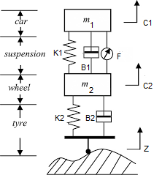

Figure 1: Quarter model of nonlinear active suspension system.

The parameters of the Nonlinear quarter car active suspension system is shown in Table 1 below.

Table 1: Parameters of nonlinear quarter vehicle model
Model parameters | symbol | symbol Values
Vehicle body mass | M 1 | 550 Kg
Wheel assembly mass | M 2 | 63 Kg
Tire stiffness | k 2 | 165,000 N/m
Suspension stiffness (linear) | k1 | 36,000 N/m
Suspension stiffness (nonlinear) |  | 3,600,000 N/m
Suspension damping (linear) | B1 | 1,200 N-s/m
Suspension damping (nonlinear) |  | 800 N-s/m
Suspension damping (asymmetrical) |  | 800 N-s/m
Tire damping | B2 | 1,800 N-s/m

Hydraulic Actuator

The hydraulic actuator consists of cylinder or fluid motor that uses hydraulic power to facilitate mechanical operation. The mechanical motion offers associate output in terms of linear, turn or oscillatory motion. As liquids are nearly not possible to compress, a hydraulic actuator will exert an oversized force. the disadvantage of this approach is its restricted acceleration.

The hydraulic cylinder consists of a hollow cylindrical tube on that a piston can slide. The term single acting is used once the fluid pressure is applied to simply one aspect of the piston. The piston can move in exactly one direction, a spring being ofttimes accustomed offer the piston a come back stroke. The term double acting is used once pressure is applied on both sides of the piston; any distinction operative between the 2 sides of the piston moves the piston to 1 side or the other. In this paper, the nominal model for the hydraulic actuator is modeled as a frist order system transfer function as

Proposed Controller Design
Fuzzy Model Predictive Control
A fuzzy model predictive control (FMPC) approach is introduced to style an impact system for an extremely nonlinear process. The two-layered computing theme avoids in depth on-line nonlinear optimization and permits the look of a controller supported linear control theory. The formal logic management (FLC) has been extensively researched since Zadeh (1965) revealed the famous paper on fuzzy sets. Its control rules are linguistic and intuitive ones that are close to means knowledge. It is applicable to use fuzzy controller once the process is non-linear, having time delay or is tough to get precise knowledge of the Model Predictive Control (MPC) has additionally developed significantly in research and industry. The basic ideas of most MPC strategies are that victimization a model to predict the future process output, calculating the management sequence to minimize the target function and victimization the receding strategy (Camacho and Bordon, 1995).
Both the FLC and MPC have their benefits and disadvantages. There exist some processes that not so precise model of them will be got or these processes are settled by the external noises. In such cases, using the non-model-based FLC strategy might lose some helpful info about the processes, using MPC strategy might result a complex management law and need a long calculation to come up with the manipulate variable. The block diagram of fuzzy model predictive control is shown in Figure 2 below.

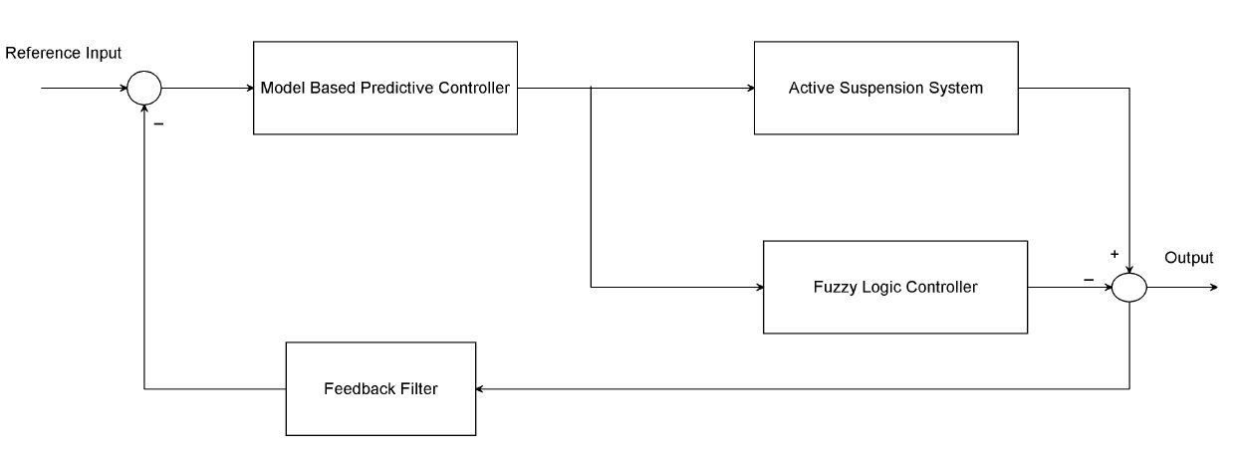
Figure 2

Fuzzy Logic Controller
In closed loop dominion systems, the classical controller has been replaced by the FLC. This quantity that the IF-THEN rules and fuzzy membership functions replaces the mathematical rule to experiment the system [2]. For the fuzzy logic mechanism, the signal variables are error (e) and derivative of error (de/dt), and the output Sus_def (suspension deflection) (u). Gaussian membership functions utilized for inputs variables and the output. Error has 9 membership functions as shown in Figure 3, derivative of error has 9 membership functions as shown in Figure 4, and output has nine membership functions as shown in Figure 5 below.

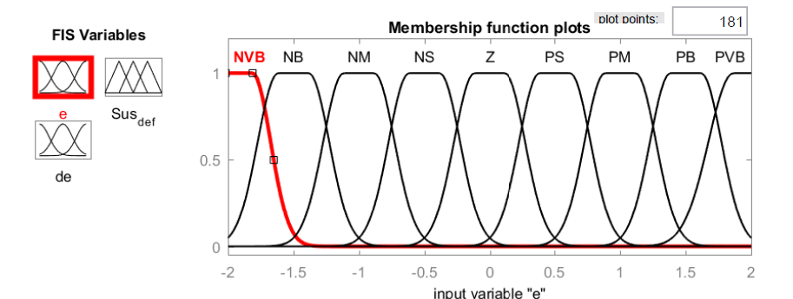
Figure 3 Error membership function

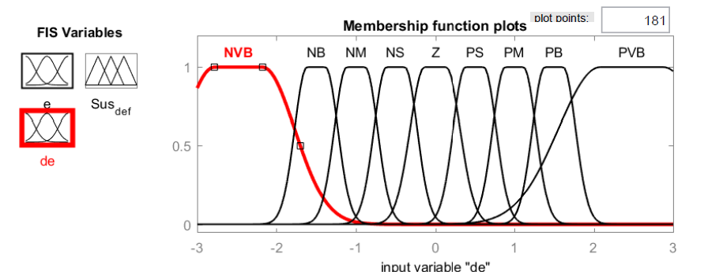
Figure 4 Change of error membership function

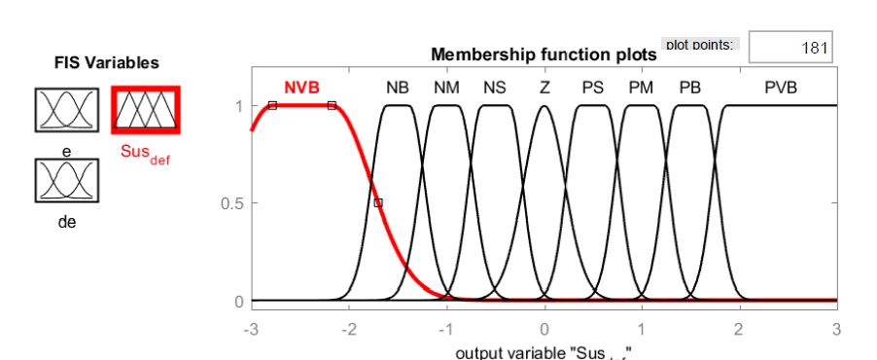
Figure 5 Output membership function

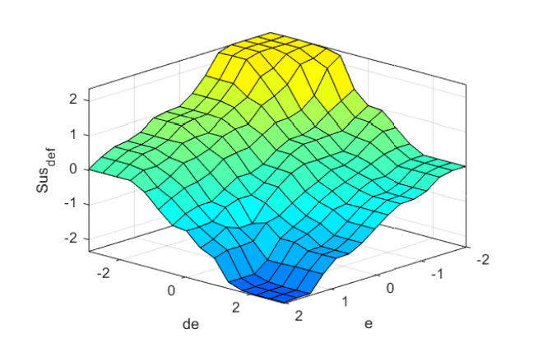
Figure 6 Surface membership function

    - Fuzzy Rule Base
The fuzzy input variable e has nine membership functions and fuzzy input variable ∆e has nine membership functions, and the output variable has nine membership functions. There are 81 rules generated as shown in Table 2.

Table 2 Fuzzy rule base
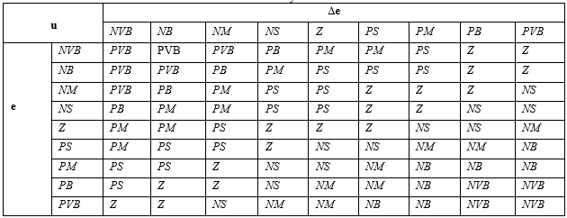

Model Predictive Controller
The MPC may be wont to control a good selection of processes reminiscent of processes with long delay time or non-minimum section systems or unstable systems. Table 3 illustrates the network architecture, training data and training parameters of the proposed controllers.

Table 2 Neural network Parameters
Network Architecture
Size of hidden layer | 6 | Delayed plant input | 2
Sample interval(sec) | 0.1 | Delayed plant output | 2
Training Data
Training sample | 65 | Maximum Plant output | 2
Maximum Plant input | 2 | Minimum Plant output | 1
Minimum Plant input | 1 | Max interval value (sec) | 30
Min interval value (sec) |  |  | 15
Training Parameters
Training Epochs |  |  | 65

Result and Discussion
Road Profiles
The profile is the vertical facet of the road, as well as crest and sag curves, and also the straight grade lines connecting them. The cross section shows the position and variety of car and bicycle lanes and sidewalks, beside their cross slope or banking. In this paper, Bump and Sinusoidal road profiles has been used to test the performance of the Nonlinear quarter car active suspension system with fuzzy model predictive controller as shown in Figure 7 and Figure 8 respectively.

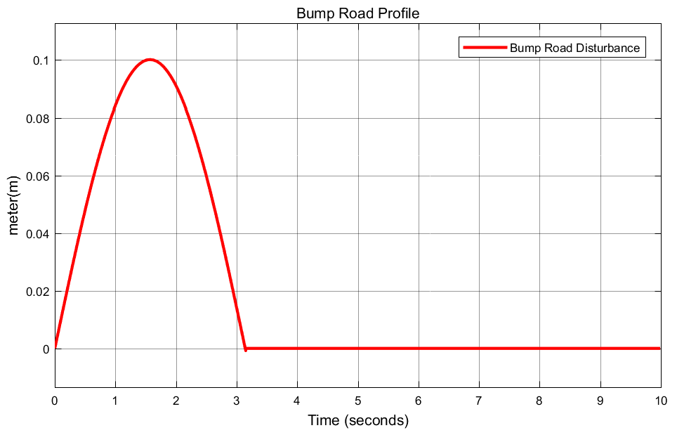
Figure 7 Bump road profile

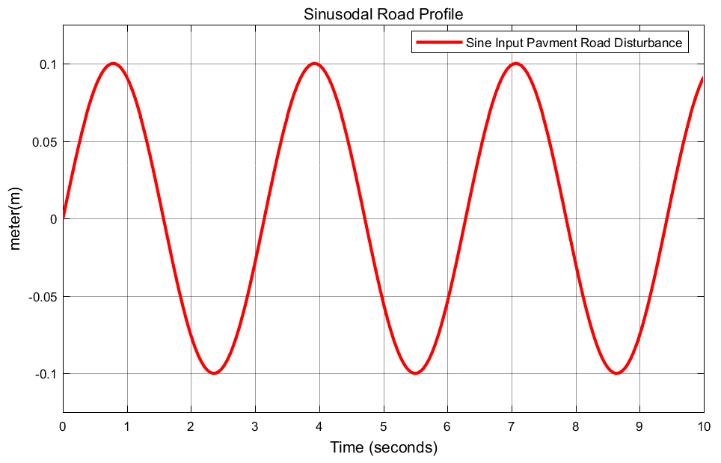
Figure 8 Sinusoidal road profile

Suspension Deflection Response to Bump Road Profile Input
The simulation of suspension deflection response of the nonlinear active suspension system with fuzzy model predictive controller for a bump road profile with comparison of semi-active and passive suspension systems is shown in Figure 9 below.

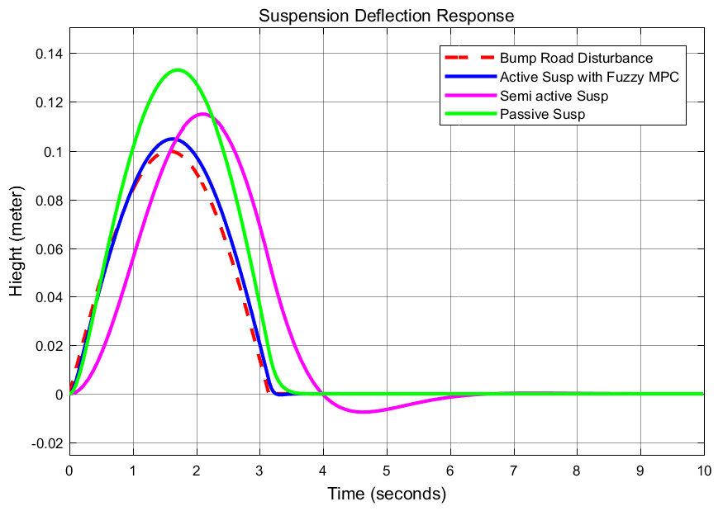
Figure 9 Suspension deflection response to bump road profile

The simulation result shows that the nonlinear active suspension system suspension deflects almost exactly like the road profile with a 3.5% error while the semi-active suspension system suspension deflects with an error of 18 % and delay error of 37.5 % and the passive suspension system suspension deflects with an error of 30 %.
Suspension Deflection Response to Sinusoidal Road Profile Input
The simulation of suspension deflection response of the nonlinear active suspension system with fuzzy model predictive controller for a sinusoidal road profile with comparison of semi-active and passive suspension systems is shown in Figure 10 below.

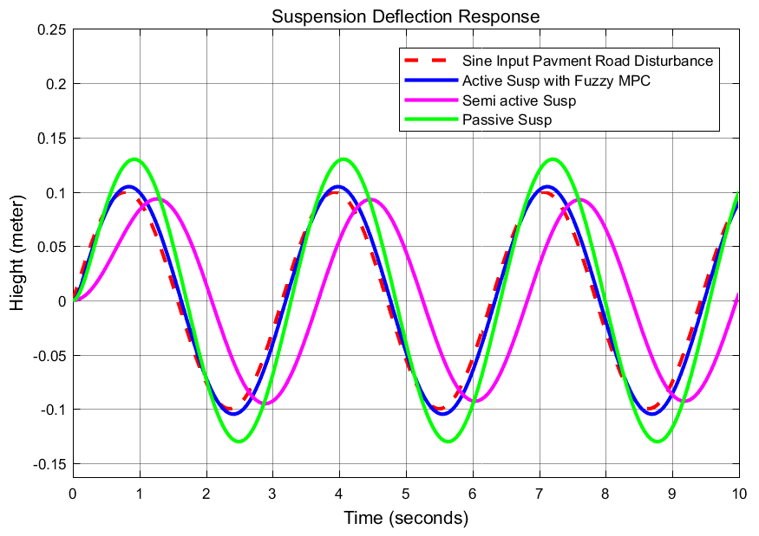
Figure 10 Suspension deflection response to sinusoidal road profile

The simulation result shows that the nonlinear active suspension system suspension deflects almost exactly like the road profile with a 0.95% error while the semi-active suspension system suspension deflects with 80 % of the road profile and delay error of 47.5 % and the passive suspension system suspension deflects with an error of 30 %.

Conclusion
The nonlinear dynamical model of nonlinear quarter car active suspension system is proposed in this paper. The nonlinear characteristic of the spring and damper are introduced in the proposed nonlinear model. Using the nonlinear model, a fuzzy model predictive controller with the parameter of the MPC and FLC laws are designed as the active control for nonlinear quarter car active suspension system. Stability analysis of the suspension deflection is done using MATLAB simulation tool. According to simulation case results, the proposed fuzzy model predictive control method obtained a satisfactory performance improvement for the nonlinear quarter car active suspension system.

Reference
- Al Aela AM, Kenne J-P, Mintsa HA. Adaptive neural network and nonlinear electrohydraulic active suspension control system. Journal of Vibration and Control. November 2020. doi:10.1177/1077546320975979
- Al Aela, AM, Kenne, J-P, Angue Mintsa, H (2020) A novel adaptive and nonlinear electrohydraulic active suspension control system with zero dynamic tire liftoff. Machines 8: 38.
- Huang, Y, Na, J, Wu, X, et al. (2019) Approximation-free control for vehicle active suspensions with hydraulic actuator. IEEE Transactions on Industrial Electronics 65(9): 7258–7267.
- Pang, H, Zhang, X, Chen, J, et al. (2019) Design of a coordinated adaptive backstepping tracking control for nonlinear uncertain active suspension system. Applied Mathematical Modelling 76: 479–494.
- Qin, Y, Dong, M, Xiang, C, et al. (2017) Adaptive robust active suspension control based on intelligent road classifier. In: 2017 IEEE 56th anual conference on decision and control (CDC), 12–15 December 2017, pp. 861–866. Melbourne, Australia: IEEE.
- Zhang, Y, Lin, Y, Liu, L (2019) Minimal learning parameters-based adaptive neural control for vehicle active suspensions with input saturation. Neurocomputing: 1–9.
- Barethiye, V. M. , Pohit, G. , & Mitra, A. (2017). Analysis of a quarter car suspension system based on nonlinear shock absorber damping models. International Journal of Automotive and Mechanical Engineering , 14 (3), 4401–4418. https://doi.org/10.15282/ijame.14.3.2017.2.0349
- Choi, H. D. , Ahn, C. K. , Lim, M. T. , & Song, M. K. (2016). Dynamic output-feedback H∞ control for active half-vehicle suspension systems with time-varying input delay. International Journal of Control, Automation and Systems , 14 (1), 59–68. https://doi.org/10.1007/s12555-015-2005-8
- Yao Jun, Zhang Jin Qiu, Zhao Ming Mei, Li Xin Active control of a nonlinear suspension with output constraints and variable-adaptive-law control. Journal of Vibroengineering, Vol. 20, Issue 7, 2018, p. 2690-2704. https://doi.org/10.21595/jve.2018.19005
- Wu Qin, Wen-Bin Shangguan, Hui Yin, Ye-Hwa Chen, Jin Huang, Constraint-following control design for active suspension systems, Mechanical Systems and Signal Processing, 10.1016/j.ymssp.2020.107578, 154, (107578), (2021).
- Jun Xiong, Xiao‐Heng Chang, Ju H. Park, Zhi‐Min Li, Nonfragile fault‐tolerant control of suspension systems subject to input quantization and actuator fault, International Journal of Robust and Nonlinear Control, 10.1002/rnc.5135, 30, 16, (6720-6743), (2020).
- Aldair, A A and Wang, W J (2011) Design an intelligent controller for full vehicle nonlinear active suspension systems. International Journal on Smart Sensing and Intelligent Systems, 4 (2). pp. 224-243. ISSN 11785608
- Dinh, H. T., Trinh, T., and Tran, V. (September 21, 2020). "Saturated RISE Feedback Control for Uncertain Nonlinear MacPherson Active Suspension System to Improve Ride Comfort." ASME. J. Dyn. Sys., Meas., Control. January 2021; 143(1): 011004. https://doi.org/10.1115/1.4048188
- Al Aela AM, Kenne J-P, Angue Mintsa H. A Novel Adaptive and Nonlinear Electrohydraulic Active Suspension Control System with Zero Dynamic Tire Liftoff. Machines. 2020; 8(3):38. https://doi.org/10.3390/machines8030038
- Shao S-J, Ren C-B, Jing D, Yan T-H. Study on the stability and vibration reduction of nonlinear active suspension system with time-delayed feedback control. Journal of Low Frequency Noise, Vibration and Active Control. April 2020. doi:10.1177/1461348420912557.

6/12/2021

