**Sheet fracture prediction in multi-point deep drawing process using ductile fracture criteria**

1Babak Beglarzadeh, 2Behnam Davoodi

1Department of Mechanical of Engineering ,Science and Research branch, Islamic Azad university, Tehran, Iran

2Department of Manufacturing Engineering, Faculty of Mechanical Engineering, University of Tabriz, Tabriz, Iran.

**Abstract**：Multi-point forming is a flexible manufacturing method for 3-D surfaces. It’s basic idea is to divide an entire die into many punches which can be arranged and adjusted precisely. These punches constitute a “configurable multi-point die”. due to the deep drawing process of sheet metal forming methods most used in various industries, In this paper the procedure of multi-point forming for deep drawing of sheet metal parts has been studied and the forming mechanism proposed in the experimental and finite element simulation has been reviewed. In view of the widespread use of aluminum alloy AA2024 in the Aerospace Industry, this alloy sheet material has been used for testing and forming parts in various conditions. Common flaws with the process suggested by conventional deep drawing process and those of this specific method potential has been identified and appropriate strategies to address these deficiencies has been provided. Ductile fracture criteria are used for predicting the tearing of sheet. In addition, the influence of forming parameters such as the material and the thickness of the elastic layer, Sheet material etc, on the process, defects and the final quality of the formed parts will be studied. The results show that deep drawing process with multi-point die is a flexibale procedure compared with conventional deep drawing process. This method can be formed more complex profiles with multiple pins and elastic layer while it is not possible in conventional deep drawing. In this procedure, by increasing the stiffness of the polyurethane layer, blank-holder force increases and the amount of dimples reduced. In general, in this method, with increasing of polyurethane layer stiffness, drawing depth of the workpiece increases. Based on the ductile fracture criteria such as Cockroft - Lathm and Clift, the elements that related to the Clift criteria, rupture earlier.

[Babak Beglarzadeh, Behnam Davoodi. **Sheet fracture prediction in multi-point deep drawing process using ductile fracture criteria.** *Life Sci J* 2021.14(6):40-46] (ISSN:1097-8135). <http://www.lifesciencesite.com.> 5. doi:[10.7537/marsnys140621.05.](http://www.dx.doi.org/10.7537/marsnys140621.05)

**Keywords**: finite element simulation, deep drawing, sheet parts, multi point forming, ductile fracture criteria.

**1. Introduction**

Nowadays, tendency is towards to the methods which have highest productivity in a shortest time. In traditional deep drawing process a stiff die with no possibility of is used. To facilitate this problem, the deep drawing process with multi-point die is used.

This method can be formed more complex profiles with multiple pins and elastic layer while it is not possible in conventional deep drawing. Finite element simulation and ductile fracture criteria such as Cockroft-Latham and Clift are used for predicting the tearing of sheet. The notion of multi-point forming was presented in Japan for the first time. Nakajima (1969) offered the implication of discrete level die and adjustable form initially. His mold is made simply with the use of wires and equipment, By adjusting the height of wires manually, surface of sheet metal can be formed. In the United States of America, Walczyk and Hardt (1998) and Webb and Hardt (1991) carried out widespread research in the field of multi-point forming. They offered a closed loop shape control system for continuous mold of discrete components and the computer-controlled equipment was made. Deep drawing test done by the equipment and the precision of forming were measured by closed-loop control system. Li and his Colleagues (2002) have done a research on the prediction and controlling the defects of forming. Dimples and wrinkles are the typical imperfections that created by the multi-point forming die in the process of forming. Numerical simulation is an effective way to predict the defects of forming, Simulation of forming process with multi-point mold done by LS_DYNA3D software, This program solves the equations with an implicit analysis. Chen and co-researchers (2005) have done disquisition in the field of sectional multi-point forming technology, In sectional multi-point forming large sheet parts have formed Part by part. This method could provide the forming of large parts, on small presses. Qian et al (2007) presented simulation analysis of multi-point forming process for dish head. They used BWC shell elements for the numerical simulation of sheet metal and to fix defects, such as wrinkles and dimples, elastic layer used. In multi-point forming Process, the pins should be rigid and sheet metal material should be anisotropic. spherical surface with a radius of 300 mm, has been considered, Multi-point forming process can optimize the deformation path of the sheet metal in order to improve the quality of forming, eliminates dimples and wrinkles and improve the capacity of Sheet Metal Forming. By Reviewing the works that have done in the field of multi-point forming process, we find that more simulation works have been done, It means that a few experimental work has been done. Deep drawing process with multi-point forming die and parameters that affect on it, had not been investigated. In this paper, with using of finite element simulation and ductile fracture criteria, a tearing of formed sheet is studied.

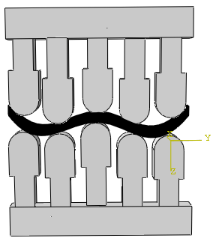

**2. EXPERIMENTAL SETUP**

The output results of the simulation are taken into account as the process parameters input for experimental testing. The components of the rigid mold are shown in figure(). In Construction of die, totally 200 hemi-spherical pins is used that any of the pins are independent and the height of each of them easily adjust. So we can properly adjust the height of the pins to create surfaces with different curvatures. Blank-holder forces that require during the metal forming process is provided by lower jacks. To perform tests, sheets with preliminary dimensions 220×220 mm of Aluminum alloy AA2024-O is used. geometrical dimensions of the rigid die are shown in Table 1. a polyurethane layer with () Shore A is used. Thickness of the Al2024 sheet is 1mm. for performing a test, two functional hydraulic press T.S.S with capacity of 100 k.N is used.

|  |  |
| --- | --- |
| **Parameter** | **Size (mm)** |
| Pin diameter | 12 |
| Die enterence radius | 7 |
| Matrix hole dimension | 150×150 |
| Sheet dimension | 220×220 |
| Poly urethane layer thickness | 10 |

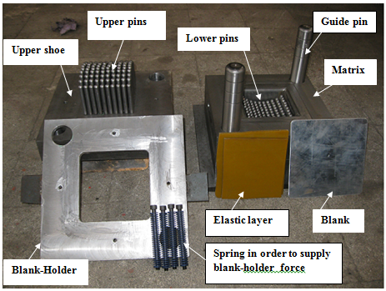

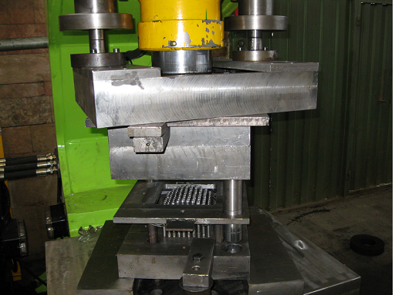

**3. FINITE ELEMENT MODELING**

**3.1 Finite element simulation**

In this study, ABAQUS / EXPLICIT 6.10.1 software is used for simulation, to determine whether the shrinkage of the part and Also consider the effects of anisotropy in sheets of aluminum, three-dimensional models have been used to analyze. Also, due to symmetry and reduced the analysis time only a quarter of the mold and the plate is modeled. Sheet model of shell and deformable, elastic layer of solid and deformable, pin, matrix and blank-holder of discrete rigid is determined. Since mold components including pins, blank-holder and matrix are modeled as rigid surfaces, mechanical properties is not attributed to them. Simulations of the used process has been set in two-step. In the first step, the blank-holder force is applied to the upper surface of the plate, and the second step is to move the upper punches to create the desired shape. contact between the sheet surfaces with polyurethane layer and the mold surfaces is selected surface to surface type. In order to model the friction of the interface of plate surfaces with die components surfaces and polyurethane layer, Coulomb friction model is used. According to reference [12] the friction coefficient between the sheet contact surface with mold and blank-holder surface 0.1, is considered. This coefficient for the contact surface between sheet and a layer of polyurethane, and polyurethane layer with the surface of the pins are 0.1 and 0.2, respectively. Elements used in the model of plate is S4R which is four-node element. For meshing the layers of polyurethane, the eight-node solid element C3D8R is used. and elements used in the upper and lower matrix, pins and components of the die are R3D4. For investigation of the grain size effect, thickness changes at critical points of the work piece and also the time of the analysis process in various scenarios comparing and at the end with probing the results, 0.0015 for numeric grading is selected.

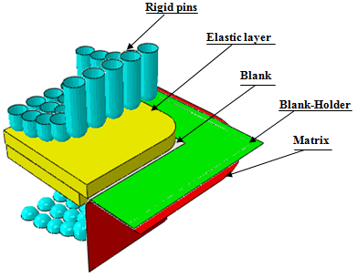

**3.2 Material model**

In view of the widespread use of aluminum alloy AA2024 in the Aerospace Industry, this alloy sheet material has been used for testing and forming parts in various conditions. Chemical composition of AA2024 are shown in Table 1.

|  |  |  |  |  |  |  |  |  |
| --- | --- | --- | --- | --- | --- | --- | --- | --- |
| **Material** | Si | Fe | Cu | Mn | Mg | Cr | Zn | Ti |
| **AA2024** | 0.50 | 0.50 | 3.8-4.9 | 0.3-0.9 | 1.2-1.8 | 0.10 | 0.25 | 0.15 |

In order to determine the mechanical properties of the sheet, based on the standard ASTM B557m(2006), specimens in three different orientation (0º ,45º ,90º) toward the rolling direction of the sheet is prepared and uniaxial tensile test was carried out in three direction. The results of these tests was used to determine the mechanical properties and anisotropy of the sheet. The mechanical properties obtained are presented in Table 2.

|  |  |  |  |  |  |
| --- | --- | --- | --- | --- | --- |
| **Sheet orientation due to rolling direction** | **Yield strength**  **(Mpa)** | **Young’s modulus,**  **E (Gpa)** | **Strain-Hardening**  **exponent** | **Strength**  **coefficient** | **Anisotropy** |
| 0º | 78 | 69 | 0.2565 | 344.09 | 0.71 |
| 45º | 75 | 69 | 0.2445 | 344.03 | 0.72 |
| 90º | 76 | 69 | 0.2322 | 328.05 | 0.75 |

Mooney - Rivilin Model is used in order to describe hyper-elastic material properties in the simulations.

**3.3** **fracture prediction in finite element simulation**

A point that should be noted is that in the finite element software ABAQUS, can not directly enter the anisotropy coefficients and shall submit to the Hill function for an anisotropic material yield stress anisotropy ratio can be used instead of strain ratios. Hill's theory is to obtain the yield function of an anisotropic material.

$f\left(σ\right)=\sqrt{\begin{aligned}F{\left(σ_{22}-σ_{33}\right)}^{2}+G{\left(σ_{33}-σ_{11}\right)}^{2}+H{\left(σ_{11}-σ_{22}\right)}^{2}+ \\ {2Lσ}_{13}^{2}+{2Mσ}_{31}^{2}+{2Nσ}_{12}^{2}\end{aligned}}$

In this relation N, M, L, H, G, F are constants that are determined anisotropy.

Rij is the ratio of the yield stress anisotropy and are defined as follows:

**

Because the strain ratios are obtained in the tensile test, Thus to convert these ratios to yield stress ratios, the following relations are used :

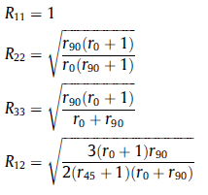

Anisotropy yield stress ratio values ​​presented in Table 3. Based on anisotropy coefficients shown in Table (4-1) have been obtained.

|  |  |  |  |  |  |  |
| --- | --- | --- | --- | --- | --- | --- |
| **Coefficient** | R11 | R22 | R33 | R12 | R13 | R23 |
| **Value** | 1 | 1.0159 | 0.93724 | 1.03924 | 1 | 1 |

Ductile fracture criterias are used for predicting the tearing of sheet In recent years, several ductile fracture criteria have been proposed that some of them are based on the ratio of the defect was introduced by Rice and Tracey. Cockroft and Lathm is one of the criteria, that is based on total plastic work per volume unit . They cited fracture criteria based on a real formability , According to that, Failure occurs in soft materials when the following conditions provided. This criteria are shown in the following equation :

$$\int_{0}^{{\overline{ϵ}}_{f}}{σ_{max} d\overline{ ϵ}=C_{1} ,}$$

$$\int_{0}^{{\overline{ϵ}}_{f}}{{\overline{σ}}_{max} d\overline{ϵ}=C_{5} ,}$$

Table 3: Material constants in the ductile fracture criteria

|  |  |
| --- | --- |
| **Ductile fracture criteria** | **Material constants** |
| Cockroft-Latham | 30/587 |
| Clift | 29/987 |

**4. Results and discussion**

Figure 2 shows the simulation model to calculate the integral I. In this section, for each of the elements that are located in critical region, the integral Ij is calculated with using of Cockroft - Lathm and Clift criteria.

*Elements that are located in critical region in order to*

*calculate the Ij integral*

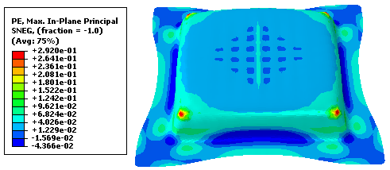

Table (5-2), is indicated the numbers corresponding to each of the criteria.

|  |  |  |
| --- | --- | --- |
| **Element number** | **Cockroft-Latham criteria** | **Clift criteria** |
| 1 | 0/946 | 0/957 |
| 2 | 0/921 | 0/931 |
| 3 | 1/249 | 1.263 |
| 4 | 0.899 | 0.909 |
| 5 | 0.857 | 0.866 |
| 6 | 0.797 | 0.806 |
| 7 | 1.147 | 1.159 |
| 8 | 0.931 | 0.941 |
| 9 | 1.194 | 1.208 |

By comparing the numbers of each of the elements, it can be seen that the elements are related to the Clift criteria, rupture earlier. In this section the experimental tests under different conditions, as well as finite element simulations, it can be seen that the results are in good agreement. This results is given in the figure (5-19).

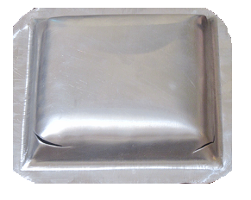

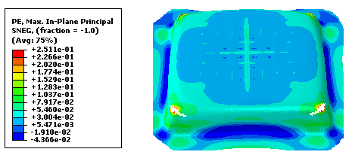

**4.1. The effect of elastic layer hardness on the tearing of sheet**

As an example, the limitation of multi-point forming method, is fragmentation of parts, while it was produced. one of the problem is prediction of failure moment in this manufacturing process. In this paper, with having a hardness properties of elastic layers, the moment of rupture in the finite element simulations Marked with ABAQUS software was determined, and the results have been validated with experimental method. so that four polyurethane layer with a hardness of 50, 65, 80 and 85Shore A are used experimentally and simulation. drawing depth of the workpiece as shown in figure (), for every hardness earned.

Maximum depth of draw For different hardness polyurethane layer

With reviewing figure (), we see that increasing of the work-piece drawing depth, has a procedure as oscillation. It dropped at first, then increases and finally decreases. The reason is related to the mechanical properties of polyurethane. If the percentage of elongation at break moment of polyurethane layers consider, we find that, the percentage of elongation at break moment of polyurethane with a hardness of 50 Shore A is more than the percentage of elongation of polyurethane with a hardness of 65Shore A .This reason cause that the drawing depth of the work-piece formed with a polyurethane with a hardness of 50S.A , is slightly more than the polyurethane with a hardness of 65S.A. In the polyurethane 80S.A, the drawing depth of the work-piece becoming more with the same piece, of polyurethane 85S.A, would be the same reason.

**5.Conclusions**

With using the stresses and strains obtained from the finite element simulation and material constants , Cockroft - Lathm and Clift criterion was calculated and then placing the numbers in the integral J, the value obtained .By comparing the numbers of each of the elements, it can be seen that the elements that related to the Clift criteria, rupture earlier.

**References**

1. M. Li,Y. Liu,Sh. Su,G. Li,**Multi point forming:a flexible manufacturing method for 3-d surface sheet**, Journal of material processing technology,1999,pp. 277-280.
2. M.Z. Li,Z.Y. Cai,Z. Sui,Q. G. Yan,**Multi point forming for sheet metals**,2002, pp. 333-338.
3. F.X. Tan ∗ , M.Z. Li, Z.Y. Cai, **Research on the process of multi-point forming for the customized titanium alloy cranial prosthesis**, 187–188: 453– pp.457, 2007.
4. G. Sun a,∗ , M.Z. Li a , X.P. Yan a , P.P. Zhong b, **Study of blank- holder technology on multi-point forming of thin sheet metal** ,187–188, pp.517–520, 2007.
5. Chen, J.- J., Li, M.-Z., Liu, W., Wang, C.-T., **Sectional multipoint forming technology for large-size sheet metal** , Int J Adv Manuf Technol, (2005) 25: 935-939.
6. Z.R. Qian , M.Z. Li,F.X. Tan,**The analyse on the process of multi point forming for dish head** ,Journal of material processing technology , 2007- pp.471-475.
7. Cai, Zhong-Yi, Wang, Shao-Hui, Xu, Xu-Dong, Li, Ming-Zhe, **Numerical simulation for the multi-point stretch forming process of sheet metal**, Journal ofMaterials Processing Technology (2008).
8. Zhang, Q., Wang, Z. R., Dean, T.A.,**The mechanics of multi-point sandwich forming**, International Journal of Machine Tools & Manufacture 48 (2008) 1495-1503.
9. Xue-peng Gong, Ming-zhe Li, Qi-peng Lu, Zhong-qi Peng, **Research on continuous multi-point forming method for rotary surface**, Journal of Materials Processing Technology 212 (2012) 227– 236.
10. H. Takuda, K. Morib, N. Hatta, **The application of some criteria for ductile fracture to the prediction of the forming limit of sheet metals**, Journal of Materials Processing Technology 95 (1999) 116-121.
11. D. Hunt, **Finite Element Assisted Prediction of Ductile Fracture in Sheet Bulging of Magnesium Alloys,** M. Eng Thesis, (2008).
12. S. Alexandrov, D.Vilotic, **A theoretical–experimental method for the identification of the modified Cockroft–Latham ductile fracture criterion,** Proceedings of the Institution of Mechanical Engineers, Part C: Journal of Mechanical Engineering Science 2008 222: 1869.
13. M. Jain, J. Allin, D.J. Lloyd, **Fracture limit prediction using ductile fracture criteria for forming of an automotive aluminum sheet,** International Journal of Mechanical Sciences 41 (1999) 1273-1288.
14. Heung Nam Han, Keun-Hwan Kim, **A ductile fracture criterion in sheet metal forming process,** Journal of Materials Processing Technology 142 (2003) 231–238.
15. Fahrettin. Ozturk, Daeyong. Lee, **Analysis of forming limits using ductile fracture criteria,** Journal of Materials Processing Technology 147 (2004) 397–404.
16. Yanxiong Liu, Lin Hua, **Fabrication of metallic bipolar plate for proton exchange membrane fuel cells by rubber pad forming,** Journal of Power Sources 195 (2010) 3529–3535.

6/2/2021