**Comparison of a Nonlinear Magnetic Levitation Train Parameters using Mixed H 2 /H∞ and Model Reference Controllers**

Mustefa Jibril, Mesay Tadese, Nuriye Hassen

Msc, School of Electrical & Computer Engineering, Dire Dawa Institute of Technology, Dire Dawa, Ethiopia

[mustefa.jibril@ddu.edu.et](mailto:mustefa.jibril@ddu.edu.et)

**Abstract：**To improve the riding performance and levitation stability of a high-speed magnetic levitation (maglev) train, a control strategy based on mixed H 2 /H∞ with regional pole placement and model-reference controllers are proposed. First, the nonlinear maglev train model is established, then the proposed system is designed to observe the movement of a suspension frame, and a control strategy based on mixed H 2 /H∞ with regional pole placement and model-reference control method are proposed. Test and analysis of the proposed system has been done using MATLAB toolbox for train levitation height, velocity and current consume. Comparative simulation results show that the mixed H 2 /H∞ with regional pole placement control strategy has a better performance under the condition of step and random train levitation height.

[Mustefa Jibril, Mesay Tadese, Nuriye Hassen. **Comparison of a Nonlinear Magnetic Levitation Train Parameters using Mixed H 2 /H∞ and Model Reference Controllers.** *N Y Sci J* 2021;14(6):7-15]. ISSN 1554-0200 (print); ISSN 2375-723X (online). <http://www.sciencepub.net/newyork>. 2. doi:[10.7537/marsnys140621.02.](http://www.dx.doi.org/10.7537/marsnys140621.02)

**Keywords:** Maglev train, Mixed H 2 /H∞ with regional pole placement, Model reference

1. **Introduction**

Maglev (derived from magnetic levitation) is a gadget of educate transportation that makes use of units of magnets: one set to repel and push the educate up off the track, and some other set to transport the expanded educate ahead, taking benefit of the shortage of friction. Along certain "medium-range" routes (commonly 320 to 640 km [200 to 400 mi]), maglev can compete favorably with high-velocity rail and airplanes.

With maglev era, there's simply one shifting part: the educate itself. The educate travels alongside a guideway of magnets which manipulate the trains balance and velocity. Propulsion and levitation require no shifting components. This is in stark comparison to electric powered a couple of units that could have numerous dozen components in step with bogie. Maglev trains are consequently quieter and smoother than traditional trains and feature the ability for tons better speeds.[1]

Maglev cars have set numerous velocity records and maglev trains can boost up and slow down tons quicker than traditional trains; the handiest sensible difficulty is the protection and luxury of the passengers. The energy wished for levitation is usually now no longer a big percent of the general strength intake of a high-velocity maglev gadget.[2] Overcoming drag, which makes all land shipping greater strength intensive at better speeds, takes the maximum strength. Vactrain era has been proposed as a way to conquer this difficulty. Maglev structures had been tons greater pricey to assemble than traditional educate structures, despite the fact that the less complicated production of maglev cars makes them inexpensive to fabricate and maintain.

The Shanghai maglev educate, additionally called the Shanghai Trans rapid, has a pinnacle velocity of 430 km/h (270 mph). The line is the quickest operational high-velocity maglev educate, designed to connect Shanghai Pudong International Airport and the outskirts of central Pudong, Shanghai. It covers a distance of 30.5 km (19 mi) in only over 8 minutes. For the primary time, the release generated huge public hobby and media attention, propelling the recognition of the mode of transportation.[3] Despite over a century of studies and development, maglev shipping structures at the moment are operational in only 3 countries (Japan, South Korea and China).[quotation wished] The incremental blessings of maglev era have regularly been taken into consideration tough to justify towards fee and risk, specially wherein there's an present or proposed traditional high-velocity educate line with spare passenger wearing capacity, as in high-velocity rail in Europe, the High Speed 2 withinside the UK and Shinkansen in Japan.

1. **Mathematical Models**
   1. **Nonlinear Modelling of EDS Maglev Train**

In order to develop the Nonlinear Modelling of EDS Maglev Train, we need to develop the mathematical modelling of the Electromagnetic and Mechanical subsystems separately.

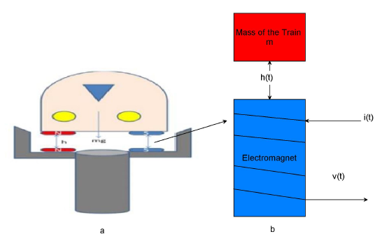

Figure 1: (a) EDS Model, (b) Single axis magnetic suspension system

Figure 1 shows a single axis magnetic levitation system is used, as well as electromagnetic and mechanical equations.

Apply Kirchhoff’s voltage equation for the electric circuit



Where u, I, R and L is applied voltage input, current in the electromagnet coil, coil’s resistance and coil’s inductance respectively.

Energy stored in the inductor can be written as



Since power in electrical system (𝑃e) = Power in the mechanical system (𝑃m),

Where  and  therefore



Where 𝑓𝑚 is known as electromagnet force Now substituting (2) in the equation (3),



Since the inductance 𝐿 is a nonlinear function of train position (𝚡) we shall neglect the leakage flux and eddy current effects (for simplicity), so that the inductance varies with the inverse of train position as follows:

 

Where, μ0 is the inductance constant, A is the pole area, N is the number of coil turns and 𝘬 is electromagnet force constant.



If 𝑓𝑚 is electromagnetic force produced by input current, 𝑓g is the force due to gravity and 𝑓 is net force acting on the train, the equation of force can be written as



Where 𝑚 = train mass and 𝑣 𝑑𝚡𝑑𝑡 𝑑ℎ𝑑𝑡, which is velocity of the train movement.

At equilibrium the force due to gravity and the magnetic force are equal and oppose each other so that the train levitates. i.e., 𝑓g = −𝑓𝑚 and 𝑓=0. On the basis of electro-mechanical modeling, the nonlinear model of magnetic levitation system can be described as follows:

The general form of an affine system



Is obtained by denoting variables for state space representation as follows



Substitute equation (9) or the state variables in to equation (1) and (7)



Then the nonlinear state space model is



Nonlinear model in matrix form is given by



Table 1: Physical paremeters of EMS Maglev train

|  |  |  |
| --- | --- | --- |
| Parameter | Unit | Value |
| M | kg | 15,500 |
| R |  | 50 |
| L | H | 1 |
|  | A | 200 |
|  | mm | 26 |
| k |  | 0.01 |
| g |  | 9.8 |

1. **Proposed Controllers Design**
   1. **Mixed H 2 /H∞ with Regional Pole Placement Controller**

The mixed H 2 /H∞ control problem is to minimize the H 2 norm of overall state feedback gains k such that what also satisfies the H∞ norm constraint. Mixed H 2 /H ∞ synthesis with regional pole placement is one example of multi-objective design addressed by the LMI. The control problem is sketched in Figure 2. The output channel z is associated with the H ∞ performance while the channel z 2 is associated with the H 2 performance.

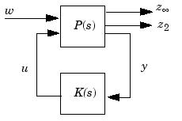

Figure 2 Mixed H 2 /H∞ configuration

The LMI regions for the pole placement are found using the command lmireg and we select the half plane region and the output region is



And we use this region for the mixed H 2 /H∞ controller synthesis.

* 1. **Model-Reference Controller Design**

The designing of neural model reference control uses two neural networks:

1. A Neural network controller and
2. A Neural network controller for the plant model

As shown in Figure 3 bellow.

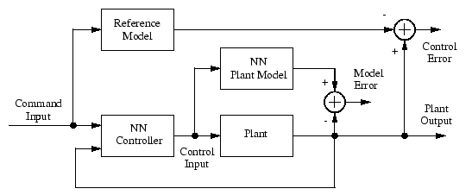

Figure 3. Block diagram of the model reference controller

There are three sets of controller inputs:

* Delayed reference inputs
* Delayed controller outputs
* Delayed plant outputs

The neural network architecture, training data and training parameters for model reference and predictive controllers are shown in the Table 2 bellow:

Table 2 Neural network architecture

|  |  |  |  |
| --- | --- | --- | --- |
| Network Architecture | | | |
| Size of hidden layer | 6 | Delayed plant input | 2 |
| Sample interval(sec) | 1 | Delayed plant output | 3 |
| Training Data | | | |
| Training sample | 100 | Maximum Plant output | 3 |
| Maximum Plant input | 1 | Minimum Plant output | 1 |
| Minimum Plant input | 1 | Max interval value (sec) | 3 |
| Min interval value (sec) | | | 1.5 |
| Training Parameters | | | |
| Training Epochs | | | 100 |

1. **Result and Discussion**

Here in this section the comparison of the performance of the Maglev train with Mixed H 2 /H∞ with Regional Pole Placement Controller and Model-Reference Controller is done for the train levitation height, velocity and current consume using step and random reference levitation height.

* 1. **Comparison of the** **Maglev train with Mixed H 2 /H∞ with Regional Pole Placement Controller and Model-Reference Controller for a Step Reference Input**

The simulation result of the Maglev train with Mixed H 2 /H∞ with Regional Pole Placement Controller and Model-Reference Controller levitation height, velocity and current consume for a step input are shown in Figure 4, Figure 5 and Figure 6 respectively.

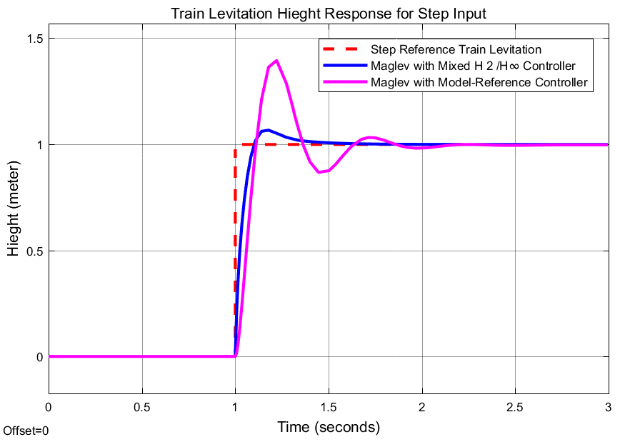

Figure 4 Step response of train levitation height

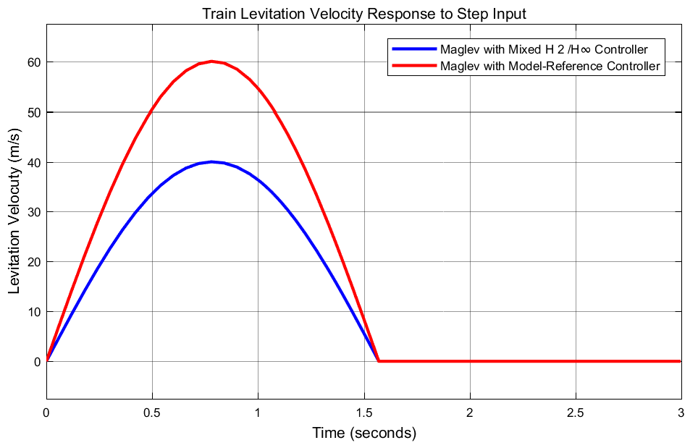

Figure 5 Step response of train levitation velocity

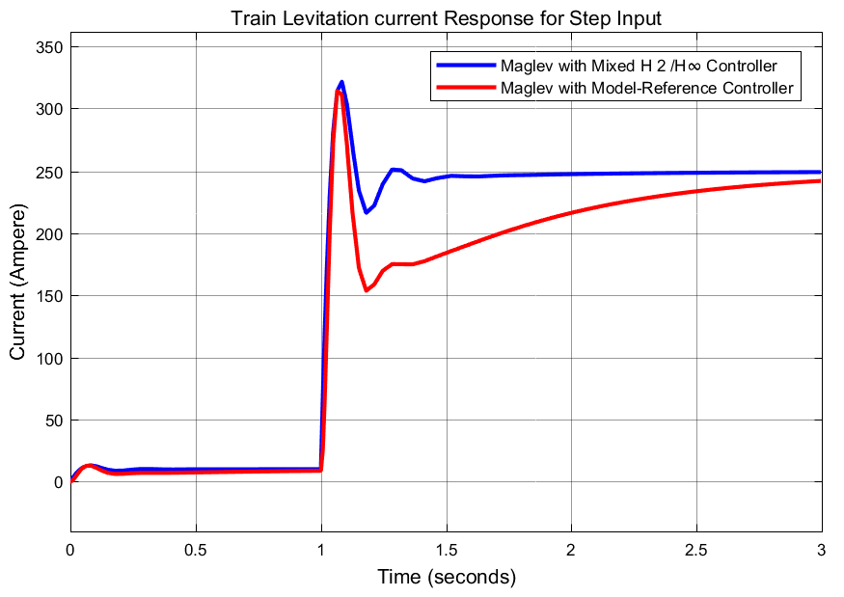

Figure 6 Step response of Maglev train current consume

Train levitation height response simulation shows that the Maglev train with Mixed H 2 /H∞ with Regional Pole Placement Controller has small rising time with less percentage overshoot and better settling time than the Maglev train with Model-Reference Controller,

Train levitation velocity response simulation shows that the Maglev train with Mixed H 2 /H∞ with Regional Pole Placement Controller has minimum velocity as compared to the Maglev train with Model-Reference Controller.

The Maglev train current consumption response simulation shows that the Maglev train with Mixed H 2 /H∞ with Regional Pole Placement Controller has small rising time with the same percentage overshoot and better settling time than the Maglev train with Model-Reference Controller.

* 1. **Comparison of the Maglev train with Mixed H 2 /H∞ with Regional Pole Placement Controller and Model-Reference Controller for a Random Reference Input**

The simulation result of the Maglev train with Mixed H 2 /H∞ with Regional Pole Placement Controller and Model-Reference Controller levitation height, velocity and current consume for a random input are shown in Figure 7, Figure 8 and Figure 9 respectively.

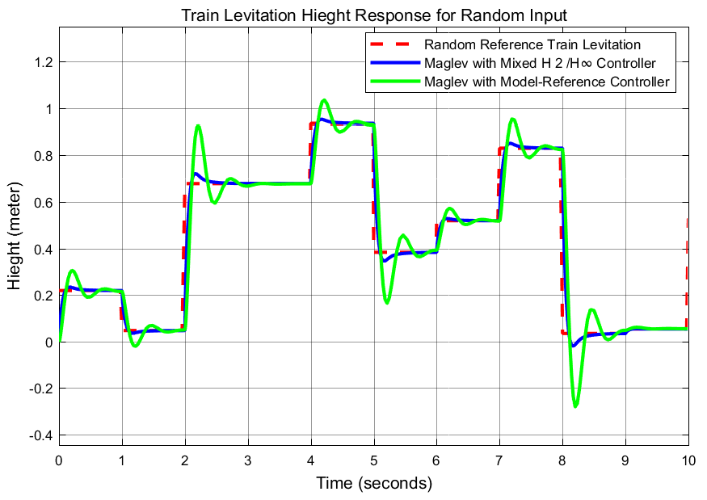

Figure 7 Random response of train levitation height

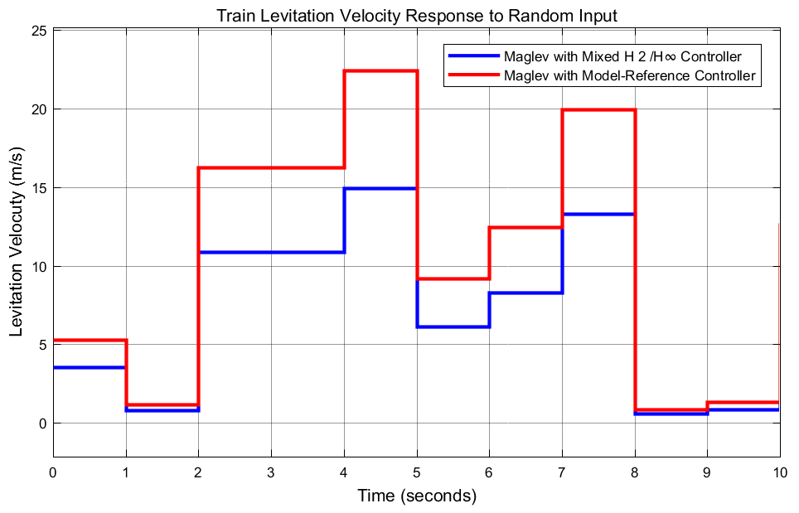

Figure 8 Random response of train levitation velocity

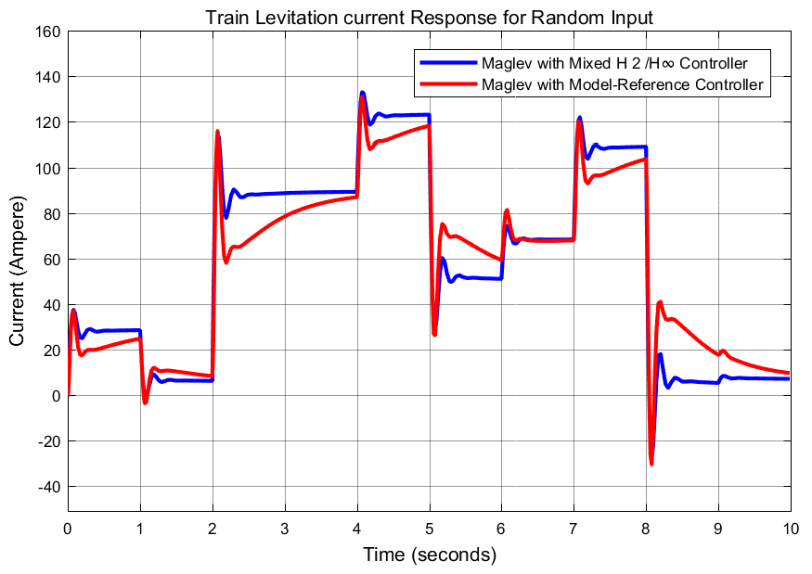

Figure 9 Random response of Maglev train current consume

Train levitation height response simulation shows that the Maglev train with Mixed H 2 /H∞ with Regional Pole Placement Controller has a small different in rising time with less percentage overshoot and improved settling time than the Maglev train with Model-Reference Controller,

Train levitation velocity response simulation shows that the Maglev train with Mixed H 2 /H∞ with Regional Pole Placement Controller has a smaller velocity as compared to the Maglev train with Model-Reference Controller.

The Maglev train current consumption response simulation shows that the Maglev train with Mixed H 2 /H∞ with Regional Pole Placement Controller has the same rising time with smaller percentage overshoot and better settling time than the Maglev train with Model-Reference Controller.

1. **Conclusion**

In this paper, a mixed H 2 /H∞ with regional pole placement and model reference levitation control approach was developed to deal with levitation height control. The mathematical model of the magnetic-levitation train systems was constructed. The proposed controllers could improve robustness against train levitation height by utilizing the Robust control method and Neural network-based technology. The system with the proposed controllers has been tested using MATLAB toolbox for train levitation height, velocity and current consume. Comparative simulation results show that the maglev train with mixed H 2 /H∞ with regional pole placement controller has a better performance under the test of step and random train levitation height than the maglev train with model reference controller.

**Reference**

1. Chen, C, Xu, J, Ji, W, et al. (2019) Sliding mode robust adaptive control of maglev vehicle’s nonlinear suspension system based on flexible track: Design and experiment. IEEE Access 7: 41874–41884.
2. Sun, Y, Xu, J, Qiang, H, et al. (2019) Adaptive sliding mode control of maglev based on RBF neural network minimum parameter learning method. Measurement 141: 217–226.
3. Humaidi, AJ, Badr, HM, Hameed, AH (2018) PSO–based active disturbance rejection control for position control of magnetic levitation system. In: International Conference on Control, Decision and Information Technologies. Thessaloniki, Greece, pp. 922–928.
4. Khimani, D, Karnik, S, Patil, M (2018) Implementation of high-performance nonlinear feedback control on magnetic levitation system. IFAC–Papers Online 51(1): 13–18.
5. Oh, S, Choi, H (2018) Robust approximate feedback linearisation control for nonlinear systems with uncertain parameters and external disturbance: Its application to an electromagnetic levitation system. International Journal of Systems Science 49(12): 2695–2703.
6. Wang Z, Long Z, Li X. Levitation control of permanent magnet electromagnetic hybrid suspension maglev train. Proceedings of the Institution of Mechanical Engineers, Part I: Journal of Systems and Control Engineering. 2018;232(3):315-323. doi:10.1177/0959651817750520
7. Adiguzel, F, Dokumacilar, E, Akbati, O, Turker, T (2018) Design and implementation of an adaptive backstepping controller for a magnetic levitation system. Transactions of the Institute of Measurement and Control 40(8): 2466–2475.
8. Bidikli, B, Bayrak, A (2018) A self–tuning robust full–state feedback control design for the magnetic levitation system. Control Engineering Practice 78: 175–185.
9. Humaidi, AJ, Badr, HM, Hameed, AH (2018) PSO–based active disturbance rejection control for position control of magnetic levitation system. In: International Conference on Control, Decision and Information Technologies. Thessaloniki, Greece, pp. 922–928.
10. Sadek, U, Sarjas, A, Chowdhury, A, Svecko, R (2017) Improved adaptive fuzzy backstepping control of a magnetic levitation system based on symbiotic organism search. Applied Soft Computing 56: 19–33.
11. Al-Araji, AS (2016) Cognitive non–linear controller design for magnetic levitation system. Transactions of the Institute of Measurement and Control 38(2): 215–222.
12. Eroglu, Y, Ablay, G (2016) Cascade sliding mode–based robust tracking control of a magnetic levitation system. Systems and Control Engineering 230(8): 851–860.
13. Ginoya, D, Chandrashekar, MG, Shendge, PD, Phadke, SB (2016) State–and–disturbance–observer–based sliding mode control of magnetic levitation systems. Transactions of the Institute of Measurement and Control 38(6): 751–763.
14. Liu, Z, Long, Z, Li, X. Maglev train overview. In: Liu, Z, Long, Z, Li, X (eds) Maglev trains. Berlin, Heidelberg: Springer, 2015, pp.1–28.
15. Safaei, F, Suratgar, AA, Afshar, A. Characteristics optimization of the maglev train hybrid suspension system using genetic algorithm. IEEE T Energy Conver 2015; 30: 1163–1170.

6/15/2021