**Temperature Control of a Steam Condenser using NARMA-L2 Controller**

Mustefa Jibril, Messay Tadese, Nuriye Hassen

Msc, School of Electrical & Computer Engineering, Dire Dawa Institute of Technology, Dire Dawa, Ethiopia

[mustefa.jibril@ddu.edu.et](mailto:mustefa.jibril@ddu.edu.et)

**Abstract:** This paper investigates the outlet temperature control for the design of steam condenser. The comparison has been made for a step drop in the steam condenser temperature set point using MATLAB/Simulink environment for the steam condenser with NARMA-L2 using Levenberg-Marquardt Algorithm and NARMA-L2 using Resilient Backpropagation Algorithm controllers. The steam condenser with NARMA-L2 using Levenberg-Marquardt Algorithm controller presented excellent and superior dynamic performance in response to the temperature drop in settling time. The overall simulation results demonstrated that the steam condenser with NARMA-L2 using Levenberg-Marquardt Algorithm controller can be an efficient alternative to the steam condenser with NARMA-L2 using Resilient Backpropagation Algorithm controller.

[Kharkwal G, Mehrotra P, Rawat YS. **Taxonomic Diversity of Understorey Vegetation in Kumaun Himalayan Forests.** *N Y Sci J* 2021;14(6):1-6]. ISSN 1554-0200 (print); ISSN 2375-723X (online). <http://www.sciencepub.net/newyork>. 1. doi:[10.7537/marsnys140621.01.](http://www.dx.doi.org/10.7537/marsnys140621.01)

**Keywords:** Steam condenser, NARMA-L2, Levenberg-Marquardt, Resilient Backpropagation

1. **Introduction**

A steam condenser is a closed vessel in which steam is condensed by abstracting the heat by cooling it with water and where the pressure is maintained below atmospheric pressure. The condensed steam is known as condensate. The efficiency of the steam power plant is increased by the use of a condenser. The steam condenser is an essential component of all modern steam power plants.

The steam condenser receives exhaust steam from one end and gets in contact with the cooling water flowed within it form the cooling tower.

As the low-pressure steam comes in contact with the cooling water, it condenses and turns into water. it is attached to the air extraction pump and condensation extraction pump. after condensation of steam, the condensate is pumped into the hot well by the help of condensate extraction pump.

The air extraction pump extracts air from the condenser and produces a vacuum inside it. the vacuum produced helps in the circulation of cooling water and the flow of condensate downstream.

The condenser is one of the critical kinds of system in thermal electricity plant, nuclear electricity plants, and marine system plant. The reliability of condenser running at once impacts the protection and financial operation of the entire energy plant or power gadget. A steam condenser is a chunk of equipment that turns steam into water. Many steam-based systems use a

circuit of water to maximize their efficiency. Water is heated into steam, the steam offers motivation for

a technique, a steam condenser turns it back into water, and the cycle begins again. The failure of the condenser may additionally cause the boiler or steam turbine unit to overheat, which endangers the safety of the whole producing unit or electricity plant.

The condenser as a “lower source of heat” performs a special position in an energy plant, due to the fact the parameters of its work have a significant impact at the performance of the installation. Therefore, it's far critical to recognize the condenser operating parameters during both design and operation. For this purpose, mathematical models describing the paintings of the condenser in modified situations are created.

Therefore, through the computer simulation experiments, the status quo of the dynamic version and knowledge the dynamic characteristics of the condenser have a wonderful significance on improving the protection and monetary operation degree of the steam condenser.

1. **Modelling of Steam Condenser**

The dynamic modelling of Steam Condenser (SC) shall be established using mass and energy balance condensation assumption. Therefore, according to the energy balance of the system, the heat of the steam will be equal to heat transferred to cooling water.



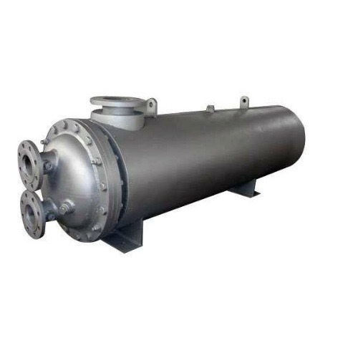

Figure 1 Steam condenser

Where, = heat duty of the condenser in [KW],  = flow rate of the mass in [kg/s], and  = latent heat of steam.



Where, =heat transfer coefficient (overall) /heat transfer area. = cooling water outlet temperature, = condensation temperature, =inlet temperature of cooling water.

This yields to energy balance equation as



=flow rate of cooling water [kg/s],  = holdup (cooling water) [kg],  =cooling water heat capacity [KJ/kgK].

Based on the constant volume assumption, mass balance equation can be derived. The ideal gas equation is



=condenser pressure [KPa], =gas constant= volume of condenser [m3],  = flow rate of steam [kg/s].

While the temperature and pressure is approximated linearly as



Equation 3 and 4 are dynamic equations and system have 7 parameters and 8 variables. The variables and parameters with their values for a steam condenser are shown in Table 1 and Table 2 respectively.

Table 1 Steam condenser variables

|  |  |
| --- | --- |
| Variable | Value and unit |
|  | 7 kg/s |
|  | 7 kg/s |
|  | 127.1 kg/s |
|  | 90 kPa |
|  | 80 0C |
|  | 78 0C |
|  | 106 0C |
|  | 9862 kW |

Table 2 Steam condenser parameters

|  |  |
| --- | --- |
| Parameters | Value and unit |
|  | 0.3 kJ/(kgK) |
|  | 8 m3 |
|  | 2455.65 kJ/kg |
|  | 456 kW/K |
|  | 8500 kg |
|  | 6.4 kJ/(kgK) |
|  | 0.006 |
|  | 0.00045 |
|  | 0.86 K/kPa |
|  | 1. C |

1. **Proposed Controllers Design**
   1. **Design of NARMA-L2 Controller**

The neuro controller described on this phase is cited through two different names: response linearization control and NARMA-L2 manipulate. It is known as comments linearization when the plant shape has a specific form (associate form). It is known as NARMA-L2 manipulate while the fortification mold may be approximated by using the same form. The vital principle of this type of control is to convert nonlinear design system into linear dynamics with the aid of cancelling the nonlinearities. This phase starts off evolved with the aid of submitting the associate system form and presentation how you may use a neural community to become aware of this model. Then it describes how the identified neural network model may be used to broaden a controller.

* + 1. **Identification of the NARMA-L2 Model:**

The first step in the use of feedback linearization (or NARMA-L2) manipulate is to identify the design to be controlled. You train a neural network to represent the forward dynamics of the system.

The first step is to pick out a styles association to use. One standard pattern this is used to symbolize fashionable discrete-time nonlinear system is the nonlinear autoregressive-moving average (NARMA) model:



Where u(k) is the system input, and y(k) is the system output. For the identification section, you can teach a neural network to approximate the nonlinear function N. If you want the system output to follow some reference trajectory *y* (*k* + *d*) = *yr* (*k* + *d*) the subsequent step is to expand a nonlinear controller of the form:



The trouble with the usage of this controller is that in case you need to teach a neural network to create the characteristic G to minimize mean square blunders, you need to apply dynamic returned propagation. This can be pretty sluggish. One answer is to apply approximate models to symbolize the system. The controller used on this section is based totally at the NARMA-L2 approximate model:



This model is in associate shape, wherein the next controller input u(k) is not contained in the nonlinearity. The gain of this form is that you could resolve for the control input that causes the system output to comply with the reference *y* (*k* + *d*) = *yr* (*k* + *d*). The resulting controller would have the form



Using this equation immediately can motive awareness problems, due to the fact you ought to determine the control input u(k) primarily based on the output at the same time, y(k). So, rather, use the model



Where d ≥ 2. Figure 2 shows the structure of a neural network representation

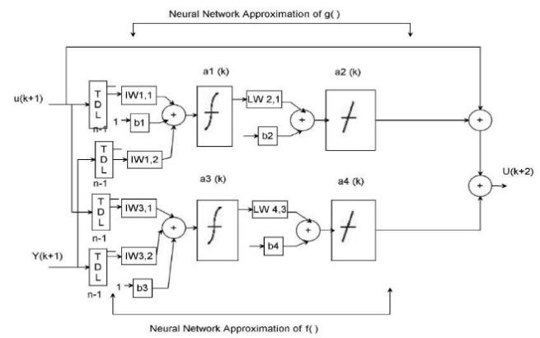

Figure 2. The structure of a neural network representation.

Using the NARMA-L2 model, you can obtain the controller



Which is realizable for d ≥ 2. Figure 3 shows the block diagram of the NARMA-L2 controller.

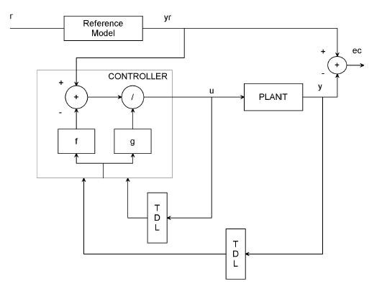

Figure 3. Block diagram of the NARMA-L2 controller

This controller can be implemented with the formerly diagnosed NARMA-L2 plant model, as shown in Figure 4 below.

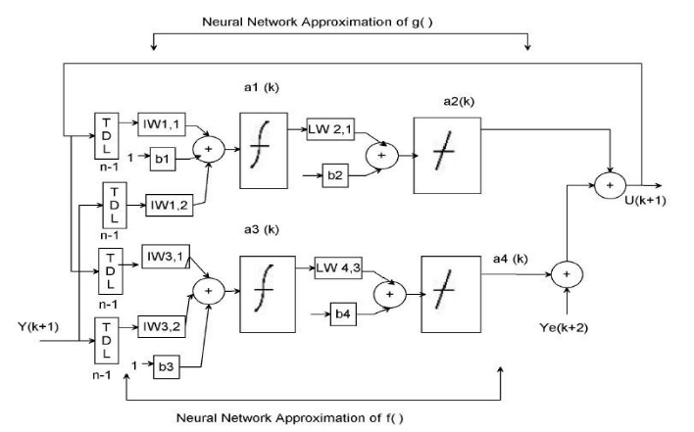

Figure 4. Previously identified NARMA-L2 plant model

Table 3 illustrates the network architecture, training data and training parameters of the proposed controllers.

Table 3 Neural network Parameters

|  |  |  |  |
| --- | --- | --- | --- |
| Network Architecture | | | |
| Size of hidden layer | 6 | Delayed plant input | 2 |
| Sample interval(sec) | 1 | Delayed plant output | 3 |
| Training Data | | | |
| Training sample | 100 | Maximum Plant output | 3 |
| Maximum Plant input | 1 | Minimum Plant output | 1 |
| Minimum Plant input | 1 | Max interval value (sec) | 3 |
| Min interval value (sec) | | | 1.5 |
| Training Parameters | | | |
| Training Epochs | | | 100 |

* 1. **Levenberg-Marquardt Algorithm**

Like the quasi-Newton methods, the Levenberg-Marquardt algorithm was designed to approach second-order training speed without having to compute the Hessian matrix. When the performance function has the form of a sum of squares (as is typical in training feedforward networks), then the Hessian matrix can be approximated as



and the gradient can be computed as



where **J** is the Jacobian matrix that contains first derivatives of the network errors with respect to the weights and biases, and **e** is a vector of network errors. The Jacobian matrix can be computed through a standard backpropagation technique that is much less complex than computing the Hessian matrix. The Levenberg-Marquardt algorithm uses this approximation to the Hessian matrix in the following Newton-like update:



When the scalar *µ* is zero, this is just Newton's method, using the approximate Hessian matrix. When *µ* is large, this becomes gradient descent with a small step size. Newton's method is faster and more accurate near an error minimum, so the aim is to shift toward Newton's method as quickly as possible. Thus, *µ* is decreased after each successful step (reduction in performance function) and is increased only when a tentative step would increase the performance function. In this way, the performance function is always reduced at each iteration of the algorithm.

* 1. **Resilient Backpropagation Algorithm**

Multilayer networks typically use sigmoid transfer functions in the hidden layers. These functions are often called "squashing" functions, because they compress an infinite input range into a finite output range. Sigmoid functions are characterized by the fact that their slopes must approach zero as the input gets large. This causes a problem when you use steepest descent to train a multilayer network with sigmoid functions, because the gradient can have a very small magnitude and, therefore, cause small changes in the weights and biases, even though the weights and biases are far from their optimal values. The purpose of the resilient backpropagation (Rprop) training algorithm is to eliminate these harmful effects of the magnitudes of the partial derivatives. Only the sign of the derivative can determine the direction of the weight update; the magnitude of the derivative has no effect on the weight update. The size of the weight change is determined by a separate update value.

1. **Result and Discussion**

The simulations of the steam condenser with the proposed controllers will present in this section. The Simulink model of the steam condenser with NARMA-L2 using Levenberg-Marquardt Algorithm and NARMA-L2 using Resilient Backpropagation Algorithm controllers is shown in Figure 5 below.

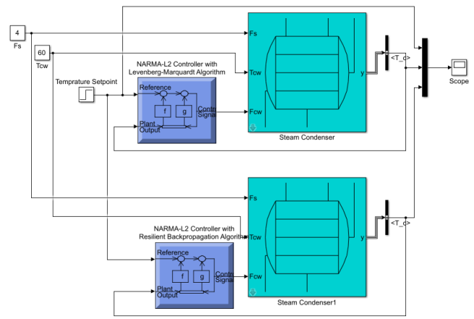

Figure 5 Simulink model of the steam condenser

**4.1** **Simulation of the cooling water outlet temperature for a step Drop in Temperature**

The Simulation output of the cooling water outlet temperature for a step drop in temperature for the steam condenser with NARMA-L2 using Levenberg-Marquardt Algorithm and NARMA-L2 using Resilient Backpropagation Algorithm controllers is shown in Figure 6 below.

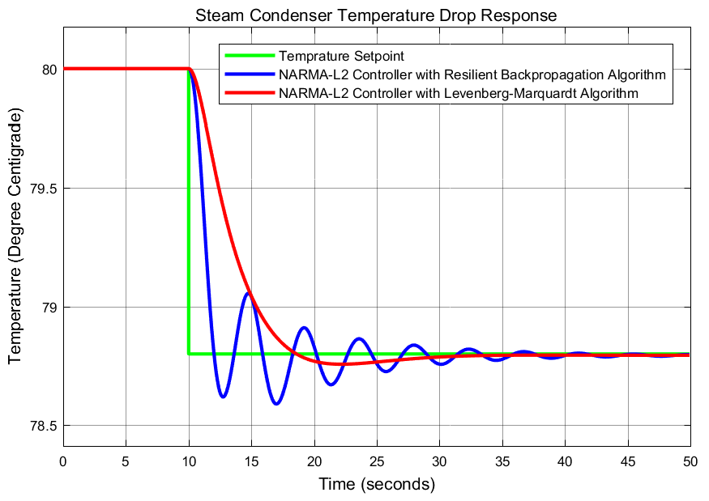

Figure 6 Simulation output of the cooling water outlet temperature for a step drop in temperature

The simulation above shows that the steam condenser with NARMA-L2 using Resilient Back propagation Algorithm controller temperature drops with an oscillation with a big settling time as compared to the steam condenser with NARMA-L2 using Levenberg-Marquardt Algorithm controller.

1. **Conclusion**

In this paper, the design of steam condenser condensate water temperature control has been done using MATLAB/Simulink software successfully. Comparison of the steam condenser with NARMA-L2 using Levenberg-Marquardt Algorithm and NARMA-L2 using Resilient Backpropagation Algorithm controllers for the control target cooling water outlet temperature using a step drop in temperature set point. The simulation results prove that the steam condenser with NARMA-L2 using Levenberg-Marquardt Algorithm controller shows a good response in improving the response of the control targets effectively with best settling time than the steam condenser with NARMA-L2 using Resilient Backpropagation Algorithm controller. Finally, the comparison and simulation results prove the effectiveness of the presented steam condenser with NARMA-L2 using Levenberg-Marquardt Algorithm controller.

**Reference**

1. Rafał Laskowski, Adam Smyk, Artur Rusowicz, Andrzej Grzebielec, Optimization of the cooling water mass flow rate under variable load of a power unit, Applied Thermal Engineering, Volume 191, 2021, 116874, ISSN 1359-4311, <https://doi.org/10.1016/j.applthermaleng.2021.116874>.
2. Tontu, M . "Performance Analysis of a Large-Scale Steam Condenser Used in a Steam Power Plant" . European Mechanical Science 4 (2020 ): 72-77 <https://dergipark.org.tr/en/pub/ems/issue/52493/644733>
3. Jibril, M.; Tadese, M.; Hassen, N. & Abebe, Y. Modeling and Performance Analysis of Shell Tube Surface Condenser under Lumped Parameters using Fuzzy Self-tuning PI Controller, International Journal of Electronics and Electrical Engineering Systems 2020, 3, 1-8
4. Mustefa Jibril Eliyas Alemayehu Tadese, M. T. Comparison of Mixed H 2 /H  with Regional Pole Placement Control and H 2 Optimal Control for the Design of Steam Condenser Innovative Systems Design and Engineering, 2020, 6, 773-780
5. Un-Ki Kim, Ji-Woong Yoo, Yeong-Jun Jang & Yeon-Gun Lee (2020) Measurement of heat transfer coefficients for steam condensation on a vertical 21.5-mm-O.D. tube in the presence of air, Journal of Nuclear Science and Technology, 57:8, 905-916, DOI: 10.1080/00223131.2020.1736200
6. Jagtap, H.P., Bewoor, A., Kumar, R. (2019). Thermal power plant condenser fault diagnosis using coordinated condition monitoring approach. Instrumentation Mesure Métrologie, Vol. 18, No. 3, pp. 223-235. https://doi.org/10.18280/i2m.180301
7. Lalatendu Pattanayak, Biranchi Narayana Padhi, Bibhakar Kodamasingh, Thermal performance assessment of steam surface condenser, Case Studies in Thermal Engineering, Volume 14, 2019, 100484, ISSN 2214-157X, https://doi.org/10.1016/j.csite.2019.100484.
8. Pattanayak, L., Padhi, B.N., Kodamasing, B. (2019). Thermal performance assessment of steam surface condenser. Case Studies in Thermal Engineering, 14: 100484.
9. Mathurkar, R. D., Lawankar, Dr. S. M. (2017). Review on steam condensation heat transfer coefficient in vertical mini diameter tube. International Research Journal of Engineering and Technology, 4: 705-710.
10. Masiwal, G., Kumar, P.S., Chaudhary, S. (2017). Performance analysis of surface condenser in 525MW thermal power plant. International Research Journal of Engineering and Technology, 9: 1931-1939.
11. Bilgili, M., Çardak, E., Aktaş, A. E. (2017). Thermodynamic Analysis of Bus Air Conditioner Working with Refrigerant R600a. European Mechanical Science, 1(2): 69-75.

5/22/2021