**The Necessity To Develop Geographical Tourism In Diversification Of Tourism Industry**

Tobirov Odiljon Kobiljon ugli

doctoral student of the Department of Ecology and Geography, Gulistan State University

[*odiljon.tobirov@mail.ru*](mailto:odiljon.tobirov@mail.ru)

**Abstract**: Diversification of the tourism industry, a comprehensive study of the tourist potential of certain geographical areas, the identification of periodic (seasonal) aspects, encourages the systematization of tourist types. Geography is a branch of science that studies the above features. Geographical tourism allows for the systematic development of its new species in order to comprehensively cover the tourist potential of a particular region.

[Tobirov Odiljon Kobiljon ugli. **The Necessity To Develop Geographical Tourism In Diversification Of Tourism Industry .** *N Y Sci J* 2021;15(5):31-38]. ISSN 1554-0200 (print); ISSN 2375-723X (online).

<http://www.sciencepub.net/newyork>. 6.doi:[10.7537/marsnys140521.06](http://www.dx.doi.org/10.7537/marsnys140521.06).

**Key words**: geography, tourism, geographical tourism, diversification, tourist diversification, tourist zoning, tourist region, tourist zone, tourist cluster.

**1. INTRODUCTION**

The Concept of Tourism Development in the Republic of Uzbekistan for 2019-2025, approved by Decree No. 5611 of the President of the Republic of Uzbekistan, adopted on January 5, 2019, sets the task to diversify and improve the quality of tourism industry services and improve tourism infrastructure*[1]*.

This encourages the diversification of the tourism industry, i.e. comprehensive study of the tourism potential of certain geographical areas, the identification of periodic (seasonal) aspects, the systematization of tourism types. The subject matter of research in the sphere of “Geography” is aimed at studying the territorial, complex, periodic and systemic features of nature-society – economy, including the provision of tourist services in a particular geo complex or geosystems.

***The problem and its solution.*** In recent years, there has been a growing interest and demand from travelers to visit complex tourist facilities in a particular area (administrative or natural) rather than belonging to the same type of tourism (eco, agro, historical, religious, etc.). Based on these requirements, the issue of diversification of tourism, for instance, reconsideration in terms of sustainable development of types and services of tourism in the regions are on the agenda.

In accordance with these requirements for the tourism industry in Uzbekistan, a number of normative legal acts have been adopted in recent years to develop the industry. In particular, the Law of the Republic of Uzbekistan “On Tourism”, adopted on July 18, 2019, and the task “ On Organization of tourist zones and tourist clusters” specified in Chapter 4.

Based on the experience of other countries such as Japan has the largest number of tourist zones in the world (30 tourist zones[2]), and China (45 tourist zones[3]), in the organization of tourist zones in certain areas, taking into account, first of all, the impact on the nature, population and economic activity of the region[4].

A number of scientists (Манаков 2011, Худеньких 2003, Зырянов 2009, Romão 2017, Rodrigues 2017, Shomurodova 2018) researched the scientific and theoretical aspects of the division of regions into tourist zones or districts. However, in the research of the above-named scientists, different views have been expressed on the division of certain areas into tourist areas and zones. For example, A.G. Manakov divided the land part of the planet into 6 tourist regions (macroregions) (Europe, the Middle East, Asia-Pacific, South Asia, Africa, America) (Манаков, 2011). For some reason, from a political point of view, it did not include the territory of the CIS countries in the separation of tourist areas and did not meet the unique geosystem law of geography. A.N. Nigmatov and his students Sh. Yakubjanova visited 15 agro-tourism zones and N. Shomuratova divided into 14 ecotourism districts. M. Mahmudov divided the Andijan region into 5 districts. Thus, the zoning of a particular area can be manifested in different scales and forms, depending on the goals and objectives set by the researcher. It should be noted that the division into regional tourist areas is different from tourist zoning. This is because the zoning is divided into hierarchical parts, and these parts are strictly scaled. On the basis of the Law of the Republic of Uzbekistan “On Special Economic Zones”, adopted on February 17, 2020, and a number of normative legal acts, tourist and recreational zones such as “Charvak” and “Zomin” have been established in the country by 2021.

Tourist zones have a positive or negative impact on the economic, social, cultural life of a particular country or region, as well as on the relationship between nature and society. These effects can be grouped into three main groups: economic impacts, socio-cultural impacts, and natural-environmental impacts (Özgüç, 1998).

As a result of the establishment of tourist zones, it will be possible to identify new tourist resources and other necessary conditions for the development of the tourism industry in underdeveloped areas, which in turn will affect the economic activity in the region. The establishment of tourist zones allows people to use certain areas for recreation and development of their culture. To do this, it is important to have a minimal impact on nature in the first place (Худеньких, 2003,).

Geography deals with tourism tourist zones, resources, favorable and unfavorable environmental factors, development of tourist routes and the above-mentioned influences (Зырянов, 2009). Because the object of study of geography is the nature, population and economy of a particular area. The subject is a regional, periodic, systematic and, of course, complex study of events. Geographers are not only successful in the sphere of tourism but also have an advantage over others in this sphere. The geographer sees the area and the tourist sees the destination. (Зырянов, 2009).

With this in mind, we are promoting geographical tourism from a geographical point of view. However, there is no scientific and practical basis for the development of geographical tourism in any country in the world, in the CIS, as well as in Uzbekistan. Therefore, there is a sufficient need to define the concept, purpose and object of geographical tourism.

***Research goals and tasks.***

In order to develop the scientific and practical basis of geographical tourism for the diversification of tourism in Uzbekistan, the following tasks are set: to reveal the concept, content and essence of geographical tourism; determine the role of geographical tourism in the diversification of the tourism industry; make suggestions and recommendations on the future plan of geographical tourism

**2. METHOD**

Geographical tourism research consists of the selection and systematization of research methods related to geography and tourism in terms of the real political and environmental situation, economic opportunities, social status.

As a result of the integration of research methods of geography and tourism, the research methodology of geographical tourism is formed (Table No. 1) and they are listed as follows.

**Table No.1**

**Systematization of methods in the methodology of geographical tourism**

SCIENTIFIC RESEARCH METHODS OF GEOGRAPHICAL TOURISM

***The first level.*** CAMERAL DESIGN

Literature review, statistics, cluster, tourist route, cartography, GIS

***The second level.*** FIELD-EXPEDITION

Stationary and semi-stationary, GIS, observation, comparison, experiment, description

***The third level.*** EXPERIMENTAL TEST

Geochemical, geophysical, aerospace, geographic modeling cartographic, valimetric, synthesis

***The fifth level.*** CAMERAL SUMMARY

Geographic comparison, geographic zoning, geographic evaluation and forecasting, deduction, induction, SWOT

Geographical tourism provides a positive effect on the geographical assessment of the tourist potential of the region and the organization of tourist zones through the systematization of scientific research methodology and the effective use of methods in this system.

**3. RESULTS**

Tourism is an area that is constantly changing under the influence of various external and internal processes, especially globalization. As the motivational attitudes of tourists change. This means the need to develop new routes for travelers through the modernization and improvement of traditional routes.

Today, there are a number of types of tourism in the world (historical, ecological, agro, religious, educational, ethnographic, gastronomic, business, sports, medical, youth tourism, etc.), and new ones are being added.

This, in turn, creates new areas of scientific research. This is called “tourist diversification” in the language of science. The term diversification (lat. diversiﬁcatio – change, diversified development) was first used by economists in the sense of expansion, renewal of the spheres of activity of enterprises (associations) and the type of products they produce. It is done for the purpose of achieving high efficiency, economic gain, elimination of bankruptcy (Konstantinova, 2013). In the tourism literature, diversification is the systematic integrated development of new species to meet the growing needs of tourists, to increase the tourist attractiveness of the region, to comprehensively cover the types of tourism in a particular area in order to attract tourists to tourist facilities throughout the year. To achieve these goals, there is a need to develop a comprehensive type of tourism. This, in our opinion, makes sense to download “Geographic Tourism”. After all, if the object of study of geography is certain regions, the subject matter of his research is the complex properties of regions.

As a result of the integration of the concepts of geography (Нигматов, 2018) and tourism (“On Tourism”, 2019), the direction of geographical tourism has emerged. **Geographic tourism** can be considered – *as a type of tourism industry, which deals with the definition, organization, conduct and accounting of policy in terms of territoriality, complexity, periodicity and structure in certain geocomplex or geosystems* (Nigmatov & Tobirov, 2021). **The purpose**of “Geographical Tourism” is to study the tourist potential of geosystems to diversify the tourism industry in terms of the subject matter of geography**.** This goal sets the following **tasks** for “Geographical Tourism”: Creating a scientific and theoretical basis for “Geographical Tourism”; Clarification of issues such as the specific object of “geographical tourism”, the subject of research, methodological framework, principles, the role of geographical and tourism-related disciplines; coordination and ordination of research methods in geographical and tourism sciences; development of the concept of introduction of “Geographical tourism” education in the national education; defining the practical aspects of “geographical tourism”, etc.

In order to form geographic tourism as a new tourist destination, it is first necessary to determine its object of study. Unlike geotourism, it studies all types of tourism in terms of territoriality, periodicity, structure and complexity, rather than underground and surface geological objects. In geographical tourism, from a practical point of view, it is expedient to hierarchically divide geotisms into tourist regions, zones and clusters.

***Tourist region*** – is an area consisting of tourist zones and clusters covering specific natural-socio-economic indicators in which tourist services are provided. ***Tourist zone*** – is an area with certain boundaries, where one or more tourist resources are located, consisting of tourist clusters (Figure 2) established for the development of the tourism industry, protection and rational use of tourist resources (“On Tourism”, 2019). ***A tourist cluster –*** *is*a set of independent organizations and individual entrepreneurs providing comprehensive tourist services and other additional services necessary to meet the needs of tourists and excursionists (“On Tourism”, 2019). The subject matter of geographical tourism is based on the study of regional, periodic, systemic and complex features of the tourism industry in the objects listed above.

**4. DISCUSSION**

At present, the most pressing issue is to improve the economic situation of the regions, along with the effective and full use of their potential. This is the most effective solution to the problem in recent years, and the tourism industry is playing a role. For the development of the economy of our country on the basis of the principles of sustainable development, the tourism sector stands out, among many other areas. Today, one of the main tasks is to increase the flow of tourists visiting our country (Table No. 2) and create favorable conditions for them. In doing so, special attention should be paid to the following features.

**Table No. 2**

**Dynamics of number of tourists visiting Uzbekistan in 2016-2020**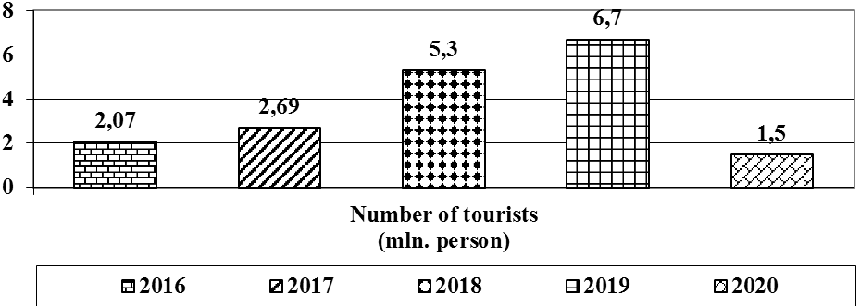

It is necessary to eliminate the concentration of tourists in a particular area (Samarkand, Bukhara, Khiva, Kashkadarya, Tashkent). These are expressed on the one hand by a large number of tourist facilities in the region (Samarkand, Kashkadarya) (On approval of the National List of Real Estate Objects of Intangible Cultural Heritage, 2019) (Table No. 3), on the other hand by the popularity of tourist facilities (Samarkand, Bukhara, Khiva) represented by It is advisable to create tourist zones to increase the tourist potential of other regions.

**Table No. 3**

**Distribution of tourist facilities throughout the administrative-territorial units of Uzbekistan**

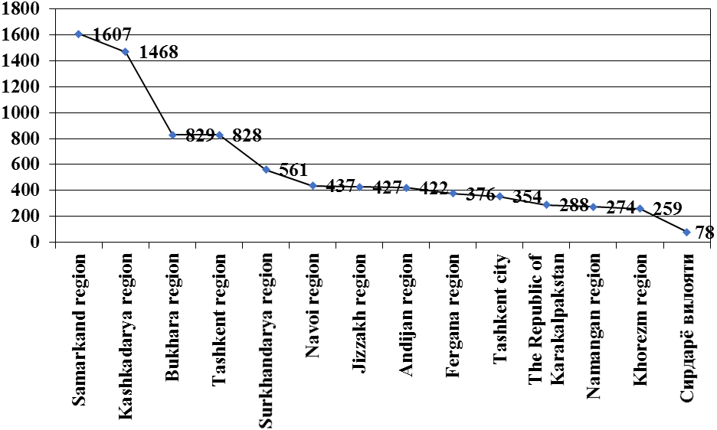

It is necessary to soften the seasonality of the tourism industry of our country. Currently, in July, August, September and October, the flow of tourists to our country is high (Tourism in Uzbekistan – 2018, 2018). To change this feature for the better, the most important task is to develop the diversity of tourism species in the regions (Table No. 4).

**Table No. 4**

**Distribution of the number of tourists visiting Uzbekistan by months**

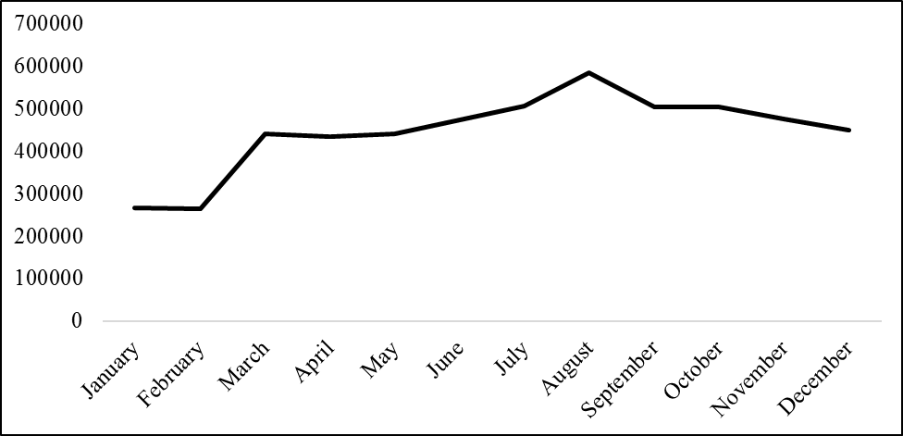

It is necessary to follow the principles of structure in the organization and placement of types of tourism. It is also necessary to develop the remaining types of tourism on the basis of known and popular tourist facilities. Tourist clusters serve as a basis for this (Tables No. 5-6).

**Table No. 5**

**Integrated tourism sectors in geographical tourism**

The main issue is the integrated development of existing types of tourism in the region. Geographical tourist areas, which are the object of geographical tourism, can be a solution to the problem. When choosing tourist areas, several tourist zones should be considered as a single tourist area. For instance, Fergana Valley is a tourist region. The only and new type of tourism that combines all the above features are geographical tourism.

**Table No. 6**

**Introduction of tourism cluster for tourism development among Kokand group districts**

**5. CONCLUSION**

To diversify the tourism industry, the study of the tourism potential of certain regions through geographical tourism can be considered as a key factor contributing to the sustainable development of all countries..

**REFERENCES**

*China adds to 45 national-level tourist, resort zones*. (29 декабрь 2020 г.). Получено из www.chinatravelnews.com: https://www.chinatravelnews.com/article/142589

Konstantinova, S. (2013). Diversification in tourism. *Conference: International scientific and practical internet conference “Actual problems of modern economy development”* (стр. 1). Dnepropetrovsk, Ukraine: Dnepropetrovsk: Gerda.

Nigmatov, A., & Tobirov, O. (13 March 2021 г.). Scientific And Theoretical Foundations Of The Concepts Of Tourism, Geography And Geographical Tourism. *The American Journal of Interdisciplinary Innovations and Research, Volume03*(Issue03-01), 1-10. doi:10.37547

Özgüç, N. (1998). Turizm coğrafyası - özellikler ve bölgeler (4. ed.). *İstanbul: Çantay Kitabevi*, 184.

Romão, J., & Rodrigues, P. (2017). Territory and Sustainable Tourism Development: a Space-Time Analysis on European Regions. *REGION. 4. 1. 10.18335/region.v4i3.*, 142.

*Tourism Zone Development Act*. (8 декабр 2016 г.). Получено из www.mlit.go.jp: https://www.mlit.go.jp/kankocho/en/shisaku/kankochi/seibi.html

Зырянов, А. И. (2014). География и туризм: различие и общность интересов. *Современные проблемы сервиса и туризма 8 (1)*, 10-15.

Манаков, А. Г. (2011). *Туристские регионы мира. География культурного наследия: Учебное пособие.* Псков: Псков: ПГПУ.

*Моддий маданий мероснинг кўчмас мулк объектлари миллий рўйхатини тасдиқлаш тўғрисида*. (4 октябрь 2019 г.). Получено из lex.uz: https://lex.uz/docs/4543266

Нигматов, А. Н. (2018). *Табиий география ва геоэкология назарияси.* Тошкент: Наврўз.

*Особые туристические зоны. Туристские регионы и зоны*. (21 июнь 2020 г.). Получено из tothostel.ru: https://tothostel.ru/shengen/osobye-turisticheskie-zony-turistskie-regiony-i-zony-gornolyzhnyi-kurort-v/

*Туризм в Узбекистане — 2018.* (2018). Тошкент: OOO «MITRA TRAVEL».

*Туризм тўғрисидаги*. (18 июль 2019 г.). Получено из lex.uz: https://lex.uz/docs/-4428097

*Ўзбекистон Республикасида туризмни жадал ривожлантиришга оид қўшимча чора-тадбирлар тўғрисида*. (05 январ 2019 г.). Получено из lex.uz: https://lex.uz/docs/4143188

Худеньких, Ю. А. (2003). Географическое измерение туризма. *Географические проблемы Уральского Прикамья: Материалы региональной науч-практической конференции* (стр. 58-64). Пермь: университет Пермь.

Шомуродова, Ш. Ғ. (2018). Чимѐн-Чорвоқ курорт-рекреация зонасида туризмни ривожлантиришнинг истиқболлари. *Ўзбекистон География жамияти ахбороти. 54-жилд*, 38-41.

5/22/2021

1. The Decree No. 5611 “On additional measures for the accelerated development of tourism in the Republic of Uzbekistan” of the President of the Republic of Uzbekistan, adopted on January 5, 2019. <https://lex.uz/docs/4143188>
2. Tourism Zone Development Act. (8 декабр 2016 г.). Получено из www.mlit.go.jp: <https://www.mlit.go.jp/kankocho/en/shisaku/kankochi/seibi.html>
3. China adds to 45 national-level tourist, resort zones. (29 декабрь 2020 г.). Получено из www.chinatravelnews.com: <https://www.chinatravelnews.com/article/142589>
4. Особые туристические зоны. Туристские регионы и зоны. (21 июнь 2020 г.). Получено из tothostel.ru: <https://tothostel.ru/shengen/osobye-turisticheskie-zony-turistskie-regiony-i-zony-gornolyzhnyi-kurort-v/>