**Simulation of All Optical Directional Coupler with Changing Central Rods Radius in Linear State by Using COMSOL Software**

Sheler Maktoobi 1, Neda Nasrollahi 2

1,2 Sama technical and vocational training college, Islamic Azad University, Sanandaj Branch, Sanandaj, Iran

[1Sheler.maktoobi@yahoo.com](mailto:1Sheler.maktoobi@yahoo.com) , 2 [neda_nasr2002@yahoo.com](mailto:neda_nasr2002@yahoo.com)

**Abstract.** In this paper, an all optical switch based on linear photonic crystal directional coupler, consists of three regions of input, coupling and output has been Simulated and analyzed in order to increase high speed and quality of switches. For this reason FDTD method has also been identified as the preferred method for performing electromagnetic simulations. We have tried to increase the coupling efficiency and reduce the required power in the linear statue. Therefore, the input signal beam can be controlled to be exchanged between two output ports to earn the highest output power. As a result, electric field intensity and the power output that are two important factors to improve the switching performance and the device efficiency. Where central row rods are (0.15a) and (0.16a), all optical directional coupler switches have been investigated and simulated by using COMSOL software.

[Sheler Maktoobi, Neda Nasrollahi. **Simulation of All Optical Directional Coupler with Changing Central Rods Radius in Linear State by Using COMSOL Software.** *N Y Sci J* 2021;14(4):78-80]. ISSN 1554-0200 (print); ISSN 2375-723X (online). [http://www.lifesciencesite.com](http://www.lifesciencesite.com/). 6. doi:[10.7537/marsnys140421.08.](http://www.dx.doi.org/10.7537/marsnys140421.08)

**Key words**: photonic crystal, all optical switches, FDTD method

**1. INTRODUCTION**

A photonic crystal is a periodic lattice of dielectric media that prohibits light waves of specific wavelengths from propagating in certain directions. The prohibited range of wavelengths amounts to a photonic band gap (PBG), which is analogous to the electronic band gap found in semiconductors wherein electrons are forbidden at certain energy levels. In some ways, a photonic crystal behaves much like a metallic waveguide, restricting the propagation of electromagnetic waves below a threshold frequency. Forbidden wavelengths are determined by material layer thickness, dielectric constant, and feature periodicity. 2-D photonic crystals can be formed by creating a periodic 2-D pattern of features in metal and/or dielectric layers using conventional IC fabrication equipment. The edges of etched features act as the interfaces that refract and reflect light and form photonic band gap regions to suppress and guide light within the plane of the crystal. Photonic Crystals will provide researchers from different fields with the theoretical background required for modelling photonic crystals and their optical properties, while at the same time presenting the large variety of devices, ranging from optics to microwaves, where photonic crystals have found application. As such, it aims at building bridges between optics, electromagnetism and solid state physics [1-3]. The most important applications of

photonic crystal structure are optical filters [4], resonators [5] ,switching [6,7], laser[8], Photonic crystal waveguide directional couplers[9] and planar antenna[10] .

**2. PHOTONIC CRYSTAL DIRECTIONAL COUPLERS**

The photonic crystal optical switch is one of the most important applications of photonic crystals in telecommunication networks. The optical switch structure based on photonic crystal (PC) directional coupler is shown in Figure 1 the device is made of two dimensional hexagonal PC structure .The ports of the coupler are tagged in Figure 1. The rods have radius of 0.2a, where a is the structure lattice constant .Directional coupler switch is consists of three regions of input, coupling and output. Total length of the coupling region is L and the central rods radius (rc) is determined to be 0.14a [11].

Different types of directional couplers with different applications and dispersion properties can be designed by variation of the number and radius of the central row rods. The coupling mechanism for all couplers, as depicted in Eq.1, depends on the frequency-dependent parameter of propagation constant (ß).

Lc = π / ǀ ßodd –ßeven ǀ (1)

Where Lc is length of the coupling region.

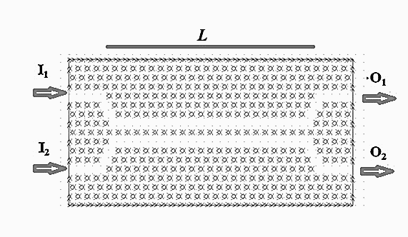

Figure 1. A directional coupler switch based on Photonic crystal

**3. SIMULATION OF ALL OPTICAL DIRECTIONAL COUPLER IN VARIOUS CENTRAL RADIUS**

All optical switches have been under intensive study in recent years due to their potential abilities for optical system and network applications. Several methods have been reported to control the propagation properties of optical devices. In this paper we have tried to obtain new results by changing the central rods. Radiuses of central row rods are considered first 0.15a and then 0.16a, where a is the structure lattice constant. Different radiuses are studied, but 0.15a and 0,16a were optimal where a is defined 575nm.

The TM band gap of the structure, as depicted in Figure 2, is in the range of 0.2735 ≤ a/λ ≤ 0.3833, where λ denotes the optical wavelength in free space. In fact, frequency range in order to analyze and simulate is determined. By removing some of the AlGaAs pillars in the structure of crystal, a guide for the frequencies within the band gap will be created.

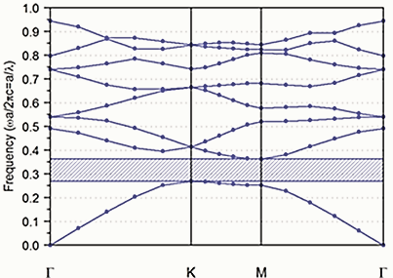

Figure 2. Band diagram for TM polarization in a triangular lattice of AlGaAs rods

Different structures with changing in central row rods (0.15a), (0.16a) in Figure 3 are observed. All simulatins and analysis in linear state have been done where “a” has been considered 575nm.

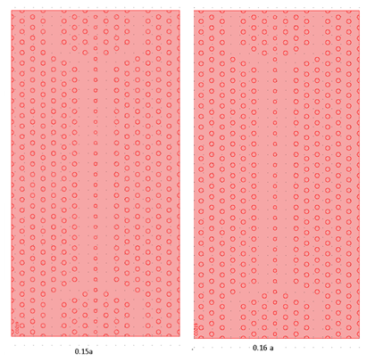

Figure 3. Periodic structures of Photonic crystal (0.15a, 0.16a) without propagation

In order to demonstrate the switching performance of the device, we have simulated the linear state, which the refractive index of the central row is unchanged during the guidance of the light wave. For linear case as depicted in Figure 4, which no pump signal is induced to the central row, the coupler is expected to operate in bar state; it means that the input light wave, I1 , with the proper frequency is guided to port O1.

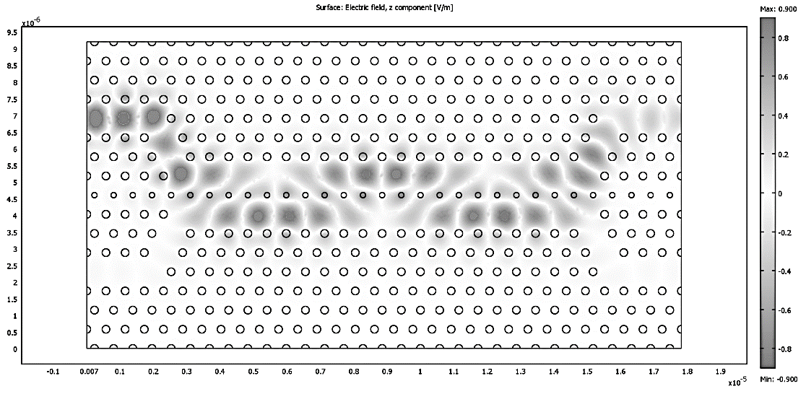

Figure 4. All-optical switch in linear state

**4. FDTD (Finite Difference Time Domain) method**

FDTD is a computationally intensive method and most reasonable calculations will need a fast computer and at least a few Gigabytes of computer memory. For most applications it is fairly simple to estimate the amount of computer memory required for a calculation. The most important factor for the memory usage, and in large part the run time, is the number of FDTD cells used to represent the structure under test. Each FDTD cell has six field values associated with it: three electric fields and three magnetic fields [13]. Additionally each cell has six flags associated with it to indicate the material type present at each of the six field locations.

In this paper, a geometrical structure with the FDTD method is formed by using COMSOL software, as Figure 5 has illustrated.

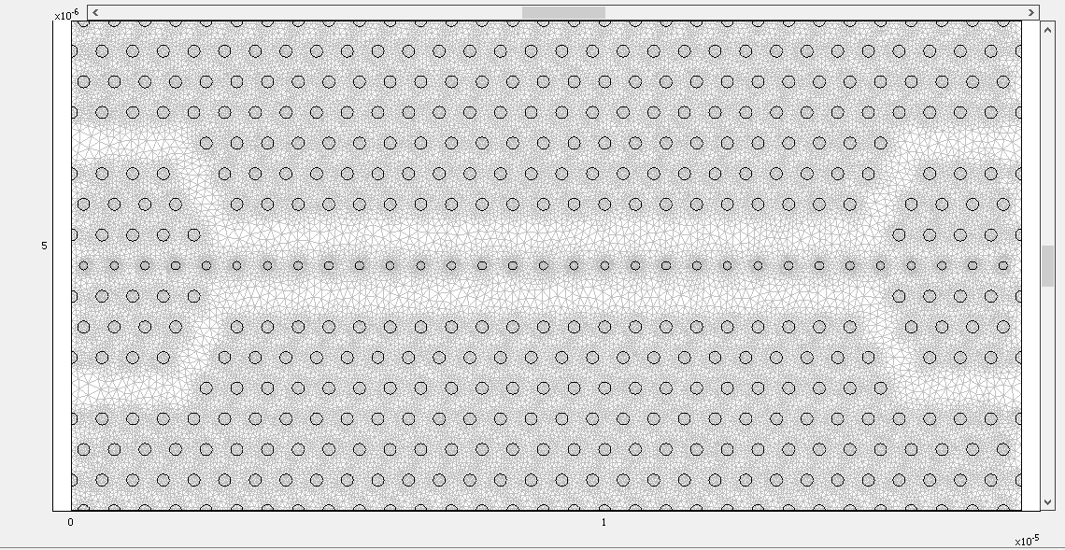

Figure 5. Dielectric rectangular as meshed in an FDTD grid

**5. RESULTS OF SIMULATION**

In this paper, we have used the COMSOL software for simulation and analysis of all optical directional coupler to switch .The resulting plots, as depicted in Figure 6 (a,b) indicate that the normalized component of the electric fields that show how the wave propagates along the path defined by the pillars.

H:\شششششششششلیر(کامسول)\comsol ghadimi\proje2\natayeje ali\غیرخطی 2.2.tif

Figure 6 (a). Normalized component electric field for (0.15a)

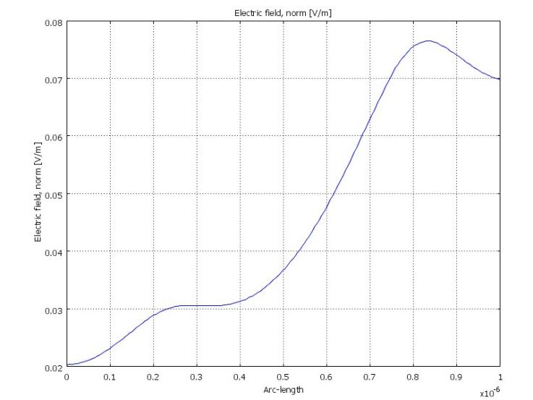

Figure 6 (b). Normalized component electric field for (0.16a)

Some methods improve performance of devices, power output can evaluate Photonic crystal efficiency. Figure 7 (a, b) contain plots of normalized power flow where the highest and lowest power for the proposed structures are illustrated. One of the most important factors in designing and analyzing is output power and numerous applications are found by super flexible in power output.

H:\شششششششششلیر(کامسول)\comsol ghadimi\proje2\natayeje ali\غیرخطی2.tif

Figure 7 (a). Normalized output power for (0.15a)

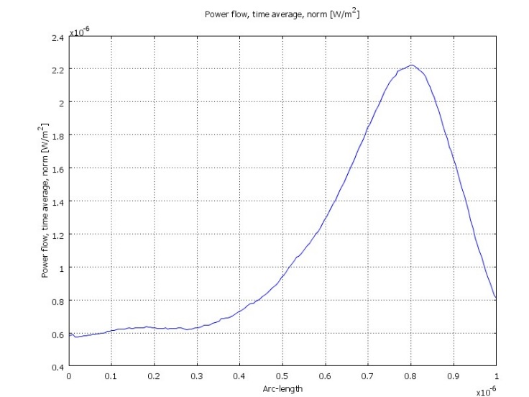

Figure 7 (b). Normalized output power for (0.16a)

**6. CONCLUSION**

Electrical switches have some limitations on switching speed compared to the speed of light. As data requirements grew, the electrical part of the electro-optical switch created limits for how much data could be transmitted. More advanced optical switch technologies were needed particularly to remove the electrical conversion when switching light signals. In this paper, all optical switches based on linear photonic crystal directional coupler have been simulated. The most output powers in the linear state have been shown moreover, the electric fields that show how the wave propagates along the path defined by the pillars, are also simulated as well. In order to proper result, COMSOL software has been used. In this paper FDTD (Finite Difference Time Domain) has also been identified as the preferred method for performing electromagnetic simulations.

**Authors**

Sheler Maktoobi1, Neda Nasrollahi 2

1,2 Sama technical and vocational training college, Islamic Azad University, Sanandaj Branch, Sanandaj, Iran.

[1Sheler.maktoobi@yahoo.com](mailto:1Sheler.maktoobi@yahoo.com) , 2[neda_nasr2002@yahoo.com](mailto:neda_nasr2002@yahoo.com)

**REFERENCES**

1. C.M. Reinke, A. Jafarpour, B. Momeni, M. Soltani, S. Khorasani, A. Adibi, Y. Xu, R.K. Lee. Nonlinear finite-difference time-domain method for the simulation of anisotropic, x(2), and x(3) optical effects. IEEE J. Lightwave Technol. 2006; 24(1): 624–634.
2. A.T. Rahmati, N. Granpayeh. Design and simulation of a switch based on nonlinear directional coupler. Optik Elsevier. 2010; 121:1631-1634.
3. M.S. Saremi, M.M. Mirsalehi. Analysis of femtosecond optical pulse propagation in one-dimensional nonlinear photonic crystals using finite-difference timedomain method. Optik.2005; 116 (10) : 486–492.
4. J. Zimmermann, M. Kamp, A. Forchel, R. Marz. Photonic crystal waveguide directional couplers as wavelength selective optical filters. Opt. Commun.2004; 230 (4) : 387–392.
5. S.H. Jeong, N. Yamamoto, J. Sugisaka, M. Okano, K. Komori. GaAs-based two-dimensional photonic crystal slab ring resonator consisting of a directional coupler and bent waveguides. J. Opt Soc. Am. B (JOSA-B).2007; 24 (8):1951–1959.
6. A. Martinez, F. Cuesta, J. Marti. Ultra short 2D photonic crystal directional couplers. IEEE Photon. Technol. Lett.2003; 15 (5):694–696.
7. F. Cuesta-Soto, A. Martinez, B. Garcia-Banos, J. Marti. Numerical analysis of all optical switching based on a 2-D nonlinear photonic crystal directional coupler. IEEE Select. Top. Quantum Electron.2004; 10 (5):1101–1106.
8. Wu, X., Yamilov, Liu, X., and Li, S. Ultra violet photonic crystal laser. Applied physics letter.2004; 85(17):3657-3659.
9. Zimmermann, J., Kamp, M., Forchel, A., Marz, R. Photonic crystal waveguide directional couplers as wavelength selective optical filters. Elsevier: Optics communications.2004; 230(4):387-392.
10. Brown, E.R., Parker, C.D., and Yablonovitch, E. Radiation properties of a planar antenna on a photonic crystal substrate. Optics info base.1993; 10:404-407.
11. Eshaghi, A., Mirsalehi, M.M., Attari, A.R., MalekAbadi, S.A. All-optical switching structure using nonlinear photonic crystal directional coupler. PIERS Proceedings.2008; 587-591.
12. Joseph, R.M., Taflove, A. FDTD Maxwell’s equations models for nonlinear electrodynamics and optics. IEEE transaction antennas and propagation.1997; 45(3):364-374.
13. Taflove, A., Hagness, S.C. Computational electrodynamics: The Finite difference Time-Domaine method. 2000: Second edition, Artech House.

2/17/2021